
UNITED INTERNATIONAL UNIVERSITY
Internship Report on ROXY PAINTS LTD.

SUBMITTED TO
DR. MOHAMMAD BADRUDDOZZA
Professor & Director - BBA and BBA in AIS Programs

SUBMITTE BY
Jeba fariha
ID: 111 162 059
BBA Department

DATE: 7th Nov 2021

Letter of Transmittal

DR. MOHAMMAD BADRUDDOZZA
Professor & Director
United International University

Subject: Submission of Internship Report

Dear Sir,
I’m student of BBA program completed my internship in Roxy paint and It is a great pleasure to submit my internship report under your supervision as a part of my BBA program. Also it’s a great opportunity to work with excellent professionals in Roxy Paints Ltd. And get to learn and experience real corporate environment.
Thank you for your kind assistance for preparing me that report. Hope you will consider all my mistakes in this report generously.

Sincerely Yours,
Jeba Fariha
ID: 111 162 059
Jeba Fariha
United International University

Acknowledgement

My acknowledgement begins with thanking my academic Professor DR. MOHAMMAD BADRUDDOZZA (Professor United International University) for providing me instruction for making this Final Internship Report. My heartiest thanks to sir for his cooperation and regular supervision that made me really confident about the desired outcome of my internship project.
I would like to show my gratitude to the whole department of Roxy Paints Ltd who have helped me to make this report providing company information and culture. I would like to thank all the employee of other department who always cooperate me and helps me to adjust with the office culture.
I have done internship under the supervision of Nadira Haque (Sr. Executive) and my head of the department Sanoarul Islam (Assistant General Manager) and really grateful to them for helping me in my every step in office.
I am very much thankful to Roxy Paints Limited and its management specially the employees of the entire Department for their cordial support to prepare this difficult study with important information and data. Without them it would not possible for me to complete this difficult task. I got all necessary guidelines, cooperation and advice from them to complete this complicated task.
And at last I want to show my gratitude for all my faculty member who have helped me to complete my courses and teach me a lot of thing which I can apply in my future work and for life. For me it was some beautiful year learning with United International University also the faculties and staff of university cooperate me a lot to earn this degree till now.

Executive Summary
Roxy Paints Limited is a painting company operating and sustain over 60 years. The company is head office is located at Dhanmondi. They have two factory in Madanpur and Kachpur. They have 8 Depot all over Bangladesh. Recently they are trying to import some building materials besides paints.
The company emphasizes on quality of product. The founder of the company is Mohammad Mujibur Rahman. Who have died in 2020 November. The employees of Roxy say Mohammad Mujibur Rahman Was not the actual founder of Roxy Paints, his father and grandfather and previous generation established this company. This company is currently a Limited Company. Soon it is trying to take part in Stock market.
Roxy family is becoming large day by day. They have 300 Employees now. They have over 5000 dealers all over Bangladesh directly and indirectly operating business all over Bangladesh.
Roxy have a beautiful working environment with experience employees. They have standard culture of work, Canteen facilities, friendly and cooperative employees made easier surviving there with activity. working with MIS was challenging. I was doing some analysis on sales and collection mainly which is provided weekly basis in next section. My collogues and supervisor helped me a lot completing this report.

Table of Contents
Letter of Transmittal 2
Acknowledgement 3
Executive Summary 4
Background of the study 6
1.1. Origin of the report 6
1.2. Background of the Report 6
1.3. Objective of the Report 6
1.4. Methodology 6
1.5. Limitation of the study 7
Organizational Overview 7
2.1. Introduction 7
2.2. Business Principles 7
2.2.1. Vision: 7
2.2.2. Mission: 7
2.2.3. Tagline: 8
2.2.4. Company Objectives: 8
2.2.5. Supply: 8
2.2.6. Demand: 8
2.2.7. Bargaining Power of Suppliers: 8
2.2.8. Market Characteristics: 8
2.2.9. Focusing Points of Roxy Paints Limited: 8
2.2.10. Nature of Business: 9
2.3. Executive Management Team 9
2.4. Product and Services Provided 10
2.4.1. List of Products Based on Different Categories: 10
2.4.2. List of Products Based on Different Categories: 10
Role of MIS in Different Department of Roxy Paint Ltd. 11
Overview of Internship Experience 11
Summary of the Report 15
Recommendation 15
Conclusion 15

Background of the study

Origin of the report
Bachelor of Business Administration (BBA) course requires 3 months internship with an organization which is add credit to university degree. I have got the opportunity to do my internship in Roxy Paints Ltd. My topic of the internship authorized by my honorable faculty to prepare this report as part of the fulfillment of internship requirement. It was mainly made by what I did, Learn and Experience from Roxy Paints.

Background of the Report
I have worked in various Department of Roxy Paints in my first month I was working with New Business Development team. Then I was working with Sales department in Sales analysis.
In this report I have represent my overall analysis on sales and collection and I will there the tools and working experience with various department.

Objective of the Report
The study has been undertaken with the following objectives:
- Finding out dealers balance, Collection, sales report and analyzing them.
- Credit Recovery of Roxy Paints.
- Getting overall Idea about Sales and collection.
- Finding out how to motivate and encourage sales field force team.
- To fulfill the requirement of the internship program under BBA program.

Methodology
Different methodologies were used to prepare the report. This report is made on based on qualitative approach and analysis and research. There are many ways and method used for making this report.
Primary data were collected:
- By communicating with the employees of different department
- By Observing the process and culture of the company
- By Observing and researching the report
Secondary Data were collected:
- From previous research
- From paint market
- From Annual Report
- From Search engine

Limitation of the study
Large-scale research was interrupted due to time constraints and for this covid situation.
This report was constructed to the observation of Head Office Dhanmondi and with some meeting with sales department from different depot. The survey was covered with the sales and collection analysis of the organization. I couldn’t reach the other depot and sales point due to company rules also relevant data was difficult to collect due to company’s security and confidentiality.

Organizational Overview

Introduction
Roxy Paint is one of the biggest national paint manufacturing company in Bangladesh established in 1953 recently taking attempts to spread their business by importing high quality and updated technology oriented painting products. Roxy Paints Ltd. have 8 Depot which is covering distribution all over Bangladesh. Unlike many such paints industry Roxy tries to remain ahead of its competitors by sponsoring innovation of local innovations.
Roxy paints now a days focused on social media marketing by posting different content and some selective approach to target the selective market. Also we all know the popular advertisement from childhood sounds “Prio Naam Prio Rong Roxy”. The logo of Roxy paints limited presents the message “Coloring The World Since 1953” also it shows a colorful effect which make us feel a vintage effect perfect for an old paint manufacturing company. Affordable price, durable quality, discount, incentive offer and social work such as seminar, debate, workshop on public welfare issues increase its value chain.

Business Principles
The vision and mission of Roxy Paints Bangladesh is very transparent. Roxy is trying to satisfied customer by quality and price both.

Vision:
Most of the brands main vision is to satisfy customer and provide the best quality within the price than other competitor.

Mission:
In covid situation most of the organization faced loss and low turnover. For this reason now Roxy is trying to overcome this situation. Till now they are trying to get back to the previous situation. Now they have some shortage of product soon they will get all the raw material from market and business will go back to there great place like before.

Tagline:
The tagline of Roxy Paints Is “Coloring the world since 1953” and by this tag line they are focusing on that they have sustained long time in market from Approximately 70 years.
As its sustain for long time its proved that they are having good quality and they have gained the trust of their customer also their research and development team successfully working with the change market and competitive market.

Company Objectives:
Roxy paints has very simple mission and vision as stated above, maintaining a sustainable market position and grow with time, by achieving customer satisfaction by providing high values at an affordable price. Their company objectives are designed based on these particular missions and visions, such as –

- Providing excellent and highest quality paints and varnishes
- As the company mainly targets the people with middle and lower middle-class income
- One of their most important objectives is to emphasize their research and development department to develop and improve product according to present trend

Supply:
Supply and demand exceeds in both the decorative as well as the industrial paints segments. Industry is fragmented.

Demand:
Demand for decorative paints depends on the housing sector and good monsoons. Industrial paint demand is linked to user industries like auto, engineering and consumer durables Barriers to entry: Brand, distribution network, working capital efficiency and technology play a crucial role.

Bargaining Power of Suppliers:
Price increase constrained with the presence of the unorganized sector for the decorative segment. Sophisticated buyers of industrial paints also limit the bargaining power of suppliers. It is therefore that margins are better in the decorative segment.

Market Characteristics:
Bangladesh paint market is already a highly competitive as evidenced by the fact that paint price increase at an average of less than 5% per year over the last ten years in spite of considerable higher inflation, huge price hike of paint raw material and regular devaluation of taka during this period. The Bangladeshi consumers have been benefited from the fierce competition in the paint sector even though underutilization of production capacity has though many local manufacturers in a shaky financial situation. It is argued that globalization and open market economy means survival for the fittest, but policy makers, in all conscience, should be ponder.

Focusing Points of Roxy Paints Limited:

- Commitment to achieve total customer satisfaction.
- Commitment to project the company as an ethical and socially responsible one.
- Commitment to continue its reputation as the pioneer of the industry.
- Commitment to continue its improvement in operation through utilization of highly professionals and dedicated team, proper process management and participation of the stakeholders.

Nature of Business:
The core business of Roxy Paints is manufacturing and marketing of paints, varnishes and coatings. It produces a wide range of paints including architectural paints, industrial coatings, marine paints and powder coatings. With a view to improving consumer satisfaction, Roxy has introduced end-user-oriented services such as Ronger Mela (Instant Tinting System), Roxy Fusion. The service technical service is provided by world famous leading colorants company Evonik, Australia.

Executive Management Team
The organizational structure of Roxy paints limited has been very straightforward and organized since many years. Their standard organizational structure is one of the reasons of their success in the industry and they have been following this structure and management organogram strictly.
In Roxy Paints, Chairman is the final and higher authority level and under the chairman, Managing Director and Executive Director are the persons who manage total 14 departments to run the organization according to the owner’s requirement.
As it falls into manufacturing industry, it is important to have a great coordination between each department, and Roxy paints is no exception. They have a remarkable coordination between each department which helps them in their day-to-day organizational activities and in their long run strategy making as well as in the implementation.
Roxy paints does business around the country so they have over 120 sales executives, approximately in 8 of the divisions, which are, Dhaka (North & South), Comilla, Chittagong, Sylhet, Barishal, Jessore, Bogra and Mymensingh. In every district, there are 1 Area sales manager who manage multiple sales executives.
Company’s sales divisions are classified area and region wise. Sales is the biggest department of Roxy Paints. They have some level who maintain sales department from management level to retail. Classification of those level mentioned below

Product and Services Provided

List of Products Based on Different Categories:
Roxy paints limited Mostly produces decorative and industrial paints. They have categorized their products into various types to simply present all of their products in front of the customer and stake holders, their list of products is given below according to their categories:
- Oil Based Paints: | - Water Based Paints:
- 777 Synthetic Enamel  - Butterfly Synthetic Enamel  - Roxy GP Thinner  - Roxy Industrial Thinner | - SPD, Roxy, Velvet, APE & APE Blaze  - Weather Guard and Weather Guard  Blaze and Weather Guard Dirt Shield.  - Water Sealer and Wall Putty  - Weather Guard Sealer/ Ex Sealer and  Oils Sealer

- Marine Paints: | - Sea Guard Paints:
- Marine Enamel  - Red lead and oxide primers  - Marine Zinc Chromate  - Marine A/C Red Oxide  Primers | - Sea Guard Enamel  - Sea Guard Red Lead and oxide primers  - S/G Zinc Chromate and Zinc Epoxy  Primer  - Epoxy ROXP

- Special Paints: | - Cement Based:
- Aluminum paint and Roxy Hammer  finish.  - Clear varnish and Copal varnish  - Roxy Butterfly hammer and New  - B/F Copal varnish etc. | - Roxy Cement Care

- Industrial Paints:
- Various types of epoxy primers.
- Epoxy enamel paints
- Decorative and Industrial ROXP
- Roxy road marking, tennis court,
epoxy flooring, coal tar epoxy etc.

List of Products Based on Different Categories:

Ronger Mela:
In order to help the customer to choose right shade and colors for their residential or industrial properties, Roxy has introduced an advanced technology which is a tinting system of colors that helps to match and mix different color to reach at the perfect share according to the customer’s requirement effortlessly within few minutes. In this regard, the company has partnered with famous foreign paint companies, such as – Evonik, Australia to import various materials. Roxy paints also acquired 100% automated mixing dispenser from Netherlands. The company promises that the customers can get their preferred shade with a single press on the button. This service is mainly developed for water-based paints.

Roxy Fusion:
Roxy Fusion is the service in which walls are decorated with different decorative patterns, colors, scenarios, art works as per customers wish. They provide the most affordable cost per square for this service. Also, the company has specialized time who will help the customers with a wide range of designs and ideas for the customers to pick the best suited design for their walls.

Literature Review

Organization Overview
The history of paint industry in Bangladesh can be said as the history of Roxy Paints Ltd. It is not only the manufacturing of quality paints since long, but also as Roxy’s pioneering the big paint market. It fought against non-Bengali or Western paints during the against the multinational during last 50 years of independent Bangladesh.
Roxy survived the protracted battle for existence. But its success was manifest not just about in survival; it won the hearts of the millions with world class consistent quality and proper customer service. Our users bear ample testimony of a national paint being international in quality and providing inexpensive cost per unit.
The oldest paint manufacturing industry of the country Roxy is pleased with having the ability to supply a good range of paints and varnishes that include distemper, interior paint, exterior paint, sealer, and primers are of water-based family. Synthetic enamel and marine paint are belonging to oil-based group. Hammer, epoxy, road, and runway marking paint and court paints are of commercial segment. Cement paint, thinners, rust, and paint removers make the full product line.
Quality is never an ending journey. Its exclusive and modern R & D unit dedicating itself equally at laboratory, plant and customer level to make sure constant pursue quality improvement and research into its present and future product configuration and presentations. The proverbial “old is gold” concept is simply meaningful if the longer term looks brighter and according to the past. Roxy’s future expansion plan includes establishing its own backward linkage project for producing time tested quality similarly as developing new paint formulations to satisfy customer’s satisfaction.
“Roxy Fusion” is an art using bold artistic colors and innovative movements to attain a composition of shades and textures which will only be achieved through the wondrous forces of nature. Fusion is supplied with 150 designs under 9 categories. Roxy has launched six Customer Care Center (3C). Customer will get total painting solution under one roof. Architect advice, computerized color visualization, trained painter service, instant color tinting system and installment payment facility on card purchase are the services offered freed from cost.

Vision and Mission of the company
Roxy Paints Ltd operates with a very clear and concrete vision and mission. The vision and mission statement of the company is given below:
Vision:
Leading the market by achieving users and stakeholders’ high level of satisfaction. Responsibly using application of knowledge, skill, and technology to improve the quality of life.
Mission statement:
- Gaining the market leadership in all sectors of traditional paints by shortest time interval.
- Giving customers high value for their money by providing them word class products and services ensuring high and consistent quality.
- To attain a high level of productivity through activating as well as executing all functional area strategies of operation.
- To improve its human resources by encouraging empowerment and rewarding innovation.
- To improve value chain activities by encouraging as well as sharing skill and knowledge to its all-value chain members.
- To work maintaining harmonious relationship with the community and wellbeing of the society.
Values:
- World-class quality
- Transparency and integrity
- Continuous Improvement
- Innovation
- Technological advancement
- Superior customer service
- Internal and external customer loyalty
Focusing points of Roxy Paints Limited:
- Commitment to achieve total customer satisfaction.
- Commitment to project the company as an ethical and socially responsible one.
- Commitment to continue its reputation as the pioneer of the industry.
- Commitment to continue its improvement in operation through utilization of highly professionals and dedicated team, proper process management and participation of the stakeholders.
- Setting measurable target at appropriate stages and continuously monitoring them.
Nature of Business:
The core business of Roxy Paints is manufacturing and marketing of paints, varnishes, and coatings. It produces a wide range of paints including architectural paints, industrial coatings, marine paints, and powder coatings. With a view to improving consumer satisfaction, Roxy has introduced end-user-oriented services such as Ronger Mela (Instant Tinting System), Roxy Fusion. The service technical service is provided by world famous leading colorants company Evonik, Australia.
Major products of Roxy Paints Limited
Production of paints and coatings is the core business of Roxy. Roxy produces a wide range of paints including decorative/architectural paints, industrial coatings, marine paints and powder coatings. The main products of the company are:
Water based products: Water Based products are the products in which water is used as a main ingrediencies.
Oil Based Products: Oil Based Product provides a protective and smoother finish than water-based products.
Industrial Paints: Thinner, cleaner and side product which is use for improve product also Merin products are in this group
Paints Accessories: Accessories like paint brush, roller which is use for cleaning and painting
Roxy Ronger Mela
Ronger Mela is an instant tinting machine which is an end user to choose color shades from a wide range of shade option according to his/her choice. Roxy provides the technical support of the service along with leading colorants company Evonik, Australia. The process of tinting system can be figured out as below:
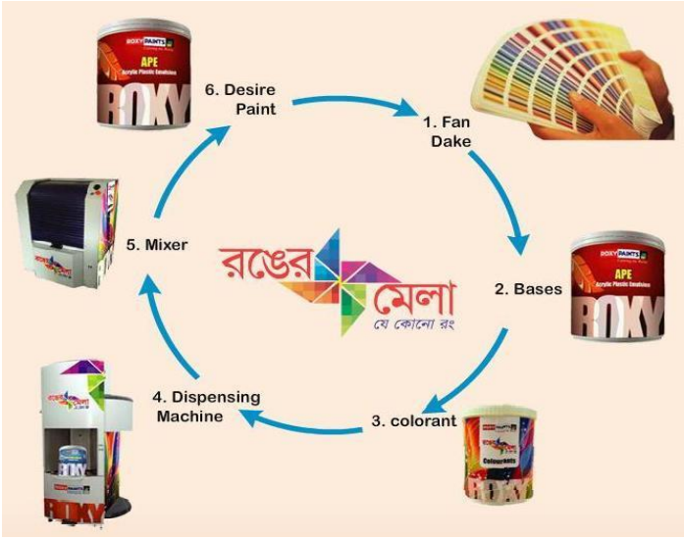

Ronger Mela Tinting System

Roxy Fusion
“Roxy Fusion” is an art using bold artistic colors and innovative movements to achieve a composition of shades and textures that can only be achieved through the wondrous forces of nature. The range of Roxy Fusion are meticulously chosen by a panel of experts consisting of architects and interior designers who analyze global fashion trends and decide on the color palette, which in turn allow consumers to be in step with the latest style and color trends. At Roxy Fusion, we believe freedom to fashion your walls. As much as we make sure, you feel at home every time you walk into it, we also take care that every time a guest walks into your home, he knows that he has entered your personal style spectrum. This year Roxy Fusion brings so many colors which allow customers to revel in their own personal style. The color palette comes in 8 distinctive themes to match your mood & personality. We call these:
- Stencil coating - ‘the Beauty of nature’ which includes a range of colors that are smooth and soothing and give the room a casual comfortable feel. It unfolds the tremendous personality and imagination which can effectively relieve daily work, life stress.

- Art coating – ‘bundle of joy' is a theme which is geared towards those who choose to see the fun side of life. These bright colors showcase a time of innocence and fun, a world that is filled with a sense of magic and joy, ageless.

- Floral coating – ‘heaven’s garden’ is the art of using flower design to create a pleasing and balanced composition. This guide serves to illustrate the variety of design styles of floral arrangements.

- Texture coating – ‘joy of creative mind’ Texture coating is higher the look and feel of the canvas. It is based on the paint, and its application, or the addition of materials for ethnic spaces that are heavy on prints and textures, walls that are warm and humble do the trick.

- Sand coating - 'rich and luxurious' is the trend which caters to the individual with ‘classic’ taste for those who crave to be the center of attention. Retro patterns in subtle colors with sand coating can be just what you need.

- Rainbow Coating – ‘abstract color’ is a range that gives the room a sense of purpose and simplicity. Shining luster as pearl, endless change color, it can bring the beats all art effect for the situation which is needed the special decorative effects.

- Splash coating – ‘color kingdom’ bold colors, free flowing ideas, cross-cultural influences, unconventional patterns and impulsive combinations give birth to the Bohemian style created by Roxy Velvet Trends.

- Kids world - “alice in the wonderland’ we decorate the wonderland of your children with the large collection of our kids world. For a kid’s space that is big on colors and patterns, you need to compliment it with bright colors and wonderland pattern are the way to go.

We at Roxy Fusion, help you create a world around you that truly reflects your identity, your persona, your style. We help you fashion your walls as an extension of your lifestyle. As a famous designer said, “Fashion is not something that exists in dresses alone. Fashion is in the sky and on the street. It is in the ideas we cultivate, the way we live and in what is happening around us."
Roxy 3C
Roxy 3C Center is a one-stop shop for all your painting needs. Now paint shopping is made easy with everything presents under one roof. Be it color advice from our color expert, customized visualization or even getting a trained Painter. Just walk-in to a Roxy 3C center and walk-out with a color solution that will make your dream home come alive. We take the pleasure in introducing the ‘Roxy 3c, a complete decorating and design service operating in Uttara, Dhanmondi, Mohammadpur, Mirpur, Gulshan &Sylhet.
Free of Cost Services from ROXY 3C:
Architect Advice: Our interior and exterior architects are ready to assist customer in guiding them color combination for their establishment. They can also suggest customer regarding the best utilization of their space.
Computerized Color Visualization: We use state of art Paint visualization software that helps customer to visualize customer’s establishment before they do the paint in reality.
Installment facilities on Credit Cards: Being the pioneer of paint industry Roxy Paints offer the customers and installment facilities on Credit Cards. Now paint your house with Roxy Paints and pay in 3-, 6- & 12-months installment with 0% interest. AMEX and SCB card holder can avail this privilege in all Roxy 3C’s.
Instant color tinting: Roxy Ronger Mela “- The latest instant tinting technology at store in technical collaboration with world famous colorants Company “Evonik “can give customer any color them visualize within few minutes.
Trained painter service: A large team of Roxy Trained painters and contractors of different locality with different specialization can ensure valued customer a hassle-free painting experience.
Sale and Customer support team:
Roxy Paints operate the business through following channels:
- 6 Depot
- 70 Sales Executives
- 50 Sales Promotion Officers
- 25 Area Sales Managers
- 4 Regional sales head
- 1 General Sales Manager
- 3000 Dealers throughout country

Consumers Buying Attitude for Decorative Paint
Sometimes consumer is very much involved in purchase but there are few differences between brands. Consumers will buy paints as quickly as they got motivated for any brand. The customer preference may vary from one another, counting on the factors like product, price, Quality, brand, and Advertisement. (Kuma, Subramanian, & Karthik, 2014). The customer buying attitude of branded paints are get influenced by various factors, which are very different from non- branded paints where price plays very important role in purchase decisions. There no significant difference, within the opinion of respondents on the product, in respect of their demographic factors and price shouldn't be considered because the first factor while purchasing branded paints. (Rao, 2014) It has been known from research that mostly the consumer's interaction with the category is on the lower side. Once the home is painted most users don't retain even a modicum of interest within the category until the house has got to be repainted. The purchase decision within the case of paints carries undue importance of intermediary over the top consumer. According to Dubey, often, it's the painter or the contractor who makes the ultimate decision of selecting the brand. (Dubey, 1999)

Price
According to Kotler and associates [5, 665] they defined the price, in the narrower sense, as "the amount of money one has to give for some product or service", while price, in the broader sense, it is seen that "the total amount of values that a consumer is changing for the benefit of ownership or usage of a particular product or service" [8, 665]. It is also mentioned that the price affects supply and demand of product or service. According to Ivana Hustić, Iva Gregurec “Price is the most important element of the market mix and the only "element that produces income". Price is one among the critical successes of a corporation because the amount determines what proportion profit are going to be obtained by organization from selling its products within the form of goods or services. Set the value too high will cause sales of the product low and also very much low value will reduce the advantages to be gained by the organization. (Baruna Hadi Brata1, Shilvana Husani2, Hapzi Ali3). According Adisaputro [4] "product price is one element within the marketing mix that generates sales revenue, while other element of the combination that generates costs". Customers consider that price is the most important factors, they're willing to spend more if organization has updated technology with new features and functionalities. Consumers are sensitive to price, therefore companies with new models should offer them at a reasonable price, which is not too expensive for the customer, and which is profitable to firm (Y. A. Kim, 2006). (Kotler & Armstrong, 2008).

2.1.2 Quality
According to Philip Kotler [1] there are eight dimensions of quality as follows: (1) performance (performance): the characteristics of operation of a major product, (2) Feature or feature (feature), (3) reliability: probability A product doesn't work or fails, (4) conformity with service ability specifications (7) Aesthetics: how a product is perceived and listened to, and (8) perceived quality determinations. While render and Herizer [2] argue that quality of a product primarily affects the company in several ways, namely: a. Cost and market share: Improved quality can lead to increased market share and cost savings. b. The company's reputation: the company's reputation follows the quality it produces; the quality will come with the perception of the company's new product, its employee handling practices, and its relationship with the supplier. c. Product liability: Organizations have a great responsibility for all the consequences of using goods or services. According to Lee and Tai (2009), marketing manager should be able to implement marketing strategies and activities as to promote consumers perceptions of higher product quality. A study by Toivonen (2012) refers that the standard of a tangible is often determined by its technical characteristic and its performance aspects. Quality is the perception of superior product compared to other competing products. According to Garvin (1998), Juran and Gryna (1989), there are four dimensions of product quality perception of COO, namely: (a) Performance: the performance in accordance with its function; (b) Durability: how long it can be used; (c) Security: safe in using it.

2.1.3 Brand
According to Aaker (2008:39) The ability of customer to acknowledge or remember that a brand may be a a part of certain product known as Brand awareness. Brand has equity if consumer recognize and remember a brand in one product category beyond another product. Main Role of brand awareness in brand equity depends on the extent in the level of awareness achieved by a brand, faster a consumer recognizes or remember a brand reflects that brand has a high value awareness. Brand awareness related to an impact that has saved in memory which reflected to consumer ability in recall or recognize a brand at different condition. Build brand awareness means making the buyer understand its category. Brand image is that the impression of the buyer mind of a brand's total personality. Through a robust brand image, then customers will have positive assumptions on brand of the merchandise offered by the corporate in order that consumers won't doubt to get products that will be offered by the company. According to Kotler (2000:161), purchase decision is referring to purchase or to do not purchase product/service. From other factors that influence the consumer in making a purchase of a product or service, usually consumers always consider the quality, price and product are already known by the public. Another statement regarding purchase decision, adding with this Schiffman and Kanuk (2008:37) said purchase decision referred as selection of an option from two or alternative. Based on the definition above, it could be said that purchase decisions are actions taken by consumer to buy a product. Therefore, purchase decision making is a process of selection of one product or service from several alternatives to solve problem by real actions. Brand image has been recognized as a vital concept in marketing and consumer behavior research (Hee,2009). The customer deals each day with various types of products and services, so, brand image that's primarily responsible for brand differentiation (Morgan, 2004). Advertising, advertisement, and PR are mass-communication tools available to marketers. As its name suggests, mass communication uses an equivalent message each one in an audience. Today, definitions of advertising abound. It can be defined as a communication process, a marketing process, an economic and social process, a PR process or information and persuasion process (Arens, 1996). Dunn et al. (1978) viewed advertising as a functional perspective, though they define it as a paid, non-personal communication through various media by business firms, non-profit organization, and individuals who are in some way identified within the advertising message and who hope to tell or persuade members of a specific audience. Morden (1991) is of the opinion that advertisement is made for establishing a basic awareness of a particular product or service in the mind of the potential customer and to build up knowledge about it. As a promotional strategy, advertising help to provide a significant tool in creating product awareness and condition the mind of the consumers to require final purchase decision. As advertiser’s their mission is to achieve potential customers and influence their awareness, attitudes and buying behavior (Ayanwale et al., 2005 and Adelaar et al., 2003).

2.1.5 Word of Mouth
Customer buying activities refers to the activities that consumer show in the process of seeking, purchasing, using, analyzing and losing products and services that they expect will fulfill their personal needs. Customer activities includes both physical activities and mental choices that result from those choices (Luo and James, 2013; Bloch et al., 1986). Rundle and Bennett (2001) defined consumer behavior as “a dynamic interaction of affect and cognition, behavior, and environmental events by which citizenry conduct the exchange aspects of their lives.” Blackwell et al. (2001) considered product disposal issues disposal in their own definition of consumer behavior as they defined “activities people undertake when obtaining, consuming and removing products and services.” Peter and Olson (1999; 2005) stated that consumer behavior “involves the thoughts and feelings of people experience and the actions they perform in consumption processes.” However, another definition taking a more encompassing interpretation of the consumer behavior by taking the marketing of a product or service into account is “consumer behavior is the study of the processes involved when individuals or groups select, purchase, use, or eliminate products, services, ideas, or experiences to satisfy needs and desires.

Conceptual Framework
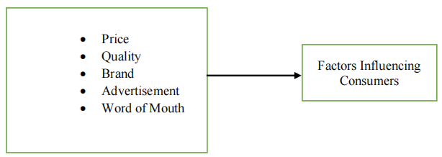

Conceptual Framework

Hypothesis of the study
Based on above discussion the study is conducted to test the following hypothesis:
H1: There is a positive relation between consumer buying behavior and Price.
H2: There is a positive relation between consumer buying behavior and Quality.
H3: There is a positive relation between consumer buying behavior and Brand.
H4: There is a positive relation between consumer buying behavior and Advertisement.
H5: There is a positive relation between consumer buying behavior and Word of Mouth.

Role of MIS in Different Department of Roxy Paint Ltd.
Roxy Paints has a designated management information system department which plays a very important role in every managerial decision making to formulate strategies and achieve future objectives. As stated earlier, the company has an inhouse and personalized management information system, which includes separate report generating database servers for almost every department.
From the ERP server, suitable information and reports are collected based on the required date and time period. Roxy paints business year is 14th April to 13th April (Bengali year basis) and the month of May is their closing month. So, information is collected and reports are generated by keeping this time period on a serious note.
Various consolidated reports are summarized to generate final amounts or numbers which is very important during formulating any strategy or to compare the actual results with the targets. For example – MIS analyzes various periodical sales and collection figures which are generated from their ERP with the targets per dealer.
MIS department of Roxy Paints Ltd. Play an important role in major decision makings and strategy formulation by creating summarized reports and generating important figures. Such as – while providing dealers with special benefits, their sales growth and target achievement percentages are calculated by the MIS department.
Every dealer is given a specific sales target while signing a business agreement. And they receive various special benefits from the company based on their sales and collection target achievement and sales growth. The company believes, these special benefits boost the sales of their product and keep the customer/party motivated.

Overview of Internship Experience
During my internship experience with Roxy Paints Ltd. I was able to develop my data management skill. Working with real data gives actual experience of my related subject. Although I found working with big data challenging.
In my 1st month I was working with Business Development Team. Who are trying to add some new type of building materials besides paints. So for expanding the business, team need an analysis of market. Making that report takes nearly one month and it was a 5-year report of company.
Recently Roxy paints working on changing their packaging, some young and energetic person are working for the designing.
We are working with three media for Data analysis and data base management.
- There is one software which is mainly use for data storage and invoice entry.
- Excel for data analysis and management purpose
- Power Bi for visualization
There are two demo of our work procedure.

Demo 1:
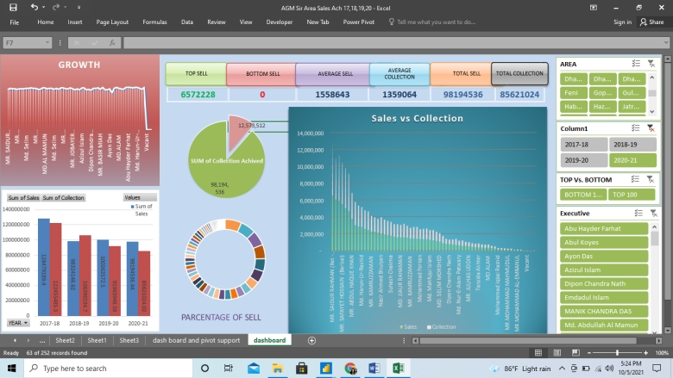
This report is the visual presentation of one quarter sales, collection and growth. From this dashboard I was going to represent the whole situation of that particular time period. There is executive wise, year wise, Depot wise, growth, percentage of collection and so on. This report can easily represent any category we want to search for.
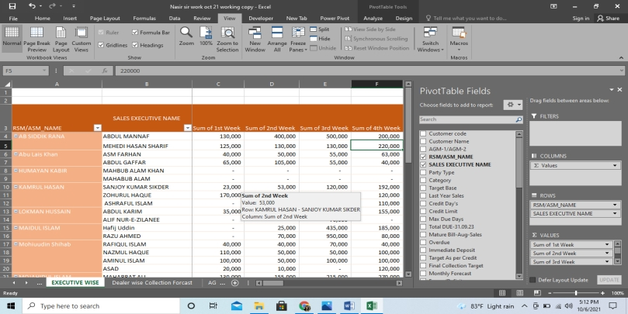
Demo 2:

We have a main source file where we get all year data then I have processed my data in my way then I have also made a pivot table for non-visual presentation then I have been made this dashboard as a visual presentation. In same way I have also made collection forecast report of all executive. when I have made this report as dealer wise at the same time I have made this pivot so that I can auto update executive wise forecast.
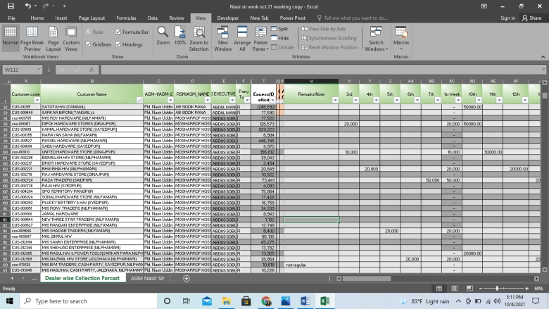
Also there is the main source file of this pivot which represent dealer wise forecast of current month.

Main source file looks scattered. That’s why we need some organized report for presenting data. Mostly we need some summation amount which is possible to found from Pivot. And when higher management want to know the overall situation they are comfortable with visual presentation.
There is another way I mentioned for visual representation of data. Power Bi is a business intelligence where we can make different visual of big data. Also can work like excel formulae, function, relation and so on. Excels drawback is if we like to run big data it looks scattered and that don’t look good. That’s why we used power Bi.
Here is a screen shot of my work where we found same data which I have presented in pivot in a visual way. This Bi report presenting executive wise, area wise, and yearly report of sales and collection. Every month we have a meeting with all sales executive where we present the performance of them. There is a reward for best executive also.so at that time we present this report to all so that they could also know more about the performance of them.
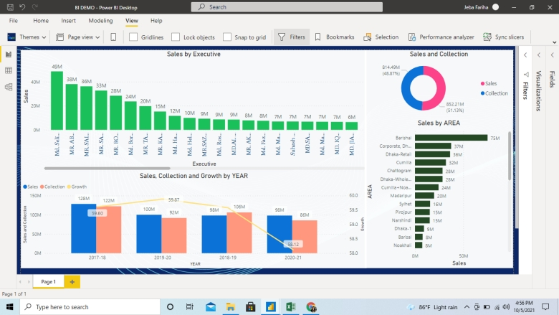
Beside my analyzing work I also maintain communication with all the sales executive about their performance. It’s one of the part of my job. Every month they are sending me a report about their performance forecast of sales and collection then I need to process those data using excel and power BI.

Summary of the Report
So here is all my work details and experience which is very related to my MIS courses. It was a big opportunity to prove my academic learning to work and for the first time I get to know how important learning those thing in my academic courses. I love to thanks all my faculty who made my situation easy by teaching me those important tools and learnings. And I always found data management work very interesting from the beginning of my MIS courses.

Recommendation
Roxy paints limited is a well-organized and well-structured company which follows proper set of rules, regulations, and business strategies to meet the expectation of its stakeholders and it’s strictly following this practice since long time. Also, the company never fails to implement present changes according to the recent business trend and customer preference. And this is how the company is holding a well-sustained position in the market.

Conclusion
During my internship period for 12 weeks, in MIS department of Roxy Paints limited, I have realized how much impact does MIS have in various departments of Roxy paints limited. The importance of management information system knows no bounds in order to manage a large scale manufacturing company and to achieve its long-term objectives and meet the stakeholder’s expectation. MIS smoothens the decision-making process and influences the strategic and resource planning of a company. Also, it helps the analyze the past information to make the road map for upcoming business year. By doing the internship these realizations and understandings has impacted my academic learnings greatly.

