
Internship Report
On
Financial Performance Analysis of Dutch Bangla Bank Limited

Submitted To

Muhammad Enamul Haque
Assistant Professor
Faculty of Business Administration
United International University

Submitted By

Anamika Jeneva Rozario
ID- 111 141 265
BBA (Major in Finance)

Date of Submission:

21/08/2019

Letter of Transmittal

21 August 2019
Muhammad Enamul Haque
Assistant Professor
United International University

Subject: Internship Report submission.

Dear Sir,

With due regard, I might want to clarify you that, it is an incredible gratification for me to submitted temporary job report on "Financial Performance Analysis of Dutch Bangla Bank" as an unavoidable piece of Bachelor of Business Administration program. I have attempted to make there port a complete one inside the given 3 months of time. I truly thank you for your direction during the planning of this report. This report portrayed my reconnaissance, learning, and experience during the temporary job.

I in this manner, appeal you to acknowledge this report and I would be thankful if you give judicious advice on the report. I also want to thank you again for your guidance and I would be available for any kind of query of the report.
Lastly beg your kind consideration for evaluating this report.
Sincerely,

Anamika Jeneva Rozario
ID- 111 141 265

Letter of Authorization

This is to endorse that the internship Report on “Financial Performance Analysis of Dutch Bangla Bank” was done by Anamika Jeneva Rozario, ID- 111141265, as a fractional attainment of BBA program.

This report has been prepare under my supervision and is a record of the bonafied work carried out successfully.

………………………………

Muhammad Enamul Haque
Assistant Professor
Faculty of Business Administration
United International University

Acknowledgement

It is truly pleasure for me to express my deep appreciation to my supervisor Muhammad Enamul Haque for assisting me the topic “Financial Performance Analysis of Dutch Bangla Bank”. The completion successfully on time of this report not has been possible without his help.

I was set in General Banking and card division of Dutch Bangla Bank Limited Satmasjid Road Branch, Dhanmondi Dhaka to function as assistant from sixteenth July to sixteenth October 2018. I would also like to thank the entire department heads and staffs who helped me in providing information. A debt of gratitude owed to the Dutch Bangla Bank’s Mr. Mostafa Kamal Ahmed (FVP & Manager), Md. Abdus Salam (SEO & Deputy Manager) Md. Nejam Uddin(General Banking In Charge), Mohammad Kowser Ahmed Khan (Credit Officer), Sumon Chandra Paul (General Banking Officer), Tasnin Swarna (Assistant Relationship Officer).

Finally I should make reference to the brilliant workplace and gathering responsibility of this bank has empowered me a great deal arrangement to do and watch the financial exercises during my temporary position time of a quarter of a year. In conclusion, I would like to thank my beloved parents Mr. Soruj Stanislaus Rozario & Mst. Sukumary Thelma Rozario, without them none of this would be possible and I would not be capable of accomplishing my goal.

Executive Summary

This report provide a comprehensive and practical overview in the field Financial Performance Analysis of the Dutch Bangla Bank Limited (DBBL)
I was assigned in the DBBL Satmasjid Road Branch with various responsibilities across various departments such as General Banking, Credit, Foreign exchange and investment division within the same branch.

First part presents the starting point of this report, opportunities, reason, goals, technique of this examination. Second part is about the outline of the Bank, Objectives, strategies, Focus, Foundation, service, item and administrations of the bank. Third section is the financial analysis part. In this part, I tried to analyze banks basic financial status over five years. In the fourth section, I compare the bank with other two peer bank to expose its financial condition and status in the market. From the monetary examination, it tends to be said that Dutch-Bangla Bank has performed sufficient in the year 2017 because of earlier year yet they ought to be progressively worried about their ROA. From the similar examination, it is apparent that the bank needs to improve itself in certain regions to be progressively focused in the market. Once more, the bank needs to concentrate on the mounting costs and development of non-performing credits.

List of Contents

1. Introduction……………………………………………………………………… 1
1.1 Introduction………………………………………………………………………….. 2
1.2 Foundation of the report………………………….…………………………………. 2
1.3 Purpose of the Study…………………………….…………………………………. 2
1.4 Methodology …………………………………………...……………………………. 3
1.5 Scope of the Report………………………………………………….……………… 3
1.6 Limitation of study………………………………………………………………..… 3

2. Company Overview……………………………………………………… …… 5
2.1 Brief History of DBBL... ………………………………………………………….... 6
2.2 An overview of DBBL………………………………………………………………. 6
2.3 Philosophy of DBBL ………………………………………………………………… 7
2.4 Focus of DBBL ... ………………………………………….………………...……… 7
2.5 Strategies of DBBL………………………………………………………………....... 7
2.6 DBBL Admired Banking Products ... …………………………………....................... 8

3. Analysis…………………………………………………………………………………10

3.1 SWOT Analysis……………………………………………………………………..… 11
3.2 Porter’s Five Forces Model…………………………………………..…………………12
3.3 Camels…………………………………..………………………………………………14
3.4 Basel –III………………………………….…………………………………………….14
3.5 Financial Performance of DBBL (2013-2017) ……………………………………… 15

4. Comparative Analysis…………………………………………………… 21

4.1 Relative Analysis of 2017 with peer banks…….…………………………….. 22

5. Recommendations and Conclusion…………………………………………………26

5.1 Recommendation……………………………………………………………………. 27
5.2 Conclusion………………..…………………………………………………………. 28
5.3 Reference ………………………………………………………………………….. 29

Introduction


  - Introduction

To be effective for the economy, the banking sector is always considered as one of the most basic sectors. In this financial time, there ought to be a sound financial framework to help the general public, instead of the economy to create in the business and business segments.

This report focuses on the Financial Performance Analysis of Dutch Bangla Bank, Satmasjid Road Branch. And comprise with other two banks.
The report was done as qualitative survey by a questionnaire whereas the senior official of the branch of this DBBL were the respondents and in order to collect for the data aggregation for this report website and annual reports of DBBL have been used.

1.2 Foundation of the report

In the focused world, study hall instruction just aides in advancing a calling by giving a degree, but the internship program strengthens the theory and learns by establishing real-world job situations by implementing real-world jobs in real-world professional execution. . For this internship report, the United International University has made compulsory for all business graduates. As a component of the BBA program, all understudies of this college should pick up a temporary position program involvement so as to increase down to earth information about the cutting edge business world. Program hierarchical connection covers a time of a quarter of a year. In the wake of finishing the temporary position program, every understudy must present an entry level position report referencing the movement performed and picked up during the entry level position period.

1.3 Purpose of the study

- To give an all in all perspective on Dutch-Bangla Bank.
- To assess the presentation of Dutch-Bangla Bank.
- To balance the bank's presentation with two other companion banks and break down their position.
- To set forward medicinal measures for the improvement of Dutch-Bangla Bank.

1.4 Methodology

In this report I use my personal oversized information and some information that I gain from discussion with DBBL staffs as my primary data source.
For Secondary data I gather information from company’s official website and annual reports. I also use some book and research paper.

1.5 Scope of the Report
I attempted to assess the presentation of the limitations of Dutch Bangla Bank. The appraisal depends on the Bank's five-year (2013-2017) execution. The report contains investigation of capital ampleness, resource quality, the executives’ proficiency, gaining limit and liquidity of the bank. I have two distributed exhibitions and they are contrasted and other two banks.
1.6 Limitation of the Study
I encountered few setbacks when creating reports. They are as follows:
- Insufficient information is the main limitation of report development.
- Report all financial ratios are not included in this report to ascertain.
- Because of time imperatives, the presentation of the bank has been contrasted with the other two banks.
- Insufficient records and productions were another impediment in creating reports.

2. Company Overview


2.1 Brief History of Dutch Bangla Bank
The principal joint endeavor bank of Bangladesh began the exercises of Dutch-Bangla Bank. The bank was an activity of nearby investors driven by M Sahabuddin Ahmed (Founding Chairman) and the Dutch organization FMO..
Dutch Bangla Bank is the principal bank in Bangladesh to be completely robotized. In 2002, the Department of Electronic Banking was built up to embrace quicker mechanization and for this situation bring present day banking administrations. Complete robotization was finished in 2003 and in this manner acquainted plastic cash with the Bangladeshi individuals. Dutch Bangla Bank additionally works the nation's biggest ATM armada and lessens client expenses and charges by 5% all the while. Besides, numerous commentators have been shocked by the way that Dutch Bangla Bank has picked a lower benefit way for the division. Dutch Bangla Bank pursued mass mechanization of banking as a CSR movement and never looked to benefit from this part. Thus, it presently offers unparalleled financial innovation coordinations to every one of its clients. As a result of this attitude, most neighborhood banks have joined the financial framework of Dutch Bangla Bank as opposed to following their own.
Indeed, even with the historical backdrop of enormous specialized ventures and even huge gifts, the certainty of clients and financial specialists has never decreased. Dutch-Bangla Bank stock made the most astounding offer value record on Dhaka Stock Exchange in 2008.

2.2 An overview of DBBL
Dutch-Bangla Bank is a second era business private bank. During its residency, this bank made an achievement in the financial area's prosperity. The bank has an accomplished group of banking experts. Beginning with a branch in 1996, DBBL has extended to thirty (39) branches, with nine branches outside the capital. It has established extensive correspondent banking relationships with several local banks to provide client services throughout Bangladesh. In order to facilitate international trade transactions, it has established correspondent relations with a number of international banks operating worldwide.

2.3 Philosophy of DBBL
Dutch-Bangla Bank Limited's Purpose Continues to Provide Modern and Innovative Products and Services to Bangladeshi Customers Partnership with FMO Opportunities for Opportunity to Attract Modern World Banking Tools and Strategies in the Western World The scene that can be mixed scene is the overall neighborhood traditions and practices. The bank is focused on being a refined and expert association, giving one-window administration to its clients.

2.4 Focus of DBBL
DBBL's center is to give one counter support of our customers covering. They provide both Commercial Banking (Deposit Accounts) and Consumer Banking (Retail Baking). In consumer banking they provide, Traveler Cheques and Foreign & Inland Remittances. They focus on Financial Services, Corporate Banking, Asset & liability management, Liquidity & capital Resources Management, Information technology and Human Resources

2.5 strategy of DBBL
The methodologies are overseeing and work the Bank in the most productive way to upgrade budgetary execution and to control cost of reserve. They make progress toward consumer loyalty through quality control and conveyance of auspicious administrations. To distinguish clients' credit and other financial needs and screen their discernment towards our exhibition in gathering those prerequisites. They try to increase direct communication with their clint to develop and cultivate a closer relation with customers. Work about companies plans, policis, and employee satisfactory level for better output.

2.6 DBBL Admired Banking Products

ATM Services
We can get DBBL ATMs everywhere throughout the nation, at our past area of our office, adjacent market, college, school and school premises, air terminal, railroad station, and so on. DBBL uses ATM pools anywhere in the country.
Treasury
DBBL is equipped to subscribe to Reuters' terminals and manage the treasury by operating on a suite network. It is also equipped with skilled manpower with skillful skills.
Account Service
DBBL gives all record benefits according to the rules of the Central Bank (Bangladesh Bank). DBBL gives aggressive loan costs and gives premium quality administrations to accounts.
Remittance
DBBL gives premium quality administrations to accumulation of settlements and settlements with the assistance of its top of the line journalists and prepared staff. Dispatches on-line banking administrations and turns into a Swift Alliance get to part, empowering its branches to send and get immediate installment directions, which help to give premium administrations.
Western Union
Western Union Financial Services Inc the United States is the main dependable and solid cash move organization on the planet. This cutting edge electronic innovation based cash move organization has increased worldwide notoriety in the most limited time by moving cash starting with one nation then onto the next..Dutch-Bangla Bank Ltd. Western Union Financial Services Inc. A delegation has signed an agreement with the United States on February 7, 2006.
Internet Banking
DBBL Internet Banking empowers a client to get to his/her own or business accounts whenever from home, office or anyplace voyaging. Web banking gives clients the opportunity to pick their very own financial time, which can spare time, cash and exertion. It's quick, simple, secure, and best.

3. Financial Analysis



3.1 SWOT Analysis
SWOT Analysis is a structure used to assess an organization's aggressive position by distinguishing qualities, shortcomings, openings and dangers. In particular, SWOT Analysis is a Foundation Assessment Model that estimates what an organization can and can't do, and measures its potential chances and dangers. Strengths and weaknesses are internal, opportunities and threats are external.
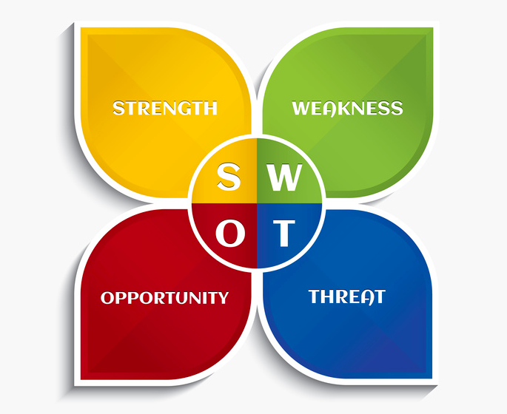
Strengths
- This commercial bank has the largest banking service provider of commercial banks and manages about 1000 corporate clients
- Their human resources are qualified, hard working & dedicated.
- The bank provides large ATM service where other bank’s client can use booth facilities as well.
- For easy and efficiently transaction they support with internet banking, rocket, agent banking which are becoming famous and clients priority.
- The bank has numerous branches even in the countryside so that it incorporates all the customers.
Weakness
- Low store rate and least adjusts are excessively high.
- Poor coordination and correspondence between Head workplaces and branches
- Insufficient employee in most busy branches.
Opportunities
- In the event that it diminishes its present expenses and charges and makes an alluring area, so that DBBL can draw in increasingly corporate customers.
- The bank can start merchant banking and expand into leasing.
- Attractive interest rate on FDR, and other services.
- Locker system in additional.
Threats
- In the long run, bank will face diluted reputation whenever these experienced employees will try to switch the job for huge work load
- The risks of all types of loans have to be diminished to carry on the market.
- Sometimes higher authority orders for personal clients avoid the rules.

3.2 Porter’s Five Forces Model

Michael E. Porter introduced a model for a industry to understand competition in business world. All industries will not make same profit. The forces help the company to realize its capability of making profit by serving its customers.

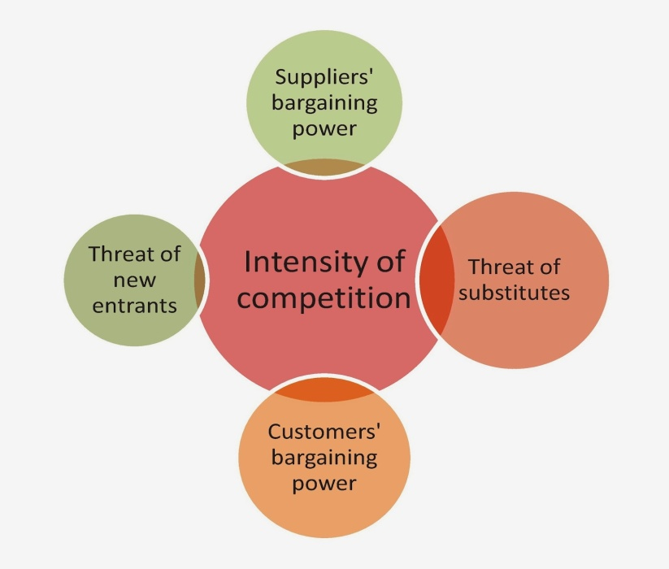

Threat of New Entrance:
Our banking industry has now reached an advanced level. Thus, the threat to Dutch Bangla Bank Limited is significant because they want to engage existing bank customers. Since the bank has been ruling for several years, the threat will not be effective.

Threat of Substitutes:

Competition arises when similar products and services are provided. Dutch Bangla Limited faces constant threat with other banks.

Power of buyers:

The ability to negotiate prices in the banking sector is immense because consumers have the ability to create pressure in this industry. This will ultimately change the price or any other service to be modified. It would be less if they only had a few options.

Power of supplier:
The bank suppliers are involved in the extra part of Dutch Bangle Bank Limited and collect money and lend money to the scarcity segment. So the ability to bargain for suppliers exists when they have a large amount of money and they are very low. Industry suppliers provide raw materials, labor and materials for production. However, banks do not need such products. Rather, suppliers are responsible for distributing check books, furniture, stationery (paper, pens, printers, photocopying machines, etc.).

Competitive Rivalry:

Many industries cannot achieve the ultimate goal because of competitors. It can be a success if you have a better idea of ​​the organization's competitors. When competitive competitiveness is minimal, the company can make enough profit and serve the highest customers.

3.3 CAMELS

CAMELS is a rating system used by the banking institutions to verify the soundness of banking practice. The rating consists of six components presented below-

- Capital Adequacy
- Asset Quality
- Management Efficiency
- Earnings
- Liquidity
- Sensitivity

CAMELS | Dutch Bnagla Bank Limited
Capital Adequacy | 14.50%(capital to Risk-weighted Aseet ratio)
Asset Quality | 84.1% (Loan-Deposit Ratio)
Management Efficiency | 7% (Net Income per employee)
Earnings | 0.90% (ROA), 13.20% (ROE)
Liquidity | Above 6% (Throughout the accounting year),  6.89% (on the balance Sheet date)
Sensitivity

3.4 BASEL – III
BASEL- III is an international, non-compulsory framework that measures bank capital adequacy, stress evaluating and market liquidity risk. The first pillar describes minimum capital requirement (MCR), second pillar narrates supervisory review process and the third pillar ensures enhanced disclosure (Discipline of market). It calculates management of capital requirements, leverage ratio, liquidity requirements.

3.5 Financial Performance of DBBL (2013-2017)

Total Loan and advances (In millions)
The explanation is that there is an increase in loans and advances. From 2013 to 2017, it has increased slowly. At the end of 2017, loans and advances stood at Tk 207,257.4 million, up from Tk 173397.8 million in 2016, an increase of 19.5%, which has doubled in five years compared to 2013.

Non-Performing Loan to Total Loan
DBBL’s Non Performing Loans Ratio stood at 4.70 % in 2017, compared with the ratio of 5.20% in the previous year and has been in volatility for more than five years. Non Performing Loans are defined as the sum of substandard, doubtful and bad/loss Loans.

Loan Segments (In Millions)
According to the pie chart in this Loan segment, corporate banks have the largest share of 89% where retail banking and SME banking cover 7% and 4%.

Capital Adequacy Ratio
After 2013, DBBL has been having a CAR around 13% and less likely to get it in a higher position. It is good that the ration didn't drop, but it should be higher.

Debt- Equity Ratio
The lower the equity ratio, the less likely a company is to be affected by the downturn in the economy, so the lowest percentage of DBBL was in 2014 (20.90%), which was the safest year in the other four years. Lastly in 2017, with this debt-to-equity ratio, DBBL is unlikely to suffer too much from a recession.

Return on Equity
The highest ROE for DBBL was in 2015 (19.30%) at it is not still that bad now. These five years have been good. But it is matter of concern that the ROE hasn't been consecutively high within these years.

Return on Asset
In 2015, DBBL received the highest return on asset but in other years, ROA was worse. Particularly after the 2015, it continues to decline, which is a very big issue for the organization.

Earnings per Share (Taka)
The earnings per share have been declining after 2015 and DBBL has to do something about it otherwise things will go west where they won't be finding a way to come back in the market.

Portfolio Mix

To reduce client-specific and industry-specific density and reduce overall portfolio risk, the bank has expanded and diversified its portfolio in 2017 to distribute it across a wide variety of client base and portfolio sectors.

4. Comparative Analysis


4.1 Relative Analysis of 2017 with peer Banks:
Another motivation behind the report is to think about the money related execution of Dutch Bangla Bank with the other two companion banks. Along these lines, I picked Eastern Bank Limited (EBL) and Southeast Bank Limited (SEBL) to contrast their presentation and Dutch-Bangla Bank dependent on a similar Camel proportion investigated above just like the principle rivalry in the market.

CAR track a bank’s risk of insolvency from extreme losses. Dutch bangla bank and Eastern bank holding 14.50% & 14.09% which considered as protected and expected to assemble its financial obligation where southeast bank maintaining 10.84%. Presently, the minimum acceptable ratio is 8% so; three of the banks are good enough.

To illustrate the graph given three banks holding leverage ratio over 5% which is not good for any financial institution. Dutch bangle 5.20%, Eastern bank 5.59% and Southeast bank 5.16%. A leverage ratio exposes how much capital comes in the form of debt (loans) or assesses the ability of a bank to meet its financial obligations. A figure of 0.5 or less is ideal.

From the stature, it is palpable that southeast Bank has 5.99% the uppermost percentage of classified loans among its peer banks. Where, Eastern Bank has 2.50% which is a healthy ratio. Dutch bangle has 5.78% which is a mild warning. A classified loan is any bank loans including unpaid interest and principal outstanding that is in danger of default.

Eastern Bank exhibits the highest profit among peer banks which is around BDT. 4260000. Dutch Bangla also maintain healthy amount BDT 3460000. On the other hand Southeast Bank has the lowest amount which is BDT 430000. Net Profit per employee shows the company how well-organized it is with its employees.

In this graph dbbl shows the maximum percentage (13.20%) which is consider as good for the bank. Easten Bank holds 11.41% and Southeast bank maintain only 4.46%. The return on equity ratio shows how much profit each dollar of common stockholders' equity generates.

Dutch-Bangla Bank and Southeast Bank sustained sound loan to deposit ratio which is 84.10%, 82.12%. Eastern Bank has the uppermost ratio which cause risk. This ratio used to review a bank's liquidity by comparing a bank's total loans to its total deposits for the same period.

5. Recommendations and Conclusion



5.1 Recommendation

- Other banks are offering attractive rates to their clients so the bank should pay attention to its interest rates.
- Surveillance should be effective in reducing the amount of non-performing loan
- If the bank can increase the amount of its deposit, it can use it to facilitate credit.
- The capital adequacy of Dutch Bangla Bank Limited is more impressive than that of other banks. The level should be tried to maintain.
- It is commendable that the bank is lending to experienced clients so that the possibility of debt settlement is low.
- The bank should increase the number of employees as they are insufficient in Satmasjid Road Branch to serve their huge customers as it's situated in a very busy area.
- Dutch Bangla Bank Limited has a better loan portfolio than other banks and it seeks to provide loan in a productive way.
- The IT department needs to develop its system so that any updates and processes can be performed immediately.

5.2 Conclusion

If the financial system is managed properly, it can contribute to and accelerate the country's overall economy. Banks must manage the financial process; Dutch Bangla Bank Limited is raising its resources for the same target for the largest contribution of the economy Dutch Bangla Bank Limited has gained recognition of most people. The bank always strives to ensure customer satisfaction by offering a variety of products and services. For this reason it never reconnects itself with the beginning of discovery and expansion.
Although there is competition among eminent banks of Bangladesh, Dutch Bangla Bank Limited has made progress on client satisfaction in its activities and has made unprecedented profit in the last few years. To achieve the bank's goals, it has to focus on credit policy and control risk. The bank's earnings depend on the credit portfolio. In order to keep up with the predictable profit margin and in the future, the bank will have to develop a robust credit strategy and must comply with the guidelines set by Bangladesh Bank for credit.

On my behalf, I would give an opinion the bank to maintain its rules properly. They also need to motivate their employees so that they provide the best service to this organization. From the practical preparations of the Dutch Bangla Bank Limited in the Satmasjid Road branch, we have given specific conclusions in an acceptable way. I have assumed that my understanding will integrate with many bank thinkers.

5.3 Reference

1. https://www.dutchbanglabank.com/
2. http://www.assignmentpoint.com/business/finance/annual-report-2016-of-dutch-bangla-bank-limited.html
3. https://www.investopedia.com/terms/t/trust receipt.asp
4. http://masterbari.blogspot.com/2014/03/pad-lim-Itr.html
5. https://efinancemanagement.com/working-capital-financing/packing-credit
6. https://www.investopedia.com/terms/c/camelrating.asp

