
United International University

Internship Report
on
“Comparative Analysis on the Implementation of
Retirement Plan in USA and Bangladesh”

Submitted to
Dr. James Bakul Sarkar
Associate Professor & Coordinator
BBA in AIS

Submitted by:
Shamim Hassan
ID: 111 183 057
School of Business and Economics

Date of Submission: September 29, 2023

Letter of Transmittal
Sep24, 2023
Dr. James Bakul Sarkar
Associate Professor
School of Business and Economics
United International University
Subject: Submission of Internship Report on “Comparative Analysis on the Implementation of Retirement Plan in USA and Bangladesh.”
Dear Sir,

With immense pleasure, I would like to present my Internship Report on "Comparative Analysis on the Implementation of Retirement Plan in USA and Bangladesh". This report encompasses the knowledge and experiential insights that I have acquired during my internship at Data Path Limited. During my whole internship period with the organization, I had a very fascinating and engaging experience. The main objective of this report is to conduct a comparative analysis of the utilization and implementation of the 401(k)-retirement plan in the United States and Bangladesh.
I made a concerted effort to adhere to the prescribed criteria during the preparation of this report. I express my sincere gratitude to you, since your assistance has been crucial in enabling me to successfully accomplish the completion of this report. I kindly request your acceptance of my report and assistance in successfully fulfilling the requirements for my BBA degree.
Yours Sincerely,
Shamim Hassan
ID: 111 183 057
Department of BBA
School of Business and Economics

Acknowledgement

My profound appreciation goes out to my wonderful supervisor, Dr. James Bakul Sarkar, for his careful supervision, steadfast support, and extraordinary attention to detail when it came to finishing my internship report. Since education never stops, my ninety days with Data Path Ltd. have been genuinely exceptional. I am thrilled to learn new things about a completely new industry as I did not have any idea about retirement plans before joining Data Path Ltd. I would like toshowcase my appreciation to all my seniors and instructors, whose advice and teachings have been invaluable to me during my training. I would like to specially thank our assistant manager, Sania Tasmin, and our team leader, Mr. Mosharrat Kabir Ananto, for their continuous support and mentoring since day one after I joined the team as a new member. All the employees at Data Path Ltd. have my gratitude for their passionate cooperation. I am grateful to my colleagues who helped me during the training period and motivated me. In the end, my appreciation goes to United International University for enabling me to experience personal growth through real-world application.

Table of Contents
Letter of Transmittal i
Acknowledgement ii
Executive Summary v
Chapter 1: Introduction 1
Overview of the Topic in Hand 1
Brief introduction of Data Path Limited 2
Chapter 2: Organizational Background and Industry Analysis 4
Historical Background of Data Path Ltd. 4
Vision, Mission, and Goal of Data Path Ltd. 4
Core Values 5
Services Offered 5
Organizational Structure of Data Path Ltd. 11
Industry Scenario 12
Industry Growth 12
Technological Aspects 13
Obstacles to Entry 14
Economic External Factors 14
Alternate Threat 14
Existing Competitor 14
SWOT Analysis 15
U.S. Policy Regarding Retirement 16
Attributes of 401(k) Industry 17
Classification of Retirement Plans 18
Contribution Calculation and Allocation of 401(k) Plan 22
Fundamentals of Retirement Plan 23
A Review of Productivity-Improving Apps and Websites 25
Bangladesh's Retirement Policy 26
Pension Scheme for Government Employees 26
The Universal Pension Scheme 30
Entry Requirements for Universal Pension Scheme 30
General Rules of Universal Pension Scheme 31
Types of Universal Pension Scheme 32
Enrollment Procedure of Universal Pension Scheme 37
Monthly Installment Payment Procedure of Universal Pension Scheme 39
Benefits of Universal Pension Scheme 40
Importance of Proper Administration of Universal Pension Scheme 40
Universal Pension Scheme Around the World 41
Evaluation of Retirement Industry of Bangladesh and USA 43
Chapter 3: Objective of the Study 47
Primary Objective 47
Secondary Objectives 47
Chapter 4: Methodology of the Study 48
Primary Sources 48
Secondary Sources 48
Chapter 5: Findings of the Study 49
Chapter 6: Recommendations & Conclusions 51
Recommendations for Data Path Ltd. 51
Recommendations for Tackling Difficulties with Retirement Plan in Bangladesh 52
Conclusion 53
References 54

Executive Summary

This report is the culmination of the abilities and understanding that I have learned during the course of the internship period. The objective of this study is to provide the procedural framework and sequential measures implemented by the government of USA and Bangladesh regarding the retirement industry. There are six chapters in this report. The introduction part of this report provides a brief introduction of Data Path Ltd. and to the topic in hand. The second chapter is organizational overview and industry scenario. This chapter provides a comprehensive review of the organization, including an examination of the underlying rationale for its establishment and the process by which it was implemented. In addition, this chapter provides an analysis of the company's services, clientele, and administrative structure. Furthermore, it includes an overview of the industry and highlights the industry’s growth trajectory. It delves into an extensive examination of the methods, rules, and regulations governing the American Retirement plan. It briefly describes the process through which a corporation may do its plan valuation, outlining the necessary procedures that must be adhered to effectively evaluate a pension plan until a logical conclusion is reached. This chapter finally provides in depth analysis of Bangladesh retirement industry scenario. Universal pension scheme was recently introduced in Bangladesh. It provides the up-to-date scenario of the universal pension scheme of Bangladesh and how it compares to other developed countries. Chapter 3 of the report addresses the underlying motivation and aim, as well as the rationale for the preparation of the report. Chapter 4 encompasses the provenance of the information used for its completion. Chapter 5 presents the findings obtained throughout the internship time, offers suggestions pertaining to identified issues. Finally, I have concluded the report with chapter 6 by focusing on the future prospect of the retirement industry of Bangladesh. It suggests how to successfully implement the retirement plans as a solution to address the challenges faced by Bangladesh in the realm of pension plans. The retirement industry is a growing industry in Bangladesh. It has the potential to become a support system for the people of our country at the end of their retirement.

Chapter1: Introduction

Overview of the Topic in Hand

An internship may be defined as a professional opportunity offered by an employer to a potential employee, often known as a trainee, allowing them to participate in job activities inside a certain firm or corporation over a designated duration. Typically, trainees are individuals who have just completed their undergraduate studies or are still enrolled as students. The duration of most internships ranges from one to three months. The internship opportunity offers flexibility in terms of both full-time and part-time positions, accommodating those seeking either paid or volunteer engagement. In Bangladesh, there exists a well-recognized phenomenon of engaging in the employment of interns who get monetary compensation on a full-time basis. It helps apprentices with practical knowledge, professional exposure, self-regulatory skills as well as comprehensive understanding of a certain sector. Additionally, the programaims to enable the employer to get advantages from the trainee's contributions. Therefore, an internship presents a valuable chance for students to use the information they have acquired over their academic tenure and acquire practical experience via the resolution of diverse problems. The implementation of internshipwithin the course of UIU provides graduates of business schools with the opportunity to incorporate their academic understandings and concepts with practical experiences with competences gained in a professional setting.
The internship has provided me with valuable possibilities to get a comprehensive understanding of the operational aspects of retirement programs. I have chosen DataPath Ltd, a major outsourcing firm of Bangladesh. I was tasked with the responsibility of conducting a thorough assessment of the retirement plans. Based on this assignment, I have compiled my internship report. This research helped my comprehension of the functioning of American retirement schemes.

Brief introduction of Data Path Limited

The organization in which I successfully fulfilled my internship is DataPath Limited. The organization has the notable distinction of having been the earliest legally established company which is actively working related to the retirement industry of USA. The individual in question is now employed by July Business Services. Furthermore, Data Path is under the supervision of Mr. Ashfaqur Rahman, who also serves as the Chief Executive Officer (CEO) of the company.
Data Path Ltd was engaged in the provision of supported functions of July Business Servicesat the beginning of 2006. In 2008, the individual began employment at July Business Services. The organization used proficient individuals to provide services for the July Business Services. Initially, the organization employed a mere ten individuals. Currently, the firm has a workforce of over 250 workers who enjoy a range of advantageous perks. July Business Service operates as a professional service provider, specializing in the USA 401(k) retirement market and offering a range of management services to its clients. Collaboration with employers and colleagues is a crucial aspect in the provision of assorted services. Additionally, it aids in the attainment of the objectives of the organization. The corporation has a substantial amount of expertise in the field of business operations. By the conclusion of 1996, the organization had a mere five personnel who were enrolled in a total of 240 retirement plans. As of the present, July Business Services has a workforce exceeding 250 individuals and manages a portfolio of retirement plans numbering over 5000.
Data Path Ltd. was established in Uttara, Dhaka, Bangladesh in 2006. Initially, the organization started its operations with a team of just six very skilled individuals, who were entrusted with the task of establishing its fundamental structure. Subsequently, when the firm expanded its workforce to include 50 individuals, a relocation to Gulshan was undertaken. During that period, July Business Services underwent a reduction in the workforce and began outsourcing a huge portion of their operations to Data Path Ltd. The firm saw significant expansion from 2015. Several organizationsof United States see the outsourcing process as a potential opportunity, similar to the one adopted by July Business Services. Nevertheless, despite the establishment of their own office, they also began to engage in business process outsourcing through Data Path Ltd. At the moment, the Data Path system is being used by many TPA business customers. Currently, Data Path Ltd. is engaged in operations in Dhaka. Data Path Ltd. is now situated in two distinct locations. The first one is at Ambon Complex situated at Mohakhali. It specifically occupies the 13th and 15thfloors of the building.

Chapter 2: Organizational Background and Industry Analysis

Historical Background of Data Path Ltd.

In 2006, JULY launched Datapath, a wholly owned subsidiary, with the aim of providing assistance for software development and outsourcing contracts. The Datapath team, which is situated in Dhaka, Bangladesh, has seen significant growth, now including over 350 experts. A considerable number of team members have ASPPA qualifications and have accumulated extensive experience in the field, spanning many years.
Data Path Ltd., the prominent outsourcing firm is established in 2008, led by Mr. Ashfaqur Rahman, who serves as the Chief Executive Officer and Managing Director of the organization. The organization offers assistance and provisions to several domestic and global enterprises. The primary objective of Data Path is to uphold and safeguard the conventional principles of professionalism and honesty, while simultaneously incorporating elements of creativity and innovation by embracing contemporary technological breakthroughs. Data Path partners with customers to assist them in achieving high-performance business outcomes by using their unrivaled expertise, broad skills across many sectors and business processes, and substantial research on successful firms. Currently, JULY's Outsourcing Services for Third Party Administrators (TPAs) effectively manages leadership and team capabilities by using resources from both our locations in the United States and Dhaka.

Vision, Mission, and Goal of Data Path Ltd.

Vision:Data Path Ltd.’s vision is to become the leading company within the outsourcing market
Mission:Their missing is to offer clients with expedient quality of work using innovative technology. The essence of the organization is innovation and change.
Goal:The main goal of Data Path Ltd. is to generate value for its customers via the provision of an amazing customer experience, as well as the delivery of great service and innovative support.

Core Values

The core values of a company include a collection of core principles that serve as guiding tenets, enabling a collective of individuals to collaborate effectively as a team and attain a shared objective. The fundamental principles that underpin the operations of DataPath Ltd. are outlined as follows:
- Quality Driven
- Openness to Novel Concepts
- Innovative Problem-Solving
- Recognition of Achievements
- Dedication to Individuals
- Team Collaboration
- Proficiency in Technical Matters
- Focus on Outcomes
- Adaptability to new rules and regulations
- Efficient Communication
- Optimistic Viewpoint

Services Offered

Data Path Ltd. provides tailored solutions aimed at enhancing operational efficiency within critical procedures of Third-Party Administrators. The retirement business has considerable significance and wields a large influence inside the United States.The United States economy is significantly impacted by this sector. Employees allocate their pension funds to Money Market accounts. They allocate their resources among several investment vehicles. This is the reason for the substantial financial market in the United States. However, the services provided by Data Path are presented in the following paragraph:

- Selection and management of plans:The responsibilities of Data Path include the provision of comprehensive recordkeeping and administrative services, which encompass tasks such as plan documentation, form development, compliance testing, and other related activities.

- Plan Design:Prior to initiating any new retirement plan process, it is essential to start the design phase. When formulating the strategy for plan design, it is essential to consider several elements, laws, norms, and regulations. For instance, the strategic development of a plan that successfully passes discrimination tests is crucial. This plan should prioritize the interests of the owners while ensuring that it does not unfairly discriminate against regular workers. Furthermore, it is vital to take into account the diverse array of payments which will be allocated to the proposed plan, along with the distinct groups of workers who may be exempted from its benefits.

- Plan Setup:In order to assess the yearly Plan statements pertaining to recent and current RPF plans, it is necessary to meet a number of administrative criteria. This procedure is often referred to as plan setup. The following are many stages involved in the establishment of procedures inside a plan:

- Establishment of Documentation
- Formulation of Questionnaire
- Compilation of Checklist
- Retention of Recordkeeper Statements
- Development of Loan Policy
- Generation of Amendment Reports

- Agreement Document:Data Path helps clients to establish agreement documents in a well-organized, plan-specific format. The responsibility of plan documentation includes the following task:

- Prototype and Planning Documentation
- Records from High-Quantity Senders
- Brief Descriptions of Plans
- Methods for Granting Loans
- Generate plan documentation following the regulatory requirements set out by IRS and DOL
- Generate the Summary Plan Description that is required for dissemination to plan participants.

- Plan Administration: During this stage, the Data Path executes a series of operations to perform estimations, calculations, and accounting processes outlined in the plan. Incorporating electronic mail contact with the clientele. Several processes of this step are provided below:

- Census importation refers to the process of bringing in data from a census, which is a comprehensive survey of a population.
- Census checking involves verifying the accuracy and completeness of the census data.
- Eligibility calculation pertains to determining the qualification or entitlement of individuals based on specific criteria.
- Vesting calculation involves the computation of the amount of ownership or rights an individual has acquired in a retirement plan.
- Contribution calculation refers to the computation of the amount of money or assets contributed to a retirement plan.
- Contribution allocation involves the distribution or assignment of contributions to individual accounts within a retirement plan.
- Contribution reconciliation refers to the process of comparing and adjusting contributions to ensure accuracy and consistency.
- Loan reconciliation involves the verification and adjustment of loan transactions within a retirement plan.
- Ending refers to the conclusion or completion of a certain process or activity. The process of balance reconciliation involves comparing and verifying the accuracy of financial records, particularly in relation to assets. This includes asset reconciliation, which focuses specifically on ensuring that the recorded values of assets align with their actual values.

- Conversion and Configuration of Plans:Data Path's Preferred Partner Networkprovides direct services to improve all facets of policy administration or arrangementtransition. Several processes of this step are provided below:

- Create Application Materials
- Coordination of Enrollment Gatherings
- Get the Initial Paperwork Ready
- Methods for Making a Donation
- Coordination of Property Transfer
- Get a letter ready to your ex-service provider.
- Informational cohesion is a prerequisite for any kind of takeover.

- Administration Services:Data Path offers a range of services to ensure the seamless and effective execution of plans as shown below:

- Maintain records pertaining to the vested percentages of participants.
- Assess the qualifications for the distribution of employer contributions and forfeitures.
- Distribute employer and employee contributions.
- Distribute the generated revenue according to a predetermined strategy.
- Determine the allocation of forfeitures if they are deemed relevant.
- Distribution of participant account balance. It involves many tasks, including the calculation of the distribution amount, the compilation of necessary distribution notifications, the completion of release forms, and the submission of IRS Form 1099-R.
- Process participant loan request. The loan processing procedure involves the establishment of loan accounts, the creation of promissory notes and amortization schedules, as well as the monitoring and recording of loan repayments.
- Process hardship withdrawal request. The processing of hardship withdrawal involves two main steps: the determination of the amount to be distributed as a hardship withdrawal and the drafting of the necessary application forms.
- Asset reconciliation. The process of reconciling trust accounts is undertaken to ensure the accuracy and integrity of financial records.
- Compile statements from the participants.
- Monitor the individuals who are obligated to receive payouts at the age of 70½.

- Compliance Testing: The most important part of US retirement plans is that they are subject to compliance testing every year. The compliance testing includes several tests that must be conducted every year to ensure that retirement plans are maintained properly in accordance with government rules and regulations. Data path completes compliance testing for all the retirement plans and assist retirement plan sponsors to properly maintain their retirement plan. The following compliance testing are performed each year:

- ADP ACP Test:ADP ACP testing which is conducted to ensure that there is no significant discrimination in contributions ratio between HCE and NHCE. It is mandatory for plans that do not comply with the safe harbor provisions to be exempt from the testing.
- 402g Test: This test ensures that employee contributions do not exceed the contribution limit fixed by IRS every year. For example: For 2022, maximum employee contribution for a participant is set at $20,500. If the participant is aged over 50, then the participant is allowed to contribute $6,500 more which leads to the total employee contribution of $27,000 maximum which is highest limit for employee contributions for 2022 including catch up.
- Deduction Test: Deduction test is also represented by 404 tests. This test focuses on whether employer contributions exceed 25% of eligible compensation of all participants.
- Annual Additions Test: Annual additions test is also represented as 415 tests. It focuses on the maximum amount a participant can contribute to a plan year. For example: For 2022, the maximum contribution a participant is eligible to is $61,000. If the participant is catch up eligible then the limit is $67,000. This limit is not fixed. It changes every year. For 2023, the annual additions limit saw a significant jump from $61,000 to $66,000.
- Coverage Testing: It is also known as 410(b) test. Coverage testing focuses on the ratio of HCE and NHCE benefiting from the plan. If the ratio is lower than 70%, the coverage test fails.
- Compensation Ratio Test: Often participants eligible compensation in a retirement plan excludes bonus, overtime, commission etc. In case of these exclusions, a compensation ratio test needs to be conducted which focuses on the compensation ratio of HCE and NHCE.
- Form 5500: Form 5500 is government filling which summarizes the financial information of a retirement plan. It also includes the number of participants in a retirement plan. All the 401(K) plans must submit form 5500 for each plan year. The normal deadline for the submission of form 5500 for a calendar plan year is July 31. However, by filling form 5558 it can be extended up to August 15, 2023. If any plan fails to submit form 5500 for any plan year, then IRS imposes fine for each day the plan is late in submitting the form 5500.
- Form 5330: It focuses on the late deposits by the plan sponsor. Plan sponsors must deposit employee contributions within 3 business days of the payroll submission for a small plan filer. For a large plan, it can be delayed up to 7 business days.

- Consultancy: In a retirement plan framework, the funds contributed by both the employer and the employee are not passively held inside the bank account of the Record keeper. Typically, funds are allocated for investment purposes with the intention of enabling members to accrue more financial resources. Data Path Ltd. functions as an investment adviser, providing recommendations to clients on potential investment opportunities.

Organizational Structure of Data Path Ltd.

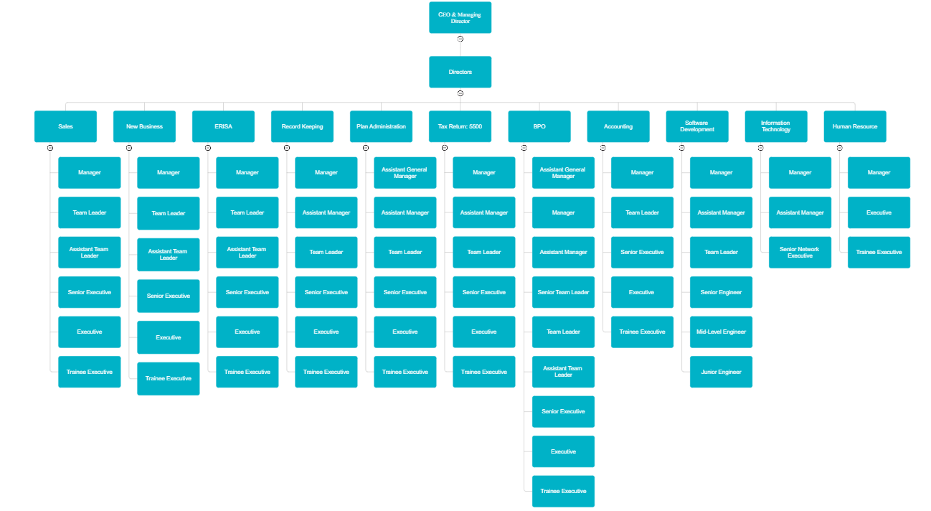

Figure: Organizational structure of Data Path Ltd.

Industry Scenario

Outsourcing

When an organization hands over control of a portion of its operations to a third party, this is known as outsourcing. The benefits of outsourcing include greater output at lower expense. Developed countries need to hire highly qualified workers on a regular basis due to the intricacies of the business. These employees would demand a salary of $10,000 per month, which is far too much for TPA businesses. As a result, some American businesses are increasing the number of jobs they send to developing nations like Bangladesh. Young people in Bangladesh have more job opportunities than those in developed countries due to reduced labor expenses. Data Path entered the market more than a decade ago and has since become a leader in the TPA outsourcing sector.

Industry Growth

The outsourcing market is expanding at a dizzying rate. Bangladesh, along with other emerging countries, stands a good possibility of succeeding in this industry. The American TPA market is also well-structed. The importance of outsourcing to businesses today is more significant than ever. The trend, however, appears to be shifting in a positive direction. In the current economic climate, an enormous number of American companies are laying off employees. Last year, Data Path added a handful of third-party administrators as clients, and this year, they expectto have more than 25% growth. Based on research, the aggregate value of assets held in defined contribution (DC) retirement plans in the United States saw a general upward trend from 2000 onwards, with the exception of a decline seen in 2018. In a defined contribution (DC) plan, a percentage of the employee's pay is allocated to a selected investment option provided by the plan, with the primary source of funding being the employee. The 401(k) plan is the prevailing defined contribution (DC) plan in the United States. In the second quarter of 2022, the expected value of assets held in retirement defined contribution plans amounted to around 9.25 trillion U.S. dollars.
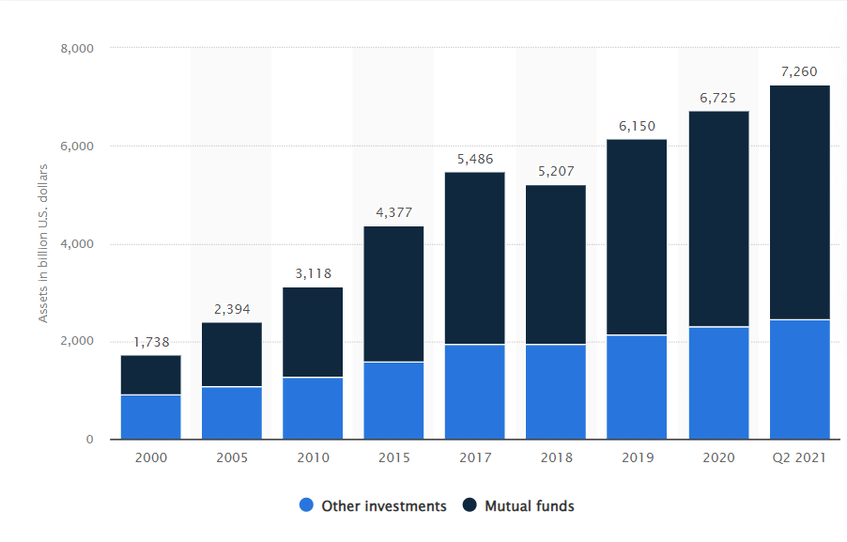
Figure: USA Retirement Plan Asset Investment From 2000-2020

Bangladesh retirement industry has not even scratched the surface of it’s true potential. It can provide a significant boost in the investment market of our country.

Technological Aspects

In the beginning, Data Path solely used software that was standard in the US retirement business. Each customer now operates autonomously and chooses from a wide range of software to meet their needs. Over the years, Data Path's schedule has shifted considerably. Data Path has many unique TPA clients and has given its employees the chance to grasp the fundamentals of several different business platforms. In addition, Data Path software development team is developing its own software for use in the RPF sector in the United States.

Obstacles to Entry

For a relative newcomer to the RPF industry in the USA, trust is of the utmost importance. The reputation of the TPA firm is at stake due to the sensitive nature of the information handled in this industry. In addition, it cannot function without a sizable percentage of a technically literate labor force. Sadly, many Americans don’t know what the RPF sector is. Therefore, starting an IT firm calls for both specialized skills and a substantial financial outlay. Therefore, it is quite difficult to enter this industry with a brand-new company.

Economic External Factors

Working with a globally recognized company like Data Path Ltd. brings in much-needed foreign currency, which helps boost our economy's positive net cash flow, raises living standards, and creates new jobs.

Alternate Threat

At this time, the program may pose a danger. Many software firms are currently working on tools that will allow for the top-down construction of RPF strategies. If you have any familiarity with the field at all, you should have no trouble using this program.

Existing Competitor

Data Path Ltd. has only one major competitor in the retirement plan outsourcing market in Bangladesh, called "Fin Source." They've been going strong since 2011, and their leaders all used to work for Data Path Ltd.

SWOT Analysis

Strengths
- Software and IT-based services that are protected against unauthorized access.
- There is a significant absence of competitive competition within the market.
- The company provides a pricing strategy that is cheaper compared to other Third-Party Administrators (TPAs) operating in the United States.
- The phenomenon of stable business expansion in Bangladesh is observed.
- The acquisition of foreign remittance by Bangladesh is a significant aspect.
- The company has established trust with other third-party administrators (TPAs) over a prolonged period of time.
Weakness
- The absence of software that is adequately created.
- The growing service sector in Bangladesh needs the provision of comprehensive training to employees, starting with foundational knowledge, which inevitably requires a significant investment of time.
- The promotional initiative and website exhibit deficiencies in terms of effectiveness and quality.
Opportunities
- Prospects for novel job opportunities
- Expanding the opportunities for the outsourcing business in Bangladesh.
- Establishing strategic alliances with many multinational corporations globally.
- The workflow is contingent upon the state of the United States economy.
Threats
- Need to rely entirely on third-party firms based in the United States.
- The local market is seeing the emergence of new rivals.
- Bangladesh is not well recognized in the international market as professional retirement service provider.

U.S. Policy Regarding Retirement

US pension policy has several distinct qualities that contribute to its widespread popularity and extensive use by both governmental entities and non-governmental organizations, even in instances of private equity.
Various companies in the United States provide retirement plan that contain tax exemption for individuals' contributions. The individuals enrolled in the retirement plan collectively acknowledge their commitment to allocate a certain percentage of their income towards the allocated investment account. Employees have the opportunity to choose from a diverse range of investment alternatives, often consisting of mutual funds. The retirement pension policy in the United States is subject to rigorous oversight and audit by three regulatory authorities inside the country.
The three entities are as follows:
- Internal Revenue Service (IRS):IRSestablishregulations governing the contributions made by employers and employees to retirement funds, as well as providing tax-related information to all citizens. The Internal Revenue Service (IRS) has levied tax obligations on many categories of retirement plans. Additionally, the Internal Revenue Service (IRS) has been engaged in the examination of Form 5500 reports, taxation records, as well as reports pertaining to wages and pay.

Department of Labor (DOL): This department is dedicated to promoting the well-being and interests of the labor force. The Department of Labor (DOL) establishes regulations pertaining to several aspects of employment, including wage and hour rules, employee compensation, workplace safety, financial assistance, and health measures.

- American Society of Pension Professionals & Actuaries (ASPAA): It serves as the primary regulatory authority responsible for overseeing retirement pension policies inside the United States. The primary purpose of the ASPAA (Association of Standardized Pension and Annuity Administrators) is to establish and enforce regulations pertaining to eligibility criteria, vesting requirements, anti-discrimination measures, and other matters related to compliance within the realm of pension and annuity administration.The Internal Revenue Service (IRS), the Department of Labor (DOL), and the American Society of Pension Professionals and Actuaries (ASPAA) conduct assessments of the rules and regulations and provide recommendations to the United States government about any necessary amendments for enhancing the retirement policy. The primary function of these organizations is to support and promote openness within the system.

Attributes of 401(k) Industry

The implementation of retirement plan in the United States was a legislative action taken by the United States Congress. The primary objective of this initiative was to incentivize people residing in the United States to actively participate in saving for their retirement. One of the advantages offered by these entities is tax protection. The allocation of tax incentives to employees who engage in the 401(k) program by the United States government presents two main benefits.
The standard 401(k) plan operates by reducing employee contributions from the main sum, especially by deducting the contribution amount from the participant's pay prior to the implementation of taxable income calculation. Consequently, the tax on income imposed on employees is subtracted from the overall annual amount and may be used as a tax deductible for the corresponding year of operation. Payments for the intervention are deferred until the employee exercises their option to receive the funds, often in the form of a pension.
The Roth 401(k) is a retirement savings scheme whereby employees make contributions from their post-tax income. This implies that the contributions are derived from the employee's remuneration after the deduction of income tax. There are no additional taxes imposed on employee contributions or investments upon an individual's attainment of old age.

Classification of Retirement Plans

Various sorts of benefit plans are offered by employers to their employees, which are determined by the nature of the organization. Employers provide employee benefits based on the compensation framework, and in some cases, employers may assume financial responsibilities of employees. Typically, the responsibility for pension funds is shared between employees and employers.
Employee Benefit Plan:Itincludes a variety of benefits provided by employers to improve the financial, social, and emotional well of their employees and their families. Typically, these provisions include several advantages, such as allocated time for vacations, insurance coverage for health and life, income protection in case of disability, and schemes for retirement savings. Several benefits are introduced with the aim of protecting the economic stability of workers during tricky situations. Research has shown that improving employee benefits has favorable outcomes in terms of mitigating staff turnover and bolstering organizational productivity. Employees express their desire for additional perks that extend beyond just cash provisions. Employee benefit programs may be categorized into two separate classifications.
Welfare Benefit Plan: It includes the following components:
- The advantages conferred in the event of illness, accidents, incapacity, or death.
- The provision of financial assistance to those who are unemployed.
- The advantages of taking a vacation.
- Assistance or educational initiatives.
- Daycare centers are facilities that provide care and supervision for young children throughout the day, often while their parents or guardians are at work or otherwise occupied.
- Scholarship funds refer to financial resources that are specifically designated for the purpose of supporting academic pursuits and educational endeavors.
- Remunerated legal services.

Pension Benefit Plan:Pension benefit plan is a long-term income generation policy for individuals.
- One of the primary objectives of retirement planning is to provide a steady stream of income throughout one's retirement years.
- The postponement of the share of income that is subject to taxation until it is dispersed.
A retirement benefit plan offers many advantages to employees, including the following benefits:
- One of the benefits provided to individuals at reaching a certain age or completing a period of service is a pension.
- Benefits pertaining to disability pensions.
- Retirement benefits derived from accumulated savings.One example of an employee account plan is the deferral of revenue for an extended time, which allows employees to delay receiving a portion of their income. Another example is a profit-sharing plan, where employees are eligible to receive a portion of the company's profits based on predetermined criteria.
Pension Benefit plans are of two types:
- Defined Benefit Plan: Itensures a predetermined sum of money to be disbursed at a certain age upon retirement. Rather than performing calculations to allocate contributions to individual participants' accounts, these plans are responsible for deciding the distribution of retirement funds. The calculation of the tangible benefit is performed using the formula specified in the planning agreement. Benefits are sometimes distributed at a deferred juncture, typically at retirement age. Most programs offer securities for employees in case of an unexpected death of a member or impairment that may limit an individual's physical capability.

- Defined Contribution Plan:A defined contribution plan, often known as an individual account plan, is a kind of retirement plan in which each member is responsible for managing and maintaining their own account. The programs show the precise sum that will be allocated to the account of the participant. For example, a suggested framework may stipulate that every eligible member is entitled to receive 5 percent of their Compensation, or a certain proportion of the overall contribution given within the plan, depending upon their compensation.

There are many distinct categories of defined contribution plans that are currently in existence. This approach operates by sustaining distinct accounts for each individual member. Within this particular context, each individual plan has a certain threshold that imposes a limitation on the maximum quantity of cash that may be allocated to a participant's account. In contrast to the defined benefit plan, the retirement period does not include the provision of an insurance payment. The participant assumes the obligation for bearing investment risk. There are several kinds of defined contribution plans.

Profit-sharing plans enable individuals to earn remuneration in the form of a portion of the organization's profits or income that can be directly attributed to their efforts, as enabled by a profit-sharing plan. The employer exercises discretion in determining the yearly contribution to the plan, with the freedom to choose the payment amount without being bound to a certain income-based criterion. While it is not necessary for this kind of proposal to clearly specify the precise annual allocation, it is crucial that it has a methodical framework for establishing the distribution.

Business organizations often choose profit-sharing plans to determine their yearly allocation of funds towards such schemes, based on their financial situation. The employer has the discretion to refrain from making contributions during a particular year in the event of minimal or nonexistent rates of return, or if the funds are designated for alternative operational necessities. While it may not be obligatory to make a predetermined yearly payment in a profit-sharing scheme, it is crucial to guarantee that profit-sharing distributions are substantial and constantly maintained to preserve the plan's sustainability. The employer maintains the prerogative to choose the yearly profit-sharing allocation; yet it is noteworthy that the employer's ability to exclude this allocation from the tax return is subject to a maximum limit of 25% of the participant's qualifying pay.

The Savings Incentive Match programs for Employees (SIMPLE Plan) was designed to address the specific requirements of small firms and streamline the management of eligible programs for administrators. The employer's plan must adhere to the criteria of a SIMPLE plan, which is designed only for enterprises with a workforce of 100 people or less. In the event that the employer achieves the requisite payment responsibilities, it is mandated that all SIMPLE plans be excused from undertaking nondiscrimination testing. It is recommended to refrain from combining SIMPLE plans with Simplified Employee Pensions (SEPs), although the clear resemblance in their names. There are two unique classifications for SIMPLEs.

- SIMPLE IRAs
- SIMPLE 401 (k) Plan

The two types ofplans have significant similarities as a result of their common feature of being individual account plans. However, there are significant disparities. The allocation of profit-sharing payments is up to the employer's discretion.

Share incentive schemes are a kind of revenue sharing agreement that incorporates flexible participation criteria, enabling businesses to put forward financial contributions to either monetary funds or company stocks. Typically, individuals allocate their financial contributions towards the purchase of company shares within the designated plan. The corporation provides its employees who earn dividends with the opportunity to exchange their ownership rights for money by selling them to the organization on days determined by the company.

Employee Stock Ownership Plans (ESOPs) are a kind of employee benefit plan that facilitates the acquisition of ownership in the employing organization by its workers. Employee Stock Ownership Plans (ESOPs) are strategically developed to provide workers with a tangible financial interest in the prosperity of the organization, so serving as a motivational tool. The Employee Stock Ownership Plan (ESOP) may be structured in two ways: as a stock bonus plan with a selective benefaction approach, or as a hybrid plan that combines stock bonus and money purchase aspects. In these proposed arrangements, a certain minimum financing threshold must be met, with the option to contribute either in the form of monetary resources or via the acquisition of company shares. One potential classification of a component inside a profit-sharing plan's 401(k), such as an employer stock investment, might be identified as an Employee Stock Ownership Plan (ESOP). To satisfy the requirements of an Employee Stock Ownership Plan (ESOP), it is essential that a plan or its designated component be mostly financed via the allotment of employer shares.

The safe harbor plan is comparable to a 401(k), but it emphasizes making personal guarantees to each worker. The agreement normally reduces all duties on the part of the authorities and is completely vested. You can choose from the "basic match," "improved match," or "safe harbor non-elective" option when it comes to this strategy.

Contribution Calculation and Allocation of 401(k) Plan

The segment of a defined contribution plan document that pertains to contributions and allocations provides an explanation of the approach used to calculate the exact sum of both mandatory and voluntary payments. The sponsors of profit-sharing plans have the authority to use discretion in determining the frequency and number of profit-sharing payments that are made on an annual basis, should they choose to do so. During a certain fiscal year, sponsors of profit-sharing programs are afforded the chance to make contributions up to the maximum limit set by the Internal Revenue Service (IRS). The plan paperwork will furthermore include the approach used by employers for the purpose of aligning contributions made to 401(k) plans.
The tax deductibility of employer contributions is contingent upon certain conditions. The plan year is often structured to coincide with the fiscal year of the plan sponsor; however, adherence to this alignment is not always practiced. The computations being referred to do not include the payment of any qualified participant over the highest annual gross compensation threshold established by the IRS.

Fundamentals of Retirement Plan

Compensation Definition:The plan document often includes references to the notion of compensation within its benefit and allocation sections. The use of comprehensive remuneration for contributors is often utilized as a means to provide motivation and recognition for their work. Nevertheless, plan sponsors possess the authority to alter several aspects of remuneration, including discretionary deferrals and relocation expenditures, as long as the resultant delineation of payment stays under the IRS-imposed upper threshold for compensation.
Eligibility: The notion of eligibility pertains to the requisite or satisfaction of certain criteria that ascertain an individual's suitability for employment. The first steps in determining eligibility for enrollment or inclusion in this plan include identifying participants and facilitating workers, including both those who are eligible and those who are ineligible. Moreover, this agreement expands its scope to include collective employees, including those who are associated with labor unions. In most instances, the phrase "qualified" refers to a person who meets the requirements for employment and fulfils the relevant qualifying conditions. The incorporation of eligibility calculations is often seen in the planning segment of academic papers, rather than being only restricted to the definition part.
Normal Retirement Age and Early Retirement Age:Many financial counsellors recognize the difference between a typical retirement date and a conventional age for retiring, but some people may mistakenly mix the two terms. The notion of "normal retirement age" refers to a certain chronological threshold, often established at 65 years. The age and seniority of the participants are represented by a distinct numerical number, such as 65 years. Furthermore, the temporal extent of their tenure is explicated, alongside the commemoration of their quinquennial milestone since enlisting in the program. In general, the early retirement age for participants is established as 55 years.
Service Hours:The maintenance of consistent service hours is achieved by adherence to the restrictions stipulated. Employees often adhere to a labor allocation system that is dependent upon the quantity of hours worked, whereby remuneration is determined based on an hourly rate. This arrangement may include several types of leave, including vacation, holidays, illness, or military leave. According to the guidelines established by the Internal Revenue Service (IRS), the stated average length of services provided is 1000 hours.
Service Year:One common definition of the first year of employment is the 12 full months that end on the anniversary of the employee's hiring date, during which time the applicant's eligibility for the plan is evaluated.
HCE Determination: The plan should acknowledge the status of a highly compensated employee provided that the participant satisfies the following requirements:
- 5% owners of the company
- Employeeswhoexceed the limit of compensation set by IRS for a certain plan year. For example: For the 2022 plan year, the compensation limit to be categorized as HCE is $130,000. If anyone earned over $130,000 in 2021, that individual would be considered as HCE.
- If a participant has a familial connection inside the designated plan, it is important to note that the family attribution extends two generations upwards and one generation downwards. The individual will be classified as HCE.
Key Employee:Recognition of key employees is contingent upon the fulfilment of certain criteria.
- If an employee has ownership of more than 1% and receives a salary exceeding $150,000.
- If the employee has a stake of ownership exceeding 5%.
- The employee's annual compensation for the year 2021, as indexed, is equal to or above $150,000, and they hold an officer position.
Compliance Testing:The purpose of conducting tests is to prevent the differentiation between employees HCE and NHCE. The most common compliance testing includes deduction test, nondiscrimination test, annual additions test, 402g test, compensation ratio test and coverage test.
Vesting:The sum received by employees upon leaving their jobs. One year of service, or 1000 hours, must be completed in order to qualify for vesting.

A Review of Productivity-Improving Apps and Websites

1. TPA: A TPA is an organization responsible for overseeing TPA services. Specifically, insurance claims and parts of the employee benefit schemes of another company. Due to the outsourcing of retirement plan administration, TPA processes everything for you. Both July BusinessServices and Data Path are TPAs. Data Path oversees not just the July service, but also many other plans that are outsourced to third parties.
2. Relius: When it comes to software and services for employee benefits, Relius is unrivaled. administrators, document specialists, record keepers, compliance officers Construction, evaluation, and reporting on pension and medical benefit plans.
3. FT William: FT William is an e-filing website compliant with EFAST 2. Their proprietary web gateway makes it possible for clients to electronically sign 5500 on EFAST 2 forms with the click of a mouse.
4. Form 8955 SSA: A supplemental report must be filed using Form 8955 SSA if the plan falls under ERISA. Plan members whose benefits are being delayed need to be reported on Form 8955 as established by theIRS. TIAA- CREF provides all the data needed to file Form 8955-SSA paperwork.
5. Unify: Unify is an online platform that provides details about a wide range of participants transactions, and a wide range of customer services to help them achieve their goals cash log, cash reconciliation, and various forms of distribution processing and evaluation.

Bangladesh's Retirement Policy

The retirement plan's benefits requirements were made public by the government of Bangladesh in 1972. To begin, the retirement was paid out in a single lump sum rather than in the customary 36 monthly installments. Furthermore, in 1974, benefits were calculated based on the rate of prior installments rather than a regular pay of 12 months. In addition, the largest amount paid was equal to 60% of the most recent installments. The unused retirement figure was also established in 1977, at 80% of the base salary. In 1994, the government of Bangladesh enacted norms and standards for all benefit holders' annuities that were uniform and standardized. Finally, On August 17, 2023, Bangladesh introduced universal pension scheme for all citizens of the country except government employees.

Pension Scheme for Government Employees

- Compensation:The allocation of retirement money is directed towards government employees who have willingly resigned from their employment as a result of downsizing initiatives implemented in certain agencies or organizations with the objective of preserving economic stability. Government personnel have the potential to receive remuneration for their previous professional engagements. It encompasses the creation of a comprehensive list of government individuals who would be susceptible to job termination, with a focus on reducing the accompanying financial expenses. The crucial element is in the augmentation of government revenue via the removal of employment. For the successful implementation of this system, it is essential that the government's income surpasses the aggregate sum of pension funds to be distributed. However, if a person is terminated from their job while carrying out their responsibilities within the designated working conditions, they will not satisfy the eligibility requirements. The practice of distributing annuities or providing compensatory payments for the cessation of designated salaries is prohibited. Employees who are assigned postal department tasks in addition to their principal obligations, such as schoolteachers or other staff members, do not qualify for pension benefits in the event of termination from the department. It is essential to recognize the following:

- In the case of a change in the official tasks, it is essential that the employee be furnished with a clear and comprehensive breakdown of the remuneration, retirement benefits, and additional compensation, in strict accordance with the prescribed norms and guidelines.
- If an employee is simultaneously occupied in two jobs and one of those roles is terminated, it is possible for either the employee or the relevant authority to manifest a wish to resign. In instances of this kind, the ultimate judgement will be the responsibility of the government.
- If a notice of termination of employment is sent to full-time workers for a length of less than three months, it is necessary to ensure that the proper pay is supplied for the period that is less than three months.

- When an employee is rehired, they have the intention to refund the remuneration. This may be achieved by subtly establishing a competition for supremacy. On the contrary, a contingent worker does not possess the capacity to do so.

- Invalid:In circumstances when an employee has mental and physical infirmities, it is within the jurisdiction of the government to provide financial support in the shape of an invalid pension. As per the service law of Bangladesh, if a participant desires to acquire early pension prior to attaining the age of 57, the head of the office will commence the procedure of rendering the pension invalid by acquiring a medical report.

In the event that a participant expresses a desire to receive an inactive pension while on leave outside of their home country, it will be necessary for them to complete an application process with the Medical Board located at the embassy of Bangladesh in the appropriate foreign nation.

The organization responsible for disbursing an inactive pension to a worker or employee is obligated to provide a succinct declaration, included inside a sealed cover letter, to the medical expert overseeing the health assessment or the governing body. The statement needs to describe the precise categories of medical interventions that the subject has undergone.In order to qualify for an invalid pension, employees under the age of 57 will be required to provide a Medical Service Report. The document should clearly state an employee’s incapacity to perform job duties is directly linked to their senior age.

The presentation of the certificate related to medical problems must have adhered to a specified format. The present matter pertains to the significant difficulty associated with obtaining a medical certificate within a reasonable period, thereby leading to the delayed acquisition of an ineligible pension.

- Superannuation:Once a government employee exceeds a certain age, they become eligible for a separate pension scheme. The clause described above is specified in the Public Service Act of 1974. The minimum age requirement for a person to qualify for pension benefits is 57 years. In accordance with that, there was a further adjustment made to the age criteria, resulting in an increase to 65 years for those serving as judges as well as those enrolled as university students. A significant issue related to this pension program is the frequent lack of accurate birth dates, which therefore requires the estimate of birth dates and subsequent disregard for age considerations.

- Retiring:In compliance with legal provisions, the governing body retains the prerogative to terminate the employment of a public servant at completion of 25 years of service, should it deem such action necessary for the welfare and interests of the general populace. However, this authority cannot be used by any other arbiter. In the event that a subordinate adjudicator desires to initiate the retirement of an employee who has successfully completed a tenure of 25 years, it is incumbent upon such authority to submit a formal petition to the relevant ministry. The issue pertaining to the retirement of gazette officials will be presented to the President of Bangladesh for deliberation.

- Option: After retiring a government employee can inherent entitlement and voluntarily terminate their job at any given point, subject to conditions. The government has the responsibility to consider and perhaps adopt the proposed course of action in this particular circumstance, since there exists no legal basis for its rejection. Nevertheless, once implemented, such a decision becomes irrevocable and cannot be altered or rescinded.

- Family: In the event of an employee with a pension plan passing away, the surviving family members become entitled to receive a kind of financial support known as a family pension. In the event that a government employee remains on active duty, they possess the prerogative to name their offspring as potential successors. However, in the absence of other candidates, the governing body retains the ability to choose a replacement for the familial pension.

- Leave preparatory to Retirement (LPR): If a retiree has accrued vacation time subsequent to the completion of the Last Pay Raise (LPR), they will qualify for a remuneration equivalent to 12 months' income for any remaining unused paid leave.

- Government Accommodation: Even in the case of death, termination, or forced resignation, government personnel are entitled to stay in their assigned accommodation. According to the stipulations, at the conclusion of the retired worker's tenure, the family is granted a two-year period of residence in the flat, commencing from the date of the retired employee's demise.

- Benevolent Fund: If any government employee passes away while working or during a time frame of two years subsequent to retirement, their dependents shall be entitled to receive a predetermined income for a duration of ten years. Only government workers are eligible for these types of pension plans. Employees of the government receive these pensions. Even though there are provident fund requirements in place for the private sector in Bangladesh, with few exceptions, most businesses do not follow them. In addition, private sector employers in Bangladesh rarely provide their staff a pension plan.

- Group Insurance: Employees within the jurisdiction have the prerogative to sponsor a candidate for the purpose of obtaining monies from the allocated reservoir. In the case of an employee's demise during their work, the foundation will provide monetary support to the family of the dead person. The total amount of monies will not exceed $100,000.

The Universal Pension Scheme

The Universal Pension Scheme was launched for the first time in Bangladesh. Universal Pension is a system of retirement allowance initiative of the Government of Bangladesh. This benefit varies depending on a person's age and contribution calculation. One can claim a pension if there are a minimum number of qualifying years of contribution. Under that scheme, all citizens of the country except government employees are included in the pension benefits. Its official journey started after the inauguration of Prime Minister Sheikh Hasina on August 17, 2023. Anyone can now register for it online, but only if they are over 18 years of age.
According to the National Pension Authority, the goal of the country's pension system is to provide benefits to every citizen. In particular, the aging population is increasing due to the increase in average life expectancy.Consequently, the universal pension system will providetheir social security.

Entry Requirements for Universal Pension Scheme

Based on the National Identity Card, anyone between the ages of 18 and 50, regardless of their professional background, is eligible to participate in this initiative. In essence, the possession of a national identification card is a prerequisite for participation in the public pension program. Nevertheless, an exception exists for expatriate individuals from Bangladesh who lack a national identification card. In such cases, they have the option to register using their passport. However, it is imperative that they get and submit their national identity card in a timely manner.Additionally, it is important to note that expatriates will incur a premium payment in a foreign currency, while their pension would be disbursed in the local currency. This measure is expected to lead to an augmentation of the nation's foreign currency reserves.
In addition, particular attention has been devoted to age-related factors. Individuals who are beyond the age of 50 are eligible to take part in the universal pension program. However, in such circumstances, he will be eligible to receive a pension after a period of ten consecutive years of payments. According to the established framework, individuals will begin receiving government pension benefits exclusively upon reaching the age of 60. At this point, they will no longer be required to make any further payments. However, if an individual attains the age of 55 and elects to engage in the program, they will begin receiving pension benefits at the age of 65.
People who are eligible for social security programs also actively engage in the specific program that is suitable to their circumstances. To participate in the social security plan, it is required that the individual surrender the benefits associated with the scheme. Bangladeshi individuals, both residents of the nation and those abroad, can submit their applications by completing the designated online form. A unique identification number will be assigned to it.

General Rules of Universal Pension Scheme

The scheme is constituted under the Universal Pensions Management Act, 2023 enacted on January 31, 2023. For its proper implementation certain rules have been laid down, which are also applicable to private sector workers.
- The age limit for participating in this scheme is a minimum of 18 to maximum 50 years as per National Identity Card (NID). Citizens after the age of 50 years can avail themselves of the scheme on special consideration, but its tenure will be 10 years. That is, after paying 10 consecutive years of contributions, he will be eligible for lifetime pension.
- Online registration is required to avail yourself of the scheme. Beneficiaries under the Social Security Program will have to waive their previous benefits if they want to avail themselves of the scheme.
- A separate account will be maintained in the name of each contributor from the time of inception of the scheme.
- A pensioner can die before the age of 75 while receiving pension. In such a case his nominee or nominated successor will get the pension for the remaining periods.This undesirable situation can also occur during installments. In that case, if the subscriber dies without completing the minimum 10 years of the scheme, then his nominee will get the accumulated subscription amount along with the profit.
- The money deposited as a contribution for the purpose of receiving pension will be treated as an investment. But the recipient will not have to pay any income tax on the pension while receiving the monthly pension thereafter.
- From August 16, 2023, the uniform service charge for mobile financial services has been added in this scheme like other government services.

Types of Universal Pension Scheme

The government has unveiled a total of six schemes. Nonetheless, four initiatives have been launched thus far. These are Probash, Progoti, Surokkha, and Somota.
- Probash: This policy only applies to individuals of Bangladeshi nationality who are employed or residing outside of the country. The monthly subscription rates for this service are set at 5,000, 7,500, and 10,000 BDT, respectively. If an individual chooses, they have the option to remit a payment equal to the value of this contribution in the local currency of the nation they are currently residing in. Upon your return to the nation, it is also possible to make payments using the local currency. Additionally, if deemed essential, there exists the potential to modify the immigration framework.

The national pension program known as 'Probash' aims to provide significant advantages to expatriate Bangladeshis. A 2.5 percent bonus will be provided in exchange for contributing. Nevertheless, the monetary incentive will not accumulate as part of the pension. The funds will be put into the bank account of the subscriber. Alternatively, the individual who has been granted permission by the contributor may also choose to withdraw the incentive amount. The aforementioned information has been obtained from the sources provided by the National Pension Authority. There is no up-to-date statistics on how many people of Bangladesh live abroad. However, last July Prime Minister Sheikh Hasina told the National Parliament that there are more than 1.49 million Bangladeshis in 176 countries.

According to the rules, the Probash scheme has the most benefits. The monthly subscription rate in this scheme is 5 thousand, 7 thousand 500 and 10 thousand BDT. The maximum pension one can get is when one starts at the age of 18. And the lowest pension will be available if you start paying contributions from the age of 50.If an individual consistently contributes 10,000 BDT each month starting at the age of 18 and continues for a duration of 42 years, they will be entitled to receive a monthly pension amounting to 344,655 BDT from the age of 60 onwards. In a comparable manner, those who have made contributions of 7,500 BDT over a period of 42 years, will be entitled to monthly pension amounting 258,491 BDT and against monthly installment of 5,000 BDT, individuals will be eligible to receive a pension amounting to 171,327 BDT.

If you contribute for 10 years, at the age of 60, you will get a pension of 7,651 against a monthly contribution of 5,000 BDT, 11,477 against a contribution of 7,500 BDT and 15,302 BDT against a contribution of 10,000 BDT. There are three modes of subscription – monthly, quarterly, and yearly. Probash Scheme installments should be paid in foreign currency by credit or debit card using anyvalidchannel.
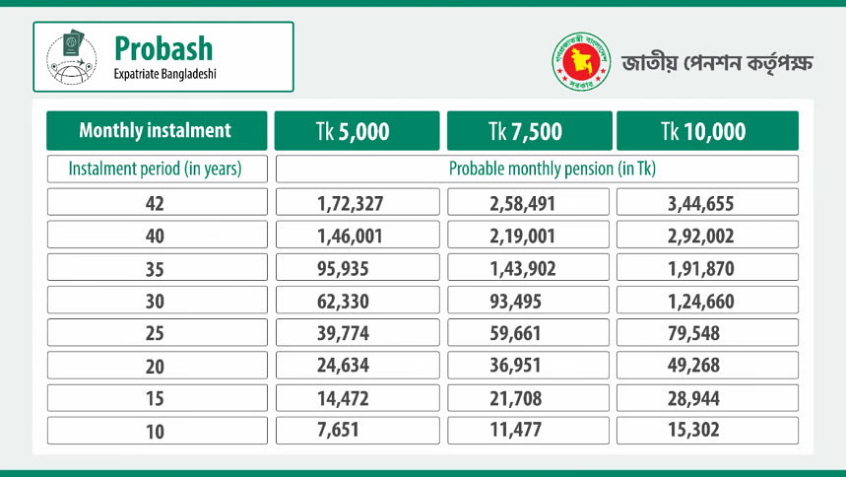

Figure: Probash Pension Scheme Estimated Return
- Progoti: For a long time, the private sector employees of Bangladesh were craving for retirement facilities and pension scheme like government employees which would ensure necessary savings for their future life after their retirement. At last, Bangladesh government introduced Progoti scheme for private sector employees. This scheme is designed specifically for those employed by privately-owned corporations. Just like the Probash scheme, the rate of subscription for Progoti scheme has been segmented into three distinct components. Participation in this plan is open to any individual belonging to the private sector who is willing to contribute a monthly fee of either 2 thousand, 3 thousand, or 5 thousand BDT. Furthermore, it is worth noting that both the organization itself and its proprietor can participate in the Pragati plan. Under these circumstances, it is anticipated that the employee would bear 50% of the overall contribution, while the other 50% will be covered by the institution.

Upon participating in the scheme at the age of 18, an individual who consistently contributes 2,000 BDT per month for a duration of 42 years would be entitled to receive a monthly pension amounting to 68,931 BDT commencing at the age of 60. In a comparable way, making an installment payment of 3000 BDT would result in a monthly pension amounting to 1,03,396 BDT while a monthly commitment of 5000 BDT will provide a monthly pension of staggering 1,72,327 BDT for lifetime after age 60.
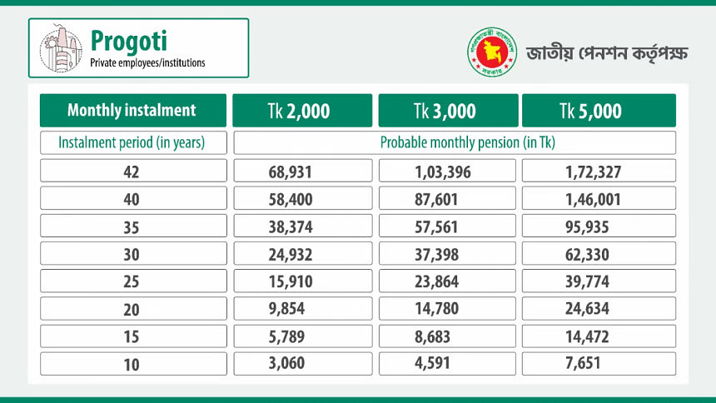
Figure: Progoti Pension Scheme Estimated Return

- Surokkha:The 'Surokkha Scheme' is designed to provide benefits to those employed in the informal sector or engaged in self-employment. Individuals involved in various informal sectors, including farming, rickshaw pulling, labor work, blacksmithing, pottery, fishing, and weaving, are eligible for inclusion under this scheme. The monthly payment amounts under this arrangement are 1000 BDT, 2000 BDT, 3000 BDT, and 5000 BDT.
According to this pension scheme, those who enroll at the age of 18 and make monthly contributions of 500 BDT would be eligible to receive a monthly pension of 34,465 BDT starting from the age of 60. Individuals who are 50 years old or older will be entitled to a monthly pension of 500 BDT for a minimum duration of 10 years. Additionally, they would get a monthly pension of 1,530 BDT starting at the age of 60.

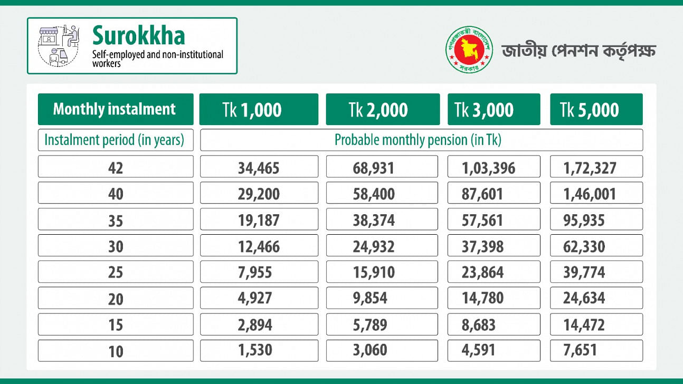

Figure: Surrokha Pension Scheme Estimated Return

- Somota:The monthly installment fee under this arrangement amounts to 1000 BDT every month. The monthly payment for the subscriber will amount to 500 BDT. The government will cover the remaining 500. Based on the findings of the Income and Expenditure Survey periodically performed by the Bangladesh Bureau of Statistics, individuals who are identified as residing below the threshold of severe poverty and are unable to meet their basic needs with their own financial resources, are eligible for inclusion in this scheme. Currently, individuals with a yearly income ranging from Tk 60,000 per annum are eligible for inclusion in this scheme.A positive aspect of this scheme is the government'sinitiative of 50 percent contribution assistance for low-income groups to provide them with support for their future life.

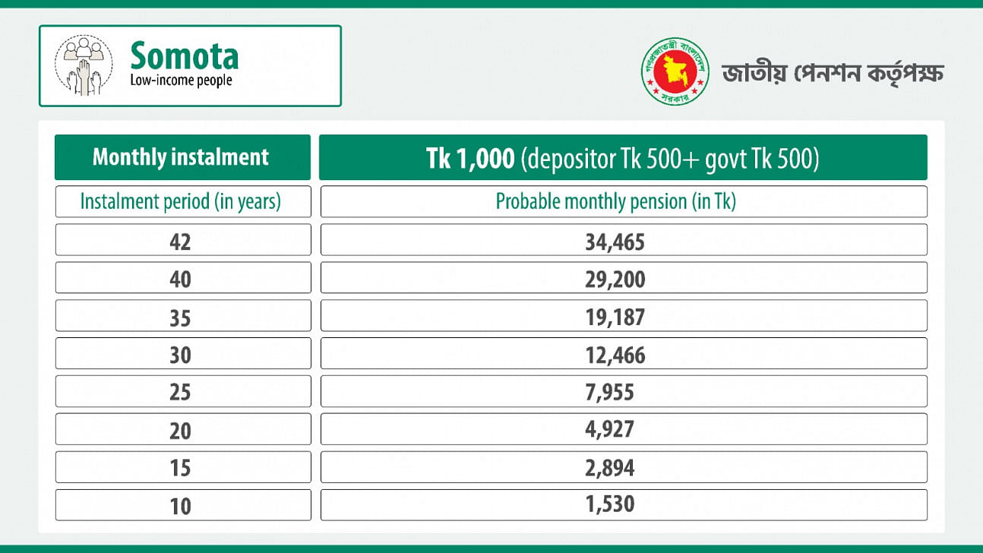
Figure: Somota Pension Scheme Estimated Return

Enrollment Procedure of Universal Pension Scheme

The enrollment procedure for the four distinct types of pension scheme is almost similar but each scheme requires slightly distinct types of documents and verification to be eligible for enrolling into the designated pension scheme. In the following paragraph, I would summarize the enrollment procedure of these four different pension schemes.
All individuals residing in Bangladesh, regardless of their occupation, including those employedin the private sector, low-income citizen is required to enroll for the program by accessing the UPension website.
The first step is consenting to the stipulated registration prerequisites by verifying one's identification. To go to the subsequent stage, it is essential for individuals to provide their consent to the terms and conditions outlined. Individuals working in any governmental or semi-governmental entity or autonomous organization are not entitled to this benefit scheme. In addition, it is not allowed to obtain any kind of allowance within the framework of the social security plan. Registration applications containing incorrect information will be subject to rejection. If inaccuracies are discovered in the application during the subscription payment process, a refund will not be issued.
In this part, the main scheme and income category should be selected. The Progoti category will be chosen by workers in the private sector. Individuals living abroad will choose the Probash classification from the available options. Individuals who are self-employed or do not belong to any organized workforce are required to choose the Surrokha category as shown on this site. Individuals who are socioeconomically disadvantaged should choose the category labeled 'Low Income' from the available alternatives. Next, individuals need to verify themselves as citizen of Bangladesh to become eligible for the pension scheme. They need to provide the National Identification (NID) number, date of birth, cellphone number, and email address individually. The NID number should consist of either 10, 13, or 17 digits. A One-Time-Password (OTP) will be expeditiously sent to the candidate's cell number and email address. The placement of the information inside the web form should be automated and directed to the appropriate specified location.
The following site will pertain to personal information. The National Identification (NID) system automatically retrieves and populates essential personal information, including the NID number, photographs, complete name in both Bengali and English, as well as the names of the individual's father and mother. Additionally, the system retrieves and presents the individual's current and permanent addresses.
To complete the yearly income field, numerical values should be entered. The selection of the Division, District, and Upazila names should be made from the provided dropdown list. Individuals are required to choose their own occupation from the array of professions listed inside the designated profession selection area. Once all the necessary information has been provided, they need to fill up the subsequent page titled 'Scheme Information'.
This webpage provides scheme information that will ascertain the monthly contribution amount and the preferred manner of payment for contributions. Candidates can choose a payment mechanism that is most convenient for them from a range of three options: Monthly, Quarterly, and Annual.
Subsequently, it is necessary to provide the selected payment method along with the requisite banking information. The bank account holder's name and account number, namely the name of the candidate or the account from which the subscription will be paid, must be supplied. When choosing a bank account, individuals often have the option to choose between two primary types: savings accounts and current accounts. Subsequently, it is necessary to provide the routing number associated with the financial institution.
On the next page, all the information about the nominee, namely, his NID number and date of birth should be given. After that the other information section will open through the 'Add Nominee' button below. Here the nominee's mobile number and his relationship with the candidate as well as how much of the candidate's share should be mentioned. If there is not more than one nominee, only one candidate shall be the nominee of the entire portion of the candidate. The 'Add More Nominees' button is for multiple nominees. Through these multiple nominees should be added and their due portion should be mentioned.
Upon selecting the "complete form" option, the website will provide a consolidated view of personal, scheme, bank, and nominee information. The registration procedure will be completed after the verification of these details and the acknowledgment of the accurate information. The fully completed application may be downloaded and stored for future use.

Monthly Installment Payment Procedure of Universal Pension Scheme

The mobile number and e-mail address provided in the application form will be informed about the installment rate and monthly installment payment date of the registrant. The amount of contribution due in installments should be deposited in the bank account of the National Pension Authority within the prescribed period. If due to any reason it is not possible to make the contribution during this period, the contribution can be made within a maximum period of one month without penalty. If this period of one month is exceeded, the penalty will be charged at the rate of 1 percent for the next day. Otherwise, the scheme account will become inactive.
The authorized bank accounts listed by the National Pension Authority may receive monthly instalments via several channels, including mobile financial services, internet banking, and credit or debit card transactions. Bangladeshi expatriates have the option to contribute funds via the use of credit and debit cards.
Depositing public pension scheme money through a mobile financial service (MFS) institution will incur an additional cost of 7 BDT per thousand monthly installments. An opportunity to deposit 500 to 10 thousand BDT per month has been reserved for each pension scheme. The Finance Department of the Ministry of Finance has fixed this cost, following which the Bangladesh Bank has issued a formal notice regarding this.
In all plans, the payment of instalments may be made on a monthly, quarterly, or yearly basis, depending on the donor's profile.A notification will be issued to the cellphone number on record upon the successful deposit of the monthly payment into the chosen bank account. In the event of non-payment of the installment, depositors will get notification, accompanied by details on the imposed penalty.
Additionally, if an organization engages in the pension scheme as an entity, both the organization and its workers will be required to collectively contribute the installments alongside the organization.

Benefits of Universal Pension Scheme

A new chapter of social security has been written with the official inauguration of the much-awaited universal pension scheme, considering the future life course of the people of different classes and professions of the country. Many people in the country have been brought under the pension benefits through four programs namely Progoti, Probash, Surokkha and Somota for the working population in the private sector, expatriate Bangladeshis, informal sector, and new income people, respectively. This initiative of the government is highly commendable.
With the introduction of the pension scheme, no one will have to depend on allowances anymore. It will ensure their economic security.Pensioners can enjoy pension benefits for life i.e., till death. But if someone dies before attaining the age of 75 years then his nominee pensioner will get pension benefits till the age of 75 years. And if the pensioner dies before 10 years of contribution, his deposit will be returned to his nominee along with the profit. The monthly contribution towards pension will be treated as an investment and the amount will be considered for tax deduction. And the amount received for monthly pension will be income tax free.
Under the scheme, the participants will be able to take 50 percent of the money deposited in the pension scheme as loan to spend on their own or family members' treatment, house construction, house repair and child's marriage.The money taken as loan will have to be paid in 24 instalments, including the fees charged by the pension authority.

Importance of Proper Administration of Universal Pension Scheme

Prominent business leaders inside the nation feel that the government's implementation of a universal pension scheme would provide a novel dimension to the economy. As per their assertion, this effort by the current government is aimed at promoting the welfare of individuals, particularly in terms of poverty reduction, economic stimulation, and the provision of social security for the citizens of Bangladesh. Prominent economists expressed their approval of this project, while also emphasizing the need for its effective administration. It has been claimed that it is crucial to prioritize efforts to prevent any degradation of public trust in an undertaking resulting from management deviations. During an interview with the media, the distinguished economist and former adviser of the last caretaker government made a notable remark, stating that the fund represents the accumulated savings of the general people. The management of the task should be conducted autonomously. The primary focus should be on the intended purpose for which the fund is being established. Public pension will generate a huge fund for the government. The efficacy of this fund hinges upon the government's ability to effectively administer it. Failure to invest in the appropriate industry may entail potential risks. The success of the fund will be contingent upon factors such as the specific location and manner of investment, as well as the anticipated return on investment. Following extensive implementation in several nations worldwide, it was determined that the program ultimately proved unsuccessful because of inadequate managerial practices. Those nations who have successfully implemented effective management practices have also achieved positive outcomes. There are many such precedents.
The government of Bangladesh is trying their best to ensure proper administration and management of retirement plan. They have assured everyone that there is no reason to worry about the deposits of pension scheme since government itself is guaranteeing it. The unique number that will be given to every pensioner will be unique. They can always check how much money is in their account with that number."

Universal Pension Scheme Around the World
Numerous nations throughout the globe have implemented universal pension schemes. The pension system in Iceland is now regarded as the most exemplary. In addition, countries such as the Netherlands, Denmark, Israel, Australia, Norway, New Zealand, Finland, Canada, Germany, Sweden, Switzerland, the United Kingdom, France, and Singapore have shown commendable performance. These Nations are well esteemed around the world for their effective administration, sound governance, sufficient pension provisions for the older populace, and substantial financial assistance provided by the state. There are four primary categories of pension schemes that are often seen worldwide. There are four primary categories of pension plans: unfunded, funded, defined benefits (DB), and defined contributions (DC). An unfunded pension scheme does not generate any cash since it does not need employee contributions. Funded pensions need contributions from either the individual, the organization, or both parties involved. The database system is designed specifically for use by government personnel. In the context of the DC system, funds are contributed by workers or organizations via deposits, while expenses are subsequently incurred from these funds. In several nations, the pension system is also facilitated by insurance firms.
India, the neighboring country of Bangladesh, implemented the National Pension System (NPS) on January 1, 2004. Initially, this system was only applicable to central government workers, apart from those serving in the military. The pension system was made accessible to individuals of all nationalities, residing both domestically and internationally, who were between the ages of 18 and 60, effective from May 1, 2009. In December 2011, in addition to government workers, non-governmental business organization employees were now mandated to take part in the pension program. Two distinct schemes were implemented for those working in the informal sector and New Zealand residents, one commencing in the fiscal year 2011-12 and the other in the fiscal year 2015-16. In addition to this, the nation has a social pension system that caters to the needs of the elderly, individuals with disabilities, and widows. Nevertheless, China has a comparatively superior position in Asia with regards to this matter. There are three distinct pension systems in place, namely the Urban Pension System (UPS) catering to urban workers, the Civil and Public Service Pension System (CPSPS) designed for government and semi-government employees, and the Rural Pension System (RPS) tailored for those employed in private sectors within rural areas.
Conversely, the United Kingdom encompasses four distinct categories of pension schemes, namely the state, occupational, private, and unfunded. The state pension is comprised of three distinct components, namely the state pension itself, the supplemental pension, and the pension credit. Individuals who earn an annual income over £9,500 in relation to the State Pension are obligated to make mandatory National Insurance payments. Individuals whose income falls below the minimum income threshold established by the state are eligible to receive an elective supplemental pension. The Pension Credit program is designed to provide financial assistance to those aged 60 and above who have low incomes. The occupational pension scheme involves the allocation of 3 percent of an employee's pay, together with an additional 5 percent contribution from either the government or the employer. Investment is made and pension is disbursed in conjunction with the earnings. In addition, the unfunded pensions are allocated to those serving in the military, government personnel, and educators. Private pension plans are a viable means of retirement savings that are handled by insurance firms.
The United States use a state-based framework for social security, employment-centric, non-funded, and privately funded pension systems. The state system of Social Security provides coverage for 94 percent of employed individuals in the United States. The disbursement of this pension is sourced from the taxes paid by the client, as well as the funds placed into the trust account and any accrued investment returns. In this approach, a sum of $1,410 is placed on a quarterly basis, resulting in a total deposit of $56,600 over a span of 10 years. Under a job-based pension scheme, the employer or government matches the employee's contributions with an equivalent amount. The unfunded programand private pension system in the nation have similarities to those seen in the United Kingdom.
According to analysts, the successful execution of the government's recently announced universal pension program may be a significant challenge for the authorities, given the substantial interest it has generated among the populace. To surmount these problems, it is essential to use comprehensive and pragmatic approaches. The social security sectors have garnered significant acknowledgement due to their use of diverse incentives. The status of Bangladesh in the trajectory of growth needs to be elevated to a more esteemed level. It is desirable that the nation sustains its advancements in many social areas for an extended period.

Evaluation of Retirement IndustryofBangladesh and USA

Bangladesh, in contrast to the United States, is a developing country that has a tough time caring for its elderly population. In the current fiscal year, the finance ministry estimates that there will be 7.5 million pension recipients. Similarly, more than 1.5 million workers would get financial aid from various organizations. According to the 2016–17 fiscal year budget reports, however, 87 percent of Bangladesh's workforce was not covered by a pension or gratuity system, as Sarkar claimed in "The Daily Star." Given that the elderly in Bangladesh is likely to see their gifts shrink as they near retirement age, we may be able to forecast that the country would face a retirement crisis. Furthermore, retirees have recently borne a disproportionate share of the burden of the COVID epidemic. Bangladesh's retirement system has not been well-regulated by the government on multiple occasions. Nonetheless, public servants are often misinformed about their retirement options. Therefore, companies that offer benefits to their workers have disregarded any inequality between their highest- and lowest-paid workers. In contrast, the United States government cares deeply about its citizens' access to retirement security. In the United States, companies that contribute to their employees' retirement savings programs might receive tax incentives from the federal government. To comply with government requirements, businesses must follow a very rigorous process when providing retirement benefits. The American retirement market is worth more over $26 trillion, making it the largest in the world. Congruent Solutions estimates that by 2020, retirement record keepers, asset and wealth managers, annuity writers, and life insurers will earn over $430 billion from these accounts. Many seniors in the United States have benefited from the security and benefits provided by the country's retirement system. In addition, retirees have a stronger financial footing in terms of consumption, income, and wealth than the general population. The retirement systems of the United States and Bangladesh are worlds apart. This research adds to the examination of these inequalities and suggests ways to constrain them so that the United States may provide a more generous retirement system for its aging population.

How U.S. Retirement Systemcan be Implemented in Bangladesh

Each governmental body typically implements a retirement system. Within the realm of pension policy, using the services of a third-party organization would provide more benefits. To effectively implement a retirement savings strategy, it is necessary to have a well-defined organizational structure. The possible impact of implementing this strategy is to alleviate current tensions, so facilitating the establishment of a more responsible and dependable corporate entity in Bangladesh. Considering the existence of the TPA in the United States, it would be prudent for Bangladesh to build a comparable institutional structure with the aim of facilitating distribution. To formulate a coherent policy, it may be prudent to delegate the oversight of Bangladesh's contribution and deferral to a highly responsible and esteemed body. The general public is dependent on his subordinates, and he will abstain from interfering in the matters of others.
Forming a Third-Party Administrator (TPA)-like entity is essential when establishing a pension plan. Reducing tension and fostering confidence in an institution that manages people's money are the primary objectives of depending on third party administrators. There are only a handful TPA firms that are trusted by the retirement industry in the United States due to the sensitive nature of the information they handle. Similarly, Bangladesh must establish a TPA-like organization to safeguard its citizens' money.
Incentives for new entrants could be provided by the government in the form of provident funds to encourage banks to provide assistance. Bangladesh must create a pension system that works for retirees and gives them the freedom to uphold fundamental human rights.
The implementation of additional rules concerning high-earning persons should be considered by the Bangladeshi government to mitigate the discrepancies that exist between workers with high incomes and those with low incomes. The use of initial deferral and contribution percentages and limitations may be employed to address and alleviate this imbalance. If the prescribed regimen is followed, NHCE will get benefits.

Government should include training sessions regarding retirement plans and benefits to Improve financial literacy of the citizens. Everyone should know about their own paychecks and how they are invested. Financial literacy will help everyone to understand the benefits of retirement plans and invest in appropriate investment funds for their retirement plan.

Chapter 3: Objective of the Study

Primary Objective

The Bachelor of Business Administration (BBA) degree offers students a broad comprehension of the theoretical knowledge required for persons in the business domain. Nevertheless, it is crucial to acknowledge that the actual work setting might significantly differ from the idealized situations portrayed in academic literature. Work experience plays a vital role in knowledge acquisition, which is why internships are a mandatory prerequisite within our academic curriculum. The primary purpose of this research is to satisfy requirement for the Bachelor of Business Administration (BBA) degree from the School of Business & Economics at United International University.

Secondary Objectives

The following are some of the secondary objectives of this report:

- To acquire knowledge about the operational procedures of third-party administrators.
- To get a comprehensive comprehension of the operational procedures of the retirement plan implemented by the organization.
- To acquire knowledge on the development and execution of the assessment process for the plan.
- To understand more about the oversight functions undertaken by the IRS and the DOL to promote transparency.

Chapter 4: Methodology of the Study

The research used the information and skills gained via the direction and assistance of experienced persons, such as senior professionals, coworkers, and supervisors. The methodology used in this study mostly involves the sources utilized for data acquisition. The following sources are outlined:

Primary Sources

- Data acquisition via collaboration with office teams.
- Engaging in inquiry with managers, staff members, and colleagues.
- The circulars disseminated by the government of Bangladesh.

Secondary Sources

- Government archives and collections, the internet, and so on.
- ERISA outlines
- Recordkeeper guidelines
- Retirement Plan Fundamental

Chapter 5: Findings of the Study

During the duration of my internship, I have focused on the retirement industry of the United States andacquired a diverse range of expertise. This study facilitated the findings within the retirement plan sectors of Bangladesh and the United States.

- There is currently no established regulatory entity in Bangladesh responsible for overseeing pension program and ensuring openness, adherence to norms, and compliance with regulations pertaining to retirement plans whereas the US retirement system is highly organized and well structured.

- In Bangladesh, there is a lack of explicit guidelines in place compared to US retirement industry to prevent discriminatory practices between workers in higher-level positions and those in lower-level positions. Employeeshave little understanding of their role in the plans. Furthermore, our deficiency in the financial sector is evident as we lack a robust retirement industry to facilitate investment in the market. As a consequence, our potential financial market remains underdeveloped. The pension amount remains unadjusted on an annual basis, whereas the rising cost of living has a direct impact on the living standards of pensioners.

- In the United States, TPAs are in charge of managing retirement plans whereas In Bangladesh Public and private sector pensions are managed by the Finance Ministry.There are currently no compliance tests available in Bangladesh for retirement plans.

- In the United States, for each plan, there are nondiscriminatory assessments to ensure that all participants receive equal pay for equal work.

- In the United States, participants are always up to date about the investment of their funds. They can select themselves in which mutual funds they want to invest their retirement funds. The Recordkeeper is where the IRS mandates that employers should save the funds of their employees, within the confines of a certain timetable. Bangladeshi contributors have no idea where their payroll deductions go when they are made. Employees only receive the money once they have retired or left their jobs.

- In the United States, Participants can either take out their whole savings upon changing jobs or transfer all funds to the new company and keep operating accounts.
There is no way for Bangladeshi participants to keep their accounts open after switching jobs.

- In Bangladesh, each month, the company, and the employee each put in a predetermined amount of money.On the other hand, in the United States, the employer's contribution is different from employee’s own contribution. There is no fixed monthly installment.

- The US retirement plan provides unique facilities to participants such as taking hardship in case of emergency situation or taking loan from the retirement plan. The universal pension scheme of Bangladesh has yet to provide the facility to its participants.

Chapter 6: Recommendations & Conclusions

The pension policy in Bangladesh is not well set up and facilitated.I have identified few challenges of managing retirement industry in Bangladesh. In order to shed light on the situation, I would like to give some recommendations that I believe will help to improve the overall structure of the retirement industry of Bangladesh as well as will be beneficial for Data Path Ltd.

Recommendations forData Path Ltd.

Appointing an individual with the basic knowledge of retirement industry is the biggest challenge for Data Path Ltd. Since, this is relatively a new and not so well-known industry in Bangladesh, it’s almost impossible to find skilled human resource in Bangladesh. Appointing the best person for the job requires a recruitment strategy geared towards placing the most qualified candidate in the open position at the best possible time. If Data Path is doing its job right, it will only hire the most competent and straightforward candidates. It needs to be managed so that productivity and efficiency are not compromised. Employeesneed be informed about retirement plan fundamentalsof the United States. Therefore, training must be conducted completely. They need effective communication skills to collaborate with sponsors. Advertising for new hires is something Data Path must do more rigorously. Data Path Ltd. uses both online platforms and conventional print media, such as newspapers and other non-digital outlets, to advertise their employment vacancies. With an ever-increasing customer base comes a corresponding rise in labor requirements. services. As a result, expanding recruitment advertising across digital and traditional media will improve the likelihood of making the correct hire.

Recommendations for Tackling Difficulties with Retirement Plan in Bangladesh

I have identified few problems of retirement plan policies in Bangladesh and the United States. These problems require attention, and some potential answers are as follows.
- The United States administers its retirement plan in accordance with federal regulations. Like the United States, Bangladesh needs non-governmental organizations to help in the development of pension policy.
- The Internal Revenue Service Reviews Form-5500 and plan valuations. The CA also analyzes the company's assets and liabilities. However, pension funds in Bangladesh are not subject to audits. The pension system in Bangladesh is notoriously opaque, and this is meant to combat that. As a result, Bangladesh has a pressing need for a watchdog organization to track the sector.
- Thirdly, private sector workers do not have access to a defined pension plan and instead get a retirement bonus. If these issues are resolved, they will be able to improve their economic standing in the community.
- To encourage workers and businesses alike to save more for retirement, the 401(k) and employer contribution limits in the United States have been raised. Pensions in Bangladesh are set by the government and are often unfavorable to workers. Thus, this issue requires a solution.
- Discrimination prevails in the Bangladeshi pension market, in contrast to the U.S. In Bangladesh, pensions for higher designated workers are higher than those for lower designated workers. However, this is not always acceptable because the salary is so much lower.

Conclusion

It is clear from the brief comparison of the retirement systems in the United States and Bangladesh that the pension policy in the United States serves as a motivating factor for people to direct their financial resources towards pension investments. In the United States, several retirement benefit programs are governed by defined rules and specified criteria. To ensure the continued validity of a plan, the Plan Sponsor must follow the prescribed set of criteria. The application of sanctions is necessary ifthere are any infractions of these regulations. The use of stringent monitoring practices inside the retirement industry yields positive results. One additional benefit pertains to tax benefits since organizations have the capacity to choose a deferred payment option that offers the most tax benefits. The US retirement plans have included criteria for discrimination thresholds in order to address and limit instances of discriminatory practices. Within the framework of the Bangladesh perspective, it is noted that the government takes exclusive authority over the formulation and implementation of pension policy. Nevertheless, this strategy does not get full approval from all employees since the pension disbursement for higher-ranking individuals surpasses that of their lower-ranking counterparts. Furthermore, the present level of pension funds is insufficient to meet the financial requirements necessary for sustaining an acceptable quality of life. The development of a third-party agency dedicated to facilitating the design of the retirement plan would have facilitated the achievement of equity within the retirement policy. Based on the extant facts, it can be deduced that the pension sector in the United States has a greater level of organization in comparison to that of Bangladesh. Moreover, it is crucial for Bangladesh to undertake a comprehensive review of its pension policy in order to adequately respond to the economic changes that have occurred.

References

- Rajib, M. S. U., Mondal, L., & Hassan, F. (2022). Universal Pension Scheme: Challenges in Bangladesh. Bangladesh Economia, 18-27.
- Mamun, M. Z., & Hossain, M. Z. (2022). The Bangladesh Pension System. In International Comparison of Pension Systems: An Investigation from Consumers’ Viewpoint (pp. 315-356). Singapore: Springer Nature Singapore.
- SM, S. R. (2023). A Critical Analysis of the Social Security of the Aged Citizens of Bangladesh. Law and Society Students' Journal, 1(1), 16-16.
- Haque, T. A. (2022). Comparative Study on Pension Policy (with Focus on USA and Bangladesh).
- Dana, T., & Payara, G. (2022). Old Age Allowance Program in Bangladesh: Policy Issues and Implementation Challenges (Doctoral dissertation, © University of Dhaka).
- Rahman, M., Khan, T. I., & Sabbih, M. A. (2021). An Estimation of the Implementation Costs and Financing Options for Introducing a Universal Pension Scheme in Bangladesh. South Asia Economic Journal, 22(1), 110-131.
- Toyota, M., & Xiang, B. (2012). The emerging transnational “retirement industry” in Southeast Asia. International Journal of Sociology and Social Policy, 32(11/12), 708-719.
- Levanon, G., & Cheng, B. (2011). US workers delaying retirement: Who and why and implications for businesses. Business Economics, 46(4), 195-213.
- Lloyd, N. (2018). Myths and realities of retirement. Benefits Quarterly, 34(4), 58-62.
- Lusardi, A., & Mitchell, O. S. (2011). Financial literacy and retirement planning in the United States. Journal of pension economics & finance, 10(4), 509-525.

