

An Internship Report On

Employee Satisfaction on Recruitment and Selection Process of Reserveit BD

UNITED INTERNATIONAL UNIVERSITY

Internship Report on Employee Satisfaction on Recruitment and selection process of Reserveit BD

Submitted To
Yeasmin Islam
Assistant Professor
School of Business and Economics
United International University

Submitted By
Nadia Hossain
ID: 111 173 093

UNITED INTERNATIONAL UNIVERSITY

Submission Date: 16/ May/ 2023

LETTER OF TRANSMITTAL
17/May/ 2023
Yeasmin Islam
Assistant Professor
School of Business and Economics
United International University

Subject: Report on "Employee satisfaction on recruitment and selection process of Reserveit BD" submitted as part of the internship.

Dear Madam,

I am gratefully and admiringly presenting my internship report on "Employee Satisfaction on recruitment and selection process of Reserveit BD". I completed the Reserveit BD Internship as partial fulfillment of the requirements for the BBA degree. It gives me the delight to work under your direction on the assignment report. I chose the employee's satisfaction with the recruitment and selection procedure of Reserveit BD, which I have seen during my internship program since I had to produce an internship report based on a practical scenario in a business. I trust this research offers some insight into the current recruitment and selection process used by enterprises in our nation. I've made an effort to observe the prescribed guidelines. If you found this document to be helpful and interesting, it would make me proud. Please consider implementing my internship report for further assessment.

Sincerely Yours,
Nadia Hossain
ID: 111 173 093
BBA Program
United International University.

ACKNOWLEDGEMENT

First and foremost, I must thank the Almighty God for providing me with the courage to conclude my internship and submit the documents. I would like to convey my sincerest gratitude to my respected academic teacher Yeasmin Islam for her kind support, guidance, constructive supervision, directives, and advice, as well as for inspiring me to complete my report. I am also appreciative to the Reserveit BD team for assisting me by providing the necessary information. During the course of my internship, I kept in contact with the management of Reserveit BD and made some significant contributions to things. The task would be impossible without them, and they aid in the compilation of the document. The overwhelming majority of them have worked at Reserveit BD. I believe that this report will motivate me in the future to take on additional initiatives and large projects since I will be satisfied that I effectively accomplished such a large assignment.

EXECUTIVE SUMMARY
As a business administration student, assessing today's business environment is critical to observe in this complex circumstance. It is crucial to review all areas of expertise, both theoretical and practical. As part of my academic curriculum, I was granted an apprenticeship program to get practical experience in business before concluding a four-year BBA program. In this paper, I endeavored to concentrate on my theoretical and practical understanding of the recruitment and selection process. The project's title is "Employee Satisfaction on Recruitment and selection process of Reserveit BD". The internship document reflects three months of recruitment and selection procedure at the Reserveit BD branch in Dhanmondi, Mohammadpur. This report attempted to find out this organization's current recruitment and selection process. This study addresses some significant concerns within the topic of human resource management in Reserveit BD. Based on the Human Resources activities of this App and IT-based organizations, current Human Resources (HR)management strategies, practices, and outcomes. The primary aim is to create an app for online restaurant reservations. The Reserveit BD was established on October 5, 2021, and operations has begun shortly after the app's release. Reserveit BD specializes in focusing on innovative technology. This paper makes an effort to clarify the organization's system and procedures step by step. Finally, the paper includes an organizational overview of the recruitment and selection procedure of Rerserveit BD. The report might help create any future study to evaluate the HR services supplied by Reserveit BD. This report is broken into four segments and is wholly based on Reserveit BD's real-world experiences. The first chapter is devoted to the document's introduction, which addresses subjects such as the study's history, rationale, scope, objective, methodology, and limitations. The second chapter provides an overview of Reserveit BD's recruitment and selection procedure. The third chapter presents the report's findings and analysis. It also contains Reserveit BD's SWOT analysis, which defines the company's internal (Strengths and Weaknesses) and external (Opportunities and Threats) environments. Finally, chapter 4 demonstrates and summarizes the report before concluding. The report's main findings demonstrate how Reserveit BD recruit, select and train employees and their satisfaction level.

LETTER OF TRANSMITTAL 3
ACKNOWLEDGEMENT 4
EXECUTIVE SUMMARY 5
1.1. Introduction 8
1.2. The rationale of the study 8
1.3. Scope of the Report 9
1.4. Objective of the report 9
1.4.1 General Objective 10
1.4.2 Specific Objective 10
1.5. Methodology of the Report 10
1.5.1 Sources of information 11
1.5.1.1 Primary Sources of information 11
1.5.1.2 Secondary Sources of information 11
1.6 Limitation of the report 11
2.1. Overview of Reserveit BD. 14
2.2. Primary Human Resource Strategy of Reserveit BD. 14
2.3. Satisfaction of employees 14
2.3.1. Satisfaction with the recruitment and selection process 15
2.3.2. Lenghty recruitment process 16
2.4. Accuracy of job description 16
2.5. Guidelines for employee satisfaction: 17
2.6. Reserveit BD follows the fair recruitment method. 17
2.7. Human Resources Department of Reserveit BD 18
2.7.1. Recruitment and Selection 19
2.7.2. Assessment during recruitment 20
2.7.3. Internship at Reserveit BD 21
3.1 SWOT Analysis: 26
3.1.1 Strengths: 26
3.1.2.Weakness: 26
3.1.3.Opportunity: 27
3.1.4 Threats: 27
3.2. Descriptive analysis with diagram/ charts 28
Employee satisfaction on recruitment and selection process 32
Lengthy recruitment process 32
Accuracy of job decsription 33
Reserveit BD follows the fair recruitment method. 34
3.3. Findings of the study: 34
4. Conclusion 36

Chapter 1

Introduction

1.1. Introduction
The report is necessary in order to graduate from United International University with a Bachelor of Business Administration (BBA). To get the certification, each student must submit an internship application and work in a business while writing an internship report. The option to work as an intern at Reserveit BD became a significant possibility. While working with the HR Department at Reserveit BD. The report is being created to illustrate the satisfaction level of employees on recruitment procedure of Reserveit BD. The Human Resources department is a relatively recent addition to the corporate world. Previously, huge firms ignored human resource management. Today, the situation has changed, with the majority of organizations implementing HRM practices. The primary reason for this is that the company is run by people, not robots, thus the recruiting process is critical. As a consequence, retaining these people and resources is crucial for long-term corporate success. Reserveit BD additionally stresses and ensures a successful recruiting and selection process. My main aim in my Internship Report is to determine the degree of employee satisfaction with Reserveit BD's recruiting and selection method.

1.2. The rationale of the study
Reserveit BD is an IT and app-based company, and many other competitors, such as Foodpanda and Hungrynaki, are there to make things harder for Reserveit BD, which will face greater competition in the coming months. As the IT industry becomes more complicated, it faces a variety of dangers. Human resource management (HRM) is the administration of an organization's people. Field agents, coordinators, workers, supervisors, and project managers will be among them. Because they administer organizations, these individuals are referred to as "Assets." These "Assets" must be utilized to administer the company and carry out projects. Having a specialized organizational team is insufficient. Fundamentally, a firm will not be able to achieve its goals unless its teams are successfully managed, motivated, and executed. System design, such as construction plans and regulations, is a method of controlling, motivating, and executing things. HRM encompasses various systems, and it is critical to attract personnel using an appropriate format in order to get qualified staff. It is also critical to keep their motivation and satisfaction levels high in order to conduct the operations efficiently.

1.3. Scope of the Report
This report will include all of the information I gathered on Reserveit BD's HR procedures throughout my internship. The article will provide thorough information on Reserveit BD so that any reader may conceptually comprehend the Satisfaction level of employees on recruitment and selection procedure of Reserveit BD A research like this one on Reserveit BD's Human Resources Practices may assist students and lecturers learn how to attract and choose employees. This information may help students both while seeking for a career and after they have one. The survey will enable for the identification of employee satisfaction levels as well as the rights and methods that should be present while recruiting. The regular recruiting process and post-recruitment processes will also be covered. The research will assist in learning the actual processes used by Reserveit BD. The final suggestions may assist Reserveit BD's HR manager in improving the recruiting and selection process. This report was created after thorough consultation with corporate personnel and a survey. The prospectus given by the asset management firm also aided in the preparation of the report. I got a fantastic chance to have an in-depth understanding of all the actions carried out by Reserveit BD's HR staff while producing the report.

1.4. Objective of the report
The internship's major purpose is to fulfill the requirements of the UIU's BBA degree. Aside from that, the interns worked with the purpose of getting practical experience in the HR department of Reserveit BD.

1.4.1 General Objective
The goal of this study is to establish whether or not the workers of 'Reserveit BD’' satisfied with the recruitment and selection procedure and want to work for the company. The 'Recruitment and Selection Procedure' is the most essential component of this study. The internship's objectives were as follows: To get hands-on experience with the responsibilities conducted in the HR Department of Reserveit BD. Clarify personal interests, talents, and competencies, as well as how they relate to job progression. To get advice from HR specialists with extensive expertise. Acceptance of the duty for ongoing education and professional development.

1.4.2 Specific Objective
The proposed study has the following objectives: "Overall recruitment and selection procedure of Reserveit BD." To determine whether or not Reserveit BD's workers are enough satisfied with the recruitment and selection procedure that is currently operating in Reserveit BD. The goal is to identify Reserveit BD's strengths and weaknesses based on the recruiting and selection process. The essential component of this report is 'recruiting and Selection,' which decides whether or not they are satisfied. Determine the degree of staff satisfaction and the overall Reserveit BD recruiting and selection method. Recognize how an employee should be handled in order to keep them content and motivated at work. Reserveit BD's recruiting technique for running their business and ruling the market with the support of personnel. In addition, critical measures for issue resolution must be recommended.

1.5. Methodology of the Report
In order to contract the report I have collected necessary information from two sources
a. Primary Sources of Information.
b. Secondary Sources of Information.

1.5.1 Sources of information
The details of the report are collected in various ways and the two sources of information are:
- Primary sources of information.
- Secondary sources of information.

1.5.1.1 Primary Sources of information
The primary data was collected from the following sources:
-Survey.
-Oral interviews with the personnel in charge.
- Interview with the administrative assistant manager, the HR-in-charge, the operations manager, and a few other personnel
- Meetings with top executives are also scheduled.

1.5.1.2 Secondary Sources of information
Secondary data was gathered from the following sources:
-Reserveit BD websites
-Various Reserveit BD papers
-The Internet.
-Job description of employees.

1.6 Limitation of the report
This report is my first practical project outside of the course curriculum. I am a BBA student who is nearing the end of my formal education. Before completing the institutional experience, formal performance at the formal level becomes difficult. As a consequence, my performance in this report is greatly influenced by my lack of practical experience. Aside from the limitations indicated above, numerous additional must be taken into account:
• Time is a major restriction that would preclude a full research of the selected problem.
• The Human Resources Department concealed a number of confidential documents, documentation, and reports from me.
• Certain business and operational strategies were limited to transfer.
• Inappropriate cross-departmental cooperation.
• Refusing to offer extra information because of additional harassment that is not their fault.
• Another reason for not releasing further information.
• Some older statistics were unavailable.
The internship term is limited, and the Human Resources Division is a vast area that is hard to explore in detail after finishing the usual office employment. The secondary source of information was inadequate to complete the confidentially of the report.

Chapter 2

Literature Review



2.1. Overview of Reserveit BD.
Reserveit BD is a company that specializes in IT and app development. Their tagline is "Select, Click, Reserve." Their primary purpose is to make people's life easier by arranging restaurant reservations for them, saving them time. Reserveit BD is a brand-new firm founded in 2021. Reserveit BD has a total of 12 employees. The company's headquarters are in Dhanmondi, Dhaka, Bangladesh.

2.2. Primary Human Resource Strategy of Reserveit BD.
Reserveit BD's primary Human Resource Strategy is proper documentation. Every process is recorded in real-time, rather than on paper. Sufficient documentation is essential while making a decision. It is argued that correct and immediately available documentation is the key to HR protection. Reserveit BD's HR department strictly enforces it.

2.3. Satisfaction of employees
It is vital that workers are satisfied with their working environment, that their remuneration from Reserveit BD is fair, and that they are properly treated. Reserveit BD should cheerfully accept the assignment that has been assigned to them. Job circumstances should be comfortable, and responsibilities should be related to their field of work. The communication system and personnel treatment at Reserveit BD should be outstanding. They should get enough training for activities, and there should be someone from Reserveit BD on hand to advise the worker as needed.
If the workers are dissatisfied, the effect will be detrimental to all parties involved in the activities, notably Reserveit BD. Someone should motivate and inspire the individual to put forth and produce the best effort that the employee is leading to achieve and accept flaws and good parts of the Reserveit BD and carry forward themselves with the Reserveit BD goodwill, so motivation is an important part that can lead to satisfaction.
These are the most often used motivators. Employee motivation is very important for Reserveit BD to stay in the market as it is an unique IT based business. And dependent on employees to make the app work. Today's Reserveit BD employees with whom I have worked expect to be treated with dignity, which reveals itself in their participation in choices that impact them. Employees might be motivated by listening to them. All incentive functions are centered on one core goal, which Reserveit BD is dedicated to achieving: having competent and flexible individuals with current skills, knowledge, and talents who exert high levels of energy.

2.3.1. Satisfaction with the recruitment and selection process
Recruitment and selection are crucial HRM activities that are aimed to develop employee power in order to fulfill Reserveit BD's goal and vision. Recruitment strategy, strategic development, screening, assessment, and control are the five best practices that Reserveit BD's HR staff should examine to boost recruiting performance. These five phases ensure that the recruiting process runs well. These strategies help assure the dependability and efficacy of the employment process. Employees that are delighted with their employment and the process of gaining them are very loyal to the firm and eager to remain around even in the worst-case scenario. They labor because they want to build their company because they have to. The research's purpose is to investigate the techniques utilized for recruiting and choosing, as well as the many sources employed, and to determine how happy workers are with the recruitment and selection process. The research used a technique that comprised the use of a questionnaire and the collection of original data from the firm. The major data source was given to 12 respondents using a standardized questionnaire. To investigate the project, the internet was used as a secondary source of data. According to the statistics, the organization's workers are typically happy with the recruiting and selection procedure. Employees are pleased with Reserveit BD's recruiting and selection procedures. Reserveit BD should improve its recruiting and selection methods/processes. Employee development and training should take priority over the installation of new technology and business processes.

2.3.2. Lenghty recruitment process
The period between an interview and a job offer is the most uncomfortable component of any job search. People may lose interest and search for alternative solutions if they have to wait too long. The perfect applicant may be among those who drop out of the race due to time constraints. If Reserveit BD takes too long to accomplish minor tasks, it may lose the perfect candidate that it is seeking for. As the prospect prefers a fast-moving firm over a slow-moving one such as Reserveit BD. According to the statistics of the respondents, a substantial number of applicants are concerned about the long recruiting procedure. That implies Reserveit BD should look into it. The position may be empty or be filled by an ineligible applicant. Reserveit BD should ensure that the recruiting process is as quick as possible while also ensuring that the ideal applicant is of the anticipated caliber.

2.4. Accuracy of job description
A job description provides information about the duties that the applicant is seeking. The job description is often utilized as the starting point for questions throughout the interview process, giving both the interviewer and the candidates with information. If the applicant selected for the new role does not satisfy the expectations outlined in the job description, Reserveit BD may face a whole new set of issues. Employee exploitation occurs when there is inaccuracy in job postings and descriptions during the recruiting process. Despite the fact that Reserveit BD's workers believe Reserveit BD maintains the veracity of the job advertisement, description, and in reality.

2.5. Guidelines for employee satisfaction:
The recommendations that Reserveit BD should concentrate on in order to understand employee happiness are given below.
High employee turnover may indicate that workers are regularly departing Reserveit BD due to dissatisfaction. Unexpected production decreases and Reserveit BD's delayed development are two further factors to consider. These are a few criteria through which Reserveit BD may assess employee satisfaction.
If the satisfaction level is low, Reserveit BD might pursue these few procedures to sustain it after the recruiting. Maintaining healthy relationships with supervisors and workers, as well as effective communication among all parties. Providing staff with training programs when they fall behind. Working conditions should be favorable, and recognition and reward, career progression, and promotions are all viable options for Reserveit BD.

2.6. Reserveit BD follows the fair recruitment method.
Unbiased recruitment entails locating and selecting prospective colleagues based on their skills and qualities. Reserveit BD has the same stance toward all applicants. According to the study findings, there is a high proportion of female workers. As a result, Reserveit BD does not discriminate against any gender while recruiting. Employees are also of varying ages. Reserveit BD does not demotivate workers by directing them based on their age, whether they are young or old. Reserveit BD also prohibits classism, which refers to a person's social rank, such as "upper class," or "lower class," or Lookism, which refers to their physical attractiveness and appearance. If the applicant is recruited internally or via a referral, Reserveit BD ensures that the candidate undergoes the same process as any other candidate. The study also shows that Reserveit BD. is fair to all applicants throughout the recruiting and selection process.

2.7. Human Resources Department of Reserveit BD
Reserveit BD HRM law practices and recruiting
The Reserveit BD Human Resources Department is responsible for the following aspects of staff management:
• Compensation and Benefits • Recruitment, Confirmation, and Re-contracting - Salary, Bonus, and Leave Encashment
• Development - Training, Orientation
• Evaluation and Performance Management of Utilization
Reserveit BD understands that market leadership requires a productive and engaged workforce. Reserveit BD respects every employee with dignity and respect in a secure and open atmosphere where individuals from all walks of life may achieve their full potential. The human resources policy of the company emphasizes work happiness, advancement prospects, and proper acknowledgement of excellent achievement.
Employee loyalty and commitment are fostered and reflected in a healthy work environment. Recognizing this, Reserveit BD has focused on human resource development, analyzing workers' strengths and weaknesses to determine individual training needs, and sending them on self-improvement courses. Reserveit BD offers its staff with both internal and external training to help them become more oriented and competent. Reserveit BD's Human Resources department is in charge of all personnel responsibilities. Recruitment and Selection Software for Payroll Employee Development and Training Attendance The major role of the Human Resources section are performance reviews.

2.7.1. Recruitment and Selection
Recruitment is the process through which a company finds its employees, and it is one of the most significant duties that every organization faces. No business can run well unless it has the right staff. Managers must work with human resources workers to create needs and anticipate vacancies in order for a recruitment effort to be successful. This recruitment might be done internally or externally.
Types of Recruitment:
There are two types of
recruitment in this organization. They are
1. Internal Recruitment
2. External Recruitment.
✔ For Internal Recruitment:
The principal methods are-
▪ Job posting
▪ Use of computerized skills inventories
▪ Referrals from other departments
✔ For External Recruitment:
Organizations rely on-
▪ Advertisements
▪ Public or private placement agencies
▪ Field recruiting
▪ Including campus recruiting
Reserveit BD recruitment and selection are also crucial. Every recruiting and selection procedure begins with a personnel demand submitted by the relevant department. -Advocacy, Discipline, and Retention Reserveit BD employ the online recruiting concept, which entails hiring employees using social media sites.
Reserveit BD believes in offering appropriate counseling for its workers' difficulties or successes. It is also quite severe on disciplinary processes and separations. Reserveit BD investigates each complaint thoroughly, and employee separation is done in a polite and timely way.
-Management of performance and quality
The performance of each employee is monitored by his or her line manager and assessed by the HR department.

2.7.2. Assessment during recruitment
Step 1: Task assignment
A written test would be given if necessary. Written tests are tasks provided to candidates by Reserveit BD that are related to the field for which they applied. That must be completed within a specific time frame in connection to the types of employment in which the applicant will be involved.
Step 2:
Online InterviewOne or two interviews will be conducted completely online. There is a general connection between Reserveit BD and the candidate. If necessary, the candidates are asked to give a presentation.
Step 3: Final interview
The final interviews are held in person. A one-on-one conversation is the most traditional. The person asking the questions should be the focus of attention. Maintain eye contact, listen, and respond to questions. Create a relationship with the interviewer and show how the interviewee's qualifications may benefit Reserveit BD.

2.7.3. Internship at Reserveit BD
Description of the job
I got the opportunity to intern at Reserveit BD for three months. I've encountered a variety of responsibilities carried out by the HR department. I was exposed to the tasks of an HR professional; there were several sorts of occupations I was made aware of; some were regular, while others were irregular. I was usually allocated to the following jobs. They were
- Creating a Facebook post and assigning it to the graphics team to be ready for posting.
- Collecting all CVs and entering the information into the Reserveit BD record on an Excel sheet.
- Calling applicants to express their interest in the position.
- Making a schedule calendar by compiling a list of candidates based on Reserveit BDs and applicants' availability.
- After that, make sure they have signed the NDA (Non-Disclosure Agreement) before going in for the face-to-face interview.
-Collecting Bio data
-Screening Bio data
-Setting Interview & training dates
-Calling For Interviews
-Making Interview Lists
-Creating Employee profiles

• Collecting Bio data
CVs are gathered for recruiting via the BDjobs website and the HR department's email. Because I usually worked in recruiting, it was my responsibility to phone candidates and determine whether or not they were interested in the position.
• Screening Bio data
We received a considerable amount of CVs since Reserveit BD was hiring a large number of people. Age, education, and geography were among the factors to be considered while screening CVs. To apply for a job, for example, an applicant must be at least 18 years old. Candidates for the Associate and Responsible positions must be graduate students, while candidates for the Journalist post must be intelligent. Candidates for Store Helper must have S.S.C.
• Setting Interview dates
After screening the CVs and categorizing them, we were to set the interview dates for each department and notify the appropriate resource personnel about the interview. And with the interview, I was supposed to set the training date for the chosen individuals. Because the initial meeting was held online, the key objective was to create a calendar and schedule the meeting depending on who was there. To do this profiles to communicate with the Training professionals about the training batches, discover the open Training slots, and finalize the interview and training batch for the workers.
• Calling for Interview
It was my responsibility to call the candidates for interviews and tell them of the interview date, time, and place after reviewing the CVs. The interviews took place at Reserveit BD's headquarters. I had to call the shortlisted applicants after the interview.
• Making Interview Lists
I had to assign a serial number to each candidate's CV when phoning them. After phoning the applicants, it was my responsibility to create an interview list that included the applicant's name, number of candidates in Google Sheets, phone number, email address, and meeting time for each candidate. The CV and all of the details about the candidate, such as educational qualifications, address, and contact number, were left blank, save for a few columns for the applicant's signature, selected, not selected, and notes. The names of the Human Resource officer and the concerned department manager who were conducting the interview were added to the bottom of the list.
• Creating Employee Profiles
Reserveit BD’s HR staff maintains track of its personnel on a Candidate sheet. I learned how to prepare files for new staff after recruiting. Every new employee is given a PIN to use for identification. The employee file comprises the employee's joining letter from Reserveit BD, the employee's CV, a photocopy of the employee's educational credentials, a reference letter, and ensuring that the applicant signs the NDA (non-disclosure agreement) before attending the in-house meeting.

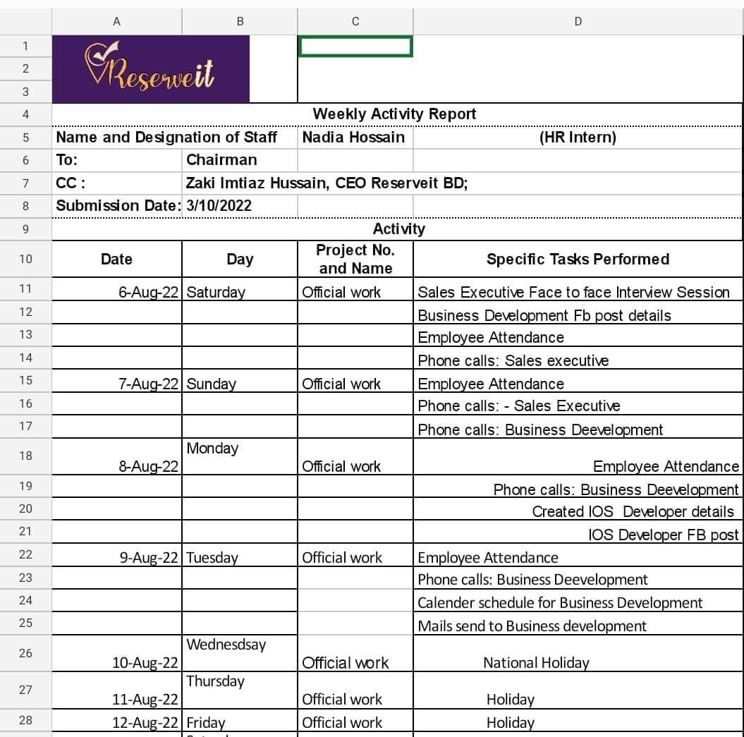

All the tasks I have performed in Reserveit BD as an HR intern have been recorded on a weekly basis and here is a sample of that.

Chapter 3

Analysis and Findings

3.1 SWOT Analysis:

3.1.1 Strengths:
A company's strengths are the most critical building blocks necessary for growth. The following are some of the most common Reserveit BD strengths right now.

Recruitment:
Their hiring and selection criteria are highly strict. Reserveit BD finds excellent people in the market by conducting thorough written and oral interviews.

Work environment:
During my stay, I found the work environment to be really pleasant. Everyone is kind, helpful, and cooperative. There is less internal friction or politics at work, which is necessary for a productive workplace.

Accuracy:
Reserveit BD maintains the accuracy of the job description and does not provide unnecessary work out of contract.

3.1.2.Weaknesses:
Though Alliance Reserveit BD is a company that has many strengths it also has some weaknesses. The followings are a few of the most common weaknesses that Alliance Capital has at the present time.
Lack of expertise:
To run the operations effectively, Reserveit BD has to recruit specialists. The objectives cannot be met with just 12 people, hence additional staff is needed.

Human Resource Planning:
Except for an annual need assessment for necessary workforces, there is little Human Resource Planning at the Organization.

Lengthy recruitment process:
Reserveit BD follows a lengthy and time-consuming recruitment process while hiring employees.

3.1.3.Opportunities:
Opportunities are good external environmental elements in a company. An organization should investigate all available opportunities. These chances are meant to help the organization. The firm should be able to become more competitive in the market by making changes. The following are potential possibilities for Reserveit BD to become more active.
Recruitment:
The majority of recruiting occurs internally; but, they can broaden the pool of entry-level candidates through campus recruitment.
Awareness:
Since Reserveit BD is an app-based platform, it should use social media to raise awareness to get ideal candidates for recruitment and achieve the goal.

3.1.4 Threats:
An organization’s threats are negative external factors. An organization should explore all possible threats available to it. These threats are intended to diminish the organization. By making improvements and adequately monitoring the threats, the organization should be able to turn more competitive in the market. The following threats are available to Reserveit BD to threaten its existence.
Challenging: The reservation app may be challenging for the user to use, and booking or canceling may be difficult and costly.

External changes: Reservations may no longer be necessary as a consequence of external changes, which might lead to the closure of Reserveit BD.

3.2. Descriptive analysis with diagram/ charts
The study attempts to identify the “Employee satisfaction on recruitment and selection process of Reserveit BD ”. To conduct the study primary and secondary sources of data are used. Primary data are collected using a questionnaire. 18 Questions were prepared and 12 HR officials were selected as a respondent. Out of 12 respondents, 8 respondents were male and 4 respondents were female. Then made a table with the result.
A structured questionnaire on a 5-point scale was developed for the variables affecting the recruitment and selection process of Reserveit BD. A five-point scale ranging from 1 to 5 with 1 indicating strongly disagree and 5 indicating strongly agree was used in this regard
However, the table is not very informative so to come up with the conclusion some pie charts have been created.

Result and Discussion:
Statements no. | Particulars | Strongly disagree (1) |  | Disagree (2) |  | Neutral (3) |  | Agree (4) |  | Strongly Agree (5)
Statements no. | Particulars |  | % |  | % |  | % |  | % |  | %
1 | Reserveit BD maintains the accuracy of the job posting and job descriptions while recruiting. | 0 | 00 | 0 | 00 | 0 | 00 | 6 | 50 | 6 | 50
2 | Reserveit BD follows a lengthy and time-consuming recruitment process. | 1 | 8.3 | 2 | 16.7 | 6 | 50 | 1 | 8.3 | 2 | 16.7
3 | The candidates are equally treated while recruiting. | 0 | 0 | 0 | 0 | 0 | 0 | 4 | 33.3 | 8 | 66.67
4 | Reserveit BD is not biased towards any candidates during the recruitment and selection process. | 1 | 8.3 | 1 | 8.3 | 0 | 0 | 3 | 25 | 7 | 58.3
5 | Employees of Reserveit BD are satisfied with the recruitment and selection process. | 0 | 0 | 0 | 0 | 0 | 0 | 6 | 50 | 6 | 50
6 | Reserveit BD is looking for innovative ideas from candidates during the recruitment and selection process. | 0 | 0 | 0 | 0 | 3 | 25 | 6 | 50 | 3 | 25
7 | Reserveit BD follows too many unnecessary stages in the recruitment process. | 4 | 33.3 | 7 | 58.3 | 0 | 0 | 0 | 0 | 1 | 8.3
8 | Reserveit BD provides unnecessary work assignments during the recruitment and selection process. | 4 | 33.3 | 7 | 58.3 | 1 | 8.3 | 0 | 0 | 0 | 0
9 | The working responsibilities of Reserveit BD match exactly the way explained during the recruitment and selection process to employees. | 0 | 0 | 1 | 8.3 | 0 | 0 | 8 | 66.7 | 3 | 25
10 | Reserveit BD encourages the interaction of candidates on a formal level during the recruitment and selection procedure. | 0 | 0 | 0 | 0 | 3 | 25 | 8 | 66.7 | 1 | 8.3
11 | Recruitment and selection procedure of Reserveit BD is quite rigid in terms of the eligibility area of employees. | 1 | 8.3 | 2 | 16.7 | 5 | 41.7 | 3 | 25 | 1 | 8.3
12 | Reserveit BD encourages internal sources during the recruitment and selection process. | 0 | 0 | 1 | 8.3 | 7 | 58.3 | 3 | 25 | 1 | 8.3
13 | Reserveit BD follows the recruitment and selection procedure fairly toward all employees. | 0 | 0 | 0 | 0 | 1 | 8.3 | 4 | 33.3 | 7 | 58.3
14 | Reserveit BD prioritized working experience rather than education during the recruitment and selection process. | 0 | 0.0 | 0 | 0 | 4 | 33.3 | 3 | 25 | 5 | 41.7
15 | Reserveit BD maintains a standard procedure for the recruitment and selection of employees. | 0 | 0 | 0 | 1 | 0 | 8.3 | 5 | 41.7 | 6 | 50

Employee satisfaction on recruitment and selection process

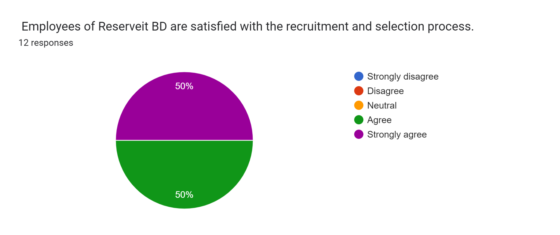

According to the survey the piechart shows 50% strongly agree and 50% agree. No one strongly disagree or disagree or has a neutral point of view.

Lengthy recruitment process
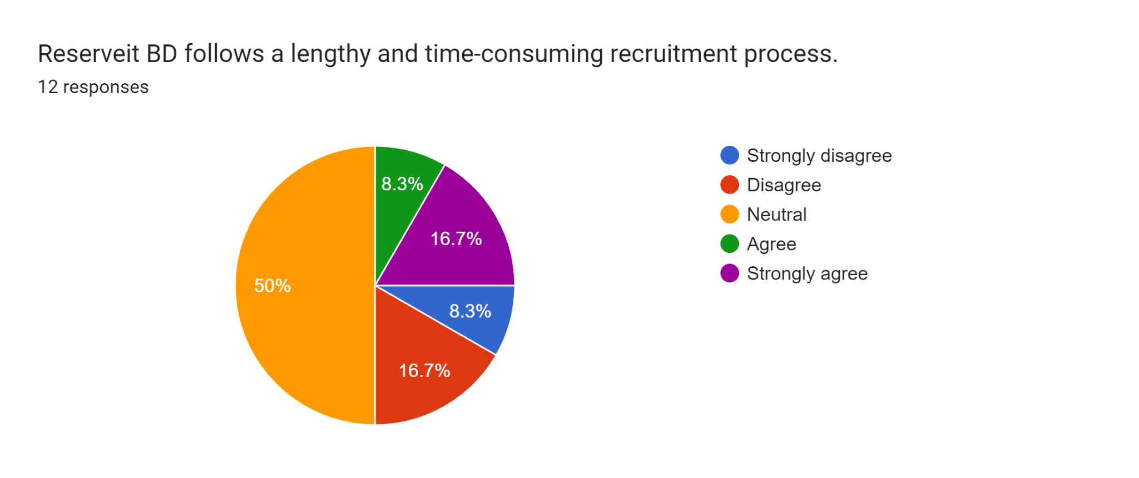
According to the survey the piechart shows 16.7% strongly agree and 8.3% agree, 50% is neutral, 8.3% strongly disagree and 16.7% disagree.

Accuracy of job description
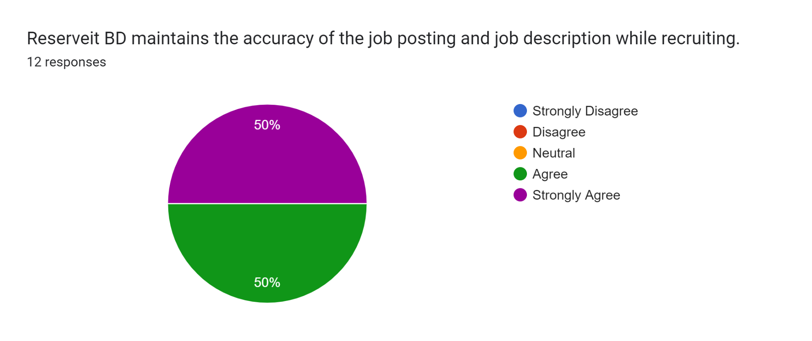

According to the survey the piechart shows 50% strongly agree and 50% agree. No one strongly disagree or disagree or has a neutral point of view.

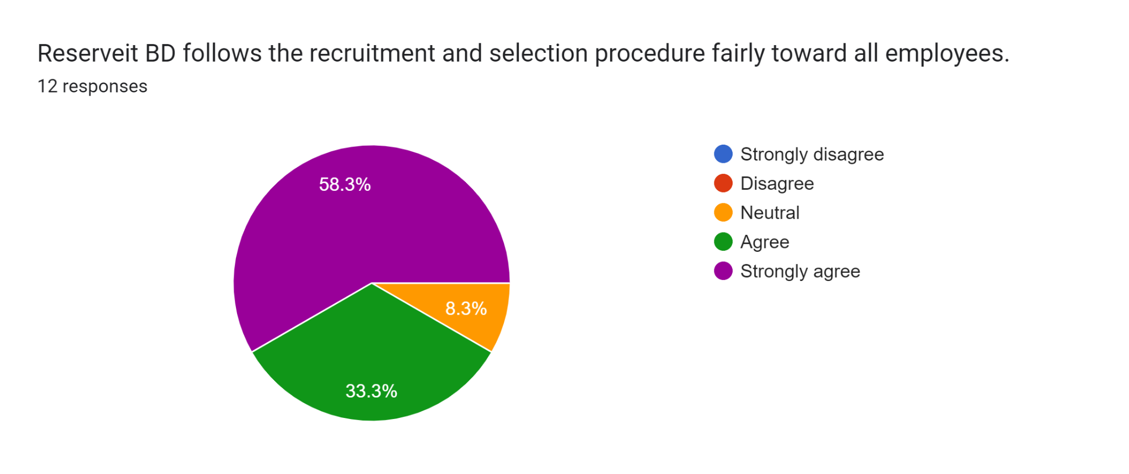
Reserveit BD follows the fair recruitment method.
According to the survey the piechart shows 58.3% strongly agree and 33.3% agree, 8.3% is neutral, no strongly disagree or disagree.

3.3. Findings of the study:
Employee satisfaction: Reserveit BD aims to keep employees happy by ensuring their happiness both throughout and after the recruitment and selection process. Reserveit BD ensures that staff members are inspired in a variety of ways and have access to advisors at all times.
Maintaining accuracy: Since employees are treated fairly and equitably both before and after the recruitment and selection process, employee exploitation doesn't happen at Reserveit BD. After hiring, Reserveit Bd continued to be accurate and stayed within the bounds of the employees' contracts.
Recruitment strategy: Reserveit BD is renowned for its recruiting strategy, which is a systematic method they use to find the ideal applicant for the position they are searching for. In order to find the finest candidates for the position that has to be filled, Reserveit BD has extremely strict hiring standards.
However, the survey has shown that Reserveit BD has a lengthy and time-consuming hiring procedure that needs to be improved. This needs to be remembered. A strong candidate may not wait through such a drawn-out procedure and could choose a better opportunity elsewhere, and there's also a chance of harming one's reputation. As a consequence, Reserveit BD should give time management top priority while hiring new employees and choosing existing employees.

Chapter 4

Recommendation & Conclusion

Recommendations:
The Reserveit BD should adhere to the proper protocols. The purpose of human resource management is to boost employees' contributions to the economy. In order to recruit productive and effective personnel, Reserveit BD needs put up appropriate training and development programs. The recruiting process should be well explained to the whole HR team. Since Reserveit BD hasn't grown, competence and their direction are required. This will enable Reserveit BD to accomplish its objectives with a team of eager and content workers.

4. Conclusion
The aforementioned rationale could lead one to believe that because time management and human resource management are ongoing problems, they have a big impact on Reserveit BD's overall performance. If Reserveit BD wishes to take full benefit of HRM, it must adhere to all HRM principles. Only a few workers are hired since the company is tiny and needs them to operate and function. There must be employees, and they must be handled professionally. The aim of recruitment and selecting should be to uphold all stages and standards while concentrating on employee satisfaction. It will eventually grow, however, and there may not be enough HR staff to run the business. Since loyal and trustworthy workers are the most important qualities for becoming an employer of choice, it should come as no surprise that businesses and organizations struggle to establish active and engaged workforces. These personnel must be capable, happy, and prepared to work in order to increase Reserveit BD's success. However, a sizable body of research indicates that increased employee loyalty and confidence in the leadership may benefit Reserveit BD's financial position. In fact, Reserveit BD's full potential cannot be achieved unless all individuals and teams are completely motivated, engaged, and productive in attaining Reserveit BD's goals. Many individuals in Bangladesh will find it challenging to adopt the restaurant reservations industry since it is so new to them. Therefore, the goal of any business should be to increase employee motivation to stay with the organization and to keep the goods in a presentable and alluring way for customers.
It was a great pleasure to work with Reserveit BD. My possibilities to develop and better understand myself as a worker have been many thanks to the welcoming staff and the environment they have established for trainees and interns. This encounter helped me see my strengths and areas for development. It helped me become more certain in my professional approach, helped me become more optimistic, and showed me how to collaborate with others. The main goals of an internship are to apply academic knowledge in the real world and get practical work experience. I appreciate the incredible support from the whole Reserveit BD HRD team for making my time at work so fulfilling. Particularly working in this field enabled me to recognize my human resources knowledge and expertise.
As a result, Reserveit BD's organizational success may be ascribed to both its effective performance assessment procedures and its outstanding recruiting and selection methods. The employment and selection procedure must still be fair and open, however, according to Reserveit BD's management. There should be measures in place to ensure that all recruitment and selection practices adhere to the Reserveit BD's standards and policies. This is because effective recruitment and selection practices will ensure positive financial returns for the company, either by ensuring employee effectiveness or by minimizing costs associated with employee training and retraining.

Reference:
https://reserveitbd.com/
https://www.researchgate.net/publication/352837739_A_Study_of_the_Impact_of_Recruitment_on_Employee_Satisfaction_at_Satpalda_Geospatial_Ghaziabad
https://www.irjmets.com/uploadedfiles/paper/volume_3/issue_12_december_2021/17750/final/fin_irjmets1639815160.pdf
http://horizonti.ekfak.kg.ac.rs/sites/default/files/Casopis/2018_2/EH_2018_2_en_Slavkovic_Pavlovic_Simic.pdf

Meetings
Surveys
Field research on Reserveit BD
Appendix: Weekly activity sheet

