INTERNSHIP REPORT



National Bank Limited



UNITED INTERNATIONAL UNIVRSITY

Internship Report
On
“General Banking Practices of
National Bank Limited”

Submitted to :
Mr. Mosabbir Uddin Ahmad
Assistant Professor

Submitted by:
Md. Kamrul Hasan Shimul
ID - 111 153 151

Date: 12.12.2020

12 December, 2020

Mr. MosabbirUddin Ahmad
Assistant Professor, School of Business
United International University.

Subject: Submission of the Internship Report

Dear Sir,

It is my pleasure to present this Report on General Banking Practices of National Bank
Limited as a requirement for completing my Bachelor of Business Administration. I enjoyed
preparing the report though it was challenging to finish within the given time. In preparing this
report, I have tried my level best to include all the relevant information related to general
banking activities of National Bank Limited.

I have a strong belief that the report will fulfill your expectation and I have tried to give my best
effort so that I can prepare a solid report as per your instruction. I would be very grateful if you
accept my report. Your kind consideration and cooperation will be highly appreciated.
Sincerely yours,

___________________

Md. Kamrul Hasan Shimul
ID: 111 153 151
BBA Department
United International University

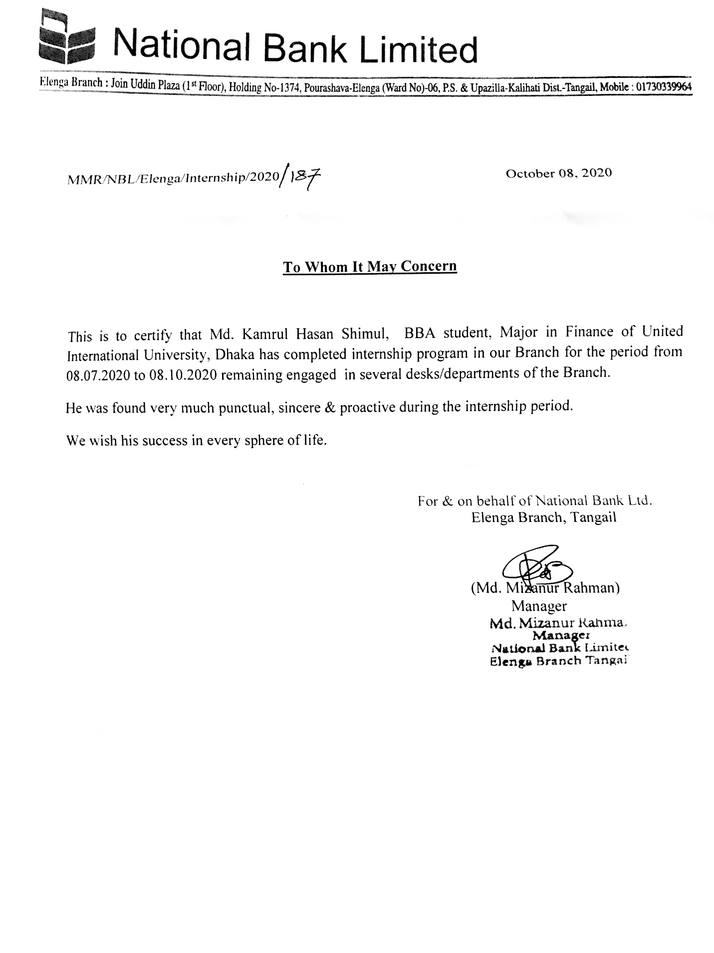
Student’s Declaration

I am Md. Kamrul Hasan Shimul, hereby announcing that I have completed my internship in General Banking at National Bank Limited for the last three months. I am convinced that this report is for academic purposes only and has no other purpose.

…………………………….
Md. Kamrul Hasan Shimul
ID: 111 153 151
BBA Department
United International University

Supervisor’s Certificate

It is my pleasure to certify that, Md.Kamrul Hasan Shimul a student of Bachelor of Business Administration (BBA), United International University, has been completed the Internship Program at National Bank Limited on ‘‘General Banking Practices of National Bank Limited’’ Successfully with acceptable performance under my supervision from July 2020 to October, 2020.

I wish him success in his life.

-------------------------------
Mr. MosabbirUddin Ahmad
Assistant Professor, School of Business
United International University.

ACKNOWLEDGEMENT

From the start, all gestures of recognition has a place with the strong Allah, the most lenient, generally every life is an animal and Allah has a generous attitiude towards their actions. In setting up this report of National Bank Limited, I have gotten exemplary help from all the representatives of National Bank Limited, Elenga Branch.

I am a lot of thankful to my authoritative director Md. Mizanur Rahman, Senior Executive Officer and Manager, National Bank Limited to offer the chance to take a shot at the Elenga branch. He has given me all thoughtful authority backing to finish the report consummately. I like to express gratitude toward Aba Khaled, First Executive Officer and Abdul Hie Miah, Executive Officer and 2nd Man, National Bank Limited for helping me in each viewpoint for the completion of the report.

I am a lot of obliged to my supervisor Mr. Mosabbir Uddin Ahmad, Assistant Professor, United International University for provide me guidance at various occasions to set up this report. It is his guided management that brought about successful finishing and opportune accommodation of the report.

EXECUTIVE SUMMARY

In recent years, Banks have moved out of the additional administration by creating new subsidiaries and merging with different types of financial institutions to give a different look to their administration. National Bank was established as a financial institution and is not different from the above. At present this bank provides various types of services. As a bank collects cash from an individual and lends that cash to a party or a business to make a profit, National Bank is also doing the same.

Three main activitiess such as Cash, Clearing and Transfer are done in the General Banking Division of National Bank. The main purpose of this report is to provide information on the general banking system of National Bank Limited. A lot of important information from the General Banking Department was coming forward when I was preparing this report.

I have discussed every activity of General Banking of National Bank and have given more importance to what is happening now as well as the experiences of the employees. The help of some theoretical knowledge has been taken into consideration. In this report I have found some findings in the analysis score on various topics and also made some recommendations

TABLE OF CONTENTS
Contents |  |  |  |  | Page  Number
Cover page |  |  |  |  | 2
Letter of Transmittal |  |  |  |  | 3
Internship Certificate |  |  |  |  | 4
Student Declaration |  |  |  |  | 5
Supervisor Declaration |  |  |  |  | 6
Acknowledgement |  |  |  |  | 7
Executive Summary |  |  |  |  | 8
Table of Contents |  |  |  |  | 9-11
Chapter 1 |  |  |  | Introduction | 12
1.1 |  |  |  | Background of the study | 13
1.2 |  |  |  | Objectives of the study | 14
 |  |  | 1.2.1 | General Objective | 14
 |  |  | 1.2.2 | Board of objective | 14
 |  |  | 1.2.3 | Specific Objective | 14
1.3 |  |  |  | Company Profile | 15 – 16
 |  | 1.3.1 |  | Brief profile of National Bank Limited (NBL). | 17
 |  | 1.3.2 |  | Mission and Vision | 17 – 18
 |  | 1.3.3 |  | Slogan | 18
 |  | 1.3.4 |  | Banking department of National Bank Limited | 18
 |  | 1.3.5 |  | Structure of National Bank Limited | 19
 |  | 1.3.6 |  | Organ-gram of the National Bank Limited | 20
Chapter 2 |  |  |  | Description of the Topic | 21
2.1 |  |  |  | Internship Topic | 22
2.2 |  |  |  | Topic Related Theory | 22
 | 2.2.1 |  |  | Account Opening Department | 23
 | 2.2.2 |  |  | Types of Deposit | 24
 | 2.2.3 |  |  | Account Opening Procedure | 24 – 25
Chapter 3 |  |  |  | General Banking | 26
3.1 |  |  |  | Overview of General Banking | 27
 | 3.1.1 |  |  | Account Opening | 28
 | 3.1.2 |  |  | Account Closing | 28
3.2 |  |  |  | Products | 29
 | 3.2.1 |  |  | Deposit Department | 29 – 41
 | 3.2.2 |  |  | Credit Products | 41 – 48
3.3 |  |  |  | Interest Rates | 49 – 50
3.4 |  |  |  | Study Framework | 51
Chapter 4 |  |  |  | Cash Department | 52
4.1 |  |  |  | Cash Section | 53
 | 4.1.1 |  |  | Cash Receive Section | 54
 | 4.1.2 |  |  | Cash Payment Section | 55
4.2 |  |  |  | Online Charge | 56
4.3 |  |  |  | Remitance Function | 57
 | 4.3.1 |  |  | Domestic Remittance | 57
 | 4.3.2 |  |  | International Remittance | 57
4.4 |  |  |  | Vault Cash Function | 58
Chapter 5 |  |  |  | Advance Department | 59
5.1 |  |  |  | Anti Money Laundering and Combating | 60
5.2 |  |  |  | Clearing Section | 61 – 63
5.3 |  |  |  | Pay Order | 63 – 64
5.4 |  |  |  | RTGS/BEFTN | 65 – 66
Chapter 6 |  |  |  | Other Important Facts | 67
6.1 |  |  |  | Dispatch Section | 68
6.2 |  |  |  | Maintaining Files | 69
6.3 |  |  |  | Audit Report | 70 – 71
6.4 |  |  |  | Deceased Rules | 72
6.5 |  |  |  | Lost Instruments | 73
Chapter 7 |  |  |  | Research and Analysis | 74
7.1 |  |  |  | Data Processing Methods | 75
7.2 |  |  |  | Analysis of Secondary Data | 76
 |  |  |  | Line Chart : Savings Account | 76
 |  |  |  | Line Chart : Current Deposit Account | 77
 |  |  |  | Line Chart : Monthly Savings Scheme | 77
 |  |  |  | Line Chart : Millionaire Deposit Scheme | 77
 |  |  |  | Line Chart : Fixed Deposit Receipt | 78
 |  |  |  | Line Chart : Century Deposit Scheme | 78
 |  |  |  | Line Chart : Sonar Bangla Amanot Scheme | 79
7.3 |  |  |  | Analysis of Primary Data | 80
 | 7.3.1 |  |  | Pie Chart: Profession of the Customer | 80
 | 7.3.2 |  |  | Pie Chart: Age of the customers | 81
 | 7.3.3 |  |  | Pie Chart: Overall Customers are Satisfied | 81
Chapter 8 |  |  |  | SWOT & Online Platform | 82
 |  |  |  | SWOT Analysis of NBL | 83 – 84
 |  |  |  | General Banking Using Online Platform | 85
Chapter 9 |  |  |  | Conclusion and Recommendation | 86
 |  |  |  | Experience | 87
 |  |  |  | Findings and Recomendation | 88
 |  |  |  | Conclusion | 89
 |  |  |  | References | 90

Chapter: 1
Introduction

Chapter Include

- Background of the study
- Objectives of the study
                - General Objective
                - Board of objective
                - Specific Objective
- Company Profile

Chapter 1 : Introduction

1.1 Background of the study

This report is part of the United International University BBA program. This is a three month report of a temporary job. I had the opportunity to work at National Bank Limited, one of the most reputed financial banks in the country. I have participated in various activities of General Banking of Elenga Branch of National Branch Ltd. And have learned those tasks well from attending. I have been involved in various activities in the financial departments and have had the opportunity to prepare to work in all departments of the bank.
The report is based on an in-depth look at various financial practices of National Bank Ltd. National Bank has all the financial practices like deposit products , credit products etc. They provides many more types of services.

This report is based on three months of experience but the biggest obstacle is the confidentiality of information. Many information banks do not disclose their information to protect their privacy and as an internship worker i am forced to keep that information confidential. The report analyzes the data of the last five years and the results are out.

1.2 Objectives of the Report

1.2.1 General Objective
The overall goals of this report are to get acquinted with the workspaces of current financial institutions and to match the work experience of a particular organization with information obtained from the BBA program.

1.2.2 Broad of Objective
- To depict the methodology of account opening, check book issue and account closing of NBL.
- To depict settlement, clearing and money office exercises of the bank.
- To recognize imperatives and difficulties looked by general banking division of NBL.

1.2.3 Specific Objectives

To accomplish the primary goal of this report, it covers the accompanying:

- To forecast the future store of the National Bank Limited.

- To analyze consumer loyalty of the National Bank restricted.

- To analyze the segment attributes of the overall banking of NBL.

- To analyze the General Banking exercises.

- To check whether any affiliation exist between Customers Satisfaction with Account types, sex, age gathering, salary level, and profession.

- To analyze the pattern of various sorts of account.

1.3 Company Profile

The rich past glory of National Bank Ltd. includes present potential future and processing projects and activities. Established as the first private sector bank fully owned by Bangladeshi entrepreneurs, NBL Bank has grown and continues to grow as the largest private sector bank over time despite many pressures. The members of the board of directors are very creative businessmen and top industrialists of the country. Participating in economic activities nationally and internationally to keep pace with the times. NBL is conducting operations as a multiple organization by bringing them into the computer network from each of its branches . Considering the future of NBL the bank’s infrastructure has been greatly improved in the past.
Entrepreneurs from all walks of life and the general public have high expectations of the NBL. It currently has 209 branches. We are also in the process of securing new customers by expading our effective and diversified approach to seize market opportunities through the development of rural SME financing and offshore banking facilities.
The rise of National Bank Limited in the private sector was an important event in the drawing of banking in Bangladesh. When the nation was in the throes of a severe recession, the government took a far-sighted decision to allow the private sector to recover in the country's economy. Several dynamic entrepreneurs came forward to set up a bank to revive the country's economy.
National Bank Limited was born as the first hundred percent Bangladeshi owned Bank in the private sector. From the very beginning it has been playing an important role in the national economy. NBL is determined to bring back the long forgotten taste of banking services. That is why we are determined to serve everyone immediately and with dignity.
At present NBR has 209 branches and agriculture branches spread across the country. From the very beginning, the Bank has placed great emphasis on foreign activities and handles a huge amount of foreign remittances. It has arranged for 415 correspondents in many countries of the world as well as 37 foreign exchange agencies in 13 countries. To facilitate, the first domestic bank means that expatriates can send their hard-earned money back to the country with a lot of confidence protection and can send to the country.
National Bank has now acquired the strength and expertise to support the banking needs of foreign investors.

Since its inception the bank was aware of its commitment to corporate social responsibility. In this regard, we are involved in the development of the education and health system and have sponsored activities and cultural activities establishes.

There is a strong team of highly skilled and experienced professionals together with the Board of Directors to formulate and implement the policy effectively.

1.3.1 Brief profile of National Bank Limited (NBL).

Name of the Company | National Bank Limited (NBL)
Chairman | Mr. Zainul Haque Sikder
Managing Director | Mr.Chowdhury Moshtaq Ahmed
Established | March 23, 1983
Legal Status | Commercial Bank
Services | Retail Banking Corporate Banking Deposits, Credits and  ATM Services.
Corporate Address | 18 Dilkusha Commercial Area, Dhaka 1000, Bangladesh
Telephone | +880 2 9563081, 9666584
E-mail | ho@nblbd.com
Website | www.nblbd.com
SWIFT Code | NBLBBDDH

1.3.2 Mission and Vision of National Bank Limited

National Bank's Mission:
We continue to expand our operations at home and abroad by adding new dimensions to our banking services, ensuring transparency, accountability, improved client service as well as our commitment to serve the community through which we reach out to people at all levels nationally and internationally. We want to achieve our goal of gaining a lasting seat in the hearts of the people as an immediate partner in improving national economic standards by constantly updating and diversifying our client services in line with the requirements

National Bank's Visions:
Ensuring the highest quality customer service through the best application of the latest information technology is our cherished vision to make a proper contribution to the national economy and establish ourselves firmly at home and abroad as the leading bank in the country.

1.3.3 SLOGAN:

A Bank for performance with potential.

1.3.4 Banking Department of National Bank Limited

- Account opening Department
- Clearing Department
- Remittance Department
- Deposit DepartmentCash Department
- Accounts Department
- Loan & Advance Department

1.3.5 Physical Structure of National Bank Limited, Elenga Branch

1.3.6 Organ-gram of National Bank Limited:

1.3.6 Organ-gram of the Bank

CHAPTER - 2
Description of the Topic

- Internship Topic

- Topic Related Theory
- Account Opening Department
- Types of Deposit
- Account Opening Procedure

Chapter 2 : Description Of The Topic

2.1 Internship Topic

General Banking: Generally, all the practices of a bank are called general banking.
Banking is a combination of financial administration such as store collection from individuals, check collection, prize advance, to protect money for its clients. I am working in NBL Bank but I am working in some departments of general banking. The NBL is under associate divisions

2.2 Topic Related Theory

General Banking is the starting point of all banking operations. It is the department, which
provides day-to-day services to the customers.

General banking section is divided with four areas. These are:

Client Services:

Involuntary areas in the branch are given to the organization which is the customer's complete plan. If any information the customer needs to know the person may come to the funeral or the bank it is considered a matter of security not all the information is given. What should be taken when the checkbook and story can be taken Premium rate conditions, how the money can be traded in another bank etc. This national agency provided for the customer needs to be extended beyond the regular plan of the people as reasonable. NBL should be considered as important as it may be fair that they will provide companies to the customer without holding the position of different banks and the wider companies will go further with a smiling face and perform well what they need.
Sooner or later the workplaces (things) for the customers have come to the new course and the obligation has been instructed. To further benefit the customers, they are sometimes asked what their interest is to the bank about it. If possible the executive tries to integrate with the customer convenience so the data provider needs to be constantly strong and dynamic just to deliver under the wire.

2.2.1 Account Opening Department:

Account opening is the portal for clients to start a new business with bank. it is the foundation of banker and customer relationship. This is one of the most important sector of a branch, considering the way that by opening bank accounts for speculation. A customer can open different sorts of accounts through this office, for example,

- Current accounts (CD)
- Savings account (SB)
- Short term deposit account (STD)
- Fixed deposit account (FDR)
- Monthly saving scheme (NMS/DPS)
- Shadhinota: A Bi-Monthly Income Scheme (SBIS)
- Monthly Earning Scheme (MES)
- Millionaire Deposit Scheme (MDS)
- Sonar Bangla Amanot
- Century Deposit scheme

2.2.2 Types of Deposit:

Demand Deposit | Time Deposits
Current Deposit ( CD ) | Fixed Deposit Recipt (FDR)
Savings Account (SB) | Monthly saving scheme (NMS/DPS)
Short Term Deposit (STD) | Shadhinota: A Bi-Monthly Income Scheme (SBIS)
Demand Draft ( DD ) | Millionaire Deposit Scheme (MDS)
Pay Order ( P.O. ) | Monthly Earning Scheme (MES)
 | Mill Century Deposit Scheme
 | Sonar Bangla Amanot

2.2.3 Account Opening Procedure:

Step 1

The Account should be introduced by one of the following:

- Need an existing current account holder of the bank for opening some demand deposit account.
- Authorities of the bank not below the position of an associate Officer
- A good individual of the locality notable to the manager

Step:2

Accepting filled up application in bank's endorsed structure referencing what types of accounts is wanted to be opened.

Step:3

- The form is filled up by the candidate himself/herself for some important information.
- Two copies of passport size photos from individual are taken.
- One copy of nominee’s photo.
- In the event of firm, photo of all partners are taken.
- Clients submit required documents.
- For CD accounts holder must submit the trade licence form and seal.

Step:4
Authorized officer accepts the application. Then officer input the information in the system and make a liquidation account for deposit that money. He or she also create base accounts for requied accounts. Officer scan those submitted signature and upload into the system.
When creating a savings account (SB A/C) or a current account (CD A/C) the officer must determine the estimated number of transation and the amount of transaction from the base on types of customer.

Step:5
Minimum Balance is must be deposited. For example- Savings account 1000 taka and Current account is opened by 5000 taka. The time deposit account holder has to deposite money as per the wish of the customer at the cash counter. Then the cash officer will authorize the customer’s deposited money and the deposited money will be credited to the customer’s account.

Step:6
Account is opened and a pay in slip book is given. For Savings account or Current account holder receiving a cheque book after some working days.

CHAPTER 3
GENERAL BANKING

Overview of General Banking:

- Account opening
- Account Closing
- Deposit Department
- Credit Products
- Interest Rates
- Study Framework

Chapter 3: General Banking

3.1 Overview of General Banking:

General banking is about a combination of specific departments and effective activities in banking activities. Basically it shows how the department collects money from one client and provides it for the following clients and works for such undeniable goals and additional targets. Relentlessly they try to meet their goal which the top organization has given the truth to achieve the general goal of communicating the bank through their branches. Each area of ​​the branch should not be led in any wrong direction in relation to the other. So it’s not the pain of the brain just the piece that has something wrong, it has to pass through every part. Additionally, all regions are set up to help each other play their activities. The department tries to get interested in why customers will come to their bank and what could be the main center behind it.

People are getting interested in bank stores to get the adjustment and protection of money scheduling and get their money back considering the needs and requirements by issuing checks. Security and involuntary organizations are expected to be key components in attracting customers to become basic materials. In all honesty, there is no association except for trade-related activities with representatives and customers.
Additionally, it tries to give the customer the best and fancy opportunity through better organization rather than constantly holding different banks.

3.1.1. Account opening:

Continuous trading must be initiated in the National Bank registry to which the account is open. Abdul Hai Mia (Executive Officer) By continuously opening an account for this type of organization, one is considered as one's own and strong client to consequently it is necessary to retain this customer for a long time in order to give irresistible organizations.
To open a record some organization should take clients who then put information about them. They have assisted the record structure in the vault with a special name to open records in the National Bank. Usually the account holder's name, father's name, mother's name, date of birth, citizenship, religion, current and intermediate territories, and the structure to fill the impression are the first significant to open a record. Speaker's supported should be compulsory and filling competitor's information like A/C holder in the structure. After this task the person in question will be given a copy of voter ID card/significant global ID/Nationality Certificate and three copies photographs (two for A/C holder and another for picked one). By then official will check it and give an A/C no. likewise store book to store money in the A/C no. By then the different official data sources data into Software. By then he prints thanks letter for speaker and A/C holder and sends these letters in independent area to checking areas of speaker and A/C holder. In the wake of confirming A/C holder's location the official issues check books to withdraw cash.

3.1.3 Account Closing:

For two reasons account can be closed. One is speculator and other is by the customer.

- By Financier: If a customer has not made any transaction in the last six years or if his account does not have minimum required balance.

- By Client: If a customer wants to close the account, he needs to apply to the officer to close the account.

Nevertheless, before long, normally the customers don't close A/C eagerly. Every so often, customers don't keep up any trade for long time. Is this situation at regardless, the A/C gets the chance to be dormant and in the long run it is closed by the bank.

3.2 Products

Different types of products are available in National Bank. Such as

- Deposit Product
- Credit Products

3.2.1 Deposit Department

The National Bank Deposit Department offers various types of deposit products to the customers :

Deposit Products:

- Savings Deposit
- Current Deposit

Time Deposit:
- Short term deposit account(STD)
- Fixed deposit account (FDR)
- Monthly saving scheme (NMS/DPS)
- Shadhinota: A Bi-Monthly Income Scheme (SBIS)
- Monthly Earning Scheme (MES)
- Millionaire Deposit Scheme (MDS)
- Sonar Bangla Amanot
- Century Deposit scheme

- Deposit Schemes:

Savings deposit: National Bank offers its clients various accounts through hassle free and low price charges. There are some limitations for withdrawing savings deposit account money on monthly basis. Additional withdrawals require prior notice or notification to the bank . It pays very little interest as this account is mainly used for regular transaction.

Benefits (Condition Apply) | Account Opening
- Interest rate is 2.50 %  - Minimum balance 1000 tk.  - Yearly maintenance charge 400 tk.  - No hidden costs.  - Received massages from the bank when the money will be deposited or withdrawn. | - 2 copies of recent photograph of account holder  - Nominee's 1 copy photo  - Need valid two photocopy of Voter ID Card to account holder’s and nominee’s.  - Signature of A/C holder in backside of both photographs including nominee’s photo

- Current Deposit:

National Bank Limited offers customers current deposit account.

For Sole Proprietorship | For Partnership
- Photoghraph  - Votar Id Card.  - Signature  - Proprietorship seal .  - Fill all of the requirements of the form.  - Two Photograph for a/c holder one of verified by introducer  - One Trade License copy.  - TIN Certificate.  - Mobile Number | - Votar Id Card of all partners.  - Signature .  - Introducer and his/her seal with signature.  - Partnership Deed.  - Two Photograph for a/c holder one of verified by introducer  - Accomplices letter of capacity to open account and endorsement for activity.  - One Trade License copy.  - Mobile Numbers

- Term Deposit:

National Bank offers mainly two types of time deposits and they are :

- Special Notice Deposit ( SND )
- Fixed Deposit

Special Notice Deposit

National Bank Limited gives good loan cost on customer's unique notification deposit and offers account to withdraw money at whatever point.

Advantages

- Minimum requirement Tk.5000 .
- There are permanent instructions for a valid account.

- Fixed Deposit:

National Bank Limited provides fixed term subsidy which will replenish the customer's reserve fund full time.
Account opening procedure :

- Collecting every needed information of A/C holder.
- Nominee must give a photo and doing sign back side.
- One photocopy of NID and 2 passport size photo for account holder .
- Tin certificate for less deduct taxation. (Not Mandetory)

Advantages:

- Any whole of cash can be spared
- Currently FDR rate is 6.00%
- Premature Encashment Account is open.
- Open an overdraft account as opposed to receiving the condition
- Bank provide a security as a cheque.

- Foreign currency deposit:

Foreign exchange deposits are classified into two categories and are as follows:

- RFC Deposit.
- NFC Deposit.

RESIDENT FOREIGN CURRENCY (RFC) DEPOSIT

National Bank Limited provides facility to keep foreign currency money in accounts through their authorized branches abroad.

Advantages

- No underlying deposit is required to open the account.
- Premium will be paid.
- They will keep in mind the minimum balance (minimum parity USD $ 1000) depending on the item each day.

Non-Resident Foreign Currency (NFC) Deposit

National Bank Limited offers the opportunity to keep unfamiliar cash savings through authorized dealer branches. All non-occupying Bangladeshi citizens and people of Bangladesh, including ethnic groups and those generally living abroad, can retain the power to carry NFCD accounts.

Advantages

- NFCD accounts can be opened for 1 month, 3 months, one and a half years and one year through USD, Pound Sterling, Japanese Yen and Euro.
- The minimum measure at the beginning is ling 1000 or 500 pounds sterling or other prescribed cash in proportion.
- Interest is paid to keep the balance in the account. This conspiracy is tax exempt in Bangladesh.

- Monthly Savings Account ( NMS/DPS):

National Bank Limited offers monthly financial plans for its customer.

Advantages

- The regular planned installments of the deposit will be Rs.500 / -, Rs.1,000 / -, Rs.2,000 / -, Rs.3,000, Rs.5,00,000 / - and Rs.10,000,000 and more ....
- Can open account of any part and position.
- An individual can open more than one account in the same branch
- Need not any SB accounts.

The Revised Payment Schedule as per Revised Rate of Interest of NBL Monthly Savings Scheme:

SL# | Monthly  Installments  (BDT) | Amount to be paid on completion of Term
SL# | Monthly  Installments  (BDT) | 03(Three)years@8.00% | 05(Five)years@8.00% | 08(Eight)years@8.00%
01 | 500/- | 20,320/- | 37,720/- | 66,580/-
02 | 1,000/- | 40,640/- | 73,440/- | 1,33,170/-
03 | 2,000/- | 81,280/- | 1,46,890/- | 2,66,340/-
04 | 3,000/- | 1,21,930/- | 2,20,340/- | 3,99,510/-
05 | 5,000/- | 2,03,220/- | 3,67,240/- | 6,65,850/-
06 | 10,000/- | 4,06,440/- | 7,34,490/- | 13,31,700/-
07 | 30,000/- | 12,19,340/- | 22,03,490/- | 39,95,110/-
08 | 50,000/- | 20,32,240/- | 36,72,490/- | 66,58,520/-

- Monthly Earning Scheme:

A customer can deposit a minimum of Tk. 100000 for a fixed period of time and will get 8.40% interest per month.

Advantages

- under this scheme and more than Tk. 10,00,000 / - can be satisfactory.
- The deposit can be opened individually or reciprocally.

The installment timetable of Monthly Earning Scheme of every single distinctive period i.e.; 1 Year, 3 Years and 5 Years will as follows:

Deposit Amount | Monthly Interest (Tk.) @ 8.10% P.A.^{(IV)} | Net Payable  After 10% Tax | Net Payable  After 15% Tax
100,000.00 | 675.00 | 607.50 | 573.75
500,000.00 | 3,375.00 | 3,037.50 | 2,868.75
1,000,000.00 | 6,750.00 | 6,075.00 | 5,737.50
1,500,000.00 | 10,125.00 | 9,112.50 | 8,606.25
2,000,000.00 | 13,500.00 | 12,150.00 | 11,475.00
3,000,000.00 | 20,250.00 | 18,225.00 | 17,212.50
5,000,000.00 | 33,750.00 | 30,375.00 | 28,687.50
10,000,000.00 | 67,500.00 | 60,750.00 | 57,375.00

- Double Benefit Account:

At present National Bank Limited allows its customers to double their profits in 9 years. This offer was earlier for six and a half years but now it has been extended to nine years.

The successful pace of Interest is 8.01% P.A (condition applied).

Advantages

- Deposit of Tk.1,00,000/ - and its numerous with no maximum cutoff will be worthy under this plan.
- Anyone who is a Bangladeshi citizen at the age of 18 or above can open an account.
- Minor resident of Bangladesh can likewise open this record. All things considered, his/her legitimate gatekeeper will work the A/C.
- An individual can open more than one account in the same branch
- Locker offices can be benefited at half lease for the primary year subject to the accessibility of storage office in the particular branch.

- Millionaire Income Scheme:

Under this scheme a person will deposit a certain amount for 4, 6, 9 or 12 years monthly for 4 months and in development he will be only 9 millionaire

Advantages (Condition Apply)

- Monthly deposit from the prescribed month for 4, 6, 9 or 12 years. Store size will be established in the residency. Contributor will get Tk. 10,00,000 / - after development.

- One person is allowed to open more than one MDS account.

- The record may be opened independently or mutually.

Monthly Installment (In Tk) | Investment Period | Terminal Value @ 8.00% (In Tk)  1,000,000.00
17,750.00 | 4 Years | Terminal Value @ 8.00% (In Tk)  1,000,000.00
10,900.00 | 6 Years | Terminal Value @ 8.00% (In Tk)  1,000,000.00
6,400.00 | 9 Years | Terminal Value @ 8.00% (In Tk)  1,000,000.00
4,220.00 | 12 Years | Terminal Value @ 8.00% (In Tk)  1,000,000.00

- Apon Thikana Shanchoy Prakalpa (ATSP):

Advantages :

- This account can be opened for 5, 8 and 10 years.
- The facility of taking loan of 80% on the money deposited is provided.
- Locker facility is provided which is a lucrative facility.

Years | Monthly Installment (Amount In Tk.) | Terminal Value (Amount In Tk.)
5 | 41,600 | 3,000,000
8 | 27,100 | 3,500,000
10 | 23,000 | 4,000,000

- Luxury Savings Deposit Scheme (LSDS):

Advantages :

- This account can be opened for 2, 3 , 4 and 5 years.

- The facility of taking loan of 80% on the money deposited is provided.
- Locker facilities can be profited at half lease for the primary year subject to the accessibility of storage office in the separate branch.

Tenure | Monthly Installment (Amount In Tk.) | Terminal Value (Amount In Tk.)
2 Years | 96,800 | 2,500,000
3 Years | 64,700 | 2,600,000
4 Years | 48,600 | 2,700,000
5 Years | 38,900 | 2,800,000

- Shadhinota: A Bi-Monthly Income Scheme:

Benefits : This deposit scheme is for 2 years.

1.The Beneficiary will get Tk. 675.00 as enthusiasm for each 2 (Two) Months against each Tk. 50,000.00 starting store. for example absolute 12 intrigue installments will be made in 2(Two) Years and the underlying store will be endless supply of the term.

2.Deposit can quickly be exchanged in FULL anytime of time. No punishment will be charged for early encashment.

3.The facility of taking loan of 80% on the money deposited is provided.
4.No charges are leived by the bank itself. The charges leived by the government are deducted from here.

Initial Deposit Amount (Tk.) | Bi-Monthly Interest Amount (Tk.)  @ 8.10% P.A.^{(IV)} | Net Payable after 10% TAX | Net Payable after 15% TAX
50,000.00 | 675.00 | 607.50 | 573.75
100,000.00 | 1,350.00 | 1,215.00 | 1,147.50
150,000.00 | 2,025.00 | 1,822.50 | 1,721.25
200,000.00 | 2,700.00 | 2,430.00 | 2,295.00
250,000.00 | 3,375.00 | 3,037.50 | 2,868.75
300,000.00 | 4,050.00 | 3,645.00 | 3,442.50
500,000.00 | 6,750.00 | 6,075.00 | 5,737.50
1,000,000.00 | 13,500.00 | 12,150.00 | 11,475.00
2,000,000.00 | 27,000.00 | 24,300.00 | 22,950.00
3,000,000.00 | 40,500.00 | 36,450.00 | 34,425.00
5,000,000.00 | 67,500.00 | 60,750.00 | 57,375.00
10,000,000.00 | 135,000.00 | 121,500.00 | 114,750.00

* Quoted amounts are characteristic. Account can be opened for any sum that is a numerous of Tk.50,000.00

- Century Deposit Scheme:

Benefits (Features):

- The time of the deposit will be 100 days.
- The reexamined financing cost will be 8.00% P.A. (condition applied) with impact from August 01, 2020.
- The beginning sum can be Tk. 50,000.00 or above.
- Interest computation is at genuine premise (for example 366/360).
- This item is auto renewable .
- Credit offices up to 80% of the kept sum will be permitted against lien on equalization of the account at the record at the overall pace of Interest of the Bank.
- Bank won't force any charge of its own. Just Government Charges will be deducted from the record.
- Link Account of this store can be kept up at any Branch of NBL.

- Sonar Bangla Amanot:

Benefits (Features):

- The time of the deposit will be 45 days.
- The amended loan fee will be 8.00% P.A. (condition applied).
- The beginning sum can be Tk. 50,000.00 or above.
- Interest estimation is at real premise (for example 366/360).
- Account opening time has been broadened. The record can be opened till 31-12-2020.
- This item is auto sustainable (Principal without intrigue/Principal with enthusiasm) inside the specified period.
- Credit offices up to 80% of the saved sum will be permitted against lien on equalization of the record at the record at the predominant pace of Interest of the Bank.
- Bank won't force any charge of its own. Just Government Charges will be deducted from the record.
- Link Account of this store can be kept up at any Branch of NBL.

3.2.2 Credit Products:

Credit products are categorized in the following:

- Overdraft
- Lease finance
- Home loan
- Small medium enterprise loan
- Consumer credit loan
- Trade finance
- Agriculture Finance.

- Overdraft:

NBL provides overdraft facilities for corporate clients for day-to-day business activities.

Advantages:

- Low charge for overdraft account support.
- Benefits are accessible against deposit receipts or home mortgage assets
- Interest rates range from 13% to 16%.

- Rent Financing:

National Bank Limited offers rental for customers with general part facility.

Financing Area

• Capital hardware.
• Different kinds of gear.
• Medical hardware.
• Lift or elevator.
• Information Technology hardware.
• Construction hardware.
• Consumer durables.

Advantages (Condition Apply)

- Competitive month to month rental.
- Tax advantage.
- Fast handling.
- Easy handover in the wake of renting period
- House Building:

Any Bangladeshi resident or NRB who is eligible for reimbursement can apply for this. Basic handover during the lease period.

Advantages (Condition Apply)

- The amount of financing reaches up to 70% or Tk. 75,00,000 which is the most significant for all development expenditure.Grace period accessible as long as 9 months in a level buy or a year in development.
- Competitive loan cost.
- No application or handling charge.

- Small medium Enterprise:

NBL offers financial sponsorship to little finance managers/attempt with new things named "Festivity Small Business Loan" and "NBL Small Business Loan" has been introduced in the Bank.

Advantages (CONDITION APPLY)

- Maximum 33.00 lakhs (festival planning) and maximum 500.00 lakhs (small business projects).
- 3 months (festival project) and 5 years (calculated over a charming period of several months (small business plan)).
- Collateral Free Advance

- Consumer Credit Scheme:

NBL provides shopping credit offices for retail clients

Financing Items

- Electronics buyer items.
- Computer or Computer parts.

Advantages

- Quick preparation.
- Competitive interest rates.
- There is no application or preparation charge.
- Easily schedule regular payments.

- Trade Finance:

The NBL separates the concerns of the entire business from cash companies, for example, to capitalize on the mechanical sector due to toll imports, advise and certify credit, trade account client, import L/C issuance, export L/C. - Bonds and guarantees.

Favorable circumstances

- Low interest rate 13.00% - 14.50%.
- At least take care of time.
- The organization charges less.

- Agriculture Finance:

Agriculture & Rural
Agriculture assumes a fundamental part in Bangladesh economy and the improvement of our nation essentially relies on the profitability of provincial territories. Understanding the significance of agrarian money in making independent work openings and financial improvement of the nation, National Bank Limited has been giving Agriculture and Rural credit facilities through its own branches the nation over since its commencement.

Features

- Credit for development of Crops and cultivating of fishery, poultry and animals and buying of agribusiness instruments and water system supplies.
- Credit for development of Pulse, Oil Seeds, Spices and Maize under Concessional pace of intrigue.
- Credit for solar based home framework, sun powered water system framework and Bio-gas plant under Refinance Scheme of Bangladesh Bank.

- Daridra Mukti:

National Bank Limited has been moving in the direction of change of fortune of the nation's mass individuals. The Bank has been expanding its assistance by method of financing at simple terms and conditions to the negligible, oppressed and low pay creating individuals and the individuals of territories of regular and man-made calamities.

Features:
- Target individuals: 'Daridra Mukti' is primarily expected to little business people and experts, bungalow and handiwork enterprises, and negligible and landless ranchers. These business visionaries, experts and ranchers can open their Bank Account by saving just Tk.10.00. Potter, metal forger, angler, tailors, bloom dealer, peddler, organic product vender, vegetable-merchant, cart puller/van puller, little and house ventures, weavers, bread kitchen thing makes, minimal financial specialists and ranchers of the under-advantaged territories, and political dissidents and their kids are qualified to appreciate this sans security and effectively accessible credit office.

- Interest rate: Low pace of enthusiasm on straightforward premise.
- Collateral security: No guarantee security.
- Loan limit: Maximum Tk.1.00 lac.

- CARDS:

Credit Card:

There are different types of cards in the NBL:

- Gold International
- Silver International
- Gold Local
- Silver Local
- Power Cards

MasterCard | VISA
Platinum DUAL | Platinum DUAL
Gold DUAL | Gold DUAL
Classic DUAL | Classic DUAL

Commonly required documents:

Commonly required documents:
  - 02 Copy P.P. Size Photograph of Applicant
  - Copy of NID
  - Copy of e-TIN Certificate
  - CIB Undertaking as per prescribed format
  - Updated Cheque*
  - Self PG (Personal Guarantee) as per prescribed format.
  - Spouse/Relative’s PG (Personal Guarantee) as per prescribed format.*
  - Copy of Guarantor’s NID
  - Copy P.P. Size Photograph of Guarantor
  - Utility Bills Copy (Titas/WASA etc.)
  - Any other required documents as per Banks & BB Policy.

Additional Papers based on Cardholder Profession:

Salaried Person:

- Office ID Photocopy
- Salary Certificate
- Bank Statement (Last 03 months)

Businessman:
- Copy of Trade License
- Bank Statement (Last six months)
- Income Statement & Balance Sheet
- Copy of Memorandum
- Corporate Guarantee (in case of Ltd. company)
- Board Resolution on ERQ Card with Lien Request

DEBIT CARD

National Bank Limited presented EMV Chip Visa Debit Card in 2016 to give every minute of every day Banking administrations to its cross country huge client base gave by ATM facilities specific branches underlining clients' interest and business significance.

Features:

- EMV Chip Based Visa Card, most cutting edge innovation for secure
- Empower for most made sure about Two Factor Authentication (2FA) on web based business exchanges through One-Time-Password.
- Can be utilized for all day, every day countrywide ATMs for whenever Cash Withdrawal at cross country ATMs bearing Visa, Q-money and NPSB Log0.
- Can be utilized for whenever buys/administrations at any vendor outlets, superstores, clinics, facilities, inn and eateries bearing Visa Logo POS Terminals.
- Ongoing SMS Transaction alert
- Least Card Fee and No Hidden Charges
- 24x7 Call Center for Customer Services
- Markdown/Privileges at various shipper outlets
- Simple to acquire once client opens a record with any of NBL Branches, we will give a Debit Card upon demand.

- No need of conveying money or a check book.

Fees:
Type of Fee | Classic | Platinum
Annual/Renewal Fee | Tk.400 | Tk. 400
Card Replacement/reissue Fee | Tk.300 | Tk. 300
PIN Reissuance Fee | Tk.200 | Tk. 300
SMS Notification Service Fee/year | Tk.200 | Tk. 200

  - Interest Rates:

SCHEDULE OF INTEREST RATE - % PER ANNUM (EFFECTIVE FROM 02-MAR-2020)

- DEPOSIT INTEREST RATE

Category Of Deposit | Slabs | Rate Of Interest (P.A.)
Savings | Any Amount | 2.50%
Special Notice Deposit | up to 25.00 crore | 2.50%
Special Notice Deposit | 25.00 crore & above | 3.50%
FDR for 1 Month | Any Amount | 6.00%
FDR for 3 Months
FDR for 3 Months | Any Amount | 6.00%
FDR for 6 Months
FDR for 6 Months | Any Amount | 6.00%
FDR for 1 Year | Any Amount | 6.00%
FDR for 2 Years | Any Amount | 6.00%

Name of the Deposit Scheme | Tenure | Effective Rate of Interest
NBL Monthly Savings Scheme (NMS) | for 3 Years / 5 Years / 8 Years / 10 Years | 8.00%
NBL Miilionaire Deposit Scheme (MDS) | for 4 Years / 6 Years / 9 Years / 12 Years | 8.00%
Monthly Earning Scheme (MES) | for 1 Year / 3 Years / 5 Years | 8.10%
Double Benefit Scheme (DBA) | Will be doubled in 9 Years
100 Days Deposit Scheme | for 100 Days | 8.00%
SHADHINOTA: A Bi-monthly Income Scheme | 2 Years | 8.10%
Sonar Bangla Amanot Scheme | for 45 Days | 8.00%

3.4 Study framework:

Findings & Recommendation

Data Analysis
Data analysis method
    ➢ Line chart
    ➢ Pie chart
    ➢ Bar chart

Perceptions of customers on general
baking
Primary data sources
➢ Face to face conversations
➢ Observation

Secondary data Sources
➢ MIS of NBL
➢ Published Documents
➢ Bank's annual Report 2019

Identifying overall customer satisfaction of National Bank limited
Ways to achieve Interview:
➢ Branch Manager
➢ Employee
➢ customers
Present status NBL general banking activities
➢ Account Opening Section
➢ Cash Section

Chapter- 4
Cash Department

Cash Section

- Cash Receive Section
- Cash Payment Section

Online Charge

Remitance Function

- Domestic Remittance
- International Remittance

Chapter 4 : Cash Department

4.1 Cash Section:

NBL features a heavy equipped cash section. Cash is received and disbursed during this section.

4.1.1 Cash Receive Section:

If any individual deposit money he need to fill deposit slip and provides it to cash officer with mentioned amount money in slip. Collecting deposit within the kind of cash is their first function. Then the officer check the name account number, total amount of taka both words and figure and mobile number. After confirmation officer (Credited) posting the deposit holder account also write done denomination of currency at the deposit book . Then other officer authorise those transections if everything is right.

NBL User Menu>Retail Operations>Teller> Teller Operations > Teller Cash> Cash deposit Local----Click

Following screen will appear :

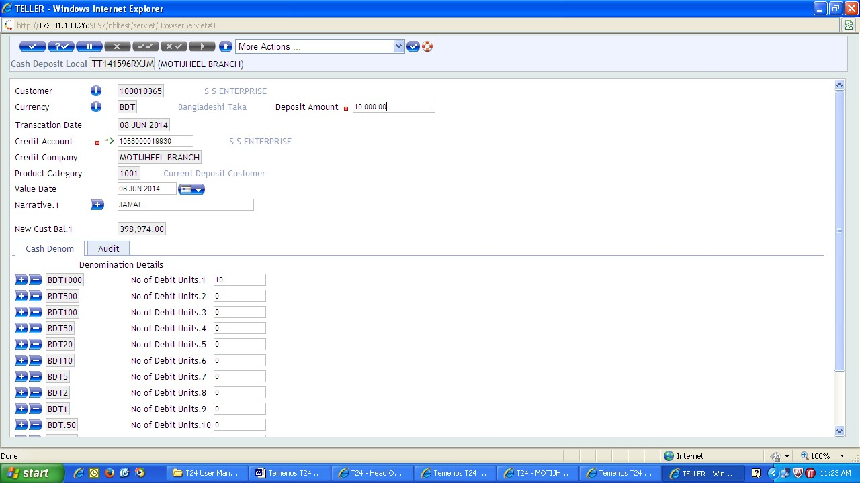
Inputter will put value in deposit Amount and credit account and narrative field . Finally give the denomination and then commit the transaction.

Authorizer will tally the transaction and if finds OK will authorize the deal from the following menu:

NBL User Menu>Retail Operations>Teller> Teller Operations > Teller Cash>Authorize/Delete Teller cash transaction ----Click

4.1.2 Cash Payment Section:

Cash Payment may be two types:

- Cash Withdrawal Local
- Cash Withdrawal Local(without cheque)

For encashment NBL use various financial Instrument. it's the special feature of the "Payment On Request" industry. Most useable instrument is Cheque, pay orders, Demand draft and debit voucher. If everything ( cheque’s number, total amount of taka both words and figure, availble account balances, signature is verified ) is correct then officer posting the pc.

For cash payment of Party A/C (SB/CD/STD) with cheque, posting should be given from following menu

NBL User Menu> Retail Operations> Teller> Teller Operations> Teller Cash> Cash Withdrawal> Cash withdrawal Local ----Click.

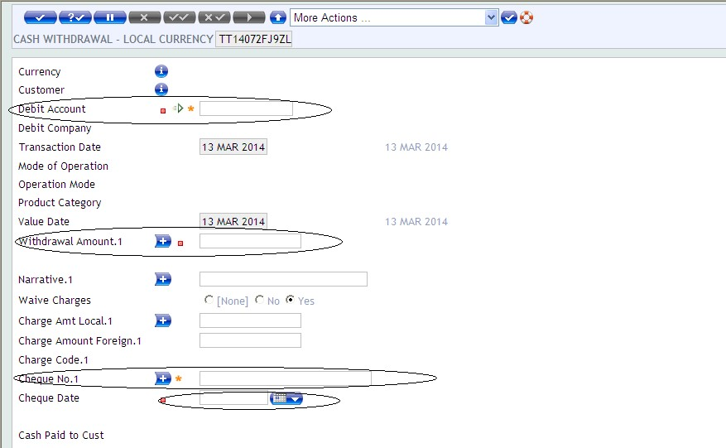

In the above screen Debit Account, Withdrawal Amount.1, Cheque No.1 and cheque date must put because these are mandatory input. After putting the amount a page of denomination will appear in which denomination should be given. The amount given in the denomination and the withdrawal amount must be same otherwise the transaction will not be taken by the system. Then officer will show the cheque’s signature and balance of the account which will appear below in the same screen.

After Inputters task, Authorizer will authorize the deal.

4.2 Online Charge:

Tk. sends through online: | Tk. Receive through online:
Up to Tk 1, 00,000 :40+6 =46 | Up to Tk 50,000 :20+3 =23
Up to Tk 5, 00,000 :75+11 =86 | Up to Tk 1, 00,000 :50+8 =58
Up to Tk 15, 00,000 :150+23=173 | Up to Tk 5, 00,000 :100+15=115
Up to tk 9, 99, 99,999 :200+30=230 | Up to Tk 10, 00,000 :300+45=345
 | Up to Tk 25,00,000 :500+75=575
 | Up to Tk 50,00,000 :700+105=805
 | Up to Tk 99, 99,999 :1500+225=1725

4.3 Remittance Function:

Remittance is most basic part of general banking. It is a sort of administration which empowers one client to move their cash to the beneficiaries' financial balance. It takes 1-2 working days to get the cash however in some cases it relies upon the supplier and structure where you are sending the cash. Remittance can be done through telegraph transfer, mail transfer, traveler’s check, and drafts and check. There are 2 remittance step.

    - Domestic Remittance
When the money is transferred within the country using medium like travelers check, mail transfer, draft or check then it is called domestic remittance.

Inward Remittance :

It can basically infer that cash was moved into bank to bank.

For example- If money is needed in our bank then money can be bought from other bank. Therefore, the bank from which the money will be bought is informed in advance. If NBL bring 50 lac taka from ohter NBL branch’s or other bank like Premier Bank the we have to go there with cash officers, a car with security guards. Then the cash officer maintains some formalities in that bank.

Outward Remittance:

Outward remittance is when another bank takes money from our bank. They also keeps us informed before providing money.

For example-

Other banks like follow the Inward remittance procedure come to our bank with their officers and security guards with protection and submit a cheque and receive their money for their bank.

    - International Remittance

When money is transferred to the another country or outside of the country using same mediums like travelers check , mail transfer, draft or check then it is called international remittance.

National Bank provide NBL Quick Pay, Western Union, Money gram and others.
4.4 Vault Cash Function:

- Entering money in a bank vault is called cash in.
- Cash out of the vault position is called vault cash out .
- The Cash in-charge of the bank maintains regular basis this cash in and cash out position.
- Here the full details ( like specific amount of cash note’s ) are stored with cash flowing in or out on Vault Cash book.
- Vault’s weekly position at each branch of National Bank has to be submitted to the head office via mail.

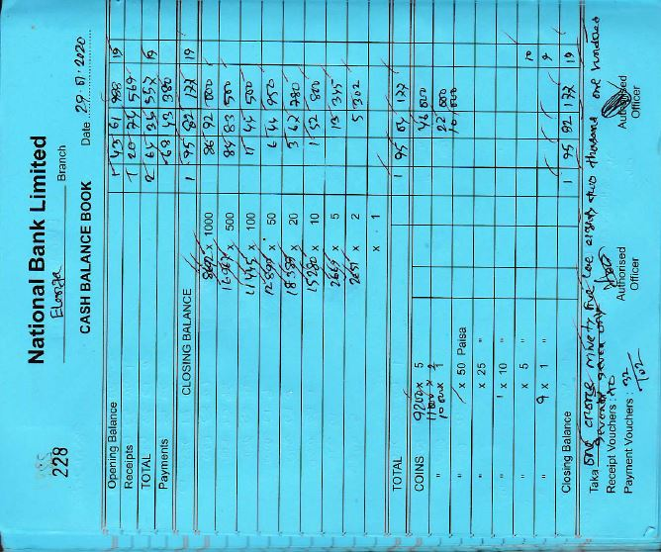

Chapter - 5
Advance Department

  - Anti Money Laundering and Combating

  - Clearing Section

  - Pay Order

  - RTGS/BEFTN

Chapter 5 : Advance Department

  - Anti Money Laundering & Combating the Financing of Terrorism:

Bangladesh Financial Intelligence Unit (BFIU) of Bangladesh Bank issued various circulars from time to time for preventing money laundering activities and combatingthe financing of terrorism. Bangladesh Bank (BFIU) and our Head Office has given instructions to ascertain Independent Testing Rating against prevention of money laundering & terrorist financing through Independing Testing Procedures.

This Branch has obtained 82 marks out of 95 and the rating of the branch is “Very Good”.

The overall performace of the Branch on anti-money laundering and combating terrorist financing function is fair. The Branch is more or less meticulous for opening of accounts as per guidlines of BFIU of Bangladesh Bank as well as Anti Money Laundering Curculars iss from time to time by the Head Office of the Bank.

Branch should meticulously follow the circulars issued by BFIU of BB and AMLD of Head Office from timeto time, maintain all required files & records, report CTR / STR / Self-Assessment Report in time and regularize the lapses as mantioned above.

Clearing Section :

In banking clearing means clearing of bank cheque. In easy word, it's a way of transferring the cash from the place of bank where cheque is drawn to the place of bank where it's deposited. consistent with the principles of the Bangladesh Bank, Banks those are a part of the financial organization has achieved the position of scheduled bank. Banks those predict to clear the cash clear each other's cheque drawn via clearinghouse. it's a financial organization system where the member banks representative gamers to clear the cheque on a daily basis.

Banks accept check and other similar instruments for crediting the proceeds to the customer's account. The bank receives multiple such instruments from account holders throughout the day. Some instruments are utilized as another bank payable. Except of those introduction to the bank of drawer as reason of receiving the proceeds, several messengers would must use thereto end. Similarly, the messengers or other banks will present plenty of check draft on this and then to the counterpart. the full procedure would require substantial time, uncertainty, expense and expenditure. it's clearinghouse where banks have to pay their arrearage. And it sits twice to figure in sooner or later.

Reasons for dishonoring cheque:
- If the drawer is not referred.
- If the account doesn’t carry sufficient cash.
- If the agreement is over.
- Payment stopped through drawer.
- Irregular / unreadable / required endorsement by the payee
- Irregular endorsement by the payee, includes confirmation from banks.
- Signature of the drawer varies.
- Changes in the word date / figures include a complete signature of the drawer.
- The check is post dated /out dated.
- Words and figures fluctuate in number..
- Crossed cheque will be given by bank..
- Proper stamp requires cancelation.
- "Account payee only" check crossed (18) Collecting irregular / required discharge

Different variation of clearing:
No. | Regular Value Instrument | High Value Instrument
1 | Normal clearing house: It consists of 2 type of clearing house that is first clearing house and second clearing house. In case of first clearing house the time it stands is form 10-11 am and for second house it is after 3 pm. | Same day clearing house: It also consists of both first & second clearing house. But in that case first house stands from 11 am-12pm and for second house it is after 2pm.
2 | Charges on Regular Value Cheque:  - Less than Tk. 50,000/- : Nil  - Tk. 50,000/- to less than Tk. 5,00,000/- : Tk. 10 (BACH will receive Tk. 8 + Bank will receive Tk. 2)  - Tk. 5,00,000/- and above : Tk. 25 (BACH will receive Tk. 20 + Bank will receive Tk.5 | Charges on High Value Cheque:  Tk. 5,00,000/- and above : Tk. 60  (BACH will receive Tk. 50 + Bank will receive Tk. 10)

Precaution while obtaining check for clearing, LBC set, OBC & Transfer:
- Account holder name same in the cheque & deposit slip.
- Cheque and deposit slip must be the same in words and in figure
- Clearing house date can be on or prior to (but not more than six months back).
- Bank & Branch name of the cheque its number & date in the Deposit slip.
- Cheque must be signed.
- Signature to confirm the date, quantity in words / figure
- Account number must be transparent in the deposit slip.
- Signature of the Depositor in the Slip Deposit.

Return House:
The meaning of return house is second home, where the Bank's members meet after 3 p.m.
receiving and distributing dishonored house located in the 1st Clearing House.

5.3 Pay order:

Basically pay order is a medium of payment which is should have been liberated by certain part of the bank which gave this. In a more extensive scene, it is a request that arranges the bank to pay a specific amount to an outsider for the customer, and such requests are commonly acknowledged by the bank that guarantees that the payment is made.

Methods of issuing pay order request:

There are many serial processes that are used to make pay order.

- The client will first complete his pay order form well and submit it to the Advance Officer.

- The officer will take the commission and vat to make this pay order.

- At that point client deposited the cash or cheque at the cash section.

- Then the cash section will check this cash better or fully checked submitted the cheque.

- The advance division will create the pay order dependent on the voucher and posting it computer.

Process of payment:
Since A/C Payee crosses the compensation request, the comparative will be sent to the responsible branch either for installment by clearing and crediting the client's record. In the settlement or advance division installment orders are taken care of the payment. Instruments are considered as debit instrument when it is paid.

Reasons of refunding pay order:

The process of pay order refunding are followed:

- The purchaser will demand a composed application to cancel the pay order

- The buyer's signature as checked on record from the first application structure

- Direct endorsement of the second officer will be looked for before the cancelation balance is discounted.

- The applicant will refuse to give it's charge.

PO/PS Issue through Cash

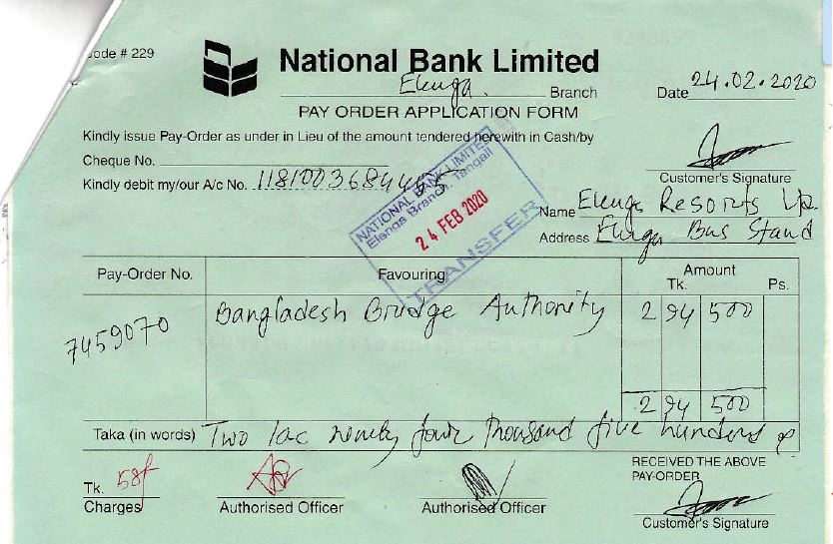

Pay Order Issue through Fund Transfer:

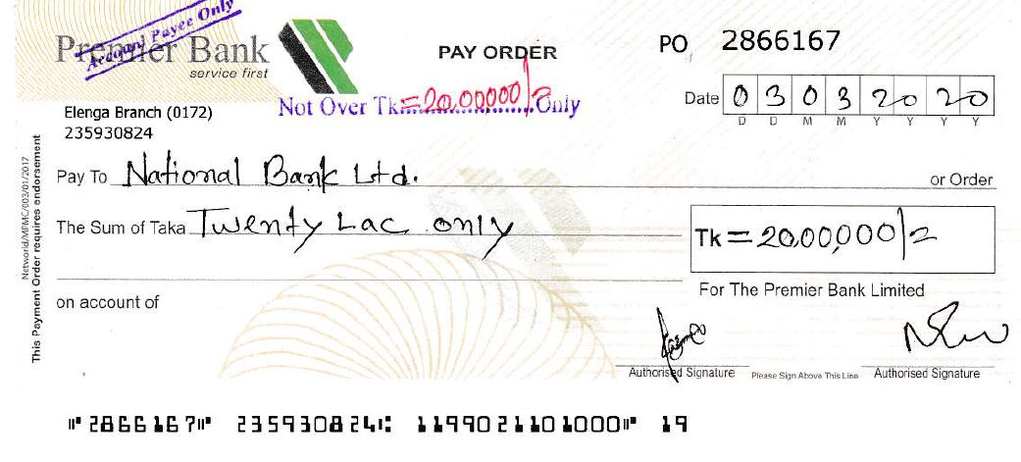

RTGS/BEFTN

5.4 Real-Time Gross Settlement / Branch Enter Fund Transfar Network.

This makes it easy to send money from one bank to another very easily. This money can be sent to another branch of the same bank or to any branch of another bank. BEFTN is conceivable to manage any bank inside one day. It is a cost free exchange. RTGS system is connected with Bangladesh Bank. Funds that run RTGS payment software have their own software depending on the internal procedures of the beneficiary bank. MICR device is used for this. National Bank Limited follows a UK system Bankers Clearing House which was called CHAPS.

In 2105, Bangladesh Bank was first introduced to this RTGS system. Now the transactions of Bangladesh are not so late like it happened before.This process is being improved day by day.

- Organizer bank itself through which it is connected to bangladesh bank and the organizer says which accounts will be credited by debiting money from which accounts.
- Bangladesh Bank mediates between the client and the organizer. Then they checks all the information as per the instruction of originating bank and completes the settlement.
- They receive instructions from BD RTGS and will actually inform which bank the funds will be transferred and the receipient bank.
- The money is sent to the account number of that person or organization.
- The transfer of funds is done by three different Ids. First, the maker inputs the data and generates the data. Second, the checker checks the input and authoriser will authorise the fund transfer.

Applicant must fill the criteria very carefully are given below:

- Name, address, phone number
- Routing number
- Beneficiary account number and name
- Amount to be remmited and total taka in words
- The customer signature of the RTGS form and the signature of the cheque must be the same.

RTGS Flow and Form’s picture

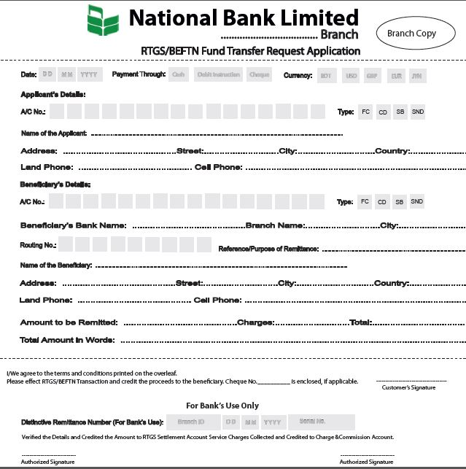

CHAPTER - 6

Other Important Facts

- Dispatch Section
- Maintaining Files
- Audit Report
- Deceased Rules
- Lost Instruments

Chapter 6 : Other Important Facts

6.1 Dispatch Section:

This department receives letters from another bank or head ofiice through courier services and sends any letter from its branch to the head office or to another bank as required. For this purpose, this department maintains two register books, one is to receive letters from outside and the other is to send letters from inside to outside. These two types of letters are stored in the register book with numbers. So that this number is called disapatch number. A branch that receives and sends such letters are given below –

Inward Mails are –

- Office Order
- HRD
- Joining Report
- FAD
- GBD
- Budget
- Pay Order Commission
- Thanks letter
- ATM Card Loan
- Profit-Loss etc

Outwards Mails are –

- Audit File
- Leave & Application
- Agri. Loan
- PDB VAT collection
- Circular letter
- Cash Collection Forwarding
- Thanks Letter
- LBC & IBC etc.

6.2 Maintaing Files:

The advanced section maintains many official files. Some of these have to be maintained every day and some have to be maintained weekly basis, monthly basis. Some more files are maintained half yearly and quarterly a year. These files often have to be submitted to auditors. A branch’s half yearly, quaterly and yearly basis files need to be sent to the head office as they prepare thos report.

Thease are the files –

SL No. | File Name | SL No. | File Name
1 | Office Order | 20 | CAD
2 | HRD | 21 | BEFTN
3 | Salary | 22 | Election
4 | Rent Office | 23 | CRM (1-5)
5 | BACH | 24 | IBTA Balance
6 | GBD | 25 | Audit File
7 | CL | 26 | Fixed Asset
8 | Agri. Loan | 27 | Police
9 | IDTT | 28 | System & Operation
10 | Basic Data | 29 | Thanks Letter
11 | Gas Bill | 30 | Sunderban Courier
12 | SME Loan | 31 | Transfer Register
13 | Training File | 32 | TP Update
14 | Generator | 33 | Joining Report
15 | Stop Payment | 34 | Voucher Register
16 | FAD | 35 | CSR
17 | Retail Loan | 36 | Release Order
18 | Internship | 37 | Advice
19 | Rate of Interest | 38 | TA/DA

6.3 Audit Report:

Auditors team are dispatched from its head office to each brance of the National Bank. Sometimes a team of these auditors is sent half yearly or annually. These auditors go to a branch and observe everything meticiolously. They check different types of documents and see if all of them are regulated or out of order.

They submit these documents to the head office at he end of this audit. Then the head office monitors all the auditors report. Then the head office gives a letter in which it is written that all kinds of problens have to be solved.The manager give proper direction to the advance section officer is in charge of solving those problems.

- Deposit part:

This section deals with various types of problems in a branch’s deposit accounts to be solved. For example-

- Approval of branch in-charge was not found
- Account was opened without obtaining any introducer
- Know your customer (KYC) was found blank/not fully filled-up
- Photograph of the account holder was not attested by the introducer
- Photograph of nominee was not attested by the account holders
- Introducer’s signature was not verified by authorised officer
- TP was found blank or incomplete
- Missing source of fund by the account holder
- Initial deposit was not mentioned
- Expired trade license against CD account

- Letter of Thanks:

Branch should send letter of thanks to the new account holder and the introducer. Then a branch have to collect the confirmation from them so that the letter has reached the permanent address or th country at present.

- Cheque Book Issue:

This section contains the auditor’s report on the problem of cheque books in SB or CD account holders in the bank. For example –
- Cheque books were issued without verifying the signature of the account holders
- Cheque books were issued without putting signature of an authorised officer
- Signature was not found on the back side of the cheque requisition slip as a token of receipt the cheque book by account holder
- Receive data of cheque book was not mentioned on the front and back side of requisition slip on many occasions
- Account holder’s name and address was not found in cheque requisition slip
- Issuing cheqye leaves were not mentioned

- Undelevered Cheque Book:

Branch should communicate with the account holders to deliver the cheque books or destroy the undelivered cheque books through office note keeping record in the cheque book issue register.

- NMS/MDS Defaulter Account:

Branch should make communication with defaulter account holders in writing and keep follow-up either to regularize the aforesaid default NMS/MDS accounts or close the said accounts observing required formalities.

6.4 Deceased Rules:

Procedure for credit balance to the deceased account, it has been decided by the Management to authorise the branches to balances Of the deceased account.

The following documents/papere should be obtained and verified by the branches before settlement or claims –

- Application of the legal heirs of the deceased.
- Original Succession Certificate
- Death Certificate.
- A certificate from the Chairmen/Commissioner of pourashava/union Parished certifying names or legal heirs.
- Persons receiving the payment from the Bank shall have be identified by a respectable accepteble to the Bank.
- Legal Succeseors/Benefieiarieg (as per Succession Certificate) shall execute Indemnity Bonds indemnifying the Bank- in case of any dispute in future.
- Branch should obtain legal opinion before payment from their legal adviser lawyer.
- Unused cheque books etc. if available, in the of deceased shall have to be returned to the respective branch.
- Branch may allow payment without obtaining Succession Certificate upto Th.6,000/— (Take six thousand) only by taking legal opinion from their legal adviser, if they are satisfied about the genuinity Of the claim.

6.5 Lost Instruments:

Sometimes customers lose a debit card or credit card wallet or storage places for many reasons. Again many times customer lose their cheque books. Sometimes the bank gives documents against the account and sometimes they lose them. Therefore, the customer will inform the bank as soon as possible.

Here is what to do when a customer encounters this type of problem are given below –

- First of all, the bank officials should be informed so that no one can commit any misdeed with his lost debit card, credit card or cheque book.

- Then according to the instructions of the bank, if it has to be done by the police, it has to be quickly. A copy of GD should be submitted to the bank.

- The bank will then stop facilities or create injunction it’s client’s lost instrument .

Chapter: 7
DATA COLLECTION AND PROCESSING

Chapter Includes:

- Ways of data/information collection
- Data/ information processing methods

Chapter 7 : Data Collection And Processing

7.1 Data processing methods

Line Chart:

The line graph is particularly effective in showing patterns. In a line graph, the vertical axis consistently shows numeric values and the horizontal axis shows time or other classification.

Pie Chart:

A pie chart is a round factual realistic, which is isolated into cut to delineate mathematical extent. In a pie chart, the circular segment length of each cut is relative to the amount it represents.

Bar Chart:

A bar chart is a diagram that presents assembled information with rectangular bars with lengths relative to the qualities that they present.

7.2 Analysis of Secondary Data:

- Line chart: Savings Account

Remarks:
Every purposes of the line chart shows the yearly record opening information. This line diagram shows the pattern of saving accounts in 2016 to 2020. We can see that the number of saving accounts opened in Jan-2016, on the grounds that the savings interest rate is high more than 2017. In 2016 the savings interest rate was 4.00% yet at present savings interest rate is 2.50%.

- Current Accounts:
Remarks: Every purposes of the line chart represent to the yearly current account (CD A/C) opening information. This line diagram shows the pattern of Current accounts in 2016 to 2020. We can see that the highest number of current deposit accounts opened in , 2019.

- Line chart: Monthly savings scheme (MNS)

Remarks: Every purposes of the line diagram show to the year to year account opening information. This line outline shows the pattern of NMS in 2016 to 2020. We can see that the greatest number of NMS accounts opened in 2020.

- Line chart: Millionaire Deposit scheme (MDS)

Remarks: Every purposes of the line outline speak to the month to month account opening information. This line graph shows the pattern of MDS accounts in 2016 to 2020. We can see that the highest number of MDS accounts opened in 2017 however 2020 will be highest.

- Line chart: Fixed Deposit (FDR)

Remarks: Every purposes of the line diagram show to the year to year account opening information. This line outline shows the pattern of sparing records in 2016 to 2020.we can see that the greatest number of FDR accounts opened in 2020 . In 2017 on the grounds that FDR financing cost is high this time.

- Line chart: Century Deposit Scheme

Remarks: Every purposes of the line diagram show to the year to year account opening information. This line outline shows the pattern of sparing records in 2016 to 2020.we can see that the greatest number of Century accounts opened in 2020. Because this scheme offer highest interest rate with special facilities.

- Line chart: Sonar Bangla Amanot

Remarks: Every purposes of the line diagram show to the year to year account opening information. This line outline shows the pattern of sparing records in 2016 to 2020.we can see that the greatest number of Sonar Bangla accounts opened in 2020. Because this scheme offer highest interest rate and lowest date of maturity.

- Line chart: All popular Deposit Products

7.5 Analysis of Primary Data:

Remarks: Above this pie chart show that 35% of the customers are service holder, 29% are businessman, 36% are business man and 15% percent are housewife, 8% are retired person and 13% from other professional background. It means that most of the customers are service holder.

Pie chart: Age of the customers

Pie chart: Overall, customers are satisfied about their banking facilities.

Remarks: Above this pie chart shows that the customers are satisfied 72%, 8% moderate and dissatisfied 20%. It means that the customers are more satisfied on their banking facilities.

CHAPTER 8

SWOT & Online Platform

- SWOT Analysis of NBL
- General Banking Using Online Platform

Chapter 8 : SWOT & Online Platform

8.1 SWOT Analysis of NBL

SWOT analysis involves monitoring the environment of an organization and the work of each department. It helps in planning and marketing to the marketers in the first place. SWOT stands for strengths, weaknesses, opportunities, and threats. Strengths and weaknesses are internal factors. Opportunities and threats are external factors.

Strengths of NBL:

- The most convenient stage is that the manager of this branch is a local resident of the municipality.
- National Bank Elenga Branch the most successful and oldest branch in elenga municipality.
- Every employee of this branch is very sincere and caring.
- Quality service is provided to every customer.
- Their relationship with the clients is very good.
- Liquidity position is very strong.
- Transportation is very good and it is possioble to reach the branch very easily.

Weaknesses of NBL:
- The FDR rate is much lower than other products of the bank.
- Some online transfer charges for a certain amount are relatively high..
- Shortage of ATM booths and distribution of drbit cards or credit cards are very low.
- Here the promotion of this bank is comparatively less than other banks.
- This branch has a shortage of officers and supporting staffs.
- There are very few people who collect remittances.
- The number of account holders in this branch is relatively low.

Opportinuties of NBL:

- There is an opporinuty to do good business in this branch of National Bank due to giving better opportinuty to the traders.
- It will be easier to attract people because of the benefits of National Bank’s product schemes.
- Placing an ATM booth here will further increase the number of customers.
- Increasing the number of officers will make it possible to provide better services from other banks.
- Increasing marketing will make it more possible to attract people.
- Paying cheques to customers as soon as the account is opened will further increase the number of transaction.
- Connecting to the Foreign Exchange Department will create a good image and also increasing customers in this branch.

Threats of NBL:

- In the meantime, all the commercial banks in the country have increased their focus on customer service
- Overall liquidity fluctuations in the money market is one of the worst aspects.
- If any bank opens a foreign exchange department here, the number of customers may decrease here.
- The charges for various facilities of this bank from the competitor are comparatively a little higher.
- There is a risk of financial loss if the loan is not properly verified.

8.2 General Banking using online platform

Adding an online platform to banking is a revolutionary step that helps ordinary people to easily complete their banking transactions from the comfort of their own place. Most of the banks in Bangladesh have already started providing this online service to their clients. National Bank needs to make a significant dent in this competitive race. But National Bank has not yet played a significant role in providing online services to its clients so they are still trying. They haven’t created their bank apps yet. This reduces both customer’s time and labour. They get e-banking facility from anywhere in the country.

Improvement areas of online General Banking:

There are some positive aspects of online service delivery and on the other ahnd there are some weaknesses that the channels that they have to go through to get customer satisfation are given below –
- Sometimes their servers are down due to technical issues that prevent them from accessing their account.
- Customers have to use ATM booths to withdraw or cash out but it is often not available in many places. Even through ATM booths are availble in many places the services is not available properly due to online problems.
- The most common and serious problems with online platforms is being hacked. Although this problem is not common, everyone needs to be aware of this weakness.

Suggestions to improve the weakness

- Server down is a big issue for any bank as it is a financial loss which makes it difficult for the customer to transaction at the same time. It creates customers disatisfaction and there is a possibility of losing the customers. Therefore they need to further develop the structural design of the server so that such problems do not happen in the future.
- National Bank needs to create its own app which is very user friendly.
- The availability of ATM booths should be further enhances so that they are easily availble in the small and large grocery shops or shoppong malls or commercial buildings.

CHAPTER – 9
Conclusion and Recommendation

  - Experience
- Findings and Recomendation
- Conclusion

Chapter 9 : Conclusion and Recommendation

There are usually 3 types of client transactions. These are cash, clearing and transfer. When clients deposit or withdraw their cash, cash is exchanged. At this point when the client requests the bank to collect or pay another bank, the order ends with clearing. At this point when a client requests the bank to collect or pay cash in the next part of the same bank, it ends with the transfer. At the Elenga branch of the National Bank, all transfer transactions are recorded on the PC and then checked to see if the debit and credit aspects are the same.

Cash Department:

In the cash department, I was assigned to check if the client had fulfilled the required check. At that time I matched the client's sign given on the check with the sign left on the bank's PC. I checked whether it was an "order check" or a "cross check". If it is an "order check", then the bank will pay the cash to the specified person. The individual's name will be on the check.
In the off-order that it was a cross check, the bank would not give the cash to anyone at that time and would transfer the cash to a specific account. No one has the money to check. Since then, in the event that all the requirements have been satisfied, at that stage I have given the checks to my supervisor. At this point, the officer in charge of the cash department is assigned to pay the client in cash

Advance and Loan Department:

Loan assumes an important role in bringing benefits to a bank. If a person needs to take a loan from a bank, he has to present some important records which are: Trade License, TIN Certificate, Bank Declaration, Bank Solvency Certificate, Property Valuation Certificate, Stock Report, NID Card etc. I was given the task of checking the basic records.

Findings and Recomendations

Findings:

- Online banking is not so good
- There is a lack of ATM and credit card sector
- Salary is lower than other banks
- Poor marketing strategy
- Fewer branches in rural areas
- FDR interest rates are lower than other banks

Recommendations:

- Need to reduce interest rate for CC account (cash credit)
- More branches should be opened in rural areas
- There should be more focus on credit card and ATM booths
- The term "Islamic banking" should be used
- Employees should be paid more

Conclusion

In conclusion, the internship program is to gain practical experience before going to work. In some places, academic theoretical knowledge is required while doing internship. I have tried my best to show the real picture of Elenga branch of National Bank Ltd. through this report. It gives an overview of the day-to-day operations of General Banking. During the internship I saw how this branch serves customers and how it provides credit facility. This branch is currently working on two to three types of loan disbursement.

National Bank Ltd. as a reputed and old bank has made its own place by doing a lot of good work in the private banking sector. This branch has enough skilled staff to provide maximum support or service to the customers. During loan disbursement, the loan officer monitors the loan very well and gives it to the client. Appianization is arranged here with the highest repect of the CC parties and they are given various facilities. Since the loan disbursement is well monitored here, there are no defaulted loans.This branch of National Bank is in a much better position where other banks have lagged behind due to default.

Since the manager of this bank is a resident of the municipality here so from other banks, so the movement of people in this bank is increasing now. The behavior of officers here is helping to attract customers. National bank Limited continues to do its utmost to provide good quality of service to the customer.

References

https://www.nblbd.com/about/deposit_int_rate
https://www.nblbd.com/about/loan_int_rate
https://www.nblbd.com/about/annual_report
https://www.nblbd.com/about/financial_statement
https://www.nblbd.com/about/transaction_charges
https://www.nblbd.com/home/atms
https://www.nblbd.com/home/foreign_remittance

Thank You

