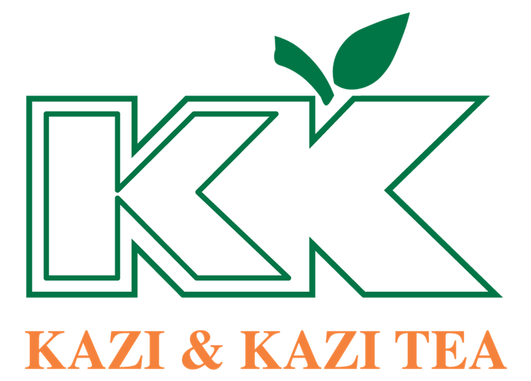

Internship Report On
"Enhancing Organizational Performance Through Employee Relations & Engagement: A Case Study of Kazi & Kazi Tea ."



Internship Report
on
“Enhancing Organizational Performance Through Employee Relations & Engagement: A Case Study of Kazi & Kazi Tea ” Estate Ltd.""

Submitted To:
Name: Nasrin Akter
Designation: Assistant Professor
School of Business & Economics

Submitted By:
Name: Ahmed Motasin Fouad
ID: 111 192 009
Major: Human Resource Management.

Date of Submission: 30th January, 2024

United International University

Letter of Transmittal
January 30th, 2024
Nasrin Akter
Assistant Professor, School of Business and Economics (SOBE)
United International University, United City, Madani Aven, Dhaka 1212

Subject: Submission of Internship report titled "How employee relations and engagement enhance
the performance of Kazi and Kazi Tea Estate".

Dear Ma’am,
This is my utmost pleasure to accomplish the internship work and submit internship report on “Enhancing Organizational Performance Through Employee Relations & Engagement: A Case Study of Kazi & Kazi Tea”, thanks to the grace of Allah, which is a requirement for the BBA program of United International University (UIU). In order to fulfill the requirements of my internship at Kazi & Kazi Tea Estate Ltd. The study provides a thorough analysis of HR's role in fostering better employee relations, which impacts employees' performance.
I would like to express my gratitude to my supervisor for helping the Kazi & Kazi Tea Estate Ltd.-PU Office team members, as well as to Md. Faruk Hossan (Assistant Manager HR & Admin) and Md. Latiful Kabir Mamun (Manager, Operations & HR) for their guidance and support in helping me learn about the HR procedures at Kazi & Kazi Tea Estate Ltd.
I have put my earnest effort to give this report a presentable shape and make it as informative and precise as possible. I thank you for providing me with this unique opportunity.
Kind Regards,
Ahmed Motasin Fouad,
ID: 111 192 009

Acknowledgement
In the beginning, I would want to thank the Almighty Allah, the Most Gracious and Merciful, for his kindness and for giving me the opportunity to successfully complete the internship and turn in the internship report on time.
First of all, I would like to express my deep gratitude to Ms. Nasrin Akter, an assistant professor at United International University's School of Business and Economics, for her sincere, valuable guidance and assistance in writing this internship report. Furthermore, I could not possibly complete such a large document by the deadline without the guidance and the structure of the report.

Also I would like to express my sincere gratitude to Assistant Manager of HR & Admin Mr. Md. Faruk Hossan my internship supervisor at Kazi & Kazi Tea Estate Ltd - PU for providing me with this valuable opportunity and for his unwavering support and guidance throughout my internship. His insightful feedback and willingness to answer my questions were instrumental in my learning and development.

I am also grateful to the entire Kazi & Kazi Tea Estate Ltd – PU team for their warm welcome and willingness to share their knowledge and expertise. I especially appreciate S.M.M Ibrahim Mahmud (General Manger, Sales & Marketing), Md. Latiful Kabir Al Mamun (Manager, Operation & HR, Sales), Litan Dey (Regional Sales Manager, Sales), Muhammad Musfiqur Rahman (Assistant Manager, Corporate Sales), Md. Al Amin (Sr, Executive, Accounts), Md. Rashidul Islam (Manager, Production) for guidance and for always being available to answer my questions. Their patience and encouragement helped me to grow and develop my skills significantly.

Finally, I would like to thank United International University for providing me with the foundation for success in my internship. The knowledge and skills I gained through my coursework were invaluable in my role at Kazi & Kazi Tea Estate Ltd.

Declaration
This is to notify that the report “Enhancing Organizational Performance Through Employee Relations & Engagement: A Case Study of Kazi & Kazi Tea”, has been prepared as a part of internship program. This is mandatory part of the B.B.A. program to submit a report. To prepare this report, I was inspired and guided by Ms. Nasrin Akter - Assistant Professor, School of Business & Economics and United International University.



_______________________

Ahmed Motasin Fouad
ID: 111 192 009
BBA, Human Resource Management
United Internation University

Executive Summary
The study examines the employee relations and engagement enhance the performance of Kazi and Kazi Tea Estate, a prestigious manufacturer. Completing the requirements for the BBA degree and gaining a deeper understanding of HRM theory and its use in practice are the two main goals of this academic internship report. The secondary objectives cover my understanding of employee relations and engagement procedures and how they affect employees' performance inside the organization and how to improve performance.
The methodology states that websites, earlier research studies, related research papers, and other publications were gathered through a qualitative interview with my supervisor, Mr. Md. Faruk Hossan, from the HR & Admin department of Kazi & Kazi Tea Estate Ltd., and that this study uses primary data, such as practical experience, in-person conversations, direct observations, etc.
The report is divided into five chapters. The first chapter covers the introduction, the study's scope, the report's objectives, its methodology, and its limitations. The literature review for the report is included in the second chapter. It covers a number of subjects, including the importance of employee relation and engagement procedures and how it could impact on an organization's performance. In the third chapter, I have included an overview, corporate details, products and services, as well as the mission and vision of Kazi & Kazi Tea Estate Ltd., to provide the reader a thorough grasp of the company.
The fourth chapter focuses on employee relations and engagement procedures, including how they are implemented, how long they take, a sample job posting, challenges that employees face, etc. A thorough description of the problems, challenges, and methods I found during the process is given in Chapter 5. This chapter concludes with some broad remarks and my experiences during my internship. In this chapter, I provided my recommendation and resolutions to the problems. The final chapter contains the appendices and references used in the internship report.

Table of Contents
Letter of Transmittal iii
Acknowledgement iv
Declaration v
Executive Summary vi
Chapter: 1 0
Introduction 0
1.1. Introduction of the topic: 1
1.2 scope: 3
1.3 Objective of the study: 4
1.3.1 Primary Objective: 4
1.3.2 Secondary Objective: 4
1.4 Methodology: 5
1.4.1 Primary Resources: 5
1.4.2 secondary Resources: 5
1.4.3 Sample Size: 5
1.4.4 Sampling Procedure: 6
1.4.5 Data Analysis: 6
1.4.6 Data Analysis Process: 6
1.4.7 Report Assemble: 6
1.4.8 Limitations: 7
Chapter: 2 8
Literature review 8
2.1 Employee relations: 9
2.2 Employee engagement: 10
2.3 Importance of employee relation and engagement: 11
2.4 How employee relations enhance the organizational development: 11
Chapter: 3 13
Organizational Overview 13
3.1 About Kazi & Kazi Tea Estate Ltd.: 14
3.2 Mission: 16
3.3 Vision: 16
3.4 Product catagories: 17
3.5 Sustainable practices: 17
3.6 Community Development: 18
3.7 Employee Welfare: 18
3.6 Corporate Social Responsibility (CSR): 19
3.7 Community: 20
Chapter: 4 22
Analysis 22
4.1 Communication Channels: 23
4.2 Employee Feedback Mechanisms: 24
4.3 Employee Recognition Programs: 26
4.4 Training and Development: 27
4.5 Improved Productivity: 27
4.6 Enhanced Employee Satisfaction: 29
4.7 ABP (Annual Business Plan): 31
Chapter: 5 32
5.1 Findings: 33
5.2 Recommendations: 34
5.3 Conclusion: 35
Appendix 36
Bibliography 37
Questionnaire: 39

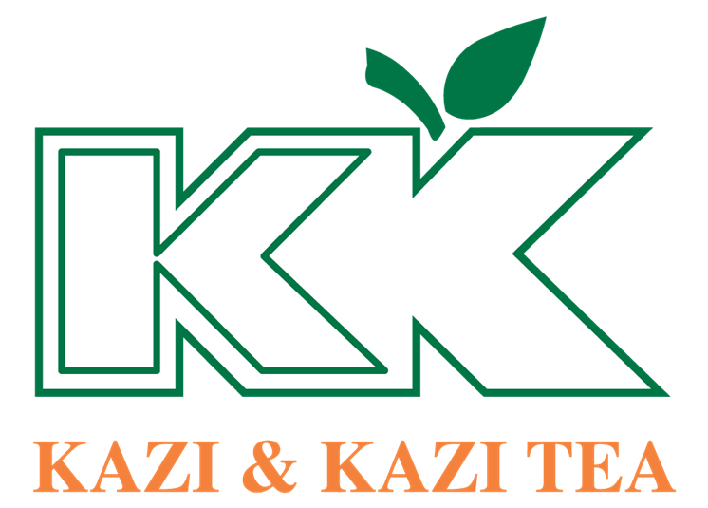

Chapter: 1

Introduction

1.1. Introduction of the topic:
Human resources (HR) are important to an organization's business operations in order to ensure its profitability and effectiveness. HR departments are in the position of establishing effective policies and procedures, training and developing staff, and establishing a positive work environment. HR plays a critical role by optimizing employee productivity and effectiveness and enhance their performance.
Nestled in the lush greenery of Bangladesh's Panchagarh district, Kazi & Kazi Tea Estate flourishes not just as a pioneer of organic tea, but also as a model for fostering employee engagement and high performance. This report examines into the vibrant tapestry woven by their commitment to cultivating a positive and empowering work environment, exploring how strong employee relations translate into exceptional tea craftsmanship and sustainable growth.
Kazi & Kazi Tea understands that happy and skilled employees are essential for success. They don't just focus on making great tea, but also prioritize strong employee relations and engagement. To stay ahead in the market, they invest in their workforce through several HR initiatives:
- Engaging employees to boost motivation and productivity.
- Finding and hiring talented people who fit the company culture.
- Providing training and development programs to equip employees with the skills they need.
- Implementing performance management systems to track progress and offer opportunities for growth.
- Taking care of employee well-being to create a positive and supportive work environment.
In essence, Kazi & Kazi Tea recognizes that a satisfied and well-trained workforce is the key to achieving their business goals and maintaining a competitive edge.
This internship report examines into the question: How employee relations and engagement enhance the performance". It takes Kazi & Kazi Tea as a case study, examining their unique HR strategies and their impact on employee performance at the factory. By analyzing their specific HR initiatives, the research aims to uncover the ways in which HR contributes to the overall success of Kazi & Kazi Tea's manufacturing operations. In core, it seeks to understand how effective employee

relations and engagement can become powerful drivers of performance, with Kazi & Kazi Tea serving as a real-world example.
This is a great statement about the report's objective and potential impact. It emphasizes the following key points:
- Introduction HR's role: The report's primary goal is to clearly define how HR contributes to fostering positive employee relationships and engagement.
- Actionable insights: Beyond just analysis, the report aims to offer practical suggestions for Kazi & Kazi Tea to further optimize its HR procedures.
- Continuous improvement: This research can serve as a valuable tool for the company to refine its HR strategy, fostering a workforce that is both skilled and engaged, ultimately propelling the factory's growth and success.
This report's main objective is to clarify the role of HR in the employee relationship and engagement and offer suggestions for further enhancing HR procedures at Kazi and Kazi Tea. By utilizing the conclusions and suggestions from this study, Kazi & Kazi Tea may continue to enhance its HR strategy and insure a skilled and driven team that contributes to the expansion and accomplishment of the company's factory operations.

1.2 Scope:
Examine the relationship between employee relations, engagement, and performance within Kazi & Kazi Tea Estate Ltd, analyze the unique HR strategies employed by Kazi & Kazi Tea to foster strong employee relations and engagement, assess the impact of these HR strategies on various performance metrics, such as productivity, quality, retention, and profitability, provide insights and recommendations for further enhancing Kazi & Kazi Tea's HR practices to maximize performance outcomes.
Employee Relations: Analyze communication practices, collaboration methods, and conflict resolution procedures within the organization. Examine the company's approach to employee voice, recognition, and rewards. Assess the role of management in building trust and positive relationships with employees.
Employee Engagement: Define the characteristics of an engaged workforce in the context of Kazi & Kazi Tea's operations. Investigate factors that contribute to employee engagement, such as job satisfaction, autonomy, and growth opportunities and analyze the company's existing engagement initiatives and their effectiveness.
Performance: Identify relevant performance metrics for Kazi & Kazi Tea's factory operations. Collect and analyze data on employee performance in relation to HR practices and also evaluate the level to which positive employee relations and engagement contribute to improved performance.

1.3 Objective of the study:

1.3.1 Primary Objective:
- This internship credits represent the culmination of my theoretical knowledge, particularly in Human Resources, and its practical application in a real-world setting.
- Through this internship, I aimed to bridge the gap between academic concepts and professional practice, actively observing and analyzing how HR knowledge translates into concrete actions and decisions within a company.
- As the topic of this internship, I’m evaluating the relationship between the company's engagement activities and key metrics related to employee’s motivation and delight, such as productivity, absenteeism, and turnover rates.

1.3.2 Secondary Objective:
- To discuss about the how employee relations and engagement enhance the performance
- Analyze Kazi & Kazi Tea's HR practices compared to industry standards and best practices identified through research.
- Asses and identify their employee relations and engagement strategies against other successful tea estates or similar-sized organizations.

1.4 Methodology:
The potential to carry out a research study successfully is dependent upon selecting a suitable and efficient methodology. In order to effectively create my report, I consulted both primary and secondary sources of information. In order to create this report, I evaluated and merged the data I had.

1.4.1 Primary Resources:
My internship report helped from a strong primary data collection strategy. This involved active participation in internships, engaging in interviews with managers, senior colleagues, and staff from different departments, and keen observation of daily routines. My supervisor's supportive guidance and additional information played a vital role in finalizing the report.

1.4.2 Secondary Resources:
I also get information from several kinds of secondary sources. As in-
- Kazi & Kazi Tea's website and annual reports: Company mission, values, HR policies, performance metrics, and financial data.
- Gemcon Group HR Service Manual
- News articles and media coverage: Interviews with company executives, reports on Kazi & Kazi Tea's initiatives and achievements.
- In house software called Human Resource Information System (HRIS)

1.4.3 Sample Size:
As I worked in the Dhaka Sales Office of Kazi & Kazi Tea Estate Ltd. (Packing Unit), here I got chance to work with Assistant Manager- HR & Admin, Manager- Operation & HR. The other HR departments of Kazi & Kazi Tea Estate Ltd works from the head office which is in Dhaka, Dhanmondi. So, basically an in-depth interview was conducted with my supervisor Assistant Manager of HR & Admin Mr. Md. Faruk Hossan.

1.4.4 Sampling Procedure:
My supervisor, the most experienced member of the team and Assistant Manager within HR & Admin, offered valuable insights. They shared their prior experience in various HR departments, allowing them to compare and contrast past practices with the current situation. I’ve gained a comprehensive understanding of the team's daily operations, the challenges and opportunities they face, and relevant details from their perspective.

1.4.5 Data Analysis:
By applying suitable analysis techniques to both quantitative and qualitative data, the research produced a deep understanding of the relationship between HR practices and industrial operation. This comprehensive study revealed key themes and patterns, informative the vital role HR plays in driving operational efficiency.

1.4.6 Data Analysis Process:
This report was mostly centered around my personal experiences. I analyzed the primary and secondary data I had gathered using both qualitative and quantitative methods in order fulfill that objective. Some of the first information I needed for my primary data collection came from my supervisor, other employees, and the people that work at Kazi & Kazi Tea Estate Ltd. The remaining information was given to me through personal interviews with my supervisor. To collect data from a variety of sources, I made a questionnaire that includes both closed-ended and open-ended questions. Qualitative data was obtained through the interview process and utilized in this study.

1.4.7 Report Assemble:
The analysis results were compiled and arranged to give a thorough understanding of “Enhancing Organizational Performance Through Employee Relations & Engagement: A Case Study of Kazi & Kazi Tea”, at Kazi & Kazi Tea Estate Ltd. The report was assembled with a focus on key concepts, benefits, and recommendations for enhancing HR practices within the company.

1.4.8 Limitations:
Though I made an effort to write a quality internship report, there were limitations on the data that could be gathered because I was an intern at the company. I was unable to fully comprehension all of the activities.
- The study is based on data that may have had access and availability limitations during the internship program. Certain insights and information might not be immediately available or could require additional verification.
- It is difficult to find out additional information because the Kazi & Kazi Tea Head Office Branch handles the majority of HR departments and activities.
- Doing this kind of study in 3 months is quite difficult. I could get more insightful details for my study with additional time.

Chapter: 2

Literature review

2.1 Employee Relations:
Employee relations, in essence, is about fostering positive and productive relationships between employers and employees. It involves a diverse range of activities like-
Building trust and respect includes ensuring fair treatment, open communication, and valuing employee contributions, addressing employee concerns; Handling grievances, resolving conflicts, and providing support in navigating workplace challenges. Creating a positive work environment with promoting employee well-being, engagement, and satisfaction through initiatives like recognition programs, career development opportunities, and a healthy work-life balance. Maintaining compliance with workplace regulations that endorsing policies and procedures that follow to labor laws and industry standards. Enhancing performance and productivity with a happy and engaged workforce is often a more productive workforce, contributing to organizational success.
Overall, effective employee relations can lead to several benefits for both employers and employees such as reduced turnover, higher morale, improved communication, and ultimately, a more well-off and successful organization.
Employee relations refer to the complex interplay of relationships between employers and employees within an organization. It encompasses the myriad ways in which employers interact with their employees, including communication, conflict resolution, negotiation, and the overall management of the employer-employee relationship (Ackers, & Wilkinson, , 2019).
According to (Farnham , 2014), employee relations are rooted in the historical context of labor movements and industrial relations. The traditional view of employee relations often focused on the management of conflict between employers and trade unions, with an emphasis on collective bargaining and industrial action. However, in recent years, the scope of employee relations has expanded to encompass a broader range of issues, including individual employment rights, diversity and inclusion, and the psychological contract between employers and employees (Gennard & Judge,, 2018).
One key aspect of employee relations is the management of employee voice, which refers to the mechanisms through which employees can express their opinions, concerns, and suggestions within the workplace (Wilkinson, 2014). This can include formal channels such as employee surveys and suggestion schemes, as well as informal avenues such as team meetings and one-on-one discussions with managers. Effective employee voice mechanisms are essential for fostering a positive workplace environment and promoting employee engagement (Gollan, 2018).

2.2 Employee Engagement:
Employee engagement is a critical aspect of organizational success, often regarded as a key factor in driving productivity, innovation, and employee satisfaction (Kahn, 1990). Although there is no universally accepted definition, most scholars and practitioners agree that employee engagement encompasses the emotional, cognitive, and behavioral aspects of an employee's connection to their work and organization (Macey & Schneider, 2008).
One of the earliest conceptualizations of employee engagement was proposed by (Kahn, 1990), who described it as the harnessing of employees' selves to their work roles. This definition emphasizes the psychological investment that employees make in their work, going beyond mere job satisfaction to encompass a sense of purpose and fulfillment derived from their roles (Saks, 2006).
Further developments in the field have expanded the understanding of employee engagement to include aspects of organizational commitment, job involvement, and discretionary effort (Macey & Schneider, 2008). Engaged employees are not only satisfied with their jobs but also feel a deep connection to the organization's mission and values, leading them to go above and beyond their prescribed duties (Bakker & Demerouti, 2008).
From a practical standpoint, engaged employees are more likely to exhibit higher levels of performance, lower absenteeism, and greater willingness to contribute to organizational goals (Harter, et al., 2002). This makes employee engagement a critical factor in achieving competitive advantage and long-term sustainability for organizations (Albrecht, 2010).

2.3 Importance of Employee Relation and Engagement:
Effective employee relations are vital for fostering a positive work environment and promoting organizational stability. High-quality employee relations contribute to a harmonious workplace, reducing the likelihood of disputes and enhancing employee morale (Gennard & Judge, 2005). Furthermore, positive employee relations can lead to increased productivity, as employees are more likely to be motivated and satisfied in their roles (Boxall & Purcell, 2008).
Employee engagement is a key driver of organizational performance and competitiveness. Engaged employees are more committed to their work, leading to higher levels of productivity and innovation (Macey & Schneider, 2008). Moreover, engaged employees are less likely to turnover, reducing recruitment and training costs for the organization (Harter, et al., 2002).
Employee relations and engagement are interconnected concepts that reinforce each other. Positive employee relations provide the foundation for building engagement, as trust and open communication are essential for engaging employees (Saks, 2006). Conversely, engaged employees are more likely to contribute positively to the workplace environment, fostering better employee relations (Harter, et al., 2002).

2.4 How Employee Relations Enhance The Organizational Development:
Employee relations are crucial for organizational development as they directly impact employee morale, productivity, and retention. Positive employee relations contribute to a motivated workforce, leading to improved performance and innovation. Conversely, poor employee relations can result in disengagement, high turnover rates, and a negative impact on the organization's bottom line.
Several studies have highlighted the positive correlation between employee relations and organizational performance. A study by (Guest, 2017) found that organizations with strong employee relations tend to outperform their competitors in terms of profitability and customer satisfaction. This underscores the importance of fostering positive relationships between management and employees for sustainable growth.
Organizations can adopt various strategies to foster positive employee relations, such as promoting transparent communication, offering competitive compensation and benefits, providing opportunities for employee development, and recognizing employee contributions. Additionally, creating a culture of trust and empowerment can enhance employee engagement and satisfaction, thereby contributing to organizational development.
Positive employee relations contribute to higher levels of employee morale and job satisfaction. When employees feel respected, supported, and fairly treated, they are more motivated to perform at their best, leading to increased productivity and performance (Armstrong, 2017).
Strong employee relations frameworks help in the timely and effective resolution of conflicts and disputes within the organization. By addressing issues promptly and fairly, organizations can maintain a harmonious work environment, preventing conflicts from escalating and negatively impacting productivity (Budd, 2018).
Employee relations also play a crucial role in fostering employee development and growth. When organizations invest in employee training, mentorship, and career development programs, they demonstrate their commitment to employees' professional advancement, leading to higher levels of engagement and retention (Guest, 2017).

Chapter: 3

Organizational Overview

3.1 About Kazi & Kazi Tea Estate Ltd.:


Kazi & Kazi Tea Estate Limited is the first-ever and only internationally certified 100% Organic tea producer in Bangladesh. It revolves around the remarkable transformation of Tetulia's barren lands into a paradise for tea connoisseurs. This metamorphosis was made possible through unwavering dedication and a steadfast commitment to sustainability.

Kazi & Kazi Tea embarked on this journey in the early 2000s, nestled in the northernmost reaches of Panchagarh, a mere 50 kilometers to the south of Darjeeling. at the enchanting Tetulia.
Because they cultivate their tea on virgin barren terrain that has never been used before, there is very little to no risk that it has been tainted with toxic pesticides from past farming. In their farming process, they’ve employ neem-based biopesticides and cow dung-based fertilizers. This assures that Kazi & Kazi tea is of the highest quality and is 100% organic.
After extensive research and consultation with the Bangladesh Tea Board, we began a plantation back on August 6, 2000, and thus our journey began. Since its introduction to the local market in 2006, Kazi & Kazi Tea has been one of the most valuable teas in the Chittagong tea auction.
Kazi & Kazi Tea producing a variety of teas to fulfill the needs of local and international markets. Their mission is to create exceptional tea while preserving the natural environment and supporting the social environment.
Kazi & Kazi Tea changed the landscape's very nature. It has turned the parched areas of distant Tetulia into a lush flora filled with wildlife.

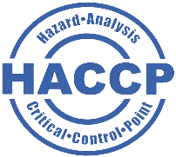

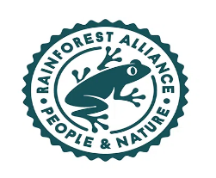




Kazi & Kazi Tea holds many International Certificates like NOP/ USDA, EU, JAS, Rainforest Alliance, Fair Trade, and HACCP as a proof of its 100% organic tea production.

Mayor Hsu, Chen-Wei of Hualien, Taiwan, honours Afra Abreshmi, a management trainee of Kazi & Kazi Tea Estate, with a token at the “2nd World Organic Youth Summit” hosted by IFOAM Organic Asia from September 13-15, 2023

3.2 Mission:
Promote organic farming: Kazi and Kazi are pioneers of organic tea cultivation in Bangladesh. They meticulously avoid harmful chemicals and pesticides, opting for natural methods like neem-based biopesticides and cow dung manure. This not only safeguards the environment but also ensures the highest quality tea with rich, natural flavors.
Empower local communities: The Kazi and Kazi tea estate provides much-needed jobs and economic opportunities for the underprivileged communities in Tetulia. They prioritize employing local workers, offering fair wages, and investing in skill development programs.
Share the magic of tea: Kazi and Kazi is passionate about sharing their love for tea with the world. They offer a diverse range of exquisite organic teas, from classic black and green varieties to invigorating herbal infusions.

3.3 Vision:
Become a global leader in organic tea: Kazi and Kazi aspire to be recognized as a benchmark for sustainable and ethical tea production. They aim to expand their reach and inspire others to adopt organic practices.
Transform Tetulia: Kazi and Kazi's vision extends beyond tea. They envision Tetulia as a thriving hub for organic agriculture, with a prosperous and empowered community.
Connect people through tea: Kazi and Kazi believe that tea has the power to connect people and cultures. They hope to foster a global community of tea lovers who appreciate the taste, tradition, and positive impact of their carefully crafted organic teas.

3.4 Product catagories:
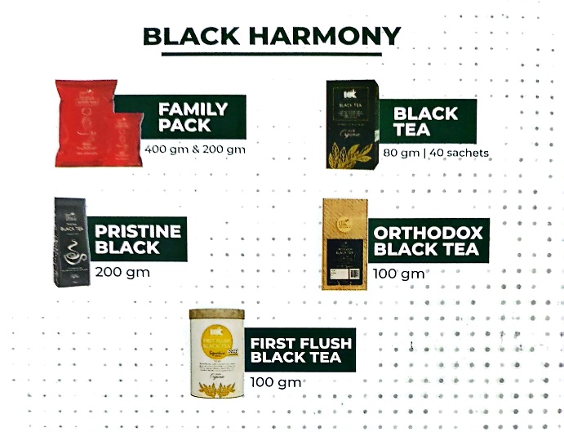

Kazi and Kazi offers a variety of tea products across several categories.
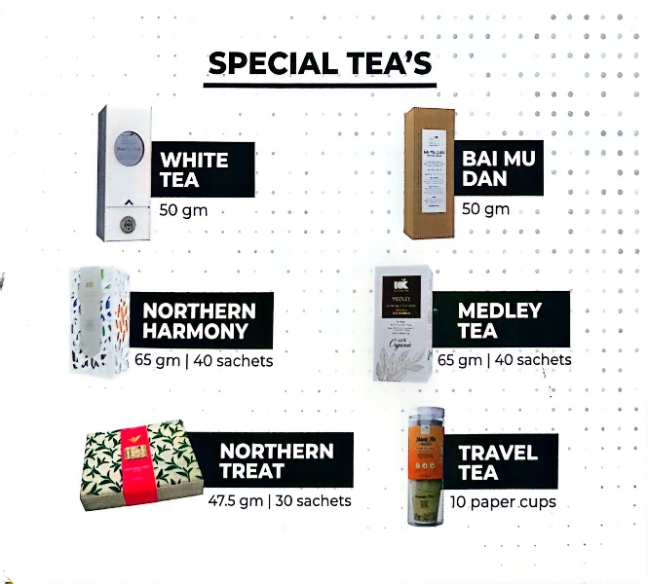
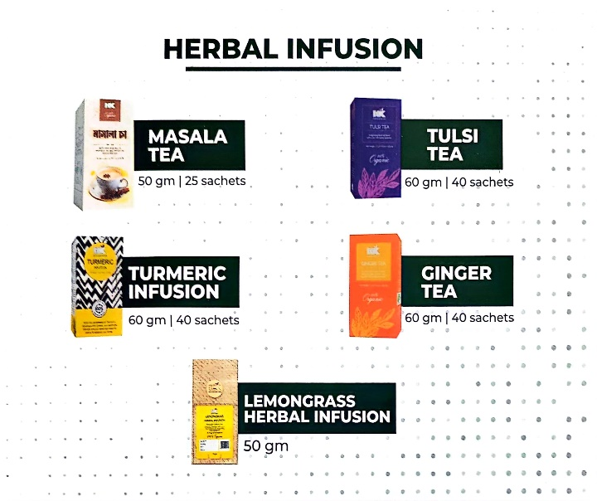

3.5 Sustainable Practices:
Kazi & Kazi Tea is dedicated to sustainable practices across its operations as an environmentally conscious company. The company prioritizes preserving biodiversity, employing organic farming techniques, and minimizing chemical usage. Additionally, Kazi & Kazi Tea is committed to ensuring fair wages and improved living standards for its tea workers and farmers by advocating for fair trade practices.
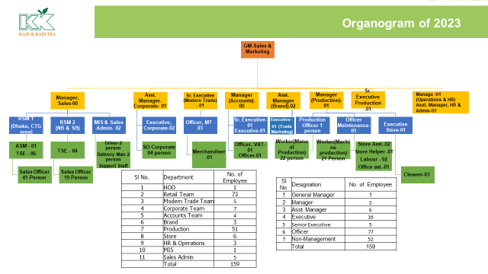
Organogram of Kazi & Kazi Tea Estate PU Ltd. 2023

3.6 Community Development:
The company may be involved in community development initiatives aimed at improving the quality of life for local communities. This could involve projects related to education, healthcare, infrastructure development, and other aspects that contribute to sustainable community development.

3.7 Employee Welfare:
Kazi and Kazi Tea Estate Ltd. might prioritize the welfare of their employees by providing fair wages, good working conditions, and opportunities for skill development and advancement. This not only contributes to the company's sustainability but also to the overall well-being of the workforce.

3.6 Corporate Social Responsibility (CSR):


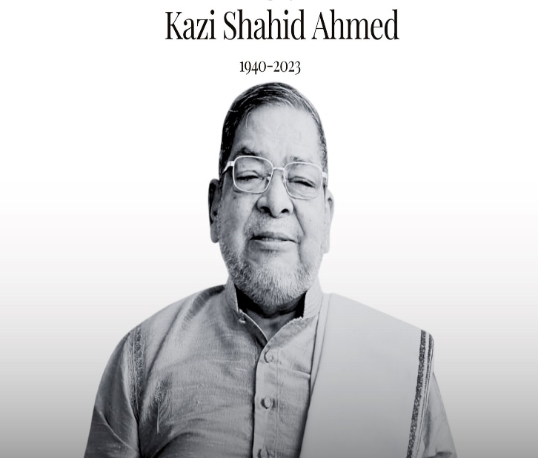
The Kazi Shahid Ahmed (KSF) Foundation serves as the CSR arm of the Gemcon Group. KSF was established by Kazi Shahid Ahmed, the leader of the Gemcon Group. It collaborates with Kazi & Kazi Tea Estate (KKTE), which is the first and only organic tea garden in the country. The goal of this collaboration is to promote rural electrification and improve the quality of life in the underdeveloped northern region where KKTE operates. Gemcon initially entered this remote area of the country to support the KKTE tea industry. Through KSF's infrastructure, which includes organic vegetable farming, biofertilizer production, organic tea harvesting, supply chain management, and educational initiatives, significant progress has been made in enhancing the assets and income of women in the area. The CSR programs of Kazi & Kazi Tea Estate Ltd. are focused on several key areas-
- KSF offers a unique cow loan program to improve the economic and social status of rural women in Panchagarh by providing them with cows. Beneficiaries repay the loan by selling milk and cow dung to KSF, thereby enhancing their economic well-being through contract dairy farming.
- Ten years ago, the University of Liberal Arts introduced the KSF Biogas program to beneficiaries, but there were issues with the brick-layered plants. KSF has since partnered with another organization to improve the program, offering benefits such as lower cooking costs, a steady supply of fertilizer, and eco-friendly maintenance.
- KSF has initiated organic tea plantations in Panchagarh to encourage local farmers to cultivate tea. The project covers 43.7 acres and has the potential for annual expansion.
- KSF has introduced organic vegetable farming in Panchagarh, providing financial capital, resources, and knowledge to support farmers in growing healthy food and reducing poverty by selling vegetables.
- Two learning centers called 'Kazi Shahid Shikhan Kendra' in Madhupur, Panchagarh district, have been established by KSF to create a nurturing environment for rural children, promoting education and basic skills development for those without access to formal education.

3.7 Community:

Kazi & Kazi Tea Estate is no ordinary tea garden. Starting in 2000 to give back to community, they sought an enterprise that would give the most people a living wage while protecting/strengthening the environment. Not content with the social programs already in place, their Cooperative (KSF)has established a revolutionary way of serving the community.

Co-operative:
The Dairy farm co-operative started in August 2005. The co-operative is open not for the workers of the tea garden but also for the neighbors. Each member receives a milking cow which they pay back not in cash, but with milk and cow dung. This “barter” form of payback takes away the pressure of cash payments, making the co-op a very attractive scheme.
This program offered a unique form of supply for the company while offering real economic benefits to the farmers. It has demonstrated the impact that building direct linkages at the supply end can have, in terms of raising living standards for the poor and securing resources essential to the core.
Fahima Begum – The Pursuit of a Dream:
Fahima dreamed of a decent house, but her husband struggled to meet the family’s basic needs. So, with a desire to help her family, Fahima joined the KKTE Dairy Cooperative in 2005. She took the ‘loan’ of a milking cow and sold the milk in the village market, and cow dung back to the garden. With the success of her first venture, she loaned more cows, and today she is the proud owner of a house made of brick walls, with a proper kitchen and sanitation. Both of her children now attend primary school and her home is lit by solar power. She has finally attained the home of her dreams; her “Shopper Bari”. Every time you take a sip of KK tea, you help an entire community live better.

Chapter: 4

Analysis
In this chapter, we'll learn how Kazi & Kazi Tea Estate Ltd. maintain employee relation and with that how it’ll impact on the engagement as well as performance and other details.
Employee relations and engagement play a crucial role in enhancing the performance of Kazi and Kazi Tea Estate Ltd. Here are some ways in which they are contribute to the company's success:
Employee relations activities at Kazi and Kazi Tea Estate Ltd. likely encompass a range of initiatives aimed at fostering positive relationships between the organization and its employees.
4.1 Communication Channels:
Kazi & Kazi Tea Estate establishing effective communication channels to ensure that employees are informed about company policies, updates, and changes. This includes regular newsletters, meetings, and digital communication platforms. Also Kazi & Kazi Tea implement multiple initiatives aimed at enhancing employee engagement, such as maintaining open lines of communication like tea/coffee invitation in every month, organizing team-building activities, and running programs to recognize staff members. They host various events and activities, like celebrating birthdays, delivering motivational speeches at the start of the workday, holding annual picnic and culture program, providing platforms for sharing ideas, and rewarding outstanding performance.
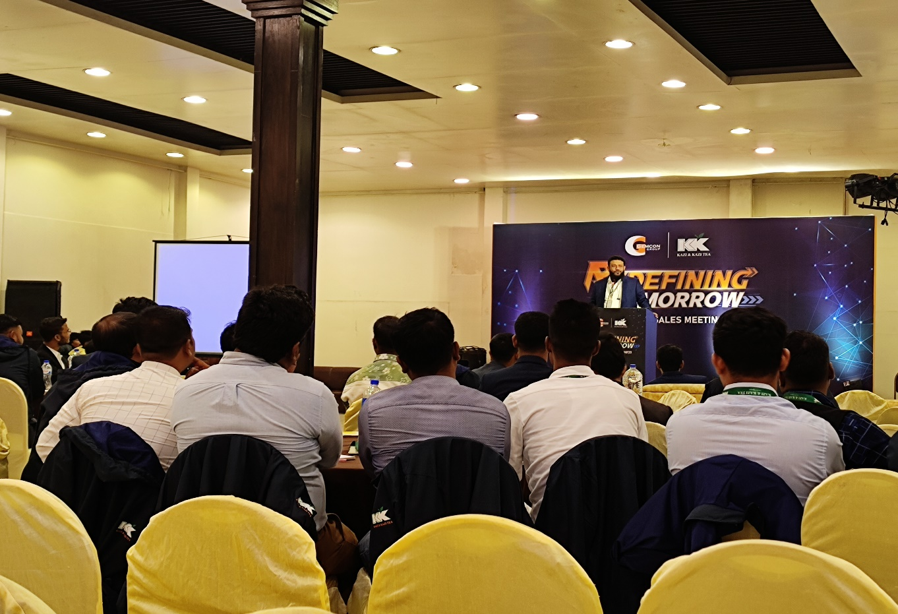
S.M.M Ibrahim Mahmud – General Manager of KKTea give motivational speeches, discussions on leadership, followership, and significance of people of Kazi & Kazi Tea Estate Ltd. at National Sales Conference “REDEFINING TOMMOROW” 2023.

4.2 Employee Feedback Mechanisms:
Implementing systems for gathering feedback from employees about their work environment, concerns, and suggestions for improvement. Kazi & Kazi Tea has done through surveys, regular feedback sessions, conferences, meetings such as they’ve arranged a monthly Retail Sales Conference, Modern Trade Sales meeting where they get a feedback about their work, discussion about their monthly report and open discussions with employees for their future improvement.
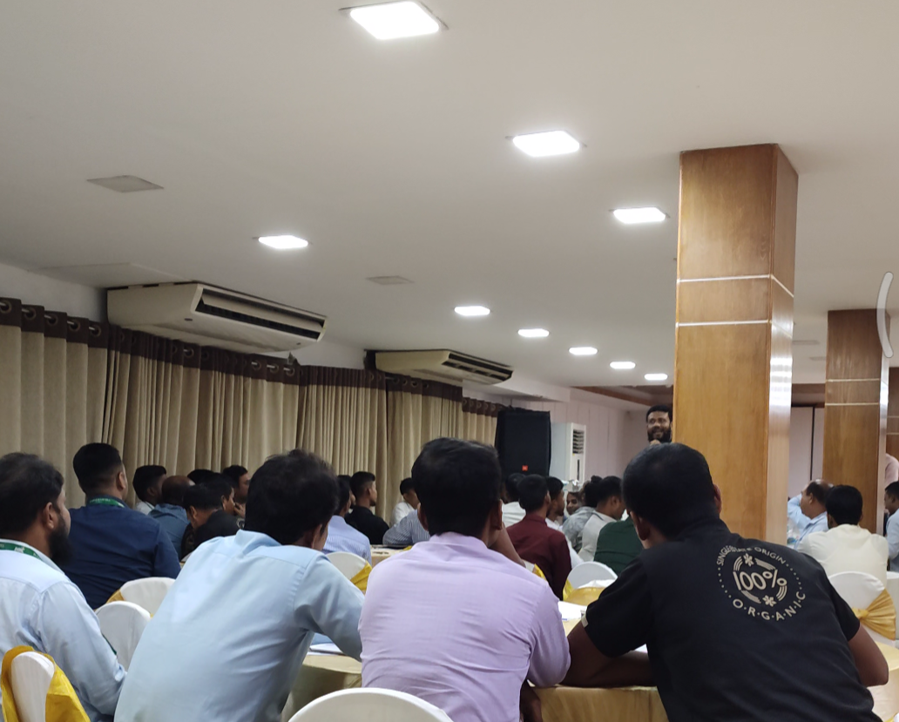
Monthly Retail Sales Conference

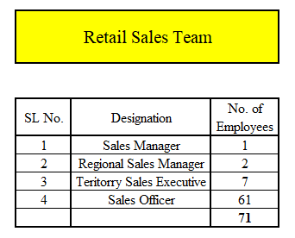
Figure - 1
According on Figure 1, the current data indicates that the last sales conference in 2024 was attended by 1 Sales Manager, 2 Regional Sales Managers, 7 Territory Sales Executives, and 61 Sales Officers from the retail sales team. Individuals from different areas of the country participate in this conference, during which they review monthly reports, receive feedback, and plan for the upcoming month.

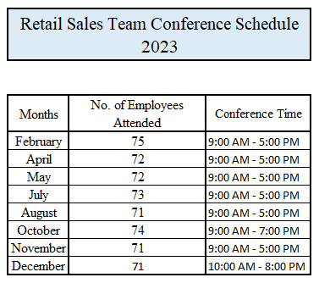
Figure – 2
According to Figure 2, Kazi & Kazi Tea Estate Limited arranges a total of 8 sales conferences in a year. Among these conferences, there is one held in December known as the Annual Sales Conference, where the sales report for the entire year is discussed, and plans for the next year are made.
4.3 Employee Recognition Programs:
Implementing programs to recognize and reward employees for their contributions and achievements. Kazi & KAzi Tea have served to boost morale and motivation within the workforce.

Corporate sales team gets their “Performance Excellence Award 2023” as Bangkok Trip at Annual Sales Conference “REDEFINING TOMMOROW’ 2023

4.4 Training and Development:
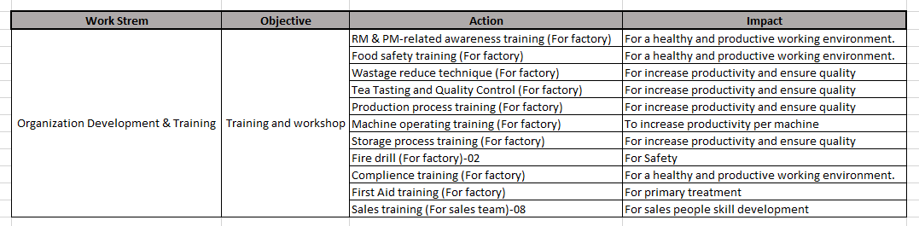
The training and development initiatives at Kazi and Kazi Tea Estate Ltd. are likely designed to enhance the skills, knowledge, and capabilities of its workforce. HR Providing the staff opportunities for employee skill development and career advancement through training programs, workshops, and mentorship initiatives. Devoting in staff development has resulted in improved productivity, enhanced product quality, and increased innovation within the factory. Initially, an analysis of training needs is conducted to identify areas for improvement. Subsequently, an annual training calendar is created based on these needs, and training sessions are scheduled accordingly. After two months of training, feedback on the output is collected, and an orientation program is organized to demonstrate the workers' progress in performance and their understanding of the work environment. This process ensures continuous improvement and development among the workers.

4.5 Improved Productivity:
Positive employee relations and high engagement levels often lead to increased productivity among workers. When employees feel valued and motivated, they are more likely to put in their best effort, leading to higher output and efficiency in tea production.
These activities are designed to create a positive work environment, foster strong relationships between employees and management, and ultimately contribute to the overall success of Kazi and Kazi Tea Estate Ltd. by focusing on employee engagement, Kazi and Kazi Tea create a work environment where employees are motivated, healthy, and committed, leading to improved productivity and reduced absenteeism.

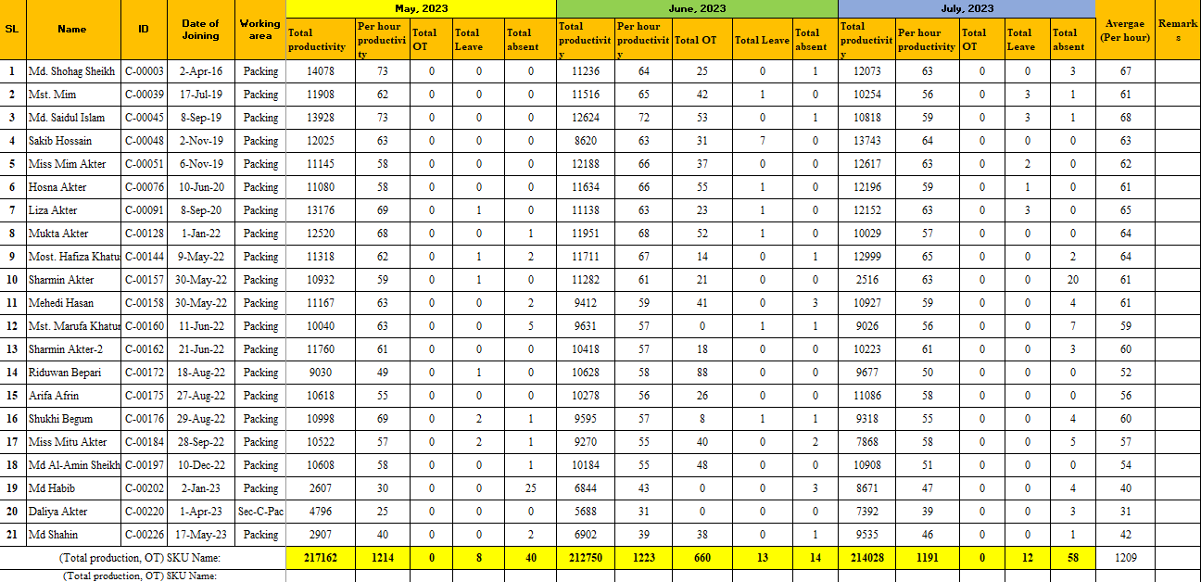
Productivity of Box Quarterly (May, June, July) - 2023 Analysis of Packing Unit

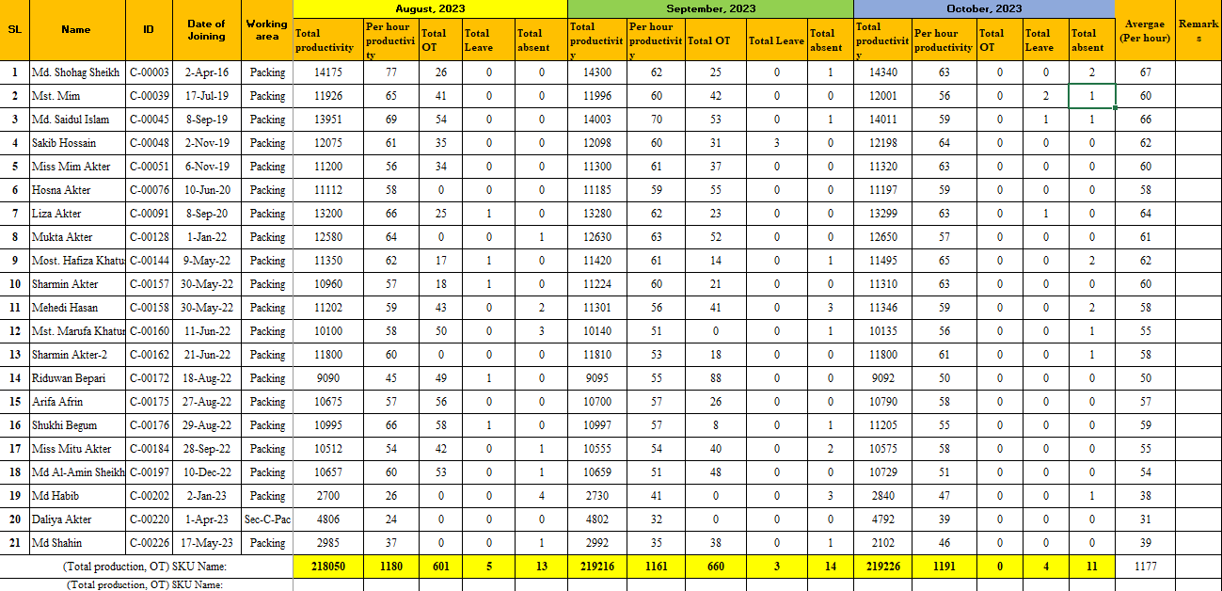
Productivity of Box Quarterly (August, September, October) - 2023 Analysis of Packing Unit

Here, above these two figures, we can see an analysis of Total Productivity, Per Hour Productivity, Total Overtime, Total Leave, and Total Absenteeism on a quarterly basis. Comparing the months of May, June, and July with the months of August, September, and October, it is found that productivity increased during August, September, and October, while absenteeism decreased.
4.6 Enhanced Employee Satisfaction:
Strong employee relations and engagement at Kazi and Kazi Tea Estate Ltd. are key to boosting job satisfaction and reducing turnover rates. Open and transparent communication is a hallmark of good employee relations, making employees feel valued and heard. The company are foster this through regular team meetings, feedback sessions, and accessible management. Additionally, providing opportunities for growth and development, such as training programs and clear career paths, demonstrates the company's investment in its employees' long-term success and well-being.
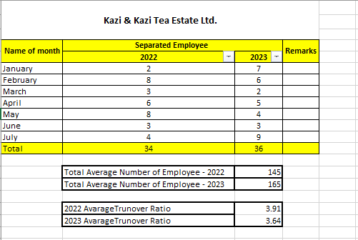
Kazi & Kazi Tea Estate Ltd. 2022 & 2023, 6 Months Average Turnover Ratio

Employee turnover are costly for an organization, as it often requires resources to recruit, hire, and train new employees. Moreover, it can lead to a loss of institutional knowledge and experience, decreased morale among remaining employees, and potentially lower productivity.
The company always tries different strategies for the betterment of its employees and enhances their engagement and performance by maintaining good and positive relationships with them. This fosters reduced turnover, ultimately leading to a more stable and productive workforce.
The figure above indicates a two-year average employee turnover ratio for the company. In 2022, the turnover ratio was 3.91, which decreased to 3.64 in 2023.

4.7 ABP (Annual Business Plan):
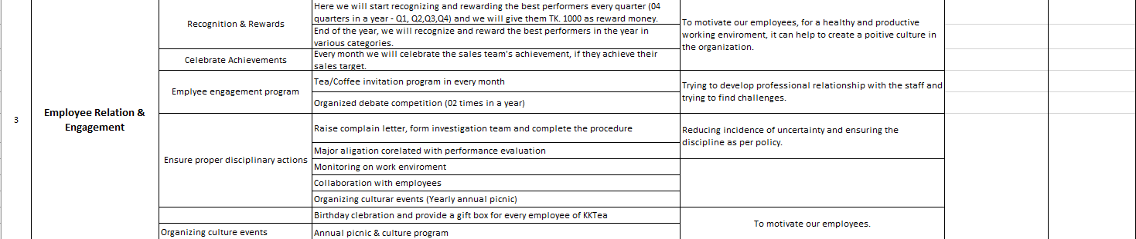
ABP 2023/2024 of Kazi & Kazi Tea Estate Ltd. for Employee Relation & Engagement

Creating an Annual Business Plan (ABP) for 2024 for Kazi and Kazi Tea Estate Ltd. focused on employee relations and engagement involve outlining specific strategies and initiatives to enhance the company's employee relations and engagement practices.
The analysis of the internship report as a whole emphasizes how important HR is to employee relations and engagement at Kazi and Kazi Tea. To demonstrate their significant contribution to performance optimization, quality tea production, and a positive work environment, the organization supports the HR department's planning, recruitment and selection, training and development, employee engagement, performance management, health and safety, and continuous improvement initiatives.

Chapter: 5

Findings, Conclusion and Recommendations.

5.1 Findings:

- It has been observed during the workforce planning process that there are two distinct times of the year when the turnover rate is highest. During these two Eid festivals, there is often a high percentage of employee turnover, which makes workforce planning challenging.
- As mentioned in the analysis section, there is currently no written policy that comprehensively covers the recruitment and selection process for all employees. Consequently, the absence of strict guidelines often results in miscommunication and complicates the procedures involved in recruitment and selection.
- The rate of internal promotions to fill vacant positions is relatively low.
- When hiring new employees, the majority of CVs come from internal sources. Outsiders therefore have less knowledge about recruitment.
- While the company possesses a website and a Human Resource Information System (HRIS) database, both are not well-maintained and suffer from slow performance. Employees sometimes meet difficulties in accessing information from these websites and databases, and the recruitment database systems are outdated.
- The job posting does not specify the salary range. The inclusion of the wage structure in the advertisement simplifies the process as there is no requirement to negotiate the salary with the applicant, saving time.

5.2 Recommendations:

- HR can focus on developing an effective succession planning strategy to enable an easy transition of skilled employees into key positions while reducing the possibility of a talent shortage. With the high rate of turnover in the later half of the year, backup plans are beneficial. It's also beneficial to keep the internal promotion ratio balanced.
- Foster work-life balance by flexible work arrangements, childcare support, and employee wellness programs. These initiatives can add to a more satisfied and productive workforce, as employees feel valued and supported in both their professional and personal lives.
- There should be a written test policy for all candidates covering the "Recruitment and Selection" procedure because it will ensure a standardized and fair evaluation process. Such a policy helps in objectively assessing candidates' skills, knowledge, and suitability for the position. Also, it provides a structured approach to evaluating candidates, which can lead to better hiring decisions.
- The job posting should clearly outline the pay scale. Many individuals are unfamiliar with the salary structure of companies, and at times, they apply for positions based solely on the advertised salary. This practice often results in Kazi & Kazi Tea Estate Ltd. losing out on valuable and skilled employees.
- HR should look into and implement technology solutions, such as employee self-service portals and HR management systems, to optimize data analytics, accelerate HR procedures, and boost overall efficiency such as by assess current processes evaluate existing HR processes to identify areas where technology can improve efficiency and data management,
by customize the chosen technology solutions to fit the organization's specific requirements and implement them across the HR department. Train Employees by Provide comprehensive training to HR staff and employees on how to use the new technology effectively.
Strong employee relations and engagement are crucial for driving performance at Kazi and Kazi Tea Estate Ltd. By implementing the recommended strategies, the company can further enhance employee satisfaction, motivation, and commitment, ultimately leading to increased productivity, quality, and long-term success.

5.3 Conclusion:

The results indicate that HR at Kazi & Kazi Tea Estate Ltd. is vital in improving industrial operations and employee performance through successful employee relations and engagement. To optimize productivity and engagement and reduce operational disruptions, HR strategically oversees the workforce, aiming to cultivate positive relationships, boost employee engagement, and enhance overall performance.
HR provides employees with the necessary training and skills to adapt to new technologies and increase productivity through talent development initiatives. Additionally, HR promotes a positive work environment that inspires employees to perform at their highest level, thereby enhancing their work efficiency.
Throughout my internship, I observed several issues within the process that are impeding its overall effectiveness. In this internship report, I have endeavored to thoroughly describe how employee relations and engagement contribute to performance enhancement at Kazi & Kazi Tea Estate Ltd. I have applied my knowledge from HR courses and attempted to align it with the company's approaches, procedures, and systems.
I am privileged to have the opportunity to work for Kazi and Kazi Tea Estate Ltd. The company claims exceptional employees who offer excellent services, creating a welcoming yet structured work environment. Their established reputation allows employees to carry out their tasks in an organized and comfortable workplace. The management is highly communicative, cooperative, and friendly.

Appendix

Bibliography
Ackers, , P. & Wilkinson, , A., 2019. Understanding employment relations. 2nd ed. s.l.:Oxford University Press.
Albrecht, S. L., 2010. Handbook of employee engagement: Perspectives, issues, research and practice.. s.l.:Edward Elgar Publishing.
Armstrong, M., 2017. Armstrong's handbook of human resource management practice. s.l.:Kogan Page Publishers.
Bakker, A. B. & Demerouti, E., 2008. Towards a model of work engagement.. Career Development International, 9 May, 13(3), pp. 209-223.
Boxall, P. & Purcell, J., 2008. Strategy and Human Resource Management. 2nd ed. New York: Palgrave Macmillan.
Budd, J. W., 2018. Labor relations: Striking a balance. 6th ed. s.l.:McGraw-Hill Education.
Farnham , D., 2014. Employee Relations in Context. s.l.:s.n.
Gennard, J. & Judge,, G., 2018. Employee relations.. s.l.:Chartered Institute of Personnel and Development..
Gennard, J. & Judge, G., 2005. Employee Relations. 4th ed. s.l.:CIPD Publishing.
Gollan, P. J., 2018. oice and involvement at work: Experience with non-union representation. Routledge.. s.l.:s.n.
Guest, D. E., 2017. Human resource management and employee well-being: Towards a new analytic framework. Human Resource Management Journal, 16 February, 27(1), pp. 22-38.
Harter, J. K., Schmidt, F. L. & Hayes, T. L., 2002. Business-unit-level relationship between employee satisfaction, employee engagement, and business outcomes: A meta-analysis. Journal of Applied Psychology, 87(2), pp. 268-279..
Kahn, W., 1990. Psychological conditions of personal engagement and disengagement at work.. Academy of Management Journal, 33(4), pp. 692-724.
Macey, W. H. & Schneider, B., 2008. The Meaning of Employee Engagement. 1(1), pp. 3-30.
Saks, A. M., 2006. Antecedents and consequences of employee engagement. Journal of Managerial Psychology, 1 October, 21(7), pp. 600-619.
Wilkinson, . A., 2014. The changing landscape of employment relations. s.l.:Oxford University Press.

Questionnaire:
Name: | Designation: | Department:

- How the organization and the engagement levels of line managers significantly influence performance evaluation?
- Do you feel fulfilled by your work?
- Do you feel that your role is meaningful within the organization?
- Do the organization’s vision and values inspire you?
- Do you receive recognition for your work?
- Do you feel valued and appreciated at work?
- Do you feel like your manager is invested in your success?
- Do you feel that there are professional development opportunities available to you?
- Do you plan to stay with the organization for another 2 years? 5 years? Longer?
- Would you recommend this organization as a good place to work?

