

INTERNSHIP REPORT
On Human Resource Management Practices of the City Bank Limited
An Internship Report Presented to The Faculty of Business Administration in Partial Fulfillment of the Requirements for the Degree of Bachelor of Business Administration.

Supervised By:
Md. Abul Mohaimen
Assistant Professor
School of Business and Economics
United International University
Submitted By:
Mithila Salmin
ID: 111 131 391
Major in Human Resource Management (BBA)
Date of Submission: 6/5/2018

Internship Report on:
Human Resource Practices of the City Bank Limited
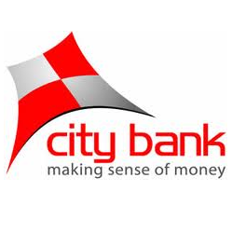

Letter of Transmittal
Md. Abul Mohaimen
Assistant Professor
School of Business and Economics
United International University
Subject: Submission of Internship Report on Human Resource Management Practices of City Bank Limited.
Dear Sir,
It is privilege to let you know, I have just performed my internship program in the City Bank Limited. I have to prepare a report based on my practical experience. This report focuses on human resource management practices of the City Bank limited.
I am very glad to submit the report; I would like to say that this report is very helpful for me to gather real life experience about whole job activities performed in a bank. I also came to know that how to handle customers and provide service to them. I have tried my level best to gather all kinds of relevant information, which could give me overall concept of this report. I hope that it will meet my expected standard.
I’m submitting this report for your kind consideration and thanking you for your constant assistance and guidance. I’m hoping that you will be glad to receive my report and oblige me.
Sincerely Yours,
------------------------
Mithila Salmin
ID: 111 131 391
Major in HRM
School of Business and Economics

Acknowledgement
At first, I might want to offer my thanks to the almighty to enable me the quality and chance to finish the report in the planned time effectively. This is a selective occurrence of corporate life I passed and delighted throughout my internship period, which helped me to set up this report. Finishing of anything requires underpins from different sources. I am especially lucky to get earnest direction and supervision from various individuals. At the very beginning, I am very pleased to successfully complete my internship in the City Bank limited.
Then I want to take this opportunity to express my profound gratitude and deep regards to my honorable faculty Md. Abul Mohaimen, Assistant Professor, Department of Business Administration, United International University, for his exemplary guidance, monitoring and constant encouragement throughout the report. The blessing, help and guidance given by him time to time shall carry me to take a long way in the journey of life on which I am about to embark. Without his continuous support and suggestion, I can’t prepare this report.
I am really thankful to the executives of CBL who have expanded full collaboration in the time of my internship. I want to give thanks to Bilkis Akther (SAVP & Branch Manager), Awal Mia (AVP and BOM), Sheeny Proshun Aunu (SVP and CSM), Nurun Nahar (ACSM), Md Abul Kalam Azad(RM).

I thank them all from the core of my heart.

Contents
1.0: Introduction 3
1.1: Origin of the report 3
1.2: Statement of the problem: 4
1.3 objectives of the report 5
1.4: Scope of the study: 5
1.5 Limitations of the study: 6
1.6 Methodology: 6
1.6.1 Data collection technique: 7
1.6.2 Sampling 7
• Population 7
• Sampling unit 7
• Sample size 7
• Sample Design 7
• Questionnaire Design 8
1.7 Abbreviation 8
2.0: BACKGROUND OF THE COMPANY 10
2.1 iNTRODUCTION 10
2.2 Mission, Vision and core Values of CBL 11
Mission: 11
Vision: 11
2.3 Objectives of the city bank 11
2.4 Banking Activities of city bank limited 11
2.4.1 Strategies of City Bank limited 11
2.5 Organogram of the city bank limited 12
2.6 Products and services of CBL 13
2.6.1 Departmental activities of CBL 13
2.7 Future Plan for upgrading product and services of CBL 14
3.1 Introduction of Human resource management 17
3.1.1 Objectives of HRM 18
3.1.2 PRINCIPALS OF HUMAN RESOURCE MANAGEMENT 19
3.2 Employee of the city bank limited 19
3.3 HUMAN RESOURCE MANAGEMENT PRACTICE OF THE CITY BANK LIMITED: 21
3.3.1 The City Bank Ltd. Human Resource Department: 21
3.3.2 Recruitment policy of cbl 22
3.3.3 Training and development program of CBL 24
3.3.4. Compensation administration of CBL 26
3.3.5 Leave 28
3.3.6 Promotional practices of cbl 29
3.3.7 Performance Appraisal policies 30
4.1 SWOT Analysis of the City Bank Limited 33
4.1.1 Strength 33
4.1.2 Weakness 33
4.1.3 Opportunity 34
4.1.4: Threat: 35
4.2: Core Financial Findings of City Bank, Pallabi Branch: 36
4.3 Findings of the study 38
4.3.1 Questionnaire analysis 38
4.3.2 Major findings 48
Recommendations 50
Conclusion 51
Reference 52
Questionnaire 53

Executive Summary
The City Bank Limited is a well-known private business bank that is working efficiently in the Bangladesh banking industry. City bank is putting forth an exceptionally customized and amicable client benefit. They examine what contemporary needs of the client and offer the administrations that best suit to them.
After completion of twelve semester of BBA program of department of Business Administration, United International University, I have completed my internship in the City Bank limited, one of the largest and renown commercial bank in Bangladesh. The objective was to analyze the human resource practices of city bank, how they deal with their customer, customer’s satisfaction level, the bank’s capability to recover load during stipulated time and the management efficiency.
The key purpose of the report has been to generate a practical understanding of the human resource practices of City Bank LTD. This report has been divided into five different chapters which I have learned and observed during my whole internship period.
Chapter one is based on the introduction which includes topics like importance of banking in Bangladesh, banking industry of Bangladesh, origin of the report, objectives of the report, methodology and limitation of the study.
Chapter two states a brief background of the banking industry and about City Bank limited. It also includes the overall banking activities, and operational processes. The product and service description also portrait in this chapter.
Chapter three is all about the theoretical analyses of City Bank Limited. This chapter includes theoretical overview of over all human resource management and its objectives. In this chapter I tried to focus on overall HRM practices of the City bank limited, it’s HR departmental activities and employee’s behavior and outcomes regarding this.
Chapter four portraits the analysis of the questionnaire and interpretation of each result which I have surveyed on the employees of CBL. This chapter also includes the major findings.
Finally, chapter five signifies the recommendation and summaries the study by giving conclusion.

Chapter- o1

Introduction of the report

1.0: Introduction
The City Bank Limited is a full administration booked business bank. It contains mutually neighborhood and Universal Institutional investors. This is basically determined with a perspective of making openings and seeking after-market specialties not generally meet by traditional banks. The City Bank has been persuaded to give "best-in-the-class" administrations to its different collection of clients spread the nation over under an on-line managing an account.
Today, The City Bank is one of the quickest developing banks in the nation. Keeping in mind the end goal to help the arranged development of its appropriation, system and its different business portions, The City Bank is as of now searching for great objective situated, excited, people for different business tasks.
The bank needs to construct a beneficial and socially dependable budgetary establishment. It painstakingly tunes in to the market and business possibilities, it is additionally helping The City Bank and partners to construct a dynamic, sound, vote based and destitution free Bangladesh.
The internship program of BBA is a requirement to take a taste of real life challenge conducted by the intern. This program is for 3-month duration. The period for this program was from 18th January, 2018 to 18th April, 2018. During this period, I have worked closely with the employees of The City Bank Limited. This report presents the outcomes of the study during the internship of The City Bank Limited (The City Bank Limited, 2012)

1.1: Origin of the report

In the focused worldwide time, classroom preparing just suits to help a graduate into a work by exhibiting a degree, nonetheless, internship program impacts the theories and taught cases to concrete by putting the understudy in a credible all-consuming purpose circumstance performing real expert undertakings, which the activity includes. For this internship, the report has made required for all Business graduates of United International University, as a part of the BBA program, every one of the students need to encounter this internship program with a motivation behind increasing down to earth understanding about the advanced corporate era. The program covers a time of three months of authoritative connection. After the fulfillment of whole period, every student needs to present their report.
As the requirements of BBA program, I have prepared this report on “Human Resource Management practices of The City Bank Limited”. My supervisor Md. Abul Mohaimen, assistant professor of school of business and economics, United International University assigned this topic.

1.2: Statement of the problem:

The main topic is the HR practices conduct or follow in The City Bank. The study is focusing on the main platform of HR regarding in banking sector, how they manage their personnel, how they structured their HR steps, how they motivate their employee and what is their overall situation.
All of those were the key point of the study. While researching or following the HR policies of HR policies many of the points or the steps have been looked away or may not be a concern for that respective branch. It may result an incomplete scenario of the CITY Bank HR. Apart of it the overall focus was remain concrete.

1.3 objectives of the report
The main objective of this report is to obtain the reasonable and practical of knowledge of banking structure and HR exercises. The broad objective and specific objectives of making this report are given below:
Broad objective:
- The broad objective of this study is to be familiar with the working environment of present institutions, know the internal culture of the corporate world, and fulfill the requirements of BBA theoretical knowledge gained from the coursework of the BBA program in a specific field.

Specific objectives:
- To understand and analyze the overall human resource activities of City Bank Limited.
- To evaluate the existing activities and techniques of City Bank Limited.
- To study the human resource efficiency of City Bank Limited.
- To fine out the strength and weakness involved with City Bank Limited.
- To suggest the way and means for improvement on policy and techniques.
- To relate the theoretical learning with the real life situation.
- To gain knowledge about the human resource activities and functions of General Banking, Foreign Exchange and Investment section.

1.4: Scope of the study:
The overall financial circumstance propagated to represent the antagonistic effect on most creating nations including Bangladesh testing the likelihood of enlisting a positive amplification. Managing an account framework holds a weighty position in a country's economy. It assumes a critical part in the monetary headway of a nation and shapes the focal piece of a money related market in an exceedingly created nation. City Bank Limited is completing an imposing activity. So far specialists have an exceptionally solid extension to diagram the entire framework. This report covers the general human asset practices of City Bank Limited and gives the essential thought of HR exercises of general banking sector. The planning of this report offers an incredible chance to have a top to bottom insight of saving money exercises rehearsed by the bank. This study has made predicated on the practical knowledge aggregated amid the time of 3 months' internship program.

1.5 Limitations of the study:
To give latest data and to influence this answer to peruse commendable, bolster from different sources is fundamental. Notwithstanding having my wholehearted exertion, I couldn't gather some data required at the season of the examination. Therefore, this study also contains some limitations. Some limitations and problems are discussing below:
- Learning general exercises and execution of an organization inside 3 months is extremely troublesome.
- Lack of proper knowledge about modern HR practices.
- Being a temporary individual of the bank, it was difficult on my part to express a portion of the touchy issues.
- The concerned employees did not give enough time because of surge keeping money hours. Thus, I confronted a few issues to comprehend few purposes of particular errands.
- Bank’s website does not contain latest year’s data and info.

1.6 Methodology:

The research is descriptive type. This briefly discloses the proper human resource management practices of the City Bank Limited. In order to meet the objectives of the study, it has been administrated by both Formal & oral discussion, direct observation, and bank website was useful to make this report. Both primary and secondary sources have been used.

1.6.1 Data collection technique:
The data are collected from two sources:
I. Primary sources:
- Discussion with the personnel of The City Bank Limited.
- Casual interview and individual discussion with employees.
- Personal observation on the activities of HR department.
II. Secondary sources:
- Annual report, publications, training materials
- Periodical statements of the bank, brochures, booklets etc.
- Official Website of the City Bank Ltd.
- Documentary file of the City Bank Ltd.

1.6.2 Sampling
Sample plan is definite plan for obtaining a sample from a given population.

Population
All the employees of The City Bank Limited have been considered as the population of the study.

Sampling unit
Employees who is working in organization

Sample size
Total sample size was 30 employees.

Sample Design
The non-probability convenience sampling procedure is used in survey to collect the information and make this report accurately.

Questionnaire Design
Questionnaire was prepared with closed ended questions. The average time of questioning is 15 -20 minutes. The nature of the questions used in the questionnaire is dichotomy with determinant choice questions and Likert scale questions.

1.7 Abbreviation

CBL= City Bank Limited
HR= Human Resource
LC= Letter of Credit
RR= Retention Ratio

Chapter- 02

Overview of the city bank limited

2.0: BACKGROUND OF THE COMPANY

2.1 iNTRODUCTION
Since liberation, Bangladesh went through delicate periods of advancement in keeping money segment. The nationalization of banks in the position freedom period planned for spare the establishments and the enthusiasm of the investors.
CBL is Bangladesh's leading private division bank. The Bank has worked since 1983 with an approved capital. 1.75 billion under the leadership of twelve leading specialists and leaders of the nation. The respectable will behind the beginning of this bank was the recognition of subjective changes in keeping money and budgeting. Today the Bank of the City serves its clients in the country and abroad with 78 branches distributed throughout the country and around 300 overseas correspondents covering all the main urban areas and business purpose of meeting the world.
The bank at the present time has 99 online branches and 1 SME advantage centers and 11 SME/Agri branch spread over the length and broadness of the country that consolidates a totally fledged Islamic Keeping cash branch. Other than these traditional movement centers, the bank is in like manner especially powerful in the elective transport zone. Recently it has 294 ATMs of its own; and ATM giving strategy to an associate bank that has more than 1150 ATMs set up; SMS Saving cash.
CBL is in charge of all tasks coordinating the issuing of the new MasterCard’s, contains journal, client benefit, credit administration and charge approvals, and showcasing the cards in country. City Bank additionally presented elite benefits to the card individuals under the Amex chooses project of Bangladesh. It additionally gives exceptional points of interest everywhere throughout the world with in excess of 12500 applications at more than 9500 vendors in 88 nations (The City Bank Limited, 2012).

2.2 Mission, Vision and core Values of CBL

Mission:
- To contribute to the financial improvement.
- To accomplish largest amount of consumer loyalty through augmentation of administrations by committed a motivated group of experts.
- To keep up continuous development of share market guaranteeing Quality.
- To expand bank's benefits by guaranteeing its steady development.
- To assure contributing administration framework and strengthening of Human Resources.

Vision:
To be the leading bank in the country with best practices and highest social commitment.

2.3 Objectives of the city bank
The major objective of The CBL is to generate a solid financial base, to acquire a decent benefit and pay an attractive profit to respectable Shareholders, to accomplish the goals, the bank works for enhancing the nature of bank's advantages by distinguishing potential great borrowers. What's more, influence the customers to open a record in the bank through their mind and knowledge and also is to keep up the notoriety through their client administrations arranged offices. To accomplish this coveted objective, it has the aim to the quest for magnificence in the atmosphere of persistent change. Since it trusts the line of greatness is ceaseless, it additionally trusts that its vital plans and business will its quality in a focused domain. Its proverb is to give each and every client administration accessible in the present managing an account strategy for their customers (Mission, Vision statement, CBL, 2012).

2.4 Banking Activities of city bank limited

2.4.1 Strategies of City Bank limited
CBL has faith in the act of Market-arranged Strategic arranging, creating and keeping up a reasonable fit between the association's goals, abilities, and assets. The purpose of such approach is to administrate the banks business and organizations with the objective that return set advantages and improvement. CBL believes in 2 corporate strategies which are given below:
- Location Based strategy
- Business Level Strategy

2.5 Organogram of the city bank limited

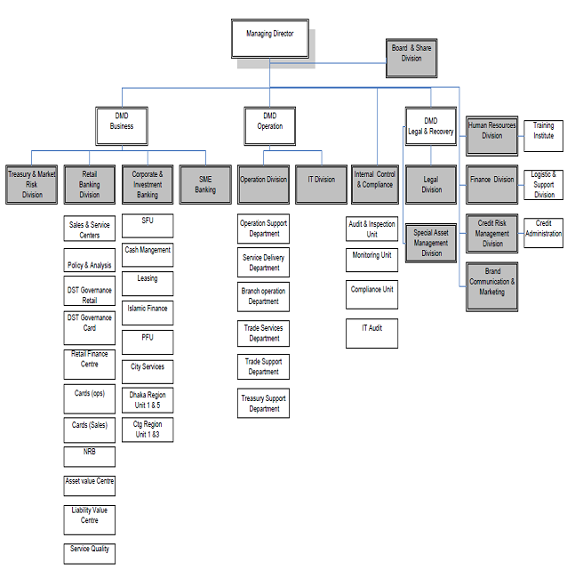

Figure 1: Organogram of The City Bank Limited (The City Bank Limited, 2012)

2.6 Products and services of CBL

The bank launched several financial products and services since its inception. Among them are:
1. Corporate & Investment Banking
2. Retail Banking
3. SME Banking
4. Treasury & Market Risks
5. Islamic Banking
6. Internet Banking

2.6.1 Departmental activities of CBL

The branches of the City Bank limited has all the required segments of the general keeping money and this segment keep running by labor with excellent managing an account information. Thus a touch of rich client benefit is winning in the branch. General keeping money of this branch comprises of various segments, specifically account opening area, checkbook issue, exchange of record, shutting of record, settlement segment, web based saving money, clearing and bills segment, money segment, information passage segment and so on.
- Account opening section
As per the law and practice, the investor client connection emerges just from the contact between the two. Furthermore, opening a record is the agreements that build up the connection between a broker and a client. So this area pays an indispensable part in pulling in client and consequently ought to be taken care of with additional care.
- Remittance
Clients of a bank need to exchange his store or cash to anyplace inside the nation they can do it through the settlement area of the bank settlement segment of general keeping money manages just nearby settlements. Amid my temporary position I have spectator in my branch manages three kinds of nearby settlements.
- Cash section
Cash is the most fluid resource and it ought to be bargain painstakingly. So this division is extremely given with escalated mind. This office begins the day with trade out vault. All money receipts and installments are made through this division. Money officer starts their exchange with taking cash from the vault, known as the opening money adjust. Vault is kept in an extremely secured room. Keys of the room are monitored money officer and Branch Operation Manager. The measure of opening money adjust is gone into an enroll. After entire days' exchange overflow of the cash stays in the money counter is returned in the vault and known as the end adjust. Cash is gotten and paid in this segment.
1.Cash Receipt: Depositors deposit money in their account through this segment by deposit slip. This segment likewise gets money from client for opening pay arrange, bank draft wire exchange and so forth this banks all money receipts are taken by this division.
2.Cash Payment: This segment acknowledges the cheque from the contributors for installment in real money. Subsequent to getting cheque first the check is examined whether it is a substantial one. Money officer judges the sum both in figure and word date of the check and mark and so on then at long last approved officer contrasts the mark on the cheque and the example mark, and check whether the adjust in the record is adequate (Report, Prime operational area of the bank, 2016, pp 19-20).

2.7 Future Plan for upgrading product and services of CBL
The City Bank Limited needs to wind up the most favored bank to by and large the nation. They need to give their clients the best in class administrations, inventive items and budgetary arrangements from brilliant outlets-all with huge grins that pass on and create best administration. In accordance with the bank's technique of making administrations more open to clients. CBL is intending to dispatch appropriate managing an account administrations and business in all branches. All branches of the bank will be brought under deals and administrations display centering retail saving money business while offering administrations to every other client of various specialty units. Understanding customer’s savings trend and market demand, CBL is launching 4 new deposit products which are:
- City Onayesh
- City Icchapuron
- City Shombriddhi
- City Projonmo
Day by day CBL is getting into the modern banking system. The professional is working hard every day to bring out the best services from the employees. CBL is blessed with a very efficient and hardworking personnel who work dedicatedly to meet the objectives (City Sheba, 2016)

Chapter- 03

THEORETICAL ANALYSIS OF THE CITY BANK LIMITED

3.1 Introduction of Human resource management
The contemporary hierarchical settings are represented by constant changes that are identified with ecological components and human resources. With regard to the natural variables, we discover the changes in the hierarchical structure of work, in the management strategies of the system, in the traditions or norms and in the monetary, political and social examples in which the associations exist. There is also a substantial change in human resources. New people are used with their new thoughts and desires, while the current workforce constantly develops opposing thoughts, dispositions and qualities (Armstrong, 2017).
Human resource management is management function that enables managers to enroll, to choose, prepare and create individuals for an association. It centers around the general workforce in associations.
Human resource refers to the information aptitudes capacities gifts bent, qualities and convictions of an association's workforce. Learning aptitudes, imaginative capacities and abilities assume an essential part in choosing the proficiency and viability of an associations workforce (Chalofsky, 2014).
Human resource development enhances the use estimation of an association. The distinction in the level of execution of two associations likewise relies upon use estimation of HR.
Definition of Recruitment:
Recruitment is the way to seek and draw competent candidates for business. The procedure starts when newcomers are searched for and closed when submitting applications.
Definition of Selection:
The selection procedure is a progression of particular advances used to choose which volunteers ought to be enlisted. The procedure starts in the time of initiates appeal for business and closures with the contracting choice. As indicated by Dale Yoder, “selection is the process by which candidates for employment are divided into two classes those who will be offered for employment and those who will not.”

Definition of Training:
Training includes organized ventures expected to upgrade execution at the individual, gathering and various leveled or definitive levels. Upgraded execution in this way proposes of quantifiable conversion of learning, capacities, mien and social lead.
According to Griffen, “training usually refers to the teaching operational or technical employees how to do the job for which they are hired.”

3.1.1 Objectives of HRM
The content of HRM is, without doubt, huge. Every significant movement of the worker's work life from the moment of entering an association until the moment they leave, falls under the domain of human resources management. In particular, the exercises include: HR-organization, work exam and planning, enrollment and determination, introduction and situation, preparation and improvement, performance exam and occupation assessment, employee compensation, inspiration correspondence, welfare, safety and well-being, mechanical relations (Dessler, 2017)

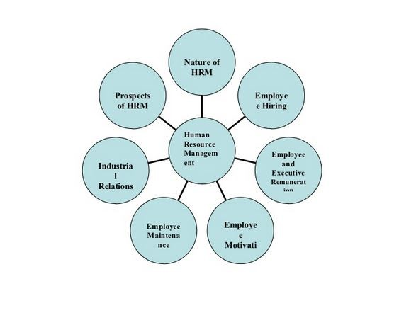

3.1.2 PRINCIPALS OF HUMAN RESOURCE MANAGEMENT

- Fairness: Fairness refers to conduct that is unbiased, just and honest. It may also mean treating employees consistently. The principle of fairness, enshrined in The Labor Relations Act, is fundamental to employee relations.
- Diversity: Diversity recognizes that people have individual characteristics that make them distinct from others, including age, language, culture, ethnicity, skills, gender, abilities, talents and perspectives.

- Equity: Equity means applying the principles of justice to correct or supplement employment practices to redress disadvantages experienced by individuals in the workplace. Employment equity is achieved when organizations are representative, fair, inclusive, diverse and respectful of differences.
- Transparency: Transparency refers to policies that are clear, frank and accessible. It also refers to conduct being free from pretense or deceit.
- Public Interest: The public interest is served when all actions and decisions of public officials and managers are based on merit, fairness and reasonable consideration of the public's need for service, efficiency, effectiveness, representation and access to information and opportunities (Garrick, 2002).

3.2 Employee of the city bank limited

The City Bank Limited has in various representative's criteria. There are diverse kinds of representatives working in better places inside The City Bank ltd. The types of employees are-

Regular employee:

The permanent stuffs are known as regular employee or agents. The general laborers are allowed to get the additional, helpers and distinctive rewards with their basic pay rates. Also, these sorts of specialists moreover have the benefit of gating extra workplaces the City Bank Limited is obliging their agents.

HR Stuff:

HR impermanent connect are for those classes whose Job delineation is such, where he/she ought to be under the quick supervision of Bank's energy, whose execution is seen by the Bank.

Outsource Stuff:

Other legally binding laborers are not entitled for any organization attestation. They will be enrolled through outsource associations. The need of any care staff through outsource association must come through HR set apart by the Division Head. HR will send the essential to give staff by the Outsource Agency.

Management Trainee Officer (MTO):
Management Trainee Officers exceedingly qualified understudies of CBL. The MTO's are standard representative however they need to understand as an understudy inside CBL for the time of one year. Following one year in the event that they can finish their learning period effectively they will end up being a senior officer specifically from the MTO.

Management Team:

Management team of THE CITY Bank includes the following positions and each position contains one member.

- Managing Director & CEO
- Deputy Managing Director
- Chief Information Officer
- Head of Credit
- Company Secretary & Head of Regulatory & Internal Control
- Head of Probashi Banking
- Head of Human Resource Management
- Head of Treasury & Financial Institution
- Head of Marketing & Corporate Affairs
- Head of Corporate Banking
- Head of Impaired Asset Management
- Head of Enterprise Risk Management
- Chief Financial Officer
- Head of Technology
- Head of Retail Banking

3.3 HUMAN RESOURCE MANAGEMENT PRACTICE OF THE CITY BANK LIMITED:

3.3.1 The City Bank Ltd. Human Resource Department:
Human resource department in The City Bank ltd. exist to urge people and relationship to achieve their objectives. CBL go up against various troubles raising from the solicitations of the agents, the affiliation and the overall population. The adjacent and general circumstances are the particularly unstable in light for creating troubles similarly reason for consistently developing regulations, especially rules that know the necessity of ascend to work potentiality. These confinements, the HR division of CBL must add to the affiliation's "essential concern" in a form which is effective (The City Bank, 2012, pp 29-33)

Human Resource Division’s Wings:
Human Resource Division of the City Bank Limited has work with six wings. The wings are-
- Recruitment.
- Administration.
- Training.
- Pay Benefits. &
- Performance Appraisal
- MIS & Strategic Planning.

3.3.2 Recruitment policy of cbl
Selection and Recruitment is an imperative piece of an association that decisively relies upon their workforce to effectively play out their central goal and accomplish their vision over the long haul. Subsequently fitting determination of contender to participate in the workforce is a basic piece of Human Asset Administration, which is affirmed by the Human Asset Division in The City Bank Restricted.
Recruitment Process:
For the recruitment The City Bank Limited uses the following process:
- Direct Recruitment:
City Bank Limited has a CV bank in HRD. In the case of direct contracting, the HRD provides a short list of CV Bank CVs or collects the CVs referred to by The City Bank Limited employees for a direct interview for the specific function selected.
- Through Advertisement:
Once in a while the HRD of the City Bank Limited can't ready to short rundown CVs for particular post from their CV Bank. In this circumstance the HRD publicize of enrollment in particular post specifying the set of working responsibilities with the base prerequisite that the candidate ought to have for the post. Also, gather CVs which are being indicated by the necessity that has been distributed in the ad. After that the CVs will be short recorded and the enlistment method will go as indicated by the immediate enrollment process.

- Internal Job Posting:
For inside occupation journey it will go through a round as lotus notes or board take note. Any current staff other than changeless additionally HR Brief (least one year with The City Bank Limited) and outsource staff (least three years with The City Bank Limited). Just the Overseeing Chief and CEO can permit special cases. Occupation particular will be portrayed in that round and intrigued applicants will have full freedom to apply resulting to the leeway from separate line director.

- Promotion:
The organization follows mainly three types of promotions. These are:
- Multiple Chain Promotion:
These accommodate a methodical connecting of each other's. Such advancements recognize multi-special open doors through obviously characterizes roads of way to deal with and exit from each situation in association.

- Up and Out Promotion:
In these promotions a worker must acquire an advancement or look for work somewhere else. Numerous colleges and other association take after this training which frequently prompts end of administration.

- Dry Promotion:
These kinds of promotions are given in lieu of increments in pay, for instance when all the pay is balanced upward to keep pace with the typical cost for basic items is called dry promotions.

- Transfer on deputation:
Based on requirements and needs bank can adopt that policy after taking the approval from MD’s Offices.

- Contract as specialist/consultant/counsel
It is not a post of regular employee. It is a contractual job and these persons are directly appointed by MD with the reference of the Chairman/ Board of Directors or Management Committee.
Recruitment Budget:
- MD and CEO tend to decide and break down the need of labor in light of enlistment required by the Offices and anticipated spending plan in view of the year in the wake of talking about with various division heads. Thusly, it is the duty of the administration to analyze the work load and complete the activity examination and additionally investigating the genuine prerequisite of representatives under different classifications, to see whether an extra hand is extremely important
- Board of executives holds the expert to at long last choose any issue with respect to any kind of enlistment.
- THE CITY Bank must perceive the significance of labor estimation and in like manner an Organ gram ought to be set up for the organization and for every department and Branch. The Organogram might notwithstanding, not be inflexible, it might be inspected and updated when fundamental now and again. Subject to survey every once in a while, the able expert according to control assigned by the head will make the arrangements.

Administration:
The Administration is the wing that maintains and controls the employees of The City Bank Limited. The administration has to go with the following work.

3.3.3 Training and development program of CBL
Human resource improvement is a fundamental pre-imperative to accomplishing authoritative objectives. Constant preparing of the representatives and administrators is gone for limit and expert aptitude working consistently. The City Bank Limited has a set up creative preparing foundation. Encountered financier's work as employees under the immediate direction of an executive.

On – the – Job Training:
Almost all comprehensively used tactics for planning happen at job. This is credited to the ease of those techniques and the effects which endeavor are fewer extravagant to this activity. On - the - job getting ready areas the agents in a authentic work situation and impacts them to emit an impression of being speedily beneficial. It is learning by doing.

Off- the -Job -Training:
Off-the-job planning spread different strategies classroom addresses, films displays, relevant examinations and other multiplication works out, and changed rule. The workplaces prerequisite for each one of these methodology move for little stopgap classroom to an itemized progression center with gigantic address entryways, supplemented by small assembling rooms with present day fluctuating media equipment, an extreme number of mirrors, and each one of the ornamentation.
The City Bank Ltd. Training institute offers these courses:
Executive Courses:
- Risk Based Capital Adequacy under Basel –II
- Executive Development Course
General Courses:
- Foundation Course for Executive officers
- Foundation Course for Assistant Executive officers
- Foundation Course for Assistant Executive Officers-Teller
- Industrial Credit & Project Financing Course
- International Trade Finance & Foreign Exchange
- English Language Course (Evening)
Course Objectives:
- To strengthen capacity of the participants on over all banking procedure.
- To transform a group of officers into efficient bankers.
- To increase resources of the bank to strengthen future capacity.
- To transform trained officers to asset of the bank in commercial running of branches
- To increase profitability through banking by trained staff.
- To enhance human & material resources for achieving the goals of the bank branches
- To create permanent resources in branches of the bank.
Rewards & Control Systems:
Reward and Control systems are carefully refined to strengthen conduct that is regarded significant to progression the commercial center. The representatives who don't hold fast to the social and conduct standards of the association, because of cacophony between the estimations of the individual and the estimations of the association; are given a reasonable cautioning to either take care of business or ship out.

3.3.4. Compensation administration of CBL

Basic Salary:
Basic salary is the actual salary that The City Bank Limited is giving the employees without any other allowances. This is the main margin of salary range. In The City Bank Limited there are thirty slabs of salary range for every job grades where basic salaries are being in flexible amount.
Travel Allowance:
The compensation has a standard traveling allowance matching with the status of employee of different categories.
Daily Allowance:
The daily allowance is admissible as per rules framed by the board from time to time.
Incentive bonus:
The board of directors at its discretion declares incentive bonus as and when deemed necessary.

Festival Bonus:
The employees or staffs are entitled to get two festival bonus to celebrate religious festival.
Employee Benefits:
CBL guarantees that provident store benefits are given to the qualified staffs of the association as indicated by the tenets of Provident Fund constituted under an unalterable trust. CBL has likewise presented 'Superannuation Fund' rather than Group life coverage strategy for the representatives. Those representatives, will's identity ready to satisfy particular criteria said in the approach of the reserve, will be entitled for the advantage of Superannuation Fund.
CBL compensation and benefit packages:

Allowance | Incentives/Benefits
- House Rent allowance  75% of basic  - Medical allowance  20% of basic  - Conveyance  30% of basic  - Lunch  Tk.200 per working day | - Yearly:  - Leave fare  - Deposit target bonus  - Two festival bonuses  - Performance bonus  - Long term:  - Provident fund  - Gratuity  - Insurance benefit  - Medical benefit
Gratuity:
A gratuity is granted to or on account in the in the event of:
- Death while in the service of the organization.
- Termination of service or compulsory retirement resulting from permanent incapacity due to physical or mental infirmity provided this has not been caused by the irregular or inappropriate habits.
- Termination of service or early retirement resulting from the abolition of his post or bona-fide retirement.
The following categories of employees are not eligible for gratuity:
- Those who are dismissed from the organization or
- Those who left or discontinued their service without the permission of the organization.
The amount of gratuity admissible to an employee is a sum equal to two month's basic pay for each completed year at the rate of last pay drawn.

3.3.5 Leave
The policies followed for employee leaves management based on the types of leaves and their criteria are given below:
Annual Leave: All officers will wind up qualified for yearly leave of 24 working days after fruition of one-timetable year. Of these 24 days 15 days must be taken as sequential leave every year. Any pending leave might be conveyed forward to the following year.
Casual/Sick Leave: Casual leave over to 14 logbook days can be allowed every year to a representative who might be not able go to obligation because of sudden sickness or critical private undertakings. Not over 2 days' easygoing leave can be taken at once in a month.
Maternity Leave: Female (affirmed) representatives will appreciate 4 months' maternity take off. One worker will be qualified for profit this leave for 2 times in her whole administration period.
Study Leave: Study Leave is conceded to a worker Study leave of greatest 2 years must be allowed to a representative without pay and remittances gave he/she has put in no less than three years of administration.
Leave without Pay: Leave without pay might be conceded to a worker in exceptional conditions where no other leave is allowable under these tenets. In the event of Leave without Pay, the period does not surpass 60 days.
Leave during Probation Period: For sick leave in the probation period, the leave has to be specially mentioned by the department. Casual leave will be granted to probationary employees after completion of 6 months. Any leave taken prior to completion of 6 months will be adjusted against the casual leave (City Bank Webpage, 2016 pp 34-37).
Encashment Facilities of Annual Leave: Yearly leave encasement offices might be permitted to the representatives for a most extreme of 90 days (based on last basic) at the season of worker's leaving the bank.

3.3.6 Promotional practices of cbl
Promotion is the rewarding procedure to develop professionalism who is the great asset of the company. As rewarding and motivating factor the uniform promotion criteria are maintained by the company.
Objectives of the promotion:
- To provide enough opportunity for the executives and officers to build up high professionalism.
- To ensure smooth career path for the deserving executives or officers.
- To motivate, reward and make dedicated as well as trustworthy employees.
- To create belongingness for the employees.
- To encourage knowledge, wide experienced and dedicated employees.

Promotion Time:
The matter of promotion CBL is handled once in year which is known as year wise promotion. The benchmark of the promotion is June 30th of every year. Those who complete the minimum required length of service fixed for promotion criteria within June 30th, can be considered for promotion.

Criteria for promotion:
- Promotions for the deserving persons who has fulfill the promotional criteria are always encouraged and maintained by the managing authority.
- For regular promotion, an employee at least requires two years’ continuous service in the same rank with satisfactory performance for the immediately past two years, who had undergone and complete the training and other promotional exams successfully are taken into consideration for the promotion.
- Regular promotion for any post below the bank’s 3rd tire is considered by the management while the promotion for the post of 3rd tire and above is considered by the board of directors as per CBL’s policies.
- The employees have to pass the promotional exam getting the qualifying marks for the next immediate higher post. The mode of written test is in English.
- Senior executive officers also have to face the promotion exam for next higher post. The examination question of the Senior Executive Officers is prepared by outside professionals.
- Senior officer and senior executive officers below the rank of 3rd tire have to face viva voce and required to get minimum qualifying marks.
- The viva board is conducted by MD who selects the other personnel of the Board.

3.3.7 Performance Appraisal policies
The performance appraisal is the way to assess the last execution of the representative, especially for the reward, progress and improvement of the personnel. The action test is a procedure that distinguishes, evaluates and creates representative actions to achieve hierarchical goals.
Purposes of Performance appraisal in The City Bank Limited:
- To review past performance
- To assess training needs
- To help develop individuals
- To audit the skills within an organization
- To set targets for future performance
- To identify potential for promotion
- To provide legal & formal justification for employment decision
- To diagnose the hidden problems of an organization
Job Evaluation:
Meaning of Job evaluation: Job evaluation is an–
Deliberate and precise systems of deciding the relative worth of different employments inside the association, in order to build up an evenhanded wage and compensation structure.
The two most basic job evaluation techniques used are, to begin with, full employment, where the professions are generally taken and placed against each other. The second strategy is one of the allocation approaches for different parts of the activity. Within the framework of the approach, different points of view or parts of the activity are examined, for example, the instruction and experience necessary to develop the activity, and a focus qualification is granted since the instructional requirements of the activity are higher The higher the scores.

Chapter- 04

Analysis and Interpretation

4.1 SWOT Analysis of the City Bank Limited
Each association has some inner qualities and shortcomings and has some outside circumstances and dangers. The following will introduce the City Bank’s internal strengths and weaknesses and external opportunities and threats:

4.1.1 Strength
1. American Express Credit Card: The City Bank ltd. has propelled both nearby and double money (BDT and Dollar) Amex Credit Cards on seventh November, 2009. Under the agreement, CBL will become the limiting distributor and seller of American express cards in Bangladesh. The image of the Amex brand, undoubtedly, is aimed at the image of the City Bank ltd brand.
2. Upgraded management: The administration group of CBL has altogether transformed since the year of 2008. Recent offices like NFB (Non supported business), regulations and investigation are unlocking for upgraded activity purposes.
3. Experience: CBL has been in the business for almost 25 years. This long time of presence in the business has supported CBL to pick up inside and out information about the business slants and also developed key association with numerous enterprises which most different banks couldn't accomplish in this short schedule.
4. Good relationship with Customers: One of the fundamental quality of CBL is they keep up a decent association with their clients. They treat their client’s cordial. That is the reason; clients would prefer not to leave the bank.

4.1.2 Weakness
- Low remuneration package: Contrasted with different banks, City Bank’s installment bundle is not so upgraded. With this lower installment strategy, CBL won't have the capacity to contract the appropriate representatives of the nation and can drop their current achieved workers to different banks.
- Poor service quality: CBL's service standard is bring down contrasted with different banks. But few chose branches (Dhanmondi, Gulshan branch), and other branch doesn't have restrictive arranged inside plan. Clients are not treated by their conviction and administration is moderate in some branches for the poor system framework.
- Existing elderly employees: A major level of CBL representatives are doing job here more than 25 years. The recent administration is thinking that it’s difficult to designate with these representatives, particularly with the personnel who are unwilling to acknowledge updated strategies and conversion inside the association.
- Lack of own ATM services: Many customers complain that ATM booths are not available in some areas or one booth is so far away from another.

4.1.3 Opportunity
- Credit Card Business: The business of Bangladesh cards shoots in recent years. ATMs, Platinum cards and cargo cards become imperative. This is done entirely to help your business and your brand image. In addition, VAT plans to incorporate the Ace card into its card business. Both assume an imperative part for VAT to be developed as a pioneer in the trading of cards in Bangladesh.
- Internet Banking: With the progression and accessibility of innovation, the requirement for web based managing an account is getting greater need. Both outside and neighborhood banks are moving towards internet managing an account to comfort the exchange procedure for the clients. CBL as well, has taken some gigantic endeavors
- Automation: As of now the greater part of CBL’s branches are associated through internet. Structure coordinate managing an account is formulating the general sector employments substantially simpler and quicker, guaranteeing better and significantly speedier client benefit. This is heading off to mechanization will unquestionably give CBL a major favorable position over different banks in the business.
- High growth of sales and trade finance: City Bank's gain an immense sum from their business group and exchange fund now daily. They need to prepare their business group appropriately on the grounds that it's an incredible open door for them.

4.1.4: Threat:
1.VISA Credit discounts: We recently said that CBL tested a certain portion of American Express in the card segment of the dispersed money industry. Regardless, the map area of Bangladesh is now controlled by Visa MasterCard. Similarly, particularly after sending Amex cards, several banks (ie, a standard contracted bank) have received notable discounts on their obligations with respect to a visa card. Under these circumstances, unusual companies in Visa can have a tremendous effect on CBL's Amex company by several banks.
2. Unable to place AMEX brand image: Contrasted with current outside banks, City bank’s image picture is gathered to some degree poor. Particularly if there should be an occurrence of administration attribute.
3.Managing a large target market: The City Bank Limited has a huge target market which comprise of buyers from bring down category customers with high total assets. As of late embraced 'Celtic Venture' is intended for exclusively the exclusive class of Bangladesh. In any case, with insignificant preparing, the current workers won't not to give adequate support of these distinctive classes of individuals, essentially since the normal administration nature of the high society differs from lower classes.
4.Management Collision: In the year 2006, a critical transformation happened in the historical backdrop of CBL's administration as a result of the sudden enrollment of certain new identities. The new administration group redeveloped the general structure of the bank and brought together its tasks. They endeavored to guarantee that the new administration comprises of youthful and exceptionally capable individuals of the business. A considerable lot of existing representatives feel that under this new administration their future prospect of occupation is zero and despite what might be expected, the new administration isn't prepared to concur that there exists a type of misconception and is attempting to persuade that lone individuals with high capacities have been decided for recently embraced ventures. This imperceptible window ornament of misconception between these two gatherings of workers can cause critical harms in the up and coming ventures of CBL.

4.2: Core Financial Findings of City Bank, Pallabi Branch:

Particulars | Year
Particulars | 2015 | 2016 | 2017
Profit ( Amount in BD ) | 22500000 | 33100000 | 54700000
Deposit (Amount in BD) | 777000000 | 959800000 | 1050000000
Employee Turn Over Rate (%) | 22% | 28% | 35%
New Current Account Open | 69 | 88 | 100
New Savings Account Open | 111 | 120 | 180
FDR Open | 40 | 50 | 70

Figure 2: Three Years Financial Analysis (CBL Website, 2016)

Figure 3: Profit & Deposit chart (CBL Website, 2016).
Figure 4: Account Chart (CBL Website, 2016)

figure 5: Employee Turnover Chart ( CBL Website, 2016)

4.3 Findings of the study

4.3.1 Questionnaire analysis
1. The behavior of the responsible person for planning the HRM/PM in your organization is up to the mark.
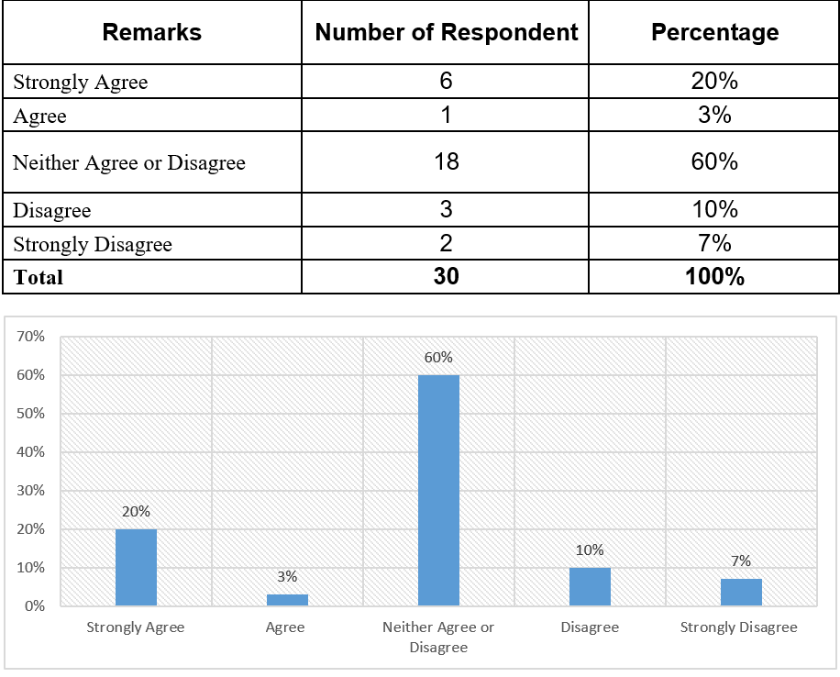

Interpretation: In city Bank major people Shows a neutral answer about the responsible person’s behavior. Here 60 % of the employees give the neutral answer. Less than 20% thinks that the behavior of the responsible person for planning for HRM is not satisfactory. And more than 20% thinks their behavior is up to the mark.

2. In the recruitment process External & Internal sources is perfectly used by your organization?
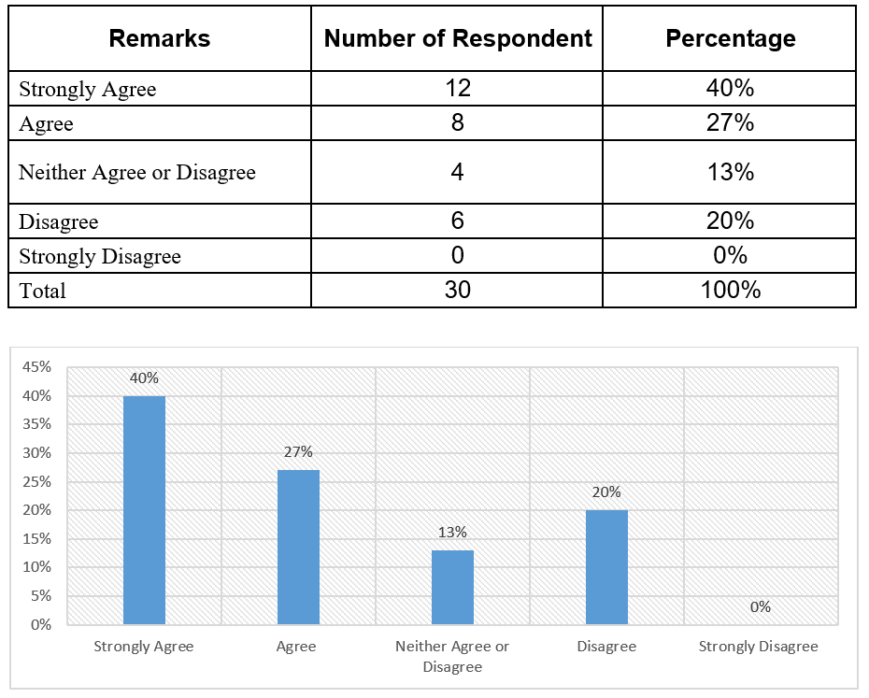

Interpretation: In City Bank major people aware about the uses of the internal and external source usability in recruitment. 40% are stated as strongly agree and 27% stated as agree because CBL is concerned about fair recruitment policy. 13% shows neutral opinion. 20% employees are disagreeing about the process.

3. In case of selection: your organizations can manage to select the best candidate among the available candidate.
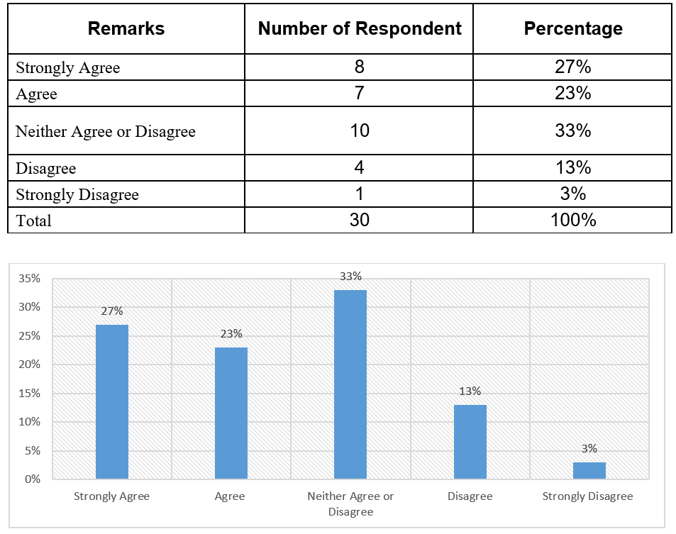

Interpretation: This feedback shows employees have mixed opinion regarding to candidate selection process. But major people have a neutral feeling about choosing the best people for the bank. Also the acceptance is grandly high. Less than 20% is disagree in this opinion.

4. Working efficiency of the employees of your organization is good enough.

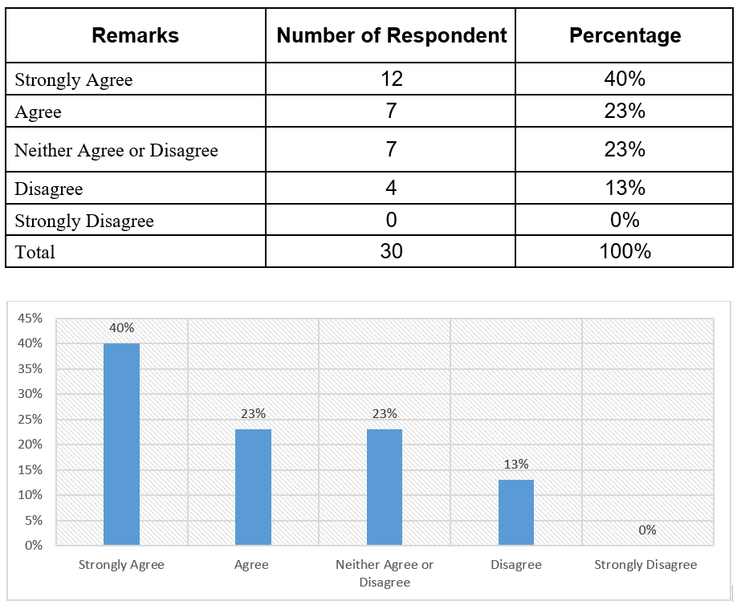

Interpretation: Major people believe that bank employee has the perfect work efficiency. Although 23% of employee gave neutral opinion. Only 13% thinks work efficiency should be upgraded.

5. In case of job analysis you face a little or no problem at all.

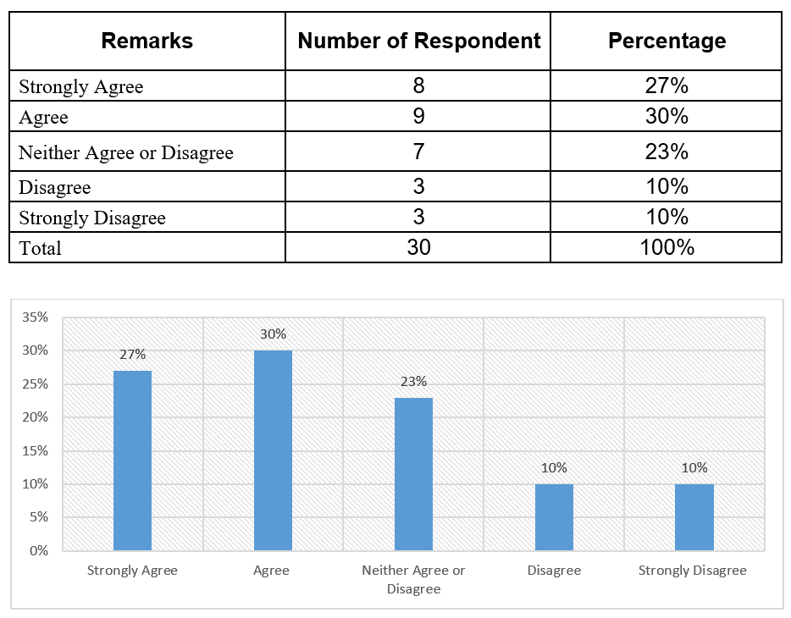

Interpretation: In case of job analysis of the bank half of the employees stay neutral and half of them strongly agree about it. Only 20% disagree on the accuracy of job analysis. Employees who are dissatisfied with the job analysis think that the department heads should be more transparent while delicate the authority to its employees.

6. Training program is regularly arranged for developing the working efficiency of the employees.
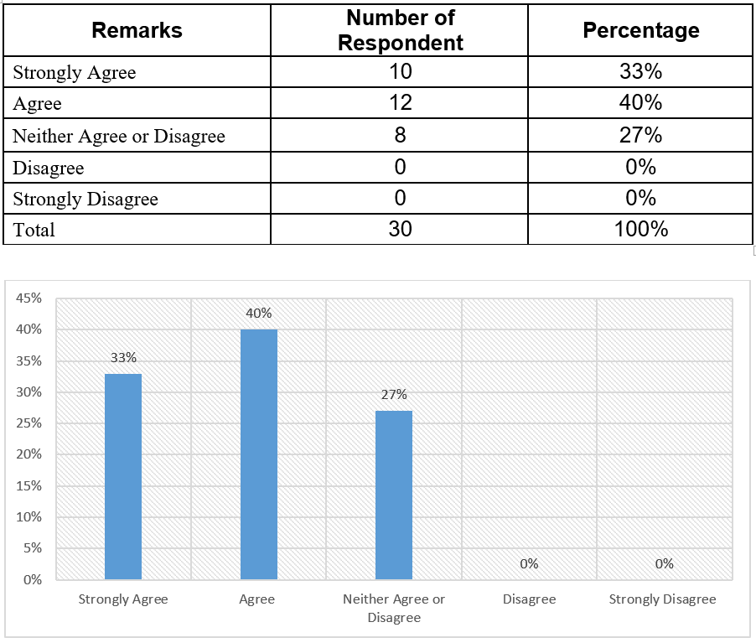

Interpretation: Majority of the employee agreed about the fact that bank has regularly arranged the training program. 27 % gave neutral opinion.

7. Your organization arranged outdoor training once in a month for better knowledge.

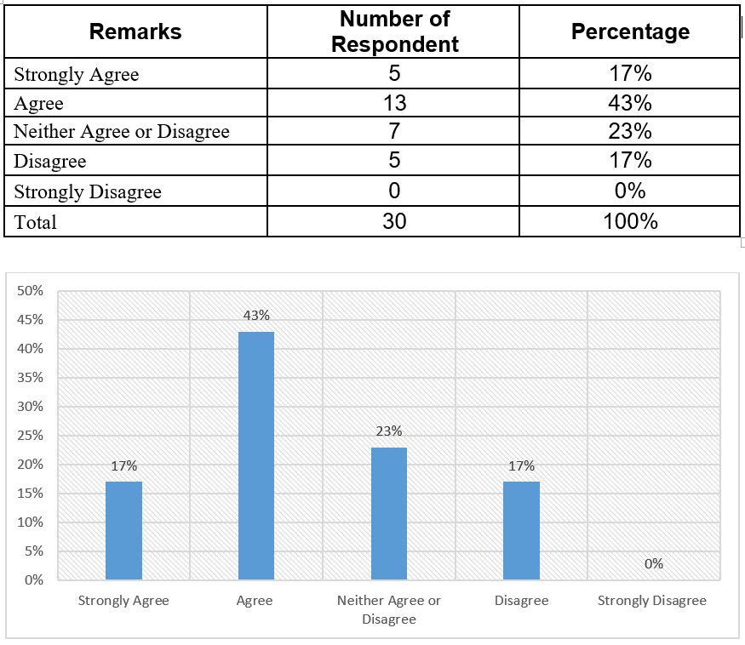

Interpretation: majority of the employee agreed about the fact that bank regularly arranged the outdoor training. 23% employees have neutral opinion about that statement. 17% employees disagree with the fact because sometimes bank can’t be able to arrange the outdoor training program for all the employees because it is very costly and time consuming.

8. For motivating the employee, financial reward is performed by your organization.

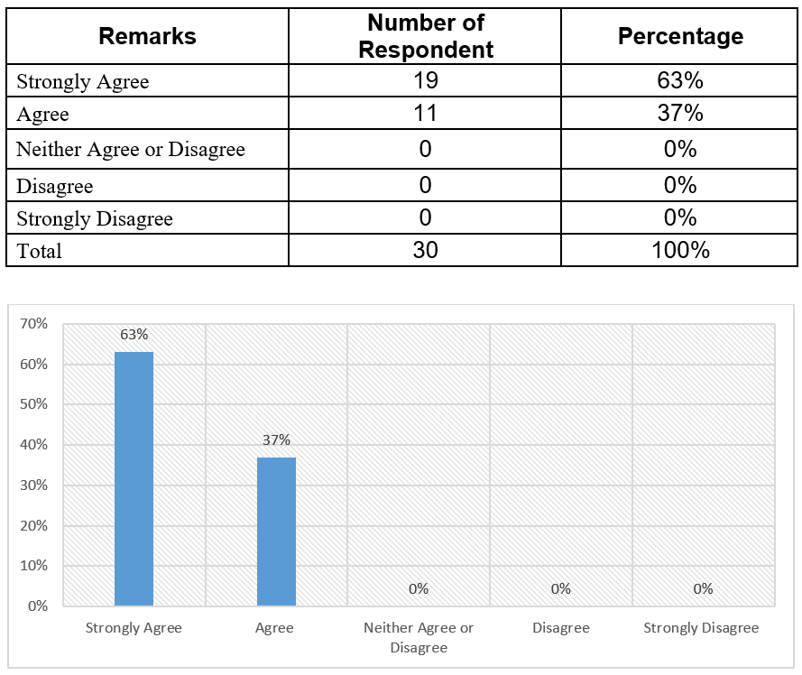

Interpretation: The majority of the employee strongly agreed about the fact that bank financially reward for motivation because CBL is concern regarding increase the work efficiency on employees by helping them by motivation.

9. Your organization can be a perfect example for maintaining a well-organized HRM/PM?

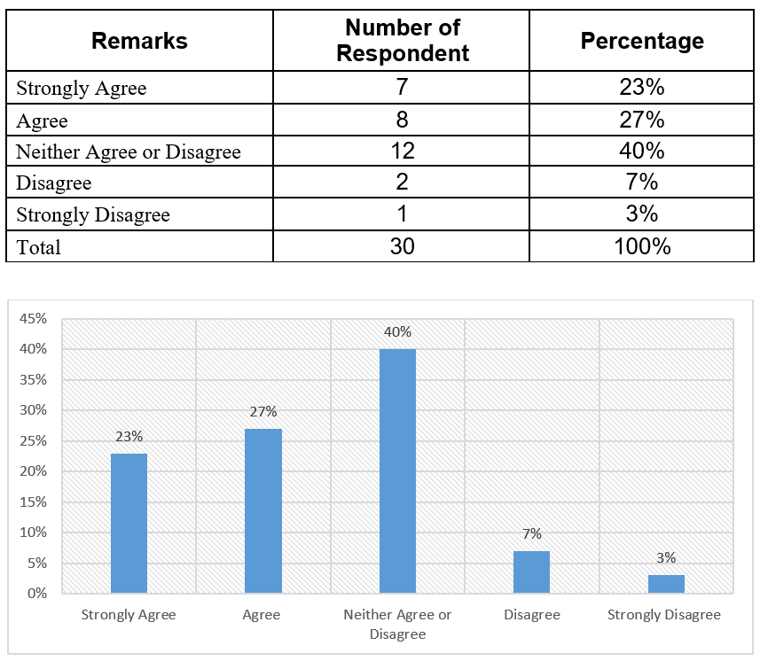

Interpretation: Majority of the employee agree about the fact that their organization is perfect example for maintaining a well-organized HRM/PM. 40% of employees have neutral opinion regarding the fact. Only 10% thinks that CBL should be improve its human resource activities and upgrade its policies for employees wellbeing.

10. Employee Promotion policy is enough transparent in your organization.

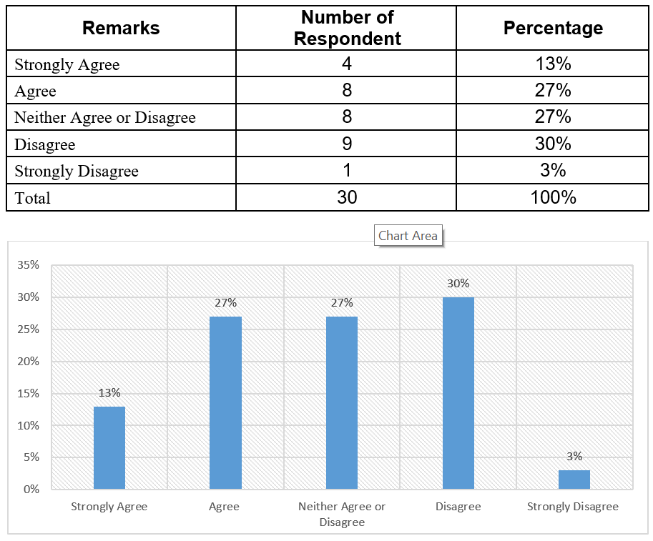

Interpretation: Close to 40% of the employee agreed and more than 30% of them are disagreed in terms of the transparency about promotional policy of the bank. 27% of employees carry mixed opinion regarding the fact. Employees who are disagree about the transparency think that favoritism sometimes interrupt in the transparency in the promotion policy.

4.3.2 Major findings

- There are lacking in the job analysis, human resource planning, recruitment and selection policy of CBL is not standard. The reason behind this fact is the manager of HRD is incapable to operate the various HRM function.
- There is lack of accuracy in following the performance appraisal because of some discrimination, favoritism and nepotisms are exercised.
- The Pay Packages of the Bank isn't focused in contrasting with other Bank working in Bangladesh.
- Outdoor training for employees doesn’t organized properly because of inefficiency of training program planning.
- Despite the fact that the association isn't in lacking of representatives, however I think there is missing of legitimate workers that implies “lack of right people in right place”.
- The human resource management of CBL does not operate standard pay structure for employees.
- A few representatives say that an additional work stack in a consistent premise is a typical paradigm of the association. Thus, the bank at some point misfortune worker's appeal.
- Just the head office contains HR division and all the HR exercises are controlled from the head office. Consequently, when at times any HR issues raised staffs need to sit tight for quite a while to settle it. Also, this office isn't excessively organized.
- Sometimes employees feel demotivated for lack of transparency in promotion policy because of favoritism and nepotism.
- Talent acquisition managers are not up to date with the strategies of choosing the best candidates.

CHAPTER- 05

Conclusion and Recommendation

Recommendations
Recommendation means to give suggestions about The City Bank ltd. On the basis of the findings and analysis of the study, my recommendations are given below:
- The human resource development personnel of CBL should be perused the modern HRM system, and generate the HRM function to each department properly because the HRM policy explore as the keystone of all human resource functions in an organization.
- The standard performance appraisal has to be prepared by the HRD manager of CBL because the success and failure of an organization is very depended on the accuracy of human resource performance.
- The manager of HRD need to operate the standard pay structure for the employees of CBL to minimize the rate of high turnover of employees.
- Training should be provided by professional consultation with the training division in the central level and mid-level.
- The authority of The City Bank Limited should establish a structure performance appraisal policy. HRD manager has to avoid the biasness so that efficient employee can get proper reward for their performance. “right man in right position”
- The HRD manager must do the succession planning. A careful and thoughtful action plan ensures that the person's responsibilities and, therefore, the effectiveness of the organization are altered as little as possible.
- The HRM authority should try to reduce the extra workload of the employee in order to reduce employee unrest and turnover.
- The organization should revise their compensation program to retain highly qualified, competent and promising employees.

Conclusion
The City Bank Limited is a bank that affirms the best support of the clients and in addition to the representatives by Human Asset Division. The City Bank Constrained is the quickest developing Bank in Bangladesh. By working in HR Division the information was learnt would be sufficiently useful to manage with the genuine hierarchical condition.
Saving money business is a developing idea from Bangladesh's perspective. Step by step, it is getting prevalent in the white collar class individuals. From absolute starting point The City Bank Restricted has effectively maintained their business with well notoriety now they make their own enthusiasm on limit in keeping money business. The Managing an account business has an awesome prospect in Bangladesh. Be that as it may, Human asset administration is an indispensable piece of any association for dealing with the workforce and guaranteeing the work productivity. Human Asset improvement is a fundamental pre-essential to accomplishing authoritative objectives. Ceaseless preparing of the workers and administrators is gone for limit and expert expertise working consistently.
So, the management of The City Bank Limited should give more concentration in this potential sector with proper strategy, better marketing policy and satisfactory customer services. As I working the Human Resource Management Department, while I end up with some observation and based on these observations some recommendation has been given in this report. Hopefully these recommendations will help to The City Bank Limited continue its progress.
I completed my internship in CBL. The organization and other employees think interns are not treated as guests for three months. I am actually involved in work, also I maintain my work time as office time. I learnt my internship about how an organization operates, its day to day activities, problems that occur every day and how to resolve them. At present I will able to apply my knowledge and learning in any organization.

Reference
Book References
Armstrong, M. (2017). Armstrong's handbook of human resource management practice. New York: Kogan Page Limited.
Chalofsky, N. (2014). Handbook of Human Resource Development. Hoboken: Wiley.
Dessler, G. (2017). Human resource management. Place of publication not identified: Pearson Education Limited.
Garrick, J. (2002). Informal learning in the workplace. London: Routledge.
Gerhart, B., Hollenbeck, J., Noe, R. and Wright, P. (2015). Human resource management. New York, NY: McGraw-Hill Education.
Haldar, U. (2010). Human resource development. New Delhi: Oxford University Press.
Harzing, A. and Pinnington, A. (2015). International human resource management. London: Sage.
Human resource policy and economic development. (1991). Manila, Philippines: Economics and Development Resource Center, Asian Development Bank.
Web References:
- www.thecitybank.com
- Annual report of The City Bank limited. 2009.
- Website – Bangladesh Bank.
Others:
- Daily statement of The City Bank limited at Pallabi Branch, Dhaka.
- Monthly Report of The City Bank limited of the year 2018.
- Statement of affairs of CBL, Pallabi Branch.
- Different document of The City Bank Limited, Pallabi Branch.

Questionnaire
Questionnaire on Human Resource Management (HRM) Practices of The City Bank Limited.
1. The behavior of the responsible person for planning the HRM/PM in your organization is up to the mark?
- Strongly Agree
- Agree
- Neither Agree or Disagree
- Disagree
- Strongly Disagree
2. In the recruitment process External & Internal sources is perfectly used by your organization?
- Strongly Agree
- Agree
- Neither Agree or Disagree
- Disagree
- Strongly Disagree
3. For recruitment the employee Advertisement & Campus Recruitment is perfectly followed by your organization?
- Strongly Agree
- Agree
- Neither Agree or Disagree
- Disagree
- Strongly Disagree

4. In case of selection: your organizations can manage to select the best candidate among the available candidate.
- Strongly Agree
- Agree
- Neither Agree or Disagree
- Disagree
- Strongly Disagree
5. Working efficiency of the employees of your organization is good enough.
- Strongly Agree
- Agree
- Neither Agree or Disagree
- Disagree
- Strongly Disagree
6. In case of job analysis you face a little or no problem at all.
- Strongly Agree
- Agree
- Neither Agree or Disagree
- Disagree
- Strongly Disagree
6. Training program is regularly arranged for developing the working efficiency of the employees.
- Strongly Agree
- Agree
- Neither Agree or Disagree
- Disagree
- Strongly Disagree

7. Your organization arranged outdoor training once in a month for better knowledge.
- Strongly Agree
- Agree
- Neither Agree or Disagree
- Disagree
- Strongly Disagree
8. For motivating the employee financial reward is performed by your organization?
- Strongly Agree
- Agree
- Neither Agree or Disagree
- Disagree
- Strongly Disagree
9. Your organization can be a perfect example for maintaining a well-organized HRM/PM?
- Strongly Agree
- Agree
- Neither Agree or Disagree
- Disagree
- Strongly Disagree
10. Employee Promotion policy is enough transparent in your organization.
- Strongly Agree
- Agree
- Neither Agree or Disagree
- Disagree
- Strongly Disagree

