
Internship Report on

Analysis of bKash Limited & Mobile Financial Services Industry in Bangladesh: An Internship Experience Perspective

Submitted to:
Dr. Md Mohan Uddin
Professor
School of Business & Economics
United International University

Submitted by:
Wahidul Haque Khan Saniel
ID: 111 161 179
BBA
United International University

Date of submission: 19th September, 2020

Letter of Transmittal

19th September, 2020
Prof. Dr. Md. Mohan Uddin
School of Business & Economics
United International University
Subject: Submission of Internship report on “Analysis of bKash Limited & Mobile Financial Services Industry in Bangladesh: An Internship Experience Perspective”
It is my privilege to apprise you that I have completed my internship report on “Analysis of bKash limited & Mobile Financial Services Industry in Bangladesh” and I want to submit it, a mandatory part of the internship program.
I have tried to complete the report as per the instructions and requirements, I have tried my level best to make this report meaningful and specific. I have used my analytical skills to collect data and my close observations from working in bKash have helped me to put information in the required segments.
I sincerely hope that it will receive due consideration and proper evaluation from your end
Sincerely yours,

_______________________
Wahidul Haque Khan Saniel
ID: 111 161 179
Bachelors of Business Administration
United International University

Acknowledgment

First of all, I would like to thank the Almighty Allah and his blessings which granted me the ability to complete the report with a safe and sound mind.
I would like to express our sincerest gratitude to the instructor of our course, Prof. Dr. Md. Mohan Uddin, School Business and Economics, United International University. Prof. Dr. Md. Mohan Uddin sir offered me continuous guidance and many significant and constructive observations throughout the study. His support, encouragement, and availability to discuss ideas and problems have contributed much to complete my report.
I would also like to thank the creators of the websites from which we extracted information regarding our report.
I am happy for being able to submit the report in due time.

Executive Summary

Bangladesh is a poor nation with 160 million people within a very small scale of the area is considered a county with one of the highest density. Which from a positive side is a very good place for businesses to grow for getting mass people available within very short reach. Mobile Financial Services operating in this country are facing a positive outcome of what they are doing. bKash provides both B2B and B2C services accumulating personal consumers & merchant consumers altogether.
The Mobile Financial Services started near 2010/2011, and the idea of mobile banking was highly adopted by the people of Bangladesh. bKash seizing the opportunity to launch this organization after years of the survey, finally launched in 2011 and since then they have been constantly on the rise and growth operating in the Growth stage of their maturity cycle.
The External, Technological, Political & Legal industry has been a near positive effect for the industry for which the MFS industry hasn’t been facing any huge drop of success in 10 years. But Regulatory factors were sometimes strict on the operation and limits. With this mixture of positive and negative effects, it can be said after the PESTEL analysis that it has a moderate effect on the industry.
The Porter’s Five Forces model (Barriers to Entry, Supplier Power, Buyer Power, Threat of Substitute and Industry Rivalry) shows that the industry is more on the favorable terms than unfavorable term due to the various threats. Which again shows how well the industry is doing in the market.
bKash is the only MFS company in Bangladesh to be having partners like Alipay, Bill & Melinda Gates Foundation, and numerous international investors. They are the only company from this country to be enlisted as the 23rd fastest business that implements improvements focused on social concerns in 2017. They intend to offer easy, accessible, and efficient financial services and extend the scope of financial inclusion in the market and their main objective is to ensuring access to a wider range of financial services to the Bangladeshi people. Starting from 2011, they have achieved a lot of milestones over the years, they are only increasing in number every other day. They provide their services to all kinds of consumers available in the country starting from general people to government. Even though it’s a Mobile financial service like all other but their product variety and category is one of the best among all the competitors, they provide more than 10 types of products/services to their customers. bKash try to follow a very sophisticated organizational structure and functionality which increases their efficiency and productivity. bKash is considered as the market leader with various strengths and opportunities but they also have some threats and weaknesses that are holding them back to go skyrocket high. If they can execute proper strategies to improve their strengths, utilize their opportunities, eliminate threats, and overcome weaknesses, then they can lead the market with a very high gap in market share. bKash is at the No.1 position in the market right now with almost 60% market share solely. They have a great future ahead lying for them benefitting both customers and themselves.
The internship experience for an intern working in the Commercial Division of the company goes to a very high workload and many decision-making processes. All the functions are operated very sophistically and they teach and train each intern as an individual. All the interns get their opportunities equally to prove themselves and implement their academic and extra-curricular skills on various tasks, and everyone has to understand the basic technological factors to work properly.

Table of Contents
Contents
1 Introduction - 3 -
1.1 Background - 4 -
1.2 Objectives - 6 -
1.3 Significance - 6 -
2 Analysis of the industry - 7 -
2.1 Specification of the industry - 8 -
2.2 Size, trend, and maturity of the industry - 8 -
2.3 Seasonality - 10 -
2.4 External economic factors - 11 -
2.5 Technological factors - 11 -
2.6 Political, legal, and regulatory factors - 11 -
2.7 Barriers to entry (High) - 12 -
2.8 Supplier Power (High) - 12 -
2.9 Buyer Power (Moderate) - 13 -
2.10 Threat of Substitutes (Moderate) - 13 -
2.11 Industry Rivalry (High) - 13 -
2.12 Summary of challenges and opportunities - 14 -
3 Analysis of the Organization - 15 -
3.1 Overview and history - 16 -
3.1.1 Mission - 16 -
3.1.2 Objective - 16 -
3.1.3 Board of Directors - 17 -
3.2 Trend and growth - 17 -
3.3 Customer mix - 19 -
3.4 Product/Service Mix - 20 -
3.5 Operations - 21 -
3.6 SWOT analysis - 23 -
3.7 Steps/Strategies to meet the challenges and opportunities - 25 -
4 Internship Experience - 27 -
4.1 Position, duties and responsibilities - 28 -
4.1.1 Position: - 28 -
4.1.2 Duties & Responsibilities: - 28 -
4.2 Training - 28 -
4.3 Contribution to departmental functions - 28 -
4.3.1 Scanning - 28 -
4.3.2 Data input - 29 -
4.3.3 Lead Generation - 29 -
4.4 Evaluation of internship performance - 29 -
4.5 Skills applied - 29 -
4.6 New skills developed - 30 -
4.7 Application of academic knowledge - 31 -
5 Recommendations - 32 -
5.1 Recommendations for improving departmental operations - 33 -
5.2 Recommendations for improving self-performance - 33 -
6 Conclusion - 34 -
References - 36 -

CHAPTER ONE

Introduction

Background
Bangladesh is a poor nation with over 160 million people residing below the poverty line, with about 14 percent of the population. Just 41 percent of all adults are banked besides (2017). Over the past two years, the usage of digital financial services evolved primarily as a result of legislative reforms in Bangladesh introduced in 2011. Such reforms enabled banks to set up subsidiaries to provide mobile banking services but also included controlling them within the banking system. The Central Bank and telecommunications regulator have urged the four main Mobile Network Operators (MNOs).
Mobile Network Operators (MNOs) in the nation to provide mobile banking services with connections to their networks. MNOs may also profit from revenue sharing arrangements, prohibited by regulators from offering mobile banking services directly. Such agreement enabled financial institutions to enter consumers in collaboration with MNOs, which had exceeded 65 percent wireless penetration by 2012.
Linkage to financial services helps to boost economic growth. Through financial services, people may overcome the suffering that will help them invest more in their health, education, and business. Financial services are also vital for people who need to work through emergencies, such as sudden diseases, which can force them to financial ruins. The current financial services situation in Bangladesh is that there are 57 banks with more than 10,000 branches recently obtaining a license, with three more banks (From 2019 report). Nevertheless, many financial analysts and economists also find this as inadequate to cover about 164.7 million people. And concerning the scope of the banking services, Bangladesh’s central bank has adopted a guideline aimed at providing banking services to the entire country's population. As per the guideline, in rural areas, 50% of new branches opened by banks in a calendar year should be created.
An MFS’s relationship with a bank can be seen as a vital step in financial inclusion. This gives hope of bringing integration into the country soon. Most countries that are active in MFS have a hybrid model with the participation of banks, mobile operators, and other stakeholders. In Bangladesh, more than 80% people are using mobile financial services, and from those who are not using, 80% (from the remaining 20% of the total population) does not use MFS because they lack knowledge on how the product works and even the existence of MFS in our country.
Bangladesh's government and companies have also started taking steps toward financial inclusion. With a strong economy, these programs offer hope for a better future.
The market leader bKash has been consistent with its growth and economical effect on Bangladesh’s economy.
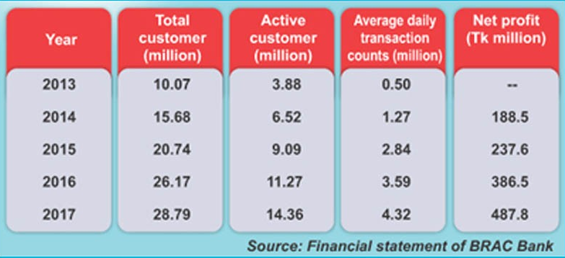
Figure 1.1: Growth of bKash Limited from in 5 years (BRAC Bank)
From Figure 1.1 we can see that bKash Limited has earned 487.8 million Taka Net profit which was 188.5 in 2014. They earned more than double Net profit within just 4 years. Not only they are earning huge amounts of money, but they are also gaining immense customer base, loyalty, and brand value.

Figure 1.2: Total Customer Growth Figure 1.3: Net Profit Growth
In 2017, the number of active customers (defined as those who made at least one purchase in the last 90 days) also increased by 6.9% compared to 2016. The company has seen the highest number of clients opening accounts in 2017 to obtain mobile financial services. From 2013 until 2017, the number of customers kept growing. In 2017, the number of customers rose to 28.76 million while the number of active customers reached 14.36 million.
School of Business & Economic internship program at the United International University is a 3-credit program that BBA students need to undertake to attain their degree. It needs a student to work for three months in a corporate organization and write a detailed report based on the experience and knowledge he or she learns from working at the organization. The author, therefore, worked at bKash Limited for my internship because as a student with a degree in Finance.

Objectives
The objectives of the report are
- to analyze the performance of the mobile financial services industry in the current market & factors affecting the industry
- to analyze the performance of bKash Limited in the current market, their product/services and to illustrate their challenges & Opportunities
- to portray the whole process of internship period of an intern

Significance
In this report, the author has tried to portray what he has learned from 4 months of internship in bKash limited. He tried to combine my textbook knowledge and the knowledge gained from working in bKash, in this report. He has mentioned how the industry he has worked in operates, their conditions, and how bKash is operating in the industry as well as how well bKash is doing. He has also mentioned his experiences and responsibilities as an intern in M-Commerce Payment System. Through this report, he wants to analyze the bKash limited and Mobile Financial Services industry in Bangladesh to illustrate a current scenario of how the market is doing.
This report contains a vast amount of data gathered from authentic sources and it also contains the analysis of crucial components like SWOT analysis, Porter five forces analysis which can help the management of bKash Limited to understand their current market position, their strengths, weaknesses, etc. and that can help them in their further decision making.
This report can also help the policymakers while making a decision and to add value to their perspective, by looking at the Economical, Technical, Political, and Legal & Regulatory factors described thoroughly. It would help industry participants to know about the market leader bKash Limited and also how the whole industry is currently doing in business.

CHAPTER TWO

Analysis of the industry

Specification of the industry
Mobile Financial Service (MFS) is a digital approach that uses the combination of banking and mobile networks to provide financial services. This helps users to carry out banking transactions without the conventional hassle. This allows users to make a mobile account deposit, withdraw, and send/receive money. In general, these activities are provided by bank employees. These agents allow bank account holders to transact money without the need to go to the bank at independent agency locations. It only involves a connection between a mobile phone and a bank account of persons/merchants. It is a great opportunity to bring the savings of our unbanked population under our banking system and to increase the amount of market investment.

Size, trend, and maturity of the industry
The mobile financial service travel in Bangladesh began with the launch of Dutch Bangla Bank Mobile Banking. They received permission from Bangladesh Bank in early 2010 and began operating on March 31, 2011. The idea was still new at the time but it was quickly adopted by people because of the advantages of the service. Immediately after Dutch Bangla Bank, bKash; a subsidiary of BRAC Bank began its journey with a value proposition of a quick, secure, convenient place to store money, a safe and easy way to make payments and money transfers that changed the mobile financial service scenario and helped it establish itself as one of the nation's largest MFS service providers.
It is clear from Figure 2.1 that the MFS market in Bangladesh is still on the growth, with the number of agents increasing 1.02% in just one month shows that all operators of MFS are still expanding their reach, with the number of registered clients are also increasing rapidly.
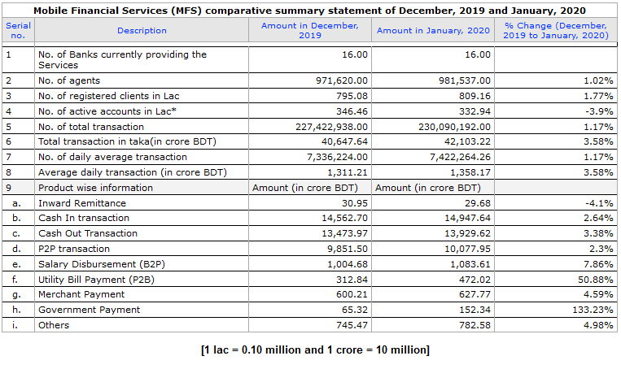
Figure 2.1: Current condition of MFS in Bangladesh [Bangladesh Bank]
People are more interested in providing salary through MFS and pay their utility fees with the same service and it shows on data that this segment is getting an immense response. Bill payments (77%), savings (76%), airtime top-ups (70%), education fee payments (60%), and merchant payments (55%) are the majority of the components of respondents were interested in using MFS for (2015 data). Bangladesh Bank issued a license to 28 commercial banks to launch the country's mobile financial services and later canceled three of the banks' licenses. Now 25 banks have the authority to provide mobile financial services, including 16 banks that are involved in the market in providing the service.

Figure 2.2: Anticipated Growth from 2019 to 2024 (The Independent)
According to BB’s report on MFS, the total volume of transactions conducted through the MFS platform was Tk. 378,885 crore in 2018, which is 20 percent higher than in 2017. Moreover, the number of active customers has also increased to 3.73 crores in 2018 from 2.1 crores in 2017. The industry has gained 120% growth rate since 2011. According to experts shown in Figure 2.2, the mobile wallet market in Bangladesh is likely to gain momentum in 2019 as a global report that forecasts its growth to USD 250 billion by 2024 from over USD 100 billion in 2017.

Figure 2.3: Growth of Total users and Active users
As of 1 February 2017, with a view to the growing unlawful usage of MFS, the central bank lowered the daily cap of mobile cash-in to BDT 15,000 from BDT 25,000, thus reducing the daily cash-out limit to BDT 10,000 from BDT 25,000. The maximum monthly cash-in limit was lowered from BDT 150,000 to BDT 100,000, and the maximum monthly cash-out limit from BDT 150,000 was reduced to BDT 50,000.
Mobile Financial Services in Bangladesh is still a booming business for organizations doing business in the industry. Since it is visible that the MFS organizations still have a huge potential market to grab, it indicates MFS in Bangladesh is still in the Growth stage of the maturity table.
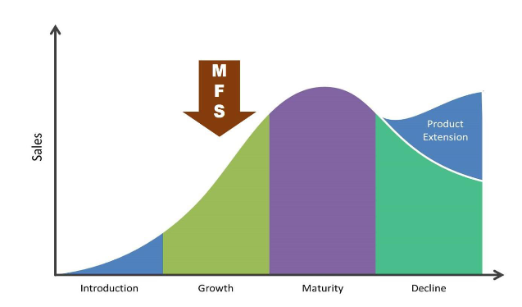
Figure 2.4: Maturity stage of MFS industry
According to the Bangladesh Telecommunication Regulatory Commission (BTRC), in December 2018 there were a total of 156,989 million mobile subscribers and a total of 91,348 million internet subscribers. In 2018, more than 46% of financial transactions took place via mobile banking, indicating an increase in the number of holders of mobile financial services that use mobile banking for various financial purposes.

Seasonality
Seasonality is a characteristic of a time series in which the data experiences regular and predictable changes that recur every calendar year. Any predictable fluctuations or patterns which recur or repeat over one year are said to be seasonal. Mobile Financial Services in Bangladesh has a repeating pattern of a business hike on each cultural major events like Eid-ul-Adha & Eid-ul-Fitr. In these two events organizations operating in Bangladesh, the MFS industry gets to gather new customer base, Hike in a transaction, and huge traffic grain through public led and advertisement led promotions. Other than those two events above, there are a few more holidays/events that bring a repetitive pattern of a transaction to MFS, such are; Pahela Boishak, Winter Vacation, Valentine’s Day, etc. People in Bangladesh tend to shop in such events and the use of MFS is the most viable payment method to them which eventually leads to high transaction and new customer base for the MFS.

External economic factors
There are more than 170 million people in Bangladesh currently. The economic condition of the whole world, not only Bangladesh is on edge of collapsing in 2020. Bangladesh Bank is trying to keep control of the economy but increasing the money supply and reducing Bank Reserve Ratio but it is still quite impossible to hold the economy at a stable position. But surprisingly this has led MFS to see a boom in their transactions. People are using Digital Payments more than the Person-to-Person payment system. Despite the hard condition of the economy in Bangladesh, MFS organizations like bKash, Nagad, Ucash, etc. are getting more customer base. bKash has recently broken a record of 4500 million transactions in one day during this pandemic of 2020. So it can be said that the Economic factors have a positive effect on MFS in Bangladesh.

Technological factors
Technological factors have a positive effect on the MFS in Bangladesh. Rapidly every digital fund transaction company has used the same technology up to now. Technology requires innovation and advancement. Even though all banks trying to provide mobile financial services or m-banking services to their customer base, they have acquainted digital platform advantage to smoothen their operations, but bKash has been winning the race since the beginning. Their well-updated mobile app has all the features a customer needs to know while using the service yet it is very easily understandable by everyone. iPay and Upay are the first ones to introduce QR code in this service system. Mobile Financial Services is still trying to develop itself and keep the hard competition alive in the market which eventually creates a positive effect on the whole industry.

Political, legal, and regulatory factors
Despite Bangladesh's political instability and internal conflicts between the MFS industry parties have been able to suppress the political obstacle Irregularities in Bangladesh and got its mark. Because of Bangladesh Bank and Government's constructive and modern approach, the mobile banking system has made significant progress in a few years. Bangladesh Govt. has deducted VAT from the mobile financial services which play a huge role in growing this sector further. Given the unfortunate situation, the mobile banking system has overcome the hindrance of political instability and by the tenth year, running was ready to build its mark in the industry. So it can be said, Political factors have a moderate effect on MFS in Bangladesh.
The legal environment is very positive for the industry. The Government has established and updated some laws and regulations for the DFS industry. Besides, in 2011 the Bank of Bangladesh released the "Mobile Guidelines. Bank Financial Services (MFS), "revised and updated later in 2015. Certain laws affect the business environment while there are certain policies that corporations maintain for themselves. The legal analysis takes each of those angles into consideration and thus outlines the ways in the light of that legislation.

Barriers to entry (High)
Mobile Financial Services in Bangladesh is directly related to the Legal & Regulatory system of Bangladesh which is one of the main parts of the Financial System. This creates a functional barrier to enter the market. There are some factors which can be highlighted, such as;
- Capital Requirement: MFS industry is led by a few organizations like bKash, Rocket, Nagad, Upay, iPay, Ucash, etc. Each has capitalized its existence in the market but the majority of the market is grabbed by bKash and Rocket. To enter this market, an entrant must have a high capital caliber to compete and operate.
- The economy of Scale: To attain the Economy of Scale in this industry, it takes large organizations to operate for a long time and reach that stage of operation. For the new entrants to enter into a new market and achieve production efficiency, it stands as a huge barrier to them.
- Distribution Channel: In MFS the distributors are known as “agents”. Agents are recruited by the organizations to reach out to both rural and urban areas and provide the service. For new entrants to capitalize in this existing market they have to come with very different unique selling propositions otherwise people wouldn’t go to their agents leaving the existing ones.

Supplier Power (High)
In a business industry where service is their product, the suppliers are the same providers. The main supplier of this business would be Mobile Network Operators and to list after that, it would be Investors and then technology business/vendors. The Mobile Network Operators in Bangladesh are very few, such as Robi-Airtel, Grameenphone, Banglalink & Teletalk. They have the coverage of the whole country. MFS is tied to these Operators because they are directly and heavily dependent on the services Mobile Network Operators provide, without their service, MFS cannot even run. But for the Mobile Network Operators, they have many other business segments where they can continue to operate. So, it can be said the power on Suppliers here are very high, MFS is bound to be in a partnership with these Mobile Network Operators. The main market leader of the MFS industry in Bangladesh, bKash has very high investors like Alipay. To operate and develop in this market, MFS organizations need constant investments and burn cash to gain more customers, but there are a few high amounts of fund investors interested, so the power they have is high as well. Technology vendors are very high in number, both local and international vendors. Mobile Financial Service organizations need to constantly innovate and develop their technological sector and maintain a highly sophisticated data server to keep hold of all the consumer data. It requires the technology vendors to provide quality and high-end products to the business holders. When filtered as per the requirement needed to satisfy MFS needs, the number of technology vendors reduces so the power they have over the industry is nor can high nor low, moderate be said.

Buyer Power (Moderate)
The buyers of this service can be divided into two parts, General public & Organizations. Several buyers are high compared to the number of sellers of this service. The general public consuming this service is known as personal consumers and organizations consuming this service are known as merchant consumers.
General Public’s (Personal Consumers) power varies place to place, such as people in remote areas have only access to MFS like bKash, they cannot avail the service of banks like people of urban areas do. So they get to say almost about nothing over MFS but people living in urban areas have all the opportunities to avail either banks or MFS, also the availability of all the MFS organizations operating in the market, so they have the power to switch or choose from numerous providers. So, the power in total general public get is moderate.
The organization’s (Merchant Consumers) power is moderate. Each ‘cash-in’ and ‘cash-out’ has a fixed rate of charge for every transaction set by the Bangladesh Telecommunication Regulatory Commission, which is 2.0%. This fixed amount pushes MFS organizations to make extra profit, they are set at a fixed rate. But Organizations need MFS in their daily business transactions, it's unsafe and complex to save cash of their daily transactions on their account, also they cannot go to the bank each day to deposit their money. bKash provides them both the service to either send their daily money automatically to their preferable bank account or keep the money on their mobile wallet. It gives the edge of advantage to the MFS over merchants availing this service.

The threat of Substitutes (Moderate)
Substitutes for Mobile Financial Services would be the traditional banking system and micro-finance banking system.
The traditional banking system is yet the most trusted medium of transaction for people in Bangladesh. Many people are reluctant to trust MFS yet, traditional banking system offers people to deposit their money, use it as a method of a transaction such as a cheque, credit/debit card, bank draft, etc. So, people choosing the Traditional banking system over MFS is a possibility but the threat of it is not as high because these two services are not mutually exclusive, people can avail both at the same time which decreases the threat meter eventually.
The micro-finance banking system is providing loans to the unbanked and remote area’s people who cannot take the service of commercial banks. People in such conditions need something to use as their banking method and Micro-finance can be directly a substitute for MFS.

Industry Rivalry (High)
The competitiveness of the industry is very high. The intensity of pressure created on one another is immense and constant. It can be defined based on some key points, such as;
- Capital Requirement: The organizations operating in this industry have already invested a huge money to get where they are now. The money required to invest in technological innovations and development to provide an efficient and trustworthy service to consumers is huge. Also, providing training to all the employees about the whole MFS requires a lot of time and money which cannot be reduced or compromised.
- Switching Cost: The threat of switching from one organization to another is up top because the switching cost it requires is close to zero. People can switch to avail of another service with no cost left behind. Which makes it hard for the operating organizations to sustain the consumer base.
- Growth: The growth opportunities for firms are high, which leads to higher competitiveness in the market to constantly fight to gain more market share. Organizations can earn revenues easily once they start in this sector, as the growth indicators are still at boom and double-digit figures.
- Competitors: There are currently 16 banks providing the mobile-banking service in this country and some non-banking financial institutions. The market is limited but the service provider is increasing as this sector is yet to reach its maturity. Which leads to higher competitiveness among each other.
- Product Differentiation: The service provided in this sector is the product and it is almost certain that the product cannot be differentiated any more than it already is. So the threat here is low.

Summary of challenges and opportunities
To summarize the whole competitive analysis of this industry,
Table 2.1: Summary of Challenges and Opportunities
Factors | Challenges | Opportunities
Barriers to Entry | High Threat | Favorable for existing firms
Supplier Power | High Threat | Unfavorable for existing firms
Buyer Power | Moderate Threat | Favorable for existing firms
Substitute | Moderate Threat | Favorable for existing firms
Industry Rivalry | High Threat | Unfavorable for both existing and new entrants

CHAPTER THREE

Analysis of the Organization

Overview and history
BKash Limited (bKash) is a Non-Banking Mobile Financial Service Provider in Bangladesh operating under a Central Bank (Bangladesh Bank) license and approval, as a subsidiary of BRAC Bank Limited. BKash provides secure, simple, and quick ways for both the unbanked and banked citizens of Bangladesh to make payments and money transfer services through cell phones. BKash is currently one of the world's leading providers of mobile financial services. In 2010 bKash began as a joint venture between BRAC Bank Limited, Bangladesh, and Money in Motion LLC, USA. In April 2013, the World Bank Community member International Finance Corporation (IFC) became an equity participant and Bill & Melinda Gates Foundation became the firm's investor in March 2014. Ant Financial (Ali Pay), a globally reputed affiliate of Alibaba Group, became an investor in bKash in April 2018. The main aim of bKash is to ensure the citizens of Bangladesh have exposure to a broader variety of financial services. It has a special focus on serving the country's low-income masses to achieve wider financial inclusion by delivering convenient, affordable, and reliable services.
About 70 percent of Bangladesh's population resides in rural areas where it is difficult to access structured financial services. And these are the individuals who require these programs most, either to collect funds from loved ones in remote locations or to use financial resources to boost their economic situation. Less than 15% of Bangladeshis are linked to the formal banking system while more than 68% have cell phones. Such phones are not only communication instruments but can be used for more important and complex computing functions. BKash was specifically planned to use these handheld apps and the omnipresent telecommunications networks to safely expand financial services to Bangladesh's underserved rural population. BKash can be reached via all Bangladesh regulated cell networks. Today bKash runs a network of over 180,000 agents throughout Bangladesh's urban and rural areas with over 30 million active accounts.
In 2017, bKash was listed 23rd in the annual survey of 'Change the World 2017' by Fortune Magazine among the fastest 50 businesses that implement improvements focused on social concerns.

Mission
Through offering easy, accessible, and efficient financial services, bKash intends to extend the scope of financial inclusion. BKash wants to provide a Mobile Financial Services solution based on a highly scalable Mobile Money platform that enables Bangladesh's citizens to send and receive money safely through mobile devices.

Objective
Ensuring access to a wider range of financial services to the Bangladeshis people. It specializes in serving the low-income masses of the State to gain greater financial inclusion by providing accessible services; Cheap and efficient

Board of Directors
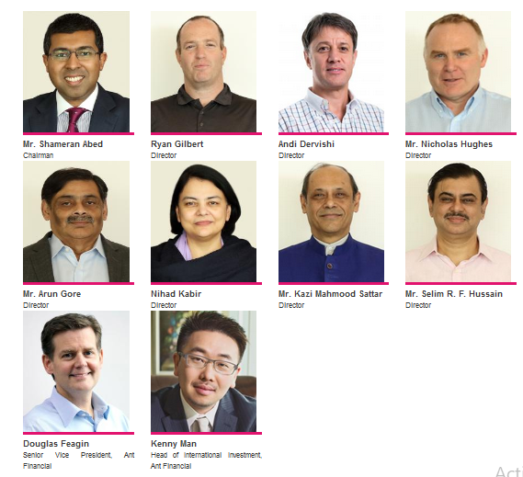
Figure 3.1: Board of Directors of bKash Limited (bKash website)

Trend and growth
bKash has been on the rise since they have started operating their business. They have achieved non-stop milestones over the years. From 2011 to 2020 bKash has grown immensely, they have a customer base of 3.1 crore active users and recently they have declared there are 2 million active bKash Mobile App users currently in Bangladesh. On average they get transactions of 4-5 million BDT every day (2017 report). They are the largest MFS organization in Bangladesh and the second largest in the world. bKash currently has possession of 60% of the market share in the country.
Some milestones achieved by bKash ltd over the years and some key facts about bKash ltd are shown below;

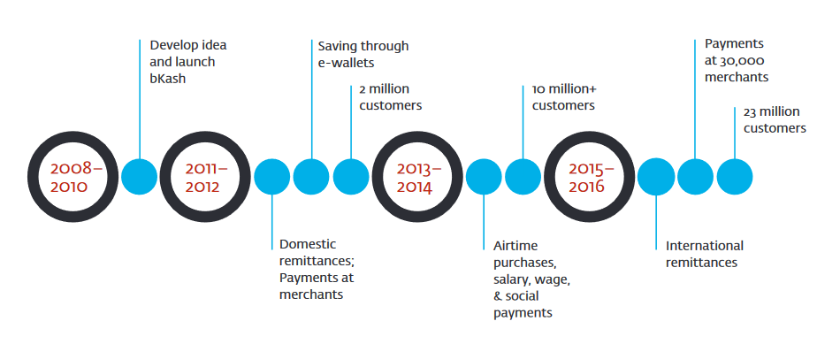Figure 3.2: Milestones achieved by bKash (World Bank.org)

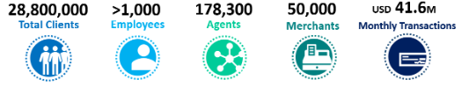
Figure 3.3: Key Facts About bKash as of 2017/2018 (IFC.org)
In Bangladesh, we have a population of 170 million. Just 30% of them have been taken under formal banking structure so far, although more than 70% of them have internet access, which is 130 million citizens. BKash thus can draw on these 130 million unbanked citizens. To analyze the growth of bKash ltd in the current market.

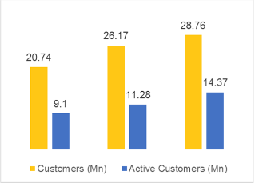
Figure 3.4: Growth of Customer and Average Daily Transactions of bKash Ltd (World Bank.org)
As we can see in the above graphs from Figure 3.4 that bKash has been on the rise from 2013 to 2017 that too at an immense pace. If we focus on the Growth of customers, we can see a rise from 20.74 million to 28.76 million (2017) total customers and from which 9.1 million to 14.37 million active customer base (2017) for bKash ltd. If we focus on the Growth of Average Daily transactions, the increase in it is huge within just 4 years. Starting from 506,032 BDT to 4,327,308 BDT average daily transaction and of which agent’s transaction reached 178,322 BDT at the year-end of 2017.

Customer mix
bKash has a huge capacity of existing consumers and for new potential consumers as well. They are trying to obtain every sector of the customer base available as their customer mix. Education Payment, Garments, Salary Disbursement, Retail Stores, Bill payment, Hospitals, NGOs, and many more are already clients of bKash Ltd. The types of customer profile bKash have, are;
- General Consumers: These are the people who use bKash as their Mobile Wallet. As of May 2019, bKash has 3.1 crore, active general users, in Bangladesh which is almost one-fifth of the whole population of Bangladesh. bKash not only targets the people of Major cities like Dhaka, Khulna, Chittagong, etc. but they also give the same importance to gain market share from remote areas and villages which is one of the biggest factors of them succeeding in Bangladesh. For General Consumers, bKash segments them geographically.
- Merchant Consumers: Merchants consumers are the organizations, companies, and stores, etc. that consume the service of bKash. Merchants are categorized into two segments mainly,
- Merchant Plus: Merchants that fall under high leveled organizations or companies or stores. The service charge for them and Bank settlement procedure differs from Merchant Lite
- Merchant Lite: Merchants that fall under Low to medium leveled organizations or companies or stores. Their Service charge is less than the Merchant Plus service charge.
  - Merchant Lite A
  - Merchant Lite Medium
  - Merchant Lite B
In 2016, there were only 700 organizations taking merchant payment but within a year of getting the payment system popular, bKash has successfully obtained 30000 organizations taking bKash payment. And the growth of merchant consumers continued to rise at a very high pace. There are over 1 lakh organizations taking merchant payments and from which 80000 is registered under bKash ltd.
- Govt. organizations: Even though there is a company backed by Govt. (Nagad) in the same industry competing with bKash, bKash has successfully acquired several govt. organizations as their clients which is a huge success for the company. Govt. organizations like Titash, WASA, DESCO, etc. are taking payments with bKash. bKash has been getting commendable success of transactions in this segment of the customer mix just after starting.

Product/Service Mix
The products/services bKash limited is offering at present are;
- Cash In: A consumer can load cash in his/her bKash mobile wallet via any ATM or Agents available, which is free of charge.
- Cash Out: A Consumer can withdraw cash from the bKash mobile wallet from any ATMs or Agents available, this is not free of charge, bKash charges a very few percentages of money while a consumer avails Cash Out service.
- Send Money: One consumer can send or transact money from his account to another consumer’s account virtually, which removes many hassles for the consumers of both ends. This requires a very little charge while transacting money.
- Payment: Consumers can avail of the service of virtual or digital payment through the bKash mobile wallet. It is vastly available in all markets in Bangladesh.
- Mobile Recharge: Consumers can recharge their number and also anyone’s number through their bKash wallet.
- Add Money: Consumers can add in mobile from a different method of wallets such as;
- Bank to bKash
- MasterCard to bKash
- Visa to bKash
- Pay Bill: Recently bKash has launched the service of paying bills via the bKash app, which is a lot more convenient for consumers than standing in lines to pay the bills. The types of bills payable through bKash are;
- Electricity Bill
- Telephone Bill
- Gas Bill
- Water Bill
- Internet Bill
- Cable TV Bill
- Education
- Interest on savings: Consumers enjoy interest on their savings varying on the amount of money saved, also who doesn’t want to avail the interest rate services they can manually deactivate this process.

Table 3.1: Interest rates varying on the balance (bKash official website)
Balance/slab | Rate p.a
BDT 1,000 – BDT 5,000.99 | 1.5%
BDT 5,001- BDT 15,000.99 | 2%
BDT 15,001 – BDT 50,000.99 | 3%
BDT 50,001 and more | 4%

- Donation: bKash has recently launched the service of collecting and providing donations whoever is voluntarily interested in avail this service can do so, many organizations have already started donating via bKash.

- International Remittance: BKash has partnered with Western Union and MasterCard to promote transfers from foreign countries that allowed the rural population to receive money directly from its family members who live and work in other countries.

Operations
The structure of the bKash organization is divided into several divisions of which there are many sub-divisions/departments. There are mainly 7 different divisions operating in bKash such are Finance, Commercial, Marketing, Customer Service, External Corporate Affairs Development (ECAD), Technology, and Human resources. An illustration of the organizational structure is given below;
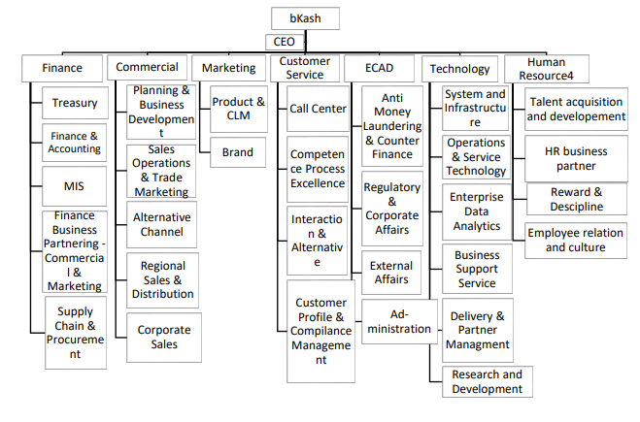
Figure 3.5: bKash limited company organogram

- Finance Division: Finances are entirely liable for all of the company's accounts as well as for all financial transfers. Those provide accounts payable and receivable monitoring, monthly and annual sales analysis, accounting processing, financial statement documentation and documenting, etc.
- Commercial Division: Commercial Division is mainly liable for generating new merchants, lead generation, Acquisition target, Acquisition strategies, Campaigns & Activations, etc.
- Marketing Division: Marketing Division deals with Public relations management, Brand Management, direct branding of products and services, database management, etc.
- Customer Service Division: Customer Service is solely created for troubleshooting of consumer problems such as call center services, Interaction with customers, Customer Profile and Compliance management, etc.
- External Corporate Affairs Development (ECAD) Division: All the external communication and business management & affairs are handled by ECAD such as administrative works, Anti-Money Laundering activities, Regulatory and Corporate Affairs, etc.
- Technology Division: Technology Division mainly deals with all the technological innovations and developments of the company as well as Research and Developments. The main sub-divisions of these divisions are; System and Infrastructure, Operations and Service Technology, Enterprise Data Analytics, Business Support service, and Delivery & Partner Management.
- Human Resource Division: The human resource management team is responsible for hiring, interviewing, assessing workers as well as performing the role of pay, preparation, and incentives for workers. This division is sub-divided into Talent Acquisition & Development, HR Business Partner, Reward & Discipline, and Employee Relation & Culture.

Like the Commercial Division, every division has a division head and subcategorized into several departments. The author as an intern had to report to the Manager of the Commercial Division and Relationship Executive Officer for my work process. The commercial division structure is given below;

Figure 3.6: Hierarchy of M-Commerce Payment

SWOT analysis
SWOT analysis is a combination of a company’s strengths, weaknesses, opportunities, and threats and which helps a company to compare and help in decision making.
Strengths
- Board of Directors: bKash ltd has the strongest board of directors among all the competitors operating in the market which gives bKash an edge of advantage over others
- Positioning: bKash has created such a position in people’s minds that everyone who talks about sending money somewhere they say “bKash me”. It has created an immense impact on both urban in rural areas. Also, bKash has been listed as the 23rd largest company out of 50, in the world in which none other competitors are yet close to it.
- Availability of Agents/Customer Center: bKash has the highest number of customer centers and Agents available in the whole country. The visibility of the company is highly ensured by them as well. They also provide 24/7 customer service to their consumers.
- First mover advantage: Even though Dutch-Bangla bank was the first one to enter the market but bKash had successfully generated their presence in the market which Dutch-Bangla failed to do. Thus, bKash even after entering 2nd on the market had taken the privileges of first-mover advantage.
- Cash Burning Capability: No other MFS organizations burn cash for the sake of market share like bKash does. bKash provides the highest number of offers throughout the whole year and also gives the highest number of cash-backs, discounts which push both the consumers and merchants to consume the services of bKash.
Weaknesses
Higher Service Charge: Nagad and Rocket provide lower service charges compared to bKash which gives bKash a disadvantage over the market share.
- Limited Daily Transaction: bKash has been through many fraudulent incidents compared to other competitors, for which Bangladesh Bank has limited their (bKash) daily transaction amount for which many consumers switch to other brands.
- Rules and Regulations: Bangladesh Bank has set strict rules and regulations regarding MFS operations, which keeps the MFS in a certain limitation of a box, specially bKash who suffers more than others because they are the ones currently in the market who almost is at the maximum stage of the box of regulation set by Bangladesh Bank.

Opportunities
- CSR Activities: CSR activities are essentially required for big organizations like bKash ltd, it helps them to put a good value proposition in people’s mind which ultimately works as a word-of-mouth marketing.
- International Transaction: bKash has a joint venture with two International Money Transferring companies, bKash can utilize this situation to extend their monetary services to international boundaries. No other competitor is even close to this range of how far bKash has its reach.
- Market Extension: Even though bKash already has the highest number of market share, there are still scopes of gathering new personal consumers as well as merchant consumers and it is suitable for both physical stores and online stores. In an online platform, bKash can rule as a sole runner because it is hardly seen as Nagad, Rocket, Upay, or iPay being available to the online businesses, if bKash can optimize more market than they already have, other competitors are likely to struggle more.
Threats
- Banks Developing: Many banks are innovating and developing their services to offer similar products as bKash or any MFS do, which will push many consumers out of MFS to traditional banking services because they have more trust in banks than MFS. If bKash can’t take proper steps to outrun those services offered by the banks, then bKash will face bad consequences.
- Higher Service Charge: As already some MFS are offering less service charge than bKash, it is already looking to be a threat to the company. Nagad is govt. backed MFS organization, they are deliberately reducing their service charges to get back at bKash and push the bKash consumers to switch to Nagad and they are already doing it successfully.

Steps/Strategies to meet the challenges and opportunities
Strategies for challenges:
To recap the challenges faced by bKash in their day-to-day activities are;
- Higher Service Charge
- Daily Transaction Limit
- Banks Developing
To overcome these challenges, bKash has to do something out of the box to make it in the long run, such as;
- As it is already certain that Nagad is pushing bKash to reduce its service charge otherwise, the market share is likely to be divided highly. What bKash can do is to, as they are already burning vast amounts of cash to attain new consumers, they can use a partial amount of money in retaining the existing customers as in to reduce their charges as well. What this will do is, it will choke Nagad in their strategy and they will be forced to stop reducing charges any further, and then bKash can think of a new strategy to get up from that situation. Even though reducing charges is a long-term step to take, but it will certainly keep the company sustainable and retain the existing customers for a longer time.
- As the transaction limit is set by Bangladesh Bank for ensuring consumer safety while using MFS, bKash must come up with something strong to stop the fraudulent acts, developing something secure and safe will make the consumers gain their trust back, also Bangladesh Bank can increase the transaction limit when the fraudulent acts decrease.
- Banks offering similar services as MFS is likely to be the biggest challenges every MFS can face. To optimize this situation in owns favor, bKash needs to come up with some services that the traditional banks cannot offer, which will make the consumers think twice before switching. It is an innovation that needs to be made to overcome the challenge.
Strategies for Opportunities:
To recap the opportunities faced by bKash in their day-to-day activities are;
- CSR activities
- International Transaction
- Market Extension

- Corporate Social Responsibilities is a marketing strategy that not only brings good brand value but it also brings new customers on board. Word-of-Mouth marketing is the most effective strategy according to various experts. bKash has already been in this field of work, they have been doing CSR activities for a long time, but it still stands as an opportunity to grab a new customer base which bKash can utilize. For example, like recently bKash has donated a chunk amount of money for the COVID-19 pandemic crisis, it most certainly created a high brand value, they need to keep doing this.
- Alipay is an investor and shareholder of bKash Ltd, Bill and Melinda Gates Foundation is a partner of bKash Ltd. bKash ltd has a vast reach to international boundaries. What they can do is to, utilize this situation to increase their range of services internationally.
- Both physical and online markets are yet to be completely captured by MFS. bKash has the largest market share but they still have the scope of capturing more. Online platforms are the most lucrative side for bKash now, they can capture all the online businesses to extend their market. Also, many physical merchants are yet to be captured by bKash. They are constantly working on it already if attained they are like to increase their market share by a huge portion.

CHAPTER FOUR

Internship Experience

Position, duties, and responsibilities

Position:
The author was hired as an Intern at bKash Limited. He was appointed as an intern of M-Commerce Payment, Commercial Division.

Duties & Responsibilities:
Main duties and responsibilities throughout the whole internship period were scanning assigned zone to find out Existing and Potential Merchants, Updating & Sorted Existing-Potential & Plus-Lite merchants wise on Microsoft Excel, Generating Lead by setting up Meeting with Potential Merchants over the phone and in-person, Participating in Meetings & Acquired Merchants successfully, Training Merchants from PIN setting to Bank Settlement Procedure, Handling Issues solving, Campaign briefing to Existing Merchants and Scan-Update-Acquire & Handle whole Impact Zone (Bashundhara City).
After a particular ongoing process of work, the author had to provide training to the newly on boarded merchants that we acquired, like, how to set pin code after opening a merchant account, how to reset pin code if the pin is forgotten or blocked, how the transfer of money from mobile wallet to bank works, how to participate in a campaign that bKash is launching and how the transaction of campaign bonuses or discounts work.

Training
While joining the company, supervisors and managers provided training on how to completely fill-up a Merchant KYC form, how to talk with merchants over the phone to fix meetings, how to sort & Update data according to the format the company follows, how to scan the assigned zone and collect information and how to handle merchants who are having trouble using bKash service

Contribution to departmental functions
Merchant Acquisition: The main duty & responsibility the author had was to find out new merchants and acquire them. So my contribution to these segments was,
    - Scanning: The first step in bringing new merchants is to scan and find out who the potential merchants are and who the existing ones are. Scanning is done by inputting store information in a diary and capturing a photo of the store. The author was assigned one zone (Dhaka 7) which consisted of the areas below;
- Bijay Sarani Walton Plaza to Monipuri Para
- Monipuri Para to Khamar Bari
- Khamar Bari to Farmgate
- Farmgate to Green Road
- Green Road to Panthapath
- Panthapath to Karwar Bazar
- Karwan Bazar to Shonargaon Road
- Tejgaon to Bijay Sarani (non-industrialized area)
So, he had to scan these areas to find out who are our potential merchants and who are existing ones.
    - Data input: The information gathered from my scanning, he had to input them on an excel sheet in a format that bKash follows and sorting them who are our potential to existing & Plus to lite merchant wise.
    - Lead Generation: After finding potential merchants, he had to call them by the number he has collected and asked for an official meeting about opening a bKash wallet. When someone agrees, he had to fix a date and create a calendar so that he doesn’t overlap meetings and upon completion of generating lead every day, he had to give that update to my supervisor.
Projects: There were a few projects that he was a part of during my Internship period in bKash, such as;
- Cashback Campaign
- Pahela Boishak Campaign

Evaluation of internship performance
The internship period was 4 months long, the author along with other interns had to go through various steps of learning the whole functionality of our job responsibility. After each task was done, supervisors would check how well the task has been done and if there is any scope of improvement, they would suggest us to do it in that certain way. Evaluation of all the responsibilities is given below,
- Scanning & Updating: After completion of scanning one certain area of his assigned list, his supervisors would check if he had gathered all the information from the merchants if he had captured the stall’s images and upon given acceptance, he needed to enlist the collected information on Microsoft Excel on a certain format that bKash initially follows and then they would check if he had inserted the data correctly or not.
- Lead Generation: Before generating leads both over the phone and in person, his supervisors would structure the whole process from the beginning to ending, and he had to follow that path to get a successful acquisition of a new merchant. After generating a lead of a new merchant, he had to show that information to my immediate supervisor and she would go to that certain meeting with the author and show him how the negotiation works and after the acquisition of a new merchant, he needed to train them about the post-opening process of bKash merchant wallet which was evaluated by my supervisors if he was doing it right.

Skills applied
While working in an organization, a person must go well prepared to complete any tasks that would be given to him/her and those define how well-skilled a person is. While the author was working in bKash the most important skills that needed to apply are;
- Technological Skills: To work as an intern at bKash Ltd, one must have to be tech-savvy to understand the functionality of technologies. bKash assigns a laptop for each intern upon joining and they have to maintain the laptop as per the system bKash tells you to. Anything wrongly done would result in a locked account. All the interns must know Microsoft Excel functions & formulas.
- Adaptability: The drastic change in the environment from graduating in Finance to working in a commercial team of bKash required me to adapt hardly in the environment.
- Flexibility: One has to be very flexible working in the Commercial team, every day the office started at a certain time but it doesn’t finish at a certain time. He often needed to stay a lot longer than office time or sometimes could leave earlier than office time. It’s a matter of flexibility of how much one can take the routine and finish his/her assigned job every day.
- Teamwork skills: Teamwork skill is a must and most important skill he had to apply while working in bKash. Co-operating with Supervisor, Manager, Colleagues is essential. He was called now and then to help in a particular task and he has always tried my level best to finish what he was asked to do. In the Syngenta Bangladesh project, we were 6 people working on the accumulation of merchant documents and were given 3 days to complete 2500 documents which were tough to match. But luckily for the teamwork skill, they eventually finished in due time.
- Workload Temperance: The pressure of work in bKash is immense. There was no free time to relax, and the responsibilities provided were huge so he had to handle the workload otherwise everything would have delayed. Fortunately, he never disappointed his bosses, he could handle what it takes to be an ideal intern.

New skills developed
It is certain that once someone joins a new company there are many skills and attributes that he/she learns from the organization and the people working around. While the author was doing his internship he has also learned some skills and those are;
- Patience: The thing needed along with the skills was patience. He had to handle plenty of different kinds of people, not everyone behaves or acts the same way. To do his tasks, he had to handle them differently and he had to be patient enough to adapt as per their behavior.
- Crisis Management: There had been times when he was lost in work for not being able to acquire new merchants and generate enough leads, but as time went by he learned how it is done, and eventually he managed the crisis well enough. He always lacked in this segment of skill but it is changed now.
- Self-discipline: The work-culture environment is very different and this was new to him. There had been a time where he mistakenly did something which he wasn’t supposed to, he learned from it and he believes that he knows how disciplinary work-environments are.

Application of academic knowledge
As the author has majored in Finance, his work environment didn’t require much of my financial skills rather needed the skills he learned in pre-major courses. As a commercial intern, he needed to understand customer behavior, needs, wants, and demands, how organizational hierarchy works. The knowledge he has learnt from academic curriculum like Microsoft PowerPoint, Microsoft Excel was well needed and applied in his workplace. Understanding Customer Relationship Management and Microsoft Excel skills were the two most applied knowledge during his internship period in bKash ltd.

CHAPTER FIVE

Recommendations

Recommendations for improving departmental operations
bKash Ltd is a very sophisticated company and follows a strongly regulated procedure of operation. But in my opinion,
The first thing that can be improved is by tracking the merchants in each area. The database has information of all the merchants’ on boarded with bKash from beginning to present but due to the heavy load of data, it is hard to identify who are active merchants and who have stopped using bKash services or who are potential merchants. If anything could be installed or any software could be developed to identify and locate stores, it would be very time saving for bKash.
The second thing would be to increase or gain their trust back. Many people think bKash is unsafe to use because of many fraud acts happening around. bKash couldn’t come up with anything solid yet to stop the frauds and knowledge the service consumers about the safety and security of the bKash wallet. It requires more co-operative actions between bKash and their consumers rather than bKash’s operation only. People need to be taught how to keep their wallets safe and act accordingly.

Recommendations for improving self-performance
Over Phone Communication: One thing the author still lacks is convincing people over the phone. He is very much behind in this skill, he can’t put a strong position with my words to convince people. There had been times when the person he was trying to convince to create a bKash wallet didn’t trust me, and he failed to generate the lead of that certain merchant.
Coping up with Corporate Environment: Corporate culture differs highly from the actual culture being told about. Working in bKash has helped me to start understanding how corporate culture works as he has received top-notch experience from working in bKash. The author believes there’s still a lot more to learn about the environment.

CHAPTER SIX

Conclusion

To conclude, we can say that bKash is one of the most influential and successful Mobile Financial Services in the world as it is the second-largest MFS Company in the world right now. Within this short period, they have reached a vast amount of population & market growth in Bangladesh. They are helping people with various essential services like Mobile Banking, Digital Payment, Disbursing Salaries, and Paying Utility Bills. Even though they have been gaining a lot of success, their growth became sloppy after 2017 and the reasons behind that are Privacy Violation, Rumors, strict Rules and Regulations, Change in service charges, etc. Mobile Financial Services as a whole is currently on the rise and at its growth stage of maturity. People are slowly switching to MFS as a universal payment system which ultimately is turning potential customers into actual consumers. But for some fraudulent acts of hackers, bKash is facing continuous blame from customers as well as Bangladesh Bank. bKash is trying hard to provide knowledge and train the consumers on how to not fall in the trap, they are continuously promoting and advertising safety issues and how to tackle them.
It is likely to say, MFS is the next big thing in this country. People will start relying more on this platform eventually. The organizations operating in this industry are trying to provide the consumers as best as they can, and for the constant competitiveness among the organizations the services are only improving and technologies are continuously developing for the betterment of both customers and organizations. bKash is already the MFS to bring the highest International Remittance in this country, it is possible to anticipate that the other competitors will not sit behind for very long. This will not only increase the brand values of the organizations but also increase the brand of value Mobile Financial Services in this country and increase International Remittance received (Which directly affects the GDP to rise). There is still a lot of markets to be grabbed by bKash, with their proper strategies being implemented, they can bring those potential customers on board, and hopefully, they can stop the fraudulent acts once and for all. With executing the right actions, bKash can hold on to their No.1 position for a long time ahead.
The author believed that his work experience in the mobile financial services industry would enhance his expertise not only in conceptual and practical finance but also in the mobile financial services field.

References
Alfadzly Alli, A. S. (2016). Business Model On “Mobile Financial Service". Dhaka.
AZAD, R. I. (2019, January 31). Bangladesh MFS market to gain momentum in 2019. Retrieved from Theindependentbd: http://www.theindependentbd.com/post/185535
Bangladesh Bank. (2020, May 1). Retrieved from bb.org.bd: https://www.bb.org.bd/fnansys/paymentsys/mfsdata.php
bKash. (2020, July 7). Retrieved from bKash: https://www.bkash.com/
bKash. (2020, May 20). Retrieved from Wikipedia: https://en.wikipedia.org/wiki/BKash
Group, T. B. (2011). The Socio-Economic Impact of Mobile Financial Services.
Hossain, T. (2019, March 17). Digital and mobile financial services facilitate financial inclusion . Retrieved from The Financial Express: https://thefinancialexpress.com.bd/views/digital-and-mobile-financial-services-facilitate-financial-inclusion-1552832325
Ikra, I. J. (2019, October 14). Blukonsult. Retrieved from Blukonsult Global: http://blukonsult.com/uncategorized/mobile-financial-services/
Jaheed Parvez, A. I. (2015). Mobile Financial Services in Bangladesh. Dhaka: USAID.
Mufazzal, M. (2018, August 12). Company profile: bKash witnesses steady growth . Retrieved from Thefinancialexpress: https://www.thefinancialexpress.com.bd/stock/bangladesh/company-profile-bkash-witnesses-steady-growth-1533875587
WING, L. A. (2019, January 15). Lightcastle Parnters. Retrieved from Lightcastlebd: https://www.lightcastlebd.com/insights/2019/01/15/digital-financial-services-the-next-step

