Internship Report
On
“Strategic Recruitment and Selection procedure followed and applied by grow n excel Human Resources & Management Consultants”

Internship Report
On
“Strategic Recruitment and Selection procedure followed and applied by grow n excel Human Resources & Management Consultants”
An internship report will be presented to the faculty of Business Administration with the prejudicial accomplishment of the requirement for the Bachelors of Business Administration degree.
Submitted To:
Md.AbulMohaimen
Assistant Professor
School of Business and Economics
United International University

Submitted By:
SyedaRafia Islam Lopa
ID: 111 142 233
Major in Human Resource Management
School of Business & Economics
United International University

Date of Submission: 25th January 2019

Letter of Transmittal
January 25.2019
Md.AbulMohaimen
Assistant Professor
School of Business and Economics
United International University

Subject: Submission of Internship Report

Dear Sir,
The internship report I have prepared on “Strategic Recruitment & Selection procedure followed and applied by grow n excel Human Resource & Management Consultants under your supervision for completing the degree of BBA program as the requirement. I would like to take the opportunity to thank you for giving your guidance and support during the period of preparing the report.
To prepare this report I believe I have collect the most appropriate data to make the report as reliable and organized as possible. I have given by optimum exertion to attain the objectives of the report and aimed that the attempt will fill the need. During my internship period the practical experience, knowledge and understandings I gather hopefully that will help me in my future professional career.
Cordial thanks once again for your patience and support.
Sincerely yours,
SyedaRafia Islam Lopa
ID:111 142 233
Major in Human Resource Management
School of Business & Economics
United International University

Acknowledgement

I would like to demonstrate my intense gratitude and generous of the Almighty Allah, the supreme ruler of the universe who empower us to accomplish my dream in reality.
My acknowledgement begins by expressing the thankfulness to my honorable supervisors of this Internship program MdAbulMohaimen Assistant Professor, School of Business and Economics, United International University, who has assigned me with recommendation for preparing this final report and also allocate me the internship report format. I would like to convey my appreciation towards my honorable faculty for his whole hearted guidance and support. A great pleasure it was to prepare the internship report on “Strategic Recruitment and Selection Procedure followed and applied by grow n Excel Human Resources & Management Consultants” under his supervision.
I am also grateful to the management of grow n excel Human Resource and Management Consultants firm for selecting me for the three months internship program. I would like to show my utmost gratitude to all the other teams in the recruitment department. I would show my profound feeling of appreciation to my authoritative administrator of this Internship Program, Manzurulhaque, Senior HR Associate, grow n excel for the endless support and enormous help throughout the training period. Without his direction, it would not have been feasible for me to proceed and after that end up with successful and an effective internship program..
The practical experience I have gathered from this training internship period will undoubtedly help me in future to build my career. I do believe that the work experience I have gathered has prepared me for taking up new challenges ahead in my career. I have tried my best to complete this internship in a well-organized manner.

Declaration
I hereby declare that the internship report on “Strategic Recruitment and Selection procedure followed and applied by grow n excel Human Resources & Management Consultants” has prepared by me after the completion of inspection with grow n excel and a comprehensive study of the existing activities of grow n excel human resources management consultants.
I also declare that this report is fairly prepared and organized by me and prepared for academic purpose which is part of my BBA program.


…………………………….
SyedaRafia Islam Lopa
ID: 111 142 233
Major in Human Resource Management
School of Business & Economics
United International University
Date: 25/01/2019
Table of Content
Chapter | Particulars | Page NO.
Chapter-1  (Introduction of the Report) | - Origin of the Report | 2
Chapter-1  (Introduction of the Report) | - Statement of the problems | 2
Chapter-1  (Introduction of the Report) | 1.3 Objectives of the Report | 2
Chapter-1  (Introduction of the Report) | 1.3.1 Broad Objective | 2
Chapter-1  (Introduction of the Report) | 1.3.2 Specific Objective | 2
Chapter-1  (Introduction of the Report) | 1.4 Scope of the Study | 3
Chapter-1  (Introduction of the Report) | 1.5 Limitations of the study | 3
Chapter-1  (Introduction of the Report) | 1.6 Methodology | 3
Chapter-1  (Introduction of the Report) | 1.6.1Data collection technique | 3
Chapter-1  (Introduction of the Report) | 1.6.2 Sampling | 3-5
Chapter-1  (Introduction of the Report) | 1.7Abbreviations | 5
Chapter-2  (Company Overview) | Background & History 2.1 Introduction | 7
Chapter-2  (Company Overview) | 2.2 Mission Statement | 8
Chapter-2  (Company Overview) | 2.3 Vision Statement | 8
Chapter-2  (Company Overview) | 2.4 Activities of the Company | 8-12
Chapter-2  (Company Overview) | 2.5 Organogram of the Organization& other details | 13-25
Chapter-2  (Company Overview) | 2.6 Recruitment Process Outsourcing (RPO) | 26-28
Chapter-3 | 3.1 Literature Review | 30-31
Chapter-3 | 3.2 Discussions | 31
Chapter-4  (Analysis &Interpretations|) | 4.1 Time Taken for the Headhunting Process | 33-34
Chapter-4  (Analysis &Interpretations|) | 4.2 In the past years numbers of jobs filled up | 35-36
Chapter-4  (Analysis &Interpretations|) | 4.3 Market Competition in the GNE | 36-37
Chapter-4  (Analysis &Interpretations|) | 4.4 Performance of the candidates | 37-38
Chapter-4  (Analysis &Interpretations|) | 4.5Feedback of the clients | 38
Chapter-5  (Recommendation & Conclusion) | Findings | 45
Chapter-5  (Recommendation & Conclusion) | Limitations | 46
Chapter-5  (Recommendation & Conclusion) | Recommendation | 47
Chapter-5  (Recommendation & Conclusion) | Conclusion | 47
Chapter-5  (Recommendation & Conclusion) | Appendix | 48
Chapter-5  (Recommendation & Conclusion) | Bibliography | 49

Executive Summary

The report is focuses on the strategic recruitment and selection procedure followed and applied by grow n excel human recourses and management consultants, one of the leading headhunting firm in Bangladesh. The headhunting team and headhunting department has their very own database to satisfy the necessity of the client and keep up the high level of confidentiality..
Recruitment Process Outsourcing (RPO) is widely recognized now a days. The report will take its readers to a journey which he or she will be able to understand how grow n excel is performing its responsibilities and execute the duties in a timely manner. Through the RPO many multinational and local company were able to reach their desired objectives and goals easily.
This report has been completed based on my 12 weeks of internship period in Grow n Excel, the Headhunting department. The exercises that are incorporated are the enrollment procedure, benchmarking, CV screening, calling, talk with sessions, remuneration and advantages and the various exercises and how it is finished.

Chapter-1

Introduction of the Report
  - Origin of the Report
The report is prepared on the result of three months internship in Grow n Excel human resources and management consultancy firm. The report is prepared with a view to provide a brief and complete idea about the head hunting, recruitment and selection process which is conducted by Grow n Excel. The lacking of GNE is also including in the report. By the report, it will be easier to gather knowledge about head hunting, recruitment and selection process. It will also help others to know about the company, the actual work of GNE, and the way they follow for head hunting, the current market position, and their management. For preparing this report I have been head hunting for more than 6 companies for their recruitment. I have collected the information based on my working observation and experience I gather during working. I have tried my level best to give the genuine and permissible information for preparing this report.

  - Statement of the problems
I choose this topic of strategic recruitment and selection procedure because it is one of the major issue in corporate. When any company need to hire employee for the vacant position they had to go through a long process to find the right candidate for the right job.

1.3Objectives of the Report
The objective is describing into two parts and those are follows:
1.3.1 Broad Objective
- To learn about the overall activities of the organization.
- To know about the HR practices in the market.
1.3.2 Specific Objective
- To implement the learning attained from internship.
- To know the current position of the company in the market.
- To get the clear knowledge about the HR field.
- To find out the actual difference between practical workings directly in the company and theoretical leanings.

1.4 Scope of the Study
This internship program provides the opportunity to take practical work experience. It helps to understand how everything happens actually, how management draws the plan and implements those plans, how employees work in the organization. This internship program will also help me further in my career.

1.5 Limitations of the study
- Company does not have enough information in their website.
- Companies hardly disclose their information.
- Some information’s are very confidential which cannot be disclosed in the internship report.
- Time limitation.

1.6 Methodology
In this report I discuss the method I used in collection of data. It specifically takes critical look.
1.6.1 Data collection technique
There are two type of data which I have collected those are given below:
Primary Data
I have collected data from first hand sources. I planned questionnaire to goggle doc send it to fill up, took interview and collect information through the observation.
Secondary Data
I have collected few data from website and journals which published by others in the past. And also collect some information from the intern reports which have been done before.
1.6.2 Sampling
Population
The total population is taken for this report is 50 HR from different companies who are the client of this company.

Sampling Unit
As the report based on HR and the company is also a HR firm so sample is also the Human resources headhunting department.
Sample Size
The sample size of the report is 30. I took the survey of 30 clients of Grow n Excel.
Research Questions
I make some questions for my research which are given below-
- Do you think the process taken by grow n excel is effective in recruitment market?
- Yes
- No
- Do you think grow n excel can play a better role in talent nurturing in Bangladesh?
- Yes
- No
- What do you think Grow n Excel can effectively align with the talent management system in our country?
- Yes
- No
- Can grow n excel take a part in the development of skill management?
- Yes
- No
- Can grow n excel take a part in nurturing talent eco system for the development of our countries workforce?
- Yes
- No
- Can grow n excel take a substantial role in decreasing unemployment rate in Bangladesh?
- Can do
- It will take time
- Not possible
- Need outside help
- Does grow n excel is playing a vital role to provide the right candidate for the right position?
- Yes
- No
- How many candidate pool grow n excel submitted for each position they are assigned?
- 1
- 2
- 3
- Specify______

- How many people get shortlisted from the pool send by grow n excel?
- 1
- 2
- 3
- Specify______
- Do grow n excel submit the work on due time?
- Yes

1.7Abbreviations
- KPI Key Performance Indicator
- GNE Grow n Excel
- RPO Recruitment Process Outsource
- Pool A folder of a shortlisted candidates which send to the clients
- Hits When a company hire from GNE pool that known as hits.

Chapter-2

BACKGROUND & HISTORY
M. Zulfiquar Hussain is the CEO and Lead Consultant of grow n excel. He has more than 12 years’ experience as Human Resources Director/Head of Human Resources in Citycell& Nestle. He was an important person who introduced various management changes in Citycell. Prior to joining in Citycell, he was the Human Resources & Corporate Affairs Director of Nestle Bangladesh Ltd. (a fully owned subsidiary of Nestle S.A. Switzerland) where he worked as Head of Human Resources for more than a decade. Mr. Hussain set up the HR function at Nestle as well as played an important role in establishing Nestlé’s operation in Bangladesh. As part of professional development programs, he participated in large number of training programs, seminars and workshops in the area of Human Resources Management, Leadership & Change Management in various countries. He also actively participated in various HR forums of different trade bodies and chambers. He is also teaching at the leading business schools (North South University, BRAC University) of Bangladesh. Mr. Hussain enjoys conducting training programs on a regular basis.

The organization likewise has exceptionally energetic powerful youthful experts in the HR region which guarantees premium support of both neighborhood and global client.

2.1 Introduction
Grow n excel is one of the leading Human Resource & Management Recruitment Consultancy firm which pay particular attention on searching Executive and outsourcing for recruitment. The company has three more sister concerns. Those are Dynamic Resource, Smart Check and Apparel Talent. Dynamic Resources is looks after on payroll, staffing and the volume of hiring. Smart Check gives the attention on the verification process. Apparel Talent is focusing on the recruitment process of the garments industries in Bangladesh. Grow n Excel is the mother company which began the journey 10 years back. To help both the individual and association by demonstrating HR and The board consulting services is the mission of grow n excel. The profundity of learning and understanding HR practices conveys the best quality administrations to its customers. Grow n Excel is one of the main human resources management consultant firm in the nation which is driven by its fundamental beliefs. Putting into thought of the enormous potential in our nation, it centers around recognizing singular prospect and constructs solid and created human capital by helping their customers in upgrading authoritative abilities to address future difficulties.
Grow n Excel contains of a determination pool of resources with an enhanced foundation to help the client constantly. Highly experienced experts are engaged with the procedure to convey quality results which coordinate the expectations of the client. The organization attempts to comprehend the tasks given by the customers and endeavor to convey the prerequisites inside given time frame.
2.2Mission Statement
With a mission to help individuals and organizations, grow n excel is engaged in providing wide range of HR & Management consulting services. We have in depth knowledge and understanding of best in class HR practices which help us to successfully deliver customized services to our clients. Grow n excel aspires to be the premier Human Resources & Management consultants in the country and is strongly driven by its core values – Professionalism, Passion and Client focus.
Considering the enormous potential of our country and its transformation, together we all have a role to play in unleashing individuals’ potential and developing human capital. Towards this direction, we assist our clients in enhancing organizational capabilities to meet tomorrow’s challenge.

2.3Vision Statement
The vision of grow n excel is to nurture the talent of Bangladesh.

2.4Activities of the Company
- Planning and Strategies of HR
The service which grow n excel provides are the planning and strategies of HR. The organization causes their clients to set up proper qualities structure which is accepted to be essential for the long term accomplishment of any association. The company masterminds sessions with the administration and attempts to set up vision for the organization and furthermore endeavor to comprehend their qualities and distinguish them through very much organized inquiries. At that point the company plays out a last introduction with the best administration talking about the following stages and discoveries and makes them mindful about how they are going to actualize their arrangement for future.

- Employment Value Proposition(EVP)

Employment Value Proposition (EVP) designs by the company which is important to mesmerize and cherish the talent segment of an organization. The EVP is the arrangement of qualities, offering and affiliation that puts a positive idea in the representative’s brain, it gives motivation to work in a specific association and addition an upper hand for both the present and future representatives. It comprises of different measurements and every one of them focal points of various qualities and the organization distinguishes the correct blends which are best appropriate for an association.

- HR Comprehensive Processes
It is believed that legitimate arrangement of human asset process with the hierarchical methodologies is important as it shows the clarity of strategies. Grow n Excel supports HR experts to go about as vital accomplices to enable organization to adjust their HR procedure with their systems and help to build up right connection between them so that it is conceivable to accomplish the authoritative objectives and destination.

- HR Audit
Grow n Excel does HR Audits which guarantees the viability of the progressing HR activities directed all through the company by discovering the disadvantages and limiting escape clauses and adjusting HR process with the organizational procedures and targets. The expert team of the company ensures far reaching HR Audit in the territory of ability procurement, execution the board, preparing and advancement, remuneration and advantages, HR procedure and procedures, hierarchical qualities and culture which will empowers the existing HR framework to meet future challenges with enhanced capabilities.

- Executive Search
Grow n Excel have a strong network of helping its clients in search of the right candidate who are suitable for the job in the organization. The company has a wide and in depth understanding of the employment market and help to locate candidate with the right skill and knowledge. These are done through a precise procedure and the colleague all have great comprehension and experience of enrollment and choice and endeavor to convey the ventures to its customers in time. Develop n Exceed expectations utilizes proficient methodology in finding the appropriate hopefuls. The organization needs to comprehend the customer’s necessities, their line of business tasks, workplace, association culture, future development designs, and so on. This procedure is somewhat setting up a benchmark and after that through that competitors are short recorded by the organization’s dynamic information bank. After that hopefuls are screened on coordinated cooperation and keeping an eye on their qualifications whether they are reasonable for the required position and the evaluation are given in an organized format. Then the organization helps with finishing competitors with suitable remuneration bundle.

- Recruitment and Selection Service
Selecting and mesmerizing the right profile of the candidates for the activity is a crucial movement. The entire procedure of recruitment can be time consuming as well as costly for some organizations. Completing our suggested whole process of regular placements or major recruitment & selection services for the client’s drives by grow n excel. The customers are highly profited as it spares a colossal measure of the executives’ time and lessens the enlistment cost to a much lower level. Additionally, it builds the customer’s selection of contender for a given occupation. The organization sets up organized procedure and apparatuses for specific enrollment and determination and creates job profile. The structure promotion/job posting for suitable media and after that shortlisted candidates dependent on the job descriptions. After that they lead fitness and composed test and competency based starter meet.

- Organizational Restructurings
Right organizational structure is the major to prevalent execution. Grow n Excel help our customer’s to pick most suitable authoritative structure to meet its present and future prerequisites. This enables the associations to enhance its productivity. It helps the organizations improve its efficiency, communication and network. Essential choices are made quicker and all the more precisely. The organization assesses current authoritative structure, procedures and methodology and prescribes a rebuilding plan. At that point it structures jobs to help rebuilt association. At that point audits reviews the current employee strengths for the executive’s survey and counsel clients to deal with legitimate or consistence

- Performance Management
Performance management conducts different exercises to ensure that the company’s targets are reliably being met proficiently and successfully. Grow n Excel proposes an all-encompassing way to deal with plan and execute execution the executives procedure for the associations.
- Planning- commonly concurring on occupation goals/targets which bolster departmental and hierarchical destinations.
- Appraisal –formal evaluation of all-over performance including discourse and concurrence on conceivable advancement alternatives.
- Developing - usage of advancement intends to convey representative execution to a higher level.
- Managing – on going survey of procedure and goals.

Grow n Excel develop performance management pack by:
- Guideline of performance management
- Setting the process of KPI/ objectives
- Conduct the effective session of appraisal
- Discussion and coaching plan for development

- Planning of Succession & Talent Management
Developing talents, retaining, identifying and making capacities is one of the key difficulties of a business as it is a critical bit of activity improvement. It is troublesome for any association to manage these things together and lead the association. Develop n Exceed expectations helps their customers by following sorted out and unsurprising method for both ability the board and progression arranging which aftereffects of ability the executives overview is joined with movement masterminding with progression arranging process.

- Planning of succession services is provided by:

- Make achievement profile for chosen positions.
- Distinguish and define activity intend to close the gap.
- Survey progression arranging process as far as availability, singular abilities versus achievement profile, prioritization and investigate the gaps.
- Identify key positions thinking about size of business, development potential, authoritative unpredictability and so on.

- Talent management service provided by:
- Assist to recognize ability pool according to concurred criteria/rules.
- Design advancement mediation for the talents.
- Establish achievement profile and assess ability pool appropriately.
- Develop ability survey rule with suitable matrix.

2.5Organogram of the Organization
The Headhunting and recruitment team of Grow n Excel comprise of highly trained, dynamic and experienced experts who are constantly prepared to take any sort of challenge and outsourced services. The quantity of youthful experts are high here who is energetic and sufficiently committed to give required HR administrations to the clients. Interns get preferences in this company. After completion of the internship period the company maximum time retained them.

Figure 1: Organogram of Grow n Excel

HEADHUNTING PROCESS OF GROW N EXCEL
Department of Headhunting
The department of Headhunting of Grow n Excel has different wings which have the different responsibilities conducted by it. The entire division comprises of four wings that are HR Outsourcing, Headhunting, Consulting Training and
.

Figure 2: Four wings of the headhunting department

HR Specialist:
Specialized HR services are done by the Chief Executive Officer Mr. M. Zulfiquar Hussain followed by Mr. Pankoj,Ms. Prema and Ms.Tania. Through discussion the competitors can investigate their inner potentiality and appreciate which position is best sensible for them and through which they can flourish in their corporate life. This consultancy is also imperative for the businesses in light of the fact that through this the business can comprehend what the individual should forecast from the applicants while topping off a position and the required duty in regards to a particular position is.
3rd Party HR Consultant:
Another imperative piece of the headhunting division is HR redistributing. The HR division of other organization comes up to the association for help with the recruitment procedure. Generally this part is finished by worldwide organizations in light of the fact that their HR divisions stay occupied to interrelate with alternate offices. It winds up troublesome for them to manage the fitting possibility for the required position. This is given high inclination for both the sides. Since enlisting improper hopeful can be expensive and lead to a critical position.
Headhunting:
One of the essential wings is of grow n excel s is headhunting. This wing began its experience from indisputably the main day of the association. The central limit of official hunt is to find the right contender for the right position, keeping each piece of the affiliation and the potential applicants as an essential concern. The client’s share the normal arrangement of duties of the circumstance with the gathering and starting now and into the foreseeable future, contenders organizes with the required criteria is sent back to the customer for further survey.
Employee Development:
It deals with all type of development for the candidates of various companies according to their company policy. The preparation is for the most part lead by the CEO and the lead consultants of Grow n Excel. This instructional course is vital to direct in light of the fact that through this, candidates can express their managers about themselves and furthermore the businesses can settle on an increasingly point by point choice about the representative and the position the person is going to fill.

Clients lists of Headhunting Department

Grow n Excel is giving best class and well improvement made a lot of practices in HR and it is working interminable to offer all balanced plan as for HR to the best dimension organizations.
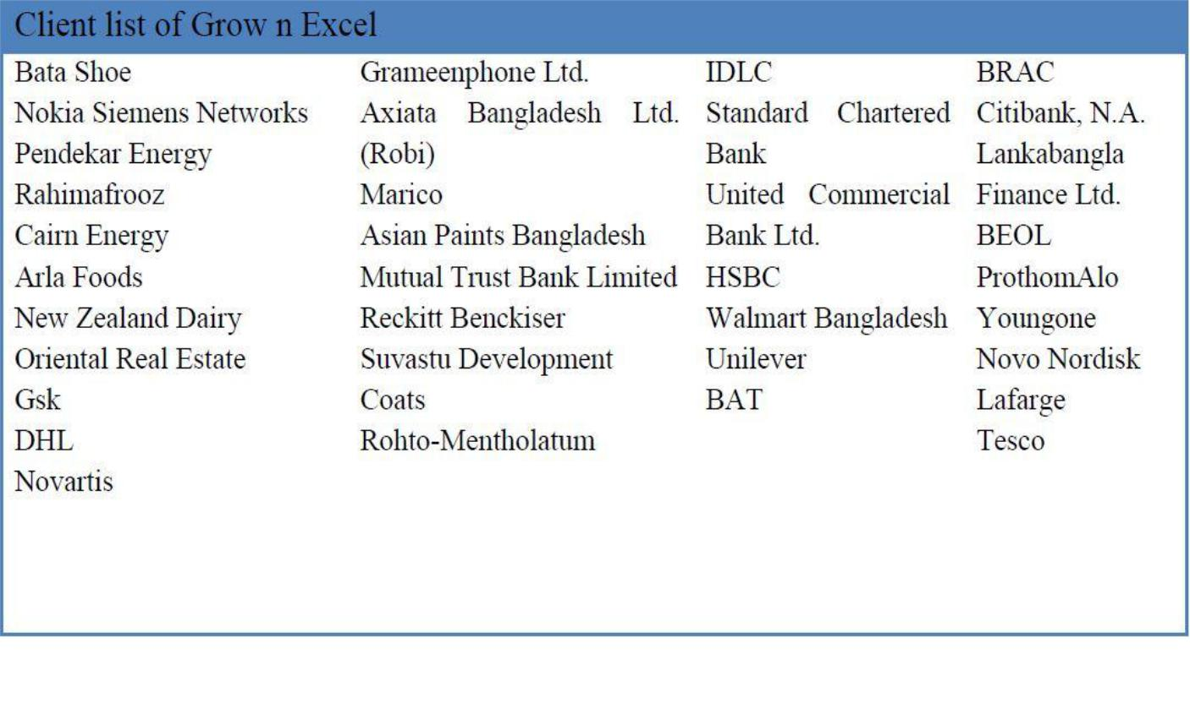

Figure 3: Client list of Grow n Excel (Source: Grow n Excel Office)

Grow n Excel profoundly presumed HR firm in Bangladesh. They are truly dependable. Both neighborhood and worldwide organizations depend on them and give them obligation..

HRIS ADMINISTRATION:
HRIS is a individual server of Grow n Excel where the resumes of individuals utilized or searching for employments accumulated, refreshed and arranged in a segment wise. The division incorporates industry wise, department wise, company wise, .With the help of trusted source(Bdjobs.com and LinkedIn) of the company the database is regularly updated. A profession computer engineer is regularly present, looking after the server. So whenever the headhunting department log into the database it is easier for them to search the candidates matching the required criteria. It is ensured that top most security available to shield the data from any sort of dangers.
Headhunting Process of GNE
Grow n Excel is follow the similar headhunting process contrasted with other human asset consultancy firm in the nation. At the point when any organization or association needs to take the administration of Develop n Exceed expectations at first they look at the organization's site and gather the fundamental data, for example, the administrations they give the client list of the company, their market reputation, the location of their office and the contact number of the company. Information about the market reputation of the company is not available in the website. But the client get the information from the sources such as social media, word of mouth, client or individuals who has taken the service before end given a positive review in the website of the company. If they want they can call the hotline number which is given in the website fix a gathering with group pioneer of scouting office. After that they visit the workplace and become acquainted with pretty much every one of the administrations in subtleties that is the organization give. The give them a proposition letter where every one of the classes and data are encased. The a customer is concur with the terms and conditions a formal mail required to send in the official mail address referencing that they concur with the approach of the organization and they are intrigued to take the administration of scouting and official pursuit program.
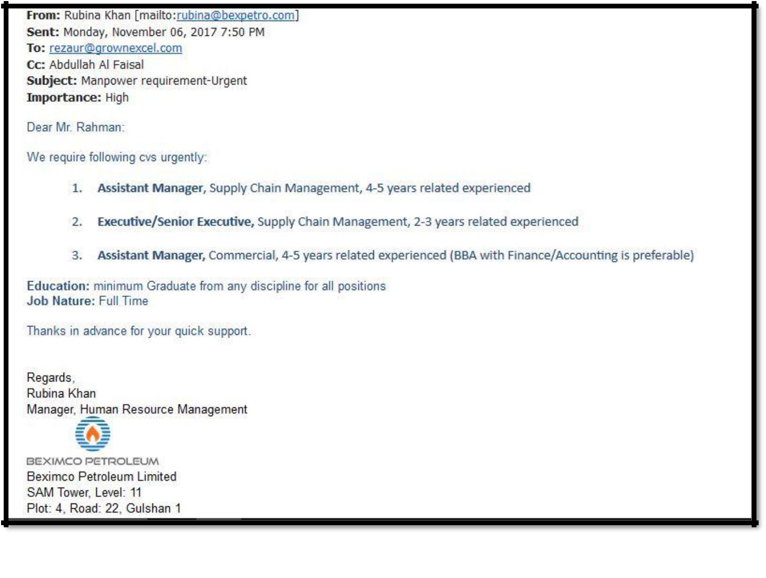

Figure 4: Client Email for the positions
The clients in the set of working responsibilities of the situation to the headhunting group (Fig 5). Position dispenses by the group chief as indicated by the skill of the colleagues. Which colleagues is a site with a specific position. They carefully study the job description and by the client and try to set a standard according to the job description. Each company has their own standard. The members study them a profile of the existing people in the client who previously worked in the position or who are currently working on this position. All kind of criteria such as experience, education, industry, functions, salary etc. need to set first.
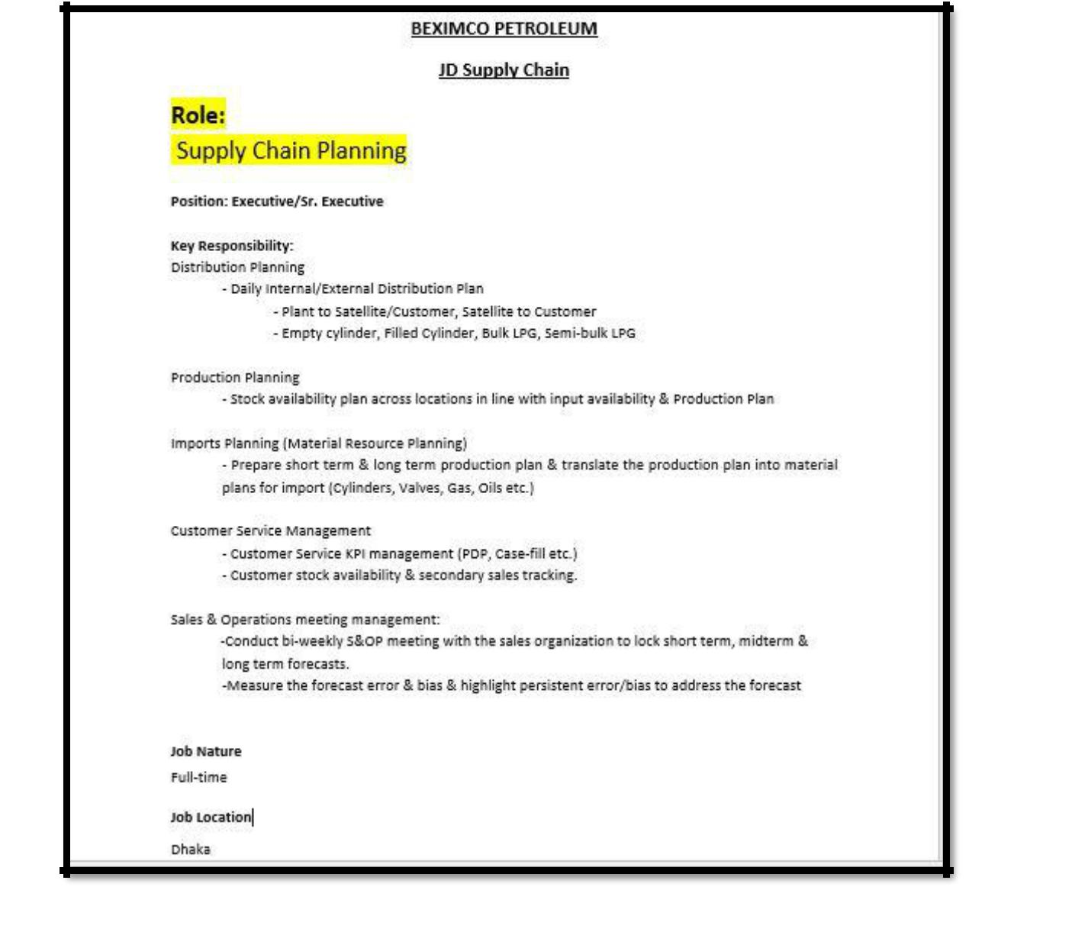

Figure 5: Job description for the position send by the client

The resumes I search by the team members which match exact or 80 to 90% with the job description after matching all the criteria. Finding resumes with 100% match is tough to find. Sometimes some of the resumes complete the matches with the job description. Minimum 100 to 150 resume is gone through by each members for each position and tries to find the accurate candidates. At least ready to 40 resumes are shortlisted from each search which are reviewed by the team leader. The team members approach the shortlisted candidates by calling them after getting a positive sign from the team leader. From the phone calls that candidates get the thought regarding the customer organization and furthermore about the position. The scope of the compensation, the advantages of the association and the obligation of the position are likewise shared. At the point when the competitors concur with all terms and conditions they are asked for to send their most recent refreshed resume in the official mail. The applicant is approached whether they connected for the customer organization inside 1 to 1.5 years back. Since the customer organization have their understanding that if the applicants who connected before for the position are ineligible to apply once more. From the shortlisted competitors not many or 6-10 hopefuls concur for the position and send their refreshed resumes.
After got the resumes that proceeded with the group chief, the individual from the group who is especially doled out for assignment does "Branding”. Branding is putting the organization logo with the sending date along-with the year and erase any superfluous things from the resume and rank them concurring. Subsequent to finishing the marking and positioning the group chief appends the resumes in the official mail and send them to the customer (Fig 6). At the point when the customer gets the resumes they experience them and give their surveys. In the event that there is everything great they illuminate the organization for meeting plan (Fig 7). On the off chance that the resumes are not sufficient, the organization bound to send some more continues to the customer. The entire procedure will rehash. At the point when the meeting plan is readied, the candidates get phone call again to inform about the interview date, time and the location. An E-mail or sms is also sent to the candidates to give them a reminder. The interview schedule is send to the client for the clarity when each candidates supposed to come when the interview is going to start. Before interview takes place the candidates get call for the follow up. All the details of the candidates is stored in an excel sheet for the future reference. This is called “Mapping” (Fig 8). After the interview, the client chooses the candidates and short listed them. Who are selected and send a formal mail to us with the candidates name and resume. When all the position are filled up the client gives feedback about the service they get from the company and makes the payment according to the agreement. Sometime the client company wanted to make the interview session in the company’s office. This kind of facility is available so that they can easily conduct the session without any problems.

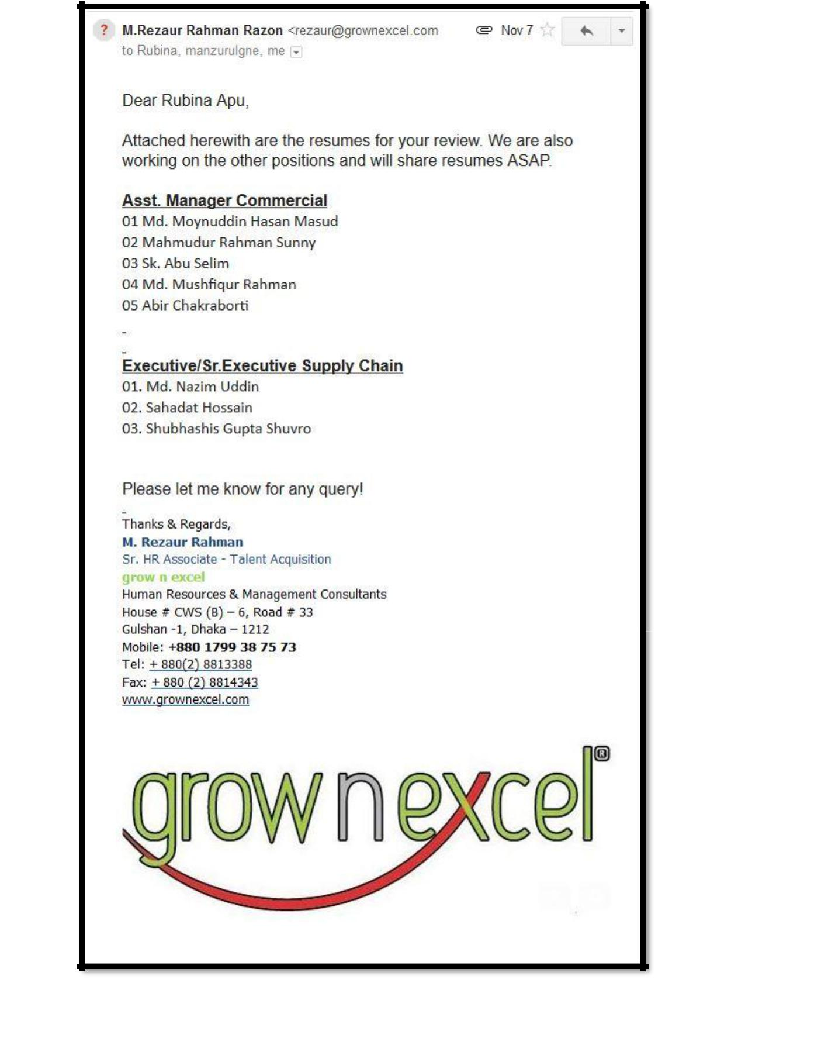

Figure 6: The list of CV’s send to the client for review

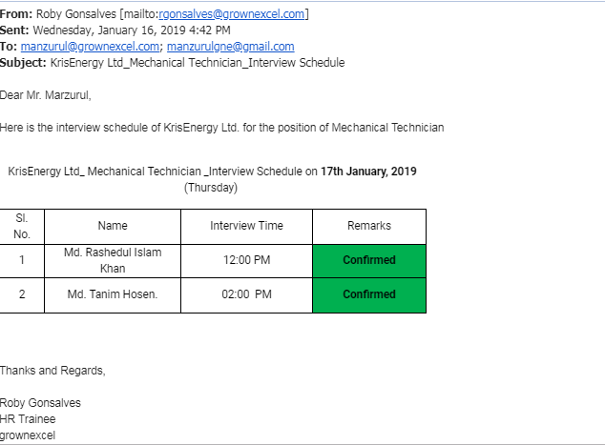
Interview Schedule prepared Sent to the Client

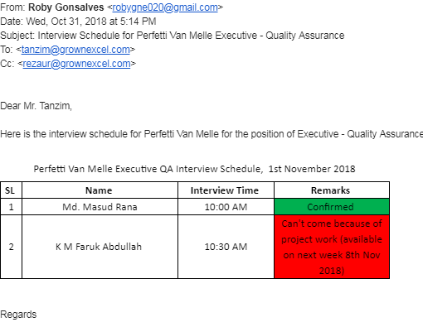
Figure 7: Interview Schedule prepared Sent to the Client

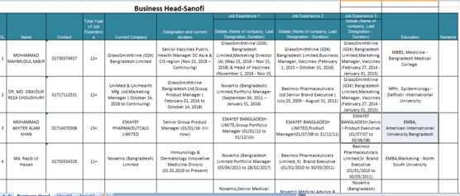
Figure 8: CV Mapping (Source: Grow n Excel Office)

As it is operating for 10 years, Grown Excel has gathered depth & breadth knowledge about the market and has grown bigger and stronger. The company is capable of placing candidates in different position in any organization, targeting large national and multinational companies. It has place DGM, AGM, GM, CEO, CMO, MD, CFO, etc. The organization is wanted to take its ability up to the following dimension by propelling its exercises all around.
Performance Tracking
Performance Tracking indicates that every day each team members are working in which job. Performance analyst who is assigned to collect the regular updates on a sheet and record the data on a excel sheet. Specifically the main reason of this performance tracking is how many position the company is covering and how many position they hits. This also records on the excel sheet that how many CV’s got shortlisted for the positions and how many pools the company is submitted to their client.(Fig : 9)
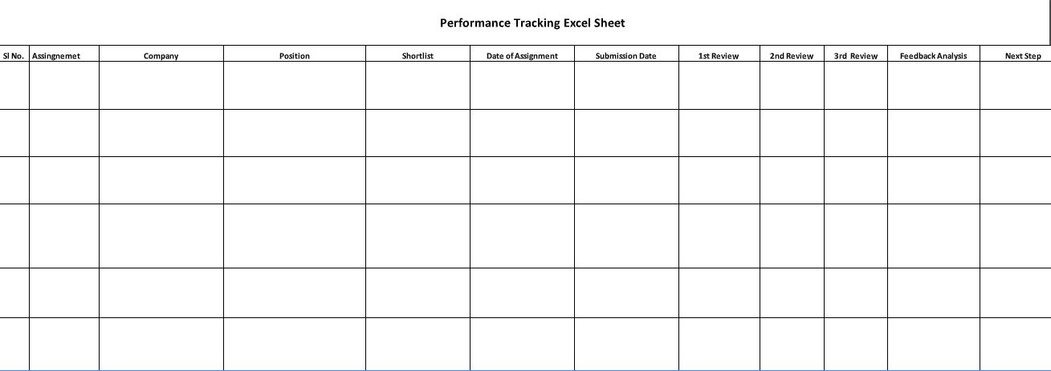
Figure 9: Performance Analysis Excel sheet (Source: Grow n Excel office)

Performance Analysis
Performance analysis is the analysis of the performance which is tracked every day. End of the month each performances are analyzed by the performance analyst. From the analysis a results came out .That outcome reported to the CEO by the analyst and discussed with all team members. This analysis give a feedback to all the members whether they are achieving the target and move towards the goal or they need to improve more and focus more. (Fig: 10)
s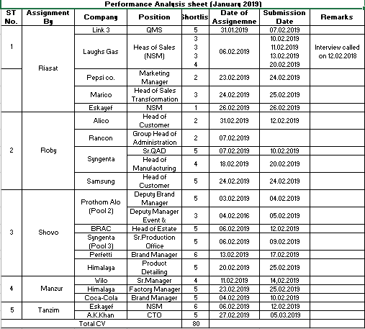
Figure 10: Performance Analysis Sheet (Source: Grow n Excel office)

Position wise CV Collection
The company collect all the CV’s and input them in a company wise and position wise of those candidates who has been shortlisted by the team members. For example, the team members sourced CV’s for the positions such as Brad Manager, Head of Finance and Accounts, Tech Transfer, Plant manager, Factory commercial and many more of Marico Bangladesh Limited. At first the CV’s of those shortlisted candidates for the position are sent to the client doing branding. After that the details of those CV’s are recorded in the excel sheet according to their position. The following table in the (Fig: 11) shows that how a company’s different positions are separately recorded in an excel sheet and also these CV’s are updated in the database as well.
This above process enables the company to search an source those CV’s easily when they need those further.

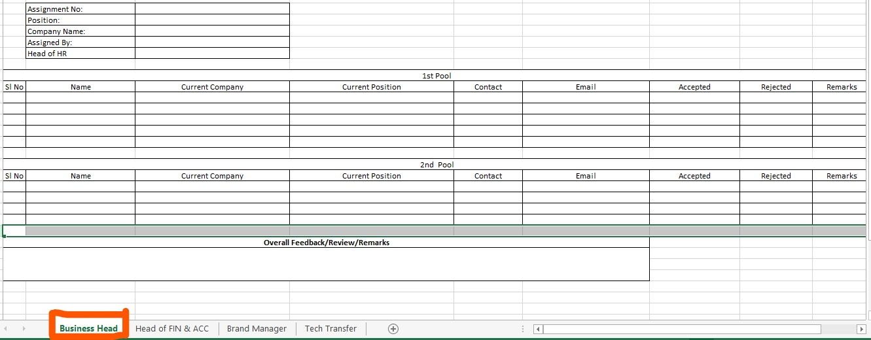
Figure 11 : Company and Position wise CV’s Collection (Source : Grow n Excel Office)

2.6 Recruitment Process Outsourcing (RPO)
RPO is done by grown excel. Top to bottom solution of recruitment is offered by the company to their client. From the very beginning they act as a recruitment partner for the organization. It creates a benchmark till the employee join in the organization. The client can save their precious time and also the expense through RPO. It also ensured that while a potential candidate approaches the professionalism must be maintained. The main necessities are profoundly engaged and there is less possibility of wrong recruitment. The client brand is portrayed more vibrantly. The candidate gets a clear idea about the company and the position.
Grow n Excel provide RPO service by:
- End to end RPO: Managing the total recruitment service of an organization.
- Partial RPO: Managing selected portion of the recruitment process.
- Project RPO: Managing short term organizational projects.

The whole RPO is done by:


- Role Profiling: Whenthe customer share the set of working responsibilities with the company, the scouting group contemplate the report and see obviously what the customer is searching for in the competitor..

- Sourcing:After the benchmark procedure, the team members look through the resumes of contender to fit for the job. It is done through the possess CV bank of the organization, posting the activity, telephone calls, long range informal communication destinations, and so forth. It's extremely hard to locate the precise coordinating resumes with the expected set of responsibilities. Some profile matches 80-90%.The group leader chooses which resumes experiencing and which to dispose of from those sourced resumes.

- Database Management: Grow n Excel maintain their own database by storing the resumes in a structured way. The database is managing by the keeping the necessary information about candidates for example, name, association working now, association worked previously, understanding, instruction, educational background etc.

- Screening: After the initial sourcing of the resumes the team members endeavor to coordinate the resumes firmly dependent on certain criteria, for example, experience, educational background. The job description of the position shared with the shortlisted candidates through phone call. If the candidates show interest then they are notifies about the written test and other details.

- Written Test: Written test is prepared with questionnaire, MCQ’s, English language section, verbal reasoning, mathematics and analytical ability. The written testinspected and the outcomes are distributed. After that the chose competitors are welcomed for the following evaluation.

- Assessment Centre: In the evaluation focus the hopefuls are given genuine circumstance. They are made a decision about dependent on the how they are managing. This is somewhat of a contextual investigation which depends on the hierarchical capacities and the difficulties it faces while working in the market. .Grow n Excel bring out the evaluation program through gathering dialog, case investigation social observation,presentation,one to one interview.

- Interview: Competency based interview conducted by Grow n Excel. It reflects that whether the candidates have that potentiality to meet up the required conduct pointers according to organizational policy. This coordinated effort is finished with the customer for the better understandings of the capabilities of the position the team is working for. The meeting session is conducted by profoundly prepared questioner.

- Reference & Background Checking: The Company has to face huge amount of problems because of the checking background and poor reference. Grow n excel is providing this particular service to make the organization more competitive.

- Employee Verification Checking: The activity obligations of the candidates ensure and verifies by GNE that the individual in question is really utilized in that situation previously or different spots he professed to have worked. It gives a point by point answer to the customer about the competitors by accumulates criticism from the past organization..
- Educational Verification Checking: The educational certificates of the candidates and verified by GNE to make sure that all the certificates are original. After the verification the point by point report and input is given to the client.

- Management of joining: Completing all the procedure GNE present all the essential documents to the client and handle all the fundamental strategies for a candidates to join the company.

Chapter-3

3.1 Literature Review
According to porter (1985), at the beginning the organization have apparently turned out to be strategic in their behavior conduct in quest for upper hand in an undeniably violent business condition. Strategic behavior includes an organization in coordinating its assets as time goes on to the requests of its changing condition Johnson and Scholes, (1999). Case of a vital choice procedure is portrayed for the situation examine Southco Europe Ltd. As per the contextual investigation, the HR work sees its center obligations as 'recognizing the correct pool of ability for building up the correct applicants. Hopefuls are intended to go to arrangement of meetings, aptitudes and ability appraisals, and are psychometrically tried to recognize regardless of whether they would be reasonable for the Southco condition. It is likewise important to guarantee that the individual collaborate well in a group.
According to Teacher Vision (2009), for strategic Recruitment and selection model to be comprehended and applied, it should be warily joined (strategic integration) with what is starting at now known and comprehends to make an increasingly generalize, higher-ask for aptitude. Joining new strategy with the regular method improves the likelihood that new information will be comprehended at a progressively significant measurement, yet it must be done intentionally and the fundamental association illuminated so the new information does not twist up confused with the customary methodology certainly knows.
Example, from the case study, Marico HR shortlists candidates dependent on ability based methodology. Candidate are relied upon to have the right stuff and ability definite in the activity and individual determination, in increases to these prerequisite, key choice spotlight on hierarchical fit, and appropriate possibility for the activity, who show a worldwide viewpoint, distinguished through work involvement and enthusiasm to travel. The vital involves that candidates are not selected dependent on custom enlistment procedure and meeting however considered on the premise on their general identity. In this manner, the match between the specialized aptitudes and work understanding of the candidate and what is depicted in the composed determination is a critical thought.

Strategic Recruitment and Selection: A Conceptual Framework
According to Sparrow and Hiltrop (1994), for recruitment and selection to be classified as strategic it must show three associated essential highlights :
- Strategic integration; a long-term focus
- A mechanism for translating strategic demands into an appropriate recruitment and selection specification.
Strategic integration anticipate recruitment and selection as a ground-breaking hierarchical system for adjusting the conduct of employees to its corporate technique. A few academics research explore demonstrate that strategic recruitment and selection procedure to occur candidates attributes must line up with the mission, vision and hierarchical explanation and incorporate into the key arranging process. This is a fundamental element for association wishing to stay focused in this tempestuous business condition and furthermore for global business attainment. For Mill operator (1984: 68) the goal of vital "staffing" is to recognize and pick those "individuals who will best maintain the association and its business over the long haul". To do this, it may includes an ability to estimate those HR requirements are important to guarantee the effective execution of an organization’s strategic plans and to build up a scope of staffing projects and exercises to discover such individuals.
3.2 Discussions
I choose this topic “Strategic recruitment and selection procedure followed and applied by grow n excel human resources management and consultancy firm” because recruitment and selection is one of the, major issue in the corporate world. The whole procedure of recruitment and selection is very costly and time consuming. Company need to pay some extra amount for those people who work for the process. Sometime they could not find the right candidate for the right position, so they have to go for the same process again. The main job of the headhunting company is “find the right candidate for the right position”. They can source the right candidates. In the report there is an elaborate discussion about the whole process grow n excel follows. All the performance done by the team members of headhunting team are tracked each day and follow up by the CEO. Those performances get evaluates end of the month. From this performance tracking the company can measure their growth and the target they wanted to fill up and also evaluate each individual’s job.

Chapter-4

4. ANALYSIS & INTERPRETATION
4.1 Time Taken for the Headhunting Process
Headhunting team needs to keep it mind that there is a time factor for that. Because a client not only approaches grown excel, also approaches to other headhunting companies as well, So there are competitions available in the market. It is observed that each HR firm wants that their resumes to be accepted. Because the companies earn money through the numbers of hits. For example, the company accepted the number of candidates for the positions.
Everyone has access on Bdjobs.com and LinkedIn which is very common and reliable source for collecting resumesBdjobs.com is bit hard to get to on the grounds that one needs to purchase participation before seeking resumes in their CV bank. Companies searched for candidates from the same sites those are all common. If a candidates approached by one company basically shows lack of interest in sharing their resumes to other companies. Then it will become difficult to source out the right candidate for the job. The company has to keep in mind for selecting a candidate about the experience, education, function, industry etc. The company who outsource the recruitment procedure is particularly merciful about instruction. Mostly they endeavor to concentrate on the experience capacities and industry. It is seen that the competitors with higher experience, performing comparable capacities lead to higher profitability and productivity taking a shot at the comparative business. Organization can accomplish their destinations and objectives effectively. Headhunting team of grow n excel take one to two weeks to source, screen and convey the contender for the meeting procedure. Some of the time it is extremely hard to get the right candidates for the right position. The team members need to buckle down for that sort of position. This is extremely uncommon sort of circumstance. The previous 10 length of years grow n excel is ready to give quality support of its clients the edge. (Fig 12).

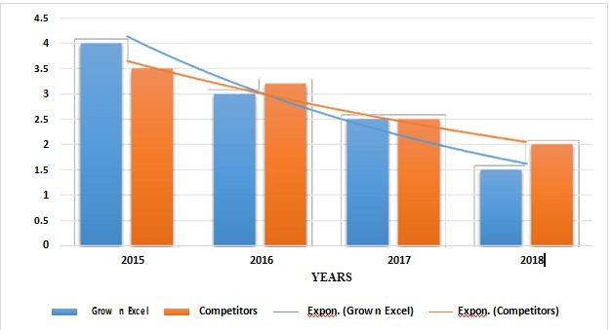

Figure 12:Time Taken for Each Step is representing by Graphs

4.2 Number of vacancy filled up in the last few years
Grow n Excel is one of the leading HR firm in the country, so it’s market reputation is too high. Many renowned industries are relying on its service because from the beginning of its journey it has been filling position. Because of the quality service and timeliness many leading companies of the country wanted to avail the service. TIC theory is followed by the company. TIC means Timeliness, Inquisitiveness and Completeness. Company’s leading consultants developed the theory. While filling up a position every single part will undoubtedly pursue each progression of their activity. Convenience alludes to time which is taken by the each members of headhunting team to perform his or her task. It is one of the core function of the headhunting team that the service they provide in a timely manner in to the client because of the market competition. Inside the chose time allotment looking, sourcing and short posting must be finished. Curiosity is the colleagues need to demonstrate the curiousness to gain from every one of the undertakings allocated to them. So it very well may be trusted that profitability and nature of the administration given by the organization to the customer is sufficient. The client refers the services to other companies as well. The team members are required to convey the best most quality administration and guarantee that the customer is completely fulfilled at whatever a position is filled.. Grow n Excel has been very productive and has the ability to fill up the clients demands. This happened on account of the simple access to the database and different training programs which the headhunting needed to experience the subsequent after joining the organization. The organization is getting high number of customers and position due to the reputation. In 2015, HR kites filled up 45 positions whereas grow n excel filled 80 positions of 15 clients. The quantity of the position filled expanded throughout the following three years in light of the fact that of their efficiency and the quality service they provide. In 2017, HR kites was unable to compete in the market and shut the business down. At the same time there was another developing firm “Enroot” in the market which a huge threat was for grow n excel. Still this company compete with others in the market. Grow n Excel had the capacity to top off additional than 140 position in 30 multinational and local organizations in 2018It is believe that in near future this number will grow more. (Fig 13)
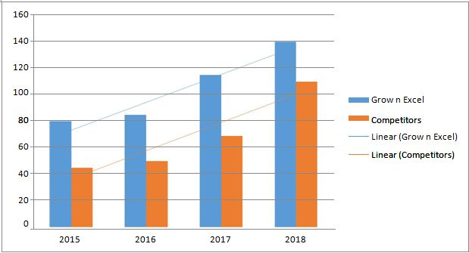
Figure 13: Number of Jobs filled (Source: Grow n Excel office)

4.3 Market Competition in the GNE
In Bangladesh headhunting business is very popular. More than 32 headhunting companies performing in the market. Organizations are frequently doing outsourcing. Company is getting recognized due to the outsourcing recruitment process. It’s happening because a lot of time saves by the outsourcing of recruitment process. As the headhunting organizations are had some expertise in the specific assignment, the likelihood of contracting the correct competitor of the correct position is exceptionally high.
Monowar Associates is one of the old organizations in the market. In 1992 they started their business. They provide high quality service so that they charge their clients for that service. Due to their charge many organizations do not prefer to take the service from them. As it increase the cost.
There is another company in the market that in Enroute. For them the competition is increasing day by day. Enroute is also dominating in the market. In the market they charge quite less than the other headhunting companies. Comparing with others their service is not up to the mark. For this reason, companies are more intrigued to redistribute their enrollment procedure from particular company. Beside the time is passing by they are trying to attract their client forwards them and increase the quality service.

There are some major competitors in the market include front desk, Talent centre, Pro-staffers LLC, cons mark, iNFiNiTY HR company limited, ward etc. For the existence of this competitors it become hard to provide service by grow n excel (Fig 14).

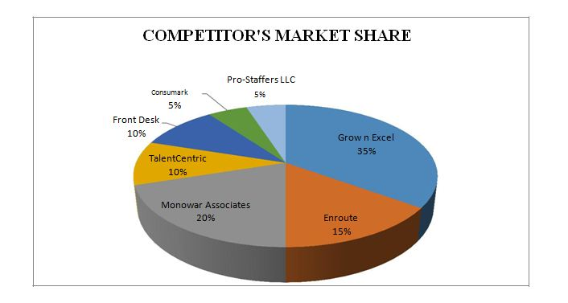

Figure 14: Market Share of the Competitor

4.4 The performance of candidates
Grow n Excel is one of the ruling HR consultancy firm in the Bangladesh. Providing best recruitment service is the main focus of it. They ensures the client they will provide the best candidates for the suitable positions. Remembering every one of the criteria that matches with the candidates. It is extremely useful for the competitors as they can investigate their inward potential and perform what they anticipate. All these conceivable on the grounds that the sources GNE competitors dependent on their industry, experience, training, capacity and secure the correct position for the correct applicant. For that, competitors can perform well at the work environment as they are specific for the activity. It is seen from the information that the general population who are put as needs be, their execution is higher than the general population who are not set. It builds the effectiveness and profitability. The hopefuls who are set in the ideal spot, they demonstrates their energy towards the work builds a ton. What's more, they remain in the organization for a significant period of time. Training also provide the candidate to increase their knowledge level and the skill. Their dedication towards the work motivates the organization's administration to contribute more on their human resource (Fig 15).

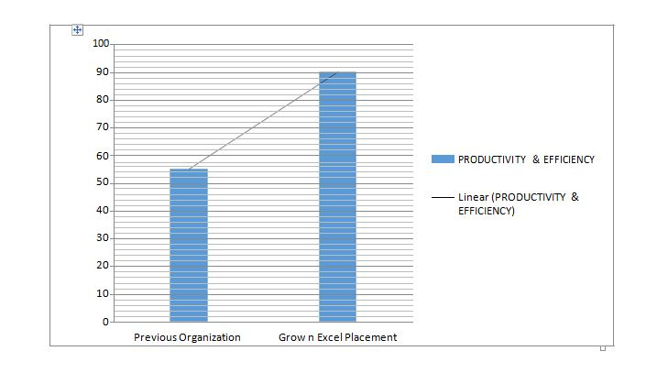
Figure 15: The % of efficiency & productivity of the candidates.

4.5 Feedback of the clients
Grow n Excel is serving its clients for a very long time. It is become one of the ruling HR consultancy firm in the country. The clients can completely rely on the company because of the quality service they provide. During this time period, the competition becomes very tough. It is very difficult to source out the high candidates for the right position. It became difficult because the availability of candidates is huge in the market. Though there is not sufficient job for them.
It’s been observed that most of the time candidates are placed wrong. So that they are not able to show their potentiality at the workplace. Grow n Excel provides the opportunity for the candidates to get a suitable job which matches with their skill and expertise. Through this, the client organization can reach their desire objectives and targets and furthermore the competitors can expand their effectiveness and profitability.
A survey is done in the middle of setting up this report from the overview it tends to be seen that the customers palatable input about the administration GNE is giving. The trusted and customary customers are approached to top off the overview and requested to give their legitimate sentiment all out 30 customers are connected for this specific reason. The consequences of the review are giving beneath.
- Do you think the process taken by grow n excel is effective in recruitment market?

Interpretation: From the survey it can be observed that the process taken by grow n excel is effective is 95% effective in recruitment market. More 5% need to be improve.

- Do you think grow n excel can play a better role in talent nurturing in Bangladesh?

Interpretations: From the survey it can be seen that grow n excel can play a better role 100% in talent nurturing in Bangladesh.

- What do you think grow n excel can effectively align with the talent management system in our country?

Interpretations: From the survey it can be observed that 75% client think Grow n Excel can effectively align with the talent management system in our country and 25% people think they are unable to do that.
- Can grow n excel take a part in the development of skill management?

Interpretations: From the survey, it is observed that client give 100% positive answer for the asking’s that grow n excel take a part in the development of skill management

- Can grow n excel can take a part in nurturing talent eco system for the development of our countries workforce?

Interpretations: From the survey, it can be seen that clients give 88% positive answer & and 12% negative about the issue that grow n excel can take a part in nurturing talent eco system for the development of our countries workforce.
- Can grow n excel take a substantial role in decreasing unemployment rate in Bangladesh?

Interpretations: From the survey, it asks that grow n excel can take a substantial role in decreasing unemployment rate in Bangladesh. The results came out is they can do 23%, it will take time 65%, not possible 12% and need outside help is 0% .
- Does grow n excel playing a vital role to provide the right candidate for the right position?

Interpretation: From the survey, it shows that client agree 100% that grow n excel is playing a vital role to provide the right candidate for the right position.
- How many candidate pool grow n excel submitted for each position they are assigned?

Interpretation: From the survey, it shows that GNE sent different numbers of candidates for the position. 54% got 2 pool, 23% got 5 pool, 15% got 3 pool and 8% got 1 pool for the positions.

- How many people get short listed from the pool send by grow n excel?

Interpretation: From the survey, it shows that percentage of the shortlisted candidates which send in each the pool by GNE to their clients. 54% got 2 shortlisted candidates, 23% got 5 shortlisted candidates, 15% got 3 shortlisted candidates and 8 % got 1 shortlisted candidates from the pool.
- Do grow n excel submit the work on due time?

Interpretations: From the survey, it is showing that 92% client said that GNE submit their work on due time and 8% give a negative feedback.

Chapter 5

Findings
Grow n Excel is a small HR consultancy firm with not more than 20- 25 employees and it is playing out its dimension best in the market to be one of the main firm in the nation. I oversaw run over different things during my 12 weeks of entry level position period which ought to be talked about here.
- Accomplishment: There is less number of worker in the organization that is the reason it requires bit of investment to execute something in the organizations. For instance, the computer utilized in the workplace is old and the product introduced in them are not refreshed. Though it is not the big problem but day by day the competition is increasing in the market, in future time consuming is kind of implementation which can prove costly.

- Resources: The physical assets in the organization is out of date and sometimes it is very difficult to remain mindful of the time. For instance, the Computers utilized in the workplace is old and the product introduced in them are not refreshed. It is extremely important to utilize refreshed programming and Computers in the work environment to decrease the measure of time devoured and be aggressive in the market.

- Management of Database: In the organization the database need to be supervise in a regular basis and should be managed properly. Day by day the numbers of candidates are increasing. They can't their resumes in the right spot GNE ought to deal with their database in such a way thus, that the applicants can present their refreshed resumes online with no burden. This will guarantee that the organization can give the best quality contender to the business.

- Outlook of the office: Though the office outlook is not that much attractive but it is equipped with all modern facilities. They can't their resumes in the right spot GNE ought to deal with their database in such a way thus, that the applicants can present their submitted resumes online with no burden. This will guarantee that the organization can give the best quality contender to the business.

Support from Superior: In three months of my internship program I found Grow n Excel for a new comer. I feel welcomed and valued by all colleagues. Specially my superior Mr.Asif Iqbal, team leader of Apparel Talent (a sister concern of grow n excel) supported me in various ways to understand my responsibilities and duties which helped me to work. After one month I was placed by our CEO to the GNE headhunting team under the supervision of Mr. Manzurul Haque, the team leader of Talent Acquisition Headhunting Team. I found the similar level treatment from the new team leader. The superiors do not put pressure of work to the juniors as they believe that it might hamper the quality of work and the output might not be satisfactory. The superiors help the juniors to learn new things and apply them in the corporate world.

Limitations
The team members are very co-operative but they're too busy to present me time to get knowledge approximately sensible activities. Moreover, they have to deal in a completely competitive environment. I had to prepare this file alone. Every assignment has some barriers. I confronted a few common constraints during the route of my internship. Those are as follows:
a. Quick of time:
I had to finish this record writing within a shorter time frame. So the time constraint of the take a look at hindering the route of vast region and time for preparing a report inside the stated duration is simply difficult.
b. Busy working environment:
The officials had a few instances been not able to provide information because of their huge habitual work.
c. Lack of enough nicely knowledgeable officials:
Few members of the wings are not well knowledgeable regarding this specific topic. They recognize but much less. I needed to face a lot problem to acquire this information.
d. Insufficient records:
A few desired information could not be accrued because of confidentially of commercial enterprise
e. Confidential troubles:
Human aid department continues very much personal about their activities and internal records.
However it was not unreasonably much simple to finish the report on the grounds that there were numerous obstructions to survive. The data was not accessible and some data are private. It turned out to be a less demanding when the organization came to know the principal subject of the report. More or less this was the limitations and barriers faced during the internship period while the report is ongoing.

Recommendation
After 3 months working in grow n excel, I found some gaps which should be fill up. To make the business more effective and efficient the organization need to fill up the gap as quickly as possible.

- The team members need to review the CV”s pool with the clients and demand feedback from them regarding each and every CV’s they have submitted.
- They have to improve our efficiency on the basis of their feedback.
- They have to reduce our response time from the moment we have received the job from our clients.
- Punctuality is an issue for grow n excel if they can be more accurate and maintain precision regarding the submission of CV pool then the probability of getting selected of the candidates will be much higher.
- Grow n Excel should focus extensively on training the newbie’s of the workforce to perform at their potential and help the aggregate workforce of the country. Grow n Excel have to realize the core ethical value of this company and the very essential value of this organization to begin with

Conclusion
Among many other firm Grow n Excel is one of the leading HR Consultancy firm in Bangladesh. It has a goal to reach beyond the boarder. The company has successfully completed 10 years in the market. The company has the experience of working with different commercial corporate body such as RMG, telecommunication, FMCG, IT etc. It had the capacity to put top class hopefuls from various foundation to different national and global organization through its journey. The talents are allowed to express their inner potentiality in the local and multinational organizations. Now Grow n Excel is seeking after its business in the national market it has an arrangement to grow its wings abroad and contend globally. There are numerous HR consultancy firm in the nation however GNE is viewed as a standout amongst the best in the business because of its execution in the earlier years.

Appendix
Survey Questions
- Do you think the process taken by grow n excel is effective in recruitment market?
- Yes
- No
- Do you think grow n excel can play a better role in talent nurturing in Bangladesh?
- Yes
- No
- What do you think Grow n Excel can effectively align with the talent management system in our country?
- Yes
- No
- Can grow n excel take a part in the development of skill management?
- Yes
- No
- Can grow n excel take a part in nurturing talent eco system for the development of our countries workforce?
- Yes
- No
- Can grow n excel take a substantial role in decreasing unemployment rate in Bangladesh?
- Can do
- It will take time
- Not possible
- Need outside help
- Does grow n excel is playing a vital role to provide the right candidate for the right position?
- Yes
- No
- How many candidate pool grow n excel submitted for each position they are assigned?
- 1
- 2
- 3
- Specify______
- How many people get shortlisted from the pool send by grow n excel?
- 1
- 2
- 3
- Specify______
- Do grow n excel submit the work on due time?
- Yes
- No

Bibliography

Website:
- UKEssays.com. (2019). Strategic Recruitment And Selection Process Management Essay. [online] Available at: https://www.ukessays.com/essays/management/strategic-recruitment-and-selection-process-management-essay.php?fbclid=IwAR1lYsHf7PN65anY8MbICLxGuBIWE0H-uAycFtnX6BwDEuTeaem6tHfIGWs [Accessed 19 Mar. 2019].
- Grownexcel.com. (2019). [online] Available at: http://www.grownexcel.com/ [Accessed 19 Mar. 2019].

Books:
- Amazon.com. (2019). Amazon.com: management of human resources: Books. [online] Available at: https://www.amazon.com/management-human-resources-Books/s?page=1&rh=n%3A283155%2Ck%3Amanagement%20of%20human%20resources

- Strategic Human Resources Planning, Monica belcourt, Kennet J. McBey, Ying Hong Maragret Yap, 15th Edition
- Strategic Human Resources Planning, Monica belcourt, Kennet J. McBey, Ying Hong Maragret Yap, 2ndEdition
- Amazon.com. (2019). Amazon.com: management of human resources: Books. [online] Available at: https://www.amazon.com/management-human-resources-Books/s?page=1&rh=n%3A283155%2Ck%3Amanagement%20of%20human%20resources [Accessed 19 Mar. 2019].
- Amazon.com. (2019). Amazon.com: management of human resources: Books. [online] Available at: https://www.amazon.com/management-human-resources-Books/s?page=1&rh=n%3A283155%2Ck%3Amanagement%20of%20human%20resources [Accessed 19 Mar. 2019].

