Impact of Learning Analytics on Product Marketing with Serious Games in Bangladesh

Mohammad Ali
Computer Science and Engineering
United International University

Swakkhar Shatabda
Associate Professor
Computer Science and Engineering
United International University

Abstract
Serious Games (SGs) are becoming popular worldwide to educate, train and inform other than entertainment but the absence of SGs is clearly noticeable in Bangladesh region. Although there exist a few educational games in Bangladesh, those are not SGs by their characteristics. SGs are applicable in many sectors such as healthcare, security, education, politics, and marketing. In this paper, we demonstrate the use of SGs combined with Learning Analytics (LA) in the product marketing domain. LA is a system for measuring, collecting, analyzing and reporting data about players. Players engage with SGs for entertainment, create raw data and our objective is to collect those data, represent those in a meaningful way to reduce typical marketing cost and time with the help of LA technique. We also present a case study which uses LA techniques with a SG to show how users’ data can be used in product marketing for a consumer product in Bangladesh.

Keywords—serious games; learning analytics; product marketing

Introduction

PC games are in the foremost position in the whole gaming industry. However, recently mobile phone or smart-phone based games have gained momentum and taking strong positions in the industry with the increasing number of smart phone devices. However, the general purpose of computer or mobile games is all about entertainment, played by people from different age groups.
A new concept called Serious Games (SGs) is coind even before the introduction of computer and electronic devices into entertainment. SGs are games which have non-entertainment goals, but used to educate, train and inform [1] and most dynamic and most interactive learning environments where players/learners can learn, train or inform themselves based on learning goal by playing the game. SGs commonly offer players rich and interactive content, large degrees of control, freedom of movement and responsibility for the actions undertaken [2]. The use of SGs to support the learning process has a long tradition as a teaching, training and learning method [3].
Playing a serious game produces highly individualized raw data that can reflect players personal choices, behaviors and performances [2]. When teachers/game manufacturers or players/learners themselves want to keep track of their progress for any learning goal, among other things, they must monitor players activity from those data.
Many methods have already introduced and one of these method is Learning Analytics (LA). LA is the measurement, collection, analysis and reporting of data about players/learners and their context for understanding and optimizing the learning [2]. It is a discipline based system which can analysis player/learner interactions with on-line resources to improve the learning process [4]. It provides a system for tracking and analyzing player/learner individual behavioral data form game-play and it helps to describe those individual data in a meaningful way and this part can help the game manufacturers or player/learner themselves to keep track on learning activity. It also helps to improve the assessment of progress, performance, learning outcome, game quality and user appreciation in SGs [5].
For getting a proper feedback of any kind of SGs, it is important to consider some factors while developing the game, such as educational goal definition, game design and implementation with a goal, interactions analysis and visualization [6]. Even after making the game it may also need to track some factors such as start-quite-end game tracking, phase changes tracking, significant variables tracking and user interaction tracking from the game to get proper feedback from individual players/learners [7].
In this paper, we present an investigation to find the factors and directions to originate SGs focuses marketing in Bangladesh. In addition to that, we build a SG by mixing marketing method with fun where people engage with the game to achieve milestone/goal or score. While playing the game, they are engaged with the learning analytics. Finally, we use the feedbacks from players generated by LA and know about players choices which helps us to reduce the marketing cost and time for a specific consumer product. Our investigation reveals prospect of developing SGs based on various scenarios such as health care, security, education, and politics.

Related Work

SGs make learning fun, challenging and rewarding where players do not realize they are actually learning when engaged in a game. They are so involved in achieving goals, making top scores competing with others and having fun that they become immersed in and master the subject matter without realizing it. Due to its huge potential ability to get feedbacks from the players/learners easily, large organizations like Deloitte, IBM, Cisco and others are embracing serious games for training, marketing and recruitment purposes and are getting positive impacts on all three business processes [8], [9].
There are some common online methods such as television/radio advertising, printed releases/magazines, billboards, business cards, flayers etc. which are commonly used for promoting/marketing a product but those online methods are time consuming and highly expensive and there is no instant and easy way to get users choice from those typical methods [10].
SGs can be used in different ways such as advergaming is a popular form of advertisement that delivers commercial messages through games [11], [12]. SGs have highly engaging ability with players, they take inferior time and they are less expensive than traditional marketing method. So, it’s an obvious work to implement typical methods through SGs for marketing a product and get feedback from customer.

Problem Analysis

According to Ericsson estimates, about 70 percent of the world population will be using smartphones by 2020 [13]. Not only globally but also in Bangladesh region, the smartphone users are increasing. The number of smartphone users has increased by 3.1 million to 8.2 million in 2015, according to a recent report published by Counterpoint Technology Market Research [14]. So, there is no doubt that with the increasing of smartphone users, apps and smartphone gaming market are also boosting in this region.
Another survey has taken on 1000 people in Dhaka city pointed out 44.20% of them think smartphone apps make their life more productive, 58% of them uses 1 to 5 apps daily where 30.60%, 22.90%, 18.70% are focusing on education, games and social apps respectively [15]. Although, already there are some learning or education related apps but very few in number and it is clearly noticed the absence of SGs in Bangladesh local app store and gaming industry. So, it is easy to predict that this is the right time to research and develop SGs in Bangladesh scenario.
We create an example and build SG for product marketing from scratch regardless of the platform and the domain of the product. Our research work also endeavors towards developing a SG with product marketing goal as particular case study. The primary research aims are how this can engage with users frequently and how this can provide player/users feedback and get users choices which are helpful to reduce marketing cost than existing typical marketing methods.
The game collects raw data from players game-play, applying learning analytics method on those data, and sorting out players/learners feedbacks step by step. Feedbacks are used to identify players personal choices, behaviors and performance and these personal behavioral data can be applied to take decisions in different fields such as choose right symptoms for specific disease, choices for fashions, right criteria of a political person etc.

Working Procedure

“Grab the Drink” is a cross platform serious game that we have developed to get users data through entertainment. This can be played from Android Mobile and Web Browsers. The game is made for university students for both entertainment and marketing purpose.
- Game Story
There is a cartoon character which is the main hero of the game. Players will play as the cartoon character. Players main target is to collect his/her favorite drink among other drinks to increase gold coins. There is a local score board and a global score board in the game where player can see top three high scored player.
- Gameplay
- Players have to register with their name, student id, age, and gender before playing the game. Players can change their profile information anytime.
- Players have to select their favorite drink among three choices. For example, we have used three renowned beverage drinks in Bangladesh. We mask those names as “Drink A”, “Drink B” and “Drink C”.
- Players have to collect his/her selected favorite drink to increase gold coins within 30 seconds, if they collect other drinks then gold coin will decrease. There are two power-up features. If player collect “bolt coin” then 5 seconds will be added with total time and if they take “big gold coin” then the total score will be increased by 5 points. “Fig 1,” shows the gameplay where the player is collecting drinks falling from upper side.
- After finishing the game, players can watch their last played score and overall score board.
- Players can see the top three scored contestants both locally and globally. Local score board shows top three scored contestants from the same android mobile or web browser and global score board shows top three scored contestants from around the world who played “Grab the Drink”.
- There is a “how to play” button where players can know about gameplay instructions.



Figure:1 Gameplay screenshot of “Grab the Drink”
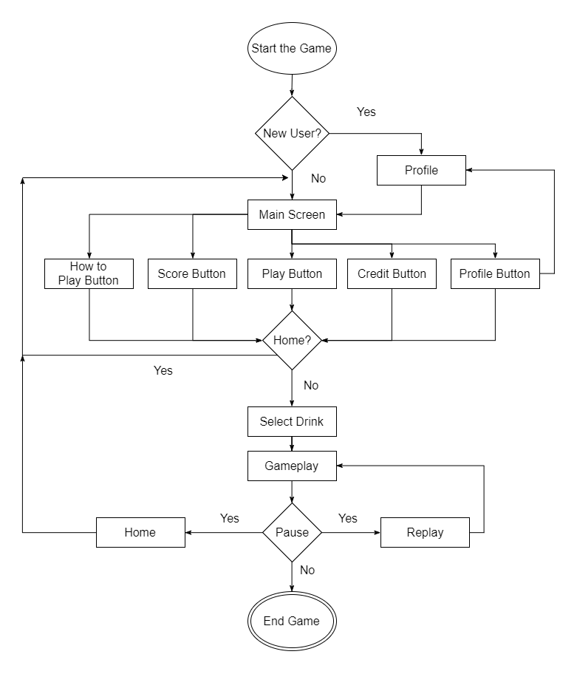
Figure 2 Gameplay flowchart of “Grab the Drink”
“Figure 2,” illustrates the flowchart of “Grab the Drink” which describes activity stages followed by players.
  - Entertainment Goal
The entertainment goal of “Grab the Drink” is to achieve highest score by collecting players favorite drink among both local players and global players. It counts local top score and global top score and shows to encourage players to achieve the highest score.
  - Learning Goal
“Grab the Drink” collects players information before gameplay. This learning analytics method takes players name, student id, age and gender. After that, it tracks players each gameplay and their selected drink with score and other activities and store those into game database. We can easily get the data from the game database and analysis it to get a specific result based on our learning goal. We short out some learning goal which we obtain from those raw data.
- How many players does play the game?
- How many male and female players are there?
- Which drink is chosen most among all three drinks?
- What is the most favorite drink selected by the female player?
- What is the most favorite drink selected by the male player?

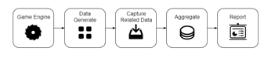

Figure 3: Learning Analytics flowchart of “Grab the Drink”
- What is the average age of all players?
“Fig 3,” shows the working flow of Learning Analytics method in “Grab the Drink” according to the learning goal.

  - Possible Benifit
If a company wants to know about their customers feedbacks and choices about their product then this game is useful. The company can easily reach their customers within a second where typical advertising or marketing method is time consuming. The company can easily promote their new product to vast number of customers and can get the feedbacks to show how many customers have reached and interacted with the product which is quite impossible with typical marketing method such as Billboard Advertisement. The company can get the feedbacks from the user where they like it or not which is costly and time consuming for typical marketing such as Survey Questioners. The company can also give promotional offer to their customers using the game and increase their sale.
  - Case Study
The game was played by 21 students of a renowned university in Dhaka, Bangladesh at their departmental festival. Students was selected randomly, they just visited the game stall, installed the game in their android mobile and played the game just for entertainment. Student, who didn’t have Android Phone, they played in the web browser of computer located in the stall. Their target was to achieve the high score but they didn’t aware of the learning goal of the game, after that raw data were generated from their gameplay. After analyzing those raw data those tables are generated:
Table I: Total Player and Gameplay of the Game

Total Player | Total Gameplay
21 | 143

Table II: Players Gender and Age

Observation | Female Player | Male Player
Players by Gender | 2 | 19
Average Age of Players | 24 Years | 22 Years

Table III: Drink Chosen Observations

Observation | Drink A | Drink B | Drink C
Drink Chosen by All Player | 69 | 47 | 27
Drink Chosen by Female Player | 4 | 10 | 0
Drink Chosen by Male Player | 65 | 37 | 27

“Table I,” shows that there were 21 players who have played the game and they played the game total 143 times. “Table II,” shows that there were 19 male players and 2 female players among 21 players and average male players age was 22 years old and average female players age was 24 years old. “Table III,” shows that Drink A was chosen 69 times, Drink B was chosen 47 times and Drink C was chosen 27 times by all players; Drink A was chosen 4 times, Drink B was chosen 10 times and Drink C was chosen 0 times by female players; Drink A was chosen 65 times, Drink B was chosen 37 times and Drink C was chosen 27 times by male players.

  - Result
From those tables we can come to some decisions about those beverage drinks. We could easily grab the attention of people by the game and 21 students selected randomly came to the stall to play the game. Nobody forced them to choose the drink, they selected their drink by themselves and played the game to obtain the high score. They played total 143 times and we can easily determine that “Drink A” is the most popular drink among those three drinks chosen by 21 players but female players like “Drink B” most and no female player has chosen “Drink C’. “Drink A” is the most popular drink for male players than “Drink B” as well as “Drink C”. Average age for the female players is 24 and male players is 22 so, those drinks are popular among young aged people. From those decisions, any specific company can get their customers choices, feedbacks or any marketing outcomes from serious game and take any strategic decision based on those results.
  - Discussion
After the case study, our future work will be directly work with a commercial company; know their existing marketing methods, identify marketing outcome for both company and customer. Those real data will help us to apply LA methods and identify key decisions to reduce marketing cost and time by a serious game. We can also take the research further by using data mining technique with LA techniques to predict users choice on any particular consumer product.
Conclusion
In this paper, we have analyzed peoples personal choices and feedbacks on a consumer product from their gameplay in a Serious Game. They played the game for entertainment but their game data reflected their choices which is essential for a company to know users feedback and choices about any consumer product. Learning Analytics methods have used to collect, measure, analysis and decide user choices and feedbacks. The game was successfully made attention to users which carried and showed any consumer product to vast number of people within a short time. We can easily modify, update and show relevant components of the game according to user choice which take less time. Our investigation reveals prospect of developing SGs based on various scenarios such as health care, security, education, and politics.

References

- F. Bellotti, R. Berta, A. De Gloria, “Designing Effective Serious Games: Opportunities and Challenges for Research,” Special Issue: Creative Learning with Serious Games, Int.l Journal of Emerging Technologies in Learning (IJET), Vol. 5, pp. 22-35, 2010.
- Wim Westera, Rob Nadolski, Hans Hummel, “Serious Gaming Analytics: What Students´ Log Files Tell Us about Gaming and Learning,” 2014.
- A.J. Faria, D. Hutchinson, W.J. Wellington, S. Gold, “Developments in Business Gaming: A Review of the Past 40 Years Simulation & Gaming,” vol. 40, 4: pp. 464-487, 2009.
- P. Long and G. Siemens, “Penetrating the Fog: Analytics in Learning and Education,” Educ. Rev., vol. 46, no. 5, pp. 31–40, 2011.
- W. Westera, R. Nadolski, H. Hummel, I. Wopereis,“Serious Games for Higher Education: a Framework for Reducing Design Complexity,” Journal of Computer-Assisted Learning (Wiley), vol. 24, no. 5, pp. 420-432, 2008.
- Ángel Serrano-Laguna, Baltasar Fernández-Manjón, “Applying learning analytics to simplify serious games deployment in the classroom,” Global Engineering Education Conference (EDUCON), 2014 IEEE
- Ángel Serrano-Laguna, Javier Torrente, Pablo Moreno-Ger, Baltasar Fernández-Manjón, “Tracing a little for big Improvements Applications,” Procedia Computer Science Volume 15, 2012, Pages 203-209
- Lynda Donovan, “The use of serious games in the corporate sector,” A State of the Art Report, Learnovate Centre (December 2012), 2012.
- Johann CKH Riedel, Yanan Feng, Aida Azadegan, Margarida Romero, Mireia Usart, and Jannicke Baalsrud Hauge, “Measuring the commercial outcomes of serious games in companies,” International Conference on Serious Games Development and Applications, pages 176-191, Springer, 2014.
- Marleen Kertscher, “10 Simple Marketing Strategies to Promote your Product Offline,” e-commerce & online marketing blog. january 26, 2016. [Online]. http://blog.vemono.com/10-simple-marketing-strategies-to-promote-your-product-offline/. [Accessed on 07/2/2016].
- Gerald Marolf, “Advergaming and in-game advertising: An approach to the next generation of Advertising,” VDM Verlag, 2007.
- Alessandro De Gloria, Francesco Bellotti, and Riccardo Berta, “Serious games for education and training,” International Journal of Serious Games, 1(1), 2014.
- Muhammad Zahidul Islam, “Smartphone penetration to reach 20pc by this year,” The Daily Star, November 17, 2015. [Online]. http://www.thedailystar.net/business/smartphone-penetration-reach-20pc-year-173410. [Accessed on 06/14/2016].
- Ishtiaq Husain, “Smartphone users on the rise,” Dhaka Tribune. january 24, 2016. [Online]. http://www.dhakatribune.com/business/2016/jan/24/smartphone-users-rise. [Accessed on 06/14/2016].
- Saif Ahmed, Zubier Abdullah, Dr Rajesh Palit, Dr Rokonuzzaman, “A Study of Mobile Application Usage in Bangladesh,” SSRG International Journal of Computer Science and Engineering (SSRG-IJCSE) – Volume 2 Issue 4–July to August 2015.

