UNITED INTERNATIONAL UNIVERSITY



Submitted to:
Ziaul Karim
Assistant Professor
School of Business and Economics
United International University

Submitted by:
Asifa Ahmed Bisme
ID: 114 171 006

Date of Submission: 23 February 2021

Letter of Transmittal

23 February 2021
Ziaul Karim
Assistant Professor
School of Business and Economics
United International University

Subject: Submission of Internship Report on “A comprehensive analysis of Audit Procedures of alternative Cash Incentive in BD (RMG Sector)”
Dear Sir,
With due respect, I would like to present a report on my internship “A comprehensive analysis of Audit Procedures of alternative Cash Incentive in BD (RMG Sector)”. In order to complete BBA in Accounting Information System at United International University I am required to submit a report on my internship. The focus of the report is to familiarize the procedure around the audit procedures of alternative cash incentive for RMG sectors in Bangladesh and HYC Chartered Accountants. The information presented in this report was collected through proper research, which made the report more dependable and gives it more validity. The internship program has permitted me to investigate and go through the work and troubles auditors confront every day.
I, therefore hope that you would be kind enough to point out my mistakes and give your valuable opinion on it. I would also like to thank you for your continuous direction and support.

Yours Sincerely,
Asifa Ahmed Bisme
ID: 114 171 006
School of Business and Economics
Department: BBA in AIS

Acknowledgement

Firstly, I would like to express my true appreciation to Almighty Allah, who has persistently given me the strength, knowledge and all the desired opportunities required to complete the report. Then, I would like to express my heartfelt gratitude towards my honorable supervisor Mr. Ziaul Karim Sir, Assistant Professor, School of Business and Economics, United International University, who has persistently supported me, directed and encouraged me throughout the course of time and helped me to complete the internship report.
This internship report has been written over the experience of working for 3 months at Howlader Yunus & Co. Chartered Accountants, beginning from 1st September, 2020 to 3rd December, 2020. It has been an incredible journey with lots of knowledge and experience. I would like to thank all my colleagues from HYC chartered accountants who supported me throughout the whole time and provided me the information that I needed. Without their support, I would not be able to complete this report. With respect, I want to thank my in charges of audit engagements Mr. Papon Saha (Deputy Manager) for his support. Finally, I would like to say that working inside the friendly environment of Howlader Yunus was a great experience and this report is a result of the sincere efforts of everyone mentioned above.
At last, I would like to show appreciation to my University (United International University), UIU Career Counseling Center, and all the programs, I have taken part in my university life.

Declaration

I, Asifa Ahmed Bisme, ID: 114 171 006, a student of Bachelor of Business Administration in Accounting and Information System, would like to state that the internship report titled, “A comprehensive analysis of Audit Procedures of alternative Cash Incentive in BD (RMG Sector)” has been exclusively prepared by me under the supervision of Mr. Ziaul Karim (Assistant Professor), School of Business and Economics while I was doing internship, at Howlader Yunus & Co. Chartered Accountants.
This report is prepared and submitted only for academic purposes. In order to complete my Bachelor of Business Administration program at United International University, submission of the report is mandatory.

Asifa Ahmed Bisme
ID: 114 171 006
Department: BBA in AIS
School of Business and Economics
United International University

Executive Summary

This report titled "A comprehensive analysis of Audit Procedures of alternative Cash Incentive in BD (RMG Sector)" - - is composed on the premise of experience accumulated through working as an intern for 12 weeks in Howlader Yunus & Co. Chartered Accountants. This report is a result of the combination of the knowledge of under-graduate program and the experience around the viable working environment. The point of this report is to examine the strategies and steps that are taken by the auditors, senior auditors as well as supervisors of Howlader Yunus & Co. Chartered Accountants amid an audit of alternative cash incentive within the RMG sector. The report is separated into six distinctive chapters. In first chapter (Chapter 1), the reason and the purpose for which the report has been prepared, objective as well as importance of preparing the report, and limitation that were confronted whereas preparing the report is mentioned. In Chapter Two (Chapter-2), the historical background of the firm and their works, data about the partners and firm’s values, mission, vision and services that are being given by the firm has been talked about. In Chapter Three (Chapter 3) literature review on audit procedures of alternative cash incentive has been discussed briefly. I have mentioned the Methodology of this report in chapter Four (Chapter 4). In the Fifth chapter (chapter 5), I have discussed about the theoretical framework of audit procedures of alternative cash incentive in RMG segment and some accounting terms for understanding the topic easily. In chapter six (Chapter 6) which is the analysis and findings portion, all the related import and export documents, all other critical data as well as all the procedures that are entirely taken after for issuing cash incentive certificates are talked about in details. In addition, the report includes how a client draws the firm closer or how the firm itself approaches a client. Other than that on the premise of restriction and impediments, I have recommended a few suggestions to move forward with the audit process.

Contents
Letter of Transmittal i
Acknowledgement ii
Declaration iii
Executive Summary iv
Chapter: 1 1
1. Introduction: 1
1.2 Objective of the Study: 1
1.3 Scope of the study: 2
1.4 Limitation of the study: 2
Chapter: 2 3
2. Historical background: 3
2.1 Brief profile of the company: 3
2.2 Membership: 3
2.3 Partners and their area of specialization: 4
2.4 Vision & Mission: 4
2.4.1 Firm’s Vision: 4
2.4.2 Firm’s Mission: 4
2.5 Commitment of GTCBL’s to Customers: 5
Chapter: 3 6
3. Literature review: 6
3.1 Introduction: 6
3.2 Government Gift to the Exporters: 6
3.2.1 Cash Incentive: 7
3.2.2 Duty Drawback: 7
3.2.3 Bonded Warehouse: 8
3.3 Cash incentive’s role in Bangladesh and evaluation of RMG sector: 8
3.4 For enjoying cash incentives facilities the conditions are: 9
3.5 Cash Incentive Audit procedure of Howlader Yunus & Co: 10
Chapter: 4 11
4. Methodology: 11
4.1 Introduction: 11
4.2 Research Philosophy: 11
4.2.1 Positivism and Interpretivism: 11
4.2.2 Justification of Interpretivism: 12
4.3 Research Approach: 12
4.3.1 Quantitative, Qualitative and Mixed Approaches: 12
4.3.2 Justification of Qualitative approaches: 12
4.4 Research Strategy: 13
4.4.1 Justification of Case Study: 13
4.5 Reason of choosing a comprehensive analysis of Audit Procedures of alternative Cash Incentive in BD (RMG Sector): 13
4.6 Reliability & Validity: 13
Chapter: 5 14
5. Theoretical Framework 14
5.1 Audit: 14
5.2 Accounting: 14
5.3 Differences between accounting, and auditing: 14
5.4 Auditor: 15
5.5 Statutory Audit: 15
5.6 Internal Audit: 15
5.7 External Audit: 16
5.8 Difference between Internal Audit and External Audit: 16
5.9 Letter of Credit: 17
5.10 Freight: 17
5.11 Terms of Reference (TOR): 18
5.12 No Objection Certificate (NOC): 18
5.13 Audit Engagement: 18
5.14 Engagement procedure in HYC: 19
5.15 Reasons behind the Cash Incentive Facility: 19
Chapter: 6 20
6. Findings and Analysis: 20
6.1 Cash Incentive Audit and Procedure: 20
6.1.1 Cash Incentive Audit: 20
6.1.2 Procedure for Cash Incentive Audit: 21
6.2 Documents for cash incentive audit those are reviewed (For RMG sector): 23
6.2.1 Bank Forwarding Letter: 23
6.2.2 Form for Application: 24
6.2.3 Back to Back LC: 25
6.2.4 BGMEA Certificate: 25
6.2.5 BTMA Certificate: 26
6.2.6 Proceeds Realization Certificate: 27
6.3 Documents of Export: 27
6.3.1 Commercial Invoice: 28
6.3.2 Packing List: 29
6.3.3 Bill of Lading: 30
6.3.4 EXP Form: 32
6.3.5 Shipping Bill/Bill of Export: 34
6.4 Documents of Import: 36
6.4.1 Pro Forma Invoice: 37
6.4.2 Sales/Purchase Contract: 37
6.4.3 Commercial Invoice: 37
6.4.4 Packing list: 37
6.4.5 Delivery CHALLAN: 37
6.4.6 Amendments to LC: 38
6.4.7 Utilization Declaration: 38
6.5 Analysis of cash Incentives procedure 38
6.5.1 File checking procedures: 38
6.5.1.1 Export Documents: 38
6.5.1.2 Import documents: 39
6.5.1.3 Meeting up discrepancies: 40
6.5.1.4 Information Input, Final and Draft Print: 40
6.5.1.5 Certificate Signing: 40
6.5.2 Export increase in RMG sector: 41
6.5.3 Bangladesh Bank hire external audit: 42
Importance findings on cash Incentives: 42
Summary of Findings and Analysis: 43
Recommendation: 49
Conclusion: 49
References 50
Appendix: 53

Chapter: 1

1. Introduction:
Internship is the procedure of working under a business firm for a certain period to get practical knowledge about the corporate world. Through internship, a student can have external involvement moving out of the boundaries of the hypothetical information. The knowledge gained through this program can be very useful to give students access to the professional world, match the theoretical learning with practical implementation, and set a career path.
As I always wanted to study Chartered Accountancy after finishing my Graduation, I selected to complete my internship program. Howladar Yunus & Co. is affiliated with Grant Thornton Bangladesh and it is one of the ranked Chartered Accountancy firm within the corporate world in Bangladesh. I joined the firm for twelve weeks internship program. Throughout the internship, I got practical knowledge on how an accounting firm works in reality, to watch and perform the accounting and audit methods. I was appointed as an audit student of Grant Thornton Bangladesh and I was engaged for Cash Incentive Audit. This report will briefly discuss my accumulated practical involvement on accounting and audit procedure.

1.2 Objective of the Study:
The BBA in AIS program in United International University has been designed in such a way that students are well prepared with the theoretical knowledge about accounting and other segments that a business graduate ought to know. In that case, the real environment at the working environment can be exceptionally distinctive than those presented in textbooks. The students’ need the viable information that they can get only from work experience. For the completion of our undergraduate program internship play a vital role.
The objective of internship is:
a) To adapt how a CA firm works its audit activities.
b) Introduce myself in a professional environment.
c) To procure broad information about the audit practices taken after by the firm.
d) To obtain information of cash incentive activities of the government to boost up the export division of the country.
e) To accumulate knowledge and procure experiences approximately the exporting and bringing in exercises of RMG based organizations.
f) To suggest how viably and proficiently the audit methods can be inventing further.
g) To know the information about the audit methods and get experience of banks and other financial and non-financial institutions as taken after by the Institute of Chartered Accountants in Bangladesh (ICAB) and the rules of Bangladesh Bank (BB).

1.3 Scope of the study:
The main purpose of the study is to get practical knowledge about auditing procedure from this internship program. As I worked at Howladar Yunus & Co., it gave me great opportunity to get viable knowledge about the Alternative Cash Incentive audit procedure of the organization. Scopes are:
- Audit process that is followed for performing any work.
- Work within the field level by testing the accounting approaches, records and accountants as a portion of audit group of Howladar Yunus & Co.
- Collect as many information as possible for internship.

1.4 Limitation of the study:
Each task has its own challenges and limitations. This also applies for the planning of this internship report. A few of the limitations are briefly written below:
- The apportioned time of the internship was very inadequate to cover all the data of the specific subject.
- Collecting a tremendous sum of data whereas working for it for three months was truly a hard job.
- Due to secrecy purposes, numerous internal data was not revealed.
- Inability to find all the circulars issued by Bangladesh Bank with respect to the cash incentive for exporting.
The privacy of their internal system for giving data to the outsider is one of the limitation of planning this report. Most of the data that was collected was not authorized for revelation. For this reason, I could not give a general idea containing detailed information of the company additionally, data with respect to the firm’s audit fees.

Chapter: 2

2. Historical background:
Howladar Yunus & Co. is an affiliate company of Grant Thornton International, which was created in 1970.
Grant Thornton is one of the leading autonomous insurance, tax and counseling companies in Bangladesh. HYC is one of the country’s oldest and most prominent specialist firms, with most experience partners. HYC’s center administrations incorporate audit & assurance, tax assessment, Vat & legal compliance, corporate back and outsourcing. (Devox, 2020)
HYC has been an efficient accounting firm for over 50 years and recognizes what is relevant to consumers. Howladar Yunus & Co’s counseling administrations are continuously committed to including esteem in their service so that they can fulfill client's expectations. Howlader Yunus & CO. got their enrollment in 1985 under the Chartered Accountants of Bangladesh.

2.1 Brief profile of the company:
Name of the Company | Howlader Yumus & Co. (HYC)
Address | House-14 (4th floor), Road#16/A, Gulshan-1, Dhaka-1212, Bangladesh
Phones | 02-9554119
Email | hyc@howladaryunus.com
Web | www.howladaryunus.com
Branch | Khulna

2.2 Membership:
Howladar Yunus & Co. is an affiliated Firm of Grant Thornton International. Grant Thornton is one of the world's leading organizations of free assurance, assess and admonitory firms. Over 35,000 Thornton individuals, in over 100 nations, are centered on making a distinction to clients, colleagues and the communities. Grant Thornton is regarded all-inclusive, as one of the major worldwide accounting organization recognized by capital markets, controllers and universal guidelines setting bodies. Over the last three years, they are the fastest developing expansive accounting organization and are always advancing and creating nearby clients.
The firm has only one office in Dhaka, capital of Bangladesh. They give four different types of services. Those are:
- Auditing,
- Income Tax, and
- Consultancy Services.
- Advisory

2.3 Partners and their area of specialization:
Name | Office | Area of Professional
Name | Office | Primary | Secondary
Mr. Muhammad Farooq, FCA | Dhaka Office | Audit | Consultancy
Md. Neaz Mohammed, FCA | Dhaka Office | Tax | Consultancy
Mr. Md. Tofazzal Islam Talukder, FCA | Dhaka Office | Audit | Consultancy
Mr. Al. Maruf Khan, FCA | Dhaka Office | Advisory | Consultancy
Mr. Amjad Choudhury, FCA | Dhaka Office | Audit | Consultancy
Mr. Dewan Nurul Islam, FCA | Dhaka Office | Advisory | Consultancy
Md. Jahidur Rahman FCA | Dhaka Office | Audit | Consultancy
Mr. Touhidur Rahman, FCA | Dhaka Office | Tax | Legal Compliance

2.4 Vision & Mission:
2.4.1 Firm’s Vision: To be the unconstrained choice of clients and professionals.

2.4.2 Firm’s Mission:
- Cost viable and quality administrations to client
- Choose, create and hold talented and inventive people and experts to reach client’s prerequisites to their ideal fulfillment
- Improvement and require based preparing for creating employees.
Firm bring imagination to making a difference our clients—governments, non-government organizations, businesses, and private organizations to form sound choices and convey superior administrations by giving them with the most noteworthy quality inquire about, specialized assistance, and consulting administrations accessible within the commercial center. Within firm’s wealthy involvement, we stay with clients of to begin with choice to numerous of the driving improvement division within the nation. Our administrations are planned to help our accomplices in satisfying their destinations in an opportune way, reliable with worldwide best practice. The firm has a faultless record of finishing its ventures inside budget and within accurate time.



2.5 Commitment of GTCBL’s to Customers:
- As part of this organization, HYC is also committed to doing so, Grant Thornton International Ltd, one of the world's leading skilled profit organizations with over 50,000 Grant Thornton individuals, over 135 nations, focusing on making a difference to consumers, colleagues and the societies.
- Grant Thornton Counseling appreciates a part of authority in its ranges of skill based on imposing qualifications, dynamism and predominant quality and different human asset.
- Grant Thornton Counseling give administrations, basically in zones of exchange advisory, corporate finance, procedure and development, organized finance, rebuilding, administration risk and compliance, social arrangement, human asset administration, organizational improvement and innovation arrangements.
- Grant Thornton Counseling Bangladesh is able to provide international quality service to their clients and give all benefits related through international networking. (Grant Thornton Bangladesh, 2020)

Chapter: 3

3. Literature review:

3.1 Introduction:
Cash incentives are given to chosen export segments in arrange to empower exports in along with the export-led financial development procedure of the nation. (Dhaka Tribune, 2019)
Alternative cash incentive also known as a compliance audit. Cash incentive on export is a financial help given by the government in arrange to boost the trade of residential goods and to keep residential items competitive within the worldwide market. This is a distinctive sort of review by which the inspectors need to legitimize the applicant’s application file with the terms of reference (TOR), Bangladesh Bank’s circular and moment approaches in arrange to certify appropriate sum of cash incentive for the candidates. Exporters can just enjoy the cash incentives facilities. The bonded warehouse and duty drawback facilities not for them. (Ema, 2017)

3.2 Government Gift to the Exporters:
In our country Government try to give different sorts of help or gift to exporters to encourage them in their work for develop country’s trade division. These comes in three forms:
a) Cash Incentive,
b) Bonded Warehouse, and
c) Duty Drawback.

3.2.1 Cash Incentive:
To motivate exports in understanding with the export-led financial development technique of the nation, the Government of Bangladesh gives export incentives to chosen export segments. The segments to appreciate such cash incentives and the particular rates to be given are overhauled each year through circulars issued by Bangladesh Bank. (Bangladesh Customs Nationak Board of Revenue, 2020)
In certain sectors, government gives the cash incentives but there are some conditions. In 1986, it started with the garments, agro, fish mill, pet bottle and flakes plastic industry and new market investigation division sectors of Bangladesh. The Bangladesh Bank gives the incentives to the qualified exporter based on their criteria. (Hossain M. J.)
Cash incentive can be used as motivation by the government of Bangladesh to extend trade and develop relationship between a few sector’s exporters and producers. In any case, it is given after the fulfillment of some certain criteria. Among those criteria, the foremost vital condition is that the sum of this incentive needs to be decided by the outside auditors of the arranging bank or by the auditors named by Bangladesh Bank.

3.2.2 Duty Drawback:
The drawback also known as discount on customs duty and taxes, charged on the components materials used for the manufacture of goods and services exported. The word "Drawback" is used to discount duties and taxes against trade only. Under the terms of subsection (1) of section 13 of the Value Added Tax Act, Section 37 of the Customs Act, 1991 examined all tariffs imposed on inputs/raw taxes pursuant to Section 37 of the Customs Act, 1969, all duties and taxes levied on inputs/raw materials used for the manufacture of traded goods or services may be discounted, but the pay assessment charged in production and the additional obligation paid on inputs/raw materials notified as non-refundable by the Government in the official newspaper.
But a couple of things, all Bangladeshi trade is zero rated, meaning that export goods and administrations are not excluded from customs duties and taxes., but moreover that obligations and charges paid on the inputs/raw materials utilized for the make of exported products or administrations are refundable in respect of the exporter. Under the arrangement of sub-section (2) of area 13 of The Value Added Tax Act, 1991, an exporter of products or services of merchandise of administrations are permitted to alter duties and charges refundable to him as downside against obligations and charges payable by him for supply of products or administrations rendered. Exporters are permitted downside on two distinctive strategies: (a) disadvantage on genuine case-to-case premise, and (b) downside on level rate. (Bangladesh Customs Nationak Board of Revenue, 2020)

3.2.3 Bonded Warehouse:
A bonded warehouse is actually a place where products are stored and stored raw products are going for manufacturing. Between this time people do not have to pay any duty.
Our Government gives this opportunity to the exporter for their raw material storage or if they import any goods for manufacturing the final product, they do not have to pay any taxes or duties. This facility provides by National Board of Revenue (NRB) to expend export industry in our country. The bonded warehouse facility also important for the export-oriented industries for their export competitiveness. The direct exporters and deemed exporters both can enjoy this facility.
Deemed Exporters means who do not export directly. They do their export business through contracting with third party. Through local back-to-back letters of credit, they receive the proceed of foreign exchange.
If exporters want to avail the Bonded Warehousing facility, they need a Bond license from the Customer Bond Commission. There are so many different types of bond licenses are available in the Bonded Warehouse Licensing Rules, 2008. (Bangladesh Customs Nationak Board of Revenue, 2020)
Bonded warehousing facility play an important role for the exporters as for this they get permission for import and get store facility without any vat and custom duties. In Bangladesh, it brings deployment in export sector. (Ahmed, 2019)

3.3 Cash incentive’s role in Bangladesh and evaluation of RMG sector:
The textile industry was started in the East Pakistan in 1947 after the Indian subcontinent was divided. Bangladeshi people who were involved in business during that time, started jute and textile production in 1960. Before the freedom of Bangladesh in 1971 textile segment was within the portion of import substitution industrialization.
In 1971, President Sheikh Mujibur Rahman directed Bangladesh Industrial to create a state-owned enterprise (SOE) called Bangladesh Textile Mills Corporation (BTMC). At that time, the president introduced a capital access policy, which followed both socialism and democracy. As a result, in 1980 of that policy most of the textiles were owned by the state. In 1982 New Industrial Policy (NPI) was sanctioned, as a result many textile and jute industry was privatized and the real owners got their business back.
The cash incentive policy started from 1986. The industry was lucrative and as it was getting good support from the government, the number of ready-made garments (RMG) business firms was on the rise. There are numerous determinant, which is the reason behind this upward slopping trend of RMG industry. This individual sector earned more than 84% of country’s overall foreign earning and it is contributing actively to the growth of national GDP.
Bangladesh is exporting Ready Made Pieces of clothing products in numerous outside nations like U.S.A, China, India, Indonesia, Thailand, Mexico, Malaysia, Korea, Japan etc. As the labor cost is cheap and accessibility of raw fabric material industry is easier, this business is prospering every day in our nation. Nearly 76 % of add up to income created from RMG exported products. A few diverse components affect the readymade clothing division in our nation. (Hossain M. , 2019)

3.4 For enjoying cash incentives facilities the conditions are:

There are different criteria for different sectors that should be met in order to use cash incentives facilities. If the Cash Incentive facility is to be taken by any exporter, then they must fulfill the Conditions:

- Products should be produced from local yarn collected from a member of the BTMA in the case of an RMG exporter (Bangladesh Textile Mills Association).

- No duty drawback facilities and bonded warehouse facilities will be available to any person for the products used in the manufacturing process for the exported items from any process from cotton to yarn, fabrics and RMG.

- The CI recipient, indicated on the local BTB L/C for the collection of cotton or yarn against the contract sheet or L/C, shall, after negotiation of documents for his own export or supplied fabrics, apply for CI facilities in the relevant form to his negotiating bank. But after realization of the export proceeds, CI will be payable. In different prescribed cases, different parties will apply. The applicable forms for him.

- Among the yarn producers, fabric suppliers, and exporters, only one group will receive cash incentives.
- Cash incentive applications will be sent to the negotiating bank within 180 days of the export proceeds being realized. (BB Circular, 2020)

3.5 Cash Incentive Audit procedure of Howlader Yunus & Co:
We know, when the organization’s financial information, nature, criteria and form is examined thoroughly it is called audit. So many different types of examination procedure are used in audit. (Gupta, 2005)
At first exporters submit application in the bank for cash incentives and through which their export transaction gets placed in the bank. After giving all the related documents, the bank corrects the documents if there is any mistake and attests all documents. Then the bank issue a letter to the firm Howlader Yunus & Co.’s and any concerned partner who deals with the cash incentive sector. After receiving the bank letter HYC sends auditors to that bank for the audit procedure. Auditors then start checking all the documents, which is submitted to the bank by the exporters.
The documents that the auditors check are Bill of lading, Export form, Commercial Invoice, Packing list, Delivery challan, Back to back LC, proforma invoice etc. They ensure that the exporters who claim cash incentives and submits documents are authentic. Also sometimes bank send all the documents to the firm so the auditors can check those files in firm. After auditors are finished checking the documents then the firm’s partner recheck all the documents. If he/she is satisfied, then lastly a certificate is prepared and signed by the partner. This means firm’s work is done and signed certificate is then send to the bank. Bank sends the certificate to the Bangladesh Bank for cash incentives on behalf of applicant.

Chapter: 4

4. Methodology:

4.1 Introduction:
In this chapter, I will talk about the research methodology of this internship report. In this methodology chapter, I talked about research philosophy, the plan of research, research approach, strategy of research procedure and reliability and validity of this work.

4.2 Research Philosophy:
The philosophy of research bargains with the origin, existence and development of knowledge. In simple terms, a research philosophy is the idea that knowledge about a concept should be gathered, dissected and used. (Business Research Methodology, 2020) . I feel a critical thinking mindset should be embraced by researchers. We should be open to the concepts of each other, but at the same time challenge each other constructively to move the field forward. Without understanding the philosophical issues, we cannot design a proper research and carry it forward. Research philosophy has numerous sections related to a wide extend of disciplines. Primarily there are two sorts of rationalities utilized by most of the people groups. One is known as Positivism and another is Interpretivism. These two concepts are discussed below:

4.2.1 Positivism and Interpretivism:
Positivism adapt itself to normal science methods. Positivism is used for research data that is unquestionable and is gathered in a value-free manner, empirical empowerment is developed and general scientific laws are established. Positivism is the term that includes a social research methodology that relies explicitly on empirical data to reveal the true essence of how society works, such as experiments and statistics. Interpretivism is the term utilized to characterize an approach to interpretivist, which helps researchers to get the considered components of the research. The philosophy of Interpretivism sees truth as a question that can only be fully realized with the help of intervention and a subjective interpretation of reality. The theory of Interprevitism considers natural
settings as the most important element. Using interpretivism the researcher interprets the actions in question. (Tourism, 2020)

4.2.2 Justification of Interpretivism:
In my report, I use interpretivism philosophies after analyzing the two types of philosophies. I think it is appropriate for the report. In this report, I have discussed about the audit procedures of alternative cash incentives. This is not an experiment or scientific research. That is why I cannot choose and use positivism philosophies. I have read some reports, visited websites and went through journals to understand the audit procedures of alternative cash incentive.

4.3 Research Approach:

4.3.1 Quantitative, Qualitative and Mixed Approaches:
There are three ways of research approaches. Those are Quantitative, qualitative and mixed approach:
Quantitative is about numbers and statistics. You will be able collect and analyze your data that is the plus point of this approach. The templates for quantitative research are objective, elaborate, and often even investigative. You will be able to analyze any drift through this approach. To clarify the relationship between more factors individuals can utilize this approach.
Qualitative approaches characterize the information incorporates behaviors, considerations, sentiments, conclusions and words. In this approach, you will get numerous points of interest approximately your particular topic or comparable information based on your topic, which is the advantage of this approach. In research, qualitative methods are essential because they allow for a thorough consideration of the dynamic context of implementation. However, you cannot make any general explanations in this approach.
A mixed approach implies that you just utilize both approaches stated above. Once you use quantitative and qualitative approaches in your study that is called a mixed approach. In this approach, you can utilize numbers; statistics to analyze your study additionally analyze reports and cases with respect to your topic.

4.3.2 Justification of Qualitative approaches:
This report will use some case studies regarding the topic known as the qualitative approach. As A comprehensive analysis of Audit Procedures of alternative Cash Incentive in BD ( RMG Sector) I have used some case studies, some reports and collection of data by some experienced people and my personal experience that is relevant to this topic. In the report, I have not used any numerical data or statistics. That is the reason I have chosen quantitative and mixed approach.

4.4 Research Strategy:

4.4.1 Justification of Case Study:
This report aims to talk about a comprehensive analysis of Audit Procedures of alternative Cash Incentive in BD (RMG Sector). Howladar Yunus & Co. is a well-known firm in Bangladesh. They have enormous amount of companies as their client. Therefore, I have used cases, reports, websites information and my personal experience to make this report. Other than the case study, I have discussed on so many things about this topic. For the topic, survey is not an appropriate method to follow.

4.5 Reason of choosing a comprehensive analysis of Audit Procedures of alternative Cash Incentive in BD (RMG Sector):
I have completed my Internship in Howladar Yunus & CO. It is a renowned firm in Bangladesh. They are ranked in the best four firms according to Bangladesh Bank. They are exceptionally proficient and they are leading in the market in many segments. It has an affiliation with an international firm ‘Grant Thornton’. In my Internship period, I had worked in Cash incentives sector. That is why I have chosen this topic.

4.6 Reliability & Validity:
Reliability alludes to whether you will get the same result by using a procedure to examine something more than once. Reliability is the extent to which the test instrument, when repeated measurements are made, provides reliable results. It implies that this report delivers a steady and reliable result. This report is reliable since all the data are genuine. No hypothetical data are not utilized in this report.

Validity alludes to how precisely a strategy is measured. Validity means the degree to which the analysis method tests what it is supposed to measure. In case this report has high validity, which means the report has been written keeping in mind that all the data presented are genuine and has the capability to bring result as the genuine characteristics. In this report, we studied all genuine data and none of them were hypothetical.

Chapter: 5

5. Theoretical Framework

5.1 Audit:
Auditing is a method where a competent and autonomous person reviews by collecting and assessing pieces of proof. The shreds of proof are quantifiable in nature. In addition, these are related to particular financial entity, which in turn makes it easier to tell the degree of consistency between quantifiable data, and a few structured criteria.

5.2 Accounting:
Accounting is a process through which we record, summarize, analyze, and report transactions to external and internal stakeholders like agencies, regulators, tax collection entities, etc. The financial statements that are usually prepared by various organizations are generally a summary of financial transactions over an accounting period.

5.3 Differences between accounting, and auditing:
Accountancy is considered an orderly information collection system of recording accounts whereas accounting is considered the method of recording them. On the other hand, auditing is the assessment or examination of accounts by the auditors.
The most or prime objective of accounting is to decide the monetary position of an organization. On the other hand, the main objective of auditing is to create beyond any doubt that all the monetary articulation records are genuine, and free from all types of material error.
No formal education on accounting is required for these things as people with essential information of accounting can maintain accounting records but an auditor must have certain formal capabilities for assessing the decency of the accounting records.
Accounting procedures begin when the recordkeeping ends and auditing process begins when accounting methods draw conclusion. In other words, without accounting, one cannot begin auditing procedures.

5.4 Auditor:
An auditor can be an individual authorized to examine and confirm the exactness of monetary records and guarantee that companies comply with tax laws and other critical rules and directions. They guide businesses out from extortion and imitations by indicating out inconsistencies or inquiries (in case they found any material misstatements) in accounting procedures. In some cases, they work on a consultancy basis to show ways to boost operational efficiencies by making a difference in the organization with legitimate direction. In addition, they also help their clients by providing tax consultancy services.
The most obligation of an auditor is to decide whether Financial documents is following the Generally Accepted Accounting Principles (GAAP) or any other form of criteria like International Financial Reporting Standards (IFRS).
There are different sorts of auditors. A few of them are contracted to work for companies, and a few of them are those who work for an exterior audit firm. The judgment of an audit report can be either qualified or inadequate. The work of an auditor has variations like statutory audit, cash motivation audit, assess audit, trade consultancy etc.

5.5 Statutory Audit:
Usually, a yearly audit done by chartered accountants, to confirm the decency of financial documents can be stated as a statutory audit. It is statutory audit, through which the chartered accountants guarantee that the financial articulations of a specific organization are free from material error, deceptions, and frauds. Thus, the utmost objective of a statutory audit is not much different from another financial documents auditing. It is the engagement of autonomous inspectors to audit the financial articulations of an organization. Towards the conclusion of the audit, a report certifies whether the financial documents comply with built up criteria (like local laws, and controls) or not. (Readyratios, n.d.)

5.6 Internal Audit:
Internal auditing can be described as an autonomous counseling program that is outlined to include additional value and make the operations of the organization more productive, and viable. Internal auditing makes a difference in bringing a more qualified, and efficiently developed, assessed,and adequacy of risk administration, control, and corporate administration processes. (The Institution of Internal Audits, 2020)

Thus, the scope of internal auditing is very wide in extend to inside of an organization as an internal audit may include vital points like an organization’s corporate administration, administration of risks, and other administration controls. But the internal auditors can not be held responsible for the company’s operation execution. Instead they offer suggestions to the administration, and the board of chiefs, and other higher authorities, the paths and strategies to improve their execution methods and evolve the administration control of the organization all together.

5.7 External Audit:
An external audit can be depicted as the one where an auditor who is fundamentally a third party conducts an occasional examination of books of accounts and other critical records. This is often done to guarantee that the records have been appropriately kept up, and are precise. In addition, they comply with built up criteria, standards, and measures. (Humentum, 2020)
Thus, an external auditor performs the audit of financial details of an organization, substance, or company as per particular built up rules, and standards or measures. The auditors are free of the organization that is being examined and contains no attachment with the entity.
Essentially, the users of finance related data of such organizations are the speculators who need to contribute within the company, government organizations, general people etc. All these clients of financial data intensely depend on the report of the external auditors to call for certain vital choices, and steps.

5.8 Difference between Internal Audit and External Audit:
There are few differences between internal audit and external audit. Those are discussed briefly below:
Firstly, we can find difference in their definition. An internal audit is conducted to assist the administration to make their operations more effective, and viable. However, an external audit is conducted to assist the shareholders, government, financial specialists, and other users of financial data of an organization to ensure that the data that has been given is free from fabric mistake, and fraud.
Secondly, the shareholders and other higher specialists appoint the external auditor whereas the management hires internal auditors.
Thirdly, the internal audit may be a portion of internal control because it makes the operations of an organization more productive, and viable. However, the external audit is not a portion of inner control because it cannot propose any advancement within the operations of the organization.

Moreover, an internal auditor can be a representative of the company whose scope of operation is constrained beneath the terms of appointment. While external auditor can be a third party, hired from the outside of the organization whose scope of operation is constrained as per the terms of appointment and other endorsed laws.

5.9 Letter of Credit:
A letter of credit (LC) is used a payment instrument for international trade and it is universally recognized and used. Through this component, a financial institution ensures financial guarantee and support to an exporter of goods. It is also known as ‘documentary credit’ or banker’s commercial credit or letter of undertaking.
A letter of credit is broadly utilized within the financing of exchanges that are international. In such worldwide exchange, the trustworthiness of contracting parties cannot be simply decided. For this reason, LC is a vital payment method in worldwide exchange as the bank takes the obligations. (Investopedia, n.d.) LC is a very useful tool for businesses that are separated by borders and have different laws inside their country.

5.10 Freight:
Freight can be considered as a charge or payment for carriage or transportation of products, and commodities by land, air or sea. Products can be transported on a freight paid ahead of time or a Freight collect basis.

If the consignor pays the freight under C&F and CIF terms, at that point the products remains the responsibility of the consignor until the consignee takes the conveyance as it arrives at the destination.
On the other hand, if the consignee under the Fob terms pays the freight, at that point the consignee gets to be the proprietor of the products and commodities when given over to the carrier against the bill of lading.

5.11 Terms of Reference (TOR):
Terms of reference are something that characterizes the real reason or reason and structures of a venture, committee, assembly, arrangements, or any other collection of people or organizations who have concurred to work all together to achieve a common objective.
The terms of reference tells how an objective will be characterized, created, and confirmed so that it can deliver an important intellect. Terms of reference moreover give a few reported confirmation or basis for making decisions within the future, conjointly for affirmation or advancement of a common understanding of the scope among partners who have an individual interest. (Wikipedia, 2020)

Making point-by-point terms of reference is basic as they characterize the visions, objectives and scopes that have to be accomplished. Additionally, they include the data on partners; characterize parts and duties who will take part in it. Moreover, TOR talks about the asset, financial, and quality, and how it will be accomplished. TORs ought to incorporate success components like risks and limitations.

5.12 No Objection Certificate (NOC):
No objection certificate can be a sort of lawful certificate. It is additionally known as NOC. Any government office, organization, institutions, people, etc. usually issues such sort of certificate. Such certificate issues an explanation that the bearer of the certificate is not objected. Such sort of certification is exceptionally much important and may be an essential necessity for most government-based divisions.

5.13 Audit Engagement:
An audit engagement is considered as an introductory place of the audit procedure. It is alluded to as a place through which an audit procedure starts. Engagement generally means an association or beginning of a method. Within the audit procedure, by an engagement letter, a firm gets involved with the client’s financial articulation, which will be assessed. More particularly, by audit engagement, an auditor not only accept the clients work and build a relationship with him but also inform the client that he has acknowledged the assessment work and clarifies his/her understanding of the audit's reason and scope. Additionally, audit engagement can allude to be a composed letter, and by this letter, the auditor can formally contact and send a notice to the clients that they will acknowledge the engagement, and they will audit this organization.

5.14 Engagement procedure in HYC:
HYC performs its engagement methods with existing clients, new clients, and by the clients who directly appoints them.
Before the starting of the engagement methods, a few official letters are traded between the clients and the firm.
For new clients, the client requires particular and financial proposals from HYC. The firm sends a proposition letter to new client after checking the paper’s circular. After getting proposition letters from different audit firms, client chooses the firm, which is most valuable for them, and after that, it recognizes the audit firm for auditing purposes. HYC gives an assertion letter portraying the firm to deal with the client after getting the proposition letter.
In case of existing clients, HYC sends a letter for reappointment where it wishes to serve the audit services once more for the client. Later, if the client is willing to take services from them again, they send an appointment letter stating that they wish to take the services of HYC again. Finally, HYC acknowledges the agreement through another formal letter.
The Client sends an agreement letter in case it is interested to work with HYC. The agreement letter ordinarily incorporates with TOR. All criteria needs to be favorable for HYC firm to acknowledge the agreement. Otherwise, HYC will not wish to work and deliver its auditing services to that specific client. After fulfillment of all the terms and conditions, HYC sends the letter that guarantees the acknowledgment of the letter as an auditor.

5.15 Reasons behind the Cash Incentive Facility:
Some reasons are written down below -
- For increment of country’s export sector.
- To set up the in reverse linkup with distinctive area.
- For increment of the foreign money reserve.
- Utilize own country’s materials rather than foreign materials.
- Want to make competitive and familiar raw products and finished goods of a few chosen sectors.
- To grow new market for export.

Chapter: 6

6. Findings and Analysis:

6.1 Cash Incentive Audit and Procedure:

6.1.1 Cash Incentive Audit:
Audit is a basic and an official way to find out error by using auditors. For auditing, there should be data, enough space and sound environment where auditors can do their work well.
Cash Incentive Audit is where auditor checks all the related file and documents matching with the cash incentive procedures and along with Bangladesh Bank Circular. After checking all files, senior auditors do some calculation to rematch with banks. At the end Bangladesh bank only decide whether applicant can get cash incentive facilities or not.

6.1.2 Procedure for Cash Incentive Audit:

1. Application submitted by the exporter for cash incentives: An application is submitted by the exporter with all the required details to the export department of the bank in which exports are carried out. The application is submitted only after the export is made and within 180 days of exporting proceeds and if in foreign currency, the export price is earned. Only then, the exporter should be eligible to get alternative cash incentives. Usually the application is authorized with different documents required by the different bodies of the government (GOB, Bangladesh Bank, The Exporters bank, Auditors etc.). All those documents are first collected and then filed accurately and after that, it is submitted through the export division of the designated bank of the exporter. All the photocopies must be verified and attested by a government official. Failure to do so or submitting any required files will result is rejection of the application.
2. The application is officially received by the bank: The export division of the designated bank of the exporter then officially receives the application with all the required documents. The authorized officer of the designated bank then verifies all the documents and attest the documents. He carefully checks all the documents submitted before verification. If the officer finds any error, the applicant is notified and he/she is required to submit the application with the correction and proper manner again required by the bank.
3. Letter issued by the bank to the concerned partner: After all the documents are checked and verified the foreign division of the head quarter of the bank issues a letter to the concerned audit firm asking them to complete the auditing procedure regarding the Alternative Cash Incentive.
4. Commencement of the cash incentive audit: After receiving the letter from the head office of the concerned bank of the exporter, the audit firm transmits the information to its auditors. Then the auditor visits the bank in question and officially starts the audit process. As soon as the officer of the designated bank completes the attestation of the documents he/she sends the file to the auditors and the auditors then start their work keeping in mind the Terms of Reference (TOR) recommended by the Bangladesh Bank in the FE Circular no 291.
5. To prepare the working file: The first work of the auditors regarding the cash incentives is to open and to setup a working file for each received application file,. It is the beginning and first hand work of these type of audits. There is a standard format prepared for this purpose and delivered by the audit firm to the auditors. The auditor then put down the information in a way which is relevant to their auditing purpose.
6. Working File Analysis: Senior students who are doing article ship under the audit firm then reviews all the working file to make sure they are original and fair. They also ensures that the certified amount is mathematically accurate. They also make sure that the calculation of the certified amount was done considering all the relevant data required by Bangladesh Bank.
7. Preparation of the control sheet and the working file crosschecking: After the senior articled students review the working files thoroughly then the auditors are required to make a control sheet that displays the most vital information on the applications. It is done only for the audit firm. It gives a full view of all the application to the auditors. This control sheet works as a database, which shows the systematic control of their working files and the application files. After this, the senior officer or the in charge of the cash incentives reviews the control sheet. He/she cross checks all the data and the control sheet is contrasted with the working files and if he/she notices it and if he/she finds any error or difference there he/she views the original file to correct the error or difference.
8. Partner’s review, and signature: After all the cross checking are done and reviewed by the in charge of Cash Incentive, finally the concerned partners reviews the whole application for final check. If any of the partners has any query they ask the in- charge to resolve the issue and review it again. If the Partners agree that, everything is all right and fairly stated then the auditors start preparing the certificate of Cash Incentives.
9. Submission of a certificate to the bank: Lastly, as the partners signed the Certificate of Cash Incentive, the certificate is then submitted to the head office of the designated bank of the exporter. The application of the certified file will also be submitted along with the documents. The Head office of the negotiating bank will receive all those documents alongside the certificate and they will grant the Certified Cash Incentive amount to the applicant if sufficient fund is available at that moment.

6.2 Documents for cash incentive audit those are reviewed (For RMG sector):

6.2.1 Bank Forwarding Letter:
The forwarding letter from the bank is where the candidate declares the cash incentive for the entire export amount. The candidate notices, in such letters of application, the type of market in which the files belong to a new market, a composite market, fabrics or others.
The person is demanding a cash incentive, for a cash incentive in accordance with the circulars of the Bangladesh Bank and is not entitled to claim any cash incentives based on the records in which it has already taken up its facilities. The candidate always acknowledges the number, date and esteem of the Master LC under which the export exchanges took place. Each record shows different bank forwarding letters, as the applicant has to apply for different records individually. These letters are sent to the export division or the foreign exchange division of the bank in question while the documents are checked by the authorized bank staff.


Figure: Bank Forwarding Letter.

6.2.2 Form for Application:
For verifying the validity and status of the files, the application form is one of the key important papers. The auditors consider the application form as the basis of the files and by coordinating the data stated in the application form, verify the unquestionable status of the documents.
The application form differs based on the type of advertising. The 'Form KA' will be the coordinator of the application form for a new market. On the other hand, the 'Type KHA' for the composite sector is arranged for the application. The organization of "Form GHA" is used to deem exports.

6.2.3 Back to Back LC:
A back-to-back letter of credit assures the funding of a single transaction by including two or more letters of credit. These transactions typically take place between the buyer and the seller as an intermediary.
So that, all the list of back-to-back letters of credit along with the application form must be attached to the applicants. The auditors must ensure that all the records supporting the whole back-to-back letter of credit have been completed or not. By verifying the type of LC, LC numbers, LC dates, LC values, and so on to fit the details given in the application form, the auditors would also ensure the accuracy of the documents.

6.2.4 BGMEA Certificate:
Bangladesh Garments Manufacturers and Exporters Association (BGMEA) is the regulatory authority of all the Garments in Bangladesh. Therefore, a certificate from BGMEA is mandatory to apply for cash assistance from the government. BGMEA certificate is collected by applicant and attached with the application file. This certificate states the details about file information. Auditor needs to crosscheck each detail of the application files and the details given in the BGMEA certificate. Along with: LC master numbers, values & dates, LC back-to-back numbers, dates, values, invoice numbers, bill numbers, send-out numbers, export value, realized values, date of realization, date of shipping, signature of authorization, and seals. It can be said that BGMEA certificate ensures the validity of export process. It should also be verified that whether certificate has authorized seal and signature or not.
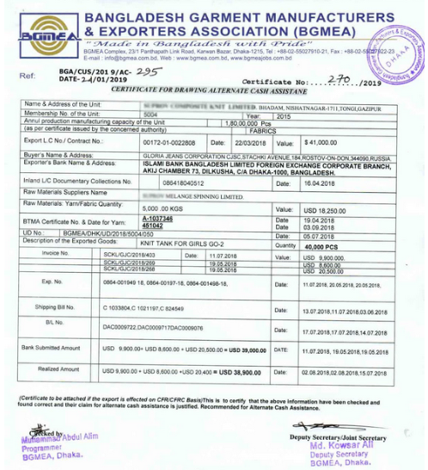
Figure: BGMEA Certificate

6.2.5 BTMA Certificate:
Bangladesh Textiles Mills Association (BTMA) certificate is issued as supporting certificates for getting the government cash incentive. Bangladesh Textiles Mills Association. issues such certificate specially for the yarn providers. The BTMA certificate includes the quantities of yarns, LC export numbers, dates, prices, bank title and department title, yarn representation, net weights, mushak number, seal & signs permitted, and so on. The auditor reviews all the information found in the BTMA certificate, along with the relevant documents attached to the file. It should be mentioned that any certificate without authorized seal signatures of BTMA would be considered as invalid.

Figure: Cash BTMA Certificate.

6.2.6 Proceeds Realization Certificate:
Bangladesh Bank issues certificate that validates export process has been realized against export from Bangladesh. It is mandatory to check proceed realization certificate altogether coordinating with information of the application form. The PRC number and PRC date are found in the Proceed Realization Certificate. In order to effectively call for a sensitive duplication of the records, these two items are exceptionally important.

6.3 Documents of Export:
The applicants state their export value for the cash assistance. For this purpose, in order to claim some sort of government cash assistance, applicants must submit paperwork to evaluators in order to check the records. As follows, the important export documents are:
- Commercial Invoice.
- Packing List.
- Bill of Lading.
- Export Form.
- Bill of Export.

6.3.1 Commercial Invoice:
A commercial invoice is a legal contract, which also acts as evidence of the dealings between the buyer and the seller in a foreign trade transaction. The seller (the exporter) as proof of foreign trade gives it to the buyer (the importer). It has product details in detail. For amounts, net and net weight, numbers for export, numbers for LC, prices, and dates. In addition, the purchaser's title, address, type of item, trade receipt value, receipt number, candidate's title, and number of amounts sent out, etc. The auditors must verification of the specified data inside the commercial invoice correlates with the data provided by the application form and the PRC. Any sort of inconsistency causes invalids the documents.
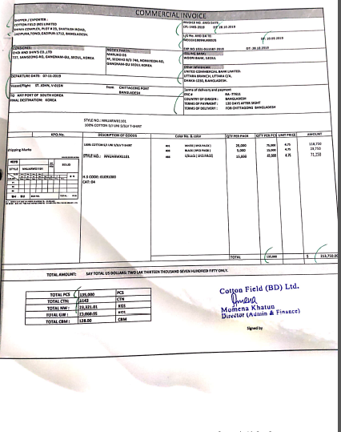
Figure: Commercial Invoice

6.3.2 Packing List:
Another important document is the packing list, which provides further importance to the physical representation of the products. It serves more measured objectives for goods being transported. It defines the conditions under which the shipping item is packaged and the number of packages in which the shipment is delivered. With the commercial receipt, the auditor verifies elements within the packaging list as well as the data contained within the application form. There must be a difference in any contradictory details within the list.
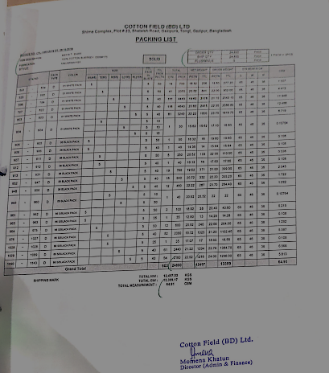
Figure: Packing List

6.3.3 Bill of Lading:

The bill of lading is an export document that is also known as a carriage contract between the shipper and the shipping line to carry out the shipment in compliance with particular terms and conditions. The terms and conditions required must be an agreement between dealer and buyer. The bill of lading is deemed to be a contract of carriage for the management of the import or export of sea cargo or air cargo. It includes export numbers, receipt numbers, date of LC and numbers, date of shipment of the form of cargo and approved seals and signs. If the bill of lading includes the word 'Freight prepaid' at that stage, the claimant must have a modern document called a cargo certificate.
For a confirmation that the shipment has been sent, the cargo certificate is given. No additional cargo certificate is needed if the bill of lading includes the word "freight collect" at that stage. And a partitioned seal sign from Bangladesh Biman may be needed for products transported by Airways if the auditors ask.
Besides a bill of lading contains shipment date PRC, commercial invoice, and packing list etc, Auditor checks all dates of shipping should be synchronized with the date specified in the application. The applicant must request the first fee for the segment. Non-submission of the initial passage fee would potentially lead to inconsistency. (iContainers, n.d.)
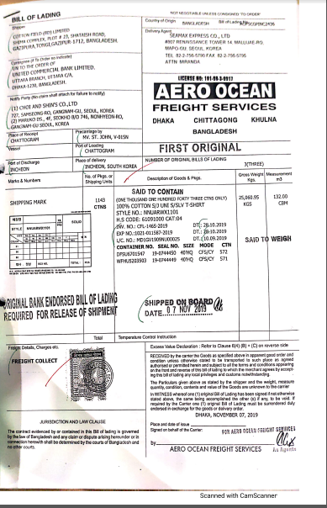
Figure: Bill of Lading

6.3.4 EXP Form:
The Export Form is known as the Exp Form, the most important document in the export process. This form is used to submit any object to a remote country. Bangladesh bank endorses this documents and it must be arranged and properly followed as a primary record. Generally, the customs authorities prepare this report, and the candidate complies properly with the report. Exp form contains many important information regarding export. Such as: Export numbers, commodity data to be exported, country of goods, port of goods, quantity, value, cash, points of interest of the merchant, date of shipment, etc.
All of this data must be consistent with the commercial invoice, packing list, lading bill, application frame and PRC. The form requires relevant seal signs and date stamps of the exporter, plus signatures of the approved bank officer. Without proper authorization, Exp form is valueless. EXP form needs certification of the authorized merchant and other authorized officials. As an evidence of genuine businessperson, this certificate is must and courses of action have been taken to realize the continued confidence. Non-submission of this certificate would lead to errors. The certificate of authoritative may be attached to the foot of the EXP form, or it may also be shown in the future with appropriate seals and signatures. (Bangladesh Customs, 2020)
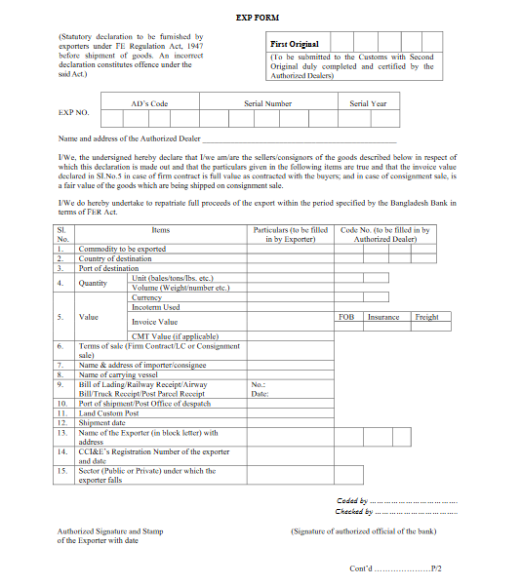
Figure: The front page of an EXP form

Figure: The Backside of an EXP Form

6.3.5 Shipping Bill/Bill of Export:
The Shipping Bill/Export Bill is the record required by the specialist of the tradition and issued by the shipping operator as shipping permission. Bill of shipping is a certificate by all parties that counts the owners, buyers, sellers, approved merchants of the dispatch.
Appropriate approved signs and seals are required for the bill of entry without which the shipment bill becomes worthless. Auditors check the authorized seal, and signs of the income officer in the front page of the Bill of entry the backside of the shipping charge allow the assessment seal to be marked by all approved authorities. Without approved seals and signs will lead the auditing to inconsistencies.(EximGuru Online Exim Encyclopedia, 2020)
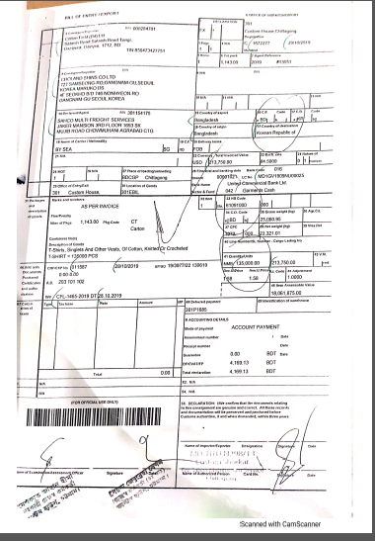
Figure: Bill of Entry (Front Page)

Figure: Bill of entry (Back page)

6.4 Documents of Import:
Raw materials are sometimes obtained by imports from neighborhood producers or from exporters from other nations. In such situations, auditors are required to review it. The following are some vital import records:
  - Pro Forma Invoice
  - Sales or Purchase Contract
  - Commercial Invoice
  - Packing List
  - Delivery Challan
  - Amendments
  - Utilization Declaration

6.4.1 Pro Forma Invoice:
A pro forma invoice is considered as a payment document of dealing. It is sent to buyers during the shipment that is transportation of goods. Additional critical data such as total weight, net weight and freight charges are found in a pro forma invoice. All pro forma invoices reflect the exact dealing costs indicated by the seller to be provided by the buyer. It also provides not only the weight of the package, shipping charges and exact deals, but also the LC number, buyer's address, and seller's receipt number. Both details inside the receipt coordinated with the request and the auditors check other relevant documents.

6.4.2 Sales/Purchase Contract:
In terms of a cash incentive audit Sales or Purchase contracts or Master LC is the most vital documents. The master LC is prepared by the merchant's nation's bank. The candidates were able to purchase some crude materials from outside the country or within the nation during composite records. Master LC moreover contains products traded, amounts beside the exchanged amount, commissions and special confidence, if any. Some of the time, due to a few variants within the exchanged quantity, the respect of the LC requires modifications through amendments. The auditor is responsible to verify the LC as well as its data.

6.4.3 Commercial Invoice:
For each imported shipment, the commercial invoice is critical. Detailed information is provided in the commercial invoice such as LC numbers and date, actual invoice value, total weight, net weight, type of material being imported. All this information must be synchronized with the application details in order to prevent inconsistencies. (Goodrich, 2005)

6.4.4 Packing list:
The record prepared by the retailer and sent to the buyer or to ensure that the items are shipped and found is a packing list. The packaging list may include the number and date of the LC, the address of buyers and sellers, the exact quantity, and the weight of the shipment. The packing list prepared for the transport offices, government specialists and customers to carefully manage the package. (Reviso, 2020)

6.4.5 Delivery CHALLAN:
Challan Distribution is a document that is normally produced where it is important to transport goods or items to travel to another location. Delivery Challans are generally sent along with the shipment of the goods. It has each and every detail of the products, and the sum of net weight, gross weight, LC numbers, destination address, origin address, value of the goods are other essential details specified in the Challan delivery. The auditors review all the related Challan distribution details with the information on the application form. (Zoho Inventory, 2020)

6.4.6 Amendments to LC:
A few amendments to the terms and conditions of the LC may be needed after the authorization of the LC. Any amendment to LC means any other modification that has been made to the LC's terms and conditions after it has been approved. Such modifications may be appropriate at any time after the LC's authorization, but any modification after the expiry date is not reasonable.
In the corrections, all these important changes must be pronounced, and it is the responsibility of the reviewers to review all the papers. (ORACLE Help Center, 2015)

6.4.7 Utilization Declaration:
For RMG divisions, the Utilization Declaration report is issued for reliability on importable crude materials from all custom ports. In order to induce government cash assistance, these documents are very important.
A record of utilization declaration includes details starting from the LC numbers to the final back-to-back LC numbers that are sent out. All the LC numbers used and sent out for the purpose of the result must be recorded in UD reports.

6.5 Analysis of cash Incentives procedure

6.5.1 File checking procedures:

6.5.1.1 Export Documents:
The auditors need to keep their mind cool and calm while checking the files as mistakes can happen and that would lead to an error- prone certificates. So keeping calm is very important.
When the auditor obtains an application, the first and foremost thing to be checked is the forwarding letter. It is also important for the auditor to verify the dates of the application, bank ID numbers, form of market, name of the branches concerned, LC number of the export, dates and values and relevant seals and signs. If the auditor finds everything to be alright then he/she can move to the next file or else discrepancies should be notified and correction should be made.
Then the auditor checks the application form. Here he matches the Export LC number, date and values with the bank forwarding letter. If these two doesn’t match then discrepancy will be announced.
After that the auditor usually check all the export documents and matches it with the application form information. At this stage the auditor checks the packing list, bill of lading, commercial invoice, export form, and bill of export. The net weight, gross weight, applicant name, beneficiary’s name, invoice value, quantities, LC number, export numbers, and all other information given in each of the documents mentioned above must be same. If they don’t match the auditor shall ask for correction and if it not corrected, then the auditor can’t issue a certificate under any circumstances.
After that they check the quantities, export number and quantity and weight of the product and matches it with the application form. The auditor checks the export number, type of freight (freight collect or freight prepaid), shipment date, etc. from the original copy of the bill of lading. He/she also checks the seals and signs in the bill of lading as it gives the bill authenticity.
From the Export form, the auditor then checks the export number, country of origin, and port of destination, invoice value, FOB value, number of quantities, and currency type, and other related information. The auditor always has to ensure that the whether the export form has the authorized certificate seals, and signs or not. The auditor will not accept any bill documents if it does not have the seal signs of Assistant Revenue Officer (ARO), and Revenue Officer (RO) respectively on the first page. Besides, appropriately authorized seals and signs on the front page, it should also be present at the back page of the bill of export. It ensures the adaptation of appropriate assessment procedures. If the applicant fails to have any of the documents sealed or signed, the auditors will not accept it unless applicant’s bank issues a No Objection Certificate (NOC) stating that the submitted documents are valid and trustworthy.

6.5.1.2 Import documents:
When checking Import documents, the auditor first checks the sales contracts. They give LC numbers, date, and value is high priority while checking it. An important clause can be found in the sales contract, which states which party is eligible for getting the cash incentive facilities.
The auditor learns about the origin of the product, from where the raw materials are procured and where the final product is made from the certificate of origin and from the certificate of the beneficiary, it is ensured by the auditors that the applicant did not claim any sort of bonded warehouse or duty drawback facilities for such raw materials.
The LC value can get changed over time and it can also be replaced by master LC. The changes or replacement of LC must be mentioned in the amendments to LC. The amendments are always checked by the auditors in case of such changes to maintain accuracy. If such changes are not mentioned in the amendments, then it must be mentioned in the Utilization Declaration. Otherwise the auditor must ask for valid reason for such discrepancy.

6.5.1.3 Meeting up discrepancies:
At this stage, where all the export and import documents have been checked, the applicant is asked to fix all the errors that was found. Then the auditors check it for one last time to see whether the errors have been fixed or not and whether the discrepancies are properly addressed or not. If the auditor finds everything to be alright, then the auditor sends the file to the firm to issue cash incentive certificate and if not the file is not sent.

6.5.1.4 Information Input, Final and Draft Print:
After receiving the file, the firm first puts input of the checked files in MS EXCEL and then issues a draft cash incentive certificate. This certificate is then checked by auditors to see if there are any errors in the certificate, if errors are found it is corrected. After all the corrections are made the final version of the Cash Incentive Certificate is printed.

6.5.1.5 Certificate Signing:
The final printed copy is then sent to senior auditors to check if there is any sort of mistake in the certificate. As they put forward the certificate after checking the error-free certificate is then sent to the concerned partner for signing. It is then forwarded to the applicant. After that, the applicant follows all necessary steps to claim the Cash Incentive.

6.5.2 Export increase in RMG sector:
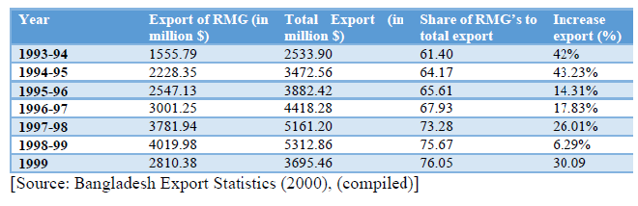
A substantial drop in exports in 1998-1999 is seen here. The main explanation for this is the horrific flood that has occurred in the entire world. The growth of exports from 1994, when cash incentive facilities were provided in the RMG sector, can be seen graphically.

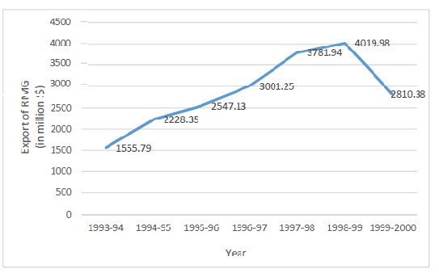
Thus, the study review that cash incentives have a positive contribution to the RMG sector's exports. It is possible to include the agrarian market. The quantity of vegetables exported increased from 3,75 000 metric tons in 1990-91 to 30,93 000 metric tons in 2007-08. The value of vegetable exports increased from $4.37 million to $60.47 million during the same period. It is appropriate to question if there has been any change in the quantity and value of exported vegetables following the implementation of the vegetable cash reward scheme in 2002-03. (December 2002). Quantity of the sale of vegetables 2007-08 (30,93 thousand mt) was 2,43 times higher than in 2001-02. (12.75 thousand MT). The export value of vegetables in 2007-08
($60.47 million) was nearly four times that of 2001-02 ($15.31 million).

6.5.3 Bangladesh Bank hire external audit:
The cash incentive was earlier granted to the applicant exporter, as calculated by the related exporter bank. But it is transmitted to a third party (external auditor) to provide a certificate ensuring the actual amount to be paid by the Bangladesh Bank because of some dishonest approaches by a group of people. Previously many companies applied for the amount of money which is not exactly real. But they got the amount with the help of a specific bank. Bangladesh Bank suffered a lot of losses because of this. The audit is carried out in favor of the consumer and the government to prevent manipulation.

Importance findings on cash Incentives:
Auditors check each and every information of the files to ensure that the export transaction has really occurred and ensure that product has been actually exported. Then they go for the calculations. Otherwise, if there is any error in the files then the calculations will also provide error prone results.
Auditors find many fraud files where client input so many wrong transactions and for that they claim they did export and expect cash incentives. If auditors do not check files correctly , their calculation also will be miscalculated and for that in our county the corruption is increasing.
After completing checking the files correctly, auditors do some calculations in the TOP sheet. Auditors do calculation based on realized value then auditors get the Cash Incentive amount. Auditors compare their calculated value with the Bank’s calculated value. The lower of the two amounts is ultimately considered as the original cash incentive and that amount will be paid by Bangladesh Bank to the client.

Summary of Findings and Analysis:
The study has made it possible to learn about export incentives offered to exporters by the government. Cash incentives are one kind of export incentive for which the government offers a defined rate for specific sectors. The overall results of the study are given below.
- The auditors work according to the rules and regulations laid out in the circulars laid out by Bangladesh Bank. It is not possible for the auditors to work beyond such rules.
- The clients or applicants of the cash Incentive are also not supportive enough if the auditors try to work beyond the rules of the circular
- Since 1994, cash incentive facilities have been given to increase exports and to build backward linkages.
- As per the central bank circular, all the applicants have applied for cash incentives.
- Auditors often have to rely on the data issued by the customers. It is also found that the papers supplied by the client are not always suitable.
- If the negotiating bank pays cash rewards irregularly, by debiting the respective bank account from their reserve fund, Bangladesh Bank may collect the money.
- Cash incentive will be received by only one party between the yarn manufacturer, fabric suppliers and exporter.

The following Specimen is an example of calculation:
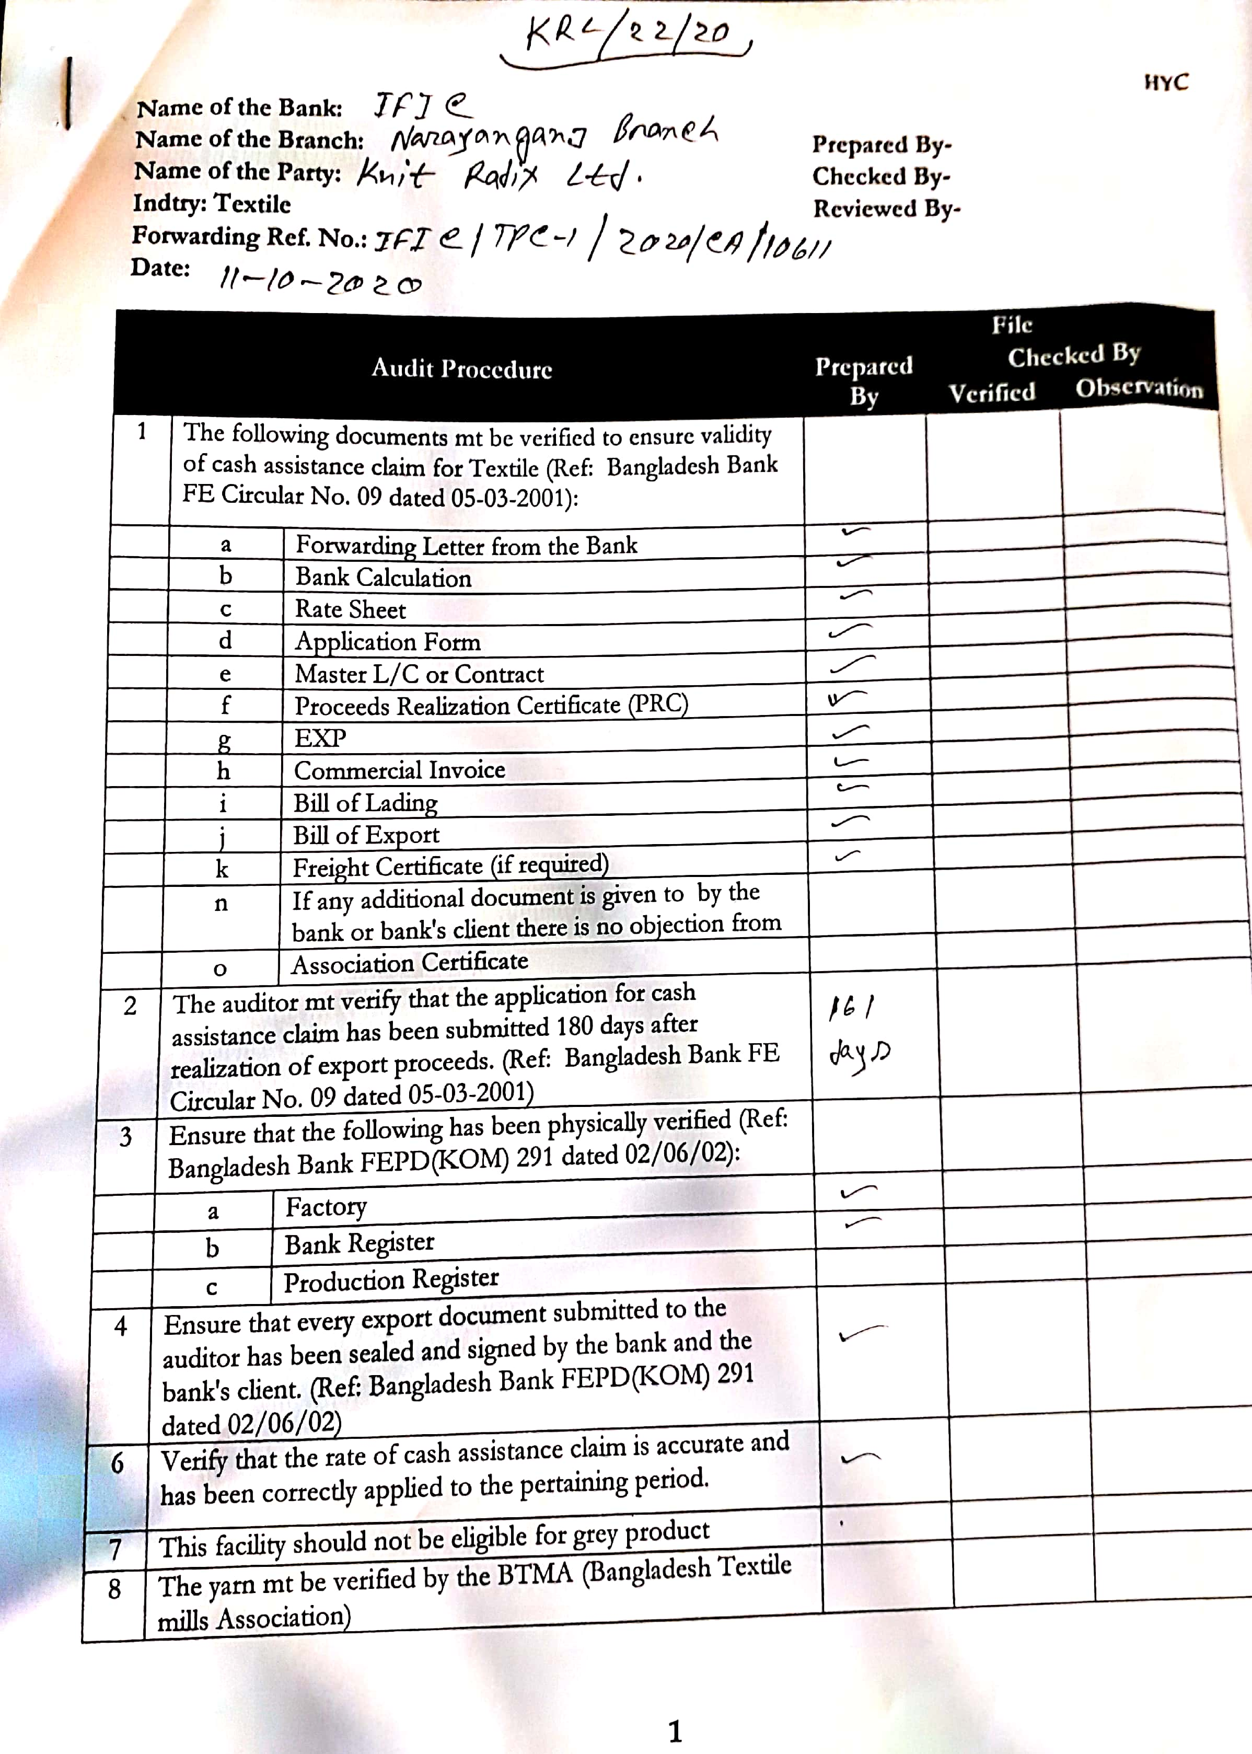

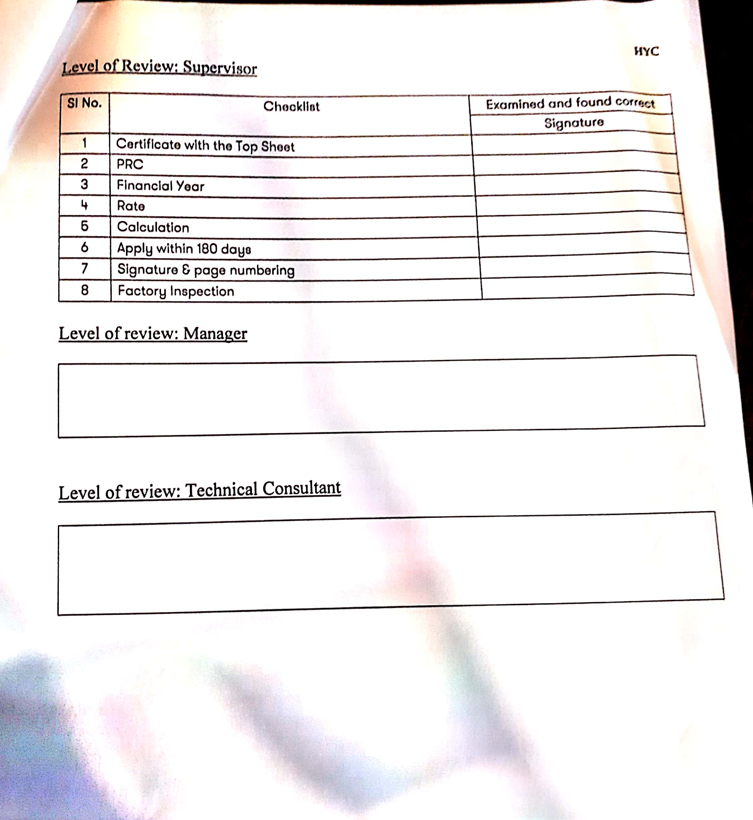

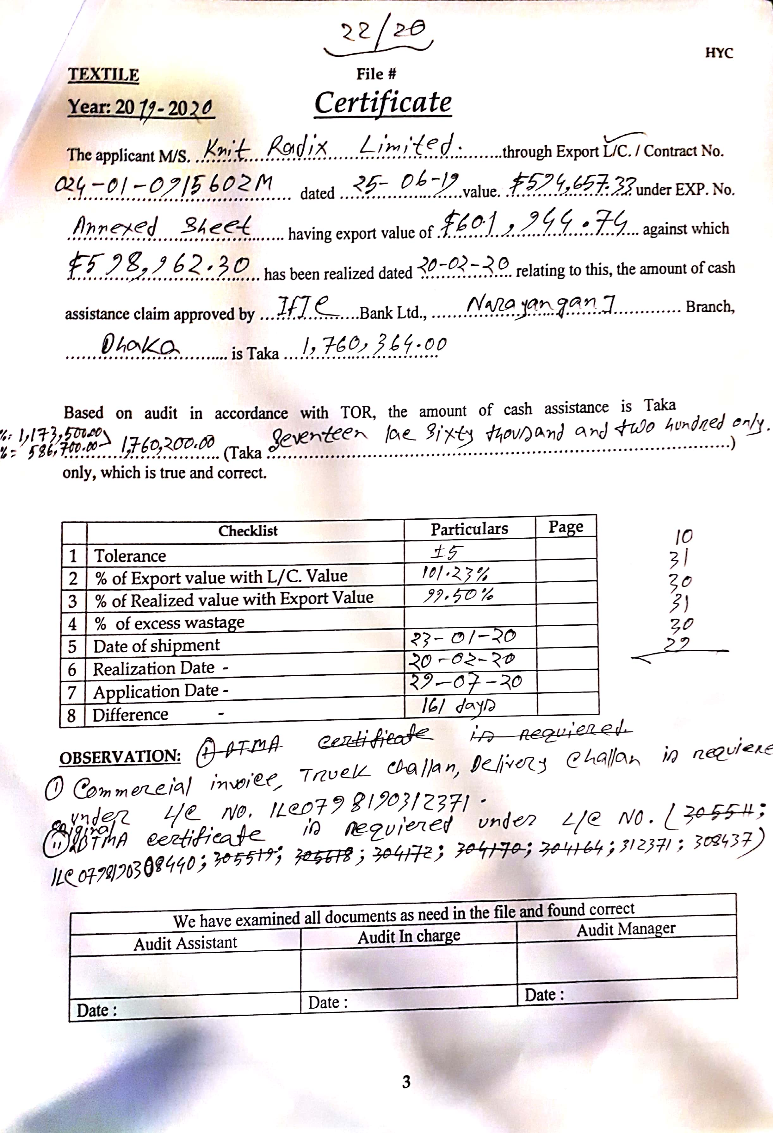
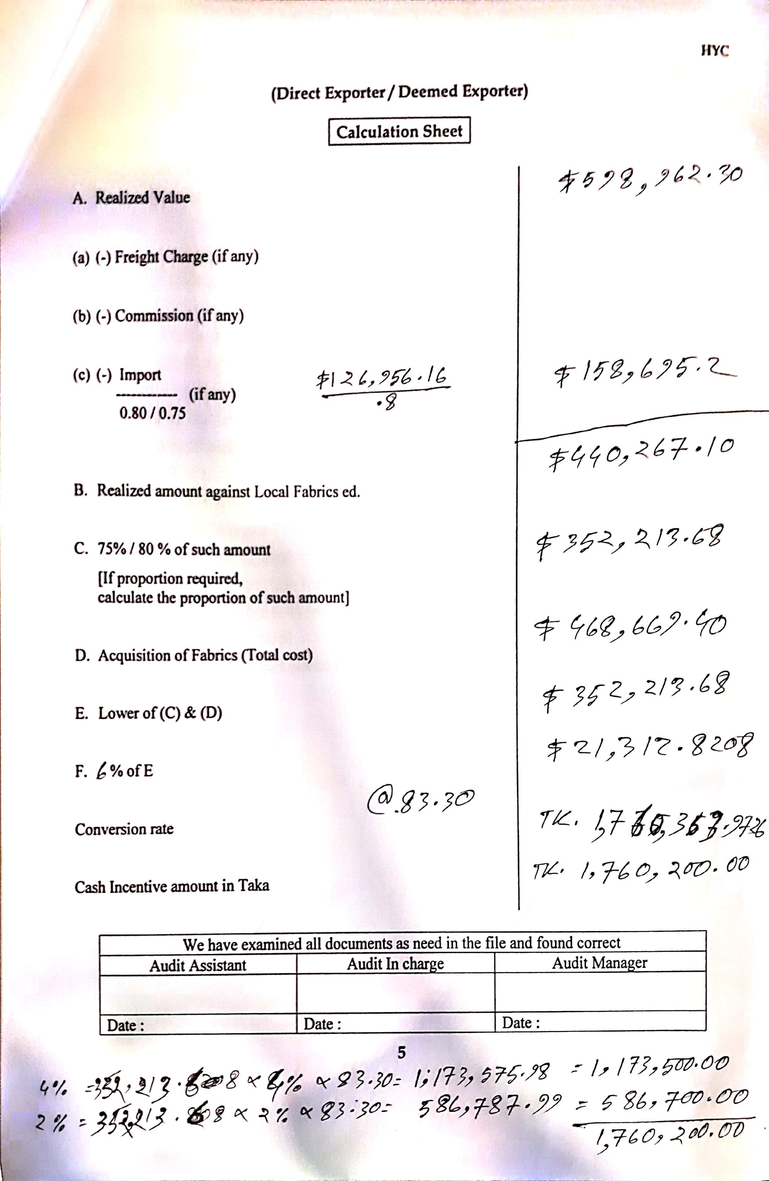


Recommendation:
There is barely any framework or a guideline that does not have any issue. The issue might not be distinguished instantly, but finding out the issues are fundamental for more effectiveness. There are a few suggestions that have been recorded underneath as to how the issues could be diminished:

- The firm may include a clause with specifying the precise time required for them to complete the total review and when the client ought to contact them to find firm's services.
- The firm can enlist a few additional article ship students for the input of the checked records. This will in the long run make their audit methods quicker than ever before.
- The firm can adjust to different present day computer program like SAP, QuickBooks, etc. in arrange to diminish the working loads on students.
- The method of audit programs for cash incentives should be presented to the group individuals who are junior in this field. ¬ The supervisor ought to make a team leader for the audit group members.
- Estimate and plan sufficient time for audit work.
- The firm ought to sear a letter with administration that contains the required information that have to be compelled to total audit work. Administration must allow orders to their representative to supply auditors required data.
- Junior student should get chance to do internal calculation for Cash Incentive beside file checking procedure.

Conclusion:
In this report, I have tried to reveal the basic audit methods of elective cash incentives for RMG segments in Bangladesh. The internship program acts as a bridge of involvement between theoretical and practical information that allowed me to obtain an improved information and understanding of the whole method as an entire. The hard work involvement made a different me to much better get it the exercises of the firm as an entire.
From my perspective, it has been a brilliant time to work as a cash incentive auditor for HYC Chartered Accountants. I think, the audit procedures of HYC Chartered Accountants will create and progress assist within the future and quality of their as of now palatable administrations will assist make strides as well.

References
Ahmed, W. (Ed.). (2019, March 19). Securing bonded warehouse .
Apparel Resources. (2020). Apparel Resources. Retrieved 2020, from https://apparelresources.com/business-news/trade/bangladesh-bank-issues-directive-cash-incentive-garment-exporters/
Bangladesh Customs. (2020). Retrieved from Exp Form Bangladesh Customs: http://www.bangladeshcustoms.gov.bd/download/EXP_Form.pdf
Bangladesh Customs Nationak Board of Revenue. (2020). Bangladesh Customs Nationak Board of Revenue. Retrieved October 2020, from http://www.bangladeshcustoms.gov.bd/
Bangladesh Customs National Board of Revenue. (2020). Retrieved 2020, from Bangladesh Customs National Board of Revenue: http://www.bangladeshcustoms.gov.bd/trade_info/export_incentives
BB Circular. (2020). BB Circular. Retrieved November 2020, from https://www.bb.org.bd/mediaroom/circulars/circulars.php
Business Research Methodology. (2020). Business Research Methodology. Retrieved November 2020, from https://research-methodology.net/research-philosophy/
Devox. (2020). https://www.devex.com/organizations/howladar-yunus-co-68937. Retrieved from https://www.devex.com/organizations/howladar-yunus-co-68937
Dhaka Tribune. (2019, june). Dhaka Tribune. Retrieved November 2020, from https://www.dhakatribune.com/business/regulations/2019/06/17/what-is-cash-incentives-on-exports
Ema, M. S. (2017). The authentication and audit procedure of alternative cash. Brac University. Dhaka: BRAC University.
EximGuru Online Exim Encyclopedia. (2020). Retrieved from Export Documents EximGuru.com: http://www.eximguru.com/exim/guides/how-to-export/ch_17_export_documents.aspx
Goodrich, J. (2005, May 8). International Trade Blog. Importing Basics. Commercial Invoice.
Grant Thornton Bangladesh. (2020, October). Grant Thornton Bangladesh. Retrieved from https://www.grantthornton.com.bd/
Gupta, K. (2005). Contemporary Auditing. In Contemporary Auditing (5th ed., p. 1095). New Delhi: McGraw Hill.
Hossain, M. (2019). The Procedure of Cash Incentive and Its Role in the RMG Sector in Bangladesh: Evidence from Bangladesh. KPMG Rahman Rahman Huq. Retrieved from https://papers.ssrn.com/sol3/papers.cfm?abstract_id=3334383
Hossain, M. J. (n.d.). VERIFICATIONOF AUDIT INALTERNATIVE CASH INCENTIVE. Daffodil International University, Dhaka.
Humentum. (2020). Humentum. Retrieved from https://www.humentum.org/free-resources/guide/external-audit
iContainers. (n.d.). Retrieved from iContainers: https://www.icontainers.com/us/2013/08/26/bl-bill-of-lading/
Investopedia. (n.d.). Retrieved November 2020, from Investopedia: https://www.investopedia.com/terms/l/letterofcredit.asp
ORACLE Help Center. (2015). Retrieved from Amendments to LC: https://docs.oracle.com/cd/E64763_01/html/LC/LC08_Amend.htm
Readyratios. (n.d.). Readyratios. Retrieved 2020, from https://www.readyratios.com/reference/audit/statutory_auditor.html
Reviso. (2020). Retrieved from Reviso A TeamSystem Company: https://www.reviso.com/accountingsoftware/accounting-words/packing-list/
The Institution of Internal Audits. (2020, November). The Institution of Internal Audits. Retrieved from https://global.theiia.org/about/about-internal-auditing/Pages/About-Internal-Auditing.aspx
Tourism. (2020, April). Tourism. Retrieved November 2020, from https://tourismteacher.com/positivism-and-interpretivism-simple-explanation/
Wikipedia. (2020, November). Retrieved from Wikipedia: https://en.wikipedia.org/wiki/Terms_of_reference
Zoho Inventory. (2020). Retrieved from Delivery Challan User Guide: https://www.zoho.com/inventory/help/delivery-challan/delivery-challan.html

Appendix:
