Internship Report
On
Evaluation of Service Marketing Mix of Hypertag Solutions Ltd.


ACCELERATING DIGITAL AND TRANSFORMATIONAL REVOLUTION



United International University


Internship Report
On
Evaluation of Service Marketing Mix of Hypertag Solutions Ltd.

SUBMITTED TO
Muhammad Hasan Al-Mamun
Assistant Professor
School of Business & Economics
United International University.

SUBMITTED BY
Abu Nayeem
ID: 111-151-170
BBA Program
School of Business and Economics
United International University

Submission Date: 05 / 07 / 2020

Letter of Transmittal

July 05, 2020
Muhammad Hasan Al-Mamun
Assistant Professor
School of Business and Economics
United International University
Dhaka.
Subject: Submission of Internship Report on “Evaluation of Service Marketing Mix of Hypertag Solutions Ltd.”
Dear Sir,
With immense pleasure, I would like to submit my internship report on “Evaluation of Service Marketing Mix of Hypertag Solutions Ltd.” I have done my Internship under your supervision. I have amassed all relevant documents and collected all necessary information for the purpose of evaluating the service marketing mix of the aforementioned organization.
In this circumstance I therefore pray and hope that you would be kind enough to accept my report.

Sincerely yours,

……………………
Abu Nayeem
ID No: 111-151-170
BBA Program
School of Business and Economics
United International University

Acknowledgement

First of all, I would like to acknowledge “The Almighty ALLAH”, the supreme authority of the universe. This is an exclusive instance of professional life I passed and enjoyed in the time of my internship. I would like to inform that I have prepared my internship report on my own.
It was a great pleasure of preparing this internship report on the various aspects of Hypertag Solutions Limited. I would like to thank and convey my gratitude to my honorable Supervisor Muhammad Hasan Al-Mamun (Assistant Professor), School of Business and Economics, United International University for letting me to prepare this report with his wholehearted supports and guidance. I would like to take this opportunity to express my sincere thanks to Hypertag Solutions Limited Project Management Division for providing me the opportunity to do my internship in this organization. I worked with all the concerned officers of Hypertag Solution Limited, Md. Shofiul Alam (Managing Director & CEO), Tushar Rahman (Operating Officer), Jahid Hossain (project manager) who kindly provided me the information and training. I am also thankful to all members of this organization for their limitless cooperation and supervision. I would like to express a deep debt of appreciation to the employees of Hypertag Solutions Limited. I would like to express a wholehearted thankfulness to our much revered supervisor, Muhammad Hasan Al-Mamun (Assistant Professor), United International University, who has given me the opportunity and directions to prepare such a meaningful report. I am also satisfied to work under his supervision and care.

Executive summary
Hypertag Solutions Ltd. was established in 2010 with a head office in Dhaka, Bangladesh with the purpose of providing state-of-the art digital technology solutions for Software, eGovt, Fintech, EdTech, Outsourcing, and artificial intelligence (AI). The main objective of this report is to evaluate the service marketing mix of the Hypertag solutions limited. Both primary and secondary data were collected and analyzed for the purpose of evaluating the various elements of the service marketing mix. Primary sources include consersations with personnel of Hypertag Solutions Ltd., interviews with the clients of the organization, and observing various work-flows in the organization. Secondary sources include annual report, company records & documents, and various published sources and websites.

The main competitors of Hypertag Solutions Ltd were found to be Tiger IT Bangladesh Ltd, Magnito Digital Limited, Southtech Gropu etc. At present, there are about eight hundred registered ICT companies in the industry. As the growth of the ICT sector is increasing day by day, many companies may come up in the ICT sector. So, we can say that the industry competition is high and it will also increase in future.

Hypertag Solutions Ltd is found to develop and implement an extended service marketing mix consisting of product, price, place, promotion, people, process, and the physical evidence. Hypertag Solutions Ltd. provides state of the art technology in the domain of Fintech, Edutech and Artificial Intelligence. Hypertag provides Various IT services to its customers and they have pre-set standardized prices for their various services. For services, place refers to the ease of access that customers have to a service. It also involves determining which intermediaries or affiliates to use to help you sell the services. Hypertag has eleven different service providing locations all over the country. Promotional activities of Hypertag include celebrity endorsement, testimonials, and other brand-building activities. By people, we mean those people who are directly or indirectly involved in the delivery of the service. This typically means employees of the company. But it can also mean subcontractors with direct interaction with customers. Various training programs are focused on the development of the people element of the service marketing mix. Hypertag is found to have specific processes for the purpose of delivering the promised services to the customers. They have made significant investment in the development of infrastructural facilities that will certainly help them to focus on the 7th element of the service marketing mix: physical evidence. Their capacity to develop and implement a well-organized service marketing mix is apparent in the management of the activities related to each element of the service marketing mix.

Key Words: Service Marketing Mix, Hypertag Solutions Ltd

Table of Contents
Chapter 01: Introduction 1
1.1 Introduction: 1
1.2 Background of the study: 2
1.3 Objective of the study: 2
A. Broad Objectives: 2
B. Specific Objectives: 2
1.4 Scope of the study: 3
1.5 Significance of the Report: 3
1.6 Limitation of the study: 4
1.7 Methodology: 4
A. Data Collection: 4
Chapter 2: Analysis of the industry 6
2.1 Hypertag’s Competitors Analysis: 6
A. TigerIT Bangladesh Ltd.: 6
B. Magnito Digital Limited: 7
C. Datasoft Systems BD Ltd: 8
D. Southtech Group: 9
E. LeadSoft Bangladesh Ltd.: 10
2.2 Size, Trend and Maturity of the Industry: 11
2.3 Industry Rivalry: 13
2.4 Summary of Challenges and Opportunities: 13
Chapter: 3 Analysis of the organization 14
3.1 Overview & History of Hypertag solution limited: 14
3.2 Company Profile: 15
3.3 Company Mission & Vision: 15
3.4 Firm’s Core values & Culture: 16
A. Core Values: 16
B. Culture: 17
3.5 Hypertag Solutions Management Chart: 18
Chapter-4: Findings 19
4.1 Service Marketing Mix: 19
A. Product/Services: 19
B. Price: 31
C. Place: 35
D. Promotion: 38
E. People: 45
F. Physical Evidence: 47
G. Process: 51
4.2 SWOT analysis of Hypertag Solution Limited: 52
A. Strengths: 52
B. Weaknesses: 52
C. Opportunities: 52
D. Threats: 52
Chapter-5 Featured Projects of Hypertag 53
5.1 Project -1: 53
5.2 Project -2: 54
5.3 Project -3: 55
Chapter-6 Recommendation & Conclusion 56
6.1 Recommendation: 56
6.2 Conclusion: 57
Chapter 7: References 58

Chapter 01: Introduction

Introduction:

An internship is an opportunity for practical work experience in a student’s chosen field of study. Internship provides us with hands-on learning outside of the classroom. Internship is the last stage of our educational part. It is the part of our BBA program.
Computer IT, or simply IT is any set of machine-readable instructions that directs a computer's processor to perform specific operations. Computer IT contrasts with computer hardware, which is the physical component of computers. IT is stored in computer memory and cannot be touched. The best IT organizations control their projects to meet defined quality targets.
Hypertag solution limited is one of the IT solutions firms. Hypertag Solutions Ltd provides core wireless services and solutions for mobile advertising, Mobile messaging, applications, contents, device management, connectivity gateway, mobile banking and mobile financial services. It has core modular service platform that delivers a wide range of carrier-grade services including rich contents, social aggregation, mobile advertising, messaging solutions, mobile marketing, storefronts and portal management, and call completion services.
Hypertag is specialized in SMS, MMS, IVR, WAP, J2ME and web based mobile solutions. Its technology is live and evolving and designed for rapid deployment and revenue generation. A state-of-the-art Common Short Code Gateway with comprehensive toolset, the company’s unmatched deployment flexibility enables operators of all sizes to compete immediately, and flexible architecture makes migration to next-generation technology simple. For completing this internship program, I was placed in an organization named ‘Hypertag Solution Limited’. Internship program brings the students to the real life experience and help to discover the potential of the graduates.
This internship program brings me closer to the practices in IT sector and helps me to develop a significant understanding about the overall activities of the Hypertag Solution Limited. In this state I have worked to reflect my entire efforts in analyzing the experience of practical orientation related to overall activities of the Hypertag.

Background of the study:
Like other business schools of the world, an opportunity is given by the School of Business and Economics of United International University to its fresh graduates to get acquainted and get practical experience of corporate world through Internship program of Three (3) month. Internship program is a critical for bachelor of Business Administration (BBA) students, designed to put them in a challenging environment of the relevant field, where the students get the opportunity to apply their theoretical knowledge into practical applications. During the internship training, Students have the opportunity to adapt themselves to the particular environment of the organization. It provides a unique opportunity to see the reality of business during student life. which enables them to building confidence and working knowledge in advice of the start of their career. To fulfill this requirement every university of business arrange a program of internship. I am really thankful to Hypertag company for letting me have this opportunity to work with them and learn the IT related knowledge that will definitely help me in my near future.

Objective of the study:

Broad Objectives:

The primary objective of this report is to evaluate service marketing mix of the Hypertag Solutions Limitecd.

Specific Objectives:

The secondary objective of my report is to understand the overall activities of an IT
Company especially “Hypertag Solution Limited.” as well as to gain professional skills &
knowledge on organizational related activities to apply them in future. The other objectives
of this report are:
- To analyze the IT industry of Bangladesh.
- To evaluate the current market situations in the IT industry of Bangladesh.
- To describe training and development programs of Hypertag
- To acquire knowledge about how an IT firm runs its operation.
- To know about the current market position of Hypertag in the IT industry
- To make some recommendations to overcome the problems currently faced by Hypertag.
- To analyze the performance of Hypertag Solution Limited.
- To describe about my internship experience in Hypertag Solution Limited

Scope of the study:

Bachelor of Business administration (BBA) requires a three months attachment with an organization followed by a report assigned by the supervisor on the organization and endorsed by the faculty advisor. I took the opportunity to do my internship in the Hypertag solution limited. The scope of the report is limited to the overall description of the activities of the companies. It is limited to organizational setup, and functions. Hypertag is a new company and it needd to go a long way to achieve goals to be one of the successful companies in Bangladesh. The report will mainly focus on how to the company work to achieve the goals and how it works or focus to gain goals by enhancing its service and reducing its complexity. The the core focus will be concentrated on the evaluation of the service marketing mix of this company.

Significance of the Report:

This report will help the readers to know about the Bangladesh IT industry and “Hypertag Solution Limited” and how they contribute to the development of the Bangladesh IT industry. It will also help to know about the activities of Hypertag Solution Limited. Moreover, this report includes performance analysis of IT industry which will help readers to know about the current situation of the IT industry and take effective decisions who wants to get involved themselves in the ICT industry. Various sectors have been discussed about the Bangladesh IT industry and ICT sector.
The reader can know what factors help in the growth of Bangladesh IT sector and IT industry. There is also a few information about performances of rivals and the substitutes of IT industry and ICT sector. The SWOT analysis will greatly help the reader to evaluate potential growth opportunities of the Bangladesh IT industry and along with Hypertag Solution Limited.

Limitation of the study:

The study was mainly conducted for the purpose of evaluating the service marketing mix of the aforementioned organization. But there were many obstacles in my pursuit. These obstacles may be termed as limitation of the study. These limitations are as follows:
- The information required for the study was not adequate.
- Confidential documents & files of the firm were not accessible.
- The time period was limited to do extensive study.
- Lack of proper knowledge and previous experiences

Methodology:

Methodology is the systematic, theoretical analysis of the methods applied to a field of study. It comprises the theoretical analysis of the body of methods and principles associated with a branch of knowledge. Typically, it encompasses concepts such as paradigm, theoretical model, phases and quantitative or qualitative techniques. A methodology does not set out to provide solutions—it is therefore, not the same as a method. Instead, a methodology offers the theoretical underpinning for understanding which method, set of methods, or best practices can be applied to a specific case, for example, to calculate a specific result. This report is descriptive in nature and observation method has been used to carry out this qualitative research.

Data Collection:

Data collection for this report was from two sources. These are-
- Primary sources:
- Conversation with the respective officers and staffs of the company.
- Informal interview with the clients.
- Desk works in different section of the company.
- Relevant file and document study as provided by the concerned officers.

- Secondary sources:
- Annual report
- Company record
- Internet
- Website
- Different papers of the company
- Magazines

Chapter 2: Analysis of the industry

Hypertag’s Competitors Analysis:

Hypertag Company has many popular & renowned competitors in IT industry. Some of the competitors are as follow:

- TigerIT Bangladesh Ltd.
- Magnito Digital Limited
- Datasoft Systems BD Ltd.
- Southtech Group
- LeadSoft Bangladesh Ltd.
- KAZ software Ltd.

TigerIT Bangladesh Ltd.:

Tiger IT builds on over ten years of experience in software development. It is one of the leading software companies in Bangladesh, pioneering in biometrics and is a world leader in Automated Fingerprint Identification System (AFIS). Tiger IT is one of the few companies worldwide to develop an NIST certified AFIS, and the first among the South Asian countries.
Tiger IT developed the complete software solution for the national ID and voter registration project for the general election of Bangladesh in 2008. The project was undertaken by the Bangladesh Election Commission in collaboration with the Bangladesh Army. The 2008 election marked a new milestone in the history of Bangladesh’s democracy with a turnout of over 80% voters. It was the first time that the citizens of Bangladesh used national ID cards with photographs. Over 80 million people and 320 million fingerprints were enrolled in 11 months.
Tiger IT’s participation and experience in the national ID and voter registration project has been highly instrumental in developing their next generation solutions. They routinely access global skilled resources and leading-edge technology that is essential in creating a strong foundation of success for large-scale projects.

Company Name: | TigerIT Bangladesh Limited.
Address: | House 21, Road 28, Block-K, Banani Model Town  Dhaka, 1213, Bangladesh.
Foundation Year: | 2000
Staff: | 251-500
Logo: | 

- Vision:
- With a bold vision – digital identities for everyone – Tiger IT marches on into the future. The implication of the vision is that when people need access to their PCs and networks, share information securely and transact, they do so without barriers and with confidence (Tiger IT Bangladesh Limited, 2017). Research and development of technologies used to identify every person through biometric means will remain a ceaseless effort for Tiger IT.

Magnito Digital Limited:

Magnito Digital is the largest digital agency of Bangladesh with a team of more than 90 people. We are famous for our unconventional company culture. Our experience and massive setup allow us to deliver services at unparalleled scale. We have worked with the largest clients of Bangladesh and have built leading brands in the digital space. It is in our bloodline to solve problems by combining creative strategies with data, content and technology. Our key strength is developing and deploying meaningful digital contents to engage with the right audience. Thanks to this, we have become the specialized go-to-agency with proven track records, for managing large scale digital products & services. Being one of the most awarded digital agencies of Bangladesh, Magnito Digital won Gold to become the ‘Campaign Asia-Pacific: Digital Agency of the Year 2015’ in the ‘Rest of South Asia’ category.

Company Name: | Magnito Digital Limited.
Address: | 6th & 7th Floor | House-7 | Road-137 | Gulshan-1 | Dhaka | Bangladesh.
Foundation Year: | 2013
Staff: | More than 70 people
Logo: | 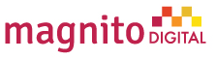

Datasoft Systems BD Ltd:

DataSoft has been a CMMI level 5, ISO 9001:2015 certified leading software product and services company in Bangladesh. Since 1998, DataSoft has successful track record of delivering innovative and cost-effective technical services to customers in both Corporate and public sectors undertakings.
DataSoft Systems Bangladesh Limited is the first software company in Bangladesh to be documented as a CMMI Level 5 Software Development company. Only **377 companies across the world has been recognized as CMMI level 5 companies. Accredited as a CMMI level 3 company since 2009, DataSoft has always been ahead of its game in comparison to other local firms. On April 24 2014, DataSoft started its journey as a CMMI Level 5 company, and with that it introduced a new era in the IT Industry of the nation.
Company Name: | Datasoft Systems BD Ltd.
Address: | Rupayan Shelford (20th Floor), 23/6, Mirpur Road, Shyamoli, Dhaka-1207, Bangladesh.
Foundation Year: | April 25, 2008
Staff: | 251-500
Logo: | 

- Vision:
- Powered by innovation, guided by integrity, deliver quality solutions to build The Digital Delta.
- Mission:
- To maintain the leading software solution provider ensuring benefit of customers, shareholders and employees.
- Developing, disseminating and exploiting the remarkable experience, expertise and knowledge of all of our people.
- Developing a distinctive competence in process development and project management.

Southtech Group:

Southtech Group started its journey in 1996 with a vision of providing ICT solutions for the betterment of society. Over a period of 20 years the Group has attained prolific growth and fulfillment that eventually led to spreading its footprint outside of Bangladesh. At present the Group comprises of 6 companies across 5 countries.
Its sister concerns include Southtech Limited, one of the largest CMMI L5 and ISO 9001:2015 certified software companies in Bangladesh. It is a Gold Certified Partner of Microsoft and a Gold Partner of Oracle. Southtech Systems Limited provides hardware, networking and data center construction solutions. Southtech Bhutan Private Limited is its second software development center in Thimphu TechPark, Bhutan. Southtech Solutions Limited, UK and Southtech Inc. USA act as the Master Distributors of Southtech Limited's software products in their respective countries.

Company Name: | Southtech Group
Address: | Dhaka Square -- 4th & 5th Floors, Plot 1, Road 13, Sector 1, Uttara M/T, Dhaka, BD.
Foundation Year: | 1996
Staff: | 201-500 employees
Logo: | 
- Mission:
- With a mission to make Southtech a household name, we thrive to pursue a win-win situation for everyone related in the process. There is no compromise in creativity, innovation, and hard work from our end to make this mission come to life.

LeadSoft Bangladesh Ltd.:

LEADS Corporation Limited has been a foremost information technology service provider since 1992 when it became the exclusive distributor for Bangladesh of the global giant NCR Corporation, and took over the support service of NCR’s the then Bangladesh customers. LEADS has come a long way since, to become the leading provider of application software for the financial sector of the country, among its myriad of different products and services. LEADS is involved in designing, developing, implementing and maintaining business application software for both domestic and overseas markets. LEADS provide Core Banking Solution (BankUltimus) for the Banking industry for both local and global market. In addition to the banking industry LEADS provides products, services and solutions for non-banking financial companies, agent banking, capital market, broker house, life insurance, enterprise resource planning (ERP) etc.
Company Name: | LeadSoft Bangladesh Ltd.
Address: | Rupayan Trade Center, 114 Kazi Nazrul Islam Ave, Dhaka 1205, Bangladesh.
Foundation Year: | 1992
Staff: | 201-500 employees
Logo: | 

- Mission:
- To understand our customers’ business & technology issues and to deliver measurable tangible results through our experience in and commitment to a varied range of platforms and products, and with dedication to stay current with reliable & proven technologies, to maximize the value of our services to our customers and to develop a competent and highly motivated workforce.
- Vision:
- To be a model of excellence as an Information & Communication Technology company that our Shareholders, Customers, Suppliers, Associates and Society would love to be associated with.

Size, Trend and Maturity of the Industry:

According to the survey of BASIS, there are over more than 800 registered software and ITES (IT Enabled Service) companies in Bangladesh at present exist. A number of unregistered small &home-based software and IT company (around few hundred) are doing their business successfully in Bangladesh. Those unregistered small and home-based software and IT company doing business for both local market and international markets. The total industry size and the revenue they earn is estimated to be around Tk. 1,800 Crores (US$ 250 million). Approximately more than 30,000 professionals, majority IT and other graduates’ people are employed in the software and IT industry show in figure 2.1. (Those information sources are Bangladesh Software and IT service Industry Recent Trends & Dynamics).
800 +
Enterprise No.
Tk 1800+
Crore
Revenue
30000+
Professionals
Employees

Figure 2.1: Overview of the Software Industry (Source BASIS Survey)

Recently BASIS carried out a survey and on this survey three hundred of its member companies. This analysis has been done on the business nature, the business volume and the size of companies. Over more than 70% of the companies are found which involved in development and maintenance of software for their clients and Customers. And a number of those are companies simultaneously engaged in providing different IT based services for their clients and customers as well. Bangladesh Software & ITES Industry revenue are show in Figure 2.1 (Those information sources is Bangladesh Software and IT service Industry Recent Trends & Dynamics).
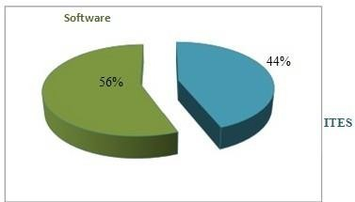

Figure 2.1: Industry Revenue Proportion (Source BASIS Survey)
However, almost half of the surveyed companies are involved in providing various types of IT based services (data/form processing, graphic/web design, content management etc.). Moreover, a significant number of companies (around18%) have developed software products or customized services, most of those have been developed over time and after repeated installations for multiple customers. Some companies are now involved in digital content development. Those companies’ delivery business, mainly they provide content services through the mobile platform.
At present the most encouraging trends in the Software industry is that, leveraging on recent positive changes. Such as most of the Internet user-base the better connectivity and also the introduction of some new payment methods (online payment – through credit card and mobile payment), a quite good number of companies (around 45%, some are dedicatedly and some are along with their core software & IT service business) are now diversifying on different web types of based services. The services they provide include specialized portals, payment intermediary services, listing services, e-Learning, e- Commerce, e-Learning, etc. Some of these companies have done quite well in terms of popularity as well as financially sustain. Some companies are now also developing web applications based on cloud delivery model. (Those information sources are Bangladesh Software and IT service Industry Recent Trends & Dynamics).
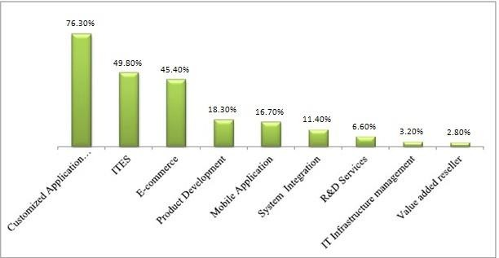

Figure 2.3: Top Export Destinations (Source BASIS survey

Industry Rivalry:

There are about 800+ Information and Communication Technology in Bangladesh according to the BASIS survey. Some of the well-known are IBCX-PRIMAX software, Kaz software, Leadsoft Bangladesh Ltd. Data craft limited. These companies are operating quite well and have successfully run their business around the country. Each ICT company provides outstanding service to their clients and meet the customers demand successfully. The clients are most of the outside of the country and they look for the quality service. So, when they give a project to a particular ICT company, they want a quality service otherwise they may switch in another ICT company. They clients looks for the company which are highly efficient and ensure better service quality.
As the growth of the ICT sector are increasing day by day, many companies may come up in the ICT sector at present around 800+ registered ICT company in the industry. So, we can say that the industry competition is high and it will also increase in future.

Summary of Challenges and Opportunities:

Bangladesh is termed as a strong emerging market performer in the ICT sector. It could be the fastest growing economies over the period to 2050. The government has been working on to provide better opportunities in the ICT sector. Since the software and ICT services market is growing, more entrepreneur will join and it would require more professional developers. Performing well and meeting requirements of the clients is a huge challenge for companies of the ICT sectors. Since Bangladesh’s growth rate is expected to be high, more & more foreign ICT companies are coming but political instability might hamper the growth and activities of the Information and communication Technology.
In a survey of BASIS, it is estimated that 800+ registered ICT companies are operating their business in Bangladesh. This sector now maintaining around 57.21 percent export growth from last nine years. The Information and Communications Technology (ICT’s) registered export earning value around US $.8 billion from the global or foreign market and from the home or domestic market it earns US$1.54 billion. And contribution to national economy around to the 1%. As the ICT sector is a faster growing it may contribute more in the national GDP in future if this sector run properly. Companies will need employees with vast experience and vast networking. As it’s a fast-growing sector need more professional developers with a vast knowledge and can continue the growth and maintain a standard quality of services.

Chapter: 3 Analysis of the organization

Overview & History of Hypertag solution limited:

Hypertag solution Limited is a brainchild of committed entrepreneurs and farsighted dreamers of IT excellence. Hypertag Solution Limited has created an image of its own in the field of transactional banking IT in Telecom and Financial Institutions through the course of its persistent effort for the last 3 years. Hypertag journey has started back in 2010 from 600 SQL with 5 employees to 25 nationwide offices and 100+ employees in Software Development, Training Institutes, and Artificial Intelligence. From the very beginning, Hypertag Solutions Ltd has always aimed high to walk in the top branch of the technology market. Started with solving mobile recharge as gift distribution for one of the popular Nokia’s campaign. Served national project to launch e-Traffic solutions for DMP. It was a thrilled journey to be expanding market internationally in Nepal and supported 30+ banks in SMS Banking services at an early stage. Hypertag’s greatest success is to launch first Mobile Money services with First Global Money and Bangladesh Commerce Bank to distribute the remittance. Finally, Belancer has opened the window of thousands of young peoples as the first online outsourcing marketplace in Bangladesh. The Company has built up an impressive list of clients, most of which comprises of leading banks and financial Institutions, Telecoms, corporate houses, Industrial Firms, Media Houses, Travels agencies and other organization which bear a name in their field. Hypertag has created a unique distributed structure, and steadily, continues to expand its IT development activities. Hypertag Employ highly qualified and skilled IT Engineers within. Depth understanding of mobile banking. In view of the quality and wide range of services as well as the growing number of clients they work with, Hypertag stand out that amongst numerous IT companies, in this regard, they assure that they do provide customer with the security and operation framework with security that their organization require.

Company Profile:

We are state of the art digital technology company since 2010. Expertise in Software, Fintech, EdTech and Artificial Intelligence. Its flagship initiative ‘Belancer’ provides full-stake skill and employment services in Bangladesh. Hypertag vision is to contribute to transforming Bangladesh into Digital Bangladesh with technical expertise and business intelligence to harness the emerging technology to drive the growth of the businesses. To achieve Vision 2021 and propel Bangladesh Future towards emerging as a strong middle-income country, empowering citizens at home and abroad with 21st-century skills will be crucial.
Company Name: | Hypertag Solutions Ltd.
Address: | (Level-3) Chandroshila Suvastu Tower, 69/1, Panthapath, Dhaka.
Email & Contact | Ph: +880 1711 000 537  info@hypertagsolutions.com  www.hypertagsolutions.com
Logo: | 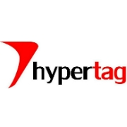

Company Mission & Vision:

- Mission:
- To be the most trusted provider of skill and employment services in Bangladesh and Asia.”
- Visions:
- Always ahead with innovative product while focusing on “work for everyone”.

Firm’s Core values & Culture:

Every company, big or small, has core values. Core values are the basis upon which the members of a company make decisions, plan strategies, and interact with each other and their stakeholders. A stakeholder is any person or organization that is impacted in some way by the company. Core values reflect what is important to the organization and its members. Core values are not necessarily dependent on the type of company or industry and may vary widely, even among organizations that do similar types of work. According to some management scholars, companies that stray from their core values may not perform as well as those that adhere to them. However, for many companies, adherence to their core values is a goal, not a reality. Hypertag’s Core values are described below-

Core Values:

- Transparency: We pride ourselves on providing complete visibility into the successes, and sometimes failures, of our business as we grow and scale. It is an integral part of our culture as we collaborate and work towards a common goal across functions.
- Control: Control and ownership over individual business impacting projects empowers our employees to think critically and contribute to the development of IT industry.
- Flexibility: We empower our employees in a work environment that is conducive to creating the optimal work/life balance.
- Team on a mission: BigCommerce is made up of amazing individuals, but it’s only through teamwork that we achieve greatness. We’re committed to helping our customers by working together with equal parts humility and ambition
- Act with integrity: We’re honest, transparent and committed to doing what’s best for our customers and our company. We openly collaborate in pursuit of the truth. We have no tolerance for politics, hidden agendas or passive-aggressive behavior.
- Build Relationships / Deliver Results: Connect with customers, partners, consumers and each other to drive success. Relationships deliver results because we can’t do our jobs without each other. When a person goes above and beyond in this area, they own their impact on our business and our partners’ success.
They dive deep to understand how and why our industry and our customers tick. We’re all about providing great service - to consumers, to customers, to our communities and to each other. A true champion of this mindset takes pride in knowing that we’re making a real difference by working together.
- Self-Improvement: We are committed to continuous investments in the growth of our team members. We also ask our teams to actively take responsibility for their own self-development.
- Support Each Other: We are committed to building an encouraging, caring, and supportive environment. We share a responsibility to support our team members and enrich their lives.
- Work Ethic Wins: We believe the teams willing to put in the extra effort, go the extra mile, and are accountable for their actions, will be the ones who see their visions and dreams realized.
- Service: We do whatever it takes to delight our partners. We support and share responsibility with the members of our team.
- Relentlessness & Humility: We are relentless in our pursuits of major victories and humble in our successes.

Culture:

Company culture can be defined as a set of shared values, goals, attitudes and practices that characterize an organization. Company culture can more simply be described as the shared ethos of an organization. It’s the way people feel about the work they do, the values they believe in, where they see the company going and what they’re doing to get it there. Collectively, these traits represent the personality or culture of an organization.
- Flat Structure & Open-Door Policy:
Any team member has access to any other member. All the C-level employees are accessible by any means of communication.
- Knowledge Sharing to off-set Risk:
In Hypertag Solution makes sure that the business and technical knowledge is not conned to a single resource and that if one developer leaves, others can be productive
- Utmost Confidentiality with Client’s Information:
Hypertag Solution signs NDAs before entering a contract. Their employees are contractually bound to keep client’s information confidential.

Hypertag Solutions Management Chart:
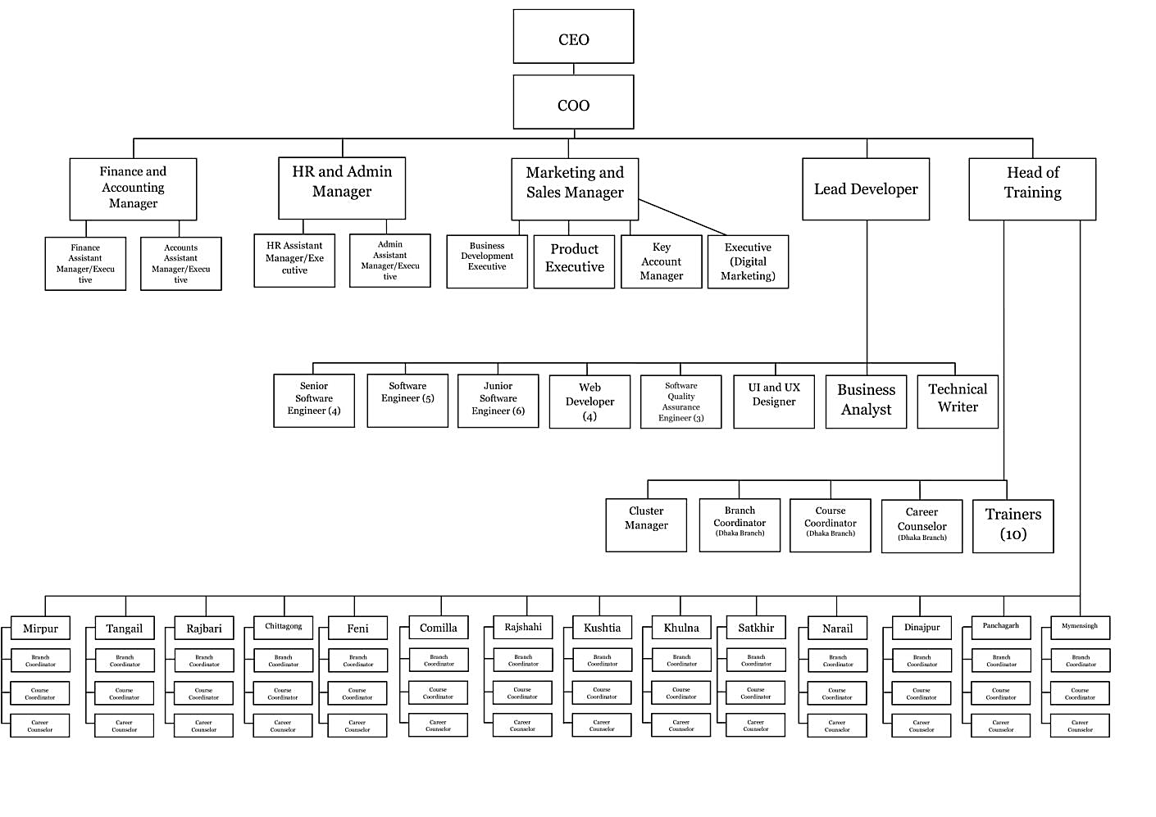

Chapter-4: Findings

Service Marketing Mix:

The Services Marketing Mix consists of a set of tactics that a company can use to promote and encourage potential customers to buy their service. The Services Marketing Mix is also known as the 7 P’s of Marketing. The Services Marketing Mix is unique to services. The model is an extension of Product Marketing Mix (also known as the 4 P’s of Marketing). All four tactics of the Product Marketing Mix used to market products remain, but three new tactics are added. The additional 3 P’s (or tactics) are needed to adequately capture the options available to market and promote services.
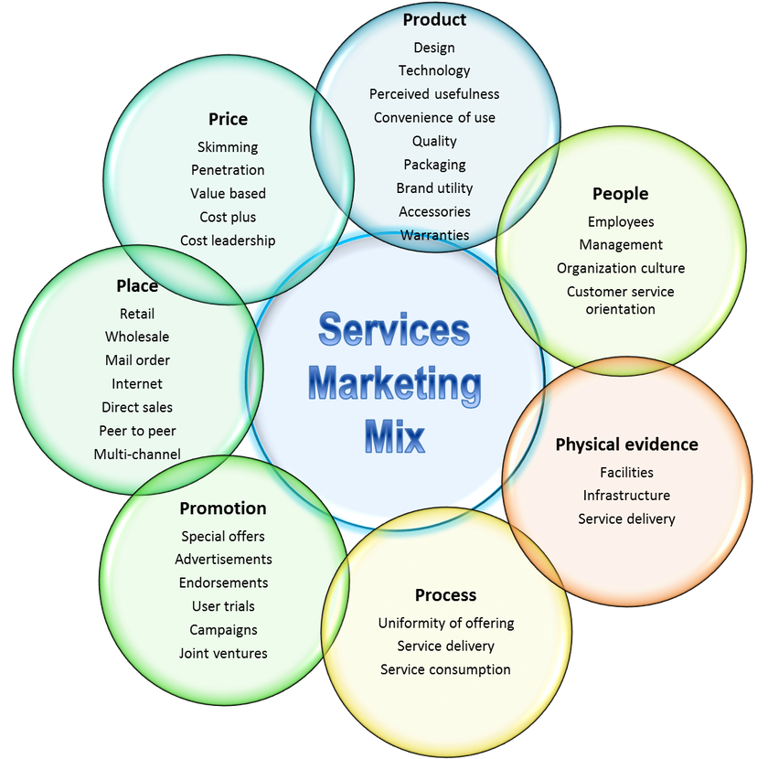

Hypertag company maintains its Service marketing mix with a satisfied manner. The service marketing mix which contains the 7P’s of Hypertag Solution Ltd are discussed below-

Product/Services:
Hypertag Solutions Ltd. provides state of the art technology in the domain of Fintech, Edutech and Artificial Intelligence.
- Hypertag Products:
- Belancer
- desh.AI
- PayON
- Rockingbee
- HyperPOS

- Belancer (Freelancing Marketplace):
Belancer.com is the first online works freelancing, outsourcing, marketplace to connect clients & freelancers to get works done on time on budget. The greatest strength of Belancer is its "Employee”. It is us who have brought about the phenomenal successes for our company. Career at Belancer has often led us in making the impossible happen. We believe we have the zeal and ability to go beyond and constantly bring about changes for the better.

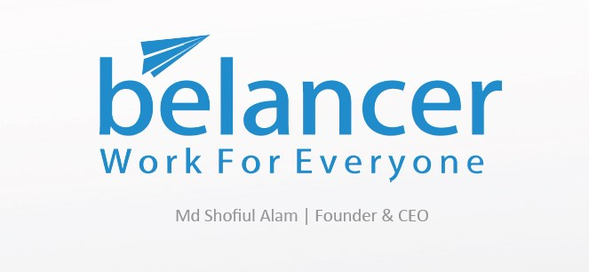

- Belancer has registered 3000+ different skillset does work for everyone.

- Belancer introduces “Recommended Badge Program” for handpicking an expert.

- “Escrow Fund Protection” does safe both Clients & Freelancers.

- Belancer incorporated in the US and connected PayPal to receive payments easily for freelancers from International clients.

- Belancer has all required 75+ modules comparing to any international benchmark.

- Belancer offers both rating & review for freelancers & employers to maintain professionalism and effective output.

- Belancer has 45,000 Freelancers, 5,500 Clients, posted “$2.5m equivalent project in 3 years.
Belancer has the following aspects-
- Browse Works
Here, anyone can browse works from varieties projects. There are multiple filter options like Budget, Type, Categories, and skills.
- Recommended Badge Program
We have recommended badge program to get authentic and proficient freelancers so that the project can be done in a professional way.
- Wallet
We have escrow management option. Escrow holds and manages the payment on behalf of Clients and Freelancers.
- Find Freelancers
Employers can choose freelancers from huge number list. We have 40,000+ registered freelancers. Employers can check freelancers’ profile from here.
- Skill set
Freelancers can select their skill from 3000+ skill set including from Data Entry to Machine Learning, Artificial Intelligence.
- Payment System
It supports all kind of payment gateway like PayPal, Bank Accounts and Local Payments (bkash).

- desh.AI (Transforming Businesses with Artificial Intelligence):

Desh.AI is working on transforming businesses with Artificial Intelligence to help the government & enterprises for the fastest growing markets. Hypertag and its AI startup desh.AI along with ICT Division, Cabinet Division, USAID & UNDP is proud to prepare the National Strategy for Artificial Intelligence of Bangladesh (2019-2024).
HyperTAG and its AI startup desh.AI along with ICT Division, Cabinet Division, USAID & UNDP is proud to prepare the National Strategy for Artificial Intelligence of Bangladesh (2019-2024).”

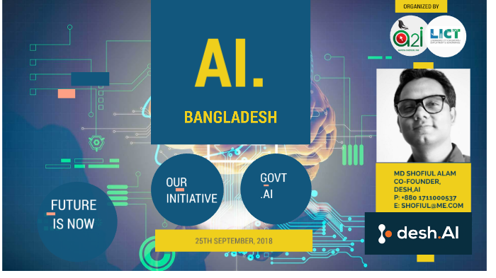
- desh.AI Industry Services:

- Public Service Delivery:
Artificial Intelligence is now changing many areas inside the private organization, yet its tremendous disruptive potential won’t stop there. Artificial Intelligence based services such as Intelligent chatbot, an interactive virtual assistant to recruit, Paperless office, Virtual Service Location Assistant, AI enabled monitoring system, Sentiment analysis tool, AI enabled training can extrude these difficulties.
- Manufacturing & Retail:
Artificial Intelligence transforms manufacturing and retail industry in its own way. Manufacturing industry like RMG sector needs so many workers to run the factories. Robotic process automation and AI-based services will be replaced in human which will reduce processing time, cost, and material waste and improve overall production, quality, and predictive measurement. Andrew Ng, the creator of deep-learning Google Brain project, says AI will perform manufacturing, quality control, shorten design time, and reduce materials waste, improve production reuse, perform predictive maintenance, and more.
- Education:
With the advancement of Artificial Intelligence, education sector is becoming more personalized and compatible for students. AI has numerous application that transforms the way of learning, student management, making class interactive, easy access to learning resources and so on. Automated rationalization of teachers, automation of administrative task, smart content, customized professional development courses, personalized learning using Adaptive learning tools, Interactive tutoring systems, and predictive tools using AI to inform pre-emptive action for students has true potential to revolutionize the world education system.
- Finance & Trade:
The computer-based digital system already shaken up finance and trading industry. Because of fraud transaction, sudden share market fall, lack of predicting the share price the future of trading belongs to Artificial Intelligence. Forecast and predictions for the stock market, chatbot for the financial institution, sentiment analysis can be worthy solutions for finance and trading industry which can lessen the share market fall, make the process easier, easy to forecast and so on.
- Smart Mobility & Transportation:
Artificial Intelligence is being used in almost every sector and every industry. Mobility and transportation sector are not lagged behind in this transformation. Moreover, AI is brought a revolutionary success in this sector having much potential.
The driverless car is the groundbreaking innovation of this century. Autonomous car, remote control cargo ship, smart track for train, digital number plate, autonomous delivery vehicle, smart highway, flight delay predictions and so on are heading to rule the mobility and transportation sector.
- Environment, Water & Renewable energy:
Climate change issue is very much alarming all over the world. The number of climate disaster is increasing day by day. AI can be game changer in environment, water and energy industry. Weather forecast and prediction, forest management, protection assistant for wildlife security can help to maintain the environment safe, stronger and manageable.

- desh.AI Industry Products:

- Aalap Chatpot
Aalap is a conversational chatbot working as a personal assistant, which can automatically conduct communication in text/voice mode through messenger, website and mobile apps etc. based on Machine Learning-Natural Language Processing.
- Retail AI
Retail AI is a set of Artificial Intelligence-based applications like facial recognition-based access control, traffic, sentiment and behavior analysis, market basket analysis and product recommendation, etc.

- City AI
City AI, a set of Artificial Intelligence and IoT based applications, can bring a sustainable city by potentially changing of systems, infrastructure and key components of a smart city. The mission of city AI is to drive economic growth and improve the quality life of people by leveraging technology.
- Smart Office
Smart Office is an automation system which can control lighting and other appliances, app for booking meeting room & desk and apps for hiring including CV sorting and skill matching etc. People leverages technology to work faster, better and flawlessly. Facial recognition-based access control and smart alarm are also part of smart office.

- Payon [Digital wallet]:
Hypertag was featured in yahoo finance as a provider of first global data deploys mobile payments and remittance technology in Bangladesh for its fintech concern PayOn.”
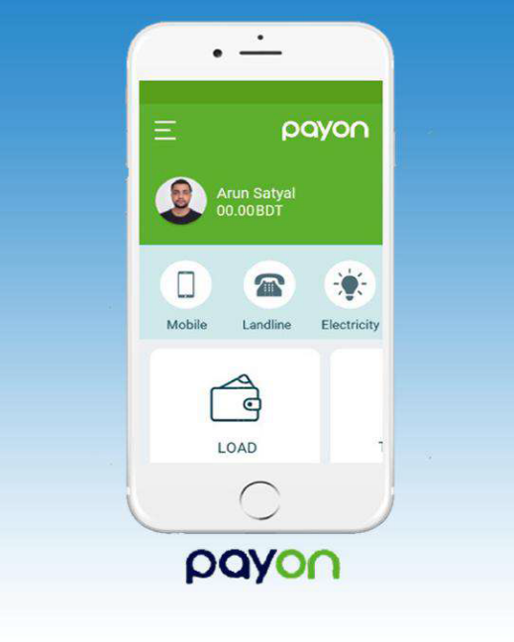

PayOn is working as a one-stop solution for digital banking services to bring the unbanked population in the digital financial ecosystem. Particularly for the customer, it is designed as one app for digital banking needs, dual-channel access, SMS cost reduction, an information hub for products and offers, and easy navigation to Branches, ATMs & Merchants. For the bank, definitely it will generate more revenue, attract merchants and promotional platform.

Mobile Banking, Internet Banking, Agent Transfer, P2P Transfer, Counter Payment, and Remittance are the core features of PayOn.

- PayON Offers
EMI Payment, Credit Card Payment, School fee payment, Remittance pick up, mobile top-up recharge and notification platform.

- PayON Admin
Features include credit scheme, credit profile, credit operation, and fee calculation and auto charging.
- PayOn Security
It has server level, application level, and network-level security.
- PayON Wallet
It can access from any areas within the country through SMS + mobile data, from abroad only through the internet, where cellular phones have reached, network works, mobile data works and SIMs are available.
- PayON Customer
Features are credit inquiry, merchant payment, top-up/recharge card, and cash advance.
- PayON Extra
Features are request, payment, fund transfer, and notification & alerts. Some additional features like merchant management with maps, promotion management center, manage blacklisted number, and credit module management, configuration & set up.

- Rockingbee:
Rockingbee is digital wings of country’s first online works marketplace belancer with 35,000 professionals. As the quality of the strategic digital campaign to bring prospects to the brand’s website, the brand can develop relationships with prospects and maintain them to the lead conversion or purchase.
Services of Rockingbee-
- Social Media
- SEO
- PPC
- Content Marketing
- Online PR
- E-Commerce
- Website
- Inbound Marketing
- Email Marketing

- HyperPOS:
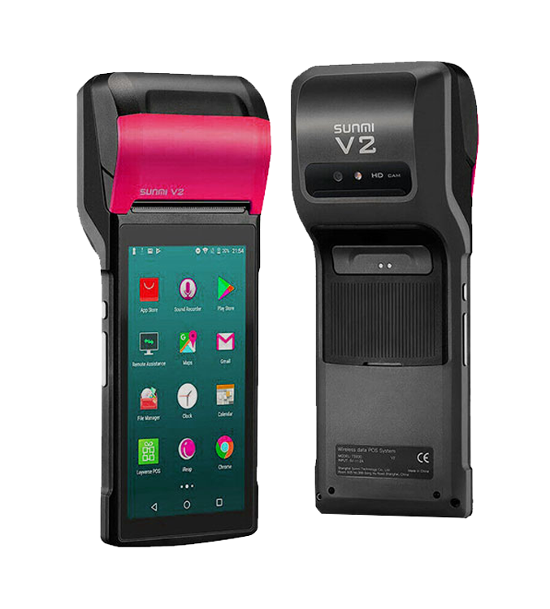
Hypertag’s the point of Sale (POS) offers total security and convenience while operating with mobility in departmental stores, supermarkets, shops, restaurants, and other merchant outlets. A global-ready POS solution environment that can be adapted to your business needs rather than vice versa, providing the features and technical capabilities needed to differentiate services, empower employees and integrate the POS with existing and new store systems while meeting demanding availability requirements. In the store, the point of sale (POS)—including in-store kiosks, self-checkout systems and traditional checkout lanes—is the heart of operations. It has to be reliable and process-optimized, and support changing customer-service requirements. Aging, rigid and uninte-grated POS solutions are roadblocks to enhanced service, higher productivity and revenue growth. But finding POS solutions that work the same way across multiple retail segments, languages, currencies and tax systems has always been challenging.

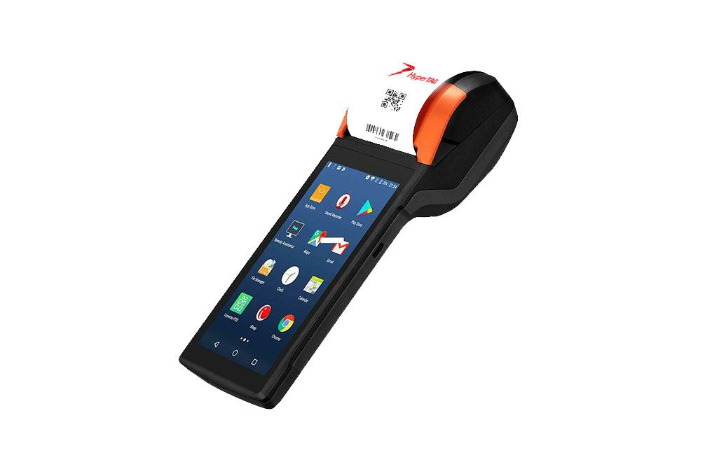
Application Areas:
- Electronic Voucher Distribution
- Money Transfers
- Medical & Healthcare
- Cash and Tax Collection
- Gaming and Lottery
- Retail & Finance

- Hypertag Services:
Hypertag Solutions Ltd. provides various services in emerging technology and IT enabled training domain. Its unique product, Belancer has built largest capacity in resource development scene in Bangladesh. It has trained 10, 000 students & professionals in employability skills with SME Foundation & LICT project. Belancer has provided job placement to 4500 trainees in different companies. Belancer Marketplace has verified 45,000 freelancers and 5, 500+ clients.
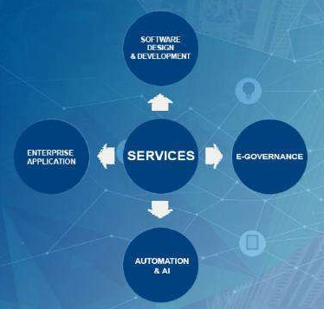

- Software Design & Development:
We provide customized software solutions for government, private and non-profit organizations. Our certified professionals are working relentlessly to provide innovative, intelligent and modern technology-based software for our clients.
- Enterprise Application:
We provide full-cycle enterprise application solutions and design services. Our goal is to be a single-entry point for any kind of web-based solution.
- E-governance:
We are serving citizens’ needs while working on government projects for more than a half decade. We are currently working with the Government of Bangladesh in different ICT Projects to achieve excellence in transforming ‘Digital Bangladesh’.
- Automation & AI:
Hypertag solutions ltd. has the expertise to transform your business into automation with the help of Artificial Intelligence (AI) technology. We build AI-based products and services to harness the cutting-edge technology in your businesses.
- Analytics & Insights:


The application produces a sea of Data and critical business insights. We help you to make sense of those data and insights scalable and flexible way for your business by using Big Data technology from your live applications’ data
- Internet of Things (IoT):


We provide integrated IoT solutions for the companies and individual customers using state-of- the-art integrated architectures, MVP development, and thorough testing services.
- Web, E-commerce & Mobile apps:
We know, how to shift our solutions to bring the result of your business growth. We use cross-platform for mobile application development. Our development team is experts in the development of both iOS and Android apps.
- Digital Marketing:
Our services will enable you with an effective value proposition of your products and services in the marketplace. We offer branding, marketing, advertisement campaign, app store optimization, SEO, social media marketing and social media analytics, etc.
- Robotic Process Automation (RPA):


We provide solution on the basis of rules and manual automation by making it a digital competency. maintaining scalability, resilience, compliance, and security. Our customers are the bank and financial institutions, investment companies, and e-commerce, etc.
- IT Strategy & Consultancy:
Hypertag offers expert, affordable IT consulting services to help you achieve your short- and long-term IT objectives. We pride ourselves in offering managed IT services to organizations of any size. We’re ready to serve in Special projects with the custom-tailored solutions your business needs.

- Cloud Infrastructure:

Hypertag solutions Ltd. offers end-to-end services for your cloud environment. We help you to transform your existing infrastructure of applications and data to the cloud.
- Business Process Outsourcing:
We offer outsourcing services, BPO services, online data entry, market research, form filling, and virtual assistant for our clients.
- Training & Development:
We are one of the leading training providers in Bangladesh. We are experts in skill development training. Our large portfolio covers different government and private organizations.
- Smart City:


Smart city services provide the mainstream ways to meet the challenges of public service, transportation and mobility, safety and security and basic citizen rights – while promoting sustainability. We make the process faster and easier to deploy these powerful tools by offering end-to-end applications.
- Electronics Payment:


We are on your wavelength experienced in bringing m-payments to the market. Our Mobile Payments Consulting teams are backed by deep industry expertise with strong m-payment operational heritage.

Price:

Hypertag provides Various IT services to its customers. Some of its course prices are listed below-
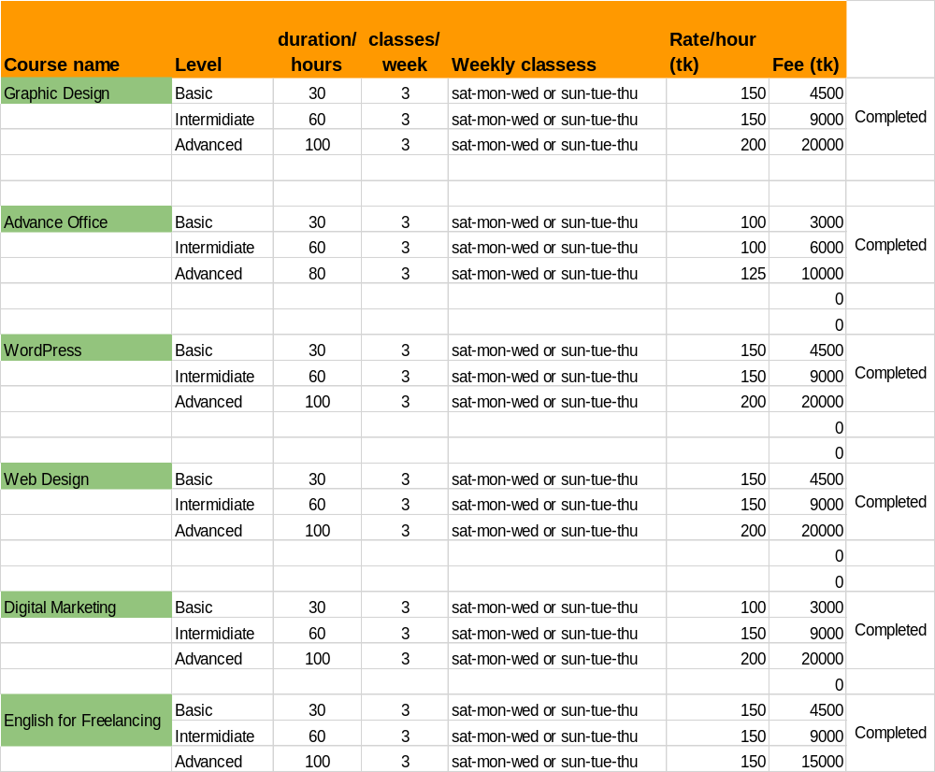

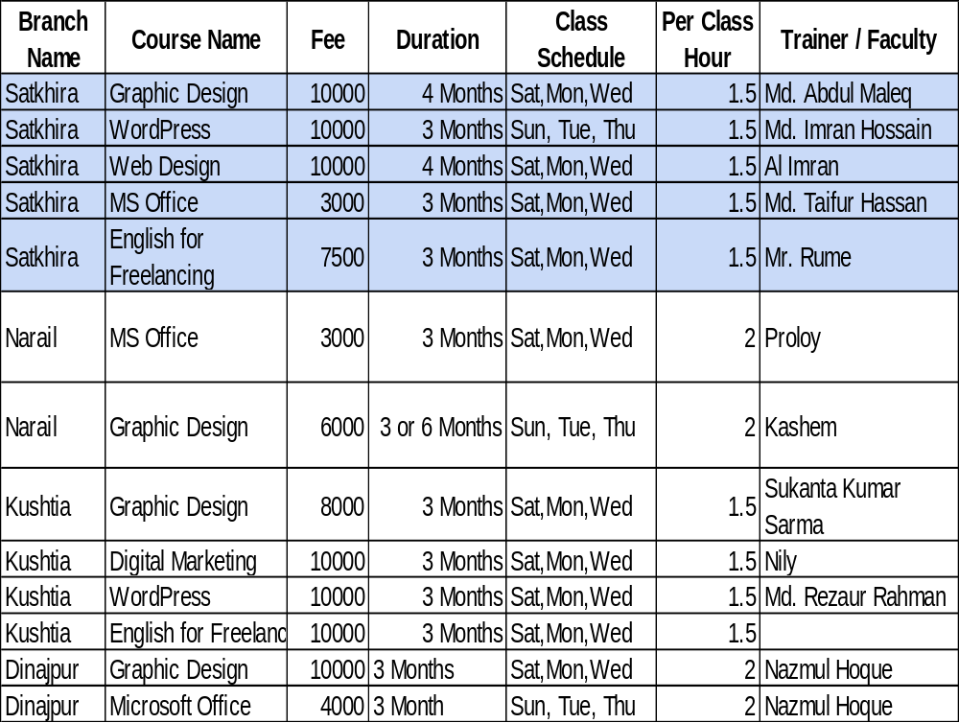

Sl. No | Center name | Address | Graphics |  | Digital Marketing |  | English
01. | Project Headway | A-12, Majid Sarani  Sonadanga, Khulna  Cell: 01777702862 | Fees (TK) | Duration | Fees (TK) | Duration | Fees (TK) | Duration
01. | Project Headway | A-12, Majid Sarani  Sonadanga, Khulna  Cell: 01777702862 | - | - | - | - | 8,000.00 | 3months
02. | UROSD | 46 KDA Avenue  Shibbari, Khulna  T:041-720323 | 10,000.00 | 3months | 10,000.00 | 3months | - | -
03 | SUNSABIL | H#38, R# 11  Khalishpur, Khulna  Cell: 01714938918 | 4,000.00 | 3months | - | - | - | -
04. | Computer Palace | Khulna Polytechnic College More  Khalishpur, Khulna.  Cell:01790013538 | 6,000.00 | 3months | - | - | - | -
05. | Bay coders | Khanjahan Ali Road  Khulna.  Cell: 01790013538 | 9,000.00 | 3months | - | - | - | -



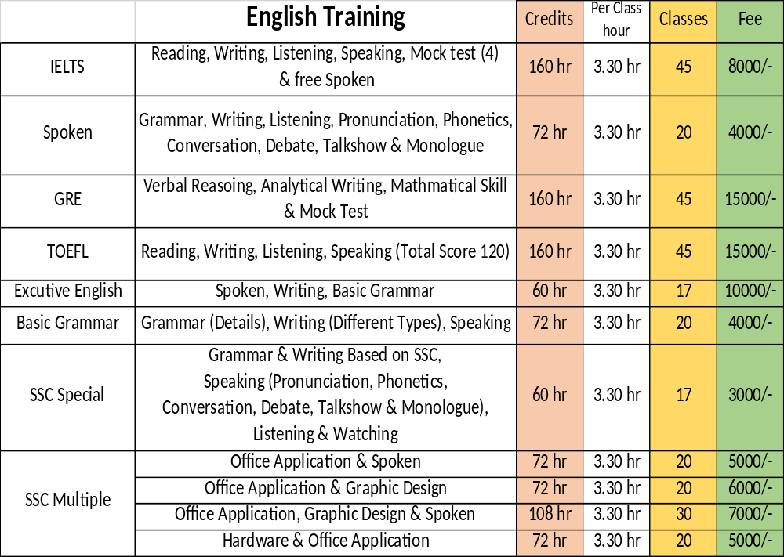

Place:

The third P in the marketing mix is the place where your product or service is actually sold. Develop the habit of reviewing and reflecting upon the exact location where the customer meets the salesperson. Sometimes a change in place can lead to a rapid increase in sales. For services, place refers to the ease of access that customers have to a service. It also involves determining which intermediaries or affiliates to use to help you sell the service for example ITservices.com
Hypertag has its Head Office in Chandrashila Suvastu Tower, 69/1 Panthapath, Dhaka 1215. Bangladesh and global offshore office in Washington DC, USA.As Dhaka is the capital of Bangladesh so it is easy for Hypertag company to carry out their business strategy all around the city. It has 25 branches all over the Bangladesh. In Dhaka city there are many companies who require IT services. Hypertag tries to provide services to all these companies as required.
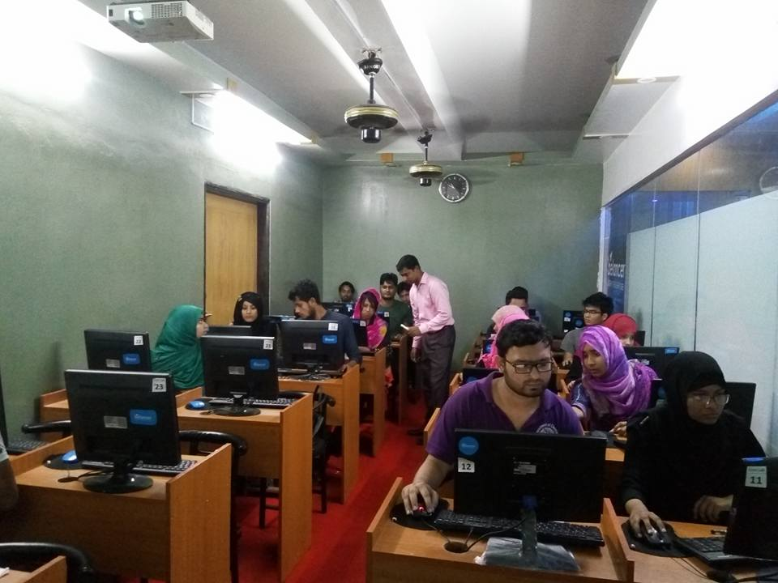
Hypertag has many branches in different cities of Bangladesh. According to the need of students who want to learn IT courses Hypertag has established different branches in Cumilla, Sylhet, Mymensingh, Kushtia, Gaibandha, Khulna, Rajshahi, Chittagong, Rangpur, Kurigram, Lalmonirhaat etc. Based on the students Hypertag provides IT course services to its customers in different cities of Bangladesh. The main operation is run from the Dhaka branch.
- Dhaka Branch of Hypertag
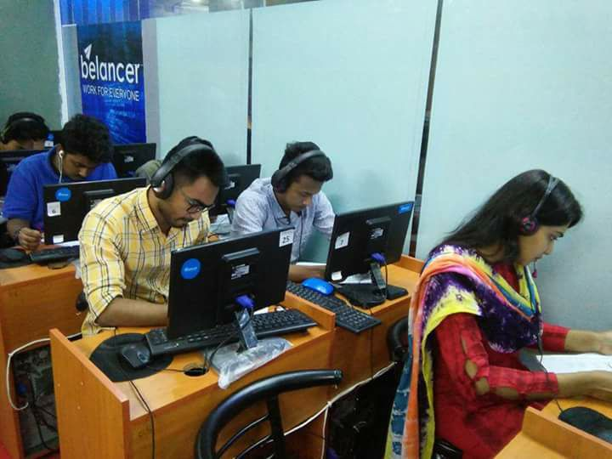
- Cumilla Branch

- Sylhet Branch
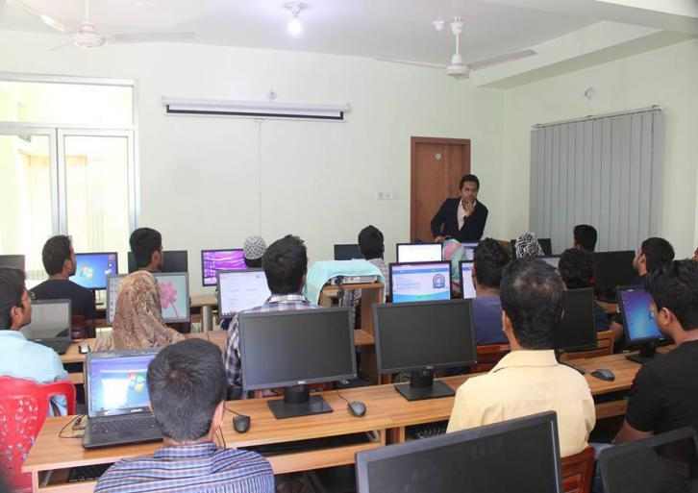
- Dinajpur Branch

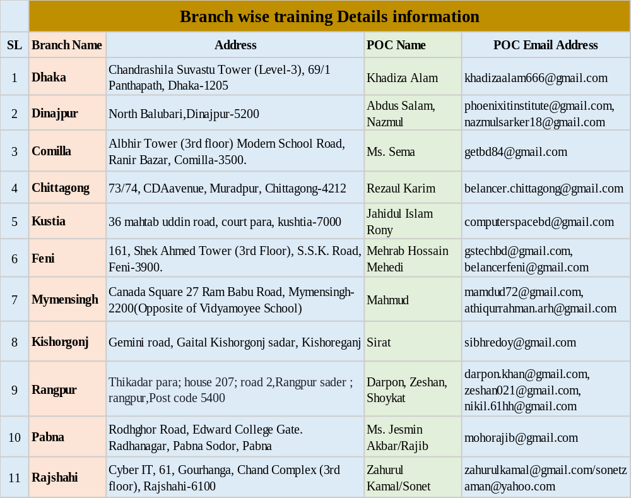
Some of their branch addresses are given below-

Promotion:

Promotion refers to the different ways you communicate, describe, and advertise your product or service. Hypertag uses following measures to promote their services-
- Celebrity Endorsement: Hypertag’s CEO and founder Md Shofiul Alam is a public figure which helped him to combine his image in this business. He has attended many businesses talk show, business programs on TV, Radio and other medias. His image and fame make him to promote his business more smoothly. Some of his pictures of attending shows are given below-
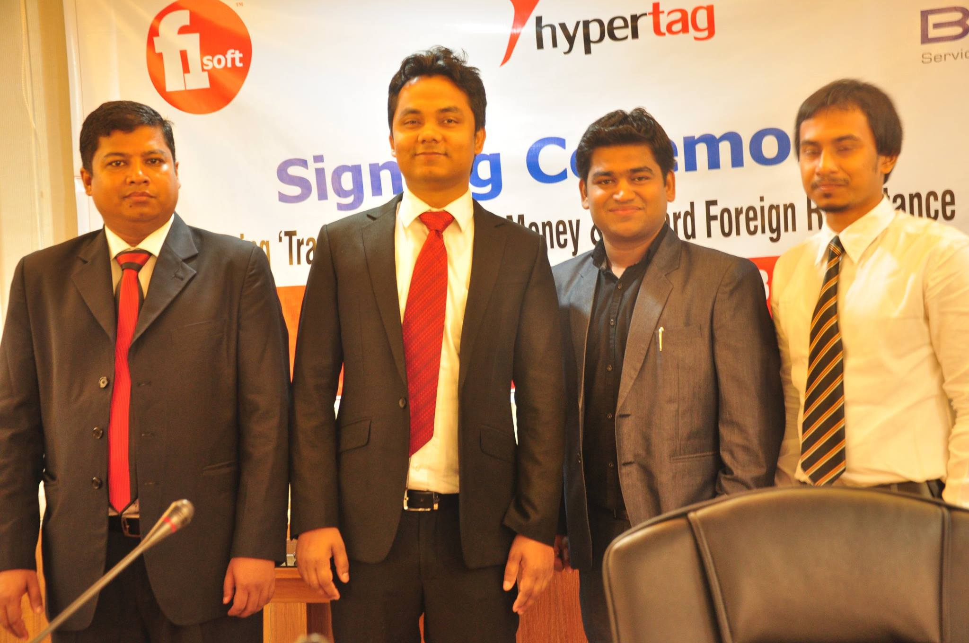

- “CEO Shofiul Alam with other entrepreneurs at F1 soft program”
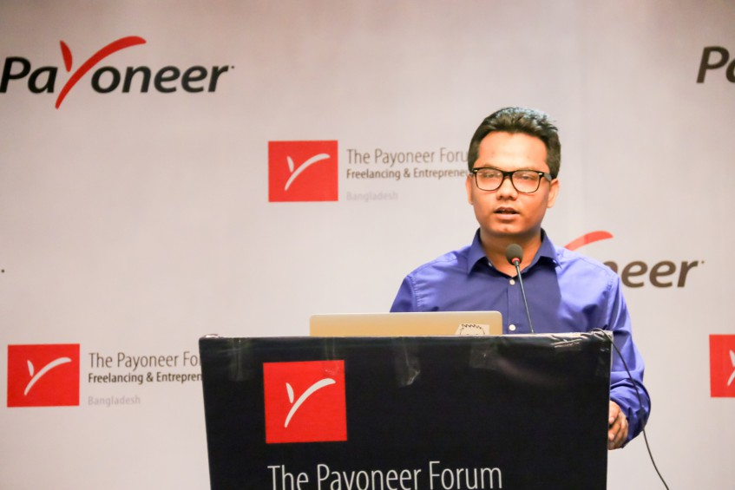

- “Md Shofiul Alam giving speech at the Pioneer Forum Program”
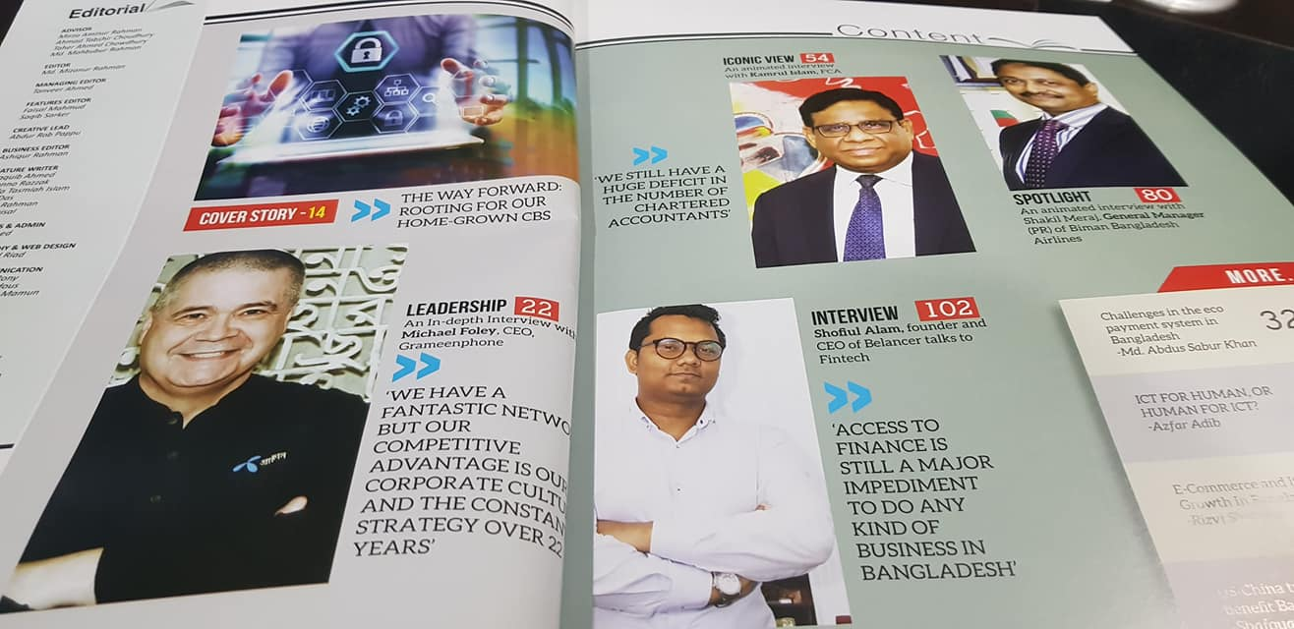
- “CEO Md Shofiul Alam’s Interview in a business Magazine”
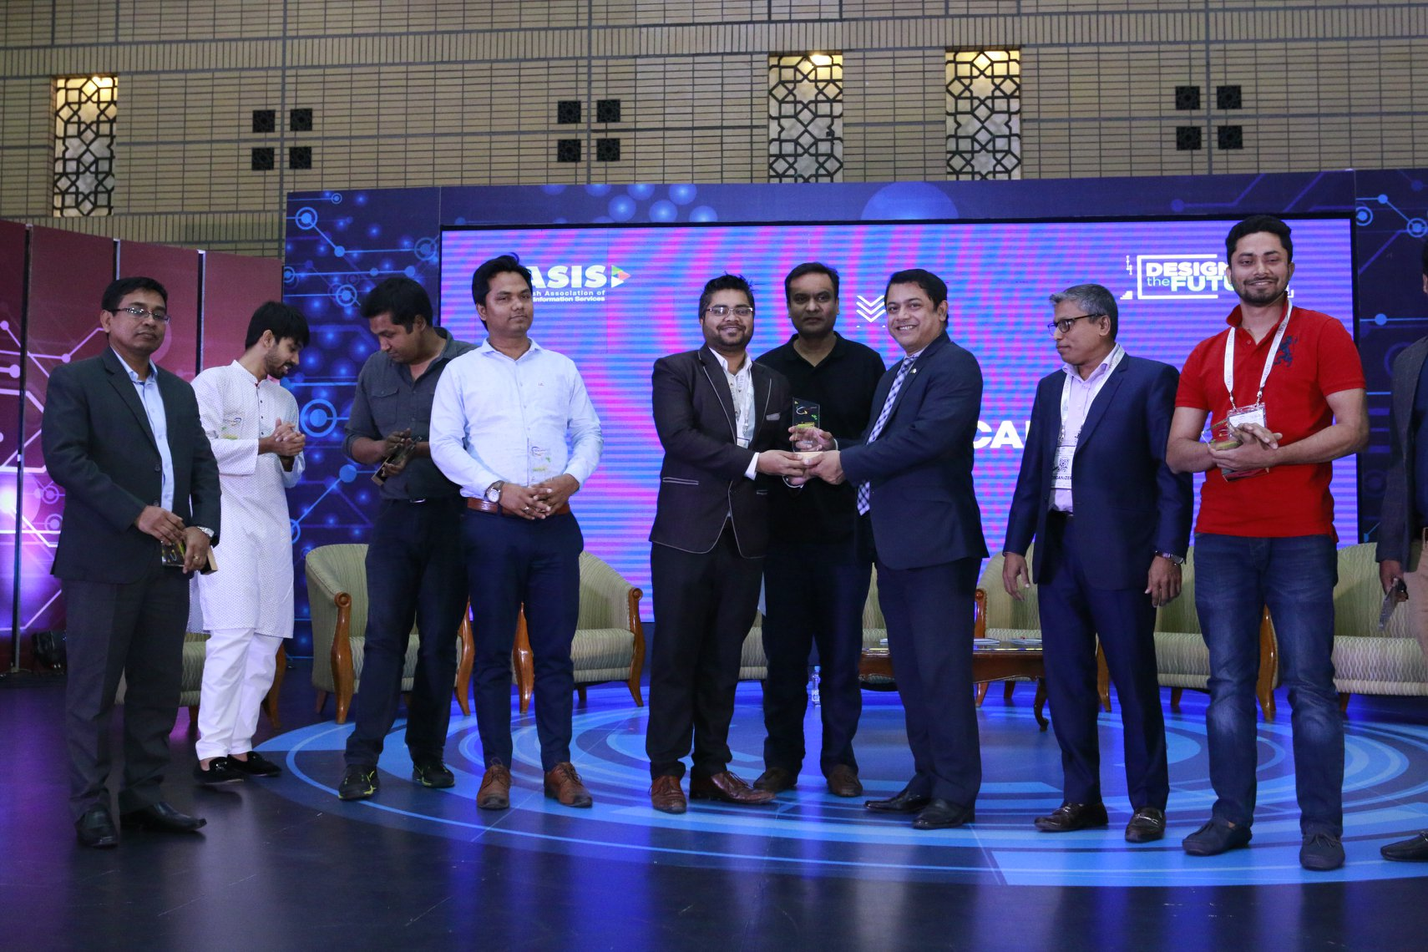
- “Hypertag CEO at the BASIS “Design for the future” Competition”

- Testimonials: Testimonials are an extremely important part of the success of your business. On your relationship-building journey, which is lined with credibility and expertise, testimonials from loyal customers are a critical part of the presence of your business. They also strengthen your reputation by expressing the trust that other people have in you and your business offerings. They are a wonderful tool that helps you to attract a deeper interest from perspective clients and existing clients and will ultimately make you and your business increasingly more successful.



- Branding: Bangladesh Govt has taken ground breaking initiative to Development of National Strategy for Artificial Intelligence of Bangladesh. Hypertag Solutions Ltd and it’s AI arm desh.AI has awarded govt contract to development of National Strategy for Artificial Intelligence of Bangladesh. In case of branding Hypertag team has always been very active. Hypertag Managing Director Md Shofiul Alam has attended many ICT related programs and also promoted his own company. He has been a part of the following programs-
- Youth Leadership talk (YLT 2020)
- Freelancers Meet (December 8,2015)
- United Nations HULT prize ceremony at Daffodil International University (2019)
- Freelancers Conference (12th December,2016)
- Startup Fest at Daffodil International University (2016)
- ACM ICPC Program (2015)

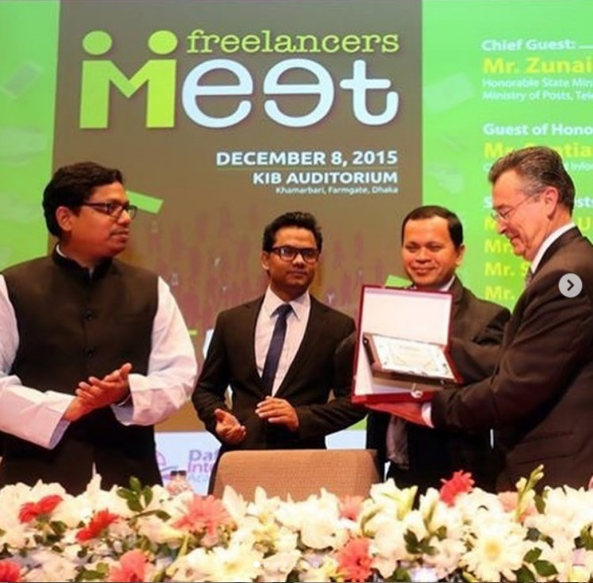
- “Freelancers Meet (8th December ,2015)”

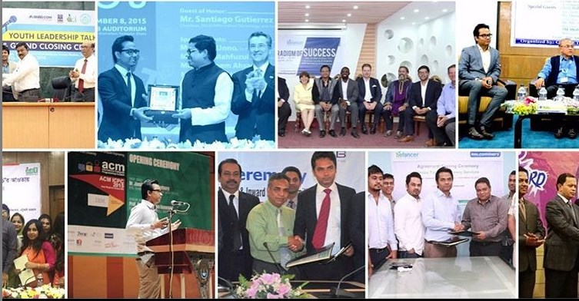
- “Youth Leadership Talk (YLT 2020)”
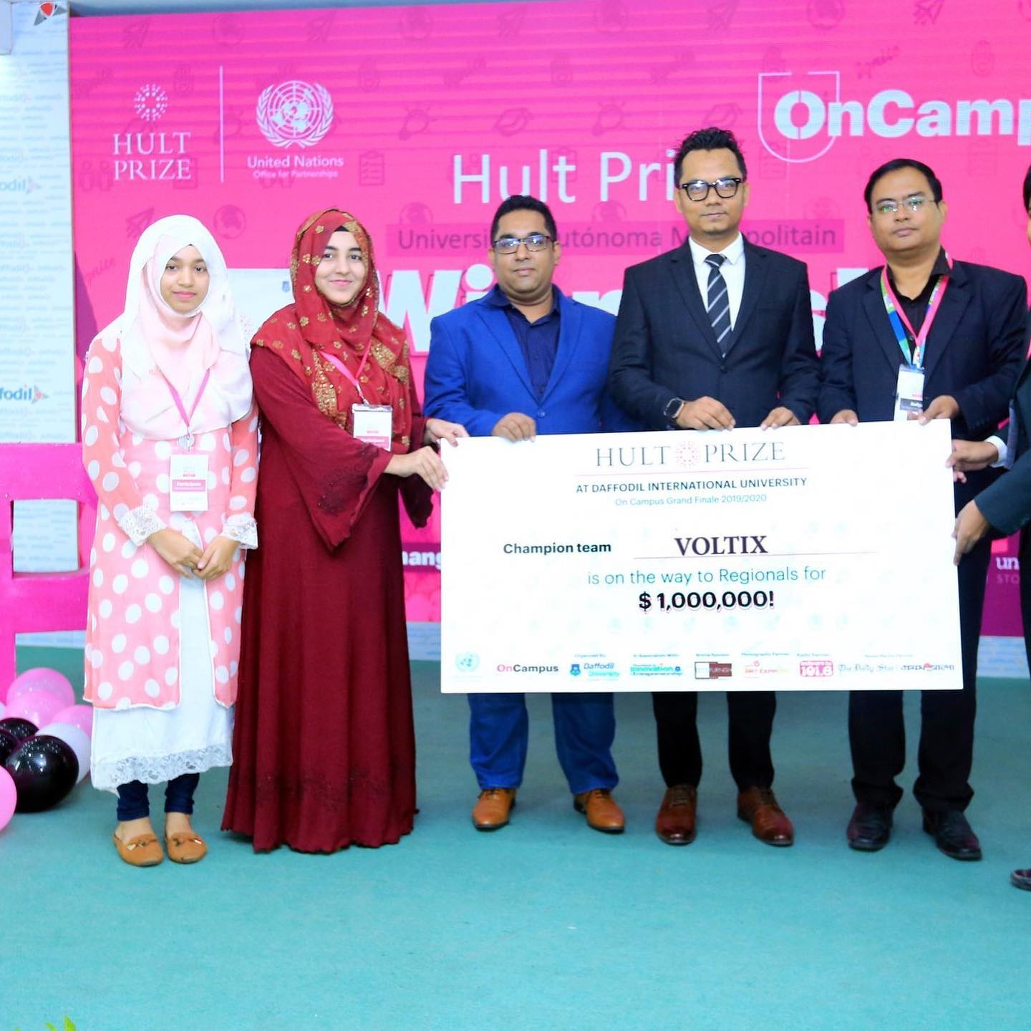
- “United Nations HULT prize ceremony at Daffodil International University (2019)”
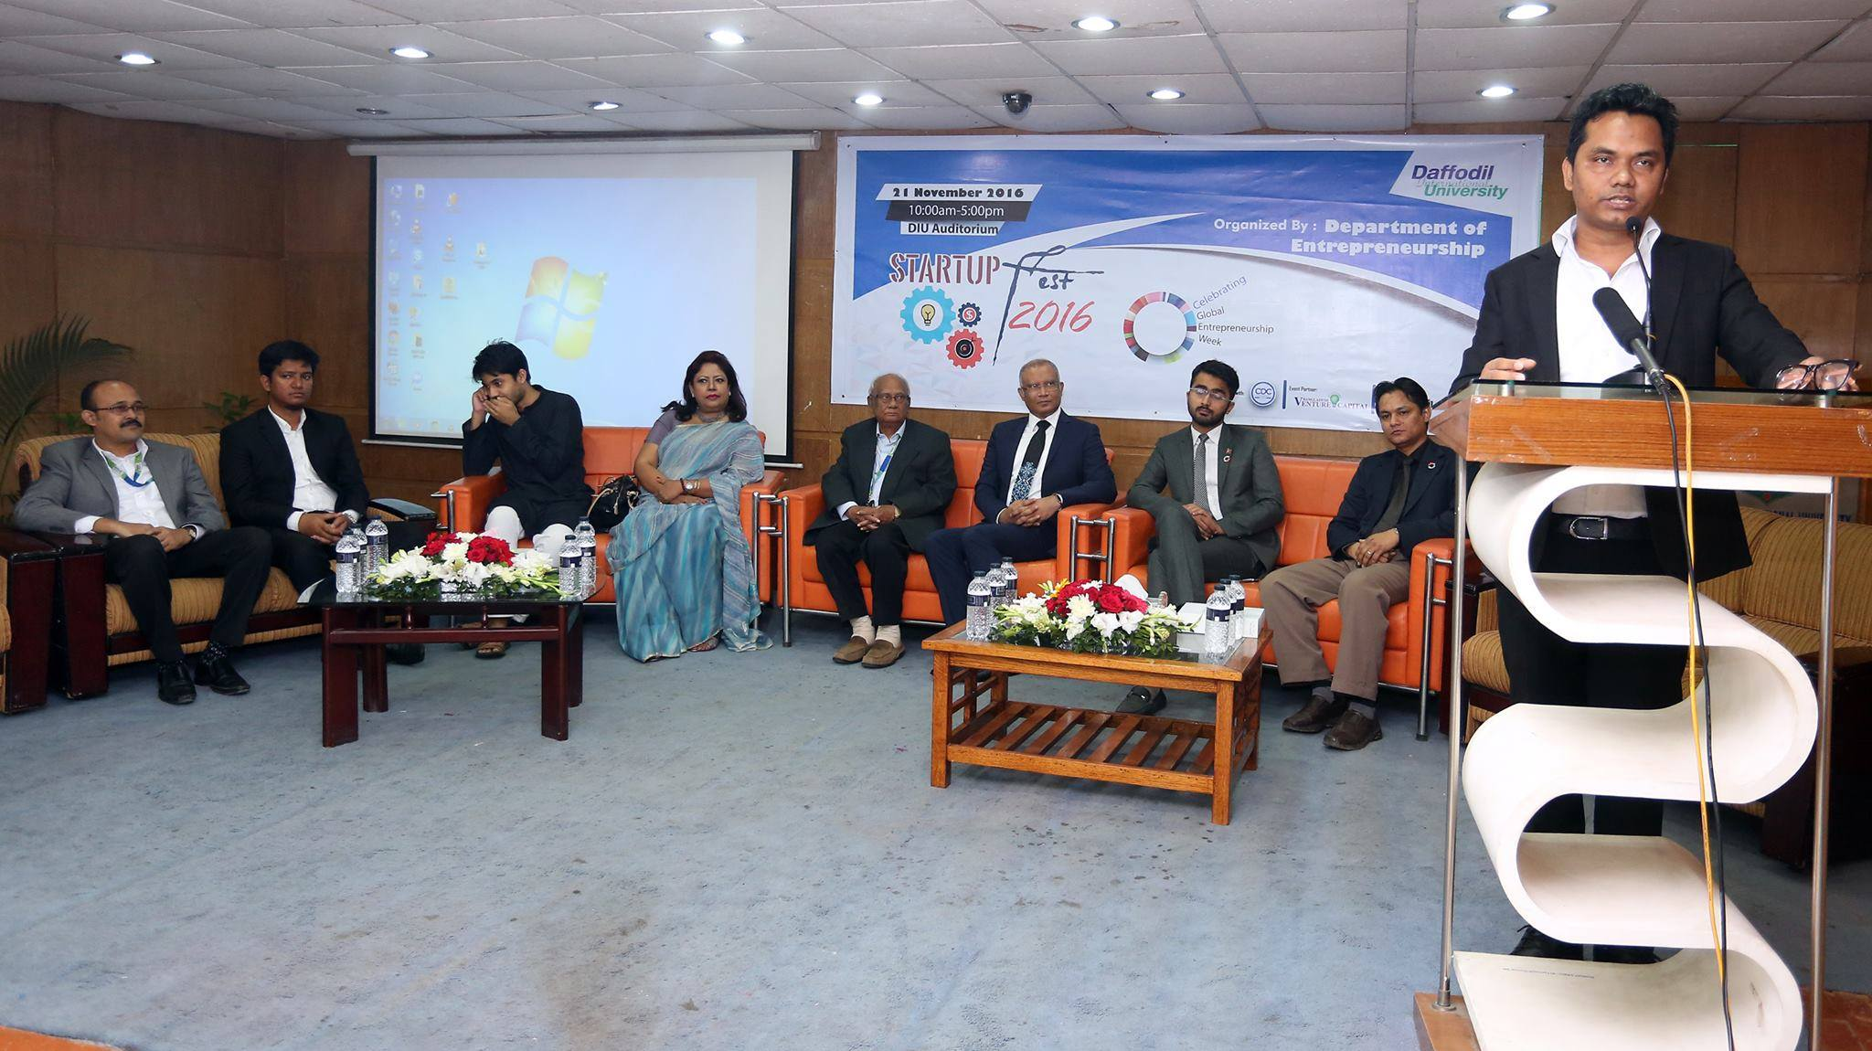
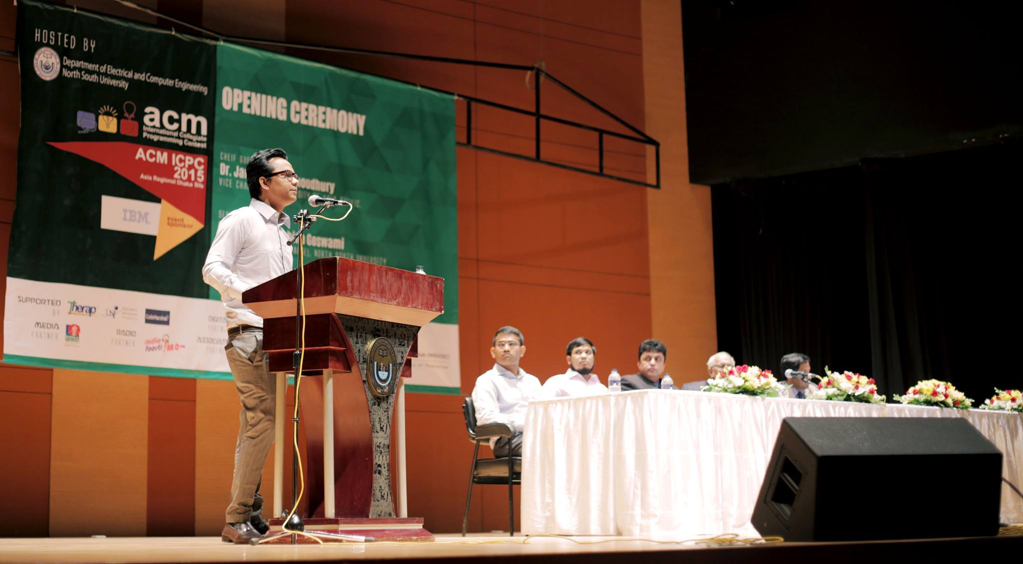
- “Startup Fest at Daffodil International University (2016)”
- “ACM ICPC Program (2015)”

For promotional branding Hypertag also has –
- Signed agreement with Bangladesh Post Office to facilitate remittance in 10k+ branches and make a one-stop service point.
- Launched the first e-Traffic Solution with DMP.
- Signed agreement with Channel24 to provide MVAS.
- Start Operation in Nepal to provide Fone bank service.
- Signed Agreement with Bangladesh Commerce Bank for Transborder Remittance and MFS.
- Signed Agreement with VISA, Master, Amex, and other banks for PayON payment Gateway.
- Launched e-Ticket with BPL.
- Features in global media for Mobile Remittance in WSJ, Yahoo, MSN Money, etc.

People:

By people, we mean those people who are directly or indirectly involved in the delivery of the service. This typically means employees of the company. But it can also mean subcontractors with direct interaction with customers. It can even refer to existing and past customers of the company. These customers represent the company through word of mouth. People are a very important factor in the 7 P’s because services tend to be produced and consumed at the same time. Because of this, the behavior of these people is very important in determining the experience of the customer. All service businesses should ensure that staff are well trained and motivated. But there is another way to adjust the people tactic. This can be done by adjusting customer experience to meet the needs of individual customers.
People of Hypertag company are those who are externally and internally related with this company.
- It has trained 10, 000 students & professionals in employability skills with SME Foundation & LICT project.
- 4500 trainees are provided job placement in different companies.
- Belancer Marketplace has verified 45,000 freelancers and 5, 500+ clients.
- Belancer has 45,000 Freelancers, 5,500 Clients, posted “$2.5m equivalent project in 3 years.
- It has more than 5000+ clients with marketplace Belancer and many more.
- Hypertag Solutions Ltd., with over 100 learning and development specialists and their domain expertise in 10+ industry verticals, has trained more than 0.5 million people locally in Bangladesh.
- Partner & Clients of Hypertag:
Customers and partners of Hypertag Solutions Ltd are what matters the most. Cooperating with Apollogic, our contractors are guaranteed the highest quality and complete satisfaction with implemented solutions. This has been confirmed by numerous successful IT projects through which our customers perceive Apollogic as a trustworthy business partner. We’ve more than 5000+ clients with marketplace Belancer and many more.
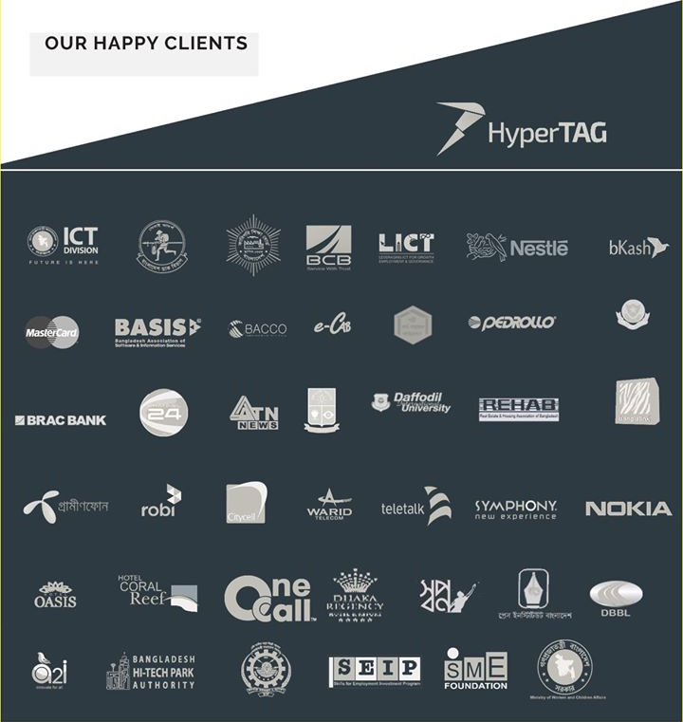

Physical Evidence:

Services are intangible. Despite this, their delivery often involves tangible elements. Physical evidence is defined as both:
- The environment or place where the service is delivered.
- Any tangible elements that facilitate the service or provide information about the service.
Based on this definition, physical evidence of Hypertag Solutions Ltd includes such things as:

Physical Evidence: | Particulars
The company’s website: | info@hypertagsolutions.com  www.hypertagsolutions.com
Business cards: | 
Company Logo: | 

- Brochure of Hypertag:
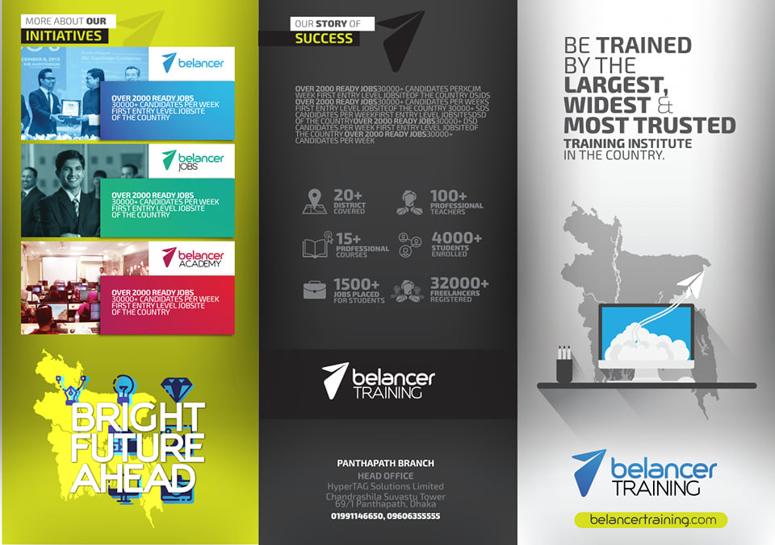

- Lab and Office view of Hypertag:
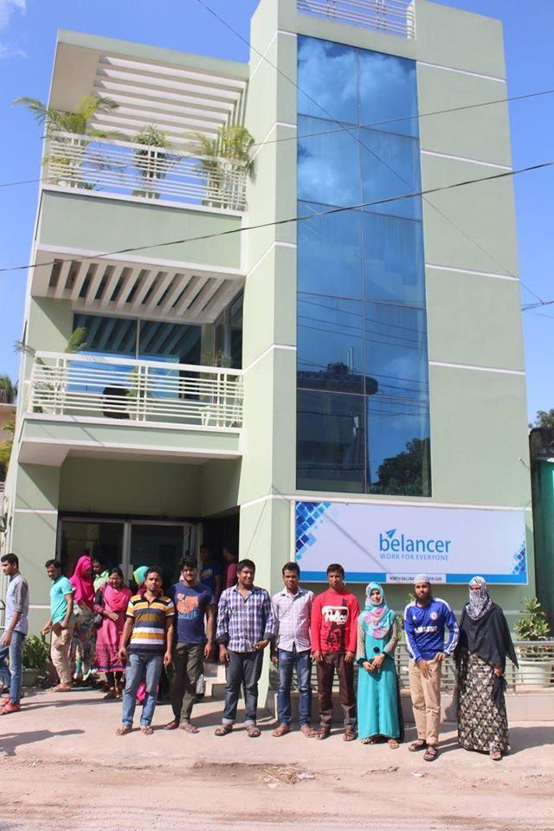
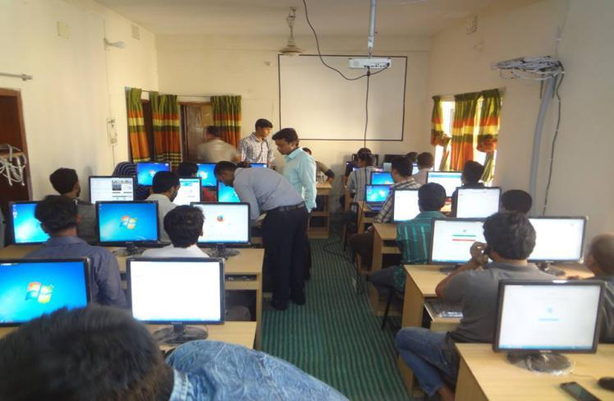
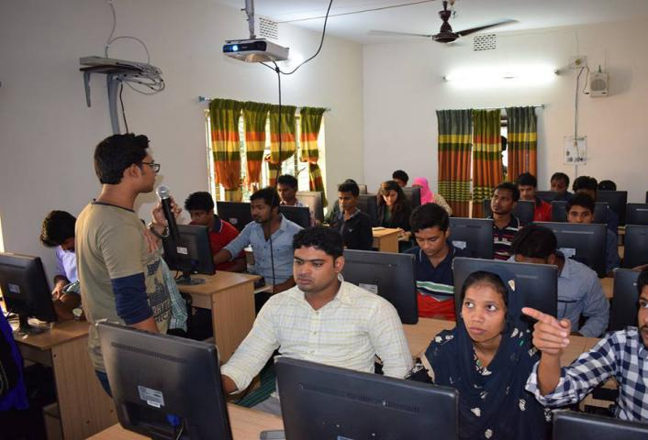

- Equipment: The major Equipment that are used by Hypertag company are-
- Database Server: A database server is a server which uses a database application that provides database services to other computer programs or to computers, as defined by the client–server model. Database management systems (DBMSs) frequently provide database-server functionality, and some database management systems (such as MySQL) rely exclusively on the client–server model for database access.
- Application Server: An application server is a server specifically designed to run applications. The "server" includes both the hardware and software that provide an environment for programs to run. Application servers are used for many purposes. Several examples are listed below:
- Running web applications
- Hosting a hypervisor that manages virtual machines
- Distributing and monitoring software updates
- Processing data sent from another server

- Web/mail Server: A web server is a computer that runs websites. It's a computer program that distributes web pages as they are requisitioned. The basic objective of the web server is to store, process and deliver web pages to the users. This intercommunication is done using Hypertext Transfer Protocol (HTTP).
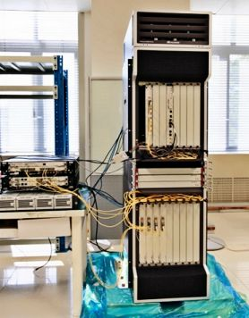
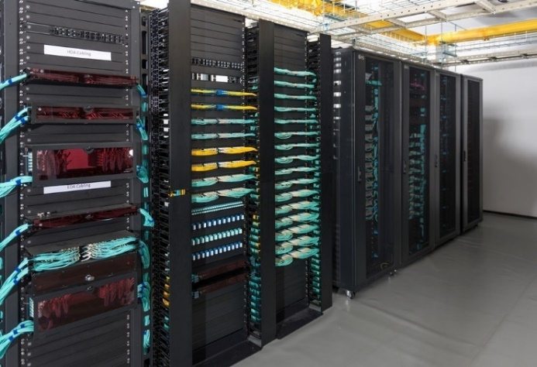
- Server Rack: A server rack is a structure that is designed specifically to house technical equipment including routers, switches, hubs, and of course, servers. The rack makes it possible to securely hold multiple pieces of equipment in one area. Server racks are typically going to be used by businesses and kept either in data centers or communications closets.
- Core Router: A core router is a router that forwards packets to computer hosts within a network (but not between networks). A core router is sometimes contrasted with an edge router, which routes packets between a self-contained network and other outside networks along a network backbone.
- Customized Software: Custom software – is the solution that is specially developed for a specific user or organization, which is in contrast with broadly used mass-market software.

Process:

Process refers to the procedures, mechanisms, and flow of activities that occur when the customer and the business interact with each other. All of these processes need to be tightly controlled to ensure consistent customer experience. They are usually defined in written Standard Operating Procedure documents (SOPs).
Basically, IT companies can be widely divided into two categories that includes service based (TCS, Wipro, HCL etc.) and product based (Google, Zoho and many more startups)
Hypertag serves the other companies so the work might include maintenance of a website, application support, billing etc.

- The Three Major Functions of Hypertag:
Governance refers to the implementation of operational parameters for working units and individuals' use of IT systems, architecture, and networks. The governance of the master data is based on workflow processes that integrate business rules and subject matter domain expertise. This is part of the conventional IT security as well as the data assurance for which the IT department is also responsible.
Infrastructure refers to the hardware components, the network, the circuitry, and all other equipment necessary to make an IT system function according to the established needs and system "size" of the company.
Functionality is perhaps the most apparent task performed by the IT department. It refers to creating and maintaining operational applications; developing, securing, and storing electronic data that belongs to the organization; and assisting in the use of software and data management to all functional areas of the organization.

SWOT analysis of Hypertag Solution Limited:

By analyzing the performance of the Hypertag, I got the following Strengths, weakness, Opportunities and Threats (SWOT).

Strengths:

- Not engaged in unfair business practice.
- Executives are highly educated and experienced.
- Hypertag has many high-profile clients like – Nokia, Nestle, GP, Robi, Bkash, ACI LTD, BASIS etc.
- Efficient management practice in the Hypertag
- Good relation with the ICT ministry.

Weaknesses:

- The promotional (advertising, posturing and bill board) activities are not up to that mark compared to other company.
- Hypertag – IT solution firm doesn’t have enough transport facilities. So, the marketing Employees face some difficulties.
- Hypertag– IT solution firm has insufficient number of workers. Some IT operators and marketing employee are needed to maintain their work properly.
- Social media involvement is very low which could be a great platform for them to promote their services.

Opportunities:

- It can increase the online services to attract more customers who require IT services.
- Hypertag can contribute more in the economic development of our country as it has a great political involvement.
- By doing social welfare activities it can become one of the best-known IT companies in Bangladesh.

Threats:

- Intense competition in IT industry.
- Government strict rules and regulation.
- Competitors Advanced technology.
- Lack of skilled employees & high turnover rate of trained employees.

Chapter-5 Featured Projects of Hypertag

Project -1:


We have provided total software solutions, mobile apps, data center and training for the Directorate of Technical Education (DTE), BTEB and BMET. Software solutions includes 75+ module on each dept, I,e User Management with Role-Based Access Control, Recruitment Information, Human Resource Management, Leave and Attendance Information, Payroll Information System, Gratuity Information System, Provident Fund Management, Training Information System, Pension Information System, Financial Management System, External Payment System, Service Management System, Procurement And Inventory Management System, Immigration Management System, Work Flow/Approval Flow Management, Vehicle Management System, Digital Signature Management and Audit Trail & Log System.

Particulars | Details
- Project Name: | Software automation, mobile apps, implement data Centre & training for directorate of technical education.
- Client Name: | BTEB, DTE, BMET, REPUBLIC OF BANGLADESH
- Date: | 01/09/2015 – 01/10/2018
- Location: | Dhaka, Bangladesh.

Project -2:

We have developed an AI-based consumer traffic & behavior analysis tool for their superstore ‘SHWAPNO’. The tool includes Face Recognition, Time Tracking, Infrared Sensor, Gender & Age, Object Analysis, Multicamera Tracking, GPS Location Tracking, Movement Analysis, Sentiment Analysis, Behavior Analysis, and Predictive Analysis. We have developed, tested and operated this solution. Gradually this system will be implemented in there all the outlets.
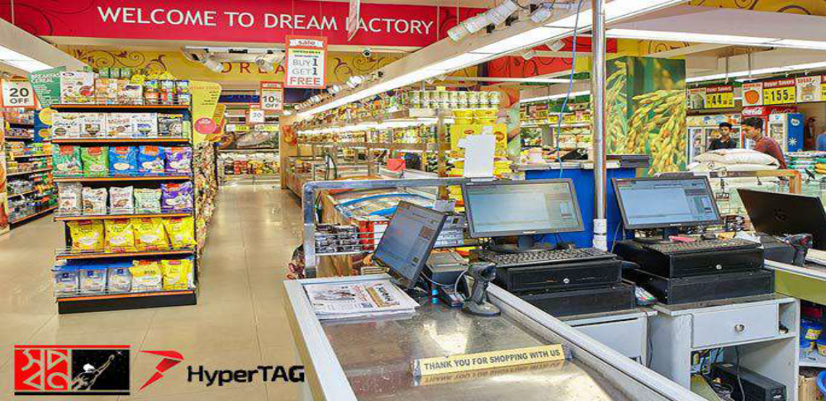
Particulars | Details
- Project Name: | Artificial Intelligence (AI) based Consumer Traffic & Behavior Analysis Tool
- Client Name: | SHWAPNO, ACI LOGICTICS LTD.
- Date: | 10/01/2019 - 01/08/2019
- Location: | Dhaka, Bangladesh.

Project -3:

LICT project is the flagship IT & ITES training project funded by World Bank and implemented by ICT Division and Ernst & Young, India. Hypertag Solutions Ltd has closely worked and implemented with EY in Foundation and TopUp training. Hypertag aimed to train 10,000 and placement of its 60% trainee. As of now, we’ve completed 6000+ training successfully in different trending trades i.e. BigData, AI, GD, Digital Marketing, Java, PHP, .NET, Mobile Apps Developer and so on. Belancer has worked on placement whereas 4500+ trainees already placed in different companies in Bangladesh and freelancing marketplace.

Particulars | Details
- Project Name: | Leveraging ICT for Growth, Employment  and Governance (LICT)
- Client Name: | ICT Division, Ernst & Young LLP, India
- Date: | 01/01/2016 - 01/02/2019
- Location: | Dhaka, Bangladesh.

Chapter-6 Recommendations & Conclusion

Recommendation:

There is always room for improvement in both individuals and companies alike. Even the most successful companies strive to be better, because when you become complacent is when you start to fail. Being better means always looking for ways to innovate. This applies to both within the company and without. Your company culture is just as important as staying relevant and valuable to your customers. While working in Hypertag as an intern I found out that it needs to focus on certain issues to overcome their shortcomings. Here are five suggestions on how Hypertag can improve its performance:
- Improve Employee Teamwork and Company Culture:
When you’re looking to improve, you should start first within your company. Improving how things work and how proficiently processes are done is the first thing you should look at when you want to improve your company’s performance. When employees enjoy the workspace, feel safe, and work together well, their value to the company increases. Good teamwork and a great company culture are how Hypertag can hire the best and keep them. The better your employees, the better your company will perform.
- Improve Documentation Processes:
Hypertag needs to keep records. These records are important for audits, they’re important to help employees deal with customer complaints, and they’re important for self-evaluation. Use a pay stub generator to keep better records of payment, and have metadata standards. This means creating better receipts and records of transactions and saving them in a uniform manner. Training the employees on how to create and store records will help for many different reasons, and being able to access records quickly and easily will improve the overall performance of Hypertag.
- Market More Effectively:
Instead of marketing to the public, Hypertag’s focus efforts should be on their target demographic. This means that they can get the same feedback as they did before for less, or get greater feedback for the same budget. When you market more effectively, it means that your efforts pay off, and your company’s sales increase.

- Always Focus on How You Can Provide More Value:
You get loyal customers when you consistently provide them with more value. This means always focusing on customer service and what services you can implement that will make their experience better. Hypertag can increase its performance by focusing on how it can provide better value. Hypertag should not get left behind by their competitors – It must be the leader.

Conclusion:

Working in Hypertag has been a great experience for me. I learnt a great deal from there and also captured some knowledge. I have been able to develop my punctuality and computer skill. I hope I will be able to do better in the future and also build a good career in the Information and Communication Technology (ICT) sector. At present ICT sector are growing fast in Bangladesh due to the development of the country. Now people highly rely on the online marketing which was not that much attractive few years ago in Bangladesh. Hypertag follows strong ethical guidelines to satisfy their clients requirement. Hypertag has a vision of becoming number one software company in the ICT of the country. Hypertag has a very small team compared to other companies but what Hypertag has are professional developers. If Hypertag wants to grab opportunities more, then it needs to expand its team as well as focus on marketing activities more & more and have to make such policy that developers stay at the organization at least 3 years. It needs to attract more talents by taking freshers. Following the recommendations above I believe both Hypertag as well as I can develop ourselves to achieve our dreams and visions. Software companies have been performing almost same as the ICT industry but it has greater opportunities by following the recommendations, they can perform much better than previous.

Chapter 7: References

70 Examples of Impactful Company Core Values. (2020). Retrieved 22 May 2020, from https://builtin.com/company-culture/company-core-values-examples
(2020). Retrieved 22 May 2020, from https://study.com/academy/lesson/what-are-core-values-of-a-company-definition-examples-quiz.html
ABOUT US. (n.d.). Retrieved May 22, 2020, from Magnito Digital website: http://magnitodigital.com/about/
Application Server Definition. (n.d.). Retrieved from techterms.com website: https://techterms.com/definition/application_server
CBN. (2017, September 28). Five Ways You Can Improve Your Company’s Performance Today - Cascade Business News. Retrieved from Cascade Business News website: http://cascadebusnews.com/five-ways-can-improve-companys-performance-today/
Company Culture: Definition, Benefits and Strategies | Built In. (n.d.). Retrieved from builtin.com website: https://builtin.com/company-culture
Custom Software Definition and Example | Existek Blog. (2017, August 29). Retrieved May 22, 2020, from https://existek.com/blog/custom-software-definition/
Database server. (2020, January 21). Retrieved May 22, 2020, from Wikipedia website: https://en.wikipedia.org/wiki/Database_server
DataSoftAbout DataSoft. (n.d.). Retrieved May 22, 2020, from datasoft-bd.com website: http://datasoft-bd.com/about-datasoft/
Denis. (2018, March 6). Services Marketing Mix: The 7 P’s of Marketing. Retrieved from Expert Program Management website: https://expertprogrammanagement.com/2018/03/services-marketing-mix-7-ps/
hypertag. (n.d.-a). PRODUCTS. Retrieved May 22, 2020, from HyperTAG website: https://hypertagsolutions.com/products/
hypertag. (n.d.-b). SERVICES. Retrieved May 22, 2020, from HyperTAG website: https://hypertagsolutions.com/services/
Hypertag Solutions Ltd | BITM Training. (n.d.). Retrieved May 22, 2020, from bitm.org.bd website: http://bitm.org.bd/institute-details/39/hypertag-solutions-ltd
leadsbd. (2019). LEADS Corporation Limited. Retrieved from Leads.com.bd website: https://www.leads.com.bd/
PROVIDE SKILL AND EMPLOYMENT SERVICE. (n.d.). Retrieved from https://hypertagsolutions.com/wp-content/uploads/2020/02/Company-Profile-HyperTAG-Feb-2020-Final.pdf
Sadaf, F. (2018). Internship Report on Bangladesh ICT Sector and Nascenia IT Limited. Dspace.Uiu.Ac.Bd. Retrieved from http://dspace.uiu.ac.bd/handle/52243/645
Southtech Group. (2020). Retrieved 22 May 2020, from https://www.linkedin.com/company/southtechgroup
The Importance of Testimonials for Your Business. (2010, September 28). Retrieved May 22, 2020, from https://www.compukol.com/the-importance-of-testimonials-for-your-business/
The IT Department: What They Do Vs. What Everyone Thinks They Do. (2019). Retrieved from Jobs.net website: http://www.jobs.net/article/cb-214-talent-network-it-the-it-department-what-they-do-vs-what-everyone-thinks-they-do/
Tiger IT Bangladesh Ltd. | Devex. (n.d.). Retrieved May 22, 2020, from www.devex.com website: https://www.devex.com/organizations/tiger-it-bangladesh-ltd-56045
Tracy, B. (2019). The 7 Ps of Marketing. Retrieved from Entrepreneur website: https://www.entrepreneur.com/article/70824
What is a Server Rack? (2018, November 12). Retrieved from RackSolutions website: https://www.racksolutions.com/news/blog/what-is-a-server-rack-2/
What is core router? - Definition from WhatIs.com. (2019). What is core router? - Definition from WhatIs.com. Retrieved October 14, 2019, from SearchNetworking website: https://searchnetworking.techtarget.com/definition/core-router
What is Web Server? Definition of Web Server, Web Server Meaning - The Economic Times. (2019). What is Web Server? Definition of Web Server, Web Server Meaning - The Economic Times. Retrieved from The Economic Times website: https://economictimes.indiatimes.com/definition/web-server
Wikipedia Contributors. (2019, January 18). Methodology. Retrieved from Wikipedia website: https://en.wikipedia.org/wiki/Methodology

