Financial Performance Analysis of Selected Jute Companies of Bangladesh

Abdullah Al Nabil
United International University

Supervisor: Nusrat Farzana
Assistant Professor
United International University

Abstract

Bangladesh is one of the top jute producing countries in the world. There was a time when 90% of foreign currency income of Bangladesh came from the jute & jute product. Unfortunately at present foreign currency income of Bangladesh from jute and jute product has been reduced. This research paper is an effort to identify the financial position, strengths and weaknesses of listed Jute Companies of Dhaka Stock Exchange (DSE) with the help of financial statement analysis tools and techniques like ratio analysis, correlation analysis, and to identify the relationship of Earning per Share (EPS) with different kinds of financial ratios. This research paper is based on secondary data. It is hoped that selected jute companies’ all stakeholders like investors, creditors, government will get benefits from this research paper. The research result shows that financial performance of selected jute companies is not pretty good. Therefore some recommendations for the listed Jute Companies of DSE for a better financial performance are provided at the end of the research paper.

Keywords: Jute Company, Financial Performance, Ratio Analysis, Correlation Analysis, EPS

Introduction

Jute is called the golden fiber of Bangladesh. Jute alone contributes about 1.58% to GDP of Bangladesh without involving any foreign investment (Bangladesh Bureau of Statistics 2011). A large segment of total population of Bangladesh earns their livelihood directly and indirectly from the jute sector. Though in the 1980s global demand for jute goods were declined, at present demand for diversified jute products (DJP) have been increasing all over the world. So, consequently export earnings from jute should be increased, but unfortunately export earnings declined by 3.11% in 2013-2014, & in 2014-2015 Fiscal Years (The Financial Express). In this research paper the financial performance of the jute companies those are listed in Dhaka Stock Exchange (DSE) are evaluated. There are 3 jute companies those are listed at DSE. They are Jute Spinners Limited., Northern Jute Manufacturing Co. Limited, & Sonali Aansh Industries Limited. In Bangladesh, no research is conducted yet, which evaluates jute companies’ financial performance. A lot of researches were conducted on production and export of jute and jute product. Many scientific researches were also conducted at Bangladesh Jute Research Institute (BJRI), but any research on listed jute companies is not conducted yet using financial statement analysis tools & techniques like ratio and correlation analysis etc. Therefore, it is hoped that this research paper will be helpful for the readers especially for the general investors.
Statement of Problem

There was a time when 90% of foreign currency income of Bangladesh came from the jute & jute product. That is Jute & Jute product was the main source of foreign currency income. (myacademybd.com) However, at present foreign currency income from Jute & Jute product is reduced. There might be various reasons behind the reduction of this income. So, it is very necessity to measure the financial performance of jute companies of Bangladesh so that problems of jute industries come to light.

Literature Review

Innocent, E. C., Mary, O. I. & Matthew, O. M. (2013) examined the Gross Profit Margin’s relationship with inventory turnover ratio & with Total Asset Turnover ratio. They also evaluated relationship of Gross Profit Margin with Creditors’ Velocity as well as debtors’ turnover ratio.

Brigham, E. F. & Houston, J. F. measured financial performance of a manufacturing firm (Allied Food Products). They used the financial ratios to compare that company with the industry average. (Fundamental s of Financial Management, Brigham & Houston, 12th Edition)

Padma (2016) aimed to measure, evaluate & compare the financial performance of selected steel companies. She used 6 ratios such as Current Ratio, Return on capital employed, Total Debt/Equity ratio, Inventory Turnover Ratio, Dividend Payout Ratio, and Earnings per Share to find the selected steel companies’ performance.

Idhayajothi, R., Latasri, Dr. O. T. V. N., Manjula, Banu A. M., & Malini R. (2014) tried to know the financial position of the Ashok Leyland. They applied Ratio analysis, Common-size statement, Comparative statement, Trend analysis to find the financial performance of Ashok Leyland & their study revealed that the financial performance of the firm is fair.

ISLAM, M., A. (2014) conducted a research to find out significant difference of Return on Asset, Return on Equity, Cost to income, Cash & Portfolio Investment to Deposit, Loans to deposit, Nonperforming Loans to Total Loan, and Net Loans to total asset with financial performance.

Objective of the report

Based on the literature review and problem statement the following objectives are set for this research:
- To evaluate the financial performance of DSE’s Jute Companies
- To examine the relationship of inventory turnover ratio (ITR) with EPS of DSE’s listed jute companies
- To know the link between Debt to Equity Ratio & EPS
- To evaluate the connection of Total asset turnover with EPS
- To determine the relationship between EPS & ROA, relationship between EPS & ROE
- To recommend general shareholders in case of purchasing share of the selected jute companies

Research Methodology

Published annual reports are used for this study which has been collected through websites. The researcher also collected some annual reports from Dhaka Stock Exchange Library. No primary data has been used to conduct the research.

Ratio Analysis: The researcher calculates the following ratios & then finds the industry average of those ratios:
- Liquidity ratio: Current Ratio, Quick Ratio
- Activity ratio: Inventory Turnover, Asset Turnover
- Solvency ratio: Debt to equity ratio
- Profitability ratio: Net Profit Margin, ROA, ROE

Correlation Analysis: In the correlation analysis it is tried to find out how the relationship among EPS & some independent variables like ROA, ROE is.
To do ratio analysis & correlation analysis, MS Excel has been used.

Limitation of the Report

- There are only three jute companies, which are listed at DSE. Consequently, number of observation has become very small.
- This research paper is based on only 5 years’ annual reports’ information. Though there is intention to use 10-15 years’ annual report’ information of selected jute companies, it has not been possible to use 10-15 years’ annual reports’ information due to unavailability of 10-15 years’ old annual reports of selected jute companies.
- It has not been possible to provide broad descriptive analysis of the ratios due to limitation of page.
- There are more than 23 financial ratios, but in this research only 7-8 ratios are being tested. So, other ratios may have impact on EPS, which is not tested in this research.

Financial Performance Analysis

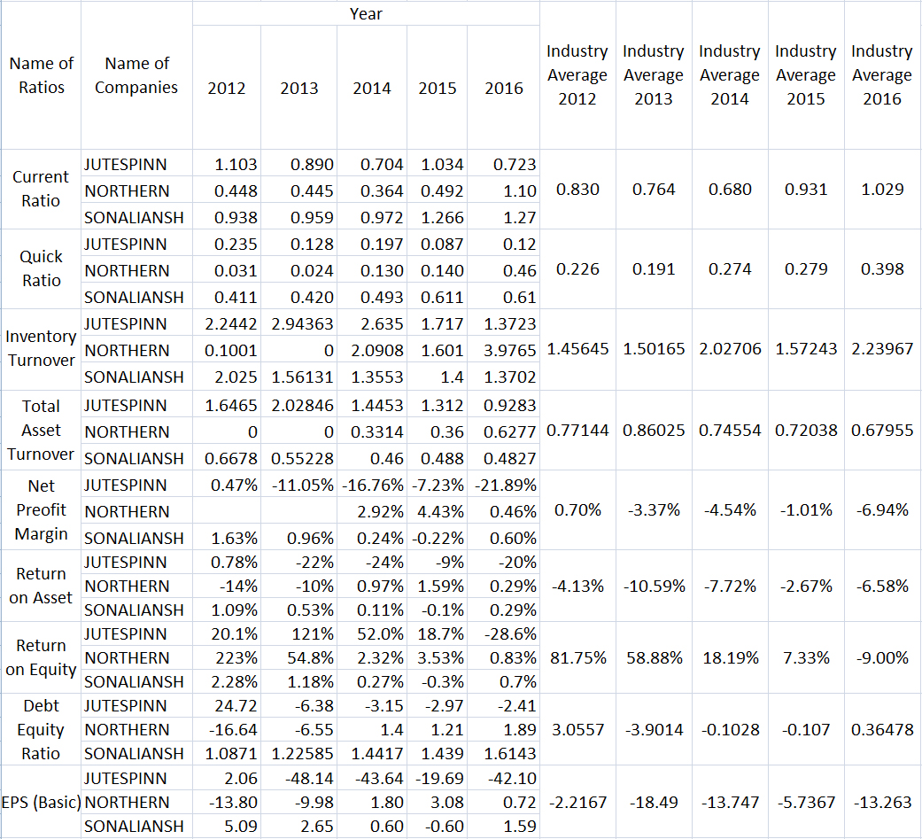

Some abbreviations are used in the above figure. In this figure JUTESPINN stands for Jute Spinners Limited; NORTHERN stands for Northern Jute Manufacturing Co. Limited, and SONALIANSH stands for Sonali Aansh Industries Limited. And EPS stands for Earning per Share.

Name of the Ratios | Average of Industry Average from 2012-2016 | Average of financial Ratios from 2012-2016
Name of the Ratios | Average of Industry Average from 2012-2016 | Jute Spinners Limited | Northern Manufacturing Co. Limited | Sonali Aansh Industries Limited
Current Ratio | 0.847 | 0.891 | 0.569 | 1.080
Quick Ratio | 0.273 | 0.154 | 0.157 | 0.509
Inventory Turnover Ratio | 1.759 | 2.182 | 1.554 | 1542
Total Asset Turnover Ratio | 0.755 | 1.472 | 0.264 | 0.530
Net Profit Margin | -0.030 | -0.113 | 0.016 | 0.006
ROA | -0.063 | -0.151 | -0.043 | 0.004
ROE | 0.314 | 0.366 | 0.569 | 0.008
Debt Equity Ratio | -0.138 | 1.962 | -3.738 | 1.362

Figure: Arithmetic mean of industry average & Ratios from 2012-2016

Interpretation of Ratio Analysis:

Current Ratio & Quick Ratio: Both current & quick ratios are liquidity ratios, which reveal the relationship of a company’s current assets with its current liabilities.
Current Ratio = $\frac{Current Assets}{Current Liabilities}$ Quick Ratio = $\frac{Current Assets-Inventories}{Current Liabilities}$
From 2012-2016 Sonali Aansh Industries Limited was doing well in terms of maintaining liquidity. Due to shortage of working capital Northern Manufacturing Co. Limited can’t maintain a satisfied level of current assets. So, this firm has in a little bit risky position.
Inventory Turnover Ratio: Using this ratio it can be measured how many times a company can sell its inventory in a specific period of time. From the figures it is seen that Northern Jute Manufacturing Co. Limited can sell its inventory most quickly comparing with other firms. This may happen because management of Northern Jute Manufacturing Co. Limited is continuously improving the human resources by conducting supervision and on-the-job training programs. That’s why their sales force may be efficient which may have an indirect positive impact on inventory turnover.
Total asset turnover: This ratio shows the efficiency through which a company is using its total assets to generate revenue. In this case, Jute Spinner Limited is the most successful company; i.e. this firm’s assets most efficiently generate revenue. This firm has utilized maximum capacity of the factory to earn maximum return.
Net Profit Margin: Among 3 jute companies, Northern Jute Manufacturing Co. Limited is the most profitable jute company since its Net Profit Margin is higher than other jute companies. Jute Spinners Limited has the lowest net profit margin due to Implementation of Wage Commission 2013, electricity outage, World Recession, increment of price of complementary goods. Moreover, Subsidies for export jute products has been decreased from 10% to 7.5%. This is also one reason for net loss margin of Jute Spinners Limited.
Return on Assets: Assets are acquired to generate revenue. ROA ratio shows how efficient a firm is in case of generating revenue through its assets. Sonali Aansh Limited is the most profitable company relative to its total assets. Due to increment of demand for diversified product, export has been increased by BDT 116784921. This may be a reason of high ROA for Sonali Aansh Limited.
Return on Equity: How much net income a company generates with the money shareholders have invested can be known through Return on Equity ratio. Northern Jute Manufacturing Co. Limited generates the highest BDT of profit with each BDT of shareholders' equity.
Debt Equity Ratio: This ratio reveals the proportion of debt that a firm is using to acquire its assets comparing with the amount of money provided by its shareholders. Sonali Aansh Industries Limited has taken on relatively little debt and thus has low risk. This is happened because Sonali Aansh Industries Limited has the maximum paid up capital among the three listed jute companies of DSE. So, it does the equity financing not debt financing.
Analysis of relationship of EPS with financial ratios & Market Price of the Share:
Statement of Hypothesis:

On the basis of literature review & research questions, the following hypotheses have been made:
Hypothesis 01: H₁ There is a positive relationship of Inventory Turnover Ratio with EPS.
Hypothesis 02: H₂ There is positive relationship between Total Asset Turnover and EPS.
Hypothesis 03: H₃ There is a positive relation between ROA and EPS.
Hypothesis 04: H₄ There is a positive relation of ROE with EPS.
Hypothesis 05: H₅ EPS and Debt Equity ratio are positively correlated.

In carrying out this paper work, a compact form of research models is developed as follows:
(EPS) _{y} = b₁ (ITR) + Є
(EPS) _{y} = b₂ (TAT) + Є
(EPS) _{y} = b₃ (ROA) + Є
(EPS) _{y} = b₄ (ROE) + Є
(EPS) _{y} = b₅ (DtE) + Є
b₁– b₅ = Coefficient for the independent variables X of companies, denoting the nature of relationship with dependent variable Y (or parameters).
Є_{i} = the error term
Where: EPS = Earnings per share; ITR = Inventory Turnover Ratio; DtE = Debt to Equity Ratio; TAT = Total Assets Turnover
Y = Dependent variable of company; X = Independent variable of company.

Findings of Correlation Analysis:
EPS & Inventory Turnover: In this case, the value of r is -0.13110615. So, EPS & Inventory turnover is negatively correlated; i.e. if Inventory turnover increases, then EPS will be decreased. Therefore, hypothesis 01 (H₁) is rejected.
EPS & Total Asset Turnover: Here value of coefficient of correlation [r] is -0.58930455. Therefore, hypothesis 02 (H₂) is rejected. EPS has a strong negative relationship with Total Asset Turnover. It also shows that the companies do not utilize their assets efficient in generating its income.
EPS & ROA: Value of correlation coefficient between EPS & ROA is 0.97049894. So, hypothesis 03 (H₃) is accepted. If ROA goes up, then EPS will also go up.
EPS & ROE: Value of coefficient of correlation [r] between EPS & ROE is -0.34128418. Hypothesis 04 (H₄) is also rejected. However, in other research papers it is seen that there is a positive relationship between EPS & ROA.
EPS & Debt Equity Ratio: Correlation Coefficient shows that there is positive relation between EPS & Debt Equity Ratio. R value of EPS & Debt equity ratio is 0.42057765. Therefore, hypothesis 05 (H₅) is accepted.

Recommendations:

- The management of jute companies must be careful about working capital since one jute company failed to generate sales in 2012 & in 2013 due to shortage of working capital. So, Northern Manufacturing Co. Limited must raise their current ratio.
- The jute industry should assign much important to inventory holdings since Inventory turnover ratio (ITR) bears negative relationship with EPS. In the annual report it is informed that due to increment of supply comparing with demand, jute products are remained unsold. The management should increase relationship with foreign buyers in order to prevent over storage of inventories & increase sales of jute products.
- Some jute factories of listed jute companies are shut down. It’s an absolute indication that cannot utilize their assets efficiently in generating more income. Consequently, negative ROA, ROE are seen in some years among the listed jute companies. In this case, the government should increase subsidies to jute sector to prevent such shut down of jute factories. If government does so, then jute companies can fully utilize their assets & social unrest will not be emerged.
- Northern Jute Manufacturing Co. Limited should increase their paid up capital, because their debt is too much high comparing with equity. This is very risky for any company, because there is a huge threat of bankruptcy if debt to equity ratio is very high as high borrowing from debtors will cause high amount of interest expense.
- Jute Spinner Limited’s net profit margin negative from 2012-2016. This is very disappointment for the shareholders of Jute Spinner Limited. The CEO of Jute Spinner Limited reassures company’s stockholders again & again, but the firm is facing net loss year after year. Therefore, Jute Spinners Limited should produce diversified jute products like Sonali Aansh Industries Limited to increase their products’ demand in the international market.

Special Suggestion for general investors:
Investors should invest in that company whose profitable ratios are high if the market is efficient. The following table provides an idea about profitability ratios of the selected jute companies:

Name of the Profitability Ratios | Average of Industry Average of Industry Average from 2012-2016 | Average of financial Ratios from 2012-2016
Name of the Profitability Ratios |  | Jute Spinners Limited | Northern Manufacturing Co. Limited | Sonali Aansh Industries Limited
Gross Profit Margin | 11.65% | 8.87% | 9.75% | 16.33%
Operating Return on Asset | -0.0503 | -0.13946 | -0.04415 | 0.03287
Pretax Margin | -2.52% | -10.45% | 2.01% | 0.88%
ROA | -0.063 | -0.151 | -0.043 | 0.004
ROE | 0.314 | 0.366 | 0.569 | 0.008

It is seen from the above table that Sonali Aansh limited’s maximum profitability ratios are better than other two companies’ profitability ratios. So, investors should buy the share of Sonali Aansh Industry limited if Dhaka Stock Exchange is an efficient capital market. Now an important question is “Is Dhaka Stock Exchange an efficient capital market?” Further study or research can be conducted to answer this question.
In the above table, ROA means return on assets & ROE means return on equity.
Conclusion:
Annual reports of the listed jute companies of DSE expressed that supply has been increased comparing with demand & consequently in the international market export price of jute products has been reduced abnormally. Moreover, Government is reducing subsidies to jute sector. That is jute sector of Bangladesh is facing some serious problems & government of Bangladesh is also careless to protect jute industry. However, if initiatives are not taken, then jute industry will face the threat of extinction as the listed jute companies’ net profit margin is seen to be negative in last few years.

References
- Padma (2016), “RATIO ANALYSIS: A COMPARATIVE STUDY OF SELECTED STEEL SECTOR INDUSTRIES”, KAAV INTERNATIONAL JOURNAL OF ECONOMICS, COMMERCE & BUSINESS MANAGEMENT, 3(2)
- Innocent, E. C., Mary, O. I. & Matthew, O. M. (2013), “Financial Ratio Analysis as a Determinant of Profitability in Nigerian Pharmaceutical Industry”, International Journal of Business and Management,
- Idhayajothi, R., Latasri, Dr. O. T. V. N., Manjula, Banu A. M., & Malini R. (2014) “A Study on Financial Performance of Ashok Leyland Limited at Chennai”, IOSR Journal of Business and Management, 16(6), PP 83-89
- ISLAM, M. A. (2014) “An Analysis of the Financial Performance of National Bank Limited Using Financial Ratio”, Journal of Behavioural Economics, Finance, Entrepreneurship, Accounting and Transport, Vol. 2, Issue No. 5, Page 121-129
- T, S. K. (2012) “An Analysis of Financial Statements of Karnataka Power Corporation Limited, Bangalore”, International Journal of Engineering and Management Research, Volume-2, Issue-3, Pages: 53-57
- Rath, A. K. (2016) “A Study on Financial Statement Analysis of Tata Steel Odisha Project, Kalinga Nagar”, Journal of Research in Business and Management, Volume 4, Issue 10, pp: 49-60
- VENKATESAN, T., & NAGARAJAN, S. K. (2012) “AN EMPIRICAL STUDY OF PROFITABILITY ANALYSIS OF SELECTED STEEL COMPANIES IN INDIA”, International Journal of Marketing, Financial Services & Management Research, 1 (10)
- Anand, M. “A Study of Financial Analysis in Textile Sector”, Journal of Business Management & Social Sciences Research, Volume 3, Issue No.6
- Brigham & Johnson, Fundamental of Financial Management, 12th Edition, Cengage Learning
- Horne, Wachowicz, Fundamental of Financial Management, 13th Edition, PHI Learning Private Limited

