ANALYSIS OF ORPAT SWEATER LTD AND ITS INDUSTRY IN BANGLADESH



AZFAR HOSSAIN ANTOR

This report is submitted to the school of Business and Economics, United International University as a partial requirement for the degree fulfillment of Bachelor of Business Administration

ANALYSIS OF ORPAT SWEATER LTD AND ITS INDUSTRY IN BANGLADESH

Submitted to:
Dr. Seyama Sultana
Associate Professor
Marketing

Submitted by:
Azfar Hossain Antor
111-172-109
Marketing
Trimester: 15


School of Business and Economics
United international university

Date of submission: 23th June 2022
Letter of transmittal

To
Dr. Seyama Sultana
Associate Professor
United International University
Subject: Submission of Internship Report.
Dear Maam,
I am pleased to inform you that I have effectively completed my Internship Report based on my research project “Analysis of Orpat Sweater Limited and its Industry in Bangladesh An internship Experience perspective’’ to fulfill my graduation requirement. For a business school student it a crucial part in to undertake a project. I gained essential knowledge about the topic area during the report creation time, which I used to properly prepare this report.
As a result, as a requirement of completing the Project, I am submitting my Internship Report on my work experience. I am confident that the prepared report will appeal to you and provide you with satisfaction. I am confident that the experience I have obtained has improved my skill set and demeanor in order for me to operate as a professional. I appreciate the tremendous amount of help and advice you've given me in completing this job.
Thank you for your kind support, without you support and suggestion I would never have completed the internship report. So, it would be kind enough if you receive this report.

Sincerely Yours

AZFAR HOSSAIN ANTOR
ID No: 111-172-109
School of Business & Economics
United International University
Certification of similarity index

Declaration of the student

I thus certify that I prepared the internship report "Analysis of Orpat Sweater Limited and Its Industry in Bangladesh: An Internship Experience Perspective" under the supervision of Seyama Sultana, Associate Professor, United International University, Madani Eve, Dhaka-1212, Bangladesh.

I further certify that the work and information presented in this internship report are original, and that no portion or whole of it has been submitted to any other university or institution in any manner for any degree or other reason.

Azfar Hossain Antor
ID: 111 172 109
BBA
(Major in Marketing)

Acknowledgement

To effectively complete an internship report usually involves numerous assistance and help from people around. To construct the report I received immense support from my teacher, friends and colleagues who helped me to prepare this report, I am whole-heartedly thankful.
Firstly, I would like to praise Almighty Allah who created this divine universe and for giving me wide knowledge, patience so, that I could undertake and complete this difficult task. I would like to acknowledge the help and support of my honorable Internship Supervisor Seyama Sultana, Associate professor of United International University, who has given me important suggestion, guidelines and supervisionforpreparing this report.
I would like to concede and appreciate the following employees of Dhaka Bank ltd, who has given their precious time, support and helped me for preparing this report, Mr. Mizanur Rahman, Manager (Commercial) and Mr. Nazrul Manager (Merchandiser) who has given me adequate information and advice to prepare this report. I am also thankful to all the other stuff members of Orpat Sweater Ltd who has shown humble appreciation towards me.
I am grateful without their help it would be an impossible task. As, I am new to this work environment to grasp everything in very short period was a difficult task so, all the help and support is much appreciated.

Abstract/ Executive summary

In this rapid evolving era business are becoming more competitive. Private RMG organization are playing a vital role to boost the financial support of the country and helping in the rise of employment. As a marketing student I was always interested in RMG sector therefore, I choose to make the report on ‘Analysis of Orpat Sweater Limited and its Industry in Bangladesh’ to conclude my B.B.A Program.
The report's first chapter is an introduction that covers the history of Bangladesh's RMG (Read Made Garments) or textile sector, as well as its current condition, growth, and recognition. The chapter also includes background of the report, objective of the report, motivation of the report, scope and definition of the report and definition of key terms.
The second chapter is about company and industry preview which is divided in many parts. This chapter includes overview and history, trend and growth, customer mix, product/service mix, operation, SWOT analysis, specification of the industry, size, trend and maturity of the industry, external economic factor, technological factor, barriers of entry, supplier power, buyer power, threat of substitutes and industry rivalry. All this aspects are described in details.
The third chapter is about the internship experience, which includes position duties and responsibilities, training, contribution to departmental functions, evaluation, skilled applied, new skilled developed and application of academic knowledge. Here, my experience through internship has been discussed.
And finally in chapter four conclusion and key facts have been described. This includes recommendation for improving departmental operation, key understanding and conclusion. There are few recommendation which will help Orpat Sweater Ltd be more organized and bring success in the future.

Table of content

Table of Contents
List of Figures 1
List of Tables 2
List of Abbreviation 3
CHAPTER I: INTRODUCTION 4
I.1 Background of the report 4
I.2 Objective of the report 5
I.3 Motivation of the report 6
I.4 Scope and limitation of the report 6
I.5 Definition of key terms 7
CHAPTER II: COMPANY AND INDUSTRY PREVIEW 8
2.1 Company Analysis 8
2.1.1 Overview and history 9
2.1.2 Trend and growth 11
2.1.3 Customer Mix 15
2.1.4 Product/service mix 15
2.1.5 Operations 16
2.1.6 SWOT analysis 18
2.2 Industry analysis 20
2.2.1 Specification of the industry 21
2.2.2 Size, trend and maturity of the industry 21
2.2.3 External economic factors 23
2.2.4 Technological factor 24
2.2.5 Barriers to entry 26
2.2.6 Supplier power 27
2.2.7 Buyer power 27
2.2.8 Threat of substitutes 28
2.2.9 Industry rivalry 28
CHAPTER III: INTERNSHIP EXPERIECNE 29
3.1 Position, duties and responsibilities 29
3.2 Training 30
3.3 Contribution to departmental functions 31
3.4 Evaluation 33
3.5 Skills applied 34
3.6 New skills developed 34
3.7 Application of academic knowledge 35
CHAPTER IV: CONCLUSIONS AND KEY FACTS 35
4.1 Recommendations for improving departmental operations 35
4.2 Key understanding 36
4.3 Conclusion 37
Reference 38
Appendix-A: 39

List of Figures

LIST OF FIGURES | PAGE NUMBER
Figure-1 (Hierarchical position of head office) | 10
Figure-2 ( Export value in Bangladesh from 2010-2021) | 14
Figure-3 ( Growth of Orpat Sweater Ltd) | 14
Figure-4( Operation process of Orpat sweater ltd) | 17
Figure-5( SWOT analysis) | 18
Figure-6( Bangladesh Sweater export trend) | 22
Figure-7 (Production value from 2012-2021) | 23
Figure-8 (Invoice) | 31
Figure-9 (packing list) | 31
Figure-10 (Bank forwarding) | 33
Figure-11( Incentive form ka) | 33

List of Tables

List of tables | Page number
Table-1 (key terms) | 8
Table-2 (customer mix) | 15

List of Abbreviation

List of abbreviation | Full abbreviation
OSL | Orpat Sweater Ltd.
RMG | Ready-made garments

CHAPTER I: INTRODUCTION

In Bangladesh, RMG sector has a huge impact on GDP and the employment. Through export of garments, Bangladesh earns a huge percentage of foreign currency. This business supports about 4.2 million people and contributes significantly to the economy. The readymade garments (RMG) business in Bangladesh is fueled by young, urbanizing workers, the majority of whom are women.
Bangladesh's Ready - made garment section has a significant impact on the country's monetary development. In Bangladesh, the RMG and Textile industries have been the major providers of distant fare for the past years except the time of the pandemic 2020-2021. This region maintains its position as the world's third-largest apparel producer and ensures the leading position in South Asia.
In 2003, Orpat Sweater Ltd. started its journey with few hand knitted machines in a limited space in Narayanganj, Bangladesh. Now, OSL have expanded their business to more than 50,000 square feet in Demra, Dhaka and head office in DOHS Baridhara. Not only expanded in space but also stretched or converted the factory from hand knitting machine to automatic jacquard machine, this increased the production by a long margin than before. Furthermore, OSL is planning to expand its business for another unit in Narayanganj in their own premises.

I.1 Background of the report

Throughout the education phase, university students continuously learn by acquiring theoretical knowledge with the help of book, lectures, slides and notes. Theoretical knowledge helps students Passover the bridge of exams and gather wide knowledge. Despite acquiring theoretical knowledge is not enough. To transit to corporate culture a student needs practical experience. A business school student must learn how to climb the corporate ladder and how business organizations works by observation and applying the knowledge acquired through learning phase. As I have concluded my educational theoretical courses from my university and gathered much knowledge so, I want to apply all my valuable knowledge to a business organization to achieve real-world experience. I have selected my internship program in “Orpat Sweater Ltd..” At Demra, Dhaka. OSL has given me the opportunity to complete my internship program.

In this report, the main description is about the operation, management, past situation, present position, future circumstances, marketing and development of RMG in Bangladesh, especially focused on an organization called ORPAT SWEATER LTD. This analysis is exaggerated in this report particularly focused on OSL.
Around 3 million professionals work for the company, with 90 percent of them being women. The entire method is inextricably linked to the pattern of creation's progression. These have been discovered that Bangladesh's inclination for low labor costs is the primary reason for the exchange of garment manufacturing.

I.2 Objective of the report

The primary purpose of this paper is to describe and analyze Orpat Sweater Limited and the Bangladeshi sweater industry. The goal of the investigation is to uncover some diverse aspects of marketing, financial, and commercial contactors in the garment sector.
I have structured the objectives of this report as following:
- To provide a better understanding of the entire exercise
- To give a high-level summary of OSL
- To concentrate on the goods and services provided to clients, as well as the facilities provided by OSL
- To gain a realistic grasp of how a textile company runs its business.
- To discover more about OSL's progress toward its Corporate Goal.
- The goal of this project is to examine the Advance department's work process and monitoring system.
- To make some recommendations for how to improve their general exercises

I.3 Motivation of the report

As a business and administrative graduate it was very interesting for me to make an analysis on an organization about the process and operation, especially how it works. The culture and work environment was new and fascinating for me, have learned plenty of skills and communication process, how to communicate with the people and convince them to provide me the data or information of what I need to complete the work or task.
However, the operational presentation of the OSL (Bangladesh) and its impact on its productivity are also discussed in this paper. Working in an RMG sector has always been one of my top priorities because many of my family members are involved in this industry and been successful. And working and making this report was fun for me as it persuaded me.

I.4 Scope and limitation of the report

Scope-
The possibility to prepare this report was technically accessible through the help of company website, google search, blogs and articles and the most vital way was the research while doing the internship in OSL. During this internship program, I had a basic knowledge about the merchandising, commercial and marketing; though I was involved mostly in commercial department it wasn’t that difficult to know other department’s exertion. Because most of the activities in RMG is done through cross functional communication. As a result of this research, I am able to make some recommendations to the company in order to increase their overall activities and financial strength in order to meet their organizational goals. Although OSL is still in its early phases of development, they have exhibited a high level of consistency in their operations in Bangladesh, and there is no doubt that this company has a bright future in Bangladesh.
Limitation-
There are plenty of drawbacks while preparing this report and time was mostly significant. As OSL is not that big of a company, the information and data is also very limited. And gathering the primary data was difficult for me because the organization was not disclosing the data. Furthermore, because of Covid-19 the job became trickier, 2020 and 2021 was struggling years for most of the industry as a cause of lockdown. That’s why primary and secondary resources of data are mixed in this report, all the primary data was not attainable.

I.5 Definition of key terms

In this report, themain topic discussed is about the overall analysis of Orpat Sweater Ltd and its industry in Bangladesh.
Starting with the introduction, main body, conclusion and recommendation, this report has all the part covered with primary and secondary data and information.
- Data collection—information about exercises and all offices is acquired from the organization's website, and personal experience while working in the company.
- Types of Data—in my report, I use optional information about the organization's general activities.
- There is some general information of the RMG sector, which was essential for explaining the study of OSL.

However, there is some key terms explained bellow.
Table- 1
WORD | EXPLANATION
Analysis | Separate and analyse the stated subject into its constituent sections or elements. Describe the assumptions that must be made in order to recognize a concept as valid.
Order | Quantity of goods which has been asked by the customers to fulfill and deliver on time in exchange of money.
Commercial | A department in RMG sector, who’s primary job is to arrange and prepare documents required by customers.
Buyer | Customers of the organization
Export Oriented | Only focus on export to other countries.
Documents | Provide evidence that is relevant to the topic. Authorities are quoted or referred to.

CHAPTER II: COMPANY AND INDUSTRY PREVIEW

2.1 Company Analysis

Sweater is a type of knitted cloth. In countries or nation, where the weather is chilly or snowy, the demand of sweater is immense. In the international market the demand of sweater is increasing more and more. Buyers from abroad are also interested in fashionable sweaters thus this increases more demand and quality of the goods which are, being& is going to be exported. Therefore, the business for sweaters is very bright for Bangladesh.

2.1.1 Overview and history

Orpat Sweaters Ltd. is a 100% export-oriented sweater manufacturing company from Bangladesh. It contributes a significant level of garments in the export of RMG sector. Orpat Sweaters Ltd. began their journey in the year 2003. Progress is defined by high performance and timely dissemination. Customer satisfaction is only a goal that is never jeopardized under any circumstances.All the management and employees of Orpat Sweater Ltd. tries to ensure the quality and timely shipment of the goods to the customers to be faithful to the commitment and trust.
Orpat sweater Ltd produces sweaters of many kinds especially cardigan and pullover for all the genders, for men, female, kids and also infants mainly for its washing plant and grinding capacity due to their good domestic facilities and high quality.
Orpat sweater is not the largest in Bangladesh but have a significant contribution the export of the country. It is situated in Demra, behind Rani Mohol, Dhaka, the plant is completely tiled, with glassed windows encircling it and abundant cross-air circulation, and it is powered by a gas generator 24 hours a day.The factory is completely tiled, has a 24-hour gas generator power supply, surrounding glazed windows, adequate cross-air ventilation, conference, inspection facilities in each level, alternative emergency stairs, full-time medical & first-aid to all operators, appropriate hygienic toilets, modern fire detection, alarm, and rescue system.
BSCI has authorized Orpat Sweater Ltd. with a grading of B, for following most of the facilities and providing compliance services in actual manner to the employees. Child labor is strictly forbidden in all divisions of our factory, and the overall set-up provides an ideal working environment.

Head-office

Orpat Sweater Ltd. has its head office named XPO Bangla situated in Baridhara D.O.H.S, Dhaka. Here, four people of management are working for communication with the customer.
Figure- 1
MANAGING DIRECTOR

MARCHANDISER MANAGER

ASSISTANT MARCHANDISER

ASSISTANT MARCHANDISER

Above is the organizational structure of Dhaka office (XPO Bangla), here the communication is done with the buyers with their inputs and converting those in to outputs through Orpat Sweaters Ltd. The development is not only for the existing customers but the team is also developing new customers for the organization.

Mission
- Pay sincere attention to the customer’s desired requirement.
- Built a culture of honesty & accountability.
- Creating new jobs and encouraging capable people to work and earn a living as productive members of society and economic contributors.
- Delivering our obligation as a good corporate personality to customers, employees, public and to the environment.

Vision
- To be a highly reputed manufacturer of sweater in the international market for its excellence in quality and service.

Objectives- The management team of Orpat Sweater Ltd. is very active and staffs are efficient and dutiful. They are committed to fulfill the reliability that the customers need, the attention & services that the buyers deserve and the quality they expect. However, the main objective is toprovide best quality and in a timely schedule to satisfy the customers.

2.1.2 Trend and growth

- Growth of RMG industry in Bangladesh.
The economic success story of Bangladesh is anchored by the ready-made garment (RMG) industry: Bangladesh is now one of the world's major garment exporters, accounting for 84 percent of the country's total exports. This is due to the garment industry's fast growth and modernization over the last decade, as well as the progress it has achieved in improving working conditions for the country's four million garment workers and more.
However, a series of workplace catastrophes that claimed the lives of over 1,000 garment workers and made international headlines catalyzed the change of Bangladesh's RMG sector over the last decade. The Tazreen factory fire in 2012 and the Rana Plaza factory collapse in 2013 exposed widespread flaws in working conditions, prompting some international clients to discontinue buying from Bangladesh and the US to remove its favorable tariff deal. However, thanks to initiatives launched in the aftermath of the disasters, such as the Accord on Fire and Building Safety in Bangladesh, the Alliance for Bangladesh Worker Safety, and the RMG Sustainability Council, Bangladesh's RMG sector is a frontrunner in transparency regarding factory safety and value-chain responsibility. Hundreds of dangerous, low-wage factories were closed as a result of these actions and remediation work in many more were ramped up.These efforts helped Bangladesh regain its appeal in the global apparel-sourcing market, resulting in a decade of tremendous expansion.
The pandemic, on the other hand, has slowed the sector's expansion at a critical time, especially as global trends in fashion sourcing threaten Bangladesh's place in industry supply chains. There were signals of a slowdown, with negative growth in the second half of 2019 compared to 2018. Then came COVID-19, which resulted in order reductions, cancellations, payment delays, and renegotiation of terms in 2020. As the epidemic threatened Bangladeshi workers' lives and livelihoods, many smaller, less well-funded firms shuttered their doors, increasing competition for smaller orders. In the first year of the pandemic, the value of Bangladesh's RMG exports plummeted by 17%, resulting in revenue losses of up to $5.6 billion. There were competitors like the country Vietnam, who were trying to overtake the RMG sector of Bangladesh but through diversification Bangladesh have retained their position in the international market. More than the competitors, the pandemic was more challenging especially on 2020. Diversifying customer countries and moving to more complicated products and value-added services have been major strategies for the sector's growth over the last decade. Bangladesh's RMG sector has made strides in diversifying its customer base in order to manage risk and respond to shifting demand trends in the global fashion market. Nevertheless, despite a decline in reliance on the US, Europe (62 percent of export value) and the United States (18 percent of export value) remain the largest customer markets for Bangladesh's RMG business. There is space to expand exports to nontraditional markets, especially while traditional markets' clothes retail sales are declining. This shows the capability of RMG in Bangladesh, surviving and growth both are adaptable and achievable.
In the chart bellow we can observe the growth of RMG in Bangladesh. However, Orpat Sweater Ltd. had also been steady and has successful growth over the years. Orpat Sweater Ltd. had started the business with manual machine with very limited customers but as time went by it has also stepped upwards and has managed its own automatic (Jacquard) machine with many more customers.

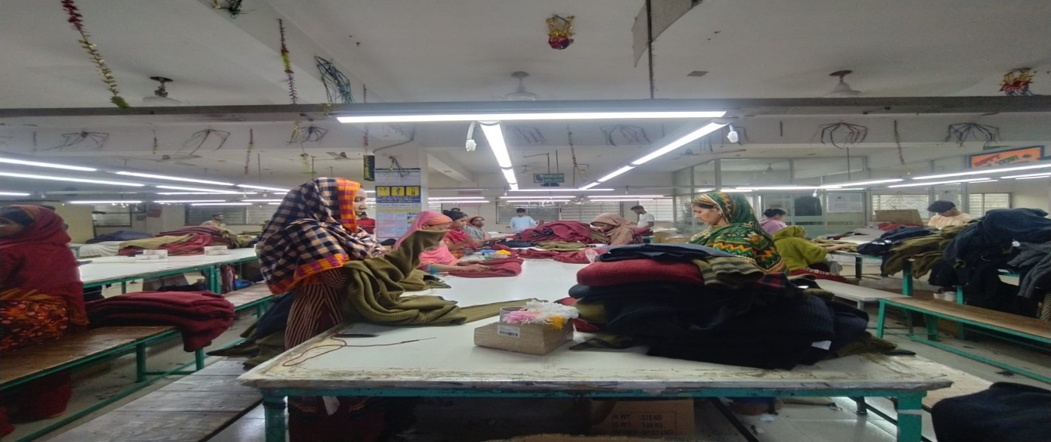
Figure-2
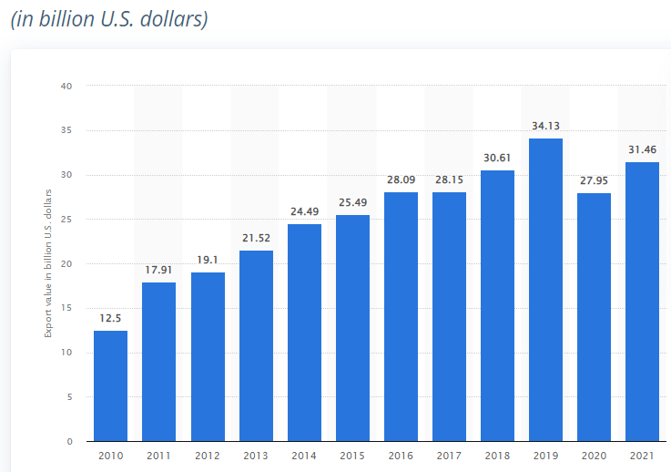
Figure-3

In the above chart, each year’s export has been illustrated of Orpat Sweater Ltd. through a Column diagram. As, we can see in 2018 and 2019, the export was good of more than $10 million and it is quiet good for a company of this size. However, in 2020 the organization suffered a lot and had a massive loss because of COVID-19. But with the help of government through pronodona (a loan with very low interest) helped the organization to recover. Nevertheless, in 2021 OSL started rebuilding and was in a breakeven which a huge leap from last year. But in 2022 OSL is planning to get back to its old position or maybe even shipping more than before because of the orders or demand of sweaters in the international market.

2.1.3 Customer Mix

The table bellow is the customers of Orpat Sweaters Ltd.
Table- 2
NAME | COUNTRY | PRODUCT TYPE
INDEPP INTERNATIONAL | JAPAN | CARDIAN, CREWNECK
YOURS CLOTHING | UK | CARDIGAN, TUNIC
SRG APPAREL PLC | UK | PULLOVER, V-NECK
AM LONDON FASHION LTD. | UK | CARDIGAN, MOCK
ARAV S.R.L | ITALY | PULLOVER, TUNIC
MJUNIK TEXTILE GMBH | GERMANY | PULLOVER, VESTS
DAVID PEYSER SPORTSWARE | USA | PULLOVER, CREWNECK
YM INC. | CANADA | CARDIGAN, VESTS
AWG ALLG. | GERMANY | CARDIGAN, V-NECK

2.1.4 Product/service mix

Orpat Sweater Ltd. delivers both tangible and intangible services to the customers to satisfy their needs and wants as much as possible.
- Records of all the export and import documents in hard and soft copy, very securely kept, so when required it can be delivered.
- The measurement of the fabric of the sweater is produced perfectly, that’s why the tension is perfect according to the buyers demand.
- The feel of the fabric is not too harsh or soft.
- The customers comment is dealt with care and precision.
- After the shipment, feedback is taken that the goods have reached to the destination safely and securely.
- When the customer visits the country, office or factory, they are provided very thing they need.
- Not only the buyers, employees are provided the best facilities possible like- separate fire exit, cleaned bathrooms, medical facilities, timely salary etc.
- Communication is maintained with the customers other than the business purpose.

2.1.5 Operations

The process of Orpat Sweater Ltd. after the confirmation of orders from the buyers:
Firstly, the merchandising manager must collect original sample of Yarn, Color swatch or Panton. No from buyer. The merchandising department communicates with the dying factory and accessories supplier, then the top-management and merchandiser manager does the consumption per order in dozens. Afterwards ordering lab dips from dying factory, orders are to be placed with dyeing factories that offer reduced costs, higher quality, and on-time delivery. Then the approval is taken from the buyers that shades are alright.
Secondly, the accessories come in place. Purchase of zipper, button, main label, size label, care label, hang tag, price tag, poly, blister& carton is to be arranged by the merchandising manager. Similar to yarn, accessories suppliers are to be communicated then choosing the vendor who provides the lower cost and better quality& due time delivery. And order them for sample development. Following the next step, after generating the accessories (zipper, button, main label, size label, care label, hang tag, price tag, poly, blister& carton), the accessories factory submits them to the buyer for approval via Merchandiser. This color is for mass manufacture.
Finally, after the buyer approved the yarn and accessory sample, Orpat Sweater Ltd. opens a back-to-back L/C against the accessories supplier's master L/C. Banks in this area only accept 75 percent back-to-back transactions. This process is done by the commercial department.
Now, Orpat Sweater Ltd. will convert raw materials in to finished product through the production process given bellow:

Figure- 4

2.1.6 SWOT analysis
Figure- 5

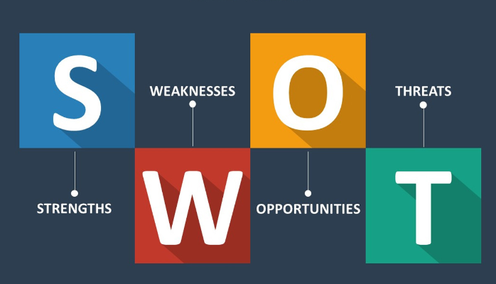

STRENGTH
- Orpat Sweaters Ltd. has great coordination with all the departments with each other including the high office staffs and the low floor staffs.
- Lower wage rate, the prime advantage of RMG business in Bangladesh is the cost of labor rate is very low.
- The profit margin of manufacturing Sweater in Bangladesh is very high compared to knit and oven. And Orpat Sweater Ltd. is no different.
- In house manufacturing of the finished product is done inside the premises; very few parts of the products are outsourced. The reason behind this is in Orpat Sweaters Ltd. only the yarn is bought from outside the company and the rest is processed inside the organization, so very less chance of any error and mishap.
- Orpat sweater Ltd. has human resources who are experienced and efficient with their individual tasks and work.
- Manages to handle any hurdle if it occurs, because Orpat Sweater Ltd. is accomplished enough to overcome any problem.

WEAKNESS
- Market is very saturated because there are too many competitors.
- There is always an upper hand for the buyer because of shifting opportunities.
- Orpat Sweater Ltd. has to import raw materials (YARN) from other countries because we don’t have enough variety or quantity in our country.
- Government rules and regulations are not flexible enough for business in Bangladesh, it takes time to process.
- Availability and retention of skilled labor and operator in the peek time of the season.
- Availability of raw materials is not accessible in Bangladesh.
- Inventory management have to remodel, there are few leaks.
OPPORTUNITIES
- Huge international market, diversification of customers is available.
- Own brand can be established through creating outlets in the countries where the environment are cooler. The production cost will be decrease because of own manufacturing plant.
- If higher quality can be provided to the customers then customer loyalty can be achieved.
- Higher risk of getting more orders or increase in production can result in rise in profit.
- Diversification of garments can be achieved like- shifting from sweater to knit or oven.

THREATS
- New entrant in this industry is easy to access.
- BKMEA and BGMEA rules, regulations and policies are complicated and tough to follow.
- Competitors can produce the same or better product, which is fashionable and trendy.
- Customers knowing the production cost of manufacturing in Bangladesh and providing the price according to that.
- International competitors are rising, who has lower labor cost like- Indonesia, Vietnam, India etc.

2.2 Industry analysis

A sub-section of RMG sector is Sweater, which is growing rapidly over the recent years. Mostly countries with cold weather have the highest demand like- USA, UK, Canada, Germany, Poland, Japan, South Korea etc. Bangladesh is not producing the basic needs but also manufacturing the sweaters with trending and fashionable designs. However, because of China exiting the sweater market it made Bangladesh to raise their supply of sweater to fulfill the gap in the international trade. According to the Bangladesh Garment Manufacturers and Exporters Association, sweater exports have increased by 27 percent in the last six years as China abandons sweater production (BGMEA). In the sweater category- cardigan, pullovers, jumpers and mufflers are the basic items. After the pandemic of Covid-19, the fear has reduced and the buyers are reluctant to order more because of the high demand.
The majority of clothes in Bangladesh are made of cotton. Only 5% of the articles of incorporation are claimed by a local financial backer. Unknown financial backer has taken control of the clothes company. This sector accounts for more than 80% of all fares in Bangladesh and generates US$27.16 billion in 2016-17. In 2016-17, this region also contributed 12.36 percent to Bangladesh's GDP.

2.2.1 Specification of the industry

The market or industry in RMG is very saturated, the competition is immense. As there are many competitors in the market, the marketing and management quality have to be at least at per or else surviving in this industry will be difficult.
The competitors of Orpat sweater Ltd are as follows- Around star sweater, Nk sweater Ltd, Safaa sweater ltd, Toptex sweater, Universal sweater ltd, Kashmilon sweater ltd. etc. The company’s mentions above are few of the competitors and there more which are not listed but they are huge which includes in the group of industries. However, competing is difficult but not impossible, providing the best quality and in time is the key. And OSL has been doing it consistently, but there are few advantages in this competitive environment like- availability of skilled labor, availability of supply of raw materials and huge demand of sweater in the international market.

2.2.2 Size, trend and maturity of the industry

The size of RMG export to other countries is enormous; the first aspect is it contributes around about 83% of the export earnings of Bangladesh. This figure is not consistent but is has been increasing slowly over last 40 years. RMG is not a small industry in Bangladesh; through this more 6 million people are employed with direct jobs. It also shares a healthy amount in GDP of Bangladesh of about 11-12%, however, it has declined in the recent past. It is a major issue of downward in RMG and it needs to be looked after. Although the government has taken few steps to overcome this by helping the manufacturers but it will take time to recover. The problem, which is well-known, is that the RMG sector's export revenues are largely reliant on four to five basic products, such as T-shirts, sweaters, and other knitted goods. Cotton-based products are heavily used, with man-made fabrics, particularly high-value fabrics like viscose, being used less frequently.
Due to the pandemic of COVID-19, it smashed badly on sweaters factory and also Orpat, because more than 75% of the yarn of sweaters are being imported from China. Therefore, there was a massive shortage of yarns and it hampered the cost of yarn to the sky. The repair work for most of the organization is still going on. The year 2020 was disaster for many sweater factories but 2021-2022 came with many expectation and business opportunities. However, it is going smooth till now and this industry is achieving the expected production and profit. It shows the sweater production in Bangladesh is sustainable and has a long-term future. Almost all the organization have ups and downs in the business and the company which has the capability to overcome the declining phase stays in the long run, Orpat Sweater had that too and managed to overcome that.

Figure- 6

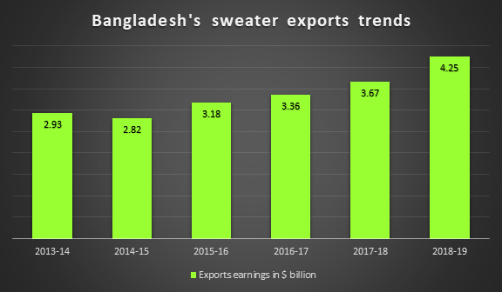

The figure above show the export trends of sweater from Bangladesh over the years from 2013 to 2019 and the figure are in $ billion.
Figure- 7
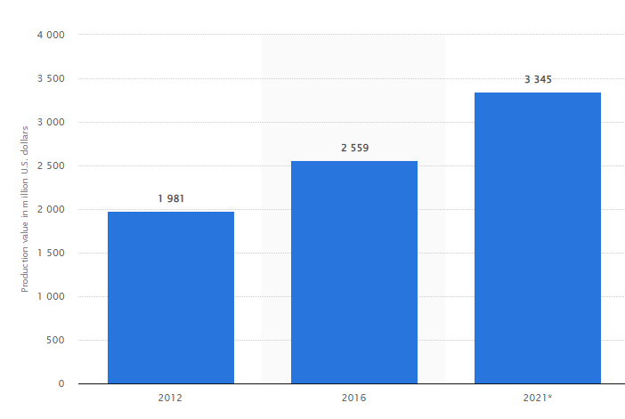

THE ABOVE CHART IS THE PRODUCTION VALUE OF SWEATERS IN BANGLADESH FROM 2012 TO 2021.

2.2.3 External economic factors

There are many external economic factors that affect RMG industry and Orpat Sweater Ltd. In RMG sector environment changes often, demanding careful planning and execution of processes. The top management and managers have to cope with the changes and come with the decision and planning to deal with that. RMG sector have to face some external economic factor, and in the following are some of the factors-
- Government policies and legal – factors is a very crucial change which happens randomly and it cannot be predicted. Sometimes there are new laws assigned and sometimes few are replaced by others. As the legal policies are not consistent, Orpat Sweater Ltd. adapts with the changes. The laws could be for, taxation, tariffs, employment law, export restriction etc.
- Economic- factor is also important because it plays a huge part in the environment of an economy by daily life, from employee well-being to a company's potential to thrive. And it can hamper in lowing the employment rate, so organization have to retain the core employees to survive in the changing environment and to gain revenue and profit. Orpat Sweater Ltd. is capable of dealing with the situation and handled it quiet well over the years.
- Demographic – factor also changes over time because organizations that are successful tend to diversify the needs and changes of their target customers. In Bangladesh, the RMG sectors are eager to diversify their product, service and target customers vary widely. Garments are exported to many region of the world from Bangladesh and different country or regions have different taste and fashion and the organization have to deal with the changes. For example- Orpat Sweater Ltd. had only exported their garments to 2/3 countries in the first 2 years but now it has exported the products to more than 10 countries.
The demographic changes that effect business are- age, gender, race, nationality, occupation, level of education etc.
- Competitive- factor is the most challenging factor in RMG in Bangladesh because there are too many competitors domestically. And every business has to keep a close eye on their competitors, have to track what the competitors are providing to their product, service and to their employees. As the market is very saturated, it is very difficult to run with the flow but Orpat Sweater Ltd. has managed it well.

2.2.4 Technological factor

Orpat Sweater Ltd. had started their manufacturing business with handmade manual knitting machines and now it is operating their knitting with more than 100 automatic jacquard machines.
However, Companies might benefit from technological advancements or face difficulty competing with them as technology advances. But to survive and compete in the market, businesses have to make the technological changes in their organization. Organizations use innovation in a variety of ways, including equipment and programming. Quality control, the invention cycle, products and businesses, correspondence, hardware, data, transportation and conveyance are only a few examples. However, for sweater factories in Bangladesh Industry has made significant investments in fully automated machinery (German, Japanese, and Chinese equipment) to replace traditional knitting. 3-D sampling improves sample submission dramatically, lowering the cost of production. The next major item will be full garment technology. Most manufacturers are also investing in digitization, including virtual sampling, fitting, and ERP solutions, in order to improve efficiency and ensure a long-term future.
There are few challenges like, skilled operator of running the automatic machines are very limited, so the resources are very less. Not only the operator but the technician for are limited and they lack the skill of repairing of the machines, this reduces the production because immediate action cannot be taken all the time. The organization has to wait for the company’s machines technician to come and repair. But on the other hand, the organization has reduced their operating cost, wastage, fixed & variable salary cost. The reason behind this is, one operator can operate 4/5 machines at a time, which is very flexible for the manufacturing companies.
Orpat Sweater Ltd. still have to go a long way, there are many types of jacquard machines with variable types of quality and quantity. Many successful companies have extensive and expensive jacquard machines, which attracts potential customer towards them because they can provide better quality and quantity. Nevertheless, Orpat Sweater Ltd. is at the right track and on its way for thousands of automatic machines. Moreover, management is an important aspect of business, and to sustain and keep record through technology is very necessary now days. Established factory have been a software called ERP, which is very effective and efficient for RMG sector because it keeps tracks and records of all departments of the factory like- Inventory, Sales, Human Resource, Purchasing, CRM,MRP, Finance, Products and Service. All this is operated by one software and shows all the records of the organization in a dashboard with one click or tab. Orpat Sweater Ltd. is planning to get this software in the upcoming season and this will make it very effective and efficient.
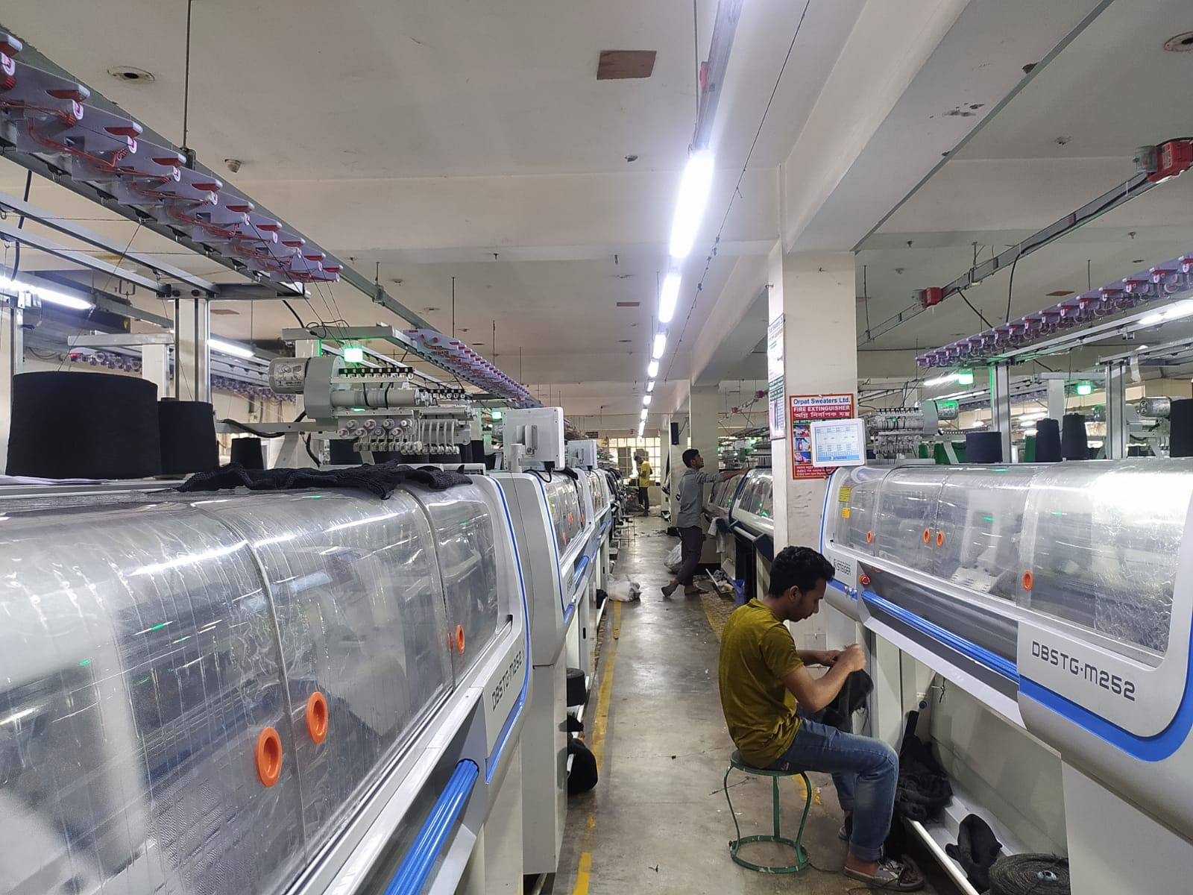

2.2.5 Barriers to entry

Bangladesh has several competitive advantages in the international market, such as the availability of low-cost labor and the generalized system of preferences (GSP), which permits Bangladesh to export duty-free to Europe with no quota restrictions. The RMG industry has long attracted both domestic and foreign investors due to its investment possibilities.Because local and export demand for garments is quickly increasing, the demand-supply gap is expanding, and new entrants can expect to benefit substantially by tapping into this available need.As a result, more companies are entering the market, such as Meerab Industries Ltd, Nippon Garment Industries Ltd, and Color Industries Ltd..Several more garment manufacturing factories would be built in the country with an investment of over Taka 300 crore, resulting in the employment of about 500,000 (0.5 million) people. The pool of new entrants into Bangladesh's RMG industry demonstrates that this sector has minimal entry barriers, as government laws are supportive for newentrants.

2.2.6 Supplier power

Bangladesh requires importing round about 80% raw materials for producing Garment.The cost of raw materials accounts for 35-40% of the entire cost of garment production. The raw materials of garments include Yarn, wool, and accessories. The majority of these raw materials are imported from China, Romania, Indonesia, Italy, and Germany. As there is a scarcity of raw materials, equipment, and machinery for the RMG business in Bangladesh, the suppliers have more considerable bargaining power. However, some of the suppliers like China and India are considered a powerful rival for Bangladesh.

2.2.7 Buyer power

Individual buyers in the RMG sector have a lot of bargaining power when it comes to negotiating price or other beneficial terms with manufacturers, therefore they usually pay their requested price, although there is room for negotiation. Bangladeshi garment manufacturer have established a strong presence on the international market. As a result, most garment manufacturers have shifted their focus to exporting, owing to their popularity in international markets. Bangladesh has a big opportunity in the RMG industry, thanks to rising demand from developed countries, where the cost of producing garment has risen dramatically due to a considerable increase in labor costs. The United Kingdom, the United States, Canada, Spain, Italy, Australia, New Zealand, Norway, Germany, Sweden, Russia, the United Arab Emirates, Denmark, France, Mexico, Argentina, Turkey, India, Nepal, Bhutan, and many other European and Middle Eastern countries are among Bangladesh's top export markets.Because they can easily switch to low-cost suppliers of garment from China, India, Indonesia, and Malaysia, these foreign customers have ample bargaining leverage to demand for price concessions and advantageous terms.

2.2.8 Threat of substitutes

Large-scale manufacturers have entered the garment industry in recent years, with their brands fighting fiercely with both domestic and foreign products of the same type.Some local firms are even manufacturing high-quality products after investing a significant amount of money. By developing demand for new items, companies like Opex Sinha Group, Tharmex Group, and Asian Apparels Ltd. are contributing significantly to this flourishing garment sector As raw material imports have quadrupled in the last decade, local major garment manufacturer of these alternative items are expanding their present capabilities while focusing on new product lines in order to attract more customer. Other substitutes of garments equivalents include stock lot, locally manufactured T-shirts and other apparel .As a result, the availability and cheap cost of substitutes is putting moderate competitive pressure on the RMG industry's existing businesses.

2.2.9 Industry rivalry

The RMG industry of Bangladesh encounters firm competition from foreign competitors like India, China, Vietnam and Indonesia, but the internal marketplace is yet weakly competitive. RMG manufacturers like Fakir Group, Masco Industries Ltd, Knit concern ltd, Square textile, Model group ltd. Fine garments continue to lead, particularly in the export market, and have recently expanded their facility to increase their share of the export market. Following the strong growth in demand for garments, all other garment makers are boosting their manufacturing capacity. Because of the global crisis and rising labor costs, wealthy countries are placing more orders for quality garment from low-cost countries; as a result, demand for Bangladeshi garments rapidly rising. In response to this rapid expansion, the number of competitors in this business is steadily expanding, with nearly similar size and competitive capabilities.

CHAPTER III: INTERNSHIP EXPERIECNE

3.1 Position, duties and responsibilities

JOB DESCRIPTION
There are many departments in Orpat Sweater Ltd. Like- Merchandising, Accounting and finance, Production, HRM, Commercial, Supply chain and Inventory Management. However, I was involved in the commercial department as an intern. Commercial department mostly involved with export and import of raw materials to finished goods with the entire document needed in the process. As an intern, my basic responsibility and task was involved with the documents of incentives which is to be submitted to Bank, Audit firm (for confirmation) and BKMEA, preparing Invoice and packing list was also part of my job. I have learned a lot of things while preparing those documents and this is only a part, there are many more which I am still learning.

JOB RESPONSIBILITY
Import and export documents are very important because it is a part of production process and all the required documents have to be accurate and in time. Invoice and packing list are crucial documents; it is prepared before the shipment of finished goods and this are required by bank, BKME, port, customers, buying house, customs, audit and many more. I was part of this and had to check many time before the submission weather there is any error or not. Incentives is another part of my job, it is a major section especially wanted by the top management and the owners. Here, incentives are given by the government against the export of garments and how much local or domestic yarn has been used. Incentives are given up to 4-9% of the realized value, it varies between countries where has been exported.

INTERNSHIP EXPERIENCE
My internship experience at OSL was excellent because of the work environment and the coordination of the employees. The workplace is very organized and each have their individual roles defined by their supervisor very clearly. In RMG sector, cross departmental communication is very important and one depends on another to have the completion of the work. OSL is aware of this cross functional team work and emphasizes a lot in this. For the completion of my document sometimes I need the weight of the garments or number of cartoon which is to be exported then I had to consult with the yarn controller or assistant merchandiser to get the correct and accurate information or data. And all of them were very cooperative.

3.2 Training

During my three-month internship, I was responsible for a number of tasks, including planning, coordinated discussion, departmental meetings & cross departmental meetings. However, everyone in OSL treats me as an employee not an intern, this caused me to rush through tasks and feel nature of the corporate world. Most of my training credit goes to Mr. Mizan and Mr. Nazrul. This gratitude is well deserved because they revealed everything to me in full over the course of three months. Other than the work, the toughest was to communicate with corporate and it was not easy. In RMG industry there are diversification of people with variety of education level and work experience, so communicating with them and convincing them to get what I need, taught me the most in this training.
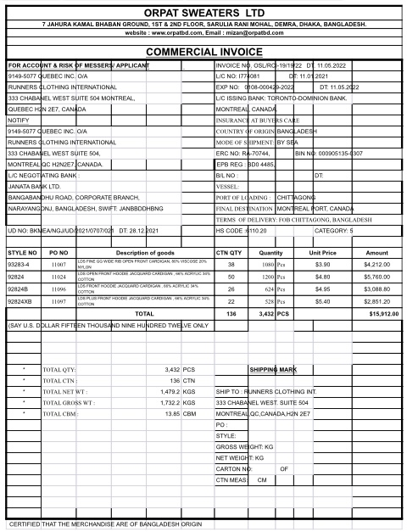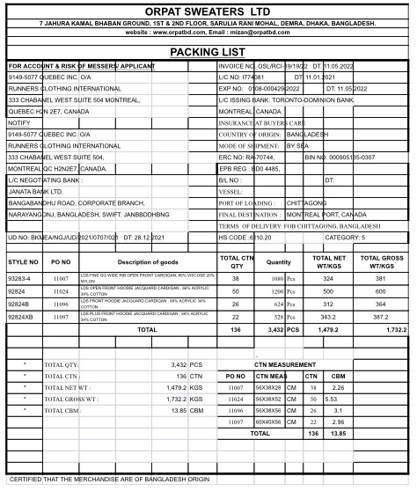

Figure-8 (Invoice of OSL) Figure-9 (Packing list of OSL)

3.3 Contribution to departmental functions

Commitment to my commercial department was hard work and honesty which I tried to do very efficiently and effectively to my capacity. Commercial department has had an impact on me because of their friendly demeanor and eagerness to assist me whenever things were not going well at work. Nevertheless, my contribution to this department has been listed bellow-
- Commercial invoice- it was prepared by me, were at first I had to recognize the format that the buyer or customers wants, which is detailed in the master L/C or contract. Here, it had to be filled with notify parties name, address, L/C or contact no., with dates. Furthermore, with invoice no and date, EXO no., ERC no., BIN no., port of loading, final destination etc. But the main details are the style no., PO no., description of goods, CTN quantity, and quantity of goods, unit price, amount, the net and gross weight of goods and the shipping mark. This is made when the goods have been gone through the packing and ready for shipment.
- Packing list- it is similar to invoice but instead of shipping mark there will be the measurements of cartoon.
- Detailed packing list- this was one of the lengthiest task because here each style and PO no. detailed data was given which includes carton no., total CTN, description, color, sizes, net weight, gross weight, TTL gross weight, TTL net weight and CTN measurement. There are orders where there is plenty of styles and each styles may have numbers of PO’s with different, and detailed packing list has to be made with each PO’s. This taught me, how to manage time and complete the work in an efficient way.
- Incentives- this is a very crucial contribution by me for Orpat Sweater Ltd., the reason behind this is the top management wanted the feed back of my work. Incentive is huge in RMG sector in Bangladesh, because this amount is given by government and the process and documents have to be precise and accurate. Here, for each file I had to prepare- bank forwarding, bank sheet, declaration, ghoshona, form ka for bank and BKMEA, form kha for BKMEA, ongikarnama and application of BKMEA. Then I have to attest all the documents to send in audit firm for approval. After the approval we send it BKMEA and bank for final approval. Few other documents are attested with the document of incentives like- invoice, packing list, EXP form, Bill of lading, import certificate, export L/C or contract, back to back L/C, UD, UD amendment etc.
- UD- preparing UD from software provided by BKMEA, here UD is need for creating back to back L/C for getting yarn and accessories for the production. I have created the UD using the master L/C or contract, purchase order and the Proforma invoice.
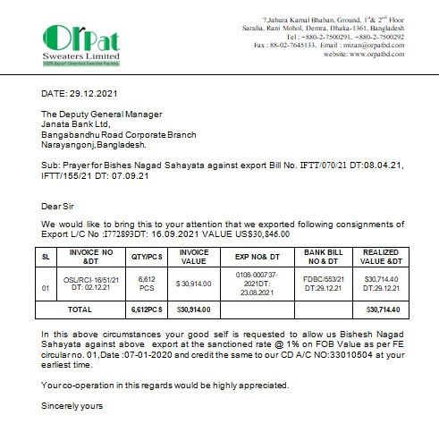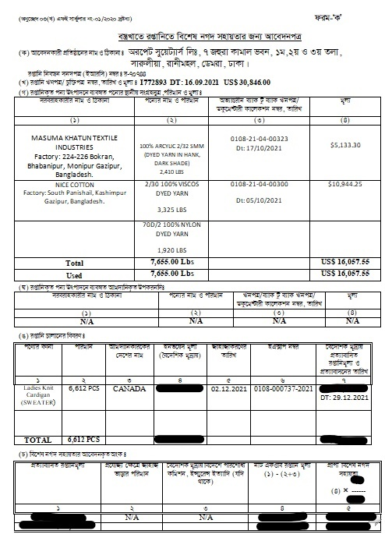

Figure-10(Bank forwarding of OSL) Figure-11 (Form Ka of incentives)

3.4 Evaluation

Regardless of the fact that I was in commercial department, all I have to do is clean up the work space. Whenever, I was given any work like- preparing invoice, packing list, bank note etc, I had given my best. I enjoyed doing all of the work because the tasks that were assigned were given complete clarification and specification. Few of the tasks were very simple and few of them were important and tough to go through but tried to do without any slip ups.
However, we are humans and we make mistakes, I had made some and that was also a learning process. The most important thing, though, was to complete the job correctly. It is critical to stay in any organization, whether as an understudy or a representative, without making such an error.

3.5 Skills applied

The BBA program requires an entry level position to complete the degree. Not only that, but a temporary position provides an opportunity for an understudy to gain experience in the corporate world. It is a period of time during which an understudy can learn and comprehend how to employ themselves as an assistant. Similarly, I've had the opportunity to put my skills to good use.
During my three-month internship with OSL, I was able to put my soft skills to use. Character qualities and interpersonal skills determine one's ability to work and communicate with others. First and foremost, my communication skills could be beneficial to the company. Intermediate Microsoft Word and Excel skills were really beneficial to me, and they are extremely crucial in this industry.

3.6 New skills developed

- Typing Bengali- corporate world in Bangladesh includes documents which are in bangla and it is compulsory. Many documents which are essential for government policies are in bangla and to make it one need to have at least a basic skill of typing Bengali. And my first learning skill was typing Bengali.
- Time management- is another very crucial skill because it is important to manage a bulky work in to a plan and make it in to sub- task. During an internship, which is essentially the start of your working life, I cannot keep track of the absences on a regular basis.
- Responsibility- Becoming honest is an important quality in the job that is sometimes disregarded when it comes to soft skills. The internship experience teaches us how to be more responsible and accountable for our decisions and tasks.
- Adaptability- is not easy for everyone and workplace is quite different. The first month was the toughest part of this internship experience. Having able to quickly adjust to the circumstances is one of the most valuable soft talents, not only for companies but also for the personal development.
- Problem solving skill- Other than deciding what to wear the next day and avoiding the looming assignment deadline, what real-life challenges have our solved so far? An internship exposes us to real-world job difficulties, allowing you to hone your problem-solving abilities.

3.7 Application of academic knowledge

I started as an intern in marketing at Orpat Sweater Limited, where I was given a lot of work to accomplish in MS Word and MS Excel, which I was able to complete quickly thanks to some prior experience. My academic courses also helped me like- service marketing, marketing management, management, business communication and many more, every courses beats and bits helped me in many ways. But the most important thing that helped me with academic knowledge was the confidence level and the belief that if I struggle in any point then I have the capability to get out and solve the problem.

CHAPTER IV: CONCLUSIONS AND KEY FACTS

4.1 Recommendations for improving departmental operations

Here, are some proposal of Orpat Sweater Ltd which should be looked upon and it will help the organization to improve it operational process and will also result in improvement in financial performance.
- The cost of raw material should be reduced because OSL is depended on local suppliers and China; there are other countries which the raw materials can be imported. There should be more of suppliers.
- Inventory management is key issue for every organization, and OSL have to manage and address this issue with proper care.
- Should increase the production volume, specially should focus on more bulk production of fewer styles.
- Hierarchy should be arranged properly and specifically.
- Technological advancement should make in management and also production, tech is the next step for future.
- Employees and workers should be more skilled and efficient.
- The work consignment should be evenly scattered and everyone should provide a feedback of their daily work.

4.2 Key understanding

Readymade garments industry plays a massive part in Bangladesh with foreign earnings and also the employment. Orpat sweater Ltd also contributes a small part in it. Since 1978 Bangladesh was involved in the textile and apparel industry and is specialized in this area.
However, the knowledge gathered while preparing this report was the potential of RMG industry in Bangladesh. The skill that our blue collar and white collar people posses in this sector is enormous, diversification of taste and fashion is a challenge for every business but matching those requirements and following those taken Bangladesh in the top around the world. Through my experience in OSL, I understood the types of documents need which exporting and importing. Following the process of law and policies with the requirement of customer, it needs of lot of paper work with precision and in time. As I was also involved in merchandising, I had a little knowledge about production; the way the cost cutting is done in every step of the product could be brain storming for many people. This business is not easy, because of our reputation and resources, it has a potential to be the top listed branch in the world. However, I enjoyed working in this industry because it is very diversified and we have lot of option and department to choose upon.

4.3 Conclusion

The role of RMG in Bangladesh has a significant impact on the country's monetary development. Orpat Sweater Ltd has its contribution in the foreign earning but still has a long way to go. For Almost 18years OSL has given a continues positive contribution to the financial and operation organizations of Bangladesh. There has been many competitors emerging after, with and before OSL has formed but many has disappeared. However few have also overtaken OSL but Orpat Sweater Ltd has been consistent with their stability and steady rise. In this competitive industry to overcome all the obstacles and strived to provide the demanded product is commendable. Every day OSL is trying to improve their work and facilities to be better day by day.
I worked as an assistant there, which enables me to gather practical information about material firms' operational activities. I depict all of the exercises I did on a regular basis during my temporary work at Orpat Sweater Ltd. However, after analyzing the operation of the organization, I observed it is growing steadily after the disastrous phase of COVID-19. In other words there was a temporary inflation and unemployment rise in the world. This had impacted everyone especially RMG but with the help of government and proper work management, this industry and OSL is again moving to its peak.
In this report I have attempted to give a short thought regarding the whole operational movement of Orpat Sweater Ltd and Bangladesh.

Reference
- http://orpatbd.com/
- https://en.wikipedia.org/wiki/Bangladesh_Knitwear_Manufacturers_and_Exporters_Association
- https://new.bkmea.com/
- http://www.bgmea.com.bd/
- https://en.wikipedia.org/wiki/Bangladesh_Garment_Manufacturers_and_Exporters_Association
- https://www.textiletoday.com.bd/
- Kotler, P. & Keller, K. (2010). Marketing Management, 14 th Edition, Upper
Saddle River, NJ, PrenticeHall.
- Kotler, Philip. (2009). Marketing Management, 11 th edition

Appendix-A:

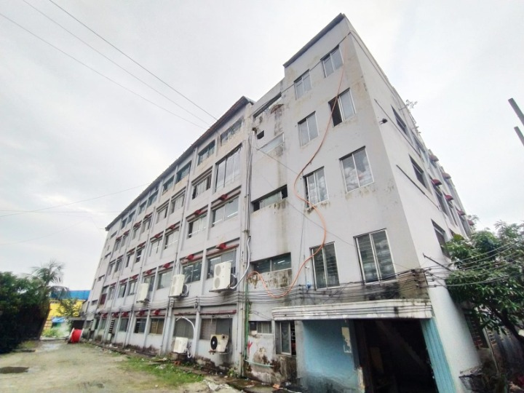

THANK YOU

