Training & Development Process and Effect on Employee Performance
Of
“ASCOTT DHAKA”



United International University
Internship Report on
Training & Development Process and
Effect on Employee Performance
Of
“ASCOTT DHAKA”

Course Name: Internship/ Project
Course Code: INT 4399
Section: A

Submitted To:
Md. Kazimul Hoque
Assistant Professor

Submitted By:
Sadia Tasnim
ID: 111 151 069
Date of Submission: 5th May, 2019

Letter of Transmittal
May 5, 2019
Md. Kazimul Hoque
Assistant Professor
School of Business and Economics
United International University

Subject: Submission of the internship report on “Training & Development Process and Effect on Employee Performance of “ASCOTT DHAKA”
Sir,
Here is the term paper on training & development process and effect on employee performance of “Ascott Dhaka” which you have assigned me in order to get a clear understanding of training and development process and practical overview of an organization. I have tried my level best to gather all kinds of relevant information, which could give overall concept of this report. I hope that it will meet expected standard. I have enjoyed a lot while preparing the report. Especially, HR courses assist me very much and made the great deal of effort really painless. I am submitting this report for your kind attentiveness and thanking you for your continuous help and counselling.
Sincerely yours,
Sadia Tasnim
ID- 111 151 069
Sec- A

----------------------
Signature
Letter of Declaration

I, Sadia Tasnim, Hereby declare that the presented report of internship titled “Training & Development Process and Effect on Employee Performance of “ASCOTT DHAKA” is uniquely prepared by me during the internship on “ASCOTT Hotels, Dhaka” which is located at Baridhara Diplomatic Zone. The report is prepared without any cheating or making any distorted information. Even I didn’t copy from any website.
I also repeat that the report is only constructed for my academic need not for any other reason. It might not be used with the business of opposite party of the organization.


……………………………….
Sadia Tasnim
ID: 111 151 069
BBA
United International University

Acknowledgement

First of all, I would take the opportunity to express my heartfelt gratitude to Allah for making me accomplish the report within the designated time. This report is a part of my academic learning reflection under Human Resource Management. Every analysis is provided with a certain period of time to complete the report.
This is high time to express my cordial thanks to our honorable supervisor, MD. Kazimul Hoque Sir (Assistant Professor, School of Business and Economics, United International University) for assigning such an effective task. Without co-operation and the guidance from him, it would not be possible to prepare a resourceful report. I am thankful to him for all the times I consulted him and for being constantly patient in guiding me throughout the whole term paper. This has enabled me to make a comparison between theoretical knowledge and practical applications of it. I am also thankful to FARIA RAHMAN (Senior Executive, HR and ADMIN) for giving me the valuable information about their company.

Table of Contents
Topic | Page Number
Executive Summary | iv
Chapter 1: Introduction  - Background of the report  - Objectives of the report  - Limitations of the Report  - Methodology  - Sources  - Methodology of collecting data | 1-2
Chapter 2: Literature Review | 3-5
Chapter 3: Company Overview  - Company Profile  - Vision Statement  - Strengths | 6-8
Chapter 4: Training & Development Process and Effect on Employee Performance of “ASCOTT”  - Analysis Process  - Design Process  - Development Process  - Implementation Process  - Evaluation Process | 8-18
Chapter 5: Finding, Recommendations, Conclusion | 19-20
References | 21
Appendix | 22-25

Executive Summary

Every Organization has its own HR department and HR policy. Under training and development, every organization have to maintain those policy. Organizations have to follow training and development policy to upgrade the position. The purpose of this report is to understand the effectiveness of the training development process that I learnt theoretically and practically. By this I will be able to match this with real life.
Here in this report I’ve chosen an organization named “ASCOTT DHAKA”. I selected this organization to have a close eye of our learning. “ASCOTT DHAKA” believes organization need training analysis to increase employee satisfaction and motivated to company. “ASCOTT DHAKA” try to provide world class service and the best value to their customers.
“ASCOTT Hotels” mainly focused to communicate and provide an enjoyable place towards foreign customer by their best space, food and environment so that they need to apply training and development process on their organization. A good training and development process confirms that those who need the training attend and provides the information to show trainees why the training will be effective to them.

Chapter 1:
Introduction

Background of the report
This report is about identifying the training development process of “ASCOTT Hotels Dhaka” and the training process they are following is the main concern of this topic. Training is teaching, or developing in oneself or others, any skills and knowledge that relate to specific useful competencies. Training has specific goals of improving one's capability, capacity, productivity and performance. Before implementing training process, organization have to go for training need analysis. Training needs analysis (TNA) is a systematic method for determining what caused performance to be less than expected or required. The whole training process have to be clear and should be maintained properly.

  - Objectives of the report

Objectives of the report are:
- To understand training development process of the organization.
- To find the problems or difficulties of the organization and employees are facing.
- To understand the employee’s perceptions regarding the implementation of training process they are practicing.
- To find out if there are any other process “ASCOTT DHAKA” follows. If yes, what are those?

  - Limitations of the Report
Limitations of this report are not that much and they gave every detail information that I needed. But there are some limitations I faced. They are:
- They didn’t mention how much they are active about training development.
- We interviewed employer, so we could not get the information from the employees of the organization.

  - Methodology:
    - Sources:
1.4.1.1 Primary Data: The primary data information was gathered through interviews, observation. The primary data are collected from FARIA RAHMAN, (Senior Executive, HR and ADMIN) of “ASCOTT DHAKA”.
1.4.1.2 Secondary Data: The secondary information was gathered from website.

    - Methods of collecting data:
Data was collected by interviewing and observing in the industry. I gathered as much data as I could, then I filtered the information that was collected and classified them under each category of this report. Employee feedback about the organization is also done by survey.

Chapter 2:
Literature Review

Training and Development is a system of an organization which emphasize on the improvement of the performance of employees and groups. It is an educational process which embroils the level of skills, concepts, changing of attitude and gaining more knowledge to prolong the performance of the employees. Effective & efficient training of employees helps in their skills & knowledge development, which eventually helps organization to improve. Training deals with knowing where employees are in the present and where will they reach with their abilities. By training, employee can learn new ideas, new methodology and reshape their existing knowledge and skills. The objective for providing the training is to build an impact that lasts beyond the end time of the training itself and employee gets updated with the new circumstance. Ravinder Tulsiani quoted about training sessions, “Training sessions are vital to the learning process, but they are only one step in the learning process and this should never be forgotten.”
Organization should analyze the organizational situation such as training, knowledge gaps and so many details before thinking about development any content or training strategies. Training team works with the top level management to identify and assess the goals and objectives for the training which need to be developed. It should be done in the first phase of training process. Organization start the process with set of questions to have preliminary ideas about the current situation and also to understand the goal of training. It helps a lot to design the rest of the plans in the process. Most common analyzing issues are the point of the training, what should be the training methods, desired type of behavioral change, how will training help etc. These phase should have clear idea about full audit of the audience, business goals, training methodologies used, media types used, etc. Through the ideas organization should come out with an analysis of training needs and a training plan. Ravinder Tulsiani quoted about strategic process of training and development, “Training alone is rarely the answer to ensuring successful behavior change in the work environment.”
After identifying, questioning and assessing the analysis phase, the training designer begins to make structural plan for the training content and to develop the design. Document will contain outline of the plan only. Design process is the stage where organization take all of the learnings of the previous phase and use it to make practical decisions. Design stage includes a strategy, delivery methods, structure, duration, assessment, and feedback of an organization. Important step is here to storyboard ideas or create a prototype. Clear overview of the course design should be come out by organization. “You can reach maximum performance by engaging in physical activities.” Lailah Gifty Akita said.
Course content of the organization should come on development phase. This stage is when design plan for the training are shaped and graphic designs are created. The authentic course content is written during the third phase called development. After training contents are designed, it is the responsibilities of top level management to execute according to the plan. Each segment of the training should be developed to match the design phase. The main content has already been fixed. The important thing is to add every level of detail and polish to the courses/ training sessions. The development process should be repetitive and continuous. According to Peter Schulz, “Hire Character, Train Skills.”
Implementation is the fourth phase. After the course content is finalized and approved by the top management of the organization at development level, the training is ready to be executed. Facilitators must give feedback and understand the curriculum as well. Books, manuals and copies of software should be acquired if necessary to be distributed during the training. Training scheduling and trainee enrollment are completed during this time. The decisions which was made in the design phase will impact how this is actually carried out. According to Ravinder Tulsiani, “Training alone is rarely the answer to ensuring successful behavior change in the work environment.”
Final phase of evaluation process should come out with feedback and effortful changes for the recent or upcoming training. It is really essential to get review on every feature of the training so that organization can enhance and revise the content for the betterment.
In the evaluation phase, feedback is generated by the participants of the training. Like trainee and employees of the organization. This points can be resolved by examine, either by paper or web based. Receiving trainees' response is essential for the success of destiny of any organization. The evaluation procedure permit the instructional designers to find out if learning goals are being achieved and how properly the training is being received. Long term of feedback may be done several months after the training has placed. These criteria of evaluations are summative and are completed after the training. Julie Bevacqua said, “In order to build a rewarding employee experience, you need to understand what matters to your people.” About feedback Dr. Christopher Lee said, “One of the most tried and true forms of management is feedback.”
Training and development mentions to a set of programs designed to amplify performance of the employees and organizational productivity. Relationship between training and development and employee performance is very important for an organization to boost up their level in the competitive markets. By training and development, employee improves their performance mostly in a positive ways. Organization’s achievement lays on how perfectly the employees are attending in their role. Employee performance of an employee lays on many issues such as motivation, commitment, and engagement. Several findings have replace the fact that training & development plays the most vital part in boosting up efforts of the employees. Training helps to solve performance difficulties by explaining broadly of the job and equipping the employees with the necessary skills to perform well. It save time and cost at the same time. Employee satisfaction, employee self-prophecy increases by training in the organization. According to Robert Kreitner and Angelo Kiniki, “It’s been shown that employees who receive regular, scheduled feedback, including training, along with an increase in expectations, actually have a higher level of worker output. This is referred to this as the Pygmalion Effect.”

Chapter 3:
Company Overview

3.1 Company Profile
Ascott the Residence Dhaka, a luxurious 4 star standard business hotel in Baridhara Diplomatic Zone of Dhaka City established in 2009, with 55 wide and comfortable rooms and suites. All guest rooms are classic and unique in design, complete with all the latest advantages and facilities. The brand new guest rooms are planned with visionary interior, advanced technology specifications and comfortable space, which escape the ordinary, and most essential of all, pleasure your feelings.

ASCOTT THE RESIDENCE – AT A GLANCE

Company Name : ASCOTT - The Residence Limited

Establish Year : 2009

Managing Director : Mr. G.M. Mosharraf Hossain

No of Employee : 245
Address : House no: 13, Road no: 8, Block no: K,
Baridhara Diplomatic Zone,
Dhaka-1212,Bangladesh.
Phone: + 88 02 9885553, 9885561-3,
Hotline: +88 09610997771-8,
Facsimile: + 88 02 9897397
E-mail: reservation@ascottdhaka.com
www.ascottdhaka.com

3.2 Vision Statement
To become the number one leading independent 4* business hotel in Dhaka providing excellent services to every customer, every time. They recognize that this cannot be done without well trained, motivated and enthusiastic employees.
3.3 Strengths
- To make their every guest happy and ensure their return as a key driver of their business;
- To exhibit nobility, supervision and sincerity in all their relationships;
- To be devoted to the financial achievement of their own unit and of their company;
- To remain deeply devoed to their social responsibility by making a positive participation to their communities, environment, colleagues, guests and business partners;
- To ensure their strategies and procedures are guest and colleague-friendly;
- To create an ambience where their subordinates may achieve their personal and career goals.

  - Services
Their services are based on basically Food and Beverage and Hotel management. They mostly involve in these two category. Foreigner stay in the hotel most. So they are concern of their hospitality. According to that food & beverage service also emphasized. They also provide • 24-hour concierge • 24-hour room service • Laundry and valet • Luggage storage • Gym • Business Centre • Gift shop • Spa • 24-hour continuous power supply

  - Targeted Customer:
The target customer for Ascott Hotels are following Sectors:
- Non Profitable Organizations
- Embassy/ High Commissions and Consulates
- Government and UN Missions
- Multinational Companies (MNC)
- RMG/ Apparels
- Overseas business traveler
- Frequent Independent Traveler
- MICE, Travel Agents
- Online Travel Agents (OTA)

  - Organogram of ASCOTT Hotels:
The organogram of ASCOTT is given below:
Human Resources
Director of F&B
Director of Engineering
Director of Rooms
Director of Human Resources
Director of Sales & Marketing
Director of Finance
Executive Assistant Manager (EAM)
Front Office
Housekeeping
Purchasing
Repair & Maintenance
Energy Center
Executive Chef
Accounts
Cost Control
IT
Sales & Marketing
Service & Production
Kitchen
General Manager (GM)
GM’s Secretary

Chapter 4:
Training & Development Process and Effect on Employee Performance
Of “ASCOTT”

Step 1: ASCOTT’s Analysis Process

To improve any organization, training and development process is the main thing to do. The process consists analysis, design, development, implementation and lastly evaluation. First attempt is analysis. And for this organization need to do need assessment. Theoretically we know that analysis should be on three factors. And by analyzing that matters and needs under the factors help to continue further process of an organization. Primarily analysis process is very important to conduct other process and disciplines. Needs assessment is a systematic process for determining and addressing needs, or "gaps" between current conditions and desired conditions or "wants".
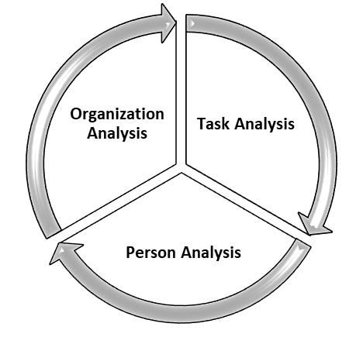
Organizational need analysis:
Organizational needs analysis assist to contrast the current ability in company with the ability need to meet future business goals. The needs analysis focus any gaps in skills, allowing to plan a training or recruitment program. ASCOTT focus on the following analysis for organization. Those are:
- Training content that affect employees’ relationship with customers.
- The procedures of aligning the program with the strategic needs of the business.
- What do they need from managers and peers for this training to succeed?
- What are the assignment and aim of the organization in regards to employee development?
- Which supplies are accessible for training?
- Does top management give support toward training?

Person need analysis:
A person analysis is the examination of the employees in the jobs to determine whether they have the required KSAs to perform at the expected level. Here we measure the actual job performance of those on the job to see whether they are performing at an acceptable level. This task might seem easy enough: simply look at the supervisor’s appraisal of the incumbents. This analysis is on basis of employee’s knowledge, skill and ability.
ASCOTT Hotel’s” provide training daily basis, weekly basis, monthly basis, yearly basis as it is needed. ASCOTT focus on these topics to do analysis on person. Those are given below:
- How to perform effectively?
- How is the knowledge and behavior of employee?
- Is the performance gap is increasing or decreasing?
- Who will receive the training?
- Do the employees have expected essential skills?

As example, if performance is poor for defective machines, by training it cannot be solved. But repairing the machine will solve it. If poor performance happen for lacking of response, then employees may not need training, but their managers may need training on “how to give performance feedback in the organization”.

Task Analysis:
ASCOTT hotels Dhaka is concerned about rooms as well as food & beverage production. They have 41 employee in the front office and 39 employee in the kitchen section. Each tasks are designed by HR department and most importantly head of HR approve the plans. Head of HR receive plans from other department and approve those according to their budget.
The tasks are performed:
- Briefing on products
- IT related basic knowledge
- How to handle fire extinguisher
- Scheduling all the plans and give it to HR department
- Joint training
- Creating yearly budget
- Matchmaking
ASCOTT hotels Dhaka basically perform the tasks effectively. Matchmaking, yearly budget, joint training, basic knowledge those tasks are performed frequently if needed. In order to “ASCOTT hotels Dhaka”, their motto is being Number 1 best hotel in the city. They are trying hard to accomplish that goal. As the tasks are difficult, they are making it easy to achieve. As example they said, match making is the toughest because each department has its own planning. They try to overcome those problems easily.
For employees’ betterment, ASCOTT hotels Dhaka give frequent training by internal trainer of the organization. They basically arrange:
- Leadership training
- Grooming training
- Sales and Marketing training
- Task planning

Step 2: ASCOTT’s Design Process

After analyzing the need assessments, ASCOTT hotels Dhaka focus on designing training process on the needed areas. Designing is all about objective of the settings. Here ASCOTT focus what should be the future alignment for the organization that they will follow.
2.1 S.M.A.R.T Method:
ASCOTT follow S.M.A.R.T objectives to improve their design process. Organization’s each target should be specific, measurable, achievable, relevant and time-oriented.
- ASCOTT is very unique about its organizational goal. To ensure that target is specific to make sure that the way it is elaborated is noticeable.
- They measure the need and according to that they analyze those. It refers to the extent to which something can be judged against some quality.
- They have clear idea whether it is achievable or not and relevant or not at the same time.
- Ascott has good sense of time orientation. It refers to the fact that an intention has end points and check points built into it.
- They try to fulfill their gap and try to minimize it. So in design process they include such method.
For example, ASCOTT hotels Dhaka emphasize Food & Beverage training, Service training which include Reservation and Customer service, Housekeeping, Sales and Marketing. They have described about how they use SMART method for design for Food & Beverage training.

2.2 Alternative Training Methods:
ASCOTT also design the alternative methods of training. They basically follow:
- Lecture | - Audiovisual
- Case study | - Team training
- Business games | - Roles play
- Behavior modeling | - On the job training
- Simulation

2.3 Budgeting:
Ascott try to provide training from internal sources or trainer. They have very skilled employee within their organization. And they also send their employee for foreign training. So after coming back from training, they transfer their learnings to their internal employee. Here they are saving their big amount of money.
They welcome external trainer also. But they do when they need and for special purpose. They spend good amount on their organizational training. Yearly they fixed budget around 2 lac on training. The HR dept. of ASCOTT Hotels Dhaka did not disclose their budget for training programs because of their policy, but they mentioned that they will go to around tk. 3, 00,000 for external trainers.
Segments for expenditure | Amount (Yearly)
Design Cost | 30,000
Development Cost | 60,000
Transfer of Training Cost | 80,000
Evaluation Cost | 30,000
 | = 2,00,000

2.4 Types of learners:
There are different types of learners in every organization. Like:
- Sensing versus intuitive Learners
- Visual versus Verbal Learners
- Sequential versus Global Learners
- Active versus Reflective Learners
ASCOTT basically give “Whole VS Part Learning style training” to their employee. They believe that if any learner is weak, they will get to overcome it by seeing others. But in some cases they divide employee. They arrange training for partly and as a whole.

2.5 Learning Environment:
In learning environment Ascott is concern about clear objectives, practice, meaningfulness, response, observation & interaction factors under training methods. Under these factors, training is perfect up to which level is measured here.
Step 3: ASCOTT’s Development Process

For development Process, ASCOTT follows some steps to give proper solution to their employee’s problems. They try to develop the content by-
- Identify the issues
- Understand everybody’s interest
- List the possible options
- Evaluate those options
- Select the best option
- Document the agreement
- Agree on contingencies, monitoring and evaluation

ASCOTT complete their development process very effectively.
- Emphasizing on the traits and identifying the factors the employees need training on, ASCOTT apply desired designed process.
- If their designed plan work in primary stage, they think about implementing it on broadly.
- If their designed plan doesn’t work well in test run, they revise the design plan and do corrections where they needed.
- They ask for possible interests from employees to overcome the situation tactfully.
- Then ASCOTT list down the possible opinions and evaluate and analysis those opinions.
- Higher management along with department heads select the best option for developing it further.
- Then they go for revised development process.
Expectations are based on performance to some extent. For many reason, employees fail to reach the expected stage. Whenever the hotel feels that their employees are not working up to the standard, they immediately arrange training. And they think training is the only solution they can apply. ASCOTT design the method on the basis of needs of employees. They emphasis on learning style for developing the training. Some people learn by listening, showing visual clips, different way of trainees teaching styles. Within each dimensions the learner will defer in their preference for how they like to earn.

ASCOTT hotel Dhaka focus on some traits. Those are:
- Negotiation skills | - CRM (Customer Relationship Management)
- Personality traits | - Language Proficiency

Step 4: ASCOTT’s Implementation Process

ASCOTT always try to make their training effective. To do that they always determine their employee’s ability to reach that session because the ability of all employees are not equal. Some of them are highly potential and some of them are moderate, so they at first they identify the employee’s ability and then make groups accordingly. Then they tell them what they are going to cover, provide information, always explain what trainees are going to see before they show a multimedia portion, and they keep the session on track. In implementation process they compare training methods for having clear idea. ASCOTT’s comparison of training methods is given on next page.

 | Presentation |  |  | Hands-on |  | Group Building
 | Lecture | Audiovisual | OJT | Simulation | Case study | Business games | Role playing | Behavior modeling | Team training
Learning Outcome
Verbal information | Yes | Yes | Yes | No | Yes | Yes | No | No | No
Intellectual skills | Yes | No | No | Yes | Yes | Yes | No | No | Yes
Cognitive strategies | Yes | No | Yes | Yes | Yes | Yes | Yes | Yes | Yes
Attitudes | Yes | Yes | No | No | Yes | No | Yes | No | Yes
Learning Environment
Clear objectives | Medium | Low | High | High | Medium | High | Medium | High | High
Practice | Low | Low | High | High | Medium | Medium | Medium | High | High
Meaningfulness | Medium | Medium | High | High | Medium | Medium | Medium | Medium | High
Feedback | Medium | Low | High | High | Medium | High | Medium | High | Medium
Observation & interaction | Medium | Medium | High | High | High | High | High | High | High
Transfer of Training Cost | Low | Low | High | High | Medium | Medium | Medium | High | High
Development | Medium | Medium | Medium | High | Medium | High | Medium | Medium | Medium
Administrative | Low | Low | Low | Low | Low | Medium | Medium | Medium | Medium
Effectiveness | High for Verbal Information | Medium | High | High | Medium | Medium | Medium | High | Medium

Step 5: ASCOTT’s Evaluation Process

Evaluation process is most important process of every organization. Without evaluation no organization can upgrade their organizational improvement. ASCOTT also do their organizational evaluation. There are two types of evaluation. Formative evaluation is typically conducted during the development or improvement of a program or course. Summative evaluation involves making judgments about the efficacy of a program or course at its conclusion. Ascott basically follows Summative evaluation system for the organization.
But evaluation process depends on organization. It may vary from one to another. It also can be made by their own. I’ve known how ASCOTT evaluate their employee and how they run the process. After providing the training proper evaluation is very important. ASCOTT Hotels Dhaka always evaluate on the basis of their predetermined training goals. FARIA RAHMAN (senior executive, HR and Admin) of ASCOTT said that “Every training brings some positive results. May be not 100% but it brings in high portion. We then think about those who still do not perform well after giving training. If we find that they are potential then give training again and if they are careless then we stop there. Next time there will be no budget for them.”
In order to the “ASCOTT Hotels Dhaka” the employees are trying to perform up to the established standard. The hotel is basically concerned about rooms as well as food & beverage production, so employees are very much self-motivated. Their process is given below:
- ASCOTT evaluate their employee by observing and giving task related to training they have taken.
- They believe in 360 degree feedback. (From other employees, peers, workers, supervisors).
- They often do survey when it’s needed. Maybe on special case or special event.
- Sometimes ASCOTT take tests or exams to boost up the acceptance capabilities of employees. If they are able to remember the training or not.
- According to result, they offer salary increment often. They give award so that employee can be motivated towards organization. Award can be monetary or non-monetary.
- ASCOTT motivate their employee by an innovative way. That is “EMPLOYEE OF THE MONTH”. They make role model for others by evaluating on the basis of performance.
- Analysis of the return on investment (ROI) of training: ASCOTT Hotels Dhaka did not provide me with actual amount of return on investment of training. But as they said that the success rate is high of a training program so the return will be high from training.
- “Effective training results in a return of value to the organization that is greater than the initial investment to produce or administer the training” ASCOTT Hotels Dhaka agreed on this statement.

Chapter 5:
Findings, Recommendations, Conclusion

Findings
Observing the whole organization, some findings I pointed out. Those are:
- ASCOTT training program is basically based on sales and marketing. And they don’t give task specific knowledge. Which can be the lacking of them.
- ASCOTT doesn’t follow “Job Rotation” which can be very helpful for their organization.
- As they are thinking about sending their employees to abroad for higher level of training, they didn’t start up yet.
- Customer relationship management can be totally different course of training, whereas ASCOTT is giving the training in a mixed way.
- Job instruction training should be given from orientation program of the employee which Ascott provide later.

Recommendations
Many training techniques are created every year to extract the best performance from the employees. By analyzing all the data from the organization. As information I can recommend some suggestions for them.
- Since the main training program of ASCOTT is based on sales and marketing, I think ASCOTT should establish on advance level training program. In this case both “on the job” and “off the job” training should be mixed up. The purpose of on the job training is to provide employee with task-specific knowledge.
- Excellent job rotation program can decrease the training cost where increases the impact of training. Job rotation is a systematic movement of employees from job to job within the organization.
- Job instruction training is a structured training approach to training which requires trainees to proceed through a series of steps in sequential pattern. The technique use behavioral strategy with a focus on skill development.
- Sometimes it is not possible for HR department to provide world class training by internal trainers.in that case ASCOTT can send their head of departments abroad for higher level of training for hotel management.
- Customer relationship management can be different training scope for the organization. It’ll help them to achieve their goal faster.

Conclusion

In order to Ascott Hotels to remain it must place the most systematic strategic aims, recognize the needs for the execution of these aims, instruct their employees and give them the proper knowledge and skills. In order to Ascott hotels, having a prosperous training process it should encourage employees to boost up their skills and honor their learning afterward. The thing that should be considered is that people are not similar and they do not learn and are not encouraged in the same way. Moreover, even if the proper training takes place in Ascott hotels, an assessment process must also happen so as to judge whether the training programmers hold have positive outcomes on employees’ performance and professional development and whether the knowledge gained is preferable to their job.
“Every organization has performance gap. If it can be measured and given proper training, organization will be able to reach its goal. If there are performance gap, that means we are ambitious” MAHMUD RUSSEL (Head of sales & marketing) said that. He also said “If the concern is revenue, our growth rate is 30% which is extra achievement from expectation.” They are concentrating on the performance gap and according to that give frequent training for meeting the goal. But as they said their performance gap is very low in terms of revenue.

References

Bibliography
Ascott The Residence Dhaka. (2001). Retrieved 04 02, 2019, from Ascott The Residence Dhaka: https://www.hotelsone.com/dhaka-hotels-bd/ascott-the-residence-dhaka.html?as=g&aid=45647911718&dsti=449751&dstt=8&akw=ascott%20residence%20dhaka&asrc=Search&ast=&gclid=Cj0KCQjw-tXlBRDWARIsAGYQAmclEOEF-sUtHGOJjwFG7msSJx8O15jM19Ij0ATANY1PbDHuDQHZ4zwaAs_xEAL
Administrator. (2018, 02 12). AssessHub. Retrieved 03 28, 2019, from Assesshub: https://www.assesshub.com/blog/5-simple-ways-measure-training-effectiveness/
Ayers, S. (2017, 09 26). bizfluent. Retrieved 04 05, 2019, from bizfluent: https://bizfluent.com/about-5412764-five-steps-design-training-process.html
Leonard, K. (2019, 01 25). Chron. Retrieved 04 02, 2019, from Chron: https://smallbusiness.chron.com/importance-training-development-hospitality-industry-64312.html
Quigley, E. (2018, 03 29). LearnUpon. Retrieved 04 05, 2019, from LearnUpon: https://www.learnupon.com/blog/addie-5-steps/
Satyendra. (2014, 02 07). Ispat Guru. Retrieved 03 25, 2019, from Ispat Guru: http://ispatguru.com/training-and-development-process-2/

Appendix

Questionnaires that I asked to employers are given below:
- What are the operation and objective of the organization concerning employee development?
- Which supplies are accessible for training?
- What aid will the top management give toward training?
- What are the learning style they follow?
- Who will governance the training?
- Do the employees have expected essential skill?
- What tasks are performed?
- How frequently are they performed?
- What knowledge is needed to perform the task?
- What kinds of training are available?
- Are the employees performing as expected?
- If performance goes below expectations, can training help to improve this performance?
- Are there any Performance Gap?
- What kind of ability an employee need for the job?

- Some important documents are also attached with the report.

Some pictures from ASCOTT Hotels Dhaka
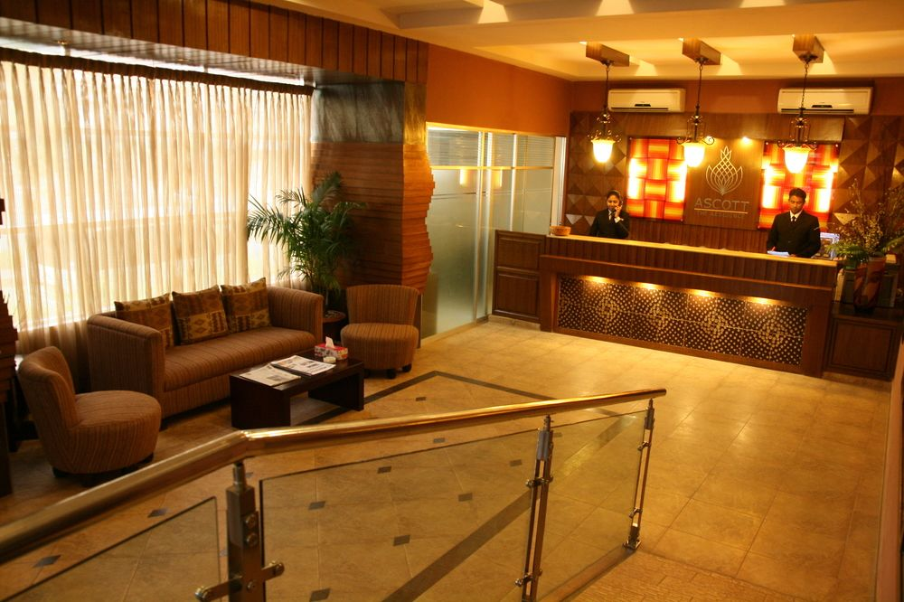


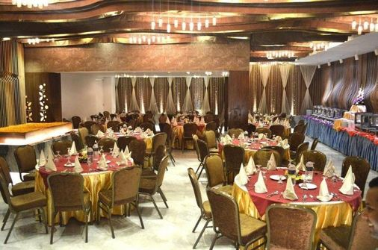
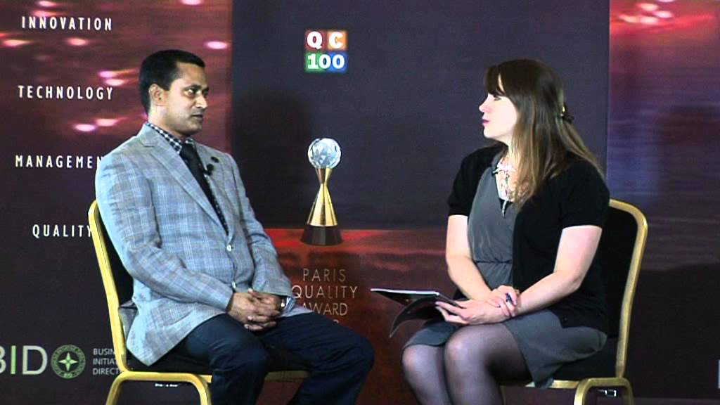

Employee Feedback about ASCOTT Hotels Dhaka

Please tell us about training provided by organization. Your feedback will be very helpful to know more about this organization. Your identity will not be disclosed. Please put tick (✔) mark on your appropriate answer on answer box about the organization.

Questions | Agree | Neutral | Disagree
Trainers are effective in their teaching. | ✔
Trainers have good knowledge about topic of training. | ✔
Overall you are satisfied with the training methods. | ✔
Assessments are based on realistic activities. |  | ✔
Training is focused on relevant skills. | ✔
Training standard is appropriate according to topic. |  | ✔
Training reflect current practice. |  |  | ✔
Organization acted on employee feedback. | ✔
Employees gain knowledge & skills they needed from training. |  | ✔
Training is an effective investment. | ✔
Resources are used properly on training. |  | ✔
Higher employee help new employees with instructions. | ✔
Authority consider employee suggestion. | ✔
Training is frequent for good for employee. |  | ✔
You are evaluated fairly and rewarded. |  | ✔

