

An Internship Report on Overall Banking Activities of a Branch of Mutual Trust Bank Ltd

An Internship Report on
Overall Banking Activities of a Branch of Mutual Trust Bank Ltd

Prepared by

Mahmuda Khan
BBA in AIS
ID: 114142004

Prepared for

Dr. James Bakul Sarkar
Associate Professor & Deputy Director
BBA Program, School of Business and Economics

United International University
February 08, 2019
Letter of transmittal
February 07, 2019

To
Dr. James Bakul Sarkar
Associate Professor & Deputy Director
BBA Program, School of Business and Economics.
United International University.

Dear Sir,

Subject: Submission of Internship Report

With due respect, I would like to thank you for assisting and supporting me to prepare this internship report. As I have done my internship report on Mutual Trust Bank, this internship report helped me to research the overall banking sector. In my internship report I tried my best to explore the main departments of bank such as General banking department, Cash department, Foreign Exchange department, and Credit department etc. I think it’s a great pleasure for me to get an opportunity to work with such bank which holds a very well position than other banks in Bangladesh. I think I am very lucky to be a little part of MTB within a very short time.

Finally, I would like to convey my sincere gratitude for giving me such a wonderful opportunity to work. I will be available for any clarification on this report whenever necessary.

Yours Sincerely,

Mahmuda Khan
BBA in AIS
ID: 114142004

Acknowledgement

First of all I would like to thank the Almighty because without him It is not even possible to think in proceeding in my work. I, Mahmuda Khan especially would like to thank my academic supervisor, Dr. James Bakul Sarkar, Associate Professor and deputy director of United International University. With his continuous guidance and support, I understood my task and he kept helping me throughout the report. Without his kind supervision this report would not have been possible.

A lot of effort and study have been put to make this report into a reality. This would not have been possible without the genuine support and assistance provided by the people whom I approached during the various stages of writing this report. Here I would like to thank my organizations supervisors, Mr. Ismail Hossain Deputy Manager (DM) and Assistant Vice President (AVP), GB incharge Farhana Akter and First Assistant Vice President (FAVP) of MTB Dhanmondi branch. I would also like to thank other officers of that branch who have been so supportive and helpful to me during my internship period. They helped me in every possible way. Without their involvement it was not possible for me to understand banking sector in this short period of time and prepare this report alone.

Executive Summary

Every day banking sector is modernizing and developing its different financial events based on their customers demand. Banking process is becoming faster, and easier to their customers. Now a day’s customers can get any bank related information easily sitting at home by their SMS banking service. Mutual Trust Bank is a third generation private bank of Bangladesh. It has started its journey on 23th October, 1999. Its starting capital was BDT 100,00,00000/-. It operates all banking activities through head office. From the starting point the number of branch of MTB was very few. But now gradually the number of branches has increased. Mutual Trust Bank offers various products based on their customers demand such as Brick by Brick, Monthly benefited plan, Children education plan, MTB School Banking, MTB Milliners Plan, etc. Beside this MTB offer various online banking activities such as MTB SMS banking, Tele banking services etc.MTB also provides other service such as Issue Pay order, Demand Draft, locker service, Credit card service and debit card service. Dhanmondi branch is the 9th position of whole bunch of MTB. In 2018 Dhanmondi Branch achieved their target profits. This branch is mainly furnished by four main department such as General banking department, Cash department, Foreign exchange department, and Credit department etc. All the departments are individuals and officers are doing their job sincerely. The regular task of General banking is to open a new account, issue pay order, close dormant account, and authorize cheque and many other. On the other hand the main task of cash department is to receive cheque from the customers and give money to the customers. Before giving money officer will at first check depositor’s signature, date, and valid amount depositor want to withdraw. If everything is ok then depositor can withdraw money. Foreign exchange department is another important department where all export, import and foreign remittance related activities has done. Here L/C is the main documents of export, import and if any nonresident Bangladeshi sent money from outside, anyone can withdraw money if he/she has an account on MTB. Anyone can also send money outside Bangladesh. Now the most important department is credit department. The main task of credit department is to sanction different types of loan. Mutual Trust Bank has established with the aim of fulfill consumers target and become a leading bank in Bangladesh.

Table of Contents
Executive Summary i
LIST OF Tables v
List Of Figures v
1.0 Introduction 01
1.1 Background 01
1.2 Objectives 01
1.3 Scope 01
1.4 Limitations 02
1.5 Methodology 02
1.6 Possible Outcome 02
2.0 General History of Mutual Trust Bank 02
2.1 Overview of Mutual Trust Bank 02
2.2 History of MTB 04
2.2.1 Vision 04
2.2.2 Mission 05
2.2.3 Philosophy of MTB 05
2.2.4 Core Values and Commitments of MTB 05
2.2.5 Slogan of MTB 05
2.3 Objectives 05
2.4 Functions 06
3.0 Products and Services 06
3.1 Banking Products 06
3.1.1 Brick by Brick 07
3.1.2 MTB Monthly Benefit Plan 08
3.1.3 MTB Education Plan 09
3.1.4 MTB Millionaire Plan 11
3.1.5 MTB School Banking 12
3.2. Banking service 13
3.2.1 Online banking service 13
3.2.2 Facilities of Online banking services 13
3.2.3 MTB Tele banking service 13
3.2.4 SWIFT Services 13
3.2.5 Pay order 14
3.2.6 Demand Draft(DD) 14
3.2.7 MTB SMS Banking 14
3.2.7.1 Facilities Avail to the Customer 15
3.2.8 MTB Locker Service 15
3.2.9 Credit Card Servics 15
3.2.10 Debit Card Servics 16
4.0 Introduction to MTB Dhanmondi Branch 17
4.1 Organogram of MTB Dhanmondi Brunch 17
4.2 MTB Dhanmondi Branch 17
4.2.1 General Banking 18
4.2.1.1 Front Desk 18
4.2.2 Cash counter section 25
4.2.2.1 Cash Payment 25
4.2.2.2 Cash Receipt 26
4.2.3 Foreign Exchange 27
4.2.3.1 Foreign exchange division 27
4.2.3.2 Functions of foreign exchange Department 28
4.2.4 Credit Department 38
4.2.4.1 Continuous loan 43
4.2.4.2 Demand Loan 43
4.2.4.3 Term Loan 43
4.2.4.4 Short term agricultural loan 44
4.2.4.5 Corporate loan 44
4.2.4.6 MTB GUNABATI 44
4.2.4.7 MTB BHAGGOBATI 45
4.2.4.8 Retail Loan 46
4.2.4.9 MTB Auto loan 46
4.2.4.10 MTB Home loan 47
5.0 Corporate Culture of MTB 47
5.1 Career Opportunity of MTB 48
5.2 Customer Service of MTB 48
6.0 My Experience as an Intern in Mutual Trust Bank 48
6.1 Introduction 48
6.1.1 My job in General Banking section of MTB 48
6.1.2 My job in Cash Department of MTB 49
6.1.3 My job in Foreign Exchange Department of MTB 49
6.2 Observation 49
7.0 Recommendations 50
8.0 My future career plan based on my internship 51
9.0 Conclusion 51
10.0 Appendix: Abbreviations 52
REFERENCES 53

LIST OF TABLES
NO.OF  Figure | Name of Table | Page
1 | Bank detailed profile. Data collect of DSE webside. | 4
2 | Monthly installment & Deposit brick by brick | 8
3 | Monthly Benefited plan | 9
4 | MTB Education plan | 11
5 | MTB Millionaire Plan | 12

List of Figure
NO.OF  Figure | Name of Figure | Page
1 | 19 years of mutual progress | 3
2 | MTB Brick by Brick | 7
3 | MTB Monthly Benefited Plan | 9
4 | MTB Education Plan | 10
5 | MTB Millionaire Plan | 12
6 | MTB SMS Banking | 15
7 | MTB Debit Card Credit Card service | 16
8 | Branch Organogram | 17
9 | Foreign Exchange | 28
10 | MTB Gunabati | 45
11 | MTB Bhaggobati | 46
12 | MTB Home Loan | 47

1.0 Introduction
1.1 Background

As a student of the Business Administration of United International University, It was compulsory for me to do internship in an organization and I have met that obligation with the support of Mutual Trust Bank Ltd. I have carried out my internship in Mutual Trust bank Ltd, Dhanmondi Branch. While preparing this internship report, I got a great opportunity of acquiring knowledge about banking.

1.2 Objective

Broadly the objective of this study is to fulfill the requirement of the BBA program. The specific objectives are given below:

- To present the current scenario of banking sector.
- To study the profile of Mutual Trust Bank Limited, this will include history of the Bank, current status of Bank, its products, organizational structure, mission and vision.
- To explicate the way how banking sector developing their business by bringing their new concept day by day.
- To gather knowledge of different banking services of MTB.
- To gather knowledge of different transactions of different departments.
- To know about the MTB products and the rules.
- To gather knowledge about foreign exchange such as export, import, and foreign remittance.
- To create awareness about credit.
- To create awareness about small and medium loan.
- To get an overall idea about the performance of the Mutual Trust Bank Limited.

1.3 Scope
In this report, I have discussed the activities of a branch of MTB. I think the report will helpful to know about the branch banking of MTB, its performance and its different departments such as general banking, credit and foreign exchange. This report is solely concentrating on overall banking activities of a branch of Mutual Trust Bank Ltd.

1.4 Limitations
No internship report is free from limitations. I have faced some problems during the study which I have mentioned below.

I had completed this report within a very short time which is not sufficient to show everything in detail. That is why I was unable to collect more information. All the officers were very helpful and I have learned many things from them. The main problem is most of the time they remain busy with their daily works. Sometimes they cannot cooperate due to their work pressure. This made it difficult for me to collect information for my study.

1.5 Methodology

This report clearly falls into qualitative category as its aims to explore branch banking activities. The information of my report is collected from both the primary and secondary sources of data.
- Primary Data: Primary data is collected from practical desk work, conversation with officers and clients, observation of different banking activities personally, through study of organizational files.
- Secondary Data: Secondary data is collected from Annual report of Mutual Trust Bank, MTB website, MNet and different articles and Journals of MTB.

1.6 Possible Outcome

I have analyzed the activities of MTB branch banking.

2.0 General History of Mutual Trust Bank

2.1 Overview of Mutual Trust Bank

Mutual Trust Bank is a public limited company which operates by Bangladeshi shares. It has a good operating performance. The main aim of MTB is to fulfill its targets and provide efficient service to its clients. It also provides a huge commercial banking service. Generally the bank has achieved success among its peer group within a short time and it also achieved success by its professional and dedicated management team. The entire management believes that all the employees have the ability to face any challenge successfully both in micro and macro levels.
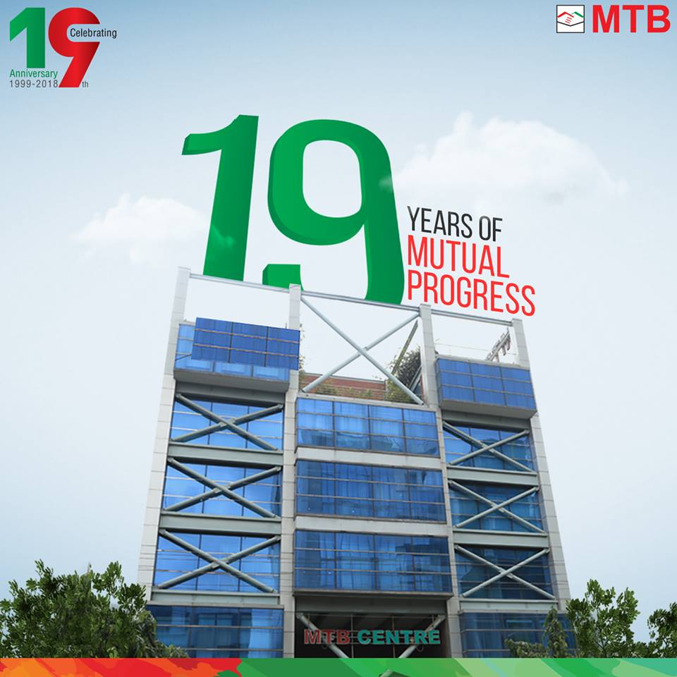
Figure 1: 19 years of mutual progress

2.2 History of MTB

The company was started their journey on 29th September, 1999 under the companies act 1994. Company started their journey as public company limited by shares and also started with all banking activities where their authorized capital was Tk 30,00,000,000 which was divide into 38,000,000, ordinary shares of Tk 100 each. On the same day the company was also issued Certificate for commencement of business and was granted license on October 5, 1999 by Bangladesh bank under the banking companies’ act 1991. It was started its banking activities on October 24, 1999. The bank performs all types of banking activities including foreign exchange business and other financial activities. At the time of starting, first two years the bank’s main focus was on delivery on personalized customer’s services and expand its customer’s services.
MTB started its banking activities by following types of banking business such as

- All types of commercial banking activities including Money Market operation.
- Merchant Banking activities.
- Investment in Company activities.
- Financiers, Promoters, Capitalists etc.
- Financial Intermediary Service.
MTB operates its financial activities through its head office under 114 branches. Mutual Trust Bank has also a very strong network with Foreign Correspondent Bank.

KEY STATISTICS | Amount
Authorized Capital | 10,000.00
Paid Up Capital | 5,096.56
Total Market Capitalization | 15,952,233,864.20
Face Value | 10.0
52 Weeks Range | 22.00-36.20
Table 1: Bank detailed profile. Data collect of DSE website.

2.2.1 Vision
Mutual Trust Bank’s vision is based on a philosophy known as MTB3V.

- One of the best performing banks in Bangladesh
- The bank of choice
- A truly world-class bank

2.2.2 Mission

“MTB aspires to be the most admired financial institution in the country, recognized as a dynamic, innovative and client focused company that offers an array of products and services in the search for excellence and to create an impressive economic value”.

2.2.3 Philosophy of MTB
MTB’s main philosophy is to become a client focused financial institution of all the banking institution by providing its service with trustworthiness and reliability.

2.2.4 Core Values and Commitments of MTB
- Customers – Provide state-of-the-art service to our customers by offering diversified products and by aspiring to fulfill their banking needs to the best of our abilities.
- Employees – We rely on the inbuilt merits of the employee and honor our relation as a part of this renowned financial institution.
- Shareholders – Create sustainable financial value for our shareholders by utilizing a sincere and efficient business methodology.
- Community – Committed to serve the society through creating employment, holding community projects and events and being an accountable corporate citizen.

2.2.5 Slogan of MTB
“YOU CAN BANK ON US”

2.3 Objectives
- The targets of Mutual trust bank limited is to offer an interest free banking system in the financial market so that it can achieve the reliability of its client.
- Build up an alliance with clients and offers a respectable relationship between the customer and employee.
- Set up a well organized money saving framework.
- Invest their profit on the basis of risk sharing.
- Accept deposit on profit and loss sharing way.
- Invest savings on prospective of economic sectors and create employment opportunities.
- Extend its banking service among all income group people which help to support their standard of living.
- Create integrity between trade and commerce.
- The main focus of the bank is to develop the economic condition of the nation.

2.4 Functions
The functions of MTB are given below:
- It offers all types of deposit accounts with on line facilities.
- It provides many other banking services.
- For the promotion of the bank it is adding new features and social activities.

3.0 Products and Services
The main target of Mutual Trust Bank Ltd is to ensure customers contentment regardless its customer’s earning position. MTB offers all types of accounts, such as Current, Savings, Short Term Deposit, Fixed Deposit, Consumer asset and liability product etc. Along with these banking operations MTB introduces many services and initiates numbers of banking products for its clients.
3.1 Banking Products
MTB consumer banking products are:
- MTB Brick by Brick
- Monthly Benefit plan
- Children Education plan
- MTB School Banking

3.1.1 Brick by Brick
The MTB product, brick by brick is a monthly deposit scheme. The name of the scheme, brick by brick comes from the concept of putting one brick after another to build a wall. In the same way deposit of small amount every month will help depositors to get a big amount after few years. This plan is generally designed for the low and middle income people. In this plan one can deposit on a monthly basis and at the end of the period he/she will get a handsome amount with a good rate of interest. Terms and conditions to open an account of MTB Brick by Brick are:
- An Adult (s) can open this account individually or jointly.
- A guardian on behalf of his/her minor can open this account but in this case the rule of minor account will be followed. The monthly installment of this plan is started BDT 250, BDT 500, BDT 1000, BDT 2000, and BDT 5000 and can be multiples of BDT 500.
- A customer can open this account for 3/5/8/10 years. More than one account can be opened by the same depositor in the same branch.
- Installment may be deposited within 20th of every month by cash or cheque or under the depositor’s instruction from another deposit account. If the 20th day of the month happens to be a holiday, the installment will be deposited by the next working day.
- Advance installments may be deposited but no additional interest will be paid for this.

Figure 2: MTB Brick by Brick

An example of Brick by brick scheme is given below:
Monthly installment | Period 3 years Rate of interest 8% | Period 5 years Rate of interest 8% | Period 8 years Rate of interest  8.10% | Period 10 years Rate of interest 8.25%
250.00 | 10,181.62 | 18,429.37 | 33,644.69 | 46,339.76
500.00 | 20,363.23 | 36,858.75 | 67,289.38 | 92,679.53
1000.00 | 40,726.47 | 73,717.50 | 134,578.76 | 185,359.06
2000.00 | 81,452.94 | 147,435.00 | 269,157.53 | 370,718.12
5000.00 | 203,632.35 | 368,587.49 | 672,893.82 | 976,795.29
Table 2: Monthly installment & Deposit brick by brick

3.1.2 MTB Monthly Benefit Plan
Generally monthly benefit plan helps people to deposit some amount of money from their monthly income. Through this plan a depositor will get monthly interest against deposited amount on a regular basis. This plan ensures the future securities of the depositor. The plan is designed generally considering the future security of the retired government and non-government employees and other calculative depositors. Terms and conditions to open a monthly benefit account are follows:
- Person/persons can invest in this plan individually or jointly.
- This plan will be 1 year, 2 years, 3 years, 4 years, 5 years, and after this plan the account will be renewed automatically.
- The minimum amount to be deposited to MTB monthly benefited plan is BDT 1, 00,000 and multiple of BDT 1, 00,000.
- More than one account can be opened by the same depositor in the same branch.
- The date, on which the deposit is received, the interest will be paid on the same date of the next month in the depositor’s saving/current account.
- If the depositor wishes to withdraw the deposited amount before the agreed term, the interest will be paid at the prevailing savings rate and the already paid excess interest money will be adjusted from the depositor’s principle amount.
- In case of the death of the depositor, the plan will cease to the function. The amount will paid to the nominee (s) with applicable interest as per the rule on proper identification.
- Government Tax/Tax at source etc. will be deducted from the payable amount as per Govt. rules.
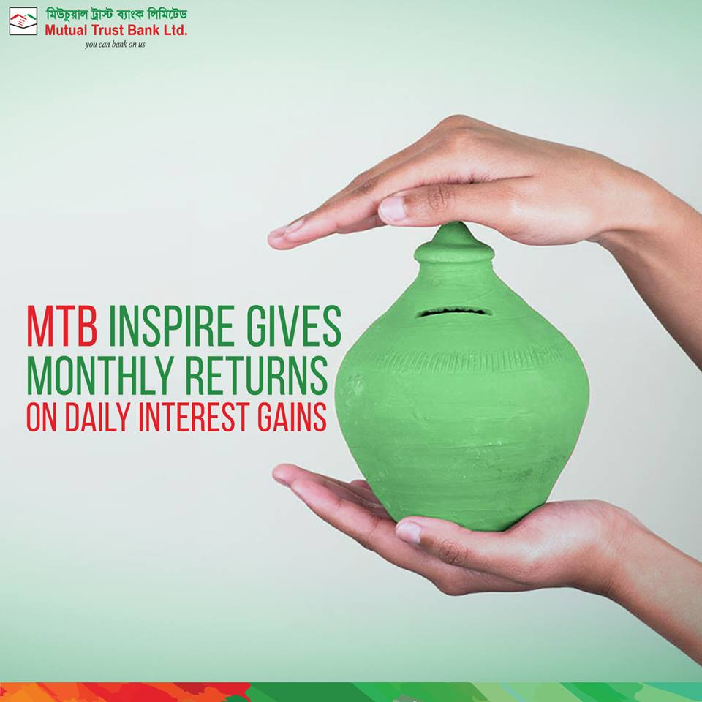
Figure 3: MTB Monthly Benefited Plan
Credit Facilities:
The customer may avail loan up to 90% of the deposited amount.
An example of monthly benefit plan is given below.
Principle Amount  (For Example) | Period | Monthly benefit  (Before Tax) | Monthly benefit (After deduction of tax @ 10%) | Monthly benefit (after deduction of tax 15%)
100,000 | 1 Year | 700 | 630 | 595
100,000 | 2 Years | 700 | 630 | 595
100,000 | 3 Years | 700 | 630 | 595
100,000 | 4 Years | 700 | 630 | 595
100,000 | 5 Years | 700 | 630 | 595
Table 3: Monthly Benefited plan

3.1.3 MTB Education Plan

There are 5 basic need of human being which is compulsory for their daily life. Education is one of the basic important needs. Without education no nation can develop. So it is the backbone of every nation. An educated nation can easily contribute to their society and economy. That is why we need to ensure proper education for our future generations. Savings is the key to build up a better future. If this savings start from the very early stage such as children education then it ensures a better future of a child. In this concern, MTB offers this plan to the parents to save for 4 years, 5 years, 9 years, 12 years, and parents can deposit any amount of money any day of the month. This plan is meant for mainly the lower income clients to ensure their children’s education / higher education.
The terms and conditions of education plan are given below:
- Any person or persons can open this account individually or jointly.
- A guardian on behalf of his or her minor can open this account but in this case the rules of minor account will be followed.
- The monthly installment of this Plan is Tk.1000/- and it multiples and not exceeding Tk 20,000/-
- A guardian will operate the account on behalf of his or her child. But in this case the rules of minor account will be followed.
- A client can deposit in this plan according to his/her choice for 4/7/9/12 years. More than one account can be opened by the same depositor in the same branch.
- Installment may be deposited within 20th of every month by cash/cheque or under the depositor’s instruction from another deposit account. If the 20th day of the month happens to be a holiday, and the installment may be deposited by the next working day.
- Advance installments may be deposited but no additional interest will be paid for this.
- Late fees @ 2% of installment amount per month will be charged for failure to deposit the installment in time.
- If the depositor fails to pay 3 consecutive installments, the account will be closed and net payable amount will be transferred to link account (if any) or to sundry Deposit account and the customer will be informed accordingly.

Figure4: MTB Education Plan

The proper example of MTB Education Plan is given below.
Monthly Installment | Period 4 years rate of interest 8% | Period 7 years rate of interest 8% | Period 9 years rate of interest 8.10% | Period 12 years rate of interest 8.25%
1000.00 | 56,575.35 | 1,12,730.45 | 1,58,232.63 | 2,44,028.76
2000.00 | 1,13,150.70 | 225,460.90 | 3,16,465.25 | 4,88,057.53
3000.00 | 1,69,726.05 | 3,38,191.35 | 4,74,679.88 | 7,32,086.29
4000.00 | 2,26,301.40 | 4,50,921.80 | 6,32,930.51 | 9,76,115.06
Table 4: MTB Education Plan

3.1.4 MTB Millionaire Plan
MTB millionaire is another deposit scheme of mutual trust bank. Generally it’s a monthly deposit scheme which will make a client millionaire after a certain period. This scheme will be very much helpful to implement a future plan successfully by small savings. If any person/persons want to open this account he/she must follow some terms and conditions such as:
- Any person/persons can open this account single or jointly.
- The scheme is mainly 4years, 5 years, 6 years, 8 years, 10 years, 12 years, and 15 years. More than one account can be opened by the same depositor in the same branch.
- Depositors have to deposit the installment within 20th of every month by cash or cheque or under the depositor’s instruction from another deposit account. Under any circumstances if the 20th day of the month happens to be a holiday, the installment will be deposited on the next working day.
- If the depositor fail to pay three consecutive installments, the account will be closed and net payable amount will be transferred to link account (if any) or to sundry deposit account and the customer will be informed accordingly.
- If the depositor wishes to withdraw the deposited amount before agreed term, the interest will be paid prevailing savings rate but no interest will be paid if the depositor withdraws the deposited amount before one year.
- In case of death of the depositor the plan will cease to function. The amount will paid to the nominee with applicable interest as per the banks rules and regulations.
- Advance installments may be deposited but no additional interest will be paid for the installment paid in advanced.
- If any person fail to deposit his/her installment then late fees will be count @ 2% of the amount of BDT 200.00 whichever is higher will be late charged per month for failure to deposit the installment in time.
- If the address of the depositor is changed, it must modify immediately to the branch in writing. Tax at sources is deducted at applicable rate.

Figure5: MTB Millionaire Plan

Proper example of MTB Millionaire plan is given below.
Rate of Interest | Monthly installment | Period | Maturity value
8.00% | 176756.00 | 4 years | 10,000,000.00
8.00% | 135654.00 | 5 years | 10,000,000.00
8.00% | 108392.00 | 6 years | 10,000,000.00
8.10% | 74306.00 | 8 years | 10,000,000.00
8.25% | 53950.00 | 10 years | 10,000,000.00
8.25% | 40,979.00 | 12 years | 10,000,000.00
8.25% | 28418.00 | 15 years | 10,000,000.00
Table 5: MTB Millionaire Plan

3.1.5 MTB School Banking
Recently MTB has started another service scheme name MTB School banking. The main target of this scheme is to save some amount of money for the school going children and also teenage students to ensure their bright future. Only for that reason MTB started this scheme. The Terms and conditions of opening the account are same but one fact is as school going children or teenage students is a minor that is why the account will be open student’s parent’s name that’s called joint account. Here three signatures will be applicable parents and student.

3.2 Banking service

3.2.1 Online banking service

Mutual Trust Bank always try to capture their market and also compete their competitors bank that is why they are providing all time online banking service to their customers. This online banking service offers customers to know the balance of their account & withdraw money anytime from any other branch of the bank.

3.2.2 Facilities of Online banking services

- Through online banking service a client of MTB can access and operate his or her account anytime anywhere.
- Client can check own account summary.
- Client can check at least 5 transaction detail through their smart phone.
- This online banking also offers services both in English and Bangla, which makes it more userfriendly.

3.2.3 MTB Tele banking service

MTB always tries best to fulfill its customers demand. Since everyone owns a Smartphone nowadays, MTB has started smart banking service. As MTB is third generation’s bank, its tele banking service offers customers access in their account through smart phone on a 24X7 basis. These facilities are totally secure and bank provide their customer a secret number to access his/her bank account. There is also a voice response system to help the customer and fulfill their requirements.
3.2.4 SWIFT Services

Generally the full form of S.W.I.F.T is Society for Worldwide Inter-Bank Financial Telecommunication. It’s a worldwide community where 200 countries of more than 7800 financial institution are connected with SWIFT. The main task of SWIFT is to deliver quantifiable business value, technological excellence, high quality messaging value, high securities and reliabilities, and the social awareness activities so that all the banking sector can follow same platform of advanced technology. This service creates a community which offers shared technology where each member can help other when necessary. Mutual Trust Bank is one of the members of this community. It has started its journey on 2004. Being a member of SWIFT MTB ensures its customers financial transactions security and quickest service all over the world.

3.2.5 Pay order

Before describing about pay order service, first I would like to describe about what pay order is and its task. Generally pay order is one kind of cheque. This cheque is given by two parties, first who issues pay order and second who receives the pay order. Issuing pay order is the safest way. Because sometimes it may be very tough to carry huge amount of money that is why a person or company issues pay order because this pay order can only be cashed by that specific person or company. If the leaf of pay order is lost, no one can withdraw the money of this pay order. Only the specific person/company can withdraw that money. The charge of pay order is given below.
Amount | Commission
Up to 10,000 | 25 taka
10001- 100,000 | 50 taka
100001- 500000 | 100 taka
For non account holder the charge will be BDT 230/-

3.2.6 Demand Draft (DD)

Generally demand draft is one kind of negotiable instruments which is similar to a bill of exchange. Customers sometimes use demand draft for the transfer of money from one place to another. The charge of demand draft is 0.15% commission.

3.2.7 MTB SMS Banking

Mutual trust bank has brought its banking business to the customer’s fingertips. It helps the customers to get textual information of 24 hours and 7 days. It allows customers to get all the information through text messages. The charge of SMS banking is annually BDT 345/-
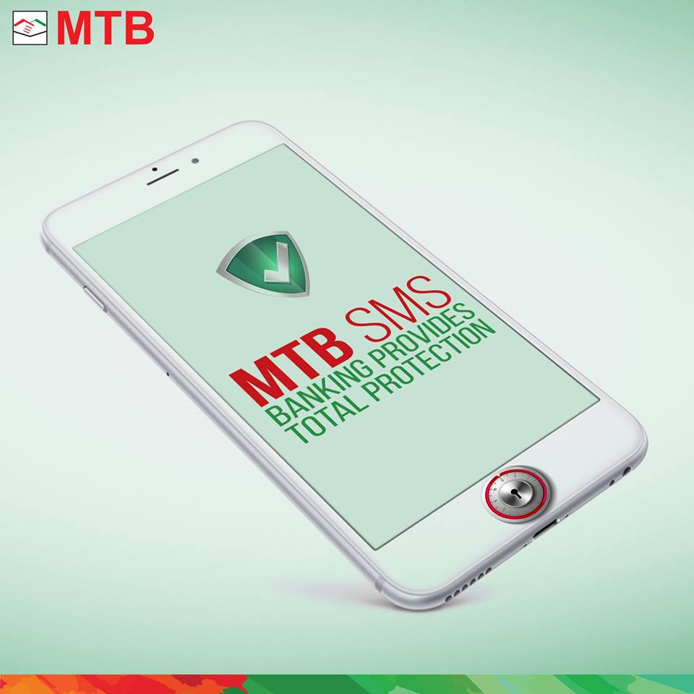
Figure 6: MTB SMS Banking

3.2.7.1Facilities Avail to the Customer

- Customer can easily access their account through their phone from anywhere of the world when necessary.
- They can easily check their balance without visiting bank.
- Through sms banking they can easily get small statement of last 5 transactions.
- When any customers withdraw money from ATM or pos machine they can get notified instantly through messages in their phone.

3.2.8 MTB Locker Service

Another service of Mutual Trust Bank is locker service. Customers can keep their valuable assets such as ornaments, money, important documents here safely. Generally three keys are available for locker service. One is provided to the customers, second one is provided to the locker in charge, and last one is provided to the deputy manager. There are three types of locker on MTB Dhanmondi Branch small, medium and large. The charge of locker is respectively 1500, 2000, and 2500 annually.

3.2.9 Credit Card Services

Bank Name: Mutual Trust Bank
Card Types: Visa Classic Credit Card, Visa Gold Local Credit Card, Visa Dual Gold Credit Card, Visa Platinum Credit Card, Master Credit Card Gold, Titanium Master Credit Card, Visa Signature Credit Card, World Master Credit Card,
Description:
- 45 days interest free period.
- Great Discount.
- Immediate cash advance facility.
- Convenient Payment option.
- E- System services.

3.2.10 Debit Card Services

Bank Name: Mutual Trust Bank
Card Types: Visa Classic Debit, Visa and Master Card Gold Debit, Master Card Titanium and Platinum, Gold Debit Card, Master Card World and Visa Signature Debit Card.
Description: MTB debit card is offered to all kind of clients who have an account of savings, current and STD. This card can be used at any banks booth, but a low amount of charge is deducted when the card is used in different ATM Booth.
- No cash fee for first year
- No time binding for withdrawal of money.
- No need to come to the bank for cash withdrawal.

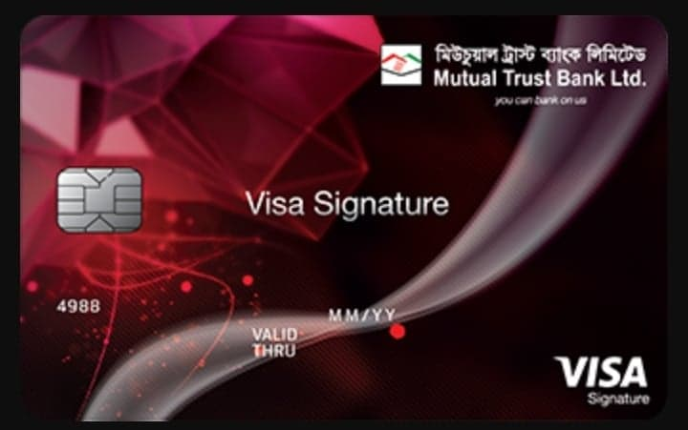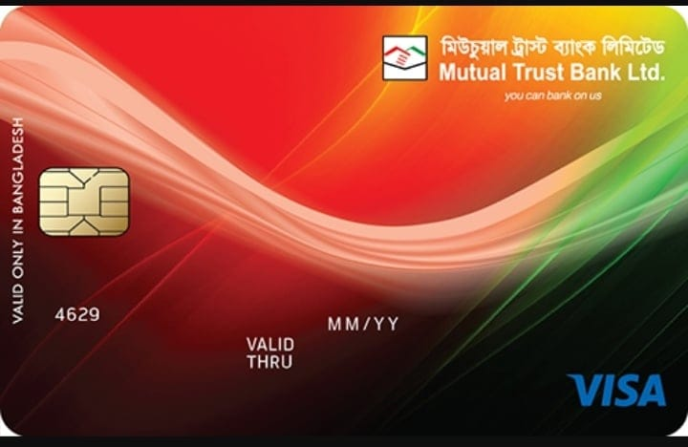
Figure 7: MTB Debit Card Credit Card service.

4.0 Introduction of MTB Dhanmondi Branch
4.1 Organogram of MTB Dhanmondi Brunch
Manager (Brunch In charge)

Deputy Manager

Foreign Exchange
Credit
General Banking
Accounts in Charge
Cash in Charge
Export
Import

Foreign Remittance

Customer Service

Receiving officer
Paying Officer

Post- Section
(Documents)
Pre-Sections
(Loaners Procedure)

Accounts
Clearing

Junior Officer
Assistant Officer
Senior Officer
Officer

Figure 8: MTB Organogram

4.2 MTB Dhanmondi Branch
Dhanmondi branch is one of the furnished branches of Mutual Trust Bank. It has started its journey on 23rd December 1999. More than 50 employees including staffs are working here. The ranking of this branch is 9th position among all branches of MTB. In 2018, this branch has fulfilled its target profit. Though the target of last year was 12 crores, but it fulfilled its target and achieved 15 core profits. This has only been possible for the hard work of the officers. On the other hand, Dhanmondi Branch is sometimes called a lady branch because the numbers of female members are more than the number of male members.

Now I am going to discuss about the most important departments of Mutual Trust Bank of Dhanmondi Branch and those are General Banking, Cash Department, Credit Department, and Foreign Exchange Department.

4.2.1 General Banking:
There are many important divisions in banking sector. General banking is one of them. Sometimes general banking is called a heart of bank. Because all the transactions are started through general banking. Generally the main task of general banking is to open savings account, open a DPS and other aspect of general banking is to bringing the operations at one place as reference for the functions at the delivery point of the customer’s service in the bank. Every day it receives deposits from customers and opens accounts, issues pay order, and demands draft etc. General banking provides its service by front desk. The main task of front desk is given below.

4.2.1.1 Front Desk:
a) Accepting Deposit:
General Banking activities start with accepting deposit. Mainly the relationship of banker and customers starts with opening a new account. If any customer wants to open a new account, at first he/she has to fulfill some formalities, after all the formalities are done then the bank update that specific account. Then he/she has to deposit some amount of money to activate his/her account.

Types of Account:
All the Commercial bank has open four types of accounts
- Current Deposit
- Savings Deposit
- Short term Deposit
- Fixed Deposit Receipt.

I. Current Deposit:
MTB always focuses on its customers demand. To meet the demand it provides the privilege to the customers to open different types of current deposits. Such as:
- Individual Account
- Joint Account
- Proprietorship Account
- Limited Company Account
Terms and conditions of current deposit Account:
- Minimum deposit of opening an account is TK 2000/-
- Customers can withdraw money through cheque book.
- No amount will be paid if the cheque leaf is post dated or torn.
- Receive against instruments cheque or money will be sign by the authority.
- Bank stops payment of cheque if an account turns into dormant account.
ii. Savings deposit:
The Interest rate of savings deposit is 0%. There are four types of savings deposit.
- Individuals account.
- Joint account.
- Limited company account.
- Proprietorship account.
iii. Short term Deposit:
The Interest rate for savings deposit is 3.5%. There are three types of deposit
- Joint account
- Proprietorship account
- Limited company account
iv. Fixed Deposit:
Generally customers open fixed deposit receipt when they have good amount of money and they want to save this money for future benefit. This FDR matures in certain period of time; this time varies from 3 months, 6 months, 1 years, 3 years, or 5 years, or 10 years. Client can withdraw the money before the certain period if he/she wants. Before opening the FDR, customers have to fulfill an application form, and submit some documents, such as NID, TIN, Salary Statement, trade license (if the client is businessman).

b) Account Opening:
By opening an account a person becomes a client of this branch. By this contractual agreement clients deposit their money and bank ensures the safety. This contractual agreement brings client and bank more close and builds bank-client relationship.
Preconditions of account opening:
- Photocopy of National ID card
- 2 colorful passport size photographs
- Photocopy of passport or birth certificate
- And one introducer who has a bank account on mutual trust bank.
Precondition of opening an account of a private limited company:
- Before Opening the account of a private limited company has to submit some documents, such as board regulations to open the account.
- Company has to submit their updated trade license.
- Company has to submit memorandum and article of association with sign and seal.
- Copies of company’s meeting and minuets must be submitted.
- Tax identification number.
- Application written in company’s letter head pad.
- Two passport size photograph of all directors of the company.
- Certificate of commencement of the company.

c) Issuance of Cheque book to the Customers:
After completing all the formalities, the bank provides a deposit book and cheque book. This cheque book can be of 10 pages, 25 pages, and 50 pages. Generally the number of pages in cheque book is assigned depending on the account type. If a client opens individual account then 10 pages of cheque book is assigned for him, and the cheque book of 25 pages is issued for current STD account holders. The client fulfills the cheque requisition slip to get their cheque book.

d) Issuance of new cheque book:
Generally new cheque book is issued when any customer apply for cheque book requisition by submitting the requisition slip. At first officers verify the signature of the account holder in the requisition slip, then bank issues new cheque book for the customer.

e) Re- Issuance of a new check book:
The procedure of re-issuing a check book is as same as issuing a new check book. The only difference is customer has to submit the requisition slip attached with the old cheque book with account holder’s signature and date. Then officer checks this requisition slip and inputs this to the computer and verifies if any missing leaf exists or not and then the number of the new cheque book is given on the back of the old requisition slip and signed by the officer.

f) Issuance of Duplicate cheque book:
If any client lost his/her Chque book, then he/she can re-issue for duplicate cheque book by fulfilling some procedures. An application must be submitted for missing cheque book. After the application has submitted the bank verifies the signature and issues the new cheque book. A special excess duty is deducted for this new cheque book with the permission of the branch manager. Then cheque series number of the new cheque book has been inputted and also recorded the old cheque book series number and number of missing cheque leaf of the book so that no one can attempt any illegal withdrawal with the missing cheque book.

g) Transfer of an account:
- If any client wants to transfer money to any account from own account, then the applicant has to put down the name of the branch and which account the client want to transfer
- Then clients signature and all documents are verified and sent by registered post
- The balance sent to the other branch when all the procedures are completed
- No charge has been deducted through this procedures

h) Closing an Account:
Some procedures need to follow to close an account, such as:
- At first, customers need to draw the entire amount and have to finish the cheque leaf. If any cheque leaf exists clients have to submit the rest to the branch.
- Then the officer of the bank will close mark those account and will destroy the cheque leaf.
- If the closing account is the joint account then an application must be submitted with the share holder’s signature.
Officer can also close the account if any client faces any problem such
- Death of any customer.
- Customer insolvency.
- Fraud related issue.
- Court declaration.

i) Stop Payment Cheque:
- If any account is dormant account then the officer will stop the payment of cheque
- If a client willingly wants to close his/her account then the officer will close the account and will stop cheque payment.
- Then the officer will mark red in the ledger book and then cheque payment will be stop.

j) Dishonor of cheque:
If bank dishonor any cheque for any reason then bank sent the customer a list of cheque return memo. Such as
- Signature mismatches to the customer
- Account is dormant.
- Endorsement of customers is Irregular.
- Cheque leaf is back dated.
- Full requisition leaf is not received.
- Destroyed cheque leaf.
- Stop cheque payment by the customer.
- Amount differs from the cheque.
- Sheds are not clear.
- Absence of customers full signature
- Absence of clearing stamp on the cheque requisition leaf.
If the cheque is dishonor by following reasons then bank immediately calls the customer and requests to visit the bank.

k) Quick service section:
Generally the quick service means provide immediate service to the customer. Such as:
- All the documents are keeping quickly when those sent by others bank or branch.
- Internal letter are sent quickly to the destination.
- The main target of quick service is sent the document quickly and safely.
- Bank will collect the document by via courier service, postal service, or by messengers.
- Dhanmondi branch provides other services such as, keeping all records related to transaction in excel sheet and maintaining two books inward (register/unregister), and outward (register/unregister) book. First the quick service related issues are recorded in the internal book and internal PC then sent to the destinations.

l) Internal document related books:
- Local Khata which is keep records only for the staff.
- Register Khata for letter.
- Inward Khata.
- Outward Khata.
m) Transfer:
Every single such instrument drawn on effectively open another Branches of MTB and saved for credit of client's record are treated as "Transfer Delivery.

n) Clearing:
Basically the main task of clearing is to collect other banks cheque, and own bank cheque, demand draft, pay order by the respected customers. Now the question arises what is clearing?
Generally clearing is one kinds of system where one bank collects their customers fund from other bank by clearing house.
Clearing House:
Clearing House is where the delegates of distinctive banks motivate together to get and convey Cheque with another banks. Ordinarily, Bangladesh Bank plays the role of the Clearing House in Dhaka, Chittagong Rajshahi, Khulna and Bogra. Sometimes Sonali bank acts as clearing house when Bangladesh Bank is out of capacity.
MTB as A Member of Clearing House:
According to the Bangladesh bank order 1972 Mutual Trust Bank Ltd has become a schedule bank. Any bank who has become the member of clearing is called schedule bank. By this clearing house schedule bankers clear cheques from different banks.
Types of clearing:
Outward Clearing:
At the point when the Branches of a bank get checks from its clients drawn on alternate way. Banks inside the nearby clearing zone for gathering through Clearing House, it is Outward Clearing. Generally this process happen when any cheque of different bank comes in the Mutual Trust Bank then MTB sent that cheque to their principle branch. The principle branch then verified all the documents and then sent the clearing house of Bangladesh Bank, after verified from the Bangladesh Bank Clearing house that cheque is again sent to Mutual Trust Bank to permit the customer to withdraw money.

Inward Clearing
In inward clearing cheques are from clearing house. All this cheques belongs to the specific bank. In inward clearing the bank only need the cheque and no voucher is needed for inward clearing.
Cheque Depositor of Clearing
Generally this rule is applied for some specific customers who have an account in Mutual Trust Bank such as Individual account, Savings account, loan account and that specific customer can only deposit clearing cheque of other bank.

o) Bill Collection
Outward Bills for collections
Generally outward bill of collection means collect bill or fees of different bank. Outward bill collections are two types such as
- Outward bill collection of different branch of different bank.
- Outward bill collection of different branch of same bank.
Inward bill for collection
At the point when the banks gather charges as a specialist of the gathering branch, the framework is known as IBC. In this situation the bank functions as an operator of the accumulation bank. The branch gets a sending letter and the bill.

4.2.2 Cash counter Section
Banking business is mainly run on cash transaction. Without cash no bank can run. Money is the key instrument of all transactions. Cash counter is an extremely delicate section of the bank since it manages generally liquid resources. MTB, Principal Branch has a well prepared money segment. This area gets money from contributors and pays money against cheque, demand drafts, pay requests, and pay-in-slip over the counter. This area manages a wide range of debatable instrument and it incorporates in Vault that utilizes as the store of money and instruments. The Vault is safeguarded up to more than Tk 3 million. Activity of this area starts with the keeping money hour. The money officer starts exchange with taking cash from the Vault, known as "Working Money Balance." Vault is kept in most anchored place. The measure of opening money balance is gone into an enlist. After entire days exchange, the cash stays in the money counter is saved once more into the Vault, known as the end balance. The primary elements of this area are money receipt and money installment.

4.2.2.1 Cash Payment
- At the point when a customer goes to the bank for money, he/she offers cheque to the cash counter.
- The cash officers of cash counter receive the cheque leaf and check it very carefully client’s signature date and other things.
- Then the cash officers check the name, account number, and the amount in word of the cheque.
- If the cheque leaf is free from error then officer allow their customer to withdraw money.
- Before withdrawal of money customer have to put on two signatures on opposite side of cheque. If the amount of the cheque is big then the amount is recheck by cash in charge very carefully.
All the employees of the every bank follow a record sheet in the cash counter. After receiving the payment they keep record of some information in that sheet, such as:
- Serial Number
- Account Number
- Amount
- Initial
After giving the payment they keep records of:
- Serial Number
- Account Number
- Amount
- Cheque Number
- Initial

4.2.2.2 Cash Receipt
- At first depositor fills up the deposit slip.
- Then depositor deposits the amount.
- Officer of the cash counter receive the money and count it and enter the amount of the money and make seal on the deposit slip with date.
- Then the slip is passed to another officer for double sign.
- Then the cash officer keeps the bank part of the slip and carbon copy is given to the customer.
- Then the cash in charge give posting of the clients from the deposit slip.

4.2.3 Foreign Exchange
Mainly the word foreign exchange has come from foreign trade. Foreign trade means doing business outside the country. Every country has some advantage and disadvantage in producing some commodities. Some countries can produce some special goods which some countries cannot that is why countries need to export and import. As more than one currency is involved in foreign trade, it gives rise to exchange of currencies which is known as foreign exchange. According to Foreign Exchange Act.1947, and export act 1950 outside trade implies and incorporates all stores, credits and equalizations payable in remote cash just as remote money instruments, for example, drafts, TC, Bill of exchange, Promissory Notes and Letters of Credit payable in any remote cash. This definition suggests that all business exercises identifying with Import, Export, Outward and Inward Remittances, purchasing and moving of outside commissions, and so forth gone under the domain of remote trade business. Remote trade can basically be characterized as a procedure of transformation of one national cash into another and of exchanging cash from one nation into another.
Foreign exchanges are three types
- Export
- Import
- Foreign remittance

4.2.3.1 Foreign exchange division
Foreign exchange division is one of the largest divisions of banking sector. By this special banking division foreign exchange becomes easier. Primarily exchanges with abroad nations are regards of import trade and outside settlement go under the sea of remote trade exchanges. Universal exchange requests a stream of products from vender to purchaser and of installment from purchaser to dealer. In this situation the bank plays an important role to connect between the purchaser and dealer. In Dhanmondi branch, there are three officers working together with great effort and team work in this department.

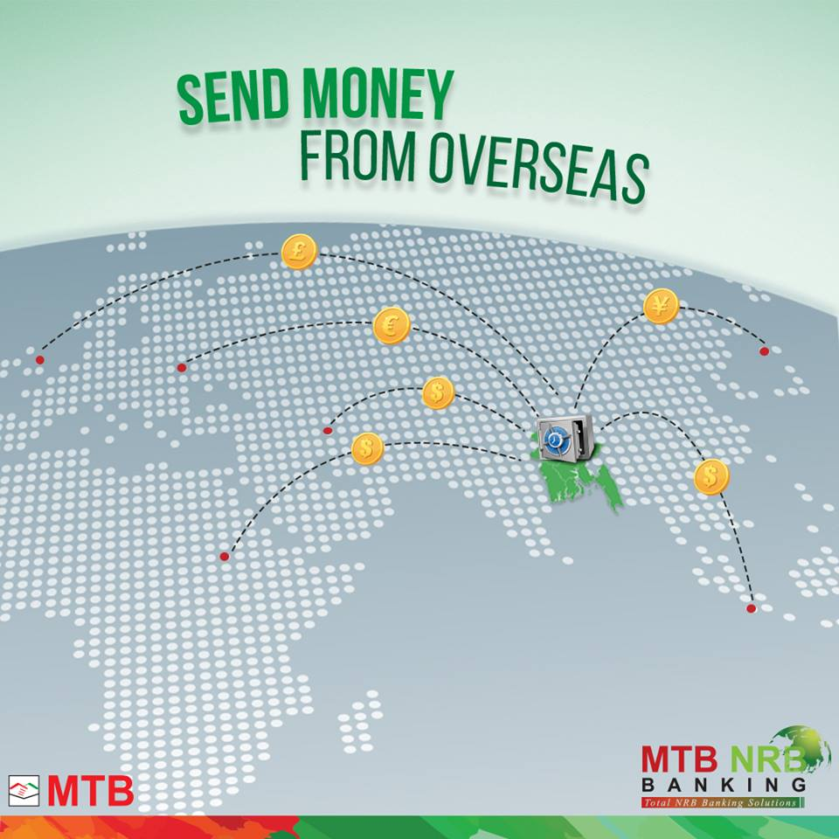
Figure 9: Foreign Exchange

4.2.3.2 Functions of foreign exchange Department
a) Import
- Opening letter of credit (L/C).
- Advance bill.
- Bills for collection.
- Import Loan and Guarantees.
b) Export
- Pre- Shipment advances.
- Purchase of foreign bills.
- Negotiating of foreign bills.
- Advancing/Confirming letter-Letter of credit.
- Advance for differed payment exports.
- Advance against bill for collection.
c) Remittances
- Issue of DD, MT,TT etc
- Payment of DD, MT, TT etc.
- Issue and payment of encashment of traveler’s cheque.
- Sale and encashment foreign currency note.
- Nonresident account.

d) Dealings
- Rate Computation
- Maintenance of foreign currency account
- Forward contracts
- Exchange position and cover operation
Most Commonly used Document
- Documentary letter of credit.
- Bill of exchange.
- Bill of landing.
- Commercial invoice.
- Certificate of origin of goods.
- Inspection certificate.
- Packing lists.
- Insurance certificate.
- Pro- forma invoice/Indent.
- Master receipt.
- GSP Certificate.
a) Import
Imports of merchandise into Bangladesh is directed by the service of business and industry regarding the Import and Export (Control) Act, 1950, with import strategy orders issued by every year, and Import Registration Certificate (IRC) and Public Notices issued now and again by the workplace of the Chief Controller of Import and Export (CCI and E). Through the procedure of import, some fundamental however which are insufficient to produce in some countries, items are foreign made to meet the neighborhood needs of the general population. MTB likewise assumes a critical job of bringing in merchandise. To acquire Import Registration Certificate (IRC) the accompanying endorsements are required.
- Trade License.
- Income tax clearance certificate.
- National Certificate.
- Bank solvency certificate.
- Asset certificate.
- Registration partnership deed.
- Memorandum and article of association.
- Certificate of incorporation.
- Rent of the business premises.
Requirements for Import:
To import through Mutual Trust Bank a customer or client requires
- To open a Bank Account.
- Import registration certificate.
- Taxpaying identification number (TIN)
- Pro-forma invoice/indent (IT).
- Membership certificate.
- L/C application from duly attested.
- Insurance cover note with money receipt.
- Others.
Import Mechanism:
To import, an individual ought to be competent to be a merchant'. As indicated by Import and Export (Control) Act, 1950, the officer of Chief Controller of Import and Export gives the enlistment (IRC) to the merchant. In the way of getting this, the individual needs to attach a letter of credit approval (LCA) from Bangladesh Bank. And after that an individual turns into a certified merchant. He asks for or educates the opening bank to open a L/C.
Source of Funding:
Import can be possible by different sources of finance, Such as
Cash
- At first the balance of the cash in foreign exchange should be reserve at the Bangladesh bank.
- Then that foreign currency account should be maintained by Bangladesh nationals working/ living abroad.

External Economic Aid:
Generally external economic aid occur when the size of the industry grows, simultaneously the cost also grows. For this reason the person who wants to import goods he/she need to keep a huge amount of money in the bank to import goods.
Commodity Exchange”
Commodity exchange means exchange something with other country when another country ready to exchange their goods. To import something person need to get ready to import.
Import Procedures:
An importer requires the following procedure to import goods.
- Candidate needs to apply for opening L/C by an endorsed form.
- Candidate needs to present the Letter of Indent or Letter of Pro-forma Invoice.
Now the question arises what is letter of Indent?
Letter of Indent: Numerous merchants have their specialist in dealer's nation. In the event that the agreement of purchasing is made between the purchasers and the specialist of the merchants at that point Letter of Indent is required.
Letter of Pro-Forma Invoice: On the other hand the agreement is made specifically between the purchasers and the dealers; Letter of Pro-forma Invoice is required.
- Candidate needs to submit IRC (Indenters Registration Certificate). It is an authentication being reestablished each year. This declaration is vital if the agreement is made between the purchasers and the specialists of the merchants. IRC is of two sorts – COM and IND. Com is given for commercial purpose and IND is given for Industrial purpose.
- Candidate has to submit letter of Credit authorization form.
- Candidate has to submit Insurance documents
- Candidate has to Submit TIN.
- Candidate has to Submit Trade license copy.
- Candidate has to Submit NOC certificate.
- Candidate has to submit customer letter head pad.
- Customer passport size photograph, NID copy and blank cheque.
- MTB letter head pad with sign.
- L/C acceptance sign.
Procedure of opening L/C to Import
- Candidate must have an account of MTB
- Candidate must have importer registration certificate.
- Best performance report on other importer bank. MTB collects this report from Bangladesh bank.
- Credit Information Bureau report from Bangladesh Bank.
- If the amount of L/C is small then the proposal approval by the bank or there is no limit.
- If the amount of L/C limit is higher than an approval from Bangladesh Bank is need.
b) Export
Export Policy
According to the Ministry of Commerce, GOB gives the general rule and motivating forces for advancement of fares in Bangladesh. Proper arrangements likewise set out ware shrewd yearly target. It has been chosen to detail these arrangements to cover a five-year time frame to make them contemporaneous with the five-year designs and to give the strategy routine. The policy situated private division, through their agent bodies and chambers are counseled in the detailing of fare strategies and are additionally spoken to in the different fare advancement bodies set up by the administration.
Export incentives:
Financial Incentives:
- First of all restructure of export credit guarantee scheme.
- Convert Taka into current account.
- Export development fund.
- Expansion of export credit period from 180 days to 270 days.
- Minimum tax rebate of 50% on export earning draw back.
- 100% export oriented firms get advantage of duty free import.
General Incentives
- Arrange National Export Trophy to successful exporters.
- Training course on external trade.
- Arrangement of international trade fairs, commodity-based exhibitions in the country and participation in foreign trade fairs.
Other Incentives:
- Assistance in improvement of quality and packaging of exportable items.
- Simplification of exports procedures.
Exports procedures:
The export and import tread in our country is regulated by export and import Act 1950.
Under the actual arrangement of Bangladesh the exporter needs to get substantial Export enlistment Certificate (ERC) from Chief Controller of Import and Export. The ERC is required to recharge each year. The ERC number is to consolidate on EXP frames and different papers associated with fares.
Export L/C:
In export of L/C there are number of formalities, which an exporter can fulfill before and after shipment. These procedures are given below.

- Obtaining Export Registration certificate (ERC) :
No exporter is permitted to send out any goods or permissible fare from Bangladesh except if he is enrolled with Chief Controller of Imports and Exports (CCI and E) and holds substantial Export Registration Certificate (ERC). In the way of applying to the CCI&E in the recommended from alongside the vital papers, concerned workplaces of the Chief Controller of Imports and Exports issues ERC. When enlisted, exporters are to make reestablishment of ERC consistently.
- Securing the order:
After getting ERC, the exporter may continue to anchor the fare arrange. The exporter can do this by getting the purchasers specifically through correspondence.
- Obtaining EXP:
After completing the registration, the exporter applies to MTB with the exchange permit, ERC and the Certificate from the concerned Government Organization gets EXP. On the off chance that the bank is fulfilled, an EXP is issued to the exporter.
- Signing of the contract:
In the way of speaking with purchaser the exporter needs to get contracted for sending out exportable things from Bangladesh itemizing product, amount, value, shipment, protection and stamp, review, assertion and so on.

- Receiving letter of credit:
In the way of getting contract available to be purchased, exporter ought to approach the purchaser for Letter of Credit plainly expressing terms and states of fare and installment.
In the way of getting L/C, the following points are given below:
- The term of the L/C is the main documents of the contract.
- As the L/C is the main document that’s why advising bank prefer L/C document.
- If the exporter think that he can shift the L/C from one place to another then exporter has to mention this on L/C.
Procuring the Material:
Subsequent to make the arrangement and the L/C opened to support exporter, the following stage for the exporter is to set about the assignment of acquiring or assembling the contracted stock.
Endorsement on EXP:
Prior to the exporters with the traditions/postal experts hold up the fare frames, they ought to get every one of the duplicates supported by MTB. Prior to shipment, exporter submits exp. frame with business receipt. At that point MTB officer checks it appropriately, whenever fulfilled, affirms the exp. without it, exporter he can't make shipment. The client must announce all fares merchandise on the EXP issued by the approved merchants.
Disposal of Export Forms:
- Original: The first copy of EXP of customs authority has been submitted to Bangladesh bank after shipment of goods.
- Duplicate: Negotiating report the duplicate of Bangladesh Bank has to submitted after negotiating date but not exceed 14 days from the date of submission.
- Triplicate: On realization of export proceeds the same bank to the same authority reports Triplicate
- Quadruplicate: Finally, the negotiating bank as their office copy retains Quadruplicate.
Shipment of Goods:
Exporter makes shipment according to the terms and condition of L/C.

Presentation of export documents for Negotiation:
- Bill of Exchange or Draft;
- Bill of leading
- Invoice
- Insurance policy
- Certificate of origin
- Inspection of
- Packing list
- GSP certificate etc.
If the entire documents are submitted properly then exporter can export their necessary goods.

c) Foreign Remittance Section:
Foreign Currency account:
Presently the activity of remote cash account has been more changed. Assets from this A/Cs are openly remittable to any nation as per the requirements of A/c holders. MTB gives the administration of outside settlement through remote money records to the customers.

Types of foreign currency account
- Foreign Currency Account
- Resident Foreign Currency deposit Account
- Non-resident Foreign Currency Account.
Requirement of Foreign currency Account Open:
Foreign currency account can be open by
- Pound sterling
- US dollar
- Euro
- Japanese Yen
Documents require to opening FC account:
For Bangladeshi Earners:
- Photo copy of 1st seven pages of valid passport and visa page.
- Photo copies of employment work permit documents.
- Two passport size photograph and nominees photograph with attested.

For Foreign national/Company/Firm:
- First of all two copies of photograph of account holders for individual operations of other account holder.
- Photocopy of relevant pages of passport for individual and other operator.
- Copies of registration in Bangladesh with board of investment, Bangladesh Bank for board of investment.
- Copies of memorandum and article of association for any company have to submit.
Mode of operation:
Generally foreign A/c opened for the sake of Bangladeshi nationals working abroad or self worker abroad would now be able to be kept up as long as the present holder wants.
That accounts may also be opened by the eligible persons within six months of their return to Bangladesh. Credit to a Foreign Account might be made against internal settlement of outside trade in any type of exchange from another FC account on non-inhabitant taka records of investors abroad.
Generally foreign remittance is two types
- Outward remittance.
- Inward remittance.
Outward Remittance:
The word outward remittance means remittance which comes from outside of the country. It includes not only remittance but also sale of foreign currency by TT. MT Drafts, traveler’s cheque it also include payment against import into Bangladesh and local currency remitted to non- resident Taka Account of Foreign Banks or Convertible taka account. Generally two forms are used to outwards remittance of foreign currency such as
IMP Form: All outward settlement by virtue of Imports is done by frame IMP.
T.M Form: For all other outward settlements T.M. shape is utilized.

Private Remittance:
- Family remittance facility.
- Remittance of membership fees/Registration fees etc.
- Education.
- Remittance of consular fees.
- Remittance of evaluation fees.
- Travel.
- Health and Medical.
- Other private remittance.
Official and Business Travel
- Official visit.
- Business travels quota for new exporter.
- Business travel quota for importers and non exporting procedures.
- Exporter’s retention quotas.
Commercial remittance
- Opening a branch or subsidiary companies abroad.
- Remittance by shipping companies and airlines, courier services.
- Remittance of loyalty and technical fees.
- Remittance on account of training and consultancy.
- Remittance of profits of foreign firms/branches.
Inward Remittance: The term" Inward Remittance" incorporates not just buys Foreign Currency by TT, MT, Drafts and so forth yet in addition buys bills, Traveler's cheques and Remittance. Two structures as endorsed by Bangladesh Bank are utilized for buy of Foreign Currencies, for example, EXP Form: Settlements got against fares of products from Bangladesh are finished by frame EXP.
Form C: Internal settlements proportionate to US$ 2000/ - or more are finished by Form" C".
On the other hand the declaration of Form C is not required if the remittance comes from Bangladesh Nationals Working Abroad.

Purchase of Currency Notes, Travelers, Cheque, etc
To purchase currency notes, travelers cheque etc some procedures have to follow, such as:
- First of all currency notes to be checked very carefully so that risk can be avoided when purchasing counterfeit money.
- While buying Travelers check mark of the holder to be acquired on the TC/s before the Bank authorities and ought to be confirmed with the mark of the holder officially given at the season of issuance of T.Cs,
- Drafts should not to be obtained under any conditions except if the holder is an ordinary/esteemed client of the bank. Reimbursement Bond to be acquired for worshiping the sum paid ahead of time to the holder if there should arise an occurrence of shame of the instrument.
- Without any approval of head office under any circumstance the private cheque should not purchased.
Dealing in Foreign Currency Notes and coins:
Only Authorized Dealers and Authorized Money Changer are permitted to deal in foreign currency notes & coins Authorized Dealers and Money Changers may freely buy foreign currency from incoming passengers regardless of nationality and regardless of whether or not a declaration on form FMJ is produced at the time of encashment. If this form is produced, the amount enchased should be endorsed on it. The Authorized Dealers may also purchase foreign currency notes, coins and other travel instruments freely from Authorized Money changers without production of Form FMJ.
Disposal of foreign currency notes/coins and other by incoming passengers:
Incoming passengers may bring in any amount of foreign exchange with declaration FMC at the time of arrival. No declaration is necessary for amounts up to US$5000/- for non residents, the entire amount brought in with declaration or up to US$5000/- brought in without declaration may be freely taken out at the time of departure or may deposit the amount in F.C Account subject to submission of form FMJ for excess of US$5000. - Or equivalent.
An incoming person who is ordinarily resident in Bangladesh
- May retain foreign exchange up to US 5000 dollar or equivalent without any declaration.
- Take out the same at the time of departure from Bangladesh Without endorsement of passport and air ticket.
- Deposit the amount in RFCD account of the persons concerned.

4.2.4 Credit Department
Another largest and most important division in banking sector is credit department. Mainly credit department plays most important role in banking sector. Now the question arises what is credit? Generally Credit is a contractual agreement, in which a borrower receives something of value now, with the agreement to repay the lender at some date in the future (Kothari, 2013)
Credit management is a dynamic field where a specific standard is maintained. Sanctioning lone is a long term process. Because arranging every document in detail is sometimes difficult. Nonstop supervision, checking and follow-up are exceedingly required for guaranteeing the opportune reimbursement and limiting the default. The general achievement in credit the board relies upon the banks credit arrangement, arrangement of credit, checking, supervision and follow-up of the advance and advance. Accordingly, while examining the credit the board of MTB, it is required to break down its credit strategy, credit system and nature of credit portfolio.
Factors consider for credit:
- Time factor.
- Operating Expense.
- Risk factor.
- Interest Rate.
- Legal considerations.
- Finance Charge.
- Inflations.
Importance of credit:
- In Bangladesh basically our business cycle mainly runs depending on lending system.
- It helps many people to create employment opportunities.
- Plays a vital rule in national economy.
- It provides a big amount of working capital for industrialization.
- It controls almost all kinds of production activities of the country.
- Cash generation occurs for its successful performance.
Credit Policy of MTB:
Mutual Trust Bank always focused on that their loans which meet organizational and regulatory standard and they are profitable. Their main targets are to establish loan policy. And that loan policy gives credit management a specific guideline to make individual loans and complete banks overall loan portfolio. In MTB there is credit policy and there is no specific credit written policy.
Key of credit:
Key of credit mainly depends on the general guidelines which are provided by the branch manager or credit officer. Mutual Trust Bank follows special guideline which is made by Corporate Head Office of MTB following the guideline of Bangladesh Bank credit Risk management. Those following guideline are given below.
- All the credit extension must be match with the central Bank and Banking Act.
- If the CBI report is not supported then the persons/clients credit will not extent.
- Always Bank has to maintain a ratio between loan and deposit. In this circumstance no compromise will allow with bank standard of excellence.
- To minimize risk increase reward.
- To ensure all kinds of ethical standard in all credit activities.
- Smartly extend credit in all area where high risk can be minimized and bank can make profit from this credit.
- Extend credit facility by analyzing the repayment capacity of the clients.
- Allow credit on business considerations after verified all the documents of the persons/companies.

Principles of Lending Money:
Before lending money all the principles and laws should be clearly understood and then protect the credit. But in practical sometimes those laws create little problem for lending money. The basic criteria can be consider as some main heading
- Principle of safety
- Principle of liquidity
- Principle of purpose
- Character and ability of the borrower
- Principle of security
- Principle of profitability
- Sources of repayment
- Principle of national interest

Principle of safety:
The main principle of sound lending is security. The precise presence of a bank relies on the wellbeing of its advances. So most extreme consideration ought to be practiced to guarantee that the assets go to the correct sort of borrower, are used so that they stay safe and the reimbursement comes in the ordinary course.
Principle of liquidity:
Liquidity implies the accessibility of Bank assets without prior warning. The liquidity of a development implies it reimbursement on interest on due date or after a short notice. Accordingly, the banks must need to keep up adequate liquidity to reimburse its investors and exchange off between the liquidity and benefit is must.

Principle of purpose:
The bank should not lend money for any purposes for which a borrower may be free from all risks but if the funds borrower are employed for unproductive. Purpose like marriage ceremony, pleasure trip etc. or speculative activities, the repayment in the normal course will become uncertain. Banks therefore discourage advances from boarding stocks and refuse advances for speculative activities.
Character and ability of the borrower:
The essential obligation of the main investor is "know your client and his business". While thinking about the character and capacity of a borrower, the accompanying point must be remembered.
- Know your customer properly
- Was he/she properly introduced?
- If the clients have any account of another bank then why he/she has come to open another account in this bank. And try to check another bank account statement.
- Have the account opening requirement check properly?
- What are the businesses of the ownership?
- What are the customer’s background and tracked record?
- Customers honesty, integrity and personal stability
- How the customers has managed financial circumstance in the past.
The branch manager ought to have the appropriate response of the above questions and ought to be to pass judgment on his capacity to utilize the credit offices further bolstering his advantage. Advance ought to be allowed just to those borrowers in whom the branch administrator has full certainty.

Principle of security:
The security offered by a borrower for a development is protection to the investor. It fills in as the security esteem for an unanticipated crisis. The security acknowledged by an investor to cover a bank advance must be sufficient, promptly attractive, simple to deal with and free from any encumbrance.

Principle of profitability:
The working assets of a bank are gathered mostly by methods for store from people in general and premium must be paid on those stores. Banks have additionally to meet their foundation charges and different costs. Premium earned by a depend on its development is the fundamental wellspring of its income (Bucci, 2011). The contrast between the premium got on advances and the premium paid on stores establish a noteworthy bit of the banker’s salary. The bank won't go into an exchange except if a reasonable return frame it is guaranteed.

Source of Repayment:
After the branch manager has guaranteed that the credit will be a productive propositioning for the bank, he should then direct his concentration toward the income circumstance of the borrower. The banks credit can be grouped into three principle classifications, such as
- A transient development will be sold by assets got in the precise not so distant future, for example, propels against remote or neighborhood bills or scaffold working where proof of credit authorize from another money related organization is accessible.
- Arrangement for current resources; this sort office is required for exchanging and/or producing exercises.
- Long term credits, lasting more than 5 years; case of such offices as interest in plant and hardware, a ranch or a shop, for the most part, a long haul is reimbursed out benefits created by the business.
Principle of National Interest:
The development of banking has reached a stage where a banker is required to identify his business with national policies. Banking Industry has significant role to play in the economic development of a country. So, the savings of the people which are mobilized by banks must be distributed to those sectors which require development in the country’s Planning Program.
Types of Credit Activities:
Credit can be classified by its nature, elements of time and financing.
Classification on the basis of time:

4.2.4.1 Continuous loan:
These are the advances having no fixed repayment schedule but have a date at which it is renewable on satisfactory performance of the clients. Continuous loan mainly includes "Cash credit both hypothecation and pledge" and "Overdraft".

4.2.4.2 Demand Loan:
In opening letter of credit (L/C), the customers need to give the full L/C sum in remote trade to the bank. To buy this outside trade, bank stretches out interest advance to the customers at stipulated edge. Nonetheless, when the L/C reports arrive, the bank asks for the customers to modify their credit and to resign the L/C archives. Request advances predominantly incorporate "Installment against Documents," "Credit against imported stock (LIM)" and "Later of Trust Receipt.

4.2.4.3 Term Loan:
These are the advances made by the save money with a settled reimbursement plan. Terms advances principally incorporate "Purchaser credit plot", "Rent fund"," Hire buy", and "Staff advance". The term loan can
- Short term loan up to 12 month.
- Medium term loan more than 12 months and up to 36 months
- Long term loan more than 36 months.

4.2.4.4 Short term agricultural loan:
These advances are transient credits enrolled by Agricultural Credit division of Bangladesh Bank in its annual advance program. Credits dispensed in farming segment for a period not over a year are likewise incorporated into this class.
Application based categories of loan:
Based on the purpose of the loan, loan are classified by
- Corporate loan
- SME loan
- Retail loan
- Auto loan
- Home loan

4.2.4.5 Corporate loan:
Any advance payment surpassing 1,00,00,000 BDT and issued for business and exchange designs is characterized as corporate loan. Such advances basically fill the need of initials for the foundation of industry or expansive scale manufacturing plant. This kind of credit is dispensed for business purposes however the sum advanced does not surpass 1,00,00,000 BDT. The sum lent here fills the need of potential (incomplete) working capital for little and medium business adventures. MTB Gunabati and MTB Bhaggobati is one kinds of SME loan.

4.2.4.6 MTB Gunabati:
In recent years, the developing countries of the world including Bangladesh have been focusing attention on the most disadvantaged group in the society-the women. Government has increased their awareness and involving women in all private and public sector and women also participating in all sectors especially on women entrepreneurship development. The importance of women’s entrepreneurship development focuses on women’s development in general and their participation in general and their participation in income generating activities in particular, while it deserves a special consideration in national development planning. Only for that reasons MTB giving chance of our women to prove their self doing something new at the same time contribute to the economy. The target customer of MTB Gunabati is only women engage in manufacturing business. The main purpose of this loan is to provide financial support to the target customers for expansion their business. The minimum loan size is BDT 50000/- and maximum BDT is 7, 50,000/- loan ceiling may be reviewed and enhance gradually in future but not exceed 50 lac. The loan tenor and grace period is up to 3 years. The debit ratio is minimum 80: 20, and the interest rate is @ 9%.
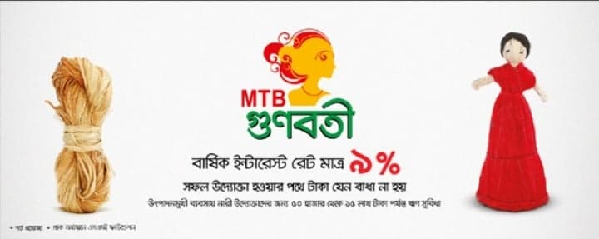
Figure 10: MTB Gunabati

4.2.4.7 MTB BHAGGOBATI:
Women are no more belong to the household activities only. Rather their movement started shifting toward ruling nation, leading corporate office, developing a business. In all over the world for the last decade women has proved their capacity and entrepreneurship skill in their respective area. The state and Bangladesh Bank fell to give a comfortable ground for the development of the women in the business entity and encouraging and inviting the financial facilitators to extend their hands. There are thousands women specially in handcrafts, boutique agro based industry, beauty parlous, readymade garments, creative works, interior design, etc keeping their superb contribution and emerging gradually. It is the right time for us to develop a product for the development of women entrepreneur, which will have a long term impact on the growth of our economy. MTB Bhaggabati is targeted to facilitate finance to women client having sound track as well as to finance the potential entrepreneur with strong KYC. The Minimum Loan is BDT 1, 00,000/- and maximum BDT 5, 00,000/- maximum loan amount can be maximize but not more than25 lac. The interest rate is 10%, repayment of tenor is minimum 12 months to 36 months.
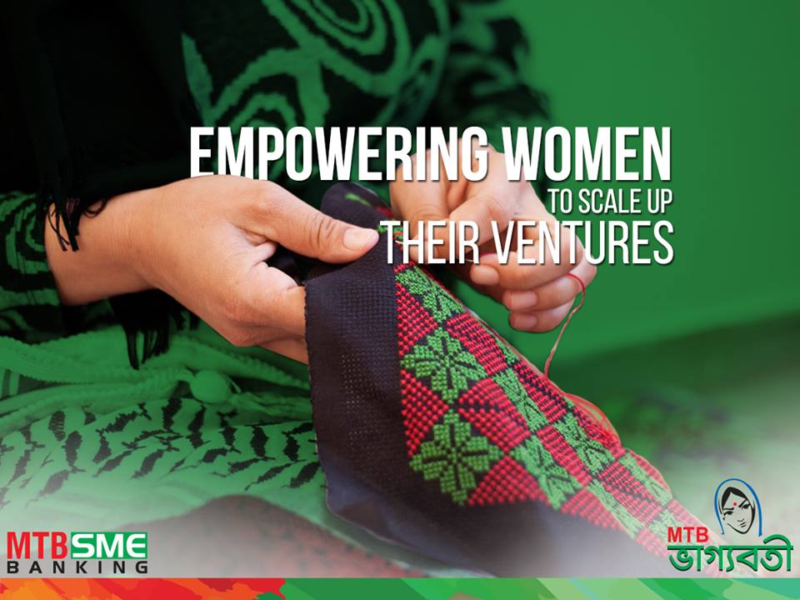
Figure 11: MTB Bhaggobati

4.2.4.8 Retail Loan
Retail loans are given for personal usage rather than for business purposes. It includes auto loan, personal loan, vacation loan, and home loan. MTB personal loan is simple, convenient, and quick.
Features
- Loan amounts of taka 50,000 to taka 10,00,000
- Easy document and quick processing.
- Option for early settlement.
4.2.4.9 MTB Auto Loan
MTB offers rewarding loan fees that would enjoyably amaze the client. MTB Auto Loans are worked for most extreme speed and ability. MTB Auto Loan is accessible for financing both new and reconditioned autos.
Features
- Loan amount of Tk 3, 00, 000 to 20, 00,000 Tk.
- Repayment of loan 12 months to 60 months.
- Competitive interest rate.
- Option for early settlement.

4.2.4.10 MTB Home Loan
Expecting to claim an own house is one of life’s most challenging task. It doesn’t matter whether it’s purchasing new house and new apartment. MTB has a wide scope of home credit choices that can be redone to your particular need. An accomplished, devoted group of specialists and a total advance bundle is set up, to meet all your lodging money needs. MTB Home Loan helps the client to fulfill their dreams.

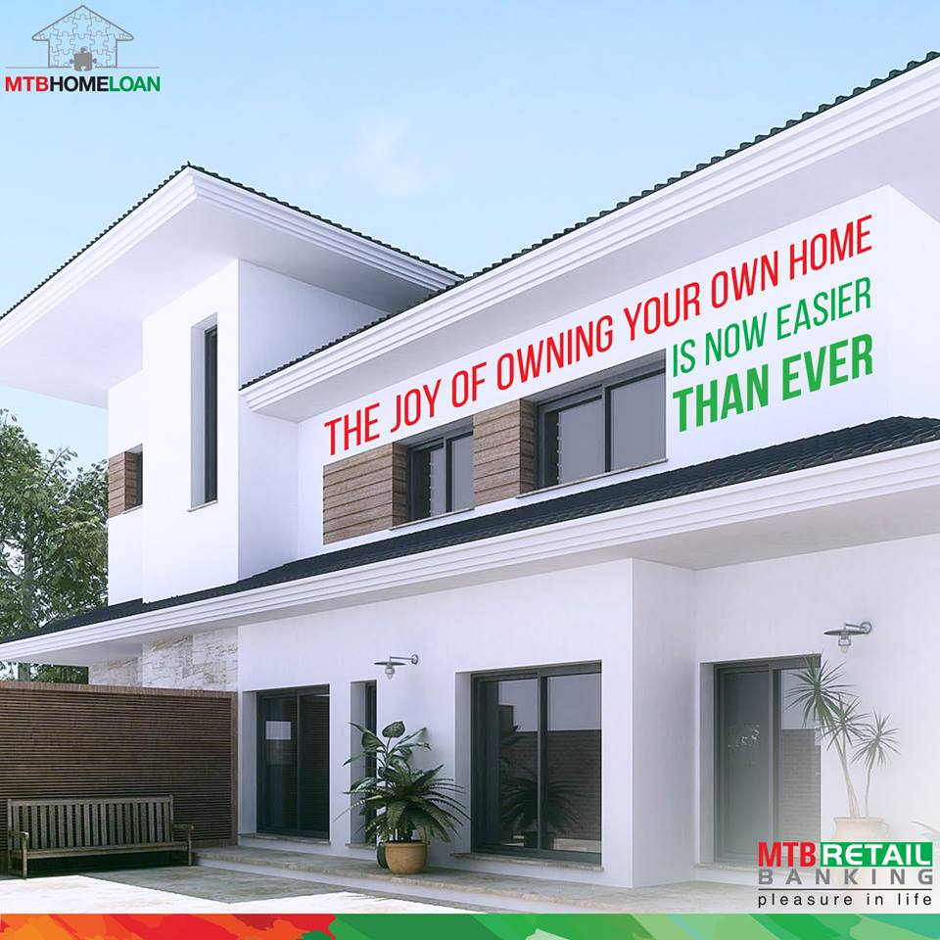
Figure 12: MTB Home Loan
Features
- Loan for resident apartment/ house purchase.
- Loan amount from BDT 5,00,000/- to BDT 1,00,00,000/-
- Loan tenor from 3 to 25 years.
- Loan amount of up to 80% of property value.

5.0 Corporate Culture of MTB
Mutual Trust Bank is one of the most furnished banks with different corporate culture. Here MTB believe in sharing norms and values and sharing sense making. The most important things of MTB are its people can easily understand and see the events, activities objectives and situation in different way. They very smartly maintain their appearance and etiquette which reflects their personality. The people in the MTB believe that they are one family where they can strongly perform together and with their unity they can overcome any challenge. The corporate culture is not earned easily rather it has been achieved by corporate conduct.
5.1 Career Opportunity of MTB
Mutual Trust Bank is an equal opportunity employer. They are offering competitive compensation packages, excellent career development programs and a friendly working environment. This section of the website will be updated as and when any job vacancies arise. And no lobbing is allowed to recruit employee. Everyone has to face interview session to be selected to join MTB.

5.2 Customers services of MTB
Proficient legitimacy and competency, flexibility, determination and dedication are the center assets that MTB consider to be of vital significance for building a customer-bank relationship. Consumer loyalty is MTB’s preeminent priority. Thusly, a content customer is MTB’s valuable success and it is considered a diplomat in the market.

6.0 My Experience as an Intern in Mutual Trust Bank

6.1 Introduction
As I started my internship at Dhanmondi branch of MTB, I felt myself fortunate to be a part of this branch for three months. It was a great opportunity for me to work in such a friendly working environment. This practical experience helped me to develop and prepare myself to enter into the corporate world. During my internship period, I have not only worked in a specific banking department but also whenever any other department needed some help with their works, they would call me. I was never officially transferred to any other department but still I got the idea of other departments simultaneously. Also, I was assigned to explain about different accounts & other questions of customers. This way I got the opportunity to serve the customers directly as well. Also, whenever any customer faced any difficulty like-writing deposit slips, cheques or any other helps, I was always there to serve them. In my internship period I worked at General Banking, Credit and Foreign Exchange department.

6.1.1 My job in General Banking section of MTB

I got the opportunity to work in the general banking section which is the starting point of all banking sectors. It’s generally taking deposits and also provides other supplementary services Such as I have also issue Pay order. I have learned how to open individual account, Non-individual account, and DPS in this sector. I have also learned how to fill up the form and KYC, TP etc. I have also issued cheque books. MTB generally follow special software. The entire task has done automatically on the software’s. The name of this software is FLORA and MNet. As an intern in the MTB, I have done many works in flora such as, update customers phone number, address, and other information. I also provided clients bank statements.

6.1.2 My job in Cash department of MTB

In my internship program my work was not confined to the general banking but I also worked in the cash department. My task in the cash department was collecting bill of different school and collect those slip. After collecting slip I have counted all the amount of the slip and then match the amount with recorded in excel file.

6.1.3 My job in Foreign Exchange Department of MTB

I have learned many things from foreign exchange department, such as how to open L/C, the documents require to open L/C, the procedures of dollar endorsement and so on. If a product is sent to any other country from our country, bank officer match all the information and keep records in a register Khata. I was given the task to match all the information and entry all the information in register Khata properly.

6.2 Observation
During my internship program, I had some observations that consist of my personal improvement as well as the banking environment. I think this is which will help me to make progress in my career in future. Some of them are:

- All the instructions of senior officers helped me to be aware of how banking system works. They helped me to rectify my mistakes. I learned more from my mistakes and also became alert not to make the same mistakes again.

- Multi-tasking and being proactive is necessary in order to be more productive.
- Learned importance of professionalism and respect the seniors.
- Learned being rational and calm in difficult situations.
- I have made a good relationship with other employees and with some clients also and it helped me to be more social.
- Patience and listening carefully are the key while dealing with any client because it is my duty to answer every query of clients and gain trust from clients.

7.0 Recommendations

There are some setbacks which need to be corrected by the administration of the bank. Some necessary steps are recommended below on the basis of collected data, personal observation, knowledge and judgment. MTB has diversified and excellent deposit and lending products in its retail banking segment. I have observed some areas to upgrade in MTB’s retail banking. Those are follows:

- Online Banking must be updated than best service provide for customer.
- The bank should introduce more products based on the market demand.
- The bank can open more branches to reach to more customers.
- The marketing department of the bank should more efficient to reach at the heart of the customer.
- Customer awareness program should be started.
- Lack of promotional activities is the major issue.
- MTB needs to start huge promotional activities for its retail banking products especially in newspaper and social media promotion.
- The existing DBR grid should be changed and increased for getting off this conservative approach. As a result retail loan declining will decrease.
- In case of policy and terms and conditions, MTB is very compliant to Bangladesh Bank’s policies and regulations.

8.0 My future career plan based on my internship
I have done my major in Accounting and Information System (AIS). Therefore, banking sector always looked a productive place for me. After working here in MTB, I’m planning to pursue my career in banking sector as this sector offers enormous prospects. It will give me the chance to know the economic condition of our country and also offers the field to connect directly with the clients. The admiration from my supervisor & co-workers encouraged and motivated me to work harder and be confident. Thus I will be delightful to pursue my career in MTB or any other renowned bank in future.

9.0 Conclusion
I am privileged enough to complete my internship program in MTB which is one of the leading commercial banks in Bangladesh. During the internship period, I was fortunate to get the guidance on professional decorum, and office etiquette. The realistic knowledge of my internship program will always guide me to pursue my career in future. Now, I understand that this training period is essential to complete the theoretical knowledge and to learn about the actual working atmosphere. So, I would like to thank United International University & MTB for giving me the opportunity of learning and gathering experiences.

10.0 Appendix: Abbreviations

MTB……Mutual trust Bank.
ATM…… Automated Teller Machine.
SME……Small and Medium Enterprise.
SOD……Secured Over Draft.
EPZ……Export Processing Zones.
GDP........Gross Domestic Product
KYC…… Know your customer ('KYC').
FDBC….. Foreign Documentary bills Collection.
TP’s…… Transaction Profiles.
CASA…...Current Account and Saving Account.
SND……Special Notice Deposit.
TO…….Take Over loan.
NRBs… Non-Resident Bangladeshis.
DBR…….Debt Burden Ratio
CPV……Contact Point Verification.

REFERENCES

- MTB. MTB Annual Report . Dhaka: MTB, 2015.

- MTB. MTB Annual Report. Dhaka: MTB, 2016

- About Us:Mutual Trust Bank.(n.d) Retrieved from Mutual Trust Bank web site

- www.mutualtrustbank.com/about-us/mtb-profile/ visited on January 05, 2019 at 7.30 pm

- issuu.com/md.papon/docs/overall_banking_system_of_mutual_tr

- www.mutualtrustbank.com/about-us/ visited on January 12, 2019 at 8.20 pm

- www.mutualtrustbank.com/wp-content/uploads/mtbiz/2016/MTB-Annual-Report-15.pdf

- www.dsebd.org/displayCompany.php?name=MTB visited on January 25, 2019 at 8.00 pm.

