
INTERNSHIP REPORT
On Human Resources Practices of Kazi Media Limited (DeeptoTV)
Supervised by:
Md. Kazimul Hoque
Assistant Professor
School of Business & Economics
United International University

Submitted by:
Rifat Ara Keya
ID: 111 141 384
Submission Date: January 8, 2023
INTERNSHIP REPORT

On Human Resources Practices of (Deepto Television)



LETTER OF TRANSMITTAL
January 8, 2023
Md. Kazimul Hoque
Assistant Professor
School of Business & Economics
United International University

Subject: Submission of Internship Report on Recruitment & Selection Practices of Kazi Media Limited (Deepto Television).

Dear Sir,
With great pleasure to let you know that I have completed my internship program at Kazi Media Limited (DeeptoTv). I will submit the internship report on “Human Resource Practice of Kazi Media Limited." This report focuses on the unique HR practices, its competitive attributes, and the current manpower scenario of KML with respect to the media industry.

I have followed all of the standard methodologies in preparing the report according to your instructions and guidelines. I have also taken help from different sources to prepare the report properly.

This has been a new field of analysis for me, and I am very thankful to you for giving me this opportunity. I expect this report will fulfill the requirements of the program and my BBA program.

I will be glad to give you any further information you may require at your convenience
Sincerely yours,

_________________
Rifat Ara Keya
ID: 111 141 384
ACKNOWLEDGEMENT,

First of all, I would like to express my gratitude to Allah for enabling me to complete the report in due time. I would like to thank my parents for helping and guiding me throughout this phase of the internship as well as throughout my academic life. Without their guidance and faith in me, I could not have come this far.

I want to sincerely thank Md. Kazimul Hoque, the assistant professor in the department of business administration at United International University who oversaw my internship, for giving me thorough criticism and guidance on this report. she always offered me advice throughout my time as a BBA student. The blessings, assistance, and direction she has occasionally provided will go a long way in assisting me on the upcoming journey through life. I wouldn't have been able to prepare my report without his constant encouragement and advice.

I would like to thank Kazi Media Limited for the opportunity and to express my sincere gratitude. I also want to express my gratitude for the advice I received from Mr. Md. Humayun Kabir, Senior Executive HR, the HR department, and other Kazi Media Limited employees who gave up their time to mentor me. They acted in a nice and polite way that I will never forget.

Throughout this internship, I have been properly directed and assisted by my superiors and coworkers. So, I'd also like to thank my coworker, Ms. Simi Ahmed, for gaining in-depth information about HR practices and challenges that can aid me in my job more effectively.

EXECUTIVE SUMMARY

This is an internship report based on the internship program that I completed in Kazi Media Limited under the Human Resource Department as a requirement of my BBA program.

The objective of the report is to identify how theories and concepts discussed in my educational program can be practiced in the aspect of Human Resource practices at a media organization in Bangladesh. As usual, primary data and secondary data were used to prepare this report. Primary data came from my day-to-day observation and interviewing their employees. Secondary data was collected from Organization's employee handbook, website, and relevant books. I tried to produce an unbiased and fair report. Here I have discussed how Kazi Media Limited runs its HR practices.

In this report, I tried to focus on how they do their HR practices and what policies they follow in it. This report also shows my observation of their HR practices. This report provides some recommendations which may help to improve their practices. Finally, the report allows focusing on theories and concepts used in The Kazi Media Limited.

Table of Contents
Name of Topic | Page No.
CHAPTER ONE  Introduction | 1-3
1.0 Introduction | 2
1.1 Goal of the report | 2
1.2 Scope regarding the report | 2
1.3 Significance of study | 3
1.4 Limitations of study | 3
1.5 Methodology of the study | 3
CHAPTER TWO  Literature Review | 5-7
2.0 Literature Review | 5-7
CHAPTER THREE  OVERVIEW OF KAZI MEDIA LIMITED(DEEPTO TV) | 9-14
3.1 Company Profile | 9
3.2 Mission Statement | 9
3.3 Vision Statement | 9
3.4 Objectives of the company | 10
3.5 Organogram of Kazi Media Limited | 10
3.6 Department of Kazi Media Limited & Activities | 11-12
3.7 Programs of Deepto Television(KML) | 12-13
3.8 Work place Environment of Kazi Media Ltd (Deepto Tv) | 14
CHAPTER FOUR  Human Resource Practice of Kazi Media Limited(Deepto Television) | 16-28
4.1 Human Resource Department of Kazi Media Limited(Deepto TV | 16
4.2 Steps Follow By KML for Recruitment & Selection Process | 17-23
4.3 KML’s Compensation Benefits | 23-24
4.4 KML’s Employee Attendance System | 24-25
4.5 Training and Development Process for KML’s Employee | 25
4.6 Performance Appraisal System | 25-26
4.7 Policies for Resignation ,Termination and Retirement of Services | 26-27
4.8 Policies of Leave | 27-28
CHAPTER FIVE  ANALYSIS & INTERPRETATIONS | 30-53
5.1 SWOT Analysis of Kazi Media Limited (Deepto TV) | 30-33
5.2 Table & Chart | 34-43
5.2 Interpretations | 44
CHAPTER SIX  INTERNSHIP EXPERIENCE | 46-47
6.1 Lessons learned from Internship | 46-47
CHAPTER SEVEN  CONCLUSION & RECOMMENDATIONS | 49-50
7.1 Recommendations | 49
7.2 Conclusion | 50
CHAPTER EIGHT  BIBLIOGRAPHY & APPENDIX | 52-56
8.1 Bibliography | 52-53
8.2 Appendix | 54-56

CHAPTER 1
INTRODUCTION

1.1 Introduction
For a student of business studies an internship period is a real-life work experience offered by an employer to exposure to the working environment, often within a specific industry, which relates to the business field of study.
In this report, I have concentrated on my topic “Human Resources Practices of Kazi Media Limited (DeeptoTV)”

1.2 Goal of the report
The following descriptions regarding the chosen subject should help to better maintain the important purpose of the lecture. Since the media industry has touched on HR-related issues in nearly all countries, it should be treated with sensitivity at all times. The study's objective was to
- To identify core HR policy practices and issues.
- Map Bangladesh Media's core HR policy issues in light of current changes in the regional and international context.
- To get knowledge of the overall HR policy, activities, and significance by visiting the organization.
- To get hands-on experience and personal observations of the entire HR policy method, functions, principles, and nature.
- To define the word human resources and how it relates to the non-banking industry in Bangladesh.

1.3 Scope regarding the report
Internships give students actual experience in the practical field of the organization. The student has a fantastic chance to develop their organizational skills in accordance with this. The culture and setting of the organization are known to the learner. The HR personnel of Kazi Media Limited is competent. The range of information I could learn about HR-related topics was therefore very broad here, and I was able to obtain practical knowledge that I could apply to my academic understanding. As a reputable company in Bangladesh, Kazi Media Limited offers a wide range of HR and treatment topics, which aids me in creating a unique and well-rounded report.

1.4 Significance of the study
The learning focuses on skills, which have an influence on Kazi Media Limited's HR Department in terms of all HR-related concerns that regulate the whole organization's policy. It also outlines how the HR Division helps the company. I made an effort to concentrate on the HR-related issue that was made worse by Kazi Media Limited's overall coverage.

1.5 Limitations of the study
The limitations of the study are listed below:
- Time Limitation: One of the most difficult challenges encountered while preparing this report was a lack of time. The internship term is four months, which is completely inadequate for understanding a broad subject.
- Data Confidentiality: The company's data is exclusive and vital. The primary impediment to making such a report used to be facts and confidentiality. Though I witnessed the company's internal processes, from expectations of life employed inside technology to appraising every critical operation, I was advised not to share too much in my internship report.
- Information Validity: Facts were gathered through observation and dialogue with corporate staff. As a result, 50% of HR policies are no longer enabled.
- Lack of Records: The incompleteness of the relevant paper is no longer published. Many procedural issues are handled directly in the operations by the highest management level, which may also bear some limits.

1.6 Methodology of the study
This report is supported by two sources of data collection methods. Those are
Primary sources: The primary data was collected from the following sources:
- Face-to-face discussion. (survey)
- Telephone discussion.
- Practical work.
Secondary sources: The secondary data was collected from the following sources:
- Websites of Deepto Television.
- Various documents of Kazi Media Limited.
- Internet.
- Books.

CHAPTER 2
LITERATURE REVIEW

2.0 LITERATURE REVIEW
Human resource management (HRM) is a popular strategy for rewarding employees for their success. It attempts to create an open, flexible, and compassionate management style so that employees will be motivated, diligent, and managed in a way that allows them to give their all to carry out the department's missions. Selection, achieving departmental goals, and productivity are all impacted by good HRM processes. Planning, hiring, and selecting personnel, as well as giving them the right training and helping them grow their abilities, are all part of the human resource management process.

Human resource management, according to Dessler (2011), "refers to the practices and policies you need to carry out the personnel aspects of your management job, specifically, procuring, training, informing, rewarding and providing in a safe, ethical and fair environment for your company's employees." The definition of human resource management according to Armstrong (2006) is "a systematic and cohesive approach to the management of an organization's most valuable assets—the people working there who individually and collectively contribute to the attainment of its objectives." According to Armstrong's Handbook of Human Resource Management Practice from 2009, "Human resource management (HRM) is a strategic, integrated, and cohesive approach to the employment, development, and well-being of the people working in organizations."

According to Reilly (1996), "human resource planning is a process in which an organization seeks to estimate the labor demand and analyze the quantity, nature, and sources of the supply which will be necessary to meet that demand." In order to schedule activities that would be more meaningful and productive and connect with the purpose of the company it supports, human resource planning aids in aligning human resource work contribution with that of the organization they assist (Deb, 2006). The planning process known as "human resource planning" enables an organization to transition from its existing manpower position to its targeted manpower position. An organization uses manpower planning to ensure that the right people are present in the right numbers and in the right roles at the right times.

The recruiting and selection process is a series of steps, as follows (Dessler, 2011):-
- To decide which post has to be filled, conduct workforce planning and forecasting.
- Create a candidate pool for the position by hiring internal or external individuals.
- Have the applicants complete an application and maybe go through a preliminary interview.
- Use a variety of selection methods, including tests, background checks, and physicals, to pick job prospects.
- Send one or more job candidates to the manager in charge of the position.
- Determine which candidate(s) to extend an offer after the candidates have undergone one or more selection interviews with the supervisor and other pertinent parties.

The four stages of recruitment and selection are as follows (Armstrong, Armstrong’s Handbook of Human Resource Management Practice, 2009):-
- Defining requirements – establishing the terms and conditions of employment; creating role profiles and person specifications.
- Planning recruitment campaigns.
- Attracting candidates – examining and assessing additional internal and external sources of candidates, including as advertising, e-recruiting, agencies, and consultants.
- Selecting candidates – sorting applications, conducting interviews, administering tests, evaluating candidates, visiting assessment facilities, extending job offers, contacting references, and drafting employment contracts.

The strategy of training involves three steps (Bass & Vaughan, 1966):-
- Statements about the program's content, the learner's qualities and environment, the overall culture of the firm, and how training relates to business objectives.
- Decisions concerning how and by whom the information will be taught, including discussion of both current industrial training techniques and new innovations and the amount to which they conform to the principles of learning.
- Management and assessment of the training program. A thoroughly planned and carried out research program must regularly evaluate the need for training and the efficacy of training programs.

Giving employees the fundamental skills they need to do their jobs effectively through training is a behavior-leading activity. The core of an ongoing initiative to enhance worker competency and organizational performance (iEduNote).

A periodical evaluation of an employee's work performance and overall contribution to a firm is called a performance appraisal. A performance assessment, sometimes referred to as a yearly review, performance review or evaluation, or employee appraisal, assesses a worker's abilities, successes, and growth—or lack thereof (HAYES, 2021).

A methodical technique to giving employees financial value in exchange for their labor is called compensation. Compensation can help with recruitment, job performance, and job happiness, among other things. An appropriate compensation management system will assist you in considerably improving employee performance and building a more committed team that is prepared to go above and beyond for your business. Such a system ought to be clearly laid out, consistent, and applicable at all organizational levels. Additionally, when it comes time to make crucial compensation planning decisions, you'll benefit from clearer visibility into each employee's performance. When it comes time to make crucial decisions on pay planning, proper compensation management will also give you a clearer view of each employee's performance. These performance evaluations are important in identifying methods to help people better their current roles and become ready for future opportunities, in addition to helping to determine salary and benefits. The most important resource for any firm is its human capital. It is accountable for each and every choice made, each and every task completed, and each and every output. Employees should be effectively managed and motivated by receiving the greatest pay and benefits in accordance with industry norms. In addition to helping to attract and keep the top personnel, the generous pay will do so (Patnaik & Padhi, 2012).

CHAPTER 3
OVERVIEW
OF
KAZI MEDIA LIMITED(DEEPTO TV)

3.1 Company Profile
Deepto Television is a private cable & satellite television channel in Bangladesh. It is a wholly owned concern of Kazi Farms Group and also known as Kazi Media Limited and its commercial transmission started from 18 November 2015. Deepto TV focuses on entertainment with emphasis on daily drama serials. All programs of the channel except for syndicated titles such as Ben 10,Janani Jamabhumi, Bahar, Feriha and Sultan Suleiman - are produced by Kazi Media Limited. Total No. of employees of the channel are 568.There are 368 permanent employees and 200 contractual employees. TV Headquarter is in Dhaka, Bangladesh. The website of the channel is www.deepto.tv

3.2 Mission Statement
Deepto television’s (Kazi media Limited) mission is:
- being acknowledged as the media's leader in Bangladesh.
- to guarantee that the whole family has access to entertainment on TV 24/7.
- involving talented, inventive, and energetic individuals.
- to guarantee viewers' happiness.
- to ensure high-quality entertainment and to establish a standard in the media business.

3.3 Vision Statement
The mission of Deepto television (Kazi Media Limited) is to stand out with the slogan of introducing change, forging new roads, developing fresh ideas, and assisting in understanding the world from a fresh perspective. To be acknowledged as Bangladesh's leading and most dependable media network, capable of connecting with anybody, wherever. To maintain unmatched service through ongoing channel updates, premium after-sales care, ongoing coverage updates, and distribution agreements with Exclusive channels.

3.4 Objectives of the company
Deepto television (KML) aspires to be Bangladesh's top-rated television network. Their mission statement is to create change, new paths, new ideas, and to assist others in understanding the world from fresh perspectives.
By prioritizing people, Kazi Media Limited seeks to establish global standards for Bangladesh's television sector. Kazi Media Limited's primary strategic goals are:
- To ensure working satisfaction to all employees thus turns into good performance.
- To deliver accurate and fast Information to viewers.
- To innovate up to date value propositions to the market.
- To ensure viewer’s Attention of all age ranges.
3.5 Organogram of Kazi Media Limited
Every organization is run by some certain departments as well as KML. There are some departments in Kazi Media Limited; here are the key points:

CEO | Programs
CEO | Broadcast Technology
CEO | Public Relationship
CEO | Distributions
CEO | Finance and Accounts
CEO | Audit
CEO | Human Resource
CEO | Support Service
CEO | Sales & Marketing
CEO | News
CEO | Research

3.6 Department of Kazi Media Limited & Activities
Each corporation is divided into distinct departments. KML is also the same. The following are some of the major points for KML's departments:
Programs: The primary purpose of the programs department is value-added service. The department's primary duties include social media network upkeep and channel scroll updating.
Broadcast Technology: The task of providing technical (visual and audio) assistance for broadcasting programs falls under the purview of broadcast technology.
Public Relationship: This department's primary duty is to produce shows about national current affairs. This department occasionally starts to worry about things that are coming up.
Distributions: The distribution department is in charge of making sure that Kazi Media Ltd. is available on every television in every home in Bangladesh. It also keeps a periodical.
Finance and Accounts: Basic functions of Finance & Accounts department are:
*Accounting is the practice of maintaining books of accounts in compliance.
*Receipt and Payments - gathering and depositing receipts
* Finance - planning budgets and managing funds
* Payment to suppliers and staff.
* Traffic billing: keeping financial records and attempting to collect bills
Audit: Review all the earnings and expenses offfrom all departments and calculate loss or profit.
Human Resources: The department of Human Resources manages employees by carrying out the following tasks: * Acquisition - Recruitment, Confirmation, and Re-contract.
* Salary, bonus, leave benefit, and other compensation and benefits.
* Development - Orientation and training.
* Performance management and evaluation of use.
* Employee relations: addressing complaints and providing guidance.
* Employee services, such as an email account, business card, and SIM card.

Support Service: The department of support services is in charge of supplying the following logistical and administrative supports to business:
* Transport Management
* Office Management
* Inventory Control
*Security Administration
*Canteen Administration
Sales & Marketing: Essentially, the sales department is concerned with business. The following are responsibilities:
* New business search;
* Potential and current client relationships.
*Management of sales events includes planning and taking part in events, campaigns, and programs.

News: News Department gathers and edits stories for daily broadcast – in Bangla and. Categories include:
* National
* International
* Current Affairs
Research: This department analyzes the market, TRP and previews the programs before broadcast. It also analyzes that KML’s programs and departments need any change or Development.

3.7 Programs of Deepto Television(KML)
Name of the programs are listed below:
- Deepto Provati
- Bhalobasha Alo Adhar
- Maan Abhimaan
- Moddhovortini
- Agunpakhi
- Bahar
- JanoniJanmovumi
- Feriha
- DeeptoKrishi(daily agriculture related show)
- Deepto Sports
Some pictures of the programs are shown below:





3.8 Work place Environment of Kazi Media Ltd (DeeptoTv)
The environment is a crucial aspect in order to get the maximum performance out of every employee. KML scrupulously abides by the ILO's and Bangladesh's labor rules and regulations with regard to health and hygiene. KML provides a secure, air-conditioned atmosphere, as well as the necessary room for movement to carry out tasks efficiently. For a clean dining area, safe drinking water, hygienic restrooms, and personal safety provisions, there are adequate and suitable arrangements.

Safety:
They take all reasonable steps to prevent fire, mechanical, and chemical hazards at work. Along with fire safety equipment like fire hydrants, smoke and fire detectors, adequate all types of fire extinguishers, gas masks, lock cutters, etc., there are unquestionably outstanding evacuation zones and routes to be employed in emergencies.

Medical & Daycare Center:
SAG understands the value of its employees' physical and mental health and how important it is for production and efficiency. Each production unit has a sufficient arrangement of medical facilities for the workers. Free medical care and medication are provided to employees. The workers' medical emergencies and health concerns will be attended to by a suitable number of full-time doctors and paramedics. Additionally, there is a good selection of daycare facilities. They have plenty of toys and clean, dry bedding. Children of employees receive free hygienic food as well.

CHAPTER 4

HUMAN RESOURCE PRACTICE
OF
KAZI MEDIA LIMITED (DEEPTO TELEVISION)

4.1 Human Resource Department of Kazi Media Limited (Deepto TV)
Deepto Television (KML) is one of the rising televisions in the media industry. They are highly concerned about their human resource practices because they can develop leadership skills in their staff, and productivity and motivation are the prerequisites of leadership. It is a process of recruiting, selecting, inducting, and orienting the employees; giving them proper training to develop their performance; and also evaluating it. Its aim is to establish a more open, flexible, and caring management style so that the employees will be motivated, skilled, developed, and maintained in a way that they can give their best performance and support to the organization.

Every employee is treated with respect and dignity at KML, which fosters a culture of openness and trust that allows people from all backgrounds to realize their full potential. The organizational human resources policy places a strong emphasis on offering employment satisfaction, career advancement chances, and proper credit for exceptional achievement. The core strategy of their human resource department is to maintain proper documentation because it helps to make proper decisions in time. It is maintained and updated strictly there. KML strongly believes in human resource practices so they have a recruitment process to train them, appraise their performance, and compensate them accordingly.
Functions of the human resource department:
- Recruitment and selection process.Process of recruitment and selection
- Compensation benefits.
- Employee attendance
- Training and development.
- Performance appraisal.
- Policies for resignation termination, on and retirement of services.
- Policies of leave.

4.2 Steps Follow By KML for Recruitment & Selection Process
There are some steps which are followed by KML’s HR department for the recruitment & selection process. Those steps of the process are sequentially and detailed below:

Find current manpower need and collect manpower requisition form:
In order to determine the current manpower requirement, the HR department first sends an email to each departmental Head or KML In charge asking them to undertake a current personnel assessment. Then if any department needs more employees they have to fill out the manpower requisition form which will be provided by the HR department. In the requisition form, there are some aspects. These are:
1) Position details: The position name, department, type of vacancy (replacement or new position), number of employees needed by which date and time new ones are required to join. If the vacancy is for replacement then the head of the department has to mention the previous employee’s name and resignation or termination date. If the vacancy is for a new position then department heads have to explain the specific reasons behind it. Those reasons have to be approved by the HR department and board of directors.
2) Job description: Here the head of the department must describe the responsibility briefly for the position.
3) Job specification: The Head of the Department will mention the required skills, educational qualifications, experience, and age.
4) Approval: Departmental Head, Head of HR (AGM), and directors will sign on it if they agree with it.

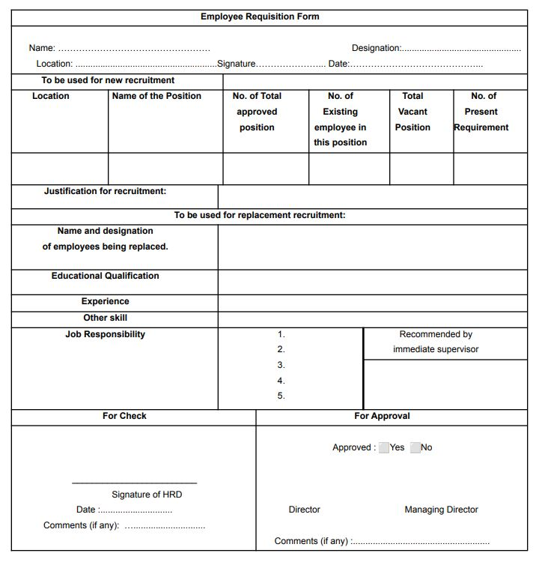

Attract applicants and collect resumes.

The human resources department will begin the hiring process after the Managing Director or CEO gives their consent. The next step will be to select how to identify prospective applications. There are two places where resumes can be obtained. Which are:

Internal sources | External sources
- Employee referrals  - Notice board  - Transfer and promotion  (other Department and other sister  concerns and head Office as all) | - Newspaper advertisement  - Online advertisement  (www.jobsdeepto.com,  www.bdjobs.com)  - Interns (previous or Existing)  - Random drop in

Here is their Job Circular Advertisement:
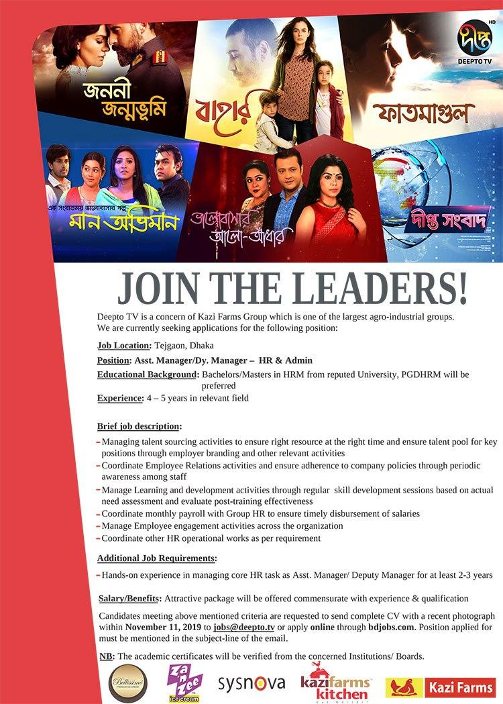
Sort out potential applicants for the position:
After Receiving Resumes, the HR department of KML starts its selection process . Resumes are chosen /in two steps. Firstly, they select applicants’ resumes. Then, they send these chosen resumes to the concerned department. After that, the concerned department does the final selection and informs the HR department. Sometimes, the concerned Department also refers some candidates on their own and sends their resumes to the HR Department to help them.

Making call list and informing candidates:
To inform the applicants about their Exam and confirm that they are attending the exam HR department makes a call list. This call list includes the applicant's name, Current company name (if any), current position or post (if any), and mobile numbers and remarks. The HR department calls them. If they can’t communicate with the applicants for any reason, they inform them via SMS.

Preparing Attendance Sheet:
The HR department will create an attendance sheet prior to the written, viva, and practical exams. The name, parent name, phone number, and a signature box of each applicant are listed on this attendance form. The attendance sheet will be prepared and delivered to the reception after that. Therefore, candidates will sign there when they arrive.

Written/Viva/Practical examination:
The HR department administers tests where candidates can participate in order to choose the ideal employee. Applicants must score 30 percent on the written exam. Exams in writing are divided into sections for English, Math, General Knowledge, and Job-Related Questions. Candidates must respond to the questions pertaining to the position in order to be considered. After reviewing the exam paper, the HR department attaches those with resumes. The board of directors' approval is then obtained. The HR division plans the viva after the written test. This viva board is made up of representatives from the HR department (usually the in charge), the relevant department, other departments/CEO, and for senior positions, the Board of Directors. In essence, interviewers assess the candidate in several ways. Which are:
- Understanding job responsibilities
- Communications skills.
- Leadership skill.
- Decision-making and Judgment abilities.
- Technical skill (if need).
- Can work hard under pressure.

Preparing the candidate's profile summary or Interview assessment Form:
The candidate's profile summary will be created by the HR division. Only for those who passed the written exam and will take the viva are the majority of the candidate profile summaries created after the written exam. The applicant's name, father's name, last education, educational institution, age, experience, and references are all listed in the summary of their application. This will make it easier for interviewers to quickly comprehend candidates.

Call the finalized candidates:
The HR division makes sure that the top candidate joins the company after the final selection. If the initial candidate cannot join in time, cannot match their requirements, disagrees with the provided salary, or has any personal issues. The HR division will then request the second or third best option. Then, on a set date and time, the HR staff calls the final candidate to ask them to bring the required paperwork.

Employment Check List for new joiners:
New Employees have to submit some important documents for their personal Files, ID card, salary account, SIM card, and visiting cards. These are
- Updated resume
- Employee Information form
- Dependable form
- Certificates and Transcript
- Releasing order (if any)
- 4 copy passport size photograph
- National ID card photocopy
- Joining letter
- Nominee form
- Medical certificate
- Blood group
- Bank account
- TIN certificate

Making personal file:
Every permanent Employee of KML has their individual personal file which is made and stored by the HR Department Manually. In this file employees all kinds of information maintained by the following sequent:
- Joining Checklist.
- Employee Information Form.
- Dependable Form.
- Proposal.
- Joining Letter.
- Appointment Letter.
- Updated resume with Interview Assessment Form on the top.
- All Academic Certificates (recent one on the top).
- Copy of NID/ Passport.
- TIN Certificate.
- Certificate of Professional Course (if any).
- Reference Checklist

HR Division justification:
The HR department confirms and justifies the new employee's documents and information when they are provided. Keep all the paperwork that his or her HR department provided in their own file after having it verified. If the new member is not provided a SIM card by KML, they also take their personal number for a visiting card.
Because of this, KML's HR department handles and maintains its HR procedures. Because they view their employees as family, the HR Department upholds the entire human resource practice of providing 100% bias-free employment opportunities to all of its employees.

4.3 KML’s Compensation Benefits:

Compensation Benefits

Promotion

Pay-roll system

Increment

Bonus

Medical allowance
Payroll system
A payroll system is responsible for managing the payment of wages and salaries by the employer to its employees. It typically includes gathering employee time information for a selected time period, and managing benefits & deductions. The KML calculation steps of payroll are as follows-
- Notify employees to complete their timesheets
- and Collect timesheets.
- Review & approve timesheets.
- Enter working hours.
- Calculate gross pay.
- Calculate net pay.
- Review.

Calculation of Employee’s Salary
Permanent employee’s total salary = Basic or net pay(50%) + Medical(20% of basic) + House rent (60% of basic) + Conveyance(20% of basic) Dining bill - Unpaid leave parents
In this way, KML’s HR department uploads each employee’s salary details into their system as a permanent employee. Their salaries will rise by 10% to 20% of their last basic salary. Other benefits will also rise as a result of this.
Bonus
KML has two annual festival bonus practices in their organization for Eid. At KMLs, all types of employees get a bonus that is 50% of their basic salary, but if any employee has to work on a festival holiday or any government holiday, that will count as overtime, and employees will get twice the basic salary each day.
Increment
KML has a yearly salary increment system for only permanent employees. Generally, their yearly income is 5% to 15% of an employee's basic salary. That can reduce their yearly profit and top management decisions as well.
Medical allowance
Every KML permanent employee receives a medical allowance for any serious medical issue. Even an employee’s spouse and children can also get this benefit. For the birth of children for female employees, KML will pay the whole cost of the hospital, and for male employees, they will pay 50%of thef total cost.

4.4 KML’s Employee Attendance System:
Kazi Media Limited usually uses a two-way verification approach to ensure their employees' attendance. They take their employees' attendance both digitally and manually. Firstly, every employee, from top-level to low, must fill up an attendance sheet where they have to mention their official start time, out time, and weekly holiday. Then they have to give their fingerprints at the door, which is direrecorded at the. This not only serves the purpose of attendance but also security issues. Then the attendance sheet is recorded in an excel file regularly by the HR so hinter employee database software called “umpire” to calculate their leave status and payroll.
KML is very concerned about their employees' regularity and efficiency even though they will pay half of the employee’s basic salary yearly as financial motivation if any employee didn’t tdoes any withoutunpaidall through the year. To control the misconduct, cut half cut the salary if their employee did not fully fill 8 hours dugout their 8-hour more than 4 days.

4.5 Training and Development Process for KML’s Employees:
There is no formal training system in KML. But for newly joined Employees development they arrange an orientation program to introduce them to the whole KML family and policies of KML so that they can do their work in an easy and comfortable way. This orientation program is hosted and arranged by the HR department and their CEO was the chief guest on it.
Sometimes department In-charge and supervisors arrange some workshops for 3 to 4 days during their employee's working hours to develop their skills, make them more productive and solve any issue or conflict that arises in the department. This can be considered on-the-job training.

4.6 Performance Appraisal System:
The main purpose why KML does Performance appraisal are:
- To overview the employee's past performance.
- To find out if their employee performance needs any improvement or development.
- To employees' individual development.
- To identify who should get promoted.
- To solve the hidden issue and crisis of KML.
This performance appraisal process is conducted by the Supervisor most by the department head, subordinates, and peers, self-appraisal, and 360- degree approach.Every June the Every Employee KML of all departments will have to fill up an evaluation of form in ‘Admire’ for their supervisor subordinates, peer, and self-appraisal.
KML uses two methods for performance Appraisal:
- Experience-based approach.
- 360-degree Feedback approach.

4.7 Policies for Resignation, Termination, and Retirement of Services:
Policies and procedures of termination and resignation of KML:
Purpose:
- When a regular or probationary employee resigns.
- When a regular or probationary employee is terminated for any criminal offense.
- When the contract of a casual or contractual employee is over.

Policies for Resignation:
Permanent Employee: If any permanent employee wants to resign he or she has to give a written notice before one month to the HR department with approval of his or her supervisor and departmental Head. He or she will get compensation and other benefits such as annual leave’s payment or Medical benefit if any due remain.
Temporary Employee: If any employee under probation, contractual and casual employee wants to resign he or she has to give notice before 15 days and he or she will get 15 days payment as well.

Policies for Termination:
Permanent employee: Authority may terminate any of their permanent employees if he or she is involved with any unfaithful deeds. They have to give 15days notice and two month salary and the terminated employee will not receive any other benefits such as annual bonus, festival bonus etc.
Temporary employee: Authority can terminate any of its probationer, contractual, and casual employee any time without any advance notice and compensation.
Policies for Retirement:
According to the police every permanent employee of KML who worked here for at least 5 years and his or her age is at least 60 will retire from his or her job. If the employee worked at KML for 5 years he or she will pay = last basic salary* 5 after his or her retirement as well as other benefits.
4.8 Policies of Leave:
KML divide their Permanent Employee’s leave policy into five types. Those are detailing below:
Casual Leave:

KML provides their employees ten weekdays with pay leave yearly. At a time an employee can take three-day leave by showing some valid reason to the departmental in charge and the HR department.
Medical Leave:

KML’s Employees can take fourteen weekdays to leave yearly. For one-day medical leave, employees don’t have to submit any medical certificate or support for their leave they just have to inform the they took this leave for sickness to the HR department but if they took leave for more than one day for sickness they have to submit valid supporting for that.
Annual Leave:

Without Casual and Medical Leave Employees can take more than twelve days yearly with pay. This leave facility is called Annual Leave. From that twelve days of leave. From those 12 days every month, employees earn 1.25-day leave. If any employee takes more leave than he /she earned then those will be considered without pay leave which means their salary will be cut for those leave. In addition, If any employee doesn’t use his/her annual leave in the whole year they will get half of their basic salary of a month after the end of a financial year as financial motivation so that he/she can be more dedicated toward work.
Maternity Leave:
This leave benefits only female employees. Every permanent female can take four months of pay leave before or after the birth of a child. She can also take two more months without pay leave for this too. To gain that benefit she must have to submit her child's birth certificate according to Bangladesh Labor Law policy.
Study Leave:
KML always encourages their Employees to higher studies even though they provide one with pay and six months without pay study leave to their permanent employee.
Replacement leave of day off:

If any employee works on their weekly holiday, any Government holiday, or festival holiday he /she can take a replacement of this holiday later within a three month period. Or he or she can take twice their per day compensation if he or she works during the government holiday and festival holiday.
To take any of those leave benefits an employee has to submit their leave form to the HR department to mention the valid reason behind leaving. Leave form will be approved by the department in charge and HR in Charge.

CHAPTER 5
ANALYSIS & INTERPRETATIONS

5.1 SWOT Analysis of Kazi Media Limited (Deepto tv)
The SWOT analysis of KML is listed below:

STRENGTHS:
- Maximum utilization of funds: Part of the Kazi business groups is KML. One of the biggest groups in Bangladesh is the Kazi business group. Kazi Firm Groups has set aside a sizable amount for their brand-new business, KML.
- Strong HR approach: KML has also set aside funds for human capital management. Fuad Chowdhury leads the KML with the goal of achieving audience happiness. KML Human Resource Management seeks experienced and new skilled people from the sector in order to achieve this objective.
- Diversified programs: KML pushed for deeper audience segmentations in order to attract and retain viewers. It provides viewers with a variety of programs, dramas, shows, cartoons, and so forth. KML invested in cutting-edge technology and equipment. Many of these pieces of equipment have already arrived, and only a few more are on the way.
- Own Building: Deepto TV owns and manages its own infrastructure, giving it greater independence and control over its satellite TV channel operations than many other satellite TV channel providers.
- Own Studio: KML has a dedicated shooting studio. The office currently has three studios. The fact that the channel doesn't have to rent another studio for filming is a plus.

WEAKNESS:
- Manipulated by other departments: KML has multiple divisions. Other department personnel being manipulated occasionally causes serious issues for the organization.
- Insufficient manpower: DeeptoTv (KML) is a brand-new television channel. They have only recently begun their adventure and are now hiring for various roles. However, the company's staff is insufficient. When a small workforce encounters a lengthy procedure, they require additional personnel.
- Office location & the external environment: One of their weak points is the location of their office. Employees and outside guests are having difficulty entering and exiting the office as a result of this. Management has also begun to take initiative to change their surrounding environment.
- Lack of own policies: KML don’t have any individual policies for their employees, they follow the Kazi farm group’s policies which are more appropriate for any corporation not for TV channels.
- Interrelated HR department: Kazi farm Group’s HR department centrally moderate the whole HR practices of all of its sister Concern.

OPPORTUNITIES:
- Skilled Employees: Despite having a small team, they make certain that the top individuals with experience and talent are chosen. With the growth of Bangladesh's ICT sector, KML may be able to expand into new platforms such as Internet online channels.
- Opportunities for employee betterment: Through proper guidelines, they will help their employees in their work.
- Training program: For existing KML personnel, some on-the-job or off-the-job training should be planned in order to increase productivity.

THREATS:
- Experienced Market leaders: The majority of the rivals in this field have extensive experience. KML can encounter some difficulties when fighting against these seasoned rivals.
- Competitive pressure: This industry already has a large number of competitors, which makes it an excellent competition industry. The competition amongst the competitors is escalating daily.
- Entrance of New TV channels: Many more new satellite TV stations are awaiting broadcasting license, which will pose a significant challenge to DeetoTv in the near future. We said in Porter's five force model that many more additional satellites will be introduced to the airwaves in the coming years.
- Political issues: Political unrest may be one of the most important risks to KML. Political upheaval in Bangladesh has in the past affected the operations of various industries.

5.2 Table & Chart
1) Kazi Media Limited’s Human Resource Practices are free from biases.

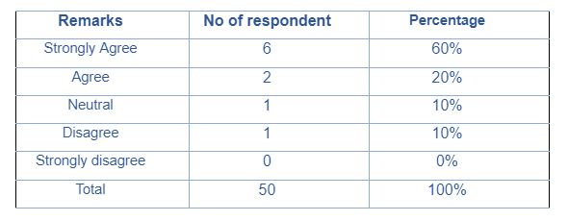
According to the graph above, Most employees agreed that KML's HR systems are unbiased and fair to its employees.

2) International candidates for recruitment are acceptable & encouraged in Kazi Media Limited.

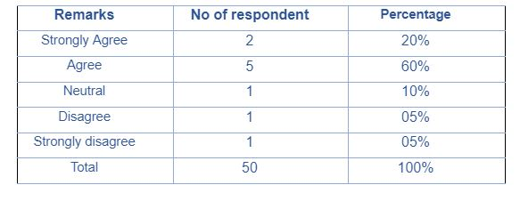
According to the graph above, Kazi Media Limited supports and welcomes international candidates for job reasons in order to raise the value of their firm by being more productive.
3) Kazi Media Limited always follows a rigid system in their HR Practices.

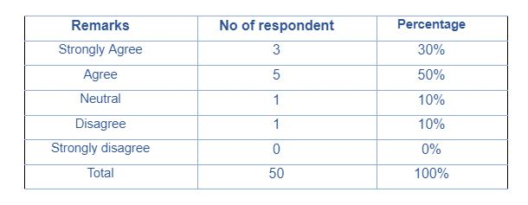
According to the graph above, half of the sample think kazi media’s HR practices are a bit rigid as they are always following traditional corporate approaches for maintaining their HR practices.

4) Kazi Media Limited’s compensation benefits are fair enough for its employees.

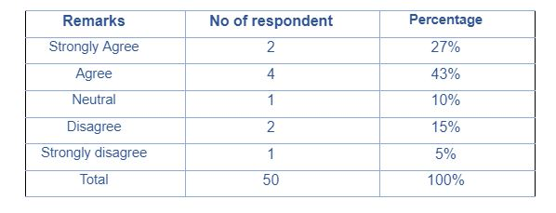
The accompanying graph shows that most of the respondents agreed with the premise that KML's employee benefits are fair enough.

5) Kazi Media Limited’s HR practices are cost effective.

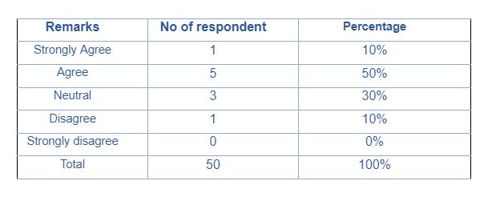

In this graph, half of KML employees agreed that HR policies are cost-effective.

6) The HR practices of KML help the employee to show their path to achieving their career goal during recruiting employees.

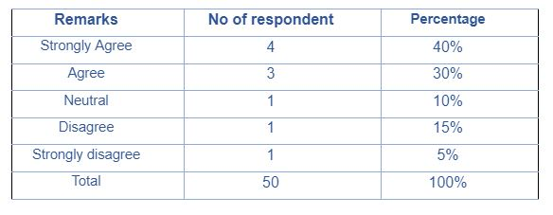
In this graph, 30% of Kazi Media Limited respondents agreed that they should be able to demonstrate their career path to their staff but the rest of other don't. They think they should get more support for their career.

7) KML’s leave benefits are not helpful to their employees.

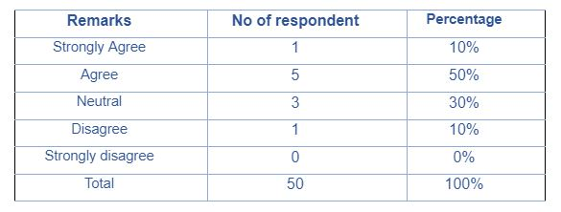
In this graph, half of the KML respondents agreed that leave benefits are beneficial because they get 32 days' paid leave in a year.

8) KML’s termination and resignation policies are fair.

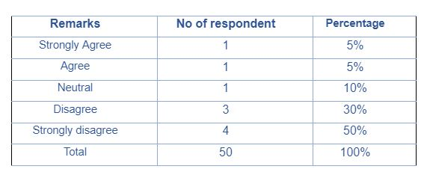
According to the graph, half of the respondents strongly disapproved of KML's termination and resignation processes this is because they didn't;y update the policies for a long time.

9) KML’s HR practices lead to achieving organizational overall goals.

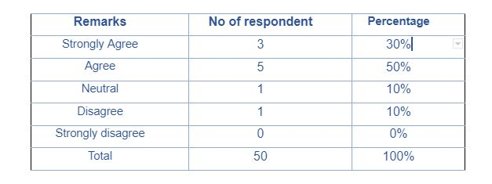
In the graph above, half of the respondents agreed that KML's HR processes help the firm achieve its goals but the rest of them can’t agree upon it.

10) KML’s Human Resource department hires employees from both external & internal sources.

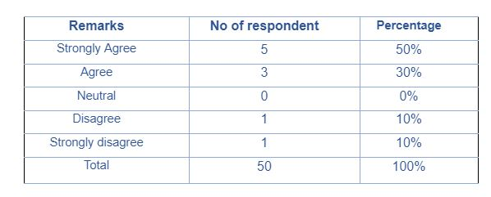
The HR department used individuals from both sources, according to half of Kazi Media Limited respondents KML hired employees from internal sources they think because of the switch of employees from their other businesses.

5.3 Interpretations
I gathered information from 50 workers of Kazi Media Limited who work in various departments in order to perform my research on the human resource policies of the company. The employees strongly affirm that they find the human resource procedures to be highly good. They are enjoying their job in the Kazi Media Family very much.

CHAPTER 6
INTERNSHIP EXPERIENCE

6.1 Lessons learned from Internship
Duties and responsibilities: During my internship, I was given the following list of tasks and obligations:
- Applicants should deposit their CV in the office CV box or email it to an official email address. CVs are collected for essential openings via the BDjobs website. In addition, I request that the Office Assistant collect the CV from a CV box.
- Collecting Wedding Invitation Card:
- Screening CV: They receive CVs in large quantities. There are few areas to be considered while screening the CV’s such as age, educational information, original certificates and location. For example, a candidate has to be 18 years old or above to apply for a job. For Associates and responsible positions the candidate has to be a graduate student and experience in their work position.
- After screening the CVs and classifying them into various categories, the interview date for various positions is set, and the candidate is informed of the interview.
- Calling for Interview: After screening the CV I was asked to separate them based on their location. It is my job to call the candidates for an interview and inform them about the interview date, time and venue. After the interview I had to call the selected candidates. While calling the candidates I have to give a serial number to their CV.
- Making Interview Lists: After calling the candidates it is my job to prepare an interview list which contains the name of the applicant, position, applicant current work place name, current working position, contact number and remarks. At the bottom of the list names of the Human resource officer and the head of the departments who are taking the interview were included.
- Making an employee profile: DEEPTO TV's HR department preserves manual and electronic records of all of its workers. I learnt how to set up files for new hires after recruitment. A new ID is issued to each new hire so they can be identified. The employee file includes the employee's passport-size photos, employee information update form, appointment letter, offer letter, proposal approval letter, joining letter from DEEPTO TV, CV, photocopies of the employee's academic transcripts, national identification card photocopies, birth certificate, previous employment records, and reference letters.
- Employee Joining: I do all joining-related responsibilities when a new employee joins. I first offer them a letter of joining. Give an appointment letter after that. After that, provide an update form to the staff. Afterward, get copies of your national ID card, passport-size pictures, and educational credentials. All required signatures and fills are included in the tasks.
- Leave Processing: Giving the employee a leave form, accepting applications, and entering data into excel files are all parts of the leave processing procedure. For a variety of reasons, employees occasionally can't get into the workplace. Sickness, domestic issues, or unscheduled leave are all potential causes. Any employee who requires leave must notify HR. I gave them a leave application when they notified me. They filled up the paperwork and gave it back to me. I entered the information into excel files after obtaining the form.
- Bank opening form: It is my responsibility to offer a new employee a bank opening paperwork after welcoming them to the organization. Dutch Bangla Bank is the bank owned by our firm. I assisted workers in completing the paperwork. I indicate all the relevant blank places so that workers would know what they need to fill in. I also gather pictures of the employees and any nominees, copies of national identification, and SSC certificates for the workers. I received the bank paperwork after filling it out and getting the required signatures.
- Sending Papers to Headquarters: Important documents and papers are sent to the KGF office for higher approval via office assistant.

CHAPTER 7
CONCLUSION
&
RECOMMENDATIONS

7.1 Recommendations
After completing the internship program, I have come up with some recommendations for Kazi Media Ltd for their improvement. These are:
- An online requisition system ought to be implemented by HR. As a consequence, the HR division will receive the requisition form right away, which will speed up the procedure.
- The HR department needs to improve their website's information system.
- The HR division may reduce the amount of paper used throughout the recruiting and selection process.
- The Deepto Television Ltd. does not provide any training for new interns or employees. However, if they provide interns any kind of training program, it will be simpler for them to adapt to the new setting.
- The HR department has to frequently examine their job site. jobs@deepto.tv

7.2 Conclusion
The global system of human resource management is progressively evolving. In Bangladesh, firms are rearranging the current HRM structure as the HRM idea develops there as well. The KaziMedia Limited is attempting to manage its human resources in a manner that is consistent with this viewpoint. There is no off-the-job training scheme in the KML. However, they have a strict maternity leave policy. Although their general activity is pleasant, if they adhere to the Labor Law Act of 2006, they may avoid these issues and establish themselves as a true HRM organization.

In Bangladesh, it is a private cable and satellite television station. It belongs entirely to Kazi Farms Group. The Kazi Media Ltd's extensive and intricate human resources division undermines the management process as a whole. The success of KML is a result of effective HR procedures and cooperation. Even though they treat their workers with decency, respect, trust, and openness where people from all backgrounds may attain their greatest career potential, KML knows that a productive and motivated staff is a necessity to success in the industry it serves. The management should keep the HR procedure as it is and as perceived to be fair, according to the research's conclusions. Since effective HR practices will ensure positive financial returns for the organization either through ensuring employee effectiveness or minimizing costs associated with training and retraining of employees, there should be measures that all HR practices adhere to the standards and policies of the company.

CHAPTER 8
BIBLIOGRAPHY
&
APPENDIX

8.1 Bibliography
Books & Journal:
- Aswathppa, K. .. (2008). International Human Resouce Management. Delhi: Tata McGraw-Hill.
- Bae, J. a. (2001). Journal of World Business. The impact of Globalization on HRM, 402-406.
- Tayeb, M. (2005). In Internatinal Human Resouce Managment (pp. 70,74,79, 99-!02). Oxford University.
- Armstrong, M. (2009). Armstrong’s Handbook of Human Resource Management Practice (11th ed., p. 515). Kogan Page.
- BASS, B., & VAUGHAN, J. (1966). TRAINING IN INDUSTRY--THE MANAGEMENT OF LEARNING.
- iEduNote. Retrieved from https://www.iedunote.com/training.
- Bhattacharyya, D. (2006). Human Resource Planning (2nd ed., p. 69). Excel Books.
- Deb, T. (2006). Strategic Approach to Human Resource Management (p. 76). Atlantic Publishers and Distributors.
- Dessler, G. (2011). A Framework For Human Resource Management (6th ed., pp. 84-85). Pearson.
- Patnaik, B., & Padhi, P. (2012). COMPENSATION MANAGEMENT: A THEORETICAL PREVIEW. TRANS Asian Journal of Marketing & Management Research, 01(01), 39. https://doi.org/publication/259786503
- Armstrong, M. (2006). A Handbook of Human Resource Management Practice (10th ed., pp. 363, 409). Kogan Page.
- Reilly, P. (1996). Human Resource Planning: An Introduction. The Institute for Employment Studies.
- Armstrong, M. (2010). Essential Human Resource Management Practice. Kogan Page Limited.

Websites:
- https://en.wikipedia.org/wiki/Special:Search?search=Recruitment%20and%20%20Selection&go=Go&ns0=1&fbclid=IwAR0Hdzv_vGm-Y0WVRTIim_55gbXe8wh4YzhofimNO7po5azsNM34O4rjyQA

- https://www.ilo.org/dyn/travail/docs/352/A%20Handbook%20on%20the%20Bangladesh%20Labour%20Act%202006.pdf?fbclid=IwAR2tzRELYqAQ4D7WMeb_-Z1X75eQg1pA1aygboEB7pM0VZgA0SJbVG_ZQR4

- https://en.wikipedia.org/wiki/Deepto_TV?fbclid=IwAR3sg7fJb7ZgDH4wYkgxGqv3y37IL7zEKO4wZA_OPWIY9qYxvOVCAMJ1dz4

- https://www.deepto.tv/?fbclid=IwAR24v6aC3vysi_MncR3dHhtRIjIkILlDrow7k1Z0667sfS_MLOwIcC22geQ

8.2 Appendix
Questionnaire


