

Internship Report
An effective study on the recruitment and selection process of SQUARE Toiletries Ltd

Prepared By: Sabera Shirin Anna
ID: 111 141 270
School of Business and Economics

Submission date: 29.04.2019

Submitted To: Mohd. Hasanur Raihan Joarder
Professor and Director, IBER,
United International University
Letter of Transmittal
February 19th, 2019
United International University
Subject: Submission of the Internship report on “An effective study on the recruitment and selection process of SQUARE Toiletries Ltd”
Dear Sir,
With due Respect, I would like to mention that my internship report is on “An effective study on the recruitment and selection process of SQUARE Toiletries Ltd (STL)” My main goal was to prepare this internship report according to your guidelines and in accordance with your direction. I want to show my gratitude to you for your encouragement and support. I have tried my best to add all the relevant information regarding the whole recruitment and selection process of SQUARE Toiletries Ltd (STL). Hope you would find this report satisfactory. I beg your pardon if there is any accidental error in the overall internship report. I have enjoyed a lot during my internship period through understanding details and gathering knowledge of the particular areas and also on writing this report.
The internal content of this report is based on the recruitment and selection process of SQUARE Toiletries Ltd (STL) which is coordinated by the Human Resource Department. Furthermore, if you have any query regarding this report please feel free to ask me.
Sincerely,

SaberaShirin Anna
ID: 111 141 270
Acknowledgement

I would love to begin by thanking Almighty Allah for giving me strength to be able to successfully finish my internship report. With the help of almighty and tremendous support and blessings of my family I have been able to complete my three months long internship at SQUARE Toiletries Ltd. I want to show my heartfelt and deepest gratitude to my Academic supervisor, United International University for his endless support and inspiration during this internship.
I must not forget to mention my appreciation to Ms. MonamiHauqe, AGM- HR, SQUARE Toiletries Ltd under whose supervision I went through my internship. I greatly appreciate her for allowing me to carry out my role independently while at the same time providing me with needed support. Moreover my thanks go to Mr. Muhammad ShahnurRajib, Senior Executive, and Mr. Khandker Nabil Abrar, Executive, Human Resource Department, SQUARE Toiletries Ltd. They were constantly there with me like mentors to ensure that this report comes out successfully. At the same time my thanks go to the other colleagues of SQUARE Group who provided me infinite hold up and helped me to learn the situation of the real corporate world.
Last but not the least, I am grateful to United International University which is the reason I am standing here at the edge of earning my bachelor degree successfully.

Executive Summary

This report is commissioned to examine the recruitment and selection process of Square Toiletries Ltd. A comprehensive research has been conducted on the recruitment and selection process of the company. In my working experience my supervisors guide me about the organizational culture, HR policies, working style and most importantly its recruitment and selection process. In my report I tried to pull all my experience, knowledge and observation of the recruitment and selection process of STL. The report also highlights the problems of the whole process which is comprised on the findings chapter of this report. My observation draws attention that STL is pretty serious about its recruitment and selection process and the HR department is really choosy about the quality of the employees. Though some betterment in areas like background check, better training facilities, introduction of computerized inventory system, standardization of question paper, medical test before joining, competitive salary packages are the key findings of the research. These findings have been included with detailed analysis. Some recommendations for the betterment of the process have been included in the later part. Some of the key recommendations are inclusion of more steps in the selection process, introduction of specialized trainings, modifications of the existing interview evaluation forms, alteration in the advertisements, participations in job fairs etc. the report has been prepared with qualitative data collected from the employees of the company. To collect information face to face interview with semi structured questionnaire was used moreover in the project part of the report the entire recruitment and selection process has been described with some examples of the company’s recent recruitments. Each step such as HR planning, recruitment sources, CV sorting, written test, interview and making the final job offer etc have been explained elaborately. The report as a whole gives a comprehensive idea about the recruitment and selection process of STL. Despite having the challenges I finally noted some problems that can be terminated in order to develop the process.

Contents
Chapter I: ………………………………………………………………………………………………1
The Organization ………………………………………………………………………………………1
1.1 Introduction ……………………………………………………………………………….2
1.2 Company History …………………………………………………………………………3
1.3 Vision and Mission ……………………………………………………………………….5
1.4 Product Offerings …………………………………………………………………………6
1.5 Departments of STL ………………………………………………………………………7
1.6 Management Hierarchy …………………………………………………………………..8
1.7 Organogram of STL ………………………………………………………………………9
Chapter II: ……………………………………………………………………………………………..10
Mt Contribution to Square Toiletries Ltd ……………………………………………………………..10
2.1 Job Responsibilities ………………………………………………………………………11
2.2 Lessons learnt during Internship …………………………………………………………11
2.3 Interaction with my Supervisor and Colleagues …………………………………………13
2.4 Difference between Expectation and Experience ………………………………………..13
Chapter III: …………………………………………………………………………………………...15
The Project ……………………………………………………………………………………………15
3.1 Objective of the report………………………………………….………………………..16
3.2 Methodology……………………………………………………………………………..16
3.3 Limitations………………………………………………………………………………..18
3.4 Recruitment & Selection………………………………………………………………….18
3.5 The Project………………………………………………………………………………..24
3.6 Recruitment Sources ……………..………………………………………………………25
3.7 Recruitment and Selection Process … ………………………….………………………..27
Chapter IV: ……………………………………………………………………………………………35
Findings and Recommendation…………………….…………………….…………………………..29
4.1 Findings…………………….…………………….…………………….………………..36
4.2 Recommendations…………………….…………………….…………………………...37
4.3 Conclusion…………………….…………………….…………………….…………….39
Appendix…………………….…………………….…………………….…………………………..40
Bibliography …………………….…………………….…………………………………………….43

CHAPTER I
THE ORGANIZATION

  - Introduction:
“The only source of knowledge is experience” – Albert Einstein. And through the internship program every fresh graduate can acquire experience by working in corporate workplace. Today’s recruiters focus more on the relative work experience which a student more specifically a fresh graduate can acquire through the internship programs. The definition of internship can be depicted to be an opportunity provided by organizations to potential employees to work in their organization for a specific period of time allowing the interns to grasp knowledge about the industry as well as groom themselves up for their future career development.
Square Toiletries Ltd is one of the key concerns of Square Group. It currently employs more than 2000 employees all over the country. To ensure the proper management of this huge manpower it essentially requires a sound HR Policy and most importantly the best manpower in the HR department as well. STL has got a very sound HR team which is always active ensuring a friendly working environment, successful-recruitment selection, job satisfaction and maintaining day to day HR operations. The work experience gathered through working with the team can be extremely attractive to burgeoning employers on an applicant’s Curriculum Vitae.
The internship opportunity of t the HR department of STL opened the chance for a great learning occasion for a BBA student. Being an HRM major an internship program at this company takes a student to the top of a learning curve which one can carry towards his challenging journey to the corporate world. This report includes the best learning output during the internship program along some critical observations and recommendations as well.
The report additionally includes the company history along with their product offerings. Moreover, the company’s future vision and other aspects as a whole are comprised in the body of the report. Joining with the undertaking part, the report additionally incorporates the activity obligation of an understudy at STL. The succeeding report is constitution of an elaborate description of my experience as an intern in the Human Resource Department of STL which started from May 28, 2018 and ended on August 28, 2018.
  - Company History:
SQUARE, today symbolizes a name- a state of mind. Sixty years of hard work, passion and commitment have brought this company from the very inception in 1958, when Square Pharmaceutical Ltd, the flagship company of SQUARE Group was established and founded by Mr. Samson H Chowdhury with his three other friends. ‘SQUARE Group’ now consists of some diversified sister concerns at different sides like Pharmaceutical and Healthcare, FMCG, Textiles, Media, TV/IT, Banking & Insurance, Security Solution, and Agriculture & Veterinary. Today Square Group has burgeoned into one of the top line esteemed conglomerates in Bangladesh. (“Square: The Rise ofa Giant”)
Name | Logo | Name | Logo
Square Pharmaceuticals Ltd |  | Square Hospitals Ltd | 
Square Toiletries Ltd |  | Maasranga Communications Ltd | 
Square Food and Beverage Ltd |  | Mediacom Ltd | 
Square Herbal and Neutraceuticals Ltd |  | Aegis Services Ltd | 
Square Informatix Ltd |  | Sabazpur Tea Company Ltd | 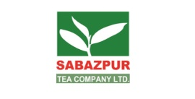
Square Fashion Ltd |  | Maasranga Production Ltd. | 
Square Textiles Ltd |  | Square College of Nursing | 
Figure: Concerns of Square Group
Square Toiletries Ltd started its journey in 1988 with a single as a separate division of Square Pharmaceuticals. In 1994, Square Toiletries Ltd became a Private Ltd Company. STL belongs to a unique nationality. In every footstep- from inimitable history of cultural heritage to the love for mother dialect to the glorious freedom fight to our beautiful flora and fauna- we are only one of its classes. This unmatchable feature of us is also acutely rooted to every one of us in our individual affinity, enthusiasm, needs, dreams and hopes. At STL they believe in the importance of uniqueness both at individual and national level. Being a part of the most admired local conglomerate of Bangladesh – Square Group, it helps to gain the expertise and upheld somber eagerness in fulfilling the expectations with the quality product ranges through utmost sincerity. They consider their clients, customers as unique in terms of their needs, and to satisfy that STL have pooled a unique team of dedicated employee and stakeholder. Only for them Square Toiletries is relentlessly striving to be “As unique as you”.



At present, STL is the country’s leading manufacturer of international quality cosmetics and toiletries with 20 brands and more than 55 products covering a wide range of categories like skin care, hair care, oral care, baby care, fabric care, scourers, male grooming and OTC.

Besides core business functions STL has long been taking active part in different philanthropic activities like employment generation program for vulnerable community, financial aid to disadvantaged and natural disaster affected people, helping acid victims, tree plantation, creating mass awareness on health and hygiene issues, supporting in education and various local community programs and many more.

  - Vision and Mission:

Vision
Square Toiletries Ltd attempt to understand the unique needs of the consumer and translate that needs into products which satisfies them in the form of quality products, high level of service and affordable price range in a unique way. (“SQUARE TOILETRIES LTD”)

Mission

- To treasure consumer understanding as one of our most valued assets and thereby exerting every effort to understand consumers’ dynamic requirements to enable us in offering maximum satisfaction.
- To offer consumer products at affordable price by strictly maintaining uncompromising stance with quality. With continuous R&D and innovation we strive to make our products complying with international quality standards.
- To maintain a congenial working environment to build and develop the core asset of STL- its people. As well as to pursue for high level of employee motivation and satisfaction.
- To sincerely uphold the responsibility towards the government and society with utmost ethical standards as well as make every effort for a social order devoid of malpractices, anti- environmental behaviors, unethical and corruptive dealings. (“SQUARE TOILETRIES LTD”).

  - Product Offerings:

The product list of STL is of a wide variety. It has enormous products regarding hair care to men grooming to baby care to dish washers. STL started its journey with only one product called Jui coconut oil and now it has 20 different brands. Among them Meril Products, Jui, Kool, Senora, Sepnil, Supermom etc are some of the most renowned names in the FMCG industry in Bangladesh. These products are giving a good fight against the competitors such as Unilever, ACI, PRAN, Abulkhair, Meghna Group, Reckitt Benkiser, GlaxoSmithkline, Abdul Monem, and Kohinoor Chemicals etc. Square Toiletries owns two factories- one in Pabna and the other in Rupshi(Narayanganj), where all these products are manufactured. Also the Product Development teams both in factory and in the head office is working relentlessly to come up with new products to meet the customers’ needs.
Their product list consists of the following 20 brands:

Jui | Kool | Spring | Chaka
Meril Baby Care | Freshgel | Xpel | Chamak
Meril Protective Care | White Plus | Sepnil | Shakti
Meril Splash | Select Plus | Senora | Saaf
Revive | Magic | Supermom | Madina



Moreover, STL is one of the few Bangladeshi companies that is successfully exporting its products in foreign countries. Those foreign countries would be the following:

India | Qatar
Myanmar | Kuwait
Bhutan | South Africa
Singapore | United Kingdom
Malaysia | Germany
UAE | Australia

  - Departments of STL:

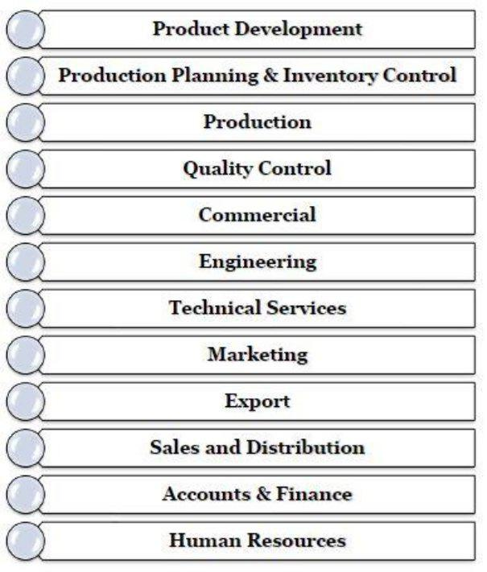

Total 3094 people are currently working in Square Toiletries Ltd (STL) including Dhaka Office, Pabna Plant and Rupshi Plant. The departments of HR, Sales, Marketing, Production, Export, Commercial, Accounts and Finance, MIS are located at the head office in Dhaka. Rest of the deprtments are distributed in factories at Rupshi and Pabna.

  - Management Hierarchy:
All the departments of STL follow a well structured hierarchy for the management positions:

Junior Execute
AGM
Senior Manager
Manager
Assistant Manager
Senior Executive
Executive
DGM
GM

Figure: Hierarchy of Management Positions
  - Organogram of STL:
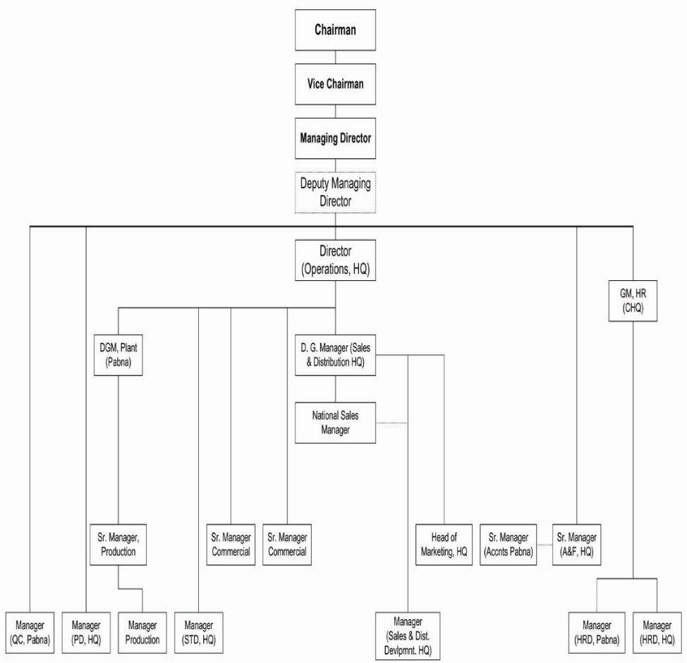

Figure: Organizational organogram of Square Toiletries Ltd
This tends to be the operational organogram of Square Toiletries Ltd. This organogram is updated every one year after consultation with the department heads.

CHAPTER 2
MY CONTRIBUTION TO
SQUARE TOILETRIES LTD

Getting opportunity to do a three months long internship program at Square Toiletries Ltd, I had to perform many HR functions during the whole internship phase. Being an HRM major student, the opportunity I got from STL opened the door for me to connect different theoretical aspects with the job. I had to execute different operations according to the guidelines from my supervisors but I worked within the HR department.
2.1 Job Responsibilities:
My core responsibility at STL was to assist the recruitment and selection team. As a whole the main work responsibilities can be enlisted as following:
- Collecting CV
- CV Sorting
- Maintaining contact with potential candidates
- Preparing Candidate Summary
- Coordinating written tests and arranging Interviews
- Checking written exam scripts
- Maintaining employee file
- Preparing job confirmation letters and hiring proposals
2.2 Lessons Learned During Internship:
Being able to work with one of the most reputed SMCG Company of Bangladesh like Square Toiletries Ltd has been a salient experience. Throughout the whole journey, my main focus was not only enhancing my experience but also be familiar with the whole corporate culture. Every lesson was equally important to me but some of the mains are explained below:
- Communication Skills:
While working in a corporate field communication is really important. An excellent communication skill is the key to survival in a workplace. In these three months I had to communicate with many people both within and outside the office.

- Technical Skill:
I had to do the majority of my tasks through Microsoft Excel. Before working in STL I only knew a few basic things about Microsoft Excel. So I had to struggle for the first few days but after that with the help of my supervisors I became able to overcome this problem. With the accomplishment of every task, my speed of typing and level of accuracy grew better.
- Analytical Skills:
Solving any complex situation through constructive solution based on the available information is known as Analytical skill. Being an intern of HR department many times I faced these kinds of situation where a Sales Officer may leave the training in between or issues with their certificates etc.
- Interpersonal Skills:
My interpersonal skills were developed through the communication skill development. The different interaction techniques that I had to grow while working in the HR Department by communicating in different environments contributed the most in developing my interpersonal skills. I got to know how to work as a team member with both verbal and non verbal communication
- Personal Development:
As the life of a university student and an employee of an organization can never be same, I got the opportunity to grow myself to adjust with the corporate culture by working in STL. I faced different circumstances during this period which helped me to think differently about any problem.
- Multitasking:
In the three month internship period I had to do multiple tasks t the same time through which my multitasking ability was developed. And I was always able to finish my tasks in the provided time limit.

- Time Management:
In STL we had 9 hours of office starting from 8.30 am to 5.30 pm and everyone had to maintain it. As it was new for me to maintain an office time so sometimes I found it difficult. But gradually I got used to it and my life became even more disciplined.
- Professionalism:
Throughout my internship, I learnt a good deal of professionalism by observing my colleagues. I also learnt that professionalism is not all about a person’s attire or looks but it is more about how a person deals with others in a professional manner.

2.3 Interaction with my supervisors and colleagues:
My supervisor was Ms. MonamiHaque, Deputy General Manager, Human Resource Department, Square Toiletries Ltd. As a person she is very hardworking and humble. She follows up everyone’s work those who are working under her with equal care. Even she used to work even after the office hours if the assigned work is important. After observing her I got so inspired that I want to develop myself by following her footsteps.
My other co workers in that department Mr. Muhammad ShahnurRajib(Senior Executive), Mr. Nabil Abrar (Executive) nd Ms. TamannaMahmuda also were very helpful and cooperative to me. With everyone’s support I was able to maintain all the rules and regulations of that department and also that organization. They also gave me suggestions about the future prospect or the career goals of my life.
2.4Difference between Expectation and Experience:
In these three months I found some gap between my expectations and actual work experience:
- Academic Theories VS Actual Work Experience:
During the under graduation life we have been taught many theories but the application of these theories is different in the actual work life. As an HR major I worked for the HR department, so the major courses were very helpful during my internship period. But I realized that there were a bit of lacking in effectiveness of the basic MIS courses offered in our University. Because if the universities teach more technical aspects of MIS functions being used in companies, it would be easier for the students to adapt.
- Work Smartly:
In our educational life it has been taught that the organizations prefer smart managers who have the willingness to work hard and has leadership qualities. Most of the people have this assumption that by working hard anyone gets success in life. But in real life a person has to work smartly as well. And to do that a person has to establish coordination with others in the organization.
- Importance of Job Experience:
By working in the Human Resource Department, I had realized that job experience is a must for future career development. Academic knowledge provides us the guideline but to get a job or even to survive in a job, we need real life job experience.

CHAPTER 3
THE PROJECT

3.1 Objective of the Project:
This report is an outcome of the job responsibilities that I performed throughout my three months long internship at Square Toiletries Ltd. This internship program is essential for every UIU student to put a significant end to their BBA program. So this report is simply a reflection of job duties that an intern does in STL as a part of the internship program.
Primary Objective:
- Identifying the effectiveness of the recruitment and selection process of STL through discovering the problems.
Secondary Objectives:
- Exploring the actual corporate world.
- Relating the theoretical knowledge with an actual work place.
- Successfully being able to earn the BBA Degree.

3.2 Methodology:
This report was made in a qualitative manner containing qualitative data regarding the effectiveness of the recruitment and selection process of STL. The information gathered are descriptive hence the result is qualitative as well.
- Selecting the topic:
The topic relies on the work that I had done at STL (HR Department) during my three months long internship. I was assigned to work on the given topic by my internship advisor after repeated discussion with me regarding the topic selection. The given topic not only goes with my job responsibilities properly but also can be considered as a significant topic.

- Sources of Data:
Both primary and secondary resources were used in order to collect necessary data. The primary resources include:
- My observation regarding the whole recruitment and selection process
- Face to Face interviews with both employees and candidates of STL
The secondary source includes:
- Internet
- Newspaper Article
- Textbook
All these above mentioned sources were used to give accuracy to this report.
- Collecting the data:
Primary data had been collected through face to face interview with the employees of HR, Sales, MIS and production department. As I worked for other departments’ recruitment process, so I included them all. The sample size for collecting data was 20 including 15 employees and 5 candidates. I used a semi structured set of questionnaire to interview the employees and candidates. The questionnaire is attached in the appendix section. Though some other questions were asked as well in order to find relevant information thatfulfills the objectives of the report.
The secondary data were collected from company website, newspaper articles and text books. In order to get information about the product line, company history etc I used the company website. Newspaper helped me know about the job postings and other relevant information. Lastly I took the help of text books in order to relate various HR topics with my job responsibilities. The data sources have been shown in the reference section of this report.

- Interpreting the data:
Being a qualitative report all the received data are shown in descriptive manner. Some figures like diagrams and tables are inserted as well in order to interpret the data with accuracy.

3.3 Limitations:
Having a proper idea about an organizations whole HR department and gathering information for this report in only three months was quite a challenge. The work pressure on interns tends to be so high sometimes that it becomes tough to multitask. Though gathering all the information by overcoming the obstacles was a learning experience for me as well. As a whole the limitations can be pointed out as the following:
- Some employees were not really cooperative in terms of giving time for the interview
- Most of the candidates as well were reluctant to give time for an intern
- In the short time pan of three months, I was able to attend a few of the recruitments. Getting involved with more of the recruitment processes could have brought a better outcome for the report.
Besides all these obstacles I managed to prepare this report overcoming all the challenges. It may contain some minor unintentional mistakes however I tried my level best to bring out the best possible outcome.
3.4 Recruitment and Selection:
Recruitment is a procedure of finding and drawing in the potential human assets for topping off the empty positions in an organization. It sources the applicants with the capacities and frame of mind which is needed in order to accomplish the targets of that particular organization. Recruitment is also known as enrollment or enlistment process. This process is an accumulation of steps for recognizing the occupations opportunity, dissecting the activity prerequisites, exploring applications, screening, shortlisting and choosing the correct candidate. To expand the effectiveness of hiring the HR people pursue the five accepted steps explained below. These five practices guarantee effective enlistment with no intrusions. Furthermore, these practices additionally guarantee consistency in the enrollment process.
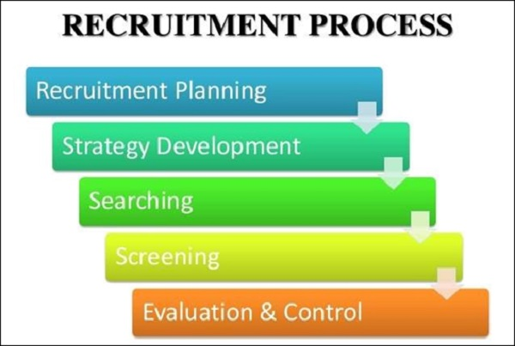
The practices are discussed below briefly:
- Recruitment Planning:
Recruitment planning is the initial step of recruitment procedure, where the empty positions are examined and portrayed. It incorporates work determinations and its tendency, experience, capabilities and abilities required for the activity and so on. Recruitment planning has the following subjects in it:
Identifying vacancy: The most essential step of recruitment plan is recognizing the opportunity. This procedure starts with getting the order for enrollments from various departments of the organization to the HR department, which contains:
- Number of positions to be filled
- Number of posts
- Obligations and duties to be performed
- Capability and experience required
Job Analysis: Job analysis is a procedure of recognizing, dissecting, and deciding the obligations, duties, aptitudes, capacities, and workplace of a particular employment. It helps to understand that what is critically important and how to perform the tasks. Its motivation is to build up and record the job relatedness of employment procedures, for example, determination, preparing, pay and execution evaluation. The following things should be kept in mind in investigating a job:
- Recording and gathering work data
- Exactness in checking the job data
- Producing expected set of responsibilities dependent on the data
- Deciding the aptitudes, learning and abilities which are required for a particular job.
The quick results of job analysis are Job description and Job specifications. Job description gives the data about the extent of job roles, obligations and the situating of the job in that organization. on the other hand job specification spotlights on the determination of the applicants, who will get hired by the HR team.
Job Evaluation: Job evaluation is a similar process of dissecting, surveying and deciding the relative esteem or worth of a job in connection to alternate employments in an organization. The primary goal of job evaluation is to break down and figure out which work deserves how much pay.
- Recruitment Strategy:
Recruitment strategy is the second step of enrollment process, where a methodology is set up for contracting the human assets. Subsequent to finishing the arrangement of job description and job specification, the following stage is to choose which methodology to take for selecting the potential candidate for the organization. Developing a recruitment strategy is a lengthy process, yet having a proper methodology is compulsory to draw in the correct applicants. The means associated with building a proper strategy are:
- Setting up a board group
- Dissecting HR methodology
- Gathering of accessible information
- Dissecting the gathered information
- Setting the recruitment strategy
- Searching the right candidates:
Searching is the procedure of enrollment where the human assets are sourced relying on the prerequisite of the job. After the recruitment strategy is done, the seeking of applicants will be introduced. Searching includes drawing in the job seekers to the job opportunities. There are two broad sources: Internal Sources and External Sources. Internal sources include promotions, transfers, formal employees, job posting, employee referrals, previous applicants etc. External sources include direct recruitment, employment exchanges, employment agencies, advertisement, professional association, campus recruitment etc.
- Screening and shortlisting:
Screening begins after consummation of the way toward sourcing the applicants. Through screening, candidates are filtered for further selection process. The screening process have three separate steps:
- Reviewing the resumes and cover letters
- Leading telephonic or video interview
- Recognizing the best applicants
- Evaluation and control:
Evaluation and control is the last stage of recruitment process. In this stage the viability and the legitimacy of the strategies and procedures are surveyed. Recruitment is an expensive procedure. Henceforth, it is essential that the execution of recruitment process is altogether assessed.
Selection is the way toward choosing or picking the correct applicant who is most reasonable for an empty post of an organization. In other words, selection can likewise be clarified as the way toward meeting the applicants and assessing their characteristics, which are required for a particular job and afterward picking up the best match for the post. The steps of a proper selection process are as follows:
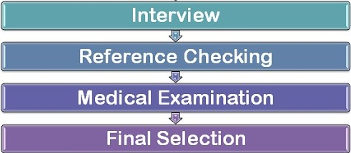

Interview: Employment interview is a process where one-on-one session is led with the candidate to realize him/her better. Through this process a questioner can get to know the internal characteristics of the candidate and aides in making the correct choice.
Checking References: Reference checking is a procedure of confirming the candidate’s capabilities and encounters with references given by him/ her. These reference checks help the questioner comprehend the lead and the conduct of an applicant as an individual and furthermore as an expert.
Medical Examination: Medical examination is a procedure of checking the physical and psychological wellness of the candidates to guarantee that they are equipped for playing up a job or not. Medical examination helps the association in picking the perfect applicants who are physically and rationally fit for the job.
Final Selection: The final selection is the last step which demonstrates that the candidate has qualified in every one of the rounds of the determination procedure and now the HR will issue him an appointment letter.

Differences between Recruitment and Selection:
Recruitment | Selection
Recruitment is characterized as the way toward distinguishing and making the potential contender to apply for the employments | Selection is Characterized as the way toward choosing the correct contender for the empty positions
Recruitment is a positive procedure with its methodology of drawing in however many hopefuls as could be expected under the circumstances of the vacant positions | Selection is a negative procedure with its disposal or dismissal of whatever number of candidates as could be allowed for recognizing the correct possibility for the positions

Importance of Effective Recruitment and Selection:
It is really important that the recruitment and selection process runs effectively because the people an organization hires will take the organization to its desired place. The importance of effective recruitment and selection is briefly discussed below:
Discovering Quality Candidates: A business’s one of the main objectives is having quality employees. Building up a job description and advertisement in spots from where individuals with correct arrangement of aptitude can be pulled in, is the initial step. It’s vital to distinguish that the new recruit will be able to perform specific tasks regardless of whether the organization is equipped to prepare them
Proper selection saves Training time and Money: If a perfect recruitment and selection process is conducted, it will save time and money of training and again recruiting new people in a very short period of time. Keeping turnover low is critical because down time could contrarily influence business incomes in the event that it turns out to be short- staffed. There are expenses and time spent putting out employment advertisements, meetings and preparing new individuals. Picking up the best match in the 1st run mitigates all these trouble.
Lessen potential legal Ramification: When an organization has an efficient procedure that it pursues for each applicant, it decreases the odds of winding up in business related legitimate issues. Employers can get sued if any applicant feels that there was some dimension of separation that brought about not getting the job. Keeping interview questions proficient and not making individual inquiries is essential to keep any misinterpretations.
Lends Credibility to an organization: Another purpose behind having a set enrollment process is to demonstrate that an organization is trustworthy for applying. Nowadays there are few job postings that are not certifiable and numerous applicants get caught under the control of fake organizations. Consequently, for getting reliable to the applicants, an organization ought to pursue explicit application methods that will make the applicants feel sure for the position they are applying for.
Helps writing a proper Job Description: It is basic to have a proper recruitment and selection process as it helps the organization to write an accurate and precise job description. A suitable job description is an indispensable piece of the general recruitment process as it portrays what essential and auxiliary assignments will be performed alongside the center skills for a specific job.

3.5 The Project:

The main topic of this report is finding out the drawbacks that Square Toiletries Ltd has in its recruitment and selection process. But in this process the first step would be to know the ins and outs of the whole process. At present more than 45000 employees are employed by Square Group all together. As STL is one of the major concerns, it employees a big number as well, which is nearly 2000. Ensuring the consistent welfare and security of their employees, STL has one of the lowest employee turnover rates, which tends to be approximately less than 10%. STL tries to maintain equal employment opportunity for both male and female, which leads to 38% of women employees.
3.6 Recruitment Sources:

These huge numbers of employees do their part of works from three different locations: Head office in Mohakhali (Dhaka), Rupshi (Narayanganj) and Pabna. But the employees working from the sales department look after various markets in different areas all over the country. STL must conduct a proper recruitment process to grab the attention of the best candidates as the manpower of STL comes from versatile background. Both internal and external sources are used in order to hire proper manpower in relevant posts.
The whole recruitment process is started when a respective department head raises a requisition and informs the HR department about the vacancy of that post. After receiving the requisition, necessary actions to post advertisement in relevant sources are taken by the HR department. The decision about the source is based on the requirements of the vacant post. STL usually uses the following recruitment sources:
External Sources:
Advertisements: The job circulars of Square Toiletries Limited are posted in two different mediums: Online Job Portals and Newspaper.

Bdjobs.com: bdjob.com is one of the biggest job recruitment sites of Bangladesh and the core recruitment source of most of the vacancies of Square Group. So habitually job posts of Square Toiletries Ltd are posted to this site as well. The process is started through the HR collecting the required job responsibilities and qualifications from the respective department. After that those requirements are sent to Mediacom (a concern of Square Group) in order to prepare the advertisement as a .jpg image. After the advertisement is ready, it is approved by the AGM-HR of STL and sent to the bdjobs.com for publishing.

The ProthomAlo: Along with the biggest job portal of the country, Square Group goes for the biggest Bengali newspaper as well. The Daily Prothom Ali is another source of recruitment of STL. Similarly as the job portal, the ProthomAlo gets a well prepared image of the job posting as well. But STL uses ProthomAlo only for the vacancies of non- executive level openings. This means this especially includes the bottom level employees of the Sales department like Sales Supervisors and Sales Officers.

The Bangladesh Protidin: Bangladesh Protidin is recently included to the recruitment process of STL. Currently being considered as the most sold newspaper of Bangladesh because of its cheap rate and availability, STL tends to post job advertisements over here. These advertisements also include the openings of Sales Supervisors and Sales Representatives.

Campus recruitment: Nowadays STL is relying on campus recruitment as well. With the help of Career Counseling Centers of the universities the process becomes easier. Except that, universities now arrange job fairs to secure the interests of their graduates. Square attended a job fair organized by Faculty of Business Studies, Dhaka University in TSC where they collected 200+ CVs which they used later on for recruitment of various departments.
Internal Sources:STL uses internal sources as well in order to recruit in various job vacancies. The internal sources include the processes of Employee referral, Job Posting and succession planning.
Employee Referral: Employee referral is one of the most used unofficial and internal sources used by STL. In this process currently working employees come up with their known candidates by whom the requirements of a particular post can be fulfilled. From the recruitment of executives to interns, this source is practiced in every level.

Job Posting: There is an urgency of non-executive employees for both the factories of Rupshi and Pabna in a frequent basis. STL shares the advertisement of these non-executive posts including machine operator, Generator operator, Lathe Machine operator, drivers etc, via email with the current employees of STL all over its factories and head office. Currently for the post of Data Entry Operator in Head office, STL is following the same source.

Succession Planning: STL always believes in creating a leader instead of hiring one. So succession planning is highly encouraged in STL. On the job training is provided by STL time to time in order to develop the employees’ skills and so that they can establish themselves as leaders in future. There are so many examples in this company that an employee joining as an executive turned out to be in a managerial position after working for a particular amount of timeframe. Though succession planning is found more effective in the managerial levels, STL tries to practice it in almost every hierarchy level of the company.

3.7 Recruitment and selection process:

The HR department of STL conducts the whole recruitment process with the support of the respective departments. Recruitment and selection is really very important because it is the manpower that will make the company flourish in present and future. Also recruiting manpower is one challenging work to do. It is difficult to put the importance of effective recruiting aside for any organization. If there is a number of two candidates for two openings, then the HR department has nothing to do more but to hire them. But as STL has created a very bright impression in the business sector, they are flooded by applicants every time they post a job. When this happens and so many people apply for one post, options like taking interviews or tests appear, because then it becomes a matter of choosing the best.
STL always looks out for people who have great caliber and are self-driven and proactive. As STL needs a massive amount of manpower in order to run their business operation, they wish to have an accumulation of various backgrounds in their organization. Therefore, HR has a hard time bringing all the different background under one roof and recruiting among them.The overall recruitment and selection process of STL can be shown in the following flow chart:
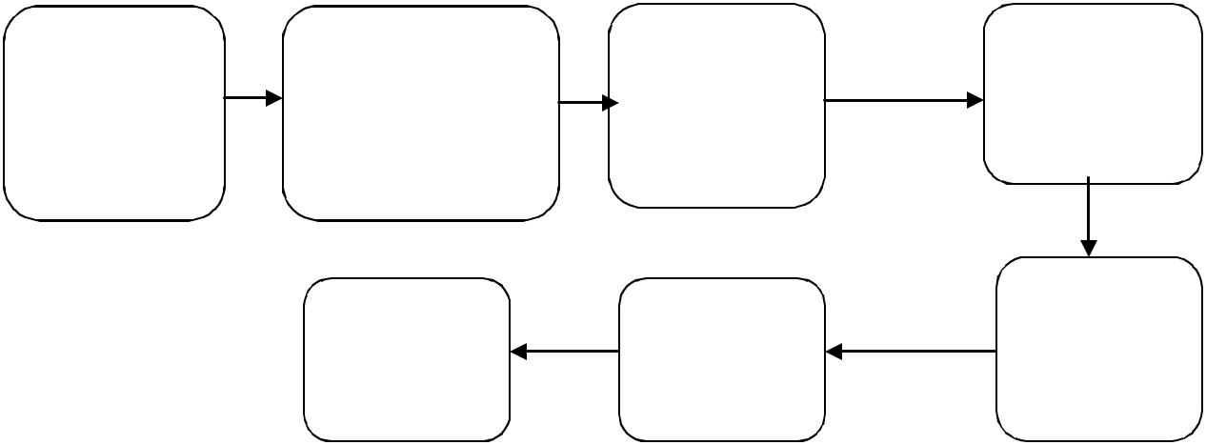
HR Planning and requisition
Creating Pool of candidates

CV Screening

Advertisement

Written Test
Interview
Job Offer

Figure: Recruitment and Selection process of Square Toiletries Limited

Square Toiletries Ltd mostly recruits people holding strong caliber and having the ability to multitask. Hard work is the only way to flourish in STL. The second thing which is mostly considered is being comfortable in working anywhere in Bangladesh. STL doesn’t have any biasness about different casts, cultures, religions or customs. Candidates who are career oriented and have the interest to do good for the company are highly wanted by the company.
So STL recruitment can be brought in a nutshell through the following points:
- Merit is one essential criterion in order to have the chance of working with STL.
- One must be medically fit to work in any position
- Sources of recruitments are mainly employee referrals and internal job postings. Campus recruitments and newspaper job advertisings are also included in the relative sources.
- Written examinations are held in order to recruit executives, Jr. Officer and non- executives.
- Panel interviews are held with functional head and HR head.
- There is zero discrimination on the basis of race, religion, culture or sex or community.
It is the major responsibility of the HR team to conduct all the necessary works for recruiting the best suited people when needed. The candidates who are capable to do a particular job and who justify a specific position are attracted through various activities run by the HR people.
The Recruitment process is started by the HR department based on the job analysis, job description and job specification. The sequence that is followed by Square Toiletries Ltd is as follows:
- Assessing the needs
- Defining the position description
- Checking the options for recruitment
- Advertising
- Sorting the applications or CVs
- Written Examination
- Selection interview
- Employment decisions
- Offer letter
- Training and orientation
- Medical checkup
- Job Placement
- Follow up
The steps starting from need recognition to job placement, all of them have complex mechanism and different types of decision making within them. Mostly the department heads take part in the complex decision making. The steps of the entire HR process are described below:
HR Planning and Requisition:
In STL historical data is used in order to do HR planning. STL primarily uses forecasting tools like trend analysis to forecast the personnel need in near future. But for the sales department STL mostly uses the ratio analysis keeping the sales target as one variable as the highest number of people are needed over there. So, the forecasting tools that are used are:
- Trend Analysis
- Ratio Analysis
When there is a vacant position in any particular department the, a hiring requisition is raised by the department head which goes to the managing director for approval through the HR department. After the MD approves the requisition officially, HR starts with the recruitment process in order to fill that vacant position with suitable personnel. So it leads the HR team to the next step which is the selection of recruitment sources.
Advertisement:
As discussed in the previous chapter the following recruitment sources are used by STL:
- External Sources: bdjobs.com, The Daily ProthomAlo, The Daily Bangladesh Protidin and campus recruitment.
- Internal Sources: job Posting, succession planning, employee referral.
For the recruitment of Executive level, STL primarily posts job ads on bdjobs.com. Besides the job ads, the HR department also receivesCVs through internal sources. The internal sources are also used in order collect CVs for non-executive level. Other than that the newspaper advertisements are also used to attract the non-executive candidates. The new inclusion in the recruitment sources of STL is campus recruitment. The organization takes part in various job fairs or career summits of different universities where they collect CVs. On august, 2018, within my working period in STL, the HR team attended a job fair which took place on TSC, University of Dhaka. Almost 500+ fresh graduates dropped their CVs over there.
Mostly Mediacom (a concern of Square Group) generates the advertisements. Some samples are attached on the appendix section of this report.
Cv Screening: CV screening is the process that starts after giving the job posting or advertisement. STL gets so many CVs in both soft copies and hard copies. The HR team always makes sure that all the CVs are checked at least once. Some basic criteria are maintained while making pools from the pile of CVs. Those are:
- Education: CGPA above 3/ No less than second division
- Experience: Based on the particular position
- Age: Depends on the particular position
As an intern I had the chance to sort CVs for the post of HR Executive, Sales Officer, and Territory Sales Officer etc. After sorting the CVs once, the selected CVs are resorted in order to ensure that only the best candidates are called for the further process. The sorting process continues until the application deadline arrives.
Pool of Candidates: After sorting and re- sorting the CVs, the HR team handovers the CVs to the AGM-HR. The CVs are reviewed by the AGM and handed over to the respective departmental head. After the final sorting by the departmental head, a few candidates get rejected due to their internal departmental relevance. After this whole sorting process the selected candidates are called for a written exam.
Written Test: The written test is the 1st step of the selection process. At Square ToiletriesLimited it is mandatory to sit for the written test for all positions except Sr. Executive and above. For the field force of sales department Regional Sales Coordinator and above are not required to sit for the written test.
The HR team and the respective department setup the question in collaboration. In STL there is always an aptitude test along with theoretical questions and situational questions/case study. The aptitude part comprises of the followings:
- English
- Mathematics
- Analytical Ability
The department, for which the whole recruitment process is going on, will set the theoretical questions to test the job related competencies of a candidate. Also some bottom level employees face current affairs/ general knowledge question instead of theoretical part.
To go for the next step, a candidate needs to get a certain mark separately in both subjective (theoretical) and objective (math, English, analytical) parts. There can be practical tests as well if the particular job has any requirements like computer test, bike riding etc.
Interview: After facing and passing the written test candidates face an interview. This part of the recruitment process is the most significant because the final decision is made based on this interview.
This kind of interviews normally happens to be panel interview or board interview. This means, the interview is conducted by a team of interviewers. The interviewers include AGM-HR, the relevant department head and other significant people of the department for which the recruitment is being conducted. They interview each candidate together but provide individual ratings. After all the interviews are done, the ratings of each interviewer are accumulated to a final score. Before the panel interview a summary of candidates is prepared which consists of the important details and notes about the candidates and it is provided to the interviewers.
The evaluation of the performance of the candidates is the most critical part. STL maintains two different forms to evaluate the performance of the candidates. The forms hold different criteria and the interviewers provide their marking on each of the criteria I order to find the most suitable candidate. The criteria are as follows:

Executive level:
Educational Background : Relation between educational knowledge and job responsibilities
Experience: Relation between previous work experience and position available
Circumstances: Relation between social status including present salary, marital status, family background and the position available)
Personal Impact: How does he or she imposes an impression on others
Knowledge advancement: Is he/she has enough knowledge about the technological advancement of the relevant profession or field.
Communication: How much communicative he/she is depending on the position available.
Attitude: Desire to grow and expectations.
Judgment: Reasoning power and logical ability

Non-Executive Level:
Educational Background : Relation between educational knowledge and job responsibilities
Experience: Number of previous jobs, reasons for job switching and relevancy to the job responsibilities of available position.
Reflex: instant reaction to critical situations/ questions put forward and spontaneous response to those
Personal Impact: How does he or she imposes an impression on others
Depth of knowledge: knowledge about the job responsibilities of available positions
Communication: Facial expression and communication with relevant parties
Maturity Attitude: Self-confidence, flexibility and work consciousness.
Safety awareness: is he/she knowledgeable about current safety issues.
Motivation: taking initiative for career growth and desire to continue growing
Other Skills: Any special skill that facilitates the job available or helps to multi task.

The interviewers asses all the above mentioned criteria and provide marks out of 5 individually for each of the candidates. Finally, taking the average mark from each interviewer the hiring decision is made.
Job offer: At last the selected candidate gets a formal job offer letter which is signed by the GM- HR. this letter includes all the job related information like probation period, salary and benefits, allowances, joining date etc. If the offer letter is accepted by the candidate, an appointment letter is issued by the HR which ensures the selection and hiring a candidate for the particular post. The day a new employee joins, a formal letter of joining is provided as well.

CHAPTER 4
FINDINGS AND RECOMMENDATION

4.1 Findings:
Working as an intern in STL, I was able to observe the whole process of the recruitment and I can easily point out some important findings, which is one of the major objectives of this report. Those findings are as follows:
- STL lacks of background check for the new employees. According to the AGM- HR of STL,”In Bangladesh’s Perspective it is really hard to check the criminal records, driving records etc. If any doubtful issue arises we contact the previous employer of the new employee” But without any background check one can easily get the job by doing forgery with the documents or academic credentials. STL only wants a release letter from the previous employer but no proper experience certificate is needed. Also they hardly contact the references that are provided by the new employee in his/her CV.
- STL is mostly dependent on hard copies of necessary documents. From sorting CVs to keeping necessary documents of the employees, they always prefer hard copies. In this case they are really traditional which leads each employee with a lot of paperwork. Being used to it for a very long time, they are reluctant to change.
- STL only concentrates on the Job Training. The training system being little unstructured, new employees specially the fresh graduates face a lot of problem to get used to the whole work system. Lack of Off the Job Trainings can lead them to being unprepared for the upcoming challenges.
- The written test question papers are not always set keeping the position or job requirements in mind. For example, for Sales Officer position, the written test includes a case study. Keeping the sales officers’ educational qualification in mind it is a very bad move.
- Many times the interviewers show idleness as a result the evaluation forms are not properly filled up. Also, before joining in the respective market the Sales Officers attend an in house training where there is a written test everyday based on previous day’s session. Mostly these test papers are also unchecked and the candidates proceed without knowing his/her own training results.
- Being in one of the leading positions of this industry, no one normally misses the written test of any position in STL. So when there are a huge number of examinees, the place for taking written exam is not enough.
- STL emphasizes on non-financial benefits rather than financial benefits. This can bring demotivation on employees.
- Sometimes the interview sessions are not conducted timely due to different issues. So the candidates have to wait for a long period of time which creates dissatisfaction.
- They never consider interns to make permanent in any particular department or position.

4.2 Recommendations:
- STL should provide more emphasis on background check of any particular candidate to avoid future problems. Calling at least one of the references provided in the CV should be in practice. This will not only give the HR people idea about the candidate but also will provide knowledge about his attitude, honesty and other characteristics.
- Some internal sites or system should be developed to keep the records of CVs to the employee details. It will reduce the use of paper which can lead to cost minimization. It can save time as well because a vast amount of paper work won’t be necessary.
- The employee evaluation form can be changed into a different format which can have options and checkboxes so that interviewers can mark from different options.This means, the questionnaire will be pre checked and questionnaire will be required to put ticks to stamp a person.
- STL should think of a bigger space for their recruitment exam. STL is a vast organization. Though turnover rate in STL is not so high but normally the selected candidates never miss recruitment exams of STL. And STL gets so many CVs, so a lot of candidates are called for written test. Also when Sales officers are hired, they are hired in batches. So a bigger space is needed for the recruitment process.
- STL should have recruitment process through which best interns will be selected and will be permanent based on his/her performance later on. It will motivate the interns more to work hard. Also it will save the time of training a new employee after recruitment.
- They should do proper scheduling of work list before calling on an interview, so that the professionalism is sustained.
- The specific enlistment programs ought to be presented for the newcomers, especially who are fresh graduates. A preparation program containing a thorough organization presentation, industrial facility visits, prologue to individual office and other applicable divisions, presenting mechanical utilizations and so on ought to be done to make things less demanding for the new employee.
- STL should begin getting associated with the job fairs more. Taking an interest on this kind of fairs in prestigious business colleges and engineering institutions will create an impression of being one of the top most employers. To get applicants from diversified backgrounds, they should accept part in the job fairs organized by various universities or job sites.

4.3 Conclusion:
It was a very good experience to work in the HR department of one of the largest local FMCG companies. This department recruits thousands of best people in various departments for decades. These three months have brought me a lifelong experience of corporate culture and provided me with some good corporate networks.
In this report I have tried my level best to portrait the stages and procedures this company applies in its recruitment. In this era the relentless contribution of Human Resource department is very much needed for a company to flourish. Besides quality product and service the Human Resource of a company is very important to bring proper success. So each company should concentrate better in their HR department. Also Bangladesh government needs to pay attention towards HR related laws more.

APPENDIX

Job Advertisements:
(a)
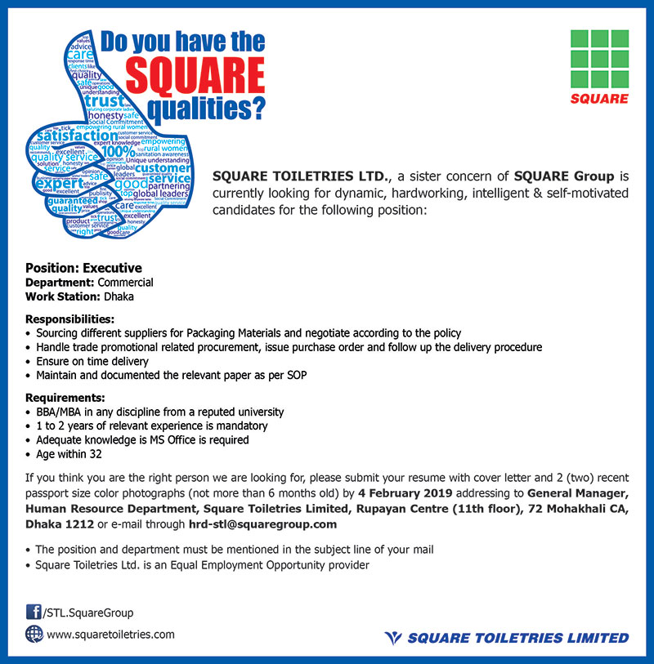

This job posting advertisement is the most recent of Square Toiletries LTD posted in bdjobs.com in February, 2019. This is an advertisement for Executive, Commercial Department.

(b)
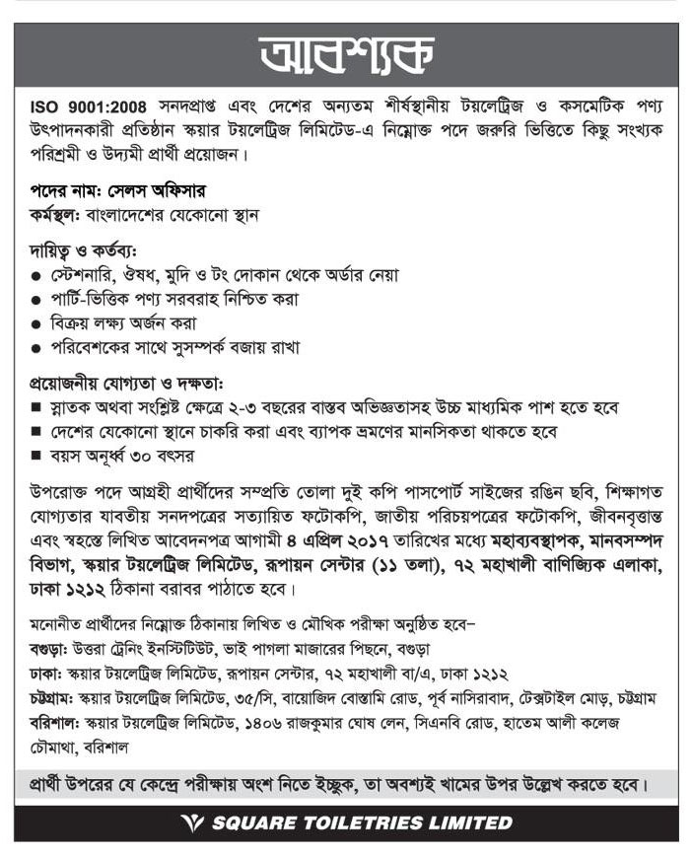
An advertisement posted for the post of Sales Officer for the Sales Department posted on March, 2017 in the Daily Bangladesh Protidin. It contains no information about salary benefits.
Bibliography:
- Websites: www.squaretoiletries.com
www.recruiter.com/recruitment-strategies.htmlwww.businessdictionary.com/definition/human-resources.html
- Text Books: Fundamental of Human Resource Management by S. P. Robbins, David A. DeCenzo
- Official records of Square Toiletries Ltd
- Mr. ShahnurRajib (Senior Executive HR, STL)
- Internship Report, Khandoker Nabil Abrar, (Executive HR, STL)

