Internship Report



Internship Report

Submitted To:
Prof. Dr. Md. Mohan Uddin
Professor
Dept. of Finance
Director of MBA and EMBA Programs
United International University
Submitted By:
Afrina Najneen
ID:111 141 198
Bachelor of Business Administration (BBA)
Major in Finance


United International University
Date of submission: 26 April, 2019

Acknowledgments

I would like to express my deepest perception to all those who provided me the possibility to complete this report. Fast of all, I would like to give my gratitude to the Almighty Allah for giving me abilities to work hard. I am also grateful to my parents who were provided me with the necessities of like since my early childhood. It is an opportunity for the students to get familiar with the real-life situation through this program.
The proposal of this report is prepared by Afrina Najneen under the supervision and guidance of Prof. Dr. Md. Mohan Uddin, United International University to fulfill the requirements of BBA degree.
I am an employee of Data-Path Ltd. from 14 November, 2018. It is very difficult for me to adequate USA retirement process. HR director of Data-path Ltd. helped me by offering different opportunity of learning. He also provided me some important advice and guidance for preparing this internship report and also organization culture.
I would like to dedicated special thanks to those people without whom it was difficult me to continue my internship report. My special thanks go to Saidur Rahman, Manager (Workflow & Form 5500), and my trainer and supervisor Ehasanul Bari, Sr. Executive Officer (Workflow & Form 5500), Nazneen Nahar, Senior Executive (Workflow & Form 5500) and Md. Rabius Sany Executive Officer (Workflow & Form 5500), for helping me in every way to complete my internship efficiently.
Finally, I would like to thank my other intern colleague for their support and honet suggestions.

Letter of Transmittal

January 11, 2019
Prof. Dr. Md. Moan Uddin
Professor
Dept. of finance
United Internation University
Subject: Submission of internship report.

Dear Sir,
I am submitting my internship report to you within the given time. I had tried my level best to engage, obey and identify the retirement activities of Data-path Ltd. and all things have been mention was my own experience. To prepared my internship report need a lot of afford to collect information’s about USA retirement industry and Bangladesh retirement provident fund.
Meanwhile, I found that retirement plan industry is favorable and rational for me. Which will help me mark up to build my career in the future. I would like to thank for your support to offering me the scope to engage in the internship program.

Sincerely Yours,
___________________
Afrina Najneen
Id: 111 141 198
United International University

Executive Summary
During my last semester of BBA program, I have done my internship at Data-Path Ltd. to have a practical exposure.
To develop the physical, financial and mental wellbeing of employees and their families, employees routinely offer benefits such as health and life insurance, leisure time, inability income and retirement plan. The US government is too much conscious and cordial about protecting the right of the retired people and brings under control them financially in retired life. The retirement plan also helps the employer to have tax savings on the gain of the organization if he sustains the plan according to IRS and DOL guidelines. Ineffectiveness to comply with the regulations will result in incapability of the plan and it will be subject to amercement. It is costly for an organization to maintain the function of a retirement plan. So organization outsource the function to a third party which is also knows as third party administrator. Data-Path is an outsourcing company which action and function of a retirement plans.
Retirement plans need to dedicate it is asset information through a form to government every year with a certain deadline. These functions are known as “workflow 5500” at Data-Path Ltd. I have prepared form SSA 8955, Form 1099-r and B1 form. In the report I have mention details about the process of those forms. It need a lot of effort and repute in the organization, faced various challenges and I also give suggestion and my opinion in the details into my report.
Last four months of my internship learned a lot about the practical and function of US retirement plan industry. Although it’s hard to relate the function of Data-Path Ltd. with any other organization in Bangladesh, but the skills and wisdom I gain from Data-Path will help me a lot for my future carrier.

Table of Content
Contents
Table of Content V
1.0 Introduction 1
1.01 Background 1
1.02 Objective 1
1.03 Significance 1
2.0. Analysis of the Industry 2
2.1. Specification of the Industry 2
2.2. Size, trend, maturity of this industry 2
2.3. Seasonality 2
2.4. External economic factor 2
2.5. Technological factor 3
2.6. Political, legal and regulatory factor 3
2.7. Barrier to entry 3
2.8. Supplier and Buyer power: 3
2.9. Threat of substitutes 4
2.10. Industry rivalry 4
2.11. Summary of challenges and opportunity: 4
3.0. Analysis of the organization 5
3.1. Overview and history 5
3.2. Trend and Growth 5
3.3. Customer mix 5
3.4. Service mix 5
3.4.1. Plan Design: 6
3.4.2. Plan Setup: 6
3.4.3. Plan administration: 6
3.4.4. Plan Operations Support 7
3.4.5. Compliance Testing’s: 7
3.4.6. Tax Compliance 7
3.4.7. Plan Recordkeeping 8
3.4.8. Participant Service’s 8
3.4.9. Payroll Services: 8
3.4.10. Fringe Benefit: 8
3.4.11. Enrollment Materials: 9
3.4.12. Investment Advice 9
3.5. Operations 9
3.5.1. Building skilled people team 9
3.5.2. Building strategic partnerships 10
3.6 SWOT analysis 11
Strengths: 11
3.6.1. Healthy company culture: 11
3.6.2. Client Driven processes: 11
3.6.3. Attractive pay and leave system: 11
3.6.4. Quality and operational control: 11
3.6.5. Expertise: 12
Weakness: 12
3.6.6. Absence of practical knowledge: 12
3.6.7. Dependency on July services: 12
External factors: 13
Opportunities: 13
3.6.8. High quality IT education market: 13
3.6.9. Expansion of business: 14
Threats: 14
3.6.10. Low return on investment: 14
3.6.11. Lack of data security systems: 14
3.6.12. Increased Competition: 14
3.7. Strategies to meet the Challenges & Opportunities 15
3.7.1.Increase efficiency: 15
3.7.2.Maintain high security: 15
3.7.3Offer quality service: 15
3.7.4. Offer cheap service: 16
3.7.5. Hold skilled employee with reward: 16
4.0. Internship Experience 16
4.1. Duties, Position and responsibilities 16
4.2. Training: 16
4.3. Contribution to departmental function 17
4.4. Evaluation 17
4.5. skilled applied: 18
4.6. New skills developed: 18
4.6.1. Unify: 18
4.6.2. Ft Willum: 19
4.4.3. Relius: 20
4.7. Application of academic knowledge 21
5.0 Recommendation 21
5.1. Recommendations for Improving departmental Operation 21
5.1.1. Work process guidelines to make training process easier: 21
5.1.2 Developing software: 21
5.2. Recommendations for improving self performance 21
5.2.1. Faster Internet Connection: 21
6.0 Conclusions 22
7.1 Appendix 23
7.2 Bibliography 24

1.0 Introduction
_____________________________________________________

Background
Internship is the way to give a good application of the theoretical knowledge. The rule and enactment and the reporting process of American retirement plans are very complex. To appreciate all the things and act accordingly is very hard even for US organizations. And it is very costly to keep in house retirement plan reporting dept. That’s way they hired third party administrator July business service which is the mother company of Data-path Ltd. The hard nature of the work makes it more difficult to train new employees to prepare allocation report. Both of the trainer and trainees face different type of problems during and after training period. For BBA student it is very important to link theoretical knowledge with practical experience. Data-Path Ltd. has conferred me the scope to have my internship program for four months. I already learned important issues regarding workflow and Form 5500 for retirement plan industry.

Objective
The objectives of the report are to produce careful analysis of the outsourcing industry in USA and Bangladesh, analysis of the company “Data-path Ltd”. The report also summarizes my internship experience in Data-path Ltd.

1.03 Significance
The report provides a systematic procedure to make a final report. Accomplish the study, data origin is to be identified and raised. They are to be serial, separated, illustrate and submitted in a methodical system and key spots are to be set out. This report can enrich the knowledge about the outsourcing industry.

2.0. Analysis of the Industry

2.1. Specification of the Industry
Outsourcing:
Outsourcing is a kind of business where third party involved. Like external service providers to delivers logistic support and IT Services. There are a lot of work done by the TPA (Third Party Administrator) those are application development, regular basis application maintenance. It can give opportunity to the customer to customize their product based on their requirement.

2.2. Size, trend, maturity of this industry
Outsourcing is a big business. This trend is increasing day by day. When comprehend level of outsourcing start to increase almost the world over the past decennia or two, one may ask why? Only one contention might be the fastness technological innovation. Answer is - with this simple idea of outsourcing anything from payroll to marketing to knowledge about the American retirement plan industry HR to legal. Now through outsourcing we can serve so many businesses and can utilize manpower of the world.

2.3. Seasonality
Outsourcing industry is all time business. Outsourcing company provides technical support for business operation on a daily basis. Though there is a certain type of outsourcing work which demand increase in the beginning of the year, because all companies calculate their profit, loss, distribution amount in the end of the year.

2.4. External economic factor
Massive Outsourcing firm can settle industrial scale inversion and can provide business succession solutions. Client benefit form that scale without making any investment themselves. It’s obvious that, this value needs to be paid for, but the outsourcing firm cans expansion the total cost among client, so no single client bears the complete worth.

2.5. Technological factor
With the help of outsource we can have the favor of eliminating obsolescence. Technological growth is increase rapidly. Specialized outsourcing firm are better than other to handle that can minimize risk through fund development. System is too much automatic that client can change instantly without being tagged into long term contact or any other investment.

2.6. Political, legal and regulatory factor
Outsourcing is now becoming most interesting issue in modern world. Where outsourcing making scopes for skilled people of developing countries like Bangladesh, on the other hand developed countries are losing job scopes like US. Who have lost their job will not return rather than white-collar jobs are losing from US companies to saved cost to remain competitive in the market.

2.7. Barrier to entry
To enter this sector one need huge technical support of skilled people and large capital to establish such IT structured company.

2.8. Supplier and Buyer power:
In outsourcing, Supplier and buyer relation is not visible but in this system supplier working performance is more potential as a consultant. Expertise’s to handle this kind of staff are directly link for the activity between both sides of the party. Their transactional relation also is different. So if the supplier performance will improve then the output of the product also is improved. We can say that, previous good performance of supplier which build upon trust can increase their buying power where on the other hand Buyer, who needs skilled labor and expertise polished work are willing to pay more based on trust and expertise of suppler but they also hold strong position as competition is increasing day by day between service provider (supplier).

2.9. Threat of substitutes
There are lots of companies in the Europe who are giving outsourcing services. In Bangladesh this industry is growing nowadays. Govt. of Bangladesh also encouraging this Industry. Govt. of Bangladesh is arranging training for youth for free of cost. So, it is anticipated that, in near future Bangladesh will able to make skilled and expertise people to catch this opportunity. So, there will be huge competition .so the threat of substitute is high.

Figure 2.9., 2.10: Threat of substitutes, Industry rivalry

2.10. Industry rivalry
The overall Outsourcing competitiveness in outsourcing industry average to potential. Subsist service providers are trying to expanding their range of the service and new comer are try to involved in the market to sustain. In this industry buyer are maintain strong position to compete with other competitor and other services. For long term relationships need lot of investment in the market to gain some profit and strong holding position. Though everyone knows the lucrative side of this industry, its very hard to build a professional company with full of skilled labor and gain

2.11. Summary of challenges and opportunity:
I had no knowledge about the activities of the Data-path Ltd. I am looking for every available site for the information but I did not understand their activities. Data-Path. Ltd. is US based out sourcing company. But in this scenario outsourcing cover lots of areas. So I was very confused about what they actually do. After joining Data-Path Ltd. and got tanning session from sam vaiya then they give us lesson to understand the activities. I got numerous training sessions on the Form 5500 dept. and other relevant form and I also get Microsoft excel training to develop myself for future.
3.0. Analysis of the organization

3.1. Overview and history
Data-path Ltd. the first outsourcing company which operated by July Business Services in Bangladesh. It is a registered company where Jhon Humohrey and Jim Hudson is the owner. July Business Service is top listed retirement service provider in USA. In 2005 Data-Path Ltd. was established with a tiny office in Uttara. In the starting their journey they provide supporting role for July business services. Then this company hired the talented employees to work for the July Services. In the beginning years it had less than 10 employees. Now nearly 150 employees are working in Data-Path Ltd.

3.2. Trend and Growth
Data Path Ltd. is doing an emerging business for the end solution for their client. When the data is gather or document received then they are process, transfer, and made a supporting document to process form which will going to be submitted in to IRS. Data-path Ltd. always trying to provide a meaningful solution that can help to client for easy understanding.

3.3. Customer mix
Data-path Limited is working for July Business Services in Bangladesh. So our main customer is July Business Services. The people of USA is also our customer but through the July Business Services.

3.4. Service mix
Data-Path Ltd. is working their operation under July business service to served retirement solution for their client.

3.4.1. Plan Design:
Retirement plan are mainly prepared to meet each employer unique goal and strategy. Whether employee recruitment and retention or maximizing benefits for the key role employees and plan designed always discuss with consultant through client service manager.

3.4.2. Plan Setup:
Plan setup provide all of the service accurately setup retirement plan or to convert existing plan from current provider.
- Volume Submitter Doc
- Loan Policy
- Paperwork setup
- Submission Contribution
- Transfer of asset through account
- Doc from previous provider
- Takeover plan need special care

3.4.3. Plan administration:
Data-Path has expertise over 10 years of knowledge about the retirement plan industry and those experts are highly knowledgeable in technical field because all of the work is computerized.
Data-Path Ltd. has QKA which are more adequate in their specific field. And they have more than 5 year of knowledge in retirement plans. Experienced professional are too much dedicated to provide full support establish relation with client.

3.4.4. Plan Operations Support
Plan operation support provide to client for maximize the value of the plan, they are using over the telephone and email communication access to provide excellence service.
- Eligible calculation method
- Allocation processing work
- Vesting calculation for key employee
- Dist. And Loan process for the employee

3.4.5. Compliance Testing’s:
Account representation complete compliance test process to maintain the integrity for the client. Those are given below

- Top heavy testing for key employee
- ACP and ADP testing for the highly compensated employee
- Min. coverage testing for key employee
- General Nondiscrimination testing for key employee

3.4.6. Tax Compliance
Data-Path Ltd. try to deliver timely form to IRS to avoided the penalty of the retirement plan. Those can be categories under below
- Form 5500 and Form 5500 SF
- Form 1099-r
- Form 5330 for late deposited
- Form 5310 for terminating plans

3.4.7. Plan Recordkeeping
Data-Path Ltd. has automatic recordkeeping service through client portal. Which always available for the client to update their daily transaction through it.
- 24 hr. online service
- Daily transaction amount
- Employer can easly access their plan
- Annual, quarter and semiannual participant statement

3.4.8. Participant Service’s
Alliance partnership with all financial providers. Data-path software team always tries to make high quality tool for the employer to secure their financial statement.

3.4.9. Payroll Services:
Data-path tries to minimized workload and increase accuracy for the client. It already establishes their market to complete other TPA service provider. July started another outsourcing dept. to doing other TPA work in July.

3.4.10. Fringe Benefit:
July services provide the following benefit.
  - Reimbursement plan for medical facility
  - Define benefit plan are commonly used plan
  - Reimbursement arrangements
  - Finding designed are specialized
  - Plan categorized through premium
  - Claim processing programs

3.4.11. Enrollment Materials:
July provide a wise decision to fund or not and if client using July recordkeeping service they are assuring and security for their financial data.
- Workbook enroll
- Education Invested.
- Worksheet risk measure
- Sheets invest reasons
- Form enrolled

3.4.12. Investment Advice
When participant invest their employee and employer portion then they follow the guideline to invest and that guideline provide through online from Data-path. July always try to keep safe and secure from cyber-attack. Clients also ensure and then they invest their money with proper guidance for our consultant. Data-path serves all the administrative work for July Business Services through July’s software and submitted the softcopy of all of its work through its own trusted network.

3.5. Operations
Data-path Ltd. Started their journey with few employees and slowly the owner created a team of skilled people.

3.5.1. Building skilled people team
July always have moderate impressed growth in retirement plan industry and added number of employer and employee through this reputation. And July and Data-path always try to contact each other through cooperative way
- Employee Culture
- Service Delivery
- New business team
- Consulting team
- ERISA consulting team
- Distribution team
- Develop key employee
- Marketing and sales presence

3.5.2. Building strategic partnerships
Data-path also maintains some relationship with American fund, MRF, MassMutual and other. Those friendly relationships need to continue farther to achieved a well good will and work should be easier for all the RK site and TPA service providers.
Data-path Ltd. follows their own organizational structure for their operations which is shown in the table-

Figure 3.5: Operations

3.6 SWOT analysis
Here we will show the SOWT analysis of Data-path Ltd.

Strengths:

3.6.1. Healthy company culture:
Data-path ltd provides a healthy company culture. They build up a culture of help and collaboration where everyone helps each other to learn and build up skills. It has own prayer hall for women and men where everyone prays which creates a friendly environment between colleagues. Data path have its own kitchen area where staffs do their lunch. Data path also arrange different cultural programs for staffs.

3.6.2. Client Driven processes:
Strong business relations & client driven approach by July services help the staffs in creating industry based, sustainable value for their consulting partners

3.6.3. Attractive pay and leave system:
Data-path provides 4 times bonus in a year with attractive salary. And follows USA rules for leave and holydays. Data-path offers 2 off day in a week and employees can also enjoy short leave. They also pay extra according to Bangladeshi holidays as they offer holidays according to USA rules.

3.6.4. Quality and operational control:
Data-path have strong organizational structure. Manager assign task with a reviewer and supervisor. Though every task is done with detailed concentration and under the consultancy of supervisor. There is a reviewer who checks the complete task again and gives review. So, the probability of error is .0000001%. Data-path follows a great strategy to control quality of their work.

3.6.5. Expertise:
Since 2005, Data-path is continuously growing by proving their expertise. July get supportive operation from Data-Path Ltd. from begging. Then this company hired the talented employees to work for the July Services. In the beginning years it had less than 10 employees. Now nearly 150 brilliant hands are working here. Data-path continuously tried to cope up with the technological change and developed their staff’s skill according to that change. With experience and skilled employees, Data-path is serving July services with more reliability.

Weakness:

3.6.6. Absence of practical knowledge:
People who work in outsourcing industry are unable to grow practical knowledge of field work. Because outsourcing is totally computer-based job. This experience of outsourcing job will only put value for next outsourcing job. So, lots of employee leaves the job for their future opportunities to work in practical field in business industry.

3.6.7. Dependency on July services:
Data-path processes operational files for July services. Employee of July services upload information of participants in server. After that, employees of data-path processes files with the help of uploaded information in server. So, data-path rely on July services for information of participants.

Figure 3.6: SWOT analysis

External factors:

Opportunities:

3.6.8. High quality IT education market:
Increasing use of technology in Businesses has opened a wide market for IT staff. People are more like to explore technologies in their business rather than following old tradition of business process. So, there will be a huge demand of IT expert. This era needs bunch of skilled staff, which can outsource any work using technology. There is a huge opportunity for skilled staff that is practicing in this field from now. Data-path will earn more reliability in future as the company is able to provide quality services in this sector when the demand is just arising.

3.6.9. Expansion of business:
Currently data-path is only processing operational files for July services. In future data path may work for other clients as like July services. It may also increase its number of services according to future demand due to technological changes.

Threats:

3.6.10. Low return on investment:
When outsourcing is not managed properly by authority and performance expectations are not properly matched between the provider and the buyer, the outcome can lead to a low ROI, or even failure.

3.6.11. Lack of data security systems:
The most important part of an outsourcing organization is the information technology domain. As this helps entire organization to focus on their core business. Data security is the main concern when it come about outsourcing business. Now hackers can easily get excess through phish email. So, organization needs to be super careful from hacker.

3.6.12. Increased Competition:
In future, more people will run after this sector. So, there will be more substitute product in the international market through online. Ultimately it will create competition of same service internationally which will empower in cost saving strategy. The battle will create for organization to offer premium service with cheaper rate.

3.7. Strategies to meet the Challenges & Opportunities

3.7.1. Increase efficiency:
Data-path Ltd. is trying to increase their efficiency to compete with other company . To increase efficiency data-path Ltd built 6 specialized departments for different types of services.

3.7.2. Maintain high security:
Data-path Ltd has special security team to handle security problem. Security of customer information is very sensitive issue for the company. Data-path Ldt. Also provides training to general employee to create awareness for phish email. So that, no hackers can steal information.

3.7.3Offer quality service:
Each team reviews finished work and sent to correction if error is found. That’s how they offers quality services and earn trust from clients and get rewarded accordingly and grabs the upcoming opportunity.

Figure 3.7. Strategies to meet the Challenges & Opportunities

3.7.4. Offer cheap service:
Data-path Ltd. offers cheap services with the help of specialized team. This strategy also helps the company to handle the challenge of competitive market.

3.7.5. Hold skilled employee with reward:
Data-path Ltd. provides attractive salary with others facilities to the employees to hold them back and make loyal employee for the company. So, the expertise labor can add value to the company.

4.0. Internship Experience

4.1. Duties, Position and responsibilities
I am doing 4 months intern in Data-path ltd. in 5500 dept. I am responsible for 3 projects currently which are SSA, B1 and 1099R. All of them are tax related form of terminated participant of 401(k) pension plan. Data-path follows all rules according to USA, because- our participant comes through July services and all the participants lives in USA.

4.2. Training:
I received training from the supervisor Ehasanul Bari, Sr. Executive Officer (Workflow & Form 5500) for SSA and 1099R Project and Md. Rabius Sany Executive Officer (Workflow & Form 5500), gave me training for B1 project. When any participant terminates from plan, Govt. of USA ensures that no money left in the organization and also verifies the taxable amount. And for that each participant needs to go for some paper work which contains details about their account calculation and personal information details. And we do the paper work for them. I also received training for online security which is online based. And one need to pass the exam to complete the training. And I got the certificate for 2019 Social Engineering Red Flags.

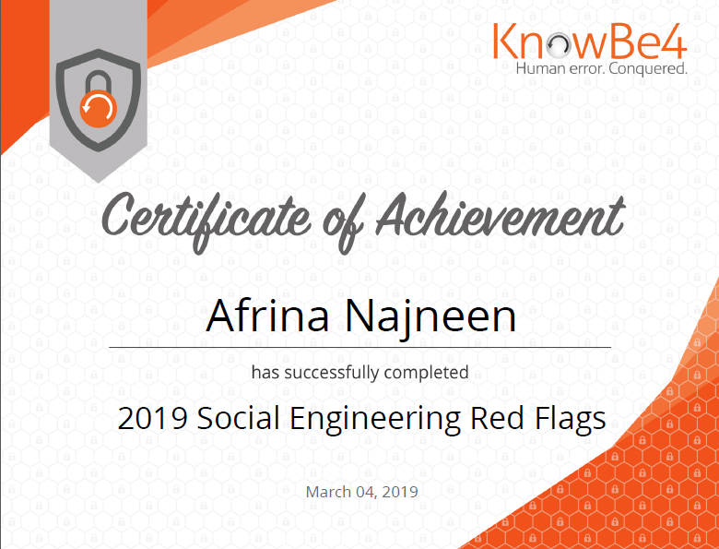

Figure 4.2: Training

4.3. Contribution to departmental function
I have worked in many different projects in the depth of 5500 (Tax Return). I am mentioning some major responsibilities for which I was assigned.
- Verify and prepare 1099R Form to report payments to independent contractors, rental property income, income from interest and dividends, sales proceeds and other miscellaneous income.
- Process Form 8955-SSA, Annual Registration Statement Identifying Separated Participants with Deferred Vested Benefits.

4.4. Evaluation
Data-path has very unique way of evaluation. They assigned task by the software and also assigned a reviewer for the review of my task. If there is no error, the reviewer sent the task to another department for further process. And the software keeps record of each click. That’s how my each and every task was evaluated by senior executives and manager.

4.5. skilled applied:
Data-path ltd mainly does IT based work. My computer skills helped me to adjust with its working environment. For a daily basis I had to use unify, relius, ftwillium, outlook, skype and adobe, excel to prepare all of projects.

4.6. New skills developed:
I was able to learn about their internal software like unify relius and ftwillium

4.6.1. Unify:
In unify, we can excess to all 401(k) plan and project details. we can update each project by our individual July ID which is created by IT dept. Our daily task is assigned by our supervisor through our individual account. Unify is used for various purpose to complete the project
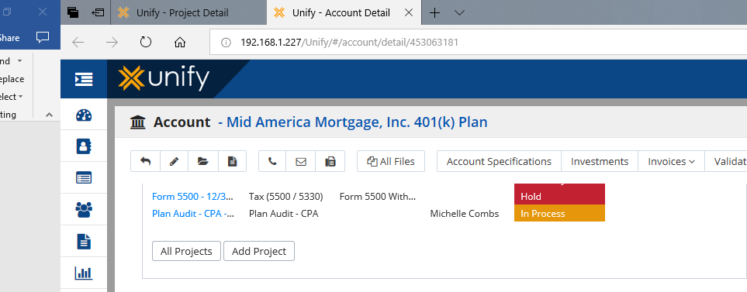

Figure 4.6.1: Unify
Each click is observed as we all are using July account to do every task.

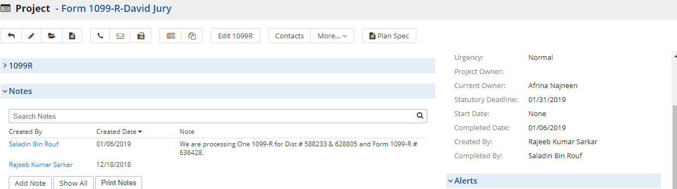
Figure 4.6.1: Unify

4.6.2. Ft Willum:
We create each plan form for each participant in Ft willium
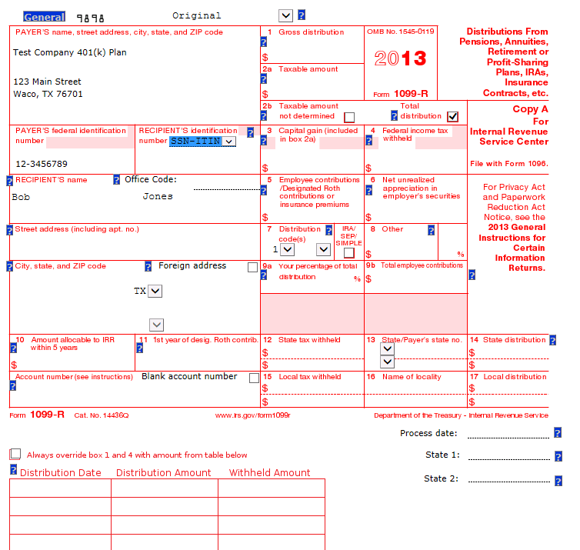
Figure 4.6.2: Ft Willum

4.4.3. Relius:
This server has a bunch of information about participant which is used to create form.
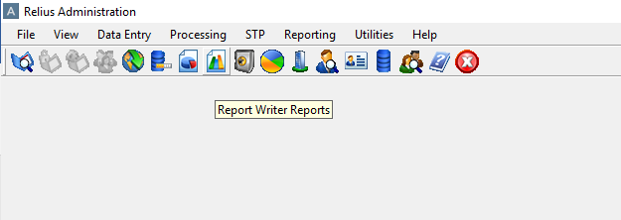
Figure 4.6.3: Relius
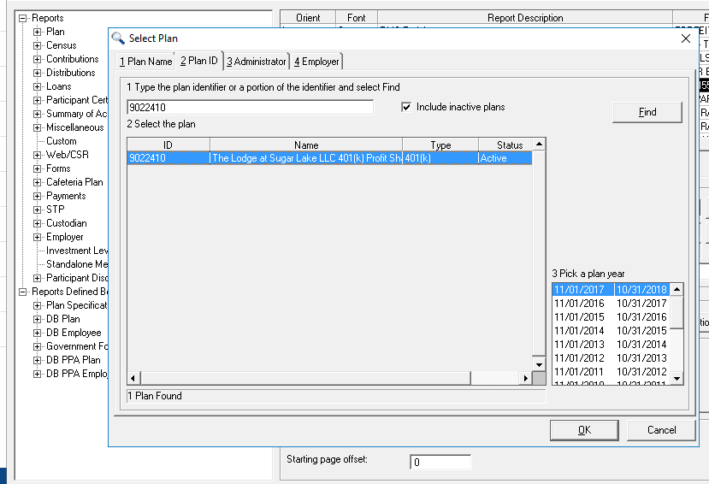
Figure 4.6.3: Relius

4.7. Application of academic knowledge
From the academic knowledge, computer skilled helped me to cope-up with their office culture. Knowledge of Microsoft excel, keyboard short cuts increased my work efficiency.

5.0 Recommendation
________________________________________________________________________

5.1. Recommendations for improving departmental Operation
5.1.1. Work process guidelines to make training process easier:
All new employees have to get training on work related areas. So it will be easier for employees if Data-path provide a guideline for different tasks. The employee also practices for few weeks with actual works. They can make mistakes as it is their first hands on. So I also think Data-path should make some demo work for the new employees to practice.

5.1.2 Developing software:
Most of the work of Data-path depends on UNIFY and Relius. A single Relius account costs huge amount of money each year. Data-path have a software development team and they are currently developing local access for UNIFY. Surely this will increase the speed of work. But they should also develop software for Relius alternative which can save a lot of cost.

5.2. Recommendations for improving self-performance

5.2.1. Faster Internet Connection:
Data-path Ltd is an outsourcing company they are depended on internet to process all the activities. . Loading problem, slow downloading makes hamper for quick process of each task. Although the Data-path has a very reliable internet connection but sometimes the speed is not satisfactory. So Data-path can take advantage of faster internet connection to speed up the flow of work

6.0 Conclusions
_____________________________________________________________

There are many outsourcing company in Bangladesh but very few companies are like Data-path Ltd. Because Data-path US based company and deals with US retirement plans. So it also impacts the culture and values of the company. Our organizations aim it to provide our customer TPA service and provide retirement plan solution.
Based on the objectives of the study the key findings are as follows:
- The key service offerings of Data-path ltd through Form 5500 and workflow department,
- Activities and procedures of form 5500 and workflow department of Data-Path ltd. are preparing Form 5500 and client can take distribution through B1 Form and 1099-R.
- The service offerings of Data-Path Ltd. provide different benefit to a client. These are retirement process getting easier. TPA service fully online based and we have highly trained consultant working in Data-path Ltd.

7.1 Appendix

ACP — Average Contribution Percentage
ADP — Average Deferral Percentage
ASPPA — American Society of pension professionals and actuaries
DOL — Department of labor
ERISA — Employee Retirement Income security act
IRS — Internal Revenue service
IRC — Internal revenue code
RPF — Retirement Provident fund
SIMPLE — Saving incentives Match plans for employee
TPA — Third Party Administrator
LPR — Leave Preparatory to retirement

7.2 Bibliography

- Application Xtender- Software Manual
- ASPPA Allocation Procedure Manual
- Guidelines for Retirement Benefit Plan, Published from DOL (Department of Labor), edition 2008
- http://en.wikipedia.org/wiki/Employee_Retirement_Income_Security_Act
- IRS (Internal Revenue Service) Reporting Guidelines for Retirement Benefit Plan, Published from IRS, edition 2008
- Relius Administration- Software Manual
- Retirement Plan Fundamentals-1, Published from ASPPA, edition 2008
- Retirement Plan Fundamentals-2, Published from ASPPA, edition 2008
- TPA Manager- Software Manual
- www.airroc.org.tw/ISLSSL2005/program/doc/III-2.doc
- www.julyservices.com
- www.firstmerc.com
- www.hartfordlife.com
- www.jhancockpensions.com

