Practices of Digital Marketing in Mental Health Organizations

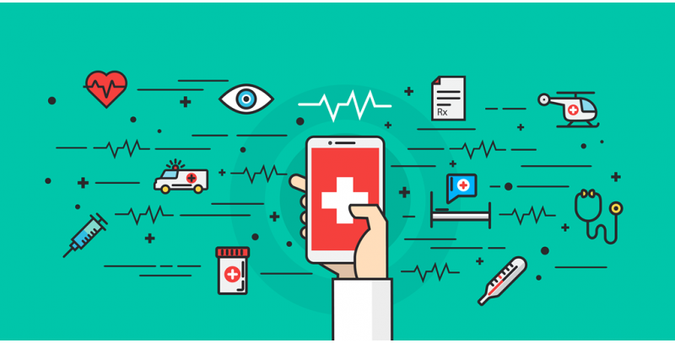

Natasha Proshad

This report is submitted to the School of Business & Economics United International University in fulfilment of the requirement for the degree of Bachelor of Business Administration

Practices of Digital Marketing in Mental Health Organizations

Submitted by
Natasha Proshad
Program: BBA
ID: 111151052
Major in Marketing

Supervised by
Kawsar Ahmmed, PhD
Professor
School of Business and Economics
United International University

Date of submission
30 August 2022

Letter of Transmittal

30 August 2022
Kawsar Ahmmed, PhD
Professor
School of Business and Economics
United International University

Subject: Submitting project report on “Practices of Digital Marketing in Mental Health Organizations”.
Sir,
Myself, Natasha Proshad, bearing ID no. 111 151 052, is a regular student of United International University, school of business and economics, would you like to submit my project report on “Practices of Digital Marketing in Mental Health Organizations” for fulfilment of the requirement of BBA degree.
I have tried my best to furnish all the things that I have found during the project program.
If you are willing to accept this project, I’ll be quite grateful.
Thank you,
Sincerely,

.............................
Natasha Proshad
111 151 052

Acknowledgement
I would like to express my deepest appreciation to those who helped me a lot to finish my project report.
First of all, I would like to thank the Almighty for giving me the patience & strength to fulfil my report in this pandemic situation.
In addition, I would want to enthusiastically support the significant role of the CEO of “Bdlisteners”, Director of “Kan Pete Roi” & some staffs of “Life Springs” who assisted me much in gathering information.
Finally, I'd want to convey my heartfelt gratitude and sincere appreciation to Kawsar Ahmmed, PhD, Professor, United International University's School of Business and Economics, for his unwavering support and direction throughout the practical orientation time. His suggestions and remarks provided a great deal of motivation to finish the paper.

Declaration

I hereby declare that the project report permitted “Practices of Digital Marketing in Mental Health Organizations” incorporates the results of my personal efforts under the supervision of Kawsar Ahmmed, PhD, Professor, United International University's School of Business and Economics.
I further insist that the work report which is original and is not part of any other students for the completion of BBA or other degrees have submitted the whole of the report.

________________
Natasha Proshad
111 151 052
School of Business and Economics
United International University

Executive Summary
Digital marketing is a part of online advertising through online-based technologies including desktop computers, mobile phones, and other digital media and platforms like- Facebook, Instagram, Twitter, LinkedIn, and YouTube which can help to promote products and services. The way brands and companies employed marketing technology evolved as a result of its development in the 1990s and 2000s.
Digital marketing campaigns are becoming more common as a result of the combination of various marketing types like Search Engine Optimization, Search Engine Marketing, Content Marketing, Impact Marketing, and so on. Digital Marketing performance is now part of the whole industry to get better information. Indeed, in mental health organizations, digital marketing strategies can be a very important issue to be addressed.
As digital advertising has a huge impact on people's social spheres, it would be time to develop digital marketing strategies among Bangladesh's mental health organizations to achieve the most effective digital results. During a critical illness, mental health organizations can lead to the use of a telemedicine platform for the safety of patients and physicians. In this way, the goal is also simple and obviously the most effective method. Mental health organizations should also enrich themselves by collecting and using additional digital diagnostic equipment to produce accurate results. According to a 2018 study conducted jointly by the government and NIMH, the frequency of psychological sickness in people aged 18 and over was 18.7%. The prevalence of disease was highest in those 60 years and over 20.2% Mental health, defined by the World Health Organization, is "a state of well-being in which a person perceives his or her abilities, copes with general health pressures, produces and reproduce, and participates in his or her community".
Indeed, a mental health organization should be organized to help its clients financially so that the service can deliver efficiently and effectively. As people become overly concerned about the internet, they tend to search the whole issue online and eventually find solutions to it, so digital marketing strategies should be set up to speed up their ongoing support of mental health organizations. This report is an effort to provide a picture of the impact and effectiveness of digital marketing strategies on mental health organizations.

Keywords: digital marketing, mental health, well-being, Bangladesh

Table of Contents

Contents
Executive Summary 4
Chapter 1 6
Introduction 6
Significance of the report 7
Objectives of the report 8
Detailed Objectives 8
Broad Objectives 8
Methodology 9
Primary Sources 9
Secondary sources 9
Scope of the report 9
Limitation 10
Chapter 2 11
Literature Review & Sector Overview 11
Literature Review 12
Digital Marketing & Digital media marketing 13
Services of Mental Health Organization; 14
Digital Platforms for Mental Health Organization 15
Needs of digital marketing for mental health organizations. 18
Overview of the Health Segment 19
Vital takeaways: 19
Environmental hygiene 21
General health sector 21
Mental health sector 23
Context regarding the vulnerable groups in terms of psychological wellbeing: 24
Financing context regarding services of mental health 25
Inadequate number of mental healthcare human resource: 25
Chapter 3 26
Analysis, Findings & Discussion 26
Respondents and sample 27
Survey Instrument 27
Findings 30
Response from the questionnaire: An analysis 30
What mental health issues do you care about? 33
Chapter 4 39
Limitations, Recommendations, and Conclusion 39
Limitations 40
Recommendations 41
Conclusion 42
References 43

Chapter 1

Introduction

For the project report, a specific topic must be chosen. “Digital Marketing Practices in Mental Health Organizations” has been given as the topic. In this digitalized era, digitalization in every sector is a burning need. In this research, I would try to find out from every aspect to how to be benefited from being digitalized the mental health organizations and the main stakeholders that is patients and also what are the barriers to be digitalized. Patients living in remote area can be more benefited by the digital practice on mental health organizations. These could be the fruitful use of the digital platforms. Likewise, in this pandemic situation the mental disorder patients could be finding useful if the mental health organizations arrange the telemedicine service for the patients. By this way, both parties would be benefited. And, the service also can run smoothly. No one needed to go outside to get the service. Modern general hospitals already have launched the service of telemedicine and support the patient’s home and abroad.

Origin of the report

In fact, a student’s academic education is insufficient to help him or her to realize their ultimate aim. As a result, without subject-specific expertise, the student must obtain information or knowledge about the other world. This report gives me the prospect to find out more about a specific topic in general.

Significance of the report

Through various online platforms, digital marketing enables business to reach their target market. This time the audiences are the mental patients who are leads to get services from mental health organisations. To win the battle for digital supremacy, today’s leading healthcare companies put a premium on content. In the healthcare industry, content marketing is about more than merely blogging and delivering tangible outcomes.
Because hospitals are so closely linked to their patients so digital marketing is an excellent way to improve this process. Positive brand impressions are currently aided by digital content. To improve marketing efficiency and return rates, new digital marketing approaches must be implemented.

Healthcare professionals may produce, convey, and offer value to their target market with the aid of marketing. Healthcare content marketing methods go beyond blogging and achieving measurable outcomes. To improve the efficiency of marketing spending and achieve higher return rates, new digital marketing tactics are required. Healthcare professionals may establish, interact with, and offer value to their target market with the aid of marketing.
Major components of reproductive health (Rh) fall under HP and PP. Bangladesh’s healthcare system is divided into four basic levels: primary care (UHC, UHFWC, and USC & CCS), secondary care (District Hospitals), tertiary care (Medical College Hospitals), and highly specialized treatment institutions.

Objectives of the report

To learn that what is the condition of the digital practices in the mental health organizations of Bangladesh. How much mental patients become benefited by the digital practices of mental health organizations. What is the basic barrier of promoting the digital services among the remote patients?

Detailed Objectives
- To acknowledge digital marketing as a contemporary strategy.
- To become familiar with the next digital marketing strategy for mental health companies.
- To identify the process of using Digital marketing in mental health organizations.
- To produce some recommendations based on the analysis.

Broad Objectives
To know the process, limitations and benefits of using digital marketing in mental health organizations in Bangladesh. Since, we are in an era of modern and digital globalization, every sector of Bangladesh Government has enriched by digital practices. Digital world has become more powerful now days. Typical hospitals have already arranged to serve the patients through digital marketing platforms. Similarly, the mental health organizations should also be used to with the digital practices as like the other typical hospitals to provide more benefit the mental disorder patients.

Methodology

Every research paper, research report, or other study requires a thorough understanding of methodology. It focuses on research design, which is a critical component of any study. I gathered information from both primary and secondary sources.

Analysing techniques of the collection data

Primary Sources
- Discussion with psychologist & psychiatrist
- Direct reflexion
- Discussion with client or patient
- Conversation with the stuffs of mental health organization

Secondary sources
- Various articles.
- Monthly publications.
- Annual reports of some mental health organization.
- Websites of various mental health organization.
- Relevant books, Study papers, Newspaper and Journals.
- Internet and report from various studies.

Scope of the report
During the course of writing this report, I was able to gain a thorough understanding of the digital marketing process as well as the present state of the mental health organization in Bangladesh.

Although I did not go out for the pandemic, but I have researched a lot websites from internet and learned so many new things that was absolutely unknown to me. I come to learn about mental disorders patients and their characteristics.

Limitation
During preparing this report the limitations were faced:
- Corona crisis, lockdown & social distance
- Insufficient data about the relevant topic
- Limited time for the study

Chapter 2

Literature Review & Sector Overview

Literature Review

Psychological well-being, defined by the World Health Organization, "is a state of well-being in which a person understands his or her abilities, is able to cope with normal health, productive pressures, and is able to contribute to his or her community." Indeed, in today's digital age it is a burning question as to whether we can benefit from the infrastructure we have been given. However, the Bangladesh Mental Health Associations are desperately needed to deal effectively with effective marketing. If it is already working, it needs to improve the percentage to get the best results. Or, we pay less attention to mental health compared to physical health. But we need to be very careful about mental health. To make people more aware of mental health, digital platforms can play an important role. As an ordinary person he worked closely with digital media in his daily life. They spend a lot of time with these platforms. Therefore, mental health organizations can do digital marketing to make more profit from this.

Mental well-being includes emotional, moral, and mental health. It has to do with how people feel, act and think. The absence of mental illness is frequently meant when the phrase “Mental Health” is used. Daily living, relationships, physical health can all be impacted by mental health. This connection functions differently though. Mental health diseases can be influenced by a variety of personal, social and physical variables. A person’s capacity to appreciate life can be reserved by paying attention to mental health.
To achieve this, one must strike a balance between one’s obligations, use of health services, and pursuits of mental health. Stress, sadness and anxiety are a few examples of conditions that might harm one’s mental health and interfere with their processes. Despite the fact, that the phrase “Mental Health” is frequently used, many medical disorders are considered psychological problems have a cause.

However, the practice of digital marketing in mental health organizations is a very important issue in recent times.
There are various types of digital marketing materials exist such as-
- Content Marketing
- Search Engine Optimization
- Advertising Marketing
- Mobile Marketing
- Digital Media Marketing
- Email Marketing
- Effective Marketing
- Affiliate Marketing
- Video & Audio Marketing
In mental health organizations, the right to digital marketing may apply. In order to strengthen quality services and similarly provide better services to clients and patients with mental illness, it is urgently necessary to make the delivery of digital marketing services by service-related
authorities. At the same time, customers also need to be digital in order to have a more efficient and profitable service. Therefore, the main goal should be for both parties to participate as much as possible through a digital platform. Digital marketing strategies for mental health organizations and other health organizations can play an important role if they go the right way.

Digital Marketing & Digital media marketing

Digital marketing meets business marketing goals through various online channels. Wikipedia states that digital marketing is a part of online marketing and online-based technologies such as desktop computers, mobile phones and other digital media platforms to promote products and services. Now, digital marketing bites traditional marketing. It has many digital marketing methods such as SEO, Search Engine Marketing, Content Marketing, Digital mass media marketing, Email marketing, E-commerce marketing, Mobile advertising, Display marketing, Video production marketing, Data analysis marketing, Blogging, Performance skills etc.
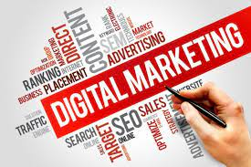
Digital media marketing is a way to drive internet site circulation or attract viewers and customers through social networking websites such as Facebook, Instagram, Pinterest, LinkedIn, Twitter, and YouTube. Digital media marketing is the subgroup of digital marketing. While the terms e-marketing and digital marketing are still vital to academics, digital mass media marketing is becoming progressively common among staff and investigators. Various types of digital marketing items are common radio marketing, television marketing, email marketing, search engine optimization, content marketing, mobile marketing, and print printing etc.


Services of Mental Health Organization;
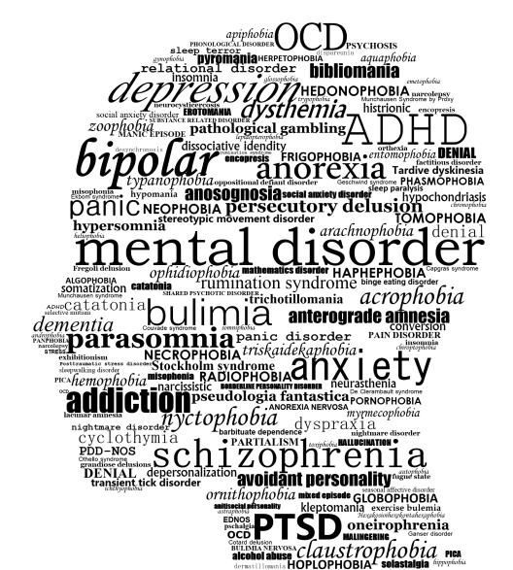
Mental health is an important part of health. In the previous week, one in six people will have had a common mental condition, according to Public Health England. More than ever, there is intense demand on the NHS to treat millions of patients with mental sickness. Digital media has become an integral part of the survives of many people who face the challenges of mental illness. All digital platforms that allow people to link with others within a virtual network (such as Facebook, Twitter, Instagram, snapchat or LinkedIn) and share, collaborate, or exchange various digital content, such as information messages, photos or videos, are referred to as digital media (Ahmed et al. 2019). Studies have reported that people existing with a variety of mental health problems, together with depression, mental disorders, or other serious mental illness, use digital media platforms at the same rate as most people, using from 70% between the ages and up to 97% of young people. All over the USA and globally, very limited people living with a mental illness are able to access adequate mental health services (Patel et al. 2018). The widespread use and universal use of digital media stages can provide innovative opportunities to address these shortcomings in existing mental health care, by improving excellence, accessibility, and access to services. Recent research has examined digital media usage patterns, the impact of digital media use on mental and social health, and the potential for gaining admiration and communicating digital media to enhance delivery. However, there is still indecision about the risks and potential harm of digital mental health media and how you can better balance these concerns with potential benefits. In this explanation, we summarize current research into the application of digital media in people with mental illness, on the impact of digital media on mental well-being, and initial efforts to use digital media to deliver evidence-based interventions to address mental health problems. We used the search phrases “mental health” or “mental illness” and “digital media” to find recently updated peer- reviewed papers on Medline and Google Scholar, as well as reference lists for the newest updates and other relevant subjects. We have reviewed the risks, potential injuries, and essential safety measures through digital mental health media. Overall, our aim was to look at the role of digital resources as a potential involvement to provide support to people with mental illness, to promote involvement and maintenance in care, and to improve current mental health services, while measuring the need for safety. We did not conduct a systematic literature search or apply any specific inclusion criteria based on the study design or kind of material condition because of this wide goal.

Digital Platforms for Mental Health Organization

The widespread use and widespread use of social media can provide new prospects which must be addressed in mental health care, by improving value, accessibility and access to services. Current studies have examined the way of using social media, the effect of uses of mental health and social media resources, and the possibilities of gaining fame and social media structures to improve intervention delivery. However, there is still indecision about the risks and potential harm to mental health communication and how it is good to measure the concerns regarding potential advantages. This article reviews recent studies about the uses of social media to deliver evidence-based programs to address psychological health issues. We searched for recently updated peer-to-peer publications that can be found on Google Scholar and Medline and also searched the reference list for the latest updates and other relevant subjects. We have studied the issues, possible injuries, and essential protection measures through the use of social media. In general, we aimed to consider the part of communication as a practicable involvement to provide care to people who has psychological illness, to encourage participation and custody in observation and attention, to improve services of mental well-being, while measuring the necessity for protection. The world is attempting to use information and communication technology more often with strategies and initiatives like “No Life Without Mental Health” and “Digital Beginning”. In this current situation, everything offers their services on a digital platform. Therefore, mental health organizations also provide their digital services and inform the general public of the benefits of good mental health.

Some of the popular digital platforms are:
- Website: Like any other organizations, mental health service providers also need to have a proper website which creates a concrete social presence and credibility for the institution, as well as helps to reach out to the maximum number of target audiences due to the overwhelmed uses of the internet by the masses.
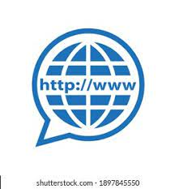
- Facebook: It offers a variety of marketing solutions both (paid and free). So, mental health organizations can promote their Facebook page or post about their services and make an online platform to reach their specific customers. Also, who are help seeking people; they can easily reach them and take the proper guideline to be mentally stable.


- YouTube: YouTube is a video-based platform where organizations can make videos or advertisements about their product or services. Nowadays every mental health organization has their own YouTube channel which is like they are presenting their profile, promoting their services & educating people about mental health.


- Instagram: Instagram is a photo-based platform but the Mental Health Organization can post various photos of their methods to provide the facilities that uses Hashtag(#) to find their intentioned clients.


- Twitter: Users post and engages with messages known as “tweets” on the microblogging social networking site named Twitter. Through posting informative blogs, people may be benefited by getting useful information. Social networking platform will also be a beneficial platform for the desired people.


- Mobile apps: Heart rate, period cycle, cognitive sports, and other things may all be tracked using applications. A self-care based software program was recently developed by certain Mental Health Organizations, that helps people to practice and use self-help for depression.


- E-commerce: It is used to purchase prescribed drugs, which helps to overcome the usual problem of drug availability in most pharmacies.
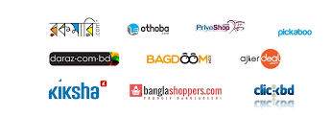

- E-hospital: Now it’s very common for the hospitals to have their own E-hospital that manages the data system, this helps to schedule, investigate and provide services. So, mental health organizations are using this to help their patients who need medical help to be mentally stable.



Needs of digital marketing for mental health organizations.

There are many challenges to helping those with chronic mental illness. A more digital approach could improve access to psychiatric treatment. And too many people are needed to find a service in a remote area; they can get help if mental health organizations use digital marketing. In addition, during special emergencies, telemedicine or the service of doctors from faraway places can help patients access the service automatically. By enhancing service quality, usability, and accessibility, the widespread use of social media can open up new opportunities for addressing these problems in mental well-being.

- Geographical challenges
Distance from treatment facilities is a significant obstacle. Most of the people are living miles away from mental health services. For that reason, they can’t take the services at their appropriate time.
Thus, technology can aid in resolving these access problems. People can use digital technologies everywhere, even in the most remote villages. The communication can be enhanced between medical staff and to people who are looking for assistance.

- Time management
- Improved patient access
- Keep patient’s comfort zone

Overview of the Health Segment

The healthcare industry comprises of companies that offer medical services, produce medical supplies or pharmaceuticals, offer medical insurances, or in some other way help consumers receive health care.

Vital takeaways:
The vital takeaways are described below:
The businesses that provide and coordinate medical and associated goods and services are included in the health care system.
Although this industry has many benefits in the United States, it is also plagued by a number of elements that might potentially cause economic issues.
Due to the disproportionate amount of money spent on healthcare in the United States compared to health results, political industry change has become questionable. A wide network of health services has been built in Bangladesh to ensure equal healthcare for all residents.
Medical universities, medical college, hospitals, make the tertiary level of healthcare infrastructure. Region clinics, maternity and kid wellbeing clinics are classified as secondary. The primary level healthcare providers are given below:
- Region healthcare complexes
- Union health and family welfare centres
- Community clinics (lowest level healthcare institutions).
This complex network is also supported by a number of NGOs and business organisations.
In 2016, Bangladesh’s GDP reached 2.37% for total healthcare expenditure. In the year 2017-18, an amount of 16 thousand 203 crore 36 lacs taka was received by the health sector.
As of 2009, the general government’s expenditure on health care as a percentage of total government expenditure was 7.9 percent. Citizens pay the majority of their healthcare bills out of pocket, accounting for 96.5 percent of private healthcare spending. The doctor : population ratio is one to two thousand, and the ratio of nurse : population is one to five thousand.

Because of having a large population people of this country faces a lot of diseases or health issues. Some of these are noncommunicable and others are communicable diseases.
The names of these diseases are given below:
- Noncommunicable disease:
- Diabetes
- Cardiovascular disease
- Hypertension stroke
- Chronic respiratory disease
- Cancer etc.
The major motivators for the high prevalence of noncommunicable diseases in Bangladesh are social transition, quick growth and unhealthy dietary habits, particularly in under privileged communities such as urban residents and slum dwellers.
- Communicable disease:
- Tuberculosis
- HIV
- Tetanus
- Malaria
- Measles
- Rubella
- Leprosy etc.
Communicable diseases are still the major diseases in Bangladesh. Still Bangladesh has achieved the way to control the communicable diseases.
This burden is exacerbated by malnutrition and environmental sanitation issues.

Environmental hygiene
As Bangladesh has large population, it’s very difficult to maintain the environmental hygiene. Environmental hygiene cannot be maintained for several reasons. These are:

- Due to lack of drinking, using pure water in many areas of the country.
- Defecation without consideration causes illnesses including diarrhoea, dysentery, enteric fever, hepatitis, and hook worm infestations that are water and dirt carried.
- Shabby rural home with inadequate lighting, ventilation etc.
- Markets and public dining areas are poorly maintained.
- Poor drainage, garbage removal and animal excrement.
- Lack of sufficient MCH (Maternal and Child Health) care services.
In Bangladesh, the issue of access to healthcare is extremely severe. Only 30% of the population has access to primary health services, and total health care performance continues to be very low by all standard criteria, according to a World Bank (1987) assessment.
Health sectors include of two types; general health sector and mental health sector. General health sectors include different types of physical inabilities or trauma. Mental health sectors include mental disorder which is also of different types.

General health sector

The public general healthcare services are divided into four levels including-
- Community-level healthcare: This level includes the domiciliary health providers and community-based clinics;
- Primary level healthcare: It includes rural health centres, union family welfare centres, union sub centres, and region health complex;
- Secondary level healthcare: Here, healthcare providers include general hospitals, district hospital, tuberculosis clinics, chest disease clinics, and leprosy hospitals;
- Tertiary level healthcare: includes post graduate medical institutes, medical college hospitals, specialized health care clinics and infectious disease hospitals.
Bangladesh has advanced significantly in the field of health during the past 50 years after gaining its independence. Medical schools, medical universities, private medical schools, private hospitals, private clinics, district hospitals, urban health care centres, and community clinics are all expanding in a noticeable way. Numerous NGOs participate in and support the delivery of healthcare. The pharmaceutical industry has made significant advancements, offering low-cost medications, injectable AIDS medications, anti-cancer medications, etc. Additionally, there is a greater broad public understanding of health-related concerns.
In family planning, there has also been satisfactory development. The population growth rate has been slowed. A vast and thriving network of private physicians spanning the country is attempting to satisfy the demands of every medical concerns.

There has been sign can’t gain in terms of polio and small pox eradication. Diphtheria and Tetanus cases have decreased due to widespread immunization and case isolation. Cholera, typhoid and dysentery cases have all decreased as overall hygiene and sanitation standards have improved. A large number of tuberculosis satellite clinics now provide free treatments. Despite the low prevalence of HIV and AIDS, overseas work remains a hazard. Malaria and Kala Jor have been greatly reduced.

Bangladesh has a population of roughly 153 million people and the annual population growth rate is 1.37%. The ratio of male to female population is 104 to100. The majority of people reside in rural areas. With a net production rate per women (15-49) of 1.03, the crude birth rate is 19.2 per 1000 people and the crude death rate is 5.5 per 1000 people. Both genders have a 69.0 life expectancy at birth (year); 67.9 for men and 70.3 for women.
For the treatment issue of a massive number of populations, Bangladesh needs a strong and organized health care sector. Along with it needed to be digitally equipped and has a vast knowledge to operate the modern machineries and serve a vast number of people.

Mental health sector

Mental health sector includes numerous mental disorders and mental disabilities. People are less concern about mental health compare to physical health. But govt. is so concern with this issue that they established the national psychological wellbeing institution.
Bangladesh aims to provide healthcare for a variety of communities. At its current location, NIMH was founded in 2001. Prior to that, beginning in 1981, it operated as the Institute of Mental Health & Research in several medical college hospitals in Dhaka city.
Mental health is an important aspect in leading a healthy and productive life; but, in countries like Bangladesh, mental problems do not receive appropriate scientific focus and are not addressed as a severe people health concern.

In Bangladesh, there are several diverse demographic groups where mental problems are more common and more severe in form. Current mental healthcare in Bangladesh is severely deficient due to a lack of public mental health clinics, a shortage of qualified mental health experts, and inadequate allocation of financial resources, poorly managed mental health policies and stigma. For mental patients, the nation has few community care facilities. The Bangladeshi government barely spends 0.44% of its overall health budget on mental health. A tiny fraction of people (less than 0.11%) has free access to necessary psychotropic drugs.
Mental health is not only just including our emotional but also psychological, and social well-being. It affects us in different ways such as:
- How we think, feel, act
- Helps to determine how we handle our stress, relate to others and make choices.
Mental health is very important at every single stage our whole lifetime.
Over the course of your life, if you experience mental health problems, you’re thinking mood, and behaviour could be affected. Many factors contribute to mental health problems, including;
- Life experience about trauma or abuse
- History of mental issues in the family background
- Issues caused by biological facts
Mental health problems are frequent, but there is assistance. People with these issues can recover, and many do. Bangladesh is a lower-middle-income South Asian country, it has a population of 163 million people, ranking it 8th in the globe. Rural areas house two-thirds of the population. Literacy rates for males are predicted to be 75.62% and 69.90% for females.
Bangladesh suffers an enormous burden of illness caused by communicable and non-communicable illnesses, including mental disorders, with only 4 hospital beds per 10,000 inhabitants. Because to a shortage of public mental health facilities, a scarcity of qualified mental health experts, insufficient financial resources distribution, and societal stigma, mental health care in Bangladesh is highly poor.
There hasn’t been a thorough examination of the nation’s present mental health situation at the national level, despite the lack of information regarding the prevalence of mental diseases and the difficulties in providing better mental health treatment.

Context regarding the vulnerable groups in terms of psychological wellbeing:

Adults: In 2003- 2005, our country undertook its first nationwide study on mental health. In 2019, a nationwide representative poll was performed for the second (and latest) time. The mental health of Bangladeshis has been disrupted by the COVID-19 epidemic.
According to one study the prevalence of depression (57.95%), stress (57.9%), stress and anxiety (33.7%) signs in the adult residents has risen significantly during the epidemic. Another research indicated that tension, anxiety, and depressed symptoms were present in 28, 55, 33, and 46.92 percent of kids who were sequestered at home, respectively.
Children: Between 13.4 and 22.9% of children in Bangladesh were estimated to have a mental condition, according to a systematic evaluation of the literature on children there from 1998 to 2004. Prevalence estimates from community-based surveys from 2004 and 2009 are consistent with those from earlier decades. The most current statistics show a lower frequency for girls than boys according to the 2019 countrywide representative survey.

Other child and teen-age groups: A thorough analysis put Bangladesh’s prevalence of autism spectrum disorders at 0.2 and 0.8 percent. According toa 2013 survey, 25% of teenagers in urban schools showed signs of depression (girls: 30 %, boys: 19 %). 36.6 % of teenagers in urban and semi-urban schools who participated in a 2018 survey had depressed symptoms (girls: 42.9%, boys: 25.7%). In 2013, statistics on depression among Bangladeshi medical students showed a similar proportion (38.9%). According to a 2019 survey of college students, anxiety and depression prevalence increased by 27.1% and 22.5%, respectively, over a 15-month period.

Financing context regarding services of mental health
The Bangladeshi government spends 0.44 percent of its overall health budget on mental health. Mental hospitals receive 67 percent of all spending on mental health. Only 0.11 percent of people get free access to necessary psychiatric drugs. The cheapest anti-psychotic and antidepressant medications have a daily out-of-pocket cost of 5.00 taka and 3.00 taka, respectively. Health insurance is uncommon, and it doesn’t usually pay for medications for mental illnesses.

Inadequate number of mental healthcare human resource:
In Bangladesh, only 0.49 percent of healthcare practitioners have had mental health training, and psychiatrist are even rarer (0.16 per every 100,000 people). The majority of these experts works in the country’s inner-city areas, particularly in Dhaka. In Bangladesh, mental health care practitioners include psychiatrists, nurses, psychologists, social workers, occupational therapists, and general mental health workers. In Bangladesh, around half of psychiatrist (54%) work in public or private mental health facilities, while 46% works for NGOs. Psychiatrists employed by the government are permitted to serve in the private clinics. About 62% of psychic-social specialists serve those mental health organizations which are run by government, while 26% works for NGOs and 12% works in both government and privately run organizations. Urban regions are heavily concentrated, and the allocation of human resources between urban and rural areas is excessively asymmetrical. Bangladesh’s psychological health care staff is sparse and unbalanced in circulation, posing a significant hurdle to the country’s improvement.

Chapter 3

Analysis, Findings & Discussion

Respondents and sample

For completing this report, I took help from some primary resources and secondary resources. I have discussed with several staffs who are leading renown mental health organisations. They were so cooperative. They also help me to develop my quaternaries. So, I have developed around 17 quaternaries to get the proper response regarding the topic of my report.
Although I got the opportunity to talk with some patient or client who took support from those mental health organisations. And I also kept close eye on mental health organisations’ activities in the digital platform.

Survey Instrument

Questions to Ask to the people and organizations who are working on mental health in Bangladesh to know how they practices Digital Marketing to provide their services.
(This is a part of a research report. Assuring that it'll not use for any business purpose and your opinion will be conserved).
Thanks in advance.

- Are you or your organisation active on online platforms on mental health issues?
- YES
- NO

- Which online platforms do you use?
- Facebook
- YouTube
- Instagram
- Twitter
- WhatsApp

- What kind of content are you usually creating?
- Audio
- Video
- Static Post
- Articles

- For whom do you usually create online content?
- Student
- Housewife
- Service Holder

- What is the age range of your target market?
- 15-24
- 25-34
- 35-44
- 45-54

- How your target market reaches you?
- Comment
- Message
- Call
- Physically visit

- What mental health issues do you care about?
- Write in short answer

- Are you able to communicate according to people's interests?
- YES
- NO
- Maybe

- Do you face any challenges regarding Digital Marketing?
- YES
- NO

- What do you consider to be important in attracting people to mental health issues?
- Posting static post about mental health issues
- Making video content about mental health issues
- Share articles about mental health issues

- How do you know that your digital communication is working?
- Analysis customer's feedback through digital platform
- Measuring customer's quantity through digital platform
- Analysis online platforms activities

- In your experience, do you notice any changes in people's behaviour on mental health issues on online platforms?
- YES
- NO
- Maybe

- If it's yes, How's it?
- Positive
- Negative
- Have you hired an agency to work with digital marketing?
- YES
- NO

- If its yes, how's the experience?
- Positive
- Negative

- Have they any knowledge about mental health?
- YES
- NO
- Maybe
- Professional ethics plays an important role in mental health issues. How do you protect this professional ethics in the content you provide on digital marketing or online platforms?
- Long answer text

Findings
It is an age of science and technology. Young and middle-aged folks utilize the internet as usual now that it is available in our country. Social networking mediums such as Facebook, Twitter, Instagram, LinkedIn, WhatsApp are mostly used by them.
So, it become very easy to get the people who need mental health support and provide them with sessions which can help them to recover from their issues.
- Spending of organizations
- Most reached platform
- Most common issues
- Age variation of users
- Profit vs Cost

Google meet, zoom become so popular in the pandemic for various issues like academic reasons, conference, online training, doctors meeting etc. Peoples of all walks of life also become used to with this online service that’s why it remains so popular.

Response from the questionnaire: An analysis

Summary of the responses are given below:

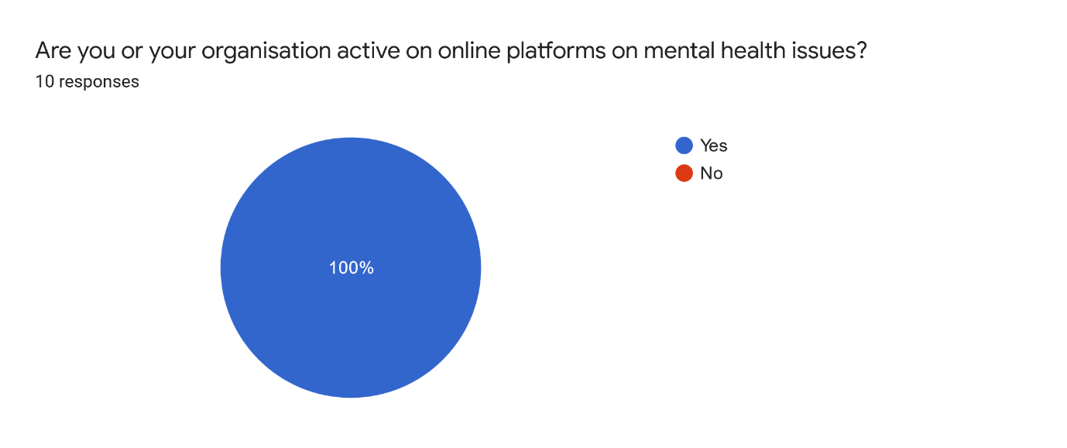
We got 100% positive response for this question.

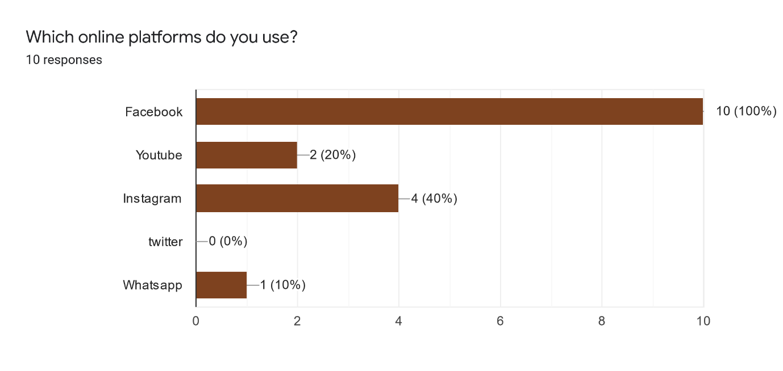
Among all the social platforms, most of the organisations prefers to use Facebook to promote mental health awareness.
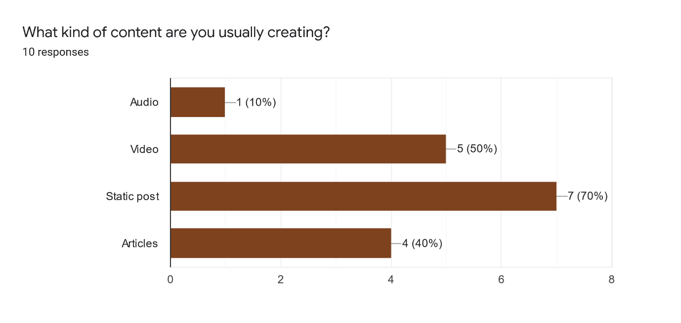
70% of them voted for static post. They try to reflect their positive thinking and mental health awareness through these static posts. They got very good responses. Other methos users also works well.
I, personally thinks that every type of contents is needed. They should practice different type of content to spread the awareness.

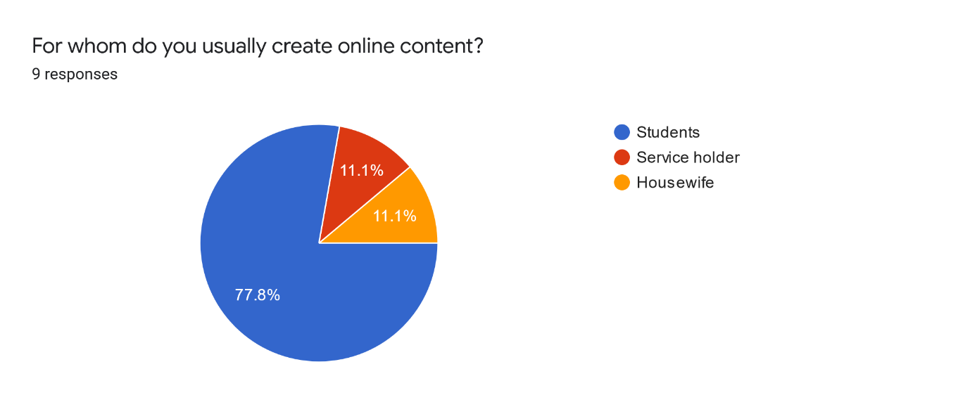
In the pie chart, we can see that most of their response was student. Their target audience age is for students. Because now-a-days students are dealing with a lot of mental health issues.

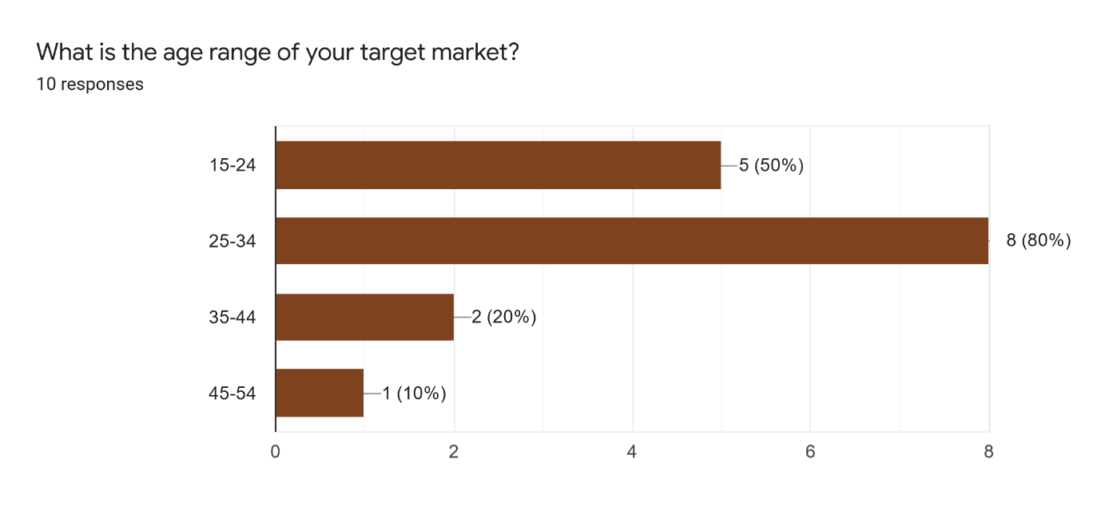
The target age range is mostly 25-34.
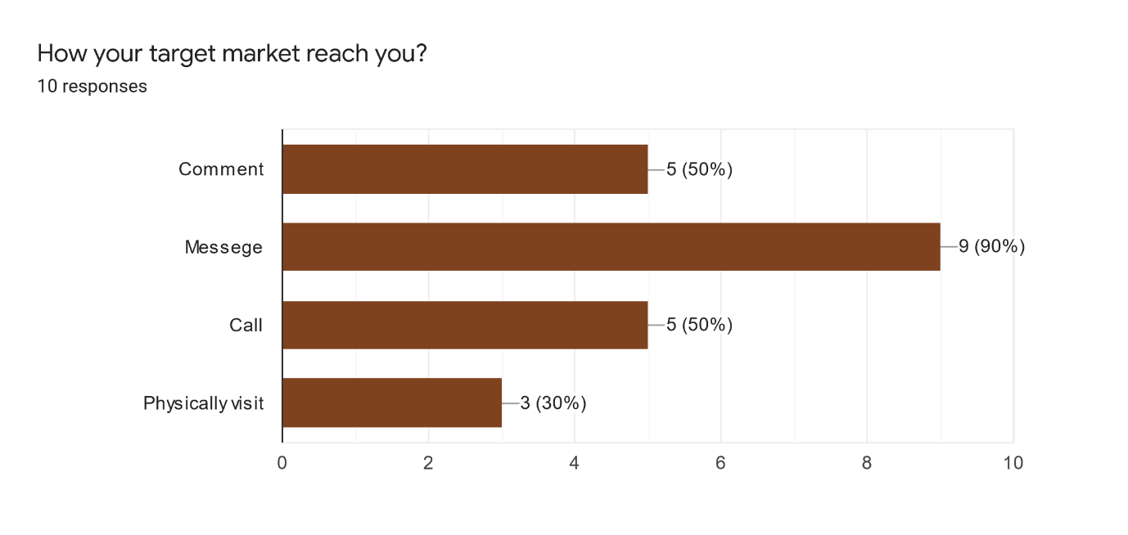
Most of the people reaches these organisations through messages in social media. So mental health organisation always should be active.
Those who are dealing with mental health issues, I insist them to visit the organisations physically to take help.

What mental health issues do you care about?

Most of the organisation reported issues like:
*Depression
*Frustration on failure
*Relationship issues
*Schizophrenia
*Bipolar disorders
*Hallucination
*Anxiety
*Mentally unstable aged people

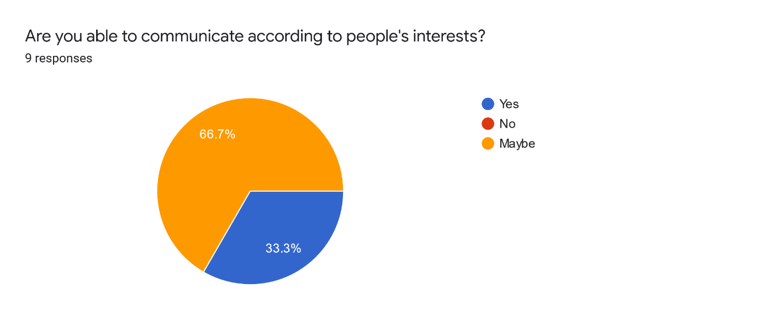
We can see from the response that organisations are trying to communicate according to people’s interests but they’re not sure if they are reaching their goals or not.
So, I think they should also get feedback from their clients.
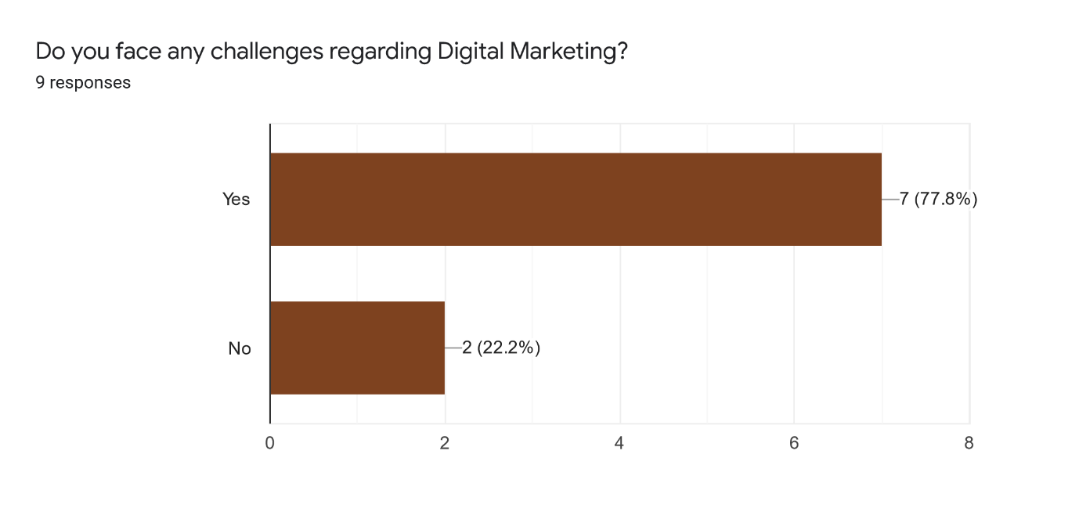
Most of the people (77.8%) faces difficulties.
So, they should make themselves more knowledgeable about Digital Marketing. And they need to know practice it more.

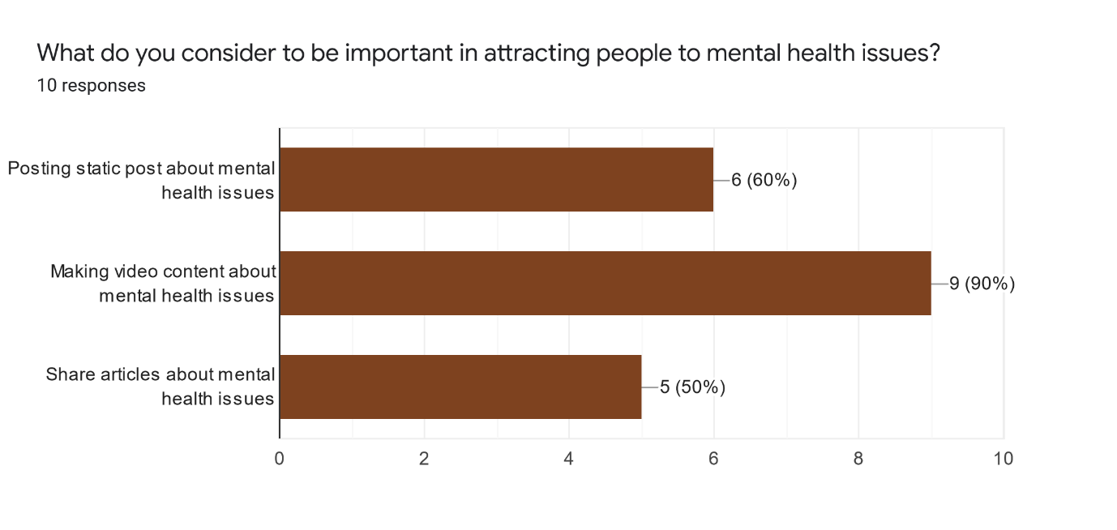

Video content is always more attractive rather than any other content. So, they also consider video content to promote the mental health awareness.
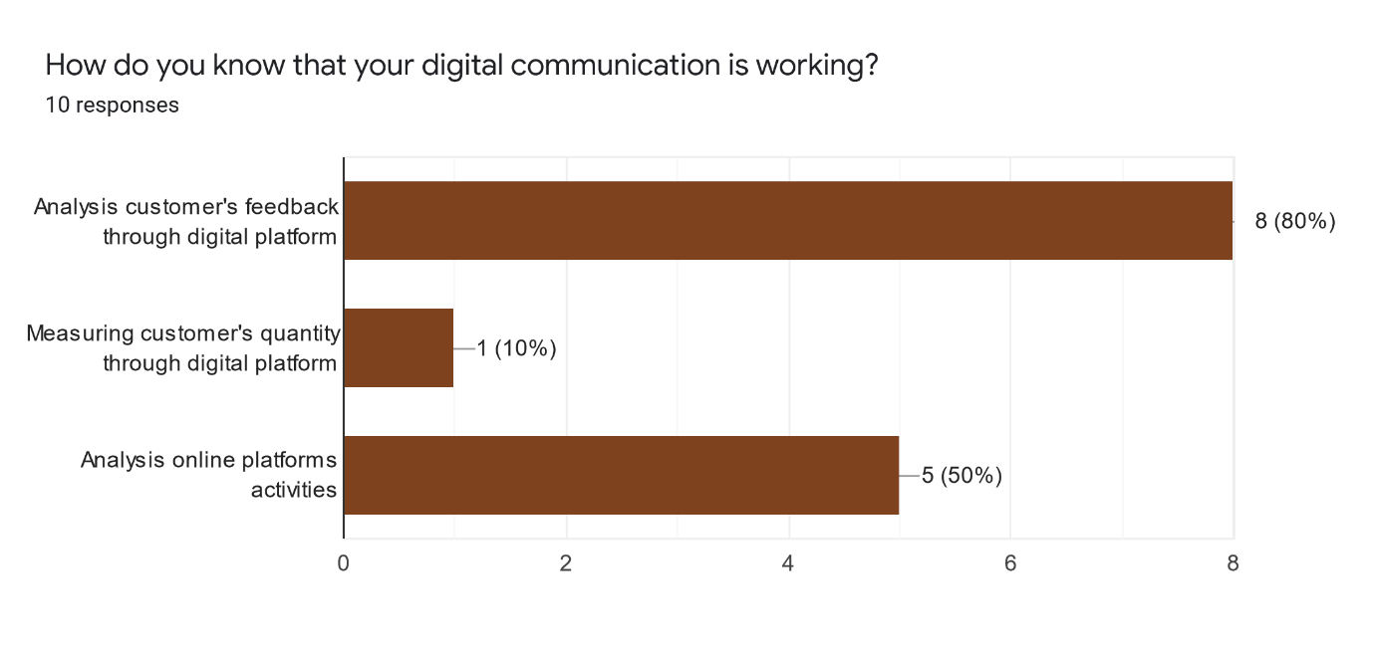
They got most of the feedbacks through online platforms. When they analyse online platform activities, they got enough response from their target market.
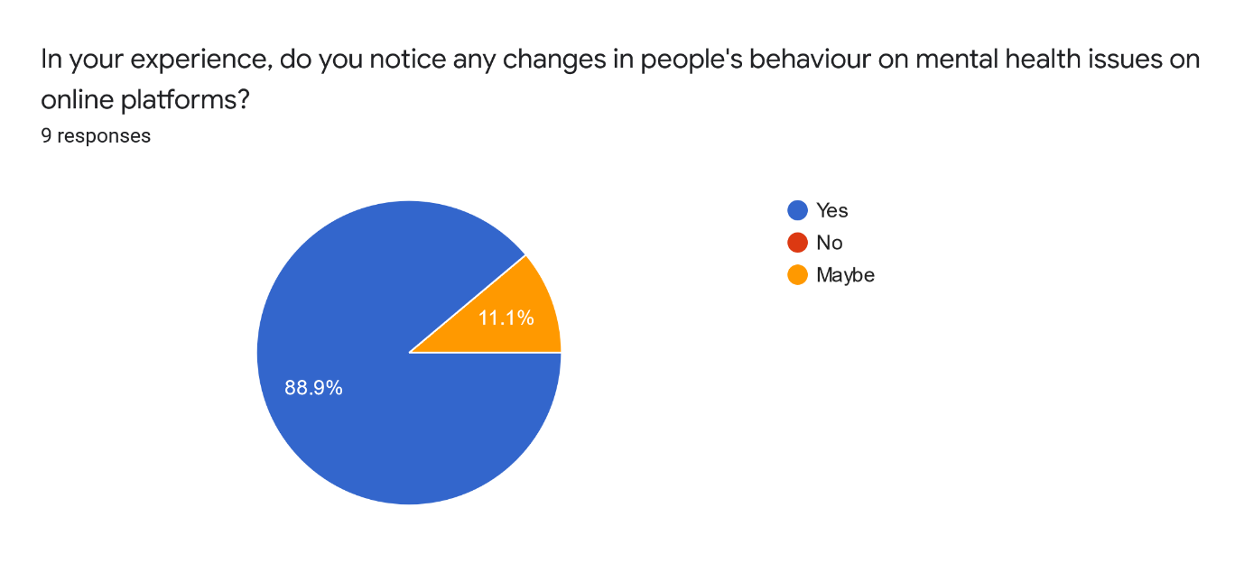
Online platforms made it easier for people to reach and share their mental health issues. The organisations definitely noticed the changes.
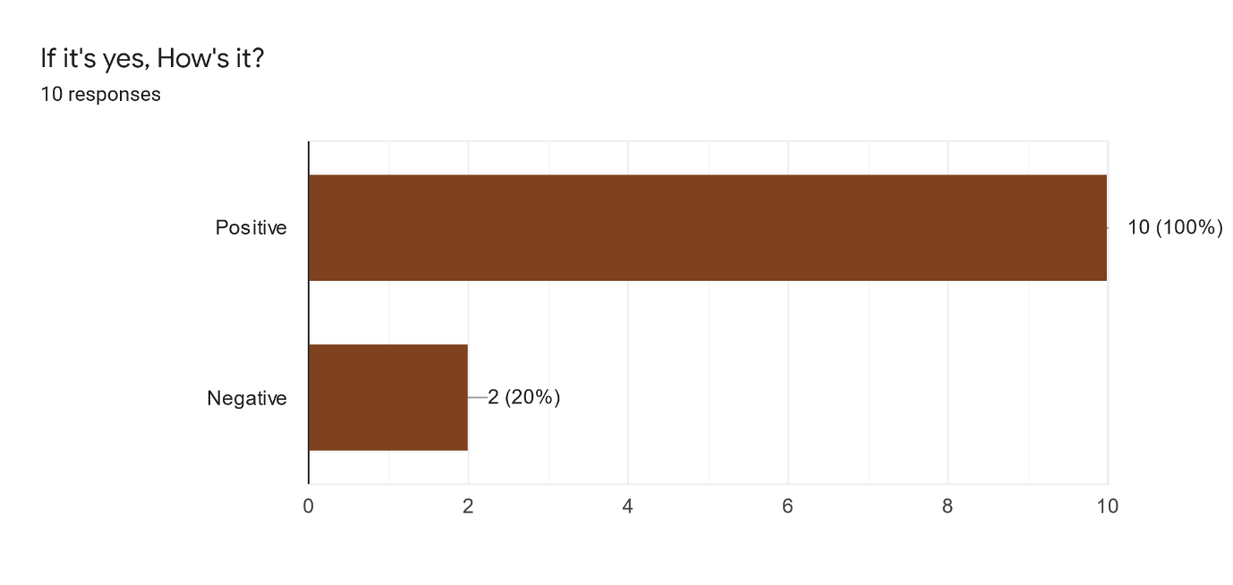

The response was most on the positive side.
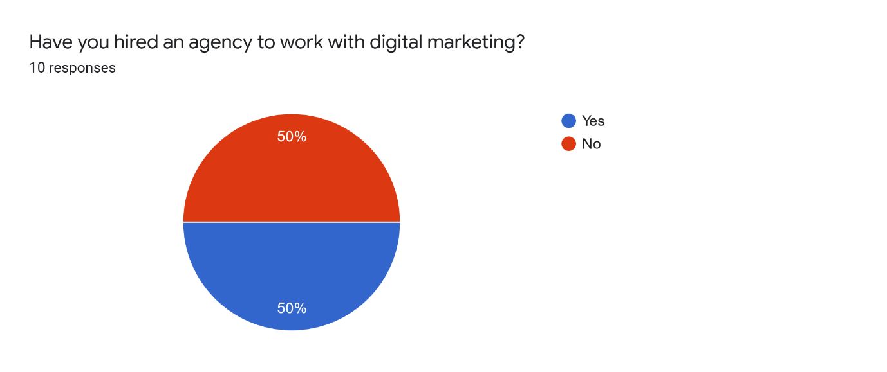
The response is fifty-fifty.
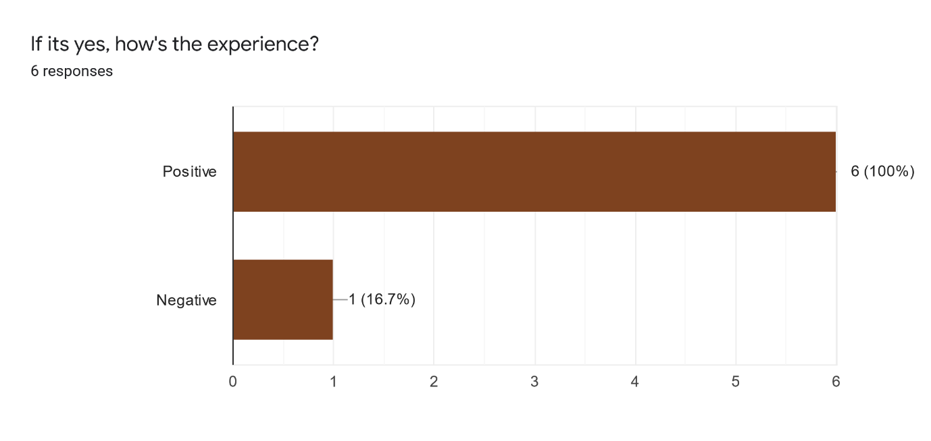
Those who has hired an agency, their experience was mostly positive.
I think other organisations should also take help form digital marketing agency.
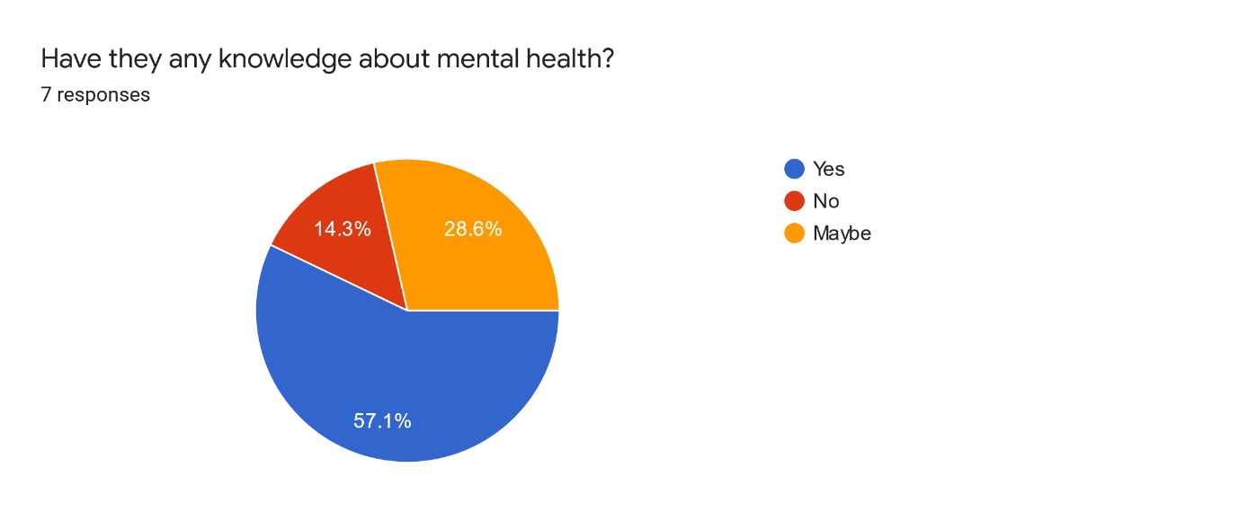
Since most of the organisation responded positively about working with an agency, they definitely have knowledge about mental health.

Professional ethics plays an important role in mental health issues. How do you protect this professional ethics in the content you provide on digital marketing or online platforms?
The ethics they mentioned in their response are given below:

*Privacy
*We don't disclose anyone's identity.
*By keeping confidential information discrete
*By providing the right choices they can make.
*By keeping their secrets. Sharing non-judgmental post or opinions.
*Try to keep their secrets. Respect them.
*I keep the conversations Private. I make them feel safe to share.
*I keep all their Secrets and conversations private. Try to motivate them more.

Chapter 4

Limitations, Recommendations, and Conclusion

During working on the topic of digital marketing practices on mental health organizations, I have faced some limitations that I have expressed the recommendations to resolve the limitations and eventually a final conclusion come to end the entitled project work.

Limitations

In Bangladesh, providing services through digital platform has numerous tasks such as:
Limited access of using telephone and computer, slow internet speed, lack of modern financial system, credit card quandary, language barricade, high rate of illiteracy. personal and other computer device’s low rate of access, Lack of flat rate phone plan.

The following is an explained summary of various limitations:
- Telephone Access
Clients who are interested in e-marketing mental health services must have access to a computer and an internet service provider (ISP).
Only a small portion of Bangladesh’s population has access to the internet.

- Expenses of Internet Connection
In comparison to other nations, the cost of internet access in our country is extremely high. Another hurdle to providing mental health treatments is the slow internet connectivity.

- Unpredictable Power Suppliers
Another obstacle for mental health organizations to provide their services through digital platforms is impulsive power suppliers. For digital marketing, sporadic electricity is a huge issue. For that reason, people can’t reach mental health organizations in their suffering time.

- Credit Card Quandary
A credit card is essential for compensation purposes. It’s not always doable for all kinds of organizations to take payment electronically for those people who do not have a credit card. Though people are making their payment through Bkash, Nagad etc which are also examples of digital transaction tools.

- Language Barrier
Another barrier to communicate with all types of people is the language barrier. Since illiteracy rate is high in Bangladesh, so a communication tool which can be an international language is essential to learn to receive the better service unless the customers may be deprive to getting the benefit of digital marketing practices.

High Rate of Illiteracy
Because this country’s rate of illiteracy is so high, most of the people are unaware of high-tech services or internet access. And it’s a big problem for practicing digital platforms to provide mental health support.

Recommendations
After research the topics in brief, some recommendations have come to publish as well. Recommendations are an obvious after any sorts of research to resolve the problem to sort out. Therefore, some recommendations are as follows;
- Need to easily access to the computer & telephone so that mass people can get the service more easily.
- It’s also a crying need to boost up the speed of internet, where internet is the key to go far in the digital world.
- Need to open up numerous financial gateways so that the customers can make payment from remote areas.
- Credit card service should also be easier to get.
- Since language literacy is a vital issue for everyone, so this problem need to handle in digital way, like use any user friendly software.
- Unfortunately, illiteracy rate is still so high. For those digital issues become more complex to the illiterate people to get services of digital marketing.
- For high illiteracy rate, people are not used to use the computer and other devices like smart phone by which they can get the service of digital marketing from staying their home.
- Phone call rate also should be flexible or customised for the special issues. Like, mobile phone operators may assign a special flat call rate for who are communicating with the doctors or health issues.

Conclusion

The presence scenario of mental disorders in Bangladesh is very alarming. Against this scenario, treatment is not enough specially in the area of marginalized populations. Scarcity in the field of mental health facilities, lack of skilled professionals, mismanagement in the distribution of financial resources, and other negative factors are making the sector vulnerable. Macro economically, the issue is made worst by the Bangladeshi government’s low investment in healthcare, inadequate lobbying, and scant research. With so many different businesses in the healthcare industry, it’s important to stands out. Especially in the world of mental health, word-of-mouth marketing can drive people to the right way.
Digital marketing practices might be another sort of business besides providing effective service to the mental disorders. Mental health organizations should be sound in providing services using digital equipment’s like Facebook, twitter, Instagram, email marketing, mobile marketing and so on. On the other hand, customers also need to be literate enough to receive the online services which would be more beneficiary for them.
Suicidal tendency is one of the serious problems for mental disorder patients. In that case it is difficult to grab them to hospital whereas easier if get the doctors’ advice and treatment remotely. Here comes the most significant issue of digital marketing. Apart from this, so many issues are existing in mental health issues where it would be better if got the service remotely, digitally.
Eventually, digital practice may play a vital role in providing a better service to the patient by staying their own home.

References
Al-Zaman, M. S. (2020). Healthcare Crisis in Bangladesh during the COVID-19 Pandemic. The American Society of Tropical Medicine and Hygiene, 1357–1359.
Bersch, C. (2021). THE STATE OF MENTAL HEALTH IN BANGLADESH. THE BORGEN PROJECT.
Chethan Basavarajappa, P. K. (2017). Digital Platforms for Mental Health-care Delivery. Indian Journal of Psychological Medicine , 703.
Faruq Alam, R. H. (2020). Stressors and mental health in Bangladesh: current situation and future hopes. Cambridge University Press.
Valarie Zeithaml, M. J. (2017). Service Marketing: Integrating Customer Focus Across the Firm. New York, United States: McGraw Hill.
Zahid Islam. (2020). Digital Marketing in Bangladesh. UNB News.

