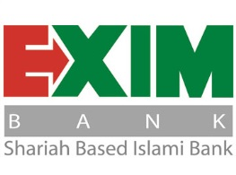

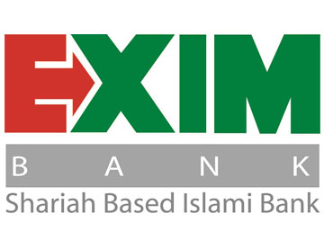



Together Towards Tomorrow

Internship Report
On
Marketing of Financial Services: A Study on Exim Bank Limited

Submitted To:
Muhammad Hasan Al-Mamun
Assistant Professor
School Of Business and Economics
United International University(UIU)

Submitted By:
Name: Mayesa Maleha Bismee
ID: 111132021
BBA Program
School of Business & Economics
United International University (UIU)
Date of Submission:30thApril,2019



LETTER OF TRANSMITTAL
30th April,2019
Muhammad Hasan Al-Mamun,
Assistant Professor
School of Business and Economics
United International University
Subject: Marketing of Financial Services:A study on Exim Bank Limited.

Sir,

Respectfully, I Want to say that I am very glad for having this opportunity to prepare the internship report which on “Marketing of Financial Services:A study on Exim Bank Limited”, under your supervision as a requirement for the completion of my Bachelor’s degree. It has been a great experience for me to be involved in this internship program and preparing this report based on my internship experienced in the aforementioned organization.The contents of this report are based on financial services of Exim bank Limited, Mirpurbranch.I want to show my gratitude to you sir, for your encouragement, effective guidelines and supports. Finally, it is a matter of great joy, and happinessfor me to present this report to you for your kind perusal.

Sincerely Yours

MayesaMalehaBismee
ID:111132021,
Program: BBA
School of Business & Economics,
United International University (UIU)

Acknowledgement

Alhamdulillah, Praise to ALMIGHTY ALLA Hour creator and the most merciful. I am so blessed that I have managed to put an end to my internship session successfullywith ALMIGHTY ALLAH’s blessings and my Mother’s heart & soul trial & also my father’s helps and supports. I would like to thank ALLAH & My parents for giving me strong mental supports, good health and ability to go through my internship peacefully and well.

I convey my gratitude to my honorable Supervisor Faculty from of School of business and Economics, Muhammad Hasan Al-Mamun (Assistant Professor), for helping me from starting to the end of the report by giving all useful instructions, helpful feedbacks to ease my journey during the internship.

Next, I would like to thank my host bank Supervisor Salina Akther (Principal Officer ), of EximBank. She is the most joyous, helpful, supportive, amiable, well-wishing person. She helps me all the way by giving my topic related information. And I also like to thank Reza Sir(FAVP), Mahabub Sir(Senior Principal Officer), Md. TariqulAlam Sir(Assistant Officer),Zahid Sir(Executive Officer),Naimur Rahman Bhai(Trainee Assistant Officer),Suborna Madam(Senior Principal Officer),Fahima Apu(Officer),Fahmida Apu(Senior officer),RifatApu(Assistant Officer), Sarif Bhai(Senior Officer), Asif Zubair Bhai (FAVP),all other employees of the Mirpur branch Exim bank.
I would like to give the heart-felt thanks to theWorld’s best parents who always support me especially thanks to my mother with the decision I took in doing my internship. Thanks To Helal Mama.Thank all of my intern colleagues, neighbors ,well-wishers & also all the faculty& teachers of my whole life.

Executive Summary

Commercial banks are one of the main contributors to the economy of developing countries. They act as financial intermediaries by performing the activities of assembling the funds from one party and lending the same to another while making a good amount of profit. People and the government itself are greatly reliant on the services provided by the different banks in the financial market. EXIM Bank Limited has started their journey as a private commercial bank on August 3, 1999. The entire working procedure of EXIM Bank Limited, MirpurBranch is divided into three departments. They are 1) General Banking 2) Investment and 3) Foreign Exchange. I have tried my best to prepare this report to be as much informative and relevant as possible. This report provides information regarding EXIM Bank Limited which includes their historical background, vision, mission, corporate strategy and the other aspects like the banking with shariah principles etc. After that the report highlights on the activities of EXIM Bank, Mirpur Branch. Then the report focuses on various types of service marketing practices (External Marketing, Internal Marketing, & Interactive marketing) of Exim Bank and my duties and responsibilities as an intern of that bank. The report is also concerned with the evaluation of the service marketing mixes of this organization. More specifically, the details of the product price, place, promotion, process, people, and physical evidence are examined with due clarity.Lastly some recommendations are provided for the purpose of improving the performance of the bank.

Key Words: Services Marketing, Financial Services

TABLE OF CONTENTS

sSerial No | TOPICS | PAGE NUMBER
1 | Introduction | 7-12
2 | Objetives of the study | 13
3 | Findings of the study | 14-31
4 | Recommendations & Conclusion | 32
5 | Appendix | 33
6 | Suggesions | 34

Introduction:
Organizational Background:
Export Import Bank of Bangladesh Limited was established in the year 1999 under the leadership of Late Mr. ShahjahanKabir, Founder Chairman who had a long dream of floating a commercial bank which would contribute to the socio-economic development of our country. He had a long experience as a good banker. A group of highly qualified and successful entrepreneurs joined their hands with the founder chairman to materialize his dream. Indeed, all of them proved themselves in their respective business as most successful star with their endeavor, intelligence, hardworking and talent entrepreneurship. Among them, Mr. Nazrul Islam Mazumder who is an illuminated business tycoon in the Garments business in Bangladesh became the Honorable Chairman after the demise of the honorable founder chairman. He is also the chairman of Bangladesh Association of Banks (BAB). Under his leadership, BAB has emerged as an effective forum for exchanging views on problems being faced by the banking sector of Bangladesh and for formulating common policy guidelines in addressing such problems.
Functioning: The Bank starts functioning from 3rd August, 1999 with its name as Bengal Export Import Bank Limited. On 16th November 1999, it was renamed as Export Import Bank of Bangladesh Limited with Mr. AlamgirKabir as the Founder Advisor and Mr. Mohammad Lakiotullah as the Founder Managing Director respectively. Both of them have long experience in the financial sector of our country. By their pragmatic decision and management directives in the operational activities, this bank has earneda secured and distinctive position in the banking industry in terms of performance, growth, and excellent management. Under the leadership of Mr. Lakiotullah, the Bank has migrated all of its conventional banking operation into Shariah BasedIslamiBankingintheyearJuly2004.
In the year 2006, Mr. KaziMasihurRahman became the Managing Director of the bank when Mr. Lakiotullah left the bank after completion of his successful 7 years as MD. Mr. Kazi served in the bank for next five years. Under his leadership, the bank has been placed on a state-of-the-sart centralized IT platform with two modern data centers where world renowned core banking software TEMENOS T24 is running along with some alternate delivery channels like ATMs and SMS banking.

On 25th August, 2011, Mr. Md. Fariduddin Ahmed has joined in the bank as Managing Director. With his long banking experience, EXIM Bank become fully compliant Bank with adequate capital and good asset quality. After retirement from Managing Director, he has been continuing his service for EXIM Bank as Advisor since 27th July 2012.
Dr. Mohammed Haider Ali Miah succeeded Mr. Fariduddin Ahmed on July 25, 2012 and has created a new dimension in EXIM history becoming the first ever in-house Managing director and CEO of the Bank. Under his far-sighted leadership, EXIM Bank has not only achieved uppermost level of performance in almost each arena of its activities but also gained confidence to place itself as one of the dynamic banks through delivering transparent and standard banking services to the customers in a compliant manner.

Vision: Exim Bank gist of vision is"TogetherTowards Tomorrow". Export Import Bank of Bangladesh Limited (Exim Bank) believes in togetherness with its customers, in its march on the road to growth and progress with service. To achieve the desired goal, there will be constant pursuit of excellence in compliance with the Islamic Shariah. Theybelieve the advantages of Islamic economy can best be extended to the people with a technology-driven modern banking system that upholds the Islamic values, and Exim Bank envisages making itself a perfect instance of that kind. The Bank’s strategic plans and networking will strengthen its competitive edge over others in rapidly changing competitive environment. Its personalized quality services to the customers with trend of constant improvement will be the cornerstone to achieve our operational success.

Scope of the Report:

This report provides a lot of information about general banking activities of EXIM Bank Limited. It delivers a broad overview of the General Banking Department of EXIM Bank Limited, Elephant Road Branch. Moreover this report contains all the observations and work experience during my.

internship period. It includes the different aspects of general banking procedures and its effects on the performance of the banking activities of EXIM Bank Limited.

MISSION:

- Extracting the full benefit of Islamic banking system for its customers.
- Providing with quality financial services especially in Foreign Trade.
- Maintaining and upgrading a technology-based professional banking environment
- Maintenance of corporate and business ethics and transparency at all levels

Limitations of the Report:

In preparing this report several complications and limitations have encountered which are mentioned below-
- EXIM Bank follows strict confidentiality of their data.

- All required information is not available in any individual branch of the bank.

- Limited scope of visiting more than one branch.

- Lack of experience and knowledge in internship report writing. Because of time constraints many of the aspects could not be discussed in this report

- Non-availability of the most recent statistical data and information

- Only three months of internship are not enough to know and learn about all the banking procedures and activities

s

Oranogramof EXIM Bank Limited:

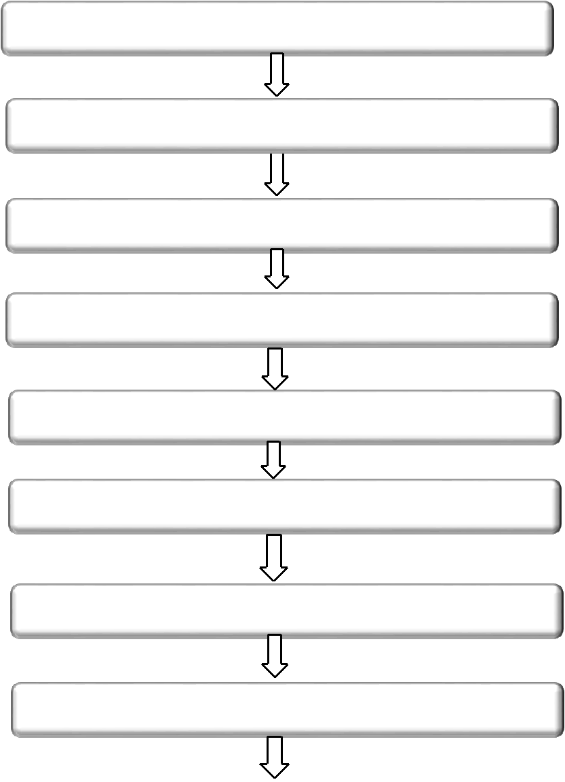
Chairman

Managing Director

Deputy Managing Director (DMD)

Senior Executive Vice President (SEVP)

Executive Vice President (EVP)

Senior Vice President (SVP)

Vice President (VP)

Senior Assistant Vice President (SAVP)

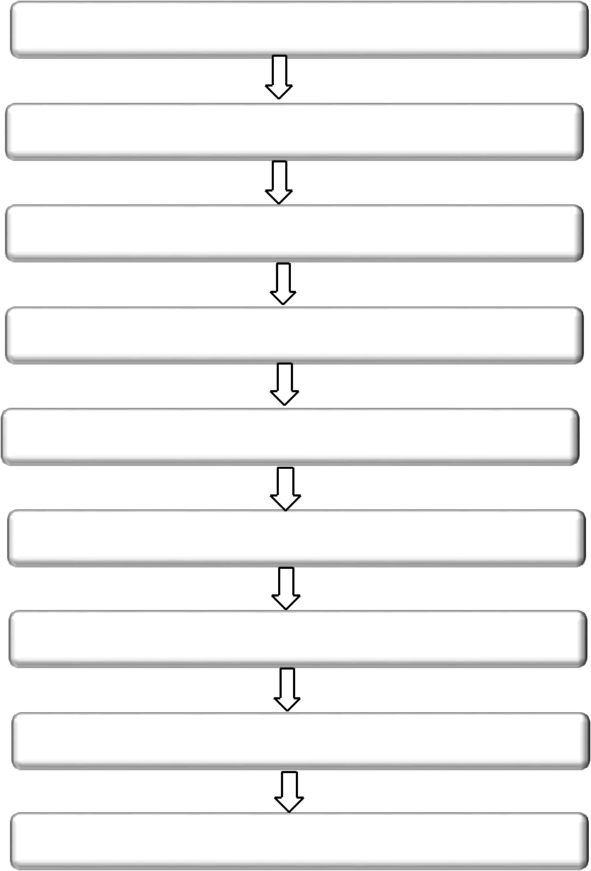
Assistant Vice President (AVP)

Senior Principal Officer (SPO)

Principal Officer (PO)

Executive Officer (EO)

Senior Officer (SO)

Management Trainee Officer (MTO)

Junior Officer (JO)

Assistant Officer

Trainee Assistant Officer(TAO)

Organizational Structure of EXIM Bank, Mirpur Branch:


Vice President (VP) & Manager

AssistantVice President (AVP)


First Assistant Vice President(FAVP)

Senior Principal Officer(SPO)

Principal Officer (PO)
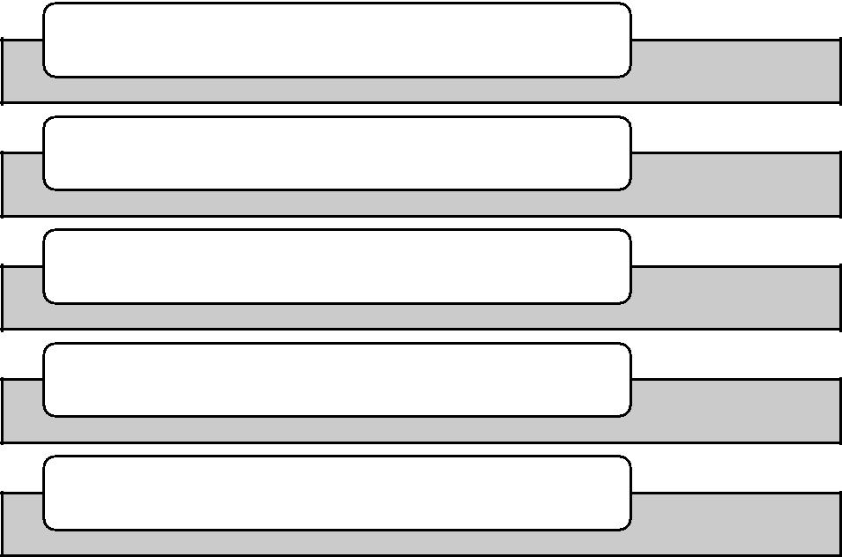

Executive Officer(EO)

Senior Officer (SO)

Officer

Junior Office

Assistant Officer

Trainee Assistant Officer(TAO)

Objectives of the Study

The Study intends to fulfill the following specific objectives-

1.To review the historical background of the Exim Bank for thepurpose of clarifying the historical evolution of the bank.
2.To evaluate the types of service marketing practices-External Marketing,Internal Marketing, and Interactive Marketing.
3.To examine the service marketing mixes of Exim bank. Morespecifically,the following elements will be evaluated–
- Product
- Price
- Place
- Promotion
- People
- Process
- Physical Evidence
4.To come up with specific suggestionsthat can be used for the purpose of improving the performance of Exim Bank.

Findings Of the Study
Service Marketing Triangle:
People (Service Employees and Customers)+Service Marketing Triangle:

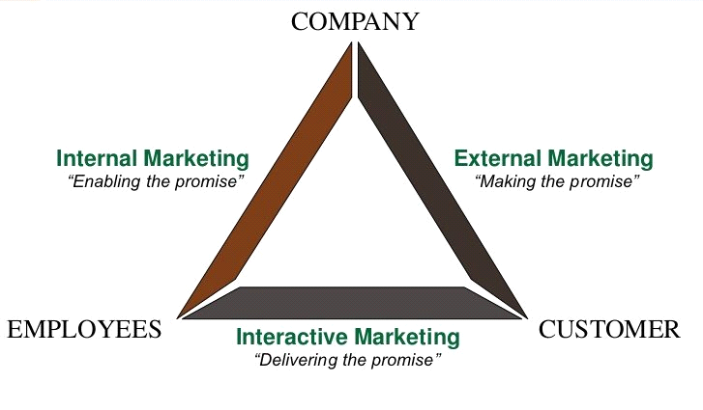

INTERNAL MARKETING: The relationship between Bank & the employees is internal marketing.Bank provides services to employee is known as Internal Marketing.They Mainly Provide to the employee training,Bonus,Salary,Pension, Gratuity etc.

Training: The bankmainly provides 3 departmentaltraining. According to their employee skills,the training may be for 1week, 1month, or 6 months.They provide PO, SPO ,General Banking training, Foreign Trade Training, Investment Training etc. Banking related subjects also included in the training program.Training is usually held in Panthopath Exim Bank training center.

Bonus: Two bonuses give to the employees.These are Eid-ul-Fitr&Eid-ul-Azha bonus.

Salary:The banks gives salary according to employees designation starting from tk-25000.

Gratuity:After 8 years from the joining of an employee get 2 gratuities.
Pension:Afterretiring all employees get pension.

EXTERNAL MARKETING: The relationship between bank & the customerisknown as external marketing.Exim Bank mainly Provide to the Customer Services are-General Banking,ForeignTrade,Investment, Shariah banking etc. They also give many types of advertisements. These types of advertisementsare mainly given by the HR department of the head office.

General Banking:General banking,where customer gets services, mainly include-how to open an account,what are the requirements need tofulfill, how to close an account etc.

Foreign Trade:In foreign trade department is divided in two parts- Export &Import.Helping customer by giving L/C related information,how to fulfill impform,expform etc.When one company wants to buy /sale product to another country’s company there is a need of one guarantor.Bank is the guarantor.And L/C is the guarantor’spaper ,where all the information are given.
Investment:Exim bank mainly invests in 3 sectors.These are-
1.Bai (according to sharia’h)
2.Partnership
3.Igara.
Service Marketing Mix

Service Marketing Mix is related with 7p.These are -

- Range of Services.
- Price.
- Place.
- Promotion.
- People.
- Process.
- Physical Evidence.

Range of Services:
Mainly Provided 3 Services.These are-General Banking,ForeignTrade, and Investment.

General Banking:General banking is the starting point of all the banking processes. This division offers day to day services to their customers. It includes new accounts, remit funds, issue pay orders and bank drafts etc. Islamic Shariah based banks like EXIM Bank collects various deposits from their customers. They provide the depositors the rate of profit they earn from their operation. According to Islamic Shariah, the bank act as Shahib-AL-Mal and customer act as a Mudarib.

Foreign Trade:In foreign trade department is divided in two parts- Export &Import.Helping customer by giving L/C relatedinformation ,how to fulfill impform,expform etc.When one company wants to buy /sale product to another country’s company there is need of one guranter.Bank is the gurantor.And L/C is the gurantorspaper ,where all the information are given.

Investment:Exim bank mainly invest in 3 modes sector.These are-
1.Bai
2.Partnership
3.Igara.

1.Bai:It is related with buy and sale productrelated invesment.Baimodeis 4 types of investment These are-Bai muajjal,Bai murabaha,Istisna,&Bai salam.
- Bai muajjal:Related with sale on credit.
- Bai murabaha:Related with profit sale
- Istisna: Related with manufacturing/construction related sale.
- Bai salam:Agriculture productive investment.
2.Partnership:It is related with more than two parties.One party is known as Mudaraba,and other party is known as Musharaka.
- Mudaraba:One party will give money& Other party will give the physical .
- Musharaka: 2 people will both involved by money and physically.
3.Igara:This mode is rent types.Igara mainly 3types.These are –Hire purchase,Igara Bill baia,Hire purchase under shirkatul milk.

PRICE:

TOPIC | EXIM BANK | OTHER BANK
Savings Account | 600 tk | 1000tk
Debit card | No charge | Charge
Service charge | 115tk | 615tk

PLACE: EXIM Bank has 123branchesin Bangladesh including SME/Agriculture.In every branch have atm booth also.Soexim bank has 123branches including 123A.T.M booths. They are mentioned below-
No | Branch | No | Branch | No | Branch | No | Branch |  | No | Branch
1 | Motijheel | 25 | CDA Avenue | 49 | Beanibazar | 73 | Magura |  | 97 | Rayer Bazar
 | Branch |  | Branch |  | Branch |  | Branch |  |  | Branch
2 | Panthapath | 26 | Chowmuhuni | 50 | Nabiganj | 74 | Hemayetpur |  | 98 | Morjal
 | Branch |  | Branch |  | Branch |  | Branch |  |  | Branch
3 | Agrabad | 27 | Satmasjid | 51 | Panchabati | 75 | Mouchak |  | 99 | Rajapur
 | Branch |  | Road Branch |  | Branch |  | Branch |  |  | Branch
4 | Khatungonj | 28 | Bashundhara | 52 | Feni Branch | 76 | Chapainawab |  | 100 | Netrokona
 | Branch |  | Road Branch |  |  |  | gonj |  |  | Branch
5 | Gazipur | 29 | Fenchugonj | 53 | Dinajpur | 77 | Neyarhat |  | 101 | Sariakandi
 | Chowrasta |  | Branch |  | Branch |  | Branch |  |  | Branch
 | Branch
6 | Imamgonj | 30 | Comilla | 54 | Keranigonj | 78 | Dohazari |  | 102 | Madhabdi
 | Branch |  | Branch |  | SME/Agri |  | Branch |  |  | Branch
 |  |  |  |  | Branch
7 | Gulshan | 31 | Rangpur | 55 | Biswanath | 79 | Sheikh | Mujib | 103 | Raozan
 | Branch |  | Branch |  | Branch |  | Road Branch |  |  | Pahartali
 |  |  |  |  |  |  |  |  |  | Branch
8 | Sonaimuri | 32 | Moulvibazar | 56 | Goalabazar | 80 | Ring | Road | 104 | Panchlaish
 | Branch |  | Branch |  | Branch |  | Branch |  |  | Branch
9 | Sylhet | 33 | Savar Bazar | 57 | Thakur | 81 | Pabna Branch |  | 105 | Sirajganj
 | Branch |  | Branch |  | Bazar |  |  |  |  | Branch
 |  |  |  |  | SME/Agri
 |  |  |  |  | Branch

10 | Nawabpur | 34 | Kawran | 58 | Sonargaon | 82 | Seed | Store | 106 | Narayanpur
 | Branch |  | Bazar Branch |  | SME/Agri |  | Bazar Branch |  |  | Branch
 |  |  |  |  | Branch
11 | Narayanganj | 35 | Mudaffargonj | 59 | Banani | 83 | Kishoregonj |  | 107 | Dattapara
 | Branch |  | Branch |  | Branch |  | Branch |  |  | Branch
12 | Shimrail | 36 | Kushtia | 60 | Bashurhat | 84 | Halishahar |  | 108 | Shantinagar
 | Branch |  | Branch |  | Branch |  | Branch |  |  | Branch
13 | Rajuk | 37 | Rajshahi | 61 | Dhanmondi | 85 | Balirtek |  | 109 | KaziNazrul
 | Avenue |  | Branch |  | Branch |  | Branch |  |  | Islam
 | Branch |  |  |  |  |  |  |  |  | Avenue
 |  |  |  |  |  |  |  |  |  | Branch
14 | New | 38 | Head Office | 62 | Dhopadighip | 86 | Jhalakathi |  | 110 | Bhola
 | Eskaton |  | Corporate |  | ar Branch |  | Branch |  |  | Branch
 | Branch |  | Branch
15 | Uttara | 39 | Golapgonj | 63 | Mymensingh | 87 | Naogaon |  | 111 | CEPZ
 | Branch |  | Branch |  | Branch |  | Branch |  |  | Branch
16 | Laksham | 40 | Chhagalnaiya | 64 | Takerhat | 88 | Mukterpur |  | 112 | Joypara
 | Branch |  | Branch |  | Branch |  | Branch |  |  | Branch
17 | Mirpur | 41 | Naria Branch | 65 | Garib-e- | 89 | Tangail |  | 113 | Jagannathpu
 | Branch |  |  |  | Newaz |  | Branch |  |  | r Branch
 |  |  |  |  | Branch
18 | Jubilee | 42 | Khulna | 66 | Cox’s Bazar | 90 | Charbata |  | 114 | Tungipara
 | Branch |  | Branch |  | Branch |  | Kasherhat |  |  | Branch
 |  |  |  |  |  |  | Branch
19 | Elephant | 43 | Pahartali | 67 | Nazirhat | 91 | Dollai |  | 115 | Lalpur
 | Road |  | Branch |  | Branch |  | Nowabpur |  |  | Branch
 | Branch |  |  |  |  |  | Branch
20 | Mawa | 44 | Paltan | 68 | Dania | 92 | Pakundia |  | 116 | Mithamoin
 | Chowrasta |  | Branch |  | Branch |  | Branch |  |  | Branch
 | Branch
21 | Bogra | 45 | Board Bazar | 69 | Gouripur | 93 | Islampur |  | 117 | Bagmara
 | Branch |  | Branch |  | Branch |  | Branch |  |  | Branch
22 | Jessore | 46 | Bahaddarhat | 70 | Sandwip | 94 | Sitakunda |  | 118 | Mohila
 | Branch |  | Branch |  | Branch |  | Branch |  |  | Branch,
 | Branch |  | Branch |  | Branch |  |  |  |  | Uttara
23 | Malibagh | 47 | Faridpur | 71 | Satarkul | 95 | Ashulia
 | Branch |  | Branch |  | Branch |  | Branch |  | 119 | TakerhatBranch,Takerhat
24 | Manikgonj | 48 | Khulshi | 72 | Barisal | 96 | Ashugonj
 | Branch |  | Branch |  | Branch |  | Branch |  | 120 | Tangail branch
 |  |  |  |  |  |  |  |  | 121 | Thakur Bazar branch

PROMOTION:
They use several types of advertisement. For Example-Online, Paper Marketing,Bill board etc.
Online: Exim bank mainly givestheir advertisement in the websites.We live in digital era.So all things are done online through internet connectivity. They use www.exim bankbd.com as their website.

Print Advertisements: Exim bank also usesprint advertisementsas promotional tools. They mainly give their advertisements or circulars in” ProthomAlo” & “Daily star”.
BILL BOARD: Exim bank gives many advertisements in the bill board.
PEOPLE:Exim bank mainly focuses on the two parties.They are-Employee & Customer.
EMPLOYEE:They mainly provide to the employee -

Training: Theymainlyprovide 3 departmental training. According to their employee skills,the training may be for 1week, 1month, or 6 months.They provide PO, SPO ,General Banking training, Foreign Trade Training, Investment Training etc. Banking related subjectsare also included in the various training programs.Trainingsare usually held in Panthopath Exim Bank Training Center.

Bonus: Two bonuses are given to the employees.These are Eid-ul-Fitr&Eid-ul-Azha bonuses.
Salary:It gives according to employee’s designation.Starts from tk-25000.
Gratuaity:After 8 years from the joining of an employee get 2 gratuity.
Pension :After retiring all employees get pension

CUSTOMER: Exim Bank mainly provides to the Customer Services are-General Banking,ForeignTrade, Investment, Shariah banking etc. They also give many types of advertisements. These types of advertisementsare mainly given by the HR department of the head office.

General Banking:In general banking,where customer gets services are-how to open an account,what are the requirements need tofulfill,how to close an account e.t.c.

Foreign Trade:In foreign trade department is divided in two parts- Export &Import.Helping customer by giving L/C related information,how to fulfill impform,expform etc.When one company wants to buy /sale product to another country’s company there is a need of one guranter.Bank is the gurantor. And L/C is the gurantors paper,where all the information are given.
Investment:Exim bank mainly invest in 3 sectors.These are-
1.Bai
2.Partnership
3.Igara.

PROCESS:To open an account banker and client make acontractual relationship. Though, the selection of a clientfor opening an account is very critical for a bank. Before the opening of an account in EXIM Bank, the following procedures must be completed by the customer.Account Opening Process is given below-
Customer fills up | After that |  | The officer verify
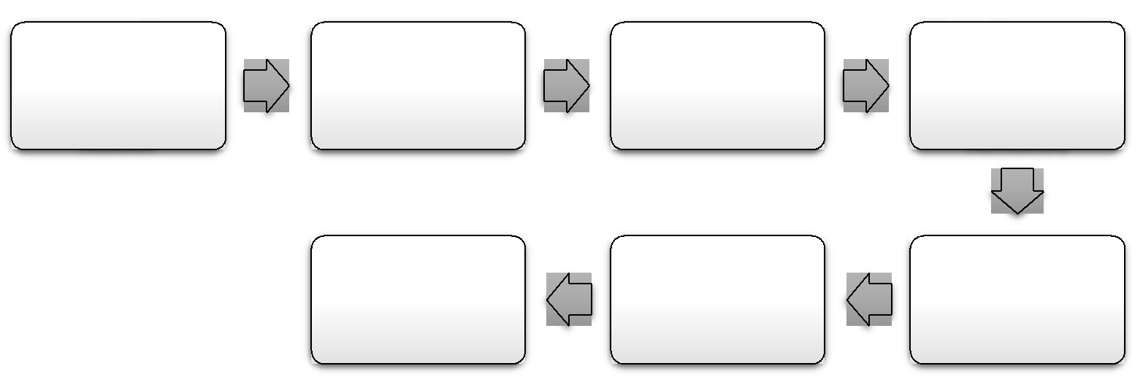  the application | After that | For individual, | the introducer
 | customer needs to | For individual, | the introducer
form in the | customer needs to | introducer is | and the
form in the | fill the specimen | introducer is | and the
Prescribed | fill the specimen | needed | documents
Prescribed | signature card | needed | documents
Manner | signature card |  | submitted

 | After depositing | Inssuance of
Bank account is | the cash, a | deposit slip and
Opened | cheque book is | the deposit must
 | Issued | be made in cash

Step1: Bank offers account introductory form to the customer/applicant
Step 2: Applicant fills up the form and specimen signature card properly
Step 3: Application form then submitted to the bank duly signed by an introducer along with two passport size photos attested from the introducer
Step 4: The authorized officer evaluates the form and verify the introducer as well
Step 5: If no errors are found, the officer will proceed with the account opening procedures
Step 6: The authorized officer will issue a deposit slip where a deposit must be made by the customer

Step 7: Then the officer will issue a cheque book for the customer
Step 8: Bank then preserves the specimen card and finally, the account is opened

DEPOSIT ACCOUNT:Deposit account can be a current account, savings account or other types of bankaccount that permits money to be deposited and withdrawn by the account holder. These transactions are noted on the bank's books and the subsequent balance is recorded as a liability for the bank and represents the amount due by the bank to the customer.
TYPES OF DEPOSIT ACCOUNT: Exim bank provides 76 types of account.They are given below-
- Mudaraba SB A/C General
- MSB A/C –Staff A/C –Staff
- EXIM Student Savings deposit scheme
- MSTD A/C
- MTDR A/C -1/3/6/12/24/36 Months
- Mudaraba Monthly Savings Scheme
- Mudaraba Multi plus Savings scheme
- Mudaraba Education Savings Scheme
- Mudaraba Super Savings Scheme
- Monthly Income Scheme
- Mud Haj Deposit
- Denmohor/Marriage
- Mud Senior Monthly Benefit Scheme-1yr
- Mud Femin Monthly Benefit Scheme -1Yr
- Mud Su-Grehini Benefit Scheme -1yr
- Mud Senior Monthly Savings Scheme –(1-2 yr)
- Mud Femin Monthly Savings Scheme
- Mud Su-Grehini Monthly Scheme
- Mudaraba Millionaire Deposit
- MudarabaKotipoti Scheme
- EXIM ruhama -3YRS double Initial Deposit
- EXIM ZIADAH -5YRS triple
- EXIM KRISHI –(3/12)YRS
- EXIM SHWAPNO (3/12) YRS
- EXIM SHEFA(3-8)YRS

MUDARABA SAVINGS DEPOSIT(MSD):MSD Is mainly 3 types.These Are-
- MSD(Savings)
- AWCD(Al Wadiah Current Deposit)
- Scheme
MONTHLY SCHEME DEPOSIT: In this deposit anyone can deposits during the banking work time,& can withdraw any time.
DEPOSIT: In MSD minimum deposit amount is 600 tk& Maximum as account holder wish.
PROFIT: Yearly Profit is 4%.Profit given once in 6 month.
SERVICE CHARGE: In 6 Months service charge is 115 tk,Highest charge 315 tk.Charges apply once in year.

Al-Wadeeah Current Deposit(AWCD):Following the Principle of IslamiShariah where in the bank is deemed as a keeper and trustee of funds as Al-Amana (on Trust). Deposit that operates by taking permission from depositors would be taken to use their fund according to Shariah Principle and depositors would not receive any profit. As such bank is under obligation to return the entire money on demanding by the customer. The account have no time barred i.e. Account Holder can withdraw money as many numbers of times as he wishes in a working day of bank.
REQUIREMENTS: Requirements are for properietorshipBusiness,Given below:
- Two Passport size photo of Account Holder(Must be attested by introducer)
- One Passport size photo of nominee (Must be attested by Account Holder)
- E-Tin Certificate (if any)
- Photocopy of valid Trade License
- Proprietorship declaration form
- Company Seal
- Photocopy of National ID card (Account Holder)+(Nominee)
- Photocopy of Utility Bill(Electricity/Gas/Telephone)
- Introducer Information &Signature
PARTNERSHIP: Partnership related information needed.These are-
- Partnership Deed+ Partnership Decleration
- Resolution of partners to open the Association letter (A/C) and authorization for its operation duly verified by the Managing Partner

- All the partners should duly sign the Partnership Letter

PRIVATELIMITED COMPANY + PUBLIC LIMITED COMPANY:
Papers needed given below-
For Private Limited Company- Board Regulation + TIN(Tax Identification Number)+Trade License+Memorandum of Articles (Directors list)+Certificate of Incorporation.
For Public Limited Company-Board Regulation + TIN (Tax Identification Number)+Trade License+Memorandum of Articles (Directors list)+Certificate of Incorporation + Certificate of Commencement.
Association/Club/Trust/Society/CharityOrganization/Educational Institution/Masjid/Madrasa Account :
- A certified copy of Bylaws/ Memorandum and Article of Association/ Trust Deed
- A verified copy of Certificate of Registration/Permission from the concern Department(s) of the Government
- List of members of the Governing Body/Executive Committee with their Address and Phone Number
- Resolution of the Board/Executive Committee/ Governing Body for opening the account and authorization for its operation duly certified by the Chairman/Secretary/President
- If it’s registered then the Registration Certificate is compulsory

The Process of Account Closing: The termination of an account may occur-
- If the customer is willing to close his/her account
- If EXIM Bank notices that the account is inactive for an extended period of time
- If EXIM Bank receives an order issued by the court

To close an account, clients will be requested to send an application along with the unused leaves of the cheque books issued to them. On receipt of the application, the following will be done-

- The signature of the account holder will be verified and the number of unused cheque leaves will be noted
- Before the closing of the account, the branch-in-charge will approve the application
- After declaring the liability, if any, and incidental charges to be debited to the account
- The standard cost is about Tk. 300 + 15% VAT. However, the closing charge of an account within three months of introductory is Tk.500 + 15% VAT
- After debiting the incidental charges to the account, the customer will be requested to draw the remaining balance from his/her account
- Then the “Account Closed” stamp will be affixed on the account opening form and specimen signature cards of the customer
- After completing all the requirements, the application will be posted with the account opening form and the specimen signature cards will be kept separately under lock and key
- Finally, the authorized bank officer will destroy the unused cheque leaves of the customer.

PROFIT:
MudarabaSu-Grehini Monthly Savings Scheme-

MudarabaFemina Monthly Savings Scheme:

It is basically a proposed benefit scheme that supports the female employees in making a helpful impact on their family the by providing fund in a family's economic crises. Weightage of MudarabaSu-Grehini Monthly Savings Scheme-

Term | Tk 1,000 | Tk 2,000 | Tk 5,000 | Tk 10,000 |  | Tk 20,000
03 years @7.95% | 40,773 | 81,547 | 2,03,867 | 4,07,734 |  | 8,15,467
05 years @8.05% | 74,066 | 1,48,132 | 3,70,331 | 7,40,662 |  | 14,81,325
08 years @8.20% | 1,35,963 | 2,71,926 | 6,79,814 | 13,59,628 |  | 27,19,257
10 years @8.30% | 1,87,327 | 3,74,653 | 9,36,633 | 1,873,266 |  | 37,46,532
12 years @8.40% | 2,48,946 | 4,97,892 | 1,244,731 | 24,89,462 |  | 49,78,924
 | Table: MudarabaSu-Grehini Monthly Savings Scheme

Term | Tk 1,000 | Tk 2,000 | Tk 5,000 | Tk 10,000 |  | Tk 20,000
03 years @7.95% | 40,773 | 81,547 | 2,03,867 | 4,07,734 |  | 8,15,467
05 years @8.05% | 74,066 | 1,48,132 | 3,70,331 | 7,40,662 |  | 14,81,325
08 years @8.20% | 1,35,963 | 2,71,926 | 6,79,814 | 13,59,628 |  | 27,19,257
10 years @8.30% | 1,87,327 | 3,74,653 | 9,36,633 | 1,873,266 |  | 37,46,532
12 years @8.40% | 2,48,946 | 4,97,892 | 1,244,731 | 24,89,462 |  | 49,78,924
 | Table: MudarabaSu-Grehini Monthly Savings Scheme

Weightage of MudarabaFemina Monthly Savings Scheme-

Term |  | Tk 1,000 | Tk 2,000 | Tk 5,000 | Tk 10,000 |  |  |  |  | Tk 20,000
03 years @7.85% |  | 40,709 | 81,417 | 2,03,543 | 4,07,086 |  |  |  |  | 8,14,171
05 years @7.95% |  | 73,867 | 1,47,735 | 3,69,337 | 7,38,673 |  |  |  |  | 14,77,346
08 years @8.10% |  | 1,35,360 | 2,70,721 | 6,76,801 | 13,53,06 |  |  |  |  | 27,07,206
10 years @8.0% |  | 1,86,266 | 3,72,531 | 9,31,328 | 18,62,656 |  |  |  |  | 37,25,312
12 years @8.3 |  | 2,47,216 | 4,94,432 | 12,36,079 | 24,72,158 |  |  |  |  | 49,44,315
 | Table: MudarabaFemina Monthly Savings Scheme on maturity

Purposes of the Scheme:

- It is a scheduled benefit scheme that inspires the senior citizens of the society towards savings of their unused money in the cost-effective deposit scheme

A scheme that helps the senior citizens for keeping their earned money in valuable account

Local Remittance Section:

Transferring money from one place to another place through an official channel is called remittance. It is risky and troublesome to carry cash all the time. Commercial banks provide remittance facilities to its customers by means of receiving money from one branch of the ustomers. There are three modes of remitting funds they are-

- Payment Order (PO)

- Demand Draft (DD)

- Telegraphic Transfer (TT)
bank and making an easier procedure for payment to another branch within the same country.
Clearing Section:Clearing is a system by which a bank can accumulate funds from one bankto another through clearing house. Clearing house is basically a place where the representatives of various banks receive and deliver cheques with another bank. As per Article 37(2) of Bangladesh Bank Order, banks who are members of the clearing house are Scheduled Banks and it’s a job of the sscheduled banks to accept and clear cheques of different banks. Mainly, Bangladesh Bank executes the Clearing House in Dhaka, Chittagong, Khulna, Rajshahi&Bogra.etc. If there is no branch of Bangladesh Bank then Sonali Bank controls this function.

Types of Clearing:


Inward Clearing

Clearing House
Outward Clearing

Inward Clearing: When the cheque of its client is received for collection from other banks, thefollowing should be checked very cautiously

- The cheque needs to be crossed

- The amount both in words and figure in deposit slip should be the same

- The cheque should not carry a date older than the receiving date for more than six months.

- The collecting bank must enquiry whether the endorsement is done appropriately or not

Outward Clearing: When the branches of a Bank obtain a cheque from its clients drawn on theother banks within the local clearing zone for collection through Clearing House, it is called Outward Clearing. The process of Outward Clearing are as follows-

- The instruments with schedules to the main branch of EXIM Bank Bangladesh Limited after issuing an Inter Branch Debit Advice (IBDA),

- Clearing stamps should be attached to the instruments

- Authorized signature endorses instruments

- The client receives the duty signed instruments and also branch code number affixed on the instruments

Cash Section:Cash department plays an essential role in the banking activities of the financialinstitute. It deals with the major purpose of the commercial bank that it receiving the deposits and paying the cash on demand. Since this sector is directly involved with the customers, the brand value of the bank depends much on it.

. The amount of opening cash balance is then enrolled in the cash register. After concluding the daily cash transactions, the remaining cash is then kept in the vault again which is known as the closing balance. Cash department monitors these things-

- Record daily transactions

- Maintain the cheques

- Provide money to depositors

- Collect money from depositors

- Record monthly closing transactions of the branch

Cheque: Cheque is a necessary document that commands a bank to pay a particular amount ofmoney from a person's account to the person in whose name the cheque has been issued. It is basically a document signed by the account holder directing a specific person to pay a certain amount of money.

Cheque Book Issuing Process:

To open an account in the bank customer is required to sign a Chequecheque book only if the account opening form is filled accurately. After that the banker will enter the name and account number of the customer against a specific cheque book series and will also keep a record on the computer.

EXIM Bank’s SMS Banking Service:EXIM Bank introduced SMS Banking servicesto provide immediate access to customer account information at any time. Any mobile phone user having an account in EXIM Bank Limited can get this service easily. The offers in SMS Banking are-

- Balance Inquiry

- Mini Statement

- Service Help

- Account Information
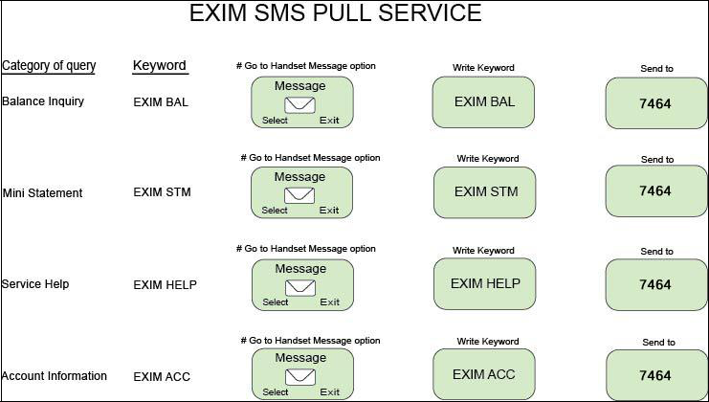

Benefits of SMS Banking:

- Quick and easy control over the status of the bank account

- SMS Banking Service of EXIM Bank is accessible for both corporate and individual customers

- Unlimited messaging service received regardless the number of transactions of the customer.

 |  |  | Banker then
 |  |  | issue the new
 |  | Records the | cheque book if
 |  | new cheque | everything is
 | Banker verifies | book number in | correct in the
 | the slip | the register | form
Requisition slip | (2) | book against | (4)
filled up |  | specific clients
appropriately |  | name
along with the |  | (3)
Account |  | (3)
Number


(1)

Bank Cheques may be Dishonored for Any One of the Following Factors:

- If the amount in figure and word differ from each other

- Cheque out of date or post- dated

- Insufficient deposit

- Payment stopped by the drawer

- Payee's authorization problem

- Crossed cheque needs to be presented through a bank

- Drawer's signature differs or any other valued reasons

The dishonor cheque is then entered in the Return Register by the authorized officer and notified the party about it. To deliver the dishonored cheque party’s signature is required in the return register. After that, the return cheque is sent to the party's mail address with Return Memo. If the cheque is not honored due to the inadequacy of funds then EXIM Bank charges 25Tk as a penalty.

OTHER WORK& ACTIVITIES OF GENERAL BANKING: These are-
- A/C Opening
- A/C Close
- Profit Paid on MTDR
- Remittance
- Money Gram
- Pay order Issue
- Pay Order Collection
- InWard And out ward
- Cheque Clearing
- Cheque Book Issue
- Debit Card Issue
- Fund Transfer
- Data Capture
- Charge Apply On Different Issue
- Give Statement Of A/C
- Give Financial Certificate
- Fund Block
- Cheque Stop on missing Cheque
- All Data collection of all activities at the end of the day
- Information giving
- Help Desk
etc

PHYSICAL EVIDENCE: For doing bank related day to day work bankers uses-PC,Mobile, Telephone,Chair , Table, AC,Printer, etc

Recommendations&Conclusion:

EXIM Bank Limited has been operating its business successfully since 1999. The bank has already established goodwill and good image among its customers by offering tremendous services. Every bank has their own unique strategies and business policies. Some bank desires to grow faster and achieve growth. Then again, some banks want to convey an image of a sound bank. Furthermore, EXIM Bank Limited is quite new in its operations in Bangladesh. Even though the financial analysis of the performance of the bank is very well in the banking industry of Bangladesh and it is expected that it has a prosperous future.

Moreover, EXIM Bank, Mirpur Branch is working well. However, there are some drawbacks in their banking system which can be overcome through the participation of more experts in decision- making process and utilizing the tools to evaluate the satisfaction of the customers. Besides this bank has established goodwill through its innovative products and services all over Bangladesh. Technology development has opened up a new dimension in the improvement of creative products, efficient services and proper customer satisfaction. Every bank should cope with this technological advancement to do better in the future.

The purpose of the internship program is to acquire knowledge from practical experience and to compare this practical knowledge with theoretical knowledge. During the three months of the Sinternship program, it is not possible for a student to go to the depth of each activity of the department because of time constraint. So the objectives of the internship program have not been fulfilled with complete satisfaction. However, the highest effort has been given to attain the objectives of the internship program. I believe that this report may show a guideline to EXIM Bank Limited for its future planning and its effective operation to succeed in its goal in the competitive business environment.

References :

- EXIM Bank Limited (2018). Retrieved from http://www.eximbankbd.com/ [Accessed June 10, 2018]

- EXIM Bank Limited . (2019). Retrieved from

  - https://en.wikipedia.org/wiki/Exim_Bank_(Bangladesh) [Accessed June 25, 2018]

- History of EXIM Bank . (2019). Retrieved from http://www.eximbankbd.com/about/about

Appendix: List of Abbreviation

EXIM | Export Import Bank Limited
A/C | Accounts
DD | Demand Draft
FDR | Fixed Deposit Receipt
PO | Payment Order
TT | Telegraphic Transfer
BC | Bankers’ Cheque
TIN | Tax Identification Number
MSD | Mudaraba Saving Deposit
MSTD | Mudaraba Short Term Deposit
KYC | Know Your Customer
PIN | Personal Identification Number
L/C | Letter of Credit
STD | Short Term Deposit
PL | Personal Loan
GB | General Banking
ATM | Automated Teller Machine
CC | Credit Card
IRC | Import Registration Certificate

