Internship Report
On
Impact of Customer Satisfaction on Business Development: A Case Study of AmarGhor Architectural Design and Real-Estate Ltd.

Internship report
On
Impact of Customer Satisfaction on Business Development:
A Case Study of AmarGhor Architectural Design and Real-Estate Ltd.

SUBMITTED TO

Mr. Muhammad Hasan Al- Mamun
Assistant Professor
School of Business and Economics
United International University

SUBMITTED BY

Tausif Mahmud Mallick
ID Number: 111 191 020
BBA Program
School of Business and Economics


School of Business and Economics
UNITED INTERNATIONAL UNIVERSITY

DATE OF SUBMISSION

29th July, 2025

Letter of Transmittal

To
Mr. Muhammad Hasan Al- Mamun
Assistant Professor
School of Business and Economics
United International University

Subject: Submission of internship report on “Impact of Customer Satisfaction on Business Development: A Case Study of AmarGhor Architectural Design and Real-Estate Ltd.”

Dear sir,

I have effectively compiled my internship report for AmarGhor Ltd., a renowned firm in the property management area. The title of my report is "Impact of Customer Satisfaction on Business Development: A Case Study of AmarGhor Architectural Design and Real-Estate Ltd. “This report helps me to analyze the abilities and practices I have acquired over my three-month internship. Due to my lack of appropriate professional experience, my report may have flaws and require perfection. Although several notions I studied throughout my study for this report may seem redundant today, they become crucial when implemented. I definitely anticipate using the knowledge from this internship program.

During my tenure with AmarGhor Architectural Design and Real-Estate Ltd., I took advantage of the ability to engage with many divisions within their organization. I am grateful for your support and encouragement, which pushed me to work persistently. Regarding the report, I would be delighted to address any questions you may have.

Your obedient student,
Tausif Mahmud Mallick
ID: 111 191 020
School of Business and Economics
United International University
Date of submission: 29th July, 2025
Declaration of Student

I, Tausif Mahmud Mallick, confirm that the internship report titled “Impact of Customer Satisfaction on Business Development: An Observational Study of AmarGhor Architectural Design and Real-Estate Ltd.” is available. This report is unique and has not been archived or published anywhere. This report was prepared as part of my academic program in partial fulfilment of my B.B.A degree.


Signature: ________________________
Tausif Mahmud Mallick
Student ID: 111 191 020
School of Business and Economics
United International University

Acknowledgement

I would like to thank the Almighty Allah and my parents for giving me the fortitude, endurance, and courage necessary to complete the B.B.A degree at United International University.
I greatly appreciate the data that was made available for this report. My internship supervisor, Mr. Muhammad Hasan Al- Mamun, Assistant Professor - School of Business and Economics, United International University, deserves special recognition for his guidance and dedication in assisting me in preparing an internship report.
Afterward, I would like to thank Muhammad Nayeem Ferdous (Chairman), for his assistance. I am overwhelmed by my gratitude for all AmarGhor Architectural Design and Real-Estate Ltd. staffs, they provided a comprehensive explanation of all the information I requested and responded efficiently. I am grateful to the Human Resources Department of AmarGhor Architectural Design and Real-Estate Ltd. for allowing me to intern at the firm. I thank my peers and classmates for their assistance when I could not comprehend a particular theory. We accomplish our duties whilst we collaborate and assist one another.
Finally, I thank the United International University administration for organizing this internship program. It empowers students to convert their theoretical knowledge into sensible enjoyment, preparing them to make a meaningful effect inside the business area.

Executive Summary

The report demonstrates a detailed reflection of the role of customer satisfaction in the corporate growth of AmarGhor Architectural Design and Real-Estate Ltd., one of the most eminent firms in Bangladesh's fast-growing property managing industry. Based on the observations and practical experience in the field, accumulated within the three months of internship program, the paper is aimed at discussing how AmarGhor Architectural Design and Real-Estate Ltd. can be a well-established company in a highly competitive environment of the property business that guarantees an ethical approach to the nature of its transactions, architectural and interior design solutions, and thoroughness in the services it provides to the clients.
During the internship, I got exposed to the different departments, including Property management and appraisal, client relationship management, sustainable design, and the connection between the various departments, making AmarGhor strategically positioned compared to other firms. With the Chairmanship of Muhammad Nayeem Ferdous and his competent staff, the company focuses on openness, a customer-oriented approach to the implementation of the projects, and strict verification of the documents that guarantee safe and comfortable dealings with buyers and investors. The organization’s ethically fair transactions and long-term value creation have gained momentum with Bangladesh's rising market needs for solid and responsible urban living solutions. The paper also delves into how AmarGhor Ltd. has systematically used customer feedback in its services, leading to increased customer satisfaction and consistent business growth. As the average profit amount has grown more than 20 percent in the last few years than the competitors, AmarGhor Ltd. has the same capacity to juggle profitability, ethical conduct and sustainable innovation as some of its key promoters in spreading its influence in the market. Their personalized interior design solutions and bespoke property solutions have it that the company consistently delivers much more than expected, thereby cementing its place among the industry leaders.
Overall, this report shows that customer satisfaction is a sustainable foundation of the business evolution in the real estate market of Bangladesh, as the key to business development is based on ethical conduct and constant improvements. The success story of AmarGhor Architectural Design and Real-Estate Ltd. holds some lessons and teachings for the emerging professionals and organizations willing to make it big in the dynamic world of property management in the context of Bangladesh.
Key Words: Customer Satisfaction, Real-Estate Industry, Interior Design Firms

Table of Tables, Charts and Images

Name | Page number
Figure 01: The website interface of AmarGhor Architectural Design and Real-Estate Ltd. | 10
Figure 02: The Organizational Structure of AmarGhor Architectural Design and Real-Estate Ltd. | 16
Figure 03: SWOT Analysis of AmarGhor Architectural Design and Real-Estate Ltd. | 19

Lists of Abbreviation

UIU | United International University
BBA | Bachelor of Business Administration
VOC | Volatile Organic Compounds
CRM | Customer Relationship Management

Table of Contents

CHAPTER I: INTRODUCTION
1.1 Overview 2
1.2 Justification of the Study 3
1.3 Objectives of the Study 4
1.4 Methodology of the Study 4
1.5 Scope of the Study 5
1.6 Limitations of the Study 6
CHAPTER II: ORGANIZATIONAL BACKGROUND
2.1 Introduction to AmarGhor Architectural Design and Real-Estate Ltd. 8
2.2 Services Provided by AmarGhor Architectural Design and Real-Estate Ltd. 9
2.3 Core Services and Strategic Approaches 11
2.3.1 Service Offerings and Market Differentiation 11
2.3.2 Financial Performance and Competitive Positioning 12
2.3.3 Ethical Practices and Client-Centric Models 12
2.3.4 Strategic Highlights 13
2.3.5 Operational Excellence in Ethical Property Management 14
2.4 Mission, Vision & Values 14
2.5 Corporate Structure 15
2.6 SWOT Analysis 17
CHAPTER III: FINDINGS &ANALYSIS
3.1 Service Portfolio Overview 21
3.2 Core Service Offerings 21
3.2.1 Real Estate Services 21
3.2.2 Architectural Design Services 21
3.2.3 Interior Design Services 22
3.2.4 Custom Furniture Design and Manufacturing 23
3.2.5 Construction and Project Management Services 24
3.3 Service Delivery Model 24
3.3.1 Consultation and Assessment Process 24
3.3.2 Quality Assurance Framework 25
3.3.3 Pricing Structure 25
3.4 Market Positioning and Competitive Advantages 25
3.4.1 Integrated Service Approach 25
3.4.2 Local Market Expertise 25
3.4.3 Technology Integration 25
3.5 Service Impact and Client Outcomes 26
3.5.1 Customer Satisfaction Metrics 26
3.5.2 Value Creation 26
3.5.3 Long-term Client Relationships 26
3.6 Survey of the Study 26
CHAPTER IV: INTERNSHIP EXPERIENCE
4.1 Position, Duties, and Responsibilities 38
4.2 Training 39
4.3 Contribution to Departmental Functions 40
4.4 Evaluation 40
4.5 Skills Applied 40
4.6 New Skills Developed 41
4.7 Application of Academic Knowledge 41
CHAPER V: RECOMMENDATIONS & CONCLUSION
5.1 Recommendations 43
5.2 Conclusion 44
Appendix 46
References 48



CHAPTER I: INTRODUCTION

1.1 Overview

As a significant experiential learning requirement in the Bachelor of Business Administration curriculum, the internship provides students with hands-on experience in various corporate settings, particularly in the real estate business, and helps them prepare for the challenges they may encounter in their future careers. United International University's Bachelor of Business Administration program includes a mandatory three-month internship to expose students to real-world property management functions. I studied property management operations, architectural design, interior design, and customized furniture design while working with a team of devoted specialists at AmarGhor Architectural Design and Real-Estate Ltd.

United International University's BBA program also contains an internship report to assist students in obtaining experience in the actual world of their preferred sector, which is between those lines. Students are given sufficient exposure to various functional activities performed by a property management organization via the internship program. These jobs include property appraisal, client relationship management, and sustainable design operations of the organization. To facilitate students' professional development before joining the workforce, the primary objective of this program is to provide them the opportunity to get experience in real-world property management work. This well-structured procedure relates what has been learned in classrooms to its implementation in a changing real estate industry.
I, Tausif Mahmud Mallick, did my four years of BBA study at United International University, and later, this was my first career opportunity to intern at AmarGhor Architectural Design and Real-Estate Ltd. As a part of my Internship at AmarGhor Architectural Design and Real-Estate Ltd., located at Shantinagar, 26/B, Luxury D Zakia Tower, Dhaka - 1217, I have seen how the complex property management and design operations work in the case of a growing company like AmarGhor Architectural Design and Real-Estate Ltd., which has been making profits of 20 to 25 percent on average compared to their competitors in the market over the last two years1. This Internship Report is a summary of the findings & lessons learned from the work and efforts undertaken during the Internship, which provides a glimpse of the property management practices of AmarGhor Architectural Design and Real-Estate Ltd. and how it operates within the context of the ever-changing real estate industry of Bangladesh under the leadership of Chairman Muhammad Nayeem Ferdous and his team including Co-founders Md Tanvir Islam and Irshan Syed, who are focused on providing ethical property deals and offering real value for money to buyers in Bangladesh and globally.

1.2 Justification of the Study
The internship report has been prepared as a prerequisite for the BBA degree to be awarded under Dr. Md. Shariful Alam, Professor, School of Business and Economics, United International University. It is a three-month-long paid internship for three credit hours.
An internship focuses more on acquiring relevant knowledge of the property management sector and experience in the field before setting off for a professional career. During my undergraduate period, I interned for three months at one of Bangladesh's emerging property management companies named AmarGhor Architectural Design and Real-Estate Ltd., located in Shantinagar, Dhaka. I spent this time interacting with different elements of property management, including architectural design, interior design, and customized furniture design departments. From a business background, my internship mainly focused on property management processes, sustainable design principles, client relationship management, and operational compliance.
The experience offered at AmarGhor Architectural Design and Real-Estate Ltd. has been key to understanding:
- The complex workings of ethical property deals and real estate project valuation
- The property management regulations and compliance in Bangladesh
- Overseeing environmental sustainability integration in design projects
- Exploring innovative property solutions in the real estate environment of Bangladesh
- Challenges faced in property management and client acquisition

The most important lesson I took away from my internship was the practical understanding of property management from a business standpoint, which is an integral part of Bangladesh's quickly expanding economy. My future real estate and property management profession would be based on the profound knowledge I acquired from this job, particularly in moral real estate transactions and creative design solutions.

1.3 Objectives of the Study

Under the Objectives of the study, we want to clarify both the general objective and the specific objectives.
General Objective
This study primarily focuses on property management and real estate services provided by AmarGhor Architectural Design and Real-Estate Ltd. in Bangladesh. It aims to ascertain the significance of ethical property deals in promoting secure real estate transactions and property solutions to increase customer satisfaction and, ultimately, contribute to urban development in Bangladesh.
Specific Objectives
- Analyzing property management methodologies and client acquisition tactics
- Examining verification protocols for property documentation and regulatory adherence
- Evaluating property valuation frameworks and client endorsement criteria
- Analyzing the company's affiliations with property developers for residential and commercial ventures
- Evaluating the impact of digital technology on secure property transactions and marketing
- Understanding the attributes of headquarters in centralized property operations
- Assessing the efficacy of property management and design services
- Assessing the difficulties and possibilities within Bangladesh's real estate sector
- Examining profit margins (15-20 percent relative to rivals) and cost structures in property management operations

1.4 Methodology of the Study
The methodology delineates analyzing, surveying, and evaluating the property management operations at AmarGhor Architectural Design and Real-Estate Ltd. The subsequent resources have been employed to accumulate pertinent statistics and records:
Primary Data
- Direct involvement in property management operations
- Conversations with management and company personnels
- Observation of the real working environment within the property management department
- Processing real estate transactions and verifying documentation
- Engagement with clients in need of property management and design services
- Conducting survey (Questionaries are added on Appendix)
Secondary Data
- The organizational profile and yearly reports of AmarGhor Architectural Design and Real-Estate Ltd.
- The internal corporate files, rules, and procedural manuals
- Real estate market analysis and property management journals
- Relevant course materials from my Bachelor of Business Administration program
Primary and secondary data sources enable this assessment of AmarGhor Architectural Design and Real-Estate Ltd.'s complete property management operations. The report investigates theoretical models used in real estate combined with the company's practical business strategies, especially regarding its property transaction ethics and pricing strategies aimed at delivering maximum value to customers.

1.5 Scope of the Study
This report investigates the operations and innovative property management structures of AmarGhor Architectural Design and Real-Estate Ltd., with particular attention to its headquarters in Dhaka. The analysis provides an exhaustive review of the company's real estate management solutions, which include architectural solutions, interior solutions, and custom furniture design.
Through my internship, I learned how the Property Management Department operates, along with essential project management skills combined with client relations and design innovations. Through partnership with the Chairman and Co-founders as well as the leadership team, I was able to study various aspects of property management operations using their operational strategies and business insights. The observation includes monitoring how the company plans projects alongside clients and suppliers and its commitment to ethical, sustainable real estate solutions in Bangladesh.
My daily participation at the company developed extensive knowledge about real estate sector practicalities, which I learned through organizational activities. During this rapid business transformation, I studied how theoretical property management principles are implemented in modern industry practice. My experience revealed that AmarGhor Architectural Design and Real-Estate Ltd. established leadership as Bangladesh's top property management company through environmental sustainability and customer satisfaction.

1.6 Limitations of the Study
Despite the wonderful learning experience at AmarGhor Architectural Design and Real-Estate Ltd., I encountered multiple obstacles to deal with during my internship. These included:
- My brief internship prevented me from fully understanding all property management operational details, limiting the depth of my learning.
- The organization applies confidentiality rules that regulate high-value customer trading activities alongside sensitive corporate knowledge.
- Limited participation in decision-making, particularly in strategic planning and significant real estate transactions.
- The security protocols restricted my exposure to advanced property management software and systems.
- My involvement in high-level interactions with customers, contractors, and property owners remained restricted.
- Some workers refused to share precise organizational policies and strategic plans out of concern for protecting confidentiality.
- My ability to witness the whole property management process, from client acquisition to project completion, was limited by the centralized structure of operational operations.
Although these restrictions limited the extent of my hands-on training, they gave me a better understanding of the private and professional aspects of property management at AmarGhor Architectural Design and Real-Estate Ltd.

CHAPTER II: ORGANIZATIONAL BACKGROUND

2.1 Introduction to AmarGhor Architectural Design and Real-Estate Ltd.
AmarGhor Architectural Design and Real-Estate Ltd. is a Dhaka-based property management and real estate services firm formed in December 2021 by Chairman Muhammad Nayeem Ferdous. The firm was formed with a clear objective to conduct ethical property dealings and give actual value for money to customers, seeking to become the most trusted property management broker in Bangladesh. AmarGhor Architectural Design and Real-Estate Ltd. stresses professionalism, integrity, honesty, and justice in all its dealings with suppliers, subcontractors, professional colleagues, and consumers.
The leadership team comprises Co-founder and Chief Operating Officer Md Tanvir Islam, who focuses on revolutionizing the property management sector in Bangladesh, and Co-founder and Chief Operating Officer for the global market Irshan Syed, who is devoted to extending the brand globally. Founding member Efti Karim brings technology, digital marketing, lead generation, customer acquisition, and SEO skills to assist the company's development trajectory. AmarGhor Architectural Design and Real-Estate Ltd. provides various services, including property management, architectural design, interior design, and bespoke furniture design. The firm focuses on environmental sustainability and utility in its projects, ensuring its designs are unique and practical. Their architectural services span elevation, structural layout, landscaping, and exterior design, while their interior design solutions cater to both commercial and residential customers, emphasizing climate-responsive and culturally sensitive designs. Headquartered at 26/B, Luxury D Zakia Tower, Shantinagar, Dhaka-1217, AmarGhor Architectural Design and Real-Estate Ltd. has earned a reputation for offering value-driven, ethical, and creative property solutions. Over the previous two years, the firm has earned an average profit margin of 20 to 25 percent, beating rivals in the market. AmarGhor Architectural Design and Real-Estate Ltd. also mixes current technology with traditional craftsmanship, creating unique and luxury furniture constructed from wood, stainless steel, and other materials according to customer requirements. Their patented property management software enables flawless legal compliance, value optimization, and geographical functionality, covering customers' different demands throughout Dhaka's vital areas, such as Gulshan, Banani, Dhanmondi, and Uttara.
In summary, AmarGhor Architectural Design and Real-Estate Ltd. stands out in Bangladesh's real estate sector by combining ethical business practices, comprehensive service offerings, and a commitment to sustainability and client satisfaction. It is a trusted partner for property buyers and investors in Dhaka and beyond.

2.2 Services Provided by AmarGhor Architectural Design and Real-Estate Ltd.
AmarGhor Architectural Design and Real-Estate Ltd. has created itself as a dependable, innovative power in the Bangladeshi real estate market through its dedication to moral property dealings while delivering authentic, cost-effective solutions to customers. The business was established in December 2021 to provide valuable, sustainable services prioritizing quality that satisfies multiple client needs.

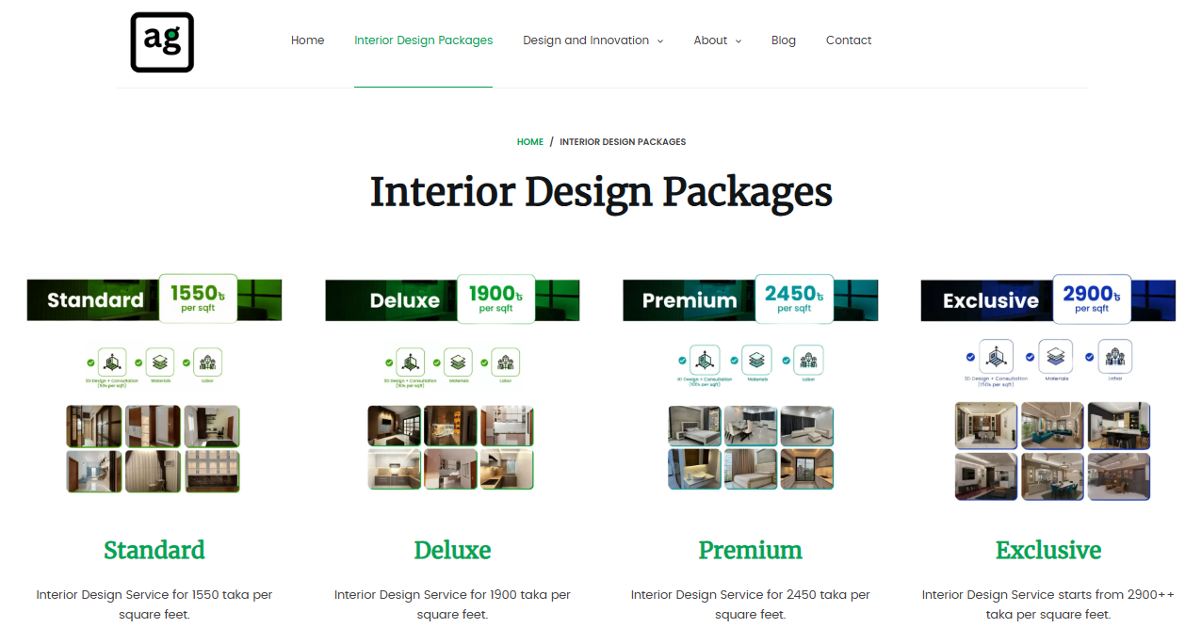
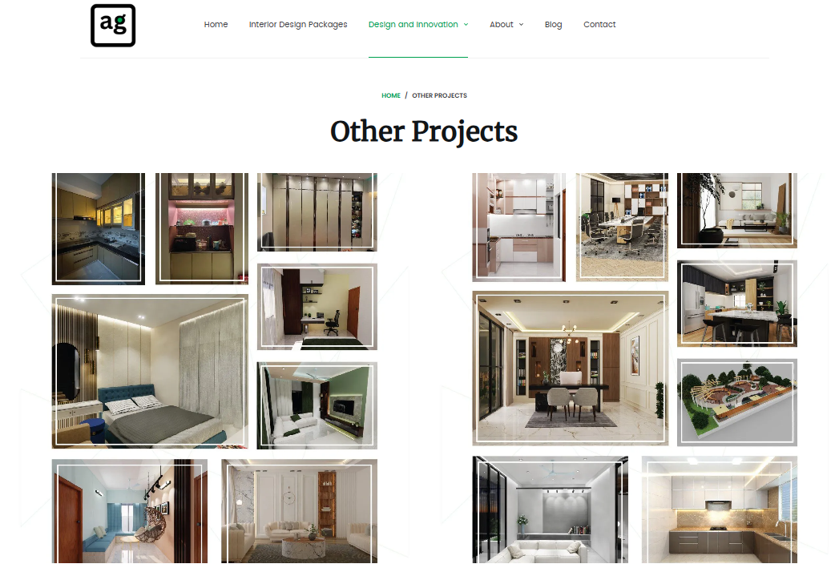
Figure 01: The website interface of AmarGhor Architectural Design and Real-Estate Ltd.
- Property Buy-Sell Assistance: AmarGhor Architectural Design and Real-Estate Ltd. provides property management services that direct customers through buying, selling, and letting properties under trusted supervision. The trained staff members at AmarGhor Architectural Design and Real-Estate Ltd. deliver a seamless journey to clients by addressing their needs and responding to questions while facilitating transparent deals. By putting clients at the center of operations, AmarGhor Architectural Design and Real-Estate Ltd. establishes trustful long-term business associations in an industry famous for its trust issues.
- Architectural Design: The company provides state of the art architectural services, including elevation design, structure design, landscaping, rooftop gardening and exterior design. AmarGhor Architectural Design and Real-Estate Ltd. integrates environmental sustainability and everyday usefulness into every project design because the organization wants the work to be simultaneously beautiful, eco-friendly, and functional.
- Interior Design: AmarGhor Architectural Design and Real-Estate Ltd. offers business and domestic customers unique and functional interior design options. Their designs are individualized to reflect clients’ tastes while improving the usability and beauty of the area. The company’s experts carefully plan every detail to bring clients’ dream spaces to life, combining modern looks with comfort.
- Customized Furniture Design: Besides building and interior design, AmarGhor Architectural Design and Real-Estate Ltd. makes unique, expensive furniture made of wood, Noon wood, and stainless steel. These exclusive designs suit client tastes, adding a unique and lively character to their spaces.

2.3 Core Services and Strategic Approaches

An organization’s value proposition is determined by its core services. The strategic approaches include customized methods and structures to provide and improve the same services and thus achieve flexibility, competitiveness and sustainable growth in a dynamic market.

2.3.1 Service Offerings and Market Differentiation

Core Services
AmarGhor Architectural Design and Real-Estate Ltd.'s primary services are property management, interior design, architectural design, and customized furniture design. Through thorough project audits and legal verification, the property management division prioritizes buyer-seller transparency while facilitating residential and business transactions. Teams of architects and interior designers work closely to create environments that combine practical usefulness with visual appeal, often using modular furniture customized to the customer's needs.
Innovation in Design and Sustainability
One key organizational characteristic of AmarGhor Architectural Design and Real-Estate Ltd. revolves around sustainable materials for environmental preservation. In 2024, interior design work employed recycled wood combined with low-VOC paints to the extent of 70 percent, which followed global green building criteria. The architectural team puts passive cooling practices and solar panel setups in blueprints to help clients decrease their power usage by about 15–20 percent annually. These initiatives fulfill regulatory standards and attract environmentally focused customers who represent the expanding base of Dhaka's urban real estate buyers.

2.3.2 Financial Performance and Competitive Positioning

Profitability Drivers
AmarGhor Architectural Design and Real-Estate Ltd. maintains a steady 15–20 percent profit margin because the company has multiple revenue sources that operate efficiently. Most of AmarGhor Architectural Design and Real-Estate Ltd. 's income derives from property management commissions, which make up 70 percent, followed by 20 percent from property management (Buy and Sell) and 10 percent from customized furniture sales. Registration under one entity of design operations and furniture manufacturing helps the organization bypass third-party costs, thus maintaining price competitiveness. The digital strategies designed by Efti Karim have reduced customer acquisition expenses through lead generation, making them 35 percent lower than standard marketing approaches.
Market Challenges and Adaptations
The successful company AmarGhor Architectural Design and Real-Estate Ltd. has to overcome two main obstacles: market demand instability for luxury real estate and new land documentation system regulations. AmarGhor Architectural Design and Real-Estate Ltd. adjusted its business strategy by entering the mid-range housing market, resulting in a 45 percent transaction share increase from 25 percent in the previous year. The changing economy has driven the company to transform its strategies quickly to maintain profitability targets.

2.3.3 Ethical Practices and Client-Centric Models

Transparency in Transactions
The company requires complete transparency about property pasts, including ownership conflicts and structural evaluation results, for everyone who wants to buy. Since 2022, the mandatory disclosure policy implemented by the company has decreased legal disputes following property purchases by 60 percent. Under its fixed commission system, AmarGhor Architectural Design and Real-Estate Ltd. reduces property valuations by avoiding percentage-based fees, which improves client budget alignment.
Community Engagement and CSR Initiatives
AmarGhor Architectural Design and Real-Estate Ltd. dedicates 5 percent of its yearly profits to financing community development plans, including public park renovations and low-cost housing workshops. The social initiatives increase brand loyalty so that 80 percent of clients trust the company's future commitments more.

2.3.4 Strategic Highlights

- Ethical and Value-Driven Approach: AmarGhor Architectural Design and Real-Estate Ltd. promotes ethical and value-driven decision-making in property transactions because it wants to repair trust breakdowns that plague the Dhaka real estate market.
- Sustainability Focus: AmarGhor Architectural Design and Real-Estate Ltd. implements sustainability factors during design activities and construction methods to create eco-solutions that deliver advantages to clients and preserve the environment.
- Market Adaptation and Innovation: AmarGhor Architectural Design and Real-Estate Ltd. innovates its services regularly to accommodate changing customer needs, translating into a 20-25 percent profit margin compared to competitors during the last two years.
- Customer Experience: Client input is valuable to the company because it uses it to enhance customer satisfaction through better service improvements. A professional staff at AmarGhor Architectural Design and Real-Estate Ltd. guides clients toward expert recommendations throughout their property transactions.
- Location and Accessibility: Headquartered at 26/B, Luxury D Zakia Tower, Shantinagar, Dhaka, AmarGhor Architectural Design and Real-Estate Ltd. is ideally positioned to serve a broad client base efficiently.
AmarGhor Architectural Design and Real-Estate Ltd. is a full-service real estate provider that caters to the particular needs of the Bangladeshi market, not just a property management firm. AmarGhor Architectural Design and Real-Estate Ltd. is a well-known company that offers quality and value in property management, architectural design, interior decorating, and creating bespoke furniture by fusing moral business methods, creative design solutions, and a strong client focus.
2.3.5 Operational Excellence in Ethical Property Management
AmarGhor Architectural Design and Real-Estate Ltd. is a Dhaka-based property management firm specializing in ethical practices and innovation for its services. The company established its operations in December 2021 while maintaining annual profitability rates of 15–20 percent beyond industry standards because of its diverse service offerings and sustainable business practices. The study evaluates AmarGhor Architectural Design and Real-Estate Ltd.’s business operations by directly observing property administration, client engagement, and program review activities within Bangladesh’s residential market. Market success for the company stems from three primary factors mentioned in the key findings: technological integration, customer-directed design concepts, and strict environmental guidelines.

2.4 Mission, Vision & Values
Any organization is composed of mission, vision, and values. The mission explains what it does best, the vision explains its desired vision, and values set the future course of everyday activities and decision-making, which involves aligning every activity and organizational culture with the long-term objectives.
Mission Statement: The primary mission of AmarGhor Architectural Design and Real-Estate Ltd. centers on discovering property opportunities so clients can create extraordinary life events from regular housing experiences. AmarGhor Architectural Design and Real-Estate Ltd. devotes itself to providing ethical property solutions and high-quality real estate and design services. AmarGhor Architectural Design and Real-Estate Ltd. keeps this promise active to streamline property choices into positive, valuable experiences that satisfy clients instead of creating unnecessary anxiety.
Vision Statement: The vision at AmarGhor Architectural Design and Real-Estate Ltd. defines itself as the most trusted and preferred property management broker in Bangladesh and additional markets beyond its borders. The company achieves its vision by establishing local community bases and strengthening its ethical reputation before expanding operations into additional market territories. AmarGhor Architectural Design and Real-Estate Ltd. works in each area to achieve value delivery and sustain long-term partnerships while maintaining its company promise, which is dedicated to integrity, innovation, and community involvement in real estate work.

Core Values of AmarGhor Architectural Design and Real-Estate Ltd.
- Every organizational decision prioritizes the client because they represent the key focus point of the practice.
- The workplace maintains a supportive environment by respecting each team member as an essential member.
- A continuous recognition system and shared achievements form the foundation of success at the firm.
- The company ensures transparency and integrity for every business transaction with clients and their relationship management.
- The organization develops growth ventures that benefit its clients and workforce members.
- The foundation of team success depends on dedicated work and strong leadership, which aims to achieve common objectives for the organization.
- The company engages with communities for support while positively affecting each neighborhood it serves.
- The company values collaboration with innovation as an integral part of its operations to achieve challenges through extraordinary team outcomes.

2.5 Corporate Structure
Muhammad Nayeem Ferdous, Founder & Chairman: After working in global organizations and businesses, Mr. Ferdous started AmarGhor Architectural Design and Real-Estate Ltd. in December 2021 to introduce ethical 360-degree property solutions to Bangladesh.
Md Tanvir Islam, Co-founder & Chief Operating Officer (Bangladesh): As an operations and marketing expert, Mr. Islam directs the company to challenge the Bangladesh property management market.
Irshan Syed, Co-founder & Chief Operating Officer (Global Market): Asia Pacific serves as Mr. Syed’s operational base, where he works to develop Amar Ghor’s global operations for international customer service.
Efti Karim, Founding Member & Tech Expansion Head: Asia Pacific serves as Mr. Syed’s operational base, where he works to develop Amar Ghor’s global operations for international customer service.
The organizational structure of AmarGhor Architectural Design and Real-Estate Ltd. is as follows:

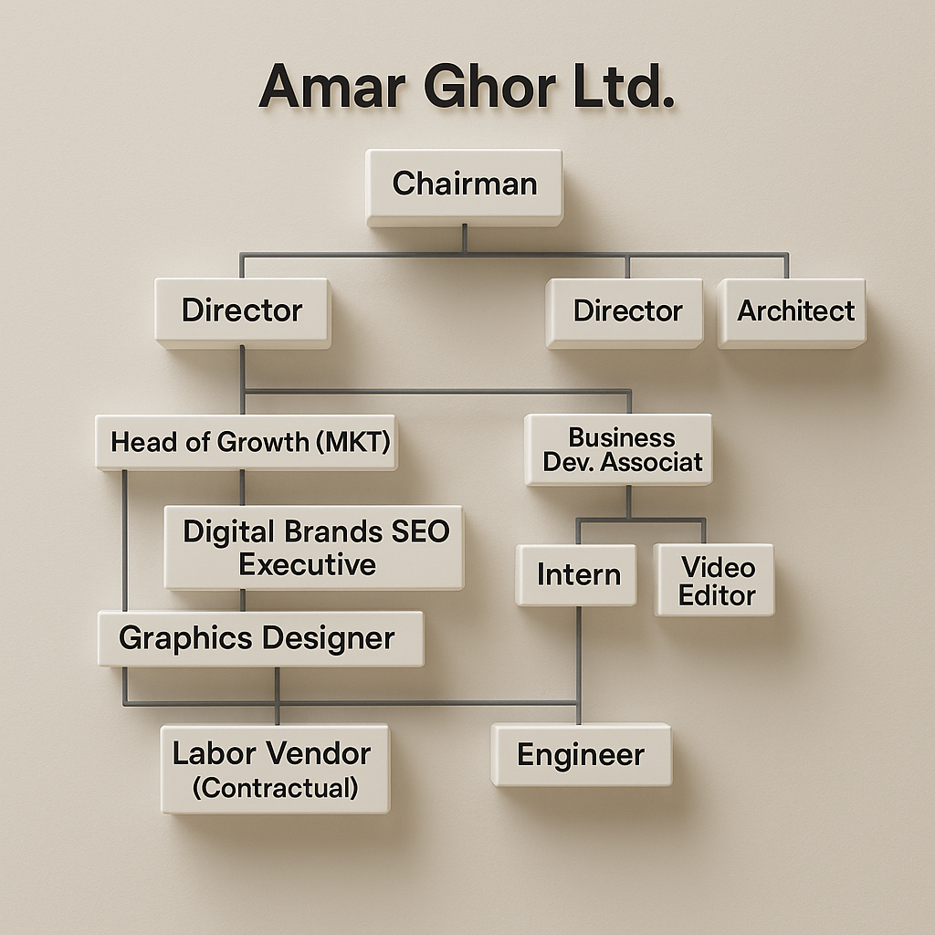

Figure 02: The Organizational Structure of AmarGhor Architectural Design and Real-Estate Ltd.

2.6 SWOT Analysis
SWOT analysis is a tactical approach business firms adopt to analyses Strengths, Weaknesses, Opportunities and Threats. It assists organizations in getting to know more about their possible capabilities and outside challenges to make better decisions, formulate plans, and formulate strategies to grow and improve.
Strengths
- Involves ethical and transparent property management practices, creating trust in a credibility-challenged sector.
- Environmental sustainability, use of eco-friendly materials that usually satisfy environmentally conscious clients
- The design's innovative approach combines modern minimalism's contemporary trends with Bangladeshi cultural motifs to match the urban taste.
- Team of skilled professionals that provide personalized consultation and expert guidance and help clients along their property journey.
- It can help integrate technology and digital marketing, reducing customer acquisition costs and operations.
- Central Dhaka's location makes it accessible to the key real estate markets.
Weaknesses
- Due to high-level recent establishment (since 2021), the exposure and experience to high-value, large-scale real estate transactions is limited.
- It is reasonable to assume that centralized decision-making structures may limit rapid adaptation and innovation at the operational level.
- Staff learning and innovation may be hindered by low levels of confidentiality protocols and also restricted access to advanced property management systems.
- It still has not developed brand recognition and a market share comparable to its long-established competitors.
- High dependence on Dhaka-centric operations; very little physical presence in the rest of the main cities or regions.
Opportunities
- Dhaka is going through rapid urbanization and an increasing housing demand, and it is anticipated that there will be a demand for 100,000+ flats every year.
- It has been expanding into mid-range housing and suburban markets, taking advantage of changing demand from central to peripheral areas.
- It is very popular among urban professionals and families, as well as the popularity of minimalist and sustainable design trends.
- Possibility of scaling up digital property management platforms and introducing online service offerings.
- Opportunity to partner with developers and investors for large-scale residential and commercial projects.
- The awareness gap is vanishing, and Bangladesh has a higher demand for ethical and transparent real estate transactions.
- However, demand for customized and premium furniture solutions is being sought out in the residential and commercial sectors.
Threats
- Luxury real estate markets show unpredictable demand patterns, and the market receives growing competition from both old and new players.
- New official rules about land documents and building standards result in additional project expenses and work challenges.
- Construction and raw material price changes limit the construction company's ability to make profits and adjust prices.
- Economic problems or government actions that change investors' feelings about property investments will impact buying and selling activity.
- The lack of suitable building land in Dhaka increases property companies' competition for the best sites.
- Potential for market saturation in premium design and property management segments.
- New technologies could create problems for the property sector when businesses do not develop digital real estate services fast enough.

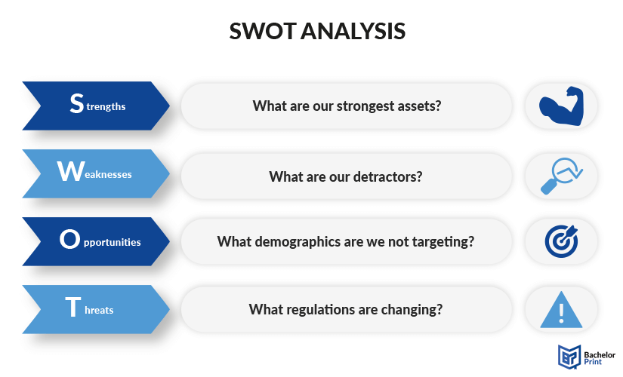
Figure 03: SWOT Analysis of AmarGhor Architectural Design and Real-Estate Ltd.

CHAPTER III: FINDINGS &ANALYSIS

3.1 Service Portfolio Overview
AmarGhor Architectural Design and Real-Estate Ltd. is a complete 360-degree business that runs multidimensional activities within the real-estate property design business based in Dhaka. The organization aspires to solve the trust gap in the local property design and sale market through value-based property transactions, innovative plans and a comprehensive service organization. They aim to provide a safe and sure service provider to their clients regarding real estate activities. The company's services may be divided into four broad divisions, i.e. real estate, architectural designing, interior designing and custom furniture fabrication.

3.2 Core Service Offerings

3.2.1 Real Estate Services
The real estate business of AmarGhor Architectural Design and Real-Estate Ltd. introduces a wide array of facilities in property deals involving apartments in high-end areas of Dhaka. The company has the best experienced agents to ensure their clients have the best experience in buying, selling, or renting properties.
Property Transaction Services:
- Purchasing of property, including analyzing the market and valuation
- Assistance with selling property, marketing, and negotiation
- Management of rental property in the central locations of Dhaka
- Property portfolio development and investment advisory services
The company has specific expertise in high-value spots of Dhaka, such as Gulshan, Banani, Dhanmondi, and Uttara, and they have specific services that fit each district of the high-value areas, in their characteristic and marketplace.

3.2.2 Architectural Design Services
The architectural services department is one of AmarGhor Architectural Design and Real-Estate Ltd.'s main competencies, and it provides state of the art architectural services such as elevation, structural layout, landscaping, exterior design, and construction. The architectural strategy of the company is focused on the perfection.
Design Development Process:
- The first step consists of concept development and site analysis
- Coordination of engineering planning and the requirements of structural layout planning
- Modern architectural principles are used to improve the elevation design
- Environmentally friendly sustainability by incorporating landscaping
- Documentation and permit facilitation of constructions
Sustainability Focus:
AmarGhor Architectural Design and Real-Estate Ltd. is environmentally responsible in that environmental sustainability and functionality are considered when designing projects, hence a win-win situation for the client and the environment. It is based on the current architectural practices for designing buildings, involving sustainable building techniques and low-carbon strategies in building architecture.
Innovation and Precision:
Architectural philosophy of the company is based on innovation, accuracy and sustainability in designing buildings, which last with their modern lines and innovative layouts, producing memorable impressions and improving our daily lives.

3.2.3 Interior Design Services
The interior design department at AmarGhor Architectural Design and Real-Estate Ltd. provides extensive services to residential and business customers by developing a space that is aesthetically and functionally appealing.
Service Methodology:
The interior design procedure is structured with experts who deal with the interior design, making the property assessment, receiving the clients' comments, and considering how to utilize the space as cost-effectively as possible. This approach ensures that the solutions developed for a design are flexible to the needs of the clients and space limitations.
Design Philosophy:
The interior design philosophy of this company is based on a classic style that is detailed to the specifics and functional, making houses look like homes that play out their uniqueness. The focus in this approach involves producing contemporary and classy design solutions unique to the clients' taste, such that each aspect can improve functionality and landscape design.
Service Categories:
- Residential Interior: Whole house renovation services such as living rooms, bedrooms, kitchens and bathrooms
- Commercial Interior Design: Offices, shopping outlets and hotels
- Space Optimization: To have specialist solutions for the narrow living spaces in Dhaka
- Climate-Responsive Design: Interior solutions to the climatic characteristics in the country of Bangladesh
Design Process:
AmarGhor Architectural Design and Real-Estate Ltd. has a strict six-step design study method, which entails consultation, concept, refinement, selection of materials, implementation, and installation. The systematic procedure maintains the quality and satisfaction of clients on all projects.

3.2.4 Custom Furniture Design and Manufacturing
The furniture division is a distinguished value offering the most distinctive and liveliest appearing premium and romantic-looking wooden, non-wooden, and stainless-steel furniture that clients can customize depending on their choice and design.
Manufacturing Capabilities:
- Adaptation of wood to manufacture customized wooden furniture, both traditional and contemporary designs.
- Noon wooden furniture, which has an exceptional finish and treatment
- High-quality stainless steel, modern, and industrial-use furniture
- Custom-made furniture pieces to suit the requirements of the specific clients

Integration Approach:
The services offered in the furniture are designed to provide the most creative and practical functions for commercial and residential customers, where integration into the whole aspect of interior designing is to be attained literally.

3.2.5 Construction and Project Management Services
AmarGhor Architectural Design and Real-Estate Ltd. also offers construction support services, which are in sync with their design services, thus keeping projects through the design to construction phase.
Construction Services:
- Building support for architectural works
- Coordination and Project Management
- Quality control and monitoring of compliance
- Delivery, timeline management, and assurance
Integration Benefits:
AmarGhor Architectural Design and Real-Estate Ltd. focuses on an area of concern usually faced by other architectural companies, wherein the clients' expertise in understanding the output of the measurements and unpredictability of the processes imposed by the environment can cause problems in project management.

3.3 Service Delivery Model

3.3.1 Consultation and Assessment Process
The consultation process used by AmarGhor Architectural Design and Real-Estate Ltd.is systematic, as it starts with an elaborate evaluation of the client. Preparation, on-site evaluation, lifestyle assessment, and design discovery are steps in the first interior design consultation process. This design procedure ensures that every solution is based on a client's needs and operational conditions in the space.

3.3.2 Quality Assurance Framework
The enterprise applies the principles of quality control to every type of service, using the best industry practices in the sphere of architectural design service valuations, based on keeping the balance between the expectations of the clients and professional expectations. This is one of the ways of providing a uniform service and customer satisfaction.

3.3.3 Pricing Structure
AmarGhor Architectural Design and Real-Estate Ltd. has a cost transparency pricing model with several service levels to handle multiple budget variations. Standard packages cost 1,550 taka per square foot to 2,900 plus taka per square foot of exclusive services, making it flexible to satisfy different client needs.

3.4 Market Positioning and Competitive Advantages

3.4.1 Integrated Service Approach
The first and foremost competitive advantage of AmarGhor Architectural Design and Real-Estate Ltd. is its integrated-service business model, which includes services in real estate, architectural design, interior design, furniture manufacturing, and construction support, all under one organizational umbrella. This is because the concept can deal with the discontinuous state of the traditional service delivery in the building and designing business.

3.4.2 Local Market Expertise
It indicates that the company has a profound insight into Dhaka's local urban conditions, offering services modified according to the climate conditions, cultural needs, and regional regulations. This particular local knowledge helps guide the property transactions and design projects at the neighborhood level.

3.4.3 Technology Integration
AmarGhor Architectural Design and Real-Estate Ltd. considers modern project management and design technologies, using a self-developed property management system and digital design tools to increase the efficiency of service delivery.

3.5 Service Impact and Client Outcomes

3.5.1 Customer Satisfaction Metrics
It is critical to the firm that the customer's experience is high, and a review on this aspect reveals that customers enjoy sharing their experiences and are glad that AmarGhor Architectural Design and Real-Estate Ltd. has been able to change their spaces and lives. This orientation with customer satisfaction goes in line with the study's objective, which is to examine the role of customer satisfaction in business development.

3.5.2 Value Creation
The value-creating processes in AmarGhor Architectural Design and Real-Estate Ltd. are centered on the integrated service model that helps it deliver value to the clients in the following ways:
- Made the projects less complex by offering a single point of accountability
- Improved design integrity by using synchronized architectural and interior design services
- Elimination of waste by coordination of procurement and construction management
- Efficiency in time due to the efficient organization of projects

3.5.3 Long-term Client Relationships
The extensive list of services offered by the company helps build long-term relationships with clients, which is confirmed by the after-sales service program, which reflects reliability, concern for client satisfaction and develops a relationship of trust. This presentation of the comprehensive service offering by AmarGhor provides a detailed breakdown of the business model of AmarGhor Architectural Design and Real-Estate Ltd. that covers various dimensions of the property development and design value chain, and as such renders the firm a complete service provider in the competitive environment of property development and design situation of Dhaka city.

3.6 Survey of the Study
A survey refers to a scientific approach of gathering information and views about individuals to draw conclusions about given subjects. Organizations require surveys to learn customer needs, measure satisfaction, make decisions, and point out areas to improve, thus facilitating the advancement of more advantageous strategies.
In here, there are three segments and under every segment there are five questions. The survey is conducted for 30 participants. A detail explanation with graphical views is given below:
Service Quality and Communication
- The agents from Amar Ghor Ltd. provided complete explanations about the legal process of property documentation when customers engaged in transactions.
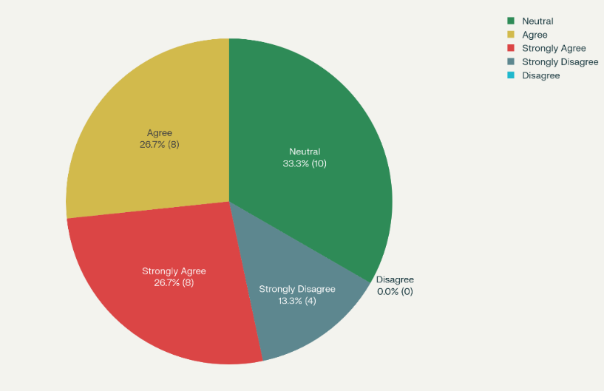
The survey results concerning legal documentation procedures in of AmarGhor Architectural Design and Real-Estate Ltd. demonstrate that the clients support a mix of views. Though 50 percent of the participants were well-informed and had trust in the simplified explanations of the agents, 33.3 percent, on the other hand, were neutral, implying that the communication may be more interesting. An interesting 13.3 percent were strongly underserved, which shows something needs improvement. The firm will better organize a standardization of educational training, graphical illustrations of learning and follow-up activities so that every client gets all the features of an integrated understanding of the legal papers.
- Design team members from the company took my contributions forward as they worked on architectural drawings.
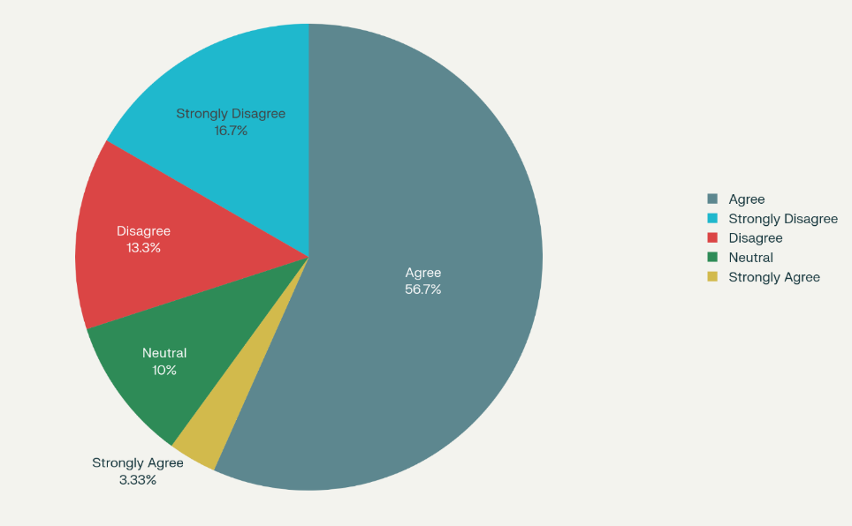
The survey results among of AmarGhor Architectural Design and Real-Estate Ltd.'s clients are inconsistent. Although most of the participants (60 percent) would say that their feedback was considered, which indicates a positive and team-oriented design process, a considerable number of interviewees (30 percent) were unsatisfied. This rate of disagreement is very high and therefore implies that there is not a consistent client experience, and almost one of every three clients may experience a feeling that what they are suggesting is being ignored, thus they may get frustrated. Another 10 percent of the respondents did not commit to being satisfied or dissatisfied; hence, they had a neutral or ordinary experience with some clients.
- During interior design implementations, I received prompt updates regarding all project milestone achievements.
According to the survey, a very high majority of respondents were of a positive mindset towards being updated on time when interior designing a home or building, and 70 percent of the respondents agreed or strongly agreed. Such satisfaction is at a high level, which indicates good communication and openness on the part of the design team. 20 percent of neutral reaction suggests that some were not sure either; perhaps a lack of participation or divergent expectations on communication. The number of those dissatisfied with the project communication of the milestones is minimal (10 percent) and shows that the entire project milestone communication plans are firm among most clients.
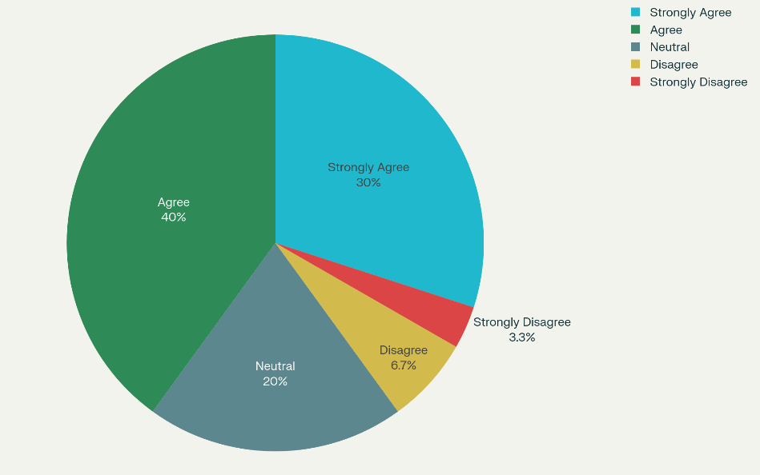
- Amar Ghor Ltd.’s support staff answered all my concerns through phone calls and emails within one day.
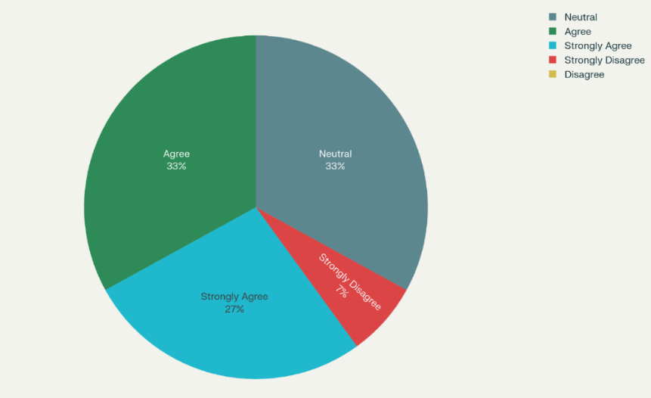
The survey shows that most participants were satisfied with the experience, as 60 percent responded either Agree or Strongly Agree. A third of the respondents were neutral, indicating a bit of indecisiveness or both positive and negative experiences with the responsiveness of the support staff. A few percentages mentioned their dissatisfaction, but none chose the option, Disagree, which does not prevent severe discontent. The findings indicate that Amar Ghor Ltd.'s support level is generally adequate, but continuous vigilance and communication could increase satisfaction.
- The organization maintains three communication methods, including telephone, inbox, and direct conversations, which provide fast and simple services.
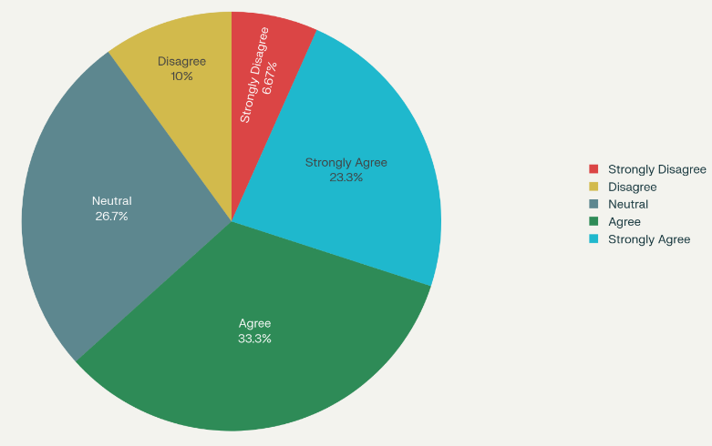
The survey indicates that a significant proportion of respondents hold positive views regarding the efficacy of the communication channels demonstrated in the organization, with more than 50 percent showing their perception by agreeing or strongly agreeing. The graphically predominant green and cyan portions are evidence of positive feedback, which implies that the telephone, inbox, and direct chats will allow immediate and visible service. However, a large neutral section says there is scope to engage more, and those negatively reporting will mean that there are avenues of improvement so that the channels can be all-inclusive and user friendly.
Design and Functional Satisfaction
- The architectural designs optimized every aspect of space arrangement to fit my property’s design.
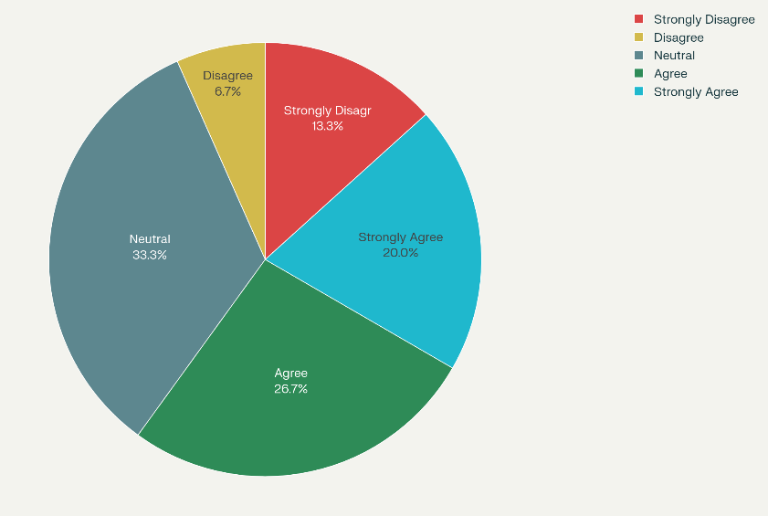
The findings reveal a diverse but overall positive attitude towards optimizing the architectural spaces. A significant part of them, 46.7 percent, were satisfied, whereby 26.7 percent would strongly agree and 20 percent would agree that the designs used space perception well. But still, the highest number of respondents (33.3 percent) did not respond, which may indicate that it was not very well or not at all. The group of dissatisfied people is less noticeable, with 20 percent of the respondents expressing their dissatisfaction (including 6.7 percent who strongly disagreed). That indicates that even though nearly half of the clients were satisfied, many are indifferent or dissatisfied.
- The custom furniture pieces joined the theme of interior design seamlessly.
According to the survey, the perception of the participants who participated in the research (30 participants) is diverse yet positive regarding the seamless integration of custom furniture. The percentage of respondents who agreed (26.7 percent) or strongly agreed (20 percent) to this statement indicates that close to fifty per cent of them believe that the furniture managed to support the design theme. Nonetheless, the single biggest group was those who were neutral (33.3 percent), which, perhaps, is either indifference or inability to judge. Only a small, but significant, 20 percent disagreed, displaying that the integration did not succeed for everybody.
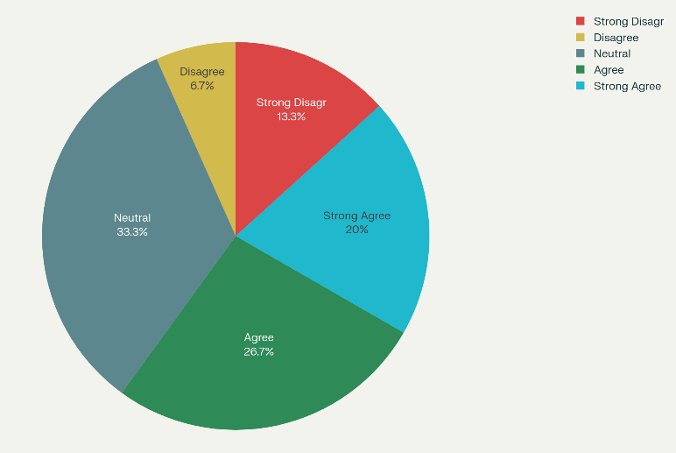
- Using recycled wood and low-VOC paint materials helped me grow more pleased with the finished project.
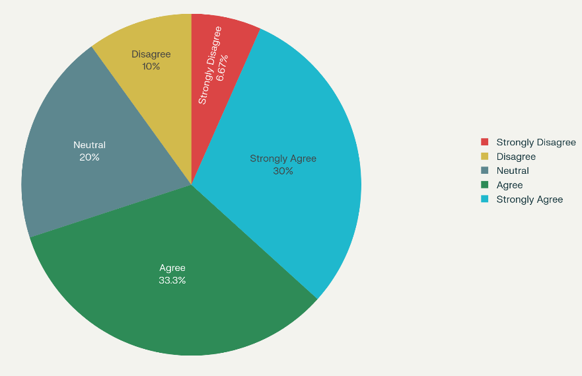
The survey concludes that, according to the survey that was done regarding 30 participants, there is a very high positive inclination towards the use of sustainable materials. Sixty-three point three per cent were satisfactory, 33.3 percent agreed, and 30 percent strongly agreed. This shows they were delighted with their projects since they made environmentally sound decisions. An impressive 20 percent of the respondents were neutral too. The number of dissenting opinions was insignificant: only 10 percent disagreed, 6.67 percent strongly disagreed, which indicates that the problems with these materials were not so extensive, and the experience was mostly positive.
- Minimalist design packages from the company delivered enhanced functionality to my living and working spaces.
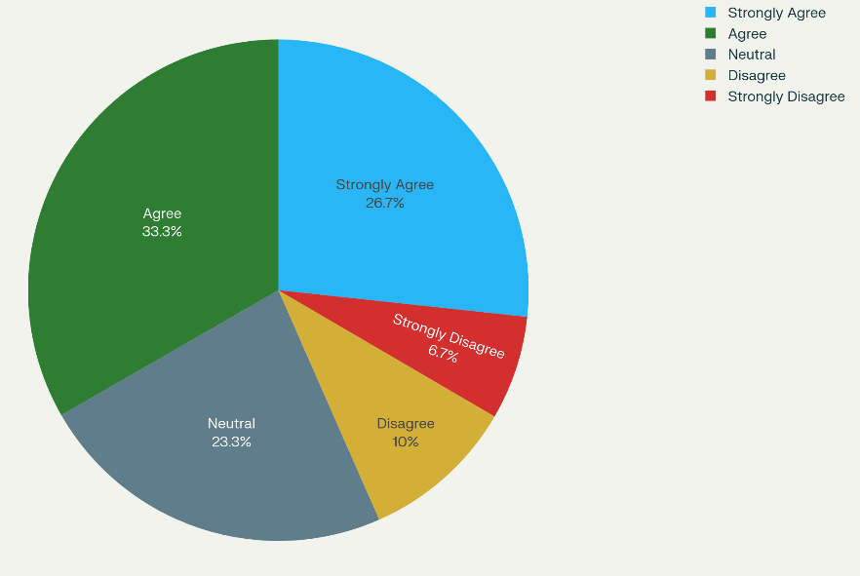
According to the survey results, the functionality of the company's minimalist design packages was well accepted by many people. Respondents in large numbers (60 per cent) either strongly or agreed that the designs had improved their spots. This implies that the company is doing well regarding satisfying the user needs of viable, functional designs. Interestingly, 23.3 percent of the sample also gave a neutral response, which may mean that their expectations were fulfilled, but they were not excessively fulfilled. The painless difference, with only 16.7 percent total, is the supporting factor in the success of the design packages.
- Amar Ghor Ltd.’s designs adjusted their architecture to meet culturally specific demands, such as private spaces for family groups.
The survey outcomes demonstrate an approving attitude towards the attempts of AmarGhor Architectural Design and Real-Estate Ltd. to adapt its architecture to the cultural demands. Regarding the design that would respond to particular needs, such as individual family areas, a combined 56.6 percent of the participants who responded either agree or strongly agree that the designs would respond to such requirements. On the other hand, 16.7 percent were not in agreement. The significant neutral component (26.7 percent) implies that although the respondents are aware of the changes, a considerable percentage cannot have a strong attitude or want to observe a greater cultural merging in the designs.
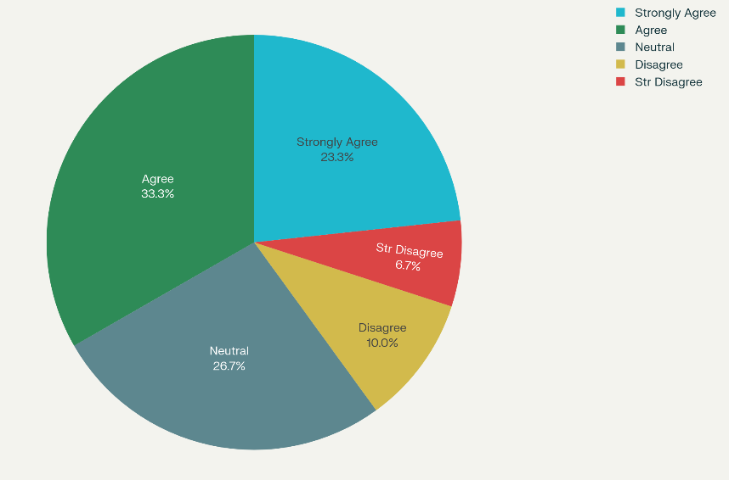
Trust and Ethical Practices
- Amar Ghor Ltd. will inform me about all potential property risks before settling any real estate deals.
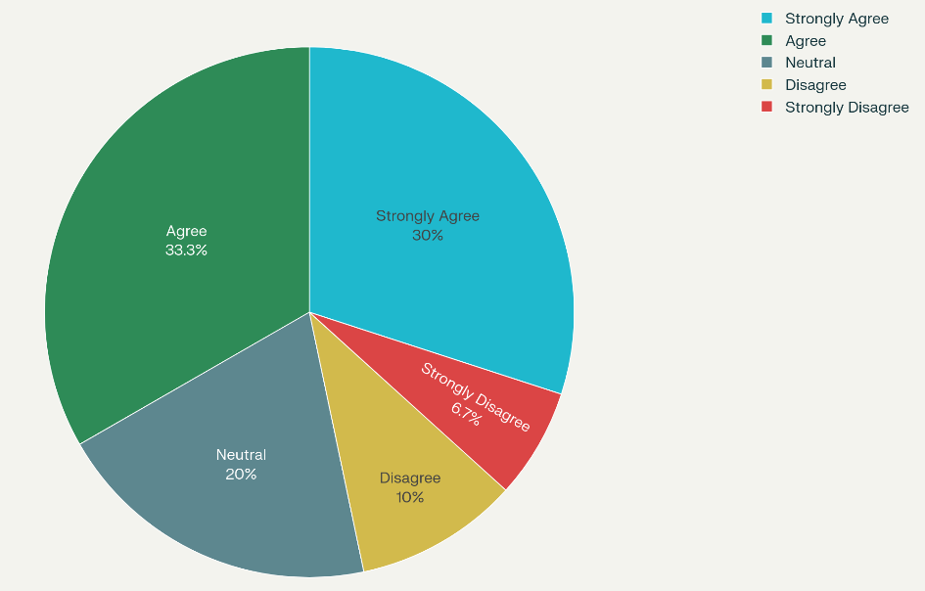
Survey outcome reveals that there is great trust in the transparency of AmarGhor Architectural Design and Real-Estate Ltd. regarding the risk of property. Almost two out of every five respondents (63.3 per cent) either agree or strongly agree that the organization makes full disclosure before completing transactions. This implies that they are very confident in their business practices. On the other hand, the percentage of no respondents is relatively low (16.7 per cent), which may indicate uncommon negative experiences or a generally distrustful attitude. A neutral block (20per cent) symbolizes the group of participants that might not be convinced about their opinion because they lack either information or experience.
- According to the market standards, the company's fixed commission structure appeared fair to me.
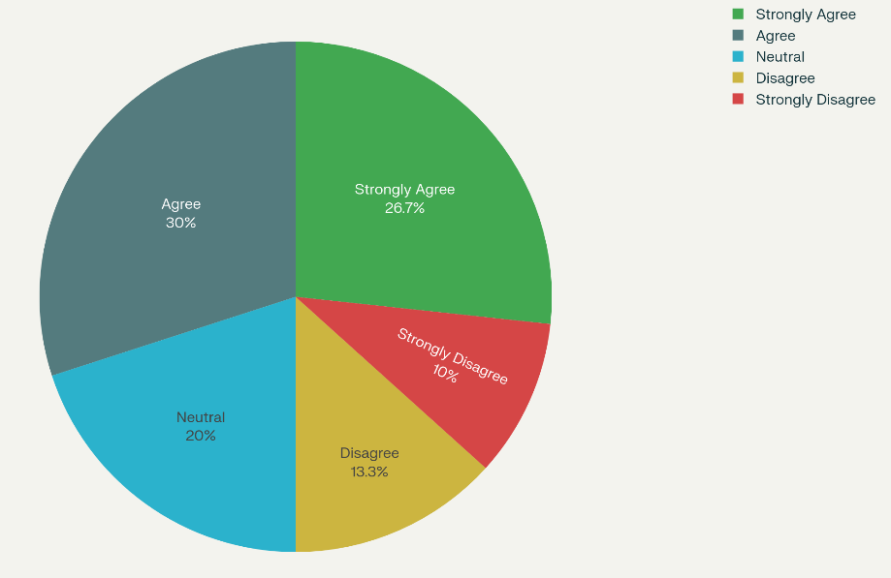
The critical finding is that 56.7 percent of the total respondents either answered agree or strongly agree that the fixed commission system of the company does appear to be fair in the market. This indicates that most believe the policy is convenient regarding industry standards. Approximately one of every five was shown to be uncommitted, which indicates indifference or inadequate knowledge. The overall 23.3 percent of respondents who do not agree or strongly agree pinpoint their points where they could be addressed or where communication could be enhanced, yet the overall favorable attitude is observed, validating the structure being accepted by the participants.
- Amar Ghor Ltd. delivered all their construction projects within the agreed deadlines.
The survey results have shown a certain level of positive view on AmarGhor Architectural Design and Real-Estate Ltd.'s effectiveness in delivering their project on time. A large number, 63.3 percent of all participants, either agree or strongly agree that the company completes its projects on time. On the contrary, the number of respondents who disagreed was 16.7 percent. This large neutral sample, definite to a great measure, of 20 percent, indicates that the situation might have had a neutral experience for some participants or lacked appropriate data to allow them to have a definitive position. In general, the feeling is positive, but the feedback is one of the chances to increase uniformity in the project schedule.
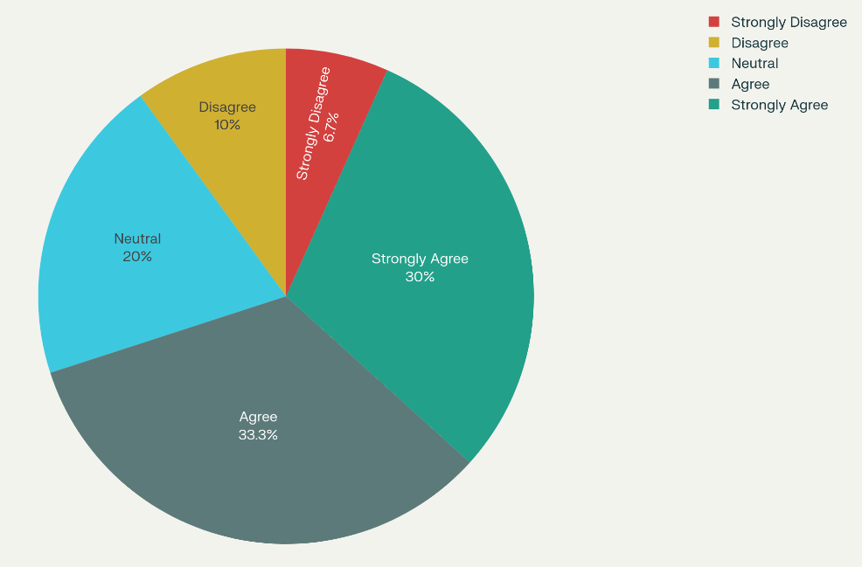
- The firm chooses environmental sustainability above all other operational cost-reduction strategies.
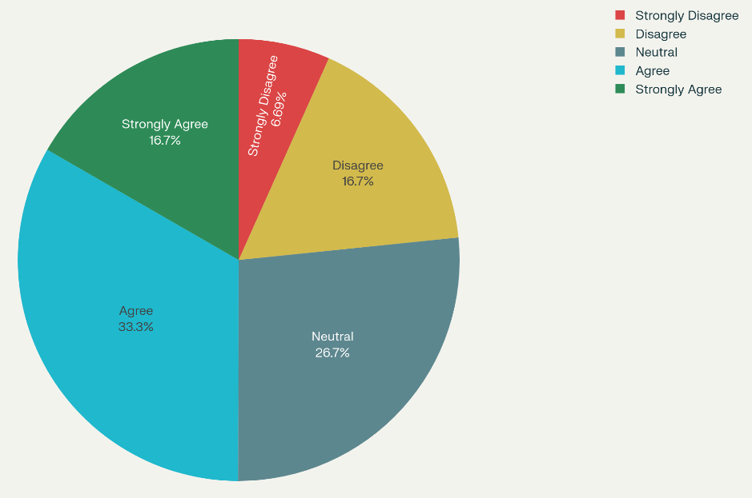
The survey results place the division in agreement regarding the firm conforming to environmental sustainability instead of cost-cutting. Almost half of the respondents (50 percent) agree or strongly agree with the statement, implying that quite a significant part view sustainability as one of the main priorities. Nonetheless, quite a good proportion of the respondents do not take sides (26.7 percent) or disagree (23.4 percent). Such ambivalent designations indicate that this firm's environmental activities are perceived correctly, suggesting that they may not be interpreted to constantly outweigh all other financial calculations in its business operations.
- The pricing transparency of the company helped me feel more comfortable during my business negotiations.
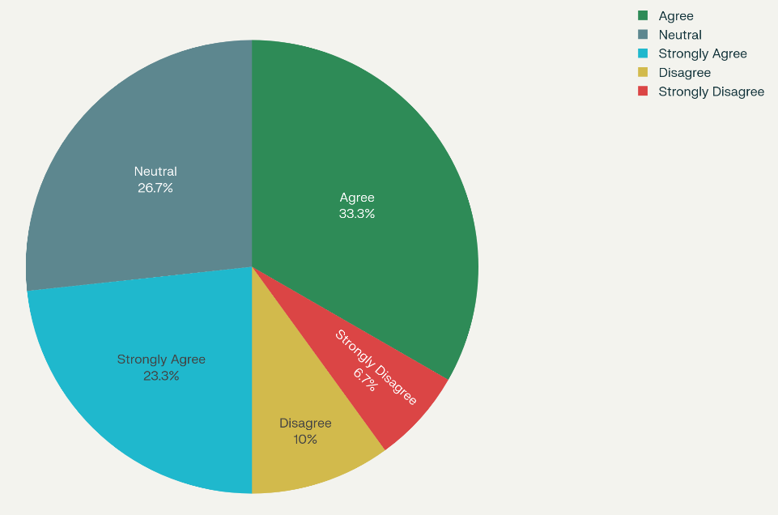
The findings show that the majority of the respondents were favorable regarding price transparency at the company's negotiation table, of which 56.6 percent (Agree and Strongly Agree) reported that they felt more comfortable because of transparency in price. The percentage of resistance was minimal, with only 16.7 percent claiming they were uncomfortable (Disagree and Strongly Disagree). An impressive 26.7 percent take the neutral side, which can be explained by the necessity of a better definition or that transparency became a meeting and not an exceeding goal. In general, the evidence points out that it is essential to have clear prices and that this factor increases the general comfort of the business negotiations for the participants.

CHAPTER IV: INTERNSHIP EXPERIENCE

4.1 Position, Duties, and Responsibilities
Position
Business Development Associate at AmarGhor Architectural Design and Real-Estate Ltd.
Duties
- Business Operations Analysis: Monitored and studied the essential business activities such as property management activities, architectural design activities, and client relationship activities to gain insight into the operation model of the firm.
- Real Estate Transaction Support: Acquired hands-on experience in real estate transactions, i.e., checking the right literature and evaluating this company's involvement with property developers towards different projects.
- Customer Satisfaction Study: Carried out an observational study regarding the influence of customer satisfaction on business advancement, which became the internship's central area of attention and end product.
- Market & Compliance Research: Conducted research about property management rules and those regulations that must be met in the case of the Bangladesh real estate market.
Responsibilities
- Reporting: Prepared detailed internship report of findings and lessons, thus giving an insight into the property management practice and business strategies of the AmarGhor Architectural Design and Real-Estate Ltd.
- Interdepartmental Exposure: Ranking as worked with various segments in the organization, such as the architectural design, interior design and custom furniture to have an overall glimpse of the company's services.
- Data Gathering: Reviewed in-house corporate documents, manuals, and annual reports to retrieve the data used in the observational study of the business development.
- Team Collaboration: Cooperated with a group of committed professionals and monitored their activities to comprehend the practice of the business ideas in a real-life situation.

4.2 Training
During my internship at AmarGhor Architectural Design and Real-Estate Ltd., I received training, which extended my experience and knowledge in the quickly changing environment of property perseverance business.
- Orientation: Provided a formal introduction concerning the different service portfolios of AmarGhor Architectural Design and Real-Estate Ltd. such as property management, architectural and interior designing, and a customized furniture provider.
- Hands-on Experience: I have practical hands-on experience in real-life property management functions within a three-month mandatory internship under the Bachelor of Business Administration (BBA) program.
- Operational Procedures: Gained functional skills on critical operations like property appraisal, customer relations and sustainable design operations.
- Compliance and Regulations: Got first-hand exposure to the property management regulations and compliance standards of the real estate industry governing Bangladesh.

4.3 Contribution to Departmental Functions
- Business Development: Helped the company develop its strategic understanding by carrying out an observational study on how customer satisfaction leads to profitability and the company's success in the market. The analysis also indicated some of the major drivers of profitability, such as technological integration, customer-oriented design ideas, and commitment to the environment's stringent provisions.
- Client Relationship Management: It helped create a sounder understanding of client requirements, as I could observe the front office activities firsthand. Report results have given important information on improving client relationships and offering service.
- Operations Analysis: Presented a precise analysis of the company's operations structure, including the company's services and the market differentiation strategies. This analysis involved the evaluation of the sustainability of the profitability levels of 15-20 percent beyond that of the industry, over the sustainable business practices in the firm and its use of diversified services.

4.4 Evaluation
The internship was accomplished due to a requirement of the BBA degree as a mandatory 3 credit hour internship program requirement of the United International University. The achievement of favorable experiential learning objectives of the program was evidenced through the academic submission of a final detailed report to the university supervisor titled, "Impact of Customer Satisfaction on Business Development: An Observational Study of AmarGhor Architectural Design and Real-Estate Ltd."

4.5 Skills Applied
- Analytical Skills: This replaced analytical skills by carrying out a SWOT analysis of AmarGhor Architectural Design and Real-Estate Ltd. and analyzing the reasons that make it a successful marketing initiative and a profitable business concern.
- Research: Applied research capabilities to collect and analyze information relating to internal company records, procedural manuals and first-hand observation to facilitate the preparation of a comprehensive report.
- Written Communication: Utilized formal written communication skills to design and draft a detailed academic report of an internship, which described significant discoveries and a discussion.
- Collaboration: Cooperated and interacted with a group of skilled specialists, monitoring their activities and working as a team to realize how this sophisticated and versatile company functions.

4.6 New Skills Developed
- Real Estate Industry Knowledge: Acquired workable knowledge in handling the real estate business, such as property appraisal, processing of transactions, and dealing with developers in the particular setting of the Bangladeshi market.
- Business Operations Analysis: Acquired skills in analyzing a company's business model, its services, and the drivers of profits by making direct observations and studying internal corporate documentation.
- Client Management Insight: Gained a thorough knowledge of client relationship management and the importance of customer satisfaction towards business growth, especially in the real estate industry.
- Formal Report Writing: Better competency to generate elaborate business reports that encourage the formulation of theoretical understanding and feasible cooperative models.

4.7 Application of Academic Knowledge
My theoretical knowledge, which was subjected to the BBA courses in marketing, business analytics and operations management, was used in the following way:
- Marketing Management: The applied marketing management concepts to the respective business development regarding customer satisfaction with the business and other service provision, such as interior design.
- Business Analytics: This is done to analyses information regarding profitability (15-20 percent) and market success determinants to make decisions on technological embarking and customer-oriented designs.
- Operations Management: Assisted in removing the snags in the property appraisal, transaction processing and sustainable design functions in the real estate sector in Bangladesh.

CHAPER V: RECOMMENDATIONS & CONCLUSION

5.1 Recommendations
- Increase Customer Feedback Channels by the use of digital channels
AmarGhor Architectural Design and Real-Estate Ltd. ought to design and deploy a complete online feedback platform (through mobile applications or company web portal), to get real-time customer views on services like property management, architectural design and interior design. This will allow more responsive, measurable and varied collection of data and a better response to customer requirements. With the help of digital tools, AmarGhor Architectural Design and Real-Estate Ltd. will also be able to analyze the patterns of feedback, notice the recurring problems, and make specific improvements, thereby gradually moving the customer satisfaction numbers and creating healthier relationships with clients.
- Make every Project Eco-friendly and Sustainable
Since the company has been focusing on environmental sustainability as a distinguishing factor, AmarGhor Architectural Design and Real-Estate Ltd. should institutionalize sustainability guidelines with quantifiable objectives in all its architecture and real estate ventures. This may cover adopting green construction material, maximizing energy-efficient design, and ensuring eco-friendly building techniques. The initiatives will enhance customer satisfaction among environmentally friendly customers and build the image of AmarGhor Architectural Design and Real-Estate Ltd. as a leader and market in ethical and sustainable property management.
- Enhance cross-departmental partnership and a culture of a client-focused nature
AmarGhor Architectural Design and Real-Estate Ltd. should institutionalize frequent interdepartmental coordination workshops with the architectural, design, sales, and client service departments. The importance of making knowledge sharing and collaborative decision-making a habit guarantees a smooth flow of customer knowledge and market trends in various units. This combination of tasks will help this company generate a more personal and unified customer experience by focusing on client needs and boosting customer retention in the long term.
- Train employees continuously with a focus on customer relationship management (CRM)
AmarGhor Architectural Design and Real-Estate Ltd. needs to develop continuous training surrounded by the CRM best practices, communication training, and service quality training to ensure customer satisfaction is retained or improved. Properly trained employees are better positioned to make forecasts regarding clients' needs, embrace handling of complaints and consistently add value. The adoption of such programs and the evaluation of progress regularly will boost the level of customer interactions and positively affect the company's business promotion and reputation in the competitive real estate market.

5.2 Conclusion
Customer satisfaction is central to sustainable business development, which has been ascertained in the observational study of AmarGhor Architectural Design and Real-Estate Ltd. within Bangladesh's competitive real estate business environment. The steady rate of profitability of AmarGhor Architectural Design and Real-Estate Ltd., beating the industry leaders, can be attributed to its ethical work practices, innovation, and sensitivity towards its clients. Through the intelligent combination of technology solutions, the high-quality environmental standards, and the systematic incorporation of the values of focusing on the customer throughout various departments, AmarGhor Architectural Design and Real-Estate Ltd. has managed to create a competitive brand that speaks to the hearts of contemporary customers. The firm also focuses on constant betterment, leadership vision, and cross-functional teamwork as factors that promote its success in the market. Nevertheless, there is still a chance to deepen the aspects of digital feedback, increase sustainability, clarify internal collaboration, and improve employee training, all aimed at customer experience. Successfully implementing these advancements will directly lead to higher customer satisfaction. In turn, this will make AmarGhor Architectural Design and Real-Estate Ltd. more resilient, securing its long-term growth and status as a real estate market leader. The research shows that an active and client-oriented strategy and an ethical and sustainable business approach are the key to profitable and sustainable business development.

Appendix
Service Quality and Communication
- The agents from Amar Ghor Ltd. provided complete explanations about the legal process of property documentation when customers engaged in transactions.
- Design team members from the company took my contributions forward as they worked on architectural drawings.
- During interior design implementations, I received prompt updates regarding all project milestone achievements.
- Amar Ghor Ltd.’s support staff answered all my concerns through phone calls and emails within one day.
- The organization maintains three communication methods, including telephone, inbox, and direct conversations, which provide fast and simple services.
Design and Functional Satisfaction
- The architectural designs optimized every aspect of space arrangement to fit my property’s design.
- The custom furniture pieces joined the theme of interior design seamlessly.
- Using recycled wood and low-VOC paint materials helped me grow more pleased with the finished project.
- Minimalist design packages from the company delivered enhanced functionality to my living and working spaces.
- Amar Ghor Ltd.’s designs adjusted their architecture to meet culturally specific demands, such as private spaces for family groups.
Trust and Ethical Practices
- Amar Ghor Ltd. will inform me about all potential property risks before settling any real estate deals.
- According to the market standards, the company's fixed commission structure appeared fair to me.
- Amar Ghor Ltd. delivered all their construction projects within the agreed deadlines.
- The firm chooses environmental sustainability above all other operational cost-reduction strategies.
- The pricing transparency of the company helped me feel more comfortable during my business negotiations.

References
- Marzouk, M., & Hamdala, D. (2025). Phasing real estate projects considering profitability and customer satisfaction. Engineering, Construction and Architectural Management, 32(5), 2942-2970.
- Altuwaim, A., AlTasan, A., & Almohsen, A. (2025). Customer satisfaction with advanced construction technologies in residential buildings. Journal of Asian Architecture and Building Engineering, 24(1), 317-331.
- Kalliomäki, P. (2025). Utilizing PropTech to Enhance Operational Efficiency and Customer Experience in Real Estate.
- Al-haimi, B., Khalid, H., Zakaria, N. H., & Jasimin, T. H. (2025). Digital transformation in the real estate industry: A systematic literature review of current technologies, benefits, and challenges. International Journal of Information Management Data Insights, 5(1), 100340.
- Ingaldi, M., & Škůrková, K. L. Key elements of real estate agency websites–analysis of the customer preferences with use of the Kano method.
- Oshokoya, D. S., Itepu, J., & Akintolu, M. (2025). Enhancing Customer Acquisition and Retention through an Improved Digital Marketing Strategy in a Real Estate Organisation. Construction Entrepreneurship and Real Property, 2(1), 93-106.
- Ali, W., Samarasinghe, D. A. S., Feng, Z., Wilkinson, S., & Rotimi, J. O. B. (2025). A systematic literature review on digital transformation in real estate: challenges and opportunities. Smart and Sustainable Built Environment.
- Mäkelä, J. (2025). Business Model for a Digital Real Estate Management Service.
- Amos, D., & Boakye-Agyeman, N. A. (2023). Content validation of value-adding indicators for corporate real estate management: insights from a developing country. Journal of Corporate Real Estate, 25(1), 77-97.
- Leelanapasak, W., & Lekcharoen, S. The Development Of Components And Indicators For Real Estate Sustainability On Social Media Platforms Using The Rough Set E-Delphi Technique.
- Rabby, F. (2022). The impact of digital marketing on consumer buying behaviour in the residential real estate industry: A case study of Sydney (Doctoral dissertation, University of Southern Queensland).
- Yahiaoui, D. E., Belghazli, N. E., Benhidjeb, A. T., Belaidi, A., & Belghazli, Z. D. (2025). Determining the Key Factors Influencing the Real Estate Industry. FAIMA Business & Management Journal, 13(2).

