COMPARISON IN THE SCREENING PROCESS AND TRAINING PROGRAM IN ASSEMBLE LINING,
“FAIR ELECTRONICS LIMITED”
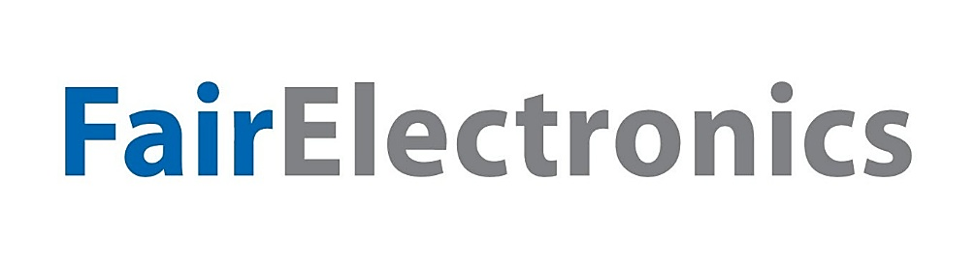

Asma Binte Islam

This report is submitted to the school of Business and Economics, United International University as a partial requirement for the degree fulfillment of Bachelor of Business Administration

DIFFERENCE IN SCREENING AND TRAINING IN ASSEMBLE LINING, “FAIR ELECTRONICS LIMITED”

Submitted to:
Name: Ms. Nasrin Akter
Designation: Assistant Professor
Major: Human Resource Management

Submitted by:
Name: Asma Binte Islam
Id: 111 201 211
Major: Human Resource Management
Registration Trimester: Fall 25


School of Business and Economics
United International University
Date of submission: June 30, 2026

LETTER OF TRANSMITTAL

Date: 22 / 07 / 2026
To
Ms. Nasrin Akter
Assistant Professor
School of Business and Economics
United International University
Subject: Submission of Internship Report
Dear Madam,
With due respect, I am submitting my internship report titled “Difference in Screening and Training Process in Assembly Line at Fair Electronics Limited” as a partial fulfillment of the requirements for completing the Bachelor of Business Administration (BBA) program under the School of Business and Economics, United International University.
The report has been prepared based on my internship experience and practical observations at Fair Electronics Limited. It reflects the screening and training practices followed in assembly line operations and highlights their differences from conventional corporate HR processes. This experience helped me connect academic knowledge with practical Human Resource Management practices.
I sincerely thank you for your guidance and support throughout the preparation of this report. I hope you will kindly accept my report and consider my work. I would be happy to provide any further information if required.
Sincerely,
Asma Binte Islam
Internship Student
Bachelor of Business Administration (BBA)
School of Business and Economics
United International University

Certification of Similarity Index

Declaration of the Student

This is to certify that the internship report titled " Difference in Screening and Training process in Assemble Lining, ‘Fair Electronics Limited’ " submitted by Asma Binte Islam, Student ID: 111 201 211, has been processed through the university’s authorized plagiarism detection engine. The resulting similarity index falls completely within the acceptable tolerance levels set by the School of Business and Economics, United International University. All external theories, data points, and frameworks have been meticulously attributed and referenced.

Corporate Evidence

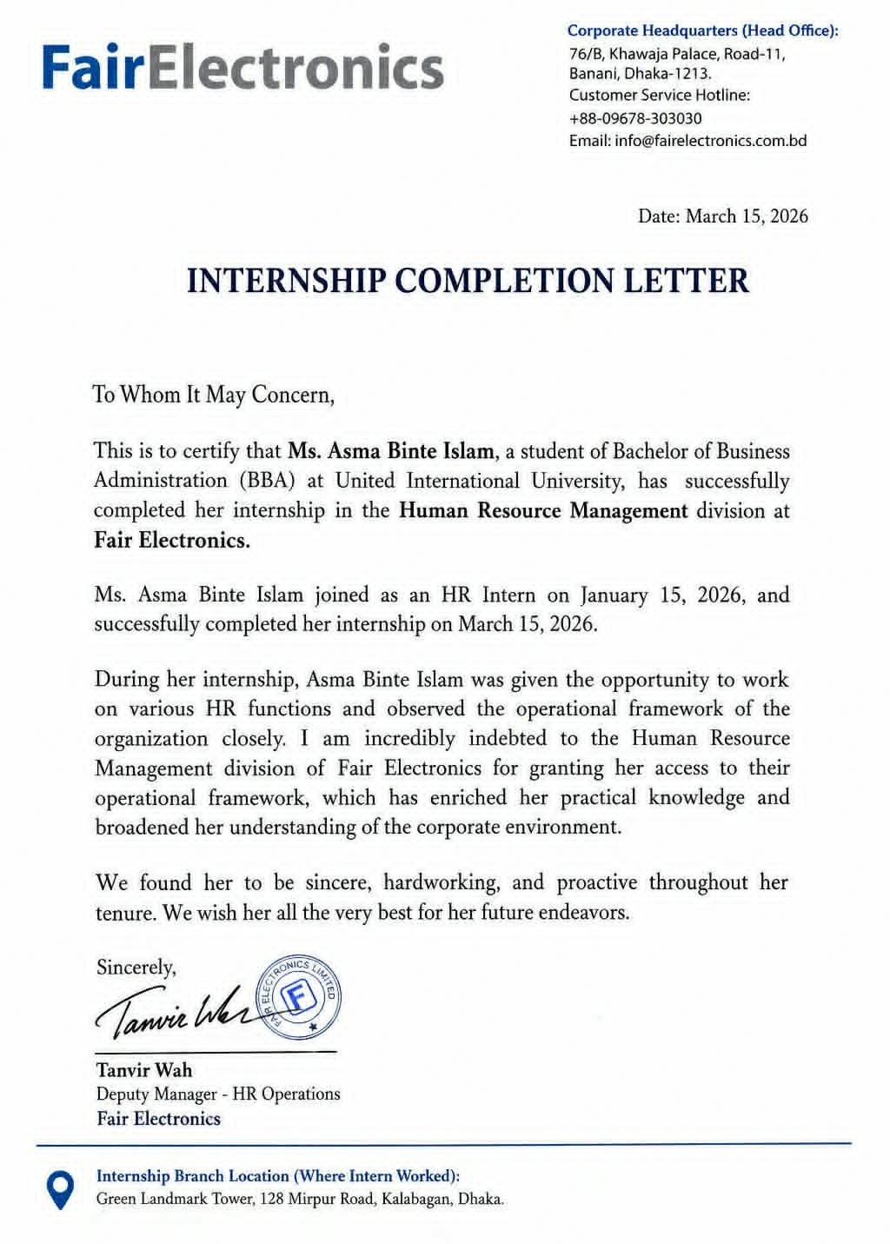

Acknowledgement

In the first place, I would like to thank the Almighty for having provided me with the cognitive endurance, good health, and focus needed for this tough internship project.
Secondly, I would like to express my deep appreciation to my academic guide [Name of Guide], whose high academic standards, structural critique, and constant motivation helped to make this report more meaningful.
I have been immensely benefited from the Human Resource Management Department of Fair Electronics as it provided me an opportunity to understand their operations. In particular, I am immensely thankful to my corporate guide and the talent acquisition team for providing me the dual experience of both the corporate office culture as well as the fast-paced high-tech culture of the factory floor. The patience of these people in explaining the technicalities of assembly line engineering and the metrics of machines and safety dynamics was very instrumental in this regard.
Lastly, I would like to thank my peers and family for supporting and motivating me during this tough task.

Executive Summary

This internship report investigates the structural variations, operational frameworks, and strategic differences between traditional corporate Human Resource Management and specialized manufacturing floor HR operations at Fair Electronics. They are the premier manufacturing and assembly partner of Samsung in Bangladesh. Grounded in my direct observations as an HR Intern, the central focus of this research details the "Difference in Screening and training process in Assemble Lining". It breaks down how talent acquisition protocols change when transitioning from corporate executive offices to high-precision manufacturing assembly floors.Traditional, or "Normal," HR operations focus heavily on a candidate's holistic profiles, cognitive abilities, communication skills, long-term leadership potential, and cultural fit within an office space. In stark contrast, assembly line screening at Fair Electronics operates as an exact operational science where candidates are filtered based on specialized technical certifications, spatial awareness, physical precision, and strict adherence to strict manufacturing guidelines. The talent sourcing approach of Fair Electronics is characterized by a dual multichannel strategy. Whereas traditional roles such as those in the corporate office will be sourced using platforms such as LinkedIn and headhunting agencies, the sourcing of assembly line technical jobs will be achieved through focused sourcing channels such as technical website sources.Additionally, this report illustrates how the concept of Training and Development affects Organizational Effectiveness in practical ways. Whereas the office staff receive occasional soft skills training, assembly line workers receive constant and frequent simulation training to ensure low levels of defects and to avoid stopping assembly line production. This way, through systematic matching of each candidate's mechanical skills to the particular tasks on the assembly line, the Human Resource department ensures that there are no downtime losses, that the sophisticated machinery used is protected from damage, and that production remains maximized.
Key Words: Comparison, Screening process, Training process, Assemble lining, Fair Electronics Limited

Table of Contents
Letter of Transmittal…………………………………………………………………………………………………………………… III
Certification of Similarity Index…………………………………………………………………………………………………… IV
Declaration of the Student………………………………………………………………………………………………………….. V
Corporate Evidence…………………………………………………………………………………………………………………….. VI
Acknowledgement……………………………………………………………………………………………………………………… VII
Executive Summary……………………………………………………………………………………………………………………. VIII
List of Figures……………………………………………………………………………………………………………………………… XI
List of Tables………………………………………………………………………………………………………………………………. XII
List of Equations…………………………………………………………………………………………………………………………. XIII
List of Acronyms & Abbreviations……………………………………………………………………………………………….. XIV
CHAPTER 1: INTRODUCTION………………………………………………………………………..1
I.1 Background of the Report ……………………………………………………………………….……………………..1
I.2 Objectives of the Repor.…………………………………………………………………….……………….…………..2
I.3 Rationale of the Report …………………………………………………………..…………………………………......3
I.4 Scope and Limitations of the Report…………………………………….………..……………………..…………3
I.5 Definition of Key Terms ………………………………………………………………………………………..………….4
CHAPTER 2: COMPANY AND INDUSTRY PROFILE………………………………………….6
2.1 Company Analysis……………………………………………………………………………………………………..…….6
2.1.1 Overview and History…………………………………………………………………………………………………6
2.1.2 Trend and Growth……………………………………………………………………………………………………..6
2.1.3 Product / Service / Customer mix………………………………………………………………………………7
2.1.4 Company Operations……………..………………………………………………………………………………….8
2.1.5 SWOT Analysis…………………………………………………………………………………………………………..9
2.2 Industry Analysis ………………………………………………………………………………………….……………….10
2.2.1 Specification of the Industry…………………………………………………………………………………….10
2.2.2 Size, Trend, and Maturity of the Industry…………………………………………………………………10
2.2.3 Industry SWOT Analysis……………………………………………………………………………………………11
CHAPTER 3: INTERNSHIP EXPERIENCE…………………………………………………………12
3.1 Position, Duties, and Responsibilities…………………………………………………………………………..…12
3.2 Recruitment and Selection Process of Fair Electronics………………………………………………….…13
3.2.1 Sourcing, Recruitment, and Screening Matrix at Fair Electronics……………………………..14
3.2.2 Recruitment and Selection Based on Roles………………………………………………………………17
2.2.3 Selection Process……………………………………………………………………………………………………..18
2.2.4 Skills Applied and Evaluation……………………………………………………………………………………18
3.3 Training & Development Practices………………………………………………………………….….…………19
3.4 HR Functions and Organizational Effectiveness……………………………………………………………..24
3.4.1 The Core Analysis: THE DIFFERENTIATION IN HR PARADIGMS………………………………….25
3.4.2 Organizational Effectiveness…………………………………………………………………………………….26
3.5 Contribution to the Organization……………………………………………………………………………………28
3.6 Evaluation…………………………………………………………………………………………..………………………….28
3.7 Skills Applied………………………………………………………………………………………………………………….28
CHAPTER 4: CONCLUSIONS AND KEY FACTS…………………………………………………………………………………29
4.1 Recommendations……………………………………………………………………….…………………………………29
4.2 Key understanding………………………………………………………………….………………………………………30
4.3 Conclusion………………………………………………………………………………………….…………………………..31
Reference……………………………………………………………………………………………………………………………………32
Appendix-A:………………………………………………………………………………………………………………………………..33

List of Figures

Figure No. | Title | Page No.
Figure 2.1 | Product Lines and Customer Markets | 7
Figure 2.2 | Operational Structure & Core Divisions of Fair Electronics | 8
Figure 2.3 | SWOT Analysis of Fair Electronics | 9
Figure 3.1 | Selection Process of Fair Electronics | 18
Figure 3.2 | Deployment of Training Process for Assembly Line | 22

List of Tables

Table No. | Title | Page No.
Table 3.2.1 | Specialized Sourcing, Recruitment, and Screening Matrix at Fair Electronics | 14
Table 3.3.1 | Comparison Between Assembly Line and Regular Line | 23
Table 3.4.1 | The Core Analysis: THE DIFFERENTIATION IN HR PARADIGMS | 25

List of Acronyms & Abbreviations

Acronym | Full Form
HR | Human Resource
HRM | Human Resource Management
CSE | Computer Science and Engineering
ESD | Electrostatic Discharge
CKD | Completely Knocked Down
SKD | Semi Knocked Down
SMT | Surface Mount Technology
LMS | Learning Management System
ERP | Enterprise Resource Planning
OJT | On-the-Job Training
OHS | Occupational Health and Safety
DPMO | Defects Per Million Opportunities
FTY | First Time Yield
SOP | Standard Operating Procedure

CHAPTER 1: INTRODUCTION

1.1 Background of the Report
Human Resource Management (HRM) is among the most vital processes of an organization as it manages the personnel that deliver the goals of the organization. The main activities in HRM normally include recruitment and selection, training and development, performance management, compensation, employee relations, and workforce planning. In case of manufacturing firms like Fair Electronics, HRM differs from the conventional HR activities in office since there are technical and non-technical workers in the organization that help in improving efficiency and quality.
The concept of modern Human Resource Management (HRM) is founded on the belief that people are the most vital asset of any organization. Nevertheless, the execution of HRM needs to be dynamic depending on the work environment of the firm. In the case of Fair Electronics, which is a consumer electronics and smartphone manufacturing company in Bangladesh, HRM is divided into two totally different work environments, namely, the corporate executive office (Dhaka) and the manufacturing assembly plants (Narsingdi).
This report is written considering my experience as an HR Intern at Fair Electronics Limited. It analyzes how initial screening processes change when evaluating desk-based corporate candidates versus specialized technical workers for working on the assembly line. This report explains the differences in training of employees working in the assembly line and those who work in the office. Specific attention has been given on how Fair Electronics recruits, selects, screens, trains, and develops various categories of employees including diploma engineers, CSE engineers, mechanics, machine experts, electricians, production operators, and administration.

1.2 Objectives of the Report

Primary Objective:
To highlight the main distinctions between traditional corporate HR screening and specialized assembly line screening and training practices at Fair Electronics.
Secondary Objectives:
  - To explain the basic activities that go on in Human Resource Management (HRM) within Fair Electronics.
  - To examining the recruiting and selection processes employed in both the office and production departments, including technical ones, like CSE engineers, mechanics, and machine experts.
  - Assessing the sources of recruits and the modes of hiring used in the office and field staff recruitment.
  - To describe and evaluate the screening and selecting procedure followed in employing assembly-line and plant-floor workers.
  - Analyzing the training and development activities carried out in the production department and its effect on the performance of workers and operations.
  - Comparing the methods of recruitment, selection, and training in office personnel and assembly-line workers.
  - Evaluating the effectiveness of Human Resource Management activities on organizational effectiveness.
To analyze the impact of HR functions on organizational effectiveness

1.3 Rationale of the Report
As Bangladesh builds upon its domestic manufacturing capability through advanced technology localization efforts, the importance of studying specialized industrial HR management cannot be understated. The present report highlights the practical application of academic concepts of human resource management by an HR intern within a highly technical manufacturing industry.
The manufacturing process is complex and entails many aspects related to recruitment and development of manpower in addition to production efficiency, quality management, and safety, it is imperative to understand specialized industrial HR management through Fair Electronics.

1.4 Scope and Limitations of the Report
Scope
The report is an analysis of the Human Resource Management strategies and systems put in place at Fair Electronics. The areas that will be covered in this report include the process of recruitment and selection at the organization, methods used in employee screening, training and development programs, and how Human Resource functions have contributed to organizational effectiveness. Other areas included in the report are practical observations made during the internship period in both office and factory settings.
The areas covered in this report include:
- Recruitment and selection at Fair Electronics.
- Screening methods for technical and non-technical employees.
- Training and development.
- Contribution of HR functions to organizational effectiveness.
- Practical observations during internship period.

Limitations
There have been several limitations in preparing this report. Some information was not available due to the company’s policy against sharing sensitive information. For instance, the performance criteria for the assembly line, recruitment data, and remuneration structure for some unique technical positions could not be accessed. The limitation also included restrictions on access to files with regards to human resource management and production process. Short duration of the internship program was an additional limitation since the analysis was partly based on observations.
Limitations associated with the research include:
- Constraints on access to confidential HR data and organizational information.
- Limitation on access to operational information related to production.
- Concealment of proprietary information about assessment tools for performance and hiring.
- Access constraints to information related to pay of specialized employees.
- Constraints on time due to internship period.

1.5 Definition of Key Terms
  - Screening: The systematic analysis of the candidate pool to determine if the candidate meets the job requirements in terms of qualification, competency, technical proficiency, and other organizational criteria.
  - Assembly Line Screening: An individual assessment approach tailored for the manufacturing sector to analyze mechanical proficiency, speed of work, spatial thinking ability, adaptability to repetitive processes, and adherence to automated assembly line processes.
  - Training: A continuous and systematic process geared towards increasing the competency, technical skills, knowledge, and overall job performance of employees.
  - Assembly Line: A production process characterized by a set of coordinated actions in order to assemble a product in an organized manner.
  - Normal (Corporate) HR: Standard human resource management practice emphasizing mostly office-related and strategic management of workforce operations.
  - On-field HR Operations: Practical activities carried out by HR personnel inside the factory or production setting.
  - Organizational Effectiveness: This refers to the extent to which organizational goals are achieved through efficient utilization of human, financial, and physical resources.

CHAPTER 2: COMPANY AND INDUSTRY PROFILE

2.1 Company Analysis
2.1.1 Overview and History
One of the most prominent electronic manufacturing companies operating in Bangladesh is Fair Electronics Limited. This company is an authorized domestic manufacturing and assembly partner for Samsung Electronics in Bangladesh. The vision behind establishing the firm was to foster hi-tech manufacturing in the country, and the company runs an industrial complex in Narsingdi where they manufacture consumer electronics and household appliances to international standards.
The firm emphasizes the need to promote and develop local industrial capabilities by combining international manufacturing practices with domestic production processes.

2.1.2 Trend and Growth
There have been notable developments in the growth of Fair Electronics through increased local demand for electronic products made locally, government support, and consistent investments in technology. In order to improve efficiency in operation and production, the company has consistently improved its infrastructure and personnel abilities.
One of the achievements made by the firm in terms of operations has been through the progressive move from SKD to CKD operations. Semi Knocked Down (SKD) assembly toward more advanced Completely Knocked Down (CKD) manufacturing processes, enabling deeper localization and improved production performance.

2.1.3 Product / Service / Customer Mix
Fair Electronics has a diverse range of product lines that is for various consumer and institutional markets.
Product Lines
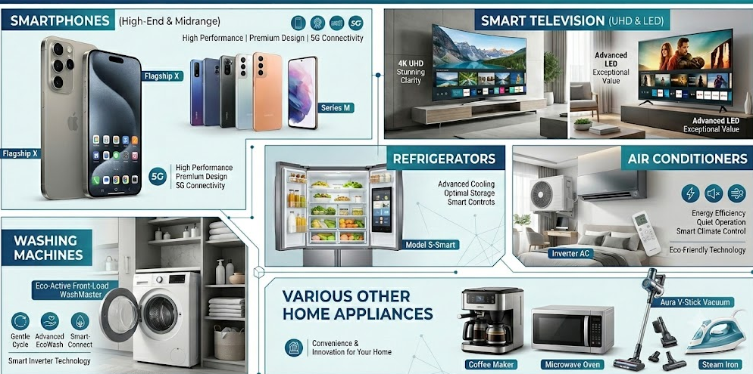
Customer Markets
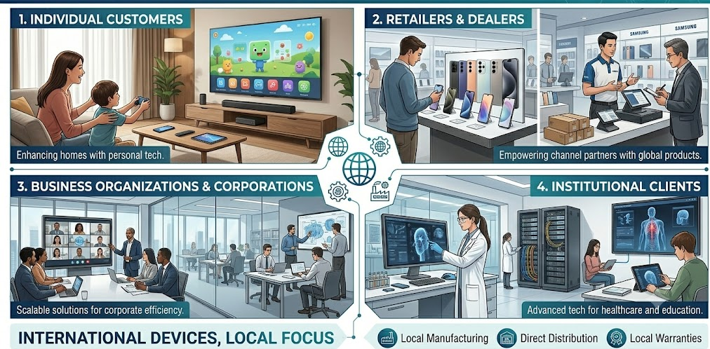
The company provides internationally recognized electronic devices backed by local manufacturing, distribution, and warranties.

2.1.4 Operations/Activities of the Company
The organizational structure of Fair Electronics consists of corporate management activities with factory manufacturing and production activities.

Operations are deeply structured and divided into two core areas:
Fair Group | Fair Electronics Operational Structure & Core Divisions
Corporate Office (Dhaka Headquarters) | On-Field Factory Plant (Narsingdi Complex)
Location:  Green Landmark Tower, Kalabagan / Banani, Dhaka | Location:  Kamargaon, Shibpur, Narsingdi
Core Functions:  - Strategic Planning  - Finance & Accounting  - Sales & Brand Management  - Marketing Campaigns | Core Functions:  - Smart Tech Assembly Line (CKD/SKD)  - Automated SMT Machinery Operations  - Precision Quality Control Labs
HR & Recruitment Focus:  - Corporate Executive Hiring  - Talent Sourcing via LinkedIn & Job Portals | HR & Recruitment Focus:  - Specialized Technical Recruitment  - Plant Engineers & Technical Staff Sourcing

Corporate Head Office (Dhaka Office)
- Strategic Planning & Business Development
- Finance and Administration
- Human Resource Management
- Sales & Marketing Management
- Executive Recruitment
- Brand and Organizational Management

Factory and Production Facilities (Production Factory Narsingdi)
- Purchase Management and Inventory Control
- Assembly Line Manufacturing (SKD and CKD)
- Surface Mount Technology (SMT) Production Process
- Automated manufacturing process
- Quality Testing Lab
- Specialized Technical Recruitment
- Warehouse/Distribution and Customer Service
This structure ensures coordination between operational execution and business strategies.

2.1.5 SWOT Analysis
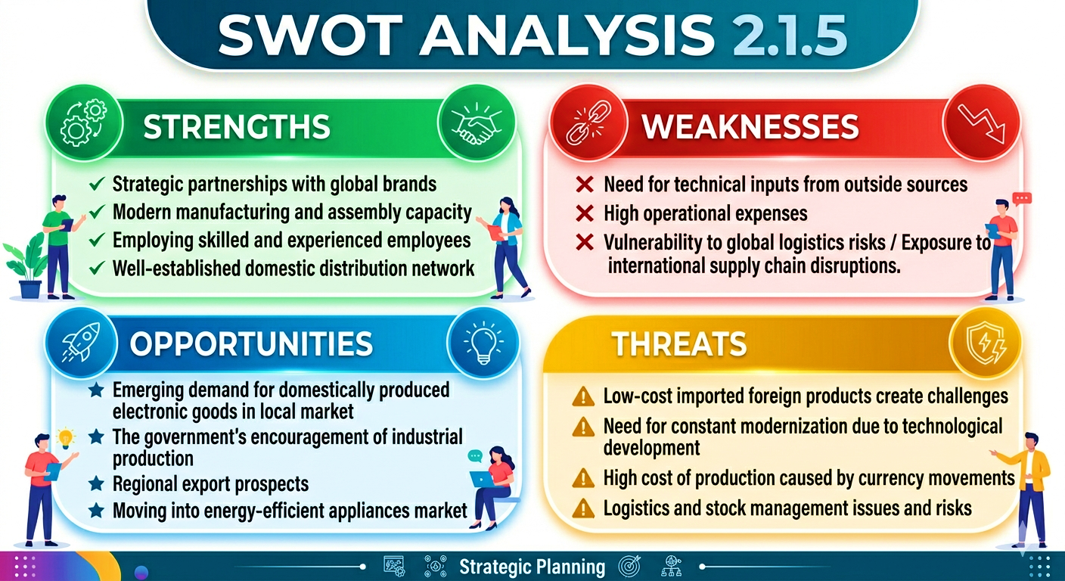

2.2 Industry Analysis

2.2.1 Industry Specification
The electronics manufacturing and assembly industry involves complex machinery, high-tech equipment, and considerable amounts of financial capital and thus is highly dependent upon sophisticated manufacturing systems, well-trained technical personnel, and adherence to international standards of quality control. This industry requires a significant amount of engineering, operating, and assembly talent as well as quality assurance experts.

2.2.2 Industry Size, Trend, and Maturity
The electronics manufacturing industry in Bangladesh has transformed itself from a country relying on imports to one that is witnessing rapid growth in its own localized manufacturing sector. The growth of the industry has been spurred by the growing disposable income of consumers, digitization, government initiatives, and private investments.
Trends currently prevailing in the industry include:
- Capacity expansion for localized manufacturing
- Increasing automation in production
- Use of SMT technology
- Increased use of AI-driven production processes
- Sustained investments in modernizing manufacturing
The industry at present reflects the features of a growth stage market, with increased industrial maturity.

2.2.3 Industry Analysis (SWOT and Competitive Factors)
Strengths
- Cost advantages of the labor force and growing technical workforce
- High domestic demand for electronics products
- Increasing industrial base
Weaknesses
- Negative impacts due to lack of domestic manufacture of semiconductors and high-tech components
- Reliance on imported raw materials and technology
Opportunities
- Production and exports of goods in the region
- Technology transfer via international collaboration
- Local industrial capacity expansion
Threats
- Rapid changes in technology and product life cycles
- Supply chain disruptions and dependence on imported products
- Extreme competition from both local and international producers
- Imports of electronic goods serving as substitute products

External & Competitive Forces
- Effects of inflation and fluctuating exchange rates on cost of production
- Large amount of money investment requirement creates barriers to entry
- Technical skills requirements reduce market entry
- Necessity for technology advancement cannot be overlooked for competitiveness

CHAPTER 3: INTERNSHIP EXPERIENCE

3.1 Position, Duties, and Responsibilities

While working as an HR intern at Fair Electronics, I was assigned to work in the department of Talent Acquisition & Operational Human Resource. In this regard, I gained exposure to HR functions in the context of office recruitment and workforce management concerning manufacturing operations. Through this diverse exposure, I practically learned the differences in performing HR functions in an office and a manufacturing environment.
Some of my responsibilities were:
- Sorting and shortlisting profiles of candidates on the basis of job requirements and competencies.
- Providing assistance in recruitment communications and coordination of interviews.
- Supervision of database and documentation of recruitment process.
- Provision of assistance in onboarding of employees and other related activities.
- Coordination of initial screening activities from various sources of candidates including LinkedIn, job portals, employee referrals, and recruitment campaigns.
- Documentation of training activities and other HR related administrative work.
- Maintaining contact with production supervisors and line managers for recruitment purposes of technical jobs.
- Learning workforce planning and operational HR functions in factories.
Such an internship helped me gain practical exposure to both HR and manufacturing workforce management practices.

3.2 Recruitment and Selection Process of Fair Electronics
In recruiting and selecting employees for Fair Electronics, the method followed is quite well structured but differs according to the type of roles to be filled. Even though the recruitment process is largely uniform, there exists great variation in terms of the sourcing technique, selection methods, and evaluation procedures based on the kind of position.
Recruitment Sources and Sourcing Channels
The Fair Electronics uses two major types of recruitment sources for attracting a wide variety of candidates from various segments and levels including corporate, technical, operations, and manufacturing levels.
Digital Recruitment Sources
- Career websites of the corporation along with its application portal
- Online job platforms (example, Bdjobs)
- LinkedIn recruitment for attracting professional and managerial level employees
- Technical recruitment sites
- Personal and industrial networks
- Executive search firms and recruitment agencies
Field and Relationship Recruitment Sources
- Referral recruitment
- University and campus-based recruitment
- Placement drives in polytechnic institute
- References in technical and industrial circles
- Local and outsourced recruitment drives
The benefit of referral recruitment is that it helps in cutting down on costs and speeding up recruitment processes, along with better retention of employees.

3.2.1 The Specialized Sourcing, Recruitment, and Screening Matrix at Fair Electronics

Evaluation Dimension | Normal (Corporate) HR Screening | Assemble Lining HR Screening
Primary Sourcing Platform | Dominantly LinkedIn and corporate executive job portals. | Polytechnic partnerships, technical references, and local marketing.
Core Screening Objective | Assessing communication, strategic alignment, and long-term career growth. | Assessing manual precision, technical certifications, and task completion speed.
Core Technical Profiles | Brand Managers, Finance Executives, and administrative personnel. | CSE Engineers, Diploma Engineers, Mechanics, Machine Experts, Electricity Experts.
Assessment Methodology | Case studies, behavioral panels, and psychometric tests are all valid tools for assessments. | Machine diagnostics, skill test exercises, and compliance checks for safety protocols.
Work Environment Orientation | Office-based: Desk Space Optimization, Digital Tool Tracking, and Cultivation of Collaboration Culture. | Field-based approach: Concentrates on the actual factory production line, ESD areas, and shifts.
Impact of Screening Errors | Results in gradual drop in team productivity or cultural mismatch over time. | Results in immediate production stops, expensive machine damage, or safety issues.

3.2.2 Recruitment and Selection Based on Roles
The method employed by Fair Electronics for recruitment and selection depends on the category of employees. Fair Electronics uses a dedicated and tiered talent acquisition process that is specifically designed for certain technical jobs:
1. Corporate Recruitment & Office Hires
Recruitment of office and administration-related jobs is done via LinkedIn, corporate job portals, professional job sites, and executive recruiting firms. Evaluation of applicants entails their academic qualification, communication skill, cultural fit, problem solving skills, and overall fit into the organization through behavior-based interviews.
- Recruitment Methods: Corporate LinkedIn accounts, executive recruitment services, and online job sites.

Evaluation Procedures: Standard corporate interview process based on business acumen, professional proficiency in Finance, Marketing, and general Human Resources, collaborative communication skills, and strategic fit.

2. Computer Science (CSE) Engineers & Technical Specialist Roles
Technical jobs involving software and automation are mainly recruited via specialized tech sites, university recruitment platforms, LinkedIn, and recruitment using portfolio sites. Assessment during the selection process entails technical skills assessment, system knowledge, capability to integrate firmware, logical reasoning and problem-solving assessment.
- Source of Candidates: Technical job sites, career fairs at engineering universities, hackathons, and GitHub profiles.

Selection Criteria: Assessment of the capability of systems automation, PLC programming knowledge, troubleshooting skills with real-time diagnostics software, and systems integration skills.

3. Diploma Engineers & Technical Trainee Positions
Diploma engineers are hired by recruitment through campus placements at Polytechnics, technical institutions network and technical job sites on-line. Selection entails knowledge in engineering basics, knowledge in manufacturing processes, blue print analysis skill and technical adaptability.
- Source of Candidates: Direct recruitment campaigns from polytechnics, local job openings for technical jobs, and the State Board of Vocational Training.

Selection Criteria: Validation of specific technical specialization, such as Mechanical, Electrical, and Electronics Engineering. The first phase of the technical selection process includes evaluation of engineering schematics, handling of tools, and machine calibration techniques.

4. Mechanics and Maintenance Staff
Recruitment of mechanics is done by recommendations, trade connections, job platforms, and industrial contacts in the area. The evaluation process is highly practical and involves test repairs, troubleshooting tests, precise work, and readiness for action.
- Source of Candidates: Companies that produce goods, trade schools, and candidates recommended by existing employees.

Selection Standards: Practical Tests on skills related to machine diagnosis, knowledge of preventive maintenance, quick replacement of parts, and compliance with LOTO policies.

5. Electricians and Electrical Systems Specialists
Recruitment of electricians is done through technical bodies, engineering forums, and referral recruitment. The selection process emphasizes industrial electricity safety knowledge, diagnostic skill, power distribution knowledge, knowledge of compliance, and risk management ability.
- Recruitment Methods: Formal electrical trade associations, professional technical institutions, and online employment agencies.

Evaluating Processes: In-depth evaluation process based on an understanding of high voltage electricity distribution, electrical safety at work in industrial plants' power systems, circuit troubleshooting under pressure, and electrical safety standards both national and internationally.
6. Machines Experts & Industrial Technical Positions
Recruitment of machine specialists entails technical recruitment via industrial networks, technical references, specialized tech job sites and professional recruiting organizations. Verification of applicant’s industrial experience, capability to operate machinery, knowledge of machinery calibration and problem-solving skills in production environments.
7. Service Providers (Logistics and Material Handling Services)
The recruitment of logistics support and other services staff members is done through outsourced providers, localized recruitment, and local hiring organizations. Literacy levels, physical strength, knowledge of safety, and reliability are evaluated.

By using effective screening and training practices, HR practices affect the efficiency of employees positively and hence organizational effectiveness.

3.2.3 Selection Process
After candidate sourcing and application collection, Fair Electronics follows a structured multi-stage selection procedure:
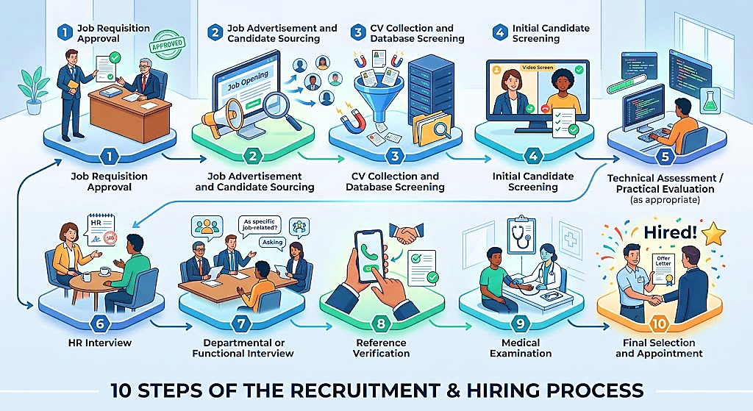
This systematic selection process allows Fair Electronics to ensure the capability of its employees matches with the needs of the organization effectively and efficiently.

3.2.4 Skills Applied and Evaluation
The practical application of skills gained in this internship was a move from theoretical HR concepts learned in textbooks to their application in an industry setting. This included the use of skills in tracking data, especially relating to candidate pipelines through various sources.
In addition, effective communication skills were gained as well. This involved learning to switch communication styles from dealing with top corporate executives to communicating on the manufacturing shop floor with engineers and assembly operators.

3.3 Training & Development Practices
Training and Development is an important aspect of organizational effectiveness for Fair Electronics, contributing towards increasing the competencies of employees, achieving excellence in operations, and creating sustainability in terms of their workforce. Different methods of training are used by the organization according to the job responsibilities of each employee.
Office Employee Training (Regular line/Corporate)
Office employee trainings aim at increasing the effectiveness of managers, efficiencies of operations, and overall proficiency levels. Such training courses are conducted to enhance administrative efficiency and aligning employees with organizational goals.
Some of the major categories of trainings provided to office employees are:
- Human Resource Policies and Compliance: Orientations regarding company policies and procedures, along with corporate ethics.
- ERP System Trainings: Practical learning about ERP systems to facilitate seamless operations and enhanced control over reporting and other aspects of operations.
- Interpersonal and Communication Skills Trainings: Enhancement of professional communicative skills along with stakeholder and interpersonal management techniques.
- Management Trainings: Courses intended towards decision-making and effective leadership and management skills.
- Professionalism Trainings: Sessions to foster alignment with corporate culture and workplace professionalism.

Assembly Line and Manufacturing Employee Training
Unlike office-based roles, assembly line employees need comprehensive practical training since it will affect the efficiency of production output, Production quality standards, and continuity of the operational affairs. The aim of the training is to ensure that employees perform their duties effectively.

Technical and Operational Training: Workers are taught practical knowledge about:
- The use of machines and manufacturing equipment
- Maintenance practices for manufacturing equipment
- Manufacturing Standard Operating Procedures (SOPs)
- Efficiency in manufacturing processes
- Production troubleshooting techniques

Training for Safety and Compliance: The safety training program is embedded in the operational system in order to mitigate risks at work and adhere to industry safety standards.
Training programs encompass:
- Occupational Health and Safety (OHS) policies
- Emergency procedures and preparedness strategies
- Hazard recognition and risk mitigation approaches
- Safe equipment uses and accident prevention techniques

Quality Control and Continuous Improvement Training
In order to provide reliable products and minimize defective items, staff members are trained in quality management concepts.
Key topics include:
- Product inspection and testing methods
- Techniques for defect detection and prevention
- Quality assurance standards and compliance processes
- Continuous improvement principles and process control

On-the-Job Training (OJT)
Fair Electronics Company widely applies On-the-Job Training (OJT) in the training process, which involves learning directly from experienced operators and line supervisors. OJT enables employees to acquire skills fast, and apply them in production immediately.

Continuous Learning and Professional Development
In order to remain competitive and respond to new industry trends, Fair Electronics conducts continuous development activities including:
- Training programs for reinforcing existing skills
- Tech talks and knowledge exchange sessions
- Bridge training for new technology
- Skills and performance improvement initiatives

Training and Development Practices: Driving On-Field Precision
Training on an electronic assembly line demands precise and systematic processes since any error made on such a highly technical assembly line could easily end up damaging electronic parts such as microchips or printed circuit boards.

DEPLOYMENT OF TRAINING PROCESS FOR ASSEMBLY LINE

Electrostatic Discharge
(ESD) Cleanroom Preparation

Simulated Assembly Line
Tactile Speed Drills

Quality Standards in Real time
Defect Identification

Production Floor Deployment (On field)

- Electrostatic Discharge (ESD) & Clean Room Training: Prior to entering the production line, all personnel receive training about ESD awareness, clean room procedures, and handling of moisture sensitive devices.
- Simulation Assembly Line and Speed Tactility Practice: Applicants receive practical experience from engaging in the simulated assembly line that does not function and practice speed tactility by gaining proficiency at performing a job in a certain time period.
- Staff members are trained to detect Defect Detection and Quality Control in Real-time: defects via visual methods and devices capable of detecting even minor defects against standards of quality like soldering flaws, part misalignment, and scratches.

In order to have more information about the variations between the manufacturing work environment and the traditional office work environment, the following comparison is made based on Fair Electronics to highlight the main variations between both.
Table 3.3.1: Comparison Between Assembly Line and Regular (Corporate Office) Work
Criteria | Assembly Line | Regular (Corporate Office)
Work Environment | The production floor (Factory) | Office setting
Work Nature | Repetitive, production-based, machine-dependent | Administrative, planning, coordination, decision-making
Recruitment Criteria | Technical abilities, physical strength, safety awareness | Academic achievement and qualification, communication skills, analytical skills
Screening Method | Practical tests, technical assessments, machine handling | Curriculum Vitae Screening, aptitude and behavioral assessments, interviews
Type of Training | Hands-on technical training, SOPs, safety, operating machinery | Orientation, ERP system, leadership, communication, office policy
Performance Evaluation | Production output, quality, rate of defects, efficiency | KPI achievement, productivity, teamwork, k, organizational goals
Working Schedule | Shift-based operations | Fixed office hours
Safety Measurement | Very high (ESD, PPE, machine safety) | Standard workplace safety measurement
Main Objective | Quality Management, Manufacturing with minimum defects | Business efficiency and organizational performance

It is clear from the above analysis that even though both the workplaces have the same set of organizational policies, there are stark differences between the HR policies of the two workplaces owing to the nature of the activities performed there. The former employees have more focus on their skill development, safety, and training, whereas the latter employees are judged on their skills related to communication, analysis, and management.
Analytical Framework
At Fair Electronics, learning and development is an integral part of strategic human resource management rather than mere administrative practices. Whereas office workers are trained to boost coordination and management capabilities, assembly workers receive performance-focused operation training aimed at enhancing efficiency, lowering errors, promoting safety, and improving product quality.

3.4 HR Functions and Organizational Effectiveness
Human Resource Management is instrumental in enhancing the effectiveness of Fair Electronics organization through its responsibility to hire and develop skilled workers who can handle administrative as well as production processes.
Traditional Human Resource Management Functions
In terms of the operation of companies, conventional human resource management focuses on recruiting and managing employees for office-based positions such as:
- Executives
- Administrative staffs
- Business finance and accounting employees
- Marketing and customer service staffs
Traditionally, the hiring process comprises the following phases:
- Job announcement/ advertisement
- CV collection
- Initial screening
- Assessment or written test
- Interview
- Reference Verification
- Final selection and onboarding
In this case, the emphasis of assessment includes skills, communication, and adaptation to the organization.
3.4.1 The Core Analysis: THE DIFFERENTIATION IN HR PARADIGMS
It will be helpful to make a comparison between the traditional corporate approaches of managing human resources and the assembly line human resource approach at Fair Electronics.

HR Pillar | Traditional Corporate HR | Specialized Assembly Line HR (Fair Electronics)
Sourcing Channels | LinkedIn, company websites, executive search firms, online job portals. | Specialized technical networks, organizational associations, field recruiting programs, digital specialized electronic portals.
Screening Focus | Conceptual qualifications, soft skills, strategic capabilities, culture. | Specialized technical skills, spatial agility, psychomotor coordination, safety awareness, detailed domain knowledge.
Training Structure | Thinking onboarding, self-paced learning through software, company-specific compliance training. | Training in simulation labs, ESD (clean rooms) safety techniques, on the job safety techniques, line balancing practice
Key Performance Indicators | Staff Engagement Statistics, Staff Retention Statistics, Yearly Appraisal of Performance. | First-time yield (FTY) ratios, defects per million opportunities (DPMO), success of achieving zero accidents, shift effectiveness.

3.4.2 Organizational Effectiveness
Human Resource (HR) functions have a considerable impact on organizational effectiveness as they help ensure that workers have the required abilities and motivation to meet organizational objectives. Fair Electronics is an example where the company has HR roles beyond administration but also offers strategic value in operations and manufacturing processes.
Increased Productivity
Recruitment and selection procedures will ensure that competent workers join the company and become more productive.
Low Turnover Rate
The career development and training processes can play a significant role in improving job satisfaction and retaining the employees.
High Product Quality
With training for the employees, they will be able to do things in the right way and hence product quality can be assured.
Better Safety Procedures
Continuous training regarding safety procedures may result in having a safer workplace where there will be little risk for hazards to occur.
Sustainability and Workforce Development
The workforce development ensures the sustainability of operations in the company.
Contribution to the Organizational Effectiveness
The processes in the HR ensure that there is alignment between work-related procedures and other activities for the strategic effectiveness of the organization.

In such a technological manufacturing setting, specialized HR management activities have an effect on organizational performance through the following ways:
- Lowering Defect Levels (Improving DPMO): Selective screening and practical training go a long way in ensuring that only competent employees’ man the assembly line. In doing so, the company eliminates errors by increasing the percentage of first-time successful yields.
- Improving Employee Safety and Regulatory Compliance: By undergoing full safety training, HR will make sure that no accidents occur in the factory. The process not only enhances safety but also prevents the shutting down of production lines, which can result in legal issues.
- Ensuring Optimal Line Performance: Effective screening enables the organization to align workers with their respective strengths to the most effective positions in the production line.

Analytical Finding
It is evident from the analysis that Human Resource Management in Fair Electronics undertakes a strategic activity instead of the administrative one. The involvement of HR activities in the recruitment, training, development, and management of the workforce results in the improved efficiency of the manufacturing process and the organizational effectiveness.

3.5 Contribution to the Organization / Operation
- Simplifying the Hiring Process: Created a streamlined process for the recruitment of entry-level technicians for assembly tasks by setting up a database of diploma engineering institutions.
- Improving the Initial Screening Process: Formulated a checklist for initial screening of potential hires that focused on their knowledge of important requirements such as being ESD-safe and meeting cleanroom standards.
- Improving Orientation Material: Improved documentation for the factory-floor orientation process by simplifying technical information about safety requirements into visual aids for entry-level floor operators.
3.6 Skills Applied
- Technical/Data Skills: HRIS skills, technical resume review, workforce analytics through Excel, and measurement skills.
- Operational Skills: Recruitment at a high volume, technical test administration, and conducting safety-compliance audits.
- Soft Skills: Cross-functional communication, conflict resolution on tight operational deadlines, and negotiation skills.
3.7 Evaluation
The internship offered a conducive setting in which the student could use academic HR knowledge to perform tasks within the real-world industry setting. Feedback from the performance evaluation indicated that I had a talent for efficiently managing the task of large-scale recruitments and paying attention to minute details when conducting resume evaluations. In modern manufacturing systems, HR plays a role in driving efficiency through efficient recruitment and training of employees.

CHAPTER 4: CONCLUSIONS AND KEY FACTS
4.1 Recommendations
- Enhance Digital Recruitment and Technical Screening
Fair Electronics can further enhance their recruitment efficiency by widening their digital recruitment avenues to include tools like LinkedIn, professional networks, and AI-based technical screening for Diploma Engineers, CSE students, and technical operators.
- Develop an Integrated Digital Onboarding Program
An integrated digital onboarding program where the company’s HR department works with the factory for onboarding would prove beneficial for managing the paperwork, safety requirements, technical skills, and adherence to policies.
- Build Stronger Institutional Partnerships and Apprenticeship Programs
In order to foster robust relationships and provide for apprenticeships in the company, Fair Electronics must forge collaborations with some of the top polytechnic institutes and technical institutions to offer apprenticeships and internships.
- Employees' Flexibility and Adaptability
Incorporating rotation and cross-training among assembly activities will help boost employee flexibility and adaptability during high-demand times.
- Succession Planning
Fair Electronics may continue strengthening competency-based assessment and succession planning strategies to support long-term technical workforce development and leadership readiness.
- Simulation-based Training Technologies
Learning through simulations in technology-assisted training environments is one-way Fair Electronics can further prepare employees for assembly processes and minimize training risks.

4.2 Key Understanding

The internship showed that HRM in industrial manufacturing is different from conventional HRM in the office setup. The processes related to recruitment, interviewing, induction, and training need to be adjusted to suit the nature of production operations.
The following lessons were learned:
- The HR approach should match the engineering and operational processes instead of merely using general office administration approaches.
- There is a need for specialized interview techniques when assessing technical workers like Diploma Engineers, machine operators, mechanics, electricians, and automation engineers.
- Training plays a critical role in shaping production quality, efficiency, skill sets, and safety at work.
- Good coordination between office-based HR and manufacturing process enhances organizational effectiveness.
- HRM helps the organization perform better through HR stability, fewer mistakes, increased capabilities, and competitiveness.
The key takeaway from the internship experience is that industrial HR cannot operate in isolation from the technical process. The HR personnel involved in recruitment and workforce planning must be aware of the technical needs of the assembly environment to select appropriate candidates for the job.

4.3 Conclusion

The results obtained in this internship report show how recruitment, selection, training, and staffing techniques used by Fair Electronics are not the same as those used traditionally within the human resources function because of the technicality involved in electronics manufacturing.
As opposed to traditional HRM techniques where the focus is more on evaluating behavior as well as fitting into the organization, the company employs more focused methods of recruitment, training, and staff management to suit the technicality. Recruitment involves a variety of employees, including Diploma Engineers, CSE engineers, mechanics, machine operators, electricians, assembly staff, and office staff using a number of channels, such as online job sites, LinkedIn, institutional links, and campus recruitment.
The analysis shows that training and development of the employees are critical in boosting competence, increasing the quality of goods produced, avoiding risk in operations, and increasing efficiency in the company. As a result, Fair Electronics is able to ensure effective assembly line operations through proper HR practices and staff management techniques.

References
- Fair Group Official Website
- Fair Electronics Official Website
- Fair Electronics, 2024. Standard Operating Procedures for Talent Acquisition and Technical Line Allocation. Internal HR Document.
- Mondy, R.W. and Martocchio, J.J., 2016. Human Resource Management. Pearson.
- Armstrong, M., & Taylor, S. (2023). Armstrong's Handbook of Human Resource Management Practice (16th Edition). Kogan Page.
- Dessler, G. (2020). Human Resource Management (16th Edition). Pearson Education.
- Noe, R. A. (2023). Employee Training and Development (9th Edition). McGraw-Hill Education.
- Fair Electronics Internal Operational HR Manuals and Structural Policy Frameworks (2024).
- Samsung Electronics Global Manufacturing Compliance Guidelines and Quality Management Directives (2023).
- Womack, J.P., Womack, J.T., Jones, D.T. and Roos, D., 1990. Machine That Changed the World. Simon and Schuster.

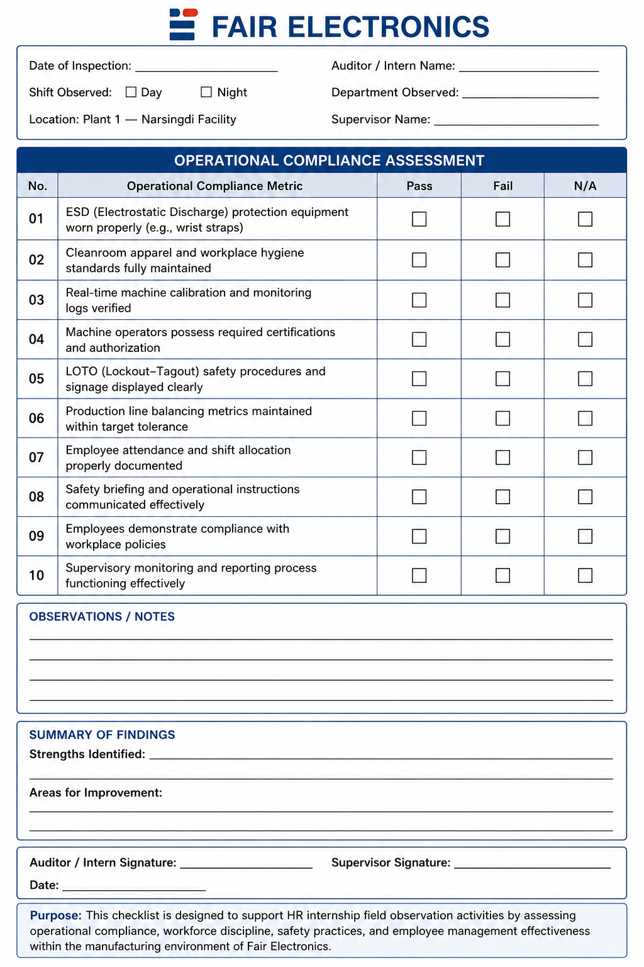
Appendix-A:

