

Internship Report
On
Market Development Activities Practiced by the EATL Limited

Submitted To
Muhammad Hasan Al-Mamun
Assistant Professor
School of Business and Economics
United International University

Submitted By
Sadiqul Islam
ID: 111 151 035
BBA Program
School of Business and Economics
United International University

Date of Submission
19 June, 2020
Letter of Transmittal

19 June, 2020

Muhammad Hasan Al-Mamun
Assistant Professor
School Business & Economics United International University

Subject: Submission of Internship Report.

Sir,
I’m glad to submit the internship report on the topic you’ve assigned me which is “Market Development Activities Practiced by the EATL Limited”. While preparing this report I tried my level best to follow your instructions.
The entire report is based on the practical knowledge I have gained from my 3 months of internship program while working in the EATL Limited. The knowledge I’ve gained from here will add a huge advantage to my career. My practical experience and analysis are illustrated in this report. While preparing this report, due to different constraints, there might be some mistakes. I would be grateful if you consider those from the excusable point of views.
I would be highly grateful if you kindly receive this report and will be pleased to answer to any of your queries regarding this report.


Sincerely yours,

Sadiqul Islam ID: 111 151 035
BBA Program
School of Business & Economics United International University
Internship Certificate
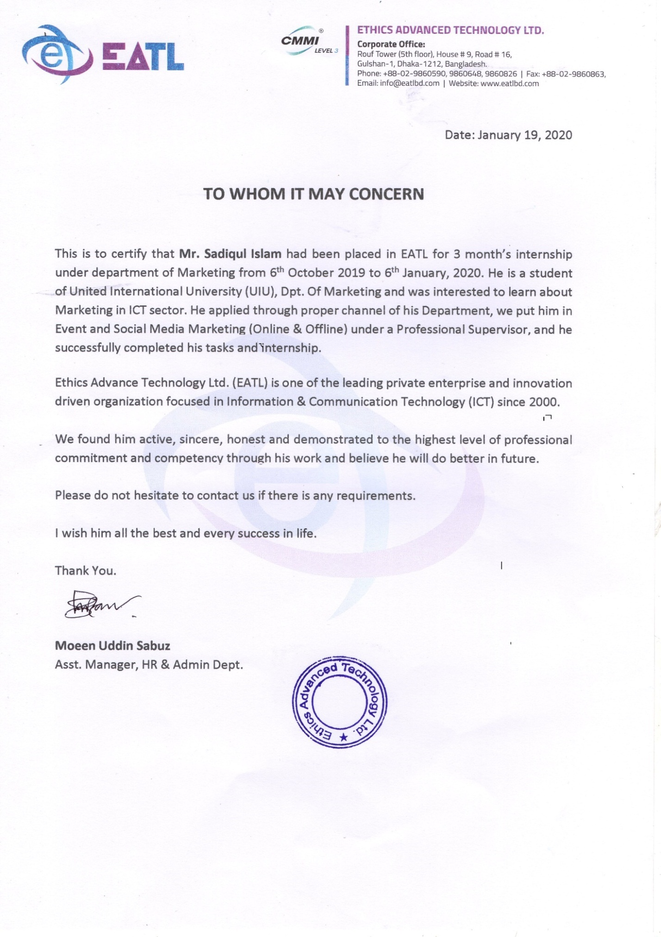

Acknowledgement

First of all, I am grateful to almighty Allah for making me able to prepare this report with the assistance of some wonderful people. My gratitude to my respected supervisor faculty Muhammad Hasan Al–Mamun, Assistant Professor, School of Business & Economics, United International University for his guidance. Without his instruction, I would not be able to prepare this report.
I am blessed to have Sharmin Mahjabin, Head of Marketing, EATL Limited as my supervisor. Without her help and guidance, it would have been difficult for me to cope with all the tasks that I am assigned to do. She helped me in all the critical activities to make me comfortable and confident in the work environment. I hope the learnings from her will come in handy in my professional life.
Also, thanks to all my colleagues for their wonderful cooperation. I would have faced more difficulties without their cooperation. I am blessed to have these wonderful people as my colleagues.

Executive Summary

This Report is prepared on EATL Limited a growing IT Company of the country. The report evaluates the business operations of EATL and an overview of the IT industry. But the main focus of the report was concentrated on the market development strategy of EATL Limited.
Over the past few decades, the software and IT service industries of Bangladesh have crossed a long road. The sector is now maturing. It is no longer a sidelined industry; this sector is emerging as a new horizon for development of the country. It is unveiling a bright future in the country’s vision of creating “Digital Bangladesh” There are more than 800 registered software and ITES companies in Bangladesh, according to Bangladesh Association of Software and Information Services (BASIS) survey.
EATL Limited is an award-winning IT Company of the country led by young entrepreneurs. They provide various IT services, of which the main services are website development and designing, cloud-based services, software development, UI/UX design and so on.
The Business development team of EATL is responsible for carrying out all the business-related tasks. This team is the first to respond to all the clients. Initial business discussions, meetings are held with the business development team. If everything goes right then, they deliver the clients to the technical team to fulfill their project. As an Intern, the key responsibilities were to help the business development team to fulfill their works successfully. Business development team tries to convert prospects into their regular business clients, so the member of the business development team must be alert and careful while preparing the documents of those clients and try best to convert the prospects into regular clients.

Key Words: Market Development, EATL Limited

Table of Contents

1.1 Introduction: 2
1.2 Background of the report: 2
1.3 Scope of the report: 3
1.4 Limitations: 3
1.5 Objective of the report: 3
1.6 Methodology: 3
2.1 EATL Background: 5
2.2 Values and culture: 6
2.3 Financial Capacity and Management: 7
2.4 Professional Experience of EATL: 7
2.5 Core Service Areas: 8
2.6 Area of Experiences: 8
2.7 Consulting Philosophy: 9
2.8 Growth and Strategic Expansion of EATL: 9
2.9 EATL Organogram: 10
2.19 Growth and trend 34
2.20 Customer mix 34
2.21 SWOT Analysis 35
3.1 Industry Overview 42
3.2 Digital Bangladesh: 43
3.3 Industry Structure: 44
3.4 Recent Trends & Dynamics of the Industry: 45
3.5 SWOT Analysis of the Industry: 46
3.6 The Challenges of the Industry: 48
3.7 Software Technology Parks 50
4.1 Internship Recruitment: 52
4.2 Position, Duties and Responsibilities: 52
4.3 About Edutube: 53
4.3.1 EDUTUBE BACKGROUND: 53
4.4 COMPANY INFORMATION: 53
4.5 HOW EDUTUBE WORK: 54
4.6 LOG FILE INFORMATION: 54
4.7 MISSION 55
4.6 Trainings: 66
Chapter 5 67
Conclusion and Recommendations 67
5.1 Conclusion: 68
5.2 Recommendations: 68
6. References: 69

Chapter 1 Introduction

Introduction:
Ethics Advanced Technology Limited (EATL) is a leading private company with innovative ICT services and solutions provider in Bangladesh, established in November 1999. EATL has developed partnership and collaborations with Bangladesh based IT companies, private sector organizations, NGOs, donors, Government, Universities and also some of the world most renowned IT expertise organization such as IBM, Sun Oracle (infrastructural partner), Prognoz, Six Dee Telecom Solutions, (business partner), Oracle (Gold Partner) and many others for developing technology and efficient solutions. EATL is a private enterprise and Social Change maker organization focused in ICT innovations for development and business sector. We are providing strategic information, technology solutions, knowledge management, web-based MIS & data management solution and mobile applications.

EATL has developed long range strategic plan for responding and expanding ICT business solutions, development programs and its support system, technical assistance to wide range of partners and delivery of high quality and effective results. With our growth and scale, we have developed partnership and collaborations with Bangladesh based companies, private sector organizations, International and National NGOs, donors, Government ministries/departments and also some of the world most renowned IT expertise organization and also developed partnership with all telecom companies in Bangladesh EATL has established institutional linkages to develop young professionals through universities, colleges, technical institutes and social media users for improving long term impact of technology.

Background of the Report:
This report entitled “Marketing Activities Practiced by the EATL Limited: A hands-on initiative through a Software Development Company” has been prepared as a requirement for the BBA Internship Program by Sadiqul Islam, Intern, EATL Limited. This report is important to understand the Marketing development of EATL Limited, a growing IT firm of country and how they carry out their business activities. Bangladesh is considered the next high prospect destination for ICT. With the vision of Digital Bangladesh, the IT industry is getting all the concentration from the government, there have been lots of incentives and subsidies introduced by the government. This report also overviews the current scenario of IT industry of Bangladesh.

Scope of the Report:
The study is based on the market development activities, analysis and observation as an Intern in EATL Limited from 06 October, 2019 to 06 January, 2019. During this period, access to many consumers, customers, industry experts and publicly available online data were gained, on which the report is based on. The scope of the report is not limited to the local market, it covers the foreign market as well especially in terms of the company’s market development activities and what are the initiatives they have taken so far.

Limitations:
The first limitation of this report is the time limit. It is not easy to find out everything about an organization in a short period of time. Besides, the company does not reveal all information due to confidentiality.

Objective of the Report:
    - To provide a descriptive narrative of the real-life experiences in terms of scenario of marketing activities of EATL Limited for the purpose of market development.
    - To analyze the present scenario of Bangladesh software industry
    - To know about the company’s activities of using various market development techniques

Methodology:
This study is the combination of both practical knowledge and the theoretical findings. This report reflects the business operations of EATL Limited and the overview of the IT Industry of the country. Both primary and secondary data have been used to prepare this report.
Sources of the data: All the information were collected from two sources.

Primary Sources: Most of the required data were directly collected from the Head of Marketing and from own working experiences.
Secondary Sources: These are the quickest source of collecting the necessary information. In this report, the information collected from indirect source are considered as secondary data sources. Information derived from internet such as articles, journals, websites and relevant sites are considered as the secondary data sources.

Chapter 2 Analysis of the Company

2.1 EATL Background:

Company Name: Ethics Advanced Technology Ltd.
Address: House#9 (5th floor), Road#16, Gulshan-1, Dhaka-1212, Bangladesh.
Phone: +88-02-9860590, Fax: +88-02-9860863

Ethics Advanced Technology Limited (EATL) is a leading private company with innovative ICT services and solutions provider in Bangladesh, established in November 1999. EATL has developed partnership and collaborations with Bangladesh based IT companies, private sector organizations, NGOs, donors, Government, Universities and also some of the world most renowned IT expertise organization such as IBM, Sun Oracle (infrastructural partner), Prognoz, Six Dee Telecom Solutions, (business partner), Oracle (Gold Partner) and many others for developing technology and efficient solutions. EATL is a private enterprise and Social Change maker organization focused in ICT innovations for development and business sector. We are providing strategic information, technology solutions, knowledge management, web-based MIS & data management solution and mobile applications.

EATL has high quality professional team and partners both local & global. Our strong collaboration, strategic relationship, innovation, networking with higher government authorities, regulatory bodies and legislators differentiate us from other concerned companies operating in this industry of Bangladesh. Since inception, our dedication and diligence in remaining technically astute have been the key ingredients of EATL’s success in several clients’ engagements. We have thus been able to maintain long-term relationship with distinctions and pride. On the pave of emerging diversification of information technology, EATL’s business strategy combines application support, system design, database administration, feasibility study, software development, hardware solution, training, social media consultancy, mobile application development, Research & Development etc.

EATL launched country’s first ever mobile app store in October, 2012 branded as ‘EATLApps’, and most of the apps are in Bangla and local context based. We have payment integration with the three largest telecom operators (MNO) in Bangladesh for app purchase from mobile balance. The EATL Apps store is also integrated with DBBL and bKash for payment processing.

EATL has developed long range strategic plan for responding and expanding ICT business solutions, development programs and its support system, technical assistance to wide range of partners and delivery of high quality and effective results. With our growth and scale, we have developed partnership and collaborations with Bangladesh based companies, private sector organizations, International and National NGOs, donors, Government ministries/departments and also some of the world most renowned IT expertise organization and also developed partnership with all telecom companies in Bangladesh EATL has established institutional linkages to develop young professionals through universities, colleges, technical institutes and social media users for improving long term impact of technology.

We believe in innovation, methodical product development and effective delivery of the committed services in partnership with our clients for getting the best outcomes. EATL has achieved CMMI Level–3 certification with help of Hi-Tech Park Authority to ensure the quality of our software and mobile apps development process.

2.2 Values and Culture:
EATL believes in integrity, transparency and responsibility. Their team always abide these values. We can get a better idea about their values and cultural practices from the following statements.
    - The clients have full access to the entire asset (code repo, project management tool). They enjoy direct communication privilege to each of the hired resource.
    - EATL is always concerned about corporate governance and take special care in preparing and reporting to the government and its different agencies.
    - EATL also fulfill their Corporate Social Responsibilities by donating 2.5% of their profit in the educational sector of the country.
    - The company offers a friendly environment to its employees, and also has time flexibility for the employees.
    - The company has a flat structure, the communication channel among the employees are remarkable, and all the employees can easily communicate with others without any sort of formalities.
EATL is always concerned about the confidentiality of their clients. Thus they sign a “Non-Disclosure Agreement” at the very beginning of the deal with their clients to make sure the information the clients share remain confidential.

2.3 Financial Capacity and Management:

EATL is financially capable to handle this type of large projects and it’s been proven in the past works completed by EATL.
EATL has a high profiled Management and strong dedicated professional comprising a number of university professors having overseas experience and strong network with the brightest talents for delivering high quality outputs. EATL fully complies with the requirement of BPDB (at 10 years of general experienced in IT industry) because EATL is a leading ICT organization in Bangladesh that was established in November 1999. EATL having track record in successfully working in the web development, ERP software and successfully designing and developing projects related to web solution and Mobile applications.EATL committed to deliver a state-of-the-art solution in this domain by the help of highly expert manpower of the organization.

2.4 Professional Experience of EATL:

EATL has a long presence in MIS in Bangladesh, since 1999 and is working for Developing and maintenance web sites& Web portal, ERP solutions, Mobile applications, Bulk SMS, voice call (OBD), IVR and digital content management, Automated Monitoring and Evaluation system and ICT related training for private and public sectors in Bangladesh. We have strong dedicated professional comprising a number of university professors having overseas experience and strong network with the brightest talents for delivering high quality outputs. We not only focus on providing solutions for meeting the requirements in a project, we try to add values to the solutions through research and innovation.EATL has already developed a large number of quality ERP modules for EDCL, IMCH, PKSF and East west medical college. EATL has already developed a large number of quality and dynamic websites for many important institutions including Bangabhaban, SEQAEP, PKSF, BARI, Community Clinic, HASAB, IMCH, NASP, BCCP, Bangladesh Parjoton Corporation, International Medical College, EATL Apps and many more. EATL has completed the project of 500 mobile apps development and 500 mobile apps trainers. It is one of the flagship projects on the way to the digital Bangladesh. EATL also has solid experiences in building different kinds of web based solutions where data visualization was one of the important features. Creating and exporting different kinds of bar graph, charts using collected data or rendering them on website also are routinely done by EATL experts.

Detail Company profile is given as Annexure-1

2.5 Core Service Areas:

2.6 Area of Experiences:

- ICT based Solutions, Web MIS and Digital Content Management
- ERP modules for Business, Social, Development Sectors
- Mobile Communication Technology
  - Mobile Apps and App Store
  - Voice Call Broadcasting (OBD), SMS Broadcasting (Bulk SMS), Call Center and IVR Service
  - Location Based Service for Monitoring & Evaluation
- Partnership in Development Programs for ICT use in Government and Non-Government (NGO) entities
- Training in ICT & Capacity Building

2.7 Consulting Philosophy:

EATL consulting philosophy is formed around the concepts of teamwork, partnership, service, and quality, both in the coordination of our efforts within our firm and in our interactions with our clients. The core project team will include highly qualified and experienced members. The strength and qualifications of our staff enable us to provide analysis that is both prompt and thorough. We strive to form partnerships with our clients. Our best statistical estimates and recommendations can be delivered only through recognition of each client’s unique situation. We design our report formats to meet each client’s needs. We will, if desired, provide the product versions so that the client has the opportunity for input and commentary before we issue final report. Effective communication of our work is a top priority at EATL. We know that even the best information is useful only if it is presented clearly in terms that the audience can understand. We pride our ability to “Development of web application, ERP system development and Mobile based application” and can easily identify with and understand. As an example, we developed 500 mobile apps for Government of Bangladesh and a large number of quality Web sites such as PKSF, HASAB, Bangabhaban, Bangladesh Parjoton Corporation, NASP, BARI, BCCP and many more. The comments from the aides and clients indicated we successfully described the complicated forces in such a way that people not familiar in developing applications easily understood. We also know that timeliness is essential to a successful assignment. We deliver quality, timely products as promised. We offer our clients superior service and quality, including CMMI-3 level certification techniques.

2.8 Growth and Strategic Expansion of EATL:

- Provide technology as software solutions for business and development sectors
- Design responsive systems/solutions for planning, monitoring, evaluation and reporting of programs and investments
- Create and innovate ICT in health, education and multi-sectors through mobile apps, web apps, software etc.
- Collaborate with partners for mutually beneficial Responses / applications / projects (local & international)
- Manage communication and capacity building efforts
- Continue R&D for Knowledge Management
- Use of lessons learned for documentation & publications

2.9 EATL Organogram:

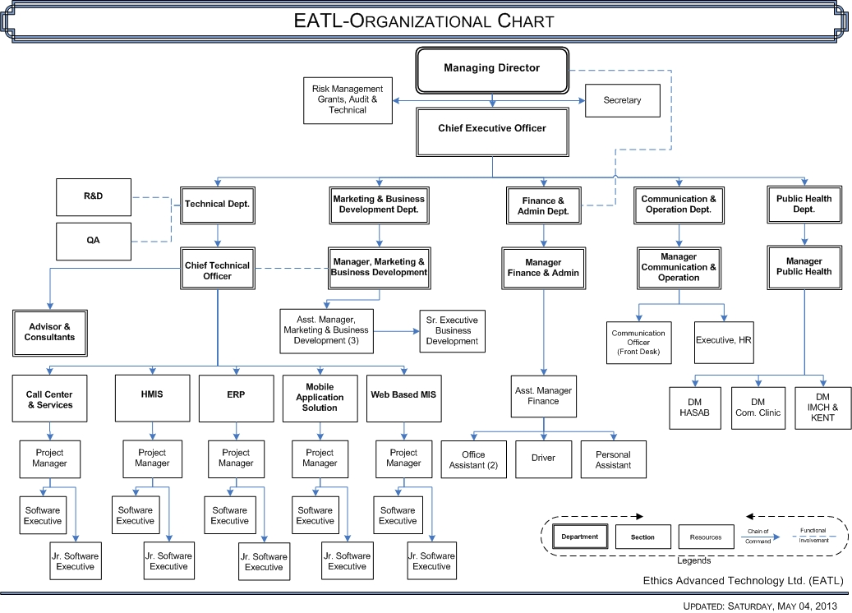

2.10 Committed to highest quality of Software Consultations and services:

EATL is a software development and IT Services Company to address outsourcing needs of various industries. We have been providing strategic IT solutions to clients of all concern, especially in ERP solution, Process Re-engineering, e-commerce solutions and Data Processing for over 11 years. We can meet your software development needs with our development expertise provided by efficient and flexible in- and outsourcing consultancy models that best match the stage of your project development cycle. We have more than 8 years of experience in web designing, web development and e-commerce consultancy. We help our clients maximize profits from Software investment through innovative solutions for today and tomorrow. We are a process centric organization; we follow Agile development methodology to ensure better service to our customers.
Our mission is to incorporate novel ideas in your software development projects and deliver valuable services that can exponentially fuel the growth of your business enterprise. We have set out to conduct business with all fairness, trust, confidentiality, commitment and transparency, keeping customer and client satisfaction at the fore.
EATL is deeply committed to enhancing the business value of clients & partners on a long term and sustainable basis through technical excellence, fair business practices, people brilliance and professional integrity.

2.10.1 EATL’s service Offerings
EATL provides a wide range of services along with complete business process management. Full range of our Software Consulting & Software Services offerings with On-shore /Near-Shore and Offshore service model.

2.10.2 Software Services:
- Tire-n Application Implementation and Support Services, Oracle Application.
- Customized Software Development, Support & Services
- Niche Products for Telecom, Government, NGOs as well as other organization
- USSD based Applications (Mobile Banking Native application and web application
- Website Design
- Graphic Design

2.10.3 Contact Center Services:
- Business Process Outsourcing Services (BPO)
- Call center/ Contact center services
- Law, Medical, Transcription, Billing needs
- Financial, Accounting and Banking needs
2.10.4 Skills based Outsourcing Services:
- Advisory services (Software Consulting and Services)
- Knowledge Process Outsourcing, KPO & Engineering Process Outsourcing, EPO
- Architectural, Engineering Designing & Developments
2.10.5 Oracle Practice at EATL:
- Oracle practice at EATL has a team with extensive experience across diverse industries and enterprise functions to help companies of all sizes to leverage their investments in applications and technology
- Extensive experience across diverse industries/areas
- Life Science
- Manufacturing
- CRM
- Banking, Financial & Insurance
- PLM
- Edge Product
- With industrialized delivery capabilities and skilled Oracle professionals, EATL is uniquely qualified to provide service on Oracle Products lines (Oracle eBusiness, Siebel, PeopleSoft)
- Implementation Services
- Integration Services
- Development Services
- Post Go-live Support Services
- Business Process Consolidation
- Oracle Instance Consolidation
- Application Upgrade Services
- Training Services
- Resourcing for Specific Customers & skill set
2.11 Advantage EATL:
- Leverage on COE and expertise gained across projects ; Availability of specialists on demand from our Partner companies in India,UK. Addresses knowledge retention and mitigates problems of dependency on few individuals
- Quick resource ramp-up/ down ; variable staffing due to variations in workload can be managed better offshore.
- Enables rotation of staff between Onsite and Offshore center leading to flexibility and operational efficiency.
- Lower attrition and 24*7 service window
- Flexible and transperent pricing models(Ticket based,user based , SLA based )
- Low operational cost vis-à-vis existing offerings from other countries/competition
- Infrastructure availability and scalability for addressing client needs

2.12 Group Companies, Partners and Customers:
Group Companies
INT. MEDICARE LTD.
Customers
PRESIDENT OFFICE OF BANGLADESH (BANGABHABAN)
BANGLADESH SHILPA BANK
SONALI BANK LTD.
RUPALI BANK LTD.
AGRANI BANK LTD.
BANGLADESH BIMAN
HOLY FAMILY RED CRESCENT HOSPITAL
BANGLADESH PARJATAN CORPORATION
DIRECTOR GENERAL HEALTH SERVICES, MINISTRY OF HEALTH AND FAMILY WELFARE
DIRECTORATE OF YOUTH ETC.
SICT, MINISTRY OF PLANING
ESSENTIAL DRUGS COMPANY LTD.
INT. MEDICAL COLLEGE & 500 BEDED HOSPITAL
GLOBAL DENTAL COLLEGE
IMPERIAL MEDICAL LTD.
UPDATE DENTAL COLLEGE
ETHICS SOLAR POWER & ENERGY LTD.
AL-KANUN LABORATORIES LTD.
ETHICS TRADING CORPORATION LTD.

Enterprise Applications


Technology and Business Partners


Infrastructure
The most essential element in EATL business philosophy is the ability to understand IT and Technological aspects and also to combine this know-how in new and innovative ways for the bennet of clients.

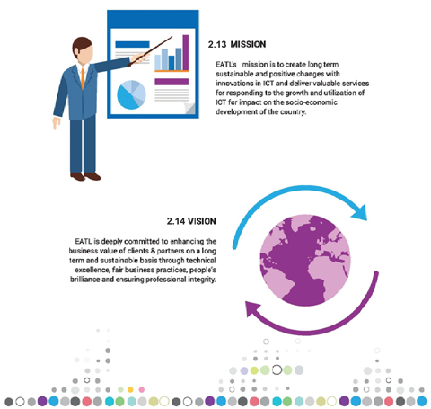

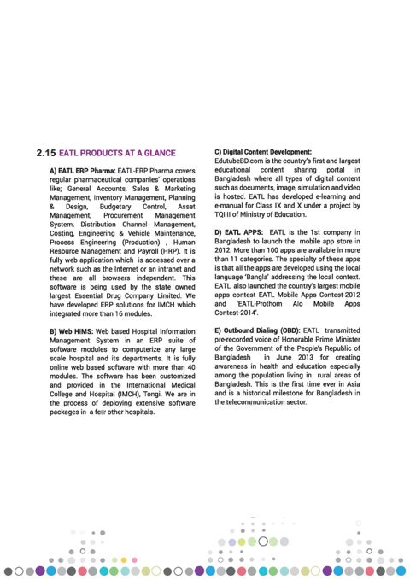
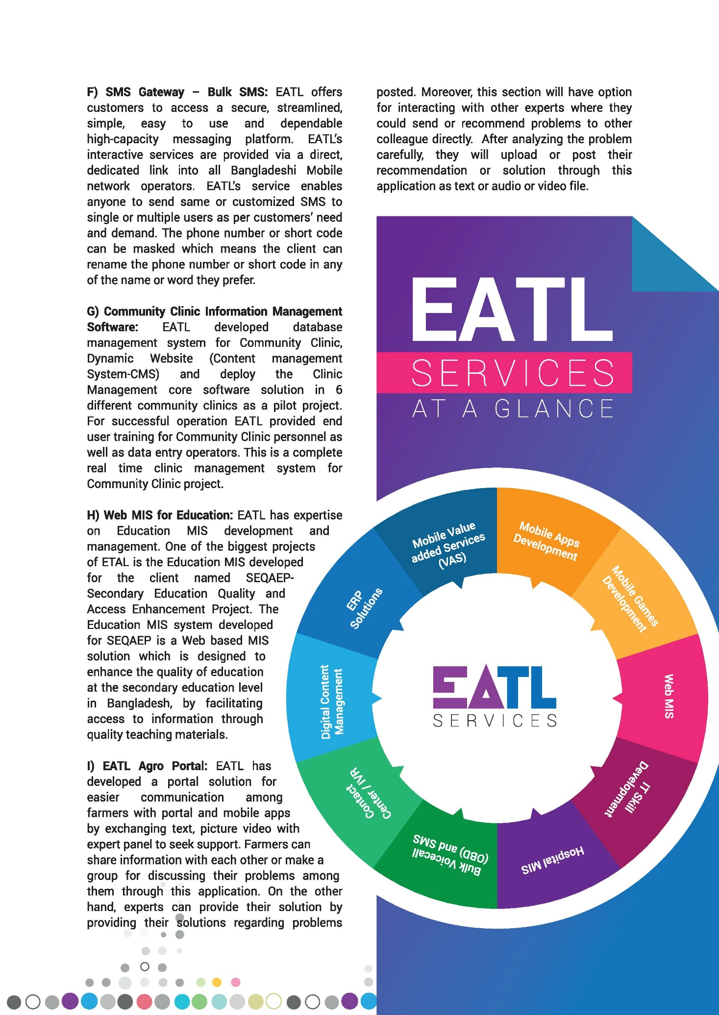
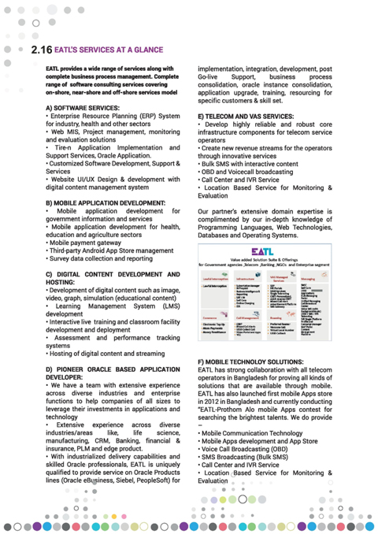
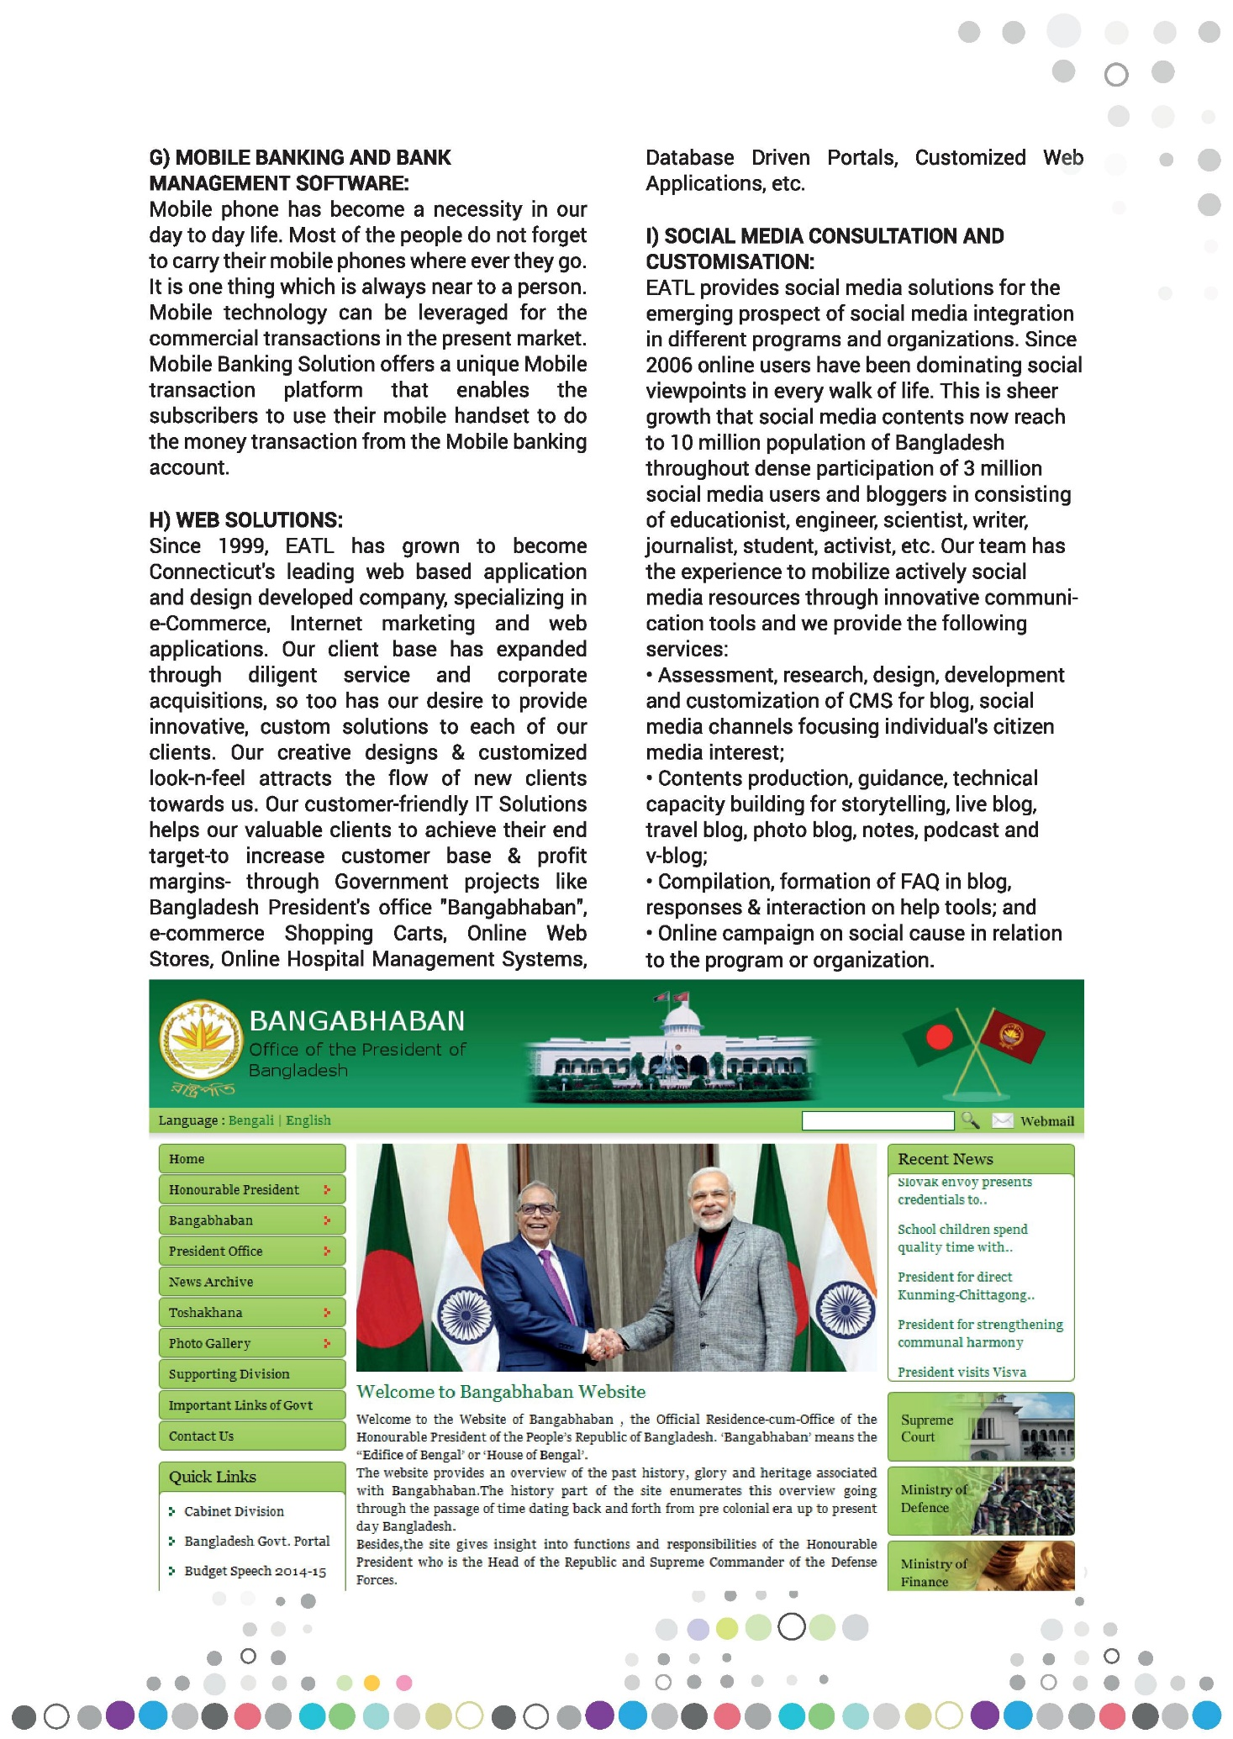
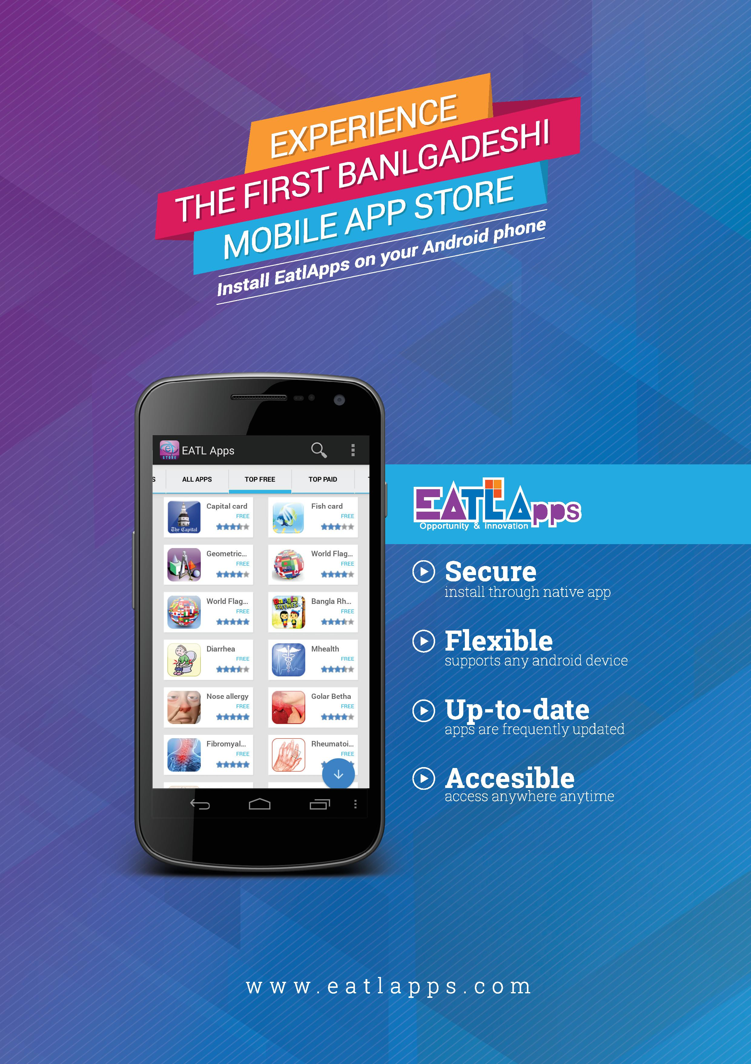

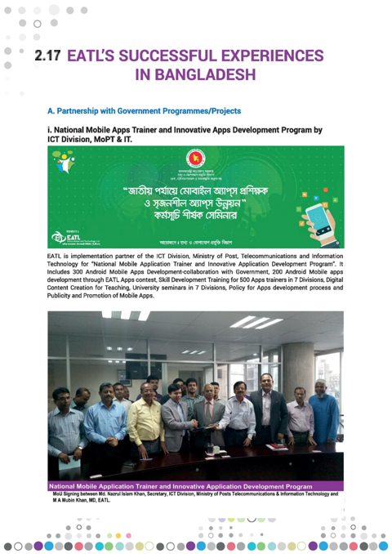
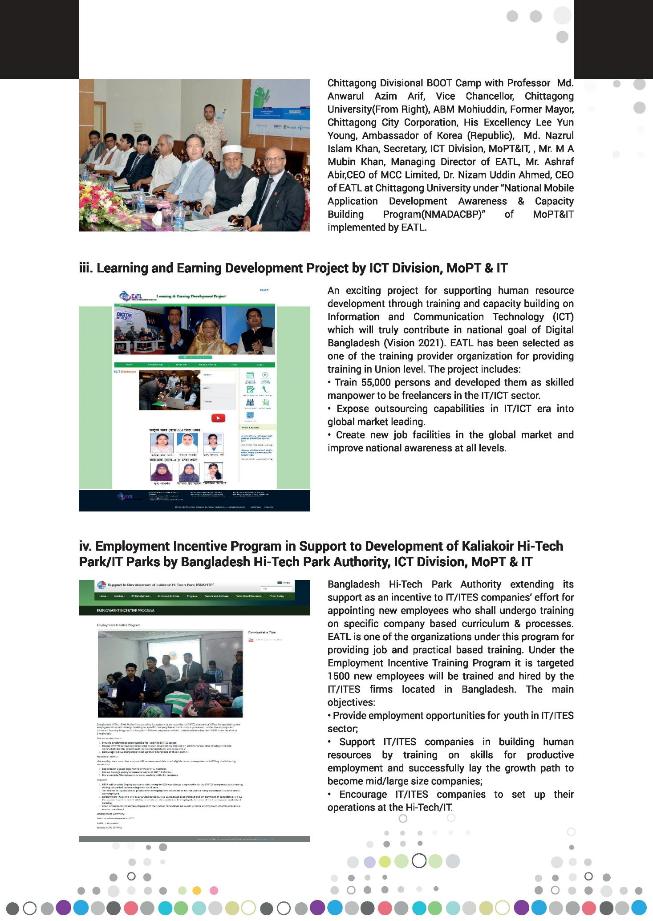
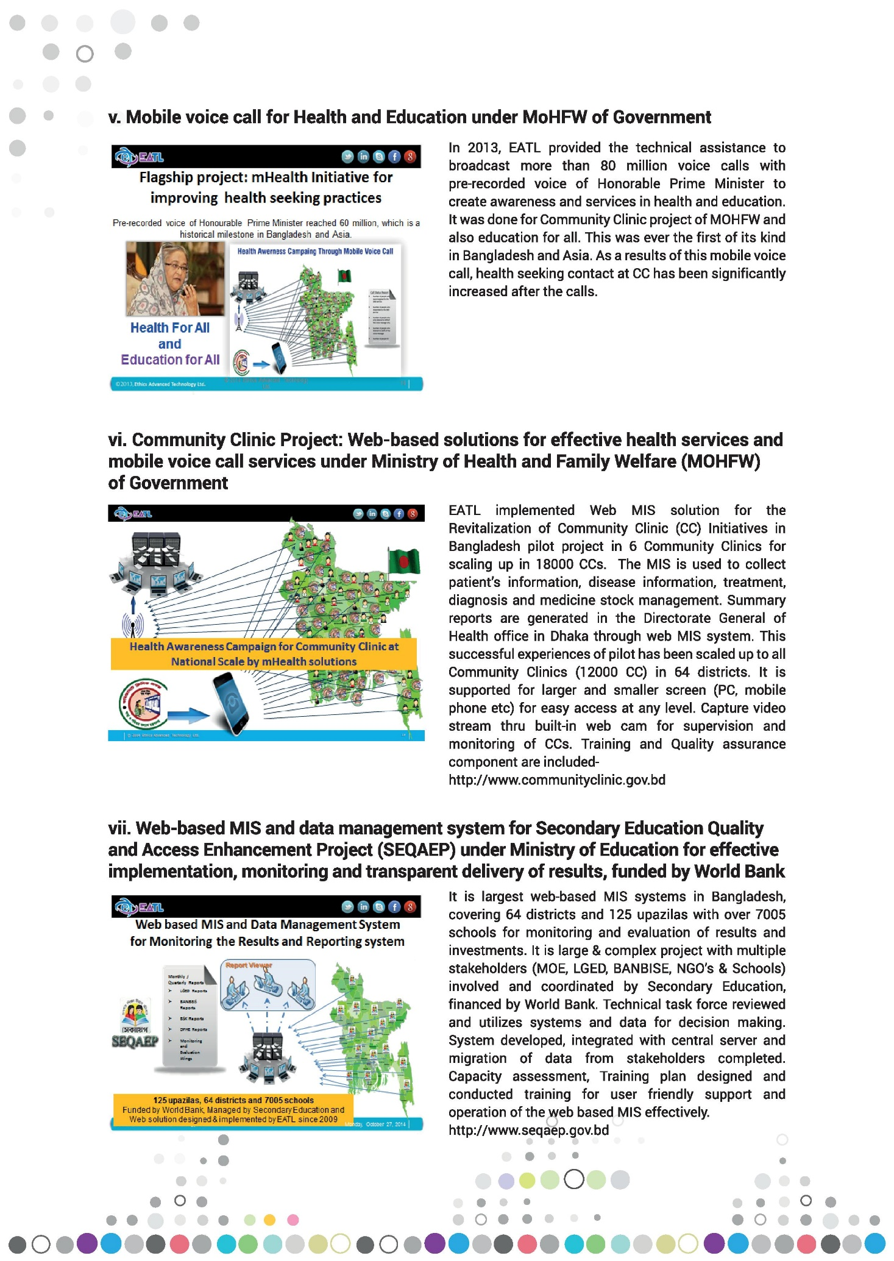
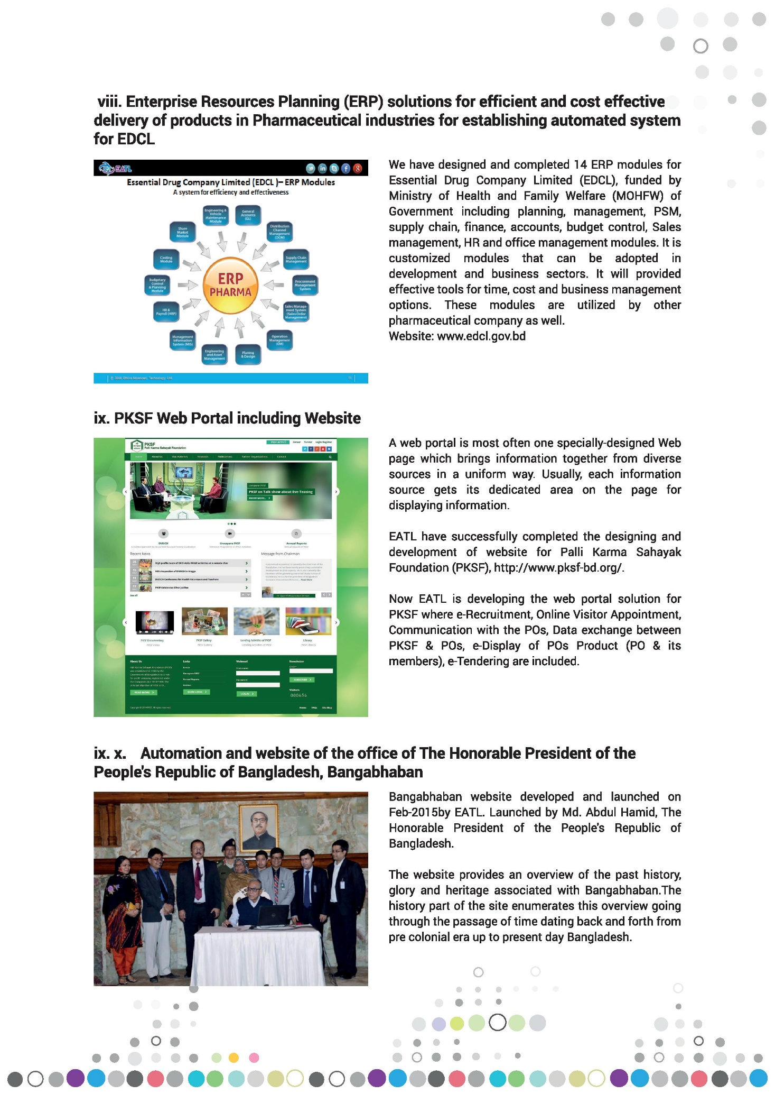
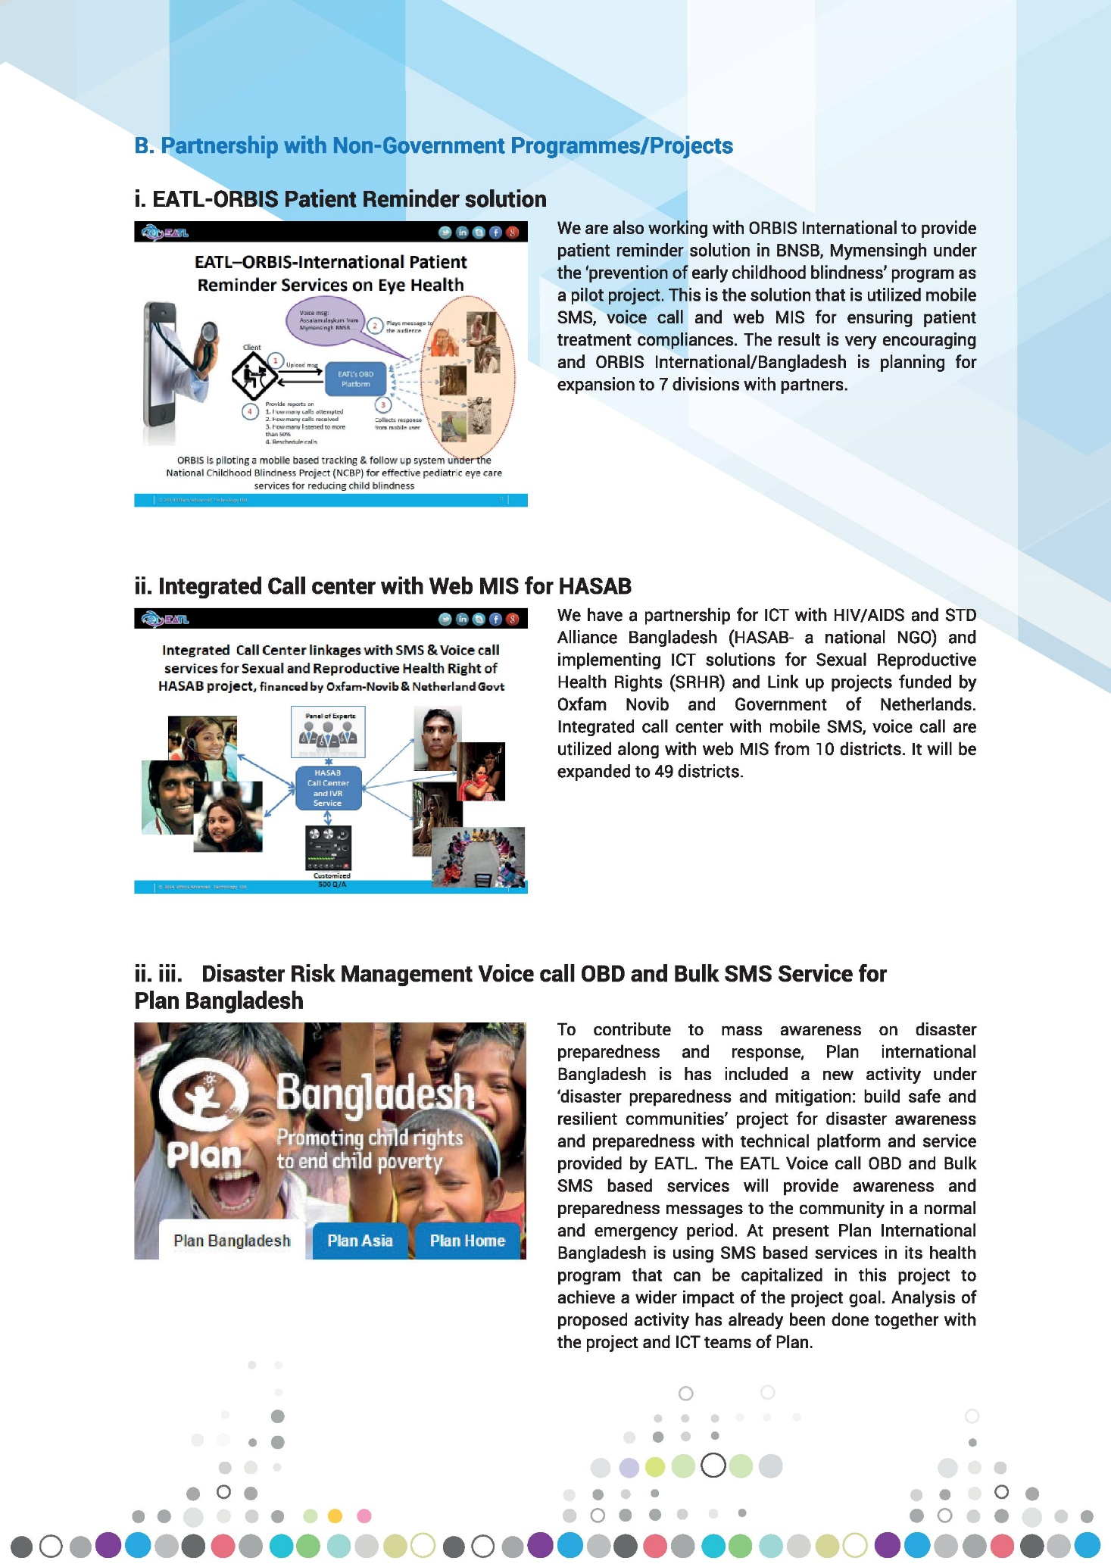
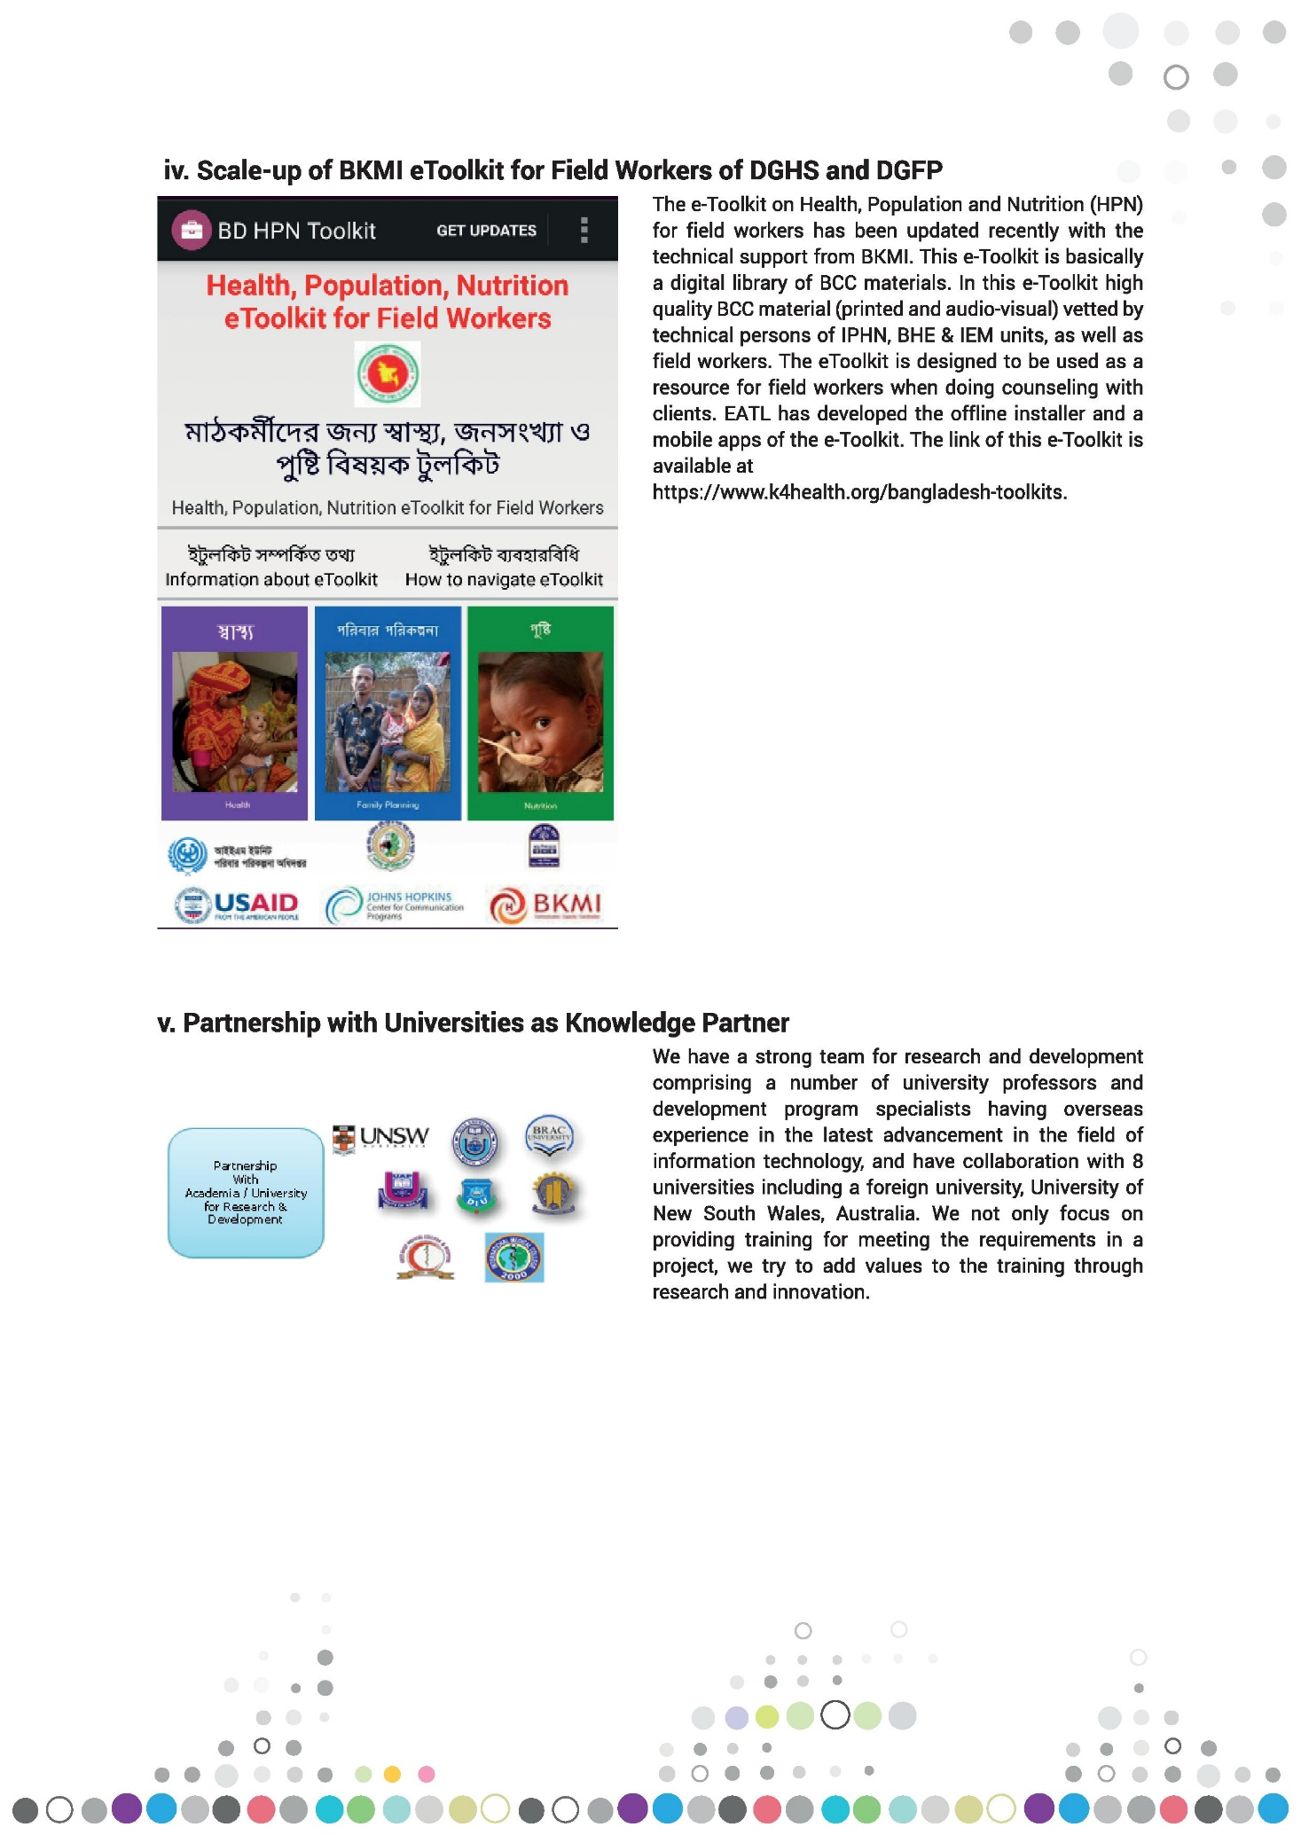
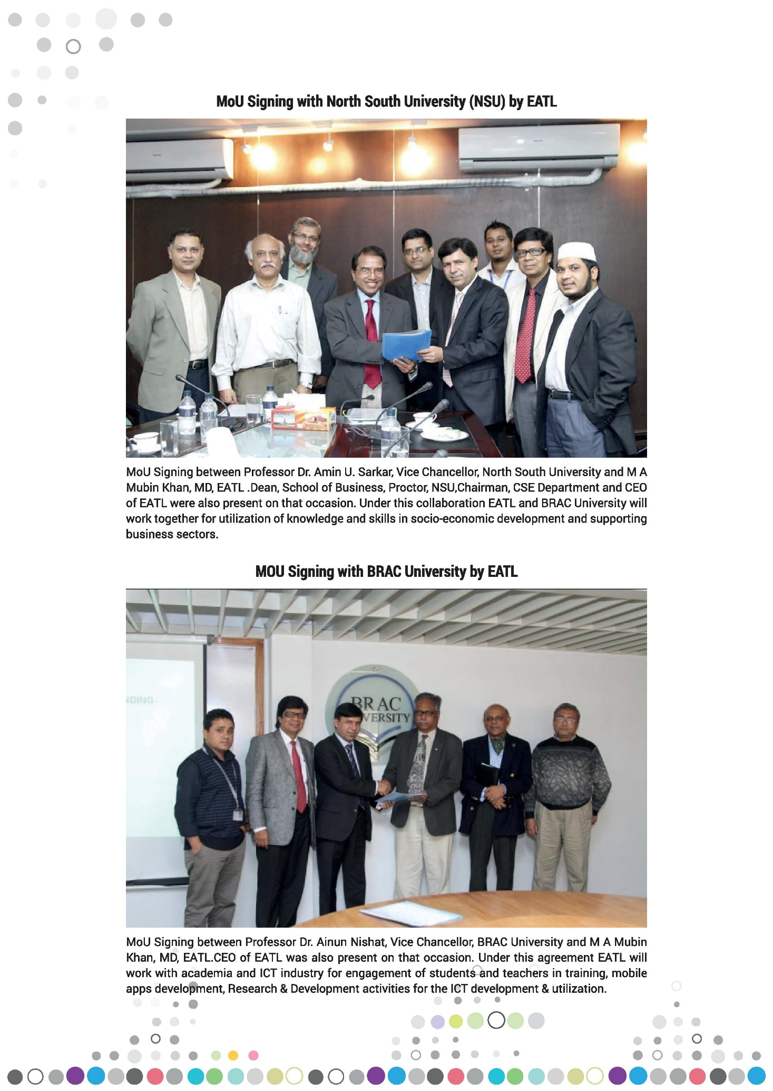
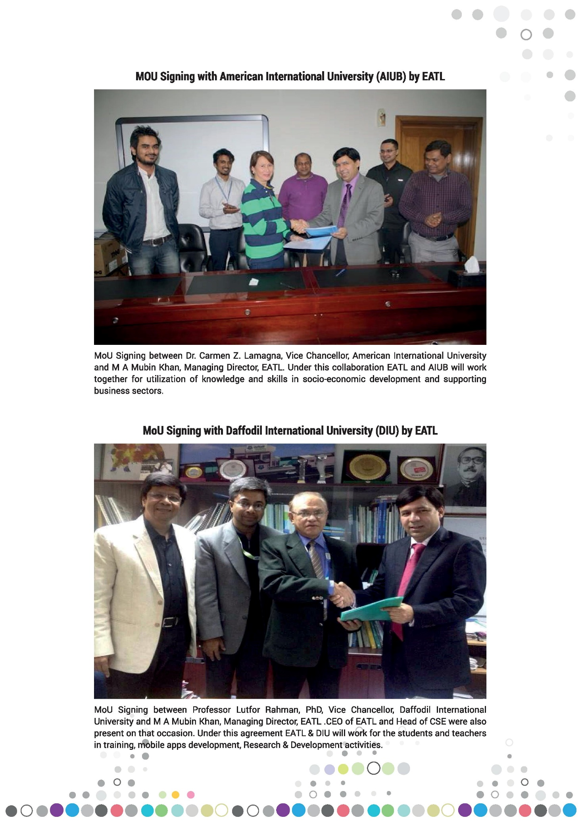
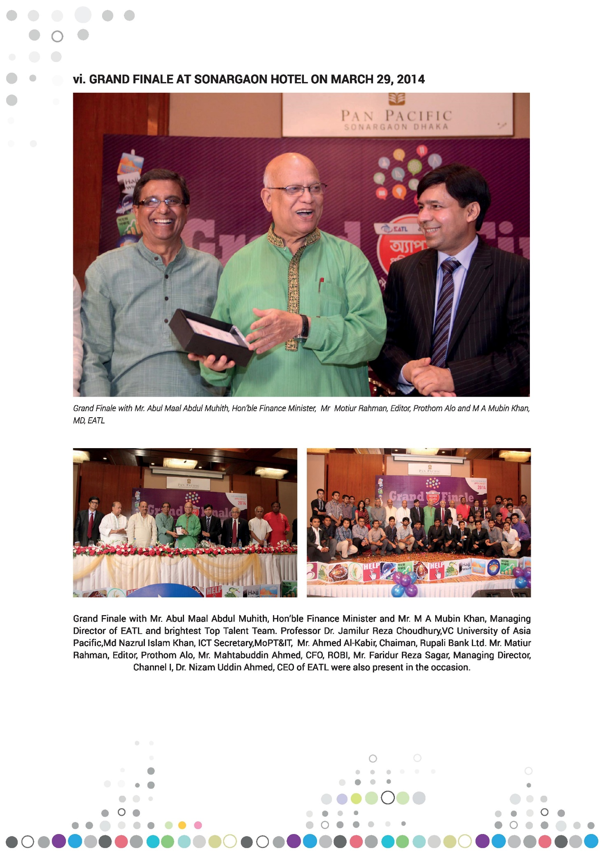
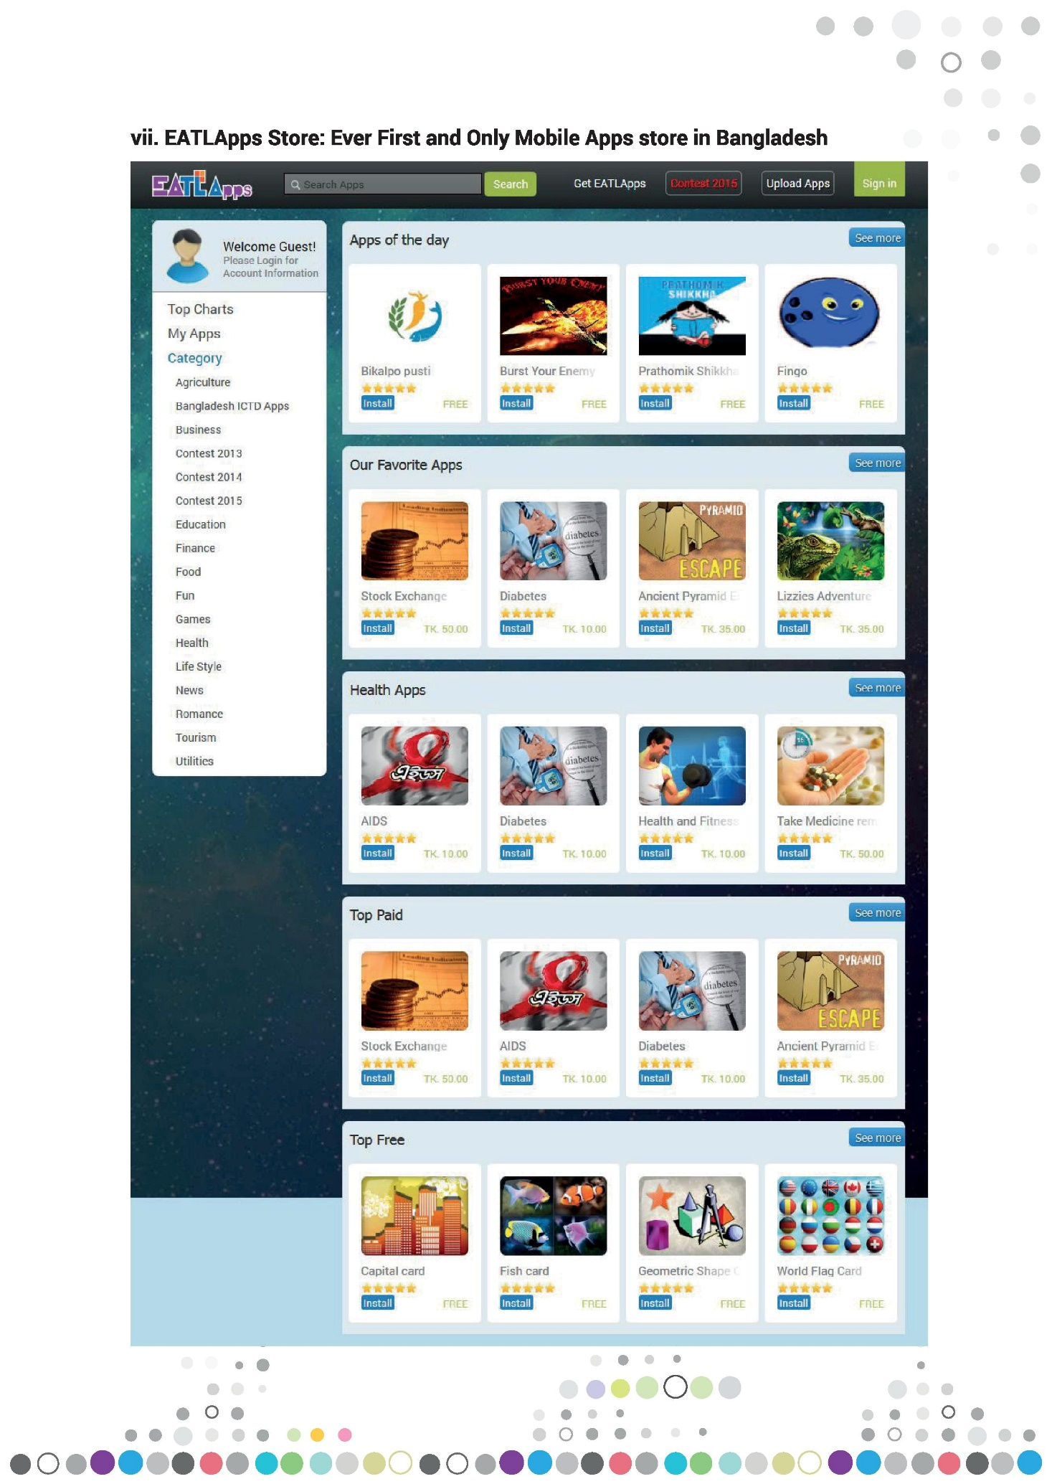
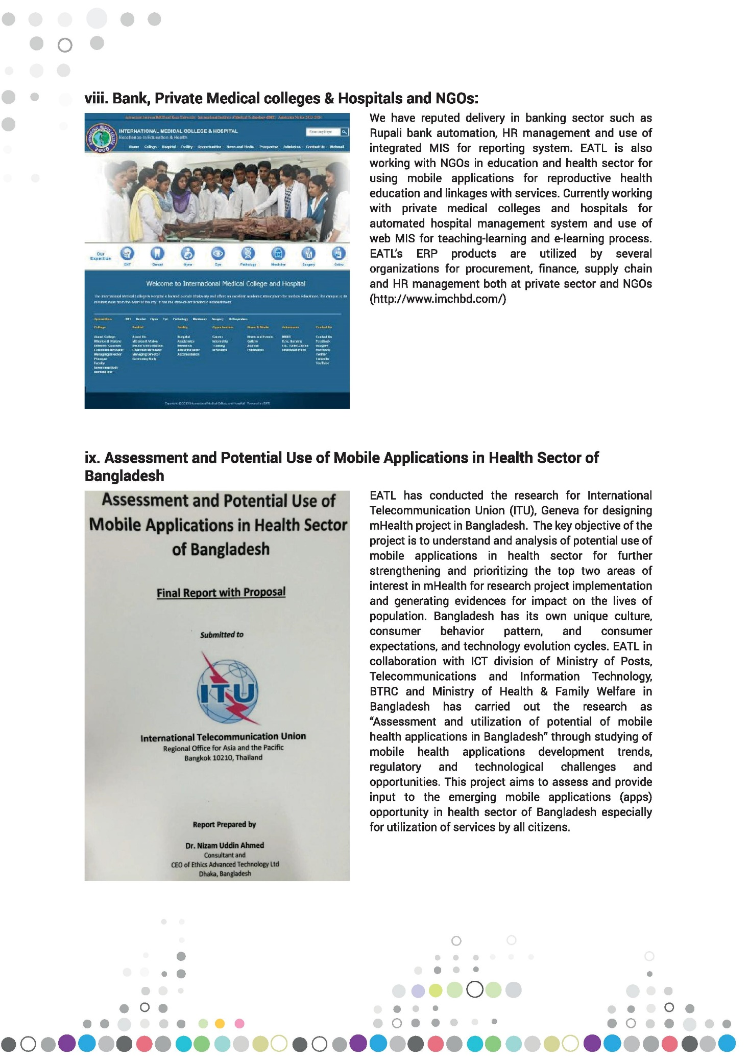
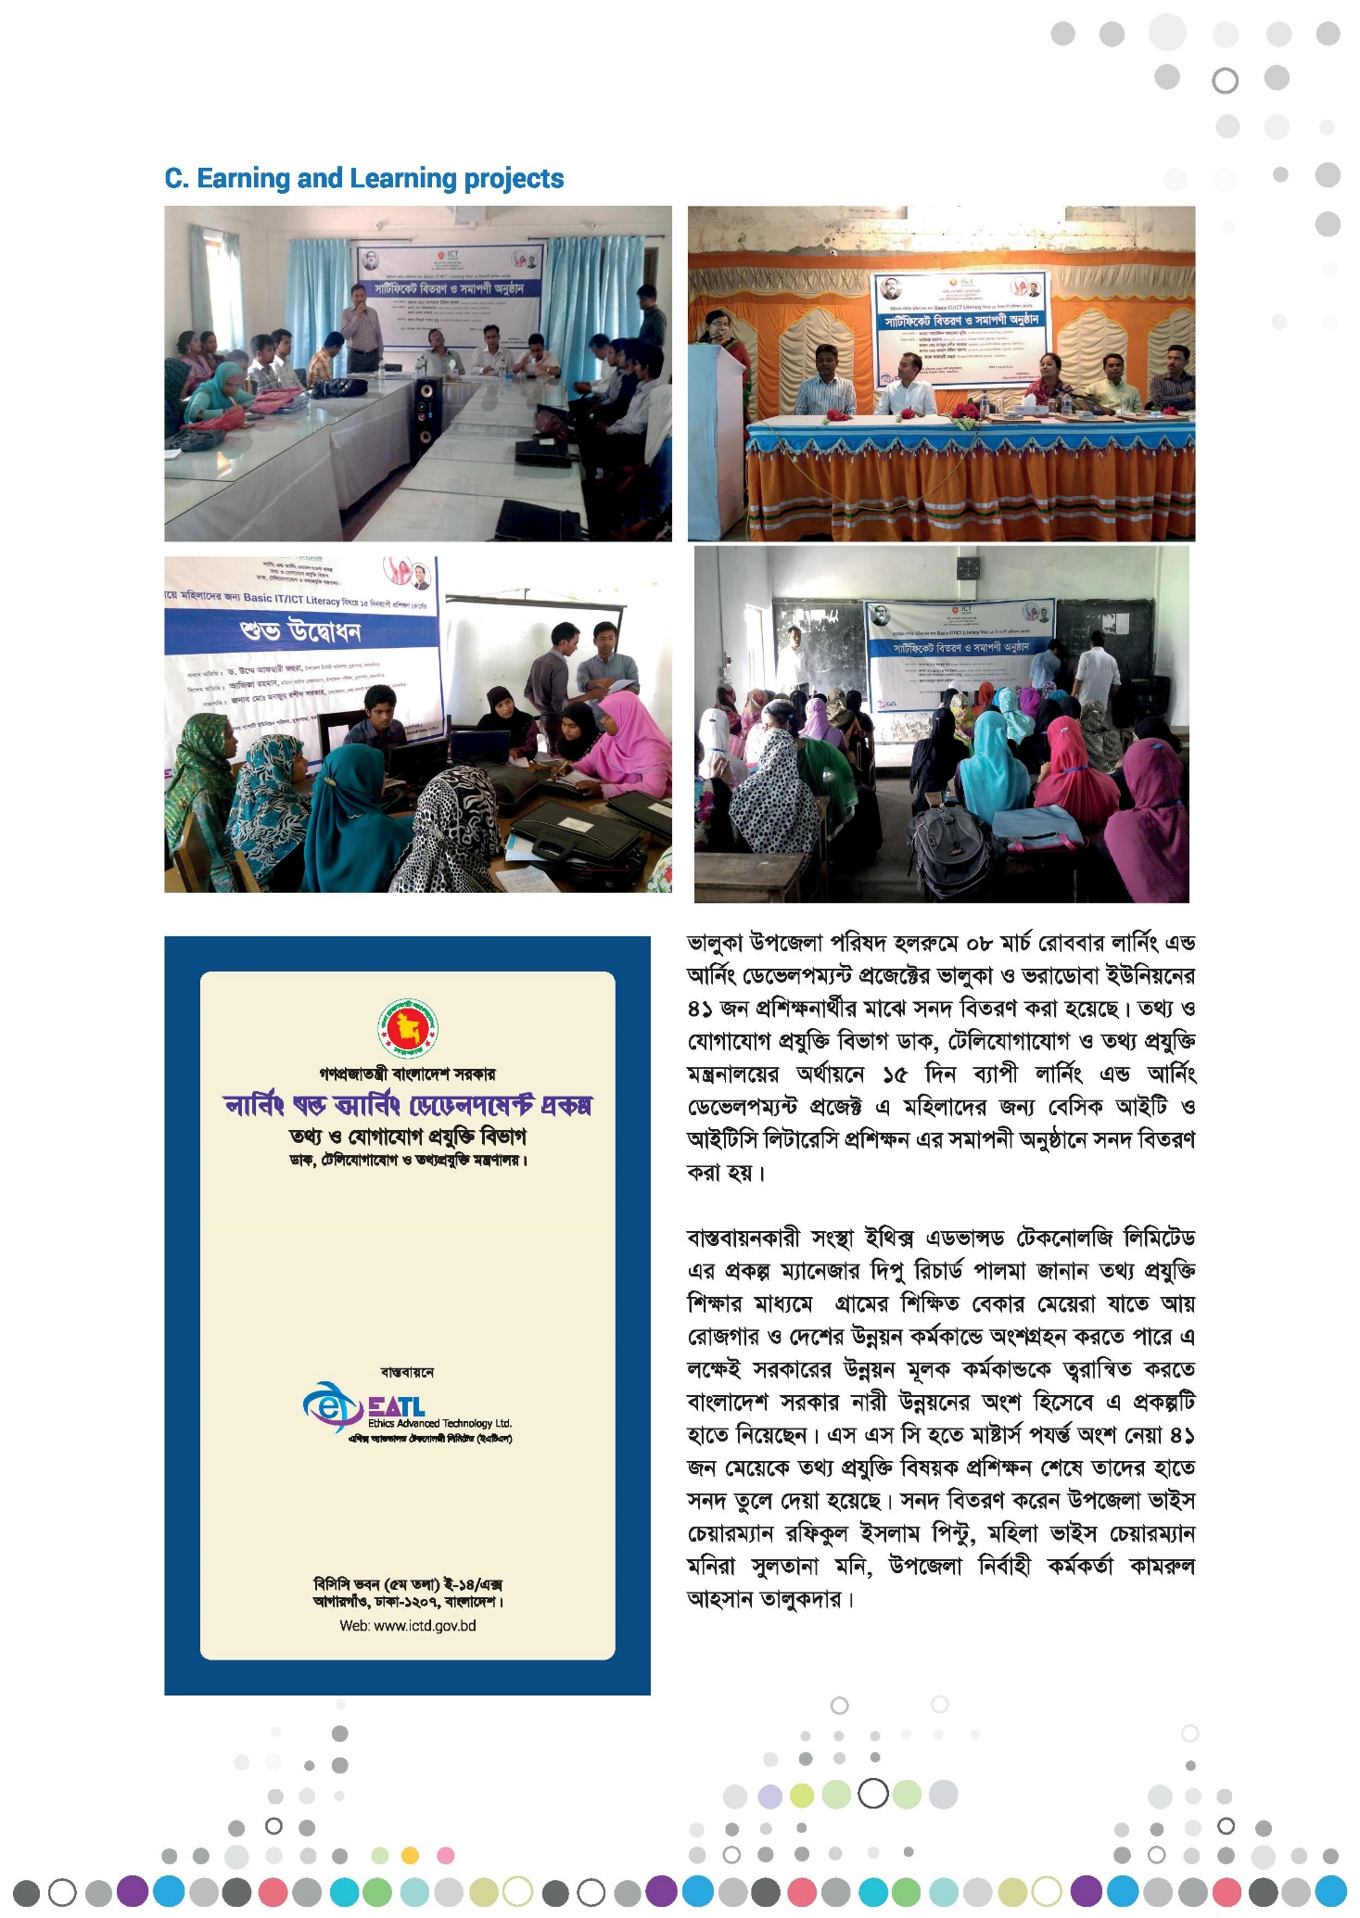
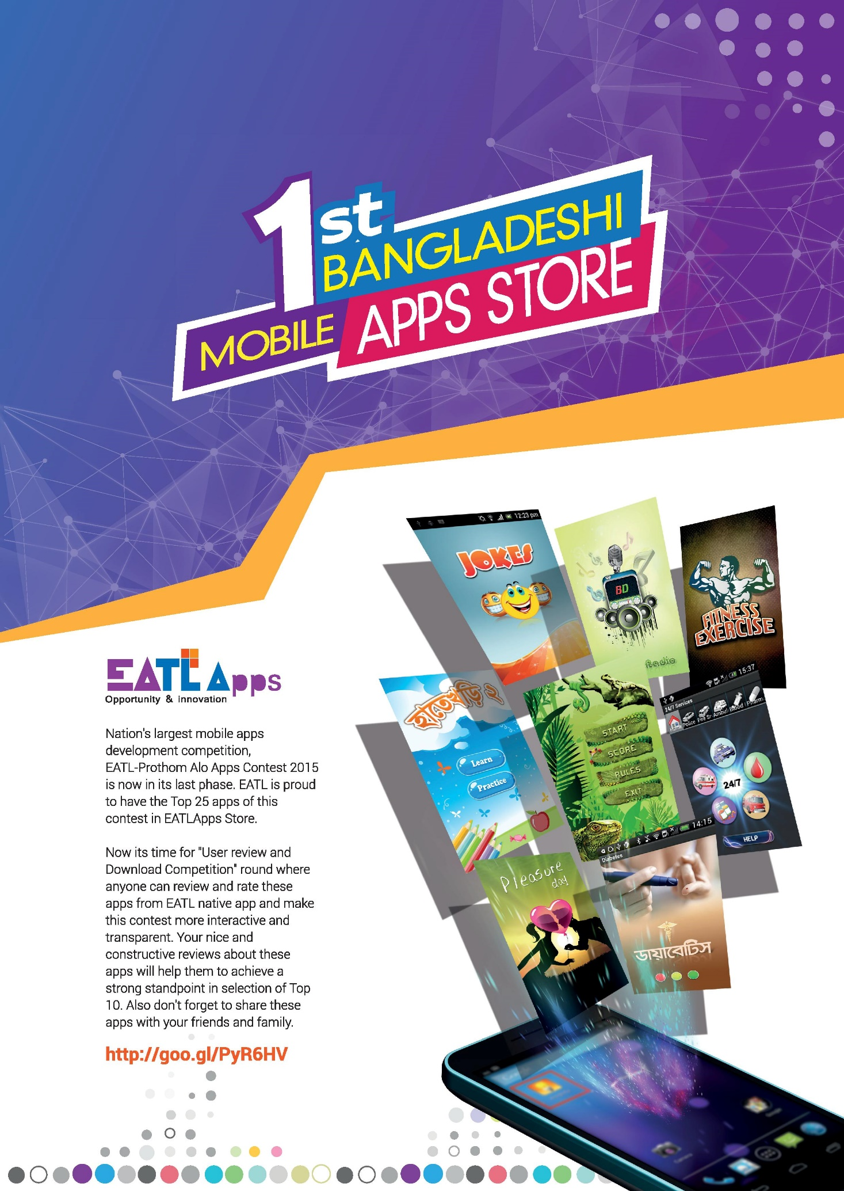
2.18 Marketing Plan of EATL:
HIMS have high prospect on medical industry. Because, to create accountability company must need this solution. There is no other option. Our focus will be, make the Mid Level Hospital/ Clinic/NGO our client. Newly developed Medical College should be targeted.
Research:

2.18.1 Customer Need:
- Accountability
- Fair Accountancy
- Reducing processing time.
- Create backup.
- Track Customer.
- Keeping History.
- Building perfect database.
- Human resource Management.
- Payroll.
- Integrate between several branches.
- Can access from anywhere.
- Track students.
- Inventory control.
- Library management.
- Hostel management.
- Class routine management.
2.18.2 Strength of EATL:
- Already build own HIMS solution.
- In house production.
- Available Engineer.
- Prompt customer support.
- Standby engineer support while developing HIMS.
- Financial backup.
- Logistics.
- Experience.
- Government influence.
- Highly experienced advisor.
- Strong business development team.

2.19 Growth and Trends
EATL has been able to set up a great team since its birth. The company now has a batch of strong middle managers and is expecting that the company will lead into next phase of growth. The focus of the company is to reduce dependency on the founders and turn the company into an employee led company.
At the same time, EATL emphasized on their organizational structure and systems to ensure effective management of their growing team. Today they are managing more projects than before at the same time with less hassle.
Their major change in strategy took them to another level. They started focusing on diversification. In 2014, EATL took a massive blow when one of the major clients ended their business with the company. It affected the growth very badly. It slowed their progress but could not stop them from coming back in track. They struggled for a time being and eventually got back their regular growth. But the company took a very important lesson from that event. They focused on diversifying their business activities, this will enable them to avoid disruptions in the future.

Customer Mix
EATL serves both institutions and individual customers. The company is mainly serving clients from Europe and North America as well as clients from the home country. EATL has referable clients in Norway, Sweden, UK, Nigeria, India, Switzerland, Canada, and USA. Individuals and some local institutions are also a part of customers of EATL IT Limited.
They are now thinking of expanding their referral customers and targeting the potential market of Japan and many other countries of Europe.

2.21 SWOT Analysis
EATL believes that the company’s success comes from disciplined actions of their sound process of software development. They focuses on the long term goals rather than short term gains which helps them to achieve impressive results for the clients. They work towards gaining client’s satisfaction and value the thought of their potential customers demand.
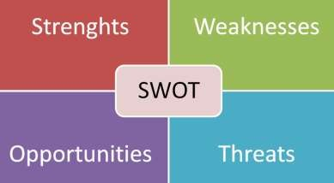

2.21.1 Strengths:
EATL‟s biggest strength is its highly skilled and talented software engineers. They follow their business standards and policies ethically. They always believe in team work and their team work brought them lots of success throughout the past years. They always maintain accountability and transparency with the clients, which makes them a trusted partner of those clients for a longer period of time. EATL‟s another core strength is the existing clients, they are continuing business with them, on the other hand, they are also referring EATL to other potential clients.

2.21.2 Weakness:
EATL started their journey with only Eight persons. Today they have more than fifty-five software engineers working to build the company as a leading company in the market. But sadly, they still lack necessary man power, they need more talented software engineers to keep pace with the leading companies in the market. Another major weakness is the slow internet connection, which hampers the productivity of the company.

2.21.3 Opportunity:
EATL has lots of opportunities in front of them if they can adopt proper marketing strategies. They need to invest more and prepare a strong platform to attract foreign clients. The introduction of digital payment system can help them a lot in doing business with the foreign companies or individuals. This will expand their business globally. Every year almost 1600 IT students complete their graduation, this can be a great opportunity for EATL to hire quality students and train them to be skilled enough for the company.

2.21.4 Threats:
The IT industry of the country is matured and more and more companies are registering in the sector. EATL‟s biggest threat is entrance of new companies in the market. On the other hand, another concerning factor for EATL is the employee turn-over rate, as EATL is a startup company, there is an active threat that the employees may leave for more established company.


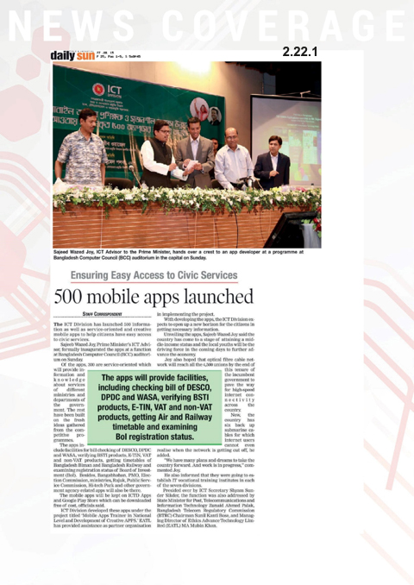

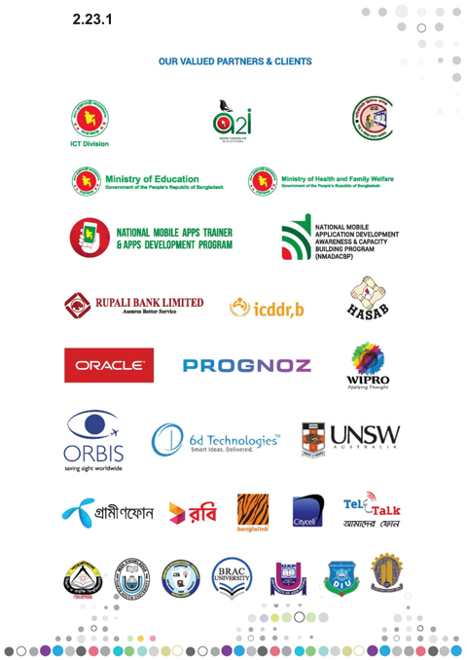
Chapter 3 Analysis of the industry

Industry Overview
The software industry has gone through a remarkable growth in the past few decades of the country. The industry has now matured. The IT sector of Bangladesh started before its independence, when the IBM Mainframe 1620 series was introduced in the Atomic Energy Commission of the country. After the independence in 1971 more advanced IT equipment began to set up in different educational, research and financial sectors of the country.
Today this industry is fully matured and is unveiling lots of opportunities to the young energetic entrepreneurs. It is contributing to the national income by giving employment to over 30,000 IT professionals and the graduates.
The most distinctive feature of this industry is the huge number of young entrepreneurs are present in this industry. In the past decades many tech savvy graduates entered the industry some of them have also completed higher education in abroad and returned to start their own business venture.
Bangladesh Association of Software and Information Service recently carried out a research on the tech industry and found out that most of the IT companies are indulged in software development activities and a large number of those companies are simultaneously involved in providing of different types of IT related services. In total half of the surveyed companies are involved in providing IT enabled services (ITES) such as, data/form processing, content management, graphics designing, website development and designing etc. A number of companies have developed software or software related products or services for their clients in the local market and abroad as well. Companies that are developing digital content are mainly providing their service through mobile platform.
The IT sector has started to go through a rapid change when the government of the country initiated the strategic “Vision 2021” plan for wide range development of the country to turn the country into a developed country by 2021. One of the integral part of Vision 2021 is “Digital Bangladesh” which emphasizes on the IT sector of the country.

Digital Bangladesh:
The “Digital Bangladesh” initiative consists of four key priorities:

    - Developing human resources ready for the 21st century
    - Connecting citizens in ways most meaningful to them.
    - Taking services to citizens‟ doorsteps.
    - Making the private sector and market more productive and competitive through the use of digital technology.
Bangladesh has climbed up 24 places in United Nations E-Government Development Index. The country has secured an impression leap upward to the 124th position in 2016 from 148th in 2014. More than 200 services are available through 5,275 digital centers established all over the country. Over 25,000 web sites including those of upazilas, districts, divisions, departments and directorates have been added to national web portal. National Enterprise Architecture (NEA) is being built by the Government to facilitate interoperability and operation of e-governance activities.

Industry Structure:

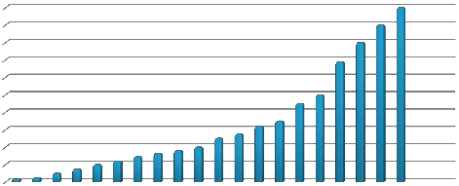

Bangladesh Association of Software and Information Service (BASIS) is the main governing body of the country that monitors the software and IT industry of the country. It started its journey in 1997 with just 17 charter members. Today BASIS have more than 1100 members and more are registering for membership. These members account for the lion’s share of the total software and IT Industry revenue of the country.
Membership Growth
1000
900
800
700
600
500
400
300
200
100
0

Graph 1: Membership Growth of BASIS (BASIS Survey 2017)

Recent Trends & Dynamics of the Industry:
According to BASIS Survey 2017, there are more than 4500 IT firms operating in Bangladesh. They are earning about revenues of 700 million US dollar. There are more than 3,00,000 IT Professionals working in the industry. 44% revenue came from the Software development, on the other hand 56% revenue came from IT enabled services, as of Survey report of 2017.



Revenue Chart
[VALUE]
[VALUE]
Software ITES
Graph 2: Revenue Chart of IT Industry

Majority of the IT companies of the country specialize in customized software development. 56% of the BASIS members claim it as their specialty. The next most common specialization IT Enabled Services (ITES), with 17% of BASIS members reporting it as their specialty, and Ecommerce/Web site development, with 12.45% of BASIS members reporting it as their specialty.
The 2017 BASIS survey also found that 43 percent of Bangladeshi IT companies had a presence in local and foreign IT markets, while 48 percent of Bangladeshi IT companies catered for the local market, leaving only 9 percent of Bangladeshi companies that cater for foreign customers.

SWOT Analysis of the Industry:
To get a better picture of the current situation of the IT industry, a SWOT analysis is must. Based on the information available on the internet and in various articles. A SWOT analysis is made on this industry.

3.5.1 Strengths:

The country’s IT sector’s main strength is its young, energetic and motivated workforce, which can be trained to be fitting for any IT roles. Bangladesh has the lowest median age in the world, which is only 26. On the other hand, young professionals can understand and communicate in English very well. This allows these professionals to be eligible for enormous pool of works and can take an IT venture forward. There is already a huge number of Bangladeshi IT professionals working in freelancing sites like freelancer.com, fiverr.com, upwork.com, odesk etc. These persons can be trained to be fit for complicated IT related activities.

3.5.2 Weaknesses:

The most vital weakness of this industry is the lack of higher level skills and know-how. Though it is easy to get human resource skilled in low-end IT activities, it is very difficult to get experienced senior-level professionals who have tons of experience in IT. The migration of skilled IT professionals to other developed countries stuns the development of this sector.
Another major weakness of the industry is the lack of physical infrastructure. Bangladesh does not have necessary infrastructures that are must for advanced IT related tasks. Poor internet connection throughout the country hampers the development of IT sector.

3.5.3 Opportunities:

The continued economic growth of Bangladesh will drive greater demand for IT enabled services at all levels of the economy. The government‟s identification of ICT as a major thrust sector of the economy and the granting of tax-free status to all IT companies are an attractive proposition for any IT company to earn attractive returns from a fast growing domestic market.
Rising labor costs in India and the Philippines give rise to a window of opportunity for Bangladesh to grab some of the ITES and BPO market as these are highly cost-sensitive industries. There is already a significant population of Bangladesh freelancers who work at online freelancing sites such as ODesk and Freelancer.com. This means that a ready population of skilled workers are already available who can take advantage of labor cost arbitrate to establish a foothold in the BPO/ITES market.

3.5.4 Threats:

The 2016 terrorist attack on a restaurant oriented by foreigners caused the security-related perception of Bangladesh to plummet to historical lows. This perception will be very hard to overcome, and any future terrorist activity will further reduce the perception of the country as a safe place to do business.
The continued trend of migration of skilled IT personnel to developed countries will continue to post a threat to the development of capable domestic IT firms, as senior level IT personnel are required in the higher-level software architecture roles

The Challenges of the Industry:

There are some challenges the industry players must consider. These challenges will determine the success of those players. The IT industry of Bangladesh has all the potential to compete in the international market side by side with our neighboring country like India, who has almost double the revenue of ours in the market. But scenarios are changing Bangladesh is showing its capabilities to the world, but to ensure sustainability of those capabilities the industry must take on these challenges to make them a strong contestant in the world market.

Development of High-Tech Infrastructure:
The development of the high-tech infrastructure is a must thing for the country. IT industries need the back up of high-tech infrastructures, without it the sector could not go much further. In this modern era of digitalization, technology evolves rapidly for that we need to remain up to dated. The current scenario of the IT infrastructure of the
country is not satisfactory. But things are changing, in the past few years the infrastructures have developed, yet it needs to be on the level from which we can challenge our competitors in the market. One of the positive sign is the development of power sector, the frequent discontinuity of electric supply has been reduced to a convenient level. The internet connection of the country still needs to be prompt. Most of the IT companies face the problem of slow internet, which eventually reduces their productivity and efficiency. The government of the country must give full emphasize on the IT industry if they are to fulfill the vision 2021 dream.

Training the Talents:
Every year thousands of graduates from IT background are expecting to enter the domestic industry. But without proper training they are not going to add much value to the industry. The IT sector of the country is going through a rapid change. The IT personnel need to be trained with all the latest technological upgrades.
The government of the country is already subsiding in training of IT personnel, as well as trying to make unskilled people skilled in IT sector. They are determined of providing all the support needed to train the people in IT sector.

Intellectual Property (IP) Rights & Data Privacy Concerns:
Intellectual property right is one of the biggest issues in the creative industries. Without the strong presence of IP rights, people who are interested in creating and innovating IT applications will at first want to protect their innovations. Bangladesh’s IP rights and data privacy concerns are not much good. The legal and regulatory environment of the country is less favorable for the IT and ITES market comparing to the off-shoring giants like India and Philippines.
Bangladesh is currently ranked 99 out of 138 in World Economic Forum’s (WEF) IP protection index. We need to improve our ranking in this IP protection index in order to prepare a well-established platform for the competitiveness of the industry. The protection of intellectual property will encourage more tech enthusiasts to join the industry and those who have completed higher education from foreign universities will likely to return to the country and use their knowledge and wisdom for the betterment of the industry, eventually for the country.

Software Technology Parks
In accordance with developing the IT sector of the country, the government has passed High- Tech Park Act in 2010. Eventually, Bangladesh Hi-Tech Park Authority was established in 2010 to create, maintain, operate and develop Hi-Tech parks.
The remarkable Hi-Tech Parks are-
- Kaliakoir Hi-Tech Park
- Jessore Software Technology (IT) Park
- Sylhet Hi-Tech Park
- Mohakhali IT Village
- Janata Tower Software Technology Park
- Barendra Silicon Valley, Rajshahi

Chapter 4
Internship Work Experience

Internship Recruitment:
EATL has a systematic procedure for recruiting interns. At the very beginning they shortlisted the candidates and then invited for a written exam, that included mathematical problems, IQ tests and basic computer skills. I have successfully passed the exam and after the final interview I joined here as a Marketing Development Intern.

Position, Duties and Responsibilities:
I joined eatl as a Marketing Development Intern. My key responsibility is to help the business development team in carrying out the Marketing related tasks. I worked under Sharmin Mahjabin, who is the Head of Marketing of EATL Limited and Moeen Uddin Sabuz, who is a Assistant Manager, HR & Admin of EATL Limited. Some of my job responsibilities include:

4.2.1 Writing blogs for company website: A blog is meant to generate awareness about a brand. Throughout my internship period I have written some blogs for the company. The topics of the blogs were assigned by my supervisor. Those were tech blogs as well as non tech blogs. The main purpose of our blogs are to connect it to the relevant audience. Another purpose of our blogs are to rank our website higher in Google SERP‟s (Search Engine Results Pages).

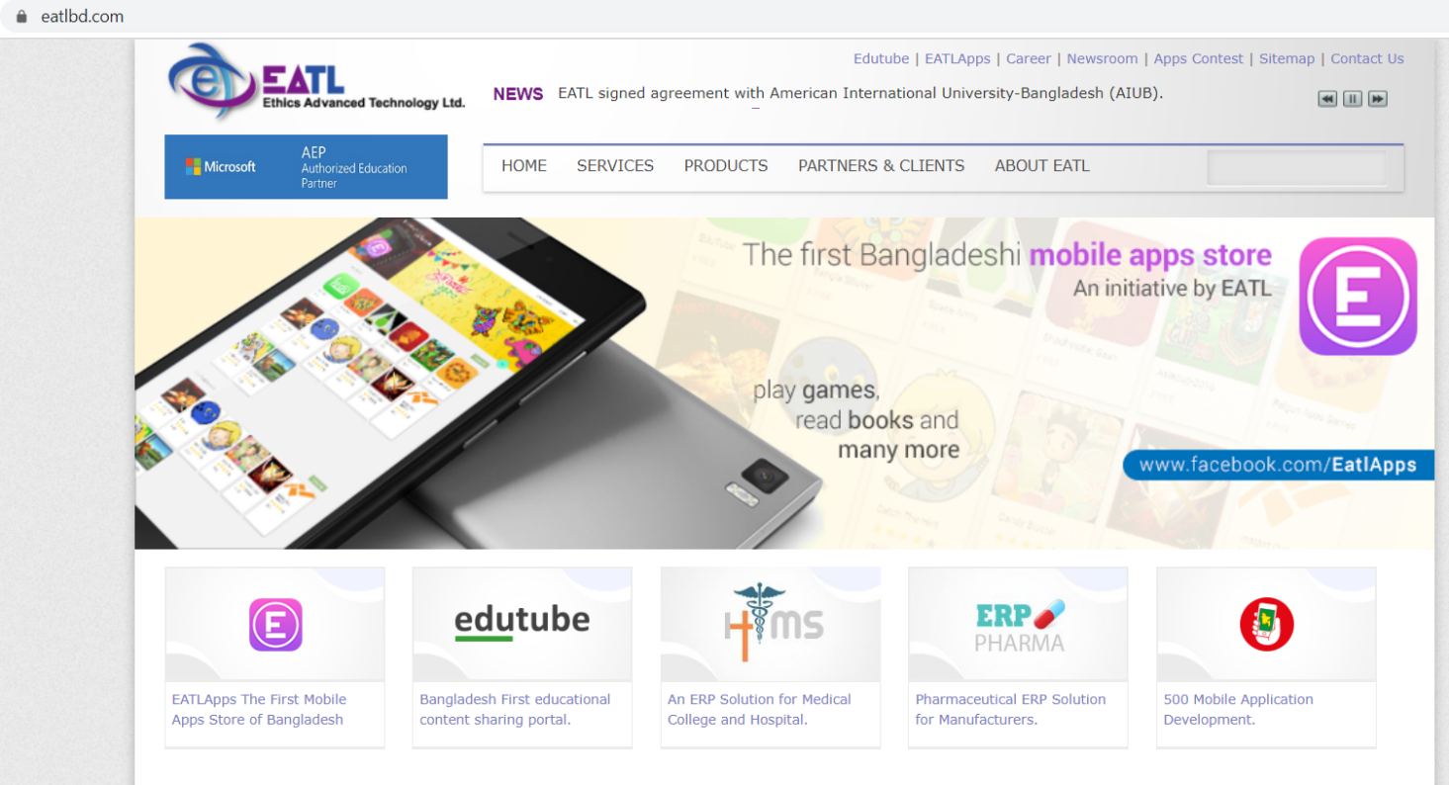
  - About Edutube:

4.3.1 EDUTUBE BACKGROUND:
The purpose of edutubebd is to remove every barrier between a similar level student in Bangladesh so that everyone gets same benefit out of learning and sharing. Majority students of Bangladesh lacks from many education facilities, contents, lectures, notes, demonstration because of proper guidance, support & infrastructure. Few affluent students get touch of excellent education materials mostly in urban areas, thus can enhance their knowledge, learning to develop & nourish their talent extraordinary. With the help of technology if we can build a platform where these facilitated students, well known teachers will provide their materials absolutely free just to help & enhance another student who couldn't access it because of location & affordability, within just a click in the portal a student of class10 , though residing in village, far way, will be able to view the same note, lectures, suggestions, that Dhaka’s best school A+ student has. In this portal anyone can have an account or subscribe for free. Then any student, teachers, parents or guardians can log in to upload their education materials & anyone can download to access.
  - COMPANY INFORMATION:
edutubebd is a part of the product portfolio of Ethics Advanced Technologies Limited (EATL). Ethics Advanced Technology Limited (EATL) is a private company and a leading enterprise with innovative ICT services and solutions provider in Bangladesh established in November 1999. EATL’s business strategy combines application support, system design, database administration, feasibility study, software development, hardware solution, training, social media consultancy and ICT services in development sectors as well. EATL launched the first ever mobile application store in Bangladesh in 2012 which is branded as ‘EATLApps’. Find more about EATL in www.eatlbd.com and get exciting android mobile apps from Bangladesh first mobile apps store launched by EATL in www.eatlapps.com Company head Office Contact House#9 (5th floor), Road#16, Gulshan-1, Dhaka-1212, Bangladesh +88-02-8153220, +88-02-8153219 For any queries regarding edutubebd mail us at edutubebd.com

  - HOW EDUTUBE WORK:
Once a user has opened an account and wants to upload a content, first it will come to site Quality Assurance team just to check : Firstly, It is an educational content, not nudity, vulgarity to prevent hackers ill motivation Secondly its not anything encouraging cheating or plagiarism at the national level After proper evaluation & approval from quality assurance the content will be up & live in the site within 24 hours. It can be in any format like a image, word file presentation, pdf, video. A new user or student visiting edutubebd for first time may search for his or her desired content in the search bar. The search result will comprise of all the relevant materials the site has like – word file, or video or presentation, matching the key word. To access it he/she needs to open the account, log in & can download & use. It comes with unlimited storage capacity for an user and will support all format of a content like image, word, pdf, presentation, video file as long as the content in retrievable or readable by general user. User may open with their existing Gmail and Facebook comment. Will be able to give comment; share & can have close group discussions in the form of written or video chatting. And it will store previous message privacy when a user is not logged in. One user will be able to subscribe for another user; eg: for teachers, lecturers to get mail notification that a new content is uploaded in the site as per his or her interest.
4.5 VISION:
Education is power. Education is wealth. With this self-determination, we hope to place education in everyone’s’ hand with the promise of a networked economy. This is a hope that keep every individual alive in the world, what keep us the too. The purpose of edutubebd is simply attaining it.

4.6 LOG FILE INFORMATION:
Log file information is automatically reported by your browser each time you make a request to access (i.e., visit) a web page or app. It can also be provided when the content of the webpage or app is downloaded to your browser or device. When you use our Service, our servers automatically record certain log file information, including your web request, Internet Protocol ("IP") address, browser type, referring / exit pages and URLs, number of clicks and how you interact with links on the Service, domain names, landing pages, pages viewed, and other such information. We may also collect similar information from emails sent to our Users which then help us track which emails are opened and which links are clicked by recipients. The information allows for more accurate reporting and improvement of the Service
  - MISSION
Our Mission is to make every individual of Bangladesh realizing sharing of knowledge makes it more powerful. To build a place where people will share everything, they learn with the bigger vision of together we learn, together we build.

  - Creating Registrations:

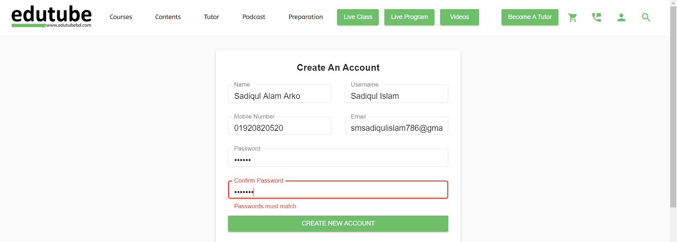

  - Creating video & MCQ contents: I had to create some video & MCQ contents for the company. Those contents were uploaded in the company’s YouTube page and other social media pages. I used Animoto website to create videos. The topics for the videos were given by my supervisor. The purpose of making video contents is to create and offer valuable contents specially customized for targeted audience. It helps to attract, engage and convert visitors. The process of uploading content on edutube is given below:

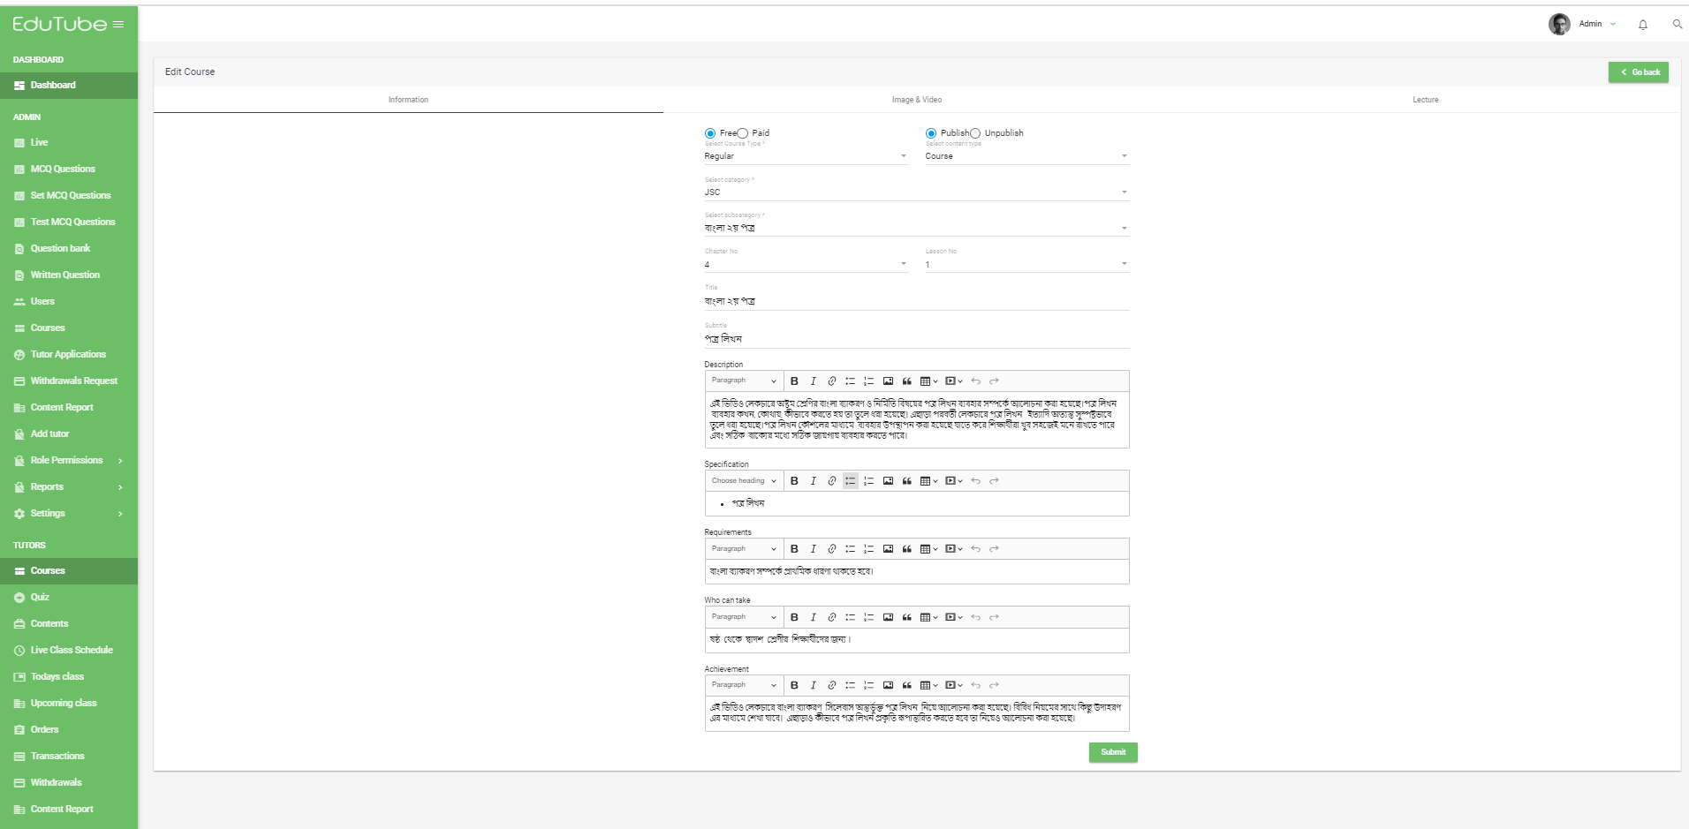

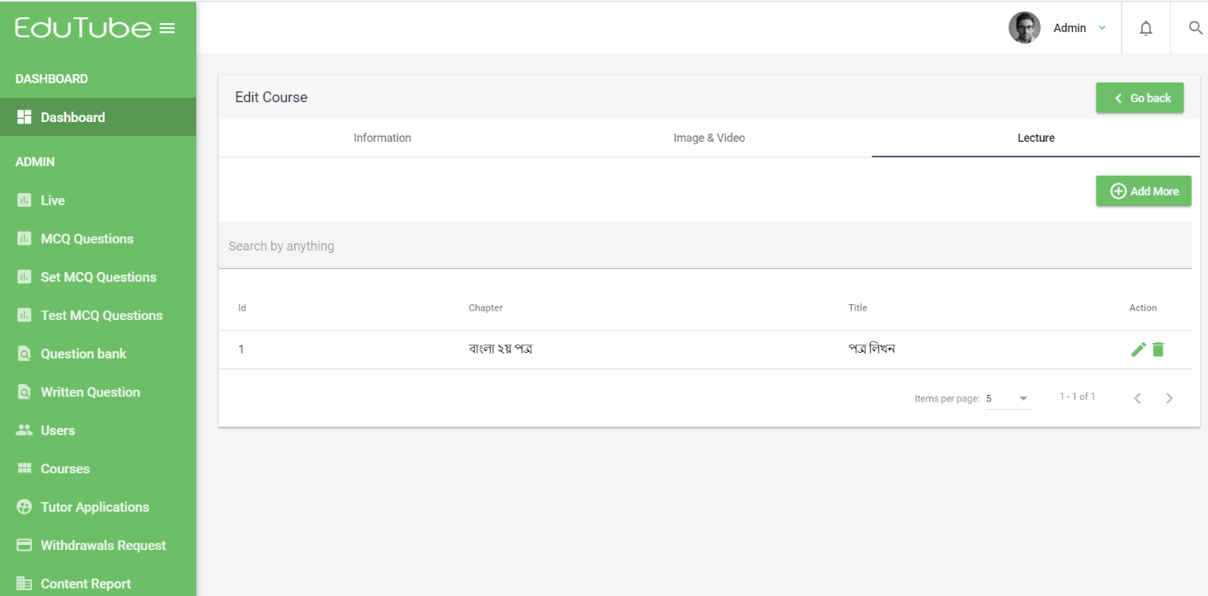

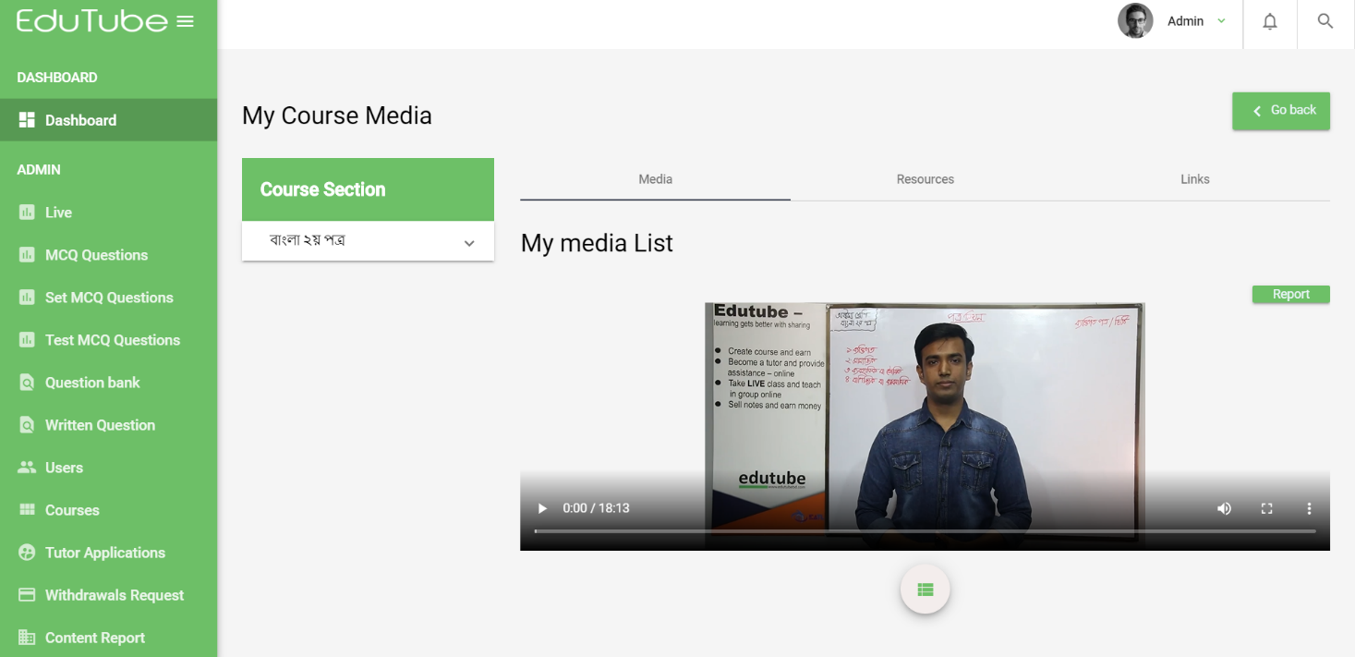

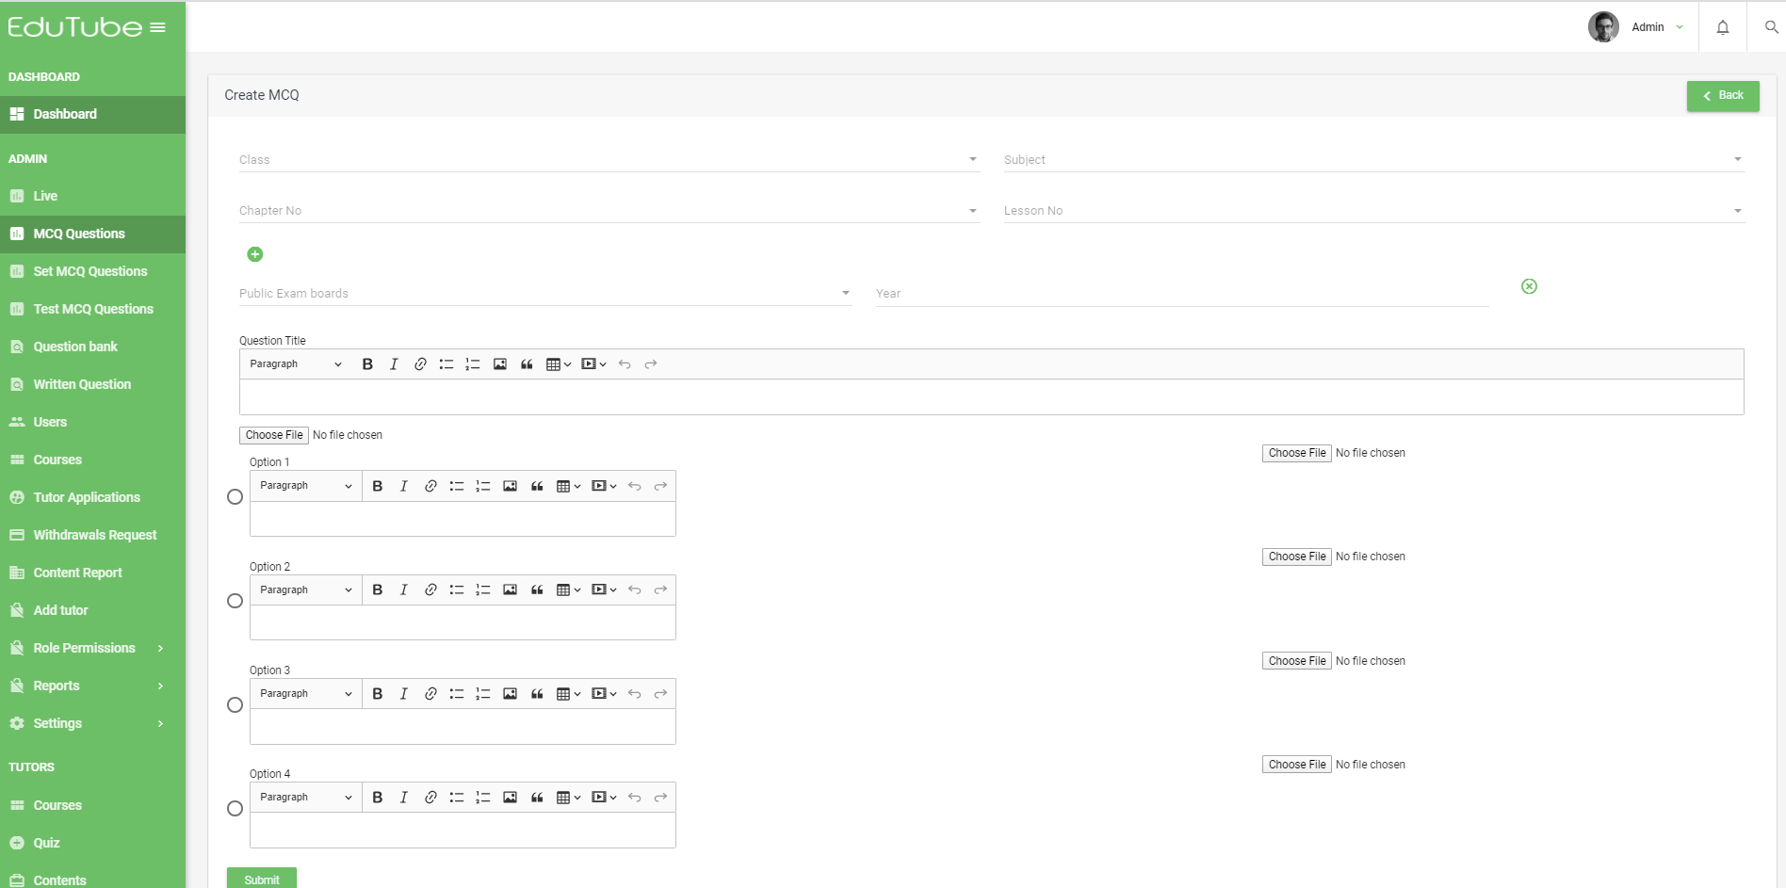

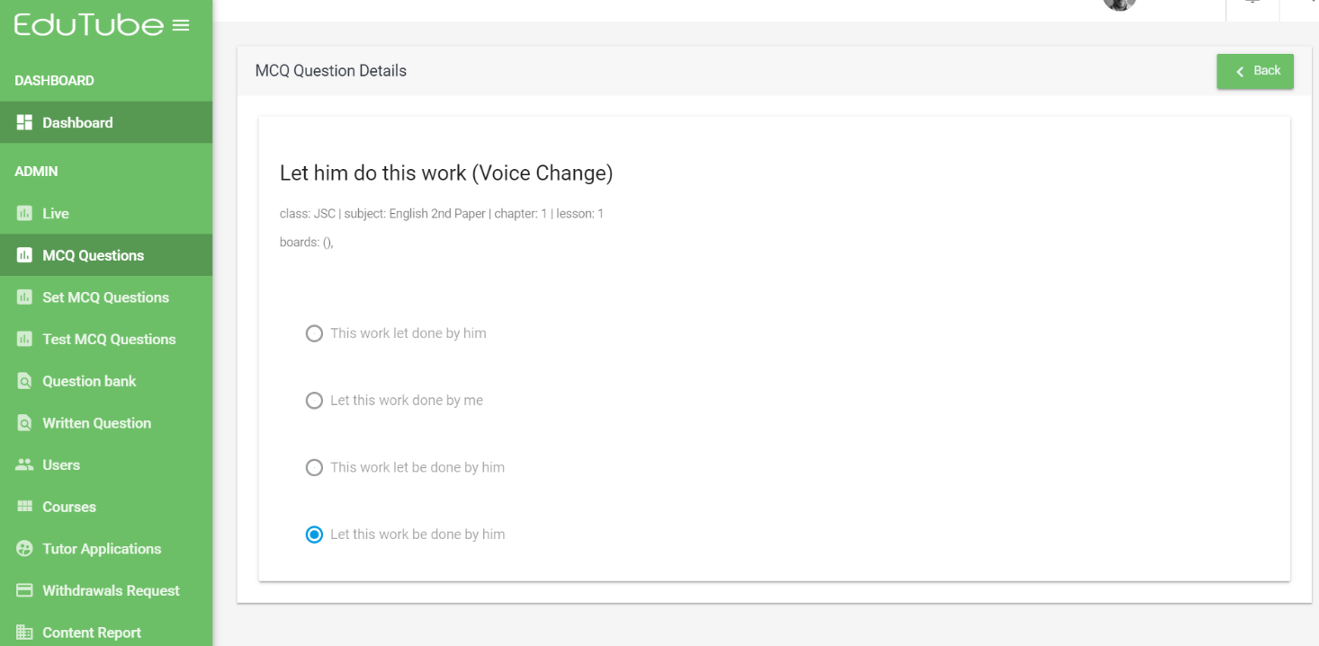

  - Seminar or event Arrange & Promotion:

    - Events & promotion:
Main responsibility is to arrange school teacher workshop, career club training, student’s seminar and as many events possible, per week also take care of online and social media promotion.
a. Event with university students’ teams to promote site
b. Workshop and camp for teachers to teach how to use the site
c. Student awareness campaign, arrange seminars
d. Conduct Facebook promotions with testimonial user videos
e. account opening
f. Increase sales subscription
g. Handle customer complain team to resolve queries

  - Market expansion:
In my three months internship period I have worked on expanding the market of edutube. The effect of my planning is executed on edutube successfully. The quarter year report is presented below:

  - Arranged several seminars and job interviews among these universities:
- United International University (UIU)
- East West University (ESU)
- South East University (SUE)
- University of Asia Pacific (UAP)
- Daffodil University
- Stamford University
- BRAC University
- Independent University Bangladesh (IUB)
- University of Liberal Arts Bangladesh (ULAB)
- International University of Business Agriculture & Technology
- European University of Bangladesh
- Northern University, Bangladesh
- Asian University of Bangladesh
- Eastern University
- World University
- Uttara University
- Dhaka International University
- ASA University
- Manarat International University
- State University of Bangladesh

4.2.3 University seminar activities:
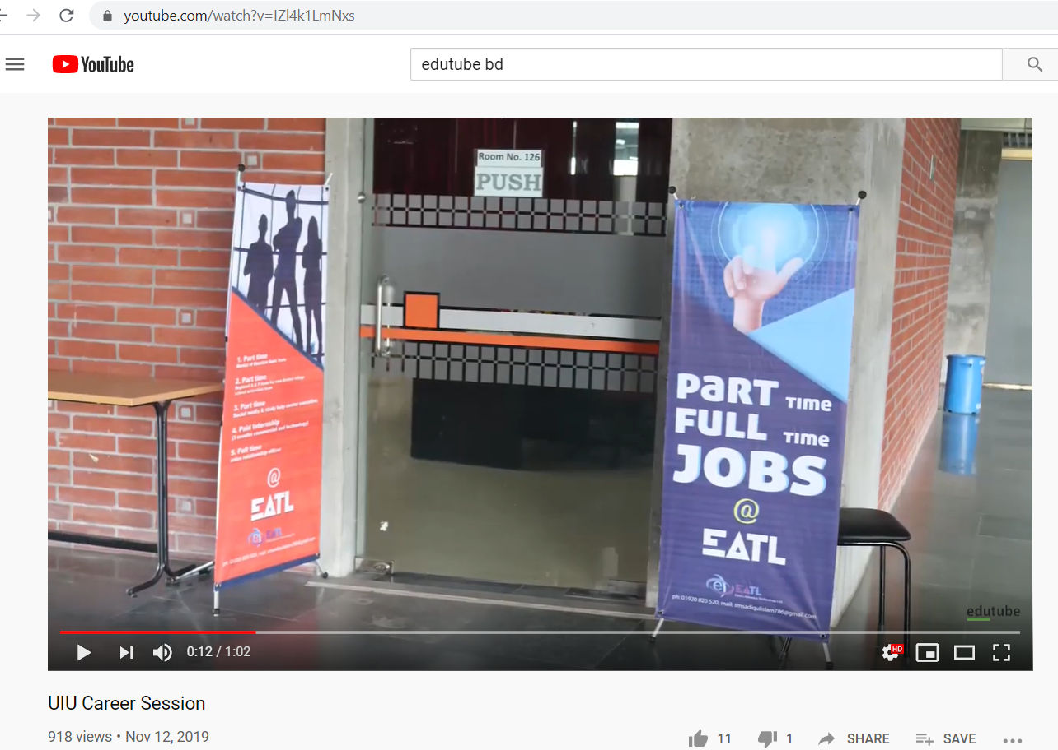
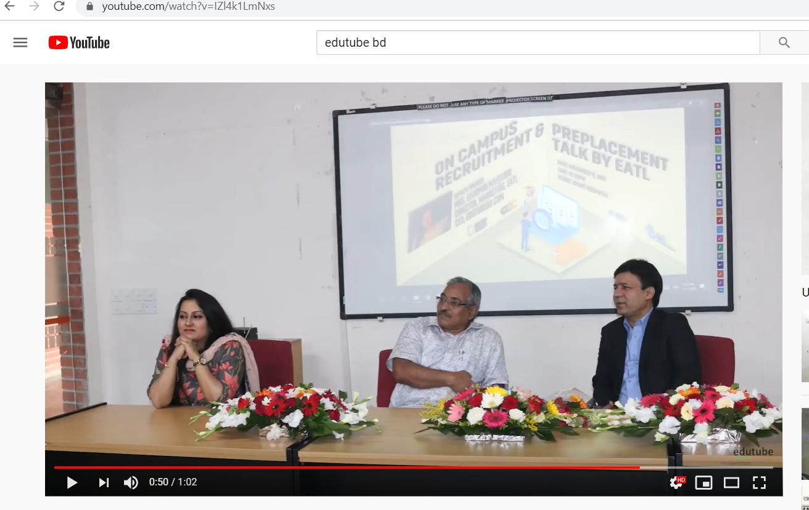
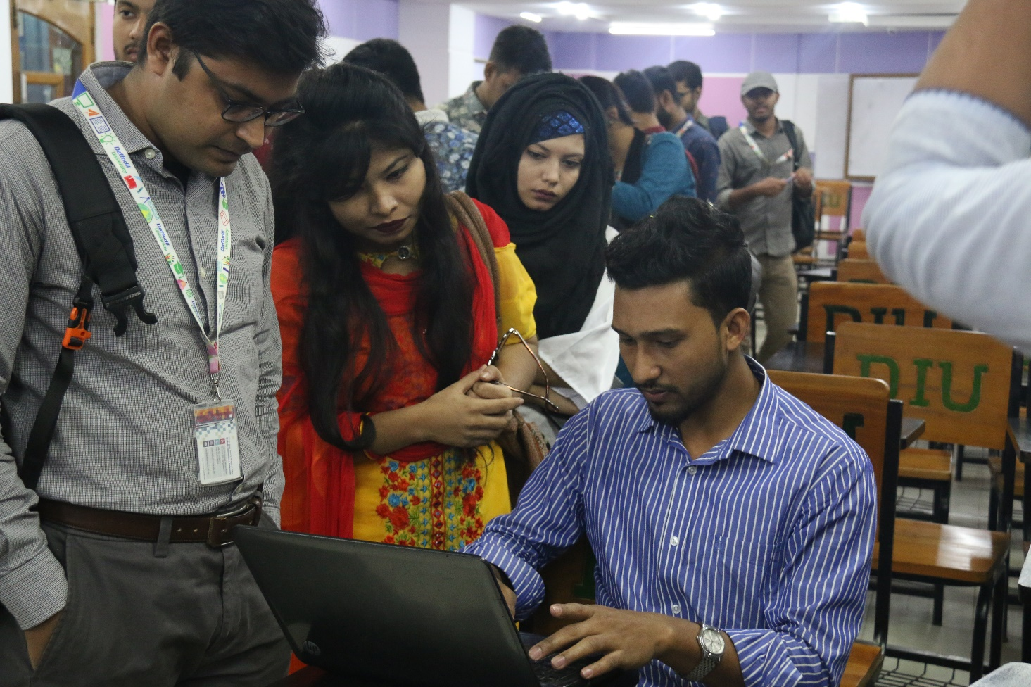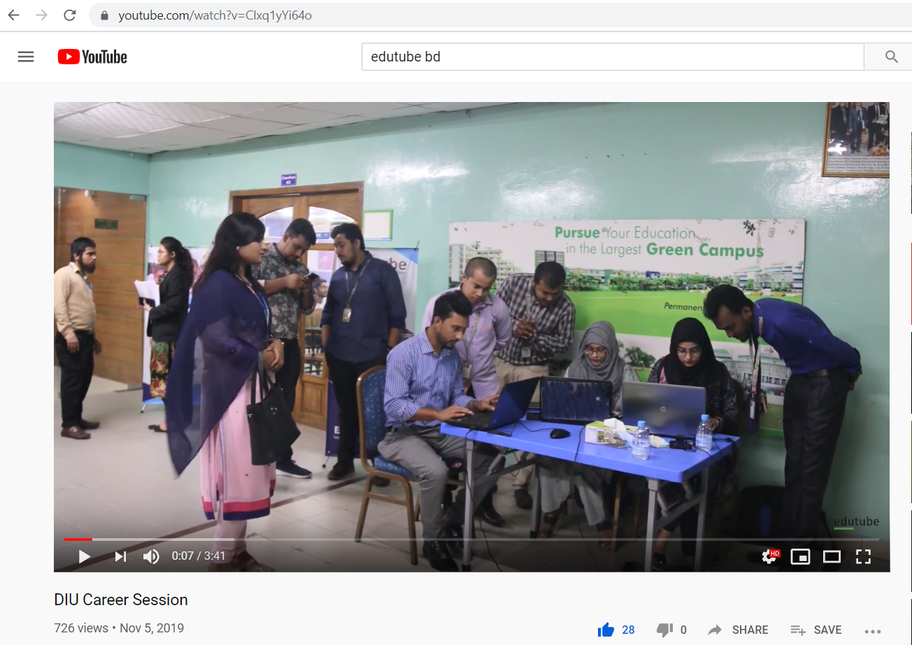

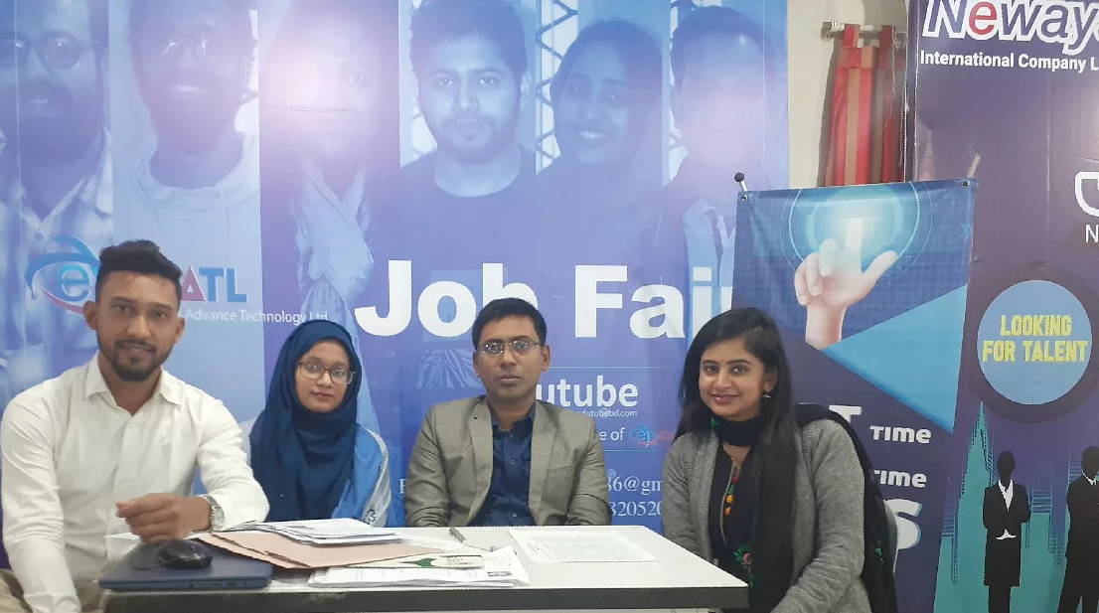
- BUBT Job Fair

  - Help preparing proposals and presentations:
The most important thing I learned is how to prepare Tender documents, learned a lot about Business Proposal Submission, Expression of Interests (EOI). I alone prepared some of the documents of tenders, Business Proposal and EOI. Tender documents basically consist of 2 parts, Technical proposal and financial proposal. We had to make proposals according to the TOR (terms of reference) document. Terms of reference define the purpose and structures of a proposal. Throughout my internship period I’ve prepared and submitted several tender proposals. They are given below:

Project Name | Description  of Service | Type of Service | Name and Address of  the Client
- Development of Web Based Automation System for the Educational Institutions & Directorate of Inspection and Audit (DIA) | The purpose of the development of Web Based Automation System which is the electronic processing of the DIA’s overall inspection and audit activities allows to publish, communicate, access, receive and submit all related information and documentation via Internet. Through this automated system DIA can monitor the overall activities of the 36000 institutions centrally and abiding of the government rules and regulations, proper utilization of government fund and improvement of the quality education. | Development of online Web-MIS | Name of Client:  Directorate of Inspection and Audit (DIA)  Secondary and Higher Education Division  Ministry of Education  Address:  1st Floor, 2nd Block, Shikkha Bhaban, 16, Abdul Ghani Road, Dhaka-1000.
- Development & Implementation of Examination Management System for National University | The goal of the proposed Examination Management System (EMS) is to automate the entire process of the Examination Division to provide better services in a paperless environment to serve the students, staff and stakeholders of the University. It will reduce the result processing time to a minimum level and ensure transparency and accountability in the process through introduction of state-of-the-art data logging at all event points. The main parts of the EMS is to,  - Integrate the hall attendance & verification of examinee in a near real-time system;  - Make the process real time at site and to automate the script distribution to reduce current logistics and resources pressure;  - Automated result processing;  - Implement the result approval and correction system with highest level of security;  - Utilize the power of mobile application to collect data from remote locations and then store the data to the NU EMS server. | Examination Management System (EMS) | Name of Client:  National University  Address:  Gazipur
- Supply, Installation and Commissioning and Operation of Electronic Fiscal Device Management Systems (EFDMS) along with Electronic Fiscal Device (EFD), Sales Data Controller (SDC) and Managed Services | The purpose of this assignment is to capture and store the transaction data of the retail/ wholesale outlets in the country. Initially 10,000 EFDs will be distributed among the outlets which will be connected to a central MIS with real-time secure data connectivity. The VAT payers will be able to make sure that government has been informed about their VAT payment. The following specific objective will be achieved after completing this assignment.  (i) An online VAT collection MIS will be established where government will have up-to-date  information about the collected VAT amount by the outlets throughout the country;  (ii) The government will be able to identify the VAT amount owed by the outlets, thus, the gap  between collected and deposited VAT will be reduced;  (iii) The dispute, arrear collection and refund issuance process will be expedited. Thus, outlet  owners will get better service from NBR;  (iv) The entire VAT collection process will be more transparent and accountable;  (v) People will be aware about VAT payment and will be willing to pay VAT. | Web-MIS | Name of Client:  National Board of Revenue (NBR)  Address:  Shegun Bagicha, Dhaka-1000
- Utilization of mobile phone technology to improve HNP service | EATL developed a mobile application integrated with web MIS and provided technical support and training in a project funded DFID under Ministry of Health and Family Welfare in partnership with icddr,b. EATL designed and implemented a mobile application with web-based interface for the community health worker under DGHS and DGFP for entering new born baby, EPI, pregnant women, newly married couples registration and services data. EATL also provided training on Basic ICT and Mobile application in Bagatipara, Natore and Chakaria, Cox’s Bazar in the last quarter of 2016. | Development of online Web-MIS with Mobile Application Integration | Name of Client:  Icddr,b  Address:  Mohakhali, Dhaka

  - Explore opportunities for tender participation:
My responsibility was to search and explore opportunities for tender participation. There are various sources to search for tenders. Some of the sources I used for searching tenders are, Tender bazar website, retendering website of UNDP, National e-Government Procurement (e-GP) portal, A2i (Access to information) website of government etc.

  - Data entry in salesforce:
Salesforce is a CRM or customer relationship management tool. One of my responsibility was to entry data of various contacts in the salesforce website. The sources of those data were the contact log where potential client’s details are recorded which includes clients name, email, 1st contact time, last contact time, requirements, time zone, phone number etc. Operational CRM is an important tool for lead generation because it frequently deals with past customer data.

Trainings:
There is no formal training procedure in the company. Employees learn and get trained from working directly in the projects. Employees actually get trained on the job. The supervisors observe the tasks an employee completes and based on that they correct their mistakes. I have tried to contribute my best to the interest of the organization, but still I feel like I could a lot more. All the works done by me are evaluated by my supervisors. After their careful evaluation my works are finalized. EATL has an online tracking system to track down the punctuality of the employees, which records in and out time.

Chapter 5

Conclusion and Recommendations

Conclusion:
Working in EATL has been a great experience. As an Intern there were some opportunities to learn a great deal from here and is also able to capture some knowledge. As there were no formal orientation, it was a bit challenging to find out the rules and regulations and how they work. It took few days to learn how the works are done there. Throughout the internship period as an Intern punctuality and responsibilities were well taken care of
At present ICT sector is growing fast in Bangladesh due to the development of the country. Now people highly rely on the online marketing which was not that much attractive few years ago in Bangladesh. EATL follows strong ethical guidelines to satisfy their client’s requirement. EATL has a vision of becoming number one software company in the country. EATL has a very small team compared to other companies but what EATL has are professional developers. If EATL wants to grab opportunities more, then it needs to expand its team as well as focus on marketing activities more & more and have to make such policy that developers stay at the organization at least 3 years. It needs to attract more talents by taking fresh graduates from both IT and business background.

Recommendations:
There are some recommendations proposed to the company to mitigate those problems. They are-
    - To maintain timings with the foreign clients, the company should follow the timings of their clients to work successfully.
    - The company must employ necessary employees.
    - To communicate with the foreign clients the company should employ interpreter on project basis.

6. References:
1. EATL- Ethics Advance Technology Limited
https://www.eatlbd.com/
2. Edutube- https://www.edutubebd.com/
3. The IT Sector of Bangladesh, retrieved from,
http://lbamcl.com/wp-content/uploads/2018/08/Bangladesh-IT-Sector-Report-July- 2018.pdf
4. A report on ICT sector of Bangladesh, snap-shot of the ICT industry in Bangladesh retrieved from,
http://jbbc.co.jp/wp-content/uploads/2014/08/A-Report-on-InformationCommunication- Technology-ICT-Sector-of-Bangladesh.pdf
5. A report on the IT Industry of Bangladesh, collected from,
https://www.thedailystar.net/op-ed/bangladeshs-it-industry-1324174
6. Bangladesh Software and IT service recent trend basis, retrieved from,
https://basis.org.bd/resource/About_Industry.pdf
7. A report on growth of IT and ITES Industry collected from,
http://lict.gov.bd/uploads/file/publication_5a3f7c94c9458.pdf
8. Hospital Information Management System (HIMS)
https://www.eatlbd.com/index.php?r=site/brochure&id=2
9. EATL APPS
https://eatlapps.com/
10. News & Media section
https://www.eatlbd.com/index.php?r=site/newsroom
11. YouTube Channel
https://www.youtube.com/results?search_query=edutube+bd

