Internship Report
On
Ranges of Services and Service Processing in Commercial Banks:
A Case Study on Prime Bank Limited




Internship Report
On
Ranges of Services and Service Processing in Commercial Banks:
A Case Study on Prime Bank Limited


Submitted To

Muhammad Hasan Al-Mamun
Assistant Professor,
School of business and economics (SOBE)
United International University
Submitted By

Mohua Jahin Moon
ID: 111 141 049
BBA Program
School Of Business and Economics (SOBE)
United International University

Date of Submission
12th - September - 2018

Acknowledgement
First of all I would like to express my gratefulness to the very kind almighty Allah, whose invincible direction helped me to finish this report. In spite of the fact that, time was extremely limited for getting the adequate information about all of banking service, however the short experience that I assembled as an internee, in Prime Bank Limited on Satmasjid Branch an advantage for all an opportunity to come in my life. I love to take the opportunity to express my profound feeling of appreciation to my reverend supervisor, Muhammad Hasan Al-Mamun (Assistant Professor, United International University) for his priceless recommendations and direction amid the Study time frame that has extraordinarily propelled me in setting up this report effectively.
I am exceedingly grateful to the greater part of the employees of Prime Bank Limited, Satmasjid Branch for their help that helped me to finish this report. Every one of them are extremely straight to the point and supportive. I couldn't think a solitary minute that I am a student of internee in that bank they help me as if I’m one of their own employee. Besides I have special appreciation towards following resource person for helping me:
- Nazrul Islam, Vice President & Head of Brunch
- Hasmot Ali, Assistant Vice President and Manager Operation.
- Sharmin Rahman, Executive Officer.
- Sottoyojit , Senior Officer.
- Emayet, Officer.
Finally, I want to express my deep gratitude to my parents and other family members and also remember my friends whose enormous helps assist me to complete my report.

Letter of Transmittal

September 2, 2018
Muhammad Hasan-Al Mamun
Assistant Professor,
School of business and economics (SOBE)
United International University
Subject: Submission of Internship Report on “Ranges of Services and Service Processing in Commercial Banks ”.
Dear Sir,
It is my great pleasure that I am going to submit the report on “Ranges of Services and Service Processing in Commercial Banks: A Case Study on Prime Bank Limited ”.

I have tried my best to follow your guidelines in every aspect of planning and preparing my report. I have collected what I believe to be most important information to make my report as specific & coherent as possible.

I Learned and enjoyed a lot preparing the report as it’s gives me the various possible opportunities to enhance my knowledge on the services provided by Commercial Banks in Bangladesh . I want to thank you for the guidance and supervision you provided me during the Internship period and helped me a lot to complete my report. All your efforts are highly appreciated sir.

I therefore pray and hope that your honour would be kind enough to accept my internship report and oblige thereby.

Sincerely yours,
Mohua Jahin Moon
ID: 111 141 049
BBA Program
School Of Business And Economics (SOBE)
United International University.

Executive Summary
After studying various theoretical concepts during the various courses of my BBA program majoring in Marketing, United international University, understanding the realistic implications and applications is the next step in the learning process. The BBA internship program gave me a chance to such advanced learning. At the appointed time of finishing my internship work and while creating this report, I learned a lot about the banking services performed by the Prime Bank ltd.

In the modern economy, consumer banking is the key zone for growth. While the growth in customer numbers in corporate banking portion is getting to be stagnant, new customers in consumer banking are emerging each day. In Bangladesh, consumer banking field is generally new.

This report depends on practical working experience at The Prime Bank Limited as a part my of internship program. The Prime Bank Limited, the first generation bank in Bangladesh appeared in 1995. It was built up with the goal of realizing subjective changes in sphere of banking and financial management. The bank today serves its customers successfully, gathering reserves from the surplus units of the economy as deposit and assembling deposits to the shortage units of the economy as credit. The bank is found to provide a wide range of services to the target market including both consumer markets and business market. Details of these services are explained in the finding part of the report. Today The Prime Bank Limited serves its customers at home and abroad with 117 branches spread over the nation and around three hundred abroad correspondences.
Key Words: Service Processing, Commercial Banks

Table of content
1.1 Topic in Hand 9
1.2 Context of the Study 10
Origin of the report: 11
Scope of the report: 11
2.1 Profile 13
2.2 Vision 14
2.3 Mission 14
Management of Prime Bank: 15
2.5 Departments of Prime Bank: 15
2.6 Operational network organogram: 16
2.7 Services: 17
2.8 OTHER SERVICES 17
2.9 Products of Prime bank 22
Industry Perspectives 24
3.1 Introduction to Satmasjid branch: 24
3.2 STRUCTURE of Satmasjid Branch: 24
3.3 GENERAL BANKING SERVICES: 25
3.4 ACCOUNT OPENING SECTION: 25
3.5 OTHER TERM DEPOSIT ACCOUNTS: 29
3.6 ACCOUNT CLOSING SECTION: 35
3.7 REMITTANCE SECTION: 35
3.8 TELEGRAPHIC/ELECTRONIC TRANSFER (T.T): 39
3.9 CASH SECTION: 40
3.10 CHECK SECTION: 41
3.11 CLEARING SECTION: 43
Objective of the report 46
Methodology of the report 47
Key Findings: 49
4.1 Quality of the Services of Prime Bank: 49
4.2 Products of Prime Bank: 50
4.3 Charges: 50
4.4 Employee Efficiency: 51
SWOT Analysis of Prime Bank Ltd 52
Limitations of the Study 54
Recommendations 57
Conclusion 60
Appendices 61
ATTACHMENTS: 62
Questionnaire 62
Elaborations of the Abbreviations Used in the Study 63

Chapter 1

Introduction

1.1 Topic in Hand
During the period of internship at Prime Bank, I was cooperatively guided by all the staffs for gaining in-depth banking knowledge. As an Intern, I have no specific job responsibility in the branch. I observed activities of almost all departments. Therefore, the major lessons that are learned and carry out some responsibility during internship can be listed as below:
- This is the first time I got opportunity to work in a corporate world, so by working in this environment I got to know about banking corporate culture practically.
- I got to know the account opening procedure.
- Issue of cheque book.
- Requisition of cheque book.
- I learned how keep all the data in the register especially for Pay Order there is a specific register book which I had to maintain.
- I learned to check all the documents before issuing pay order.
- Filing pay order form.
- Assist customer to fill out the account opening form correctly and also obtain all necessary document.
- Dealing with customer.
- I learned how they keep all debit & credit Card info in the register.
- Bank statement issuance.
- Handling incoming calls.
- Realized the work pressure at the time of performing tasks.
- Learnt the importance of relation between clients and bank.
- Learned how to deal with varieties of people and their queries and providing appropriate information to the customers.
- Learned to speak, function and work in corporate way.
At the end of my internship I can say I learned lot of practical working things of banking system which totally different from our academic knowledge and I also learned how to deal with customer in different situation and also I saw that bank service also vary on client and banks relationship.

1.2 Context of the Study
Prime Bank Limited “A bank with a difference” is perfectly applicable; it’s fast growing ability and within a short period acquiring the position at the top slot in terms of quality service to the customers’ ad the value addition to the shareholders prove its accuracy. As a Private Sector Bank, Prime Bank Ltd was incorporated under the Companies Act, 1994 on February 12, 1995.
Prime Bank Ltd. being a banking company has been registered under the Companies Act 1913 with its registered office at 5, Rajuk Avenue, Motijheel commercial area, Dhaka 1000.Later latter it was shifted to Adamjee Court Annex building, 119-120, Motijheel Commercial Area Dhaka -1000.
Prime bank has already made significant progress within a very short period of its existence. The bank has been already graded as a top class bank in the country through internationally accepted CAMELS rating. The bank has already occupied an enviable position among its competitors after achieving success in all areas of business operation.
Prime bank offers all kind of Commercial Corporate and Personal Banking services covering all segments of society within the frame work of Banking Company Act and rules and regulations laid down by our central bank. Diversification of products and services include Corporate Banking, Retail banking and Consumer Banking right from industry to agriculture, and real estate to software.
Prime Bank, since its beginning has attached more importance in technology integration so that the bank can offer varieties of services to its clients. In order to retain competitive edge, investment in technology is always a top agenda and under constant focus. Keeping the network within a reasonable limit, its strategy is to serve the customers through capacity building across multi-delivery channels. Their past performance gives an indication of their strength. They are better placed and poised to take their customers through fast changing times and enable them compete more effectively in the market they operate.

Origin of the report:
This report is originated having three months long internship program originated after finishing the BBA program from Department of BBA under United International University. A student needs to embrace a field of examination of any organization for top to bottom investigation during the internship program. This report is the result of the given internship topic, recommended by my honorable supervisor, Muhammad Hasan-Al Mamun, Assistant Professor, United International University and the human resource department of Prime Bank Limited, Head Office.

Scope of the report:
Banking sector is a substantial and troublesome zone. A bank has distinctive products, diverse services and distinctive clients. Distinctive departments of a bank perform diverse activities.
In any case, the scope of present investigation was limited in a particular territory of an organization such as in Prime Bank Limited, Satmasjid Branch. So this examination says just in regards to the service activities of Prime Bank Limited, Satmasjid Branch. However, This examination covers just different Services of Prime Bank Limited, Satmasjid Branch as it were.

Chapter 2

Organizational Background

Organizational Background

2.1 Profile
The backdrop of economic liberalization and financial area changes, a gathering of profoundly fruitful neighbourhood business visionaries imagined a thought of drifting a commercial bank with various viewpoint. For them, it was competence, excellence and consistent delivery of reliable service with superior value products.. Appropriately, Prime Bank was started and commencement of business began on seventeenth April 1995. The shareholders are well known identities in the field of exchange and trade and their stake ranges from shipping to textile and finance to energy etc.
As a completely licensed commercial bank, Prime Bank is being occupied by a very expert and devoted group of employee’s with long involvement in banking. They always hunt for comprehension and envisioning client needs. As the banking situation experiences changes so is simply the bank and it repositions in the changed market condition.
Prime Bank has effectively gained huge ground inside a brief time of its reality. The bank has been reviewed as a best class bank in the nation through internationally accepted CAMELS rating. The bank has officially involved a lucky position among its rivals in the wake of making progress in every aspect of business activity.
Bank is a financial institution. The economy is generally reliant on the bank since the bank encourages the economic and financial exchanges. Prime bank limited is a quickly developing private division bank and the bank is now at the best space as far as quality administrations to the clients and esteem expansion for the investors. The bank gained palatable ground in every aspect of business task in 2014.
Prime Bank Ltd. is one of the few banks allowed by the Bangladesh in the mid 90's. These banks are known as the second-age banks and lucky to stay insusceptible from the awful credit culture. Prime Bank Limited was intended to give commercial and venture banking administrations to a wide range of client going from little business visionary to enormous business firms. Other than interest in exchange and business, the bank takes an interest in the socioeconomic advancement through the support in need segments like agriculture, industry, housing and self-employment. Prime Bank Limited needs to set up, keep up, and direct a wide range of banking, investments and businesses in Bangladesh and abroad with predominant administration quality and execution.

2.2 Vision
To be the best Private Commercial Bank in Bangladesh in terms of efficiency, capital adequacy, asset quality, sound management and profitability having strong liquidity.

2.3 Mission
To build Prime Bank Limited into an efficient, market-driven, customer focused institution with good corporate governance structure.
Continuous improvement of its business policies, procedure and efficiency through integration of technology at all levels.

Management of Prime Bank:
Boards of directors are the sole expert to take choice about the undertakings of the business. Presently there are 13 directors in the management of the bank. Every one of the directors have great scholastic foundation and have immense involvement in business sector in Bangladesh. Mr. Md Shirajul Islam Mullah is the administrator of the bank. The board of directors holds gatherings all the time. There are distinctive committees in the bank for the effective management of the bank.
• Board of Directors: There are 13 Board of Directors in The Pime bank limited.
• Policy Committee: This committee manages any policy matters identified with the banks new items, new business advancement and any kind of policy identified with Prime Bank Limited. It situates fortnightly.
• Executive Committee: It situates monthly.

2.5 Departments of Prime Bank:
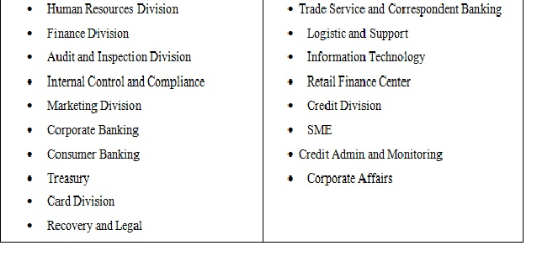
The bank sorts out every one of the occupations considering their interrelationship and they are allotted in a specific department to control the system effectively. The departments are fitted for the specific works and the execution of a specific department is estimated flawlessly. Prime Bank Limited has following departments:

2.6 Operational network organogram:
Prime Bank maintains a strong organizational hierarchy in which every individual performs their duty very sincerely. The full hierarchy of Prime Bank Ltd. is given below:
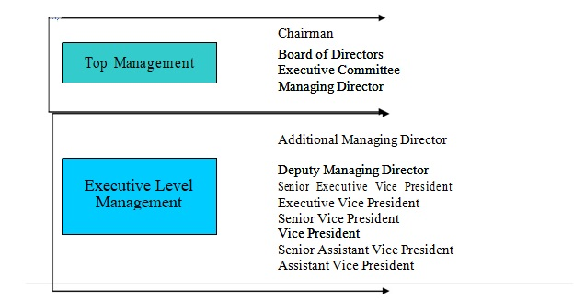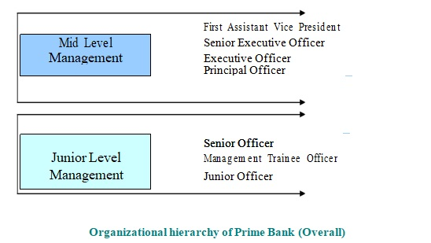

2.7 Services:

The Prime Bank Limited launched several financial products and services since it’s inception.
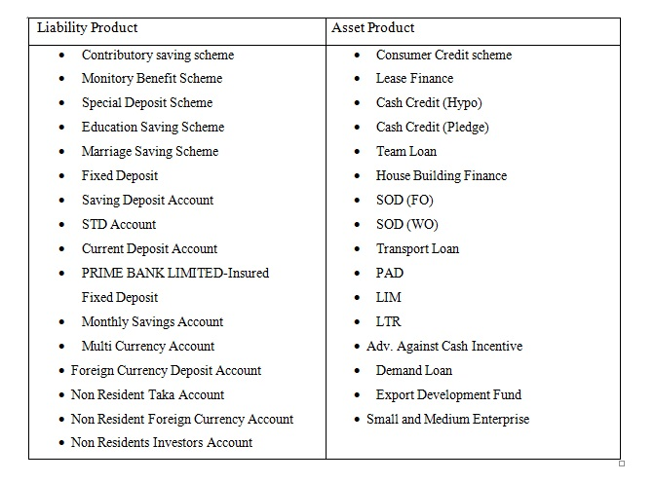

2.8 OTHER SERVICES
Consistent with the modern edge and competing in the competitive market, The Prime Bank Limited has introduced some innovative banking services that are remarkable in a country like Bangladesh. The services offered by the bank are as follows:

2.8.1 On-line Banking
The bank has set up a Wide Area Network (WAN) the Bangladesh over to give online branch banking office to its esteemed customers. Under this plan, customers of any branch will have the capacity to do banking exchange at different branches of the bank.
Under this system a customer will have the capacity to do following sort of exchanges:
• Cash withdrawal from his/her account at any branch of the bank.
• Cash deposit in his/her account at any branch of the bank independent of the location.
• Cash deposit in other's account at any branch of the bank independent of the location.
• Transfer of cash from his/her account with any branch of the bank.

2.8.2 SWIFT Service
The Prime Bank Limited is one of the first few Bangladesh Banks to obtain membership of SWIFT (Society for Worldwide Inter-bank Telecommunication). SWIFT is a members’ owned cooperative which provide a first and accurate communication network for financial transaction such as Letter of Credit, Fund Transfer etc.
2.8.3 SMS Banking
Prime SMS allows you 24-hour access to the key financial information of your Prime Bank Account. It is the least complex method for discovering your account's day by day/month-end adjust. With Prime SMS you neither need to sit tight for your announcement to touch base through mail nor have or call up branches to ask about your adjust and last couple of exchanges. When you turn into an individual from SMS Banking you will have 24-hour access to the key financial information.
2.8.4 Retail Banking:
As a part of risk diversification strategy PBL expended the lending activities in this sector during 2006. The growth rate of PBL’s consumer financing was 38% 2013. The loan schemes offered by the bank include Home Loan, Loan against Salary, Marriage Loan, Car Loan, Hospitalization Loan, Education Loan, Doctors Loan, Travel Loan etc.
2.8.5 SME Lending:
Job creation is fundamental and it must originate from Little and Medium Endeavour that will at last command the private area. Amid 2013 bank's System was centred around client accommodation. The Bank gave working capital loans to providers or merchants of extensive companies or groups of little exporters of non-conventional things. Exceptional advance of SME is Tk.437 million. The development rate of PBL's SME Lending was 41% amid this year.
2.8.6 Corporate Credit:
PBL’s strategy is to provide comprehensive service to the clients of this segment who are large and medium size corporate customers with expertise in trade finance and related services. Other than exchange fund bank are giving working capital back, venture fund and orchestrating syndication for our corporate customers. Syndication and organized Fund Unit of the Bank fortified its stride in the consortium financial market and masterminded various syndication bargains for its corporate customers

2.8.7 Islamic Banking:
In the year 2008, the bank has stepped up with regards to distinguish the greater part of its Islamic banking exercises by embracing a nonexclusive name of 'Hasanah' - the brand name for Islamic items and administrations of the bank, which has been utilized in the Qur'an and the Hadith a few times to signify great deed, welfare, prudence, excellence spot etcetera, that communicates Prime Bank's ability for working towards prosperity of humankind through Islamic banking exercises. It is discovered that the venture and deposits developed by 38% and 89% individually in the year 2013. The operating benefit of Islamic Banking Branches developed by 45% amid the Year.
2.8.8 Credit Card:
In the year of 2005, Prime Bank Ltd has launched VISA card. Before that PBL started its credit card operation in 1999 by introducing Master Card. Now PBL has become the first local Bank of the country to achieve principal membership of both the worldwide-accepted plastic money network i.e. Master Card and VISA. PBL has redesigned the credit card facility by providing the incentive of “Free Life Insurance Coverage” for their valued cardholders to mitigate the financial risk.

2.8.9 International Trade Management:
This division is operational throughout the group and PBL’s core strength is trade finance and services. With an experience, Prime Bank has developed knowledge of trade finance, which is world class. Principle services to shippers incorporate imports letter of credit, import bills for gathering and consecutive letters of credit offices. Services give to exporters incorporate fare letters of credit, coordinate fare bills, securities, and assurances.
2.8.10 Institutional Banking:
Prime Bank Limited gives an extensive variety of services to institutional customers, commercial, shipper and national banks; merchants and merchants; insurance agencies; assets and administrators, and others. It gives relationship chiefs who are near their clients and talk nearby dialect. This wide system of institutional banking offices incorporates exchange, presentation, critical thinking and renders counsel and rules on neighbourhood exchanging condition.
2.8.11 Treasury:
Treasury activities had been thought as a critical road for money age reason inside Head Office. Indeed, previously, pay from treasury task was very sizable and noteworthy to the aggregate salary produced by the bank. The treasury division distributes day by day and week by week cash pamphlets, which give investigations of money inclines and related issues. Courses and workshops are led for clients now and again on outside trade related points. Prime Bank is one of the primary neighbourhood banks in Bangladesh to incorporate treasury dealings of nearby currency market and outside money under one Treasury umbrella. The bank has handled significant volumes of treasury over the last several years. Prime Bank’s Dealing Room is connected with automated Reuters Terminal facility thus enabling the bank to provide forward/future facilities to its corporate clients at a very competitive rate.

2.8.12 Foreign Exchange Business
Throughout the years, foreign trade activities of the bank assumed a critical part in the general business advancement of the bank. The bank has built up association with upwards of 110 new foreign reporters abroad in this way raising the aggregate number of journalists to 350. The aggregate import and fare business taken care of by the bank amid the year 2013 was TK 52,639 million and Tk 41,801 million. The development rate was 46%. The bank has additionally gone into settlement game plans with a few banks and exchange houses and hopes to deal with expanded volume of settlement business over the not so distant future.

2.9 Products of Prime bank
Prime Bank Limited offers different sorts of deposit products and loan schemes. The bank additionally has profoundly qualified efficient staffs who have the ability to oversee and meet every one of the necessities of the bank. Each account is relegated to an account chief who by and by deals with it and is accessible for dialog and request, regardless of whether one composes, phones or calls.
2.9.1 Loan Schemes:
- General Loan Scheme
- Consumer Credit Scheme
- Lease Finance
- House Building Loan & Apartment Loan Scheme
- Advance against Shares
- Custodial Services for investors (both individual & institutional) investing in through Stock exchange
- One stop services for payment of utility bills.
- Credit cards

Chapter 3
Industry Perspectives

Industry Perspectives

3.1 Introduction to Satmasjid branch:

Satmasjid Branch is the 22nd branch of Prime Bank Ltd. The name of the present branch Manager is Nazrul Islam, VP. The overall banking operation of Satmasjid Branch can be divided into three broad sections. These sections are:
- General Banking Services

- Foreign Exchange Division

- Credit Division

Account opening, Local Remittance, Clearing, Deposit and Accounts are the subdivisions that belong to the General Banking service Division, where as Import, Export and Foreign Remittance are the subdivision under Foreign Exchange Division.
At present about 23 personnel work at Sat masjid Branch of Prime Bank Limited.

3.2 STRUCTURE of Satmasjid Branch:

3.2.1 Deposit:
Everyone knows that the deposit is the soul of a Bank. From the very earliest starting point of Prime Bank , satmasjid Branch is aware about deposit develop. The branch is attempting to improve the situation step by step. The deposit on june 30, 2018 was 171, 98, 02,716.49 corers.

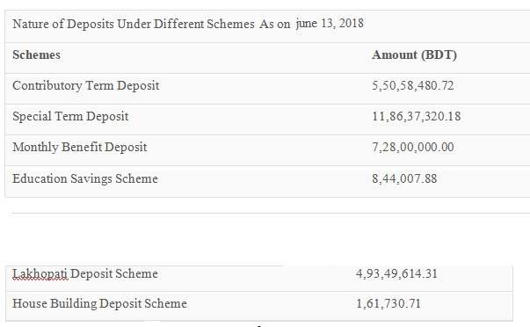

3.3 GENERAL BANKING SERVICES:
The general banking service department does the most imperative and fundamental works of the bank. Every single other department are connected with this department. It likewise assumes a crucial part in deposit preparation of the branch. As a matter of fact general banking is known as the mother of banking. Be that as it may, PBL gives diverse sorts of accounts, locker offices and exceptional kinds of savings scheme under general banking service.

3.4 ACCOUNT OPENING SECTION:
The connection amongst banker and customer starts with the opening of an account by the customer. Determination of customer for opening an account is exceptionally urgent for a bank. Indeed, extortion and phony of numerous sorts begin by opening account. Along these lines, the Prime Bank Limited takes most noteworthy alert in such manner. In any case, PBL opens the accompanying accounts for its customers:
- Current account (Compact disc A/C)
- Savings account (SB A/C)
- Fixed deposit account (FDR A/C)
A brief on this Accounts are given underneath:
3.4.1 CURRENT ACCOUNT:
Current account is absolutely a demand deposit account. Fundamentally it very well may be open with the end goal of business. There is no confinement on pulling back cash from this account. It is appropriate when reserves are to be gathered and cash is to be paid away at visit interim. It is the most reasonable for private people, traders, dealers, merchants and exporters, factories and production line proprietors, limited organizations and so forth. For opening a current account least deposit tk 5,000/ - is required alongside initial reference. No premium is given on the current account deposit cash. The accompanying focuses are essential:
- A current account is a running and dynamic account. There is no limitation on the number and the measure of withdrawals from a current account.
- The banker is under a commitment to reimburse these deposits on demand, so they are called demand liabilities of a banker.
- The essential goal of current account is to spare customers, for example, businessmen, join stock organizations, open specialists, and so on from danger of handling a great deal of cash.
- The bank does not pay enthusiasm on current deposits while then again, some bank charge for accidental charges on such accounts.
- The bank gives overdraft offices additionally in specific cases.
- The account holder can pull back the deposited cash from his account with the check, which will be issued to the against his account number.
- The cancelation fees for current account is tk. 100.
- An account holder can withdraw and deposit cash in his account in various times in a week.
3.4.2 SAVINGS ACCOUNT:
Savings account is considered all individuals. Anybody can run this account for his own or business purposes. To open this account depositor need to give in any event Tk.1000 at the season of opening. The principle target of this account is to elevate bring down salary individuals to spare their bit of their wage for their future utilize. Consequently there is confinement on withdrawals in multi month. Substantial withdrawals are allowed just against earlier notice.
- Any grown-up individual can open this account with his own particular name or with another person that shared service.
- Any minor can open this account with the direction of the gatekeeper.
- Any organization/club can open this account.
- Any uneducated individual can open this account with his thumbprint. So he can withdraw cash from his account within the sight of himself.
Anyway, the other noticable highlights of the sparing account are as per the following:
  - Frequently withdrawal of cash isn't encouraged.
  - Usually, withdrawal not permitted more than ¼ of the total balance.
  - One may permit pulled back his sum most extreme two times every week.
  - Seven days’ notice is required for withdrawal of substantial sum.
  - Account holder isn't permitted to pull back the sum more than 25000 at any given moment.
  - The rate of intrigue is 6% against savings account.
  - The depositor can deposit cash in his account in a few times. However, in the event that he needs to deposit pay arrange, check draft and so forth., he needs to cross that instrument as an account payee.
  - If the account holder needs to close his account he needs to pay a wiping out charge that is tk.100/ - for the sparing account.
  - The number of leaves in the sparing account's check book is 36.
3.4.3 FIXED DEPOSIT RECEIPT:
All things considered Fixed Deposit Receipt (FDR) isn't an account. It just deposits receipt. It is prevalently known as "Time Deposit". Since these deposits are not repayable on demand but rather they are pull back capable subject to a time of notice. The imminent fixed deposit holder is relied upon to top off an application frame recommended for the reason expressing the sum and the time of deposit. The application itself contains the principles and controls of the deposits including the space for example signature. The general highlights of FDR are as per the following:
• Payment made on expiry of concurred period.
• FDR considered one, three, six and year time span.
• Payment demanded before expiry of concurred date then punishment might be charged.
• Introducer isn't required for this situation.
• Two duplicates of account holder and chosen people photo are required.
• Loan might be authorized against FDR.
INTEREST RATE OF FIXED DEPOSIT RECEIPT:
 | SL. No. |  |  | Period |  |  |  | Amount | Rate of Interest
 |  |  |  |  |  |  |  |  | (%)
 | 01 |  |  | One month |  |  |  |  | 7.5%
 | 02 |  |  | Three months |  |  |  |  | 8.25%
 | 03 |  |  |  | Six months |  |  |  |  | 8.50%
 | 04 |  |  |  | One year & above |  |  |  |  | 8.75

3.5 OTHER TERM DEPOSIT ACCOUNTS:
- Monthly Benefit Deposit Scheme (MBDS A/C)
- Contributory Savings Scheme (CSS)
- Double Benefit Deposit Scheme (DBDS).
- Lakhpoti Deposit Scheme (LDS) and
- House Building Deposit Scheme (HBDS)

    - MONTHLY BENEFIT DEPOSIT SCHEME (MBDS):
MBDS are another fundamental part of Prime Bank Ltd. This account is made for the benefit of the general population who mean to meet the monthly spending plan of their families from the salary out of their deposit. This scheme is reasonable for trusts, club and establishments or different affiliations, which grant monthly grants to the understudies and so forth. We know the bank is the most anchored place to deposit cash. Along these lines, individuals can come and run this account effectively for huge savings with little portion every month.
The terms and conditions for operating MBDS account:
1. To open a MBDS account the customer needs to utilize its shape and should have an introducer and additionally the name of the chosen one. On the off chance that the customer give bore witness to photo, it would be useful at the season of shutting the account.
2. The deposit of Tk. 25,000 and products thereof, yet greatest Tk. 25, 00,000 will be worthy under the scheme.
3. The deposit will be for a time of 5 years. The foremost sum is refundable on development.
4. Profit will be paid on monthly premise @ Tk. 1,000/ - and net of duties @ Tk. 900/ - per Tk.1, 00,000.
5. Payment of monthly benefit begins from the resulting month after a reasonable least hole of 30 days from date of deposit.
6. If the street numbers of the depositors transforms, he/she quickly need to illuminate it to the bank.
7. Income assessment, Tk. 10% will be deducted on the pay got from the deposit.
8. The customer can exchange his/her account to another branch of a similar bank by just for unique reason.
9. The receipt isn't transferable.
10. Advance against lien on such Receipt can be permitted up to 80% of the deposit bearing ordinary rate of intrigue predominant at the time on Overdraft/Loan.
11. In case the instrument is lost the method for issuance of a copy will be the same as pertinent if there should arise an occurrence of loss of FDR.
12. During the time of such Overdraft/Loan, the monthly benefit will be credited to the concerned Overdraft/Loan.
13. Normally, the deposit isn't cashable before 5 years. Be that as it may, if any depositor can pull back his deposit before development because of certain unavoidable reasons, he/she will be permitted to do as such in the accompanying way:
• No benefit including premium will be took into account pre-develop encashment inside one year.
• If the accounts/deposits are shut/enchased following 1 year of its opening, benefit will be permitted on the deposit at existing typical savings deposit rate.
• If the measure of monthly benefit officially paid surpasses the sum payable at ordinary savings rate.
14. The bank has the privilege to change the principles or refresh the entire thing of MBDS

3.5.2 CONTRIBUTORY SAVINGS SCHEME:
Contributory savings scheme is appropriate for centre and high society individuals who need to set aside some cash for sometime later. In this task depositor need to deposit cash for a long time any portion measure at the season of opening of the A/C. Any individual can open the scheme by following appropriate direction. At the season of opening account under CSS customer must allude his/her SB A/C. No. for his/her benefits sum or may open SB A/C at the season of development for getting monthly annuity sum. Singular amount sum will be paid after development or monthly benefits will be paid for the following 5 years as indicated by the extent of deposit. For instance, a brief chart of lump sum amount and monthly pension instalment payable are shown in the following chart:
 | Size of monthly deposit |  |  | After 5 years terminal value |  |  |  | Pension for next 5 years
 | 2,000 |  |  | 1,60,000 |  |  |  | 3,457
 | 3,000 |  |  | 2,40,000 |  |  |  | 5,186
 | 4,000 |  |  | 3,20,000 |  |  |  | 6,915
 | 5,000 |  |  | 4,01,000 |  |  |  | 8,644
 | 6,000 |  |  | 4,81,000 |  |  |  | 10,373

3.5.3 DOUBLE BENEFIT SCHEME:
This offer is extremely alluring for the individual who has extra money in hand. By this account individuals can deposit their cash for a time of six years and after the development he/she will get double cash back. By this account individuals can utilize their optimal cash by which he can't win or can't capable or don't feel secure to contribute on business. Under this venture his/her cash can be completely anchored with some benefit following couple of years.
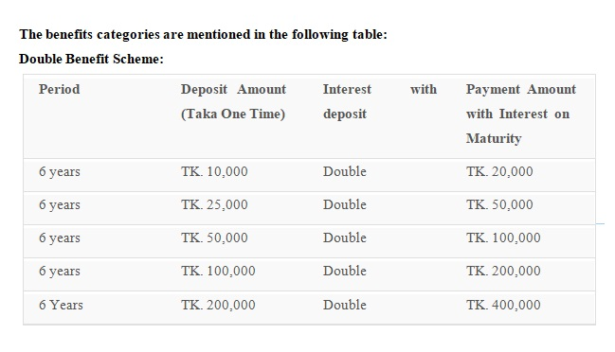

3.5.4 LAKHOPATI DEPOSIT SCHEME:
The scheme is reasonable for the individual who means to deposit cash for next utilize. Typically, by this account individuals can deposit their cash for various period, after the development he/she will get Tk.1, 00,000/ - back. The benefits classifications are specified in the accompanying table:

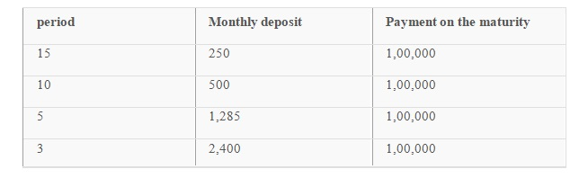

3.5.5 HOUSE BUILDING DEPOSIT SCHEME:
This scheme is another alluring scheme for interested individuals who will contribute cash for various periods for sometime later. It is ordinarily reasonable for the resigned individual. Other than minor can open the scheme agreeing all customs related with opening of minor's account. For house building loan offices it is the absolute best scheme on the grounds that the depositor will be permitted to take loan from the bank against it. As indicated by the portion and term of the deposit, value building sum will be Tk.10 lac/Tk.20 lac and a diagram in such manner is specified below:
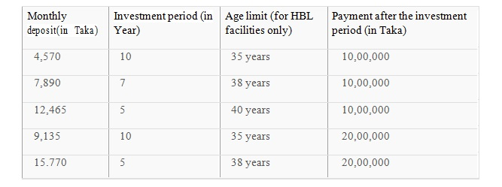

3.6 ACCOUNT CLOSING SECTION:
It is a general appropriate for each account holder to close his or her account whenever s/he discover badly arranged to proceed. Yet in addition has a few customs. The individual needs to apply to the director of the particular branch saying the purpose behind the account closing likewise the date when he might want to close his/her account with 100/ - account closing charge.

3.7 REMITTANCE SECTION:
This department is another essential piece of the Bank. This department additionally issues and gets PO, PS, DD, TT, and so on. By this department customers can send their cash to better places of the nation or on the planet. This department is encourages the bank to residential and worldwide exchange for the customers.

The things of this dept. are following:
3.7.1 PAY ORDER (PO):
Procedure of issuing Pay order : Client is provided a Pay Order shape with a commission voucher and vat on banking service voucher. In the wake of filling the frame the client pays the cash in real money or with check. The concerned officer at that point issues PO on its particular square. The officer at that point records the number the PO obstruct on the PO shape then two approved officers sign the square. Toward the end client is furnished with the two sections of the square subsequent to marking on the square of the bank's part.
Accounting procedure of pay order:
a) On issuing of PO
1. | Cash A/C of party A/C | ————Dr.
 | PBL General A/C | ————Cr.
 | Income A/C commission on PO ——Cr.
2. | PBL General A/C ————— Dr.
 | Bills Payable A/C- P.O ———-Cr.
b) On encashment of P.O.
Bills Payable A/C —————Dr.
Party A/C ————————Cr.
Payment of Pay Order (PO):
AS the PO issued by the bank is crossed one it isn't paid over the counter. Despite what might be expected the sum is exchanged to the payees account. To exchange the sum the payee should properly stamp the PO.
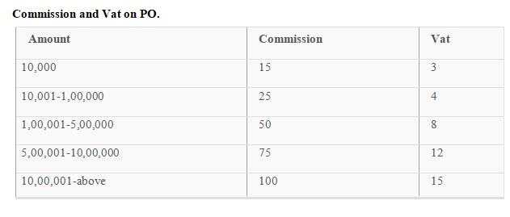
3.7.2 DEMAND DRAFT (DD):
A demand draft is a composed order of one branch upon another branch of a similar bank, to pay a specific some of cash to or to the order of a specified individual. Drafts are not issued payable to carrier. Practically speaking, drafts are not to be drawn between branches inside a similar city.
Procedure of DD Issue:
• Customer is supplied a DD form with a commission voucher and vat on banking service voucher.
• Customer fill up the form which incorporates the name of payee, measure of cash to be sent, trade, name of the cabinet branch, mark and address of the cabinet.
• The client may pay in real money or by exchanging the sum from his/her account (if any).
• After the cash is paid and the form is scaled and marked likewise it is given to the DD issuing work area.
• Upon receiving the form concerned officer issues a DD on a specific block. The DD square has two sections, one for bank and another for client.
• Bank's part contains issuing date, cabinet's name, payee's name, entirety of the cash and name of his drawer branch.
• Customer's part contains issuing date, name of the payee, aggregate of the cash and name of the drawer branch.
• After gathering all the required information passage is given in the DD Issue enlist and in the meantime, bank issue a DD affirmation slip tending to the drawer branch. This affirmation slip is gone into the DD counsel issue enlist and a number is put on the affirmation slip from a similar enlist. Later on the bank sends this slip to the drawer branch. No less than two Review - 1 officer sign the DD square and sum is fixed on the DD with an exceptional red seal to shield if from material modification. The quantity of DD is put on the DD form. Next the client is supplied with his/her part.
PAYMENT OF DD:
At the point, when a DD is brought for payment, the branch look at the accompanying issues:
• Whether the DD is drawn on them.
• Whether it is crossed or not .
• Whether it is appropriately marked by the approved officer of the issuing branch.
• The branch at that point looks at whether the affirmation slip has arrived or not.
• If the affirmation has not arrived, the DD is given passage in the Ex-Guidance enrol.
• Concerned officer records the date on which the DD was paid on the affirmation slip and sign on it.
• When the affirmation slip touched base before the DD, it is gone into the DD exhortation enrol and kept in a record. Later on, when the DD arrives the date is put on the affirmation slip and the previously mentioned method is connected.
• When the circumstance of payment emerges concerned officer looks at whether it is crossed or not If it is crossed he should simply exchange the sum to the account specified in the DD by crediting the account and charging the issuing branch.
• If every one of the particulars are OK and the payee is authentic bank made the payment.
3.7.3 PAY SLIP (P.S):
Pay slip is generally utilized for bank's inside payment purpose. It has been watched that the bank has issued a pay slip for the sake of payee then the central office has sent the pay slip with a sending letter. Two duplicate of the sending have sent to the Head office. In the photocopy of the sending the approved officer has given mark has expressed "gotten" so this paper can be utilized as a record that the Head Office has the pay slip with in order. This paper has put in the vital office as an archive. At that point the pay slip has been given to the individual, the lender of the bank as a supplier.

3.8 TELEGRAPHIC/ELECTRONIC TRANSFER (T.T):
There might be several kinds of funds transfer for which a client may wish to specify the payment process in his own direction to the Bank. In such cases, the Bank will follow to execute the guidelines as specified by the Client. Prime Bank Limited claims all authority to course the assets transfer through any methods accessible in order to execute the transfer guidelines on the specified payment date. Neither the Bank nor consequent banks in the process will essentially research inconsistencies amongst names and identifying or account numbers and may execute guidelines based on the number given in the directions regardless of whether such number identifies a man different from the named bank or recipient.

3.9 CASH SECTION:
The Prime Bank Limited has a substantial prepared money section. Money is received and dispensed in this section. The money section comprises of three junior officers.
3.9.1 CASH RECEIVE SECTION:
Any individual can deposit cash by filling up the deposit slip or pay in slip and gives the form alongside the cash to the officer. The officer checks the A/C number, measure of taka both in words and in figure. At that point the officer gives the section to the getting money book and additionally composes the group of cash at the book of deposit slip. At that point the officer sends the deposit slip counterfoil credit voucher and money book for rechecking the particulars and for a second signature. After this second mark stamp "money received" is given over the credit voucher. By the day's end aggregate of parchment book are entered in the money book and aggregate of the credit vouchers are discovered and checked with the past sections. The procedure is same for money received the date of the following day.

3.9.2 CASH DISBURSING SECTION:
The PBL received different money related instruments for encashment. The regular instrument handled by the branch is check, demand draft, pay orders, and charge money vouchers and so on. This instrument is hacked for condo tenor. If the instrument is good it is sent for posting by PC. In the wake of posting, mark is verified by the head. At that point the check is sent for abrogation. In the wake of checking the A/C number, payee guideline and date the wiping out, officer drops the check. The procedure is same for other budgetary instrument alongside the clearing step. Conveyor check is paid in real money cross check is adjusted to the A/C.

3.10 CHECK SECTION:
Check book issue has portrayed underneath as far as a few cases saw in the bank.
Check book issue to the individual aside from proprietor of the accounts:
It has been watched that a customer that is proprietor of the account has needed to draw a check book by someone else from the bank then the approval letter of the proprietor to draw this check book more likely than not presented by the carrier. In the approval letter the conveyor's mark must be verified by the proprietor of the account.
Check book issue to the account holder:
At the point, when a current account holder needs to draw a check book from the bank then he goes to the bank with the requisition slip which is as of now settled in the check book that was conveyed to him before this recently one. There is securing slip in each check book issued by the Prime Bank Limited.
It has been watched that if the proprietor of the account has needed to draw a check book by a carrier then the conveyor's mark has showed up on the upper left hand side (on the back of the requisition slip) on the requisition slip. And the conveyor signature has been confirmed by the account holder by a mark, which has showed up on the base left hand side (on the rear of the requisition slip) just underneath the carrier's mark.
At the point, when the check book is lost:
It has been watched that when a check book has been lost by an account holder, the holder of the account more likely than not filled an indemnity bond which have been approved by an underwriter. The underwriter must need to keep up an account in the Prime Bank Limited and the mark of the underwriter must need to show up on the indemnity bond.
Indemnity Bond:
Indemnity bond depicts that if there is any misfortune or risk for the issuing of this new check book regardless of the old check book is lost; the underwriter will be at risk for this misfortune or obligation.
Process:
At first the requisition slip must be filled by the account holder. On the requisition slip the principle segments are:
1) The name of Bank
2) The name of the branch
3) Date
4) CD/SB Account No
5) Containing no. of clears out
6) Name of the account
7) First serial no and last serial no of the leaf
8) Address of the account holder
9) Signature of the account holder
10) Signature of the approved officer
At that point, these segments must be filled by the account holder, the approved officer and the check book issued who are on the work area for offering services to the customer. The work area man at that point gives passage in the "Check Book Issue Enlist". The parts on the enrol book are date of issue, check serial no, account no of the account holder.

3.11 CLEARING SECTION:
This department has three fundamental employments. They are:
1. Inward check clearing
2. Outward check clearing
3. Attending house
3.11.1 Inward Check Clearing:
This is the contrary stream of the Inward check leeway. At the point when PBL's check sends to other individual of other Bank, that Bank will do a similar thing to assert cash from Prime Bank Ltd. with a similar strategy like Inward clearing of that Bank. At the season of Outward Check for clearing, the things must be checked: The Clearing Seal, The Support Seal, and The Branch Seal.

3.11.2 Outward check clearing:
Any branch of Prime Bank Ltd. receives a check of other Bank to gather cash, at that point the branch sends the check to its Head Office. The Head Office organizes the checks independently by the name of different bank and then it send to the separate bank for leeway by the clearinghouse. Those checks of different Bank to gather cash for the ordered individual are called Inward Check for clearing. At that point these registers run for passage with the Inward Registry Book and Database of Clearing Department.

Chapter 4

Objectives and Methodology of the Study

Objective of the report

Objectives of the Study: The specific Study objectives of this internship report can be summarized here:
- To evaluate the historical overview of the Prime Bank Limited.
- To evaluate the position of Prime Bank Limited in the context of overall banking industry of Bangladesh.
- To describe the services provided by Prime Bank Limited.
- To describe the process of processing the identified services.

Methodology of the report
The methodology of this report is altogether different from conventional reports. I have gathered information depending on the practical observation. However, this report needs to require some primary and secondary information. Nevertheless, in the end nearly the whole report comprises of my practical observation.
While setting up the report, I have taken data from the following sources:
  - Primary Sources:
• Observation of banking activities.
• Overflowing Discussion with the in-charge for general banking department of Prime Bank Limited, Satmasjid Branch.
• Working with my own particular experience while internship program.
  - Secondary Sources:
• From Daily notes of my diary (containing my activities of practical events in Prime Bank Ltd) kept up by me,
• Various publications on Bank,
• Website of Bangladesh Bank,
• Website of Prime Bank Limited,
• Yearly Financial Report of the bank,
• Personal examination with bankers,
• Different booklets issued by Head Office and Bangladesh Bank.

Chapter 4
Findings of the Study

Key Findings:
A survey has been directed by me on 50 clients who are presently Prime banks customer. The survey for the most part done by face to face conversation during the 3 months of my internship period.
The Conceptual Framework:
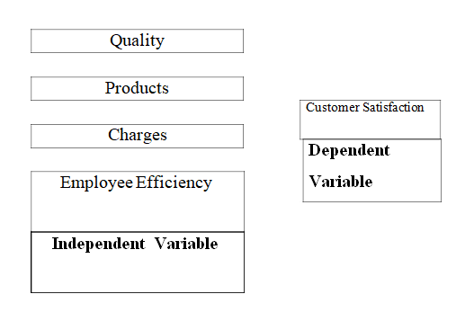
On the base of survey, theoretical analysis and practical experience of 3 months of my internship program, the following findings are identified during the period:

4.1 Quality of the Services of Prime Bank:
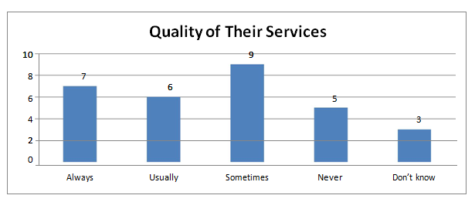
In case of Prime Bank Limited, the customer service quality isn't sufficiently satisfactory as per the view of the customers, regarding responsiveness and assurance of the employees. Customers saw a moderately low service quality. It has been recognized that civility, immediacy, and state of mind of the representatives towards their work are the basic issues and need to enhance altogether to give better quality service to the customers.

4.2 Products of Prime Bank:
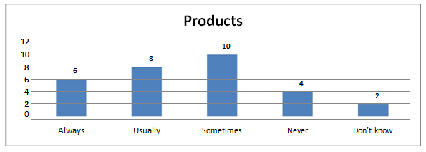
From a customer perspective and from this survey, I can state that customers are not sufficiently satisfied with Prime Bank's products and services. Their FDR rate is low, similarly some other commercial bank. Indeed, even they close some of products, for example, monthly benefit, double benefit, lakhopoti store, Savings Certificate and so forth.

4.3 Charges:
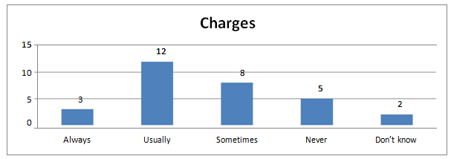
Customers are very happy with their charges. Customers need to pay high charges in the event that they exchange their cash from one record then onto the next record. Regardless of whether they need to issue any pay order, they need to pay a high commission. Prime bank charges high sum if any customers need to close their fixed store. Then again, PBL charges high on their Master Debit Card. So representatives are typically happy with prime bank's charges.

4.4 Employee Efficiency:
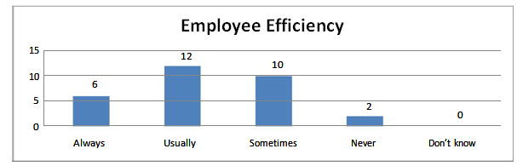
The majority of the employees don't have adequate knowledge about various transactions and numerous customers don't feel secure in transactions with prime bank, customer service quality increases with enhanced assurance which is genuine so prime bank can enhance confirmation by giving customers exact information. The greater part of the customers of the bank request greater quality service particularly fast, precise service and great behaviour from bankers as they think a private bank should give such quality adequately. It has been discovered that wrong and slow work process regularly propels the customers to differentiate the bank with the government's bank, which is definitely not a decent sign for the reputation of the bank.

SWOT Analysis of Prime Bank Ltd
Each organization is made out of some inside strengths and weaknesses and furthermore has some outside opportunities and threats in its entire life cycle.I also work on some information of Prime bank Limited to create a SWOT Analysis and Finally I have created a Complete SWOT analysis on the basis of the services provided by the bank.
STRENGTHS  - Stable source of fund  - Concentrated market  - Wide net work of brunches  - Well Furnished and air conditioned  - Experienced Top management  - Diversified product line  - Satisfactory IT infrastructure | WEAKNESSES  - Late in Service delivery  - Relatively high overhead expense.  - Long term credit is not sufficient.  - Deposit is lower than advance.
OPPORTUNITIES  - Development through opening brunches in rural sectors.  - Prime Bank Training Institute (PBTI)can use this opportunity to train their employees in specific areas and create specialized and expert people for the bank.  - The bank has the prospect to select high quality banking software which will make the banking operations easier and smooth as providing quality service | THREATS  - PBL is lagging behind in Technological sites.  - Market pressure for lowering the interest rate  - Shrinkage in export, import and guarantee  - Business due to economic slump  - Banking activities of Competitors  - Govt. pressures to reduce interest rate  - New rules and regulations imposed by Bangladesh bank.

Chapter 5
Limitations of the Study

Limitations of the Study
Some of the Potential problems faced in preparing this report are:

- It was extremely hard to gather the data from different work force for their job limitation.

- There were a few troubles in understanding few activities due to not being pertinent to the theoretical knowledge.

- Due to the secrecy of the Bank's strategy limits unveiling a few information.

- The greater part of the cases I need to utilize previous year's information for the assessment and investigation since.

- Information, about the execution of the bank of the year 2018, have not yet been uncovered by the bank. Since the yearly annual report and the financial statement of the bank are distributed at the long stretch of August every year.

- The investigation of such a short course of time isn't free from limitation. So time limitation is the primary purpose of limitation.

- Some of the information needed for the internship report , composing some of the time, couldn't be gathered due to unbearable year-ending workload at the branch.

- At the long stretch of June in the branch, there was huge year-ending workload, which here and there goes about as an obstruction in transit of my exertion.

- Working in a practical banking condition is not quite the same as the scholastic knowledge.

- Employers are excessively occupied with their work area work so they have less time to influence me to comprehend the work area job

- Bank needs to keep up part of mystery so as an assistant I was not permitted to know all stuff and data

- Adapting all the entire banking services inside only three months was extremely intense.

It is too much difficult to comment and suggest based on only the annual report and information collected from written documents.

Chapter 6
Recommendations and Conclusion

Recommendations
As per earnest observation, a few recommendations for the changes of the circumstance are given below:

Being a fresh Graduate, this will be my pleasure to propose on the service execution and activities of the Bank and on the experienced proficient bankers. The issues below are a portion of my perceptions based on my education prevailing conditions contrasting with different banks and in some cases on the customer's perspective.

  - Prime bank needs to introduce new short term scheme like micro credit for poor people and small Entrepreneurs. Our Bangladesh is a poor nation, the vast majority of the general population has no enough cash to begin new business ventures. Through the development of independent business opportunity, a nation can develop. Small business are easy to handle and manage and also less risky for the Investment as a Banker. More-over these sorts of customers are significantly more loyal and legit to the Bank. Grameen Bank is the best example for this. Huge business opportunity lies around there. PBL administration should think how to explore this chance.

  - Prime Bank Ltd. need to focus around their special services of their attractive products.

  - They also need to focus around the marketing aspects by informing the customers about its products and offering services charges.

  - Banking is service-oriented marketing. Its business benefit relies upon its service quality. That is the reason the authority always needs to know about their service quality. Employees must give special consideration regarding the clients. For that, they can enroll more employees.

  - Often customers complain that all customers are not treated similarly. They need to wait a long time to have a service. According to them, valued and loyal customers always get extra facilities and services from officers where ordinary customer do not. Limited number of employee is one reason of lower customer service. In the event that PBL enlists more employees and every single employee are committed to their work than the quality of the service will obviously enhance. Every one of the customers should treat in same way.

  - Customers often request greater quality service, particularly quick, precise service and great behavior from bankers as they think a private bank should give such quality adequately. It has been discovered that inappropriate and moderate work process frequently forces the customers to differentiate the bank with the government bank, which is awful for the reputation of the bank. HR department need to be serious while recruiting employees, to make sure the bank is getting well-mannered employees and those who can provide all the related services with quality.

  - PBL performs the majority of its exercises technologically in their own server name "Temonus" T24 instead of physically which has connected all branches with the head office. Because of this software task become more, smooth and stress-free yet the truth of the matter is that sometimes, it doesn't work properly or work very slow that is the reason the officers couldn't provide the anticipated service to their valued customers. This may hurt the reputation of the bank. IT Department should solve the problem of the software to ensure greater service of their clients.

  - Bank should utilize work rotation to evacuate work monotony among the officers which will expand their effectiveness also.

Hopefully, these suggestions will help PBL with improving their current service quality. Viably oversaw, clients feedback creates various opportunities for the improvement of interpersonal relationships between the customer and a bank's employees. This close relationship with the clients will be create additional value in consumer mind. It will give general and dependable customer feedback and subsequently the chance to make the essential proactive improvements to enhance services of Prime Bank Limited. This will empower the bank not only to act promptly to satisfy the customer but also to solve the similar problems in the upcoming days.

Conclusion
Prime Bank Ltd. offers a practical orientation to the new comers with regular corporate culture. This three months internship program with Prime Bank Ltd. undoubtedly will help me a lot to comprehend and adapt to any future corporate culture. The bank has developed itself as one of the most disciplined and promising banks in the commercial banking sector in Bangladesh under the dynamic supervision of its skilful administration group driven by Mr. Nazrul Islam. In this competitive market, Prime Bank Ltd. competes with the others commercial banks as well as with the govt Banks and delivering various ranges of products and services daily to its clients and has earned the capacity in more positive contributing towards economic development of Bangladesh as compared with other banks. Prime Bank Ltd. invests relatively more funds in advertising to their sevices and products. It has been working its service operation with incredible achievement and possessed the capacity to make constructive contribution to the economy of Bangladesh by virtue of its devoted and expert personnel. That is the reason Prime Bank Ltd. has situated itself one of the leading bank in Bangladesh. To the gateway to practical professional life, an experience at PRIME Bank Limited as an intern was a privilege for me.

Appendices

Reference:

Enhancement of Retail Banking Operation of Commercial Banks – Professor shamsuddoja – University of Chittagong.

BB library - Bangladesh Bank - Books on various disciplines like Finance, Banking, Central Banking.

Commercial Bank - Investopedia – Ranges of services performed by Commercial Banks.

Corporate Milestones - Prime Bank Limited - Completion of 10 years of service by thr Prime Bank

Some Important links:
- http://en.wikipedia.org
- http://www.primebank.com.bd/index/home/financial_reports
- lankabd.com/dse/stock.../PRIMEBANK%60S/prime-bank.../financial-statements
- https://bd.linkedin.com/in/shamsul-arefin-99923b124
- www.bangladesh‐bank.org
- www.investopedia.com

ATTACHMENTS:

Questionnaire
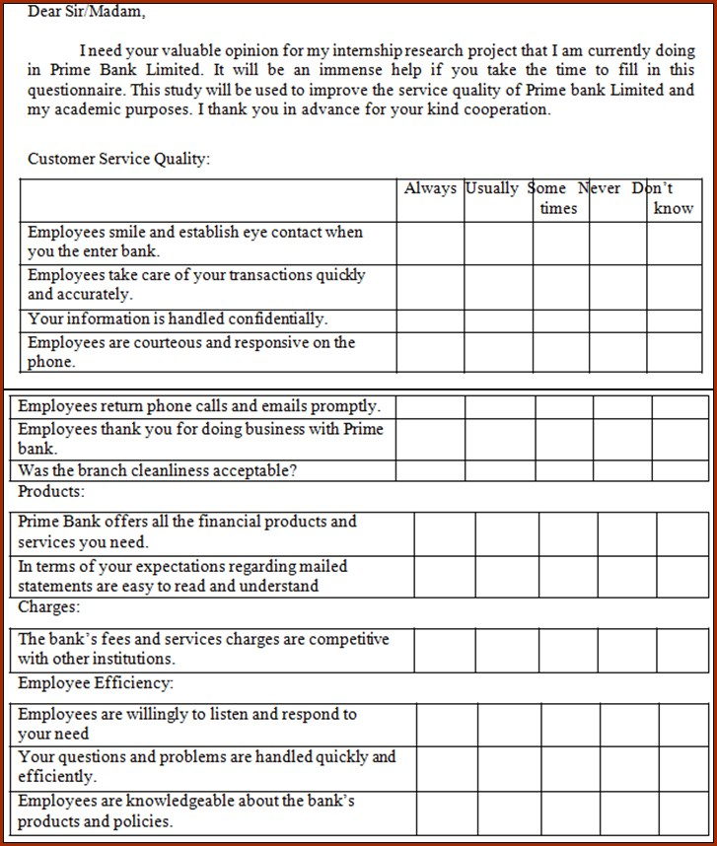
(Survey results showed in charts in the finding part of this report.)

Elaborations of the Abbreviations Used in the Study

- OBC = Outward Bills for Collection
- DD = Demand draft
- T.T = Telegraphic Transfer
- LBC = Local Bills for Collection
- IBC = Inward Bills for Collection
- IBTA = Inter Branch Transaction Advice
- PO = Pay Order
- PS = Pay slip
- A/C = Account
- MBDS A/C = Monthly Benefit Deposit Scheme
- CSS = Contributory Savings Scheme
- DBDS = Double Benefit Deposit Scheme
- LDS = Lakhpoti Deposit Scheme
- HBDS = House Building Deposit Scheme
- FDR = Fixed Deposit Receipt

