Competitive Situation Analysis of Premier Bank Limited
Name of the student
Sristy Saha


This report is submitted to the school of Business and Economics, United International University as a partial requirement for the degree fulfillment of Bachelor of Business Administration.

Internship Report
On
Competitive Situation Analysis of Premier Bank Limited
Course code: INT 4399
Submitted To
Dr. Khandoker Mahmudur Rahman
Professor
School of Business and Economics
United International University
Submitted By
Sristy Saha
ID: 111 161 394
Bachelor of Business Administration
Major in Marketing
School of Business and Economics
United International University
Date of Submission
May 12, 2022

Letter of Transmittal
May 12, 2022
Dr. Khandoker Mahmudur Rahman
Professor, School of Business and Economics
United International University
Subject: Submission of Internship Report
Dear Sir,
I am really delighted and honored to present my internship report on "Competitive Situation Analysis of Premier Bank Limited," which fulfils a portion of the Bachelor of Business Administration degree requirement.
For the purpose of making this report useful and comprehensive, I have combined my work experience at Premier Bank Limited with the study of competitive situational analysis, along with the substance of some secondary material from their website.
It was a wonderful chance for me to complete the report under your supervision, and I thank you for that. I am grateful for your unwavering support and courteous collaboration. I believe you will find my internship report to be satisfactory.
Sincerely

Sristy Saha
ID: 111 161 394
Bachelor of Business Administration
School of Business and Economics
United International University
Declaration of the Student
I am Sristy Saha, student of BBA program, School of Business and Economics at United International University.
In my internship report, I attest that the information included within is based on three months of hands-on experience gained while working in the customer service department of Premier Bank Limited (Matuail Branch). It was prepared only for academic purposes under the guidance of Dr. Khandoker Mahmudur Rahman, Professor, and School of Business Economics of United International University. I am the only author of this report. I did not do anything wrong in any manner throughout the study or writing of this report.

Sristy Saha
ID: 111 161 394
Bachelor of Business Administration
School of Business and Economics
United International University

Acknowledgement
To begin, I would want to express my gratitude to the Almighty for the favor with which I was successful in completing my internship report on time and successfully.
Then, I would like to extend my heartfelt appreciation to my internship supervisor, Dr. Khandoker Mahmudur Rahman, Professor, United International University's School of Business and Economics, for his constructive advice and invaluable assistance. It is true that I would not have been able to complete the report on time and with accuracy if it had not been for his invaluable direction, support, and collaboration throughout the process. I am delighted to have the opportunity to complete my internship report under his supervision.
And finally, I would want to my gratitude to Tanjum Sultana, Officer, Customer Service department, Premier Bank Limited (Matuail Branch) for providing me with the chance to obtain valuable practical experience as an internship. For my part, I would also like to thank the team of marketing and customer service teams of Premier Bank Limited (Matuail Branch). They were essential in helping me to discover an easier approach to deal with the obstacles I had on the job and in finishing my study and report on time.

Table of Content

Executive Summary vi
Chapter 01: Introduction
1.1 Introduction of the Report 2
1.2 Topic of the Report 2
1.3 Objectives of the Report 2
1.3.1 General Objectives 2
1.3.2 Broad Objectives 3
1.4 Scope of the Report 3
1.5 Methodology of the Report 3
1.5.1 Primary Sources 4
1.5.2 Secondary Sources 4
1.6 Limitations of the Report 4
Chapter 02: Company Analysis
2.1 Corporate Profile of Premier Bank Limited (PBL) 6
2.2 Mission, Vision and Core Values 7
2.3 Business Strategy 8
2.4 Business Operations 9
2.5 Products with Interest Rates 10
2.6 Organogram of the Bank 11
2.7 Business Performance (2016-2020) 11
Chapter 03: Project Analysis
3.1 Situational Analysis 14
3.1.1 Role of Banks in Economic Growth of Bangladesh 14
3.2 Competitive Intensity and Bank Response 15
3.2.1 Threat of New Entrants 16
3.2.2 Bargaining Power of Customers 16
3.2.3 Bargaining Power of Suppliers 17
3.2.4 Threat of Substitute 18
3.2.5 Competitive Rivalry 18
3.3 SWOT Analysis 19
3.3.1 Strengthen (Internal Factor) 19
3.3.2 Weakness (Internal Factor) 20
3.3.3 Opportunities (External Factor) 21
3.3.4 Threats (External Factor) 21
Chapter 04: Findings, Recommendations and Conclusion
4.1 Findings 24
4.2 Recommendations 25
4.3 Conclusion 25
References 26

Executive Summary
Competitive analysis is performed to better understand your company's position in the market. Intelligence gathering and tactical application go hand in hand, and this technique does both well. Including a competitive analysis in your company plan can help you outperform your rivals and retain customers. Asset purchase is made simpler, new client acquisition strategy is better understood, and investment financing is more readily available. Additionally, it may have a favorable effect on the company's performance and profitability. The study's goal is to figure out what elements impact Premier Bank Limited's growth in the competitive market edge in the bank industry of Bangladesh. With the use of a SWOT analysis and Porter's five forces model, Premier Bank Limited is able to understand what influences the market in the banking service sector, as well as what influences the business of Premier Bank Limited itself. Premier Bank Limited may benefit from using Porter's Five Forces to better understand the forces at play in the market and make strategic modifications based on those findings. Using a SWOT analysis, it is possible to identify the most essential aspects that may help organizations identify risks and opportunities in a competitive marketplace. Studies show that certain financial institutions in Bangladesh rivals are leading the pack. Furthermore, Premier Bank Limited must take on additional marketing challenges to dominate the industry as well as develop the company. Lack of fulfilling customers’ services according to their demand and digital bank services from other competitors are the main factors for the growth of Premier Bank Limited that have been discussed in this report. However, towards the conclusion of the repot, some recommendations were made in order to enhance the growth of Premier Bank Limited in the banking industry of Bangladesh.

CHAPTER 01
INTRODUCTION

Introduction of the Report
Individuals, businesses, and governments need a comprehensive variety of services, which commercial banks are now providing in a leading position in their respective sectors. Commercial banks are the major source of income or contribution in Bangladesh at the moment. By participating in an internship program in the banking industry, students may obtain practical information that will assist them in understanding real-life circumstances, introducing a career route, and developing a career path with practical experience.
Preparing this report was a requirement for the completion of an internship course at United International University as well as a component of a Bachelor of Business Administration (BBA) degree. This report was written based on my research, work experience, and theoretical knowledge gained while enrolled in my BBA degree. the Premier Bank Limited is a full-service financial institution in Bangladesh. I consider myself fortunate to have been offered this internship opportunity. For the last three months, I have been working as an intern for the organization, and throughout my employment, I have been preparing for my study, which is a prerequisite for obtaining my BBA credential from United International University.

Topic of the Report
An analysis of Bangladesh's banking sector would benefit from this report, I believe. The study of the report’s title, "Competitive Situational Analysis of Premier Bank Limited," was suggested by Khandoker Mahmudur Rahman, Associate Professor at United International University's School of Business and Economics.

Objectives of the Report
The study's objective is to compare Premier Bank Limited with other financial institution in Bangladesh in order to examine the overall banking service industry in Bangladesh. Additionally, the primary objective is to identify and study the reasons that are impeding the expansion of Premier Bank Limited's banking services. The objectives of the study, on the other hand, are split into the following two categories:

General Objectives
- In order to evaluate and contrast the real-world condition with the principles acquired throughout the UIU BBA program.
- The purpose of this introduction is to introduce myself while gaining professional skills, enhancing personal character, and exploring a diverse variety of employment opportunities.
- To have a thorough understanding of marketing tactics and how they are implemented in the real world of business.

Broad Objectives
- The purpose of this study is to analyze the existing scenario of the banking service industry in Bangladesh.
- To conduct an analysis of Porter's five forces in Bangladesh's banking industry.
- To find out the Premier Bank Limited's strengths, weaknesses, opportunities, and threats.
- To ascertain the obstacles impeding Premier Bank Limited's growth and development into a competitive market leader in the banking industry of Bangladesh.
- To provide recommendations on how to overcome the barriers preventing Premier Bank Limited from growing and becoming a market leader in the banking industry of Bangladesh.

Scope of the Report
Business development is a challenging endeavor that may be stymied for a number of reasons. There are several factors that might affect a company's growth potential, so management must keep an eye on them. A constantly changing environment necessitates recognizing the factors that can adapt and react to it and the potential for employee training and progress.
In contrast, increase alone does not ensure growth. Because of the absence of "push" factors like possible replacements, new businesses that take advantage of identified market opportunities are expected to have a stronger growth orientation. Identifying the company's most important aspects and then using them to create and expand the company is essential.

Methodology of the Report
According to the report's methodology, this part discusses how the study was conducted and the sources that were used.

Primary Sources
- Formal and informal discussions with the employees of Premier Bank Limited resulted in the creation of this report.
- On the basis of my own personal experience while working as an intern at Premier Bank Limited (Matuail Branch).

Secondary Sources
- From academic books for understanding the concepts of competitive situation analysis and marketing strategies.
- Online blogs, articles, business news etc.
- Annual Report of Premier Bank Limited.

Limitations of the Report
- The internship term was insufficiently long to allow for the acquisition of practical expertise.
- No comprehensive data could be gathered because of the organization's limitations as a financial institution.
- During my three-month internship at Premier Bank Limited, I was responsible for all of the company's tasks. This made it difficult to complete the research and write the report at this time.

CHAPTER 02
COMPANY ANALYSIS
Company Analysis
An overview of the organization, its mission, vision, objectives, core values and five years’ business performance has been highlighted in this chapter that will provide a short relevant scenario of the topic of the report.

Corporate Profile of Premier Bank Limited (PBL)
Founded on June 10, 1999, the Premier Bank Limited is a full-service financial institution. Service First" was the Bank's guiding principle when it opened its doors on October 26, 1999. Customers may choose from a comprehensive selection of deposit products, loans and advances, credit cards, and other services to meet their needs. Many different kinds of current accounts, savings accounts, term and personal loans, debit/credit cards, continuing loans, and internet banking are included in the Product Basket. There are also Treasury & Synchronization services and other financial products.
Table 1.1: Premier Bank Limited at a Glance
Premier Bank Limited (PBL) - Private Commercial Bank
Form of Business | Banking Service
Key Business Segments in Banking Services | Retail Banking, Corporate Banking, SME, Cards, Islamic Banking, Premier Securities and Treasury Management
Members of Board of Detectors | 12
Number of Branch | Total of 120 Branches 18 AD & 102 Non AD with 12 Agri/SME
ATM Booths and Sub Branches | 11 sub-branches and 90 ATM booths
The Premier Bank Limited is also celebrating its 21st anniversary in 2021. They are both pleased and honored to have played a significant part in the economic sector's transformation and the county's rise to prominence as a major financial player as a result. Innovating new and proven banking products and services has gained us the confidence, respect, and admiration of our customers. As a partner in the nation's sustainable economic growth, they are always striving to do their best.

Mission, Vision and Core Values
Mission
- In order to provide opportunities for more people in more places, we want to be the most compassionate and customer-friendly financial services provider on the planet.
- To maintain stability and good growth while increasing the value of the company's stockholders' investments.
- To increase efficiency and minimize costs per transaction by using technology at every level of the organization.
- To focus on maintaining a high degree of integrity and transparency in all Bank transactions.
- In order to create a positive working environment in order to recruit highly qualified employees who are both proud of and excited about working for the bank.
- To be socially responsible and to work to advance living equality via effective contributions to social development.
Vision
- A strong vision guides the Bank toward its ultimate goal of being the greatest among the world's leading financial institutions.
Core Values
Better Relationship
Easier Banking
Service First
Corporate Citizenship
Corporate Governance
Assured Confidentiality

Figure1.1: Core Values of Premier Bank Limited


Business Strategy
- Proactive
Premier Bank Limited, they strive to improve their lives and their work. 'Reactive Management,' on the other hand, has no room for frivolity. Through practice, they may get better at foreseeing and responding to situations.
- Begin with the in Mind
Every action they do is a direct reflection of their aim. They establish their goals based on what is in front of and beyond them, as well as what are inside them. Efforts begin immediately to meet the deadline.
- Put First Things First
They choose to focus on things that have a positive effect on mental health. Things that are most important are not subject to the whims of things that are less important.
- Think Win- Win
An attitude of win-win always seeks mutual gain in all human relationships. As part of their philosophy, they want all parties to go away with a positive outlook. When they prepare in advance, they are able to work together in a mutually beneficial way.
- First Comprehend then be Understood
Over and above all other values, they place a high importance on their capacity to communicate. The majority of the time, they patiently listen to others more than they are heard ourselves. They try to figure out what is expected of them first, and then they position their selves as appropriately as they possibly can.
- Care and Share alike for the Society
They are concerned about the sentiments, needs, and experiences of the general public, and they share their interests on an equal footing. A better society and more affluent Bangladesh are their ultimate goals as they strive to help those who are less fortunate and less fortunate than others in the community. That they can contribute in more ways than simply providing financial services is an honor and a privilege for them.

Business Operations

Managing the day-to-day operations of the bank is the responsibility of Premier Bank's Operations Division, which ensures that all operational components of the bank's activities work safely and soundly.
- Design and execute operations strategies, plans, and processes that are in accordance with Business Functions as they are identified.
- Create policies that support the culture and goals of the organization.
- Developing, implementing, and monitoring processes, workflows, and procedures that are connected to Operations is their job.
- Ensure that operational efforts are consistent with the basic principles and culture of the organization.
- Establish a thorough set of objectives for performance and development.
- Manage corporate connections with regulators, business partners, and suppliers.
- Maintain daily control over the Departments / Units under Operations in accordance with the approved Organization Chart.
- Ensure that the Bank complies with the law in an effective and efficient manner.
- Controlling operating costs is a management function.
- Evaluate the efficacy and efficiency of operating procedures and make necessary improvements.
- Encourage people to achieve their highest levels of performance and devotion.
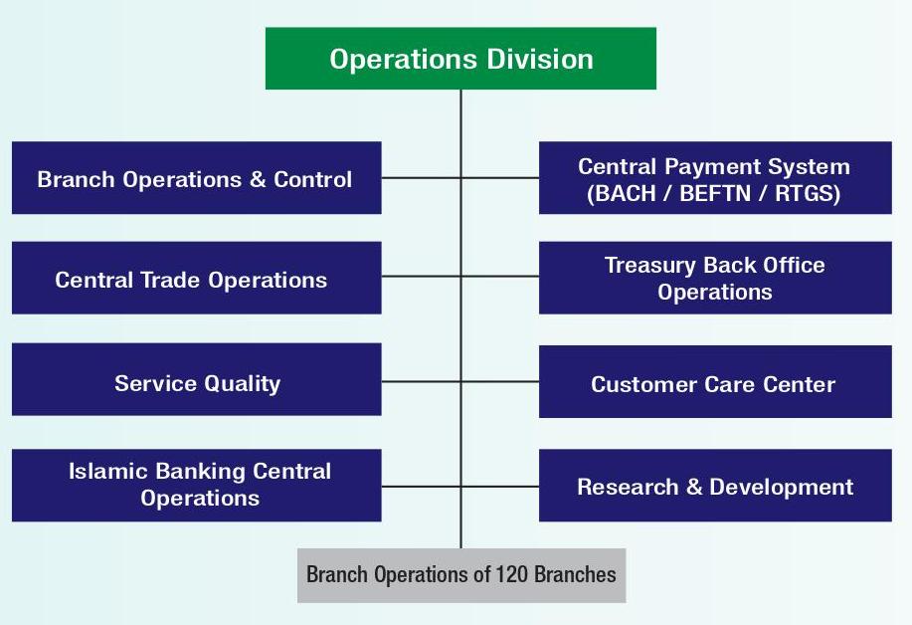
Figure1.2: Key Functions of Operational Division of Premier Bank Limited

Products with Interest Rates
Product Name | Duration | Parameter | Rate
FDR | 1- 2 months | Any amount | 3-3.25%
FDR | 3 Months  6 Months  12 Months  36 Months | For Employee Provident Fund, Retail Deposits, and Gratuity Funds | 5.65%  5.70%  5.75%  5.75%
FDR | 100 days | 5 Lack or Above | 6.00%
FDR | 13 Months | 10 lack or Above | 6.50%
SB Deposit | ------ | 5k to 1 Lack | 2%
SB Deposit | ------ | 1 lack or Above | 2.5%
Payroll Account | ------ | Up to 1 lack to 1 core | 1-2.50%
Premier Supper Account | ------ | 5 to 100 Core or Above | 3.00 – 4.25%
Premier 50 Plus Account | ------ | 10 Lack to 1 Core | 2.00-5.00%
Premier Remittance Savers | ------ | 1k to 10 Lack | 0.50-2.00%
Saving Account | 3 to 10 years | 500 or its multiple | 6.00-6.25%
Income Scheme | 1 to 5years | 10k or its multiple | 6.00-6.25%
Figure1.3: Listing of Products and Interest Rate

Organogram of the Bank
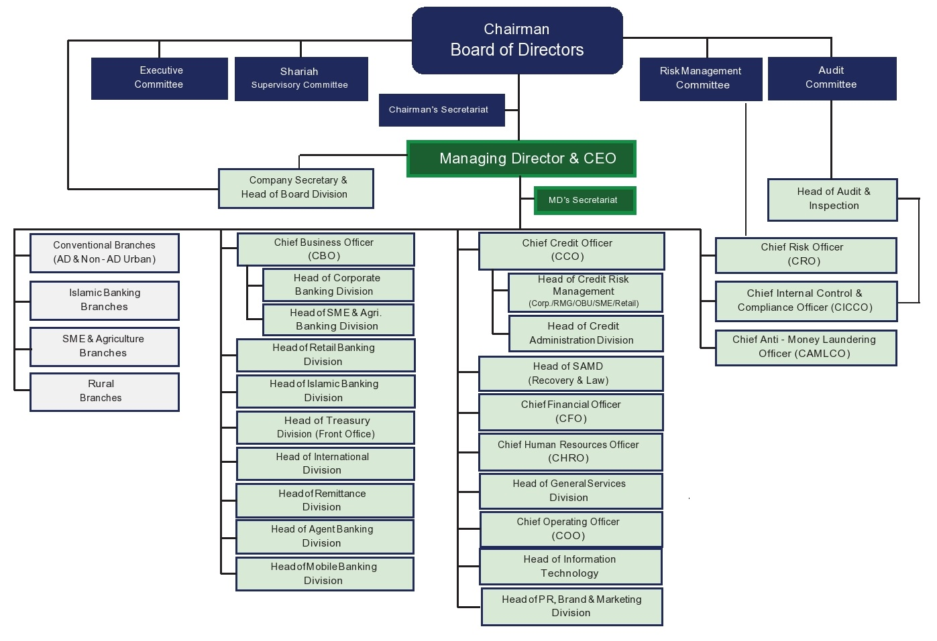
Figure1.4: Organogram of Premier Bank Limited

Business Performance (2016-2020)
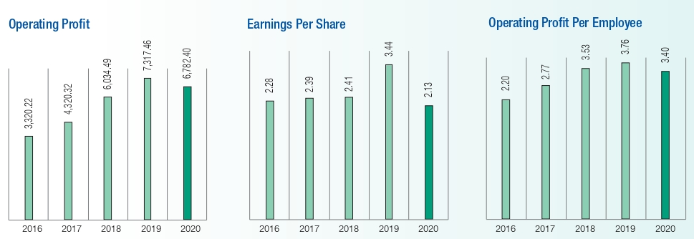
Figure1.5: Five Years’ Performance of Premier Bank Limited

That does not imply, however, that everything will be perfect in 2020. As they entered the pandemic-ridden economic landscape, they had a good amount of power. The Premier Bank Limited had a difficult year in 2020, but it was also a year in which they established a number of new records in their various businesses, including operating and net income. Operating profit decreased from BDT 7,317.46 million a year earlier to BDT 6,782.48 million, but this still reflects a good underlying performance across their various companies and units. In 2021, they have every reason to believe that their earnings will rise significantly. The Bank continues to make considerable investments in goods, people, and technology, while their major businesses increased somewhat in revenue and net income. Despite the fact that they boosted deposits by 15.58 percent and expanded loans by 12.84 percent, they were able to retain strict credit policies and a strong balance sheet.

CHAPTER 03
PROJECT ANALYSIS

Situational Analysis

Role of Banks in Economic Growth of Bangladesh
Bangladesh's economic growth would not be possible without the contributions of commercial banks. They serve both the public and private sectors by providing funds that may be invested. Banks have also played an important part in Bangladesh's economic progress to the four primary drivers of growth such as (a) RMG, (b) Labor Supply, (c) Agricultural and (d) SME (Barkat-e-Khuda, 2022).
When it comes to bank scams like money laundering and bad loans, the opposite is true: banks face a number of challenges including poor management and governance, a dearth of strong leadership, and a lack of adherence to ethical norms (Barkat-e-Khuda, 2022).
Bangladesh relies significantly on imported goods. In order to help the RMG business flourish, raw materials, accessories, and equipment are all imports that must be made. For a long time now, banks have been providing the sector with payment, lending, and risk management services.
As a percentage of total export financing in 2017, private commercial banks (PCBs) had the largest share (60%) followed by state-owned commercial banks (SoCBs). There has been a rise in both the volume and the share of bank loans to the RMG industry between 2014 and 2017, the most recent year for which data is available. The cost of imports has steadily increased over time. Exports of EPZ grew from US$21,629 million in 2007-08 to US$43,663.0 million in 2016-17 as a result of an increase in total import payments (Barkat-e-Khuda, 2022).
Banks help migrant employees send money home. The nation received fewer remittances between 2010-11 and 2016-17, while remittances via banking channels also decreased. However, Bangladesh received more remittances previous fiscal year due to a robust worldwide economic recovery, particularly in the Middle East. Many banks have upped their efforts to improve remittance inflows via their separate channels owing to a scarcity of US dollars caused by increasing import payments versus a reduction in export profits (Barkat-e-Khuda, 2022).
Agricultural and associated sectors have been given special attention by the government because of the sector's importance. Between 2013 and 2017, crops got more than half of all agricultural loans, followed by livestock and other agricultural businesses.
Priority one went to commercial banks, followed by specialized financial institutes, state-owned financial institutions, and international financial institutions (Bangladesh Bank Annual Reports). As a whole, its payments to agriculture increased fivefold, from BDT 15.63 billion in 2001-02 to BDT 82.15 billion in 2017-18, while its total disbursement to crop output increased 3.6 times, from BDT 8.59 billion to BDT 30.62 billion. In FY17, they provided BDT 210 billion in credit, exceeding their target of BDT 175.50 billion by a significant margin. The FCBs and PCBs exceeded their targets by a total of 44 percent and 36 percent (Barkat-e-Khuda, 2022).
"SME Credit Programs and Policies" were created by the Bangladesh Bank in 2010 to help small businesses achieve sustainable inclusive growth. It is up to commercial banks and non-financial institutions (NBFIs) to set their own goals and objectives as part of this initiative. Since 2012, both the targets and the actual spending have increased. Even though the target was BDT 1338.6 billion, all banks and NBFIs delivered BDT 1439.7 billion to 697,000 small and medium-sized businesses. A total of 49,000 of Bangladesh's BDT 45.1 billion went to women-owned companies (Barkat-e-Khuda, 2022).

Competitive Intensity and Bank Response
The Porter's five forces model, which helps evaluate the degree of competition in a specific sector, is very beneficial to new enterprises and those entering new industries, among other things. The threat of new entrants and substitutes, the negotiating power of suppliers and buyers, as well as the competitiveness of their individual sectors versus one another are all factors that companies and industries must contend with in order to stay competitive. There are a variety of elements that influence the profitability of a firm or industry. When the five forces are at their most severe, there is almost no firm in this sector that delivers favorable investment returns. In contrast, if the five components are moderate, there is room for higher returns.
The pressure exerted by rival firms in the same industry is known as competitive intensity. Some rivalry is beneficial since it encourages the development of new ideas in the workplace. Teams and individuals strive to be the greatest while they are competing against each other, regardless of the circumstance. The Premier Bank Limited constantly responds to the competitive factors that are detected throughout the regular course of business in order to keep its competitive advantage. Competitive intensity is influenced by a number of variables, such as the following:
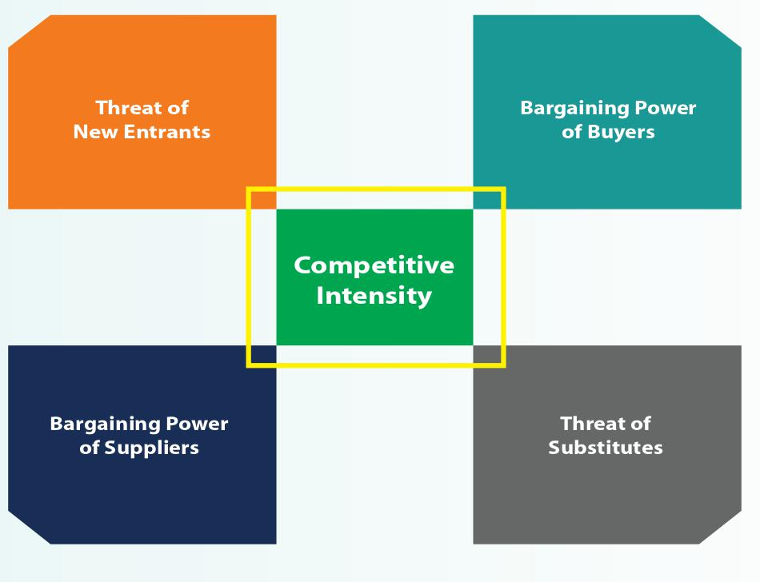

Threat of New Entrants
The government is under constant pressure to allow new banks and financial institutions from well-known political figures and organizations. Apart from that, a number of international banks are now giving financial facilities to local enterprises at lower rates of interest and with more flexible terms and conditions than before.
Strategy of Premier Bank Limited
In order to tackle the threats posed by new entrants, they are engaged in the following initiatives:
- They are making significant investments in digital banking with the goal of increasing client convenience while also improving their capacity to meet their increasingly complex needs.
- Launching innovative solutions and services on a continuous basis to meet the demands and requirements of a diversified consumer base.
- Maintaining the greatest possible degree of regulatory compliance by rigid adherence to all applicable standards.
- The retail and SME industries have already seen significant improvements, and they are now concentrating on growing their current client base even more. By introducing new and diversified services, they want to attract new clients.

Bargaining Power of Customers
Customers may relatively easily migrate to other banks completely, or even only part of their service needs, resulting in a reduction in the overall size of the engagement with the bank. In today's era of promotional campaigns, investment clients have more bargaining power than ever before. This is owing to the low switching costs that are associated with the large number of banks that are present within the business.
Strategy of Premier Bank Limited
One of the strategies they use to attract and keep clients is the implementation of the following initiatives:
- Providing deposit rates that is competitive with the market.
- Providing service standards that are unsurpassed in the industry.
- Making digital banking accessible to them on the move, allowing them to undertake a variety of financial transactions on the go.
- Providing interest rates depending on valuation, as well as flexibility in terms of foreclosure, processing costs, and so on.

Bargaining Power of Suppliers
For the banking sector, depositors are the primary source of capital, and their negotiating power is more powerful in Bangladesh currently than at any point in its history. Liquidity problems plague the majority of financial institutions. Consequently, depositors now have the upper hand as banks compete for their business by offering them high interest rates. Deposits from customers and borrowings from other financial institutions are the two main sources of funding, and both are subject to market fluctuations.
Strategy of Premier Bank Limited
In order to get a competitive advantage over our supplier relationships, they use the tactics outlined below:
- They provide their depositors with competitive interest rates while also ensuring that they get best-in-class service.
- The bank partners and investors can rest easy knowing that we will fulfill their commitments and live up to their expectations when they put their trust in us to manage their finances.
- In order to help us reach their objectives and ambitions via their time, effort, and expertise, they give them with suitable salary and effective professional development programs.

Threat of Substitute

Many financial services formerly exclusively accessible via banks have been made available to the general public by firms outside of the banking sector. Transferring money through BKASH, NAGAD, and other similar alternatives are only a few examples.
Strategy of Premier Bank Limited
They are looking for new possibilities that may arise as a result of changes in technology and regulatory laws in order to capitalize on the benefits of being first to market. As a result, they are considering the introduction of a digital wallet.

Competitive Rivalry
The banking sector in the nation consists of 61 scheduled banks, 5 non-scheduled banks, and 34 non-banking financial institutions (NBFIs). Because of the significant concentration of service providers, it is quite simple to transfer from one provider to another. Banks are also in the process of creating new goods and services, which will help them to strengthen their client acquisition methods while also reducing the market share of current service providers.
In addition, there are several big local banks that provide a diverse variety of asset and liability solutions at attractive interest rates.
Strategy of Premier Bank Limited
In order to protect their market and gain more market share, they have taken the following steps.
Investing in cutting-edge technology allows them to provide their customers cutting-edge financial products and services, which increases consumer confidence and enhances the whole experience.
- In order to make a difference, they believe that service excellence cannot be commoditized or copied.
- As a result, our consumers return to them time and time again because of their high service standards and exceptional experiences.
- As a company, they've always had a dedicated following of consumers. This gives them a significant edge in a highly competitive business, even as we work to maintain and grow their existing customer base.

SWOT Analysis
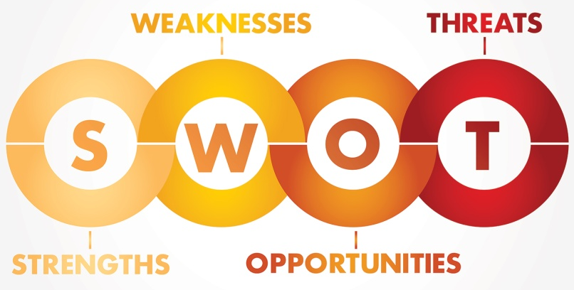
SWOT analysis indicates internal elements (Strength, Weakness) important to our industry which are under our control/ability and external factors (Opportunity, Threat) exist in our company surroundings within which we confront continuing our day to day operation.
The following critical factors are vital to SWOT analysis, according to Premier Bank's viewpoint, and they are listed in alphabetical order below:

Strengthen (Internal Factor)


Stronger liquidity and Capital Base
The CRAR (Capital-to-Risk Weighted Assets Ratio) of 13.64 percent was successfully maintained by Premier Bank, and the cost-to-income ratio was reduced to a satisfactory level.

Good Corporate Governance
The bank's board of directors ensures that strong ethical standards are created across the organization and analyses the bank's compliance with the Central Bank on a regular basis. It is recognized by the board of directors that excellent corporate governance practices are essential in the generation of significant shareholder value and the protection of the interests of all stakeholders.

Enriched Human Capital
They have a well-developed human resource pool and a healthy work environment for providing the most possible value to the company.
- To collect data on the efficiency of human resource usage,
- In order to provide information on the condition of a human asset, such as whether it is being kept effectively and if it is appreciating or depleting, and
- By categorizing the financial effects of various human resource management techniques, it is possible to aid in the creation of successful human resource management practices.
Typically, by the use of the following methods, Human capital is valued.

Diversified Products and Services
Premier Bank provides their valued customers with a diverse range of contemporary corporate, retail, and SME products, as well as regulatory services.

Stronger Branch Network
'Service First' is not simply a catchphrase for them; it is something they really believe in. It is a primary and major focus of their operations, which are carried out via 120 branches, 118 ATMs, and 17 agent banking outlets spread throughout urban and rural regions.

Performer of Regulatory Compliance
Since its start, Premier Bank has been in complete compliance with all Bangladesh Bank and National Board of Revenue tax and VAT regulations.

Weakness (Internal Factor)

- Limited SME and Retail Exposures
When compared to other market leaders, Premier Bank has minimal exposures to the retail and small and medium-sized enterprise (SME) markets.
- Dependence on Core Banking Line Up
Because Premier Bank does not have any other substantial revenue streams, the bank's interest revenue income and total income decreased as a result of the reduced deposit-loan proportion of 6-9 percent.
- Absence of Advanced Technology
Premier Bank's investment in the information technology industry to expand physical infrastructure and upgrade software is insufficient, and software up gradation is restricted. It is already working on cyber security measures, but there is still more work to be done in this area.


Opportunities (External Factor)
- Governments Initiatives Towards Development
Currently, the Bangladesh government is investing in infrastructure development, such as the Metro train system, four-lane highways, Padma Bridge, the Big Port in addition to a number of other development projects. As part of this progress, Premier Bank is prepared to face the problems that may arise in collaboration with key stakeholders.
- Women Entrepreneurship in Rising
Women's entrepreneurship has risen in recent years as literacy and educational attainment have both grown. There are specific service desks at Premier Bank for Women Entrepreneurs. Women business owners can rely on our experienced Relationship Managers and custom-tailored solutions to meet all of their banking requirements.
- GDP Growth along with other Business Development
Bangladesh's rise in the business and commerce world is a result of its long-term strong GDP growth (save during the COVID-19 period) and its departure from low-income nations. As a result, the banking business in Bangladesh is seeing fresh growth prospects as the country's GDP and per capita income rise.
- Islamic Banking Wings
The bulk of the population is Muslim, and hence adheres to an Islamic shariah-based economy. Islamic financial services and Shariah-compliant goods and services are becoming more popular in the banking business nowadays. To that end, Premier Bank, an Islamic banking subsidiary, is being established as a component of the broader shariah-based financial system. Prepaid Hajj Card from Premier Bank is a unique option for your financial requirements while visiting Saudi Arabia's Holy Lands for your Hajj.

Threats (External Factor)

Recent COVID 19 Pandemic Effects
Because of the prolonged lockdown during the pandemic era, GDP growth fell to 5.20% of the intended 8.20%. Bank loan disbursement and loan recovery were so low that interest revenue was drastically decreased, and this has had a negative impact on the business sector.

- Non-Cooperation from Bad Customer
Bangladesh bank adopted interest-free issued loans due to covid-19 impacts for certain duration. After being able to pay interest on time, a client decided to take advantage of the opportunity to avoid paying interest. In addition, some customers abuse the loan they were granted by fraudulently submitting paperwork.
- Unanticipated Event
These days, the most sophisticated IT tools and technologies are being used by hackers and cyber criminals. Customers may lose faith in banking security due to a sudden increase in cybercrime.
- Lower Interest Rate
Other than credit cards, the government has set a maximum interest rate for loans of up to 9%. As a result, sustainability in the near future was negatively affected.

CHAPTER 04
FINDINGS, RECOMMENDATIONS AND CONCLUSION

Findings
Bangladesh's stimulus package is highly dependent on credit, and the banking sector will have to play a major role in that process in 2021. Both the Bangladeshi economy and the country's banks and financial institutions depend on effective administration of the stimulus package. In order to provide proper oversight, the open-rationalization approach includes the identification and selection of the impacted enterprises, as well as monitoring of the whole process. When it comes to identifying and selecting the impacted businesses that are more likely to benefit from the stimulus packages, the Corporate Banking Division of Premier Bank Limited is more careful and methodical. Because of low interest rates and high capital requirements, as well as increased competition from shadow banks and new digital entrants, the covid-19 crisis will pose significant challenges to the conventional banking business model as well.
Beside, multiple challenges have been identified as impeding the expansion of Premier Bank Limited's bank service business in Bangladesh based on the existing status of the banking sector in Bangladesh, competitive market environment, internal and external factors, and have been categorized as follows:
- Premier Bank Limited encourages its employee to perform on a salary-based system by providing incentives, advantages, and other benefits such as performance bonuses, profit-sharing, and risk-sharing incentives.
- Customers and clients may not be able to meet their demands on time due to a lack of ATM booths, which is time-consuming.
- Many or Several clients are unable to make it to the bank during the banking transaction period, which results in the bank losing a certain number of customers who are busy at work.
- One of the most noticeable weaknesses in the Account Opening and Dispatch area has been the lack of a marketing department. The task of the bank would have been much simpler if there had been a completely separate and segregated marketing section.
- The technical instrument has not been upgraded in a long time. Take, for example, the lack of a copying machine and an interconnecting telephone at the Matuail branch.
- There are just a few departments in the general banking sector.

Recommendations
- There are six categories in the general banking sector that are directly connected to each other. As a result, the GB division should be subdivided into further parts. The bank should raise its rates. Personal relationships with its customers are fostered by a well-organized GB section of the company.
- Premier Bank Limited should expand the number of personnel at its branches in order to provide better service to their customers.
- Clients and workers should both be responsible for filing complaints in a Complaint Box. Because certain internal politics produce unpleasant circumstances, it is important to understand them.
- The number of ATM booths should be increased, and the services provided by the ATM booths should be improved.
- Premier Bank Limited should have a marketing department that is independent from the rest of the company.
- It is necessary to bring in the appropriate technical instrument to the bank.

Conclusion
Many new commercial banks have sprung up in the past few years, increasing the level of competition in the banking industry. Currently, Premier Bank Ltd. is on a track to import services. All of the initiatives and services offered by Premier Bank Limited are being developed to the greatest degree of excellence.
As an intern at Premier Bank Ltd Matuail Branch, I am grateful for the experience. A number of financial systems I had never heard of before have been introduced to me throughout my time at the bank. To put theory into practice, I need to practice what I've learned. I feel that these three months of my internship will assist me in developing my professional skills and enabling me to make an informed decision about my future career path.
In general, I would say that every industry has both positive and negative aspects, and if I consider Premier Bank Limited's existence, the positive aspect is that they are very much focused on improving their existing strategy and adding valuable products to earn their customers' preference and loyalty.

References

Barkat-e-Khuda. (2022, January 11). Economic growth in Bangladesh and the role of banking sector. Retrieved from The Financial Express: https://thefinancialexpress.com.bd/views/views/economic-growth-in-bangladesh-and-the-role-of-banking-sector-1547220114
Interest Rate. (n.d.). Retrieved from Premier Bank Limited: https://premierbankltd.com/pbl/interest-rate/
Kashem, M. S. (n.d.). Ahead in Competition through SWOT Model: Banking Industry Perspective. Retrieved from Ideas: https://ideas.repec.org/a/arp/ijefrr/2016p8-15.html
Keller, P. K. (2018-2019). Marketing Management (Global Edition). Boston: Pearson.
Mohammad Akram Hossain, F. (2020). Annual Report. Bangladesh: Premier Bank Limited.
Rahman, K. M. (2016). Strategic Planning and Marketing Models. In Strategic Marketing Management in Asia. Emerald Group Publishing Limited.
Velea, G. C. (2015). The Strategic Positioning of the Financial Banking Companies - Key Factor for Achieving Competitive Advantages. Knowledge Horizons - Economics, 103-106.

Mohammad Akram Hossain, F. (2020). Annual Report. Bangladesh: Premier Bank Limited.
Mohammad Akram Hossain, F. (2020). Annual Report. Bangladesh: Premier Bank Limited.
Interest Rate. (n.d.). Retrieved from Premier Bank Limited: https://premierbankltd.com/pbl/interest-rate/
Mohammad Akram Hossain, F. (2020). Annual Report. Bangladesh: Premier Bank Limited.
Mohammad Akram Hossain, F. (2020). Annual Report. Bangladesh: Premier Bank Limited.

