
Internship Report
on
Analysis of HR Practices of Deepto Television

Supervised by:
Ms. Piana Monsur Mindia
Assistant Professor
School of Business & Economics
United International University

Submitted by:
Sadia Alam Mumu
ID: 111 161 117

Date of Submission: 25/02/2022

Internship Report
on
Analysis of HR Practices of Deepto Television



Letter of Transmittal

February 25th, 2022

Ms. Piana Monsur Mindia
Assistant Professor
School of Business & Economics
United International University

Subject: Submission of Internship Report on Analysis of HR Practices

Dear Mam,
I would like to submit my internship report titled “Internship Report on Analysis of HR Practices of Deepto Television” which is a part of my ongoing BBA program and it is required to complete my BBA program from United International University.
While working on the report I tried to follow each and every guideline that you setup and advised. It was very enlightening experience to work in new venture and I also have enjoyed my internship period at Deepto Television. The authority of Deepto Television has extended their cooperation whenever required.

Sincerely yours,

Sadia Alam Mumu
ID: 111 161 117

Acknowledgment
All my thanks go to my project administrator MS Piana Monsur Mindia who has helped me throughout the whole report. Without her help and direction completing this report accurately would be an impossible task for me.
I am very grateful to Mr. Masud and Mahmudul Hasan (Associate Producer) for giving me the opportunity to do my internship at Deepto Television. I am sure that their excellent and futuristic managerial activities will give inspiration and motivation to anybody to build one’s career properly.
I also want to thank Md. Humayun Kabir, Executive HR, and all the individuals of Deepto television for their support. Without their full support, I could have not completed my report. I am grateful to all employees of Deepto TV, how they accept me as a colleague even though I was an intern. Their support motivates me to complete the report legally.

Table of Contents:
Executive Summary 7
1. Introduction of the report 9
1.1 Introduction: 9
1.1.1 Origin of the Report: 9
1.1.2 Background of the Report: 9
1.2 Scope of the Report: 10
1.3 Objectives of the Report: 10
1.3.1 Primary Objectives: 10
1.3.2 Secondary Objectives: 10
1.4 Methodology: 10
1.4.1 Primary Sources: 11
1.4.2 Secondary Sources: 11
1.5 Limitations: 11
2. Introduction of the Organization 14
2.1 History of the organization: 14
2.2 Mission, Vision &Objectives: 15
2.3 Product &services: 15
2.3.1 Current Broadcasting Services: 16
2.4 Organization Structure: 18
2.4.1. Organogram of Deepto Television: 18
2.4.2. Departments of Deepto TV: 19
3. Discussions of HR functions of Deepto TV 21
3.1 Human Resource Planning of Deepto Television: 21
3.1.1 Assessing Current HR: 22
3.1.2 Forecast HR Demand: 22
3.1.3 Forecast HR Supply: 22
3.1.4 Match Demand & Supply Forecast: 22
3.1.5 Action Plan: 22
3.2 Assessment Evaluation: 23
3.2.1 The 360-degree Feedback: 23
3.2.2 Assessment Center: 23
3.2.3 HR (Cost) accounting: 23
3.2.4 Management by objectives (MBO): 23
3.2.5 Field Review: 24
3.3 Compensation & Benefit: 24
3.3.1 Fixed Pay: 24
3.3.2 Variable Pay: 24
3.3.3 Equity Pay: 25
3.3.4 Medical: 25
3.3.5 Insurance: 25
3.3.6 Accommodation: 25
3.4 Requirement & Selection Process of Deepto Television: 26
3.4.1 Collecting Manpower Requisitions Form: 27
3.4.2 Attract applicant & Collecting Resumes: 27
3.4.3 Sort out applicants: 28
3.4.4 Make call list and informing candidates: 28
3.4.5 Getting ready applicants profile outline: 28
3.4.6 Creating presence list: 28
3.4.7 Examinations: 28
3.4.8 Communicate to long last choose applicants: 29
3.4.9 Conduct applicants check list for fresh comers: 29
3.4.10 Joining: 30
3.5 Leave Policy: 30
3.5.1 Leaves under the law: 30
3.5.2 Holidays under the law: 31
3.5.3 Maternity leave & benefit: 31
4. Analysis & Findings: 33
4.1 Findings: 38
5. Recommendation and Conclusions: 41
5.1 Recommendation: 41
5.2 Conclusions: 41
Bibliography 43
Appendix 44

Executive Summary
The temporary internship I have done in Deepto TV was a 6-month period entry level job. There I worked under the Human Resources Department as a requirement of my BBA Program in UIU.
This report is all about my days in Deepto Tv as an intern and how Deepto Tv manages their employees and does business. Deepto Tv follows five major functions of HR, these are: - Human Resource planning, assessment evaluation, compensation & benefit, recruitment & selection process and leave policy. In this report, I have discussed all these functions elaborately.
In Deepto Tv my major work was to inform candidates after they were selected through examinations, but often my seniors assign me with different types of work like listing the salary sheets or checking the attendance sheets. So, I have gained some experience in different types of HR activities.
In this report I tried to show my internship participation in Deepto TV. My report consists of five chapters, in chapter one; there I discussed a short introduction about the report, its background and its origin, scope, objectives and methodology of the report. In chapter two, I showed the overall organization, organizations history, its mission, vision & objective as well as organizational structure. In chapter three I gave a brief discussion about all the functions of HR in this report such as a detailed HR planning of Deepto TV and assessment evaluation also, I write how they recruit and select employees for different projects and departments. In chapter four I also done a survey with the employees of Deepto TV about their feelings, pros and cons of working for Deepto TV etc. After the survey I find that some improvement should be done in the HR functions and I also recommended some thoughts of myself for the betterment of the company that I shows in chapter five.

Chapter One-
Introduction of the
report

1. Introduction of the report
1.1 Introduction: Modern business are highly complex because of its overhanging customer preferences and taste. Also, globalization is a factor here, now organization should maintain an international standard to cope up with the market. Every company wants a loyal group of customers and so do Deepto wants a loyal group of viewers. They make profit from them.
To maintain all the task every company has some highly qualified personal. This study of report tries to focus all the Human Resources activities of Deepto Television and how did they manage all the personnel to perform an effective task.
1.1.1 Origin of the Report: Now a days only academic knowledge isn’t enough to be a graduate. Everyone needs to know the business world and prepare himself for the forthcoming unborn commercial word. This report has given me the occasion on how Deepto TV manages its human resources and apply the strategy to satisfy the organization goal.
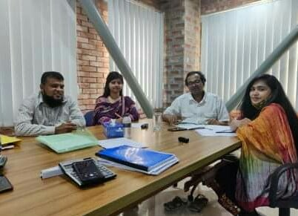
Picture: Our HR team is working on a project
1.1.2 Background of the Report: Internship program is an important aspect to complete a BBA program and it also unlocks the corporate world to the students. Through an internship program, student face the corporate world and can learn the reality of this world. They can improve their capabilities and can take notes for the future.
1.2 Scope of the Report: I worked as intern for Deepto TV for almost 6 months. There I work closely with the employees of the organization and watch how do they work there and cope all the things up.
1.3 Objectives of the Report: The objective of my report was to watch the business world in person closely as an employee, so that I can understand the competition and situation of corporate world. That would help me in my future. The internship program shows me the following things:
1.3.1 Primary Objectives: The report that I am doing as a HR intern must have a specific objective. The specific objective of the report is to analyze the HR practices of Deepto TV. I wanted to go deep down in their strategy, how they control mass number of employees with their strategy. To complete this report, I have followed questionnaire pattern.
1.3.2 Secondary Objectives: The secondary objective of the report was to finish it. Although I do have some objectives of my own.
- To recruit the best employee
- To design some HR strategies for Deepto TV.
- To develop some traits and necessary HR plan.
- To provide new ideas about HR
- To recommend some solutions about the problems that Deepto TV faces

1.4 Methodology: For a better report I tried to collect the information from two main sources. Those are primary sources and secondary sources.

1.4.1 Primary Sources:
- Questionnaire survey from 10 (Ten) employees of Deepto TV
- Office Visit
- Observing directly
- Discussions with manager, supervisor and employees of Deepto TV
- Direct conversations with clients
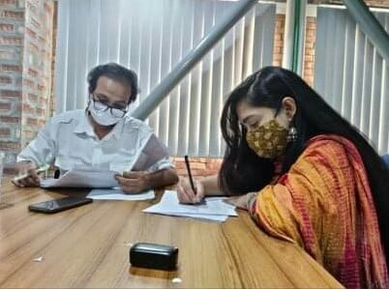
Picture: I am collecting some information from Office

1.4.2 Secondary Sources:
- Online Reports from Deepto TV
- Job circulars
- Information from the web
- Wikipedia

1.5 Limitations: While preparing the report I faced some certain limitations.
- It was very hard task for me to collect some information directly
- There was a lack of sufficient resources.
- A very few information was in the web, so I collected the main information directly from Deepto TV.
- I was an intern in Deepto TV, so they do not want me to know everything including their plans and financial parts.

Chapter Two-
Introduction of the organization

2. Introduction of the Organization

2.1 History of the organization:
Deepto TV is a private string & satellite TV channel in Bangladesh. It's a wholly valued concern of Kazi Granges Group and operates under Kazi Media Limited and its marketable transmission started from 18 November 2015.
Deepto TV focuses on entertainment with emphasis on diurnal drama diurnals. All programmers of the channel except for distributed titles similar as Ben 10, Power puff Girls, and Sultan Suleiman-are produced by Kazi Media Limited. The channel also shows Bengali dubbed foreign serials and has daily drama serials. The channel air both entertainment programs and news programs with equal attention to details. They served news in a unique style that is different and interesting too. They gain popularity on Krishi programs. The channel focus is on providing content according to their viewer’s demand and tastes.

2.2 Mission, Vision &Objectives:
2.2.1 Vision: Their vision is to achieve viewer satisfaction and want to be the best satellite TV channel countrywide.
2.2.2 Mission: Their mission is to become number one TV channel. They also wanted to several auditory or audiences from the Indian TV channels like Zee bangle and Star jalsha and draw them towards their programs. They wanted to be a number one from January 16 to 22 among local TV channels and on number four after star Jalsha, Zee bangle and star plus in terms of viewership of Bangladeshi audience.
2.2.3 Objective: Their objective or motive is to sustain their position and have to maintain the quality of their work. So, in order to remain very best they have to keep coming up with good programs which are really a big challenge.

2.3 Product &services:
As it is a television channel so they only give services by showing different programs. Deepto Tv gained popularity by broadcasting “Muhteşem Yüzyıl” a Turkish TV show Bengali translated to “Sultan Suleiman”. Alongside they broadcast cartoons like Ben10, PowerPuff girls etc.
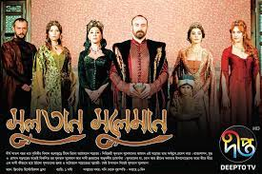
Picture: Deepto Tv presents “Sultan Suleiman”

2.3.1 Current Broadcasting Services:
The list of current broadcasting programs of Deepto Tv are given below-
- Deepto Provati (daily musical morning show)
- Khujey Firi Takey (daily drama serial)
- Aparajita, based on the novel Baluchori written by Ashapoorna Devi (daily drama serial)

Picture: “Aparajita” Drama Serial
- Palki (daily drama serial)

Picture: Drama “Palki”
- Kadın (locally known as Bahar)
- Feriha (Adını Feriha Koydum) (Bengali dubbed drama series; shown daily)
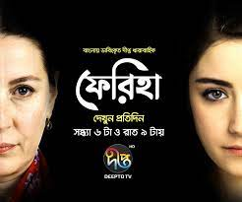
Picture: Bangla Dubbed “Feriha”
- Highlander (Bengali dubbed drama series; shown daily)
- Mashrafi Junior (Bengali drama series)
- Deepto Shangbad (news) - non-traditional news coverage focusing on issues of interest; daily from *12.00pm, *2.30pm to 3.00pm and *11:00pm to 11.45pm; segments Deepto Sports *12.15 pm & *11.45 pm.
- Deepto Krishi - documentary on farmers and the role farming plays in their lives; on-air date is to be finalized
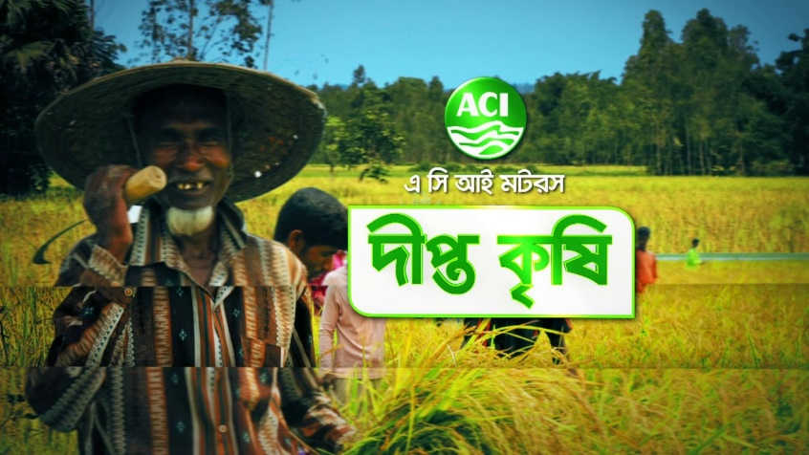
Picture: “Deepto Krishi Tv Show”
- Talk Show Tokkatokki - talk show on topics and burning issues of the day, hosted by Robaet Ferdous; from 12:00am to 1:00am
- Talk Show Drishshopot - talk show on academic topics, hosted by Firoz Ahmed; only on Saturdays from 12:00am to 1:00am
- Deepto Chhayachobi - classic feature films; shown daily
These are the current programs that Deepto TV broadcast daily. Also, there are special programs and shows that only broadcasted during any special occasion or Friday.

2.4 Organization Structure:

2.4.1. Organogram of Deepto Television:

Figure 2.1: Deepto TV Organogram
Any organization run under a specific level of peoples or officers and so do Deepto TV the CEO of Deepto TV “Fuad Chowdhury” controls the whole organization with some specific departments like HR, Sales & Marketing, News, Accounts, Distribution, Support Service etc.

2.4.2. Departments of Deepto TV:
Each organization has some specific departments. The departments of Deepto TV are-
- Business Department: Main focus of this department is keeping the company up-to-date. And conducting business through advertisements.
- Communication Department: It’s a broadcasting department that helps broadcasting programs by giving specialized help in communication process of programs.
- Current Affairs: The main objective of this department is to air programs with the pace of current trends and occasion of the nation.
- Conveyances: In Bangladesh every television each family unit have must be under the Independent Television Ltd, it was granted by the distribution office.
- Human Resource: This department is in charge of selecting the employees and prepare a perfect balanced salary structure for the organization.
- Bolster Service: It’s a support service that deals with Corporate Management, Distribution Management and Stock Management.
- Videography: They are in charge of all videotape affiliated workshop of the station including, catching to the altering of the program.
- Sales & Marketing: This department only deals with businesslike-
- New Business look
- Customer belief
- Sales Occasion Administration
- News: This department collects the hot topics and news of the country as well as the world. There are: -
- National News
- International News
- Current Affairs

Chapter Three-
Discussion of the HR functions

3. Discussions of HR functions of Deepto TV
Human Resources are the heart of any organizations. They manage the whole organization and makes proper uses of the available resources. Keeping up appropriate information is the strategy of Deepto TV’s HR. In Deepto TV every procedure is achieved in time. Every time a decision is taken; proper and legal document is required. It is said that main task for HR is correct and simple to find proper documentation. All these functions in Deepto Television are done by the HR Dept.
So Deepto TV put the most supreme attempt on the advancement of HR, they try to maximize the quality of the workers, they are given time to prepare for self-improvement. Deepto TV sorts out both in house and outer preparing to improve the information of the workers.
The principal functions of Deepto TV HR divisions are:
- Human Resource Planning
- Assessment Evaluation
- Compensation & Benefit
- Recruitment & Selection Process
- Leave Policy

3.1 Human Resource Planning of Deepto Television: Human Resource planning is a part of HR department that includes a goal. And to obtain that goal we will need a number of employees. We need to develop a plan that will collect the information from our potential human resources needs and will help us to achieve our plan. So, accumulation all the human needs is a significant part of this plan. So, the main part of HRP is to hire and develop workers.
In Deepto TV the HR manager along with his assessor discussed how the human resources should be planned according to the budget and time of the work.
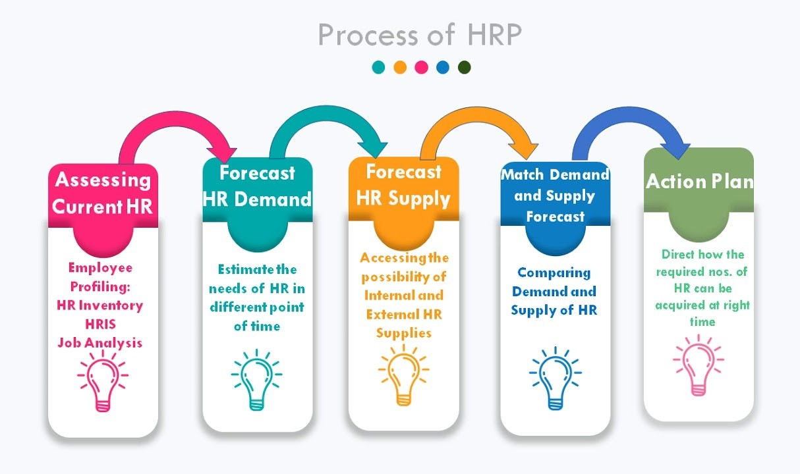
3.1.1 Assessing Current HR: The managers of Deepto TV make a list of their employees and analyze if they are capable of meeting the company target.
3.1.2 Forecast HR Demand: Then they estimate the needs of HR in different departments and in different points of time.
3.1.3 Forecast HR Supply: Then they started to forecast the number of human resources they could provide for different departments.
3.1.4 Match Demand & Supply Forecast: Now they compare their human resource supply with their current demand and forecast if they needed any more resources.
3.1.5 Action Plan: After all that work the managers along with their assessors plan how Deepto TV will move forward throughout the whole year.

3.2 Assessment Evaluation: Assessment evaluation consists of the following methods:
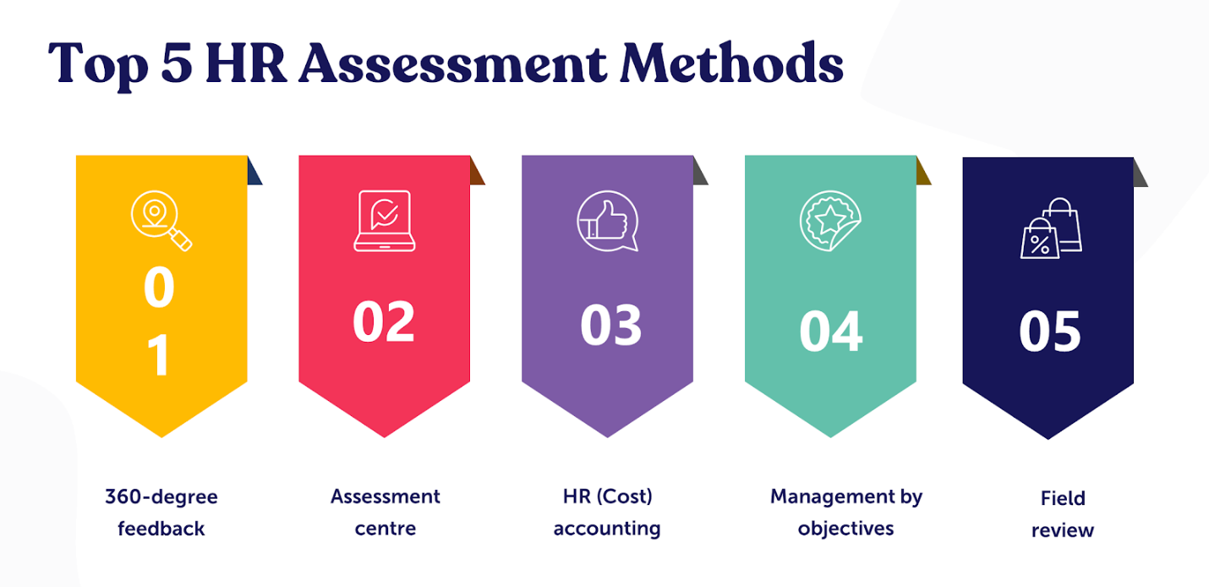
3.2.1 The 360-degree Feedback: The 360-degree feedback review is the most popular method in the HR realm. HR manager and his assessor collects the feedback on an employee’s performance from everyone affiliated with them. It describes how an employee works within the company.
3.2.2 Assessment Center: This method takes HR assessment in a central location where managers, assessors and employees gather. Then they asked to perform a series of task or to be grouped for the task. The assessors then can analyze the specific work-related skill that the institution need by role playing games, simulations, exercise and conducting workshops.
3.2.3 HR (Cost) accounting: In Deepto TV the managers measure the cost and value of people to organizations. It involves measuring cost incurred by private firms and public sectors to recruit, select, hire, train and develop employees and judge their economic value to the organization.
3.2.4 Management by objectives (MBO): In Deepto TV employees and managers sit together at the start of a year or quarterly and plan goals and the processes required to reach those goals for the next financial round. This makes the relationship of managers and subordinates stronger.
3.2.5 Field Review: This is a time-consuming method where HR department follows and asses an employee, evaluating their working style, output and effectiveness. This is useful when the HR team is concerned that if the employee getting biased review for the managers.
In Deepto TV me with my two co-workers collected the feedback and submitted to our superior officer.
3.3 Compensation & Benefit: Compensation is what the employee receives for their work. It is monetary and non-monetary return for the work done by them. There are different types of compensation and benefit.
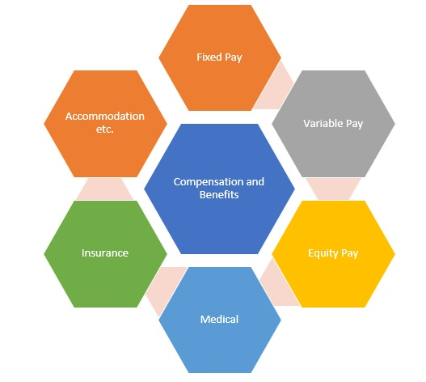
3.3.1 Fixed Pay: It is the basic salary that the employee will get no matter he works hard or not. I was an intern in Deepto TV and my Fixed pay was 6000 takas.
3.3.2 Variable Pay: It is also known as performance pay. It is used to reward and recognize employee contribution beyond their job requirements.
3.3.3 Equity Pay: Equity compensation is a non cash pay that is offered to an employee that includes options, restricted stocks and performance shares and these represents ownership of the firm for company employees.
3.3.4 Medical: It is quite simple method that company pays for the employee’s medical. It is sometimes called medical expenses coverage when an employee injured by an accident.
3.3.5 Insurance: This is a benefit that workers get when they get a work-related injury or illness. Some companies even provide normal insurance benefits to their employees.
3.3.6 Accommodation: Sometimes companies pay employees with accommodation such as during a holiday trip the company offer their employee a free hotel room with meals.

3.4 Recruitment & Selection Process of Deepto Television:
Recruitment and selecting employees are one of the main and important part of the HRM of Deepto Television. All the steps of requirement are shown below:

3.4.1 Collecting Manpower Requisitions Form: First of all, the HR department of Deepto Television notify all other department of the company that they are in need of manpower. Then each division should refill the labor order frame. In demand frame there are few elements. These are:
3.4.1.1 Vacancy Subtle Elements: It contains a form about what needed such as employee type, position name, openings, number of workers required etc. There are two kinds of elements. These are:
- Transfer
- Fresh Entry
Managers must include the past employee’s name, positions, times of their work. Schedule and their leaving date. Managers must include their opinion about that employee and also include how a new position is raised. This judgement must be approved by the HR division and other admin panels.
3.4.1.2 Employment Portrayal: Here the managers must mention all the responsibilities that the worker must do and abide. There must be a list of all the sets of responsibilities.
3.4.1.3 Employment Detail: Managers must include a detailed employment vacancy. Age, experience and educational qualifications are a matter as well as skills and capacity.
3.4.1.4 Final Consent: This is just a coronation for the new employees. Where DGM, HR manager and all the panel heads will sign the document and approve the new employee.
3.4.2 Attract applicant & Collecting Resumes: On this step the company post their job vacancy on different sites, websites, newspaper to attract the deserving applicants. After several CV’s are dropped by applicant then the Human Asset Department will begin their investigation to select the deserving CV’s. There are two hotspots for gathering CVs, these are: -
3.4.2.1 Internal Sources: Here the managers collect resumes of the employees who are already working in the institution, it also lowers the cost of Hr. These are:
- Referrals from employee
- Information Notice Line
- Transfer & Development within the institution
3.4.2.2 Outside Options: Here the selected applicants are from outside the institution. It may be costly but opens a great scope to find new talents. The factors are:
- Public Promotion
- On Line Advertisement in different media
- Finding talents through internship program
3.4.3 Sort out applicants: To find the perfect candidate first of all the HR managers selects some of the employees from his own perspective and also asks his assistant to choose some more. After gathering all the selected applicants; their CV are sent to the admin panel. There they decide which one to select.
3.4.4 Make call list and informing candidates: After the selection from the admin panel it’s time to make a list of the candidates whom we are going to call for the examinations. My main task was to inform them about the examinations and the exam time and date as well as how to prepare for the exams.
3.4.5 Getting ready applicants profile outline: Now the HR division will set a profile for each applicant. There they will include the biodata of the applicants, their father’s name, mother’s name, last training, educational background, experience, last job, height, age, marital status and many more, to know the candidates more closely and clearly. This will help HR to understand the candidate in a moment during the viva.
3.4.6 Creating presence list: That’s a normal participation sheet that keeps proof about the candidate who attended the exams. This sheet contains candidates name, their father’s name, versatile number and mark box. Each candidate will signature on this sheet before entering exam or a viva.
3.4.7 Examinations: Selected contenders will sit for the test. Applicants will need to score at least 30 to pass the exams. Questions are based from 3 different group such as, English, mathematics and general knowledge. There is also extortion related inquiry. The hopeful must answer that part too or otherwise they will not qualified.
After the test the HR office checks the exam papers and selects the deserving candidates. They will sit for the viva. The viva board contains 4-5 members of admin panel. They make an employee profile for better understanding that candidate during the critical moment of the viva. Then they started to question each candidate based on their profile and personal skills and traits. Also, they want to hear why they left the previous job.
Questioners also wants some skills from candidates.
These are-
- How competitive they are during a task
- How do they interact with others?
- Candidate’s ruling ability
- Their intellectual skills
- Their advance skills.

3.4.8 Communicate to long last choose applicants: After all the exams and viva the HR offices guarantees the deserving applicants for a job posting but they had given a time to bring all the legal documents on a fixed date. Failure to bring all the documents on time may result the cancelation of the job.
3.4.9 Conduct applicants check list for fresh comers: All the new joiner should submit some papers which is mandatory. Such as:
- Their Curriculum Vitae
- Candidates Details Application Form
- Certificate and Transcript
- Release Form
- Certain amount of passport size photographs those are verified by a first-class government officer
- Candidate’s National ID card photocopy
- Joining letter
- Their Nominee forms
- Verified Medical Certificate
- Blood group
- Bank account

3.4.10 Joining: In the joining day when the candidates submit their data, the HR office verifies them once again and make two copies to keep the records and return the original copy back to the candidates. Then HR dept. ask another 2 copy of photographs which are signed by a Govt. officer, their personal contract number, blood group and NID.
Therefore, the requirement and selection process of Deepto TV is conducted. The HR dept, tried to conduct this process fairly so that they can give a hundred percent bias free opportunity to all the employees.

3.5 Leave Policy: Deepto TV strictly follows the Bangladesh Labor law and their leave policy is according to the law.
3.5.1 Leaves under the law: There are three types of leaves under the labor law:
- Casual leave
- Sick leave
- Annual leave with wages
Casual leave: Every worker has an opportunity to take casual leaves with full wages for ten days in a calendar year. Such leave shall not accumulate and carried forward to the succeeding year.
Sick Leave: Every worker has a right to claim the sick leave with full wages for fourteen days in a calendar year. But he\she must be examined by a registered medical practitioner and doctor has to issue certificates. Such will not be accumulated and carried forward the succeeding year.
Annual leave with wages: After one year of continuous service every adult worker shall able to claim the annual leave. The annual leave will be computed at the rate of one day leave with wages for every 18 working days. However, still he can claim that in the succeeding period of twelve months, if a worker doesn't avail the leave as mentioned over.
3.5.2 Holidays under the law: There are two types of holidays under the current law. These are:
- Festival Holidays
- Weekly Holidays
Festival Holidays: Every worker has the right to take 11 days of paid festival holiday in a calendar year. During the working in any holidays, the worker will get two additional holidays with full payment.
Weekly Holidays: In Deepto TV every worker will get a 1 (one) day of weekly holiday.
3.5.3 Maternity leave & benefit: Every woman will have the right to get payment of maternity leave. The benefit period will be 8 (eight) weeks preceding the anticipated day of her delivery and 8 (eight) weeks immediately following the day of her delivery.
However, those women who worked less than six months immediately the preceding of the delivery will not get the benefit. Also, those who have two or more surviving children will not able to claim the maternity benefit however she can apply for any other benefits.
the maternity benefit which is overdue under this act shall be payable at the rate of daily, weekly or yearly average pay. The day-to-day, weekly or yearly average pay, shall be calculated by dividing the total pay earned by the woman during the three months immediately preceding the date on which she gives notice by the number of days she actually worked during the period. Such payment shall be made wholly in cash.

Chapter Four-
Analysis & Findings

4. Analysis & Findings:
I have prepared a small survey with my 10 (ten) colleagues in Deepto TV. I prepared a questionnaire and give them each questionnaire to answer. The answer consists from Strongly Disagree to Strongly Agree and made points according to the answers from 1-5.
The results are below:

Comment: Among my colleagues 2 believe answered strongly disagree, 1 disagree, 3 answered neutral, 4 people agreed and 1 strongly agreed.

Comment: On this question maximum people agreed that the planning of Deepto TV is accurate.

Comment: I find here mixed opinion among my colleagues.

Comment: Well as a television channel it is obvious that everybody will not get that number of holidays.

Comment: More than half of my colleagues agreed to that, still the percentages of disagree with alarming.

Comment: It is a kind of 50-50 situation here.

Comment: Half of my colleagues are happy with their remuneration.

Comment: I can say everyone agreed to that.

Comment: Everyone strongly agreed that HR policy will lead to the organizational goals.

Comment: With no disagree, the answers are quite positive.

  - Findings: From my questionnaire survey, the major findings of my reports are: -
- Recruitment process of Deepto tv is not free from biasness through the majority agreed but the disagree rate is also 30 percent.
- Employees believed their HR Planning is perfect that 70 percent of the employees agreed
- Deepto TV is not aware about employee’s compensation and benefits; 10 percent disagreed and 30 percent strongly disagreed about that
- As a television channel, it is obvious that everyone will not get enough holiday. Employees get their holidays according to their departments. Half of the employees is happy with the holidays and half is not.
- 60 percent of the employees agreed Deepto TV is aware about the maternity benefit, yet with the other 40 percent, the results are quite alarming.
- 30 percent of the employee agreed that the internal requirement is based on the relationship with the superior and 30 percent disagreed; also, the neutral rate is 40 percent.
- 50 percent employees are happy with their remuneration, 30 percent neutral and only 20 percent are not happy with their remuneration.
- 70 percent of the employees strongly agreed and the rest 30 percent also agreed that the HR policy of Deepto TV is cost effective
- 100 percent of the employees strongly agreed that the HR policy of Deepto TV will lead to the organizational goal.
- In total 90 percent agreed that the assessment evaluation of Deepto TV is accurate, and the rest 10 percent says neutral.

Chapter Five-
Recommendations & Conclusions

5. Recommendation and Conclusions:

5.1 Recommendation: Organizations should conduct several types of programs for the betterment of the employees. They should conduct authoritative training, customer management training and budgetary training to focus on the goal more effectively.
- The Recruitment process should be free from biasness, Deepto TV may also hire some agency to conduct the requirement process and keep it free from all sort of biasness.
- They should aware more about employees’ compensations and benefits because it is the main motivation for any employees.
- They should be aware about the employees’ holidays. Everyone should get enough holidays. They should prepare a schedule for holidays of different departments.
- They should be aware about their maternity benefit. Though is not that big problem but still the survey results are not decent. A different board should arrange for this topic.
- Their internal requirement should also be done accurately. Though the superior wants their favorite employee to work with them. But still it should be done without any biasness.
- Training practice time must have to expand
- The valuation of the training should be done more strictly
- HR team should develop an advance training system
- They should compete with the top tv channels in BD for better performance
- They should focus more on the outer training
- Deepto TV must adapt modern training techniques
- They should investigate why some workers in the past quitted jobs

5.2 Conclusions:
Training program for any organizations opens the door for another opportunity where they can compete against the best of all. Training enhances the productivity and capability of any organizations. Deepto Tv maybe a bit back dated for training programs but sure they will improve more and more in the near future.
From all the activities, human resource planning of deepto TV impresses me the most. The admin panel of Deepto TV surely worked hard for the process. How they asses demand and supply will always be a trademark for any other institution.
Also, by talking and collecting data from the employees I realized Deepto TV are always active in financial terms. Though I am an intern that’s why they do not share financial terms with me but surely by chitchatting with the colleagues I can assure that they are on the right path.
At last, but not least I cannot finish my report without talking about their selection and recruiting process. Thus, candidates must compete a very hard paths and with lots of deserving candidates. This is the reason why Deepto TV competing against any other channels so fast and so quickly. After a lot of tests and viva they select their deserving employees. I can assure that the selection process is full free from biasness.
Although after completing my 6 months internship from Deepto TV, I am grateful to them and I wish them Goodluck in their near future.

Bibliography
(Human Resources). Wikipedia. Retrieved from Human resources - Wikipedia
Chopra, B. (August 31, 2015). Importance of training & development in an organization. The Economic Times. Retrieved from Importance of training and development in an organization (indiatimes.com)
(“Covid-19 Pandemic in Bangladesh”, 2021). Wikipedia. Retrieved from COVID-19 pandemic in Bangladesh - Wikipedia
(“Deepto TV”, 2021). Wikipedia. Retrieved from Deepto TV - Wikipedia
Kenton, W. (July, 2020). Human Resources. Investopedia. Retrieved from Human Resources (HR) Definition (investopedia.com)
(“Training & Development in HR”, 2017). CPD Courses. Retrieved from Training and Development in HRM | Training and development in human resource management (cpdcourses.com)
UK Essays. (November 2018). Training and Development in HRM Management Essay. Retrieved from Training And Development In Hrm Management Essay (ukessays.com)
Ukachi, L. When people go to work, they shouldn’t have to leave their hearts home. LinkedIn. Retrieved from (32) “When people go to work, they shouldn’t have to leave their hearts at home.” – Betty Bender | LinkedIn
(“Human Resource Management”, 2021). iEduNote. Retrieved from Human Resource Management(HRM) (iedunote.com)
McLagan, P, A. (1983). American Society of Training & Development. Google Article. Retrieved from Patricia McLagan‬ - Google Scholar‬

Appendix
Questionnaire Sample:
- Recruitment process of Deepto Television free from biasness?
(1) Strongly Disagree (2) Disagree (3) Neutral (4) Agree (5) Strongly Agree

- Human Resource Planning of Deepto Television is accurate?
(1) Strongly Disagree (2) Disagree (3) Neutral (4) Agree (5) Strongly Agree

- Deepto TV is aware of all the compensation and benefits?
(1) Strongly Disagree (2) Disagree (3) Neutral (4) Agree (5) Strongly Agree

- Do you get enough holidays according to the laws?
(1) Strongly Disagree (2) Disagree (3) Neutral (4) Agree (5) Strongly Agree

- Maternity benefit of Deepto TV is well measured?
(1) Strongly Disagree (2) Disagree (3) Neutral (4) Agree (5) Strongly Agree

- Internal requirement is based on the relationships with the superior?
(1) Strongly Disagree (2) Disagree (3) Neutral (4) Agree (5) Strongly Agree

- You happy with your remuneration?
(1) Strongly Disagree (2) Disagree (3) Neutral (4) Agree (5) Strongly Agree

- HR policy of Deepto TV is cost effective?
(1) Strongly Disagree (2) Disagree (3) Neutral (4) Agree (5) Strongly Agree

- HR policy of Deepto TV will lead organizational goals?
(1) Strongly Disagree (2) Disagree (3) Neutral (4) Agree (5) Strongly Agree

- The assessment evaluation of Deepto TV is accurate?
(1) Strongly Disagree (2) Disagree (3) Neutral (4) Agree (5) Strongly Agree

