Performance Analysis of Commercial Banks in Bangladesh: A Comparison between Islamic and Conventional Banks



Report
On
Performance Analysis of Commercial Banks in Bangladesh: A Comparison between Islamic and Conventional Banks

Supervised By
Muhammad Enamul Haque
Assistant Professor
School of Business and Economics
UIU University

Submitted By
Tahara Zinnat
ID: 111 141 351
BBA (Finance)
School of Business and Economics

Date of Submission:
April 16, 2019

LETTER OF TRANSMITTAL
16 April, 2019
Muhammad Enamul Haque
Assistant Professor
School of Business and Economics
UIU University
Subject: Submission of the project.
Dear Sir,
I would like to thanks my honorable teacher to help me to prepare the project report on “Performance analysis of Commercial Banks in Bangladesh: A comparison between Islamic and Conventional Banks’’. While preparing this report I learn many things by following your guideline and highlight the performance evaluation on Islamic and Conventional Bank.
Without your proper guidance it is impossible for me to prepare this report and now it is fully completed. So I request you to accept my report and pardon me if there is any mistake.
I would like to thanks for your help and co-operation.
Yours sincerely
………………….
Tahara Zinnat
ID: 111 141 351
School of Business and Economics
UIU University

Acknowledgement
Firstly I would like to express my gratitude to almighty Allah who gives me the ability and power to prepare the task of the project report properly.
Secondly. I am very much grateful to my supervisor, Muhammad Enamul Haque, Assistant Professor, School of Business and Economics, of United International University (UIU) for his advice, guidelines, suggestion to prepare the report. He also helps me to find out the topics of the project. By following his guideline I completed my report.
Finally, I thank my parents and friends who help me and mentally support me to prepare the report of the project.

Declaration
The project report titled ‘’ Performance analysis of Commercial Banks in Bangladesh: A comparison between Islamic and Conventional Banks’’, submitted by Tahara Zinnat, ID: 111 141 351, a student of school of business and Economics of United International University whose major is Finance has prepare the report. I ensure that this report is done by me and only for the BBA program. Also it is not submitted for any degree or any other purposes.

…………………………..
Tahara Zinnat
ID: 111 141 351
School of Business and Economics
UIU University

Executive Summary
Bank is an economic institution and its aim is to earn profit through exchange of money and credit instruments. It is a service oriented as well as profits oriented organization. The main concern is to analysis the financial performance of four Islamic and Conventional banks in Bangladesh for the time period 2013-2016. Five ratio dimensions like liquidity ratios, profitability ratios, solvency ratios, efficiency ratios and market ratios have been applied to measure the performance analysis of commercial banks. The main objective of Islamic bank and conventional bank is same and that is profit making.
Report has been organized in four chapters. First Chapter is introduction of the study; the second part is background of the Islamic and conventional banks; third Chapter describes the analysis and interpretation of financial performances and forth chapter is the conclusion about the project.
The financial performances of Conventional and Islamic banks have been measured over the period of 2013 to 2016 applying the ratio analysis techniques. Report also focuses on statistical tool of standard deviation to make sure that which banks have better outcomes compared to others. The conclusion is that although conventional banks generate more return compared to the return of Islamic banks, Islamic banks have less risk element inherent in business operations and therefore, investment is lucrative for Islamic banks rather than traditional banks.

Table of Content
Chapter: 01………………………………………………………………………………….........1
1.1 Introduction………………………………………………………………………………..…..2
1.2 Origin of the report……………………………………………………………………….…...2
1.3 Objective of the report………………………………………………………………….……..3
1.4 Data collection……………………………………………………………………….……..…3
1.5 Limitation of the report………………………………………………………………..……....4
Chapter: 02……………………………………………………………………………………….5
2.1 Islamic bank in Bangladesh…………………………………………………..……….………6
2.2 Conventional bank in Bangladesh……………………………………………...……………..7
2.3 Islamic bank Vs Conventional bank……………………………………………..……………8
Chapter: 03……………………………………………………………………………………….9
3.1 analysis and interpretation………………………………………………………...…………10
3.2 Ratio Analysis and Description………………………………………………..…………….11
3.2.1 Liquidity ratio ………………………………………………………………..……………11
- Murabaha Revenue to Total Assets………………………………………..…………….12
- Murabaha Revenue to Customers Deposits…………………………………..………….14
- Shareholders Equity to Total Asset…………………………………………..…………..16

.

3.2.2 Profitability ratio………………………………………………………………..………….18
- Return on Total Income…………………………………………………….……………19
- Return on Shareholders Euity……………………………………………………………21
- Return on Total Asset……………………………………………………………………23
3.2.3 Solvency ratio…………………………………………………………………..………….25

Customer deposit to total asset………………………………………………………..…26

Total Liability to Total Asset……………………………………………………….……28

3.2.4 Efficiency ratio…………………………………………….…………………….…………30
- Investment to Total Assets…………………………………….…………………………31
- Total Expense to Total Revenue…………………………………………………………33

3.2.5 Market ratio……………………………………………………………………….………..35
- Market value…………………………………………………………………….……….36
- Price Earnings Ratio…………………………………………………………….……….38
- EPS………………………………………………………………………………….……40
Chapter: 04…………………………………………………………………………….………..42
Conclusion ………………………………………………………………………………………43
Chapter: 05……………………………………………………………………………………..44
References………………………………………………………………………………………45

Chapter: 01
Introduction

1.1 Introduction
Bank is a financial institution. It is the backbone of our economy. It deals with money and it is their main product. In our economy, Banks plays a major role in the financial sector. The banking sector of Bangladesh starts after the Indepence period in 1971. So, our banking sector has several types. The Bangladesh banking sector starts with six types of commercial bank, two national bank and three foreign banks. But now we have five categories of banking sector. They are: State owned bank, Development bank, Private bank , Foreign bank and Islamic bank.
This report focuses on the “’ Performance analysis of Commercial Banks in Bangladesh: A comparison between Islamic Bank and Conventional Bank’’. In our country there are several types of Islamic bank and Conventional bank. The Islamic banks are: Al-arafah Islamic bank, Export import bank of Bangladesh limited, First security Islamic bank, ICB Islamic bank, shahjalal Islamic bank etc. The Conventional banks are: HSBC, Dutch bangle bank limited. Sonali bank, Janata bank, City bank, Dhaka bank, and BRAC bank etc.
For preparing this report I choose four (4) Islamic and Conventional banks to analysis the bank performance.

1.2 Origin of the report:
For completing the BBA program a project report is an essential part. The goal of the project report is theoretical and analysis part in real life situation. The report is completed under the supervision of Muhammad Enamul Haque, Assistant Professor, School of Business and Economics. My report title is “Performance analysis of Commercial Bank in Bangladesh: A comparison between Islamic Bank and Conventional Bank’’.

1.3 Objective of the report:
The main objective of the project report is to measure the Performance analysis of Commercial Banks in Bangladesh: A comparison between Islamic and Conventional Banks’’ Other objectives can be stated as follows:
- To know the characteristics of both Islamic bank and Conventional bank.
- To achieve the information regarding the banking environment and its services.
- To estimate the future position.
- To know how they operate their activities.
- To show how Islamic banks investments are different from conventional bank.

1.4 Data collection:
There are two types of data sources. They are:
- Primary data sources.
- Secondary data sources.
To prepare this report I basically use secondary data which have been collected from different annual report of respective Islamic and Conventional bank, different online publication. The selected Islamic and Conventional banks are: Al-arafah Islamic bank, Social Islamic bank, Shahjalal Islamic bank, Islamic bank Bangladesh limited, BRAC bank, Dutch-bangla bank, Dhaka bank and city bank.
Basically to measure the comparative study of the performance analysis between Islamic and Conventional banks I used ratio analysis technique and has been justified the statistical concept of standard deviation.

1.5 Limitation of the report:
The limitations of the report are:
- Obtaining info and interpreting according to my understanding.
- Lack of knowledge.
- The major problem is when doing the research was unavailability of appropriate data.
- Time limitation.

Chapter: 02
Background of the study

Though my topics is Islamic bank and conventional bank, there are several Islamic bank and conventional bank. But I am trying to analysis four (4) Islamic bank and conventional bank. They are: Al-arafah Islamic bank, Social Islamic bank, Shahjalal Islamic bank, Islamic bank Bangladesh limited, BRAC bank, Dutch-bangla bank, Dhaka bank and city bank.
To analysis the performance analysis between Islamic bank and Conventional bank, I am describing five dimension of ratio and also describe the Islamic bank and Conventional bank.

2.1 Islamic Bank in Bangladesh:
In the late 17th and early 18th , muslims create this types of bank which gives facilities to interest free banking activities. But now 614 interest free banks are present all over the world. Today Islamic bank not only presnt in Islamic country but also present in the western world.
In 1974, Bangladesh signed in Islamic development bank whose activities done by following Islamic sariah. In 1978, Islamic Foreign Minister Conference is recommended by Bangladesh. In 1980, Foreign Minister Conference is held in Pakistan where Bangladesh Foreign Minister Prof. Shamsul Hoq takng some steps for Islamic bank.

Al-arafah Islamic bank is started in 1995 and follow Islamic sariah. They focus some unique sector like Hajj abd it is a biggest opportunity for muslim. It also focus on SME,agriculture sector etc by following Islamic sariah.
Islamic bank Bangladesh limited is started in 1983. They also follow Islamic sariah. They are concern about social responsibility and it is their unque sector. Their deposits name is Mudarabah. This bank product and services are deposits products, investment product reual development service,SME service , foreign exchange service etc.
Shahjalal Islamic bank is started in 1991. They also follow Islamic sariah. They helps to the society by following the sariah. Their deposits name is mudarabah. They provide lakhopoti service for poor people. They also have opportunity for rich people. This bank provide commercial service and Islamic service. Giving a small notice around seven days anyone can withdraw money. Mudarba is monthly income based service. It is a fixed deposit and the duration is about three years.
Social Islamic bank bank is started in 1995. They also follow Islamic sariah. This bank invest in low cost house, agriculture, education, health etc. they have formal abd informal banking avtivities. It is a concept of 21st century of three sector banking model. The banking sector is monetize by voluntary and management system for the first time in the history of banking

2.2 Conventional Bank in Bangladesh:
Conventional bank is based on interest. They charge interest fee on the transaction and earn money which is called profit. Conventional bank was found in Middle East, Greece, Rome. In 3400 to 3200 the appearences of the bank is religious belief. First modern conventional bank is found in Italy in 1407.
Their rules is to be vital to their enjoyment. It invest in agricultural plants such as vegetables and fruits and other product.
BRAC bank Bangladesh limited is founded in July 4, 2001. It is a private bank and its financial service are card service, retail banking service, foreign exchange service etc. This bank sponsor for the bangladesh cricket team in 2018 -2020. Its own ATM booth number is currently 447 SME banking.
Dhaka bank Bangladesh limited is founded July 5, 1995. It is a private commercial bank and its headquarter in Dhaka. This bank has three SME services and 100 brances in our country. It gets SME awards in 2014. Higher interest is charged and it is a internet based activities. Customer can login their account by the ID and Password.
Dutch -Bangla bank limited is founded 1995. . It is a joint venture commercial bank. Itsproduct is most innovative and affordable. . Its own ATM booth number is currently 4000 and the largest network service in our country. One of the largest doner in Bangladesh is Dutch -Bangla bank. In 2007 , it arrange a larges scholarship program . another social activities are medcal and educational service.
City bank limited is founded 5n 1983. It is a private commercial bank. the era of the bank is globalization and consolidation among the multinational and foreign companies. This bank manage Corporate & Investment Banking, Retail Banking , SME Banking etc.

2.3 Islamic Bank Vs Conventional Bank:
In the conventional bank money is a product of medium exchange .interest charge is applicable here. Govt or people easily take the loan as interest is include here. Conventional bank follow market economy. This bank use commodity money. Aggrement is not exchange and disburse cash, running , working capital finance in the bank. The features are create deposit. Financing, deposit service etc. They make maximum profit at any way. Lending money and getting back money is included with interest. punishment and condition is included.
In the islamic bank real asset is a product of medium exchange .interest charge is not applicable here. Govt can not take loan without knowind that is is a national goods investment fund. Islamic bank follow sariah. Islamic bank works Sariah-like profit and loss sharing system. Islamic banks earn their money through trading, fees on services, leasing etc which follow sariah. Its features are sharing profit and loss, free from interest etc. maximum profit in counted by following sariah. The fundamental function is participate in partnership business.

Chapter: 03
Analysis and Interpretation

3.1 Analysis and Interpretation:
To measure the performance analysis I basically use the ratio analysis tools which will be measured by the following dimension.

Dimension of the ratio

Market ratio
- Market value.

- Price Earnings Ratio
.
- EPS.
Efficiency ratio
- Investment to Total Assets.

- Total expenses to Total revenue.

Solvency ratio

Customer deposit to total asset.

Total liability to total asset.

Profitability ratio
- Return on Total Income.

- Return on share holders’ equity
.
- Return on total asset.

Liquidity ratio
- Murabaha Revenue to Total Assets.

Murabaha Revenue to Customers’ Deposits

.
- Shareholder’s equity to Total Assets.

3.2 Ratio Analysis and Description
3.2.1 Liquidity ratio
Liquidity ratio is the ratio of large liquid asset held by financial organization to make their capability to gather short term obligation. In short, it is the ratio between liquid asset and liability. This ratio is important to show whether a business is able to pay its short term debt. They focus on it to know the current expense and income.
- Murabaha Revenue to Total Assets

A ratio of an organization's effectiveness in dealing with its advantages in connection to the Murabaha Revenue produced. It is called total assets turnover.

Murabaha Revenue to Customers’ Deposits
This ratio is the ability of a bank to payback the customers deposit from Murabaha revenues.

- Shareholder’s equity to Total Assets
This ratio is the money of the bank as the percentage of total asset.

Murabaha revenue / Revenue to total asset (Islamic bank)
Name of the bank | 2013 | 2014 | 2015 | 2016 | Mean | STDEV
Al-arafah Islami bank Ltd | 1.153 | 0.972 | 0.635 | 2.631 | 1.348 | 0.882
Islamic bank Bangladesh Ltd | 5.181 | 4.524 | 3.885 | 3.954 | 4.386 | 0.602
Shahajalal Islamic bank Ltd | 1.573 | 0.942 | 0.654 | 0.465 | 0.909 | 0.484
Social Islamic bank Ltd | 0.377 | 0.164 | 0.108 | 0.465 | 0.279 | 0.170
 |  |  |  |  | 1.730 | 0.295

(Conventional bank)
Name of the bank | 2013 | 2014 | 2015 | 2016 | Mean | STDEV
BRCK bank Ltd | 0.551 | -0.114 | 1.092 | 1.023 | 0.638 | 0.556
Dhaka bank Ltd | 1.174 | 1.766 | 1.822 | 1.684 | 1.612 | 0.297
Dutch Bangla bank Ltd | 0.902 | 0.928 | 0.773 | 0.778 | 0.845 | 0.081
City bank Ltd | 0.029 | 0.046 | 1.150 | 86.329 | 21.889 | 42.964
 |  |  |  |  | 6.246 | 21.327

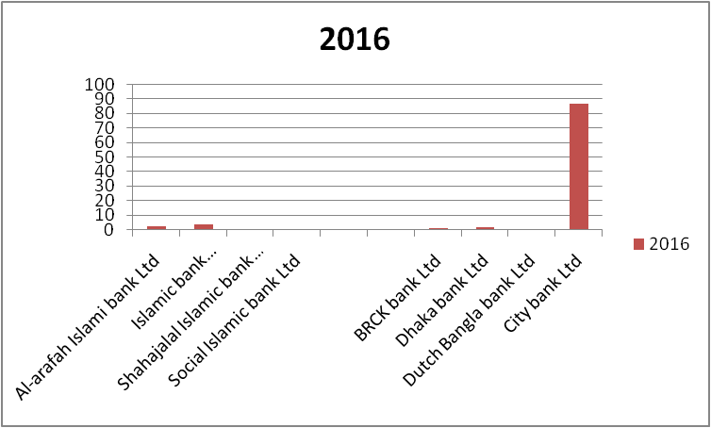

Interpretation
Based on the Islamic bank, the return generated capability of Social Islamic bank ltd is more stable in generating the return because its standard deviation is lowest. Then, Shahajalal Islamic bank ltd is stable in generating the return because its standard deviation is lowest. After that, Islamic bank bangladesh Ltd is stable in generating the return because its standard deviation is also lowest. Finally, Al-arafahl Islamic bank Ltd which is also stable in terms of generating the return capability because its standard deviation is also low.
Based on the Conventional bank, the return generated capability of Dutch Bangla bank ltd is more stable in generating the return because its standard deviation is lowest. Then, Dhaka bank ltd is stable in generating the return because its standard deviation is lowest. After that, BRCK bank Ltd is also stable in generating the return because its standard deviation is also lowest. Finally, the City bank Ltd which is not stable in terms of generating the return capability because its standard deviation is high.

Murabaha revenue / Revenue to customer deposits (Islamic bank)
Name of the bank | 2013 | 2014 | 2015 | 2016 | Mean | STDEV
Al-arafah Islami bank Ltd | 8.402 | 0 | 45.218 | 23.783 | 19.351 | 19.859
Islamic bank Bangladesh Ltd | 53.873 | 33.970 | 0 | 50.734 | 34.644 | 24.693
Shahajalal Islamic bank Ltd | -3.360 | 47.376 | 11.893 | 4.901 | 15.203 | 22.337
Social Islamic bank Ltd | 3.919 | 2.146 | 0.701 | 4.901 | 2.916 | 1.866
 |  |  |  |  | 18.029 | 10.404

(Conventional bank)
Name of the bank | 2013 | 2014 | 2015 | 2016 | Mean | STDEV
BRCK bank Ltd | 14.379 | -0.763 | 76.533 | 8.556 | 24.676 | 35.129
Dhaka bank Ltd | 20.313 | 34.990 | 34.245 | 17.582 | 26.783 | 9.120
Dutch Bangla bank Ltd | 9.659 | 11.449 | 12.458 | 13.517 | 11.771 | 1.642
City bank Ltd | 0.785 | 0.589 | 32.467 | 138.214 | 43.014 | 65.211
 |  |  |  |  | 26.561 | 28.789

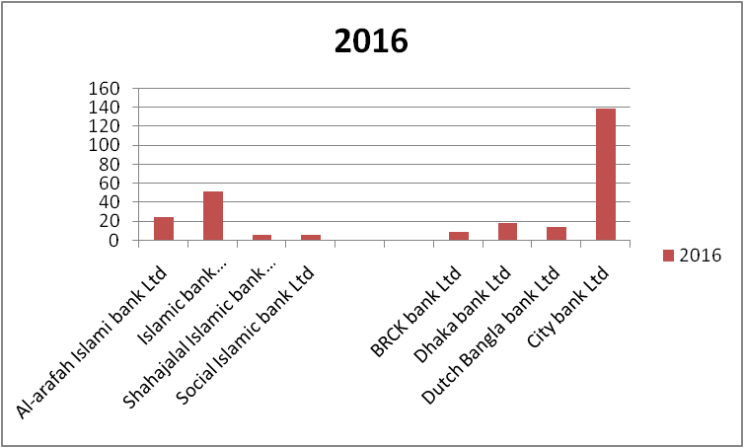

Interpretation
Based on the Islamic bank, the return generated capability of Social Islamic bank ltd is more stable in generating the return because its standard deviation is lowest. Then, Al-arafah Islamic bank ltd is unstable in generating the return because its standard deviation is high. Also Shahajalal Islamic bank Ltd is not stable in generating the return because its standard deviation is also high. Finally, Islamic bank bangladesh Ltd which is also unstable in terms of generating the return capability because its standard deviation is also high.
Based on the Conventional bank, the return generated capability of Dutch Bangla bank ltd is more stable in generating the return because its standard deviation is lowest. Then, Dhaka bank ltd is stable in generating the return because its standard deviation is lowest. After that, BRCK bank Ltd is not stable in generating the return because its standard deviation is highest. Finally, the City bank Ltd which is also unstable in terms of generating the return capability because its standard deviation is also high.

Shareholders equity to tatal asset (Islamic bank)
Name of the bank | 2013 | 2014 | 2015 | 2016 | Mean | STDEV
Al-arafah Islami bank Ltd | 8.373 | 7.879 | 7.646 | 7.186 | 7.771 | 0.494
Islamic bank Bangladesh Ltd | 7.972 | 7.149 | 6.516 | 6.122 | 6.939 | 0.808
Shahajalal Islamic bank Ltd | 8.821 | 9.044 | 8.707 | 7.607 | 8.545 | 0.641
Social Islamic bank Ltd | 8.775 | 7.899 | 7.197 | 7.607 | 7.87 | 0.669
 |  |  |  |  | 7.781 | 0.129

(Conventional bank)
Name of the bank | 2013 | 2014 | 2015 | 2016 | Mean | STDEV
BRCK bank Ltd | 2.769 | 1.429 | 8.381 | 8.624 | 5.301 | 3.739
Dhaka bank Ltd | 8.231 | 8.029 | 7.591 | 7.145 | 7.749 | 0.483
Dutch Bangla bank Ltd | 6.825 | 6.753 | 6.292 | 6.609 | 6.619 | 0.236
City bank Ltd | 87.438 | 86.956 | 16.909 | 45.481 | 59.196 | 34.373
 |  |  |  |  | 19.716 | 16.521

Interpretation
Based on the Islamic bank, the return generated capability of Al-arafah Islamic bank ltd is more stable in generating the return because its standard deviation is lowest. Then, Shahajalal Islamic bank ltd is also stable in generating the return because its standard deviation is also lowest. After that, Social Islamic bank Ltd is stable in generating the return because its standard deviation is also lowest. Finally, Islamic bank Bangladesh Ltd which is also stable in terms of generating the return capability because its standard deviation is also low.
Based on the Conventional bank, the return generated capability of Dutch Bangla bank ltd is more stable in generating the return because its standard deviation is lowest. Then, Dhaka bank ltd is also stable in generating the return because its standard deviation is also lowest. After that, the BRAC bank Ltd is stable in generating the return because its standard deviation is also lowest. Finally, the City bank Ltd which is also stable in terms of generating the return capability because its standard deviation is also low.

3.2.2 Profitability ratio
A profitability ratio measures a company's performance. it is simply the capacity to make a profit from income earned then deducted all costs and expenses related to earn the income.

- Return on Total Income

This ratio is the profitability percentage rate from a bank. It is determined by the net profit by total income.

- Return on share holders’ equity

This ratio is the connection to the investors value. it shows the growth in the gainfulness of investors.

- Return on total asset

This ratio is the benefit of utilizing the advantages. it shows the effective utilization of resources that create more benefit. It is the company’s earnings before interest and tax.

Return on total income (Islamic bank)
Name of the bank | 2013 | 2014 | 2015 | 2016 | mean | STDEV
Al-arafah Islami bank Ltd | 29.895 | 24.231 | 24.642 | 28.716 | 26.871 | 2.857
Islamic bank Bangladesh Ltd | 19.945 | 14.442 | 11.225 | 13.984 | 14.899 | 3.652
Shahajalal Islamic bank Ltd | 25.936 | 14.346 | 24.132 | 26.606 | 22.755 | 5.703
Social Islamic bank Ltd | 22.519 | 22.519 | 24.678 | 26.606 | 24.080 | 1.967
 |  |  |  |  | 22.151 | 1.595

(Conventional bank)
Name of the bank | 2013 | 2014 | 2015 | 2016 | Mean | STDEV
BRAC bank Ltd | 54.419 | 77.586 | 16.146 | 25.889 | 43.51 | 27.925
Dhaka bank Ltd | 30.125 | 29.589 | 21.426 | 16.774 | 24.478 | 6.498
Dutch Bangla bank Ltd | 15.665 | 15.809 | 19.551 | 10.733 | 15.439 | 3.616
City bank Ltd | 10.386 | 21.017 | 26.936 | 70.249 | 32.147 | 26.308
 |  |  |  |  | 28.893 | 12.807

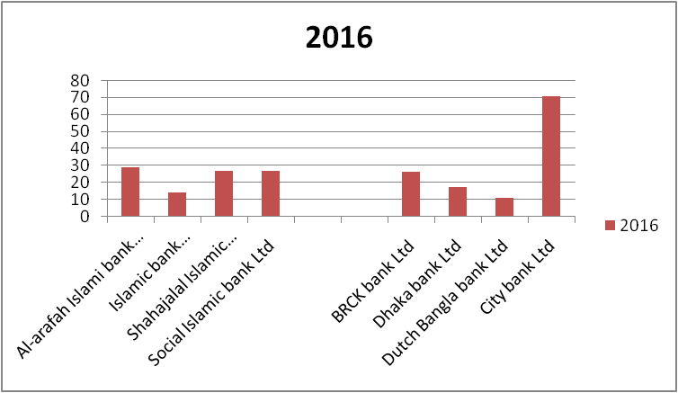

Interpretation
Based on the Islamic bank, the return generated capability of social Islamic bank ltd is more stable in generating the return because its standard deviation is lowest. Then, Al-arafah Islamic bank ltd is also stable in generating the return because its standard deviation is also lowest. After that, the Islamic bank Bangladesh Ltd is stable in generating the return because its standard deviation is also lowest. Finally, the Shahajalal Islamic bank Ltd which is also stable in terms of generating the return capability because its standard deviation is also low.
Based on the Conventional bank, the return generated capability of Dutch Bangla bank ltd is more stable in generating the return because its standard deviation is lowest. Then, Dhaka bank ltd is also stable in generating the return because its standard deviation is also lowest. After that, the City bank Ltd is stable in generating the return because its standard deviation is also lowest. Finally, the BRAC bank Ltd which is also stable in terms of generating the return capability because its standard deviation is also low.

Return on shareholders equity (Islamic bank)
Name of the bank | 2013 | 2014 | 2015 | 2016 | Mean | STDEV
Al-arafah Islami bank Ltd | 52.527 | 57.869 | 57.124 | 59.477 | 56.749 | 2.981
Islamic bank Bangladesh Ltd | 0.919 | 0.609 | 0.434 | 0.561 | 0.631 | 0.206
Shahajalal Islamic bank Ltd | 45.877 | 44.523 | 44.534 | 48.244 | 45.795 | 1.752
Social Islamic bank Ltd | 50.129 | 55.264 | 64.005 | 48.244 | 54.411 | 7.051
 |  |  |  |  | 39.396 | 2.931

(Conventional bank)
Name of the bank | 2013 | 2014 | 2015 | 2016 | Mean | STDEV
BRAC bank Ltd | 63.934 | 65.796 | 80.171 | 80.357 | 72.565 | 8.923
Dhaka bank Ltd | 53.803 | 53.800 | 50.113 | 60.498 | 54.554 | 4.328
Dutch Bangla bank Ltd | 100.40 | 95.578 | 92.998 | 90.074 | 94.763 | 4.380
City bank Ltd | 6.804 | 6.838 | 0.311 | 0.031 | 3.496 | 3.841
 |  |  |  |  | 56.344 | 2.383

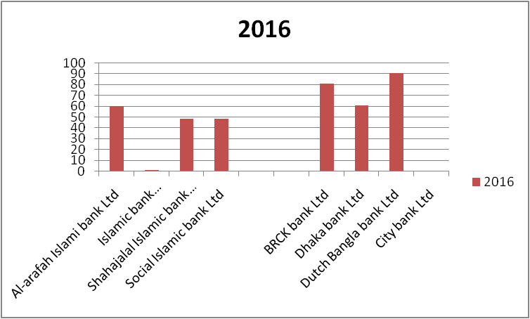

Interpretation
Based on the Islamic bank, the return generated capability of Islamic bank Bangladesh ltd is more stable in generating the return because its standard deviation is lowest. Then, Shahajalal Islamic bank ltd is also stable in generating the return because its standard deviation is also lowest. After that, Al-arafah Islamic bank Ltd is stable in generating the return because its standard deviation is also lowest. Finally, the Social Islamic bank Ltd which is also stable in terms of generating the return capability because its standard deviation is also low.
Based on the Conventional bank, the return generated capability of City bank ltd is not stable in generating the return because its standard deviation is highest. Then, Dhaka bank ltd is stable in generating the return because its standard deviation is lowest. After that, Dutch Bangla bank Ltd is also stable in generating the return because its standard deviation is also lowest. Finally, the BRCK bank Ltd which is also stable in terms of generating the return capability because its standard deviation is also low.

Return on tatal asset (Islamic bank)
Name of the bank | 2013 | 2014 | 2015 | 2016 | Mean | STDEV
Al-arafah Islami bank Ltd | 1.315 | 1.105 | 1.706 | 1.227 | 1.3383 | 0.259
Islamic bank Bangladesh Ltd | 57.883 | 58.970 | 50.343 | 65.576 | 58.193 | 6.241
Shahajalal Islamic bank Ltd | 1.050 | 0.578 | 0.936 | 0.976 | 0.885 | 0.210
Social Islamic bank Ltd | 0.991 | 1.238 | 1.137 | 0.976 | 1.086 | 0.124
 |  |  |  |  | 15.375 | 3.022

(Conventional bank)
Name of the bank | 2013 | 2014 | 2015 | 2016 | Mean | STDEV
BRCK bank Ltd | 0.964 | 0.729 | 1.085 | 1.794 | 1.143 | 0.459
Dhaka bank Ltd | 1.334 | 1.278 | 0.815 | 0.725 | 1.038 | 0.313
Dutch Bangla bank Ltd | 1.073 | 1.020 | 1.144 | 0.639 | 0.969 | 0.226
City bank Ltd | 0.613 | 1.249 | 1.420 | 0.998 | 1.070 | 0.351
 |  |  |  |  | 1.055 | 0.097

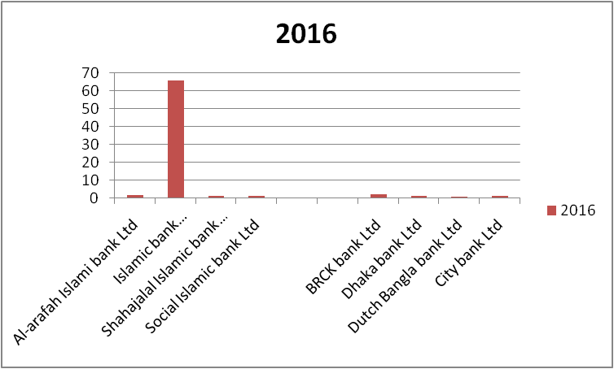

Interpretation
Based on the Islamic bank, the return generated capability of Social Islamic bank ltd is more stable in generating the return because its standard deviation is lowest. Then, Shahajalal Islamic bank ltd is stable in generating the return because its standard deviation is lowest. After that, Al-arafah Islamic bank Ltd is stable in generating the return because its standard deviation is also lowest. Finally, the Islamic bank Ltd which is also stable in terms of generating the return capability because its standard deviation is also low.
Based on the Conventional bank, the return generated capability of Dutch Bangla bank ltd is more stable in generating the return because its standard deviation is lowest. Then, Dhaka bank ltd is stable in generating the return because its standard deviation is lowest. After that, city bank Ltd is also stable in generating the return because its standard deviation is also lowest. Finally, the BRCK bank Ltd which is also stable in terms of generating the return capability because its standard deviation is also low.

3.2.3 Solvency ratio

Solvency ratio is the ability to meet company’s long term debt. It is the company’s after tax income, depreciation etc. This ratio varies from industry to industry and is greater than 20 percent which can be consider. The greater profitability ratio the lower solvency ratio defaults on its debt obligation.

Customer deposit to total asset

This ratio is the level of customer deposit to total asset ratio. This ratio represent the financial asset of the bank.

Total liability to total asset
This ratio is the cash financedwith total assets. It is the financial leverage if the company. Companys total asset is financed with creditors.

Customer deposit to total asset (Islamic bank)
Name of the bank | 2013 | 2014 | 2015 | 2016 | Mean | STDEV
Al-arafah Islami bank Ltd | 12.889 | 0.000 | 1.404 | 11.061 | 6.339 | 6.576
Islamic bank Bangladesh Ltd | 9.617 | 13.316 | 0.000 | 0.023 | 5.739 | 6.783
Shahajalal Islamic bank Ltd | -4.681 | 1.988 | 5.498 | 9.493 | 3.075 | 6.011
Social Islamic bank Ltd | 9.607 | 7.650 | 15.470 | 9.493 | 10.556 | 3.397
 |  |  |  |  | 6.427 | 1.564

(Conventional bank)
Name of the bank | 2013 | 2014 | 2015 | 2016 | Mean | STDEV
BRCK bank Ltd | 3.837 | 15.009 | 1.428 | 11.958 | 8.058 | 6.463
Dhaka bank Ltd | 5.780 | 5.046 | 5.322 | 9.578 | 6.432 | 2.119
Dutch Bangla bank Ltd | 9.338 | 8.101 | 6.211 | 5.758 | 7.352 | 1.668
City bank Ltd | 3.802 | 7.883 | 3.543 | 0.625 | 3.963 | 2.984
 |  |  |  |  | 6.451 | 2.173

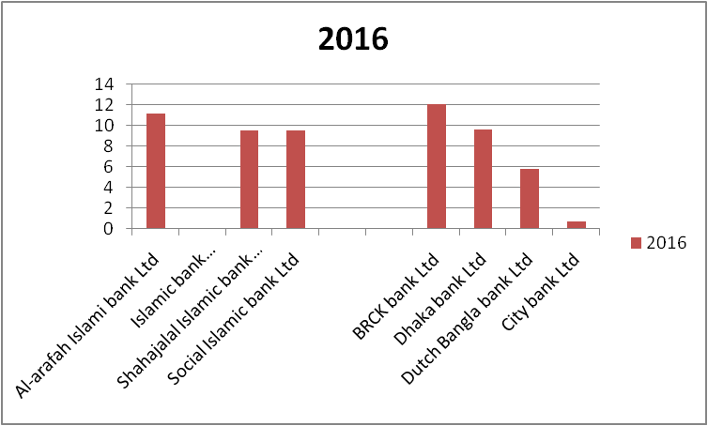

Interpretation
Based on the Islamic bank, the return generated capability of Social Islamic bank ltd is more stable in generating the return because its standard deviation is lowest. Then, Shahajalal Islamic bank ltd is not stable in generating the return because its standard deviation is highest. After that, Al-arfah Islamic bank Ltd is not stable in generating the return because its standard deviation is also high . Finally, Islamic bank bangladesh Ltd which is also unstable in terms of generating the return capability because its standard deviation is also high.
Based on the Conventional bank, the return generated capability of Dutch Bangla bank ltd is more stable in generating the return because its standard deviation is lowest. Then, Dhaka bank ltd is stable in generating the return because its standard deviation is lowest. After that, BRCK bank Ltd is also stable in generating the return because its standard deviation is also lowest. Finally, the City bank Ltd which is also stable in terms of generating the return capability because its standard deviation is also low.

Total liability to total asset (Islamic bank)
Name of the bank | 2013 | 2014 | 2015 | 2016 | Mean | STDEV
Al-arafah Islami bank Ltd | 90.707 | 91.371 | 91.604 | 92.181 | 91.466 | 0.609
Islamic bank Bangladesh Ltd | 92.038 | 92.851 | 93.484 | 93.878 | 93.063 | 0.804
Shahajalal Islamic bank Ltd | 90.997 | 90.780 | 91.130 | 92.253 | 91.29 | 0.658
Social Islamic bank Ltd | 91.225 | 92.101 | 92.803 | 92.253 | 92.096 | 0.654
 |  |  |  |  | 91.979 | 0.084

(Conventional bank)
Name of the bank | 2013 | 2014 | 2015 | 2016 | Mean | STDEV
BRCK bank Ltd | 98.194 | 97.809 | 91.619 | 91.376 | 94.749 | 3.759
Dhaka bank Ltd | 91.769 | 91.971 | 92.408 | 92.855 | 92.251 | 0.483
Dutch Bangla bank Ltd | 93.175 | 93.247 | 82.398 | 91.391 | 90.053 | 5.175
City bank Ltd | 9.187 | 8.712 | 83.091 | 54.519 | 38.877 | 36.474
 |  |  |  |  | 78.983 | 16.783

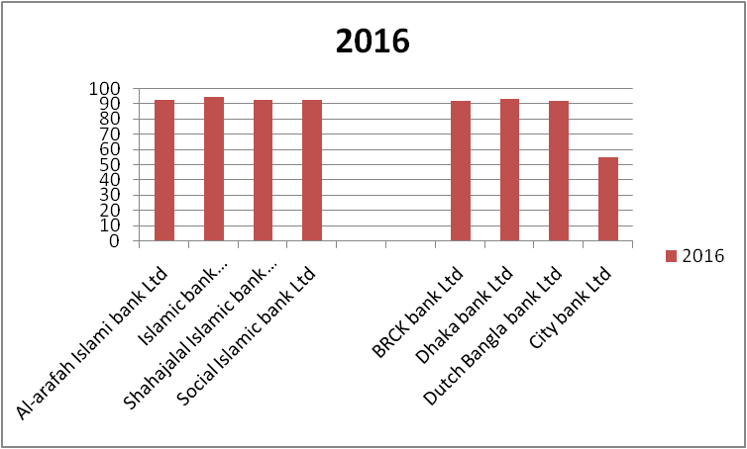
Interpretation
Based on the Islamic bank, the return generated capability of Al-arafah Islamic bank ltd is more stable in generating the return because its standard deviation is lowest. Then, Social Islamic bank ltd is stable in generating the return because its standard deviation is lowest. After that, Shahajalal Islamic bank Ltd is stable in generating the return because its standard deviation is also lowest. Finally, Islamic bank bangladesh Ltd which is also stable in terms of generating the return capability because its standard deviation is also low.
Based on the Conventional bank, the return generated capability of Dhaka bank ltd is more stable in generating the return because its standard deviation is lowest. Then, BRCK ltd is stable in generating the return because its standard deviation is lowest. After that,Dutch Bangla bank Ltd is also stable in generating the return because its standard deviation is also lowest. Finally, the City bank Ltd which is also stable in terms of generating the return capability because its standard deviation is also low.

3.2.4 Efficiency ratio
Efficiency is another dimension of calculating the ratio which utilize the productivity and viability of the bank. Efficiency ratio measures as a percentage of its revenue. The operating expenses are in this ratios are numerator and its revenue is in the denominator, a lower efficiency ratio means that a bank is operating better.

- Investment to Total Assets
This ratio is the banks capacity. It is the representation of the investment amount by total asset. Higher ratio prompts the higher income.
.
- Total expenses to Total revenue
This ratio is calculating by total asset divided by total revenue. Its creates its income with least expenses.

Investment to total asset (Islamic bank)
Name of the bank | 2013 | 2014 | 2015 | 2016 | Mean | STDEV
Al-arafah Islami bank Ltd | 72.600 | 69.731 | 70.929 | 72.011 | 71.318 | 1.264
Islamic bank Bangladesh Ltd | 73.931 | 70.657 | 72.352 | 76.626 | 73.392 | 2.537
Shahajalal Islamic bank Ltd | 70.861 | 66.679 | 70.217 | 0.000 | 51.939 | 34.675
Social Islamic bank Ltd | 60.402 | 64.143 | 68.536 | 73.121 | 66.551 | 5.499
 |  |  |  |  | 65.8 | 15.887

(Conventional bank)
Name of the bank | 2013 | 2014 | 2015 | 2016 | Mean | STDEV
BRCK bank Ltd | 1.301 | 1.155 | 8.811 | 9.046 | 5.078 | 4.447
Dhaka bank Ltd | 12.989 | 12.409 | 11.793 | 10.537 | 11.932 | 1.050
Dutch Bangla bank Ltd | 9.427 | 8.979 | 7.593 | 11.939 | 9.485 | 1.813
City bank Ltd | 17.964 | 16.199 | 11.829 | 19.259 | 16.313 | 3.241
 |  |  |  |  | 10.702 | 1.509

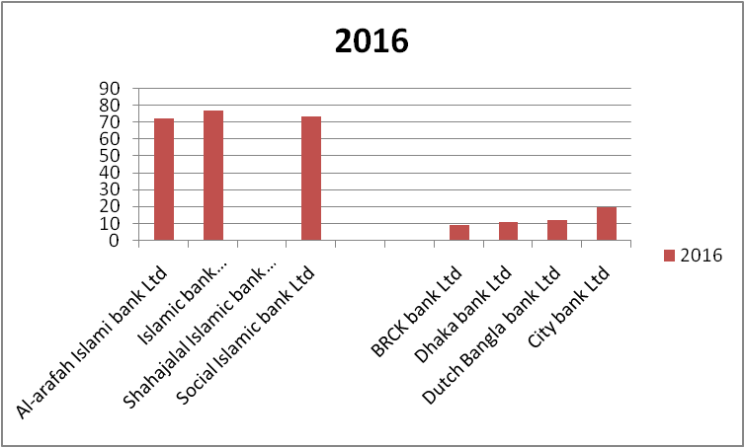
Interpretation
Based on the Islamic bank, the return generated capability of Al-arafah Islamic bank ltd is more stable in generating the return because its standard deviation is lowest. Then, Islamic bank bangladesh ltd is stable in generating the return because its standard deviation is lowest. After that, social Islamic bank Ltd is stable in generating the return because its standard deviation is also lowest. Finally, Shahajalal Islamic bank Ltd which is also stable in terms of generating the return capability because its standard deviation is also low.
Based on the Conventional bank, the return generated capability of Dhaka bank ltd is more stable in generating the return because its standard deviation is lowest. Then, Dutch Bangla bank ltd is stable in generating the return because its standard deviation is lowest. After that, city bank Ltd is also stable in generating the return because its standard deviation is also lowest. Finally, the BRCK bank Ltd which is also stable in terms of generating the return capability because its standard deviation is also low.

Total expense to total revenue (Islamic bank)
Name of the bank | 2013 | 2014 | 2015 | 2016 | Mean | STDEV
Al-arafah Islami bank Ltd | 35.022 | 33.992 | 33.992 | 33.992 | 34.249 | 0.515
Islamic bank Bangladesh Ltd | 43.655 | 44.058 | 48.102 | 55.342 | 47.789 | 5.421
Shahajalal Islamic bank Ltd | 46.460 | 52.934 | 52.173 | 50.183 | 50.438 | 2.894
Social Islamic bank Ltd | 46.681 | 40.929 | 41.574 | 50.183 | 44.842 | 4.393
 |  |  |  |  | 44.329 | 2.130

(Conventional bank)
Name of the bank | 2013 | 2014 | 2015 | 2016 | Mean | STDEV
BRCK bank Ltd | 12.402 | 6.475 | 48.301 | 46.215 | 28.348 | 21.985
Dhaka bank Ltd | 42.247 | 44.465 | 47.772 | 38.169 | 43.163 | 4.029
Dutch Bangla bank Ltd | 63.962 | 61.672 | 58.878 | 65.658 | 62.542 | 2.939
City bank Ltd | 52.739 | 51.265 | 50.377 | 135.722 | 72.526 | 42.142
 |  |  |  |  | 51.645 | 18.444

Interpretation
Based on the Islamic bank, the return generated capability of Al-arafah Islamic bank ltd is more stable in generating the return because its standard deviation is lowest. Then, Shahajalal Islamic bank ltd is stable in generating the return because its standard deviation is lowest. After that, social Islamic bank Ltd is stable in generating the return because its standard deviation is also lowest. Finally, Islamic bank bangladesh Ltd which is also stable in terms of generating the return capability because its standard deviation is also low.
Based on the Conventional bank, the return generated capability of Dutch Bangla bank ltd is more stable in generating the return because its standard deviation is lowest. Then, Dhaka bank ltd is stable in generating the return because its standard deviation is lowest. After that, BRCK bank Ltd is also stable in generating the return because its standard deviation is also lowest. Finally, the City bank Ltd which is also stable in terms of generating the return capability because its standard deviation is also low.

3.2.5 Market ratio
Market ratios are used to analyze the current share price of a publicly-held company's stock. The aggregate amount of stockholders' equity, divided by the number of shares outstanding. The Market ratio also called the Price ratio. This ratio is a financial valuation metric used to evaluate a company's current market value relative to its book value. The balance sheet shows the company's total assets, and how these assets are financed, through either debt or equity

- Market value

This ratio is the price of the market place. It is used to the market capitalization in open market. It increases the quantity of current share price.

- Price Earnings Ratio (Times)

This ratio share price to the earnings per share.It is the company’s current price to its EPS. It is called price multiple or earnings multiple.

- Earnings Per Share

This ratio is the investor's value. It is the measurement of overall performance and an indicator of the possible amount of dividends that is expected.

Market value (Islamic bank)
Name of the bank | 2013 | 2014 | 2015 | 2016 | Mean | STDEV
Al-arafah Islami bank Ltd | 19.1 | 14.9 | 14.7 | 15.9 | 16.15 | 2.036
Islamic bank Bangladesh Ltd | 45 | 37 | 32 | 35 | 37.25 | 5.560
Shahajalal Islamic bank Ltd | 16.77 | 12 | 14 | 15 | 14.443 | 1.991
Social Islamic bank Ltd | 13.3 | 13.6 | 14.4 | 18.4 | 14.925 | 2.363
 |  |  |  |  | 20.692 | 1.723

(Conventional bank)
Name of the bank | 2013 | 2014 | 2015 | 2016 | Mean | STDEV
BRCK bank Ltd | 32.2 | 37.2 | 48.7 | 64.1 | 45.55 | 14.165
Dhaka bank Ltd | 18.8 | 18.3 | 19.7 | 17.9 | 18.675 | 0.776
Dutch Bangla bank Ltd | 104.7 | 105.8 | 107.6 | 116.7 | 108.7 | 5.466
City bank Ltd | 20.2 | 21.8 | 20.4 | 27.2 | 22.4 | 3.278
 |  |  |  |  | 48.831 | 5.820

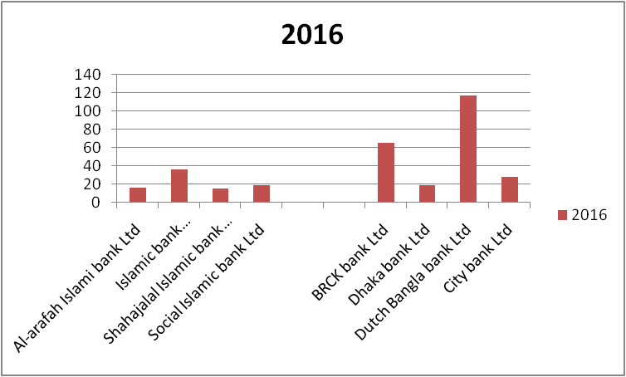

Interpretation
Based on the Islamic bank, the return generated capability of Shahajalal Islamic bank ltd is more stable in generating the return because its standard deviation is lowest. Then, Al-arafah Islamic bank ltd is stable in generating the return because its standard deviation is lowest. After that, Social Islamic bank Ltd is stable in generating the return because its standard deviation is also lowest. Finally, Islamic bank bangladesh Ltd which is also stable in terms of generating the return capability because its standard deviation is also low.
Based on the Conventional bank, the return generated capability of Dhaka bank ltd is more stable in generating the return because its standard deviation is lowest. Then, City bank ltd is stable in generating the return because its standard deviation is lowest. After that, Dutch Bangla bank Ltd is also stable in generating the return because its standard deviation is also lowest. Finally, the BRCK bank Ltd which is also stable in terms of generating the return capability because its standard deviation is also low.

Price earnings ratio (Islamic bank)
Name of the bank | 2013 | 2014 | 2015 | 2016 | Mean | STDEV
Al-arafah Islami bank Ltd | 7.76 | 6.77 | 6.53 | 6.18 | 6.81 | 0.678
Islamic bank Bangladesh Ltd | 12.35 | 11.24 | 11.54 | 10.11 | 11.31 | 0.927
Shahajalal Islamic bank Ltd | 8.6 | 11.27 | 7.67 | 7.43 | 8.743 | 1.759
Social Islamic bank Ltd | 7.66 | 5.02 | 4.89 | 7.43 | 6.25 | 1.499
 |  |  |  |  | 8.278 | 0.499

(Conventional bank)
Name of the bank | 2013 | 2014 | 2015 | 2016 | Mean | STDEV
BRCK bank Ltd | 11.14 | 10.34 | 14.19 | 10.21 | 11.47 | 1.859
Dhaka bank Ltd | 5.28 | 5.13 | 8.57 | 8.4 | 6.845 | 1.896
Dutch Bangla bank Ltd | 10.5 | 9.6 | 7.1 | 13.2 | 10.1 | 2.518
City bank Ltd | 18.5 | 8.2 | 5 | 6.1 | 9.45 | 6.178
 |  |  |  |  | 9.466 | 2.066

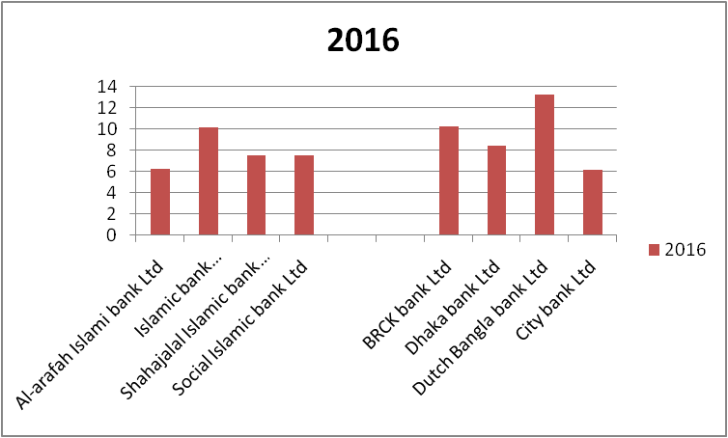
Interpretation
Based on the Islamic bank, the return generated capability of Al-arafah Islamic bank ltd is more stable in generating the return because its standard deviation is lowest. Then, Islamic bank bangladesh ltd is stable in generating the return because its standard deviation is lowest. After that, Social Islamic bank Ltd is stable in generating the return because its standard deviation is also lowest. Finally, Shahajalal Islamic bank Ltd which is also stable in terms of generating the return capability because its standard deviation is also low.
Based on the Conventional bank, the return generated capability of BRCK bank ltd is more stable in generating the return because its standard deviation is lowest. Then, Dhaka bank ltd is stable in generating the return because its standard deviation is lowest. After that, Dutch Bangla bank Ltd is also stable in generating the return because its standard deviation is also lowest. Finally, the City bank Ltd which is also stable in terms of generating the return capability because its standard deviation is also low.

Earnings per share (Islamic bank)
Name of the bank | 2013 | 2014 | 2015 | 2016 | Mean | STDEV
Al-arafah Islami bank Ltd | 2.46 | 2.2 | 2.25 | 3.07 | 2.495 | 0.399
Islamic bank Bangladesh Ltd | 3.4 | 2.49 | 2.04 | 2.77 | 2.675 | 0.569
Shahajalal Islamic bank Ltd | 1.78 | 1.02 | 1.76 | 2.02 | 1.645 | 0.433
Social Islamic bank Ltd | 1.74 | 2.71 | 2.95 | 2.02 | 2.355 | 0.569
 |  |  |  |  | 2.293 | 0.089

(Conventional bank)
Name of the bank | 2013 | 2014 | 2015 | 2016 | Mean | STDEV
BRCK bank Ltd | 3.19 | 2 | 3.43 | 6.28 | 3.725 | 3.859
Dhaka bank Ltd | 3.56 | 3.57 | 2.3 | 2.13 | 2.89 | 0.783
Dutch Bangla bank Ltd | 10 | 11 | 15.1 | 8.8 | 11.225 | 2.735
City bank Ltd | 1.1 | 2.7 | 4.1 | 4.5 | 3.1 | 1.541
 |  |  |  |  | 5.235 | 1.351

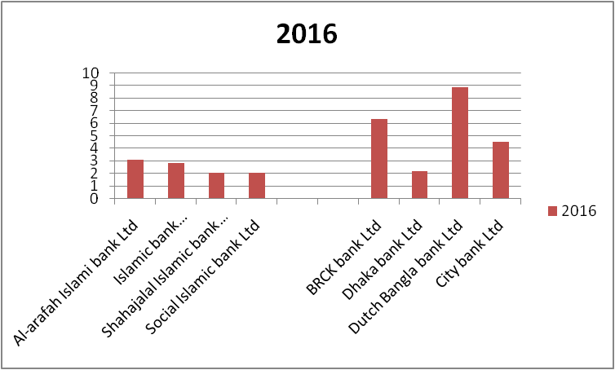

Interpretation
Based on the Islamic bank, the return generated capability of Al-arafah Islamic bank ltd is more stable in generating the return because its standard deviation is lowest. Then, Shahajalal Islamic bank ltd is stable in generating the return because its standard deviation is lowest. After that, Islamic bank Bangladesh Ltd and Social Islamic bank Ltd is stable in generating the return because its standard deviation is also lowest and same. But Islamic bank Bangladesh Ltd is more stable than Social Islamic bank Ltd because of its return generated capability.
Based on the Conventional bank, the return generated capability of Dhaka bank ltd is more stable in generating the return because its standard deviation is lowest. Then, City bank ltd is stable in generating the return because its standard deviation is lowest. After that, Dutch Bangla bank Ltd is also stable in generating the return because its standard deviation is also lowest. Finally, the BRCK bank Ltd which is also stable in terms of generating the return capability because its standard deviation is also low.

Chapter: 04
Conclusion

Conclusion:
This report objective is to measure comparative analysis of performances of Islamic and Conventional banks in Bangladesh. In Bangladesh, the trend of Islamic banking is getting special attention day-by-day with the focus on conducting businesses based on Shariah perspective in parallel with conventional banking activities.
As Islamic bank is more popular day by day, people want to lead their lifestyle following the Islamic rules. People don’t have clear idea about the difference between interest and profit as banks do not encourage this in their marketing strategy. Islamic bank is more popular to the people of Muslim countries and also many conventional banks in Bangladesh have already open Islamic banking section. It is become new marketing strategy for banks to attract new customer. I tried to measure the financial performances over the period of 2013 to 2016 applying the ratio analysis techniques. Report also focuses on statistical tool of standard deviation to make sure that which banks have better outcomes compared to others.
In terms of liquidity dimension, Islamic banks have better position to satisfy the short-term obligations over conventional banks. But conventional banks have more capacity to generate the earnings compared to Islamic banks although the variations of all profitability ratios are greater which indicate that conventional banks have more risk. This outcome can be supported from the results of other dimensions. Conventional banks are relying on more debt than Islamic banks and therefore they fail to efficiently handle the assets in business relative to Islamic banks. The market dimension indicates that price-earnings ratio is lower compared to the price-earnings ratio of Islamic banks with lower standard deviation. The conclusion is that although conventional banks generate more return compared to the return of Islamic banks, Islamic banks have less risk element and therefore, investment is lucrative for Islamic banks rather than traditional banks.

Chapter: 05
References

- https://www.scribd.com/document/292940736/Internship-Report-on-General-banking-of-Islami-Bank-Bangladesh-Limited
- http://dspace.bracu.ac.bd/bitstream/handle/10361/4242/Final%20Report.pdf?sequence=1
- https://www.google.com/search?ei=RqJpXIKQI5D0rQHKkZ3QBQ&q=conventional+bank+definition&oq=conventional+bank+&gs_l=psyab.1.2.35i39l2j0l8.4209.7788..11066...1.0..0.158.369.0j3......0....1..gws-wiz.......0i71j0i22i30.rwjb24o_4UI
- https://www.researchgate.net/publication/331089587_FINANCIAL_PERFORMANCE_ANALYSIS_OF_ISLAMIC_BANK_AND_CONVENTIONAL_BANK_IN_PAKISTAN_2015-2017- A_COMPARATIVE_STUDY
- http://dspace.bracu.ac.bd/xmlui/bitstream/handle/10361/6462/12104167_BBA.pdf?sequence=1&isAllowed=y
- https://en.wikipedia.org/wiki/BRAC_Bank_Limited, https://en.wikipedia.org/wiki/Dhaka_Bank_Limited, https://en.wikipedia.org/wiki/Dutch_Bangla_Bank, https://en.wikipedia.org/wiki/CITY_Bank_Limited
- https://en.wikipedia.org/wiki/Al-Arafah_Islami_Bank_Limited
https://en.wikipedia.org/wiki/Shahjalal_Islami_Bank_Limited
https://en.wikipedia.org/wiki/Social_Islami_Bank_Limited
https://www.islamibankbd.com/

