PROJECT REPORT
ON
The Impact of E- Recruitment on Organizational Performance: A Study on Elegant Group

PROJECT REPORT
On
The Impact of E- Recruitment on Organizational Performance: A Study on Elegant Group
Submitted To
Shayla Khanam
Assistant Professor
School of Business and Economics
United International University
Submitted By
Ashkia Parvin
ID: 111 182 017
School of Business and Economics
BBA Program, Major in Human Resource Management
United International University


UNITED INTERNATIONAL UNIVERSITY
Date of Submission: April 28, 2023

Letter of Transmittal
April 28, 2023
Shayla Khanam
Assistant Professor,
School of Business and Economics
United International University
Subject: Submission of Project Report on the Impact of E- Recruitment on Organizational Performance: A Study on Elegant Group.
Dear Ma’am,
With all due respect, I am writing to inform you that, with the assistance of the almighty Allah and your direction, I have finished the report needed by the requirements of the INT 4399 course.
I would like to extend my appreciation to you for affording me the opportunity to familiarize myself with the corporate environment and the formal academic report. Both of these entities have proven to be advantageous to my endeavors. The objective of the study was to enhance the comprehensibility of the subject matter.
I am highly confident that this report will not only fulfil, but also surpass your requirements and anticipations. I would greatly appreciate it if you could provide your thoughtful evaluation and acceptance of the report.
Sincerely Yours,

Ashkia Parvin
ID: 111 182 017
School of Business and Economics
BBA Program, Major in Human Resource Management
United International University
Declaration of the Student
The undersigned, Ashkia Parvin, a scholar enrolled in the BBA (HRM) programme within the School of Business and Economics at United International University, hereby attest that the contents of this report are solely intended for academic pursuits. The present document has been produced in fulfillment of the requirements of INT 4399 at the university.
Furthermore, I attest that all data presented in this report has been collected and organized solely by me. The document in question does not comprise any material that has been previously published or written and has been sanctioned for recognition towards a degree from United International University or any other educational establishment. The present report incorporates data from a reliable source that has been duly referenced.
Sincerely Yours,
Ashkia Parvin
ID: 111 182 017
School of Business and Economics
BBA Program, Major in Human Resource Management
United International University

Acknowledgment
Firstly, I would like to express my gratitude to Allah for the blessings that enabled me to complete my project report in a timely and successful manner.
However, I would like to take this opportunity to express my gratitude towards certain individuals whose aid was indispensable in enabling me to successfully complete this project programme and compose this report.
I express my gratitude to Shayla Khanam, Assistant Professor, School of Business and Economics, United International University the esteemed faculty of my university's INT 4399 Project course. The completion of this report independently would not have been feasible without the provision of instruction and guidance from the aforementioned individual.
Finally, I am also grateful to all the employees of elegant group to participate on the interview and survey session.

Table of Contents

Executive Summary vi
1.1 Introduction of the Report 2
1.2 Objectives of the Report 2
1.2.1 Broad Objective 2
1.2.2 Specific Objectives 2
1.3 Methodology of the Report 3
1.3.1 Primary Data 3
1.3.2 Secondary Data 3
1.3.3 Designing a Questionnaire and Collecting Information 3
1.4 Limitation of the Report 4
2.1 E- Recruitment System 6
2.2 Steps of E- Recruitment System 7
2.3 Types of E-Recruitment 9
2.5 Contribution of E- Recruitment System in Garments Industry of Bangladesh 10
2.6 E- Recruitment and Organizational Performance 10
3.1 Overview of the ELEGANT GROUP 14
3.1.1 Mission 14
3.1.2 Goal 14
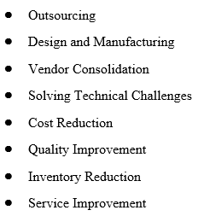 14
3.1.3 Strength of Elegant Group 14
3.1.4 Buyers and Clients of Elegant Group 15
3.1.5 Products and Production Capacity 16
3.1.6 Sustainable Department of Elegant Group 16
3.2 Hierarchy and Departmentalization of Elegant Group 17
3.3 Number of Employees in the HR Department of Elegant Group 18
3.4 HRM Operations at Elegant Group 19
4.1 Approach of Data Collection and Analysis 22
4.1.1 Research Factors 22
4.2 Demographic Characteristics 22
4.2.1 Percentage of Gender 23
4.2.2 Designation of Staffs 23
4.2.3 Work Experience 24
4.3 Descriptive Analysis 24
4.4 Findings 38
4.4.1 Scope in E-Recruitment System at Elegant Group 38
4.4.2 Challenges in E-Recruitment System at Elegant Group 38
5.1 Recommendation 40
5.2 Conclusion 41
References 42
Survey Questionnaire 44

Executive Summary
The report titled “The Impact of E- Recruitment on Organizational Performance: A Study on Elegant Group “was initially developed as a mandatory coursework component for the BBA Programme at United International University. The report focuses on the digitalization and e-recruitment trends in Elegant Group. The aim of this report is to ascertain firsthand experiences in the corporate world. The Elegant group's flagship company is Elegant Textile Mills Ltd., which produces high-quality yarns, fabrics, and garments for the domestic and markets. In addition to Elegant Textile Mills Ltd., the Elegant Group also owns and operates several other companies such as Elegant Spinning Mills Ltd., Elegant Apparels Ltd., Elegant Design and Development Ltd., and Elegant Power and Telecommunications Ltd. The Elegant Group is known for its commitment to quality, innovation, and sustainability, and has won numerous awards and recognitions for its achievements in various fields.
The study starts with a comprehensive introduction to the overview of Elegant Group, encompassing the objectives of the organization, the extent of its vision, and its present limitations. Subsequently, with the aim of mitigating the workforce deficit across multiple departments, the Human Resources department intends to introduce an electronic recruitment and selection system within their organization. E-recruitment, an online recruitment technique, can effectively and efficiently filter applications based on the applicant's relevant experience, abilities, and education level. The efficacy of an online job recruiting system is predicated upon several key components, including Human Resource Planning (HRP), job analysis, the identification of suitable candidates, the utilization of appropriate online media as both internal and external sources, the screening and selection process, and the impact of these factors on organizational performance. This study aims to investigate the trends and effectiveness of online recruiting as a solution for employing applicants in the current competitive landscape. Specifically, the study focuses on the context of RMG sectors of Bangladesh and Elegant Group. This report presents crucial components, including recommendations and key insights that can aid HR managers at Elegant Group in the development of e-recruitment systems.

CHAPTER 01
INTRODUCTION

Introduction of the Report
When compared to more conventional forms of advertising like newspapers and periodicals, the cost of placing job advertisements online is far lower. This results in a rather cheap product. Press insertions may occasionally be illegible due to limited word count and line length. Because there is no restriction on the number of characters that may be used on the internet, any and all relevant information can be communicated in an uncomplicated and plain way. Candidates' responses are gathered in a standardized and uniform manner, making it easy to compare them. This provides a paper trail that can be checked for conformity with regulations and makes it easier to make fair judgments about candidates. It is feasible to expeditiously publish a comprehensive job advertisement online and streamline additional recruitment administrative processes through automation within a brief timeframe. Both the transmission and response time exhibit immediacy. To pursue employment opportunities with this organization, individuals may submit their application via the company's website and attach their curriculum vitae. As was previously said, e-recruitment has the potential to automatically exclude unqualified applications, allowing a shortlist to be established in minutes rather than days. Because of this, business process efficiency is improved.
This project report has been written to satisfy the requirements for graduating with a Bachelor of Business Administration. As part of my research into the elegant group, I have picked up some useful abilities in human resources management and protocol compliance. My academic advisor in the Department of Business and Economics at United International University supervised the original research for my paper, which includes extensive coverage of the aforementioned topics.

Objectives of the Report
The complete set of objectives of the study are presented below:

Broad Objective
- The present study aims to identify the overarching patterns in the utilization and execution of the e-recruitment system of Elegant Group.

Specific Objectives
The report outlines several objectives, which are enumerated as follows:
- To gain an understanding of the overview of the Elegant Group.
- The objective is to conduct an analysis of the factors pertaining to e-recruitment systems utilized by the Elegant Group.
- The aim of this study is to assess the benefits and challenges related to the implementation of e-recruitment systems within the Elegant Group.
- In order to assist the HR manager of Elegant Group in devising and executing efficient e-recruitment systems for acquiring capable personnel for the organization, certain suggestions are proposed.

Methodology of the Report
The project was accomplished by utilizing a blend of primary and secondary sources. The present document primarily comprises the author's contributions as a Human Resources intern at Elegant Group, encompassing the surveys that were conducted.

Primary Data
The principal approach employed to gather data for this study was conducting interviews with employees of the organization. The remaining data was acquired through the implementation of the methodology outlined in the subsequent sections. The present document incorporates primary and secondary data:
- A discourse conducted in person regarding a pertinent subject matter.
- The methodology employed in this study involved conducting interviews and surveys with employees of Elegant Group's head office.

Secondary Data
- The Elegant Group's official website is a primary source of information for this study.
- Secondary sources such as newspapers, journals, annual reports, and articles that pertain to the topic of the study will also be utilized.

1.3.3 Designing a Questionnaire and Collecting Information
The study has gathered both qualitative and quantitative data for research purposes. The present study employed the following methodologies for data acquisition.
• Structured interviews and informal conversations were conducted with the personnel of Elegant Group's headquarters (AJ Heights).
• The study involved the creation of a questionnaire and subsequent collection of data from a sample of 30 employees for the purpose of conducting a survey.
A standardized questionnaire is being utilized to conduct research on the subject matter. A survey instrument was developed consisting of 20 statements and five-point Likert scales to facilitate data collection. The research was conducted by Elegant Group's headquarters, with the involvement of a sample of 20 of their staff members.

Limitation of the Report
This report was developed based on feedback obtained from Human Resources departments. From the standpoint of certain employees, data that can be linked to them is deemed inconsequential and therefore does not warrant confidentiality. The issue of time constraints was also a factor. During the course of the analysis and research, time constraints prevented a thorough examination of a significant sample. My contract had a temporal limitation of three months. Nonetheless, the allotted time is insufficient to conduct a comprehensive and unambiguous investigation. Owing to a scarcity of data, logical inferences had to be drawn. The report may contain errors due to the presence of scribbles. Despite encountering several obstacles, I made a concerted effort to complete the report to the best of my ability.

CHAPTER 02
LITERATURE REVIEW

This chapter provides a comprehensive overview of the literature (the theoretical foundations) on the topic of digital transformation, digital technologies, digitalization, and online recruiting (also known as e-recruitment) in the context of a business setting.

E- Recruitment System
According to (Danialarj, 2013), an e-recruitment system is an online platform that allows organizations to manage their recruitment process electronically. It involves using various technologies and online tools to attract, screen, and hire candidates. The system may include features such as job postings, candidate applications, resume databases, interview scheduling, and communication tools.
E-recruitment, often known as online recruiting, is the practice of finding, evaluating, and ultimately selecting new employees using electronic means. This method of recruitment has become increasingly popular over the years due to the convenience and cost-effectiveness it provides for both employers and job seekers (Wołodźko K., 2017).
Online recruitment involves posting job vacancies on various job boards, company websites, social media platforms, and other online platforms to attract potential candidates. Job seekers can then apply for these positions online by submitting their resumes and other required documents through email or online application forms (Urbancová H., 2017).
There are a number of benefits to doing a search online rather than offline. For starters, it broadens the scope of a company's recruitment efforts, allowing them to identify qualified applicants from all over the world. Second, it saves money by doing away with other, more costly options like newspaper ads and staffing firms. Finally, it helps recruiters prioritize their time by automating the screening and short listing process, narrowing down on the best possible prospects (Álvarez, 2012).
However, online recruitment also has its challenges. One of the main challenges is the high volume of applications that recruiters receive, which can make it difficult to screen and identify the most suitable candidates. There is also the risk of fraudulent applications and the need to ensure the security of personal data submitted by job seekers (Herbell K., 2018).
Overall, online recruitment is a valuable tool for employers looking to streamline their recruitment process and reach a wider pool of candidates, while providing job seekers with convenient access to job vacancies (Wroblowská, 2016).
According to (Danialarj, 2013), Here are some of the benefits of using an e-recruitment system:
- Faster and more efficient hiring process: By automating various stages of the recruitment process, such as resume screening and interview scheduling, the e-recruitment system can significantly speed up the hiring process (Danialarj, 2013) .
- Cost-effective: E-recruitment eliminates the need for paper-based job postings and resumes, which can be expensive. It can also reduce administrative costs by automating many aspects of the recruitment process.
- Wide reach: Online job postings can reach a much larger audience than traditional methods, increasing the pool of potential candidates (Danialarj, 2013).
- Better candidate experience: E-recruitment systems often provide candidates with an easy and user-friendly application process, making it easier for them to apply for jobs.
- Data-driven decision making: E-recruitment systems can provide hiring managers with valuable data on candidate performance, recruitment metrics, and other factors that can inform their decision-making process.
Some of the potential drawbacks of e-recruitment include the need for adequate technological infrastructure, potential data privacy concerns, and the risk of bias in the screening process. However, with proper implementation and training, an e-recruitment system can be an effective tool for organizations looking to streamline and improve their hiring process (Danialarj, 2013).

Steps of E- Recruitment System
E-recruitment, also known as online recruitment, is the process of using technology to attract, screen, and hire candidates for job positions (Urbancová H., 2017). The steps involved in an e-recruitment system can vary depending on the specific platform being used and the needs of the organization, but generally include the following:
- Job Posting: The first step in e-recruitment is creating a job posting that accurately describes the job duties, qualifications, and requirements. The job posting should be appealing to potential candidates and clearly explain the job's purpose and responsibilities Urbancová H., 2017.
- Job Board Placement: After creating the job posting, the organization must determine where to post it. Online job boards such as LinkedIn, BD Jobs, and Face Book Job Vacancy Pages are popular options.
- Resume Submission: Once the job is posted, candidates can submit their resumes online, often through an online application system that is linked to the job board. The system may require candidates to fill out an online application form, provide their resume and cover letter, and answer pre-screening questions.
- Resume Screening: After receiving applications, recruiters or hiring managers will review the resumes to determine if the candidate meets the basic requirements of the position. This process may be automated using applicant tracking software that can scan resumes for keywords and qualifications Urbancová H., 2017.
- Candidate Assessment: Once a candidate's resume has been reviewed and they meet the basic requirements of the position, recruiters or hiring managers may conduct a phone or video interview to further assess the candidate's qualifications and fit for the position.
- In-Person Interviews: After the initial screening and assessment, the most promising candidates are invited for in-person interviews. Depending on the organization's needs, multiple interviews may be required to make a final decision Urbancová H., 2017.
- Background Checks: Before making a job offer, organizations often perform background checks on candidates to verify their employment history, criminal record, and education.
- Job Offer: After the organization has selected the best candidate, a job offer is made. The offer may include details about the job responsibilities, salary, benefits, and start date.
- On boarding: Once the candidate accepts the job offer, they begin the on boarding process, which includes paperwork, training, and orientation to the organization's culture and policies (Pin J. R., 2001).
- Follow-Up: After the on boarding process is complete, the organization should continue to follow up with the new employee to ensure their success and address any concerns or issues.

Types of E-Recruitment
According to (Danialarj, 2013), E-recruitment, also known as online recruitment or internet recruitment, refers to the use of internet technologies to attract, screen, and hire job candidates. There are several types of e-recruitment methods, including:
- Job Boards: Online job boards are websites where job seekers can search for job postings by keyword, location, industry, and other criteria. Employers can also post job vacancies on these websites to attract qualified candidates (Thompson L. F., 2008).
- Social Media: Social media platforms such as LinkedIn, Twitter, and Facebook are increasingly being used by employers to advertise job openings and source potential candidates. Social media allows employers to reach a large pool of job seekers quickly and cost-effectively (Albert, 2004).
- Company Website: Employers can also post job openings on their company websites, which can attract job seekers who are specifically interested in the company and its culture.
- Recruitment Software: Recruitment software can automate many aspects of the hiring process, including candidate sourcing, resume screening, and applicant tracking. These tools can help employers streamline the recruitment process and identify the most qualified candidates quickly (Pin J. R., 2001).
- Mobile Recruitment: With the increasing use of smart phones and mobile devices, mobile recruitment has become an important e-recruitment method. Employers can use mobile-optimized job boards and career websites to attract job seekers who are using their mobile devices to search for job opportunities (Lang S., 2011).
- Video Interviews: Video interviews are becoming more popular as a way to screen candidates remotely. Employers can use video conferencing software to conduct live video interviews or pre-recorded video interviews to assess candidates' skills and qualifications.
Overall, e-recruitment methods offer employers a cost-effective and efficient way to attract and screen candidates, making it easier to identify the most qualified candidates for open positions (Silber, 2012).

Contribution of E- Recruitment System in Garments Industry of Bangladesh
According to (Rahat, 2014), the use of E-Recruitment systems in the garments industry of Bangladesh has significantly impacted the way recruitment is done. Here are some of the contributions of E-Recruitment system in the Garments Industry of Bangladesh:
- Increased Efficiency: E-Recruitment systems have made the recruitment process faster and more efficient, allowing companies to streamline their recruitment efforts. The process is automated, which reduces the time and effort required to sort through resumes and applications manually (Rahat, 2014).
- Cost-Effective: E-Recruitment systems eliminate the need for expensive recruitment agencies and reduce the costs associated with recruitment. It saves money on advertising, printing, and mailing job postings.
- Wider Reach: E-Recruitment systems allow companies to reach a wider audience of job seekers beyond their geographic location, increasing the pool of candidates from which to choose (Galanaki, 2002).
- Improved Candidate Experience: E-Recruitment systems allow candidates to apply for jobs from the comfort of their homes, reducing the time and money required to attend interviews in person. It also provides candidates with a more user-friendly and convenient experience, allowing them to easily search and apply for jobs.
- Improved Data Management: E-Recruitment systems help companies manage data more effectively, reducing errors and redundancies in the recruitment process. It provides an organized database of resumes and candidate information, making it easier to track and manage applications (Rahat, 2014).
Overall, the use of E-Recruitment systems in the garments industry of Bangladesh has contributed to a more efficient, cost-effective, and streamlined recruitment process. It has enabled companies to reach a wider pool of candidates, improve the candidate experience, and improve data management, ultimately leading to better hiring decisions.

E- Recruitment and Organizational Performance
E-recruitment is the process of using technology to attract, screen, and hire candidates for job vacancies within an organization. E-recruitment is increasingly becoming popular due to its ability to reduce time and cost associated with traditional recruitment methods (Lang S., 2011).
E-recruitment can positively impact organizational performance in the following ways:
- Wider Reach: E-recruitment allows organizations to reach a wider pool of potential candidates than traditional methods. This increases the chances of finding the best candidate for the job, thus improving the quality of the workforce (Lang S., 2011).
- Cost-effective: E-recruitment reduces the cost of recruitment by eliminating the need for printed materials, postage, and other expenses associated with traditional recruitment methods.
- Faster Hiring: E-recruitment allows organizations to screen and interview candidates more quickly. This reduces the time to fill vacant positions, enabling the organization to operate more efficiently (Lang S., 2011).
- Improved Candidate Experience: E-recruitment provides candidates with a more user-friendly and interactive experience, which can improve their perception of the organization and increase their likelihood of accepting job offers.
- Better Data Management: E-recruitment systems store candidate data electronically, making it easier to track and manage recruitment metrics. This can help organizations identify areas for improvement and make data-driven decisions to improve their recruitment processes (Tuten, 2001).
Overall, e-recruitment can help organizations to attract and retain top talent, reduce costs, and improve efficiency, leading to improved organizational performance.
Concerning the efficacy with which companies implement their policies and realize their goals and visions has motivated researchers to study the topic of organizational performance. (Daniel, 2019). Managers are increasingly aware that their companies may gain a competitive advantage by instituting effective procedures for recruiting and managing their human resources. Employee commitments to improved performance are essential for any business that places a premium on excellence, quality standards, creativity, and innovation. Of course, there are companies where employees don't have to put in any effort at all and yet succeed (Daniel, 2019).
Organizational performance analysis looks at how well an organization is doing in relation to its stated goals and objectives. Organizational performance, according to Armstrong and Baron (2004), is "a coordinated strategy for sustaining organizational success via the enhancement of individual and group productivity."
Research shows that providing workers with recruiting and promotion opportunities increases their commitment, decreases attrition, and leads to improved productivity, quality, service, safety, and financial outcomes. Organizational output has been significantly boosted by the widespread use of e-recruitment due to its many advantages.
Intangible assets, such as intellectual property rights and technical, commercial, and organizational know-how, significantly impact an organization's competitiveness (Breese, 2001). The first step toward innovation and creativity is locating reliable internal and external information sources. This means that companies either already possess the necessary knowledge or have the resources to quickly and easily acquire it (Albert, 2004).
Soo et al. (2002) argue that an organization's innovation and market and financial success benefit from its capacity to learn and use new knowledge. Because of the internet, businesses may now experiment with new structures and forms of cooperation. Job seekers and employers are better matched more regularly thanks to these partnerships (Malone & Laubacher, 1998). To get an edge over the competition, businesses rely on their employees' inventiveness to solve problems in the areas of manufacturing, marketing, and administration.
Organizational productivity is crucial to its continued existence and expansion. Manpower productivity is defined as the ratio of output per unit of labor input. It's a measure of how well a company uses its employees to their full potential. Managers in both the commercial and governmental sectors increasingly understand that a competitive edge may be gained by instituting and maintaining an effective human resource management system. Hence, high-performing and creative workers are the bedrock of productivity at every level (Stone D. L., 2006).

CHAPTER 03
COMPANY PROFILE

Overview of the ELEGANT GROUP

The Elegant Group was founded by M. A. Kader in 1989 and has since grown to become a significant player in the Bangladeshi business landscape. The group's flagship company is Elegant Textile Mills Ltd., which produces high-quality yarns, fabrics, and garments for the domestic and international markets. In addition to Elegant Textile Mills Ltd., the Elegant Group also owns and operates several other companies such as Elegant Spinning Mills Ltd., Elegant Apparels Ltd., Elegant Design and Development Ltd., and Elegant Power and Telecommunications Ltd.
Overall, the Elegant Group is known for its commitment to quality, innovation, and sustainability, and has won numerous awards and recognitions for its achievements in various fields.

Mission
The mission of the Elegant Group is to create value for customers, employees, and shareholders while contributing to the economic growth and sustainability of the industry and the wider community.

Goal

Strength of Elegant Group
- The Elegant group is headquartered in a self-owned building located in Hemayetpur, which is situated in close proximity to the capital city of Dhaka in Bangladesh. From this central location, the organization exercises control over all of its subsidiary units.
- Each unit is equipped with a comprehensive management system that oversees all aspects of their product, from sampling to fishing.
- The garments industry has been designed and the buildings have been installed with a focus on ensuring health and safety measures are in place.
- During their designated hours, the medical centre and healthcare staff affiliated with the organization offer complimentary medical care and medication to their staff and labour force without charge.
- Regarding Social Welfare, the Elegant Group surpasses any other garment company in its endeavors and undertakings.
- The Elegant Group provides Child Care facilities for the children of its employees and labor force, while also offering opportunities for children to engage in educational and recreational activities at no cost. Additionally, the company adheres to ethical principles in the exportation of all its products and services.

Buyers and Clients of Elegant Group
The Elegant Group collaborates with leading retailers and buyers in the nation.


Products and Production Capacity
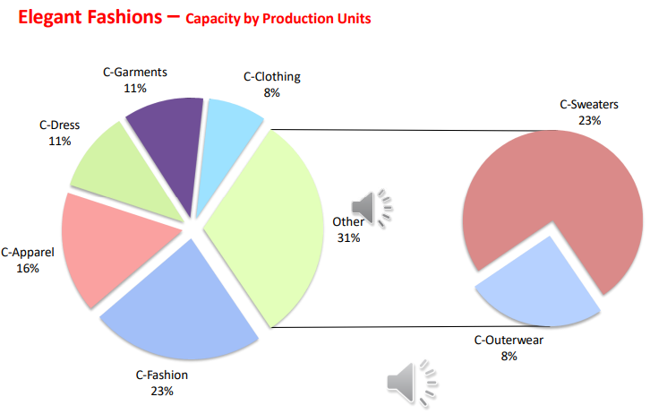
Figure3.1: Production Capacity of Elegant Group

Sustainable Department of Elegant Group
The Elegant Group has established a specialized Sustainable Department, consisting of a team of dynamic, youthful, and knowledgeable professionals who collaborate with experts from around the world and local academic institutions. The team responsible for sustainability will oversee the coordination of pertinent initiatives across various departments within Elegant Group Textiles:

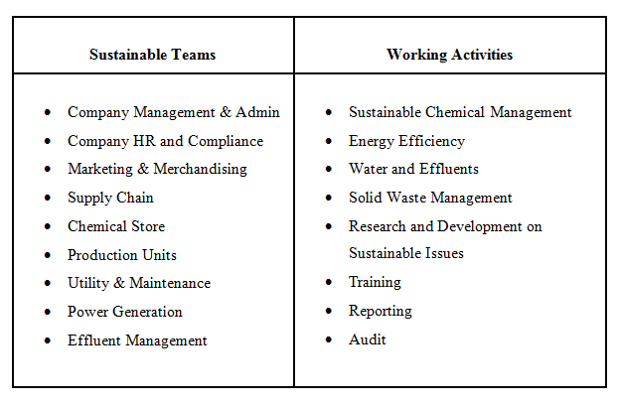
Figure3. 2: Sustainable Department

Hierarchy and Departmentalization of Elegant Group
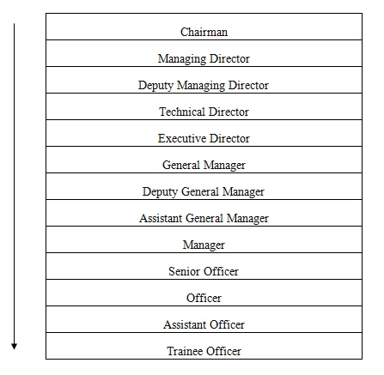
Figure3. 3: Hierarchy System of Elegant Group
The management of the Elegant Group involves a range of activities and responsibilities, including:
- Production planning and control: This involves managing the production process to ensure timely delivery of products to customers while optimizing efficiency and minimizing waste.
- Quality control and assurance: Ensuring that products meet quality standards is essential for the success of the RMG sector. This involves implementing quality control measures at every stage of the production process, from sourcing raw materials to finishing products.
- Human resource management: The HRD of Elegant Group is highly labor-intensive, so managing the workforce is crucial. This involves recruiting, training, and retaining skilled workers, ensuring compliance with labor laws and regulations, and providing a safe and healthy working environment.
- Supply chain management: Managing the supply chain involves sourcing raw materials, managing inventory, and coordinating with suppliers and logistics providers to ensure timely delivery of products.
- Sales and marketing: The team of Elegant Group operates in a highly competitive global market, so effective sales and marketing strategies are essential for success. This involves developing and implementing marketing campaigns, building strong relationships with customers, and identifying new market opportunities.
- Financial management: Effective financial management is essential for the success of the Elegant Group. This involves managing cash flow, budgeting, forecasting, and financial reporting.
Overall, successful management of the Elegant Group is a combination of technical skills, industry knowledge, and business acumen. Effective managers in this sector must be able to navigate complex supply chains, adapt to changing market conditions, and balance the needs of customers, employees, and stakeholders.

Number of Employees in the HR Department of Elegant Group
The nomenclature of the labor department underwent a modification approximately three to four years ago, resulting in its current designation as the Personnel Department. Despite the employment of over 4500 individuals, the department's HR operations are managed by a team of 15 individuals. Five individuals are currently experiencing a sense of being overburdened due to the substantial amount of work that needs to be accomplished..

HRM Operations at Elegant Group
At a macro level, it is imperative to evaluate the training prerequisites in relation to the organizational objectives and tactics. Failure to engage in this activity may result in the expenditure of resources on training initiatives that do not effectively contribute to the organization's objectives. There are several ways in which a training budget may be misused. For instance, individuals may receive training in skills they already possess. Additionally, the budget may be expended on rest and recuperation sessions that provide entertainment but do not contribute significantly to the acquisition of necessary job skills or knowledge. Alternatively, the budget may be allocated towards flashy hardware that satisfies the training director's preferences but does not align with the organization's needs. The HR teams at Elegant Group are engaged in various HR operations, including but not limited to:
- Recruitment: Elegant Group must constantly hire new workers to keep up with demand. Recruitment processes are typically conducted through local labor markets, with many companies relying on third-party labor agents to source workers. However, this can sometimes lead to issues related to worker exploitation and unfair labor practices, such as the charging of illegal recruitment fees.
- Training and Development: The HRD of Elegant Group, as workers need to be trained on the specific skills and techniques required for garment production. The company offers on-the-job training programs to help workers develop these skills, and some also provide more formal training through partnerships with vocational training institutes.
- Compensation and Benefits: The HRD of Elegant Group functions in the RMG sector, as workers typically earn low wages and are often not provided with benefits such as health insurance and retirement plans. While minimum wage laws are in place, enforcement can be a challenge, and many workers still earn less than the minimum wage. The company has begun to offer more competitive wages and benefits in order to attract and retain workers, but more needs to be done to ensure fair compensation for all workers in the sector.
- Labor Relations: The HRM function in the Elegant Group, as there have been frequent labor disputes and strikes in the industry in recent years. Unions are not widely recognized in the sector, and workers often face significant barriers to organizing and collective bargaining. The Company works to improve labor-management relations and ensure that workers are able to exercise their rights to freedom of association and collective bargaining.

CHAPTER 04
ANALYSIS AND FINDINGS

Approach of Data Collection and Analysis
This section provides a comprehensive discussion of the methodologies and procedures utilized to carry out the study and analysis. This study encompassed a range of topics, including factors and variables pertaining to the subject matter, the design of the questionnaire, the size of the sample, the collection of data, and the analysis of data.

Research Factors
The purpose of this study is to analyze the online recruiting strategy used by Elegant Group. Therefore, a large number of explanatory factors were required. The following theoretical framework may be used to show how Elegant Group's online recruiting efforts have contributed to the company's success.
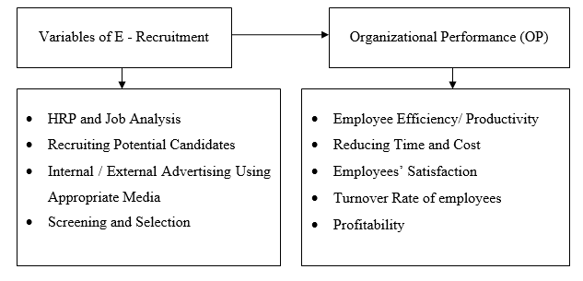
Figure4. 1: Research Factors of E-Recruitment and Organizational Performance

Demographic Characteristics
The survey was conducted with the participation of 30 employees from the Elegant Group's Head Office. As a result, the sample size has been determined to be 30.

Percentage of Gender
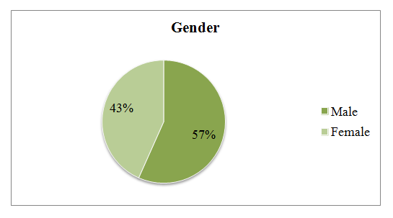
Figure 4.2
According to the data presented in Figure 4.2, the proportion of male survey respondents was 57%, whereas the proportion of female respondents was 43%. Consequently, the survey has elicited a higher quantity of responses from male participants in comparison to their female counterparts.

Designation of Staffs
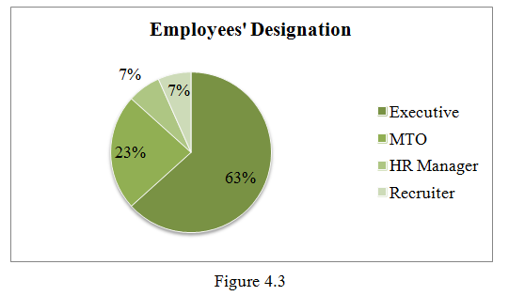
Figure 4.3
As depicted in Figure 4.3, the survey results indicate that out of the 30 employees who participated, 63% hold executive positions, 23% occupy MTO posts, 7% are HR Managers, and 7% are recruiters.

Work Experience
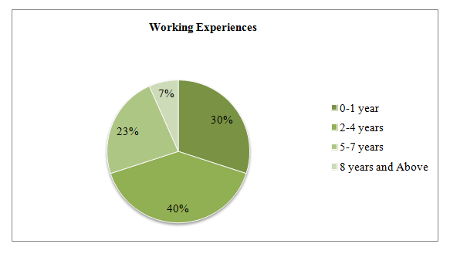

Figure 4.4
The results showed that 30% of the staff had less than a year of experience, while 40% had between two and four years on the job. Twenty-three percent of workers had between five and seven years of experience, while seven percent had at least eight years.

Descriptive Analysis
Statement 01: Through job analysis and workforce planning, the organization determines its current and future requirements.
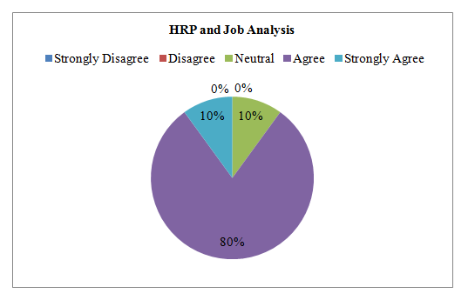
Figure 4.5
Figure 4.5 shows that between 10% and 80% of respondents agreed that Elegant Group's human resources department is working with the HR manager and a team of hiring experts to fulfil the company's full staffing needs through the application of workforce forecasting and job analysis.

Statement 02: The organization effectively draws and motivates a growing pool of candidates to submit their applications.
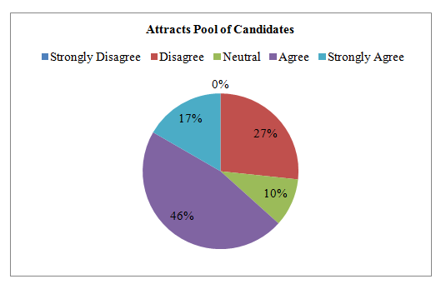
Figure 4.6
Based on the findings presented in Figure 4.6, it can be inferred that a majority of the participants, specifically 63%, expressed their agreement with the notion that the human resources department of Elegant Group is actively engaged in attracting and motivating prospective candidates to apply for positions within the organization, with the aim of fostering favorable perceptions of the recruitment process. The residual 10% of participants remain impartial, while 27% of respondents asserted that the Human Resource Department of the organization encounters challenges in procuring a pool of prospective candidates at a minimal expense.

Statement 04: The procedures for E-recruitment and selection within the organization are conducted in a fair manner.
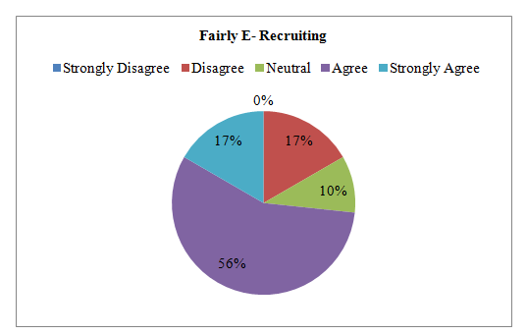
Figure 4.7
As per the information presented in Figure 4.7, a majority of 73% of the participants concurred with the aforementioned assertion. According to the survey results, 10% of the participants expressed a neutral stance, while 17% of the respondents held a contrary view, asserting that employers occasionally base their decisions on age, race, and ethnicity in the context of e-recruitment procedures.

Statement 04: When making decisions regarding hiring, the organization considers the qualifications and competencies of each potential employee.
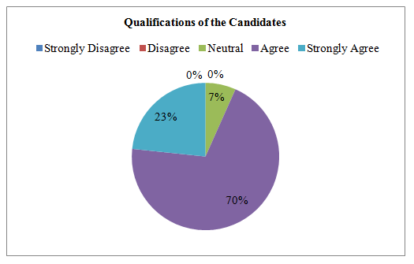
Figure 4.8
Based on the data presented in Figure 4.8, it can be observed that 93% of the participants concurred with the statement, while 7% of the participants maintained a neutral stance.
Statement 05: The Equal Employment Opportunity (EEO) standards are generally applicable to all employees, regardless of their gender, ethnicity, or race.
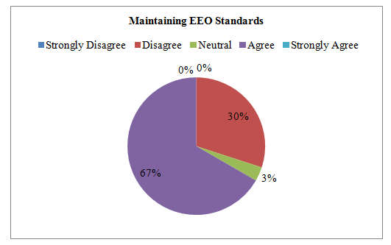
Figure 4.9
As per the information presented in Figure 4.9, a majority of 67% of the participants concurred with the aforementioned assertion. The survey results indicate that a minority of respondents, specifically 3%, expressed a neutral stance towards the statement. On the other hand, a significant proportion of respondents, specifically 30%, disagreed with the statement and posited that the organization's employment decisions may be influenced by unconscious bias on certain occasions.
Statement 06: The organization has its own internal recruiting system (including a website, email, online bulletin board, etc.).
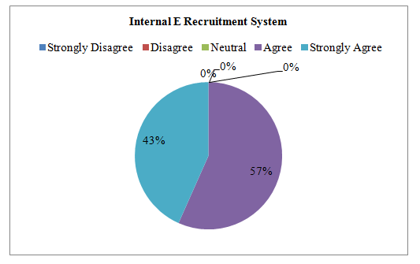
Figure 4.10
Based on the findings presented in Figure 4.10, it can be concluded that all respondents concurred with the notion that the recruitment of personnel to occupy vacant positions within the organization may entail the use of internal advertising. Various forms of media can be utilized for recruitment purposes, such as specialized e-Recruitment media, email, and advertisements on the organization's web portal.

Statement 07: Social media is a great tool for finding suitable candidates from external sources.
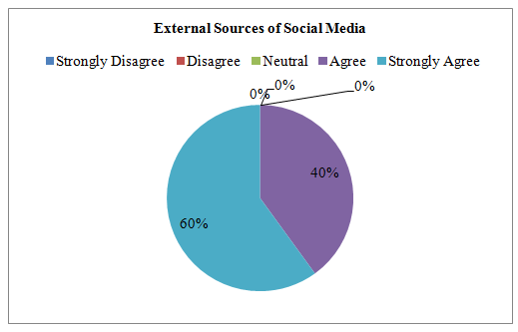
Figure 4.11
Based on the findings presented in Figure 4.11, it can be inferred that all participants surveyed concurred that the organization's recruiters possess the capability to leverage various resources, such as social media networks, during the recruitment of fresh personnel. Additionally, the employment of social media networks was deemed to be an inventive solution that has the potential to yield cost savings.
Statement 08: The application process within the organization has been enhanced through the utilization of social media platforms for job advertising.
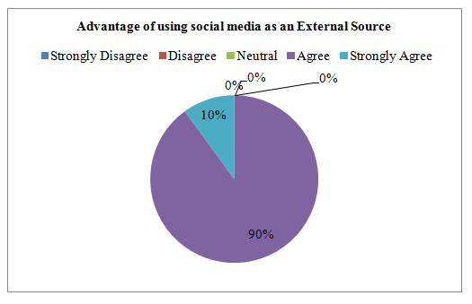
Figure 4.12
Based on the findings presented in Figure 4.12, it can be inferred that all participants surveyed concurred that social media platforms offer a digital space that holds considerable promise for recruitment purposes. The utilization of social media networks as a data source for evaluating candidates is a significant aspect in organizational decision-making. This data enables human resource managers to identify the social connections of individuals and ascertain the presence of any potential matches. Subsequently, individuals have the capacity to obtain either favorable or unfavorable endorsements.
Statement 09: E-Recruitment is a useful strategy for attracting potential applicants through online advertising, such as pop-ups, that are disseminated across various social media platforms.
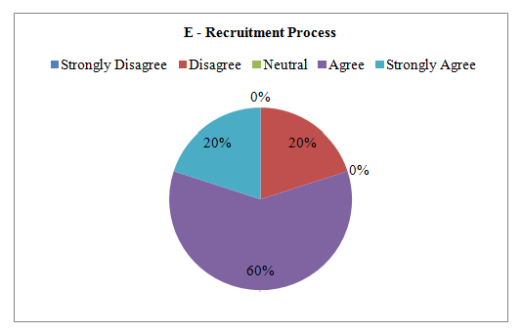
Figure 4.13
As depicted in Figure 4.13, a majority of 80% of the respondents concurred with the aforementioned statement, while the remaining 20% expressed dissent and contended that the recruitment process of the organization may take a longer duration due to the large pool of applicants.

Statement 10: The utilization of newspaper advertisements has the capacity to draw in a broader range of potential candidates compared to alternative sources.
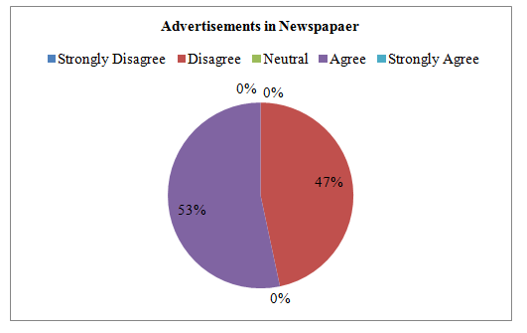
Figure 4.14
Based on the findings presented in Figure 4.14, a majority of the respondents, specifically 53%, expressed their agreement towards the notion that job advertising in newspapers is appropriate for prospective candidates residing in remote areas. Conversely, 47% of the respondents disagreed with the statement, citing that online job postings are more accessible to a wider audience and therefore, a more efficacious method of garnering attention compared to job postings in newspapers.
Statement 11: The best way to locate a new work is to make a profile on the career websites of various organizations.
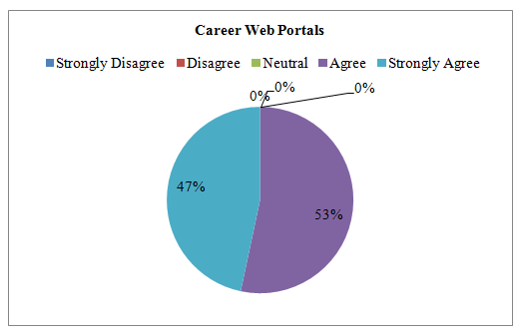
Figure 4.15
Based on the data presented in Figure 4.15, it can be inferred that all of the participants surveyed expressed the belief that career web portals have the potential to serve as a means of filling vacant positions within the organization.
Statement 12: To complete the screening process, the organization makes use of applicant tracking tools and software for psychological evaluations and skills-based assessments.
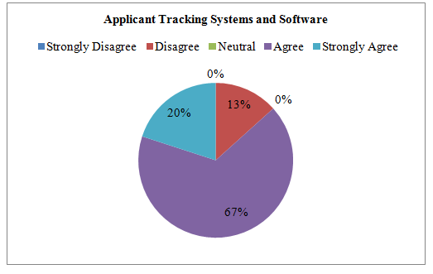
Figure 4.16
As per the data presented in Figure 4.16, a majority of 87% of the participants concurred with the aforementioned assertion. Thirteen percent of the survey participants reported that the screening process of applicants poses a challenge for the Human Resources Department (HRD) due to the large volume of applicants. Consequently, it takes a longer duration to screen and identify suitable candidates.
Statement 14: The organization's Electronic screening tools help the organization go through large numbers of applications and find the best candidates for open positions.
Figure 4.5
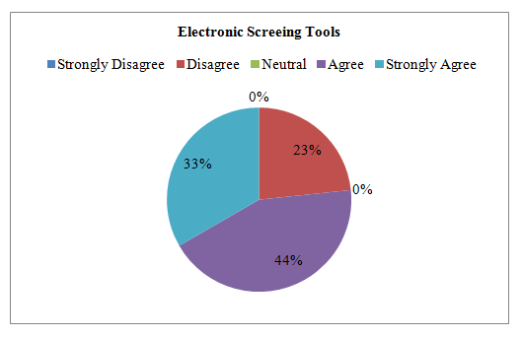
Figure 4.17
Based on the findings presented in Figure 4.17, it can be concluded that all respondents concurred with the notion that the recruitment of personnel to occupy vacant positions within the organization may entail the use of internal advertising. Various forms of media can be utilized for recruitment purposes, such as specialized e-Recruitment media, email, and advertisements on the organization's web portal.

Statement 15: The organization’s E-recruitment allows for a more modern and user-friendly application process, which can improve the candidate experience and help to attract top talent.
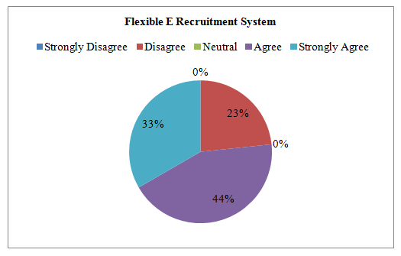
Figure 4.18
Based on the findings presented in Figure 4.18, it can be concluded that all respondents concurred with the notion that E-recruitment allows candidates to apply for job vacancies from anywhere and at any time, using their computers or mobile devices. This convenience saves time and effort and makes the application process more accessible.
Statement 16: Effective e-requirement systems within an organization can significantly reduce the cost of employee training.
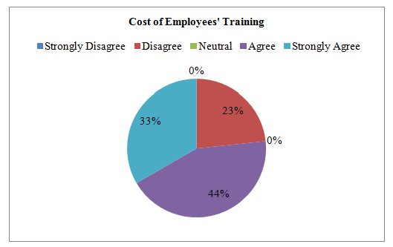
Figure 4.19
As per the data presented in Figure 4.17, a majority of 77% of the participants concurred with the aforementioned statement. The remaining 23% of participants reported that on occasion, the insufficiency of qualified candidates necessitates employee training or recruitment processes, which may result in increased organizational costs.
Statement 18: The organization’s E-recruitment helps to enhance employees' satisfaction with the recruitment process and their overall experience with the organization.
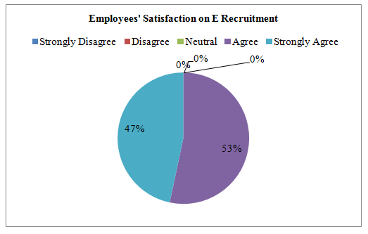
Figure 4.20
Based on the findings presented in Figure 4.20, it can be concluded that all respondents concurred with the notion that E-recruitment systems can provide a more transparent and fair recruitment process by ensuring that all candidates receive equal treatment and are assessed on their merits. This can help to increase employees' satisfaction and trust in the organization's recruitment process.
Statement 19: A successful electronic recruiting system may reduce staff turnover, absenteeism, and boredom.
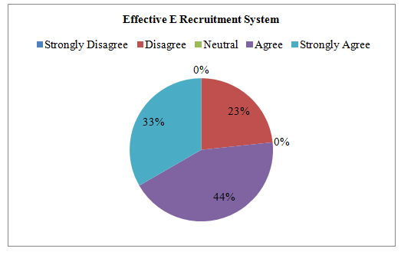
Figure 4.21
As per the data presented in Figure 4.21, the entirety of the participants concurred with the aforementioned assertion.
Statement 20: The growing rivalry has impeded my likelihood of selection due to the organization's online recruitment process.
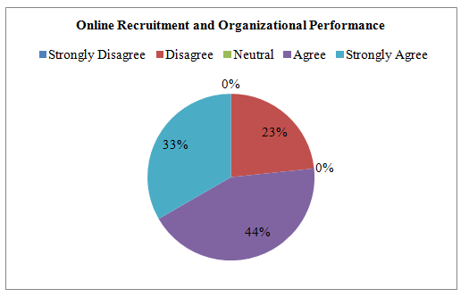
Figure 4.22
Based on the data presented in Figure 4.22, it can be inferred that all participants surveyed were in agreement with the aforementioned statement.

Findings
Upon conducting an analysis of both primary and secondary data, the identified limitations and parameters of E-recruitment and its effectiveness have been established.

Scope in E-Recruitment System at Elegant Group
- The reduction of expenses for the company. Furthermore, online job postings are a more cost-effective alternative to print advertisements in newspapers.
- The reduction of recruitment time and effort at the organization has been significant.
- This facilitates the recruitment of suitable employees who possess the required skills.
- The efficacy of the recruitment process has been enhanced.
- The platform offers uninterrupted availability to a digital repository of curriculum vitae, accessible at any time of the day or week.
- Online recruitment facilitates the prompt elimination of unqualified applicants by the organization.
- Recruitment websites furnish significant data and information pertaining to competitor compensation, among other things, which aid HR managers in making various HR decisions, including promotions and industry salary trends. Recruitment websites furnish significant data and information pertaining to the remuneration provided by competing entities, among other things.

Challenges in E-Recruitment System at Elegant Group
Electronic recruitment, despite its numerous opportunities and benefits, is accompanied by a number of drawbacks and limitations. Included in the group are the subsequent items:
- The organization faces a challenging and time-consuming task in screening, reviewing, and verifying the legitimacy of skill mapping and resumes of thousands of applicants.
- In numerous regions of Bangladesh, there exists a limited prevalence of Internet usage, inadequate availability of online resources, and insufficient familiarity with the Internet. Consequently, in the process of recruiting fresh personnel, companies cannot solely depend on virtual platforms and internet-based portals.
- Currently, there is a preference among employers and workers in Bangladesh to engage in face-to-face communication as opposed to utilising electronic mail.

Recommendation
As an individual currently employed within the HR division of ELEGANT Group, it is my assertion that despite the organization's widespread recognition, the HR division prioritizes the needs of its own department. Upon conducting an analysis, it was discovered that other firms and banks exhibit a higher degree of activity in online recruitment systems. The present electronic recruitment systems and methodologies could benefit from certain improvements.
- Whenever a job vacancy arises, the website will generate job postings, and interested candidates can expeditiously submit their applications online by completing their resumes and uploading them to the database. This measure will effectively obviate the necessity for utilizing recruitment agencies and the concomitant costs. Furthermore, this approach will be economically feasible. By leveraging recruitment data and analytics, organizations can consistently improve their recruitment procedures and make more informed decisions. Nevertheless, the acquisition and analysis of data may present challenges. Spreadsheets represent a method for monitoring recruitment data, however, they necessitate manual labor, are susceptible to human mistakes, and lack compliance. This poses a challenge in accurately monitoring data and trends. Efficient and streamlined approaches for gathering and arranging data are essential for recruitment teams.
- The Human Resource Development (HRD) department of Elegant Group is mandated to uphold transparency and accountability in its endeavors to enlist potential candidates from alternative channels, including online advertisements. Moreover, it is incumbent upon the recruiting organization to furnish the candidates with comprehensive details regarding the recruitment procedure, duration of the interview, instructions for utilizing online recruitment platforms, remuneration spectrum, perks, and other terms and conditions pertaining to the job. Both the organization and the candidate bear the responsibility of adequately preparing themselves for the electronic recruitment procedure.
- The Human Resource Development (HRD) department of Elegant Group, in its capacity as an employer, possesses the capability to devise resolutions for the numerous challenges that are linked to online recruitment. It is advisable to priorities an in-person meeting with the prospective employee before finalizing their hiring decision. The process of evaluating the prospect will be facilitated, leading to a more informed selection of the most suitable candidate for the position. Upon completion of the e-recruitment process, the employer will have the ability to conduct a background check on the applicant. It is advisable to exercise caution while selecting a potential candidate to collaborate with, and not to make hasty decisions. It is advisable to allocate sufficient time to enable the prospective candidate to thoroughly evaluate the offer and arrive at an informed decision.

Conclusion
The optimization of various aspects of contemporary corporate operations, such as recruitment, has been made feasible by technological advancements.
The utilization of online recruitment may attract and facilitate the recruitment process for potential candidates. During the recruitment process, recruiters commonly employ various methods such as their company's website, third-party job sites or boards, CV databases, social media, or search engine marketing. Recruitment through the internet is frequently executed by means of an organization's personal website. Given that personnel constitute a company's most prized asset, it is imperative to exercise prudence in the recruitment process to ensure the organization's overall prosperity. The Human Resource Department bears the responsibility for crucial facets of the employment process, such as recruitment, employee retention, and motivation. The paramount determinant of the effectiveness of an online job recruiting approach is the level of performance achieved.
In terms of efficiency, dependability, and security, internet recruitment surpasses the internal recruiting systems of numerous businesses. Instead of posting advertisements on external online platforms, it would be more economically viable and conducive to enhancing brand awareness if diverse entities were to establish an internal online recruitment system on their respective websites. The Elegant group has indicated a preference for an online recruitment system over the internal and external recruitment systems currently employed by the organization.

References

Albert, G. B. (2004). Personal writ shaft, 6th edition. Ludwigshafen, Germany: Friedrich Kiel Verlag.
Álvarez, G. (2012). New Technologies in the University Context: The Use of Blogs for Developing Students' Reading and Writing Skills. International Journal of Educational Technology in Higher Education, 9(2).
Balcerzak P.A., P. B. (2017). Digital Economy in Visegrad Countries. Multiplecriteria Decision Analysis at Regional Level in The Years 2012 and 2015. Journal of Competitiveness, 09(2).
Barber, L. (2006). E-recruitment Developments . Brighton: The Institute for Employment Studies.
Cascio W.F., M. (2016). How Technology Is Changing Work and Organizations. Annual Review of Organizational Psychology and Organizational Behavior, 3(01).
Danialarj. (2013). E-recruitment; Types, Drivers and Challenges. Retrieved from danialarj.wordpress.com: https://danialarj.wordpress.com/2013/05/21/e-recruitment/
Daniel, D. C. (2019). IMPACT OF E-RECRUITMENT ON ORGANISATIONAL PERFORMANCE. International Journal of Economics, Business and Management Research, Vol. 3, No. 03.
Galanaki. (2002). The decision to recruit online: a descriptive study. Emerald Career Development International , 7(4): 243-251.
Herbell K., Z. J. (2018). Facebook or Twitter? Effective recruitment strategies for family caregivers. Applied Nursing Research, 41(1).
Lang S., L. S. (2011). Drivers, challenges and consequences of E-recruiting: a literature review. Proceeding: SIGMIS-CPR ’11 Proceedings of the 49th SIGMIS annual conference on Computer personnel research., ACM New York: 26-35.
Petter S., D. W. (2012). The Past, Present, and Future of “IS success”. Journal of the Association for Information Systems, 13(5).
Pin J. R., L. M.-D. (2001). Internet Recruiting Power: Opportunities and Effectiveness. International Research Centre on Organizations (IRCO); Research Paper no, 439.
Rahat, M. (2014). Practice of E-Recruitment in RMG Sector. Retrieved from SlideShare: https://www.slideshare.net/smRahat/bgmea-university-of-fashion-and-technology-hrm-1
Silber, M. J. (2012). Online Recruitment. US Business Services Research: BMO Capital.
Sorgner A., B. E.-B. (2017). The Effects of Digitalization for Gender Equality in the G20 Economies, Women 20 study, (1 st ed.). Kiel: Kiel Institute for the World Economy.
Stone D. L., S.-R. E. (2006). Factors affecting the acceptance and effectiveness of electronic human resource systems. Human Resource Management Review , 16(2).
Thompson L. F., B. F. (2008). E-recruitment and the benefits of organizational web appeal. Computers in Human Behavior , 24(5).
Tuten, P. C. (2001). Internet recruiting in the banking industry. Business Communication Quarterly , 64(1).
Urbancová H., R. P. (2017). Employer branding in the agricultural sector: making a company attractive for the potential employees. “Agricultural Economics. Prague: Czech academy of agricultural sciences, 63(5).
Webster, C. D. (2003). The use of technologies in the recruiting, screening, and selection processes for job candidates. International Journal of Selection and Assessment , 11(2-3): 113−120.
Wołodźko K., W. J. (2017). The Use by Large Polish Organizations of Information about CSR Activities in e-Recruitment. Economics and Sociology, 10(2).
Wroblowská, Z. (2016). Requirements for Brand Managers and Product Managers Responsible for Competitiveness of Product and Brands. Journal of Competitiveness, 8(3).

Survey Questionnaire
The Impact of E- Recruitment on Organizational Performance: A Study on Elegant Group
Dear Respondent,
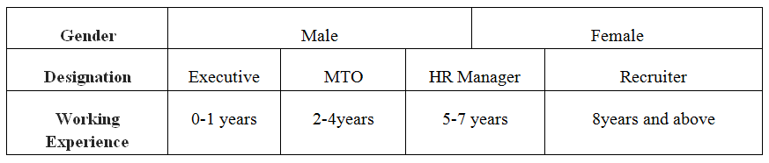
The HR staff members and management at Elegant Group will be interviewed about the E-Recruitment Systems and Processes used by the organization using the following questionnaire. The information provided will be used solely for academic purposes.
Statement |  | Strongly  Disagree  (1) | Disagree  (2) | Neutral  (3) | Agree  (4) | Strongly  Agree  (5)
Human Resource Planning and Job Analysis
01. | Through job analysis and workforce planning, the organization determines its current and future requirements.
02. | The organization effectively draws and motivates a growing pool of candidates to submit their applications.
Hiring Potential Candidates
03. | The procedures for E-recruitment and selection within the organization are conducted in a fair manner.
04. | When making decisions regarding hiring, the organization considers the qualifications and competencies of each potential employee.
05. | The Equal Employment Opportunity (EEO) standards are generally applicable to all employees, regardless of their gender, ethnicity, or race.
Internal / External Advertising Using Appropriate Media
06. | Internal recruitment system (through internal web portal, email, online bulletin etc) exists in the organization.
07. | Social media is a great tool for finding suitable candidates from external sources.
08. | The application process within the organization has been enhanced through the utilization of social media platforms for job advertising.
09. | E-Recruitment is a useful strategy for attracting potential applicants through online advertising, such as pop-ups, that are disseminated across various social media platforms.
10. | The utilization of newspaper advertisements has the capacity to draw in a broader range of potential candidates compared to alternative sources.
11. | The best way to locate a new work is to make a profile on the career websites of various organizations.
Screening and Selection
12. | To complete the screening process, the organization makes use of applicant tracking tools and software for psychological evaluations and performance-based assessments.
13. | The organization's E-recruitment process that involve reviewing resumes and applications, conducting interviews, and making final hiring decisions.
E – Recruitment and Organizational Performance
14. | The organization's Electronic screening tools help the organization go through large numbers of applications and find the best candidates for open positions.
15. | The organization’s E-recruitment allows for a more modern and user-friendly application process, which can improve the candidate experience and help to attract top talent.
16. | Effective e-requirement systems within an organization can significantly reduce the cost of employee training.
17 | The organization’s E-recruitment system makes the recruitment process more convenient for candidates.
18. | The organization’s E-recruitment helps to enhance employees' satisfaction with the recruitment process and their overall experience with the organization.
19. | A successful electronic recruiting system may reduce staff turnover, absenteeism, and boredom.
20. | The growing rivalry has impeded my likelihood of selection due to the organization's online recruitment process.

