



Internship Report On
General Banking and CSR Activities of
Shahjalal Islamic Bank Limited

r
United International University
School of Business & Economics

Internship Report On
General Banking and CSR Activities of
Shahjalal Islamic Bank Limited

Submitted To:
S.M. Asif-Ur-Rahman
Asst. Professor – Marketing
School of Business & Economics
United International University

Submitted By:
Shanto Leonard Gomes
ID: 111 162 081
Major: Marketing (BBA)
United International University

Date of Submission: October 21, 2021

Internship Authorization Letter
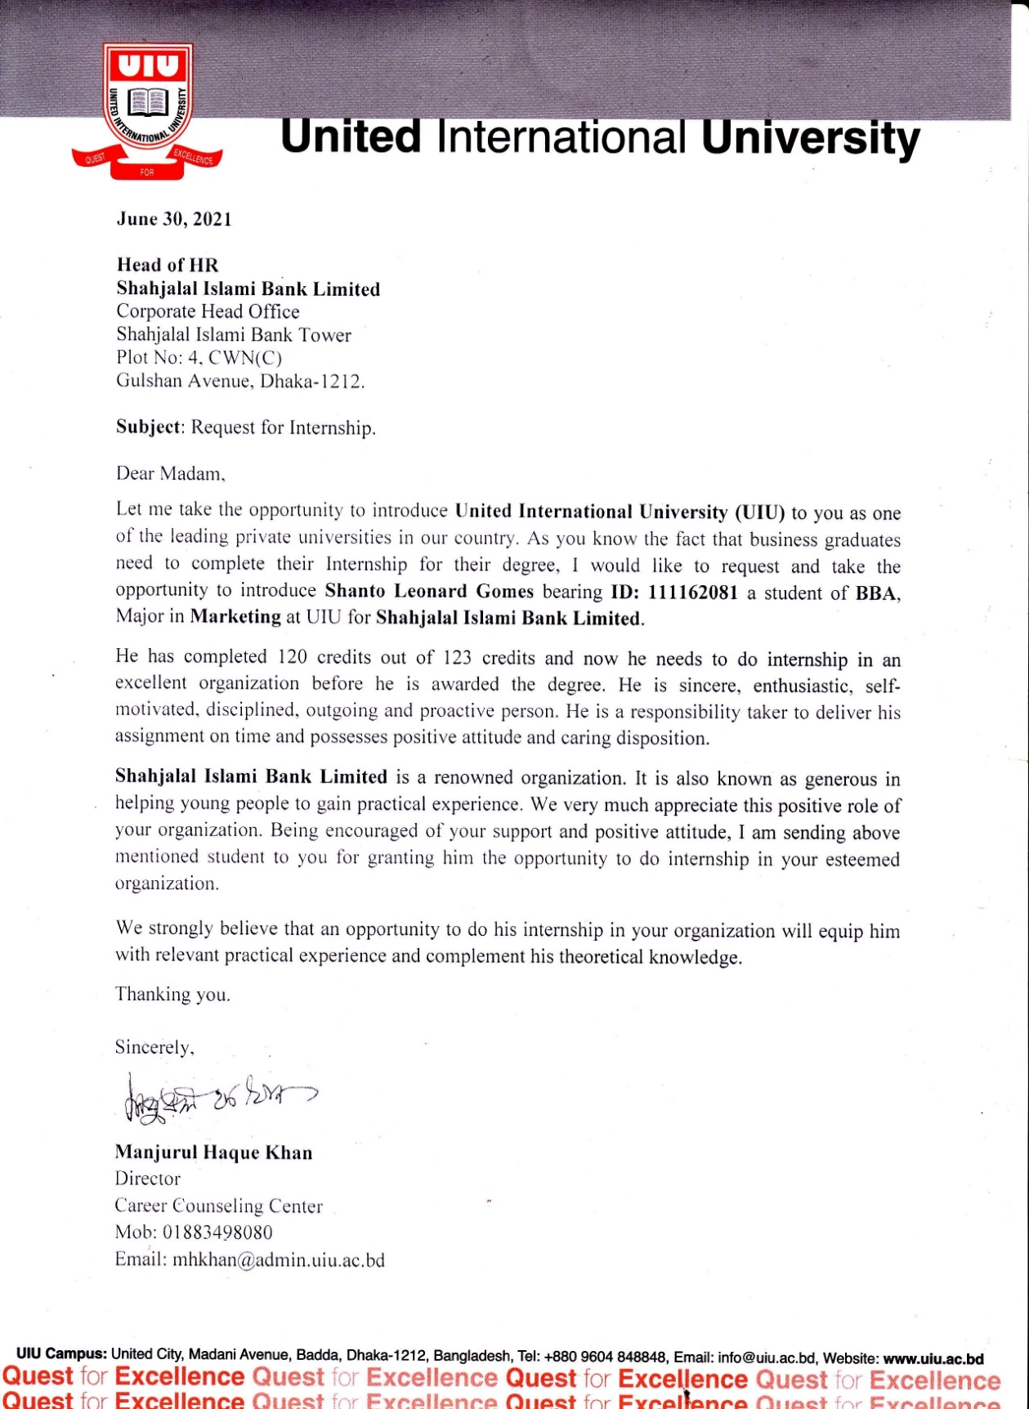

Letter of Transmittal

21th October, 2021
S.M. Asif-Ur-Rahman
Assistant Professor
School of Business & Economics
United International University

Subject- An application for accepting the Internship Report.

Sir,
With due respect, I would like to tell you that, by the grace of God and your unwavering support, I have finished the internship report under your supervision in order to satisfy the criteria of my internship.

It gives me great pleasure to present my report, "General Banking and CSR Activities of Shahjalal Islamic Bank Limited". I have an excellent working environment at SJIBL, which is also a learning environment for me, since it demonstrates the differences between real and hypothetical work.

As such, I would want to express my gratitude for all of your support and instructions, as well as the hope that you will continue to provide guidance in the future. As a result, I will be available to answer any questions you may have.


Sincerely,

Shanto Leonard Gomes
ID: 111 162 081
BBA in Marketing
United International University

Acknowledgement

To begin, I would like to offer my heartfelt appreciation to GOD for allowing me to finish my report on "General Banking and CSR Activities of Shahjalal Islamic Bank Limited." I would want to express my sincere gratitude and respect to my academic supervisor, S.M. Asif-Ur-Rahman, Assistant Professor at UIU SOBE. Without his kind bearing and genuine guidance, I could not have imagined writing this report. His administration and guidance created this initiative, which resulted in the completion of this report. I am also highly grateful to all of my supervisors at Shahjalal Islami Bank Limited and especially thanks to in charge of General Banking Department, First Executive Officer; Ruma Pervin, and all the team members whom I worked with within the General Banking Department who have guided me through my workdays. All of these individuals have contributed to my ability to do well throughout my three-month internship, learn, and gain new skills and information. It would not have been feasible for me to learn about business culture and the financial industry without the help of these people.

Finally, I want to thank everyone else at United International University and Shahjalal Islami Bank Limited who helped me along the way with their kind and patient support. Without their help, putting together this report would have been very impossible.

Table of Contents
Executive Summary 9
Chapter 1: Introduction of the Report 11
Introduction 11
Origin of the report 11
Literature Review 12
Literature Review of Islamic Banking 12
Literature Review of CSR 16
Purpose of the Report 19
Scope of the Report 19
Limitation 20
Methodology 20
List of Abbreviation & Technical Terms 21
Chapter 2: Analysis of the Organization 23
Shahjalal Islami Bank Limited Overview and History 23
Vision 23
Mission 24
Motto 24
Strategies 24
SJIBL's Prominent Individual 25
Organogram 27
Shahjalal Islami Bank Ltd. Divisions 28
Products and Services of SJIBL 29
Deposit Accounts 29
Schemes of deposits 32
Cards 34
Corporate Investment Products 36
Retail Investment Products 38
SME Investment Products 39
AGRI Investment Products 39
Sustainable Investment Products 39
Other Banking Services 39
SWOT analysis of SJIBL 40
PESTEL Analysis of SJIBL 42
Departments of SJIBL Eskaton Branch 44
CSR Activities of SJIBL 46
SJIBL Foundation 47
Shahjalal Islami Bank Foundation Objectives 47
Shahjalal Islami Bank Limited’s Source of Fund for Donation 48
Why does SJIBL make this CSR investment? 49
Sectors to Focus on for CSR 49
SJIBL's Preference for Corporate Social Responsibility 52
Beneficiary of CSR 52
Expenditure of the Bank in the Area of CSR 54
Chapter 3: Internship Experience in SJIBL 56
Position, Duties, and Responsibilities 56
Position 56
Duties 56
Responsibilities 60
Training 61
Contribution to departmental functions in SJIBL 61
Contribution to the General Banking (GB) Department 61
Evaluation of internship performance 63
Acquired knowledge and skills through an internship with SJIBL 64
Academic Knowledge in Practice 66
Chapter 4: Recommendation 68
Recommendation 68
Chapter 5: Conclusion 71
Conclusion 71
Appended Part 72
Reference 72
Appendix 73

Executive Summary

This report is based on the Shahjalal Islamic Bank Limited's "General Banking and CSR Activities." It is the outcome of a three-month internship at Shahjalal Islami Bank Limited, Eskaton Branch, as mandated by faculty and supervisor S.M. Asif-Ur-Rahman, Assistant Professor of United International University's BBA Department. Shahjalal Islami Bank Ltd's ordinary banking operations and CSR initiatives are being documented is the purpose for the creation of this report. Here, I have attempted to demonstrate how they oversee regular banking operations as well as CSR initiatives. Besides that, I've shown the positive effect these practices have had on the bank. Account opening, security instrument dealing, customer service and other bank administrations are all part of general banking. This includes managing currency, money, clearing charges, and other fees. But financial institutions like banks have a lot to gain from corporate social responsibility (CSR) initiatives. In order to provide an excellent banking service, it is necessary to integrate all of the various monetary operations.

Five chapters comprise this report. The report's introduction is discussed in the first chapter. This chapter discusses the report's origins, background, literature review, mission statement, scope and limitations, methodology, and a glossary of abbreviations and technical terminology. The second chapter is entirely dedicated to the report's findings and analysis, in which I detail "General Banking Activities and CSR Activities" of "Shahjalal Islami Bank Limited." The third chapter details my internship experience in the Eskaton branch of "Shahjalal Islami Bank." The fourth chapter discusses my recommendation as an intern. And the last chapter is the fifth. Finally, I have included an appendix and references in the annex section.

Chapter 1
Introduction of the Report

Chapter 1: Introduction of the Report

Introduction
A nation's most important goal is to represent the global economic development of that country. The banking industry plays an important role in the country's economic development. By being adept at gathering and attracting interesting securities from savers, the sector is critical to development that is both cost-effective and progressive. Its second function is to entice investment and output via the provision of loans. It may also represent an economic extension to most of the economic zones, such as agriculture, corporations, and the commerce sector, according to the report. Banks are working hard to ensure that capital requirements are implemented for investment projects.

The General Banking sector is responsible for the management of cash, money, clearing costs, account opening, security instrument dealing, client service, and other bank administrations. On the other side, corporate social responsibility (CSR) is a major benefit provided by financial organizations such as banks. CSR is a term that refers to the corporate social responsibility (CSR) that banks take on. All public and private limited banks in Bangladesh are governed by the Bangladesh Bank's financial act and security compliance regulations. The Bangladesh Bank establishes rules and closely oversees commercial banks' compliance with them.

Origin of the report
The paper was written after a rigorous three-month internship at SJIBL's Eskaton branch in Dhaka. After completing 120 credits of BBA coursework, students must complete an internship/project summary. As I selected internship as a means of completing my last three credits of the BBA degree, I began my internship at Shahjalal Islami Bank Ltd. I gathered the knowledge and abilities suggested by SJIBL's human resources department over these three months. This report is the culmination of my three months of SJIBL practice.

Literature Review

Literature Review of Islamic Banking

Islamic Banking Concepts
For those who are unfamiliar with the term, Islamic banking is a new form of banking based on principles that adhere to Quranic standards prohibiting usury and certain activities, such as lending money for interest. Islamic banking's economic reasoning is built on justice, efficiency, stability, and development, all of which may be found in the Quran. In the Islamic banking system, industrial and/or commercial risk is shared more equitably between entrepreneurs and capital owners, and investment profits are distributed to investors in proportion to their proportional capital, it is thought. The traditional banking system caters to the most creditworthy borrowers, while the Islamic banking system is more likely to focus on projects that are both productive and lucrative. To be sure, Islamic finance theoretically rejects the notion of favoring some customers over others based on their socioeconomic status, and it promote social harmony among various socioeconomic groups.

Islamic banking serves the same function as conventional banking, except that it is governed by Shariah laws known as Fiqh al-Muamalat (Islamic transaction regulations). The fundamental premise of Islamic banking is profit sharing and the prohibition of riba (usury). Profit sharing (Mudharabah), safeguarding (Wadiah), joint venture (Musharakah), cost plus (Murabahah), and leasing are all popular Islamic ideas utilized in Islamic banking (Ijarah).

Historically, Islamic banking may be traced back to the Prophet Muhammad's (Sm) use of mudaraba (Islamic cash loans). The Prophet (Sm) acted as a mudarib (agent) for his wife, who entrusted him with her money or goods in exchange for a percentage of the profits. The Prophet (mudarib) was given a portion of the proceeds as payment for his efforts (and for being an entrepreneur). However, the mudarib was exempt from liability for any damages incurred as a consequence of unforeseen circumstances associated with travel or a failed business endeavor.

Mudaraba is the name given to this type of partnership. Musharaka is a kind of partnership in which the musharik (agent) contributes to the capital and, as a result, has a greater claim to the profits. Iraq's tax income was transported to Medina in a mudaraba as far back as the seventh century, according to historical accounts. According to legend, Caliph Umar used orphans' money to fund his merchant trade activities between Medina and Iraq. As early as the ninth century, traders traveling the north-south trade route between Egypt and Jeddah used musharaka partnerships to save costs and increase profits. In the 17th century, the Turkish city of Busra had 32 mudaraba contracts in effect. Tunisia, Indonesia, the Arabian Peninsula and India were among the countries where Mudaraba was in use.

The ancient practice of a 'three-tier mudaraba' was the inspiration for modern Islamic banking ideas. There is a person who wants to put money on the first layer, namely rab-al-mal This person's capital will be given to him under contract by the rab-al-mal, and he will then turn it over to him, as agreed upon in their contract. The last person in this chain of trust is the mudarib (agent), to whom the rab-al-mal entrusts his capital. (What Is Islamic Banking? 2021)

Islamic Banking's Purpose
In the banking industry, an Islamic Bank is a financial organization that works to apply and actualize Islamic economic and financial principles. Islamic banking's primary goals are as follows:

- In order to carry out interest-free banking operations
- It's time to move away from traditional banking and toward participatory banking.
- It is permissible to invest in many ways according to Islamic Shariah.
- It is possible to take investments on a profit-sharing basis.
- A financial system that prioritizes social welfare will need to be set up.

- To provide assistance to the poor, the helpless, and the low-income population in order to encourage their participation in the labor force.
- Assist in the creation of new jobs while also contributing significantly to human growth.
- Help the nation expand and develop in a balanced manner, especially in the less developed regions, by conducting investment activities
- Contribute to the Islamic economic system's ultimate aim. (What Is Islamic Banking? 2021)

Worldwide Adoption of Islamic Banking
Islamic banking's growth and development, along with conventional interest-based banking's, is a relatively new phenomena. Banking in Islam is in dissociable from the Islamic economic system. In the fifties, it was primarily a study topic and only included works by academics and philosophers. In the 1960s, real trials were conducted, and in the 1970s, Islamic financial institutions began to acquire traction in the United States. During the 1980s and 1990s, Islamic banking was consolidated, and today it is the only welfare banking system in contemporary times.

So the Islamic banking movement made steady development and took on a new dimension and function when the Nasser Social Bank was established (1972) In 1977, Faysal Islamic Bank opened branches in Egypt and Sudan. Established in Jordan in 1978, the Islamic Bank of Finance and Investment entered Turkey in (1983). In 1978, Pakistan proclaimed all of its banks to be Islamic, and in 1984, Iran did the same. International Financial Institution with regard to institutions, the creation of an emergency development bank was regarded an important milestone in Islamic banking history.

There are now approximately 300 Islamic financial institutions operating across the globe, encompassing both Muslim and non-Muslim nations with varying socioeconomic environments.

The emergence of Islamic Banking in Bangladesh
If the Islamic economy develops, Islamic banking will fulfill its real duties, which are outlined in Islamic law or Islamic law. Islamic banks are rapidly taking over in Bangladesh today. They're backed by Saudi Arabian and Kuwaiti investors. The first Islamic bank in Bangladesh was founded in 1983 by Islamic Bank Bangladesh Limited (IBBL). So far Bangladesh has eight Shariah-compliant Islamic banks, including IBBL (wikipedia, 2021) The following are only a few examples: Islami Bank Bangladesh Ltd
- Shahjalal Islami Bank Ltd.
- Al-Arafah Islami Bank Ltd.
- EXIM Bank Ltd.
- First Security Islami Bank Ltd.
- ICB Islamic Bank.
- Social Islami Bank Ltd.
- Union Bank Ltd.
- Standard Bank Limited
- Global Islamic Bank Ltd (former NRB Global Bank)

Some major cities now have also Islamic Banking branches of nine conventional banks: Prime Bangladesh Limited (PBL), Dhaka Limited (DBL), South East Limited (SEBL), Premier Limited (PBL), The City Limited (TCL), Jamuna Limited (JL), Arab Bangladesh Limited (ABL), Standard Chartered Bank (SBC), and HSBC (Hong Kong and Shanghai Banking Corporation).

Literature Review of CSR

What is CSR?

As a result of corporate social responsibility, organizations prepare for social and common concerns in their trade operations and naturally with their partners. Globally, CSR is referred to as private sector self-regulation. "Corporate Social Responsibility" (CSR) is a company's duty to manage its operations such that they have positive social, common, and monetary impacts. It's part of a company's approach to corporate management and affects every link in the supply chain, as well as employee health and safety. Almost every business, whether public or private, requires a lot of reputation. As a means of building and maintaining trust, corporate social responsibility (CSR) is critical. Companies build solid reputations, attract favorable attention, save money via operational competence, reduce environmental impact, and motivate employees through their work performance advancement. (Corporate Social Responsibility (CSR) Definition 2021)

Objectives of CSR
Corporate social responsibility's primary goal is to increase transparency into the company's business practices and operations.Corporate social strategies include accepting responsibility for societal development as part of the organization's overall social and environmental strategy. With regards to corporate social responsibility (CSR), the ultimate goal is to enhance the shared value of a company and its employees. Incorporated social responsibility (CSR) encompasses everything from health and safety to human rights and social well-being.

It includes things like labor conditions, corporate management, and environmental management. Additionally, it prioritizes environmental and social progress in addition to economic growth CSR is a company's feeling of duty. It refers to measures made by a business to give back to the community in which it operates. (Corporate Social Responsibility (CSR) Definition 2021)

Types of CSR
A company's corporate social responsibilities help the community at large. Companies may fulfill several kinds of corporate social responsibilities by making contributions of various kinds of financial or material value. Contributing to corporate social responsibility may provide a significant competitive advantage for any business.. Since their CSR may be evaluated by their customers as well as the public, CS Obligations Company must maintain moral and competent preparations while taking on these obligations. This section summarizes a few key points about four different types of corporate social responsibility (CSR).
- Economic Responsibility
- Legal Responsibility
- Ethical Responsibility
- Philanthropic Responsibility

Economic Responsibility: This is a business's first duty, and it must be profitable. A business can only be successful if it is lucrative in the long run and benefits society. It's important to establish a balance between economics, the environment, and altruism when it comes to economic responsibility since they are all linked.

Legal Responsibility: Of the four responsibilities listed above, this is the most critical since it will demonstrate how companies manage their interaction inside the workplace. A few examples of genuine obligations that a company should follow include business regulations, competition with other businesses, charge standards, and the prosperity and security of workers.

Ethical Responsibility: Government support for delegates is provided through ensuring acceptable work practices for both employers and employees of suppliers. It implies that there will be no sexual orientation, color, or specialized division among the workers and that every expert will be given a respite even with pay for ascent to work and unequaled living compensation remittance guaranteeing acceptable work rehearses each representation.

Philanthropic Responsibility: Committing one's self to helping others implies fulfilling one's moral obligation. To ensure that the less fortunate and vulnerable individuals on our world may thrive, this model considers their well-being as well. This shows that businesses are doing their part in fulfilling their lofty social duty. Donate your time, money, or assets to national or international charities and organizations. (Corporate social responsibility - Wikipedia 2021)

Corporate Social Responsibility (CSR) in Bangladesh's Banking Industry
This country has a number of different kinds of financial institutions, with the Bangladesh Bank serving as its primary authority. Bangladesh has both scheduled and non-acheduled banks, in addition to the central bank mentioned above.. The country has six commercial banks and 42 non-bank financial institutions. You'll find two types of private banks in this market.

Traditional PCBs are one approach, with 34 banks participating as industries in traditional and interest-based business models.

In addition, there are 8 Islamic Shariah-based banks and 9 foreign commercial banks in Bangladesh, as well as 3 specialized institutions. (Corporate social responsibility - Wikipedia 2021)

Socially Responsible Business Practices and Banks
CSR has become an integral aspect of business in recent years, with the majority of banks making contributions in the CSR area. CSR is something that 46 banks in Bangladesh are doing right now.

For the period of time between 2007 and 2010, the number of banks working together has grown dramatically in terms of corporate social responsibility (CSR) consumption.

Organizational CSR confirms companies' commitment to acting ethically and including financial advancement for people while elevating the value of human existence for both workers and locals. To encourage commercial banks to play an important role in people's well-being, the Bangladesh Bank set a high standard for their own behavior CSR in the contemporary world; examines well-being practices and provides information on CSR practices of the specified banks in Bangladesh, and concludes with limitations and suggestions for better CSR activities of the banks in Bangladesh in the modern world. (Corporate social responsibility - Wikipedia 2021)

Purpose of the Report

Primary Purpose
The primary aim of this report is to describe Shahjalal Islamic Bank Limited's general banking operations and CSR practices.

Specific Purpose
- To get understanding about SJIBl banking operations.
- To have a thorough understanding of the components of each division.
- To get familiar with the procedure for establishing a new account.
- To get an understanding of CSR-related actions and accomplishments.
- To learn about their CSR practices.

Scope of the Report
For the most part, I've concentrated on speculative aspects of ordinary banking and CSR operations. The scope of this report is limited to Shahjalal Islamic Bank Limited's general operations and CSR policies. Shahjalal Islamic Bank Limited's CSR activities are also highlighted in the report.

Limitation
I encountered a few limitations when writing the report and throughout my internship term. I've done my best to make the article as thorough as possible. The following are the main limitations of my study:
- The major problem with the revision is that it was unable to get all of the information needed for the research because of confidentiality concerns.
- Many issues were left unresolved due to a lack of time.
- Internal data could not be accessed due to a lack of available options.
- It was difficult to gain the attention of the employees/officers since they were all preoccupied with their jobs.
- Because they abide by Sharia law, they operate differently than other commercial banks.

Methodology
Sample size – The SJIBL Eskaton branch employs about 30 people, both male and female. I spoke with employees face to face and had personal discussions about their work processes. I prepared certain questions and asked them in accordance with the degree of satisfaction and a few distinct words.

Source of Data
- Primary Source-
- Confrontational conversation with distinct customers and officials
- Desk work
- Observation in Person
- Attending meetings enables me to ascertain how they handle customer loyalty and dissatisfaction.

- Secondary Source-
- The Shahjalal Islamic Bank Limited's Annual report
- Different kinds of archives given by the concerned officers of the association
- SJIBL's local site
- Relevant books, inquire about paper, diaries and web investigates

List of Abbreviation & Technical Terms
KYC = Know Your Customer
TP = Transaction Profile
GB = General Banking
EFT = Electronic Fund Transfer
RTGS = Real Time Gross Settlement
NID = National Identity Card
EC = Election Commission
MOA = Memorandum of Association
AOA = Articles of Association

Chapter 2
Findings and Analysis about the Organization

Chapter 2: Analysis of the Organization

Shahjalal Islami Bank Limited Overview and History
SJIBL is a Shariah-compliant commercial bank run by individuals rather than the government. In line with the Islamic principles of the Banking Corporation Act of 1991, it was established on May 10, 2001, according to the corporation's website. SJIBL's activities and services have evolved throughout time, including the establishment of additional offices in key cities around the nation to offer a variety of services, such as investment and deposits.. The Islamic system of administration works well for the Muslim community. In order to raise the country's GDP, develop innovative commercial goods that generate actual revenue. Management at SJIBL is powerful and helpful, and they possess exceptional abilities and knowledge. The management team is led by veteran banker Mohammad Shahidul Islam. In the national economy, the Board of Directors' education is extensive (Shahjalal Islami Bank Limited (SJIBL) 2021).

SJIBL has become a strong competitor to all other commercial banks. SJIBL provides a variety of projects with the highest return on investment. Since this is a company based on Sariah law, they call this loan an investment. They are trying to bring something new to their banking functions. SJIBL has received great help in the process of investment and foreign trade, and plays a central role in the expansion of the country's industry. Its distinctive innovations are highly praised by customers (Shahjalal Islami Bank Limited (SJIBL), 2021).At present SJIBL has 132 Branches across the country. (Shahjalal Islami Bank 2021)

Vision
To be the unique modern Islami Bank in Bangladesh and to make significant contribution to the national economy and enhance customers' trust & wealth, quality investment, employees' value and rapid growth in shareholders' equity. (Shahjalal Islami Bank 2021)

Mission
- To provide quality services to customers
- To set high standards of integrity
- To make quality investment for organization and customer
- Sustainable business growth
- To ensure maximization of Shareholders' wealth
- To extend our customers innovation with Islamic principles
- Development Human resources to meet the challenges of the time. (Shahjalal Islami Bank 2021)

Motto
Committed to Cordial Service (Shahjalal Islami Bank 2021)

Strategies
- To seek the highest level of client satisfaction and to gain their trust
- To efficiently manage and run the Bank
- To ascertain consumers' expectations and to assess their impression of their ability to fulfill them
- To conduct reviews and changes of policies, processes, and practices in order to strengthen the organization's capacity to provide superior customer service.
- To educate and develop all workers and to equip them with sufficient resources in order to adequately meet the customers' requirements.
- To increase organizational efficiency by communicating corporate policies, strategies, and processes to workers openly and promptly.
- To foster a collaborative work atmosphere.
- To broaden the company's portfolio across both retail and wholesale sectors. (Shahjalal Islami Bank 2021)

SJIBL's Prominent Individual

Board of Directors | Executive Committee and Risk Management Committee | Board Audit Committee
Mr. MD Sanaullah Shahid (Chairman) | - | -
MD Harun Miah (Vice-Chairman) | - | -
Mr. MD Abdul Barek (Vice- Chairman) | Member of Risk Management Committee | -
Dr. Anwar Hossain Khan, (Director) | Chairman of Executive Committee and Member of Risk Management Committee | -
Mr. Abdul Halim, (Director) | - | Member of Board Audit Committee
Mr. Mohiuddin Ahmed (Director) | Member of Executive committee and Risk Management Committee | -
Mr. Akkas Uddin Mollah (Director) | Member of Executive committee | -
Mr. Khandaker Sakib Ahmed (Director) | Member of Executive committee | -
Engr. Md. Towhidur Rahman (Director) | Member of Executive committee | -
Mr. A.K. Azad (Director) | - | -
Mr. Mohammed Younus (Director) | Chairman of Risk Management Committee and Member of  Executive committee | -

Mr. Mohammed Golam Quddus (Director) | - | Member of Board Audit Committee
Mr. Fakir Akhtaruzzaman (Director) | Vice-Chairman of Executive committee | -
Mr. Md. Moshiur Rahman Chamak (Director) | - | -
Mrs. Tahera Faruque (Director) | - | -
Mrs. Jabun Nahar (Director) | - | -
Mr. Fakir Mashrikuzzaman (Director) | -
Mr. Ekramul Haque (Independent Director) | - | Chairman of Board Audit Committee
Mr. K. A. M. Majedur Rahman (Independent Director) | Member of Risk Management Committee | Member of Board Audit Committee
Mr. Nasir Uddin Ahmed (Independent Director) | - | Member of Board Audit Committee
Mr. Muhammed Shahidul Islam (Managing Director) | - | -

Organogram

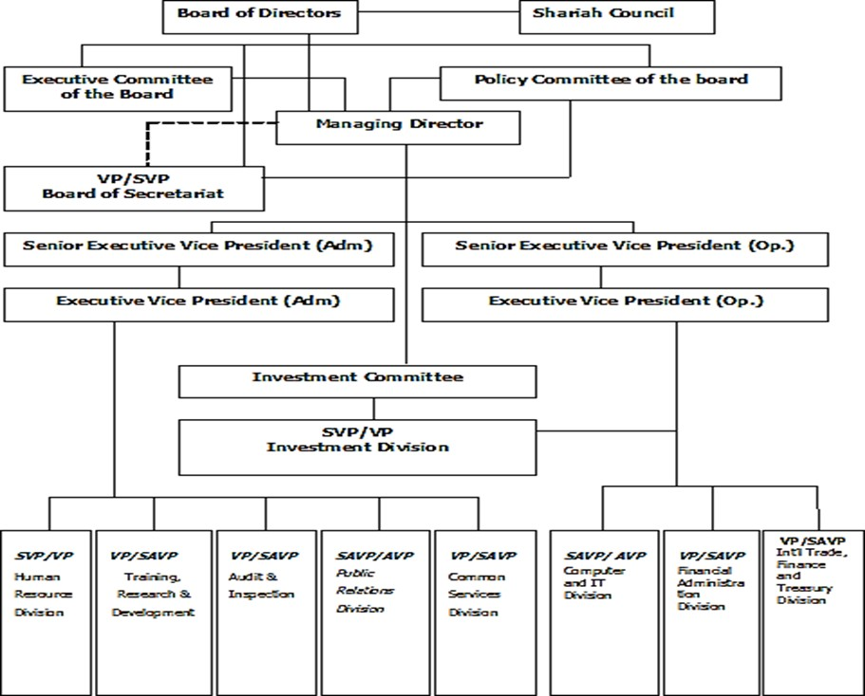

Shahjalal Islami Bank Ltd. Divisions
All departments within Shahjalal Islami Bank Ltd. are subdivided into smaller units. The following are the divisions' primary divisions:

- Division of Human Resource: When it comes to the organization's most valuable assets, workers are at the top of the list. Recruiting new workers and providing employee perks and services are the primary concerns of this section.. Motivating employees to perform efficiently and successfully is a cornerstone of this division's strategy.

- Division of Training, Research & Development: This division focuses on training the employees of this organization. Also focuses on research and development of the organization.

- Division of Audit and Inspection: It's the section in charge of auditing and inspecting everything from a company's finances to its operations. During that year, they give each department a certain amount of money they may spend. They're also in charge of funding and access, as well as operational tasks.

- Division of Public Relation: This division is primarily responsible for
- Expanding your company's marketing network throughout the nation
- Incorporating trade marketing techniques and practices
- The process for gathering data on competition

- Division of Common Service: Except for the credit and financial sector, this section may manage all the general operations. This section is in charge of conceptualizing and executing all administrative tasks.

- Division of IT: Information technology-related tasks may be handled by this section. There is an IT division for each branch, and the IT division at the corporate headquarters receives a report on all branch-level operations

- Division of Financial Administration: This division offers credit proposals, disburses them and monitors them. This division is in charge of recovering the debts supplied to it. Branches have their own credit division, while the head office credit services division supports all branch-level operations.

- Division International Trade, Finance and Treasury: This department's operations extend beyond national borders. This division is in charge of overseeing and controlling all foreign branch-level work.

Products and Services of SJIBL

Deposit Accounts
- Al-Wadiah Current Deposit: The depositors' fund is referred to by Al Wadiah. An Al Wadiah deposit is the generic phrase. The current account is a subtype of this account. Companies and organizations may use a current account that's tailored just for them. The transaction cap is higher than the amount of money you may put in your savings account.

- Mudaraba Savings Deposit: The Mudaraba Savings Deposit is the most popular account type, just as with the other financial institutions (MSD). Savings accounts, with a monthly profit-sharing rate of 2%, are purchased or opened for the aim of saving.

- Mudaraba Special Notice Deposit: According to this policy, all transactions involving Mudaraba Special Notice Deposit Accounts will be handled quickly, with care, and any associated transaction risks will be properly addressed. MSND is a financial deposit instrument with a profit potential. Al Wadiah Current Deposit account's transactional attitude

is the same, except the account holder must provide notification before withdrawals are made. Standard processes for performing KYC via appropriate identification and acquiring personal identity papers are followed when establishing MSND in order to monitor and control the risk of receiving funds from potentially fraudulent or money laundering funding sources. Individuals who want to open one of these accounts must first get permission from the manager or deputy manager to do so. Employees are prohibited from opening MSND accounts in their own names without first obtaining permission from SJIBL's corporate headquarters.
Rate of Mudaraba Special Notice Deposit (SND)

Less than Tk. 1.00 crore | 1.50%
Tk. 1.00 crore to less than Tk. 25.00 crore | 1.75%
Tk. 25.00 crores to less than Tk. 50.00 crore | 2.00%
Tk. 50.00 crores to less than Tk. 100.00 crore | 2.00%
Tk. 100.00 crore and above | 2.00%

- Mudaraba Term Deposit Receipt: This is a very conservatively invested account. This product is purchased by those who want to set aside a particular amount of money for a certain length of time. There is a time and amount-dependent variation in the rate of this.

Rate of Mudaraba Term Deposit Receipt (MTDR)
i) 1 Month
Less than Tk. 1.00 Crore | 1.50%
Tk. 1.00 Crore & above | 1.25%
ii) 2 Months
Less than Tk. 1.00 Crore | 1.75%
Tk. 1.00 Crore & above | 1.50%
iii) 3 Months
Less than Tk. 1.00 Crore | 3.75%
Tk. 1.00 Crore & above | 3.50%
iv) 100 Days
Less than Tk. 1.00 Crore | 3.75%
Tk. 1.00 Crore & above | 3.50%
v) 175 Days
Less than Tk. 1.00 Crore | 3.75%
Tk. 1.00 Crore & above | 3.50%
vi) 6 Months
Less than Tk. 1.00 Crore | 3.75%
Tk. 1.00 Crore & above | 3.50%
vii) 1 Year
Less than Tk. 1.00 Crore | 4.00%
Tk. 1.00 Crore & above | 3.75%
viii) 400 Days
Less than Tk. 1.00 Crore | 4.00%
Tk. 1.00 Crore & above | 3.75%
ix) 2 Years : Any Amount | 4.00%
x) 3 Years : Any Amount | 4.00%

- Mudaraba SJIBL School Banking: This is a parent-operated student account. That's a 2.50 percent return on investment. Age restrictions range from five to seventeen years old for students opening this account. Because the account holder is under the age of 18, they are unable to act as an operator on the account. As an alternative, they'd have a guardian (representative) who served as their virtual account operator. There is no signatory authority for account management for the account holder. This account may be opened with a deposit of at least BDT 200. There are no service fees with this account, and you get a free atm card as well. This account has a profit rate of 2.5 percent, which is greater than the savings rate. However, due to the limited amount of money in this account, transactions are restricted.

- Mudaraba Money Spinning: It is a part of the Mudaraba Savings deposit account that clients may open a Mudaraba Money spinning account as an alternative. A win-win situation where both parties benefit. The Mudaraba concept of Islamic Shariah allows for the creation of savings accounts known as Mudaraba money-spinning funds. It's important to note that Mudaraba Money spinning accounts are designed primarily for high-net-worth individuals and families that are looking to save.

People in the high-value section of society, such as government, semi-government, and autonomous sector paid employees, are the company's target clients. These include professionals like physicians, engineers, and chartered accountants as well as self-employed businesspeople and retirees.

- Mudaraba Savings Payroll Account: This is a bank account used to hold an employee's wages. A 2% profit margin is maintained by workers from various industries or organizations.

Schemes of deposits
- Mudaraba Multiple Benefit Scheme: As part of this plan, a down payment of tk. 10,000 is required, as well as an additional multiplier

Rate of Mudaraba Multiple Benefit Scheme
i) Double Benefit | 6.00%  (Amount will be doubled in 11 years 7 months)
ii) Triple Benefit | 6.24%  (Amount will be tripled in 17 years 8 months)

- Mudaraba Monthly Income Scheme: There is a Tk. 1.00 Lac minimum deposit and a Tk. 1.00 Lac multiplier for this scheme.

Rate of Mudaraba Monthly Income Scheme
i) 1 year | 4.20% (Tk.350.00/- per month per lac before tax)
ii) 2 Years | 4.20% (Tk.350.00/- per month per lac before tax)
iii) 3 Years | 4.20% (Tk.350.00/- per month per lac before tax)

- Mudaraba Monthly Deposit Scheme: It's a monthly deposit account. Procurement encourages people to save money for monthly installments. The plan deposit account must be opened first. Also, there is a mechanism where the account user may either deposit in cash or have the deposit automatically deducted from their savings account at a set date each month. However, purchasers of this product may want to connect their accounts to save monthly bank visits. No deposit accounts need withdrawals at maturity. Time and quantity also affect the rate.
Rate of Mudaraba Scheme Deposits
Period | Installment
Period | 500 | 1,000 | 2,000 | 5,000 | 10,000 | 25,000 | 50,000
3 Years (5.79%) | 19,700 | 39,400 | 78,800 | 197,000 | 394,000 | 985,000 | 1,970,000
5 Years (5.91%) | 34,975 | 69,950 | 139,900 | 349,750 | 699,500 | 1,748,750 | 3,497,500
8 Years (6.02%) | 61,775 | 123,550 | 247,100 | 617,750 | 1,235,500 | 3,088,750 | 6,177,500
10 Years (6.11%) | 82,850 | 165,700 | 331,400 | 828,500 | 1,657,000 | 4,142,500 | 8,285,000

- Mudaraba Millionaire Scheme:
Rate of Mudaraba Millionaire Scheme

i) 5 Years (Tk 14,300/ Per Month) | 5.90%
ii) 10 Years (Tk. 6,050/ Per Month) | 6.07%
iii) 12 Years (Tk.4,700/ Per Month) | 6.11%
iv) 15 Years (Tk.3,370/ Per Month) | 6.18%

- Mudaraba Haji Deposit Scheme: People who want to save some money for Hajj may benefit from Hajj Scheme goods, which are marketed for them. Products are well-known in Muslim areas since Hajj is a significant prayer for Muslims. BDT 3,100 to BDT 30000 per month is the starting monthly payment range. It's more expensive to borrow money for a short period of time since the installments are greater. From one year to ten years, the period and amount have a different return on investment (ROI). With the most recent changes, this account's profit margin is now between 5.55% and 6.21%.

Rate of Mudaraba Hajj Scheme Deposit
Year | Account opened in 2020 (From 1st December 2020)
Year | Monthly Installment | Expected Amount payable at Maturity to meet-up Hajj Expenses | Rate
1 | 30,000 | 3,71,000 | 5.55%
2 | 15,200 | 3,87,225 | 5.69%
3 | 10,350 | 4,08,325 | 5.87%
4 | 7,800 | 4,23,250 | 5.91%
5 | 6,350 | 4,45,000 | 5.98%
6 | 5,250 | 4,56,000 | 6.01%
7 | 4,550 | 4,77,150 | 6.07%
8 | 3,850 | 4,77,525 | 6.11%
9 | 3,450 | 4,98,580 | 6.15%
10 | 3,100 | 5,16,500 | 6.21%

Cards
With the advancement of technology in the financial sector, the card has taken on a new dimension. Since they have partnered with VISA International, they have introduced two new solutions to better serve their customers that use VISA ATMs and Point-of-Sale terminals. (Shahjalal Islami Bank 2021)


- VISA Electron (SJIBL VISA Debit Card)
- VISA Prepaid (SJIBL VISA Prepaid Card)

- SJIBL VISA Prepaid (Local)
- SJIBL VISA Prepaid (International)
- SJIBL VISA Prepaid (Dual)
- SJIBL Souvenir Card (Local)

SJIBL VISA Debit Card: Debit cards use the "My card, my money" idea for the benefit of the consumer. Customers of SJIBL with Al-Wadiah Current Deposit (AWCD), Mudaraba Savings Deposit (MSD), or Mudaraba Short Notice Deposit (MSND) accounts may apply for an SJIBL VISA Debit Card. One have complete authorization to withdraw cash from ATMs, go shopping or eating at any time he/she wants. One can also pay utility bills and have 24-hour access to account information through SMS, for example. (Shahjalal Islami Bank 2021)

SJIBL VISA Prepaid Card (Local): Shahjalal Islami Bank Limited VISA Prepaid Local Cards are available to consumers who do not have an account with the bank. Prepaid cardholders may access their accounts from anywhere in Bangladesh using the card's PIN code. VISA Prepaid Local Cards acceptable at any local merchant outlets, ATMs, etc. that are branded with the SJIBL VISA logo. (Shahjalal Islami Bank 2021)

SJIBL VISA Prepaid Card (International): Customers with or without an account with Shahjalal Islami Bank Limited may use SJIBL VISA Prepaid International Cards. Cardholders may use the card to pay for travel quotas, exporters retention quotas, or to record liens on their FC accounts in US dollars. They may be used at any ATM or merchant outlet that accepts VISA, even those that don't have the Visa logo. (Shahjalal Islami Bank 2021)

SJIBL VISA Prepaid Card (Dual): The SJIBL Souvenir Card's design makes it an eye-catching and eye-catching item. SJIBL Souvenir Card works much like a Gift Card in that it may be used by anybody who wants to. The intended client may either get the card immediately or modify it as needed. Every VISA branded merchant outlet, ATM, and so forth accepts the SJIBL Souvenir Cards. (Shahjalal Islami Bank 2021)

Corporate Investment Products

- Murabaha: From the Arabic terms Bai and Ribhun, comes Bai-Murabaha. Bai signifies purchasing and selling, while Ribhun indicates profit. A profit-oriented selling is Bai-Murabaha. For the purposes of this definition, the seller sells certain specified products (permissible under Islamic Shari'ah and local regulations) to the buyer at a cost plus negotiated profit (mark-up), payable in cash or by installments at a future date agreed upon. To finance, the bank buys the products from the supplier and sells them to the customer for a profit. So, a customer asks the bank to buy something for him and the bank obliges. For a certain profit above the cost. (Shahjalal Islami Bank 2021)

- Bai-Muazzal: The Arabic terms „Bai and „Ajal are the roots of the name Bai-Muajjal. Bai signifies purchasing and selling, while Ajal indicates a certain length of time. Bai-Muajjal translates as “Credit Sale or Deferred Sale" in the original Arabic. When a vendor offers specified products (permissible under Shari'ah and the country's law) to a customer at an agreed-upon set price payable in lump sum at a specific future date or over the course of a specific time by installments, this is known as Bai-Muajjal. Buyer orders and specifies the items that vendor sells to them. (Shahjalal Islami Bank 2021)

- Hire Purchase under Shirkatul-Meelk: As a result of extensive use, the HPSM contract has become a unique variant. There are three contracts in all, and this is a combination of them: Shirkat, Ijarah, and Sale are the first three components of a Shirkat. (Shahjalal Islami Bank 2021)

Shirkat: Shirkatul Melk means "sharing in ownership," while Shirkat means "partnership." A Shirkatul Melk contract refers to an agreement in which two or more people each contribute equity, buy a joint asset, and collectively own it, as well as share the profit and suffer the loss in proportion to their individual equity. (Shahjalal Islami Bank 2021)

Ijara: Ijara is an Arabic word that implies consideration, repayment, salary, or rent. This is the true worth of an ASSET in terms of trade or consideration, return, salary, or service rent. Hiree (owner of asset) and Hirer (user of asset) enter into an Ijara contract in which the Hirer receives a particular service or benefit in exchange for a stipulated payment or rent from the Hiree's asset. (Shahjalal Islami Bank 2021)

Sale: An agreement in which the seller transfers ownership of certain items or assets (e.g., real estate) to the buyer in exchange for a price agreed upon by both parties is called a sale. As part of HPSM, the bank sells and transfers ownership to the customer against payment of a price set for that section, either gradually or all at once throughout the rental term or after rental agreement expiration. (Shahjalal Islami Bank 2021)

- Ijara: One party is the Hiree (Lessor) and the other party is known as the Hirer (Lessee) in a contract to acquire a rentable asset/property for the purpose of taking advantage of the asset's services by the Hirer in exchange for payment of rent and the asset's value to the Hiree on a periodic or installment basis in order to obtain ownership of said rented asset. To conclude a hire buy transaction, parties sign contracts that take effect one at a time. As soon as the lease or rental agreement's term expires, a Bai takes effect, which initiates the sale or purchase of the property covered by the first contract. (Shahjalal Islami Bank 2021)

- Bai-Salam: "Salam" implies "pre-order." “Bai-Salam” is an Arabic term that means “peace”. Pre-paid sales or purchases are referred to as "Bai" or "Salam". For items to be delivered later, it means paying beforehand. It is a transaction in which the seller agrees to deliver specified items at a later date in return for an upfront payment. The customer pays in advance for items that will be delivered at a later date. (Shahjalal Islami Bank 2021)

According to the Islamic Shariah and local laws, the seller sells certain commodities/products to the buyer in advance at an agreed price payable upon contract execution, and the commodity/product/s are/are delivered as per specification, size, quality, quantity at a later date in a particular location. Banks advance money for different inputs in exchange for a portion of the crop/finished products sold in the market. It is ideal for agriculture and industry. (Shahjalal Islami Bank 2021)

- Quard-e-Hasana: Assist/loan with the condition of returning the principle without interest. Beneficial loans require borrowers to pay back their principal at maturity. As long as there is no reference (explicit or implied) to this fact, the borrower is free to compensate the lender for the loan. No more than one quard may be provided per customer by a bank. It can't charge a percentage yearly. To offer a quard against a client's deposit, the bank may refuse to pay any profit. However, the remaining deposit should be profited as agreed. (Shahjalal Islami Bank 2021)

Retail Investment Products
- Household Durable Scheme
- Housing Investment Program
- Car Investment Scheme
- Semi Pucca Housing Investment Scheme
- Investment for Self-employment
- Investment Scheme for Executives
- Investment Scheme for Doctors
- Investment Scheme for Marriage
- Investment Scheme for Overseas Employment
- Investment Scheme for Education (Shahjalal Islami Bank 2021)

SME Investment Products
- Cottage & Micro Enterprise Investment Program
- Small Business Investment Program
- Medium Enterprise Investment Program
- Women Entrepreneur Investment Program (Shahjalal Islami Bank 2021)

AGRI Investment Products
- Network & NGO linkage (Shahjalal Islami Bank 2021)

Sustainable Investment Products
- ETP/Waste Treatment Plant
- Solar Panel/Solar Irrigation Pump
- Bio Gas/Bio Fertilizer/Vermicompost
- Green factory/Green office
- Waste paper/plastic recycle plant
- Compressed Block Brick/HHK/Tunnel Kiln
- LED bulb manufacturing/assembly plant
- PET Bottle/Plastic Waste Recycling Plant (Shahjalal Islami Bank 2021)

Other Banking Services
- ATM Services
- Remittance Services
- Locker Services
- Online Banking
- SMS Push-Pull
- SWIFT

- REUTERS
- SJIBL Student File
- Evening Banking Services
- Internet Banking Services
- Utility Bill Payment Services
- Priority Banking Services
- e-GP Services (Shahjalal Islami Bank 2021)

SWOT analysis of SJIBL
Traditionally, systems of analysis like SWOT are done using a set of five factors. An organization's SWOT analysis makes it simple for others to understand. A quack's perspective on a company is exactly what it sounds like. Using this information, we can identify the organization's advantages and disadvantages as well as potential growth areas and dangers. In the competitive market, a SWOT analysis gives the business an edge over the competition. SJIBL SWOT analysis is something I'm attempting to learn more about.


Strengths
- Good corporate governance practices are followed strictly
- High Levels of Compliance in the Workplace

- Knowledge about the RMG industry
- Reputation in the market as a bank that adheres to Islamic law
- liquid position that is both comfortable and convenient
- A sizable proportion of the international commerce business market

Weaknesses
- An increase in the cost-income ratio in the long term
- Very little knowledge about retail investing, which is rapidly increasing
- In the Dhaka region, there is a significant concentration of investment
- A preponderance of the reliance on corporate entities
- Price competition has reduced margins and therefore yields

Opportunities
- Digitalization Has Taken Off in Force
- Islamic banking is becoming more popular, as shown by the rising interest
- An increasing number of people in the middle class
- Large-scale initiatives are being implemented by the government
- Remarkable rebound in the economy after the effects of COVID 19

Threats
- Western economies suffer economic consequences of the COVID outbreak
- Investing Recovery and Asset Quality Challenges in the Post-COVID Period
- Threat from the Internet
- Competitor ferocity in the market
- An insufficient array of Islamic bank financial instruments
- Reduced interest in making investments

PESTEL Analysis of SJIBL
Macro-environmental (external environment) variables have an effect on an organization. A framework or technique for analyzing and monitoring these aspects is called PESTEL analysis. The setting in which every business organization works is known as a context. A business organization's environment has a variety of effects on and affects the company activity. As a result, doing an environmental study is critical at every stage of a company's life cycle. An organization's environment may be divided into two types: the internal environment and the external environment. Politics, economy, social issues, technological advancements, the environment and law all fall under the umbrella term "PESTEL" elements. A long-term study of this kind is critical for stakeholders, especially shareholders, since it informs them of how important external variables may affect the performance or capacity of a company to generate value.
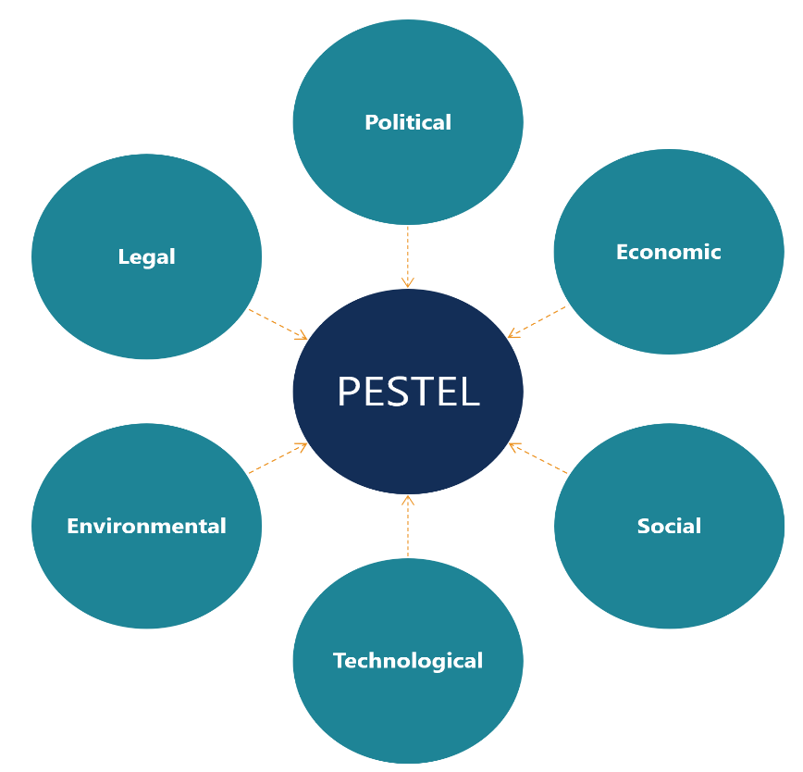

Political Factors

- Tariffs and trade agreements
- Instability in the political system
- Inflation, government investment and borrowing policies, and policy incentives all affect the money supply

Economic Factors
- Economic Trends at the Global Level
- scenario involving export and import of goods
- Inflation
- Growth in the currency exchange rate, as well as in domestic and international assets

Social Factors
- Population Growth
- Differences in the age group
- Changes in lifestyle brought about by shifts in social values
- Application of modern technology
- quality of education
- The Practice of a Religion

Technological Factors
- Technology of the Future
- Internet intrusion, technological disruption are all terms that describe cyber security in some way.

Environmental Factors
- Regulation of the Finance Industry for Long-Term Sustainability
- limiting the amount of carbon released

- Environmentally friendly project
- Changes in the climate

Legal Factors
- Equal Chances
- Extensive regulation
- Atmosphere juridique
- Time resolution
- Practice of alternative dispute resolution

Departments of SJIBL Eskaton Branch
In their Eskaton Branch, SJIBL has distinct departments. Those are general banking, cash, investment, remittance, foreign exchange, cheque clearing. SJIBL conducts its service from a dedicated department based on client demand.

General
Banking
Cheque
Clearing
Cash
SJIBL Eskaton Branch
Foreign
Exchange
Investment
Remittance

- General Banking: The General Banking (GB) division has been working from the inception. This includes tasks like supplying data and checking it against the data repository, establishing and canceling accounts, entering data, debit cards, cheque books and pay order.

- Cash: You may find it mostly under the heading of "General Banks." To deposit and withdraw money, the cash department is responsible.

- Investment: This Islamic shariah-based investment department aims to place money in various industries via the use of various investment strategies. To begin investing, you must first do research about the individual, company, or industry in which you want to place your money. Compilation gathers and validates data; risk assessment is performed; if a match is found, money is invested in order to maximize shareholder returns.

- Remittance: When a person sends money in the local currency to family or friends who live in another nation but aren't related to them by blood or marriage. In the remittance department, everything comes together.

- Foreign Exchange: This foreign exchange (FX) department is responsible for a certain currency. They transfer currency between countries based on the value of the currency; it may be two or more currencies. Occasionally, they invest or purchase money in order to benefit from future sales, a practice known as arbitrage.

- Cheque Clearing: When a customer walks in with a check from another bank and wants to deposit money into another bank account, the whole transaction is handled by the cheque clearing or bank clearing department.

CSR Activities of SJIBL
For banks, corporate social responsibility (CSR) refers to an internal self-regulatory system that makes sure they follow the letter of the law, adhere to ethical standards, and adhere to regional, national, and international norms. In order to meet the '3P' idea of people, planet, and profit, it follows the institution's CSR ambitions and objectives as a whole.

When it comes to corporate social responsibility (CSR), it's all about raising awareness and taking concrete steps to promote social and environmental sustainability. Through its corporate social responsibility initiatives, SJIBL strives to integrate economic, environmental, and social concerns.

Corporate social responsibility (CSR) is an initiative undertaken voluntarily by companies. To the greatest extent possible, it represents the company's commitment to social, environmental, and community goals.

As a result, corporate social responsibility (CSR) is now generally accepted and acknowledged as a helpful instrument for promoting sustainable development. Because of this, companies in rich and developing nations alike are increasingly proactive in incorporating CSR into their daily operations. In the current day and age, there are new conceptual CSR alternatives to consider. People have begun using new terminology such as socially responsible enterprise, social innovation, benefit companies, and social business. SJIBL's CSR values are all its own.

It is of the greatest significance to SJIBL that its CSR initiatives be constantly pursued. On behalf of the current as well as future generations, we have advocated for and taken part in a wide range of activities including education, relief of poverty and healthcare as well as supporting a variety of national and environmentally friendly projects.

SJIBL Foundation
The "Shahjalal Islami Bank Foundation" was created by the Bank to guarantee the welfare of the larger community by using the C.S.R. & Zakah money. (Shahjalal Islami Bank 2021)

Shahjalal Islami Bank Foundation Objectives
- To offer medical treatment to the impoverished and destitute
- To offer financial assistance for the education of deserving but impoverished students
- To help individuals afflicted by flooding, cyclones, or other natural disasters financially
- To contribute to humanitarian initiatives such as blanket distribution
- To contribute financially to the country's cultural and sporting development
- To engage in social and environmental initiatives that advance the cause of a green economy
- To contribute to the implementation of the United Nations' Sustainable Development Goals
- Contribute to the socialization of human rights
- To provide assistance with the conservation, promotion, and preservation of the natural environment and its resources

- To contribute financially to the establishment of the country's religious organizations (Shahjalal Islami Bank 2021)

Shahjalal Islami Bank Limited’s Source of Fund for Donation
- Zakah collected from the general public
- Zakah is donated in accordance with the ending balance of the bank's statutory reserve, share premium, general reserve, and retained profits, among other things.
- Manat
- Fitra
- Kaffarah
- Usor
- Suspicious income
- Delinquent income from terminated investments
- Interest on Bangladesh Bank deposits
- Interest earned on conventional bank accounts and Nostro accounts held in foreign jurisdictions. (Shahjalal Islami Bank 2021)

Shahjalal Islami Bank Ltd's approach to corporate social responsibility (CSR) has been influenced by the following factors:
- Investor Responsibilities
- The obligation to provide excellent customer service
- Taking Responsibility for Vendors
- Responsibilities to the Neighborhood
- Taking Environmental Responsibilities Seriously

Why does SJIBL make this CSR investment?
- Improve the company's overall culture
- Adding value through enhancing the image of your business
- The ability to communicate effectively with all stakeholders will improve
- More media attention will be given.
- Increase the Loyalty of Your Customers

Sectors to Focus on for CSR
As a result of the corona virus outbreak, Bangladesh Bank has revised its corporate social responsibility (CSR) circular and ordered all scheduled banks to provide 60% of their entire CSR annual budget to the healthcare sector by 2020. Banks are also encouraged by the healthcare sector's regulatory authority to purchase PCR equipment, ventilator machine and oxygen tank for the treatment of corona patients. SJIBL engaged in CSR in the following areas in accordance with a circular from the Bangladesh Bank:

Particulars of CSR by SJIBL | Year-2020 (in million)
Education | 39.05
Healthcare | 7.46
Environment & Disaster Management | 67.14
Blanket Distribution | 56.08
Others Including PMs Relief Fund | 153.75
Total | 323.48

Education
Educated people have the advantage since they have a passport to success in the future. As a result, education is seen as one of the most effective tools for changing the course of human history across the globe This is why Shahjalal Islami Bank Limited has been giving scholarships to deserving students for years, as well as contributing to the growth of educational infrastructure by purchasing needed school supplies and other equipment.

It was decided to hold the scholarship giving event in November 2020 on a very small scale, with just 10 students invited, in order to preserve social distance in the middle of COVID 19. However, scholarships were awarded as normal to 500 needy and deserving students through bank transfers. To help deserving and deserving students, SJIBL has made education-related CSR contributions throughout the course of their education. Rather than being a hindrance, this aids students in finishing their academic career. As a result of this, the Bank has also made CSR contributions to educational institutions for the purpose of helping them build up their facilities.
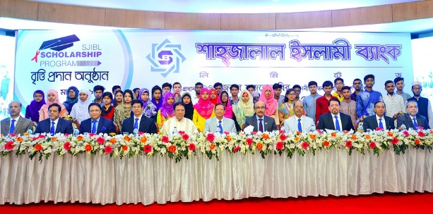
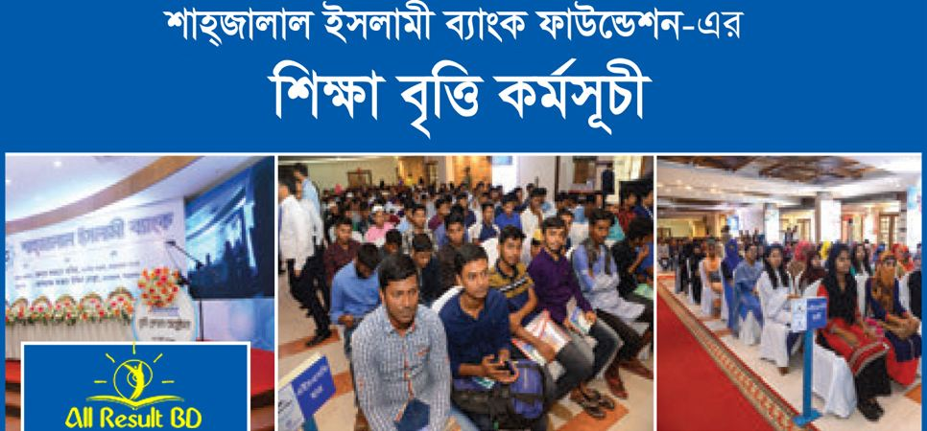

Healthcare
In the same way that other civic rights are essential, healthcare is also. SDG 3: Improve the health of people and the environment (SDG). People's demand for health care is growing exponentially due to the expanding global population. Health treatment for the underprivileged has been made easier through donations from SJIBL to various health care facilities. SJIBL. Healthcare-related CSR is made in two ways by SJIBL.

- For medical treatment, such as a contribution to COVID sufferers
- For medical prevention, such as money for disease prevention, please donate

SJIBL prioritized curative healthcare above preventative healthcare due to the COVID 19 pandemic and the government prioritized healthcare over any other activity in 2020 because the COVID vaccine was sold globally in 2021.

Environment & Disaster Management
Maintaining a healthy relationship with the planet falls on every one of us on an individual and communal level Ecological protection should not be sacrificed for economic gain. So, SJIBL's CSR goes toward environmental conservation or helping to create a more environmentally friendly economy. Another topic covered by environmental CSR is disaster management in storm or flood-prone areas. When it comes to environmental and disaster management, I'm all in.

There are two basic kinds of CSR:
- Blanket distribution
- Tree planting

Tree planting initiatives are typically held from May to July, with blanket distribution taking place throughout the winter. When it comes to Environment & Disaster Management, the bank expects to spend Tk. 67,141 million in CSR by 2020.
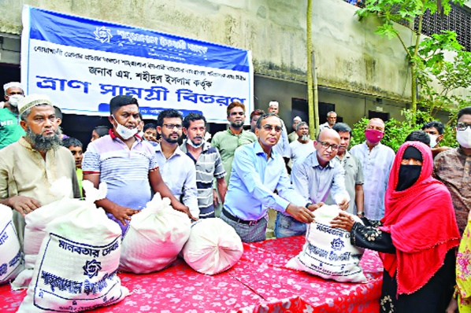

The Other Facets of Corporate Social Responsibility
This bank believes that as a socially responsible corporation, what happens within the firm has an impact on consumers and other stake holders beyond the walls of the business. SJIBL has contributed to the growth of sports, the arts, and culture in Bangladesh by making donations to a variety of cultural and sports organizations and by supporting cultural events. As a result, it has aided in the advancement of women's rights. SJIBL classifies CSR as humanitarian assistance under the following two headings:

- Donation for national cause or catastrophe relief fund
- Donation to PMs relief fund to help with foreign problems
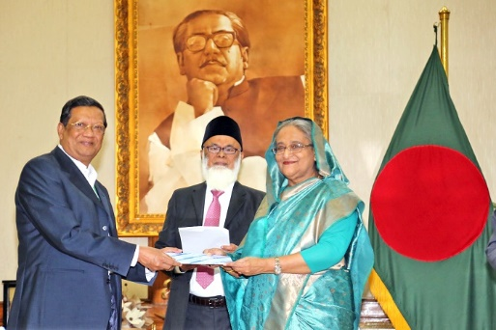

SJIBL's Preference for Corporate Social Responsibility
- Poor yet deserving students get financial assistance for their education
- Social responsibility programs for government hospitals in the medical field
- Environmentally friendly CSR such as tree planting and blanket distribution in response to climate change
- In lieu of local prejudice, CSR is being implemented in many sectors
- CSR in the form of the PMs Relief Fund
- CSR for those who are less fortunate

Beneficiary of CSR
Both organizations/institutions and individuals get CSR from SJIBL. When making a gift to an organization or institution, it's difficult to know exactly how many people it will benefit. SJIBL CSR thinks about two things at once, like many other companies.

- The number of people who will benefit from CSR.
- Amount of CSR/donation made

Those who have benefitted from SJIBL's CSR include the following people and organizations:

Sector of CSR | Number of Individual Beneficiary | Number of Institution/Organization as Beneficiary
Education | 1,443 | 12
Healthcare | 27 | 4
Environment | 13 | -
Blanket Distribution | 1,63,488 | -
Others | 229,333 | 16
Total | 230,816 | 32

Expenditure of the Bank in the Area of CSR
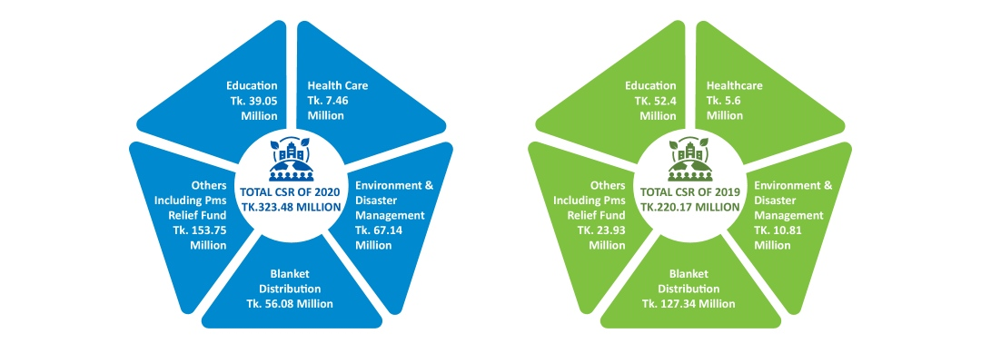

Chapter 3
Work experience as an SJIBL intern



Chapter 3: Internship Experience in SJIBL

Position, Duties, and Responsibilities
I have done different tasks in Shahjalal Islami Bank Limited (SJIBL) Eskaton Branch. I have spent most of the time working in general banking department and investment department. In the general banking department I have worked from opening account to closing account, most of the tasks were done by me expect some specific tasks. SJIBL uses “Ultimus” software for all of their activities.

Position
I was an intern in the branch. As an intern I worked most of the time in general banking department and investment department as they selected me for the particular departments.

Duties
As most of the time as an intern my department was general banking department and investment department. I have done almost every task in general banking department and investment department except the transaction update of the money in the “Ultimus” software. In general banking department I have done tasks like giving to information to customer, accounting opening, helped customers to open an account like savings deposit, fixed deposit and current deposit. I also had collect the documents from the customer and had to verify those. I used to verify the NID information from EC server. I also did data entry, cheque book listing, debit card and pin listing according to the date. I also used to call the customers for receiving cheque book and debit card from the branch. I also verified the signature. I scanned signature card. I have also scanned different documents for investment departments. Sometimes there were documents like company memorandum, articles of association, TIN papers etc. I have also filled out credit card forms for the investment department.

Duties and Learning Weekly Basis

1st Week
- I was introduced to all the employees of Shahjalal Islami Bank LTD (Eskaton Branch). They warmly welcomed me. They showed me different departments and also show that what type work is being done there. The operational manager assigned me in the general banking department first.
- On the second day I supervisor GB in charge gave me a brief about the work which I have to do. On that day I made a serial of the pay orders, filled KYC (Know your customer) form and TP (Transaction Profile) form. The next day I had verified the NID of the clients from election commission server. On the fourth and fifth day, I have filled savings account deposit forms.

2nd Week
- In the 2nd day of second week I have created almost 5 mudarabah savings account and 10 savings accounts
- I had registered debit card and pin on the manual book
- I had also organized pay orders
- I organized different files and documents
- Filled current account deposit forms

3rd Week
- Learned about School Banking Account
- Continue verifying NID from the EC server
- Leaned about different codes of different accounts
- Learned about transaction profile ratings

4th Week
- Filled Mudaraba Term deposit form and learned about it in deatils
- Gave direction to the clients about where they have to fill the information
- Sent “Thanks Letter” to client’s address for verifying their address
- Got detailed idea about the “Bank Ultimus” software

5th Week
- Learned about EFT(Electronic Fund Transfer)
- Got idea about credit card forms
- Scanned signature cards of the client and upload that on the “Ultimus Software”
- Continue filling savings deposit form

6th Week
- Learned about RTGS (Real time gross settlement)
- Continue Verifying NID (National Identity Card) from the EC(Election Commission) server
- Filled current deposit form
- Made serial of the Pay Order
- Scanned documents for investment department

7th Week
- Learned about authorization letter
- Continue filling current deposit form
- Scanned different documents

8th Week
- Wrote authorization letter for a client
- Filled mudaraba current deposit forms
- Continue making serial of the Pay Order
- Scanned MOA and AOA of different organizations for investment department

9th Week
- Continue making serial of the Pay Order
- Learned about Money Spinning account
- Filled savings deposit form
- Continue Verifying NID (National Identity Card) from the EC(Election Commission) server

10th Week
- Filled credit card form
- Continue Filling Savings deposit form
- Scanned different documents

11th week
- Continue Verifying NID (National Identity Card) from the EC(Election Commission) server
- Filled Money Spinning Account forms
- Continue making serial of the Pay Order

12th Week
- Filled credit card forms
- Made serial of different documents
- Filled Mudaraba term deposit forms
- Continue making serial of the Pay Order
- Scanned investment departments documents

Responsibilities
I was responsible for the general banking and investment department tasks. I had to do data entry. I also had to collect different required documents for opening accounts such as NID, Birth Certificate, TIN paper, BIN paper, photographs of account holder and the nominee. I had to fill out the account opening form according to these documents. I also had to fill out some information through verbal communication such as monthly income, occupation, the relation of the nominee, address and mobile number. I also had to arrange the filled files serially for future finding purpose. I was also responsible for making serial of debit card and pin. And also for making serial of Pay order.

I also had to verify signature while any customer comes to the branch physically for receiving debit cards and cheque. It was one of the most important responsibilities for me. Because it was a very risky task.

I always tried to fulfill the job tasks with all my dedication and hard work. Because I think that through doing these I could complete my job properly.

Training
The internship did not include any formal training, yet the whole time I was there was nothing but training. My bachelor's degree mandated that I study about business culture first-hand, and I'm doing my best to soak it up and use what I've learned. As a result of this, I was able to advance in my profession. My internship training session has taught me a lot of new things. It has taught me how to collaborate with others, how to adhere to directions from superiors, and how to complete tasks on schedule.. When the chance arises, I make an effort to adhere to the company's culture and way of life in my daily activities. Banks and Islamic financial systems have fascinated me since my studies in economics and politics. To top it all off, the employment market in Bangladesh has been opened to me now! As a result, I believe this internship training period will be beneficial to my future professional development.

Contribution to departmental functions in SJIBL
SJIBL's Eskaton Branch has three departments, though. Previously, I had positions in both "General Banking" and "Investment," each of which was very different. Compared to one other, these assignments are very dissimilar. However, I was given the chance to work with the investment department on occasion.

Contribution to the General Banking (GB) Department

Account Opening: The whole time I was an intern, I spent helping my superiors establish new accounts. SJIBL's server holds all of the account holder's personal information due to the digital banking system. However, for secondary purposes, an account opening form was required to be completed. It's not possible for me to create an account on the server since it's run by Bank Ultimas, and that's a big deal. Opening an account for a customer requires assistance from two parties: the customer and my supervisor.

To begin, the customer requests that the account opening section establish a new account on his or her behalf with the company. I was given the responsibility of providing instructions to clients by the manager. As an intern, I've instructed him to fill in necessary fields like signature, phone number, designation, and nomination information, all of which must be completed. Customers are not obliged to complete the full form in order to provide better customer service.. It was my responsibility to make sure I had all the required paperwork and to confirm my National Identification Number on the electoral commission's server (EC). I've been tasked with entering the client's personal data. To complete the account opening process, I submit the completed application to Bank Ultimas and have them input the data into the system. To ensure the signature was properly inserted, I was tasked with doing a quality control check. I have to keep a good communication procedure and etiquette in place when communicating with the customers. The customer additionally appreciated my assistance before establishing the account by explaining a feature, such as the profit index rate of several accounts. My data entry work includes KYC completion and risk assessment based on the transaction profile (TP). Following the completion of the previous steps, a signature is required before the file may be uploaded to the server. My boss would sometimes ask me to scan a dummy before uploading it. the account opening officer was required to seal and sign the document together with the branch manager, as was the approving officer. The paperwork had been signed and was now ready for completion. My task was to arrange the paperwork.

Contribution to closing the accounts: Closing the account necessitates completing an application for account closure, which is available online. They delegated that task to me, and I was tasked with sorting them from the ordered forms. The Manager or Deputy Manager marked the form once they'd located it. That form was reorganized in the closing account section once all these procedures were completed. The more information I could provide for customers who were trying to cancel their accounts, the better.

Contribution to Assisting Clients: Several components and pieces of information are required for a customer to run an account.. To manage an account, most people use a checkbook and a debit card. When a customer establishes a savings and current account, he or she is often given a checkbook. To be able to accept checks, you must recognize the checkbook when it arrives. Input the data depending on dates was my job, and then sort it out manually. I arranged the books and stored them in the vault after entering data into the appropriate registered book. So, when he or she arrived, I handed over the checkbook and verified his or her signature. Finally, my boss activated the checkbook in “Bank Ultimas” software using all of these procedures. Aside from that, the card also has the same issues. Everything is in a new location now that the cards and PIN have been organized. My superiors had to scan and send the card acknowledgement document to the card division. The letter of appreciation that was sent for the address verification has been organized by me as well. In order to arrange such items, I had to input the data from the external book in my computer.

Contribution to the Investment Department: I also worked in the investment section in addition to the basic banking department. I scanned a number of key papers for the investment department, including the business memorandum and articles of association, both of which were critical in making an investment choice. It was under the investment department so I filled out credit card applications for them as well." Important papers for the investment department have been typed by me, as well.

Evaluation of internship performance
Many topics were taught to me during my three-month internship at Shahjalal Islamic Bank Limited (SJIBL). All of the general banking operations are now well-known since I worked in that area. You already know about all I've done throughout the internship period, right? I had Ruma Pervin as a boss who was constantly trying to educate me about banking operations in general.

She was a constant source of advice and direction for me. That made me feel comfortable approaching her with any questions or concerns I had, which was crucial for me as an intern or a newcomer. In my opinion and in the opinion of SJIBL workers, I did an excellent job throughout my internship. As a result of the fact that they failed to bring out any of my errors throughout my internship. My efforts are directed toward doing well since it is what I usually want to do, and because they educated me properly and provided clear directions, I had no difficulty following orders. As long as I performed well, they'd offer me compliments. Given everything, I think my internship performance was excellent, and I am happy with it. I also believe the folks at SJIBL are happy with it.

Acquired knowledge and skills through an internship with SJIBL
Over the course of my internship, I've learned a great deal, and in order to put what I've learned into practice.

Time Management: In this 3 months has taught me how to manage time properly. As an intern I had to attend the office on time. I had to work till evening. And after coming back to home I also had to prepare my internship report. While working in office I had to deal with my many works. In which time I had to which work for that I had to manage time also. For attending office at time I had to sleep early and get up early in the morning so that I could attend my office at time. This things wouldn’t be possible without proper time management. Through this internship period I have learned these things. I also saw my colleagues how they manage time.

Computing Skill: This internship period has also enriched me with computer skill. Because of scanning different documents and data entry my typing speed has increased. I got to know about how banking software works and how to operate that. Sometimes I also had to work with Microsoft word and Microsoft excel which helped me to develop my Microsoft office skill.

Communication Skill: It is one of the most important skill in regular day to day corporate life. As I had to communicate with different clients regarding their query and also had to give them solution of their problems through this I have communicate a lot. I also had to communicate with my supervisors and other colleagues in order to complete a task properly. Through this way it was really beneficial for me to increase my communication skill.

Team Work: From my university life I have seen that we have to work in a group. But in this internship period I have seen that in reality. Because in “Shahjalal Islami Bank” every work is linked with one another. So for providing proper service to the client we had to work in a team. In this way I have also learned team work in real life.

Islamic Banking: In my academic life I got to know very little about “Islamic Banking”. But after working here I get to know about different Islamic banking investment policy, deposit schemes, other Islamic banking activities in details which will help me in future for my career.

Coping with Difficult Situation: My work experience was not so smooth. Sometimes it was really difficult. There were sometimes a lot of work pressure which came all on a sudden. Sometimes I had to deal with lots of client in one day. I had to do multitasking by doing general banking department’s work and investment department’s work at the same time. I have learn these things by seeing my seniors and colleagues. I have seen them how they deal with such critical situation. And that helped me how to have patience and cope with that type of situation.

Concentration Power: As banking activities are really sophisticated so one have do it very carefully. While filling out different important forms, scanning different documents I have to really careful so that I didn’t make any mistake. I had to put my concentration fully on the work in order to complete any task. In this way this internship period has increased my concentration power.

Academic Knowledge in Practice
All of the concepts I acquired in school were fresh in my memory while I prepared for my internship, and they were all helpful. What I've learned so far will be useful in this situation, I thought. However, in reality, things are a little different since in my job, I didn't use any particular concepts; instead, I relied on the business common sense that I developed throughout my time at university to help me deal. Many hypothetical and real-world issues, as well as many written reports and projects later on, I've developed problem-solving abilities that have been invaluable throughout my internship. In college, I was part of a group or team, and that experience has prepared me for my internship, where I will be working with a team. During my internship, I put the organizational skills I acquired in my BBA degree at the university to use.

Chapter 4
Suggestion & Recommendation

Chapter 4: Recommendation

Recommendation
In my time as an intern at Shahjalal Islamic Bank Limited Eskaton Branch, I worked in the general banking and investment departments. General banking is the busiest of the departments, although all of them are under a lot of stress. In order to establish an account, provide checkbooks, deliver debit cards, deliver bank statements and verify solvency and close accounts, General Banking department’s staffs have to deal with a large number of customers and clients each and every day. All of these GB activities are standard fare. Despite the fact that they are doing well, I can offer some advice as an intern. In addition, I offer suggestions for them on how companies may enhance their CSR efforts.

- Because the front desk is part of the general banking division, it becomes very busy here. The people working at the front desk could do a better job of delivering excellent customer service. Clients have complained about being bothered by their own tardiness. A possible answer to this issue is to provide more training to the workers. The addition of more workers may also be an excellent choice in this case.

- The workers have a one-year goal of establishing new accounts. In order to effortlessly achieve their goal, workers need put more effort into marketing than they now do.

- The number of printers, scanners, and photocopiers should be raised. Customers may be forced to wait an excessive amount of time if equipment is disrupted. It causes a lag in the delivery of services, which may damage the bank's reputation for excellent customer service.

- SJIBL is often questioned by clients regarding the quantity of ATM booths available, which has a detrimental effect on their expectations of the service they will get. Given their rivals in the industry, they have a relatively low number of ATMs booths in Bangladesh with only 109 in total. Banks that already provide excellent ATM service can step up their efforts to improve customer satisfaction in the competitor's market by increasing ATM booths.

- Since Shahjalal Islami Bank is very concerned about their CSR activities. But they should put more emphasize on CSR activities to create a distinctive brand image of the bank in the minds of the customers.

Chapter 5:
Conclusion

Chapter 5: Conclusion

Conclusion
In order to keep its clients happy, Shahjalal Islami Bank Limited strives to provide top-notch service. Every time they do anything, they think about their consumers. To them, consumer choice is more important. According to Islamic law, they strive to provide consumers with the highest quality goods at the lowest possible price. So that through providing Islamic financial solutions, SJIBL has a goal of establishing long-term financial stability. As a result of the high entrance hurdles caused by capital needs, regulatory compliance and security concerns the Islamic Banking industry is expanding. This pattern will be difficult to maintain if the bank is unable to offer better services. They need to put in more effort than their competitors. They should be more prepared than their competitors. More campaigns and marketing for products are needed to ensure an ever-growing customer base. It's clear that the business is excelling in its CSR efforts. So, they've built something entirely new. Customers will associate the bank with its unique brand if it prioritizes CSR efforts more than other activities. They are doing a fantastic job but, in comparison to their rivals, it isn't good enough.

Finally, my experience as an Intern at Shahjalal Islami Bank LTD has broadened my understanding of financial services, company administration, and the account-opening procedure. As a new entrant to corporate life, these last three months have been some of the most exciting of my life so far. As a result of my internship experience, I am now a better marketer. As a result, I'll be able to progress in my professional life.

Appended Part

Reference

Website Links:

- Shahjalal Islami Bank. (n.d.). About SJIBL � Vision & Mission. Retrieved from https://www.sjiblbd.com/about.php.

- Shahjalal Islami Bank. (n.d.). About SJIBL � Foundation. Retrieved from https://www.sjiblbd.com/Foundation.php.

- Shahjalal Islami Bank. (n.d.). Products & Services � SJIBL Cards. Retrieved from https://www.sjiblbd.com/Card.php.

- Shahjalal Islami Bank. (n.d.). Products & Services � Investment Schemes. Retrived From https://www.sjiblbd.com/investment.php.

- Tarver, E. (2021, October 6). Islamic Banking. Retrived From https://www.investopedia.com/terms/i/islamicbanking.asp

- Islamic Banking and Finance - Wikipedia. (2014, September 15). Islamic banking and finance – Wikipedia. Retrived From https://en.wikipedia.org/wiki/Islamic_banking_and_finance

- Fernando, J. (2021, February 2). Corporate Social Responsibility (CSR). Retrived From https://www.investopedia.com/terms/c/corp-social-responsibility.asp

- Corporate Social Responsibility - Wikipedia. (2020, September 15). Corporate social responsibility - Wikipedia. Retrieved From https://en.wikipedia.org/wiki/Corporate_social_responsibility

Reference of Books
- The Annual Report- 2020 of Shahjalal Islami Bank Lim

Appendix
