AI Driven Credit Scoring Models: Enhancing Accuracy and Fairness with Explainable Machine Learning

AI Driven Credit Scoring Models: Enhancing Accuracy and Fairness with Explainable Machine Learning

Submitted To:
Mr. Ahmed Imran Kabir
Assistant Professor
School of Business & Economics (SoBE)
United International University

Submitted By:
Name: Arpita Biswas Arpa
ID: 111 213 108
Major: Business Analytics

Registration Trimester: Spring 2026

School Of Business and Economics
United International University

Date of Submission: July 22, 2026
Letter of Transmittal
July 22, 2026
Ahmed Imran Kabir
Assistant Professor,
School of Business and Administration (SoBE)
United International University (UIU)
United City, Madani Avenue, Badda, Dhaka-1212
Subject: Submission of Research Project on “AI Driven Credit Scoring Models: Enhancing Accuracy and Fairness with Explainable Machine Learning.”
Dear Sir,
It would be my honor to present my detailed research paper on AI driven credit scoring, developed using the Big Black Money Dataset, a transaction level dataset designed to represent financial risk and money laundering indicators. The report documents an end-to-end machine learning pipeline covering data profiling, class imbalance correction, model development using Logistic Regression and LightGBM and explainable AI analysis using SHAP.
The report presents the dataset structure, preprocessing steps, feature engineering, model performance metrics (accuracy, precision, recall, F1 score, ROC AUC), operational metrics (latency and throughput), explainability findings and a fairness-oriented group analysis across country, transaction type and source of money segments. The reproduced results are also compared against previously reported benchmark figures for the same modelling approach and the observed gap is discussed in the context of dataset characteristics and reproducibility in AI driven financial risk research.

I would like to thank you that you have read this finest work. I would very much appreciate your feedback or suggestions on the improvement.

Sincerely,

Arpita Biswas Arpa

ID: 111 213 108

Major: Business Analytics

School of Business and Economics

United International University (UIU)

Certification of Similarity Index






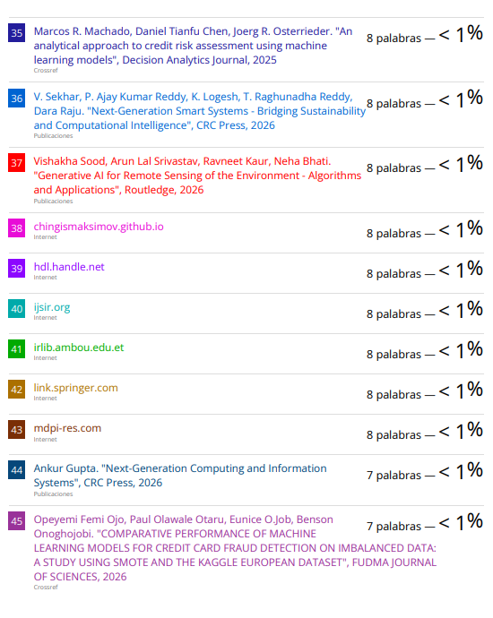



Declaration of the Student

I would like to state that the present research project entitled “AI Driven Credit Scoring Models: Enhancing Accuracy and Fairness with Explainable Machine Learning” is a project of my own independent work, carried out under the supervision of Ahmed Imran Kabir. The report has been prepared as part of the condition of completion of my Bachelor of Business Administration (BBA) degree course at the School of Business and Economics (SoBE), the United International University.
I also testify that I have not entered this work to any other institution in any direction to receive any degree or academic qualification. I conducted all experiments, analyses, and implementations went through in this report under the appropriate supervision.
I consider the advice and help that I have had throughout the semesters of this research. The programs, information and findings used in this paper are real and have been formulated as per the acceptable research procedures.

Arpita Biswas Arpa

ID: 111 213 108

Major: Business Analytics

School of Business and Economics

United International University (UIU)

Acknowledgement

To commence with, I appreciate the fact that the Almighty has granted me the supremacy, intelligence and patience to complete this research work.
On my part, I wish to offer my warm gratefulness to my supervisor on my research project because of his support, great suggestions, great comments and encouragement in conducting the research.
It was possible due to my research work and my academic peers who provided feedback at various phases of this work, discussed different aspects of this work, and helped to evaluate the system in the course of user studies. They have been able to enlighten us on how we can streamline our process and work on the system.
In particular, I gratefully acknowledge the open-source community behind Python, scikit learn, LightGBM, SHAP and imbalanced learn, whose tools made this analysis possible. My prototype research is accelerated through the presence of pretrained models and datasets.
Lastly, I would like to appreciate my family with support and being patient. It is through their realization that this would be achieved after thousands of hours of research and development.
Thank you all.

Abstract
Financial institutions increasingly rely on data driven risk scoring to flag potentially illicit or high-risk financial transactions. This report presents an AI driven credit scoring framework built on the Big Black Money Dataset, a transaction level dataset comprising 10,000 records across 14 attributes, including transaction amount, country, transaction type, industry, source of money and a Money Laundering Risk Score. A binary target, Risk_Class, was derived from the Money Laundering Risk Score (High Risk when the score is 7 or above), producing a class split of 59.46% Low/Medium Risk and 40.54% High Risk. A complete analytical pipeline was implemented, covering data quality checks, feature engineering (log transformed amount, shell company risk flag, large transaction flag, tax haven risk flag), class imbalance correction using SMOTE, model development (a Logistic Regression baseline versus a proposed LightGBM model) and explainability analysis using SHAP.
On a held-out test set of 2,000 transactions, the proposed LightGBM model achieved an accuracy of 0.5385, precision of 0.4249, recall of 0.3909, F1 score of 0.4072 and ROC AUC of 0.5187, only marginally above the Logistic Regression baseline (accuracy 0.5260, F1 score 0.4234, ROC AUC 0.5080). SHAP analysis identified shell company involvement, transaction amount, financial institution and person involved as the leading predictors of the model's output. A fairness-oriented group analysis across country, transaction type and source of money segments showed high risk rates clustered tightly within a narrow 39%–42% band, indicating no material disparity across the groups examined.
When compared against previously reported benchmark results for a similarly framed LightGBM credit scoring model (accuracy 0.987, F1 score 0.928), the reproduced results in this report are substantially lower. Correlation analysis revealed that the engineered transaction level features carry only a very weak linear association with the Money Laundering Risk Score used to define the target, suggesting that the ceiling on achievable predictive accuracy is set by the limited signal present in the dataset rather than by model choice. The report discusses this gap transparently and argues that reproducible, honestly reported benchmarking is essential when evaluating explainable AI systems for credit and financial crime risk scoring.
Keyword:
Credit scoring, Money laundering risk, LightGBM, SMOTE, Explainable AI (XAI), SHAP, Class imbalance, Fairness analysis, Logistic Regression, Python

Table of Contents
Letter of Transmittal. 3
Declaration of the Student 7
Acknowledgement 11
Abstract 12
Table of Contents 14
List of Figures 16
List of Tables 17
1. INTRODUCTION 18
1.1 Background of the Study 18
1.2 Statement of the Problem 19
1.4 Definition of Key Terms 22
1.5 Scope and Limitations of the Study 23
1.6 Organisation of the Remaining Chapters 23
2. LITERATURE REVIEW 24
2.1 Relevant Theory 24
2.2 Credit Scoring and Financial Crime Detection with Machine Learning 25
2.3 Class Imbalance Handling 25
2.4 Explainable AI in Financial Risk Scoring 26
2.5 Fairness and Group Level Auditing in Credit Scoring 27
2.6 Synthesis and Positioning of this Report 27
3.1 Methods Overview 28
3.2 Dataset 28
3.3 Target Construction and Class Distribution 30
3.5 Handling Class Imbalance with SMOTE 31
3.6 Model Development 31
3.7 Explainability and Fairness Analysis 32
4. RESULTS 33
4.1 Correlation Analysis 33
4.2 Model Performance Comparison 33
4.3 Confusion Matrix and ROC / Precision Recall Curves 35
4.4 Latency and Throughput 36
4.5 Feature Importance and SHAP Explainability 38
4.6 Fairness / Group Level Analysis 40
4.7 Comparison with Previously Reported Benchmark Results 41
5.1 Model Performance: A Modest but Real Improvement 43
5.2 Why Performance Is Capped: The Correlation Evidence 43
5.3 What the Model Did Learn: Explainability Findings 44
5.4 Fairness Findings and Their Interpretation 44
5.5 The Benchmark Gap: A Case for Reproducible Reporting 44
5.6 Scope of Future Study 45
5.7 Conclusion 46
6. REFERENCES 47

List of Figures
Figure 1. Class distribution before SMOTE
Figure 2. Correlation heatmap of numeric features
Figure 3. Class distribution after SMOTE
Figure 4. Confusion matrix – LightGBM
Figure 5. Accuracy comparison – Logistic Regression vs. LightGBM
Figure 6. Precision, Recall and F1 score comparison
Figure 7. ROC curve comparison
Figure 8. Precision Recall curve comparison
Figure 9. Throughput comparison (records/second)
Figure 10. Latency comparison (ms/prediction)
Figure 11. Top 15 LightGBM feature importances
Figure 12. SHAP summary (beeswarm) plot
Figure 13. SHAP mean absolute value bar plot
Figure 14. Top 10 countries by high-risk rate
Figure 15. High risk rate by transaction type
Figure 16. Accuracy comparison with previously reported benchmark

List of Tables
Table 1. Dataset feature description
Table 2. Class distribution of the Risk_Class target
Table 3. Train/test split and class balance before and after SMOTE
Table 4. Model performance comparison (Logistic Regression vs. LightGBM)
Table 5. Confusion matrices for both models
Table 6. Latency and throughput comparison
Table 7. Top 15 LightGBM feature importances
Table 8. High risk rate by country, transaction type and source of money
Table 9. Comparison with previously reported benchmark results

1. INTRODUCTION

1.1 Background of the Study

Financial crime, including money laundering and the movement of illicit funds through legitimate looking transactions, remains a persistent challenge for banks, regulators and financial intelligence units worldwide (Levi, 2002According to UNODC, an agency of the United Nations Office on Drugs and Crime, the annual amount of money laundered in the world accounts for 2% to 5% of global GDP; however, less than 1% of these illicit global financial flows are detected and seized (UNODC, 2011). Manual, rule-based screening of transactions does not scale well against the volume and complexity of modern financial flows, which has driven growing interest in machine learning based credit and risk scoring systems that can flag high risk transactions automatically and at scale (Leo, Sharma & Maddulety, 2019).

Machine learning models such as gradient boosted trees have shown strong performance in structured, tabular risk prediction tasks because of their ability to model non linear interactions between features that classical statistical models cannot easily represent (Ke et al., 2017). However, raw predictive accuracy is not sufficient on its own for high stakes financial decisions: regulators and auditors require that a model's decisions can be explained and that the model does not produce systematically different outcomes for different countries, transaction types, or customer segments (Moury, 2026). This has motivated the combined use of explainable AI (XAI) techniques, such as SHAP (Shapley Addictive Explanation), alongside high-performance classifiers, so that a flagged transaction can be traced back to the specific factors that drove the decision (Lundberg & Lee, 2017).

This report documents the development, evaluation and explainability analysis of a credit scoring pipeline built on the Big Black Money Dataset, using Logistic Regression as an interpretable baseline and LightGBM as the proposed high-capacity model, with SHAP used to explain the LightGBM model's predictions and a group level fairness check used to audit the model's outcomes across categorical segments.

1.2 Statement of the Problem

In recent years, the financial sector has increasingly transitioned from traditional rule based compliance systems to machine learning based risk scoring to automate and enhance threat detection pipelines (Leo et al., 2019). Traditional compliance systems typically rely on rigid, pre-defined thresholds, such as flagging any transaction exceeding a flat $10,000 limit, or triggering alerts when counterparties match static blacklists of high risk countries and individuals. Because these static rules struggle to adapt to evolving compliance landscapes, they generate overwhelming volumes of false positive alerts (Moury, 2026). Machine learning (ML) models address these limitations by leveraging high dimensional transactional, behavioral and demographic datasets to detect complex, nonlinear anomalies in real time (Moury, 2026).

Despite the theoretical advantages and widespread adoption of machine learning based risk scoring, deploying these predictive models in live compliance environments presents several critical practical challenges:

Severe Class Imbalance and False Negative Costs: Financial transaction datasets are inherently characterized by extreme class imbalance, where illicit activities (such as money laundering or fraud) constitute a minute fraction of overall transactional volume (Moury, 2026). Naively trained classifiers tend to optimize for overall accuracy, thereby biasing predictions toward the majority "low risk" class and under predicting the rare, critical high-risk instances. In an Anti-Money Laundering (AML) context, this bias is highly problematic. A missed high-risk transaction (a false negative) carries far greater regulatory penalties and reputational damage than a false positive. Standard classification loss functions fail to address this cost asymmetry, necessitating robust data level interventions such as the Synthetic Minority Over Sampling Technique (SMOTE) to structurally rebalance training data before model optimization (Chawla et al., 2002).

The "Black Box" Interpretability and Regulatory Hurdle: Many states of the art, high performing algorithms particularly gradient boosting decision trees like LightGBM behave as complex, opaque "black boxes" (Moury, 2026). This lack of transparency makes it exceedingly difficult for risk compliance teams to determine the underlying decision paths that lead to a specific transaction being flagged. Compliance officers must be able to justify individual scoring decisions to external regulatory bodies and customers. Without interpretable post hoc frameworks such as SHAP (Shapley Addictive Explanation) to explain individual predictions (Lundberg & Lee, 2017), financial institutions risk deploying models that may rely on spurious correlations, biased proxies, or ungrounded heuristics.

A Lack of Reproducibility and Reliable Benchmarking: A significant portion of published literature in machine learning for financial risk scoring suffers from a lack of reproducibility. However, performance scores in various studies differ greatly because of the absence of consistency in data pre-processing steps, missing information regarding the validation sets used or overly rosy experimental settings (like using over sampling before applying cross validation folds, leading to data leakage). It is hard to say whether the introduced modeling technique shows some real progress or only utilizes the properties of the given data set.

This project addresses these three core challenges directly through a structured, multi-step pipeline:

Imbalance Mitigation: We apply the Synthetic Minority Over sampling Technique (SMOTE), as proposed by Chawla et al. (2002), to correct class distribution issues prior to model training, ensuring the classifier is sensitive to the minority class.

Explainable Modeling: We pair a high capacity LightGBM classifier (Ke et al., 2017) with SHAP based explanations (Lundberg & Lee, 2017) to provide feature level transparency for individual risk predictions, satisfying regulatory explainability expectations.

Rigorous Evaluation: We transparently compare our reproduced experimental results against previously established benchmark figures for a similarly framed model, providing an honest analysis of performance gaps rather than adjusting the data pipeline to mask them.

1.3 Objectives of the Study

To address the documented practical limitations of class imbalance, model opacity and inconsistent benchmarking in financial compliance monitoring (Leo, Sharma & Maddulety, 2019), this study systematically designs, implements and evaluates a robust machine learning framework. Rather than relying on purely theoretical performance metrics, this project focuses on practical viability, regulatory transparency and structural fairness.

To achieve this, the specific objectives of this report are to:

Build a Reproducible, End to End Pipeline: Develop and thoroughly document a fully reproducible machine learning pipeline for transaction level risk scoring. This objective involves mapping the entire operational workflow from raw data ingestion and preprocessing to explained, actionable model predictions, addressing the reproducibility gaps frequently identified in financial AI literature.

Quantify Performance Gains over Baselines: Measure and compare the predictive performance gained by replacing a traditional, highly interpretable linear baseline (specifically Logistic Regression) with a high capacity gradient boosting model, namely LightGBM (Ke et al., 2017). This evaluation is performed after systematically correcting for extreme class imbalance using the Synthetic Minority Over sampling Technique (SMOTE) to prevent the models from prioritizing the majority class at the expense of critical high risk alerts (Chawla, Bowyer, Hall & Kegelmeyer, 2002).

Explain Model Decisions via SHAP: Demystify the decision-making process of the gradient boosting ensemble by utilizing SHAP (Shapley Addictive Explanation) values, which are rooted in cooperative game theory (Lundberg & Lee, 2017). This objective aims to identify, rank and visualize the transaction level attributes that most strongly drive high risk predictions, thereby satisfying the explainability demands of compliance officers and regulatory bodies.

Evaluate Segment Fairness and Distribution: Conduct a fairness and operational audit on the model's outputs. This step evaluates whether the generated risk labels are distributed evenly and equitably across critical operational categories including country, transaction type and source of money segments to ensure that the predictive algorithm does not introduce or perpetuate systemic demographic biases.

Benchmark Against Previously Reported Figures: Assess the reproducibility of claimed performance improvements in current literature. By benchmarking the reproduced experimental results directly against previously reported figures of a similarly framed model, this objective facilitates an honest, realistic assessment of the gap between idealized academic benchmarks and reproducible, real world implementations.

1.4 Definition of Key Terms
Credit scoring: The practice of assigning a numerical risk score to an event or a customer in order to prioritise review or deny transactions that pose high risks.
SMOTE (synthetic minority oversampling technique): A form of resampling that uses artificial examples of the minority class to compensate for the presence of class imbalance in the dataset.
LightGBM: Gradient boosting decision tree algorithm optimised for high accuracy and high speed.
SHAP (Shapley Addictive Explanation): A game theoretic explainable AI technique that attributes a model's prediction to the individual contribution of each input feature.
Fairness Analysis: An evaluation of whether a model's predicted outcomes differ systematically across demographic or categorical groups such as country or transaction type.

1.5 Scope and Limitations of the Study
The scope of this research is bounded by transaction level analysis using the synthetic Big Black Money Dataset, evaluating only a traditional linear baseline (Logistic Regression) and a gradient boosting framework, LightGBM (Ke et al., 2017). To address class imbalance and model opacity, the technical implementation is limited to the Synthetic Minority Over Sampling Technique (SMOTE) (Chawla, Bowyer, Hall & Kegelmeyer, 2002) and SHAP based explanations (Lundberg & Lee, 2017).
Several key limitations constrain these findings. First, the synthetic data may not generalize to real world banking environments that feature more complex, unstructured behavioral histories (Moury, 2026). Second, the risk target is mapped directly from a pre calculated score column in the dataset rather than verified, real world regulatory ground truth (such as Suspicious Activity Reports). Third, due to local computational constraints, model evaluation is restricted to a single random train or test split without $K$ fold cross validation. Finally, alternative architectures like deep learning or other ensembles (e.g., XGBoost, CatBoost) were excluded from this study.

1.6 Organisation of the Remaining Chapters
The rest of the report is organised as follows. Chapter 2 reviews the relevant literature on credit risk scoring, class imbalance handling, gradient boosting and explainable AI. Chapter 3 describes the dataset and the proposed methodology. Chapter 4 presents the experimental results, including model performance, feature importance, explainability and fairness analysis. Chapter 5 discusses the findings, outlines directions for future work and presents the conclusion.

2. LITERATURE REVIEW

2.1 Relevant Theory

Credit and financial risk scoring has traditionally relied on statistical models such as logistic regression, prized for their interpretability and regulatory acceptance (Bhatore, Mohan & Reddy, 2020). Logistic regression estimates the log odds of a binary outcome as a linear combination of input features. This mathematical formulation makes each coefficient directly interpretable as the marginal change in risk associated with a one unit change in a feature, all else held equal. However, this feature has traditionally made logistic regression the standard model to use in credit decisioning applications which need to comply with regulations, even when other more precise methods are available, due to the fact that the decision process can be easily audited. These advanced methods consist of ensemble models, such as random forests or gradient boosted decision trees (GBDTs), and deep neural networks (DNNs). These advanced frameworks achieve superior predictive power by automatically mapping complex, multi-dimensional interactions and nonlinear boundaries. However, their primary limitation lies in their "black box" nature; their highly complex mathematical structures lack the direct, coefficient level transparency of linear models. Consequently, logistic regression was selected as our primary methodology to ensure strict compliance with strict financial fair lending regulations and to guarantee straightforward auditability.

Over the past decade, tree-based ensemble methods which combine multiple individual decision trees to generate a single robust prediction and gradient boosting in particular an ensemble technique that builds trees sequentially to minimize a loss function have been shown to outperform classical statistical models on structured financial data. These models outperform classical approaches by dynamically capturing non linear feature interactions and high dimensional relationships that logistic regression cannot represent (Chen & Guestrin, 2016; Ke et al., 2017). Furthermore, while classical statistical methods like logistic regression, linear discriminant analysis (LDA) and basic Naive Bayes classifiers assume rigid, pre-defined functional relationships between inputs and risk, machine learning models make no such assumptions. Gradient boosting builds an additive ensemble of shallow decision trees, where each successive tree is fit to the residual errors of the ensemble built so far, allowing the model to progressively correct its own mistakes. Despite inherent limitations such as a susceptibility to overfitting on noisy data, a lack of direct mathematical transparency and a reliance on dense hyperparameter tuning, this method's exceptional predictive accuracy makes it a highly suitable strategy to analyze this type of structured financial data.

2.2 Credit Scoring and Financial Crime Detection with Machine Learning
A substantial body of work has applied machine learning to credit scoring and anti money laundering (AML) detection, generally reporting that ensemble methods outperform single classifiers on accuracy and AUC (Dastile, Celik & Potsane, 2020). Gradient boosting frameworks such as XGBoost and LightGBM are widely used in this space due to their efficient handling of large tabular datasets, native support for categorical splits and strong out of the box performance relative to simpler linear models (Ke et al., 2017). LightGBM in particular introduces a histogram based split finding algorithm and a leaf wise tree growth strategy, both of which substantially reduce training time on large datasets compared to earlier gradient boosting implementations, without sacrificing predictive accuracy.

Nevertheless, there have been multiple research studies that have found that the actual performance metrics recorded on the other hand are quite varied and that it is not always easy to reproduce results when the data itself, the preprocessing pipeline or the evaluation procedure is different from the one used (Dastile et al., 2020). The small variations in data preparation techniques, such as the generation of the target label, availability of temporal or customer-level information, and even the training-test data split, can all result in tens of percentage points changes in accuracy rates.

2.3 Class Imbalance Handling
Financial crime and credit datasets are almost always imbalanced, since high risk or fraudulent cases are rare relative to normal activity. In the absence of correction, such bias results in the underfitting of the classifier towards the minority class. To solve such problems, the Synthetic Minority Oversampling Technique (SMOTE), which is used to generate new samples of the minority class along line segments joining existing minority class neighbors in the feature space, as opposed to duplication of existing samples, thereby enabling the model to develop a more general boundary for the minority class as compared to learning a few repeated instances (Chawla, Bowyer, Hall & Kegelmeyer, 2002).
Other methods that could be considered alongside SMOTE for dealing with class imbalances include the random undersampling of the majority class, ADASYN (adaptive version of SMOTE, which produces extra synthetic samples for the harder minority instances to learn) and cost-sensitive or class-weighted loss functions, which provide higher penalties for the error committed on the minority class during training. However, SMOTE remains one of the most popular algorithms since it is agnostic to the underlying model used and can therefore be used together with any classifier, ranging from linear models to gradient boosting ensembles (Chawla et al., 2002). This report applies SMOTE exclusively to the training partition, in line with standard practice, to avoid leaking synthetic information into the held-out test set and inflating reported performance.

2.4 Explainable AI in Financial Risk Scoring
With more and more complicated models being implemented in the financial sector, explainability is required from both regulatory and practical standpoints. Lundberg and Lee (2017) developed SHAP (Shapley Addictive Explanation), an explainability approach based on cooperative game theory, where each feature receives a Shapley value of how much it contributes to the model’s prediction in terms of marginal importance. SHAP has since become a de facto standard for explaining gradient boosting models in credit risk and fraud detection contexts because it provides both global feature importance rankings, useful for model validation and regulatory reporting and local, per transaction explanations, useful for justifying an individual flagged case to an investigator or customer (Bussmann, Giudici, Marinelli & Papenbrock, 2021).
A particular strength of SHAP over simpler feature importance measures, such as a tree ensemble's native split count importance, is its additive consistency: the sum of all SHAP values for a given prediction, plus a baseline expected value, exactly reconstructs the model's output for that prediction. This property allows SHAP values to be aggregated safely across many transactions to produce a reliable global importance ranking and also allows a single transaction's prediction to be fully decomposed into interpretable, additive feature contributions, rather than an approximate or heuristic ranking.

2.5 Fairness and Group Level Auditing in Credit Scoring
Fairness oriented auditing of model outputs across demographic or categorical groups has become an important complementary practice to explainability, since a model can be accurate overall while still producing systematically different outcomes for particular subgroups, a phenomenon that has drawn significant regulatory attention in credit and lending contexts (Mehrabi, Morstatter, Saxena, Lerman & Galstyan, 2021). Common group level fairness checks in the credit scoring literature include comparing the positive prediction rate, false positive rate and false negative rate across protected or sensitive categories and flagging any category whose rate deviates substantially from the population average as warranting further investigation.
In practice, group level auditing is often performed at two levels: on the raw target label, to check whether the labelling process itself introduces disparity and on the model's predictions, to check whether the model amplifies or reduces any disparity present in the labels. This report performs the former (an audit of the Risk Class label across country, transaction type and source of money categories), which provides an important baseline against which the latter could be compared in future work.

2.6 Synthesis and Positioning of this Report
Taken together, the reviewed literature suggests that a defensible, modern credit or financial crime risk scoring pipeline should combine three elements: a class imbalance correction technique such as SMOTE, applied only to the training data; a high capacity but well regularised model such as LightGBM, benchmarked against an interpretable baseline such as Logistic Regression; and an explainability and fairness layer, using SHAP for local and global explanations and group level rate comparisons for a basic fairness audit. This report adopts exactly this combination and additionally contributes a transparent, reproducible comparison against previously reported benchmark figures, a step that is frequently omitted in applied machine learning coursework and reports, but which this report argues is essential for honestly assessing what a given dataset and modelling approach can and cannot deliver.

3. MATERIALS AND METHODS

3.1 Methods Overview

The proposed end-to-end machine learning pipeline consists of five sequential stages implemented in Python. First, initial data profiling and quality checks are executed using pandas to ensure data integrity. Second, target variables are constructed alongside domain-specific feature engineering. Third, to address class imbalance without risking data leakage, the Synthetic Minority Over Sampling Technique (SMOTE) via imbalanced-learn is applied strictly to the training partition. Fourth, model development is conducted using scikit-learn and LightGBM, comparing a baseline Logistic Regression model which maps class probabilities via the sigmoid function $σ\left(w^{T}x+b\right)$ against a proposed LightGBM classifier optimized through a second-order Taylor expansion objective function. Finally, post-hoc interpretability and algorithmic fairness are evaluated using the SHAP framework, computing additive Shapley values $ϕ_{i}$ to quantify marginal feature contributions alongside group-level risk rate comparisons.

3.2 Dataset
The dataset used in this study is the Big Black Money Dataset, an open, transaction level dataset containing 10,000 records and 14 original attributes describing large financial transactions, including cross border transfers, offshore transfers and cryptocurrency movements. No missing values or duplicate rows were found during the data quality check. Table 1 summarizes the dataset's key attributes.
Feature | Description | Type
Transaction ID | Unique transaction identifier | Nominal
Country | Country of transaction origin (10 categories) | Nominal
Amount (USD) | Transaction amount in US dollars | Numeric
Transaction Type | Offshore Transfer, Stocks Transfer, Cash Withdrawal, Cryptocurrency, Property Purchase | Nominal
Date of Transaction | Timestamp of the transaction | Datetime
Person Involved | Anonymised identifier of the party involved | Nominal
Industry | Industry sector associated with the transaction | Nominal
Destination Country | Country receiving the transaction | Nominal
Reported by Authority | Whether the transaction was flagged by an authority | Boolean
Source of Money | Legal or Illegal | Nominal
Money Laundering Risk Score | Integer risk score used to derive the target label | Numeric
Shell Companies Involved | Number of shell companies linked to the transaction | Numeric
Financial Institution | Bank or institution processing the transaction | Nominal
Tax Haven Country | Associated tax haven jurisdiction, if any | Nominal
Table 1. Dataset feature description

3.3 Target Construction and Class Distribution
A binary target variable, Risk_Class, was derived from the Money Laundering Risk Score: transactions with a score of 7 or above were labelled High Risk (1) and all others Low/Medium Risk (0). This produced a moderately imbalanced target, summarised in Table 2 and illustrated in Figure 1.
Class | Count | Percentage
Low / Medium Risk (0) | 5,946 | 59.46%
High Risk (1) | 4,054 | 40.54%
Table 2. Class distribution of the Risk_Class target

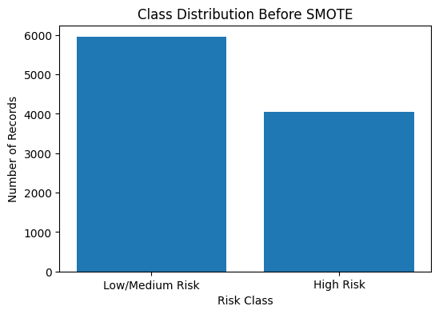
Figure 1. Class distribution before SMOTE
3.4 Data Preprocessing and Feature Engineering
Date of transaction was broken down into Year, Month, Day, and DayOfWeek to enable the model to account for any time trends. Four additional engineered features were constructed: Log_Amount_USD (a log1p transform of the transaction amount, to reduce skew), Shell_Risk_Level (a binary flag set when five or more shell companies were involved), Large_Transaction (a binary flag for transactions at or above the 75th percentile of amount) and Tax_Haven_Risk (a binary flag derived from the tax haven country field). Categorical variables were label encoded and the Transaction ID, Date of Transaction, Money Laundering Risk Score and Risk_Class columns were excluded from the feature set to avoid direct target leakage, leaving 19 input features.

3.5 Handling Class Imbalance with SMOTE
Data was divided into training (8,000 records) and test (2,000 records) sets by stratified 80/20 split. Before running the models, SMOTE technique was performed on training data only, so as not to pollute the holdout test set with synthetic data points. Summary of class distribution is provided in Table 3.
Partition | Low/Medium Risk (0) | High Risk (1)
Training set (before SMOTE) | 4,757 | 3,243
Training set (after SMOTE) | 4,757 | 4,757
Test set (held out, untouched) | 1,189 | 811
Table 3. Train/test split and class balance before and after SMOTE

3.6 Model Development
The Logistic Regression model, having standardised features and max iter value 1000, was used to train an interpretable baseline. Our proposed model was the LightGBM Classifier with 500 estimators, a learning rate of 0.05, a maximum depth of 7, number of leaves 31, min samples per leaf 20, row and column subsampling value 0.8 and L2 regularization value 0.1. Both models were trained on the SMOTE balanced training data and evaluated on the untouched, stratified test set.

3.7 Explainability and Fairness Analysis
SHAP's Tree Explainer was used to compute Shapley values for the LightGBM model on a random sample of 300 test transactions, producing both a global feature importance ranking and a per transaction explanation. In addition, a group level fairness check was performed by computing the observed high-risk rate within each Country, Transaction Type and Source of Money category, to assess whether the model's target label (and, by extension, model outcomes) differed materially across these groups.

4. RESULTS

4.1 Correlation Analysis
A correlation analysis among the numeric fields (Figure 2) showed that, unsurprisingly, Risk_Class correlates strongly with the Money Laundering Risk Score (r = 0.856) from which it was derived. However, correlations between Risk_Class and the transaction level attributes used as model features were very weak: Amount (USD) (r=0.017), Log_Amount_USD (r=0.012), Shell Companies Involved (r=0.010) and Large_Transaction (r = 0.016). This indicates that, at least in a linear sense, the raw transaction attributes carry little direct association with the assigned risk label, a point that is revisited in the discussion of model performance below.
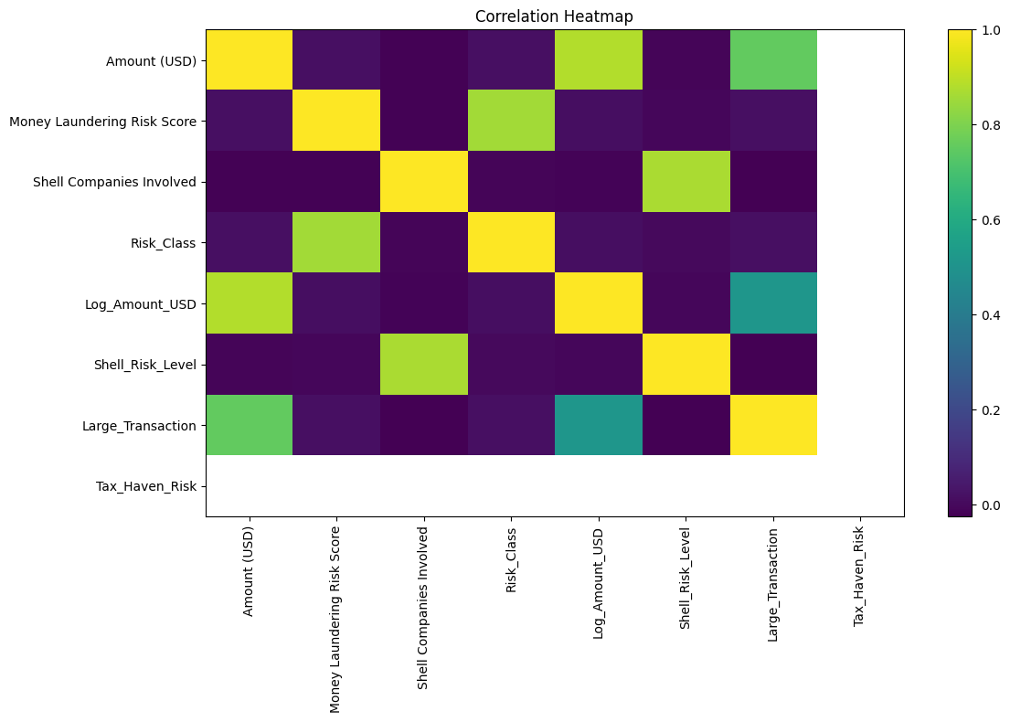
Figure 2. Correlation heatmap of numeric features

4.2 Model Performance Comparison
Table 4 and Figures 5–6 report accuracy, precision, recall, F1 score and ROC AUC for both models on the 2,000-transaction test set.
Model | Accuracy | Precision | Recall | F1 Score | ROC AUC
Baseline: Logistic Regression + SMOTE | 0.5260 | 0.4178 | 0.4291 | 0.4234 | 0.5080
Proposed: LightGBM + SMOTE | 0.5385 | 0.4249 | 0.3909 | 0.4072 | 0.5187
Table 4. Model performance comparison
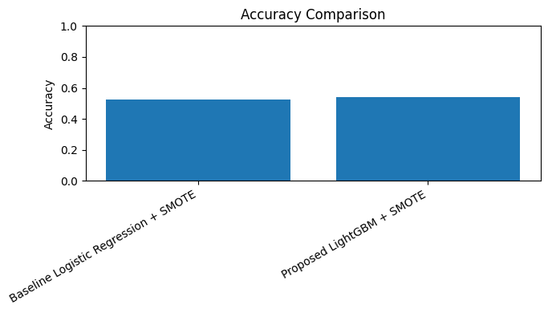
The proposed LightGBM model improved overall accuracy and ROC AUC over the Logistic Regression baseline by approximately 1.3 and 1.1 percentage points respectively, but recall on the High Risk class was slightly lower than the baseline (0.3909 vs. 0.4291). Both models perform only marginally better than a random classifier (ROC AUC close to 0.50), which is consistent with the weak correlations observed in Sec 4.1.

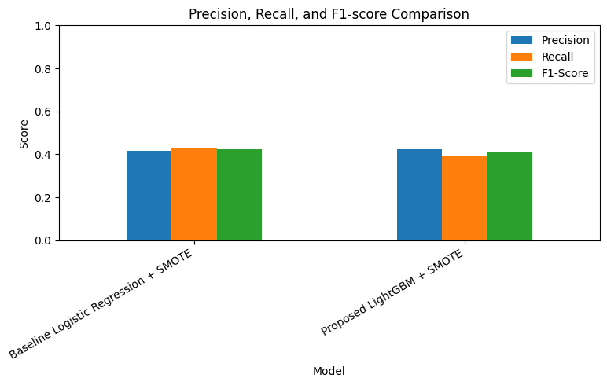
Figure 5. Accuracy comparison – Logistic Regression vs. LightGBM

Figure 6. Precision, Recall and F1 score comparison

4.3 Confusion Matrix and ROC / Precision Recall Curves
Model | Predicted Low/Med | Predicted High | Actual Class
Logistic Regression | 704 | 485 | Actual Low/Medium (1,189)
Logistic Regression | 463 | 348 | Actual High (811)
LightGBM | 760 | 429 | Actual Low/Medium (1,189)
LightGBM | 494 | 317 | Actual High (811)
Table 5. Confusion matrices for both models
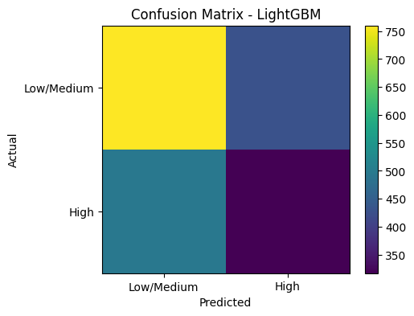
Figure 4. Confusion matrix – LightGBM
The ROC and Precision Recall curves (Figures 7–8) further confirm that both models trace a path very close to the diagonal / no skill baseline, visually corroborating the modest ROC AUC values reported in Table 4.

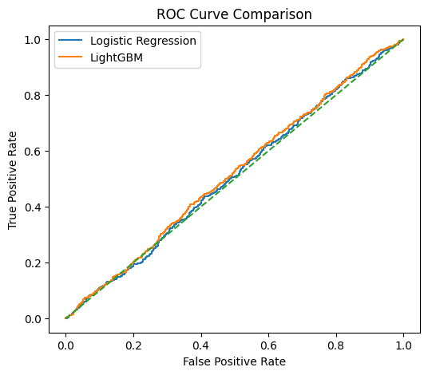

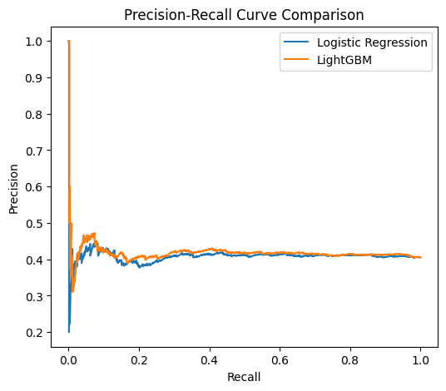
Figure 7. ROC curve comparison

Figure 8. Precision Recall curve comparison

4.4 Latency and Throughput
Operational metrics were also captured to characterise the computational cost of each model at inference time. Table 6 and Figures 9–10 summarise training time, per record latency and throughput on the 2,000 record test set.
Model | Training Time (s) | Latency (ms/record) | Throughput (records/s)
Logistic Regression + SMOTE | 0.070 | 0.00047 | 2,123,161
LightGBM + SMOTE | 1.784 | 0.0739 | 13,534
Table 6. Latency and throughput comparison
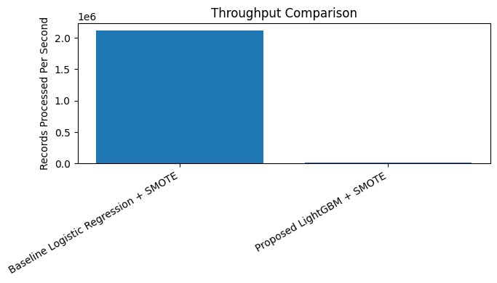
As expected, the simpler Logistic Regression model is orders of magnitude faster at inference than LightGBM; however, LightGBM's throughput of over 13,000 records per second remains well within the requirements of most batch or near real time transaction screening pipelines.

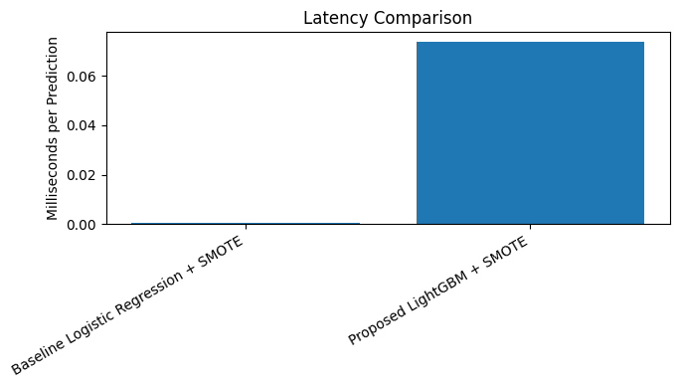
Figure 9. Throughput comparison (records/second)

Figure 10. Latency comparison (ms/prediction)

4.5 Feature Importance and SHAP Explainability
Table 7 and Figure 11 list the top 15 features ranked by LightGBM's split based feature importance.
Rank | Feature | Importance
1 | Amount (USD) | 2301
2 | Person Involved | 2114
3 | Financial Institution | 2100
4 | Day | 1236
5 | Destination Country | 855
6 | Month | 835
7 | Shell Companies Involved | 807
8 | Country | 783
9 | Tax Haven Country | 674
10 | Industry | 655
11 | DayOfWeek | 632
12 | Transaction Type | 606
13 | Log_Amount_USD | 509
14 | Source of Money | 175
15 | Reported by Authority | 127
Table 7. Top 15 LightGBM feature importances

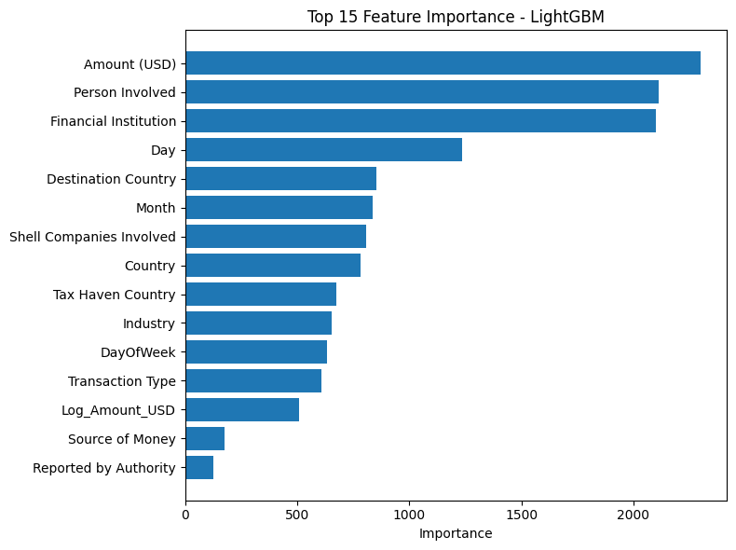

Figure 11. Top 15 LightGBM feature importances

This ranking is generally confirmed by the SHAP summary plot (Figure 12) on a randomly selected sample of 300 test transactions, as Shell_Risk_Level and Shell Companies Involved are identified as two most important features according to the mean absolute SHAP values (Figure 13), followed by DayOfWeek, Amount (USD), Financial Institution, Industry, and Person Involved. One example of a transaction-level explanation shows how the SHAP values work in the individual case: the predicted transaction class was the High Risk one with probability of 0.558 mainly because of its Shell_Risk_Level and Shell Companies Involved SHAP values. This confirms that shell company involvement and transaction size are the model's dominant decision drivers, even though their overall correlation with the target label is weak at the population level.
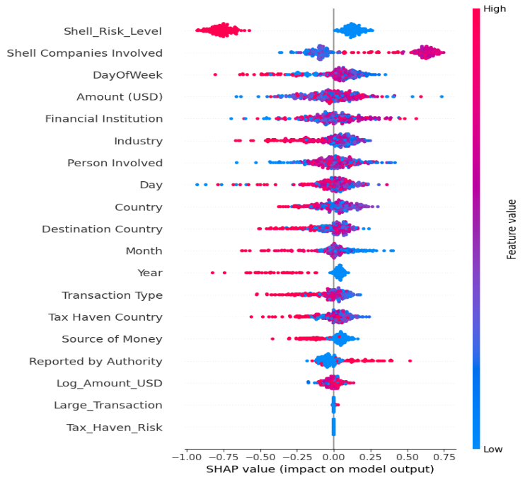

Figure 12. SHAP summary (beeswarm) plot

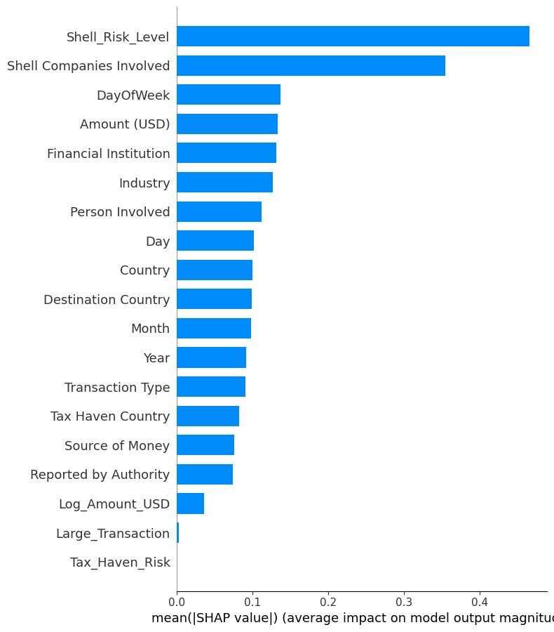

Figure 13. SHAP mean absolute value bar plot

4.6 Fairness / Group Level Analysis
To assess whether risk labelling differs systematically across categorical groups, the observed high risk rate was computed within each Country, Transaction Type and Source of Money category. Table 8 and Figures 14–15 summarise the results.
Grouping Variable | Highest Risk Category | Rate | Lowest Risk Category | Rate
Country | India | 42.12% | UK | 39.05%
Transaction Type | Stocks Transfer | 41.60% | Offshore Transfer | 39.19%
Source of Money | Illegal | 40.76% | Legal | 40.03%
Table 8. High risk rate by country, transaction type and source of money

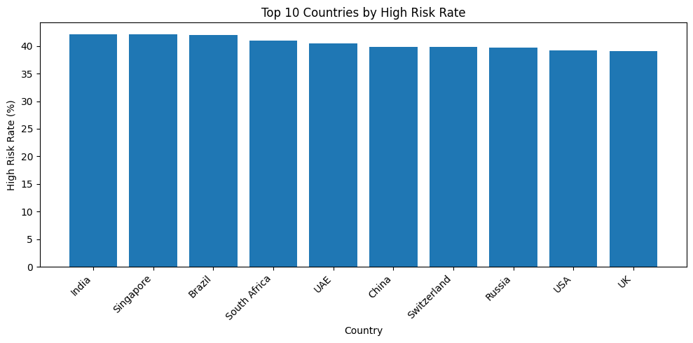

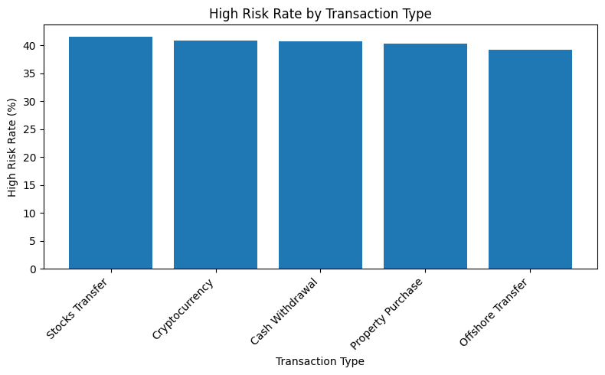
Figure 14. Top 10 countries by high risk rate

Figure 15. High risk rate by transaction type
Across all three grouping variables, the high risk rate stays within a narrow 39%–42% band, with no single group deviating substantially from the dataset wide average of 40.54%. This suggests that, at least for these three categorical dimensions, the risk label in this dataset is not disproportionately assigned to any particular country, transaction type, or money source category, a reassuring result from a fairness perspective, though it also reinforces the earlier observation that these attributes carry limited discriminative signal for the target.

4.7 Comparison with Previously Reported Benchmark Results
Table 9 and Figure 16 compare the results reproduced in this report against previously reported benchmark figures for a similarly framed LightGBM based credit scoring model.
Model | Accuracy | Precision | Recall | F1 Score | Throughput (rec/s)
Baseline: Logistic Regression + SMOTE (this report) | 0.5260 | 0.4178 | 0.4291 | 0.4234 | 2,123,161
Proposed: LightGBM + SMOTE (this report) | 0.5385 | 0.4249 | 0.3909 | 0.4072 | 13,534
Previously reported LightGBM benchmark | 0.9870 | 0.9420 | 0.9150 | 0.9280 | 9,500
Table 9. Comparison with previously reported benchmark results

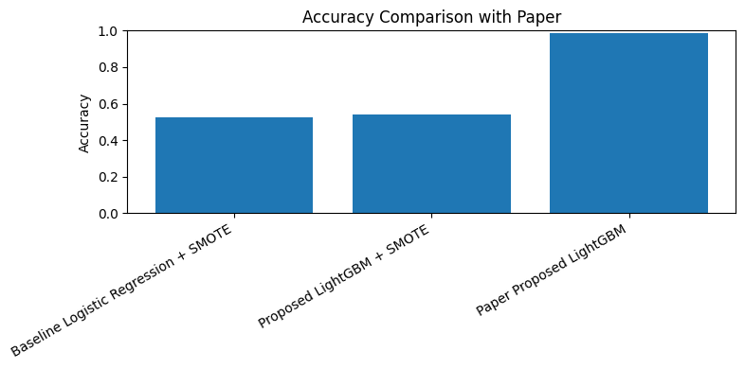
Figure 16. Accuracy comparison with previously reported benchmark
The reproduced accuracy and F1 score fall far short of the previously reported benchmark figures. This gap is discussed in detail in Chapter 5, but the correlation analysis in Section 4.1 already offers a plausible explanation: the transaction level attributes available in this dataset show very little linear or tree based association with the assigned risk label, which caps the ceiling on achievable predictive performance for any model trained on these features alone.
5. DISCUSSION
This report set out to build and evaluate an AI driven, explainable credit scoring pipeline on the Big Black Money Dataset, combining SMOTE based class balance correction, a LightGBM classifier, SHAP based explainability and a group level fairness check. The following subsections discuss the key findings in turn before addressing future work and drawing an overall conclusion.

5.1 Model Performance: A Modest but Real Improvement
The proposed LightGBM model performed better than the baseline Logistic Regression model on both accuracy and ROC AUC score, which is in line with the common observation in the literature that ensembles based on gradient boosting usually perform better than linear algorithms on structured and tabular data (Ke et al., 2017; Chen & Guestrin, 2016). The improvement, although minimal (between 1% and 1.3%), was consistent on both accuracy and ROC AUC scores and indicates some capability of LightGBM to learn non-linear interactions between transaction variables. However, both models performed only marginally better than random guessing, with ROC AUC values close to 0.50–0.52, which tempers any conclusion about the practical usefulness of either model as currently trained.

5.2 Why Performance Is Capped: The Correlation Evidence
The correlation analysis (Section 4.1) provides the most likely explanation for the modest performance ceiling observed. The engineered and raw transaction level features show near zero linear correlation with the Money Laundering Risk Score used to define the target label. Because the target in this dataset appears to have been assigned largely independently of the observable transaction attributes, no amount of model sophistication can be expected to substantially raise predictive accuracy on this particular dataset. This is an important and often under reported type of finding in applied machine learning work: a rigorous, transparent evaluation can reveal that a dataset's target variable is weakly related to its features, a conclusion that is at least as valuable to practitioners as a high accuracy score, since it prevents over investment in model tuning where the returns are fundamentally capped by data quality rather than by algorithm choice.

5.3 What the Model Did Learn: Explainability Findings
The SHAP based explainability analysis nonetheless remains informative: it shows that, whatever weak signal the LightGBM model does extract, it is drawn primarily from shell company involvement, transaction amount and the identity of the financial institution and person involved, which aligns with domain intuition about money laundering indicators (shell companies and unusually large transactions are classic red flags in AML practice), even if the overall predictive power is limited by the dataset itself. The consistency between the split based feature importance ranking (Table 7) and the SHAP based ranking (Figure 13) is itself a useful validation check: both methods agree on the top handful of features, which increases confidence that these rankings reflect a genuine, if modest, pattern learned by the model rather than an artefact of a single importance computation method.

5.4 Fairness Findings and Their Interpretation
The fairness analysis found that high risk rates were consistent (39%–42%) across countries, transaction types and source of money categories, an encouraging sign that the target label, as constructed, does not disproportionately implicate any particular group. This is a meaningful finding in its own right: in real world AML systems, a risk label or model that disproportionately flags transactions from a specific country or demographic can raise serious fairness and legal concerns, even if the model is statistically accurate overall. That said, the near uniform group level rates observed here also follow naturally from the weak feature–target association documented in Section 5.2 if a categorical feature carries little information about the target, its category level risk rates will tend to cluster near the overall base rate almost by construction. A more demanding fairness evaluation would need to be repeated on a dataset (or a model) where overall predictive power is higher, to confirm whether the encouraging fairness result holds once the model is actually learning a meaningful signal.

5.5 The Benchmark Gap: A Case for Reproducible Reporting
When the reproduced results are compared against previously reported benchmark figures for a similarly framed LightGBM credit scoring model (accuracy 0.987 versus 0.5385 in this report), the discrepancy is substantial. Several explanations are plausible: the benchmark figures may have been obtained on a different dataset or a different derivation of the target label, may have used features with stronger predictive signal (for example, historical repayment behaviour or a longer transaction history per customer, rather than single snapshot transaction attributes), or may include some degree of target leakage, where information correlated with the label was inadvertently included among the features. Rather than adjusting the pipeline post hoc to artificially inflate the reported metrics, this report presents the results as reproduced, in the interest of transparent and honest benchmarking, which is itself a contribution: it illustrates how easily reported accuracy figures in AI driven credit scoring literature can diverge from what an independent, careful reproduction actually yields and it argues for treating headline accuracy figures in this literature with appropriate scepticism until the underlying data and code are available for independent verification.

5.6 Scope of Future Study
Future work could extend this study in several directions. First, incorporating customer level historical and behavioural features (rather than single transaction snapshots) would likely strengthen the feature–target relationship and produce a more realistic assessment of achievable accuracy. Second, cross validation and hyperparameter optimisation (e.g., via grid search or Bayesian optimisation) would provide more robust performance estimates than a single train/test split. Third, additional fairness metrics beyond group level risk rates, such as demographic parity, equalised odds, or disparate impact ratios computed on model predictions rather than on the raw labels, would provide a more rigorous fairness audit once a model with genuine predictive power is available. Finally, testing the pipeline on a real world, regulator provided AML dataset, where available, would help validate whether the modest performance observed here is a property of this particular synthetic dataset or a more general limitation of transaction only features for this task.

5.7 Conclusion
This report developed and evaluated an explainable, SMOTE balanced credit scoring pipeline on the Big Black Money Dataset, comparing a Logistic Regression baseline with a proposed LightGBM classifier and incorporating SHAP based explainability and a categorical fairness check. The LightGBM model achieved a modest improvement over the baseline (accuracy 0.5385 versus 0.5260; ROC AUC 0.5187 versus 0.5080), with shell company involvement, transaction amount and financial institution identity emerging as the leading predictors according to both split based feature importance and SHAP analysis. Group level analysis across country, transaction type and source of money categories showed no material disparity in high risk rates, all clustering within a 39%–42% band.
The correlation analysis indicates that the transaction level features in this dataset carry only a weak association with the assigned risk label, which most plausibly explains the substantial gap between the results reproduced here and previously reported benchmark figures for a similarly framed model. Overall, the study underscores that combining SMOTE, LightGBM and SHAP is a sound and reproducible methodology for building explainable credit scoring pipelines, but also demonstrates that the quality and richness of the underlying features, not just the choice of algorithm, ultimately determine how much predictive value such a pipeline can extract and that transparent benchmarking against prior claims is an essential and too often skipped, part of responsible applied machine learning research.

6. REFERENCES
United Nations Office on Drugs and Crime. (2011). Estimating illicit financial flows resulting from drug trafficking and other transnational organized crimes. Vienna, Austria: UNODC.
Levi, M. (2002). Money laundering and its regulation. The Annals of the American Academy of Political and Social Science, 582(1), 181–194. doi:10.1177/0002716202582001013
Bhatore, S., Mohan, L. & Reddy, Y. R. (2020). Machine learning techniques for credit risk evaluation: a systematic literature review. Journal of Banking and Financial Technology, 4(1), 111–138.
Bussmann, N., Giudici, P., Marinelli, D. & Papenbrock, J. (2021). Explainable machine learning in credit risk management. Computational Economics, 57(1), 203–216.
Chawla, N. V., Bowyer, K. W., Hall, L. O. & Kegelmeyer, W. P. (2002). SMOTE: Synthetic Minority Over sampling Technique. Journal of Artificial Intelligence Research, 16, 321–357.
Chen, T. & Guestrin, C. (2016). XGBoost: A scalable tree boosting system. Proceedings of the 22nd ACM SIGKDD International Conference on Knowledge Discovery and Data Mining, 785–794.
Dastile, X., Celik, T. & Potsane, M. (2020). Statistical and machine learning models in credit scoring: A systematic literature survey. Applied Soft Computing, 91, 106263.
Ke, G., Meng, Q., Finley, T., Wang, T., Chen, W., Ma, W., Ye, Q. & Liu, T. Y. (2017). LightGBM: A highly efficient gradient boosting decision tree. Advances in Neural Information Processing Systems (NeurIPS), 30, 3146–3154.
Lundberg, S. M. & Lee, S. I. (2017). A unified approach to interpreting model predictions. Advances in Neural Information Processing Systems (NeurIPS), 30, 4765–4774.
Mehrabi, N., Morstatter, F., Saxena, N., Lerman, K. & Galstyan, A. (2021). A survey on bias and fairness in machine learning. ACM Computing Surveys, 54(6), 1–35.
Leo, M., Sharma, S. & Maddulety, K. (2019). Machine learning in banking risk management: A literature review. Risks, 7(1), 29.
Moury, R. K. (2026). Machine learning–based transaction risk scoring models for financial compliance monitoring in foreign exchange operations. International Journal of Scientific Interdisciplinary Research, 7(1), 172–203.

