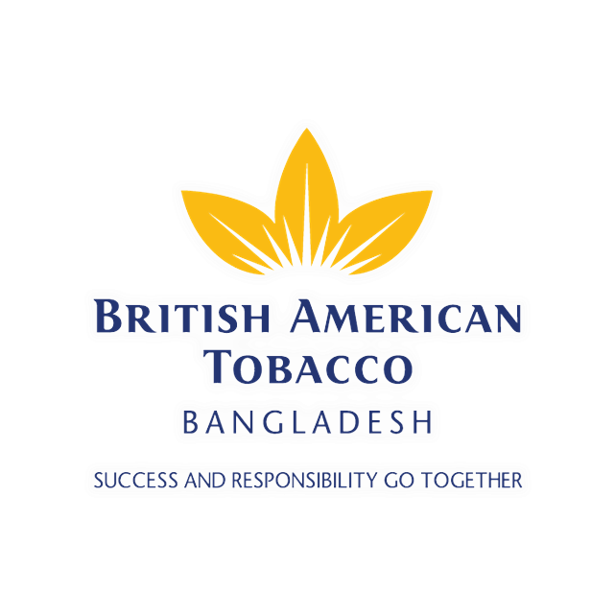
Derby Pack Upgrade: How an Execution of Packaging Upgrade can Rejuvenate a Low Segment Brand

 | United International University
 | QUEST FOR EXCELLENCE

Derby Pack Upgrade:
How an Execution of Packaging Upgrade can Rejuvenate a Low Segment Brand

Submitted by:
Ahmed Yusuf
ID: 111 151 578
Major: Marketing
School of Business & Economics
United International University

Supervised by:
Dr. Kawsar Ahmmed
Associate Professor
School of Business & Economics
United International University

Date of Submission: May 15, 2019

Letter of Submission
May 17, 2019
Dr. Kawsar Ahmmed
Associate Professor
United International University
Dear Sir,
Subject: Internship report on “Derby Pack Upgrade: How an Execution of Packaging Upgrade can Rejuvenate a Low Segment Brand”.
It is a great pleasure to present to you my report on “Derby Pack Upgrade: How an Execution of Packaging Upgrade can Rejuvenate a Low Segment Brand”. which I have diligently worked on during my role with the Trade Marketing team of British American Tobacco Bangladesh from 15th October 2018 till date.
I have gained the most interesting & informative experience while working for this report. My endeavor for learning about the trade marketing efforts of BATB has not only been fruitful, but it also has given me a new insight into the requirement of situation-based marketing and branding perspective. Incorporating vast amounts of information into a concise report was indeed a challenge for me. I earnestly hope that the report will meet the standards that the institute has set for us. I am always available for further query and clarification.
Sincerely,
Ahmed Yusuf
ID: 111 151 578
United International University

ACKNOWLEDGEMENT
I want to express my sincere gratitude to Mr. Md Mahfuzur Rahman Maruf, former Area Manager, Faridpur, who has been my line manager in British American Tobacco Bangladesh for assigning me the responsibilities in this organization and Dr. Kawsar Ahmmed, Associate Professor, United International University, for approving the project and authorizing me to prepare this report. I am also indebted to him because he was kind enough to guide me in solving every problem I faced.
I would also like to mention Mr. Salman Ahmed, Area Manager, Faridpur who took over the role and is my current line manager. He has been extremely helpful during my preparation of the internship report.
I am grateful to my colleagues in the Activation, Trade Marketing and Distribution department of BATB and to my friends and family members for their co-operation that helped me through my tenure of being a Territory Officer in this esteemed organization

EXECUTIVE SUMMARY
British American Tobacco (BAT) is the leading tobacco company in Bangladesh. The low segment is the biggest tobacco price segment in Bangladesh with BAT low brands occupying 65%+ of the segment (30.8 billion annual volume). Of the 3 brands that are operating in the low segment within the BATB portfolio, Derby is the largest and most popular brand.
Price Increase during the year’s fiscal budget takes place every year and is a very common phenomenon. Last year, every brand in the low segment suffered a price increase from BDT 3 to BDT 4 per stick while the VFM segment took a shift from BDT 4 to BDT 6. However, the companies decided to hold the pricing at 5 which resulted in a large number of consumers shifting from low to VFM as an upgrade. Hence Low Segment brands of BAT started suffering a volume drop which made it important to create safety in case a price increase changes the scenario this year. Thus, to inject value into the most popular low segment brand, BATB designed a pack upgrade which was carried out to enhance the equity of the brand.
As a Territory Officer of British American Tobacco Bangladesh posted in Madaripur, I was tasked to properly execute the Derby PUG Campaign in my territory and was expected to augment the campaign as per the requirements of my specific market.
This report discusses the execution of Derby PUG campaign in Madaripur Territory and its impact on the overall industry segment, consumer behaviour, sales trend and brand performance.

Keywords: British American Tobacco, Derby, popular brand, Campaign, Bangladesh.

TABLE OF CONTENTS
Letter of Submission 3
ACKNOWLEDGEMENT 4
EXECUTIVE SUMMARY 5
CHAPTER 1 9
INTRODUCTION 9
1.1 Origin of the Report 10
1.2 Objectives: 10
1.2.a Broad objective 10
1.2.b Specific objectives 10
1.3 Rationale: 11
1.4 Scope: 11
1.5 Limitations 11
1.6 Methodology 12
1.6.1 Data Collection 12
CHAPTER 2 14
ORIENTATION TO THE ORGANIZATION 14
2.1 British American Tobacco Bangladesh Company Ltd. 15
2.2 The Vision and Mission of BATB 16
2.3 Historical Background of BATB 16
2.4 Tobacco Industry of Bangladesh 17
2.5 Company Strategy 17
2.6 Structure of BATB 18
2.7 Brands of BAT 19
2.7.1 International Brand 19
2.8.2 Brands in Bangladesh 21
2.8 Socio-Economic Contributions of BATB 23
CHAPTER 4 25
TOBACCO INDUSTRY COMPETITOR ANALYSIS 25
Introduction 26
Chapter 5 27
An Overview of Khulna Region 27
5.1 General Overview 28
5.2 Geographic Overview 28
5.3 Basic Characteristics of Khulna Region 28
5.4 Market Share of Khulna Region 29
CHAPTER 6 31
OVERVIEW OF M/S LUBNA TRADERS & M/S KAZI SAYED ALI DISTRIBUTION HOUSE OF MADARIPUR-1 31
6.1 Background 32
6.2 Overview of Madaripur Distributary Market 32
6.3 Basic Characteristics of Madaripur-1 Territory 32
6.4 Business Operation of Madaripur Territory 32
6.5 Fact sheet of Madaripur-1 33
CHAPTER 7 34
DERBY PUG CAMPAIGN EXECUTION IN MADARIPUR TERRITORY 34
7.1 Project description 35
7.2 Scope of the project 35
7.3 Target consumers 35
7.5 Criteria of success 36
CHAPTER 8 37
EVALUATION OF DERBY PUG CAMPAIGN’S IMPACT IN THE MARKET 37
8.1 Impact of New Pack on Consumers’ Minds 38
8.2 Impact of campaign activities on Derby’s Brand Equity 39
8.3 Impact of the new pack on the sales of Derby 40
FINDINGS 41
CONCLUSION 42
BIBLIOGRAPHY 43

LIST OF TABLES
Table 1: Geographic Coverage of Khulna Region 25
Table 2: Territories and Distribution Houses of Khulna Region 26
Table 3: Fact sheet of Madaripur Distribution House 30
Table 4: Pre-Launch Activities 33
Table 5: Launch Activities 33

CHAPTER 1

INTRODUCTION

1.1 Origin of the Report
The report titled “Derby Pack Upgrade: How an Execution of Packaging Upgrade can Rejuvenate a Low Segment Brand” has been prepared to fulfil the requirement of my three credits of Internship in the BBA Program. I have joined the Trade Marketing and Distribution team of British American Tobacco Bangladesh on October 15th, 2018 and I have prepared this report based on my assigned responsibilities to assess the performance and success of the campaign in Madaripur-1 territory.
Year on year Price Increase (PI) in low segment created a stretch in price-value equation for low segment brands. In 2018 a 33% PI impacted consumption and hence volume in the segment. Track incidence also reflects a pressure on the value index for all the low segment brands. At the same time emergence of DNP and consumer incentives from competition (slide promotion etc.) creates additional pressure on low brands such as Derby.
It was imperative for BATB to inject value in their low segment brands to remain as consumer’s top preference. As par product space discovery (PSD) study, core product was in line with consumer preference and had been rated superior amongst focus consumer segments. That left pack upgrades as an avenue to inject value and enhance the equity of the low portfolio.

1.2 Objectives:
1.2.a Broad objective: The objective of the report is to identify the impact of Derby Pack Upgrade and how it has rejuvenated a low segment brand.
1.2.b Specific objectives: The specific objectives include:
- Impact of the new pack on consumers’ mind
- Impact of campaign activities on Derby’s Brand Equity
- Impact of the new pack on the sales of Derby

1.3 Rationale:
The research will provide valuable insights into the various new changes brought in by an upgrade in the packaging of the brand Derby. The consequences comprise not only of consumption pattern but also how the packaging influences the smokers’ mindset towards the entire habit of smoking this brand. It will also seek to explore to find any change in the consumers’ mindset about the brand and the product. It will also discussow this upgrade in packaging has helped the brand become a Champion from a winner.

1.4 Scope:
The smoking population in Bangladesh is huge and hence, the population size will be rather large. However, the scope of the report will not only be confined to chain smokers but also extend its reach to the occasional smokers, the tobacco companies’ pricing decisions and even the retailers. No underage smoker has been contacted during this study. No advertisement or probing activities have been conducted as a part of this report.
As a Territory Officer of Madaripur the scope of the research will be confined within the demarcation of the territory which will cover the consumers of the low segment brand and retailers carrying low segment cigarettes.

1.5 Limitations
Due to the qualitative nature of the research and the survey, in most cases change in consumer mindset will be highlighted as the main reason for the change in the number of smokers. The respondents may not cooperate, i.e. they might not provide us with sufficient time. Another limitation may be that respondents may feel uncomfortable to reveal personal details about personal problems such as their addiction towards cigarette or how the probable price change will affect their consumption pattern. Personal limitations on my part include those of time since, I am a full-time jobholder.

1.6 Methodology

1.6.1 Data Collection
I will be relying on interviews and questionnaires mainly for my data collection. I plan to reach out to around 100 smokers mostly male dominated. The intended smokers for the interviews and questionnaires will come from low segment consumers and economic class C and lower. The questionnaires will be self-administered. I will also use journals, articles and reports by qualified individuals as reference.

Primary Sources
The primary sources include the first-hand information we would gather from the subjected sample group. The data collected directly from the smokers by carrying out a survey is the primary set of information we would be using for the research.
Secondary Sources
The secondary sources include a relevant set of samples that would give us information about the subjected sample. The secondary data used for this research paper is mainly constrained to the BATB ERP system called PRISM. Data from nationwide and Regional BATB survey were used for consumer perception assumptions. Data from 3rd party survey was used to validate post launch results with the monthly retail audit.
Several scholarly articles and journals were explored to have a better understanding of the impacts of Packaging change in this industry.
Sample Size
For determining the sample size, an area sampling of clusters was done that have a significant share of the low segment. Derby being the dominant brand in these clusters. While selecting consumers for the survey in those clusters, judgmental sampling was done to pick out the proper respondents who were willing to share and spare time for the survey. A total of 100 responses were taken from these clusters. The respondents were all male and consumers of Derby.

CHAPTER 2

ORIENTATION TO THE ORGANIZATION

2.1 British American Tobacco Bangladesh Company Ltd.
British American Tobacco (BAT) is one of the pioneer cigarette manufacturers in the world. It is a company renowned for its very fine global tobacco and Next Generation Products, with brands sold in over 200 markets. The company was formed at the turn of the 20th century with the objective of establishing a worldwide business. Tracing its heritage back to a joint venture formed by the Imperial Tobacco Company of the United Kingdom and The American Tobacco Company of the United States in 1902, today's British American Tobacco Company was born.
Based in London, UK, today BAT is the world’s second largest quoted tobacco group by global market share. Employing around 50,000 people worldwide, the company consists of over 300 brands in its portfolio.BAT makes the cigarette chosen by one in eight of the world’s one billion adult smokers and have their portfolio rich in innovative tobacco and nicotine-based products. With their powerful brands, geographic diversity, talented people, and a proven strategy, the company is anchored to continue delivering value for shareholders today.
Extent of operation of British American Tobacco Company include:
• Americas (including North and Latin America)
• Asia-Pacific (Japan, South Korea, Malaysia, China & the countries of Australasia and South and East Asia)
• Africa

British American Tobacco was founded in 1902 and was first listed in 1912. Today, it is one of the top five companies listed on the London Stock Exchange by market capitalization. With factories in 42 countries and offices all around the world, BAT has long played a significant role in local communities, as well as across the globe. British American Tobacco is a company with a rich history. One that has seen evolution through organic growth and mergers and acquisitions. It is also a company that has reached several milestones through its 110 year journey. Going typically through the historical lane, in 1902, Imperial Tobacco Company of the United Kingdom and The American Tobacco Company of the United States formed a joint venture – The “British-American Tobacco Company Ltd. Operations extended to West Indies, India, Ceylon (Sri Lanka), East Africa, Java, Malaya (Malaysia) and Nigeria in the next following years. They Entered the US market through purchase of Brown & Williamson. The 1960s/70s/80s marked the period of diversification for British American Tobacco. In 1999 there was a merger between British American Tobacco & Rothmans International. Since then, there has been no turning back, penetrating new markets, developing new products, and ultimately seizing new opportunities internationally.

2.2 The Vision and Mission of BATB
BAT’s vision is to be the best at satisfying consumer moments in tobacco and beyond. By identifying that customers are the core concern, and by believing that addressing the customers’ evolving needs and behaviors is the main driving force behind their success – BAT drives to become the leader of their industry through best consumer moments. Tobacco and beyond – happens to be the second part of the vision, whereby the company recognizes the strength of their traditional tobacco business, and the opportunities that are seen in the Next Generation Products.

2.3 Historical Background of BATB
BATB was established back in 1910 as Imperial Tobacco Company Ltd. with head office in Calcutta. In the very beginning, Imperial Tobacco Company (ITC) launched a branch office at Moulvibazar, Dhaka in 1926. Cigarettes were made in Carreras Ltd, Calcutta. Imperial and Carreras merged into a single company in 1943. After the partition in 1947, cigarettes were coming freely from Calcutta, but introduction of customs barriers in 1948 between India and Pakistan interrupted the smooth flow of cigarettes from Calcutta to East Pakistan.
In March 1, 1949, Pakistan Tobacco Company (PTC) came into existence with head office in Karachi; with the assets and liabilities of ITC Limited held in Pakistan. The then East Pakistan Office was situated in Alico Building, Motijheel. In order to meet the increasing demand, the first factory in the then East Pakistan was established in Chittagong in 1952. From then onwards requirements for cigarettes for East Pakistan markets were met from products manufactured in Karachi. In 1954, PTC established its first cigarette factory although high-grade cigarettes still came from West Pakistan. The Dhaka factory of PTC went into production in 1965. After the war between India and Pakistan in 1965; the import of tender leaf from India for the production of Biri was stopped. After independence, Bangladesh Tobacco Company (Pvt.) Limited was formed on 02 February 1972 under the Companies Act 1913, with the assets and liabilities of PTC. British American Tobacco played a pivotal role in BTC's creation in 1972 and since then has been involved in BTC's development every step of the way. To pronounce the successful relationship with British American Tobacco, BTC changed its name and identity to British American Tobacco (BAT) Bangladesh Company Limited on March 22, 1998. The company changed its identification to establish commitment to the highest international standards.

2.4 Tobacco Industry of Bangladesh
There are two main tobacco associations in Bangladesh. i.e. Bangladesh Cigarette Manufacturers Association (BCMA) and Bangladesh Biri Manufacturers Association (BBMA) representing the industry. The main cigarette manufacturers in Bangladesh are:

- British American Tobacco Bangladesh
- Japan Tobacco International
- Abul Khair Tobacco
- Nasir Tobacco
- Azizudin Industries and
- New Age Tobacco.

The main biri manufacturers are:
- Akij Biri
- Abul Biri
- Nasir Biri
- Karikar Biri
- Aziz Biri and
- Hundreds of local biri manufacturers.

2.5 Company Strategy
In order to deliver their vision, their strategy for creating shareholder value has four guiding principles around which all their efforts revolve – Enterprising Spirit, Open Minded, Freedom Through Responsibility and Strength from Diversity.
Enterprising Spirit: The company has the confidence to passionately pursue growth and new opportunities whilst accepting the considered entrepreneurial risks that come with it. As a group, BATB is bold and strive to overcome challenges. This is the cornerstone to the success of BATB.
Open Minded: The company is forward thinking and anticipate consumer needs, winning with innovative, high quality products. The organization listens to and genuinely considers other perspectives and changing social expectations. BATB is always open to new ways of doing things.
Freedom Through Responsibility: BATB always strives to do the right thing, exercising our responsibility to society and other stakeholders. The company uses the freedom to take decisions and act in the best interest of the consumers.
Strength Through Diversity: In BATB, we respect and celebrate each other’s differences and enjoy working together. We harness diversity of our people, cultures, viewpoints, brands, markets and ideas to strengthen the business. We value what makes each of us unique.

2.6 Structure of BATB
BATB is a public limited company. Management Director is the operational head and appointed by the British American Tobacco. Head of every department carries out their functions with the help of line managers. Different departments have different structure according to their function and responsibility.
The Board of Directors and Executive Committee (ExCo) govern the overall activities of the company. The Board of Directors is composed of 10 members who are called Directors. The Chairman heads the Board of Directors. Chief Executive of British American Tobacco Bangladesh is called the Managing Director, who is normally appointed by BAT Holdings. Managing Director of the company is the chairperson of the Executive Committee. This committee includes the head of all the functional departments.

2.7 Brands of BAT

2.7.1 International Brand

As a major Fast Moving Consumer Goods (FMCG) company, BAT are proud of their solid reputation for producing the best & high quality brands that are chosen by one in six of the world’s adult smokers. British American tobacco produces many local brands to satisfy the needs of various markets. But BAT has well established international brands that are highly accepted by the consumers all over the world. Among the international brands these are four Global Drive Brands- Dunhill, Kent, Lucky Strike, and Pall Mall. These brands account for about 21% of the global volumes from the subsidiary companies.
Some of the international brands of BAT are listed below:
Kent was launched in America in 1952 and is now sold in over 70 countries. It is a free-standing premium brand for consumers who seek a mild and smooth taste. 45 billion Kent cigarettes have been sold in 2006. The brand achieved its fourth consecutive year of double-digit growth, rising 16 per cent on 2005 with strong growth in Russia, Eastern Europe and Chile.

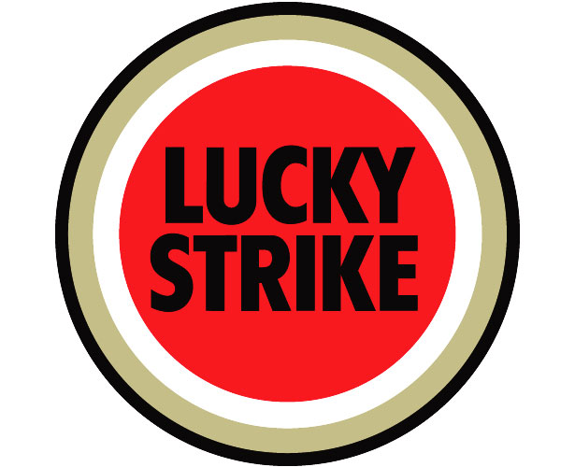
Dunhill was launched in 1907 and is now sold in more than 120 countries. Dunhill's role is to establish a strong global position in the premium / super premium segment. In 2006, total Dunhill volumes were 33 billion cigarettes, up 6 per cent on 2005. Key markets include Australia, Malaysia, South Korea and Taiwan.

Lucky Strike, launched in 1871, it is one of the oldest trademarks in the world and is sold in more than 90 countries. It is among the top leading global brands for the premium segment and 2006 saw the launch of new product and packaging initiatives. Volumes in last year rose 0.4 per cent to 22 billion cigarettes. Key markets include Germany, Spain and France.
Pall Mall was introduced in 1899 and is now sold in more than 60 countries. It is BAT’s leading global value-for-money brand. Pall Mall delivered outstanding growth in 2006, with volumes up 40 per cent on the previous year to 46 billion cigarettes, making it the bestselling brand in the portfolio. Key markets include Germany, Poland, Spain and Russia and Bangladesh. While the Global Drive Brands remain central to BAT’s strategy, BAT is also increasing the profile of Vogue.
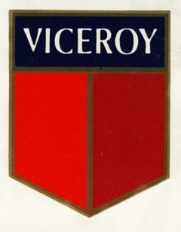

Vogue is a super-premium brand and includes the aromatic Vogue Aroma. Sales are strong across Europe, especially Russia, and the brand is well placed to grow where consumers are increasingly able to trade up to premium brands.

Viceroy is sold in over 30 countries. Introduced in 1936, key markets for Viceroy today include Romania, the Middle East, Turkey, Bangladesh and Argentina.

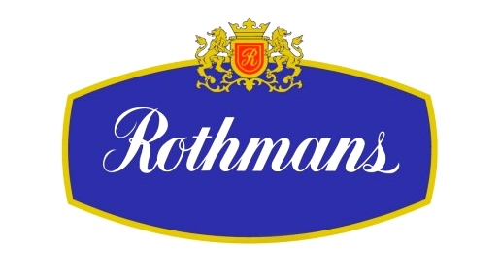
Rothmans was launched in 1890 and is now sold in about 115 countries. Key markets include France, Italy, South Africa and Saudi Arabia.


Kool was introduced in 1933 and is now among the world's biggest selling menthol cigarettes. Available in more than 45 countries, Kool is one of the fastest growing brands in Japan and is also popular in the United States and a number of Latin American countries. Smokeless snus under the Kool brand is currently in a pilot market by the company in Japan.


Benson & Hedges cigarettes were created for the then Prince of Wales in 1873. British American Tobacco acquired the rights to the brand in a large number of overseas markets in 1956. Today, British American Tobacco Group companies sell Benson & Hedges in more than 80 countries, including Australia, New Zealand, Bangladesh, Nigeria, Malaysia and South Africa.

State Express 555 was launched in 1895 and is one of British American Tobacco's best-selling cigarettes. Now sold in more than 55 countries, the brand is particularly popular with smokers in China, Taiwan, Bangladesh and Vietnam.
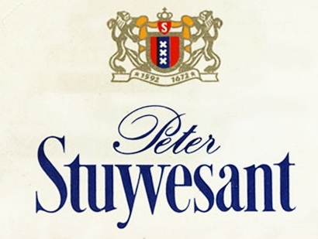
Peter Stuyvesant was first launched in South Africa in 1954 and then internationally in 1957. Now sold in around 55 countries, Peter Stuyvesant is popular in South Africa, France, The Netherlands, Greece, and Malaysia. Smokeless snus is currently being test-marketed under the Peter Stuyvesant brand by the company in South Africa as part of a year-long consumer trial.
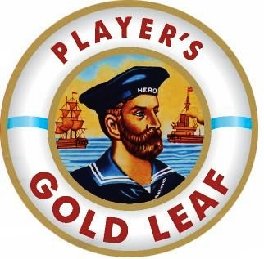
John Player Gold Leaf is today sold in over 20 countries and is particularly popular in Pakistan, Bangladesh, Sri Lanka and Saudi Arabia. The brand dates back to the 1890s. For historical reasons, British American Tobacco does not own the brand in the UK, continental Europe or the United States.

2.8.2 Brands in Bangladesh
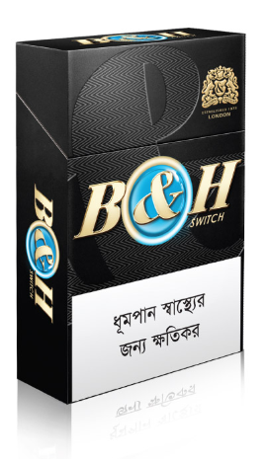
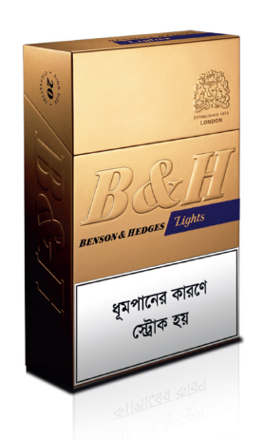
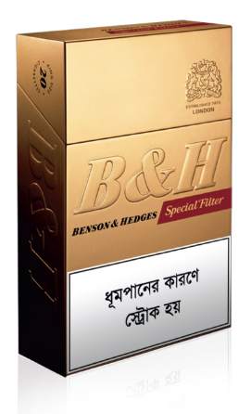
British American Tobacco Bangladesh operates in key segments of the cigarette market of Bangladesh with drive brands like Benson & Hedges, John Player Gold Leaf, Pall Mall, Star and Pilot.
Benson & Hedges cigarettes were initially made for the Prince of Wales back in 1873. British American Tobacco acquired the rights of the brand in a large number of overseas markets in 1956. Today, British American Tobacco Group companies sell Benson & Hedges in more than 80 countries in the world. In Bangladesh Benson and Hedges was launched in 1997 and it is dominating the premium segment of cigarettes in Bangladesh. B&H has a value of TK 9-10/ stick and can be found in three different flavors, Special Filters, Lights & Switch.
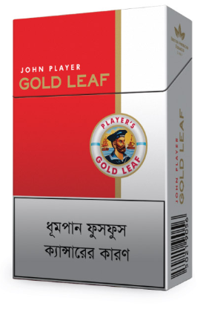
John Player Gold Leaf is one of the oldest brands of BATB in Bangladesh that was launched in 1980 and one of the highest selling brands in the Medium Segment in the market. JPGL is mostly found in the Saudi Arabia, Pakistan and Sri Lanka. JPGL has a value of TK 4.5/ stick.


Star, a local Brand launched 40 years ago still generates leading sales in terms of volume. Star operates in the Low Segment and has a price of TK 3/stick. Star occupies the leadership in the low segment outside Dhaka, where it has tremendous popularity among smokers. BATB launches colourful new packets for star during the Spring Season in Bangladesh to represent the true colours of Bangladesh.
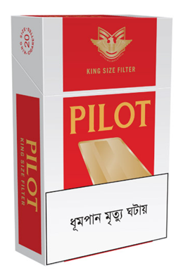
Pilot: In October 2009, British American Tobacco Bangladesh introduced another brand, named Pilot in the Low segment. This brand replaced the other LS brand Viceroy which failed to create enough competitive advantage over the existing brands of other major players. Successful introduction and implementation of the superior brand building activities through various cycles made Pilot a popular VLS Brand.


Derby: The newest brand in BATBs portfolio, Derby was launched with the intention of capturing the massive volume contributory Low segment and complete the up-trading model from the ground up. It has since lived up to its billing and enjoys particularly good performances in Sylhet and Khulna region. Currently, the brand has two distinct varieties: Derby Regular/FF & Derby Style.

2.8 Socio-Economic Contributions of BATB
British American Tobacco Bangladesh engages in various community development programs in the country. The company is one of the highest taxpayers in the country.
- The company contributes through tax more than Tk 12000 million to government annually (largest private sector taxpayer)
- It is proactively involved in afforestation program in rural areas of the country since 1980’s. Every year it distributes over two million plants free of charge to farmers. Since the inception in 1980 the company till date has planted and distributed 38 million trees across the country with a survival rate exceeding 91%.
- It supports Shandhani (posthumous eye donation) and the Centre for the Rehabilitation of the Paralysed as well as other charitable development organisations.
- It is involved in vegetable seed multiplication program.
- In national disasters the company has lent timely support to people of the affected regions.
- Is committed to develop backward linkage industries for the cigarette industry, leading to significant improvements in the packaging industry.
- Committed to rural wealth and hygiene improvements through concerted activities in rural areas.
- Assistance to tobacco farmers in crop cycle planning and optimum utilisation of land.
- Run programmes to promote farmers' literacy, health, hygiene, education, family planning awareness and bank accounts.
- Provide prompt relief and generous support to affected communities in cases of natural disaster.
- Commitment to the principles of sustainable development through high international standards of environmental, health and safety practice.
British American Tobacco Bangladesh has won many awards during the last 30 years. Among the awards won are the 1st Prize of Prime Minister's National Award on Tree Plantation 99, Prime Minister Afforestation Award in 1993, Presidents Award in Agriculture in 1975, FAO Award in 1999 and the National Export Trophy award in 2000. It has also received the prestigious Environmental, Health and Safety Silver Award in 1998 and 1999 in a row for no lost time accident in any part of the company.

CHAPTER 4

TOBACCO INDUSTRY COMPETITOR ANALYSIS

Introduction

The main cigarette manufacturers today are:
- BATB- British American Tobacco Bangladesh
- JTI- Japan Tobacco International
- AKTC- Abul Khair Tobacco Company
The main biri manufacturers are:
- Akij Biri
- Abul Biri
- Nasir Biri
Currently, the two main associations in the tobacco industry are BCMA i.e. Bangladesh Cigarette Manufacturers Association and BBMA i.e. Bangladesh Biri Manufacturers Association.
As of this day, the industry comprises of a biri market of about 75 billion sticks while the manufactured cigarettes through machine make up about 55.5 billion sticks. Biri became the most popular smoked product in 1979. However, the biri market has been declining since 2003 while the machine manufactured cigarette market is on an increasing trend. This resembles the switch that consumers are making towards more socially acceptable product in order to stabilize the social pressure and minimize health risks and to harness the need to smoke better quality products.

Chapter 5

An Overview of Khulna Region

5.1 General Overview
Khulna Region is BATB’s 3rd largest region in Bangladesh if we consider the perspective of volume. The average monthly STT volume was about 833 million per month in 2018 which is 3rd highest after Dhaka and Chittagong.

5.2 Geographic Overview
Districts under Khulna Region’s demarcation are:
Chuadanga | Khulna | Meherpur
Narail | Jessore | Faridpur
Bhola | Shatkhira | Magura
Jhalokathi | Bagerhaat | Madaripur
Potuakhali | Chuadanga | Rajbari
Borguna | Jhenaidah | Gopalganj
Barisal | Shariatpur
Table 1: Geographic Coverage of Khulna Region

5.3 Basic Characteristics of Khulna Region
If we closely observe the business of BATB in Khulna Region over the past few years we would be able to identify 3 broad market characteristics of the regions. As tobacco consumption pattern is heavily dependent on the economic vibrancy, the market nature of the region also changes according to these three broad characteristics. These three broad characteristics are:
- Increasing Urbanization of Khulna City Corporation due to the opening of Mongla port.
- Agro based Economy in wider Kushtia, Jessore & Khulna with certain level of Agro Industrialization (Rice Mills & Fishery).
- Agro based Riverine belt in the Southern part of Bagerhat, poor Infrastructure & road communication.

5.4 Market Share of Khulna Region
Khulna Region is divided in 4 areas and 20 territories in total. The two areas of Khulna Region are Khulna Area, Faridpur Area, Barisal Area & Kushtia Area. These areas are divided in 19 territories. The business operation in Khulna region is spread in the following manner:
Region | Areas | Territories | Distribution House
Khulna Region | Khulna Area | Khulna 1 & 2 | M/S Rafiq Enterprise
Khulna Region | Khulna Area | Jessore 1 & 2 | Azizur Rahman Co.
Khulna Region | Khulna Area | Shatkhira | M/S Sheikh Brothers
Khulna Region | Kushtia Area | Chuadanga & Meherpur | Desh Trade Link
Khulna Region | Kushtia Area | Jhenaidah | Sanaullah Traders
Khulna Region | Kushtia Area | Kushtia | Joardar Traders
Khulna Region | Barisal Area | Barisal 1 & 2 | J. Ahmed and Co.
Khulna Region | Barisal Area | Patuakhali | Hajee & Sons
Khulna Region | Barisal Area | Bhola | A Rahman & Sons.
Khulna Region | Barisal Area | Barguna | Hajee & Sons.
Khulna Region | Faridpur Area | Faridpur | Mir Akhter Hossain Ltd.
Khulna Region | Faridpur Area | Rajbari | M/S Tarik Ahmed Dipu
Khulna Region | Faridpur Area | Madaripur 1 & 2 | Lubna Traders
Khulna Region | Faridpur Area | Magura | M/S Akram Enterprise
Table 2: Territories and Distribution Houses of Khulna Region
Khulna Region has always been a strong market for British American Tobacco Bangladesh. Traditionally all the brands of BATB portfolio performed exceptionally well in this region. Over the years the market share of this region is as follows:
Since 2017, Khulna region has seen an upward trend in the growth of market share. From a market share of 59.9% in 2017, Khulna Region now has a staggering market share of 64.5% in 2019.
Chart 1: Market Share Trend in Khulna Region

CHAPTER 6

OVERVIEW OF M/S LUBNA TRADERS & M/S KAZI SAYED ALI DISTRIBUTION HOUSE OF MADARIPUR-1

6.1 Background
M/S Lubna Traders was established as the Distribution house at Madaripur in 1990. The current Distributor or Valued Business Partner (VBP) of this house is Monirul Islam Bhuiyan, a popular businessman of the district and influential personnel. M/S Kazi Sayed Ali is also a distribution house of Madaripur-1 doing business with BATB since 1985 and the name of the distributor is Kazi Shafayat Hossain.

6.2 Overview of Madaripur Distributary Market
Madaripur-1 is the 3rd largest territory of British American tobacco Bangladesh in terms of volume in Khulna Region. It contributes a volume of approximately 1.9 mln sticks daily.

6.3 Basic Characteristics of Madaripur-1 Territory
If we closely observe the business of BATB in Madaripur-1 Territory over the past few years we would be able to identify 3 broad market characteristics of the territory. As tobacco consumption pattern is heavily dependent on the economic vibrancy, the market nature of the territory is quite unique with all the brands having a very good volume as the following characteristics ensures volume of different brands. These three broad characteristics are:
- Increasing level of Urbanization in Madaripur district.
- Agro based Economy with certain level of Agro Industrialization (Rice & Jute Mills)
- Economic vibrancy created for being the development hub between Dhaka Division and the southern belt of the country through the construction of Padma Bridge.

6.4 Business Operation of Madaripur Territory
Geographically Madaripur-1 Territory is a very wide spread territory and the population is highly dispersed. As such, the retail universe is also very complicated and scattered. So for smooth sales and distribution operation of Madaripur Territory, it has been divided into 6 Distribution Points. As mentioned above, the main house is located in the middle of Madaripur City. There are five more “On Site Distribution Operation (OSDOs)” and one distribution house. These are:
  - Madaripur Main House
  - Gopalganj Main House
  - Vhurgata
  - Tekerhat
  - Kashiani
  - Kotalipara
The whole market was divided into 59 routes. All of these routes were divided in either one or two sections. One route that 1 section is a Daily route & serviced six times a week and a route having two sections is a thrice per week (3/w) route.

6.5 Fact sheet of Madaripur-1
Coverage | Distribution Points | 4
Coverage | No. of DSS | 9183
Coverage | Frequency | 3/w
Field Force | Territory Sales Assistant | 3
Field Force | Business Manager | 2
Field Force | Sales Manager | 2
Field Force | Sales Supervisor | 9
Field Force | Sales Representatives | 59
Field Force | Brand Representatives | 5
Field Force | Brand Representative Supervisor | 1
Field Force | Contract Merchandiser | 15
Field Force | Contract Merchandiser Supervisor | 1
Field Force | Assistant Sales Representative | 24
Field Force | Others | 8
Logistics | Scooter Van | 3
Logistics | Tri Van | 12
Logistics | Pannier Box | 27
Logistics | Cover Van | 1
Logistics | Motorbike | 5
Logistics | N-Xpress | 4
Logistics | Total | 51
Table 3: Fact sheet of Madaripur Distribution House

CHAPTER 7

DERBY PUG CAMPAIGN EXECUTION IN MADARIPUR TERRITORY

7.1 Project description
The Derby Pack Upgrade campaign was set to be launched on the 3rd of February, 2019. The package change highlighted the following three characteristics:
- The Pack’s Modern Design: A better looking and attractive design in the pack
- The Pack’s Embossing: A premium feel to create an upward aspiration
- The Similar Taste: No change in taste.
The campaign used the following tag line referring to the new pack as Champion Pack:
দেখার মতো, দেখানোর মতো চ্যাম্পিয়ন প্যাক।
Emotional engagement was expected to be done through the campaign. The Champion tag was used because everybody wants a ‘Champion’ thus the most popular low cigarette brand in Bangladesh had taken a changeover into ‘Champion Pack’.
Campaign KPIs:
KPIs were set and later calculated to measure success. The KPIs of the campaign were as follows:
Primary KPIs:
- Awareness: Total awareness among consumers within 3 months from launch
- Volume: Achieve properly the volume targets of Feb-Apr’19.
Secondary KPIs:
- Distribution: Ensure thorough 100% placement in all outlets

7.2 Scope of the project
The launch was carried out in all of national Derby markets

7.3 Target consumers
The primary target was Derby consumers while the secondary target was competition Low and VFM consumers.

7.5 Criteria of success
The criteria of success for BATB would be to 100% reach to retailers that it serves, complete consumer contact target to within the allocated time, availability of the new pack in all the target outlets and no dual existing with the old pack, and most importantly, not to lose sales because of insufficient volume or product awareness. However, it would not have been possible for me to visit all 9183 outlets in my territory or follow up with all the consumers who are coming in contact with the new Champion Pack. So as mentioned earlier in this report I conducted surveys on 100 consumers to measure success.

CHAPTER 8

EVALUATION OF DERBY PUG CAMPAIGN’S IMPACT IN THE MARKET

8.1 Impact of New Pack on Consumers’ Minds
The Survey has given a directional idea considering the scoping and sample size of the study that, the consumers have indeed a positive disposition about the new pack launch of Derby.
Of the 100 respondents only 2% have not noticed the change in the pack of Derby. Rest 98% have admitted that they have noticed and heard about the new Champion Pack of Derby. Not only that, of these sample size, 83% responses refer that the new pack is indeed more attractive and has a modern look to it.
The survey results are as follows:
Question 1 Response
Question 2 Response

8.2 Impact of campaign activities on Derby’s Brand Equity
In order to find the effect of Derby’s Pack Upgrade in building Brand Equity, a model based on 3 independent variables has been developed. These are, Brand Awareness, Brand Association and Brand Loyalty. In the research model, the dependent variable is ‘Brand Equity’ which is related to the independent variables. In the research it will be shown how closely, the independent variables are related to the dependent variable, i.e. if consumers felt associated with the brand. To understand this, it was needed to collect responses of the survey based on these 4 variables. At the end of the study if it is found that the factors had effect on building brand equity of Derby, it will have higher possibility that the Campaign had helped building Brand Equity of Derby.
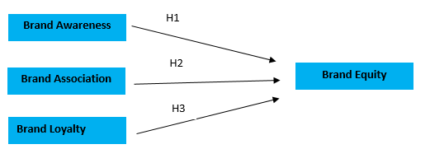
Figure 1: Factors affecting Brand Equity of Derby
The model was formulated to conduct the research. However, please note that smokers were Derby were primarily asked to regarding the factors of why they were smoking Derby. The all answered positively about Brand awareness, pricing and pack upgrade.
Brand Awareness
When we talk about any product – knowing about the product is a key factor to ensure brand equity. When the consumers will know about the product, they will have higher chances of trying out the product. If the brand awareness is there, people will definitely move towards having brand equity. Thus, brand awareness is highly connected towards assuring brand equity.
Brand Association
Customers don’t only need to have brand awareness; they also need to feel associated to the brand to feel inclined towards it. For Derby, the consumer class is mostly people of low economic class and they always dream of associating themselves to the brand which resembles their lifestyle. Derby’s ‘Champion’ pack upgrade was initiated to give them a feeling of accomplishment. Thus, brand association is important to generating brand equity.
Brand Loyalty
Derby, despite being a brand in BATB low segment – it is still very contributing to the portfolio of the company. To make sure of its mark in the competitive market – it is very important to offer value to the consumers so that they feel inclined towards the brand. That will make them loyal to the product and thus, it will build brand equity.

8.3 Impact of the new pack on the sales of Derby
As it can be seen that the Champion Pack launch in the market had already created a vibrancy in the market, this was going put an impact of the STT numbers of the market. The sales numbers of Derby before and after the launch is discussed below.

Figure 2: Derby Sales in Madaripur territory (Dec'18 - Apr'19)
Since the launch of the Champion pack on the 3rd February’19, there has been a surge in the sales of Derby in Madaripur territory. If we see the trendline below, we can see that the sales have been 7643.98 thousand in December’18 and in January’19, it was 8365.61 thousand. The trendline picks up in February’19 and hits a sales number of 9039.71 thousand sticks.

FINDINGS
Derby’s new Champion Pack created a huge buzz in the market due to the campaign activities. The pre and post launch activities have ensured that the consumers get to know about the new pack changes in the market. It was imperative to make sure that the consumers were communicated with the message that only the pack had changed but the product was exactly the same as before.
A packaging change for low brand like Derby has impacted greatly in the consumer minds. Derby being the first brand in the low segment with modern pack trait like embossing which was never seen before by the consumers of the low segment. This has played a huge impact in getting a positive conviction of the consumers about the Champion Pack. The word ‘Champion’ also stuck to the retailers’ and consumers’ minds. This has also created a positive disposition of the brand among concerns.

In order to find the effect of Derby’s Pack Upgrade in building Brand Equity, a model based on 3 variables were. These are, Brand Awareness, Brand Association and Brand Loyalty. In the research model, the dependent variable is ‘Brand Equity’ which is related to the independent variables. In the research it will be shown how closely, the independent variables are related to the dependent variable, i.e. if consumers felt associated with the brand. At the end of the study it is found that the factors had effect on building brand equity of Derby. Thus, the Derby PUG Campaign had helped building Brand Equity of Derby.

As we have discussed above that the sales of Derby have seen a upward trend ever since the launch of the new campaign. It had been widely accepted by the retailers in the trade end. The consumers have also had a smooth transition into the new familiarization of the new pack.
The sales have seen a 13% growth against the launch date. It can be concluded that the Derby PUG have increased the overall sales and performance of Derby in the Market.

CONCLUSION
With an incredibly diverse and calculated brand portfolio, British American Tobacco Bangladesh (BATB) Company has become the market leader in Bangladesh Tobacco industry. And it is the united efforts from each department that made this success possible. Most importantly, the role of the marketing department is unbound in words to express. Its dynamic strategies in various circumstances have allowed the company to become the market leader in Tobacco Industry.
Khulna region is a unique region in its own ways. The market is strongly competitive, especially the ever growing Low segment, for the company and maintaining the same market share is the biggest challenge. However, as every problem has solutions, issues were recognized and the way forward has been identified. With timely implementation of the changes that were mandatory, the house that was losing market share once has now turned the tide by starting to gain market share and swung back to a growing momentum.
However, there is no limit to improvement, a lot more can be done to this distribution house to contribute more towards the success of the company.

BIBLIOGRAPHY
British American Tobacco Bangladesh Co. Ltd. http://www.interact.com. Explored and
Accessed by, 09-3-2014.
British American Tobacco Bangladesh Co. Ltd. http://www.bat.com. Explored and Accessed by, 16-6-2014.
“Distributor’s Manual” of British American Tobacco Bangladesh Co. Ltd. pp: 2-28. Accessed by, 25-09-2008.
Mymensingh Regional “Retail Audit” of 2009 & 2010.
“Record Keeping Book” at Khulna distribution house. pp: 37-59.
Alon, I., & McKee, D. (1999). Towards a macro environmental model of international franchising. Multinational Business Review. 7 (1), 76-82.
Anonymous (2003). “Franchise Zone,” Entrepreneur.com April 13.
Barney, J. (1991). Firm resources and sustained competitive advantage. Journal of Management. 17 (1), 99-120.
Bellett, G. (2003). More Canadians finding future in franchising: Being your own boss is part of the attraction. Vancouver Sun. July 14, E1.
Brown, C.L.&Lattin, J.M. (1994). Investigating the relationship between time in market and pioneering advantage. Management Science. 40 (10), 1361-1369.
Chan, P.S., & Justis, R.T. (1992). Franchise management in East Asia. Academy of Management Executive. 4 (2), 75-85.
Chaplin, D. (1998). Country report-Middle East-Strategic platform. Franchise International. (http: www.franchise-group.com/fi_mag/ngmiddleeast.html, accessed May 7, 2001).
Contractor, F.J. (1982). The role of licensing in international strategy. Columbia Journal of World Business. Winter, 73-83.
Day, G.S., & Wensley, R. (1988). Assessing advantage: A Framework for diagnosing competitive superiority. Journal of Marketing. 52 (2), 1-20.
Dunning, J.H.,&McQueen, M. (1981). The Eclectic Theory of International Production: A Case study in the international hotel industry. Managerial and Decision Economics. 2, 197-210.
Eroglu, S. (1992). The internationalization process of franchise systems: A conceptual model. International Marketing Review. 9 (5), 19-30.
Franchise Zone (wysiwyg://154http://www.entrepreneur.com..., accessed April 18, 2003).
Gupta, A.K., & Govindarajan, V. (2000). Managing global expansion: A conceptual framework. Business Horizons. March-April, 43, 45-54.
Hackett, D.W. (1976). The international expansion of U.S. franchise systems: Status and strategies. Journal of International Business Studies. 7 (1), 65-75.
Hoffman, R.C., & Preble, J.F. (1991). Franchising: Selecting a strategy for rapid growth, Long Range Planning. 24 (4), 74-85.
Ogbuehi, A.O.(Ed.), Proceedings of the Academy of International Business Northeast (pp. 48-54). Conference held at Bryant University, Smithfield, RI, (October 7-9).
Hoffman, R.C., & Preble, J.F. (2004a). Global franchising: Current status and future challenges. Journal of Services Marketing. 18 (2): 101-113.
Julian, S.&Castrogiovanni, G.J. (1995). Franchisor geographic expansion. Journal of Small Business Management. April, 33 (2), 1-11.
Kerin, R.A., Varadarajan, P.R., & Peterson, R.A. (1992). First-mover advantage: a synthesis, conceptual framework, and research propositions. Journal of Marketing. 56 (4), 33-52.
Kohli, A.K., & Jaworski, B.J. (1990). Market orientation: The construct, research propositions, and managerial implications. Journal of Marketing. 54 (2), 1-18.
Kotler, P., & Armstrong, G. (1989). Principles of Marketing, Englewood Cliffs, NJ: Prentice Hall.
Lambkin, M. (1988). Order entry and performance in new markets. Strategic Management Journal. 9 (Summer Special Issue), 127-140.
Liberman, M.B. & Montgomery, D.B. (1988). First-mover advantage. Strategic Management Journal. 9 (Summer Special Issue), 41-58.
Makadok, R. (1998). Can first-mover and early-mover advantages be sustained in an industry with low barriers to entry/imitation? Strategic Management Journal. 19 (7), 683-696.
Michael, S.C. (2003). First mover advantage through franchising. Journal of Business Venturing. 18 (1), 61-80.
Miller, K. (1992). A framework for integrated risk management in international business.
Journal of International Business Studies. 23, 311-332.
Mittal, S., & Swami, S. (2004). What factors influence pioneering advantage of companies?
Petersen, B., & Welch, L.S. (2000). International retailing operations: downstream entry and expansion via franchising. International Business Review. 9 (4), 479-496.
Preble, J.F. (1992). Global expansion: The case of U.S. fast-food franchisors. Journal of Global Marketing. 6 (1/2), 185-205.
Robinson, W.T., & Fornell, C. (1985). Sources of market pioneer advantages in consumer goods business. Journal of Marketing Research. 22 (3), 305-317.

