An analysis of critical success factors in small and medium enterprise banking in Bangladesh- A case study of United Finance Ltd.




Internship report on
An analysis of critical success factors in small and medium enterprise banking in Bangladesh- A case study of United Finance Ltd.

Submitted to:
Ziaul Karim
Assistant Professor
United International University.

Submitted by
Joy Krishna deb
ID 111 143 225

Date of Submission: 08-08-2020

Letter of transmittal

8th August, 2020
Ziaul Karim
School of Business & Economics
United International University
Subject: Submission of Internship Report.
Dear Sir,
It’s my pleasure to submit this Internship Report topic “An analysis of critical success factors in small and medium enterprise banking in Bangladesh- A Case study of UFL” which is part of my course requirement for the graduation of BBA.
This report described the united finance Ltd. success factor in small and medium banking in Bangladesh. I tried to include all information in this report sincerely and correctly.
I hope that you will like this report. In this case, it will be meaningful to me. In any case, if you need any explanation or clarification in this report please contract.
Sincerely yours,
Joy Krishna Deb
Id 111 143 225

Acknowledgement
My special thank goes to the employees in our office. Their valuable support and advice help me to prepare the report.
I express my deep gratefulness to all employees of our branch and also my department member for their cooperation to collect information from various sources and helped me to complete this report. I also thank Farizma Hossain Management Trainee in the Human resources department of United Finance Ltd.
Finally, I am appreciating to my supervisor Ziaul Karim for supporting me and provide guidance to prepare this report.

Abstract
Small and medium enterprises SMEs are viewed as a most productive medium which can push financial and social improvement to experience notable advancement and improvement as they offer valuable service to buyers, and give a necessary job. With this in consideration, they are necessary for obtaining experience, training, and technical and managerial skills.
Some other interior factors could be the purpose of the achievement of these organizations. The motivation behind this research is to recognize the principle factors that generally used to show the success of the small and medium enterprise.
Data have been gathered by using a mixed-method approach: First, 100 sets of questionnaires were circulated among supervisors of SMEs; Second, information was gathered by utilizing organized face to face conversation.
Keyword: SMEs success, Critical success factor, small and medium enterprise.

Table of Contents
Chapter 1 1
1. Introduction 1
1.1 Origin Of The Report 1
1.2 Objective of the Report 1
1.2.1 Overall objective 1
1.4 Limitations of the report 2
Chapter 2 3
2 Literature Review 3
2.8.1 Strategic factor 6
2.8.2 Operational variables 7
2.8.3 Technological factor 7
Chapter 3 11
3. Research Methodology 11
3.1 Introduction 11
3.2 Research Philosophy 11
Justification of Positivism 12
3.3 Quantitative and Qualitative data collection techniques 12
Justification of Quantitative and Qualitative data collection techniques 12
3.4 Research Strategy 12
Justification of Survey& Case Study 12
The target population 13
The sampling frame 13
The sampling method 13
The sample size 14
3.5 Data collection 14
3.6 Data analysis 14
3.7 Reliability and validity 15
Chapter 4 16
4. United Finance Ltd. Background (UFL) 16
4.2.1 Vision 19
4.2.2 Mission 19
4.2.3Goals 19
4.3 Succeed at Every Level 20
4.4 Career 20
4.4.1 Our Recruitment Policy 20
4.4.2 Regular Employee 21
4.4.3 Contractual Employee 21
4.4.4 Internship 21
Chapter 5 22
5. Products of united finance Ltd 22
5.1.1 Assets 22
5.1.1 22
Assets Financing Options (Long Term 28
5.1.2 Liability Product 32
5.1.2.1 Affordable HOME LOAN: 32
5.1.2.2 Home Loan 33
Deposit Products: 34
5.1.2.1 Insured Deposit Scheme (IDS) 34
5.2 Cost Administration: 39
Chapter 6 40
6. Financial condition of UFL 40
6.1 Analysis of Debt to Equity of UFL 40
6.2 Analysis of Debt to Asset of UFL 42
6.3 Analysis of Equity Multiplier Of UFL 44
6.4 Analysis of net profit 46
6.5 Analysis of ROA of UFL 47
6.6 Analysis of ROE of UFL 48
6.7 Loan Facilities 49
6.8 Geographical location wise lease, loan and advance 50
6.9 Geographical area wise lease, loan and advances (Inside Bangladesh Rural): 51
6.10 Analysis by Security from Borrowing from Banks, Other Financial institution and Agent: 52
Chapter 7 53
7. NBFIs in Bangladesh 53
7.1 Overview of Bangladeshi NBFI 53
7.2 Leasing industry in Bangladesh: 53
Chapter 8 55
8 Analysis of Success factors of UFL: 55
8.1 Strategic Focus 55
Integrity 55
Meritocracy 55
Learning 55
Teamwork 55
Passion 55
Job Training 55
Guiding 55
Out of Office Activities 55
8.2 People: 56
8.3 Operational factor: 56
8.4 Technological factor 56
8.5 Target Market 57
8.6 Financial Factor 57
Interest Income 57
Income from long and short term finance: 57
Income from share: 57
Deposit Income 58
Income from fee 58
8.7 Risk Management: 58
Pre-emptive Risk management 58
Contemporaneous Risk Management 58
8.8 Sustainable Initiative: 59
8.9 Employee benefits 59
8.9.1 Short term benefits 59
8.9.2 Post emplacement benefit 59
Provident fund 59
Gratuity fund 59
Life insurance scheme 60
Chapter 9 61
9.1 Findings: 61
9.2 Recommendation 61
9.3 Conclusion 62
References 63

List of Table
Table 4.1 Key person | 17

List of Figure
Figure 1 Organizational Structure | 20
Figure 5.1 Products of united finance Ltd. | 22
Figure 5.2: Procedure of Credit-Sale Financing | 23
Figure 5.3 : Procedure of Distributor Finance | 25
Figure 5.4 Procedure of short term Revolving | 27
Figure 5.5 Procedure of Lease financing | 29
Figure 5.6 Procedure of Term Loan | 31
Figure 6.1 Debt to Equity | 40
Figure 6.2Analysis of Debt to Asset of UFL | 42
Figure 6.3 Equity Of UFL | 44
Figure 6.4 Analysis of Net Profit | 46
Figure 6.5 Analysis of ROA | 47
Figure 6.6 Analysis of ROE | 48
Figure 6.7 Loan Facilities of united finance | 49
Figure 6.8 Geographical location wise rent | 50
Figure 6.9 Geographical area wise lease, loan and advances (Inside Bangladesh Rural) | 51
Figure: 6.10 Analysis from borrowing from banks, other financial institution and agents | 52

Chapter 1

1. Introduction
  - Origin Of The Report:
Today’s business world is very dynamic and competitive therefore organizations searching for ability, talent, innovative, ingenious graduates who have a place with a high level of degree. At present business, graduates are the core part of the business world. All, business graduates need to have both theoretical and practical knowledge to deal with the business appropriately. To be comfortable with organization culture and to get some reasonable information about an organization, a business student must prepare a project report for the BBA. As a part of the BBA at United International University, the course Internship consists of 3 credits.
1.2 Objective of the Report:
Objectives of the internship report can be separated into two segments, for example, overall objective and specific objective. These two portions are described below.
    - Overall objective:
Overall objectives of internship report about the small and medium enterprise banking in Bangladesh.
1.2.2 Specific objective:
- To know about the general information about the finance company
- To know about the products of the company.
- To know the finance procedure
- To know the Company’s financial condition
- To learn how to make a feasible report.
- To explore some of the recent issues in a finance company in Bangladesh

1.3 Scope of the report: By preparing this project paper based on the ‘"analysis of critical success factors in a small and medium enterprise”
Which can give a way to get familiar with the overall finance organization. It gives the real picture of the finance system and procedure of Bangladesh. This report has limited information but I can assure you that I am trying my best to describe every part.
1.4 Limitations of the report There were some limitations to this report. Those limitations are described below –
1. As Non-banking organizations, it has few limitations to serve all the real data of the organization to every individual. As a result the study mostly depends on official files, annual reports, and websites.
2. Unavailability of up-to-date information.
3. Enough data isn’t available in the yearly report of united finance limited.
Anything which will adversely affect the image of the organization could not be disclosed.

Chapter 2

2 Literature Review
2.1 Introduction
This research paper aims to describe the success factors of small and medium enterprise banking (SMEs) in Bangladesh based on a case study of United Finance. Before we describe the SME sector, there we need to discuss the previous research study on the SME sector in Bangladesh. In Bangladesh, there are many SME banking sector plays an important role in developing our economy. There is a close relationship between, the performances of the people and SME sectors. The SME sector focuses on the establishment in different sectors in Bangladesh. We know that most of the study focuses on a large company. Some large company getting success and other failures. This study shows that the impact of entrepreneurs, characteristics of the small and medium enterprise, strategic factor, operational factors, and technical factor for business success in Bangladesh.
2.2 SMEs contribution in Bangladesh economy
The SME sector performances refer to the SME sector's success in a country. SMEs sector performance characterized the company’s ability. Every company's success relates to the achievements of the organization's goal and objective. Success is the key to every business. There are more than 50000 small industries and cottage industries in Bangladesh. The present research shows that GDP earning percentage for SME in Bangladesh is 25%. Planning commission surveys estimate those small cottage industries between 100,000 to 150,000. ADB. (2003)
2.3 Entrepreneur characteristic
Entrepreneurs play a vital role in the SME sector to ensure business success. Entrepreneur refers to the individual character and Demographic characteristics. The demographic characteristic like education, age, work experience, gender, background, impact on entrepreneurial intention.

Demographic characteristic
Studies found that 25 to 45 year’s age range was the most successful entrepreneurial activity. Reynolds et al.(2000). A study found that female entrepreneurs are less likely to be founders of new businesses than males. Another study found that males were generally higher entrepreneurial intentions than females. Wahid.(2003)
2.4 Individual quality
The individual qualities of the proprietor have been under expanding interest. A few efforts have been made to clarify business achievement or disappointment in terms the personalities of the business person (Glancey, Greig and Pettigrew 1998; Stewart Jr., Watson, Carland and Carland 1998). Nooteboom (1994) featured that one of the most significant attributes of the private sector is its assorted variety. The sources that produce assorted variety lie in the change of the foundations, thought processes, and objectives of the business people. As indicated by Yusuf (1995) individual characteristics and attributes have been recommended to influence firm achievement.
2.5 Entrepreneur orientation:
A few analysts have contended that achievement is driven by the entrepreneur orientation (cf. Covin and Slevin 1991; Lumpkin and Dess 1996; Wiklund and Shepherd 2004). As indicated by Lumpkin and Dess (2001), the idea of entrepreneur orientation comprises of five measurements: independence, inventiveness, hazard taking, proactiveness, and competing aggressiveness. Self-sufficiency is characterized as an autonomous activity by an individual or a group for delivering a business idea or a dream and helping it through to finish. Inventiveness alludes to the readiness to help imagination and experimentation. Hazard taking, methods an urge to take intense activities, for example, searching into new markets. Proactiveness is an open door chasing and forward-looking viewpoint. The fifth measurement, competing aggressiveness, follows the rule of a company's attempts to beat the business rivals (Lumpkin and Dess 2001).
2.6 Entrepreneur readiness
Entrepreneur status in this research alludes to self-viability. The term self-viability, gotten from Bandura's (1977) social learning hypothesis, refers to an individual's faith in their capacity to play out a given job. As indicated by Ryan (1970), self-understanding assumes a significant job in the advancement of goals. Aims and their hidden minds are observation based, which should imply that they are found out what's more, can be consistently affected, and not fixed by character characteristics framed in youth.
2.7 Characteristic of SME
SMEs characteristic alludes to the origin of business, length time in activity, size of business, and capital sources that assume a significant job on business achievement.
Origin of business:
As indicated by Smallbone, Leig, and North (1995), the origin of business in little firms, where authority was ordinarily joined in at least one people and future objectives for the business may be resolved as much by close to home way of life and family factors as by business contemplation.
They assumed that one characteristic which distinguished the best performing firms from different firms in the research was their promise to develop. Additionally, they found another characteristic that distinguished high development firms from others were their ability to procure different organizations.
Length time in activity
Length time in activity might be related with expectation to absorb information. Old players most likely have gained much from their knowledge than have done by new comers. Kristiansen, Furuholt, and Wahid (2003) discovered that length time in activity was fundamentally connected to business achievement. Moussavi (1988) in his unpublished PhD statement expressed that experience with respect to the proprietor/supervisor factor adding to the endurance of organizations. In their investigation of new little firms, Duchesneau and Gartner (1990) found that lead business entrepreneur in effective firms were bound to have been raised by innovative guardians, to have had a more extensive business experience and progressively earlier startup experience, and to accept that they had less control of their achievement in business, than ineffective business people. They additionally found that lead business entrepreneur in effective firms worked extended of time, had an individual interest in the firm, and were acceptable communicators. Besides, fruitful firms were those started with goal-oriented objectives, and lead business entrepreneur had an distinct and comprehensive business plan (Duchesneau and Gartner 1990). Firms with more than one investor when it was set up were essentially more liable to endure (Westhead et al. 1995). Training and related knowledge in business have been viewed as basic achievement factors for little firms (Yusuf 1995; Wijewardena and Cooray 1996).
Size of big business
The size of big business reflects how long business in work terms. McMahon (2001) discovered that business size altogether connected to better business execution. Big businesses were found to have a more high level of progress.
Capital source
In research in Australia, McMahon (2001) found that more trust upon outer account associate with better business development. In previous research in Indonesia, Kristiansen, Furuholt, and Wahid (2003) found that business success was essentially connected to market achievement. SMEs that exploited family and outsider invest experienced a more significant level of progress.
2.8 Three broad categories customer service factor in SME Banking

2.8.1 Strategic factor
An organization, strategic elements give a way to progress. Strategic components are those things that an organization needs to get directly to prevail with its key partners, their clients, providers, workers, proprietors, and some other organization, specialty unit, or person that they rely upon for progress. The partners utilize these standards to judge the organization (Kenny, 2001).
The strategy is a way of success for all financial organizations in our country. A strategy is key to the success of every organization. An organization needs to provide a strategy for getting this success. United finance applied those strategies for their stakeholder, supplier, customer, and employee success. Every year the UFL management team made a strategic plan for organizational development.

2.8.2 Operational variables
Operational variables can be considered as major contributing components towards the achievement of SME banking. As indicated by Thampy (2010), the significant test for banks is to connect the data asymmetry. The proof shows that banks just get monetary records and the profit and loss accounts from around 66% of their SME customers. Progressively complex records, for example, financial plans for next year, data on inventories, cash-flow forecast are only from time to time (European Commission, 2003). In any case, this data has improved in correlation with a couple of years back (Ayadi, 2005).
An organization's success depends on operational factors. United finance operating factor that helps to develop their business are given below-Thampy (2010).
- Control the skill of the supply chain team.
- Control of distributions channel.
- Range of all products based on their quality.
- Fully utilization of technologies.
- Create a good business culture.
- The performance of the business and sales team.
- Control the overall expense of the company.

2.8.3 Technological factor
The technological factor also depends on organizational success. Technology and skillful employee can achieve organizational success. The organization uses a safe website and software that prevent their client data. The technological elements organize easy to use sites, safe sites, and other relevant frameworks and personalized services. These components allude to the security of customers' individual information; safe transactions prevent stolen money, and their misuses (Shah and Morabito, 2007).
2.9 Supportive organizational factors
IS combination and advancement of online business inside organizations had the biggest evaluated standard factor. This recommends these two factors had the most significant level of co-variety with the other symbolic factors for the dormant variable, strong organizational elements. Data framework mix is important to keep processing costs, to convey incorporated items continuously across channels, and to examine client-related databases for promoting purpose. Help from top administration had the second most elevated standard factor. Focusing on the significance of this variable, Shah and Morabito (2007) expressed that the proactive help from top administration and advancement of an online business upgrade an organization’s capacity to change itself rapidly. Secure site and other related frameworks, adaptable organizational structure, adaptable workforce, accessibility of assets all had a huge standard factor.
2.10 Quick and responsive service
This factor had the most elevated difference among all components, demonstrating its significance in the achievement of SME banking. It includes transfer of service, quick and coordinated business plans, quick responsive client service, cross selling and customized service. The lease is regularly not the significant driver of SME banking benefit, however might be the best way to keep customers. Fixed incomes originate from giving a set-up of adequately packaged, and deposits product – following the customer's needs. Cross selling gives shopping advantages to bank customers.
2.11 Target-based marketing
Target-based marketing caught the second most elevated change in the world. It incorporates data about SME buying conduct, web-explicit advertising also, development of current markets. SME banking includes higher volumes than corporate banking and more profound performance than retail banking. The aptitudes required, for example, deals with the executives, SME information, and customer services– frequently don't coordinate those of a conventional financier. Successful banks embrace customized programs for their SME business customers.

2.12 SME-banking policy and model
The SME banking market comprises of the organizations whose money related prerequisites are excessively huge for microfinance, however are too little to even think about being viably served by corporate financial models. In this way, banks need a diverse plan of action for SME banking. Great credit scoring furthermore, appraising model improves the consistency of credit choices and lower the expense of loaning to SMEs. Another contributing variable is risk management. Control risk in the setting of littler customers, with possibly higher recurrence and lower esteem exchanges, adds to the unpredictability. While there was a variety in the quality of factor over the SME-banking strategy and model marker factors, it was apparent that every one of the four-pointer factors contributes towards SME banking strategy. This recommends that one individual variable doesn't characterize SME-banking strategy; rather an organization must be used to precisely portray SME-banking strategy in the quick pacing financial condition.
2.13 Improved client services
This factor is involved in the accessibility of service, an incentive for SME customers, and easy to use the site. The incentive for SME customers has the most label of benefit. The marketing channels keep on dividing, finding better approaches to draw in with clients turns out to be progressively dangerous. Building client incentive forces support client integrity.
Development of Hypotheses
The analysis of literature following hypotheses are given below-
H1 There is a positive relationship between Entrepreneur characteristic and SMEs business success
H2 Positive relationship between the characteristics of small and medium enterprise and SMEs business success

Conclusion
The study finds out the entrepreneur characteristic and characteristics of small and medium enterprise business success factors in Bangladesh. Also found entrepreneurs have a significant effect on the business success of Bangladesh. The SMEs business owners need to know their products and services, and he involved in a business, should strict the business, define market clearly, pay attention to details. We need to ensure a strong social network and government relations to achieve business success. The successful business organization communicates with its customers, suppliers, workers. Business cooperation also enables the improvement of a small firm's strategic position enters the international market, reduces cost, and copes up with the new technologies.

Chapter 3

3. Research Methodology

3.1 Introduction
This part briefly discusses the research area with some basic data. In the methodology part research philosophy, the design of research, research approach, the method of research the strategy of research, the procedure of data collection, the sampling method and data analysis procedure have been discussed.

3.2 Research Philosophy
The research philosophy will follow the author’s important theories and these theories serve as bases for the research strategy. For the most part, research philosophy has numerous branches identified with a wide scope of controls. Inside the extent of business specifically, there are two principle research methods are followed:
- Positivism
- Interprevitism
Positivism researches:
Positivism researches the analyst is free to structure the investigation and there are no outlines for human rewards inside the study. Crowther and Lancaster (2008)[2] contend that when in doubt, positivist investigations, as a rule, embrace deductive methodology, though the inductive research approach is normally connected with a phenomenology reasoning.
Interprevitism approach:
Interprevitism approach depends on the naturalistic methodology of information assortment, for example, conversations and investigations. Secondary information research is additionally well known for interpretivism reasoning. In this sort of study, implications develop as a rule towards the finish of the study procedure.

Justification of Positivism
As a way of thinking, positivism holds fast to the view that accurate knowledge and information increased through perception, including estimation, is dependable. In positivism considers the job of the analyst is constrained to information collection and translation in a targeted way. The analysis of research philosophies we find that positivism is best than other philosophies.

3.3 Quantitative and Qualitative data collection techniques
The quantitative analysis can be defined as 'involving the combination of numerical information and showing the perspective on the relationship among hypothesis and investigation as deductive, an inclination for science approach, and as having an objectivist origination of social reality (Bryman,2015).
Qualitative data collection techniques are exploratory and are worried about picking up bits of knowledge and comprehension of basic reasons and inspirations. Polonsky and Waller (2011)[2] classify vision, pictures, structures and structures in different media, just as verbally expressed and printed word and recorded sound into subjective information assortment techniques.

Justification of Quantitative and Qualitative data collection techniques
After analysis of two data collection techniques we will use quantitative and qualitative data. Quantitative information collection strategies depend on irregular measurement and organized information assortment instruments. Findings of quantitative researches are normally simple to introduce, review, analyze and hypothesize. Qualitative methods are frequently viewed as giving rich information about genuine individuals and circumstances and being progressively ready to comprehend conduct and to comprehend conduct inside its more extensive framework.

3.4 Research Strategy

Justification of Survey& Case Study
This study aims to findings the success factor of small and medium enterprise banking in Bangladesh. The purpose behind overview research in an investigation is to turn out to be increasingly acquainted with a point and to evaluate basic ideas about it. Rockart and Flannery, (1983) did a study to help characterize the different kinds of end-client processing that were created in organizations.
Sampling Design Procedure

The target population
Polit and Hungler (1999:37) allude to the population as a total or entirety of the considerable number of objects, subjects, or individuals that adjust to a lot of determinations. In this research, the population was Bangladeshi males and females. Here we considered race, age, educational status, financial status, and neighborhoods.
Reason of Choosing UFL
United finance is one of the largest financial institutions in Bangladesh. Their financial condition is better than other organizations and their market share also high. The business condition is very good. Those are the reason for choosing the case study of United finance.

The sampling frame
The way toward choosing a segment of the population to serve the whole population is known as sampling (Haber, 1998). Males and females were chosen. Time and cash were saved by choosing a sample to be concentrated as opposed to trying to examine the whole the population of males and females who mentioned top management.

The sampling method
This study has utilized a non probability sampling method for collecting information. A non probability sampling strategy was received which, as per (Haber,1998) is less overwhelming and will in general produce less exact and fewer agent tests than probability sampling. Non probability sampling suggests that not each component of the population has a chance for being involved in the sample, for example, service, portion, purposive, and organize testing methods (Burns, 2001). The non-probability sampling method may have constrained the generalization of the discoveries.

The sample size
A sample is a subset of a population chose to take participate in the research, it is a small amount of the entirety, chosen to take an interest in the examination venture (Hungler 1999). A sample of 100 individuals from SMEs situated in the Dhaka, Narayangonj, Khulna, and Chittagong was picked with the end goal of this investigation.
In our undertaking for a refined dependable poll that may bolster our exploration of approving observationally the recognized achievement components of SME banking, we looked through the writing and found the poll created by Shah and Morabito (2007) significant for our investigation reason.

3.5 Data collection
The survey was separated into three sections. The primary segment included segment characteristics and profile data of the respondents. The respondents were approached to rank comments on logical conditions identified with every achievement factor in the second area. This area comprised of 10 inquiries which were planned to the success of small and medium enterprise banking utilizing 5-point Likert scale strongly agree to disagree. In the third area, the respondents were requested to score the significance of the business achievement. A total of 100 sets of questionnaires were circulated among supervisors of SMEs, just 95 members were responded. An aggregate of 95 was gotten and 89 were chosen to guarantee testing match the proportion of the level of working gender, age, and level of the executives they are included.

3.6 Data analysis
Confirmatory factor investigation is figured as the most popular measurable technique for testing a suggested factor structure (Schumacker, 1996). Polit and Hungler (1999:267) characterize information as data got in a course of research. In this research, information was gathered by utilizing organized face to face conversation. An organized meeting plan was utilized to catch information pertinent to the investigation's goals and study questions. The data analysis method is measured by utilizing the following equation:

n=nz2+pq∕nd2+z2pq
Where,

n= number of sample
Z= standard value
P= percentage of success
q= percentage of failure
d= error

3.7 Reliability and validity
Attempts were made to amplify the unwavering reliability and validity of the scale. All builds under research were seen as thoughtful since the clear item extremely correspond and the importance of the builds would not change if an individual's items were evacuated (Jarvis et al., 2003). To analyze the reliability of the scale, we utilized composite unwavering quality to check the inner consistency of builds which has supposed to be progressively responsible as it isn't influenced by the number of pointers utilized in the build (Chin, 1998a, 1998b). To test the validity of each scale, evaluation of converging and discriminate validity has been recommended (Churchill, 1979). Converging validity was analyzed through factor loadings and normal fluctuation extricated. Validity is characterized as a proportion of truth or lie of the information got through utilizing the study (Burns ,2001).

Chapter 4

4. United Finance Ltd. Background (UFL)
UFL start its business as a united leasing company limited in 1989 to focus on a single product. Duncan Brother Limited is a good establishment company working in Bangladesh for more than 152 years. UFL obtain a license from Bangladesh Bank in 1995, as a financial organization. Dhaka Stock Exchange has been listed as A category share. UFL is the main thirteen financial organizations permitted by the Bangladesh Bank to collect the deposit.
At first, UFL focused on lease finance to the corporate clients but at the end of the year, it has been diversifying product category from corporate to individual. The UFL start their leasing organization with just a single office in the Dhaka. At a time the company expands business whole over the country. Now UFL works through 23 branch offices all over the country and every one of the 64 districts under its financial coverage.
United Leasing Company changes the company name to United Finance Limited in 2014. They change the company name to expand the business. Now they are not only a leasing company but also a financial organization in the country.
United Finance Ltd Milestones:
- United Finance Ltd was established in 1989.
- Start of Operation, 12 Sep 1989.
- Public Issue of share, 28 March1994.
- On 23 June1994 Dhaka Stock Exchange (DSE)
- On 20 Apr1995 Declared dividend
- On 18 May2000 increased authorized capital
- On Sep 2005 start of fixed investment product.
- Start of Credit Sale Finance operation, 3 Oct2005.
- Start of extending Head Office (Rose N Dale), 13Jun2008.
- On 15May2010 build a training Center Northern S.R. Tower
- On Sep 2011 start affordable home loan operation
- On 24 Nov 2011. increased authorized capital
- On Apr 2012 start distributor finance business.
- Changing the Company Name to united finance ltd, 13 Nov 2014. (United Finance Limited, 2015).

Table 4.1 Key person:
Name/ Title | Current Board Membership
Imran Ahmed, 66 Chairman | UFL. Bangladesh, Duncan Brother Limited., Duncan Product Limited., Laungla Sylhet Tea Company. Limited., Eastland Camelia Limited., Octaviaus Steel and Company. of Bd Limited., Surmah Valley TEA Company. Limited., Amo Tea Company. Limited., The Chandpore Tea Company. Limited., The Mazdehee Tea Company. Limited., The Allynugger Tea Company. Limited., Chittagong Warehouses Limited., Duncan Properties Limited. Bangladesh, The Lungla Sylhet Tea Company. Limited.
Syed Kaiser Tamiz Amin( MD) | UFL .
Abdur Rouf bhuiya, 80 Director | Camelia Duncan Foundation, United Finance Limited. Bangladesh, Laungla Sylhet Tea Company. Limited., Amoo Tea Company. Limited., The Chadpore Tea Company. Limited., The Mazdehe Tea Company. Limited., Octaviaus Steel and Company. of Bd Limited., Duncan Brother Bangladesh Limited., Duncan Product Limited., Eastland Camelia Limited., The Alynugger Tea Company. Limited., Chittagong Warehouses Limited., Duncan Properties Limited. Bangladesh, The Laungla Sylhet Tea Company. Limited.
M M Alam (Independent director ) | UFL
AFM Misfaqus Samad Chawdhury, Director | UFL
Lutful Hakim Khan, Director | UFL. National Broker Limited.
Susan Ann Walker 52 Director | Lawrrie Group Plc, Eastern Produce Investments Limited
C K Hayder Director | Global Leasing Securities Limited., United Finance Limited. Bangladesh
A F Nesaruddin, Director | UFL. Bangladesh Khulna Water Supply and Sewerage Authority, Singer Bangladesh Limited.

4.2 Objects of the Organization
The objective of the company to helps the improvement of a profitable private organization to extend its business smoothly. The UFL main target to extend its business in lease financing. Such as machine purchase, equipment purchase, and vehicle purchase for official purposes. The company also finance many project businesses to complete their project work. UFL's main objective to focus on leases finance in any organization. The company also investment for all kind of manufacturing industry and vehicle purchases.

4.2.1 Vision
We serve better for everyday.

4.2.2 Mission
- Dedicate ceaseless exertion to raise items and administrations for continuing serious end.
- Assure good service to their client.
- Assure good, financial performance and return on investment to manage risk.
- Assure fully trained every employee and used all updated technologies.

4.2.3Goals
- Customers: Provide better service quality to achieve customer satisfaction in terms of providing service in time, fair of all clients, and add value.
- Risk Management: Actively reduce the risk and follow the internal issue.
- Sharer: Need to increase Earnings Per Share.
- Employee: Create a good working environment; provide training to all employees for better service.
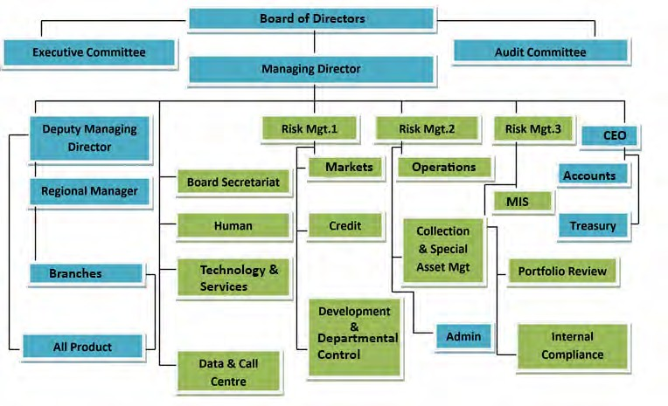
Figure 1 Organizational Structure:
Figure 1: Organizational Hierarchy

4.3 Succeed at Every Level:
The best perspective here is that you are treated like a family. Here is a good working environment. The colleagues congratulate you to join the company. Every member of this organization is very helpful. The culture of the organization support learning to each employee. The company gives you the workplace that is based on trust and where you can develop your skill and build up your career.

4.4 Career
4.4.1 Our Recruitment Policy: The Company recruits employees for the entry-level and upper-level positions. The employees who recruit for entry-level they need proper training and guidance for taking all responsibility. They can be promoted to the next level if every employee's performance is good.
Career Choices for the Applicants in united finance ltd: united finance ltd gives the Applicants 3 types of choices -
4.4.2 Regular Employee: The Permanents employees of United Finance Ltd. Applicants who can apply for this position are given below –
- Students can apply for this position after graduation/post-graduation
- Regular employee vacancy open for all functional and support department

4.4.3 Contractual Employee: In this agreement, there is a certain time that the employees are hired. The applicant who can apply for this position is given below-
- Newly graduate from any department such as BBA, MBA, and CSE students can apply for this position.
- Even students can apply for this position.
4.4.4 Internship: The students need to gain work experience and the requirement for a qualification they must have to complete the internship program.
- United Finance offers 3-6 months internship program.
- Intern students assigned with specific departments to complete the internship program

Chapter 5

5. Products of united finance Ltd

Figure 5.1
5.1 There are two types of products-
Figure 5.1 Products of united finance Ltd.
5.1.1 Assets: The products of Assets can be two types. Those are Working Capital Solutions (Short –Term) and Asset Financing Options (Long-Term). The detailed information about Asset Products of United Finance Ltd is given below.
5.1.1.1 Working Capital Solutions (Short – Term): Working Capital Solutions gives for a short-term period. The detail information about this product are given below--
1. Credit-Sale Financing (CSF): CSF is a mode of financing receivable arising out of a supply of goods or delivery of services on credit. The descriptive part of Credit-Sale Financing is given below -
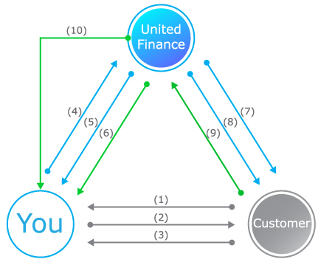
Figure 5.2: Procedure of Credit-Sale Financing
Products Overview: Here the detailed information about this product is given. Who is target customer, financial conditions, repayment system everything regarding these products are given below -
a) Purpose: To meet working capital requirements by financing the client’s procurement from suppliers.
b) Target customer: Small/medium/large traders involved in distributorship that procures goods from importer/manufacturers after payment of cash/pay order.
c) Finance Amount: Determined by considering the frequency of client’s average procurement and amount per procurement from the supplier(s) in a trade cycle of the client.
d) Facility Tenure: One year and renewable, based on performance.
e) Repayment: Repayment is made on or before the maturity of each drawdown through postdated cheque or BEFTN.
f) Security: Personal guarantee, one cheque covering total finance amount, hypothecation, or registered charge on inventory, receivables, and cash. Additional security is required for financing stock holding or limits above the collateral-free limit.
g) *IADA: Noninterest-bearing account, maintained by the clients, the balance of which is used to adjust interest and other charges. The balance of the account determined by the prevailing schedule of fees.
h) Maximum Drawdown Amount: Highest monthly average calculated from last 12 months raw material purchase excluding the seasonal/festival procurement.
I) Festival/Seasonal Drawdown Amount: Peak/Seasonal procurement from the last 12 months purchases trend or Importer/Manufacturer which can be drawn only one month before the specific season/festivals.
j) Drawdown Frequency: Maximum two drawdown’s per week for each supplier based on the trade cycle and procurement pattern from importer/manufacturers. (United Finance Limited, 2005).
2. Distributor Financing: Distributor Finance is a revolving working capital facility for a local and multinational product manufacturing company. We provide the money facility of the distributor on-time payment to their supplier and achieve the target market. The descriptive part of Distributor Financing is given below-
-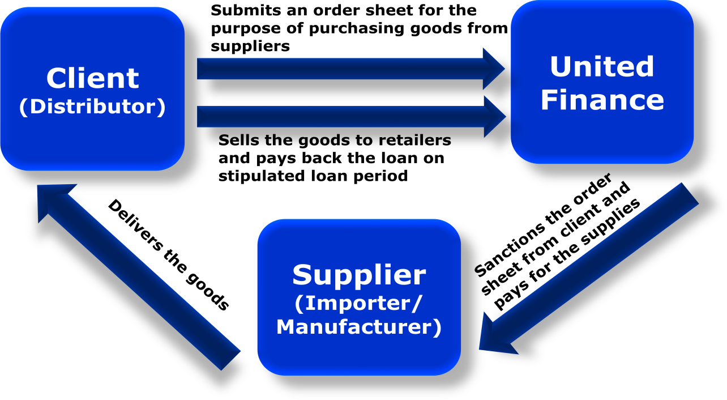
Figure 5.3 : Procedure of Distributor Finance
Product Overview: Here the detailed information about this product is given. Who is target customer, financial conditions, repayment system everything regarding these products are given below -
a) Purpose: To meet working capital requirements by financing the client’s procurement from suppliers.
b) Target client: Small/medium/large traders involved in distributorship that procures goods from importer/manufacturers after payment of cash/pay order.
c) Finance Amount: Determined by considering the frequency of client’s average procurement and amount per procurement from the supplier(s) in a trade cycle of the client.
d) Facility Tenure: One year and renewable, based on performance.
e) *IADA (Interest Adjustment Deposit Account): Noninterest-bearing account, maintained by the clients, the balance of which is used to adjust interest and other charges. The balance of the account determined by the prevailing schedule of fees.
f) Repayment: Repayment is made on or before the maturity of each drawdown through postdated cheque or BEFTN.
g) Security: Personal guarantee, one cheque covering total finance amount, hypothecation, or registered charge on inventory, receivables, and cash. Additional security is required for financing stock holding or limits above the collateral-free limit.
h) Maximum Drawdown Amount: Highest monthly average calculated from last 12 months raw material purchase excluding the seasonal/festival procurement.
I) Festival/Seasonal Drawdown Amount Peak/Seasonal procurement from the last 12 months purchases trend or Importer/Manufacturer which can be drawn only one month before the specific season/festivals.
j) Drawdown Frequency: Drawdown Frequency: Maximum two drawdowns per week for each supplier based on the trade cycle and procurement pattern from importer/manufacturers. (United Finance Limited, 2015)
Short term revolving: This facility goes for some clients who need money for a specific time. United finance provides money for this company which facing money related problems to do the special project work. The descriptive part of Short Term Revolving is given below -
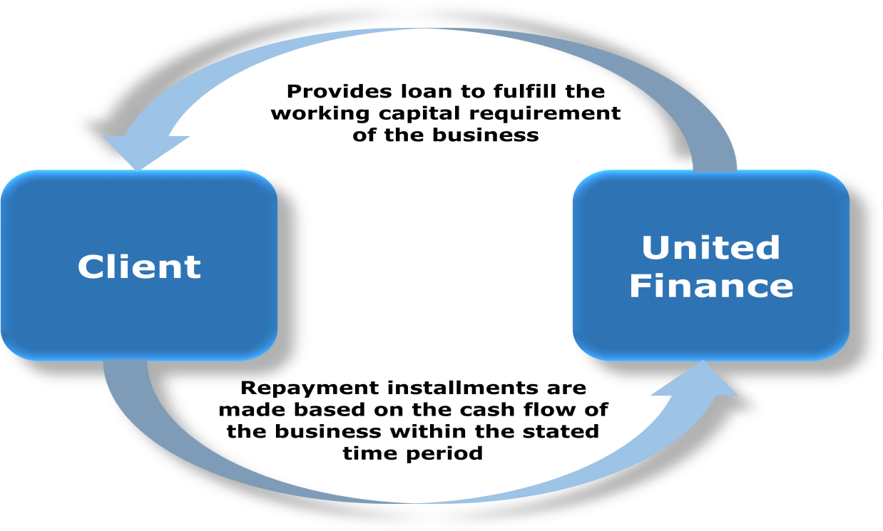
Figure 5.4 Procedure of short term revolving
Product Overview: Here the detailed information about this product is given. Who is target customer, financial conditions, repayment system everything regarding these products are given below -
- Purpose: To meet the working capital requirement.
- Target Customer: Small/medium/large-sized manufacturing/trading/service-oriented businesses involved in a regular supply of goods/services to its buyer(s) on credit.
- Finance Amount: Limit of total inventory 70% and working capital net require 100%. Receivables of the previous year or a total of the work order in hand, whichever is lower.
- Facility residency: One year and renewable, based on performance.
- IADA: Noninterest-bearing account, maintained by the clients, the balance of which is used to adjust interest and other charges. The balance of the account determined by the prevailing schedule of fees.
- Repayment: Repayment is made on or before the maturity of each drawdown through postdated cheque or BEFTN.
- Security: Personal guarantee, one cheque covering total finance amount, hypothecation, or registered charge on inventory, receivables, and cash. For facility above the collateral-free limit, acceptable collateral i.e. Land mortgage is required.
- Maximum Drawdown Amount: Highest monthly average calculated from last 12 months raw material purchase excluding the seasonal/festival procurement.
- Minimum Drawdown Amount: Lowest monthly average calculated from last 12 months raw material purchase excluding the seasonal/festival procurement.
- Festival/Seasonal Drawdown: Peak/Seasonal procurement from the last 12 months purchases trend or Importer/Manufacturer which can be drawn only one month before the specific season/festivals.

Assets Financing Options (Long Term).
These are the products that United Finance Ltd gives for the long-term period. The detail information about those products is given below-
- Lease: This facility provides for a short, medium, and large manufacturing company or group of companies. A company can apply for this loan to purchase machinery, equipment, vehicles, and raw material. The descriptive part of the lease is given below -
-

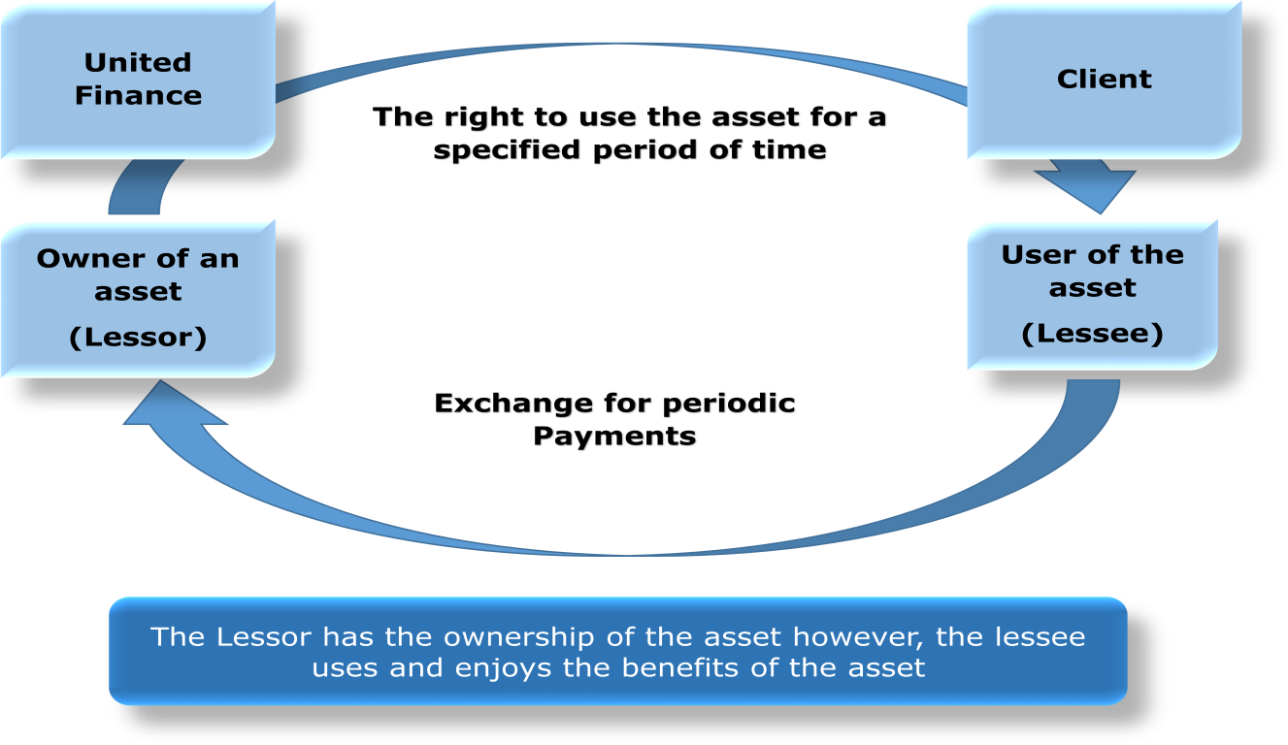
Figure 5.5 Procedure of Lease financing
Product Overview: Here the detailed information about this product is given. The types of lease, who is target customer, financial conditions, repayment system everything regarding these products is given below -
Types of Lease:
- Finance Lease: This lease is an agreement that permits a leaser to the temporary use of assets. The lessee enjoys benefits from the asset.
- Operating Lease: Operating lease an agreement that permits for use of assets. The operating lease doesn’t carry the ownership of assets. It is assets that represent the balance sheet, where the company balance sheet did not include the assets leased and liability of rent payment.

- Purpose: Increases revenue-generating reduces costs. Hence increases profit generation.
- Target Customers: Small/Medium/Large industries included in manufacturing/services/trade businesses.
- Finance Amount: The minimum amount of finance is 100,000 Tk. & maximum ups to the entire cost of the asset. A maximum of 80% of assets is financed for small businesses.
- Facility Tenure: Minimum 12months - Maximum 60months.
- Execution: The repayment against a leased facility must start within 12months of the first disbursement.
- Repayment: Equal monthly installment or structured payment based on the cash flow of the business.
- Prepayment: Full or partial payment may be accepted at any time before the maturity of the facility.
- Security: Ownership of the leased asset is primary security. A personal guarantor or cheque covering receivables can act as additional security.

Term Loan: United Finance Ltd provides a term loan facility for a short, medium, and large company. UFL offers loans for the company which needs money for long term investment to expand the business. The descriptive part of the term loan is given below -
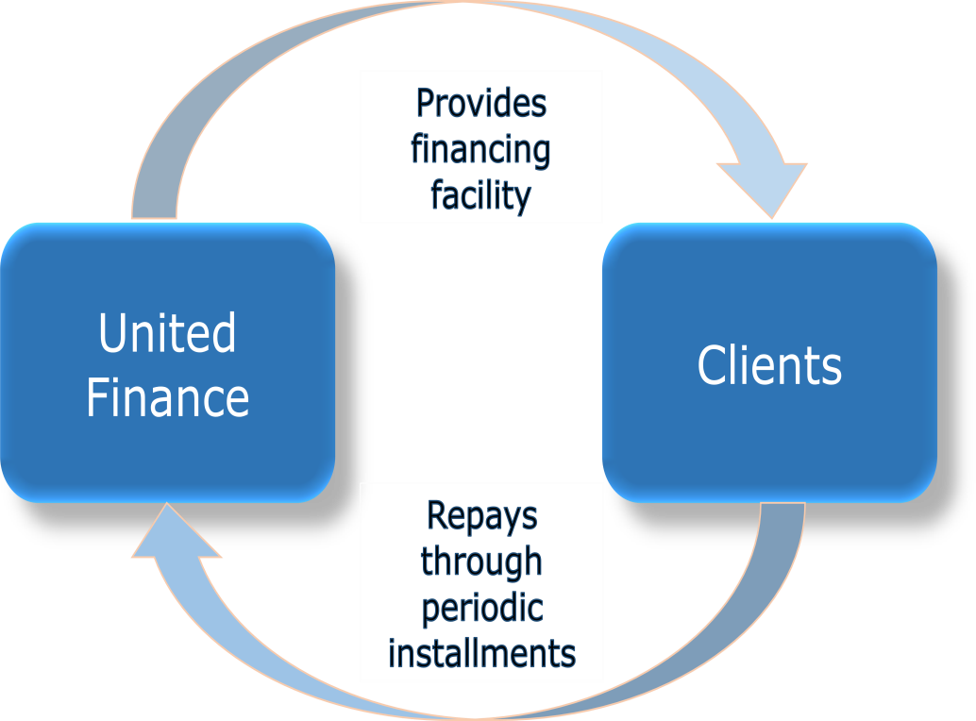
Figure 5.6 Procedure of Term Loan
Product Overview: Here the detailed information about this product is given. Who is target customer, financial conditions, repayment system everything regarding these products are given below -
- Purpose: Cash finance to fulfill business requirements.
- Target Customer: Medium/large industries involved in service/trade/manufacturing businesses.
- Finance Amount: Minimum Tk. 100,000 – maximum as per requirement & security coverage.
- Facility Tenure: Minimum 12months – maximum 60months.
- Execution: The repayment against a loan facility must start within 12months of the first disbursement.
- Prepayment: Full or partial payment may be accepted at any time before the maturity of the facility.
- Repayment: Equal monthly installment or structured payment based on the cash flow of the business.
- Security: Personal guarantee, one cheque bearing total receivable amount along with interest, land mortgage, etc. can be forms of security.

5.1.2 Liability Product

5.1.2.1 Affordable HOME LOAN:
Affordable home loan facilities provide to build up a new building. It is a housing finance facility. If any individual applies for this loan our company tries to fulfill those personal dreams. United finance provides many benefits for an affordable home loan.
Product Overview: the detailed information about this product is given. Who is target customer, financial conditions, repayment system everything regarding these products are given below -
- Purpose: Construction, expansion, repair, renovation, new flat purchase, building development, land purchase, build in a new office developed a commercial project.
- Target Customer: Developer Company, government employee, private sector employee, and businessmen of middle and higher middle-income groups.
- Finance Amount: the maximum loan amount tk 50 Lac and minimum loan amount tk 1 Lac.
- Facility residency: The maximum tenure will be depending on the age of the owner. The facility tenure will be expired in 5 to 10 years.
- Interest rate: Adjustable interest rate based on government rules and regulations. United finance also follows the Bangladesh bank rules.
- Interest during Construction Period (IDCP): IDCP will be the same rate as the interest rate when they apply for a loan. The owner of the land can pay a monthly installment basis loan amount.
- Disbursement: United finance provides a cheque to their client for loan payment. The bank cleared the cheque and transfer money from the united finance account to the client’s account.
- Repayment: Loan installment will be based on the income and expenditure of the client. The entire loan is to be repaid through an EMI basis. The amount will be calculate principle amount and monthly rests amount prevailing interest. Also, the interest rate will be calculated.
- Mode of installment: The facility can be repaid through cheques or BEFTN, RTGS, Cash, Fund Transfer.
- Prepayment: Partial prepayments are allowed on the anniversary of loan and United Finance Ltd must be informed 45 days prior in writing. During any other time, charges will be applicable as per company policy. Full prepayment is not allowed before six loan installments. After that, full prepayment can be made with final adjustment fees.
- Security: Registered home of the property financed will be the essential security. A personal guarantee of owner also is security.
5.1.2.2 Home Loan:
Product Overview: the detailed information about this product is given. Who is target customer, financial conditions, repayment system everything regarding these products are given below -
- Purpose: Construction/ expansion/ repair/ renovation/ purchase of home or apartment.
- Target Customer: Salaried individuals, self-employed individuals, or businessmen of middle and higher middle-income groups.
- Finance Amount: Minimum loan Tk. 5 Lac- Maximum loan amount will be Tk. 200 Lac (subject to a maximum loan to value ratio).
- Facility tenure: The maximum tenure will be depending on the age of the owner. The facility tenure will be expired in 5 to 10 years.
- Interest rate: Adjustable interest rate based on government rules and regulations. United finance also follows the Bangladesh bank rules.
- Interest during Construction Period (IDCP): IDCP will be the same rate as the interest rate when they apply for a loan. The owner of the land can be paid a monthly installment basis loan amount.
- Disbursement: United finance provides a cheque to their client for loan payment. The bank cleared the cheque and transfer money from the united finance account to client account.
- Repayment: Loan installment will be based on the income and expenditure of the client. The entire loan is to be repaid through an EMI basis. The amount will be calculated principle amount and monthly rests amount prevailing interest. Also, the interest rate will be calculated.
- Mode of payment: The facility can be repaid through cheques or BEFTN, RTGS, Cash, Fund Transfer.
- Prepayment: Partial prepayments are allowed on the anniversary of loan and United Finance Ltd must be informed 45 days prior in writing. During any other time, charges will be applicable as per company policy. Full prepayment is not allowed before six loan installments. After that, full prepayment can be made with final adjustment fees.
- Security: Registered home of the property financed will be the essential security. Personal guarantee of owner also is security.
5.1.2 Liabilities: The liabilities product of United Finance is different types of deposit. The deposits of United Finance are given below:

Deposit Products:

5.1.2.1 Insured Deposit Scheme (IDS)
It is a month to month saving scheme for the depositor to save money for the future. Those scheme benefits will provide after a certain time. A depositor can withdraw money when the scheme date expired. A depositor can deposit money on a monthly installment basis.
Benefits (IDS):
- Higher rate of return and safe investment
- Every individual will be permitted to deposit money.
- The depositors can encash money after the completion of the IDS date.

- There will be no other cost include.

Eligible criteria:
- The person legally citizen in Bangladesh can apply for IDS.
- Especially 16 to 55 age people can deposit.
- Installment can be made through BEFTN/Check/Pay Order/Cash.
- Government tax and vat will also deduct.
Features of Insured Deposit Scheme (IDS):
- The deposit scheme offers 3000 to 25000 deposit every month.
- Deposit tenure minimum 3-month maximum of 5 years
- If any case the depositor will be died then the deposit amount transfer the nominee account.
Insured Educational support scheme ( IESS)
It is a month to month saving scheme for the depositor to save money for the future. Those scheme benefits will provide after a certain time. A depositor can withdraw money when the scheme date expired. A depositor can deposit money on a monthly installment basis. The students can apply for a loan based on the IESS. Students can be paid their tuition fees through this loan.
Benefit of (IESS):
- Higher rate of return and safe investment
- Every individual will be permitted to deposit money.
- There will be no other cost include.
- The depositor can withdraw money after the completion date IESS
Eligible criteria
- The person legally citizen in Bangladesh can apply for IESS.
- Especially 5 to 25 age students can deposit.
- Installment can be made through BEFTN/Check/Pay Order/Cash.
- Government tax and vat will also deduct.
Features of Insured Education Support Scheme (IESS):
- The students can deposit money tk 1000 to tk 5000 every month.
- Deposit tenure will be 3 to 5 years.
- If any case the depositor will be died then the deposit amount transfer the nominee account.
Shanchoy Scheme (SS)
It is a monthly deposit scheme. A depositor can deposit money on a monthly installment basis. After the complete of shanchoy scheme tenure the depositor can get interest amount and also principle amount.
Benefit of shanchoy scheme:
- Higher rate of return and safe investment
- Housewife, student, teacher, doctor, consultant, and lawyer will be permitted to deposit money.
- After the complete of shanchoy scheme date, the depositors can encashment money
- There will be no other cost include.
- The company also provides a quick loan for their shanchoy scheme clients.
Feature of shanchoy scheme:
- Minimum amount tk 500 and maximum amount tk 10,000 will be deposit every month.
- Deposit tenure will be 3 to 7 years.
- The maturity advantage is tk 20403 up to tk 1128607.
- This product doesn’t require any initial deposits.
Easy Millionaire Scheme:
If any person wants to make a fixed deposit that the person can choose an easy millionaire scheme. It is a product where a depositor can deposit a fixed amount of money. The person can deposit money more than tk 1 million.
Advantages of easy millionaire scheme:
- Higher rate of return and safe investment
- It is very flexible for all clients
- After the complete of tenure, the depositors can encashment money. In special case depositor can withdraw money after complete of 3 month.
- This scheme is allowed for every person and organization owner such as businessman, club member and politician, etc.
- The company also provides a quick loan for their Easy Millionaire Scheme clients.
Features of Easy Millionaire Scheme:
- A fixed amount needs to be a deposit.
- The minimum deposit amount tk 50,000 and the maximum amount tk 100,000.
- Deposit tenure will be 3 to 10 years.
Millionaire plus Scheme
If any person wants to make a fixed deposit that he person can choose a millionaire plus scheme. It is a product where a depositor can deposit a fixed amount of money. The person can deposit money more than tk 1 million.
Advantages of millionaire plus scheme:
- Higher rate of return and safe investment
- It is very flexible for all clients
- After the complete tenure, the depositors can encashment money. In special case, depositors can withdraw money after complete of 3 month.
- This scheme is allowed for every person and organization owner such as businessman, club member and politician, etc.
- The company also provides a quick loan for their Millionaire plus Scheme clients.

Features of millionaire plus scheme:
- The minimum deposit amount tk 50,000 and the maximum amount tk 500,000.
- Deposit tenure will be 3 to 7 years.
- An initial amount of tk 50,000 needs to be deposit to open the account.

Earner Schemes
The senior citizen people of our country who want to deposit their pension amount for those people need earner scheme. The depositor can save money and at the same time they get higher interest.
Advantages of earner schemes:
- Higher rate of return and safe investment
- It is very flexible for all clients
- This scheme is allowed for government employees.
- The company also provides a quick loan for 60% investment amount.
Feature of Earner Scheme:
- The minimum deposit amount tk 1,000 and the maximum amount tk 5,000.
- Deposit tenure will be 1 year to 3 years.
Term Deposit Schemes
The person who wants to open a fixed deposit account for those client term deposit scheme is best. The depositor can deposit money for a specific time. After the tenure date, the company return the depositor principle amount with interest.
Benefits of Term Deposit Schemes:
- Higher rate of return and safe investment
- It is very flexible for all clients
- The depositors can encash money after the complete of tenure.
- This scheme is allowed for every person and organization owner such as businessman, job holder, doctor, teacher, and consultant.
- The company also provides quick loan based 80% investment of deposit amount.
Features of Term Deposit Schemes:
- The minimum deposit amount tk 10,000 and the maximum amount tk 50,000.
- Deposit tenure will be 3 months to 60 months.
- An initial amount of tk 10,000 needs to be deposit to open the account.

5.2 Cost Administration:
In 2018 all financial company major challenge was collecting deposit form customer and also loan disbursement. Because the deposits rate was higher in every financial institution and Banking organization, on the other hand, the loan interest rate was very low. In 2018 income of interest increase 29.14% against increased in company expense 32.20%. The company added a new employee to expand their business activity. That’s why an increase in salaries and allowances at 8.81%. The company opens 3 new branches to increase business activity and achieve the target market. Here also increased in decoration cost, office rent, electricity bill, equipment cost, etc. In 2017 last quarter one branch office shift from rented building to company own building that’s why decrease rental expense 19.14%. So, the companies operating cost increase by 9.38%.

Chapter 6 
Debt to Equity Ratio
6.99
6.2
6.95.6
5.67
6.7
5.5
6.34.9
4.99
4.29
3.77
2014
2015
2016
2017
2018
Industry Average UFL

6. Financial condition of UFL

6.1 Analysis of Debt to Equity of UFL
 | 2014 | 2015 | 2016 | 2017 | 2018
Industry Avg. | 3.77 | 4.29 | 4.99 | 5.67 | 6.99
United Finance | 5.5 | 6.2 | 6.3 | 6.9 | 6.7
Figure 6.1 Debt to Equity
Analysis:
From the diagram and determined information it is seen that
- In 2014, 2015, 2016, 2017and 2018 the average debt equity ratio of united finance Ltd. was higher than Industry Avg.(Except 2018). The difference between industry avg. and UFL Avg. is a bit high in the last five year. : 2014: 5.5> 3.77; 2015: 6.2>4.29; 2016: 6.3>4.99; 2017: 6.9>5.67and the special case 2018: 6.7< 6.9 that is - 0.29.

- We see that 2014, 2015, 2016, 2017and 2018 this five-year data of united finance ltd. debt to equity ratio was more than the industry average ratio. The higher level of the UFL debt-equity ratio doesn’t mention that the performance was good than the other financial institution. The high-level leverage was not depicted the low performance as well as it cannot express united finance carry Debt finance. Whereas non banking organization has different value they use debt as a raw material not reinvest. So high level of debt-equity doesn’t depict poor financial performance in united finance. The industry average was not more different from the united finance Debt equity average. The industry debt-equity and UFL debt-equity was a little higher and we analyze that it occurred high risk.

6.2 Analysis of Debt to Asset of UFL
Debt to Asset Ratio
86.81%
84.45%
84.69%
85.8419%
83.46%
82.87%
80.57%
77.73%
75.41%
2014
2015
2016
2017
2018
Industry Average UFL

 | 2014 | 2015 | 2016 | 2017 | 2018
Industry Avg. | 75.4% | 77.7% | 80.5% | 82.8% | 85.4%
United Finance | 83.4% | 84.4% | 84.6% | 86.8% | 85.8%
Figure 6.2Analysis of Debt to Asset of UFL
Analysis:
However, in this circumstance it can conclude that:
- In 2014, 2015, 2016, 2017and 2018 the average debt equity ratio of united finance Ltd. was higher than Industry Avg. The difference between industry avg. and UFL Avg. is bit high of last five year. 2014: 83.4%> 75.4% that is 8%; 2015: 84.4% > 77.7% that is 6.7%; 2016: 84.6%>80.5% that is 4.1%; 2017: 86.8%>82.8% that is 3.9% and 2018: 85.8% > 85.4% that is 0.4%.

- We see that 2014, 2015, 2016, 2017and 2018 this five-year data of united finance ltd. debt to asset ratio was more than the industry average ratio. The higher level of the UFL debt assets ratio doesn’t mention that the performance was good than the other financial institution. The high-level leverage was not depicted the low performance as well as it cannot express united finance carry Debt finance. Debt assets average ratio of united finance last five years 85%. Most of the assets used for Debt finance. Whereas non banking organizations run their business through customer funds. So a high level of debt assets doesn’t depict poor financial performance in united finance. The industry average was not more different from the united finance Debt assets average. So, we can say the collection of assets is accepted in debt finance. The industry debt assets and UFL debt assets was little more high and we analyze that it occurred high risk.

6.3 Analysis of Equity Multiplier Of UFL
Equity Multiplier
7.99
7.18
6.67
7.05
6.05
6.43
6.53
5.99
5.29
4.77
2014
20154
2016
2017
2018
Industry Average UFL

 | 2014 | 2015 | 2016 | 2017 | 2018
Industry Avg. | 4.7 | 5.2 | 5.9 | 6.6 | 7.9
United Finance | 6.0 | 6.4 | 6.5 | 7.1 | 7.0
Figure 6.3 Equity Multiplier Of UFL
Analysis:
However, In this circumstance it can conclude that:
- In 2014, 2015, 2016, 2017and 2018the average Equity of United Finance Ltd. was higher than Industry Avg. The difference between industry avg. and UFL Avg. is bit high of last five year: 2014: 6.0 > 4.7; 2015: 6.4 > 5.2; 2016: 6.5 > 5.9; 2017: 7.1 > 6.6 but the year 2018 ratio decrease: 7.0 < 7.9.

b) We see that 2014, 2015, 2016, 2017and 2018 this five year data of united finance ltd. equity multiplier ratio was more than the industry average ratio. The higher level of the UFL equity multiplier ratio doesn’t mention that the performance was good than the other financial institution. The high-level leverage was not depicted the low performance as well as it cannot express united finance carry Debt finance. The equity multiplier average ratio of united finance last five years is 6.6%. Most of the assets used for Debt finance. Whereas non-banking organizations run their business through customer’s funds. So, a high level of equity multiplier doesn’t depict poor financial performance in united finance. The industry average was not more different from the united finance equity multiplier. So, we can say the collection of assets is accepted by debt finance. The industry equity multiplier and UFL equity multiplier were a little higher and we analyze that it occurred high risk.

6.4 Analysis of net profit
Net Profit Margin
41.87%

35.43%
34.30%
31.86%
30.02%
33.43%
36.03%
31.95%
321.1315%
2014
2015
2016
2017
2018
Industry Average UFL

 | 2014 | 2015 | 2016 | 2017 | 2018
Industry Avg. | 41.8% | 30.0% | 33.4% | 31.9% | 31.3%
United Finance | 35.4% | 31.8% | 34.3% | 36.0% | 32.1%
Figure 6.4 Analysis of Net Profit
Analysis:
- In 2014, 2015, 2016, 2017and 2018the average net profit margin United Finance Ltd. was higher than Industry Avg. The difference between industry avg. and UFL Avg. is bit high of last five year: (41.8% < 35.4%, 31.8%>30.0%, 34.3%>33.4%, 36.0%>31.9%, 32.1%> 31.3%).
- We see that 2014, 2015, 2016, 2017and 2018 this five-year data of united finance ltd. net profit margin ratio was more than the industry average ratio (except the year 2014). The higher level of the UFL net profit margin mentions that the performance was good than the other financial institution. The net profit margin average ratio of united finance in the last five year is 33.92%. Whereas non banking organizations net profit margin average ratio of 33.68%. So, a high level of Net profit margin average ratio shows better financial performance in united finance. The industry average was not more different from the united finance Net profit margin average ratio. So, we can say the collection of profit is accepted.

6.5 Analysis of ROA of UFL
ROA
2.47%
1.94%
2.04%
1.91%
1.71%
1.77%
1.68%
1.46%
1.510%
2014
20158
2016
2017
2018
Industry Average UFL

 | 2014 | 2015 | 2016 | 2017 | 2018
Industry Avg. | 2.4% | 1.4% | 1.7% | 1.6% | 1.5%
United Finance | 1.9% | 1.9% | 2.0% | 1.7% | 1.5%
Figure 6.5 Analysis of ROA

Analysis:
- In 2014, 2015, 2016, 2017and 2018 the average return on assets of United Finance Ltd. was higher than Industry Avg. The difference between industry avg. and UFL Avg. is bit high of last five year: (2.4% < 1.9%, 1.4% > 1.9%, 1.7% > 2%, 1.6% > 1.7%, 1.5% = 1.5%).
- We see that 2014, 2015, 2016, 2017and 2018 this five year data of united finance ltd. return on assets ratio was more than the industry average ratio (except the year 2014 and 2018). The higher level of UFL return on assets mentions that the performance was good than the other financial institution. Return on assets average ratio of united finance last five years is 1.8%. Whereas non-banking organizations return on assets average ratio of 1.72%. So, a high level of return on assets average ratio shows better financial performance in united finance and we can say the collection of return on assets is accepted.

6.6 Analysis of ROE of UFL
ROE
13.35%
11.72%
12.30%
12.72%
11.26%
10.52%
9.62%
7.59%
1.510%
2014
2015
2016
2017
2018
Industry Average UFL
 | 2014 | 2015 | 2016 | 2017 | 2018
Industry Avg. | 11.2% | 7.5% | 9.6% | 10.5% | 1.5%
United Finance | 11.7% | 12.3% | 13.3% | 12.7% | 1.5%
Figure 6.6 Analysis of ROE
Analysis:
- In 2014, 2015, 2016, 2017and 2018the average return on equity of United Finance Ltd. was higher than Industry Avg. The difference between industry avg. and UFL Avg. is bit high of last five year: (11.7% > 11.2%, 12.3% > 7.5%, 13.3% > 9.6%, 1.5%=1.5%)
- We see that 2014, 2015, 2016, 2017and 2018 this five year data of united finance ltd. return on equity ratio was more than the industry average ratio (except the year 2018). The higher level of UFL return on equity mentions that the performance was good than the other financial institution return on equity average ratio of united finance last five year is 20.6%. Whereas non-banking organizations return on equity average ratio of 8.6%. So, a high level of return on equity average ratio shows better financial performance in united finance and we can say earning of return on equity is accepted.

6.7 Loan Facilities

Figure 6.7 Loan Facilities of united finance
Source: United Finance Financial statement
In this graph, we can see that is 3 type of loan that is provided by United Finance Ltd. Those are term loan, home loan (HL), short term loan, and CSF advances. As the graph shows most sources of funds of United Finance Ltd are invested in a Term loan. In terms of loans, they invest 49% of funds. After term loan, they give loans in Short term loan and CSF advances which is 45%. These two loans take a huge amount of their total loanable fund. Another sector of loan is a Home loan which is 6%. Only a small amount of money is used to give loans in this sector.

6.8 Geographical location wise lease, loan and advance
Figure 6.8 Geographical location wise rent
Source: United Finance Financial statement
Geographical area shrewd rent, advances and advances (Inside Bangladesh Urban )
Most of the lease, loans, and advances based on Geographical basis are given in Dhaka Division. More than half the amount of lease, loans, and advances are given in Dhaka Division which is 66%. After Dhaka Division, United Finance Ltd gives loans in Chittagong Division which is 19%. But this is very low compare to the Dhaka Division. They also give loans to other divisions. But that is not a huge amount. They give loan in khulna division, rajshahi division, rangpur division, barisal division, sylhet division but the average percentage of giving loan are below 7%. Especially the Sylhet Division and Barisal Division are nearly 1% of the total loan amount.

6.9 Geographical area wise lease, loan and advances (Inside Bangladesh Rural):
Figure 6.9 Geographical area wise lease, loan and advances (Inside Bangladesh Rural)
Source: United Finance Financial statement
In rural areas, they give more loans and advances in the Chittagong Division. A huge amount of money is given in the Chittagong Division. The Average percentage of loans in the Chittagong Division that United Finance Ltd Gave is 26.18%. In Rangpur, they gave 3.92% of the loan. In Rajshahi Division, they give 1.26% of loans and in Barisal Division they give 1.96% of loans.

6.10 Analysis by Security from Borrowing from Banks, Other Financial institution and Agent:

Figure: 6.10 Analysis from Borrowing from Banks, Other Financial institution and Agent.
Source: United Finance Financial statement
The security against the borrowing of the fund in United Finance Ltd is secured (corporate guarantee), secured (FDR pledged as security), and unsecured. The security which is used more is Secured (FDR pledged as security). The percentage is 56%. And the security which is least is Secured (Corporate guarantee) which is near to 3%. Unsecured securities are used more compare to the Secured (Corporate guarantee). And the percentage is 41%.
Earnings Per Share:
The earnings per share of an organization fluctuate every year than this becomes risky for the investor to invest in that company. If the earnings per share of an organization are 20tk but the next year it becomes 6tk than investors are not interested to purchase the share of that company.

Chapter 7

7. NBFIs in Bangladesh

7.1 Overview of Bangladeshi NBFI
In Bangladesh, a non-bank financial institution is operating its business as a banking organization. All operational activities of this institution followed by the central bank rules and regulations. The non-Bank financial institution plays an important role in various sectors to meet their financial needs and also helps the economic development of a country. The banking sector and NBFIS both play an important role in influencing people to deposit money. Bank and financial organization involvement make each other competitors and try to achieve a similar goal. They are also tried to develop their own business and venture into an area where others do not operate their business. In Bangladesh, there are two types of NBFI such as Finance company and Insurance Company those dealing with mutual funds. NBFIS control by the financial act of 1993 (FIA 93). They provide loans for industry, agriculture, housing, and real estate business. The non-bank institution offers high rates to attract the client for an increasing deposit while banks are struggling to offer a high return on a deposit.

7.2 Leasing industry in Bangladesh:
As Bangladesh is an emerging developing country, many foreign Leasing companies are coming to Bangladesh. This is good news that foreign investment will increase but also alarming for a local company as competition will increase too. That’s why a local company needs to care about this matter and should take the necessary steps so that they can compete with foreign companies. As steps they should consider their service of quality, acquiring faith of people, etc.
Sri Lanka's People's Leasing to enter Bangladesh: People's Leasing and Finance Plc, Sri Lanka's popular non-bank, is entering Bangladesh, with domestic credit volumes also expected to grow to 15 percent in 2016. People's Leasing has entered into a deal with Alliance Leasing and Finance Company to buy a 51 percent stake, the firm said in a stock exchange according to Chief Executive D P Kumarage, in 2016, the firm was expecting 10 to 15 percent growth in its leasing business, despite an increase in the loan-to-value ratio for leases.
People's Leasing and Finance Services face the loan-loss problem for breaking the rules of Central Bank and suffers for inadequate deposit although they offer higher returns. Bangladesh Bank provisions for the director of a company, and a financial institution or their family member cannot take loans from their own company. But in People’s Leasing and Finance Services, five directors took loan almost 400 cores and didn’t payback. That’s why they were removed from the institution. To avoid arrests, warrant one of the directors offers to pay 100 cores and the Anti-Corruption Commission informs this to Bangladesh Bank. Bangladesh Bank suggests the organization to make new directors board by removing those directors. This kind of event will decrease the faith of people from the leasing company. Other directors of other companies will get the courage to break the rules of Bangladesh Bank But one positive side is that Bangladesh Bank has taken the right step to tackle this kind of situation.
In Bangladesh, three Non-Bank financial institutions are facing to operate their business activity such as People’s finance and financial service, First finance, and Bangladesh industrial finance company Ltd. Reliance finance is another one company their situation was very bad according to the industry insiders.

Chapter 8

8 Analysis of Success factors of UFL:

8.1 Strategic Focus
Integrity: Every time we have correctly done by the work without any compromise. We are conclusive, straight, and, responsible for work. We practice sound judgment in our organization that complies with the rules and follow the law.
Meritocracy: We provide all opportunities to our entire employees for better work and make each other a good career and retain the best possible work.
Learning: The Company provides a learning opportunity for all employees to gain theoretical knowledge. Continues training both from home and abroad to improve knowledge. If any employee fails to do any work than another employee helped this person to do this work.
Teamwork: Teamwork getting more success in the organization. Every employee shares their opinion to done by the work successfully. If teamwork is good than we can get more feedback to produce more. It’s not just like a benefit for the organization it also getting motivation for the employee. The team supervisor needs to focus on employee job satisfaction.
Passion: The Company always focuses on passion work for each employee. They have a creative mind and focus on new technologies. Passion keeps us more motivate in every time.
Job Training: The first year every employee opportunity to work several departments for getting ideas about the financial sector into a comprehensive one. Then engage every employee in the corporate world.
Guiding: The supervisor paying attention to employee concerns related to his/ her performance. Supervisors and colleagues help their team members to reduce grievance.
Out of Office Activities: Out of office activities like Pohela Baishak programs, office tour, lunch party, game, etc refresh every employee's mind. It is an internal part of office culture.

8.2 People:

- Hired employed dependent on ability and individual qualities.
- Planned out with a structure that is clear yet versatile to change.
- UFL offered chances to build up their important aptitudes and experience.
- Comprehend the general organizational plan and what is anticipated from them.
- Are remunerated for superior achievement, separately and as a group.
- Frequently reviewed as far as achievement and improvement plans.
- Are offered self-sufficiency to settle on choices aligned with key objectives.
- Are propelled by concentrating on their qualities and give positive input.
- Are kept aware regarding new improvements with regular conversations.
- Help out one another to accomplish consumer loyalty and benefits.
- Are available to change when new difficulties or procedures require it.
- Have a genuine contribution to choices or changes which influence them.

8.3 Operational factor:

- UFL tries to achieve higher consumer satisfaction.
- Are recorded, estimated, and controlled with full employee input.
- Are clarified so individuals comprehend duties regarding making value.
- Support development and joint effort everywhere the organizations.
- Are revised when something turns out wrongly so it won't return.
- Are constantly improved with exciting cooperation.
- Are helped through suitable computer data systems and programs.

8.4 Technological factor
The utilization of technology in service delivery is still at an incipient stage. Discussing clients utilizing technology to do money related exchanges and services. Online services presently and telecommunications services help in the future would help United Finance convey a high caliber of services at moderately lower costs when contrasted with the current services delivery systems. This will help United Finance diminish framework costs and repeating administration costs.

8.5 Target Market
The company provides its loan facility in certain sectors of the market. United finance targets those clients whose previous loan record is very good. Therefore the target market of UFL which focus are given below:
- Short and large range organizations
- Well established portfolio and good performance.
Main target
- The company which is potential, sincere, and reputed
- The company who need investment in equipment to growth
- The company whose profile is good.

8.6 Financial Factor
Revenue Recognition

Interest Income
The company’s main target to collect revenue from many sources like loan interest, lease interest, and advance. If interest remaining above 90 days isn’t considered revenue it considered as suspense interest. When suspense interest received it is considered as cash income.

Income from long and short term finance:
Short term and long term loan interest also an income for our organization. If interest remaining above 90 days isn’t considered revenue it considered as suspense interest. When suspense interest received it is considered as cash income.

Income from share:
United finance invests its equity share in the share market. The company sale their share and collect dividend income from an equity share.

Deposit Income
United finance main target to collect deposits from every individual. The collection of deposits is an income when the deposit money invests in loan purposes.

Income from fee
When the company receives documentation fee it is considered as an income.

8.7 Risk Management:
Risk is a common issue for every company. If a company wants to achieve success then the company needs to take any risk. The company needs to identify the risk and try to manage all kinds of risks to achieve success. Here the three risk management factor is given below-

Pre-emptive Risk management
The organizations operating procedure can acquire everyday operational activity. The operation process is the strength of every business. This activity was helping to make a strong operational establishment to achieve company growth in the future. The organization needs to increase its human resources to reduce risk. Also need to provide a training facility for all employees.

Contemporaneous Risk Management
Every branch needs an expansion of additional employees to collect the loan amount, collection of the deposit, and also increase the business.
Post-facto Risk Management:
The management authority decides to reduce risk and also apply business strategy. The company research team and advisory service authority help management authority to take the decision. The company use analytics data in taking decision and performance evaluation to improve the operational activity in the next year. The Audit department and compliance department were strict the company activity. Both departments help the board committee to exercise the activity of the company. The companies were to establish risk management policy with Bangladesh bank guideline. Firstly, identify the risk factor than set up guidelines to monitor. Finally control the company risk. The guidelines and policies need to review in every year. United finance tries to maintain a workable environment in every time.

8.8 Sustainable Initiative:
The organization focuses on the countries business environment and performed to achieve sustainability. But not only follow the environment the organization also follows the governance and social aspect. The climate changes and environmental change create a bad impact on business. The organization support sustainability initiative where possible, through finance, everyday activity, and develop a stronger organizational culture. The organization has prepared a sustainable initiative report to follow the global reporting initiative standard which is included in the UFL annual report.

8.9 Employee benefits

8.9.1 Short term benefits
The company provides every month’s salaries, medical allowance, vehicles, and two festival bonus, every year. Those benefits help our organization employees. Those facilities bring job satisfaction to every employee very much and provide standards of quality service.

8.9.2 Post emplacement benefit

Provident fund
The company operates a provident fund to support their employee. Both employees and the company equally participate in operate. Every employee of this company getting a loan facility based on the provident fund. The national board of revenue recognized the fund.

Gratuity fund
The main objectives of the gratuity fund to maintain a long term relationship for employees of this company. The permanent employee of this company can get this scheme, basically, the employee who completes five years in this company. It is made a yearly basis at the end of the year an employee gets benefits who are eligible for the provision.

Life insurance scheme
The permanent employee of this company is considered for a life insurance scheme. Especially the company provides health insurance facilities for all permanent employees, their children, and their spouse.

Chapter 9

9.1 Findings:
In the analysis of financial statement of United Finance Ltd. some findings have found which are given below-
- The analysis of Debt equity ratio we found that the united finance average more than the industry average. If the debt equity same or high in next year than we say the business is the right way.
- The analysis of Debt to total assets we found that the united finance average more than the industry average. It is a risk for united finance. We see that other organization’s average Debt to assets ratio is high and face risk. United finance tries to minimize its risk level.
- The analysis of the Equity multiplier ratio we found that the united finance average and industry average is high or low. So, we say risk level the same in united finance.
- The analysis of Net profit margin we found that the united finance average more than industry average. So, United finance operates their business activity is very good.
- The analysis of Return on assets we found that the united finance average more than industry average. So, United finance also operate their business activity is very good.
- The analysis of Return on Equity we found that the united finance average more than industry average. So, United finance need to continue this position
9.2 Recommendation:
It is a very common issue in any company to operate its business. United finance has some problems in operating its business activity. The following step can be solving this kind of problem.
- Bangladesh Bank needs to strict particularly to the directors of a non-bank institution so that every non-bank financial institution follows the rules of the central bank accordingly and loan default occurrence can be reduced.
- Government-owned companies have many unused lands and every year they are facing loss. Either Govt. do something to make profitable of those companies or sell the companies to the private organization as much private organization shows their eagerness to buy Govt. owned company.
- For collecting more deposits only increasing the return rate will not always be fruitful if people don’t have enough knowledge about the organization. So, it is necessary to increase publicity as people can easily identify the organization.
- The united finance net profit margin, return on assets, and return on equity level is more than other organization. It is good for united finance but if they want to earn more profit than they need to minimize their operating cost.
- The management team needs to concern to operate their business. They need to provide a training facility to improve their employee quality and ensure the full use of technology.
9.3 Conclusion:
The Finance company plays an important role to develop in our country. Bangladesh Bank and the government plays an important role in monitoring the financial sector in Bangladesh. Bangladesh Bank provides guidelines for monitoring this sector. Financial sector performance shows that they provide better service to their clients. All financial organizations made each other competitors. They increase investment in profitable organizations and try to capture the market. United finance targets those clients whose business performance is good and invests money for in their business development. Also our countries industrial sector development united finance plays an important role. United finance shows higher performance in the last few years. The profit margin of united finance more than in organization so united finance maintains their market position and takes some initiative for better improvement.

References

United Finance Limited. (2015). CHAIRMAN STATEMENT. Retrieved from United Finance. https://www.unitedfinance.com.bd/financial/ar2018.pdf
United Finance Limited. DISTRIBUTOR FINANCE. from https://www.unitedfinance.com.bd/distributorfinance.html
United Finance Limited CAREER. Retrieved from United Finance Limited: https://www.unitedfinance.com.bd/career.html
United Finance Limited CREDIT-SALE FINANCING. from: https://www.unitedfinance.com.bd/creditsalefinancing.html
United Finance Limited Annual Report [online], Available from: https://www.unitedfinance.com.bd/irfrpt.html
ECONOMYNEXT – People’s Leasing and Finance Plc, Sri Lanka’s largest non-bank lender,( May 31, 2016),https://economynext.com/sri-lankas-peoples-leasing-to-enter-bangladesh-4770/
https://www.thedailystar.net/frontpage/single-digit-loan-and-bank-deposits-will-effective-soon-bangladesh-1860631
United Finance Limited (2014-2018), Annual Report [online], Available from: https://www.unitedfinance.com.bd/irfrpt.html [Accessed: 2020]
Union Capital Limited (2014-2018), Annual Report [online], Available from: http://www.unicap-bd.com/Performance.html [Accessed: 2020]
LankaBangla Finance Limited (2014-2018), Annual Report [online], Available from: https://www.lankabangla.com/investor-relations/ [Accessed: 2020]
IDLC Finance Limited (2014-2018), Annual Report [online], Available from: http://idlc.com/investor-relations-reports.php [Accessed: 2020]
International Leasing And Financial Services Limited (2014-2018), Annual Report [online], Available from: http://www.ilfsl.com/Annual_Reports.html [Accessed: 2020]
IPDC Finance Limited (2014-2018), Annual Report [online], Available from: https://www.ipdcbd.com/aboutus/investmentrelation [Accessed: 2020]
GSP Finance Company (Bangladesh) Limited (2014-2018), Annual Report [online], Available https://gspfinance.com/investor_relations/financial_statements [Accessed: 2020]
FAS Finance & Investment Ltd. (2014-2018), Annual Report [online], Available from: http://www.fasbd.com/annual-reports.html [Accessed: 2020]
Phoenix Finance and Investments Limited (2014-2018), Annual Report [online], Available from: http://phoenixfinance.com.bd/financial_report/annual_report [Accessed: 2020]
Uttara Finance and Investments Limited (2014-2018), Annual Report [online], Available from: https://www.uttarafinance.biz/financials.php [Accessed: 2020]
Prime Finance & Investment Limited (2014-2018), Annual Report [online], Available from: http://www.primefinancebd.com/index.php/investor-relations/annual-reports [Accessed: 2020]
Vyas, Vishal & Raitani, Sonika & Roy, Ankur & Jain, Priyanka. (2015). Analysing critical success factors in small and medium enterprises banking. World Review of Entrepreneurship, Management and Sustainable Development. 11. 106. 10.1504/WREMSD.2015.066981.
Islam, Md. Aminul & Khan, Mohammad & Obaidullah, Abu & Alam, Syed. (2011). Effect of Entrepreneur and Firm Characteristics on the Business Success of Small and Medium Enterprises (SMEs) in Bangladesh. International Journal of Business and Management. 6. 10.5539/ijbm.v6n3p289.
Ghosh, B., & W. Kwan. (1996). An analysis of key success factors of SMEs: a comparative study of Singapore/Malaysia and Australia/New Zealand, in The 41st ICSB World Conference Proceedings I, 215-252. Stockholm, Sweden, June 16-19.

Ayadi, R. (2005) The New BASEL Capital Accord and SME Financing: SMEs and the New Rating Culture, CEPS Reports in Finance and Banking, pp.1–82.

Byrne, B.M. (2001) Structural Equation Modeling with AMOS: Basic Concepts, Applications and Programming, Lawrence Erlbaum Associates, Mahwah, NJ.

Chandok, V. (2006) ‘New ways of financing small and medium enterprises’, CAB CALLING,
July–September, Vol. 30, No. 2, pp.22-23.

Shah, M.H. and Morabito, A.B. (2007) ‘A survey of critical success factors in e-banking:
an organizational perspective’, European Journal of Information Systems, Vol. 16, No. 4,
pp.511–524

Thampy, A. (2010) ‘Financing of SME firms in India: interview with Ranjana Kumar, Former
CMD, Indian Bank: Vigilance Commissioner, Central Vigilance Commission’, IIMB
Management Review, Vol. 22, No. 3, pp.93–101

Chin, W.M. (1998a) ‘Issues and opinion on structural equation modeling’, MIS Quarterly, Vol. 22, No. 1, pp.7–16

Glancey, K., Greig, M., & Pettigrew, M. (1998). Entrepreneurial Dynamics in Small Business Service Firms.
International Journal of Entrepreneurial Behaviour & Research, Vol. 4, No. 3: 249 – 268.

Nooteboom, B. (1994). Innovation and Diffusion in Small Firms: Theory and Evidence. Small Business Economics, Vol. 6, No. 5: 327 - 347.

Yusuf, A. (1995). Critical success factors for small business: perceptions of South Pacific entrepreneurs. Journal of Small Business Management, 33 (2), 68-73.

Covin, J. G., & Slevin, D. P. (1991). A Conceptual Model of Entrepreneurship as Firm Behaviour. Entrepreneurship Theory and Practice, Vol. 16, No. 1: 7 – 25.

Wiklund, J., & Shepherd, D. (2004). Entrepreneurial Orientation and Small Business Performance: A Configurational Approach. Journal of Business Venturing, Vol. 20. No. 1: 71 – 91.

Lumpkin, G. T., & Dess, G. G. (1996). Clarifying the Entrepreneurial Orientation Construct and Linking It to Performance. Academy of Management Review, Vol. 21, No. 1: 135 – 172.

Bandura, A. (1977). Social Learning Theory. Englewood Cliffs, New Jersey: Prentice-Hall.

Ryan, T. R. (1970). Intentional Behavior: An Approach to Human Motivation. New York: The Ronald Press Company.

Smallbone, D., Leig, R., & North, D. (1995). The characteristics and strategies of high growth SMEs. International Journal of Entrepreneurial Behaviour and Research, 1(3), 44.

Morisette, S., and Mike Schraeder. (2007). Affirming entrepreneurship: the best hope for organizations. Development and Learning in Organizations.

Duchesneau, D., & W. Gartner. (1990). A profile of new venture success and failure in an emerging industry. Journal of Business Venturing, 5 (5), 297-312

Westhead, P. (1995). Survival and employment growth contrasts between types of owner- managed high technology firms. Entrepreneurship Theory & Practice, 20 (1), 5- 28.

Wijewardena, H., & S. Cooray (1996). Factors contributing to the growth of small manufacturing firms: perceptions on Japanese owner/managers. Journal of Enterprising Culture, 4 (4), 351-361.

Wiklund, J., & Shepherd, D. (2004). Entrepreneurial Orientation and Small Business Performance: A Configurational Approach. Journal of Business Venturing, Vol. 20. No. 1: 71 – 91

Question | Strongly Disagree | Disagree | Neutral | Agree | Strongly Agree
Does United Finance give enough products or services for their client?
Does United Finance know their client's needs?
Are you get services on time?
Does this company provide standard services?
Does United Finance provide an online facility for clients?

