
United International University
Internship Report
On
Human Resource Management Practices of Agrani Bank Limited.
Submitted To
Ms. Piana Monsur Mindia
Assistant Professor
School of Business and Economics
United International University
Submitted By
Sharuf Alam
ID: 111 153 143
School of Business and Economics
United International University
Date of submission: 08/02/2021
LETTER OF TRANSMITTAL
08 February 2021
Ms. Piana Monsur Mindia
Assistant Professor
School of Business and Economics
United International University
Subject: Submission of Internship report on Agrani Bank Ltd.
Madam,
With an extraordinary arrangement joy and satisfaction, I submit to you my report named “Human Resource Management of Agrani Bank Limited, Islami banking window, Islampur branch” as per the necessity of my Internship report. I worked for this organization for last 3 months of 2020 as Undergraduate Assistant, and adapted bunches of things related with HR and their current circumstance.
I made an honest effort to assemble all the directions given to me.

Yours sincerely
Sharuf Alam
ID: 111 153 143
School of Business & Economics
United International University.

ACKNOWLEDGEMENT
Above all else I might want to thank the Almighty to let me and help me all approach to set up this report effectively. My sincere thanks go to my honorable supervisor Ms. Piana Monsur Mindia madam, who has helped me in every step of my report. Without her help and consolation this report would not be conceivable such an undertaking to upgrade my reasonable information about genuine circumstance. I likewise thank all other people who helped pretty much is setting up this report.
I might likewise want to thank to my internship supervisor Ariful Rahman Senior officer and Foysal Noman Manager, Agrani Bank LTD Islamic Banking Window.

Table of Contents
Introduction: 3
Origin of the Report: 3
Scope of the Report: 3
Objectives of the report: 3
➢ Primary Objectives 4
➢ Secondary Objectives 4
Methodology of the report: 4
➢ Primary Sources: 4
➢ Secondary Sources: 4
Limitations of the Report: 5
History: 7
Mission, Vision, Value Statements: 7
Products and Services: 7
➢ Deposit 7
➢ Foreign Currency Account 8
➢ Term Loan 8
➢ Rural & Agro Credit 8
➢ Small & Medium Enterprise Loan 8
➢ Foreign Exchange Market 8
➢ Islamic Banking Service 9
Deposit 9
Investment 9
Organization Structure 10
What is Human Resource? 12
Functions of an HRM 13
Human Resource Management includes the following aspects: 14
Job Analysis: 15
Recruitment & Selection Process 16
The Process of recruitment: 16
Training: 17
Performance Appraisal: 18
Compensations, Rewards and Benefits: 18
Pattern of compensation 18
Labor law/ Employee Law practice of Agrani Bank: 19
Condition of the services: 20
Classification of employees: 20
Identity Car: 20
Procedure for leave: 20
Retirement policy: 20
Health and Hygiene: 20
Safety: 21
Analysis and Findings of the report 23
Recommendation: 25
Conclusion: 25
Appendix 27

Executive Summary
In chapter one I have discussed about the origin of the report , scope of the report, objective of the report, methodology of the report and limitation of the report.
In chapter two I have discussed about the history of Agrani Bank Ltd. Agrani Bank was first established in 1972. I have discussed about the mission vision and value statement of AB. The main mission of AB is to improve the banking experience. Vision of AB is to become one of the leading state owned commercial bank in the country. I have also discussed about the product and services of Agrani Bank and Organization structure. Agrani Bank offers eleven different type of services.
In chapter three I have discussed about the Human Resource functionality. The main function of Human Resource is Job analysis, Employee recruiting and selection, Employee training and development, Compensation and Benefit, Employee performance and management, Managerial Relations and Labor relations.
In chapter four I have discussed analysis and findings of the banking environment. And finally in chapter five I have discussed the recommendation and conclusion.

Chapter One

Introduction of the report

Introduction:
Internship is the final stage to complete BBA degree. Only academic knowledge is not enough for completion of the program physical working experience helps to connect academic knowledge with working environment. This report is a prerequisite for the fulfillment of BBA under the branch of business organization of United International University.
Previously HRM ignored by big organization. Today the circumstance has changed, vast majority of the association are underlining on HRM practice. A HR department of company provides a company policies and makes important decision which helps a company’s management to operate the organization.

Origin of the Report:
I was assigned to prepare my internship report on the “HRM practices of Agrani Bank” for the accomplishment of my Internship Requirement. I worked for this association in most recent 3 months as an “Undergrad Collaborator”. I set up this report based on my commonsense working experience.

Scope of the Report:
Agrani Bank is one of the government bank in Bangladesh. On this report I have showed about HR activities of the bank. In agrani bank I got some facilities to make this report.
- All the employees were so friendly and they guide me through my internship period.
- They tried to provide information up to their limitations

Objectives of the report:
The objectives of this report are to provide an overall Human Resource Management Practices and all related policy followed by the Agrani Bank Limited.

Primary Objectives
- The Primary Objective of the report is to implement the theoretical knowledge with working environment of the bank.

Secondary Objectives
- The secondary objective is to get working experience for the fulfillment of the Internship program
- Understanding the banking Human Resource Policy

Methodology of the report:
The report is created by using lots of descriptive information. I have completed my internship report based on some information which helped me a lot to do this report successfully. Information has collected and finished the report from two different types of sources.

Primary Sources:
- Personal Observation
- Discussion with senior employees of the Agrani Bank Limited.
- Information from senior colleagues.
- In details interview

Secondary Sources:
- Year final report of Agrani Bank Limited
- Official web site of ABL
- Text book

Limitations of the Report:
- COVID19 is large issue, for this reason I fail to reach my expectation.
- Lack of help of Top Management.
- Bank strategy ought not to unveil the secret issues.
- As I was not permanent employee they did not share much information
- As HR division on a Bank is dominant they did not gave me proper access to their information source.

Chapter Two

Introduction of the organization

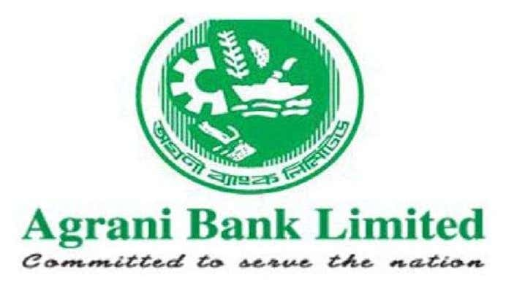

History:
Agrani Bank Limited was set up on 26 March 1972 by combining two deserted Pakistani banks Commerce Bank and Habib Bank. The Bank is completely claimed by the Government of Bangladesh. Agrani Bank is administered by a Board of Directors comprising of 12 individuals headed by a Chairman.
Beginning at 2009, the bank has 11 Circle working environments, 34 Divisions in authoritative focus, 62 zonal working environments and 941 branches including 27 corporate 40 AD branches. The affirmed capital of the bank was 8 billion. They are furthermore the owners of Agrani Bank Cricket Club.
Bank has its 561 branches out of complete 891 branches orchestrated in nation areas executing however much 29 assignments focusing in on commonplace people. During my temporary job at Agrani Bank LTD, I was set in Islami banking window, at Islampur branch.

Mission, Vision, Value Statements:
Vision: To turn into the best leading state owned business bank of Bangladesh.
Mission: To work morally and fairly inside the stringent frame work set by our controllers and exercises from best practices to improve our business arrangements and methods to the advantage of our clients and representatives
Value Statements: They esteem in trustworthiness, straightforwardness, responsibility, pride, variety, development and polished skill to give undeniable degree of administration to every one of our clients and partners inside and outside the country.

Products and Services:

Deposit
- Current Deposit
- Saving Deposit
- Fixed Deposit
- Students Saving Account (School Banking)
- Life Insurance Policy A/C
- Framers A/C

Foreign Currency Account
- Foreign Currency (FC) A/C
- Resident Foreign Currency Deposit (NFCD) A/C
- Loan & Advance

Term Loan
- Export Cash CD
- Industrial Credit
- Housing Loan
- Consumer Credit

Rural & Agro Credit
- Crop Loan
- Fishery Loan
- Agri Machinery Loan

Small & Medium Enterprise Loan
- Service Sector Loan
- Trading Sector Loan
- Manufacturing Sector Loan

Foreign Exchange Market
- Preparation of Exchange Rate
- Letter of credit
- Other Foreign Exchange Service
- Cash Service
- ATM Service
- Foreign Currency
- Fund Transfer
- Utility Bill Collection
- Issuing Foreign Draft
- Value Added Service
- Locked Service
- Issue Management

Islamic Banking Service

Deposit
- Al Wadiah Current A/C
- Mudaraba Savings A/C
- Mudaraba Term Deposit

Investment
- Bai Murabaha (Pledge)
- Bai Muazzal (Hypo)
Those are some service and there is more service in their investment sector.

Organization Structure
Board of director
Chairman
Director

Non clinical stuff member
Clinical stuff member
Attorney general
Officer
Senior officer
Principle officer
Senior principle officer
Assistant general manager
Deputy General Manager
General Manager
Deputy managing director
Managing director

Chapter Three

Discussion of HR Function



What is Human Resource?
Human asset the executives is the utilization of human asset in an association through the administration of individuals related exercises. The accomplishment of any affiliation depends upon the real, profitable and suitable organization of the HR. HR orchestrating Division is several works for HR the chiefs. The fundamental work of HR Planning Division is to portray human asset the heads framework, to keep up the individual record of each staff and official, keep up the execution evaluation, make the PRL outline and train to concerned specialist in due time, uphold increase, encashment of leave, repayment of retirement advantage, leave embrace inside and outside of Bangladesh, grant higher appraisals, update the human asset the heap up data structure and to check the political free thinker's approvals from the related organization. Existing staff strength of ABL as on 31 December 2019 is given below:
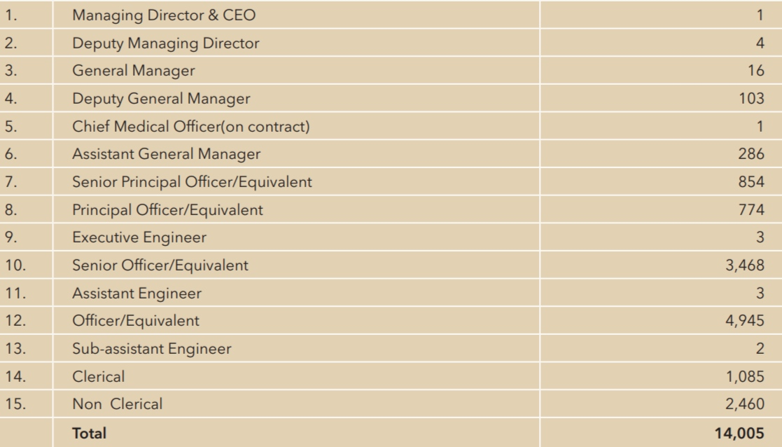

Functions of an HRM
For more specific and clearly we try to cover top 7 Function of an HRM. By this we can easily capture the whole HR related works and activates
- Job Analysis:
Describe the obligations, duties and tasks of the task to recruit the correct representatives.
- Employee recruiting & selection:
Recruit and hold qualified workers to accomplish the objectives and destinations of an association.
- Employee Training & Development:
Give to appropriate preparing and right advancement of the on-boarded competitors.
- Compensation and Benefits:
Build up impartial and reasonable compensation for everybody.
- Employee Performance Management:
Guarantee that the representatives are profitable and meet the objectives and goals of the association.
- Managerial Relations:
Decide the day by day target and how to activate the labor force.
- Labor Relations:
Give legitimate standards, guidelines and arrangements about work relations.

Human Resource Management includes the following aspects:
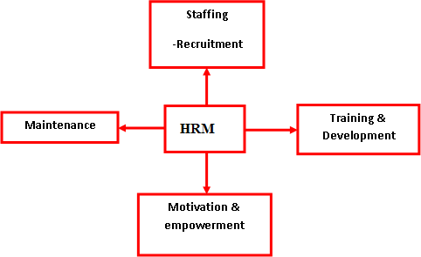



Aspects of HRM

Job Analysis:
The method of deciding the obligations and abilities need of a task. A Job analysis determines the scope and details of a job. It says about the duties responsibilities and KPI of the job.
There are two outcomes of job analysis:
- Job Description: A list of job duties and responsibilities of the job that specify the job.
- Job Specification: A list of work for the job and skills, experience needed to accomplish the job.
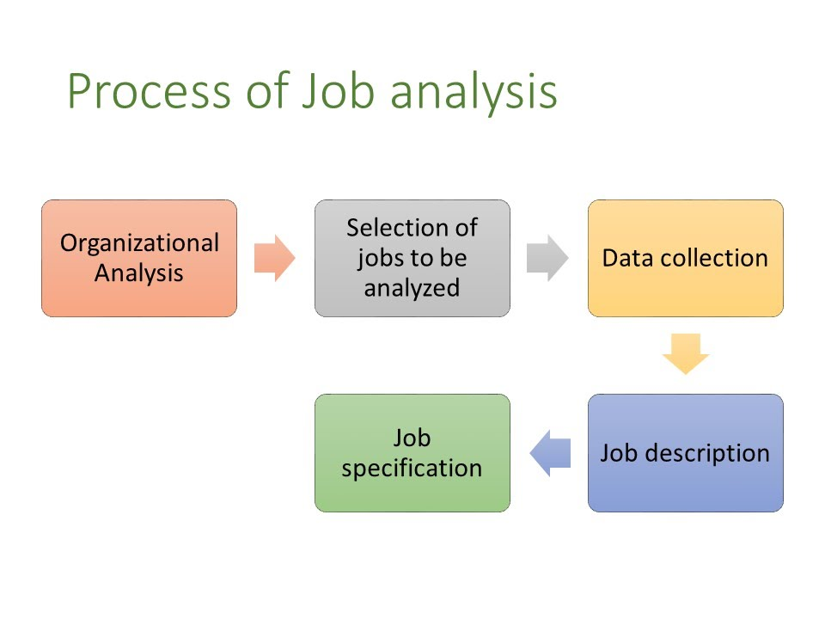
All the steps showing below to illustrate HRM practices of The Agrani Bank Limited:-

Recruitment & Selection Process
Recruitment is the way of finding accurate person for a specific position as per job circular.
Before a division finds a way to utilize staff, it should work out the kind of staff it needs as far as evaluation and rank, and the time scale in which the staff are required.The Bank recruits its officer through some process of examinations which is directly controlled by Bangladesh Bank.

The Process of recruitment:
The recruitment process is organized by Bangladesh Bank. And after that as per every government bank requisition Bangladesh Bank provides recruited employs. For recruitment Bangladesh Bank follows process pointed below:

- Advertisement: First Bangladesh bank announce advertisement of the job through National Paper of the country.

- Written Examination: After the collection of CV candidate have to sit for an examination for the job. Which will qualify the candidate’s academic knowledge and job knowledge.

- Interview of Selected Candidates from Preliminary Interview: After passing the written test the selected candidate have go for another process. They have to sit for an interview in front of interview board. In which the mental ability and other qualities checked.
- Final Posting: After passing all the process Bangladesh Bank gives posting of selected employees as per the requirement of govt. owned banks.
This process of selection is calls BRC. In Bangladesh AFTER BCS it is the most valued public office recruitment process.

Training:
The target of preparing and advancement is to empower government workers to procure the information, aptitudes, capacities and perspectives important to empower them to improve their exhibition. Staff preparing and advancement should focus on the division's targets and objectives and staff's skills in accomplishing them. A vital methodology has the following attributes:


When work here last 3month in my observation I may provide some information about training and development methods that Agrani Bank Limited follows which is given as under.

Training:
- Specific On the job Training
- Office environment learning
- Softwear learning
- Training via online session
Development:
- Job rotation
- Managerial on-the-job training

Performance Appraisal:
Performance appraisal is characterized as assessing a worker's current or past presentation comparative with their performance standard. Bangladesh Bank does performance appraisal on behalf of government. Bangladesh bank does this performance appraisal through some audit every year. For that Bangladesh Bank set some qualities for employees to maintain.
- Work standard
- Monitoring Employees performance
- Fair Notice to improve the performance.
- Encouraging the employees to improve the over all performance.

Compensations, Rewards and Benefits:
Compensation: The compensation process is managed by the Bangladesh Bank as per government compensation Scale. The other rewards are also given by the Bangladesh bank. As example every employees get housing facility education for children facility free health benefit.

Pattern of compensation
- Reward: Reward gave to the employees by evaluating their performance in the organization. It is of two types (1) Reputational reward (2) Financial reward.
(1) Reputational Reward: Intrinsic rewards is the social recognition of the employees and respected position is given.
(2) Financial Reward: It is tangible reward such a yearly bonus and other facilities which is given by the Bangladesh Bank.

- Benefits: Some special benefits are provided to the employees that is health Benefit, accommodation Benefits, Transportation Benefits, Free Education for the children, Retirement benefits are gives as pension every month.


Agrani bank ltd, provide different types of reward and benefit to their employees which is given below;
- Cash Benefit
- Promotion
- Provident fund
- Gratuity
- Group Insurance
- House building loan
- Medical facilities

Labor law/ Employee Law practice of Agrani Bank:

There is so many rules and regulation in agrani bank. Agrani Bank maintain some practices for the betterment of their employees.

Condition of the services:
There are some conditions for the employees that bank regulate to protect confidentiality of the governments assets.
- The rules and regulation are implemented by Bangladesh Bank, which employees are bound to follow.
- All rules are made on the favor of employees.

Classification of employees:
There are two kind of employees in the bank. One is permanent employee and one is temporary employee.
Temporary employees are intern that bank assign for three month/ Six month.

Identity Car:
Bank provides identity card to every permanent employees to verify.

Procedure for leave:
For any leave employees submit an application to the bank manager. The manager verifies and approve the leave if necessary for the employee.

Retirement policy:
The retirement policy of agrani bank is selected by the Bangladesh Bank. Bangladesh Bank selected retirement age as per the government policy.

Health and Hygiene:
Agrani Bank provides clean and hygiene working environment for their employees.
- During the Covid 19 situation bank provides necessary musk’s hand gloves and also hand sanitized to every employees.
- Not only that the Bank provides rules to maintain social distance for employees and the customer of the bank.
- They also provide water purifier for the employees which is maintained daily basis.
- Bank also provides separate dining room for employees so that they can have their meal properly.

Safety:
Bank provides general safety to their employees and also they provides some facility to customer.
- Bank has a fire exit in case of emergency
- Bank provides Police protection for the customer if the customer demand to have.
- Bank has some fire extinguisher for emergency situation.

Chapter Four

Analysis and Findings



Analysis and Findings of the report

Everything has a positive side and negative side. We should consistently focus on both sides. I have discovered few points by screening my working environment.
- The administration of this bank isn’t completely modernized. We are living in modern era. In this era almost every bank use modern equipment’s. Agrani banks has a lack of modern equipment’s.
- It provides compensation according to the government pay scale. As it is a government bank it is regulated directly by the government.
- In this branch the equipment’s are not up dated. In this modern era to provide fast and more secure banking facilities bank should update its equipment’s.
- Performance appraisal is being followed, but realities they don’t, they only setting their target or standard for branch manager.
- Employees have good relationship each other.
- Salary given by their position and by their ages, not performance based.

Chapter Five

Recommendations & Conclusions


Recommendation:
I discover something that is a few suggestions, if the bank follows the proposal mentioned bellow;
- Employees need to follow or use modern things or up-to-date things. Its improve employees performance.
- To increase the productivity of the employees bank can offer bonus based on basic salary
- Every branch needs HR department that helps employee a lot. HR department easily follow up employee and they give proper feedback regular basis.
- Employees need regular basis feedback, HR need to follow up them and give regular basis training in good manner. ( Employee who needed)
- Performance appraisal is being followed regular basis for every work.
- This branch need to updates their computers and equipment’s that’s used in daily basis.

Conclusion:
This Internship report proposed to perceive HR practices of Agrani Bank Limited. I am amazingly fortunate that I found the opportunity or chance to work here. Through working for them this workplace came even more close to me. Their HR exercises are substantially more-clear in commonsense work life. The point I have picked is a fundamental piece of HR subject. How an association deals with its human. Resources can be effectively sorted out by contributing this piece of HR. This will result is workers feeling submitted and vigorous towards the affiliation. Every affiliation should open the entryway for fresher to do their temporary job and help them appropriately. I got full assistance from my supervisor similarly as from the affiliation. This will show how much representatives are centered on their work.

Bibliography

- (Agrani Bank, 2020)
- (Agrani Bank, 2011)
- (Annual Report, 2010)
- (HR Policies and Practices in Agrani Bank Limited, n.d.)
- (Annual Report 2013, n.d.)
- (Annual report 2013, n.d.)

Appendix

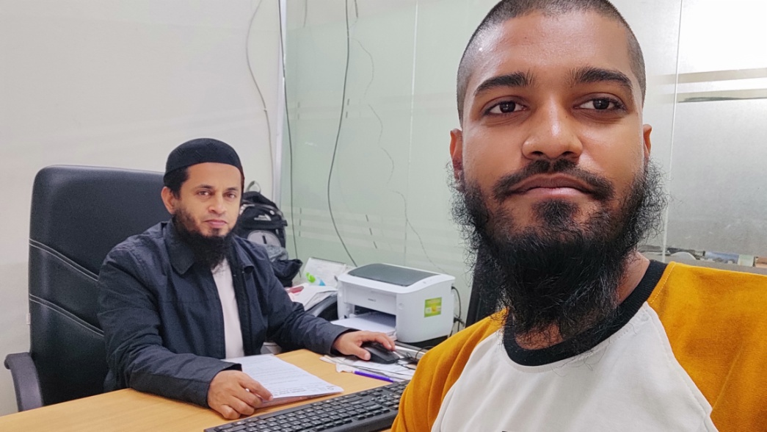
Foysal Noman
Manager
Agrani Bank LTD
Islami Banking Window, Islampur branch, Dhaka
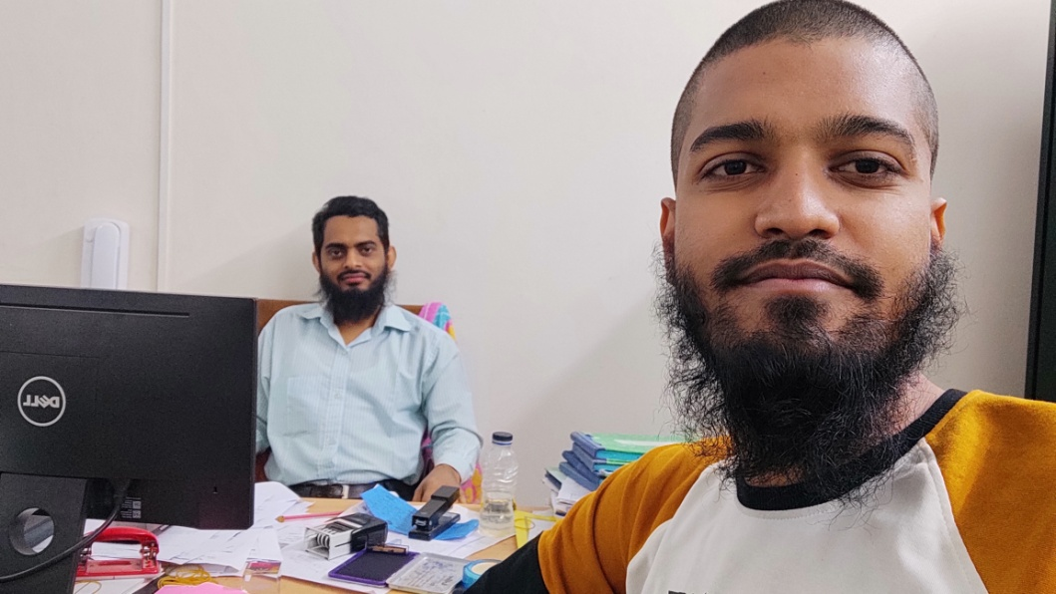
Arifur Rahman
Senior Officer
Agrani Banking LTD
Islami Banking Window, Islampur Branch, Dhaka

