Promotional Activities of Aarong: A Leading Brand in Retail and Lifestyle Industry in Bangladesh

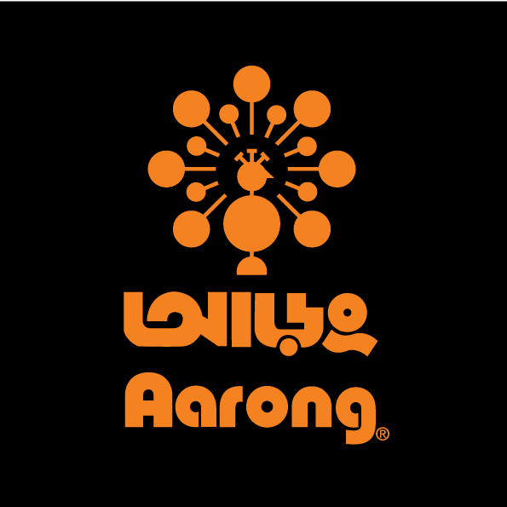



Promotional Activities of Aarong: A Leading Brand in Retail and Lifestyle Industry in Bangladesh

Submitted To:
Dr. Md. Shariful Alam
Associate Professor
School of Business and Economics
United International University

Submitted By:
Israt Jahan Eme
ID: 111133169
BBA

Date of Submission: 15th July, 2020
Letter of transmittal
July 15th, 2020
Dr Md Shariful Alam
Associate Professor
School of business and economis
United International University

Subject: Submission of Internship Report
Dear Sir,
With due respect, I am submitting my internship report on the topic “Promotional activities of Aarong, A leading brand in Bangladesh retail and lifestyle industry.” which has been compiled as per your requirements for completing my BBA program.
Prepared this report is based on my experience practical experience of Aarong. The experience is helping me to better understand about an organization and how an organization promotes itself and it help me in my future career to be a good marketer.
I would like to express my gratitude to you for providing me the valuable assistance and guidance for completing this report. However, it will be a matter of joy if you enlighten me with your views and thoughts regarding the report. I’ll wholeheartedly welcome any clarifications and suggestions needed in this report.
Sincerely,
Name: Israt Jahan Eme
ID: 111133169

Acknowledgement
This report is based on my entire experience about Aarong. The journey learns me a lot and I gathered a lot of things in my mind which will help me in my future career. It is the great chance for anyone to see closely how successful organizations like Aarong doing and operating their business proudly. At first I would like to thanks my Almighty Allah to enabling me to complete this report about promotional activities of Aarong, A leading brand in Bangladesh retail and lifestyle industry. My supervisor Dr. Md shariful Alam, I would like to thank him to choose me the topic and help me to complete this report.” I also thanks to United International University, school of business and economics for arrange the internship program where students can practically experienced the corporate life with fulfil academic requirement.

Executive summary
This report is about the Promotional activities of Aarong, a popular lifestyle and retail brand in Bangladesh established in 1978 with the purpose of reducing poverty from the rural area. Aarong is an enterprise of a non-profit NGO BRAC. From 1978 to now, in that long journey, Aarong now has 21 outlets with Taaga outlet and also give online service with their web page. With that online service, they provide home delivery service also with various delivery options. Aarong has 13 AAF centers from where Aarong collects their products. More than 70000 artisans all over the country earn their livelihood from work with AAFcentere. In this report the first chapter is all about origin, a brief introduction of Aarong, objective, scope and limitation of the study. Here detailed information is given about Aarong. Chapter two is the methodology part that discusses the data collection method and types of data. The third chapter is about background, logo, mission, vision, values, growth, operational activities, product line, and channels of promotion, competitor analysis, and swot analysis. The next chapter is about research findings and analysis. After all of those, the last one is about the conclusion, recommendation, and reference.

Table of content
Topic Name | Page Number
Chapter 1: Introduction  - Origin of the report  1.2 A brief introduction of Aarong  1.3 Objective of the study  1.4 Scope of the study  1.5 Limitation of the study | 1  2  3  3  3  3
Chapter 2: Methodology of the study  2.1Data Collection Process  2.2 Types of Data | 4  5  5
Chapter 3: Organizational Overview  3.1 Background  3.2 Logo  3.3 Mission  3.4 Vision  3.5 Values  3.6 Growth  3.7 Operational Activities  3.8 Product line  3.9Channels of Promotion  3.10 Competitor Analysis  3.11 SWOT Analysis | 6  7  8  8  8  8  9  9  10  16  16  17
Chapter 4: Research Findings and Analysis  - Promotional Act ivies  Advertising  Sales Promotion  Internet Marketing  Direct Marketing  Personal Selling | 18  19  19  19  23  25  27
Chapter 5: Conclusion And Recommendation  Conclusion  Recommendation  References | 28  29  29  30

Chapter 1
Introduction

  - Origin of the report
The topic of this report is the promotional activities of Bangladesh most popular retail shop Aarong. My supervisor Dr. Md Shariful Alam, faculty and assistant professor, School of Business and Economics, United International University, help me to select the topic. The main purpose of the report is to give an overall view about Aarong which I practically experienced.
1.2 A brief introduction of Aarong
Aarong is the most popular retail sector in Bangladesh. The name Aarong means village fair and it is the sister concerns of BRAC which is the world largest NGO. The founder of the BRAC Aarong is Fazle Hasan Abed. The brand began their journey in 1978 to empower rural artisans to rise above property.
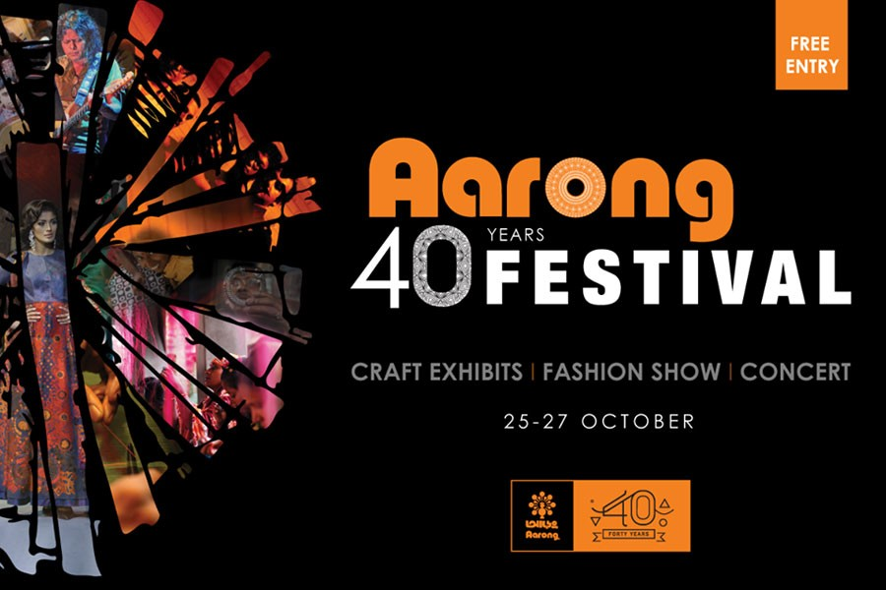
Aarong is now one of the largest fashion and lifestyle retail chain in Bangladesh with their 21 outlets all over the country and over 100 fashion and lifestyle product lines. Aarong has also an e-commerce sector (www.aarong.com) with that they also provide the best customer service to their customers. Aarong turn 40 years of their retail journey with their great product and service.

Aarong has a large number of product lines and those are cloths, jewellery, fabrics, household products, leather, brass, cane, wood, clay, herbal products, and foods.
Aarong provide handmade product to the customer which is made by the rural people with their own merit. Aarong also give a chance to those people who want to be an entrepreneur and don’t get the chance to show their talent and with concern of that Aarong take some products from some independent producers and also Aarong concern about those products quality. Aarong do some agreement with their independent producer where they ensure the product quality and uniqueness.
20th December 2019 the founder of Brac and Aarong sir Fazle Hasah Abed passed away.
1.3 Objective of the study
The objective of the report is to provide a brief summary of promotional activities of Aarong, which is the most popular retail sector in Bangladesh. With this report we can see how Aarong make differentiate them from other and how they compete with their competitor. This report is also the basic requirement of my education.
  - Scopes of the study
This report is about Aarong’s promotional strategy and this also covers Aarong’s history, products, services, process flow also the competitor analysis. This study will be helpful for the learners to know how to promote a brand.

1.5 Limitation of the study
Time is the main limitation point to complete this report. There have some boundaries to share all types of information to broader way.

Chapter 2
Methodology of the study

2.1 Data collection process
Primary data and secondary data both used in this report. The organizational information like history, logo, mission, vision, values, product information’s are secondary data which is collectives from the Aarong website. And the findings of promotional activities are the primary data which is found from the organizations internal people like marketing department.
2.2 Types of data
1. Primary: Data collect from the organizational internal people, employees, my supervisor and some is from the observations.
2. Secondary: The source of secondary data is the web site of Aarong, research paper, media advertising.

Chapter 3
Organizational overview

3.1 Background
With peoples love and affection, Aarong successfully pass 40 years of their retail life, and also hold the position of best Bangladeshi retail brand in the retail sector. Aarong start their journey in 1978 to empower the rural people and artisans to rise above the poverty. Aarong mainly focus the rural women who have the potential to hold on our tradition with their work.
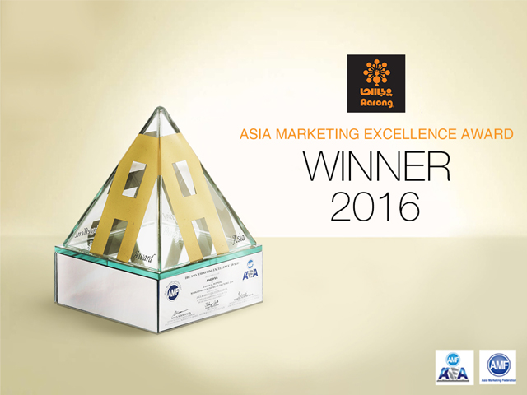
Aarong start their journey in 1978. Its purpose is to support rural artisans to find market to their product and now Aarong supports more than 65000 artisans. The founder of Brac Sir Fazle Hasan Abed established the world largest development organization Brac in 1972. Brac survey the Bangladeshi market and find that the rural woman has a magic on their hand, they make beautiful handmade product but they has no place to sell those and if they can get a place to sell their product they can remove their poverty. With this sense in 1976 Ayesha Abed who is the wife of Fazle Hasan Abed started some project to make nakshi kantha, cane basket, mats, and jute products. After her departure in 1982, a trust was initially set up by contributions from late Ayesha Abed’s family. This is treated as Aarong production centre and supplies all of its production to Aarong and here artisans are given various skill development trainings. Aarong has some IPs means independent business persons who supply products to Aarong upon order. IPs has been affiliated with Aarong since its first year. Aarong directly communicate with their end consumer through 21outlets service also with online service. In September 23, 2016 Aarong win the award of Marketing 3.0 which was organized by Asian marketing federation (AMF). In 2017 Aarong got the best craft brand award.

3.2 Logo
The logo of Aarong is combined with two colour one is orange and another one is black. Orange shows the symbol of energy, warmth and the black shows the professionalism, elegance. In Aarong’s logo there shows an image of peacock which reflect the brightness and pride. The logo is emphasizing the eco-friendly products.
3.3 Mission
The mission of Brac Aarong is to empower people and communities in situation of poverty, illiteracy, disease and social injustice. Their interventions aim is to achieve large scale, positive changes through economic and social programs that enable women and men to realize their potential.
3.4 Vision
A world free from all forms of exploitation and discrimination where everyone has the opportunity to realize their potential.
3.5 Values Brac Aarong strictly focus on 4 values:
3.6 Growth
Aarong has now 21 retail shops all over the country like Dhaka, Chattogram, Khulna, Halishahar, Sholoshahar, Mymensing, Narayanganj, Sylhet, Cumilla, Bogura. With those outlets they also provide service with their online shop.
Aarong’s key achievements at a glace
- Leader in Bangladesh craft fashion industry
- Revival of Nakshi Kantha, Jamdani and Muslin
- Popularizing the cotton handloom industry
- Introduction of AZO, PCP free dyes in cotton fabric production
- Winner of Asia Marketing Excellence Award 2016
- Award for Best Craft Brand 2017

3.7 Operational activities

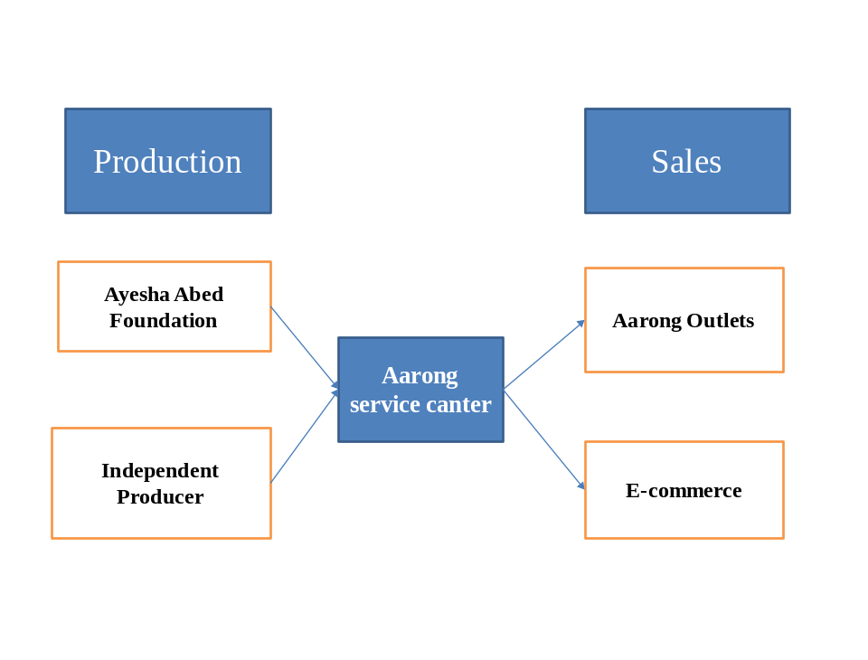
Figure: Operational Process of Aarong

3.8 Product line

Household:
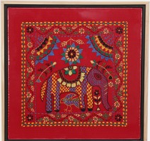
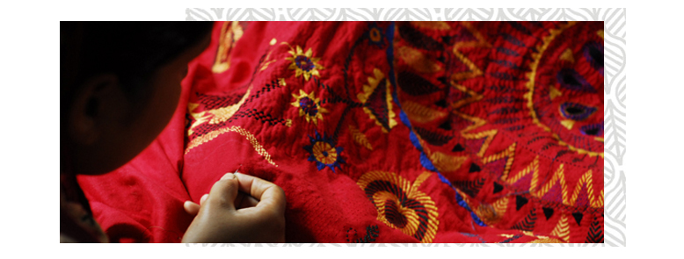
Household items are mainly the textile items. Different types of bed covers are available like: king/master bed, Queen/ double, Semi double and single. Based on kids test and choice Aarong also include the curtains for kids’ room decoration. Table cloths are also based on 6 chairs and 8 chairs. Cushion cover sizes are available with 14, 16, 20, 24, and 30.

Home decor:
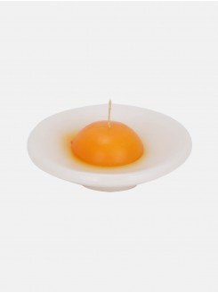
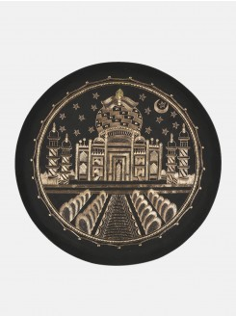
Aarong has too many home decor items and those items are made with wood, clay, cane, bamboo, paper, ceramic, brass, wrought iron. Decorative items are included with candles, candle stands, lantern, wall hanging, tapestry, mirror, flower vase, planter, lamps, lamp shades, mug, glass, plate, bowl, tea pot, key ring, hammock, painted rickshaw decoration piece, door hanging, wind chime, dry flower, desk calendar, wall clock and so on.
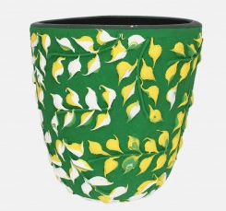
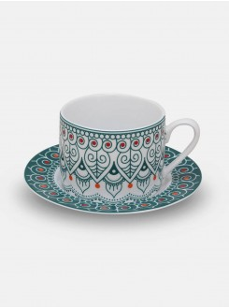
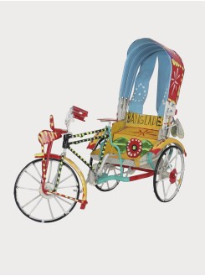
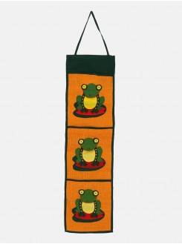

Means wear:
Aarong focus on different level of customer and based on that they produce different types of product with customer choice and preferences. For men’s wear Aarong produce their Panjabi in cotton fabric, adi cotton fabric, silk, endi-silk, endi-cotton fabric so that based on customer choices customer can find out their comfortable and desirable product. The size of the Aarong Panjabi start from 38 and the end size are 48 and it has also regular fit and slim fit option. The size of Aarong cloths is two inch larger than other brand and non brand products. Shirt and T- shirts size are also start from S and end with XXL.

Product Name | Type
Panjabi | Regular, Exclusive
Pajama | Aligori, Churidar, Shalwar
Shirt | Ethnic, Casual, Executive
Tee shirt | Regular, Polo

Women’s wear:
Jamdani is the tradition of Bangladesh. With Jamdani saree, aarong produce muslin, silk, cotton, katan. Aarong’s Shalwar kameez is also 2 inch larger than other brand and non brand cloths. The size of the shalwar kamieez is also start from 32 to 46. Aarong is also produce ladies Panjabi which is unique from other brands and the demand of the product is very high from the customer end and customer highly satisfied with this product. With ladies Panjabi Aarong also produce Kurta, long dress, maternity wear, dupatta, scarf, unstitch febrics.

Product Name | Type
Saree | Cotton, Muslin, Silk, Katan, Nakshi kantha, Jamdani, Brac silk
Shalwar Kameez | Casual, Semi-dressy, Exclusive
Shawls | Viscose, Cotton, Silk, Nakshi kantha
Fabric | Cotton, Silk, Muslin, Linen and Cashmilon, 3 piece set, 2 piece set

Leather items:
Cow, Goat, buffalo, sheep leather are use to produce Aarong leather items. Genuine leather and suede leather both are used to produce shoe, bag, belt, wallet, file cover, pen holder,

Product Name | Type
Shoe | Sandals, Shoes, Heels, Pumps, Nagras
Bag | Regular, Executive, Mobile holder, Passport holder, Shopping bag
Jewellery box | Lipstick case, Finger ring box, Earring box, Bengal box, Watch box, Mirror, Pen holder, Card holder

Jewellery:
All gold jewellery of Aarong is gurrenteed to be 21 karat and for the diamond jewellery gold is 18 karat Belgium cut diamond. Silver are original deshi silver and the pearls are original cultured pearl. Fashion jewellery items are mainly junk jewellery those are made with wood, brass, metal, fabric, puthi. Thoseall jewllery items are produce with Aarong own employees. The design of Aarong jewellery is highly appreciated by their customer.
Aarong also provide after self service for gold, diamond, silver and pearl jewellery. For gold items, customer can exchange that within 3days and for than they don’t lose any amount. After 3days, customer lose 12% on exchange the product and for the cash refund the customer cand refund the money based on their purchase value and they lose 25%. For Diamond, the customer can change the product within 3days and don’t lose any amount, after 3days they lose 10% for exchange that item and for the money refund the customer lose 20%. But customer can’t change the nose pin items.
For silver item, customer can exchange the product within 7days and they lose 12% if they want to exchange that product. For silver items, customer also get the after sale service. Customer can wash and repair the silver product for life time. For repair some additional charge may include but for the wash they can enjoy this service with free of cost.

Product Name | Type
Gold | Earring, Finger ring, Mala, Bangles, Bracelet, Nose pin, Locket, Chain
Diamond | Nose pin, Finger ring
Silver | Ear ring, Finger ring, Toe ring, Mala set, Payel, Bangles, Bracelete, Baby bala, Tickly, Tayra, Nose pin, Nolok, Locket, spoon,
Gold Plated | Mala, Earring, Finger ring,
Pearl | Mala, Bala, Earring, Finger ring, Locket, Bracelet, Payel
Fashion Jewellery | Mala, Bala, Earring, Finger ring, Toe ring, Payel, Nolok, Bracelet

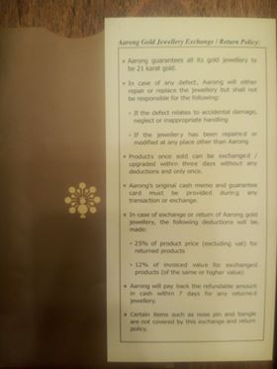
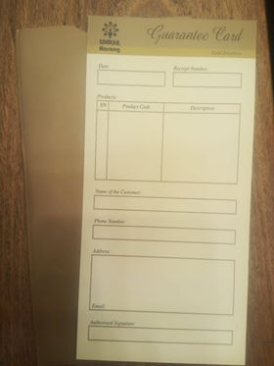
Customer can change the gold and diamond items. When customer purchase gold or diamond items they receive a guarantee card. When they want to exchange or refund against the gold or diamond items they have to show the guarantee card. All the terms and conditions are written opposite site of that guarantee card.

3.9 Channels of promotion

3.10 Competitor analysis
In this era of technology now competition is higher then before. Being the number one retail brand and keep in that place is more tough. Aarong has their own style to serve their product and service to their consumers and it happily accepted by their consumers. Some of the competitors are now try to copy that pattern of product and service to improve their brand. Some of Aarong’s competitors are Anjons, Deshi dosh, Bishwo rang, Kay kraft, Some online business are compete with Aarong with their niche product line like Biskut Factory.
Aarong has their own version of competitive analysis and they are so clear about that and with that strategy they successfully complete their 40 years of retal journey.

3.11 SWOT analysis
Strength: As a sister concern of Brac, Aarong got an extra advantage with that it helps them to get easily acceptance from people of Bangladesh. Also Aarong has a strong financial foundation. Aarong mainly focus on handmade traditional product and for that reason the perception of people are totally different about Aarong rather than any other retail brand. Now Aarong is the number one leading brand in the retail brand industry. The office environment of Aarong is gender friendly.
Weakness: For any kind of decision making Aarong always depend on Brac. Productions are decentralized. Products are handmade and thats why the price of the products are high. There a lack of automation.
Opportunity: The demand of craft item are growing day by day and because of that Aarong got more acceptance from the people who want crafty products.Aarong always try to innovate and add new product lines. With the addition of e-commerce site Aarong can provide the online service where people are now feel more comfortable to do shopping from from and got the product with fast home delivery service.
Threats: In this economical growth stage competition is very high and the business industry is grown up day by day. Customer are more conscious about the product price and also the product quality.

Chapter 4
Research findings and analysis

4.1 Promotional activities of Aarong
Advertising
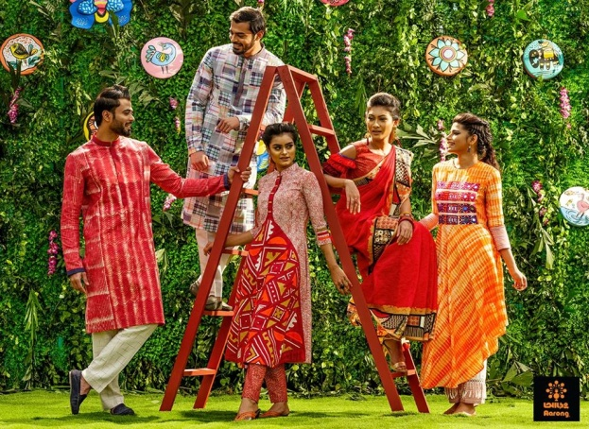
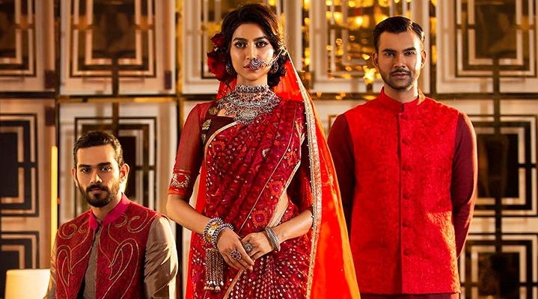
Aarong promote their products through advertise via billboard, print media. For every occasion like Wedding, pohela fulgun, valentine, international mother language day, Independent day, Women’s day, Pohela boishakh, Victory day Aarong create new bill board and photo shoot for print media advertising. 2018 Aarong create ramp walk for promote their Pohela Boishakh collection. Aarong celebrate their 40 year journey with 3 day long program at Army stadium. The name of the program was Aarong 40 year’s festival. Where they arrange some feature where visitors can experience live craft demonstrations of different crafts, craft workshop, craft exhibits, arrange producer award ceremony, Fashion show, arrange 3day long concert.

Sales promotion
Aarong give a yearly sale where they try to reduce their quantity which is called yearend sale. The preparation of that sale is huge and they give that sale on all of their outlets and also in their e-commerce site. The promotion of that sale is given on their web site, facebook page, newspaper, billboard, and give message on their consumers mobile also. Aarong select some items and give up to 70% discount on those specific items. The duration of that sale is not more than one month. Before stated the sale customers were aware about the sale and they also make some preparation for that big sale.
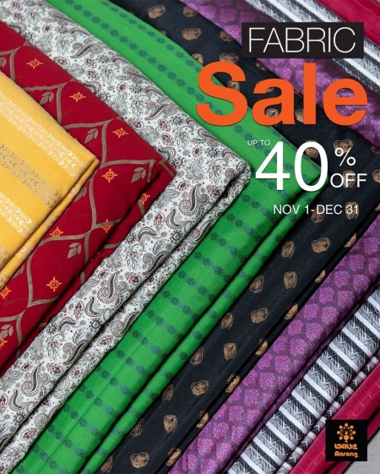

In any occasion some bank and bkash offer a certain amount of cash back or discount offer to attract the customer attention. Bank or bkash they jointly create that agreement with Aarong. With this types of promotional offer customer can benefited from their bank and bank will give those benefit to their customers. Aarong has no liabilities on those types of promotional offers.
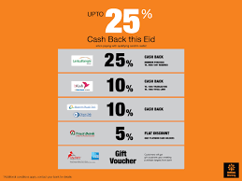

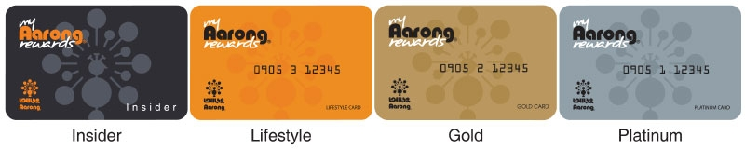
Anyone can be a member of Aarong with purchase any amount and share their contact number to the server of Aarong and they will be the Insider stage of Aarong family. For insider, there has no physical card facility but they can always keep in touch with Aarong. Insider can know about Aarong new collection news, promotional news, can get some bonus points all they can get via sms to their mobile phone. Aarong has the physical membership card facilities and any customer can be a member of Aarong if they can shop of 10000 taka without VAT from one outlet within one day. Aarong has 3stage of MARC (My Aarong Rewards Card), 1st is lifestyle then gold and next is platinum stage.

For lifestyle members they will earn 1 reward point for every Tk. 100 spent at Aarong outlets across the country. For gold members they will earn 2 reward points and for the Platinum members they will earn 3 rewards points.
Collecting a minimum of 100 points entitles the My Aarong Rewards member to redeem points. 1 point equal to Tk. 1 and fraction point can be earned.

Card Type | Status keeping during 24 month | Upgrade duration 24 month
Lifestyle | 250 points | 3,000 points for Gold Card
Lifestyle | 25,000 Tk shopping | 30,0000 Tk shopping
Gold | 1000 points | 8,000 points for Platinum card
Gold | 50,000 Tk shopping | 40,0000 Tk Shopping
Platinum | 3000 points | N/A
Platinum | 1,00,000 Tk Shopping | N/A
My Aarong Reward Cardholder can redeem points in multiples of 50 points. i.e. redeemable at 100, 150, 200 points. Minimum redeemable points are 50. My Aarong Rewards Card cannot be used on discounted or promotional items. Aarong reserve all the right to cancel or discontinue a card at any given time. This card is not a cheque guarantee or credit card.
Aarong and some company jointly arrange some facilities for MARC holders. Sometimes MARC holders can enjoy those facilities with their families also and get a certain amount of discount.
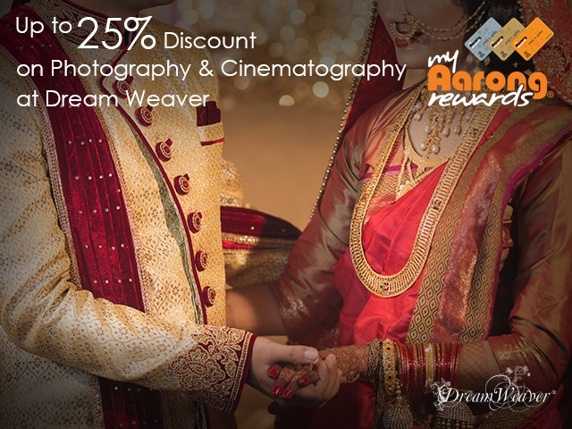
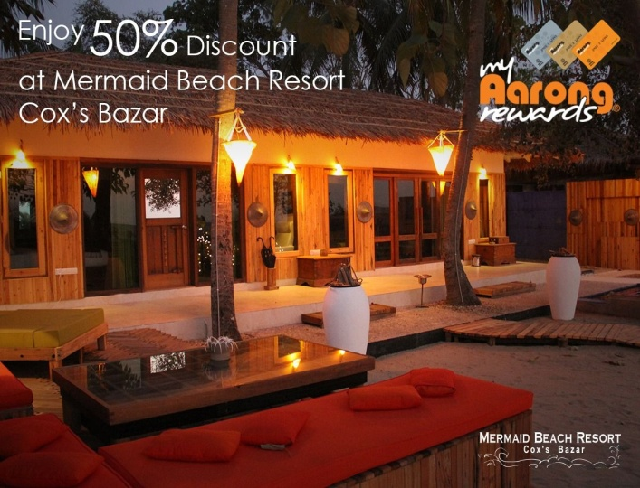
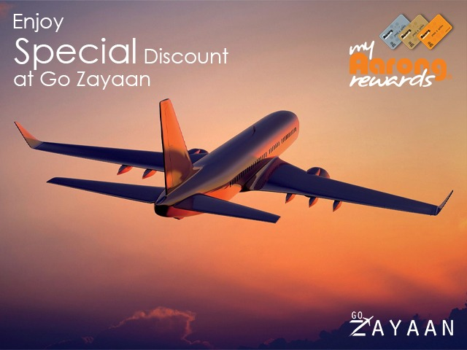
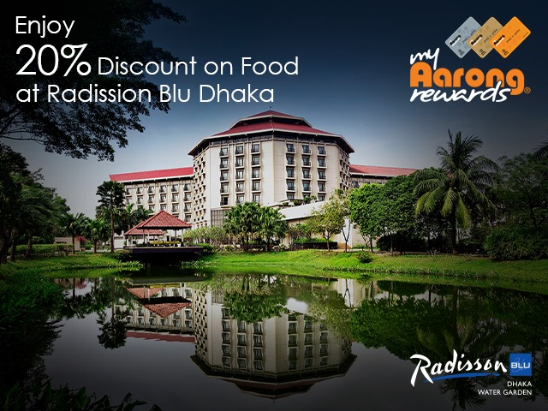

Internet marketing
Aarong maintain their business through outlets and also with their web site. www.aarong.com is their official web site with that web site anyone from anywhere can do shopping from Aarong and they don’t need to come to the outlet. From 16 july 2014 Aarong bring that service for their consumers.
Billing and payment methods: After the confirmation of the order a system generated invoice will sent directly to the customer registered mail id, or as an alternate they can find and reprint the bill from their personalized Aarong account and prepare for the payment process. The VAT is applicable for purchase from e-commerce also. The readymade garments is 7.5% and for others product is 5%.
Payment: To provide client the best and convenient service Aarong have introduce the fastest, reliable and easiest payment options as stated below:
- Payment via visa, master card (debit, credit and gift card)
- bKash
- Cash on delivery

10% discount for BRAC employee on e-commerce purchase.
Shipping and delivery: Once the item leaver from Aarong warehouse , the shipping method the customer choose on the checkout page determines how quickly customer shipped item delivers to their doorstep. Customer can choose a different shipping method for each item on their order. As add on they can also check their destination for availability of shipping.
Shipping method:
- Standard shipping: Deliver within 3-4 business days.
- Express Shipping: Delivers within next day or 48 hours.
- International Shipping: Currently not applicable.

Shipping cost:
- Customer can avail Free Delivery at their intended address for a purchase of more than BDT 5000 (total weight must be no more than 3kg)
- BRAC employee can avil FREE DELIVERY at Brac center, Aarong center, Brac university and Brac head office( purchase of any amount)

The standard shipping costs is given below:
Shipping method | Shipping Time | Shipping Cost
Standard Shipping | 3-4 business days | BDT 80
Express Shipping | Next day | BDT 200
International Shipping | N/A | N/A
Normal Shipping:
Weight | Costing | Shipping Method
1kg | TK 80 | Normal Shipping
2kg | TK 120 | Normal Shipping
3kg | TK 160 | Normal Shipping

Next day Delivery within Dhaka City additional TK 200 within normal shipping rate.
Express shipping:
Weight | Costing | Shipping Method
1kg | TK 280 | Express shipping
2kg | TK 320 | Express Shipping

Above cost is for the first 1kg. Once the weight of order crosses at the limit, that weight will be charge TK. 40 as additional charge per kg.

Direct marketing
Aarong sell their product directly to the end customers who consume the product. Aarong has total 21 outlets. Within Dhaka Aarong has 14 outlets and in outside Dhaka they have 8 outlets and Aarong has an web site with those they directly reach to the end of the consumer and who are the real customers of those products.
Within Dhaka Outlets | Outside Dhaka Outlets
- Dhanmondi 1  - Dhanmondi 2  - Mogbazar  - Mirpur 1  - Mirpur 2  - Uttara  - Wari  - Gulshan  - Jamuna future park  - Banani  - Bashabo  - Bashundhara city  - Narayangong | - Chattogram  - Halishahar  - Sholoshahar  - Sylhet  - Khulna  - Cumilla  - Bogura  - Mymensing  - Jessore

Aarong Gift Voucher: Aarong has the gift voucher (AGV) facilities. AGV is introduced to the customer as a smart solution to their gift purchasing problem. There are four types of amount of available: 100,200, 500 and 1000.
Customer can purchase Aarong gift voucher (AGV) and gift it to their friends/family or they can use it themselves. One can take any product from any regular Aarong outlet in exchange of equal amount AGV.
Aarong gift Voucher (AGV) has a validity of 2year from the purchasing date. One AGV can use only one time, cannot be used multiple times.
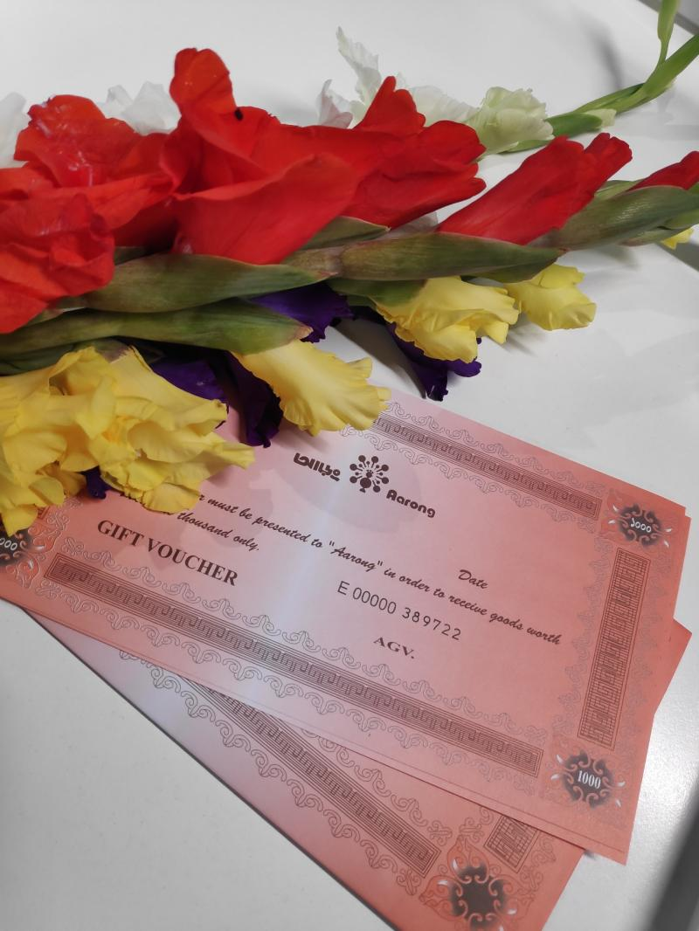

Aarong Gift Card: Aarong also has Aarong gift card. Anyone can purchase this from any outlets of Aarong and also from the Aarong web site (www.aarong.com). Four types of amount are available in gift card: 1000, 2000, 3000, and 5000.
This card can be redeemable from any physical Aarong outlets including Taaga outlet. Card can be redeem within one year from the purchasing date. This card is for single transaction and if there have any remaining amount, is not exchangeable with cash or other.

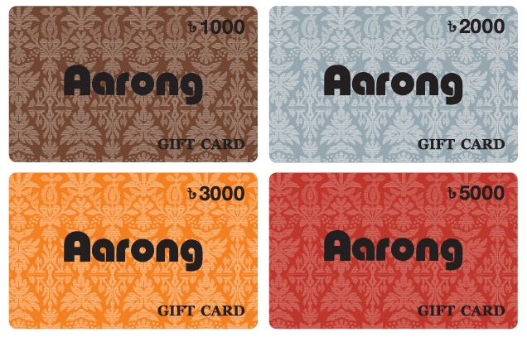

Alliance Gift Voucher: Different organization present gifts to their employees on different occasions. They come to an agreement with Aarong and make their customized gift voucher. This gift voucher is issued from Aarong central Service (CS).
These gift vouchers have different types of discount offers and different types of validity as per the agreement. It contains both the logos of Aarong and the relevant organization.
Personal selling
Aarong has a large number of families who always work for their customer how they do better from their end. Aarong also has a large number of Sales Associate whose main duties and responsibilities is to give outstanding service to their customer. For all outlets Aarong has permanents stuff who gives the service over the year to their customer and before Eid, Aarong hire a large number of employees only for the Eid and the validity of that employees is one month. Eid-ul-fiter, which is a very big event for muslim country like Bangladesh. People of Bangladesh are celebrating this occasion with their family and friends.

Chapter 5
Conclusion and recommendation

Conclusion
Being a popular lifestyle and retail brand Aarong proudly pass their 40 years journey. From the very beginning to now they help the artisans. Aarong always collect feedback from their customer and improve those lacking areas. Aarong represent the Bangladeshi culture outside of the country with their products and product designs, they protect the designs.
Recommendation
Aarong have to more concern about the design and quality of their product. They should improve their online service facilities with give more focus and attention of customer care service. If Aarong can deliver their product outside of Bangladesh customer will be very happy who want to do shopping from Aarong and want those product to their desire destination. Aarong can increase their outlets outside of Dhaka.

References:
- https://www.aarong.com/
- http://www.brac.net/
- https://en.wikipedia.org/wiki/Aarong
- https://en.wikipedia.org/wiki/BRAC_(organisation)

