‘PROJECT REPORT’ On
Corporate governance and corporate sustainability
Submitted in the partial fulfillment of the requirement for the award of degree of
Bachelor of Business Administration (BBA)
United International University



Under The Supervision of: Submitted by:

Mofijul Hoq Masum Rafia Habib
Assistant Professor ID: 111141274
School of Business & Economics United International University
United International University
Date of Submission: Spring 2018



LETTER OF ACKNOWLEDGEMENT:

“Acknowledging the debt is not easy for us as we are indebted to so many people”. I grave this opportunity because of this project report is the result of unbelievable amount of inspiration, willingness and all type of support that I have received from others.
At first, I would like to say that I am grateful to Allah for giving me patience, courage and time to complete this task properly within the scheduled time.
I would also grateful to my honorable and respectable Teacher Mofijul Hoq Masum, Assistant Professor of school of BBA Program of United
International University, who support me in organizing my entire project. Without his valuable support and cooperation showed me the way towards the successful and proper way of completion of project.
At last, I would like to say that I have tried hard and soul for preparing this report in time and correctly. However, there might be some mistake and silly error due to my ability and time constraint. In this point, I seek your extra consideration towards my mistake.

LETTER OF TRANSMITTAL:
Mofijul Hoq Masum
Assistant Professor
School of Business & Economics
United International University
Subject: Submission of the project report titled corporate governance and corporate sustainability.
Dear Sir,
I am very much pleased to submit my project report to you on “Corporate governance and corporate sustainability”. In the time of preparing this report, I have gathered a lot what I believe to be the most needed on sustainability reports. Experience that I have gathered in the period of my reporting will remain as a most valuable asset and its usefulness will never end in my life. I have worked hard and gathered knowledge to preparing this report. I will be always available for answering my query on this report.
I appreciate that this approach really contributes in giving my course learning a lasting shape in me.
I think that the report will meet all the demand which you want, your expectation and your support will give me a perfect idea about the subject. Please inform me about any query of this report.
Sincerely,
Rafia Habib
ID: 111141274
BBA,
United International University

Abstract:

This project paper focuses on corporate sustainability and Corporate Governance from the core of view of attachment and in correlation with the measurement of corporate performance, Corporate Sustainability Reporting that is also gaining in importance in Bangladesh. In that present time this topic in hand I mean corporate governance, sustainability is the key element of the economic era, and business investors mind all the spheres. Moreover, it helps to promoting new idea and creative resource for all the administration. It helps to support the target and fulfillment of the project. By the rule of the OECD principles (OECD Principles, 2004) it is it is think over that an effective corporate system for a company can change the system towards good enough which is also applicable in Bangladesh. A good side is also come in Bangladesh. It is good for us. Corporate sustainability is a good sign of our country. Now Bangladesh Company, bank and other institution can incorporate their idea, thought about the society. In addition, environment aspect includes in it.

EXECUTIVE SUMMARY:

Corporate Social Responsibility has been well defined as “the integration of business
operations and values whereby the interests of all stakeholders, including customer,
employees, investors and the environment are reflected in the organization’ policies and actions” all over the world. Corporate Social Responsibility also deal with own citizen social welfare, a wide responsibility. Corporate social responsibility goes into a business model, which is also reflect in Bangladesh.
Every work has a purpose. I have a clear purpose to do this project report. Purpose is to understand the CSR including its element, which contributing the key rule concept to the increase market share and profit.
This report includes the introduction, which incorporate topics like origin of the study, objective of the study, background of the study, methodology of the study, limitation of the study in the first part. Here I describe a way and the background of the study to prepare the report. In the next part of the report, I put a brief highlight about corporate governance in the era of Bangladesh.
In addition, most important the main part of the report is an exploration of the CSR activities with different type of industry. Finally, I have tried to explain the impact of CSR on different industry of Bangladesh.

Table of contents:
Introduction………………………………………………………………….1-6
A brief Introduction………………………………………………………….3
Rational of the study…………………………………………………………4
Background of the study…………………………………………………….5
Limitation of the study………………………………………………………6
Objective of the study……………………………………………………….7-8
Methodology of the study…………………………………………………...9-10
Literature of the study………………………………………………………11-18
Findings and analysis……………………………………………………….19-20
Conclusion………………………………………………………………….21-22
Reference………………………………………………………………..….23-24

Introduction


  - Introduction:

Corporate sustainability and corporate governance standard systems are a wide range of system in the era of business industry to promoting new idea. A company can adopt the sustainability idea or not it only depends on the organization. It is a voluntary system. This standard of corporate sustainability is not created and not adopt only for the government pressure. Instead of this sustainability standard systems are non-government initiatives that only create for own idea and the growth production to meet its own target demand. This approach is helpful both the consumer and the business which is a wider version of sell and guide all the product of a company.
Corporate sustainability standard is very popular day by day. There are now very few industries, which are, not concentrate on corporate social responsibility. Now a day all type of industry focuses on CSR for their own fulfillment. In addition, this demand in increasing supply and the other production side.

  - A brief Introduction:
Corporate Governance and corporate sustainability is a global process but is a voluntary system means non-government system as well as in Bangladesh. It is a strategy to incorporate the strategies and idea to focus on the best point and decision. Can we say something clear about corporate governance and corporate sustainability? We all know many definitions. Yes, there are lot of definition about sustainability as well as Bangladesh. Now Sustainability is growing up rapidly.

Now I give a brief idea about sustainable development. Sustainable development build on three pillars. Such as economic pillar, social pillar, environmental pillar. At first comes the economic pillar, which is used for profit generating to fulfill the demand. Then comes the social pillar, which focus only the people like individual and the other group company. Last, the environmental pillar focuses on the protection of the natural resource the welfare of the society improvement of the society etc. that are related to the environment. Quality of an environment impact a lot on the society.

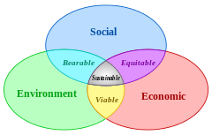

From our analysis according to different company in Bangladesh, a company is interested to seek the sustainable development to measure its performance. In addition, there is a question how a sustainable standard can help to fulfill the goal. Sustainable standard a helpful strategy to earn asset up goal. In all industry, perspective there is a need for environmental and social era. Sustainable development is a measurement indicator to develop a society all type of need, which is also established in Bangladesh. As we know the most known the Global Reporting Initiative (GRI), which focus that topic mean sustainable development.

It gains a valuable space in all the standards for its importance. By this process, a man can reach to its goal. It is can assist an individual Sustainable strategy is a corporate strategy which help to monitor the process, growth, to improve the profit and many things. It is very helpful to incorporate many things. In addition, it is helpful to connect the society and measure the goal as well as the Bangladesh context.

  - Rational of the study:

Corporate sustainable standard system is seeking important day by day for its real demand. Its increasing demand to drive its market towards profit rapidly all over the world as well as the Bangladesh. Here we describe about the structure of the sustainability and the process of the structure. Then there is a brief of the history of the structure. In addition, there is an evolution of the study. In addition, in the next part we say about the effectiveness and efficiency of this standard, how it works well and its movement. Corporate sustainability system is a market-based system. In addition, it organizes in a systematic way. It talks all about the society.
Now it is a very important issue for all the organization. All institution looks a great concern about it. Moreover, by the help of the sustainability company can rapidly grow its profit, its market shares. Another name of sustainability is eco. By it we can easily understand sustainability go with the meaning of society. By doing a great work of society, an institution can go one-step ahead. Therefore, it is a plus point for an organization.
Today it is rare that organization are not concern about CSR. All company has the different types of sector of CSR activities. Some of them are doing well with that. Some of them are plat threes, some are giving food to the poor, some are help the poor child etc.

  - Background of the study:

Corporate sustainability corporate governance is the first voluntary system, which gather all attraction for its importance. It is first introducing for its agriculture purpose like soil associate. However, day by day its demand is increasing. It is go ahead not in boundary in soil associate.

Come into a trade fair and gain a trade certificate to an extra path. This trade certificate replicated in 1988. In addition, replicated in several market beyond Netherlands and other country. This approach is an organic movement all over the world. It known as a global approach.

These system is emerged in 1990 for the developing the sustainability all over the world. In addition, its response is very great in the society. It is very challenging. Which are set for fish, agriculture now it is set for global welfare of the society. Its main fact is that this system offers for non-government. In addition, all type of change including environment.

In that, generation sustainability comes with a great change. All NGO, many welfare institutions all say a great concern about it. Different types of people seek interest about it. At first, this system is nothing but today without this system, no institution can go. Therefore, it is a helpful thing for all individual.

  - Limitation of the study:

I have faced some limitations while I am concocting this report. If these constraints are not come into my step, then I think my report will more easily for me. Some limitation is given below:

- There is problem in collecting data from Different types of sources.
- For secondary data, I go through problem of collecting record of documents in the all types of space.
- Time is main concern of it. My time is very short to incorporate all.
- Scope of our study is so wide that analytical and comprehensive study is not possible.

Objective of the study

- Objective of the study:

2.1 Board Objective:
The primary objective of the study is to complete the partial requirement of the awarding of the BBA degree from the School of business & economics, United International University. It is a board objective

2.2 Specific Objective:

Some other objective like that:

- To detect the problems of sustainable reporting system.
- Examine the role of sustainable reporting system of Bangladesh.
- Analyze the current status of sustainable reporting system in Bangladesh;
- Review the situation regarding their access to sustainable reporting system.
- To provide necessary recommendations to over-come the problems.

Methodology of the study

- Methodology of the study:

I have used two methods for the study.
- Descriptive analysis
- Financial and sustainable statement analysis
Certain methods and techniques have been utilized to collect data for this research paper. Both primary and secondary sources where chosen as effective means of collecting data relevant for this report. The report was creative project in nature. Data have been collected from both primary and secondary sources.

Primary sources of data:
- Formal discussion with the source officer and client officer.
- Informal discussion with the client’s officer and source officer.
Secondary sources:
- Annual report of 30 Companies
- Sustainable report of those 30 companies
- Annual report of Financial and non-financial institution.
- Sustainable report of financial and non-financial institution.

Literature of the study



- Literature of the study:

  - Importance of Corporate Governance

The importance of Corporate governance includes two things such as contribute corporate prosperity and accountability of others. With a core concept of development, globally increase the demand of responsibility. It conducts the investor and performance. Investors tend to seek opportunities outside their domestic markets ever more often. The companies trying to gain resources on the international capital markets, however, often find that capital is only available for those who conform to the internationally accepted standards of corporate governance and publishing of information. These are only some of the reasons leading to the worldwide improvement of the Corporate Governance standard and, in some degree, to its convergence. The defining of corporate governance is not a matter of unified terminology. In the evaluation of CG (Kavalíř, 2005) the corporate governance is described with the following quotes: a system through which companies are managed and controlled. The statutory bodies are responsible for corporate management. The responsibility of a body covers the setting of a company’s strategic goals, the management keeping check on realization of the goals, supervision of the management and informing shareholders about the performance of duties of a steward (Cadbury, 1992). According to another description of CG (Demb & Neubauer, 1992) it is a process through which companies respond to the rights and requests of stakeholders.
According to (Klírová, 2001) corporate governance is understood as the key element in the effort to reach economic efficiency and a growth justifying increase in the investor trust. It encompasses a broad range of problems arising from the relationships between the corporate management, the administrative authorities, shareholders and the other stakeholders.

There are various definitions of the corporate governance - e.g. the Corporate Governance Principles created by the Organization for Economic Co-operation and Development (OECD) in 1999 state the following:

“Corporate governance is a system through which business companies are managed and controlled. The structure of corporate governance defines the division of rights and duties between the individual stakeholders in a company and lays down detailed rules and procedures for the decision-making on business matters of a company. On this basis, a structure is created that establishes the company goals and the means of reaching the goals and monitoring performance “.
In 2004, the principles of supervision and management of companies from 1999 were reviewed with the aim of responding to the new requirements of the capital market. The corporate governance according to the OECD Principles (2004) is expected to help – as an effective system of corporate governance in place within an individual company as well as across the whole world.
The gravest problem is seen in the lack of transparency of corporate activities and low responsibility for the ensuing effects.
The problems of supervision and management of companies generally concern the power and ownership relations between the basic interest groups. The greatest emphasis is placed on making the relationship between the business owners and the shareholders more efficient; in the broader sense, also the relations with the other interest groups (i.e. stakeholders) are involved, such as the state, financial institutions, contractors, customers, employees and the surrounding community. This sphere covers the boundary areas between the economy, law and the theory of organization (Keasey, Thompson, & Wright, 1999).

The worldwide research in this field continues to focus on quantitative and qualitative assessment of corporate governance in companies. Recently a number of assessment indexes, quotients or scorecards have been developed, used within decision-making on investment in different companies (e.g. Corporate Governance Quotient, Corporate Governance Scorecard, Standard and Poor ‘s CG Scores, The World Bank Institute ‘s Composite Governance Indicators).

In Bangladesh, context corporate governance is also see as a great importance. Now a day maximum company focus on it.

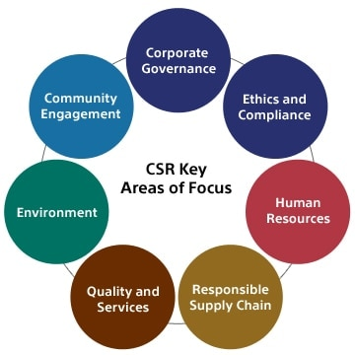

  - Sustainability Integration and Corporate Governance:

At present organization try to accept the sustainability standard. Corporate sustainability come with a global change as well as in Bangladesh. We all know about the three dimension of the sustainability standard. Such as economic responsibility, social responsibility, environmental responsibility. Social and environmental is different from economic responsibility. All companies need the profitability. Moreover, profit enlarge our growth structure. So every company concern about it.

To know the definition of sustainability at first we have to know the characteristics of sustainability.
Characteristics of sustainability:
- Establish the ethical corporate governance.
- Give a safe environment to the employee.
- Place an equal dimension in the workplace.
- Minimize the wrong impact.
- Creating opportunity for all.

Corporate sustainability is all about effectiveness. It has a great attachment about the sustainability. In a corporate sustainability have to all the characteristics should present. Corporate sustainability is very famous today trend.

The strategy of sustainability has three dimension it is very much important. The environmental, social and economic factors and Corporate Governance are core of sustainability. Without the three dimension, nothing can happen. By this three dimension, all companies can create the CSR.

It is important to create measurable and relevant goals of sustainable development and suitable metrics, and further integrated reporting on the financial and non-financial information on the internet bait is important for us to go a goal and this goal can help us to fulfill our demand. Only the sustainability can help to focus on it. The companies in Bangladesh who provide incomplete information they are not success in it. The solution for it that at first identify the dimension then select which we should focus on it.

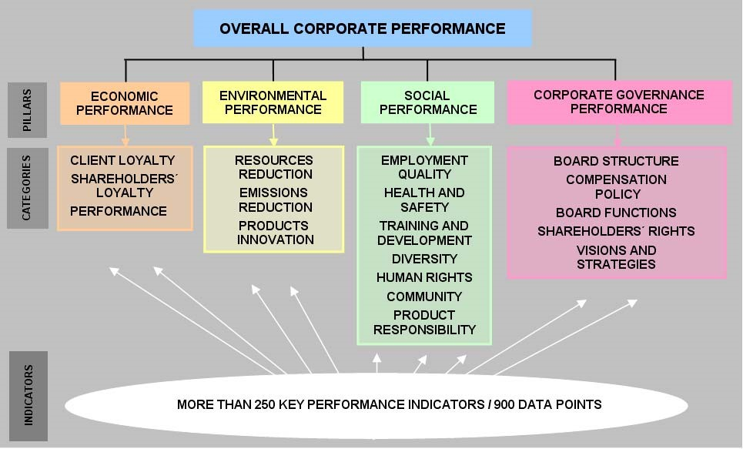
Figure 1. Observation of companies.

  - Environmental, Social and Corporate Governance (ESG) performance in relation to Sustainability Reporting
Between the relation of environment and social criteria the Corporate Governance (ESG) for measure the performance of sustainable reporting is gaining in importance in Bangladesh era.
The environmental, social and economic factors and Corporate Governance are the core factor of corporate structure. It is very much popular now a day. This strategy is not compare with anything. This assessment is very much helpful to set up a goal and achieve it.
Some important initiatives are given below.
Global Reporting Initiative (GRI). GRI is united nation initiatives. It is an idea of creating a sustainability reporting which formulate in 1997.It is comparable to success. For the sustainability, reporting it is must. Moreover, it is very much helpful to cooperate.
World Intellectual Capital Initiative (WICI). WICI was formed in 2007 and it is very much famous. It is a joint reporting system. It is not as popular as GRI It has a goal of clear attention.
The reporting according to GRI contains information from three areas – economic, environmental and social.

Environmental indicators are focus on all related work environment. Like protect the environment. Protect the tree, gas, water etc. It is all about environment pillar. Many organizations set a goal to success in environment pillar.
Economic indicators – focus on profit, market share and growth. Many company focus only on it because it is help to incorporate sustainability plus the growth rate. Therefore, it is very much helpful
Social indicators – It is all about the identification, clearance and the article of society. Many organizations only think about the money and money. However, should not do it. Should think about the society.

As we say, Global Reporting Initiative (GRI) has focus on the needed area of a society and increase the potentiality.

  - Highlights of Recent Engagements of Bangladesh industry in CSR Practice:

- CSR initiatives of banks mainly focus on financial abnormalities and too much population segreggession in different types of project.
- Secure the health system, education system and cultural/recreational activities for fulfillment of differ sector problem.
- Promoting the health conscious programmer
- Arranging different types of good sanitation, educational programmed.
- Humanitarian & disaster relief for people
- Adoption of solar energy and different new new idea in Bangladesh
- A safe drinking water project was commenced by one of the banks to provide safe
- Water to non-educated people.
- Distribution of sewing machines among the women of Somvupura union under
Sonargaon upazila for increasing their self-reliance and well off condition only for women

Chart Title

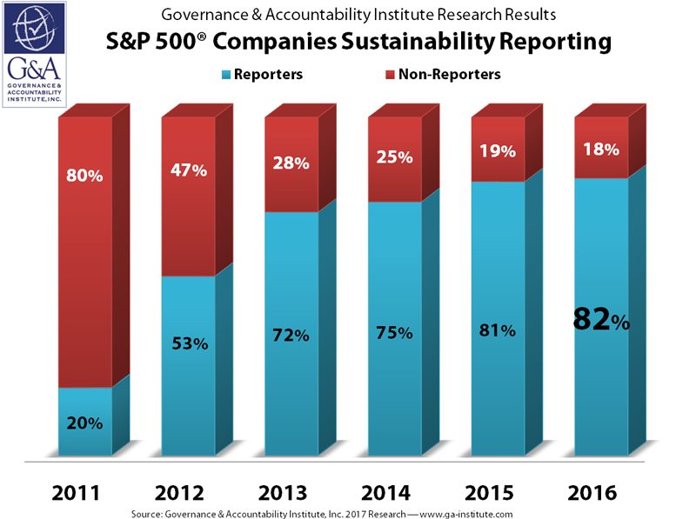

Findings and analysis

- Findings and analysis:

Corporate sustainability and corporate sustainability is a core concept of business. By the help of it, many organizations can set a goal and can fulfill its demand. Sustainability established the growth rate. It incorporates the risk and opportunity both. There are lot of practice and rule on sustainability. In addition, all are very much conscious about the CSR. In Bangladesh, many organizations put a focus on corporate social responsibility. However, many organizations still now not concern about CSR. They should also concern about it. Without a good sustainability report, an organization cannot go a good pillar of success.
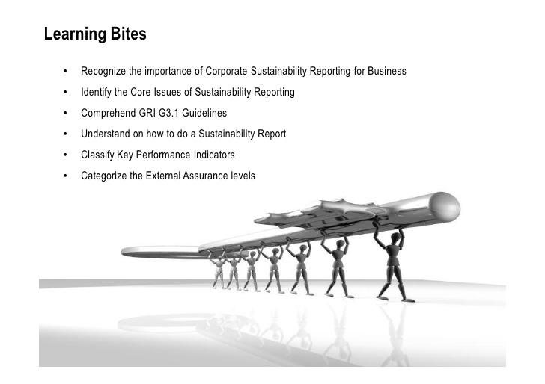

Conclusion and recommendation



- Conclusion:

Corporate governance is understood as the key element in achieving economic performance and growth ensuring increased trust of the investors all over the world. It gives a wide definition to the organization owner and the supply. It also builds the relationship. It increases the market share and growth structure rapidly. Decision-making process is now easy for that. All assessment is now based on sustainability reporting. A dynamic system focus on all factor consisting area. The annual and sustainability standard are focus on CSR and Based on CSR so by this way there is a possibility to comparing company’s result in different year back to back.

Appendix

Reference:
Thiele, L. (2016). Sustainability. Cambridge, UK: Polity.
Corporate Governance of Sustainability. (2007). Edward Elgar Ltd.
Grove, H. and Clouse, M. (2017). CORPORATE GOVERNANCE PRINCIPLES AND SUSTAINABILITY. Corporate Governance and Sustainability Review, 1(2), pp.13-19.
Elkington, J. (2006). Governance for Sustainability. Corporate Governance: An International Review, 14(6), pp.522-529.

Idowu, S., Vertigans, S. and Schiopoiu Burlea, A. (n.d.). Corporate Social Responsibility in Times of Crisis.
Banik, A., Das Gupta, A. and Bhaumik, P. (n.d.). Corporate governance, responsibility and sustainability.
Lawrence, S., Collins, E. and Roper, J. (2013). Expanding Responsibilities of Corporate Governance: The Incorporation of CSR and Sustainability. Indian Journal of Corporate Governance, 6(1), pp.49-63.
Aras, G. and Crowther, D. (2012). Business strategy and sustainability. Bingley, U.K.: Emerald.
GreenBiz. (2018). Corporate governance and sustainability: Who's connecting the dots?. [online] Available at: https://www.greenbiz.com/article/corporate-governance-and-sustainability-whos-connecting-dots [Accessed 23 May 2018].
Pepsico.com. (2018). Corporate Governance - PepsiCo. [online] Available at: http://www.pepsico.com/About/Corporate-Governance [Accessed 23 May 2018].
En.wikipedia.org. (2018). Environmental, social and corporate governance. [online] Available at: https://en.wikipedia.org/wiki/Environmental,_social_and_corporate_governance [Accessed 23 May 2018].

