 United International University

An internship report on
“Balance Scorecard for ElCO Cables Limited.”

Submitted to
Mofijul Hoq Masum
Assistant Professor
School of Business and Economics (SOBE)
UNITED INTERNATIONAL UNIVERSITY
Submitted by

Md. Obayedul Hoque

Id- 111 152 166

Date of Submission: 10th March 2022

Acknowledgement
Firstly, I am expressing my deepest gratitude to Allah for giving me the capability to complete this report as the requirement to accomplish my bachelor degree within the scheduled time.
Obviously, I am grateful to my superintendent Mofijul Hoq Masum, assistant professor, School of Business and Economics (SOBE) of United International University. His guidance, suggestions and encouragement made me capable to complete the assigned task in a short period of time. Without any hesitation, I can say that I would probably unable to accomplish the report in a proper way without the continuous support and valuable advice from the very beginning.
My special thanks to Md. Kamruzzaman, Head of finance and accounts of ELCO cables limited, account Officer Mr. Sonjoy kumar, Aminul islam and Md. Atikur Rahman and other personnel of ELCO cables for their support and cooperation.

Letter of Transmittal

10rd March 2022
Mofijul Hoq Masum
Assistant Professor
School of Business and Economics (SOBE)
United International University

Subject: Submission of internship report.

Dear Sir,
I have completed my internship report on Balanced Scorecard for ELCO Cables limited under your soft supervision as a requirement of completing my bachelor degree. I tried my best to comply with the instructions accordingly to prepare the report
I expect you will have the report as you expected. I am expressing my gratitude towards you for your continuous and prolonged guidance and encouragement to complete the report appropriately and also look forward to receiving your suggestion and comment regarding this task.

Sincerely yours
Md. Obayedul Hoque
ID. 111 152 166
School of business and Economics
United International University

Declaration

I, Md. Obaydeul Hoque, hereby asserting that the internship report on Balanced Scorecard for ELCO Cables limited submitted to SOBE of United International University as a requirement of accomplishing my bachelor degree in Accounting is uniquely prepared by me. I also would like to state that the report is prepared only for academic purpose only.

Md. Obayedul Hoque

Date: 10th March 2022

Abstract

To gain a sustainable development in an industry the performance measurement should be performed appropriately and continuously. The conventional method of PAMS cannot pave the way of efficiency than the modern performance techniques. Kaplan and Norton introduced a holistic approach of PAMS to overcome the drawbacks of ancient PAMS blended with both financial and non-financial ( Internal business process, customers and learning & growth)perspectives. The BSC measures the organizational performance based on several aspects and a number of parameters. So, the obvious purpose is to explore the appropriateness of the BSC philosophy in respect to the ELCO cables limited. The objective of the report is to understand the financial and non-financial appraisal system of the company, how they perform the manufacturing process and day to day activities and the present condition of the cable market of Bangladesh. The findings of the report regarding the company based on BSC that the organization always keep their eyes on customer’s needs and demands as they can shape their product line accordingly since they want to be one of the leaders of the cable industry and for this they do customer satisfaction survey. The company tries to capture 7% of the market share by 2025. . They always try to control defect-free rate wile utilizing the maximum production capability. The company is trying to improve its customer response time and new product development period keep pacing with the industry giants. The company has a set of talent and polite board of directors who try to maintain the code of conducts for the maximum benefit for both the company and its personnel. The market of the cable sector is growing over the time because of the extension of power gridlines throughout the country. The cable market of Bangladesh is rising on an average of 15% over a year since the government of is looking forward to supply electricity for all by 2022, though the Covid-19 impacted the growth performance downward to some extent. The company should take necessary steps to raise public awareness regarding safety and quality issues and take initiatives to increase the branding values complying with international standards.

Table of Contents
Acknowledgement ii
Letter of Transmittal iii
Declaration iv
Abstract v
List of Acronyms 7
1 Introduction 8
1.1 Introduction to the topic in hand: 8
1.2 A brief introduction of the organization 10
1.3 Objectives of the Study 12
1.4 Rational of the study 12
1.5 Scope of the study 14
1.6 Limitations of the study 14
2 Methodology of the Study 15
2.1 Data design 15
2.2 Data analysis and presentation 16
3 Organizational background & Industry Perspective 17
3.1 Industry Scenario 17
3.2 Historical Background of the corporation 18
Mission: 18
Vision: 18
Management and focus of the organizations: 18
Core Values 18
3.3 Functional activities of the organizations 19
3.4 Investigation of SWOT of the company 21
4 Findings and Analysis of the Study: 23
5 Recommendations 27
6 Conclusion 28
7 Internship Experience 29
8 Bibliography 31

List of Acronyms

BSC : Balanced Scorecard
PMMS : Performance Measurement and Management System
KPI : Key Performance Indicators
ROI : Return on investment
NI : Net Income
R&D : Research & Development
IACS : International Annealed Copper Standards
FR : Flame Retardant
PVC : Polyvinyl chloride

Introduction

Introduction to the topic in hand:
The cable market of Bangladesh is expanding at an average of 15 percent per year because of increasing the power gridlines as Bangladesh government expected to provide the electricity for all by 2022 (Chakma, 2018). For sustainable development in this industry operational perspectives must be prioritize at the very beginning. That is why focusing on the performance measurement regarding key performance indicators (KPI) assigned by the corporation. Performance measurement system is a regular process to identify, measure and develop the performance of individuals and groups as well as aligning the performance with the strategic goals of the corporation (Aguinis). The conventional method of performance measurement and management system cannot pave the way of efficiency than the modern performance techniques (Masum, Fakir, & Hossain, 2017). For the purpose of overcoming the downsides of using primitive methods of performance appraisal methods Kaplan and Norton (1992, 1996, 2000) have initiated the balanced scorecard blending a superior synergy of considering both financial and non-financial aspects including four perspectives- financial, internal business process customers, and learning and growth for evaluating performance of the organization.
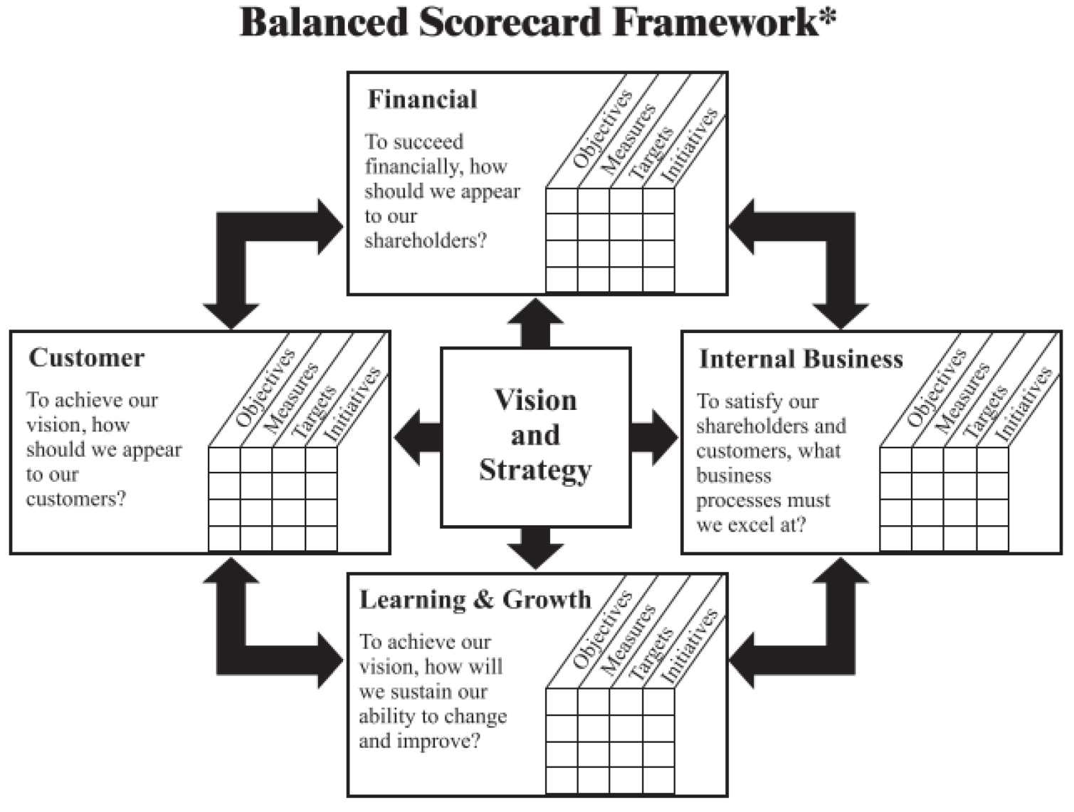

Figure 1: Co-relation of Corporate strategy and BSC perspectives
Kaplan and Norton expressed that the balance score card paves the mission and strategy of an organization into a comprehensive set of activities and provides the framework for strategic measurement and management (Kaplan & Norton, 1992). The Balanced Scorecard (BSC) model has four major perspectives these are discussed in following-

Financial Perspective: The financial perspective of BSC deals with the economic consequences for the actions implemented by the organization and shareholders’ investment. Generally this perspective uses to evaluate sales, expenditures, return on investment (ROI), revenue, net income (NI), cash inflows and outflows and so on (Kaplan & Norton, 1992).

Internal Business Process Perspective: This perspective states that the results of internal business processes leads to satisfy personnel of the organization and financial success of the organization. Process innovation, lead time, shortage, and waste etc. are measured in this section (Kaplan & Norton, 1992).

Customer Perspective: This perspective reflects how customers think about the organization. The customer perspective is so important because the organization can find it own position in that industry by this perspective. Under this perspective customer satisfaction, feedback, loyalty etc. are measured (Kaplan & Norton, 1992).

Learning and grownth: the learning and growth perspective is related with the personnel of the organization. Common measures used are empowerment, employee motivation, training and growth opportunity, employee capabilities, information systems capabilities under this perspective (Kaplan & Norton, 1992).

A brief introduction of the organization

Elco Wires and Cables Limited started its journey on May 07th, 2013 taking into consideration producing the best qualitiful electric wires and cables in diversified electrical network. The factory of the company is situated at shilat under Gazipur district and the corporate office is at Dhanmondi 8/A. The factory of the company is equipped with modern technology based machineries to produce and test different types of electrical cables. For ensuring the best quality the company is committed to provide high grade electrical cables and wires by using best raw materials from primary manufactures. The product range covers all cables and wires usually used in electrical network and duly marked with ELCO Cables embossed or printed which is a mark quality. The company intends to become one of the best manufacturers of PVC/XLPE insulated Low Voltage Cables and overhead conductors (elcocables.com).

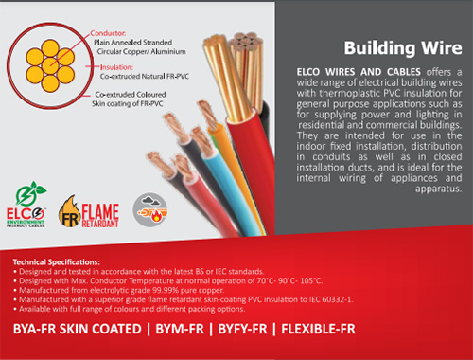
The company mainly focuses on quality, safety and reliability as its main strength is coping with the international standards by maintaining the highest quality. For achieving the fullest customer satisfaction and excellence the products are being produces by using quality raw materials. The whole product lines of ELCO cables limited have been valued for its several qualities for example – superior performance, durability and ability to withstand temperature variations. The company is certified by ISO 9001, BSTI and BUET. ELCO Cables In addition to our strengths in advanced has also established a solid pipeline in distribution and logistics, sales and customer service in addition to technology and manufacturing process in pursuit of client’s requirements and committed to deliver the products accordingly (elcocables.com).
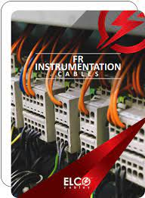

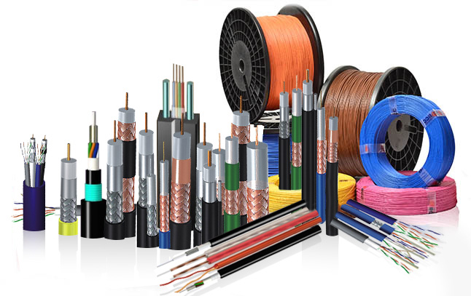

Objectives of the Study
According to the modern performance measurement literature that in contingency, evaluating a firm’s performance needs to consider on a greater dependence on non-financial aspects like information and knowledge, customer satisfaction, quality and efficiency and efficient research and development. Norton and Kaplan suggested, a firm can never gain sustainable competitive advantages without measuring such non-financial parameters. The BSC philosophy can provides us guidelines to ensure the efficiency of cable companies and accelerate their operations.
The objectives of the study are as follows:
- To understand the financial performance evaluation system of Elco Cables Limited.
- To understand the non-financial performance appraisal system of the organization.
- To understand how the company run its manufacturing process and maintains its day to day activities.
- To show a pattern of work and provide suggestions through this report.
- To explore the present condition of cable industry of Bangladesh.

Rational of the study
The demand for cables is increasing day by since the globalization and effects of technology as well as the extension of power gridlines throughout the country. The cable market of Bangladesh is rising on an average of 15% over a year since the government of is looking forward to supply electricity for all by 2022. For sustainable development for this flourishing industry should focus on performance evaluation accordingly. The conventional method of performance measurement and management system cannot pave the way of efficiency than the modern performance techniques (Masum, Fakir, & Hossain, 2017). In order to overcome the shortcomings of using primitive performance measurement the BSC comes up with the best perspectives considering both the financial and non-financial perspectives financial, customers, internal business process and learning and growth to evaluate the overall performance of the organization that can give the holistic view of the organization and can give a roadmap to attain its strategic goals.

The Vision
To become the industry leader and presence in international market.

Strategy

Supplying quality products that surpass needs
Pricing rightly
Quality employees
Customer satisfaction
Continuous improvement
Shareholder expectation

Learning & Growth
Internal Business
Customer
Financial
Safety and security
Wastage management
Trader effectiveness
Shape customer requirements
Customer satisfaction
Loyal customer base
High level professionalism

Increasing sells
Return on capital
Cash-flows
Profitability
Empowering workforce
Continuous innovation
Improving Product & service

Scope of the study
Throughout my internship period at ELCO cables limited gave me the opportunity to know some basics about the cable industry. I also observe the practice of management and official activities. Since the future of cable industry of Bangladesh is really bright so I tried to focus on their performance appraisal system based on BSC model established by Kaplan and Norton in 1992. I got valuable guidelines from my honorable instructor and also received some articles and journal links that gave me the scope to discuss about the Balanced Scorecard performance system in relation with Elco cables limited.

Limitations of the study
To prepare the term paper I also experienced some impediments –
- Since the company is a private organization I was not able to collect the financial data hence they are sensitive and that is the big limitatation while considering the financial perspective of BSC model.
- Generally Balance Scorecard model is the area of management related course, since my area of study is Accounting, so it was not too much easy for me to construct a correlation with the organization financial and non-financial perspectives as a whole.
- I was not able to contact with actual customers to know their feedback about the organization and its product.
- During the Covid 19 I joined with the organization and that time the lockdown was imposed for a long period of time that gave a shorter time to experience a variety of things like factory visit, work environment, talking with the worker of the factory and so on.

Methodology of the Study

Data design
For collecting data a number of approaches can be followed by the researchers. Basically all the data collection sources can be divided into two major classes- Primary data and Secondary data.
The primary data are those data gathered by the researcher him/herself to solve the specific problem at hand. Primary data takes a long period of time and expensive but these are real time data. There are several ways to collect the primary data for example-
- By conducting surveys
- Preparing questionnaire
- Personal interview
- Self observation
- Experiments and so on.

The secondary data are those data collected earlier period of time by someone. Secondary data are economical, quick and easy to use. A person can collect secondary data from different sources such as-
- Journal articles
- Government publications
- Websites
- Books and Publications
- Internal records etc.
To prepare the report complete and presentable I used both primary and secondary information. The methodology of data sources are as follows:

Collection of Primary Data
- By talking with the staffs of the organization personally I collected some information.
- I took informal Interviews with the employees with whom I worked for.
- While I was with the organization as an internee I collected some information by self observation
- Based on my practical experience during internship period.
Collection of secondary Data
- I collected some information about the organization from ELCO cables website.
- I studied different books on Balance Score Card (BSC) appraisal system.
- I took a look on annual reports of public listed cable companies.
- I studied some journals and periodicals recommended by my honorable instructor and
- By using Internet I collected some information.

Data analysis and presentation

For analyzing the data I used Excel tools and for presenting the data I used different pie charts, column charts and I showed some illustration and diagram as required.

Organizational background & Industry Perspective

Industry Scenario
In Bangladesh, there are almost 121 companies those are producing wires and cables at present. Along with the bust demand for the gridlines it also has a huge demand in the housing and industrial sectors. The industry experienced on an average growth of 15 percent within the last 15 (Chakma, 2018). The demand is continuously rising and the cable market of Bangladesh is increasing at a rate of 15.-20 percent per year since the government look forward to supply electricity for all by 2022. In 2017 the cable manufacturing industry made an worth of TK 6,500 core. The market share of different cables companies are in following:

Historical Background of the corporation

Mission:

The mission statement of the ELCO cables limited is “ Creating values for stockholders, customers, employees and environment as well as for the society.”

Vision:
The vision statement of the company is "to become one of the market leaders in cable industry and to have a continuously growing presence in both national and international markets.”

Management and focus of the organizations:

Elco Wires and Cables Limited started its journey on 7th May 2013 under the company act 1994 as a joint stock corporation to produce the superior quality wires and cables in a global electrical network. The factory of the company is situated at shilat, Sreepur,Gazipur district and the corporate office is at Dhanmondi 8/A. The factory of the company is equipped with modern technology based machineries to produce and test different types of electrical cables. The company focuses on high quality product by using the best quality raw materials from the primary suppliers to offer high grade electrical wires and cables to meet the customer satisfaction. The product range covers all cables and wires usually used in electrical network and duly marked with ELCO Cables embossed or printed which is a mark quality.

Core Values

Quality:
The product quality of ELCO cables is judged at every stages like-
Selection/ Procurement of raw materials
In process / On-line quality check
Checking the finished products completely
The testing is always need to maintain highest international standards. The company also offers its customers the facility of pre-delivery testing and inspection by their own cost at the testing laboratory.

Customer Relations:
For the aim of making a loyal customer base the business development and sales team of the company closely work with the customers to understand their product requirements and gives a hand them to select the right product.

Team works:
The company also focuses on team work that they believe it is important to gain success.

Functional activities of the organizations

Product or service line of ELCO cables Limited: The Company offers different types of products such as-
- Polyvinyl Chloride (PVC) low voltage flame retardant (FR) cables
- Flame retardant skin coated building wire
- XLPE low voltage flame retardant cables
- Medium voltage flame retardant cables
- Overhead conductor
- Flame retardant instrumentation cables
- Flame retardant communication cables

Management:
The organizational hierarchy of the ELCO cables limited is as follows
Board of directors

Investigation of SWOT of the company
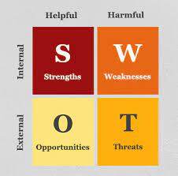

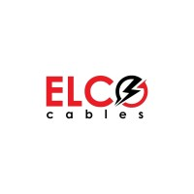

- The strengths of ELCO cables are as follows
  - BEST COPPER USED: According to the International Annealed Copper Standards (IACS) the company uses 99.99% pure copper with the highest level of electrical conductivity. The conductors are fully annealed and well compacted circular to ensure minimum loss throughout the length of the cable which saves huge electrical energy.
  - Safety from fire: The Company produces 100% product with Flame Retardant (FR) PVC compound which are suitable to bear fire.
  - Safety from electrical shocks: Elco Wires and Cables produces special PVC compound which provides higher insulation resistance. Higher Convection of Heat (Higher Thermal Stability)
  - Elco Wires and Cables produces special PVC compound with higher convective heat dissipation capability which makes it capable to carry higher current in overload conditions and ensures better electrical and mechanical performance.
  - Environment Friendly: Elco Wires and Cables PVC compound is totally lead free, so it is safer for human health and green environment.
  - Uses the best technology: ELCO WIRES AND CABLES plant established with ultra modern facilities, high tech machinery, well equipped laboratory and the whole manufacturing set up is exported from the world renowned machinery and technology suppliers.

- The Weaknesses of ELCO cables are as follows:
  - The brand value of the company is lower than its competitors.
  - Lower advertising and promotional activities.
  - Lower percentage of market share.
  - Fewer departments to handle the operation more effectively.

- The Opportunities involved with the company are as follows:
- As the marker of cable industry is growing the company can expand its activities across the country.
- Since the government of Bangladesh aimed to provide with electricity to all, so it will increase the demand of cables and the company can grab the opportunity.
- The growth of coble industry is now upwards from the last fifteen years.
- The product quality and safety issues are as standard as market leaders so they can be a good company in this industry in terms of brand image, sales and market share.

- The Threats involved with the company are as follows:
- The completion in so high form both inner part of the country as well as international.
- Low quality product also available with lower prices that attract a number of customers who are not conscious about the quality, safety and environmental issues.

Findings and Analysis of the Study:

The company valued its customer’s interests and for this reason they always try to collect its primary materials as good as possible to maintain the quality products as it promised. They always keep their eyes on customer’s needs and demands as they can shape their product line accordingly since they want to be one of the leaders of the cable industry and for this they do customer satisfaction survey. They company always conscious about the customer’s review and complaints. The company tries to capture 7% of the market share by 2025.

The company always keeps their focus on the internal business processes so that it can produce its product efficient and effective way. They always try to control defect-free rate wile utilizing the maximum production capability. The company is trying to improve its customer response time and new product development period keep pacing with the industry giants.

The company has two main plants- one is factory and warehouses and the other is its corporate office. The company has a set of talent and polite board of directors who try to maintain the code of conducts for the maximum benefit for both the company and its personnel. They offer snacks and lunch facilities for their factory workers as well as the corporate employees subsidizing half of the cost. The company offers its employees a good remuneration base and allows the employees to have a shot chat between their jobs. They also offer a neat and clean environment for their employees. The employees of the company also receive two festival bonuses and even the senior employees can have advance salary when they are required. The company sometimes arranges recreation facilities for their employees at its own cost. The employees also get leave when they are in an emergency case. The company provided transportation facilities during the covid-19 lockdown period.

The company is also sincere about the corporate social responsibilities. They always try to maintain the environmental rules and regulation that is why the established their factory out of the Dhaka city. They use 99.99 copper based environmental materials. They have a land near their factory where they planted a lot of trees to reduce the carbon-dioxide emitted by the factory. They gave away shirts and jackets to needy peoples.

- Employee
empowerment
- Training
- Satisfaction
- Skills
- Knowledge
- Incentives

- Market share
- ROI
- Revenue
- NI
- Cash Flow

- Minimizing Carbon emission
- Lead free production etc.
CSR
- Purchasing fair trade products
- Wastage management
.
Vision & Strategy
Customer Perspective
Internal Business Process
Financial Perspective
Learning & Growth Perspective
- Inventory
- Quality control
- Product lead-time
- Process innovation
- Regulation & social process

- Satisfaction
- Customer retention
- Customer Service
- Loyalty
- New product & Market

The financial part is discussed hypothetically since the company felt insecure to give its financial information. So based on the three different public listed corporation we can assume the financial condition of the industry specially the assigned company- ELCO wires & cables limited.

Deshbonduh ( in cores)

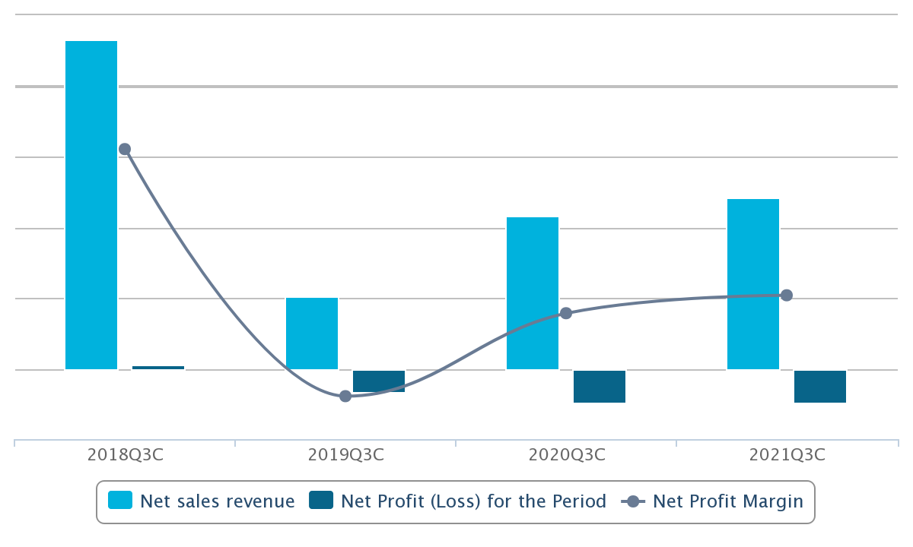
Eastern Cables limited.

BBS CABLES LTD (Lakh)

So, from the financial performance of these companies we can perceive that the overall industry is growing over the time though the Covid-19 impacted the performance downward to some extent, so it could be same for ELCO cables limited as well.

Recommendations

- The brand image of ELCO cables limited is too low, so the company must focus to enhance it brand value.
- The company should develop its marketing activities by using all online and offline method to become a familiar figure of its industry.
- The growth opportunity of employees of the company is not satisfactory so they should focus on this area.
- The training facility of the employees should improve because the availability of training for employee is not up to the mark.
- There are only one printer for all departments, they should equipped with more for each department.
- The marketing department requires more manpower to capture new segments across the country.
- Though they are producing high quality product but they should also let to know the customers about that and for this reason they should create more conscious among people through customer care department.
- The company is conscious about their environmental and safety issues and they should continue it.

Conclusion

The Balance Score Card of Kaplan and Norton is already adopted by a number of organizations in developed countries like the United States, Britain, Australia and so on, as it already demonstrated that it meets several managers’ needs. Along with the financial aspect of traditional method of performance appraisal, the Balance Scorecard also conglomerate non-financial aspects that gave that an edge for the drivers of future performance measurement system. The BSC encompasses financial, business processes, customers and growth and learning perspectives. In these circumstances, I think by adopting the Balance Scorecard philosophy the company will be able to attain its strategic goal, vision and mission strategy and accelerate the functionality in an effective and efficient way. Since the BSC strategy includes the strategies of the vision and mission of an organization hence definitely it will be the filler for the company to achieve the long term success.

Internship Experience

To achieve my Bachelor degree I had to do an internship, so I got the opportunity to do my internship at ELCO cables limited. During my internship period I knew, learnt and perceived several things those are as follows:
- Firstly, I was encounter with time management that is office hour from 10 AM -6PM.
- Actually, I am not comfortable with formal dress, but when I joined at the organization I had to dress formally to maintain the corporate dress code.
- I was not accustomed with using Tally/ERP software. The organization gave me the opportunity to get familiar with these staffs.
- There, I learnt to do photocopy and scanning documents.
- Once I went with an employee at IBBL to withdraw tk. 500,000 and waited more than 3 hours because the bank account of ELCO company were one branch and we went to another branch and the fact was our Account manager forgot to inform them earlier.
- I knew the guidelines formulated by the administration while considering the employees especially for company’s drivers and delivery man to calculate their compensation on trip basis.
- The finance and account manager once instructed me to calculate some numbers based on some principles developed for workers of the company and we got some false calculation made for claiming more compensation.
- I can perceive how important the co-operation with several departments because they are interlinked with each other to accomplish a task successfully.
- I had good relationship with four employees of accounting department and the helped me to understand the recording system of the company like preparing debit and credit voucher, inputting in Tally and ERP software.
- It helped me to become more careful and sincere about my task and communicate with a new person with confidence.
- I learned about their marketing system, delivery and due collection method, for example they divided their market based on division and then district and they have marketing officer in each zoon to deal with the local dealers, deliver product and collect money. After collecting money they send the money receipt on whatsapp then the corporate office staff put the transaction on their database.

Bibliography
(n.d.). Retrieved from elcocables.com: https://elcocables.com
Aguinis, H. Performance Management. Pearson Education.
Chakma, J. (2018). Cable industry flourishes. The Daily Star .
Kaplan, D. R., & Norton, D. D. (1992). The Balanced Scorecard—Measures That Drive Performance. Harvard Business School Press.
Masum, M. H., Fakir, A. A., & Hossain, M. K. (2017). Multi-facet Performance Measurement System for Textile Industries: A Comprehensive Study from Bangladesh. Research Journal of Finance and Accounting .

