Internship Report on
“Overall Human Resource Practices of Domino’s Pizza Bangladesh”
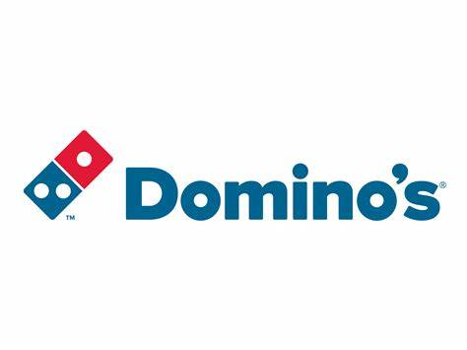

Name of the Student
Sumaiya Shaina
ID: 111173015

This Internship Report will be submitted to the School of Business and Economics, United International University as a part of my Bachelor of Business Administration Degree Requirement.



School of Business and Economics
United International University

Submitted To:
Jakowan
Assistant Professor
United International University
Submitted By:
Sumaiya Shaina
ID: 111173015

Date of Submission:
November 06, 2024

Letter of Transmittal

November 06, 2024
Jakowan
Assistant Professor
United International University
Subject: Submission of Internship Report on “Overall HR Practices of Domini’s Pizza Bangladesh”.
Dear Sir,
It is a great privilege to present my internship report on “Overall HR Practices of Domini’s Pizza Bangladesh” under your supervision. This report will provide insight into the Human Resource Practices of Domino’s Pizza Bangladesh where I have completed my Internship. I have tried to describe both academic and practical experience to make the report findings sustainable. I have tried to reflect on all the major learnings throughout the internship period in my report. I am truly grateful to you for allowing me to complete my internship with your generous moral support and instruction.
I have collected information from the company superiors while professionally working with them. So the authenticity of the information was highly emphasized. Therefore, with all the quantitative and qualitative information, I have tried to make the report very sincerely. However, if there is any confusion that needs to be clarified or rectification to be done, it will be my honor to do so.
Finally, I have successfully prepared my internship report with my greatest efforts and expect that you will be pleased to read this report. I therefore pray and hope that you will be kind enough to accept my internship report. Thank you very much for your kind co-operation.
Sincerely
Sumaiya Shaina
ID: 111173015


Date: 11/06/2024

INDEX OF SIMILARITY CERTIFICATION

Title of the report: Overall HR Practices of Domino’s Pizza Bangladesh
Student Name: Sumaiya Shaina
Student ID: 111173015
Supervisor: Jakowan
Department: BBA

I am confirming that my internship program report is unique with no similar information will be found or no plagiarized material will be found. To complete this report, I did not use any unethical practices.

Sumaiya Shaina
ID: 111173015

Date: 11/06/2024

DECLARATION OF THE STUDENT

I, Sumaiya Shaina, declare that I have prepared this internship report on the topic “Overall HR practices of Domino’s Pizza Bangladesh”. My internship period was a very valuable time for me. I have made a proper analysis regarding the Human Resource practices of Domino’s Pizza Bangladesh. I was able to learn many corporate things by preparing this report.
I have collected both the primary and secondary data by myself for finishing this report. I assure you that I have prepared this internship report in a good manner and this report is one of the unique reports of the BBA program.

Date: 11/06/2024
ACKNOWLEDGEMENT

I would love to express my sincere gratitude and heartfelt appreciation to my Internship supervisor Mr. Jakowan (Assistant Professor), Department of Human Resource Management at United International University for helping me throughout my internship and serving as a mentor who incredibly understands. I am thankful for his assistance, guidance, scheduled meetings, and advice, which inspired and helped me finish my report. I would not have been able to finish this report without his continuous assistance and guidance.
I also want to thank the esteemed Khurshid Imbisat Chowdhury (Head of HR) for his outstanding leadership and dedication. Moreover, I would also like to thank my, on the job supervisor Tahmid Shahriar Sizan (Senior Executive & Payroll) for providing me with guidelines throughout to understand all the HRIS processes in the real-life field and permitting me to submit my official internship report on my given topic. He tried to help me promptly whenever I asked for any suggestions or sought any help. He also helped me finish my internship report by giving me convenient time and information. I am very grateful for his immense support and guidance because, without his guidance and cooperation, I might not be able to finish my report so efficiently.

In addition, I would like to mention the names of two more special people whom I will always cherish for their tremendous support and guidance. Mr. Shafayet Rezvee (HR BP) was my mentor and he guided me throughout the internship program and taught me the most important corporate skills while considering my queries. Moreover, Kishore Tabassum Tuba (Senior Executive) helped me a lot while making my internship report by sharing her prospects and insights. The entire team was supportive during my internship period. I felt privileged to get such opportunities.
Furthermore, I am thankful to Domino’s Pizza Bangladesh and Jubilant FoodWorks Limited family for allowing me to do my internship with them and for providing me with a highly constructive and friendly working environment.

EXECUTIVE SUMMARY
The report begins with an organizational overview of Domino's Pizza Bangladesh, where I completed my internship. Throughout my internship, I observed the comprehensive HR practices at Domino's Pizza Bangladesh. I have found them particularly interesting, leading to the focus of this report on this highly significant aspect in the present global marketplace. In Bangladesh, efficient HR practices have become a critical competitive advantage, as they provide opportunities to enhance employee productivity, satisfaction, and overall organizational performance.
As a Quick Service Restaurant (QSR) chain, maintaining effective HR practices is crucial for ensuring high employee engagement, satisfaction, and retention, directly influencing service quality and customer satisfaction. A robust HR framework is essential to support the dynamic and fast-paced nature of the QSR industry. The report dives into various aspects of HR management, including recruitment and selection, training and development, performance management, employee engagement, and compensation and benefits.
Throughout my internship, I discovered several important factors for effective HR practices in Bangladesh. From the standpoint of Domino's Pizza Bangladesh, there are a lot of obstacles that can prevent HR strategies from being implemented effectively. However, careful preparation and execution can considerably minimize the challenges, such as workforce demand, employee turnover rate, quality assurance, and onboarding and talent acquisition process needs careful consideration.
As an HR intern, I focused on and analyzed each factor essential to the HR management process. In addition, based on the Bangladeshi context, I identified several significant consequences and offered some long-term fixes to these problems.
Furthermore, as a member of the HR management team, it is evident that effective HR practices are critical for increasing profitability and customer satisfaction, which leads to cost savings and improved overall efficiency.
I conducted interviews with key corporate representatives from Domino's Pizza Bangladesh, and Jubilant Foodworks Limited India, collecting significant insights into how good HR practices contribute to the employee life cycle, the challenges they encounter, and potential solutions to these challenges.
In summary, this report emphasizes the crucial role of effective HR management in advancing organizational success at Domino's Pizza Bangladesh. It highlights the strategic importance of human capital in achieving business goals and offers a comprehensive analysis of current practices, challenges, and possible enhancements in the HR field.

Table of Contents
EXECUTIVE SUMMARY v
CHAPTER-1: Introduction 1
1.1 Background of the Report 1
1.2 Objectives of the Report 1
1.2.1 Primary Objective: 1
1.2.2 Secondary Objective: 1
1.3 Scope and Limitations of the Report 2
1.3.1 Scope and delimitation of the study: 2
1.3.2 Limitations of the research: 2
1.4 Methodology of the Report 3
1.4.1 Types of Data: 3
1.4.2 Data Collection Process: 3
1.4.3 Sample Size: 3
1.4.4 Sampling Technique:. 3
1.4.5 Area and Time of Research: 4
1.5 Review of the Related Literature: 4
CHAPTER-2: Organization Overview 6
2.1 Company Profile: 6
2.2 Domino’s Pizza in Bangladesh: 7
2.3 Domino's Pizza Group Mission, Vision & Values: 8
2.4Food Items Provided by Domino’s Pizza Bangladesh 8
2.5 Corporate Structure: 11
CHAPTER-3: Overall Human Resource Management Practices of Domino’s Pizza Bangladesh 12
3.1 Concept of Human Resource Management: 12
3.2 Human Resource Management in Domino's Pizza Bangladesh: 13
3.3 Functions of HR in Domino’s Bangladesh: 13
3.3.1 Recruitment process of Domino’s Bangladesh: 13
3.3.2 Selection process of, Domino’s Pizza: 14
3.3.3 Training and Development: 14
3.3.4 Compensation and Employee Benefits 15
3.3.5 Data Management: 16
3.3.7 Employee Engagement and Motivation 17
3.4 Challenges of HRM in Bangladesh's economy 18
CHAPTER-4: Internship experience 20
CHAPTER-5: Findings & Recommendations 21
5.1 Findings: 21
5.2 Recommendations: 22
CHAPTER-6: Conclusion 23
References 24

Introduction

Background of the Report
I have written this internship report on the “Overall Human Resource Practices of Domino’s Pizza Bangladesh. HR is the backbone of a business organization. The HR department works closely with the employees of an organization. It also provides the support and structure needed for an organization to thrive in today's fast-paced and ever-changing world. By prioritizing and implementing sound HR practices, organizations can enhance their competitive advantage, achieve sustainable growth, and cultivate a thriving workplace culture. Without HR, a company would struggle to attract talent, maintain a positive work environment, and navigate the complexities of managing a diverse workforce.

Objectives of the Report

Primary Objective:
The primary objective of this internship report is to complete the requirements for United International University's (UIU) Bachelor of Business Administration (BBA) program and secure the BBA certificate.

Secondary Objective:
The specific objectives of the report are as follows:
- To study the HR strategies and methods for managing employees at Domino’s Pizza Bangladesh;
- To obtain an understanding of the history and general details of Domino’s Pizza Bangladesh;
- To understand the processes for recruiting and onboarding new employees to attract top talent and ensure a smooth onboarding experience;
- To understand the primary HR goals, mission, vision, and corporate profile of Domino’s Pizza Bangladesh
- To know the efficiency of using the Human Resources Information System (HRIS) for day-to-day business activities.

Scope and Limitations of the Report

1.3.1 Scope and delimitation of the study: During my internship at Jubilant FoodWorks Bangladesh Limited, I worked closely with HR professionals and learned about Human Resource Management. I helped with recruitment, onboarding new employees, preparing Pay Rolls and forwarding letters, incorporating new employee information into the Master Database, and organizing celebratory lunches to keep employees engaged and happy.
I also learned how to create fair performance reviews and develop training programs to help employees understand their tasks and grow. I saw firsthand how important it is to have good communication and clear policies to maintain a positive work environment.
Attending HR meetings and visiting stores gave me a deeper understanding of the latest trends and best practices in HRM. All these experiences have greatly enhanced my knowledge and skills in human resource management and will be valuable for my career in the future.

1.3.2 Limitations of the research: In my research, I have pointed out a few limitations. For instance, if I consider my research topic, it is so broad that few areas might left untouched because of the information access constraints and limited respondents constraints. Moreover, I want several limitations. Those are as follows:
- Firstly, I got very few respondents, who actually could share their valuable prospects.
- Secondly, as all of my respondents work in the corporate office, most did not have that much time to discuss the issue properly.
- Thirdly, I could not conduct interviews with any other department leaders. I felt that might have been more informative if I could have taken interviews of other departments, as HR works with all the departments.
- Lastly, the workload and responsibilities were huge during my internship period, as the company has already grown bigger in Bangladesh with 35 outlets all over the country and more pending. Therefore, it was a bit difficult to concentrate on my report which was a part of my academic life.
However, limitations will always be there, we will have to pull the best out of it. Therefore, I have tried my best while working on this report.

Methodology of the Report

Types of Data: In this report, I have tried to use both primary data and secondary data to find out the research findings and recommendations. The primary data are those, which are conducting various types of studies and research. Primary data can come from multiple sources, such as surveys, questionnaires, observations, interviews, etc. On the other hand, I have gathered secondary data from various sources, such as books, newspapers, websites, statements, records, and so forth. Moreover, this research is based on quantitative analytical research. I have also used descriptive research on my internship topic.

Data Collection Process: To prepare this research paper, I have collected both primary and secondary data. I have collected the primary data by conducting personal interviews with both senior and junior HR employees of Domino’s Pizza Bangladesh. I have also asked different types of technical questions to the Country Head of HR and the HRIS Head responsible for overseeing operations in India, Sri Lanka, Nepal, and Bangladesh. I have also communicated with different employees from the other departments of the organization to gather a more comprehensive understanding of HR practices and challenges. After asking them questions, they provided their valuable opinions. By taking their opinions finally, the primary data have been found and those are present in the study. The secondary data, I have collected from the official website and the other websites, articles, and the annual report of Domino’s Pizza Bangladesh Limited.

Sample Size: In this research paper, I selected employees from the HR department and other departments as the sample. Among the sample of those employees, five employees are from the superior level of the HR Department and two are from the subordinate level of the HR department.

Sampling Technique: In my research on the overall HR practices at Domino’s Pizza Bangladesh, I used stratified sampling to ensure a clear and accurate analysis. I first divided the workforce into different groups, such as corporate HR staff, store managers, and frontline employees, because each group uses HR practices differently. I then randomly selected people from each group to collect data, to make sure all the important roles in the company were included. This approach helped me study HR practices at different levels and provided a balanced and accurate reflection of the company's overall HRIS system.

Area and Time of Research: This paper is based on the “Overall Human Resource Practices of Domino’s Pizza Bangladesh”. The roles and functions of the Human Resource Information System (HRIS) of Domino’s Pizza Bangladesh. It has taken almost 2.5 months to prepare the internship report by taking the primary and secondary data from different sources.

Review of the Related Literature:

The practice of Human Resource Management is crucial for managing any workforce efficiently. Earlier, HR tasks used to be handled manually, requiring considerable time and effort. This was particularly challenging for organizations with a large number of employees. However, with the advent of technology, the landscape of HR practices has drastically changed. Companies like Domino's Pizza now use advanced systems to streamline and automate their HR operations. Using digital tools and systems in HR operations has made it easier for the company to manage its workforce activities efficiently and effectively. Domino's Pizza Bangladesh aligns its HR practices with its operational goals to build a strong and motivated workforce. In any business, especially in a Quick Service Restaurant (QSR) chain like Domino’s Pizza Bangladesh, effective HR management plays a key role in achieving operational success. The importance of having well-structured HR practices has become more significant as businesses grow and face competitive pressures.
HR practices include various activities related to employee recruitment, training, performance management, and benefits administration. Key HR Practices at Domino’s Pizza Bangladesh are:

- Recruitment and Selection: One of the main functions of HR at Domino's Bangladesh is recruiting and selecting suitable candidates. This process involves identifying talent through online job portals, social media, and internal referrals. Recruitment focuses on finding individuals who align with the company's values and can work efficiently in a dynamic environment. The HR team ensures that employees hired are capable of handling the demands of customer service and food preparation, which are essential to Domino's operations.
- Training and Development: Domino’s Pizza emphasizes the importance of training and developing its employees. The HR department organizes regular training programs to enhance the skills of new and existing staff at both the corporate and operational levels. These programs help employees to improve both technical skills and soft skills. Through training, employees become more efficient, which ultimately benefits the company by increasing service quality and operational speed.

- Performance Management: Domino’s Bangladesh structured performance management to monitor employee productivity and job satisfaction. The HR department evaluates employees based on performance metrics like customer feedback, punctuality, and teamwork. Employees who perform well, often get rewards with promotions and bonuses, which motivates others to improve. Regular performance reviews also help to identify the areas where employees need further improvements.

- Compensation and Benefits: Domino’s ensures that every employee gets fair compensation on time. The HR department works to provide a comprehensive benefits package, which includes competitive salaries, health benefits, and performance-based incentives. Offering these benefits not only helps retain employees but also improves overall employee satisfaction.

- Employee Engagement and Motivation: Engaging employees and keeping them motivated is a priority at Domino’s Pizza Bangladesh. The HR managers organize monthly events to celebrate the milestones and birthdays of their corporate employees and operational staff. This kind of celebration creates a sense of belonging among employees, which leads to higher motivation and productivity.

By focusing on key areas like recruitment, training, performance management, compensation, and employee engagement, Domino’s HR department plays a crucial role in ensuring the smooth functioning of the company.

Organization Overview

Company Profile:

Before getting started with Jubilant FoodWorks Limited and Domino’s Pizza Bangladesh, I would like to provide some background on Domino’s Pizza International.
Domino's Pizza Limited was founded in 1960 in Ypsilanti, Michigan, by Tom Monaghan and his brother James, and has since become a successful global leader in pizza delivery and carryout business. Domino's was first known as "DomiNick's" until it was renamed in 1965. The brothers renamed the restaurant "Domino's Pizza" after learning that another company was already trademarked "DomiNick's" and was rapidly expanding. (History, 2024)
In the 1980s, Domino's Pizza introduced its famous "30 minutes or free" delivery guarantee, establishing a strong reputation for speed and reliability. (Kung, 2011)
The company has also embraced technology, launching an innovative online ordering platform in 2007 and a mobile app in 2011, which have transformed the way, customers interact with the brand.
As of 2018, Domino’s Pizza had around 15,000 stores, including 5,649 in the United States, 1,500 in India and 1,249 in the United Kingdom. The company operates in over 83 countries and has a significant presence in markets like the United States, the United Kingdom, Australia, and India. Domino's now serves customers in 5,701 cities worldwide.
Domino's usually has master franchise contracts with a single company per country. However, certain organizations, such as Jubilant Foodworks, own franchises in many countries. Below there are some information regarding the Domino’s master Franchise programs:

- Australian Domino's Pizza Enterprises holds exclusive rights to operate and franchise the chain in Australia, New Zealand, France, Belgium, the Netherlands, Japan, Germany, Luxembourg, Denmark and Taiwan. They were the first companies to obtain master franchises from the parent company in 1993 and 2006. (Franchise, 2024)
- In 1993, Domino's Pizza Group (DPG) obtained master franchises in the UK and Ireland. In addition, they owned the master franchise for Germany in 2011 and Switzerland, Liechtenstein, and Luxembourg in 2012 by purchasing the Swiss master franchise holder. (UK, 2024)
- Jubilant FoodWorks, an Indian company currently holds the master franchises for India, Nepal, Bangladesh, and Sri Lanka. Who made India the largest international market for Domino's outside its home market by opening over 1,000 Domino's outlets. The company operates approximately 1200 stores across 264 Indian cities as of 2019. (Limited, 2024)

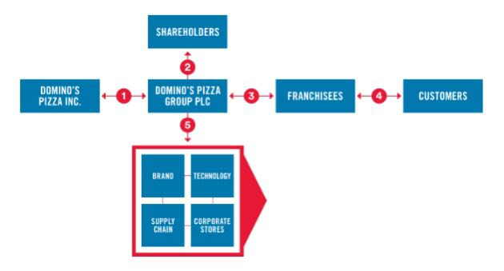
Figure 1: Domino’s INC. Business Structure
2.2 Domino’s Pizza in Bangladesh: On March 25, 2019, Domino's Pizza made its official debut in Bangladesh by opening its first restaurant in Rangs Fortune Square, Dhanmondi Dhaka. As a joint venture between Golden Harvest QSR Limited, a branch of the Golden Harvest Group, and Jubilant FoodWorks Limited (JFL), the largest food service company in India, Domino's Pizza made its debut in Bangladesh. (Star, 2019)
Jubilant FoodWorks Limited first required approval to operate in Bangladesh. Simultaneously, they sought a local partner for the venture. Consequently, Jubilant FoodWorks and Golden Harvest QSR jointly formed a new entity called Jubilant Golden Harvest LTD to represent Domino’s Pizza in Bangladesh, with Jubilant FoodWorks holding 51% ownership and Golden Harvest QSR holding 49%.
In September 2021, Jubilant FoodWorks exercised its first call option to acquire an additional 39% share in the joint venture, aiming to increase its ownership to 90%. Subsequently, on March 22, 2022, the company used its second call option to purchase the remaining 10% ownership, thereby gaining complete control of the joint venture. The cost of these call options to buy the 49% stake amounted to BDT 38.90 crore (US$3.3 million). To comply with Bangladeshi regulations, one share in Jubilant Golden Harvest remains with a company nominee. (Habib, 2022)
Currently, Domino's Pizza Bangladesh operates 35 restaurants, across the country, including in Dhaka, Chittagong, Khulna, and Cox's Bazar, and is soon to open its first outlet in Sylhet.

2.3 Domino's Pizza Group Mission, Vision & Values:

- Mission Statement: Domino's Pizza Group has a clear mission to leverage the potential of opportunities and turn everyday ordinary moments into something extraordinary for customers.

- Vision Statement: The Company has a straightforward vision to become the number one pizza brand in every neighborhood and worldwide.

- Values of Domino's Pizza Group: Domino's Pizza Group holds several important values that guide its actions.

- The company puts customers first, ensuring they are the focus of everything it does.
- Respect is also crucial, as the team treats everyone with kindness and consideration.
- The company celebrates success as a part of its culture of acknowledging and sharing achievements.
- The company believes in creating growth opportunities and encourages honesty in all its dealings.
- Hard work is a core principle, as the team commits to putting in the effort needed to succeed.
- Embracing community is essential and Domino's actively supports and engages with the neighborhoods it serves.
- The company promotes winning together through teamwork and collaboration, and it seeks to inspire solutions by encouraging creativity and innovation to overcome challenges.

2.4Food Items Provided by Domino’s Pizza Bangladesh:
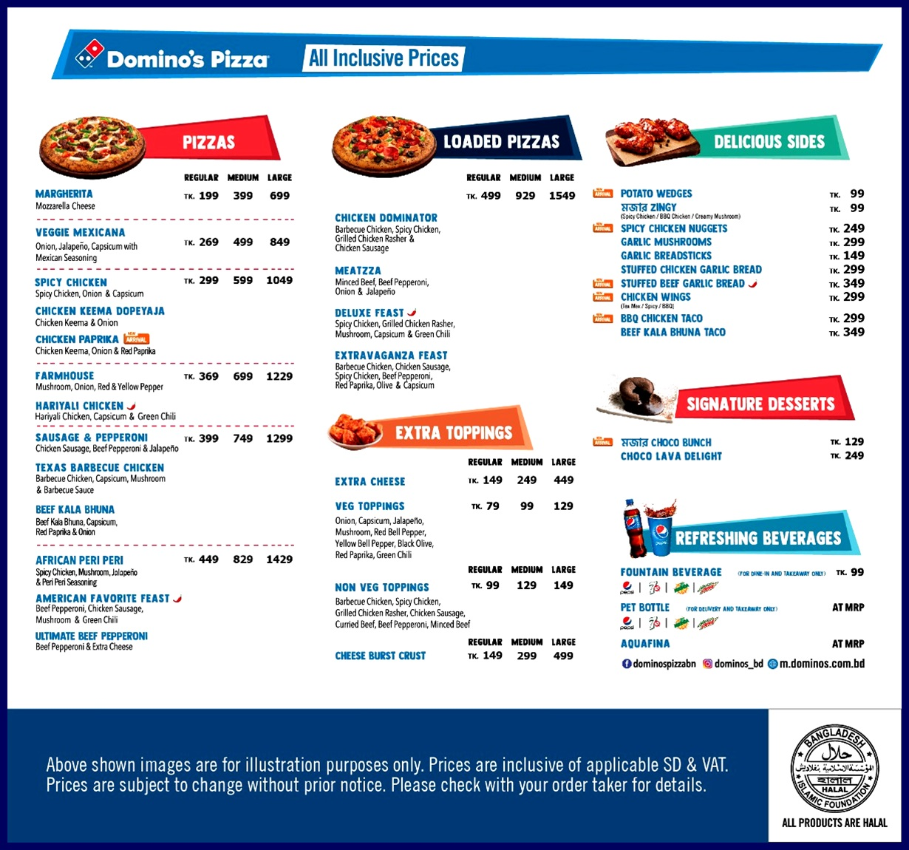
Here is the menu for Bangladesh.
They serve both beef and chicken at the same time. Domino's mainly uses a "differentiated targeting strategy" so that, it can meet all types of customers' needs and wants. Everyone has unique tastes and preferences. That is why Domino's Pizza has made a strong position as a good pizza company in this industry and people actually feel that Domino's cares about their customers. This helps Dominos to take a position in the industry in the other world.
Dominos has a positive position and reputation among the foodies. There are more items like a chicken meatball, roasted chicken wings, Choco lava cake, Butterscotch mousse cake, etc. They import most of these items in a cold transportation mode. (Menu, 2023)
However, when moving to a new market & product development, previewing the Marketing Mix is very crucial as the success of the product depends on these four decisions. 4p’s consists of price, place, promotion, and product. Therefore, Dominos also worked on their marketing mix as it is very important before starting any new business. The pricing strategy of, Domino's has an upper hand over its rivals.
When Domino's Pizza enters a new international market, it always adjusts its strategy to fit local preferences, cultural practices, and market conditions. Its expansion into Bangladesh followed the same approach. Here are some of the key features and strategies Domino's used for its operations in Bangladesh:
- Halal Compliance: Since the majority of Bangladesh's population is Muslim, it was essential to make sure that all products and food preparation techniques matched halal requirements. Domino's Bangladesh ensures that its food fits with dietary and religious requirements.
- Menu Customization: Domino's introduced pizzas with a touch of Bangladeshi flavors. This includes using spices, sauces, and ingredients that appeal to local tastes, and blending global pizza recipes with regional cuisine.
- Affordable Pricing: Recognizing the country's economic conditions and the spending ability of the average consumer, Domino's rolled out budget-friendly deals and low-cost pizza options to make their food more accessible.
- Smart Store Locations: In congested cities like Dhaka, Domino's set up outlets in strategic spots to ensure quick deliveries despite traffic issues. This strategy helped them reach a wide range of customers across the city.
- Digital Integration: To appeal to tech-savvy young people and city residents, Domino's has made ordering easy with an app and online options. Features like real-time order tracking, online payments, and customer feedback options were included.
- Eco-Conscious Efforts: Responding to global environmental concerns, Domino's Bangladesh has started using eco-friendly packaging and is exploring sustainable sourcing of ingredients.
- Community Involvement: Domino's engages with local communities through events, special promotions during local festivals, and partnerships with local celebrities.
- Employee Training and Job Creation: To maintain the brand's global standards in food and service, Domino's invests in training its local employees. Through provides training in cooking and customer service. This also helps create local job opportunities.
- Reliable Supply Chain: Domino's has established a strong supply chain network in Bangladesh, ensuring fresh and high-quality ingredients. Whenever possible, they source locally, supporting local businesses and producers.
- Health and Safety Standards: Domino's enhanced its hygiene practices, offering contactless deliveries and following strict sanitation measures in both kitchens and dining areas.

In summary, Domino's Pizza in Bangladesh is not just another international brand. It has carefully adapted to the Bangladeshi market, providing not only tasty pizzas but also a customer experience that connects with local values.

2.5 Corporate Structure: The organizational structure and salary grading of Domino’s Pizza Bangladesh Limited is as follows:

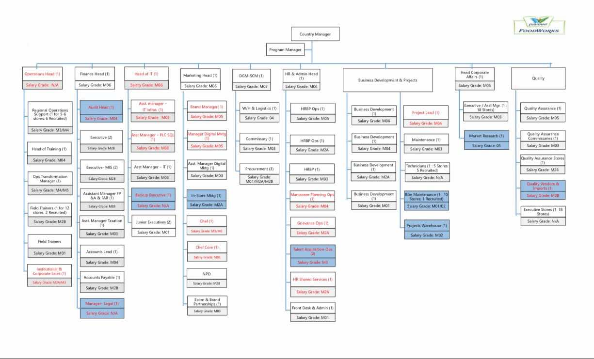
Figure 2: The Organizational Structure of Domino’s Pizza Bangladesh

Although Domino's Pizza Bangladesh is owned by Jubilant FoodWorks, an Indian company, it is operated by both the Indians and Bangladeshi people, and it requires an effective organizational structure to operate smoothly. Here, one will be the Boss or country head among Indians and will control everything and all the employees will be working under him/her directly and indirectly. One country head for the overall operations. Then, comes the individual Department head or deputy managers of HR, Supply Chain, Fin & Act, and IT sector. The marketing part is directly under the control of Jubilant Food Works Ltd.'s Delhi team, under those managers, there are some officers, senior executives, and executives. They hired some interns too. These employees are for the corporate office. For running the store, they hired other people too like team members, crewmembers, and 4/5 Guest Delight Managers. Domino’s has sent their managers to Thailand, India, and America for training. At first, the total number of Bangladeshi employees was around 40 but right now, it is more than one thousand and gradually increasing.
Indian deputy managers of Finance, HR, Supply chain, and IT often come to Bangladesh to train Bangladeshi managers. They stay here for a long time and teach both new and existing employees about new terms so that Bangladeshi managers can perform their work smoothly. Now from India, they monitor the whole activities. The entire business is on SAP. SAP is an ERP software and the Indians own it. Everything that happens in the business operations, goes to the SAP and the Indian managers check the SAP daily. By checking the SAP, they can realize how well the business operations are running here, in Bangladesh. To collect and store every employee's data, they use a software named "iSeek”. In iSeek they collect and store each working and ex-employer and employee's personal and work-life data.

Overall Human Resource Management Practices of Domino’s Pizza Bangladesh

3.1 Concept of Human Resource Management: Human Resource Management (HRM) is a strategic approach to managing an organization's most valuable assets "its people". Human Resource Management ensures that a company runs smoothly by hiring the right candidates, providing proper training, ensuring employee's well-being, and helping them to grow within the organization. Every business organization wants to achieve success and profits by meeting its organizational goals. In addition, Human Resource Management (HRM) is the process of making effective and efficient use of an organization's human assets to achieve its goals.

3.2 Human Resource Management in Domino's Pizza Bangladesh: Domino’s Bangladesh uses the Human Resource Information System (HRIS) to operate its managerial and official works gracefully. The whole HR team of Domino’s Bangladesh is dedicated to helping the company achieve a competitive advantage by hiring the best employees. The mission of Domino's Bangladesh HR team is to support the company in achieving outstanding outcomes by hiring talented individuals, helping them with skills development, and creating a positive and fun work environment where everyone can do their best.

3.3 Functions of HR in Domino’s Bangladesh: The Human Resource team in Domino's Bangladesh uses some key functions to specialists in different areas to support the company. The functions they use are as follows:
3.3.1 Recruitment process of Domino’s Bangladesh: The HR managers of Domino's help the stores, supply chain centers, and office teams with their stuffing needs. The "Talent Acquisition" team works on recruiting the right people for the company. They mainly use two types of processing to hire employees. Those are:
- Internal Recruitment Process: Internal hiring plays a significant role in Domino's Pizza Bangladesh. HR managers of Domino's mostly prefer internal hiring as it's both cost and time-saving. They value employee recommendations as well because currently, active employees can easily identify eligible and qualified candidates to fit with the company's culture. One of the key initiatives they follow is the “BUDDY GETS BUDDY or BGB” program. This program allows existing employees to recommend individuals from their networks for available positions within Domino's Pizza. If the recommended candidates meet the required educational and other qualifications, they can join the Domino's team. In addition to internal hiring, Domino’s also values the contribution of “INTERNS”. The company regularly offers internship programs designed for recently graduated students looking to gain practical experience to learn about various aspects of the business. Among the interns, they hire those who stay dedicated to their work and do well during their internship period.
- External Recruitment Process: Although Domino's Bangladesh prefers internal hiring at the same time it recognizes the importance of external hiring to bring in fresh talent and diverse perspectives. For the external recruitment process, Domino's Bangladesh uses various strategies and activities to attract the best candidates.
- For external hiring, they post job vacancies on online job portals like "BDjobes.com", and "Shomvob”. They also post on social media platforms like “LinkedIn”, “Facebook” and the company’s official website.
- Domino's Bangladesh also participates in job fairs targeting recent graduate students eager to start their careers.
3.3.2 Selection process of, Domino’s Pizza: Domino’s Bangladesh follows some steps during their selection process for both internal and external recruitments. Those steps are:
- Job Posting First, Domino’s post job advertisements on the company's website, various job portals, and different social media platforms to attract a diverse pool of candidates.
- Application Submission: Interested candidates then submit their applications, which include a resume and cover letter detailing their qualifications and experience.
- Initial Screening: The HR team reviews online and offline applications to shortlist candidates based on their qualifications, skills, and relevant experience. This step also includes phone interviews to assess basic eligibility and to know candidates' preferences or expectations.
- Assessments: Selected candidates then undergo various assessments, such as skill tests, written tests, and personality assessments to evaluate if they are fit to work at Domino's or not.
- Interview: Shortlisted candidates get invitations for one or more interviews via Email, phone calls, and text messages.
- Reference Checks: After the interview section, the HR manager conducts reference checks to validate the selected candidate's previous work history and performance.
- Job Offer: Candidates who successfully pass the selection process receive a formal job offer outlining the terms of employment, including salary, benefits, and other relevant details.
- Onboarding: Once the candidate accepts the offer, they enter the onboarding process, which includes training and orientation.

3.3.3 Training and Development: HR of Domino's Bangladesh provides various types of training to every new and existing employee of its company to ensure work effectiveness and efficiency. From top-level employers to lower-level employees, there are several training processes to ensure they all have the necessary skills to perform their roles gracefully. Some common types of training they provide:
- Orientation Training: This is for every new employee to introduce them to the company's culture, policies, and procedures. This training helps them understand their responsibilities and workplace expectations.
- On-the-Job Training: From this training, employees learn by doing their daily tasks under the supervision of a more experienced or senior manager or colleague. This training mainly focuses on practical, day-to-day tasks like using equipment or machines (computer, printer, etc.), food preparation, and customer service.
- Technical Training: Employees who work with digital technology and equipment like POS systems, and payroll systems, get training on how to use these tools efficiently.
- Leadership and Corporate Training: This training program is for the Top-level managers or the department heads. This training focuses on building or increasing leadership skills, team management, quality control, decision-making, and effective communication. Domino's provides this training mostly overseas like India, Thailand, Nepal, Sri Lanka, etc.
- Customer service training: Mostly cluster managers, store employees, and deliverymen get this type of training to interact with customers, handle complaints, and ensure a positive customer experience.
- Product & Preparing knowledge training: Employees who work in commissary get this training before joining. Through this training process, employees get to learn about Domino's menu, the ingredients to make all the food items, the preparation process, and nutrition information.
- Safety & Hygiene training: Domino's provides safety indications to its head office employees but it especially provides training on food safety, hygiene practices, and workplace safety to ensure employees who work in commissary and store maintain health standards and minimize risks in the kitchen.

3.3.4 Compensation and Employee Benefits: Domino’s Bangladesh provides a good range of employee benefits and compensation packages to its employees. They do so to keep their employees motivated and ensure the well-being and job satisfaction of every employee. Some of the key offerings are as follows:
- Competitive Salary: Domino's employees receive a competitive salary that aligns with their roles, previous work experience, and market slander.
- On-time Salary: The HR managers who handle payroll, work effectively to pay their employees by the 25th of the month. This keeps the employees motivated and satisfied.
- Festival and performance bonuses: Domino's gives Festival bonuses twice annually on both Eids. The festive bonus is 50% of the employee's gross salary. On the other hand, performance bonuses are based on someone's performance throughout the month or year.
- Employee Discounts: By ordering through employees' official phone numbers, employees can enjoy up to 50% discounts on the menu by using a coda twice a month. The company also provides unlimited free tea and coffee facilities to its head office employees.
- Flexible working hours: Domino's Bangladesh offers flexible scheduling for their employees, especially for part-time workers who work at outlets and commissaries. For corporate office employees, they can do "work from home" in urgencies without coming to the office.
- Paid Time Off (PTO): Employees receive paid leave with terms and conditions, sick leaves, and public holidays.
- Health & Medical benefits: Domino's Bangladesh employees also get health insurance and medical allowances to cover healthcare costs.
- Safe & Supportive Work Environment: The organization provides its employees with a safe and inclusive work environment that focuses on employee well-being and satisfaction. They also ensure compliance with labor law and health and safety regulations.

3.3.5 Data Management: Jubilant Foodworks Limited uses a specific software named "iSeek" to collect and store every employee's pieces of information who actively work in their organizations in all the countries they operate their business. Like Domino's Pizza India, Domino's Pizza Bangladesh employees also use "iSkeep" software to keep the master data of every employee's personal information and working history. The Indian management team uses this software to monitor employee’s work and salary disbursement. In Domino's, every employee uses punch machines in the corporate office and all the stores. Punch matchings help HR managers track employees' work times and Attendance Management. These machines record when an employee enters and exits the workplace by scanning fingerprints. The punching machine data is also integrated with the payroll system every month to calculate working hours, overtime, and deductions for late arrivals and absences. Domino’s uses various digital systems in its order-taking process to ensure that the orders are quicker to process and accurate, whether from online platforms, mobile apps, or in-store kiosks. This advanced and strategic data management system is the key to maintaining competitiveness in the fast-paced food delivery industry.
3.3.6 Grievance: There is a team in the HR department in Domino's Bangladesh to handle the grievances of every working employee. The grievance team handles formal complaints or concerns, raised by employees regarding workplace issues. These issues involve unfair treatment, workplace politics, harassment, discrimination, or conflicts with managers and colleagues. The grievance team allows employees to express their dissatisfaction in an organized or official manner and give resolution through formal channels within the organization.
There are other functions as well, which Domino's HR managers use to operate its official activities smoothly, are-
- Performance and Behavior Management
- Employee Relations
- Promotion of Employees
- Planning and forecasting
- Performance Evaluation
- Total Quality Management
- Organizational Development

3.3.7 Employee Engagement and Motivation: At Domino’s Pizza Bangladesh, the HR team organizes events (once a month) to celebrate employee milestones and birthdays. It is a key part of maintaining a positive and inclusive work environment. These celebrations help to boost morale, improve employee engagement, and create a sense of belonging among staff, both in the corporate office and across the operational teams, including delivery drivers and kitchen staff.
- Corporate Employees: For corporate employees, the HR team typically organizes a monthly event to celebrate all the birthdays and work milestones (such as work anniversaries or notable achievements) for that month together. These gatherings usually include Cake cutting, team lunch, recognition speech, and personalized gifts.

- Operational Team Members (Delivery and Store Employees): For team members working in stores or as delivery drivers, the HR team follows a similar but more casual approach. They organize a monthly celebration in each store to honor team members. This might involve a cake, snacks or lunch, and informal gatherings during quieter hours to ensure zero disruption in business operations. Given their work schedules, celebrations are often held in-store, ensuring that all employees can participate.

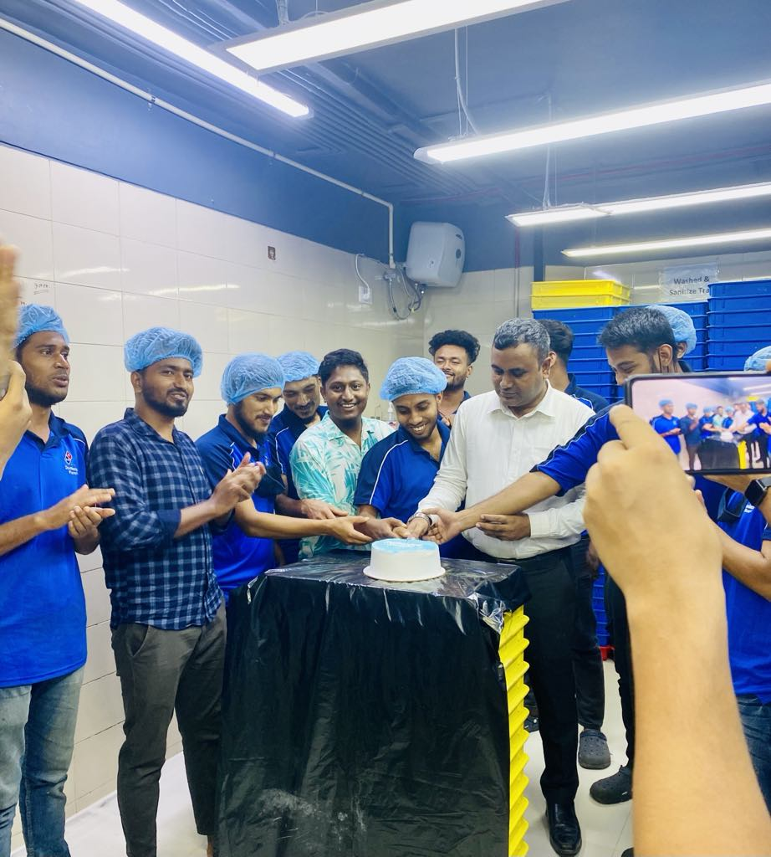
Figure 3: Shows an In-store monthly celebration of team members

In both cases, these monthly celebrations ensure that employees, regardless of their role, feel recognized and appreciated, which ultimately contributes to higher job satisfaction and retention across the company.

3.4 Challenges of HRM in Bangladesh's economy: There is no doubt that Domino's Pizza is doing an amazing job operating in Bangladesh. It is successfully operating 35 outlets all over Bangladesh so far and soon there will be more. Although Domino's Bangladesh has been working successfully, it also deals with drawbacks, particularly affecting the HR team. I am going to mention some of the challenges I have personally faced during my internship period working in the HR department
- Increasing Workforce Demand: Domino's Pizza Bangladesh faces a growing demand for its workforce due to several factors. As more people in Bangladesh seek fast food and convenient dining options, the company should hire additional employees to keep up with customer demand, especially in new locations. To ensure high-quality food and service, Domino's HR team requires hiring skilled workers in food preparation, customer service, and delivery.
- High Turnover Rate: One of the major challenges for HR managers at Domino’s Pizza Bangladesh is the high turnover rate among store employees and commissary crew. Competitors like KFC, Herfy Bangladesh, and Pizza Hut actively try to attract these employees by offering marginal salary increases and other incentives, which leads to employees leaving frequently for slightly better offers. This frequent turnover increases the workload on the HR department. They constantly recruit and train new staff, leading to higher operational costs and reduced efficiency.
- Talent Acquisition Challenges: The high turnover rate also affects talent acquisition. Since rival companies are offering slightly higher salaries, it becomes difficult to retain and recruit experienced or skilled employees. Additionally, many potential employees may have limited experience in the food chain industry, making it harder for HR managers to find well-trained workers who can easily fit into the company's operational standards.
- Onboarding Process Complications: Every Saturday Domino's Onboard like around 20-30 employees to operate the outlets and commissary. Due to the minimum educational qualifications and lack of prior experience among many new hires, the onboarding process is also challenging. Many of these employees come from different parts of the country, often forgetting to bring essential documents or certificates required for legal employment. Without valid documentation, the company cannot legally register their names, further delaying the onboarding process. This not only slows down their entry into the workforce but also affects the payroll and increases the administrative burden on the HR team.

Solutions to overcome these challenges:

- To maintain an efficient workforce demand, Domino’s Pizza Bangladesh can focus on strategic hiring and providing comprehensive training.

- To reduce turnover rates Domino’s Pizza can implement non-monetary benefits such as offering one free meal in a week or meal vouchers they can use on their days off or extend to family members.

- They can also provide transportation facilities, at least for the female employees whose shifts end at night.

- Domino's Pizza Bangladesh could improve its onboarding process by implementing a more efficient system to support employees from rural areas in preparing for their roles. This might involve providing a checklist of necessary documents via text message or phone call.

- They can also help employees find places to stay or offering local support for those moving from rural areas to work in city branches could make their transition easier and encourage them to stay longer.

- To reach a wider audience, Domino’s Pizza Bangladesh can utilize outdoor advertising such as billboards and banners in high-traffic areas near schools, colleges, or urban centers where potential candidates are located. Digital advertisements on popular websites and mobile apps can also generate interest. Highlighting specific roles, benefits, and the work environment in these ads will make Domino's an appealing employment option.

Internship experience

I started my internship at Jubilant FoodWorks Bangladesh Ltd. (Domino's Pizza Bangladesh) in the Department of Human Resources on 25 April 2024, and it continued until 25 July 2024. During these three months, I had the opportunity to work on plenty of HR-related tasks, gaining hands-on experience and expanding my understanding of corporate HR practices.

In my first week, I underwent a comprehensive training program, which provided me with the necessary knowledge and skills to perform my responsibilities efficiently. Following the training, I took on multiple key tasks, including:

- I was involved in organizing and maintaining the employee database, ensuring all information was up-to-date and accurately recorded. I used "iSeek” to record and maintain the employee data.
- I played a key role in the onboarding process of new employees, assisting with documentation, and orientation, and ensuring smooth integration into the company.
- I worked alongside the recruitment team to assist in sourcing candidates, scheduling interviews through phone calls, and maintaining candidate records.
- I helped in the implementation of the HRIS system, ensuring data migration, and familiarizing the team with its functionalities.
- I was also responsible for managing the process of creating salary cards for employees in collaboration with Eastern Bank Limited (EBL), ensuring accurate data entry and timely issuance of the cards.

Throughout my internship, I handled various tasks assigned by my manager, completing them with professionalism and dedication. I gained a lot of useful knowledge about, how the HR department and the overall corporate setup works during my time at Domino’s. I am confident that the skills I have developed will be highly beneficial in my future professional endeavors.

Findings & Recommendations

Findings: During my internship at Domino's Pizza Bangladesh, I noticed various difficulties and areas for improvement within the HR practices of Domino's Pizza Bangladesh. These findings are as follows:

- The HR department sometimes struggles with managing the workforce due to a lack of important resources. This results in delays in addressing employee concerns or completing HR tasks on time. The department also lacks the expertise and skills to manage employee-related tasks smoothly.

- Domino’s Bangladesh encounters challenges in quality assurance due to inconsistent food quality across outlets, high employee turnover, and gaps in training. Maintaining consistent food quality across all outlets can be challenging due to variations in staff training. Differences in preparation methods and ingredient handling can also lead to discrepancies in product quality.

- Outdated technology and software sometimes delay HR tasks. It causes slowdowns in managing employee information and other important work;

- Some departments, including HR, are short-staffed. This puts more pressure on the current employees and makes it difficult for the company to operate at full capacity;

- Unlike other corporate offices with typical 9-to-5 hours, employees at Domino's Pizza Bangladesh often find themselves working beyond their official hours. Though they arrive at 9 am, it is not uncommon for them to stay until 8 or 9 pm. This is because the Indian team schedules meetings at random times, without considering the local team’s schedules, affecting their work-life balance;

- Domino's Pizza Bangladesh does not provide transportation or lunch for its corporate employees, unlike other companies. This makes things more difficult, especially since employees already work long hours;

- There is a noticeable lack of strong communication and collaboration between departments, which affects workflow and leads to inefficiencies in completing tasks across teams;

- The office space is not very comfortable. It is crowded and noisy, which makes it hard for employees to focus on their work or communicate well with each other.

Recommendations: To implement potential growth, Domino's Pizza Bangladesh Limited should develop many things in their organization. They should take the following steps for their future growth & improvement:

- The Company should update its technology and systems to make work more efficient. Better technology use will help the HR team manage employee data faster and it might reduce delays in completing tasks. The company should ensure that the HR system is reliable and has no interruption. This will help in timely performance reviews and allow managers to assess employees' progress immediately;

- The company should look into expanding the workspace or rearranging it to reduce noise and overcrowding. A comfortable work environment will help employees focus better and increase productivity;

- The HR department needs more resources to perform its duties efficiently. Hiring additional staff or providing better tools will help them address employee concerns and complete tasks more quickly. In addition, the HR team should receive more training and support to improve their ability to manage tasks smoothly.

- Domino's should consider hiring more staff in short-handed departments. This will reduce the workload on current employees and allow the company to operate more effectively;

- The company should work with the Indian team to schedule meetings at appropriate times that fit the local employees' schedules. This will help maintain a better work-life balance for employees and reduce burnout;

- To improve employee satisfaction, Domino’s should offer transportation and lunch facilities like other corporate offices. This will help employees save time and money, especially considering their long working hours;

- The company should encourage better communication and teamwork between different departments. Regular meetings or collaboration tools could help departments stay connected and work together more efficiently.

- They should address customers' complaints and feedback carefully. Because effectively managing customer feedback is crucial. If they fail to address complaints, it can harm the brand's reputation. Therefore addressing these challenges is vital for ensuring high quality and customer satisfaction.

Conclusion

The main aim of this report was to examine the HR practices of Domino's Pizza Bangladesh and identify areas that need improvement. Although the company has a skilled workforce and provides training to its employees, it faces significant challenges that require attention. These challenges encompass extended working hours, absence of employee benefits like transportation, quality assurance, lunch, ineffective communication between departments, etc.
By implementing the recommendations in this report, Domino’s Pizza Bangladesh can significantly enhance its HR practices. Improving employee support and creating a more positive work environment will boost employee morale and productivity. Additionally, promoting better communication and collaboration between departments will result in a more streamlined operation.
This is an opportune moment for Domino’s Pizza Bangladesh to make effective decisions. By investing in its employees and updating its systems, the company can establish itself as a frontrunner in the fast-food sector in Bangladesh. With these enhancements, Domino’s Pizza Bangladesh can attain its business objectives and make a constructive contribution to the overall workforce and the economy of this country.

References

Franchise, M. (2024, November 2). Domino's Enterprises . Retrieved from Domino's Enterprises : https://en.wikipedia.org/wiki/Domino%27s_Pizza_Enterprises#:~:text=Domino's%20Pizza%20Enterprises%20Ltd.,Domino's%20Pizza%20Enterprises%20Ltd.&text=In%202018%2C%20Domino's%20was%20inducted,Business%20Leaders%20Hall%20of%20Fame.
Habib, A. (2022, May 12). The Daily Star. Retrieved from The Daily Star: https://www.thedailystar.net/business/news/dominos-pizzas-indian-master-franchisee-buys-bangladesh-part-3021451
History, D. (2024, November 4). Domino's Pizza Int. Retrieved from Wikipedia : https://en.wikipedia.org/wiki/Domino%27s
Kung, M. (2011, May 25). HuffPost Business. Retrieved from HuffPost Business: https://www.huffpost.com/entry/dominos-tweaks-retired-30_n_77121
Limited, J. F. (2024, October 21). Wikipedia. Retrieved from Wikipedia: https://en.wikipedia.org/wiki/Jubilant_FoodWorks
Menu, D. P. (2023, September 15). BD Food Blog. Retrieved from BD Food Blog: https://bdfoodblog.com/restaurants/dominos/
Star, T. D. (2019, March 26). Retrieved from https://www.thedailystar.net/lifestyle/news-flash/news/dominos-pizza-now-bangladesh-1720177

