Determinants of Customer Loyalty in Mobile Telecommunication Industry in Bangladesh
______________________________________________________________________________

Mehrab Afrin

This project report is submitted to the School of Businesses & Economics, United International University as a partial requirement for the fulfillment of Bachelor of Business Administration Degree

Determinants of Customer Loyalty in Mobile Telecommunication Industry in Bangladesh
______________________________________________________________________________

Submitted by
Mehrab Afrin
Program: BBA
ID: 111 171 004
Major in Marketing

Supervised by
Kawsar Ahmmed, PhD
Professor
School of Business and Economics
United International University

Date of submission
14.11.2021

Letter of Transmittal

November 14, 2021

Kawsar Ahmmed, PhD
Professor
School of Business and Economics
United International University

Subject: Submitting a project report on "Determinants of Customer Loyalty in the Bangladeshi Mobile Telecommunications Industry"

I'm Mehrab Afrin, ID 111171004, and I'm a regular student at United International University's School of Business and Economics. I'd want to submit my project report on "Determinants of Customer Loyalty in the Mobile Telecommunication Industry in Bangladesh" for the BBA degree requirement.

I've done my best to provide all of the items I've discovered during the project's duration.
If you are so kind as to receive this, I will be overjoyed.
I’ll be highly encouraged if you are kind enough to receive this project.
Thank you.

Sincerely yours,

.............................
Mehrab Afrin
111 171 004

Acknowledgement

I'd want to offer my heartfelt gratitude to everyone who assisted me in finishing my project report.
First and first, I want to express my gratitude to the Almighty for providing me with the patience and strength to complete my report in this dreadful circumstance.
I'd like to convey my heartfelt gratitude and sincere appreciation to my project supervisor, Kawsar Ahmmed, PhD, Professor, United International University's School of Business and Economics, for his unwavering support and direction throughout the practical orientation phase. His suggestions and remarks were a fantastic source of motivation for me to finish the report.

Declaration

I thus declare that the project report entitled "Determinants of Customer Loyalty in the Mobile Telecommunication Industry in Bangladesh" is the result of my own efforts under the supervision of Kawsar Ahmmed, PhD, Professor, United International University's School of Business and Economics.

I also insist on submitting the entire work report, which is original and has not been submitted by any other students for the completion of their BBA or other degrees.

________________
Mehrab Afrin
111 171 004
School of Business and Economics
United International University

Executive Summary
Bangladesh is an impoverished country that qualifies as a developing country. However, this country is making only a sluggish progress in letting go of various forms of ultramodern automation. People in this country are unstoppably becoming more liberal and interested in trying out new products as they become available, notably in the automation business. The telecommunications industry is one of the most notable actors in Bangladesh's adoption of cutting-edge technologies. Though this initiative began in Bangladesh in 1971 and 1989, respectively, in the case of mobile telecom drivers, quick expansion and severe competition in this endeavor is a relatively recent success. This investigation has been accelerated by the fierce competition in the telecom industry. Using data from Khulna, Bangladesh, this study was designed to determine the compensation of guests in the telecommunications sector. For this issue, an ineffective model was established, which insisted on collecting data from Grameen Phone, Robi, and Tele Talk guests. Except for client support, plant characteristics are appreciatively linked to customer contentment in this research study. As a result, Bangladesh's request variables, assuming quality of the task handed over by the organization, added perceived value to the guests, and a clear picture of the telecom service provider are concerned that influence visitor contentment or displeasure. Client handling by the government, on the other hand, has had little impact on the guests. The inclusion of these topics in this research study is critical to the overall performance of Bangladesh's telecommunications. The reason for this is that if authorities focus on the specific concerns that have a positive impact on customer pleasure, it will be easier for them to attract new visitors, keep them alive, and mold them into pious people. Otherwise, expenditures and sweating can be saved by not attaching vital bones. Since research has shown that request difficulties with perceived quality have a significant impact on client satisfaction, authorities should improve their service quality and offer new services to increase client satisfaction. In addition, in their marketing and promotion concerns, the mobile firm authorities should focus on value addition to various sections for client contentment. They should also be more concerned with maintaining the company's image in terms of overall product and service.

Keywords: Customer loyalty, Telecommunication service, Operators, Bangladesh
Table of Contents

Letter of Transmittal 3
Acknowledgement 4
Declaration 5
Executive Summary 6
Chapter 01 9
Telecommunication Service in Bangladesh 9
Introduction: 10
List of Mobile Telecommunication Companies of Bangladesh: 13
Contributors of the industry: 13
A Sketch of the Market: 13
Chapter 02 15
Literature Review 15
Defining Customer Loyalty 16
Significance of customer loyalty: 16
Factors of influencing customer loyalty: 17
Variables of the present study: 18
Definition of satisfaction: 18
Figure No. 2.1 19
Significance of satisfaction: 20
The way the marketers or customers get benefited by the satisfaction 21
Customer satisfaction and customer loyalty 21
Reputation 21
Figure No. 2.2 22
Importance of reputation: 22
The way the marketers or customers get benefited by the reputation 23
How reputation influences customer loyalty: 23
Defining Trust 24
Figure No. 2.3 24
Importance of trust: 24
The way the marketers and customers benefited by the trust 25
How trust influences the customer loyalty: 25
Perceive Value 26
Figure No. 2.4 26
Importance of perceive value 26
The way the marketers and customers are benefited by the perceive value 27
How perceive value influence the customer loyalty 27
Figure No. 2.5 28
Importance of habit 28
The way the marketers and customers are benefited by the habit: 29
Habit and customer loyalty 29
Definition of Convenience Value: 29
Importance of Convenience Value: 29
The way the marketers and customers get benefited by the Convenience Value 30
How Convenience Value influences the customer loyalty 30
Chapter 03 31
Methods, Findings and Analysis 31
Measurement 32
Analysis and Findings: 33
Analysis of Column Chart 34
Analysis of Line Chart 35
Analysis of Pie Chart 36
Analysis of Bar Chart 37
Analysis of Scatter Chart: 38
Recommendation 39
Recommendation to improve or fix the issues of telecommunication companies: 39
References: 41

Chapter 01

Telecommunication Service in Bangladesh

Introduction:
According to Wikipedia, deregulation of Bangladesh's telecommunications sector began in a small way in 1989, with the allocation of a license to a private driver for the provision of cellular mobile services, among other things, in order to compete with the Bangladesh Telegraph and Telephone Board (BTTB), the former monopoly provider of telecommunications services in Bangladesh. In the late 1990s, there were significant changes in the number of fixed and mobile services stationed in Bangladesh, and the number of services in operation has since expanded tremendously in the last five years.
Government and public sector initiatives have aided the assiduity's growth, and it is currently one of Bangladesh's largest diligences. As a thriving country, it has attracted a large number of foreign investors. The Bangladesh Telecommunication Regulatory Commission (BTRC) is a non-supervising agency that controls telecommunications licensing, regulation, and other issues. The calling law in Bangladesh is 880. The following are important dates in the history of Bangladesh's telecom industry:
1853 : Telegraph branch under Posts and Telegraph Department, British India.
1971 : Under the Ministry of Posts and Telecommunications, it was renamed Bangladesh Telegraph and Telephone Department.1975 : Reformed as Telegraph and Telephone Board.
1979 : Bangladesh Telegraph and Telephone Board (BTTB) was established, with the authority to award licenses for telecom and wireless services.
1981 : Bangladesh's Telex Exchange has gone digital.
1983 : In Dhaka automatic digital ITX has been started.
1985 : In this year coinbox Telephone service has introduced in Bangladesh by BTTB.
1989 : In Bangladesh, the GENTEX telegraph messaging service was launched.
1989 : Bangladesh Rural Telecom Company has been granted a license to operate exchanges in 200 upazilas across the country..
1989 : Sheba Telecom has been granted permission to operate exchanges in 199 upazilas across Bangladesh.
1989 : Pacific Bangladesh Telephone Limited and Bangladesh Telecom, both cellular phone companies, were granted licenses..
1995 : BTTB and TSS launched their card telephone service in Bangladesh..
1995 : BTTB's regulatory authority has been handed to the Ministry (MoPT).
1995 : In Dhaka, the second and third ITXs have been installed..
1996 : GrameenPhone has been granted a cellular mobile phone license.
1996 : Bangladesh has received a cellular mobile license from Telecom Malaysia International.
1998 : Policy on Telecommunications.
2000 : British Teleco and Global Telecom Service (GTS) have formed a Telex Exchange joint venture.
2001 : The Bangladesh Telecommunication Regulatory Commission will be established under the Telecommunication Act (BTRC).2002 : ICT Policy.
2004 : Teletalk (BTTB mobile) has launched a cellular phone.
2005 : Egypt-based Sheba Telecom was purchased by Orascom.
2006 : NGN was first introduced in BTTB..
2008 : BTTB was renamed Bangladesh Telecommunications Company Limited (BTCL), with the government owning 100% of the company. Bangladesh Submarine Cable Company Limited was founded from the Submarine Cable Project (BSCCL)
2008 : NTT DoCoMo, a Japanese company, purchased a 30% interest in Aktel.
2009 : Bharti Airtel bought a 70% interest in Warid Telecom.
2009 : Operators of Internet Protocol Telephony Service Providers (IPTSPs) have been established.
2010 : Robi Axiata Limited is the new name for Aktel.
2012 : Teletalk, a state-owned company, launched a 3G mobile service in October..
2013 : For private enterprises, a 3G auction was held.
2014 : Teletalk, Grameenphone, Banglalink, and Robi have 3G coverage in 64 districts.
2016: On November 16, 2016, Robi and Airtel combined, and Robi became the merged firm.
2018 : For private enterprises, a 4G auction was held.
2018 : The 4G mobile service was launched on February 19th.
Structure: According to the National Telecommunications Policy Act of 1998 and the International Long Distance Telecommunications Services (ILDTS) Policy Act of 2007, mobile drivers must be connected via Interconnection Exchange (ICX), and all transnational calls must be routed through the International Gateway (IGW), which is connected to mobile and fixed drivers via ICXs.
When a call is placed to another network, the Interconnection Exchange (ICX) will allow all calls from mobile and fixed drivers to travel to the destination network if the call is deemed to be legitimate, and will pass to the IGWs if the call is transnational. Calls entered from IGWs will likewise be delivered by ICX.Below illustrate the structure of connection between different interfaces.

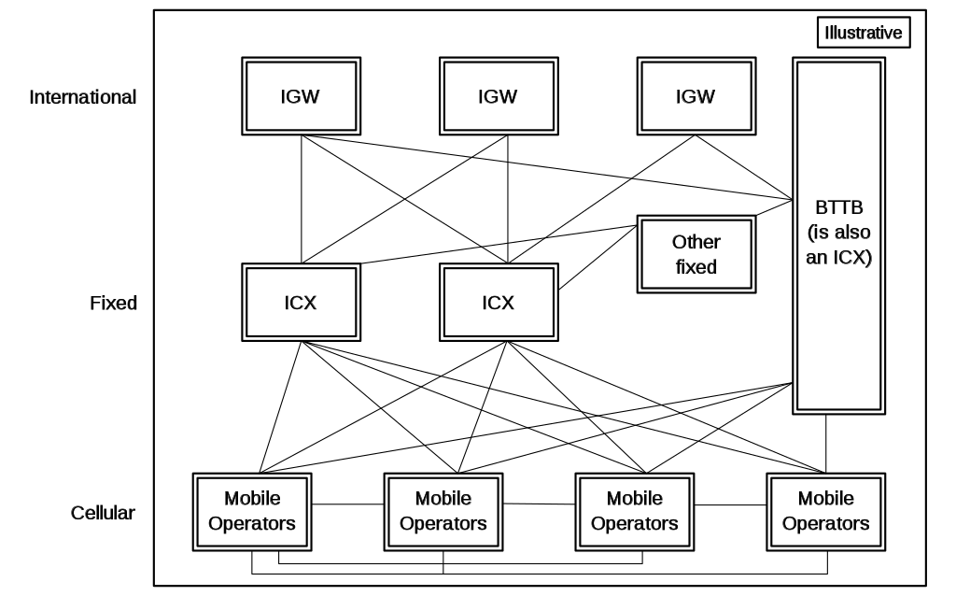
Figure No. 1.1

List of Mobile Telecommunication Companies of Bangladesh:
- Airtel
- Banglalink
- Bijoy Phone
- BTCL
- Grameen Telephone
- Grameen Phone
- Onetel Communication Ltd.
- Peoples Tel
- Ranks Tel
- Real VU
- Robi
- SAtel
- Tele Barta
- Teletalk

Contributors of the industry:
In Bangladesh, there are four licensed mobile operators: Grameenphone, Robi (which recently merged with Airtel), Banglalink, and state-owned Teletalk. Virtual network drivers (MVNOs) do not yet function in Bangladesh; nevertheless, the BTRC is evaluating the potential of permitting them to submit a request.
Grameenphone, Banglalink, Teletalk, and Robi are the four players now in demand (under which Airtel operates). Before the Robi-Airtel merger and Citycell's demise in 2016, the request featured six players. Because of the assiduity's oligopolistic structure, competition is fierce.

A Sketch of the Market:
Whenever Bangladeshi governments have attempted changes in the recent two decades, the situation has rapidly changed. In Bangladesh, the nature of telecommunications has also altered. significantly. In its efforts to change, Bangladesh's government has been visionary. The mobile request remains the primary focus of Bangladesh's telecom sector. As the drivers expanded their structure, Bangladesh's mobile request began to receive a tremendous amount of original capital expenditure.
There has been a significant shift in the way data is produced and used on several occasions A number of government bodies and regulations will respond to the growing number of internet addicts by enacting tough data occupancy laws that will result in significantly higher data center occupancy. As pall computing, particularly pall computing, develops, there will be a significant increase in the rate at which on-premise installations are outsourced to third-party data centers.
Bangladesh boasts a plethora of public telecommunications networks. To expand the network's coverage region, a large number of telecom subscribers was required. It is also necessary to make large investments in the communication infrastructure in order to strengthen it. Between 2019 and 2022, Bangladesh's telecom authorities expect a significant development of its network infrastructure.
To address an increase in data usage, the top mobile authorities have planned to boost content. Due to the dominance of the mobile member, the fixed line request in Bangladesh is still under construction. Furthermore, fixed telephone lines are sluggishly diminishing as the number of mobile members grows.
Because it is such a large public network, the telecom sector has invested much in the transitional request during the previous two decades. Although fixed mobile phone lines are still an important part of the public infrastructure, expansion in this area has slowed as demand has switched to mobile phone services. Wireless Local Loop (WLL) services have been widely used in the effort to expand introductory telephone services across the country. At the same time, the government has enthusiastically backed two programs aimed at extending content.
The sharing arrangement was seen as critical for a faster rollout of base stations in Bangladesh's vast interior, which was difficult to penetrate due to poor roads and a lack of electricity. Structure firms have been through a lot of restructuring in recent years, with drivers growing and, in some cases, dividing these units. There was also a greater readiness to hire outside contractors to build the edifice. Dispatch halls were extremely important in this industry. A variety of government programs and legislation will result in an increase in internet users while also enforcing strict data residency restrictions, requiring a considerable increase in data center capacity. The high level of investment in new data centers has resulted from the rapid development in the volume of data handled each year, as well as the growing need for data localization.

Chapter 02

Literature Review

Defining Customer Loyalty:
Client fidelity describes an ongoing emotional relationship between you and your client, manifesting itself by how willing a client is to engage with and constantly purchase from you versus your contenders. Fidelity is the outgrowth of a client’s positive experience with you and works to produce trust..
- Loyal customers
- Purchase repeatedly
- Use what they purchase
- Interact with you through a variety of different channels
According to the Wikipedia Client retention refers to the capability of a company or product to retain its guests over some specified period. High client retention means guests of the product or business tend to return to, continue to buy or in some other way not disfigurement to another product or business, or tonon- use entirely.
Significance of customer loyalty: Customer loyalty increases profits, improves sales success and allows for sustainable growth. A well-designed and well-executed loyalty programmer can help you retain existing customers, attract new customers, reduce turnover and drive profits.
Customer loyalty is a customer’s willingness to interact with or buy from a specific company on an ongoing basis. Loyalty can stem from many things, but in general a loyal customer will associate favorable experiences with a brand therefore increasing their likelihood to make repeat purchases with that business. Loyal customers spend 67% more on products and services than new customers. Even though your most loyal customers only make up 20% of your audience, they provide up to 80% of your revenue.
Benefits of customer loyalty for a business:
- Drive repeat business
- Increase revenue
- Create brand ambassadors
- Defend against the competition
- Gain valuable feedback

Factors of influencing customer loyalty:
Client perceived value, brand trust, client satisfaction, reprise purchase guested, and commitment are plant to be the crucial impacting factors of guests brand fidelity.
1. Convenience.
When buying consumer products, numerous pious guests transgress simply because the store where they regularly buy your product ran out or does not carry it presently. They may still prefer your product, but after all, there are other brands in stock and they do not have time to chase your product down.
2. Prospects.
Your product must continue to live up to their prospects in every way. It not only has to continue to deliver on its brand pledge and remain applicable, but its price, value, and vacuity must continue to be reliable.
3. Client service.
The way your company stands behind its products can be as precious as the product itself. A good bond and nippy resolution of issues keep guests, who may have had a disappointing experience, buying your product.
4. Particular connections.
The way guests are treated by third parties, similar as salesman, store clerks, or your own representatives can make or break client fidelity. Numerous do not buy your product as much as they “buy” the person who vended it to them.
5. Prices.
Guests want some consideration for continuing to do business with you, especially when they've other options. Offering savings, lagniappes, and other forms of special attention to your pious guests can't only keep them from going away but may be the reason they recommend you to their musketeers.
6. Character.
How your product plays in the media, both marketable and social, can impact long- term connections. Your company’s fiscal, labor, and sourcing practices are now subject to the scrutiny of a decreasingly transparent world where consumers realize that they bounce with their purchases.
7. Community outreach.
When you stand for commodity beyond your product, when you support the causes important to your guests, and when you share in their community, you make a bond of fidelity that's hard to break. This gives them a social reason to come and remain pious.

Variables of the present study:
Variables of the present study are Customer Loyalty, Satisfaction, Reputation, Trust, Perceive Value, Habit and Convenience Value.
Definition of satisfaction: Customer satisfaction is a word that is widely used in marketing, according to Wikipedia. It's a metric for how well a company's products and services meet or exceed consumer expectations.

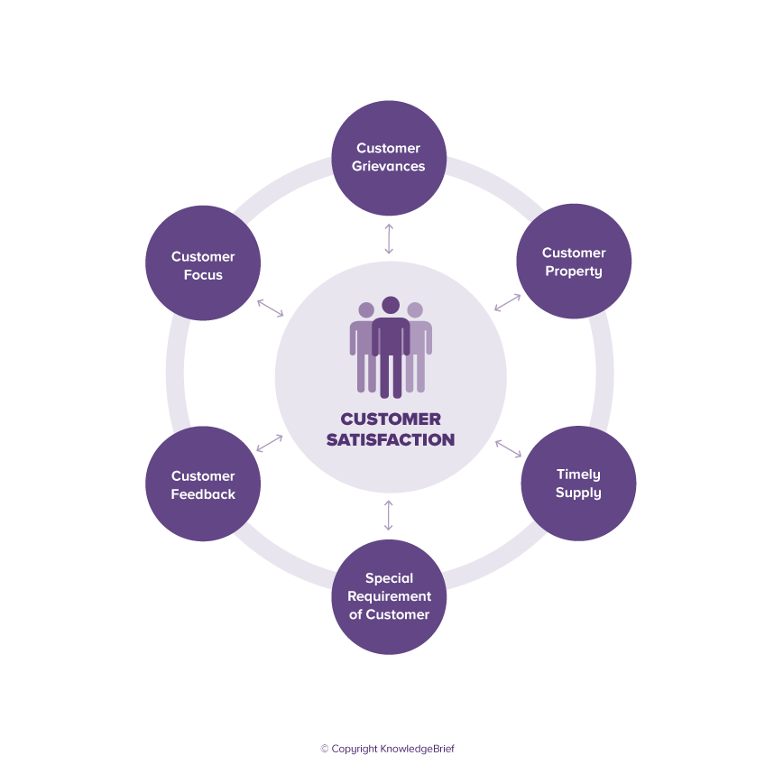

Figure No. 2.1

Client satisfaction, according to Philip Kotler, is defined as "a person's sensation of pleasure or disappointment as a result of measuring a product's perceived performance or development versus his or her prospects." Despite the fact that Kotler employs abstract concepts such as pleasure and sadness, the description f (perceived performance, buyer's prospects) = client satisfaction.
Then there's client satisfaction, which is determined by perceived performance and future potential. The consumer's perception of the product or service experience is referred to as perceived performance. On the other hand, buyer prospects are told by
- Word of mouth, referrals, or eyewitnesses Product performance in recent history Reviews
- What are the opinions of challengers on the product or service?

The promise of ignition made by its own marketers is far from vague.
While AK Rai acknowledges that client satisfaction is influenced by perceived performance and prospects, he proposes a more thorough formula for client satisfaction. Client satisfaction equals the difference between the client's impression of the service and the client's expectation of the service.
Significance of satisfaction:
We've gone over three different definitions of client satisfaction. But why is it important for corporations to stress it? It may appear like firms are performing intuitive effects, but there is more to it. Client pleasure has previously been shown to be a reliable predictor of purchase intent and client loyalty. Client integrity is a significant indicator of client retention, and there are five compelling reasons why client retention is important. According to HBR, getting a new client is 5x to 25x more valuable than keeping an existing one. According to Gartner, your devout guests, who make up 20% of your client group, generate an additional 80% of your revenue. According to MarTech, guests are 3x to 10x more likely than cold leads to spend. A 5 increase in customer retention results in a 25 to 95 rise in gains, according to Fred Reichheld, the inventor of the net protagonist score. The longer a customer stays with a product, the less price knowledge he or she has compared to a new person appraising it. All of this also applies to visitors to your website. Reprise callers are more likely to spend more time per runner and are also more likely to provide a review. Client retention and churn are aided by satisfied guests. It results in lower expenditure or more money available for other conditioning. It generates more revenue as well as positive word-of-mouth. And, by focusing on keeping our customers happy, we'll be able to improve our customer service, call center relations, dispatching, and the product itself. It'll also help us prepare for the next task: gaining client loyalty. "There's a tremendous difference between delighted visitors and devout guests," says client service specialist Shep Hyken. Satisfactory is a state of being satisfied. "Fidelity is a feeling." Shep writes about this in a blog post titled "Why Client Satisfaction is a Myth." So, how do the marketers benefit from the delight of their customers?

The way the marketers or customers get benefited by the satisfaction:
If we think from the marketers’ side, they would be benefited by the satisfaction directly whenever the customers put satisfaction to the marketers and tend to purchase product from the same vendors. Sometimes the customers love to purchase a product from a vendor who actually staying far away from the buyers. But still he do purchase from him because of the satisfaction issue. At the same point, marketers would love to get the satisfied customers to sell his product easily, in fact without any hassle.
Customer satisfaction and customer loyalty:
Satisfaction influences customer loyalty directly because if a customer is satisfied his loyalty would be increased. Similarly a customer’s dissatisfaction decreased the customer’s loyalty. The more the satisfaction level is the more the customer loyalty will be. It is needless to say that, indeed it is a matter of fact that, if a customer is satisfied he will repeatedly purchase the product or get the service. This would be positively influenced customer by satisfaction. Customers perceived that, he will be a loyal customer whenever he gets the importance from the vendors. On the contrast, an offended unsatisfied customer would be tried to change the vendor. That would be the negatively influenced.

Reputation:
Because the perception of what is and is not reputable is in the "eye of the beholder," defining reputation can be challenging. From a variety of academic and professional backgrounds, a variety of definitions of reputation have been presented. 'Reputation,' according to the 'American Heritage Dictionary' (1970: 600), is "the public's general opinion of one."
1a : overall quality or character as seen or judged by people in general. B: recognition by other people of some characteristic or ability has the reputation of being clever. 2: a place in public esteem or regard : good name trying to protect his reputation.
.



Figure No. 2.2

Importance of reputation:
Reputation is a culmination of how society, including customers, stakeholders, employees, and the general public, views a business or individual. Reputation determines the social standing of a person in the society. It is a measure of his or her influence. A person enjoying good reputation is definitely preferred for better jobs and for taking up leadership roles. And good reputation has never hurt anyone.
The benefits of a good reputation include:
- More business opportunities
- Lower marketing costs
- Attracts loyal supporters
- More customers and sales
- Distinguishes you from competitors
- Promotes good relationships with clients
- Greater revenues
- Cost-free advertising
- Attract better quality prospective employees
- Higher company value
No matter whom you are or what your goal is, without a good reputation you’ll find it difficult or almost impossible to achieve success. Customer swan the most for their money, so naturally they choose the company or person they think is superior. No one wants to pay for a product or service that is lower quality than they initially believed. So whether you’re pitching a new client or looking for business partnerships, your reputation affects your bottom line.

The way the marketers or customers get benefited by the reputation:
Indeed, reputation tends marketers to dealing with a customer. As well as a customer also likes to do shopping or dealing with someone who has better reputation. Reputation has a strong power to fetch the marketer or customer to accomplish the task. So, undoubtedly reputation plays a vital role for both the marketers and customers in marketing arena.

How reputation influences customer loyalty:
Having a good reputation not only commands the customers' trust but also influences buyers. It helps improve the trust in the beliefs and intentions of business. People think high of the vendor and they do not need to think twice when purchasing a product or service from the vendor. They are also more willing to share more information about their needs, follow the advice and to do business with. So, as a business, one should determine the extent to which the reputation influences trust and in getting a positive purchase intention.
Reputation may be either positive or negative. However, both the positive and negative reputation influence buyer. A customer tends to purchase a product repeatedly from the same buyer because he got something good from him. Some sort of good reputation turned him to do so. On the contrast, a customer dislikes to deal with someone because of some reason. Probably this would be the negative reputation. It is easily assuming that both the type of reputations influence buyer buying tendency directly.

Defining Trust:
Trust is a central part of all human relationships, including romantic partnerships, family life, business operations, politics, and medical practices. If you don’t trust your doctor or psychotherapist, for example, it is much harder to benefit from their professional advice.



Figure No. 2.3

Importance of trust:
When you know someone is not secure, it affects your relationship. Constantly, it can break a relationship. People got to have others they will trust. Whether it’s in particular connections, work, or society as a whole, trust is essential. Some reasons why trust is important;
I. Psychological safety
II. Encourages questioning and trouble- taking
III. Encourages fast opinions
IV. Improves communication
V. Promotes tone- confidence
VI. Increases productivity
VII. Facilitates meaningful connections
VIII. Reduces stress
IX. Increases heartstrings of optimism
X. Trust is good for communities
The way the marketers and customers benefited by the trust:
Trust is one of the vital variables for marketing arena. If one is not that trustworthy, the whole thing will just destroyed. The relationship builds on the trust. And a relationship is significant issue for doing something together. When customer is a trustworthy to the marketer, that marketer would get a consistent customer which is needed in a competitive market. A trustworthy and loyal customer is far better than 10 untrustworthy customer who are not that much consistent.
Similarly, whenever a customer gets a trustworthy marketer who is sincere and honest in his delivery and behavior, undoubtedly he will consistently meet with him and get service from him.
How trust influences the customer loyalty:
Any relation starts and develops on trust are stays for a very time. Whereas untrusted relationship never stay long. Buyer customer relationship also is a factor to go with for successful dealings. In that connection, needless to say that trust is a base of a strong relationship. The buyers always like to deal with someone whom they can make trust. Trustworthy people can easily influence the buyer; in fact trust is a main power to influence the buyer.

Perceive Value:
Perceived value is a customer's own perception of a product or service's merit or desirability to them, especially in comparison to a competitor's product. Perceived value is measured by the price the public is willing to pay for a good or service. The marketing of a product or service involves attempting to influence and increase its perceived value, which can emphasize qualities such as its aesthetic design, accessibility, or convenience.

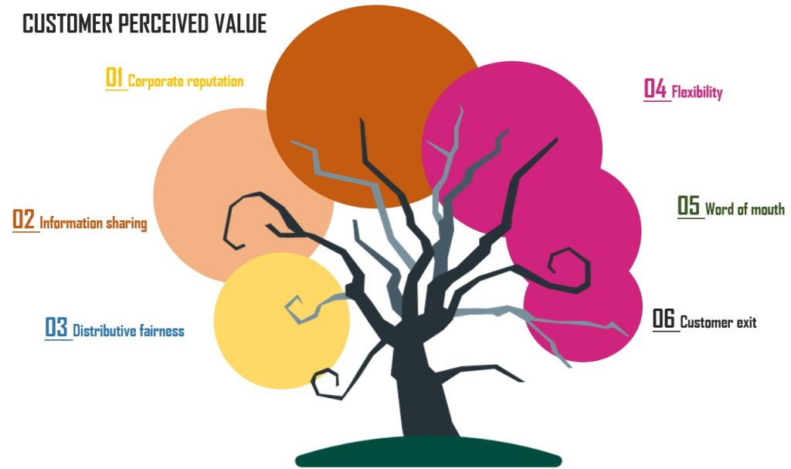

Figure No. 2.4

Importance of perceive value:
Customer perceived value is important because marketing professionals can use the idea to predict how a consumer may view a product. When the perceived value of an item increases, the business or company can price it higher or sell more units, both of which result in higher profits. For that particular reason, perceive value has a specific value for both party. It plays a vital role for increasing the rate of sell of a product.
If anyone wants to increase the product’s perceived value, he needs to show customers that the product is better than the competitors’. Therefore, marketers define their product’s unique attributes and benefits to improve the perceived value.
The way the marketers and customers are benefited by the perceive value:
Perception is an attribute to imagine a product before purchase. Perceive value has a strong value by which a marketer and a customer get benefited. When a customer perceives a product quality, color by the marketer, no doubt that the brand value and price of the product may increase more than before. The buyer then tends to purchase the product more confidently.
How perceive value influence the customer loyalty:
Actually a buyer becomes more curious to purchase a product when he may perceive about the product. At least he can visual the product by perceives, so perceive value has a strong power to influence the customer loyalty.
Definition of Habit:
According to the Wikipedia, a habit is a routine of behavior that is repeated regularly and tends to occur subconsciously. The American Journal of Psychology defined a "habit, from the standpoint of psychology, [as] a more or less fixed way of thinking, willing, or feeling acquired through previous repetition of a mental experience."

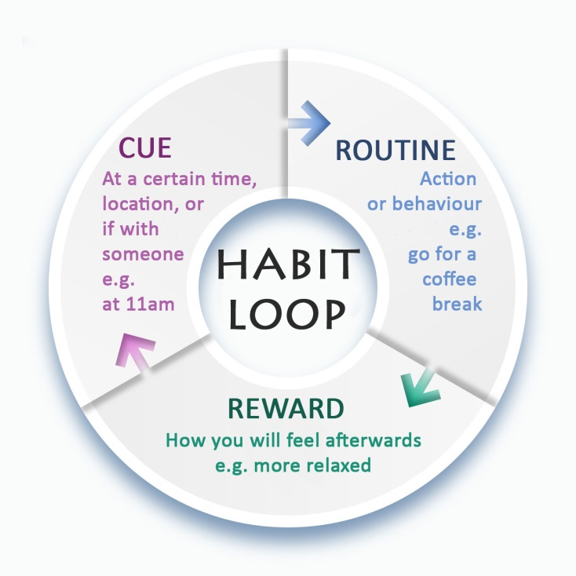

Figure No. 2.5

Importance of habit:
Habits are essential to our health. They can make or break your chances of achieving and maintaining our life pretensions like sticking to an eating plan, exercising regularly, and managing diabetes/ other medical conditions, along with adding quality of life and promoting life.
Habits literally shape our everyday conduct that grows stronger the further we perform them. This process shifts habits from proactively making opinions to getting more and more automatic.
Although habits can be a good thing like moving your body on a diurnal base or drinking enough water, they can also come a disadvantage too. However, you need to rewire your t Habits are a series of events where you have to fete the cue; produce a good response (habit), If a bad habit is created. In order to change a nasty habit with an honest one, you've got to vary the response. Allowing and replace it with a new bone.

The way the marketers and customers are benefited by the habit:
Habit is normally refers to tend to do the same thing repeatedly. When a marketer got a customer buying product repeatedly from him, it would definitely a beneficial issue for him. No doubt, there are so many attributes to have the habit to buy things from the same person. Reputation, trust, perceives and so on. Similarly, the buyer also tends to buy something from a habitual marketers probably his behavior is favorable, or products quality is good. It is a possible reason to do the buying or selling thing to the same person.
In that way, both marketers and customers get benefited by the habitual activities from the opposite options.
Habit and customer loyalty:
Buyers go to purchase a product by getting a review from different ways. It is another ways to show the habit to purchase a product. Buyer’s habit is to buy a product from a vendor although there are so many competitors in the market. Obviously there are some different reasons behind to create a habit of a person. A person tends to buy or become a repeated buyer with a habitual act. Habit always moves the buyers to go to the same way. By such way, habit influences the buyer.
Definition of Convenience Value:
Convenience value refers to that, one tries to manage someone on some particular issue. From the customer’s side, convenience value has a very specific definition. The customers tried to convince the marketers to buy the best product with a least or reasonable price. On the other hand, the marketer always tries to hold the best customers and refrain from buying from the competitors. For that reason, a better sales person has the right ability to convince a customer and assist to buy such product which he was not intended to buy.
Importance of Convenience Value:
To convince someone to do the job by a person accordingly is not so easy task. For that, convenience someone has a vital value. Whenever marketers convince a loyal customer to purchase a product and the customer buy it, it absolutely refers the marketers high convenience value. So, it is easily assume that convenience value is important for both the marketers and customers.
The way the marketers and customers get benefited by the Convenience Value:
Both of the marketers and customers become got benefited by the convince value. Skilled marketers tried to convince the customer and he will become successful when the customer purchases the product. On the contrast, the clever customer intended to lower the price of the product by using the bargaining power. He would be successful when finally purchase the product with the price he demanded. So, it seems that the convenience value has a importance in marketing zone.

How Convenience Value influences the customer loyalty:
Customer loyalty is typically influenced by the convenience value of the marketers. Marketers are always like to patronize those customers who are loyal and consistent. If a marketer’s has the convenience quality he would be better marketer among the competitor. Although the customer loyalty may influence either positively or negatively the convenience value of the marketer but still it carries a value.

Chapter 03

Methods, Findings and Analysis

Measurement
Following measurements are used to collect data from the customer/subscribers relating to their use of different mobile connections. To measure the variable, five-point Likert scale was used as given below.
(5) Strongly Agree ; (4) Agree ; (3) Neutral ; (2) Disagree ; (1) Strongly Disagree

Gender
Age
Name of your mobile company
Customer Loyalty
My preference for this mobile network would not willingly change
It would be difficult to change my beliefs about this mobile network
Even if close friends recommended another mobile network, my preference for this mobile network would not change
I will buy from this mobile network the next time I need to purchase other network service
I intend to keep using the telecommunication services from this mobile network
Satisfaction
My choice to use this mobile network was a wise one
Using this mobile network has been a good experience
I am satisfied with the services of this mobile network
Reputation
This mobile network company has a good reputation
This mobile network company has a good reputation compared to other rival companies
This mobile network company has a reputation for offering good services
This mobile network company has a reputation for being fair in its relationship with its users
Trust
Based on my experience in the past, I know this mobile network company is honest
Based on my experience in the past, I know this company cares about customers
Based on my experience in the past, I know this company is not opportunistic
Based on my experience in the past, I know this mobile network company is predictable
Based on my experience in the past, I know this mobile network company know its market
Perceived Value
Services of this mobile network company is good value for money
Price/fee charges by this mobile network company are acceptable
In this mobile network company, service is considered to be a good deal
Habit
I usually use the mobile network of this mobile company for communication and other service
This is my preferred mobile network company providing mobile communication services
When I need to communicate with other or get any network service, this is the first mobile network I try
I often use the service of this mobile network company
Convenience Value
I value the ease of using this mobile network services
Using this mobile network services is an efficient way to manage my time
I value the convenience of using this mobile network services

Analysis and Findings:

Now, if I accumulate the averages of each part, it would be shows like below;

CL | SAT | REP | TRS | PV | HAB | CV
3.91666667 | 3.5 | 3.6 | 3.527778 | 3.5 | 3.8 | 3.6

- CL Stands for Customer Loyalty
- SAT Stands for Satisfaction
- REP stands for Reputation
- TRS stands for Trust
- PV stands for Perceive Value
- HAB stands for Habit
- CV stands for Convenience Value

Now, time to analysis the data using some charts. Here I have use some charts to analysis the data of some mobile user or customer like; column chart, line chart, pie chart, bar chart and scatter chart, etc. Hopefully I may get a clear picture from the charts.

Chart no. 01: Column Chart

Analysis of Column Chart: If I consider the values of the average is “X” axis and the categories of the customer’s survey on “Y” axis, it is shown that the average of CL is above 3.9, means most of the attendees perceived as positive on customer loyalty issue over the mobile operators. The average ratings of SAT are 3.5. Whereas REP is 3.6, which is a bit upper in compare to the SAT. In question of trust issue (TRS) of the mobile user, it shows a bit upper than 3.5 but below 3.6. PV value is shown accurately 3.5 in the column chart. Habit (HAB) of the mobile phone user is shown the average data is 3.8 and convenience value (CV) is 3.6.

Chart no. 02: Line Chart

Analysis of Line Chart: If I consider the value of response from the respondents for different questions is “X” axis and the categories of the customer’s survey on “Y” axis, it is shown that the average of CL is above 3.9, means most of the attendees perceived as positive on customer loyalty issue over the mobile operators. The average ratings of SAT are 3.5. Whereas REP is 3.6, which is a bit upper in compare to the SAT. In question of trust issue (TRS) of the mobile user, it shows a bit upper than 3.5 but below 3.6. PV value is shown accurately 3.5 in the column chart. Habit (HAB) of the mobile phone user is shown the average data is 3.8 and convenience value (CV) is 3.6.

Chart no. 03: Pie Chart

Analysis of Pie Chart: If I consider the value of response from the respondents for different questions is “X” axis and the categories of the customer’s survey on “Y” axis, it is shown that the average of CL is above 3.9, means most of the attendees perceived as positive on customer loyalty issue over the mobile operators. The average ratings of SAT are 3.5. Whereas REP is 3.6, which is a bit upper in compare to the SAT. In question of trust issue (TRS) of the mobile user, it shows a bit upper than 3.5 but below 3.6. PV value is shown accurately 3.5 in the column chart. Habit (HAB) of the mobile phone user is shown the average data is 3.8 and convenience value (CV) is 3.6.

Chart no. 04: Bar Chart

Analysis of Bar Chart: If I consider the value of response from the respondents for different questions is “X” axis and the categories of the customer’s survey on “Y” axis, it is shown that the average of CL is above 3.9, means most of the attendees perceived as positive on customer loyalty issue over the mobile operators. The average ratings of SAT are 3.5. Whereas REP is 3.6, which is a bit upper in compare to the SAT. In question of trust issue (TRS) of the mobile user, it shows a bit upper than 3.5 but below 3.6. PV value is shown accurately 3.5 in the column chart. Habit (HAB) of the mobile phone user is shown the average data is 3.8 and convenience value (CV) is 3.6.

Chart no. 05: Scatter Chart

Analysis of Scatter Chart: If I consider the value of response from the respondents for different questions is “X” axis and the categories of the customer’s survey on “Y” axis, the dot is shown that the average of CL is above 3.9, means most of the attendees perceived as positive on customer loyalty issue over the mobile operators. The average ratings of SAT are 3.5. Whereas REP is 3.6, which is a bit upper in compare to the SAT. In question of trust issue (TRS) of the mobile user, it shows a bit upper than 3.5 but below 3.6. PV value is shown accurately 3.5 in the column chart. Habit (HAB) of the mobile phone user is shown the average data is 3.8 and convenience value (CV) is 3.6.

Customer Loyalty | Satisfaction | Reputation | Trust | Perceive Value | Habit | Convenience Value
3.91666667 | 3.5 | 3.6 | 3.527778 | 3.5 | 3.8 | 3.6

Table No. 4

If I analysis from the above table, may find some very specific value for different variables. Let’s compare the values within the variables.
Value of satisfaction is 3.5 which is above average and below agree. When satisfaction level is situated in this point, customer loyalty may upwards but not up to the mark, but still it influence the customer loyalty.
Value of reputation is 3.6 which is also may considered as agreed level which refers that reputation influence the customer loyalty.
Value of trust is 3.6 which is also influence customer loyalty directly.
Value of perceive value is 3.5 from which we may consider that it influence the customer loyalty with a remarkable state.
Value of habit is 3.8 which is really influence the customer loyalty very strongly.
Value of convenience value is 3.6 which is also influence the customer loyalty strongly.

Recommendation
Recommendation to improve or fix the issues of telecommunication companies:
Today’s customer no longer bases their loyalty on brands, products, or prices. Their loyalty is dependent upon the service they receive, their experience of a business, and their level of satisfaction. To thrive and succeed in a highly competitive world, your business needs to put in a serious effort to delight your customers. A recent survey by American Express publishes that 40 percent of U.S. customers seek out a real person’s support over the phone to resolve complex issues such as payment disputes or complaints. This underscores the need for telecom companies to take customer experience seriously.
Some recommendations like;
- Reach out to Disgruntled Customers
- Personalize the Engagement
- Understand Customer Expectations
- Resolve service issues faster
- Harness customer data effectively
- Taking customer focus to the next level

References:
- https://en.wikipedia.org/wiki/Customer_retention
- https://emarsys.com/learn/blog/what-is-customer-loyalty-and-why-is-it-important/
- https://www.consumerbrandbuilders.com/7-factors-effect-customer-loyalty/
- https://citeseerx.ist.psu.edu/viewdoc/download?doi=10.1.1.685.1091&rep=rep1&type=pdf
- https://en.wikipedia.org/wiki/Customer_satisfaction
- https://instituteforpr.org/reputation/
- https://watchthem.live/perceived-value/
- https://www.psychologytoday.com/us/blog/hot-thought/201810/what-is-trust
https://theimportantsite.com/10-reasons-why-trust-is-important/

