An Evaluation of Consumer Purchase Intention: A Study on Juice Industry in Bangladesh

Noman Ahamed Pream

This report is submitted to the School of Business and Economics, United International University as a partial requirement for the fulfillment of Bachelor of Business Administration Degree.

An Evaluation of Consumer Purchase Intention: A Study on Juice Industry in Bangladesh.

Submitted by
Noman Ahamed Pream
Id: 111 151 477
School of Business & Economics
Program: BBA
Major: Marketing

Submitted To
Dr. Kawsar Ahmmed
Associate Professor
School of Business & Economies
United International University

Date of Submission: 21 August, 2019

Letter of Transmittal
Date: 21 August, 2019

Dr. Kawsar Ahmmed
Associate Professor
School of Business & Economies
United International University
Subject: An Evaluation of consumer purchase intention: A Study on Juice Industry in Bangladesh.

Dear Sir,
This is my immense pleasure to present my internship report on factor influencing consumer PI of Juice which I am assigned by your supervision.
I have tried my best to prepare this internship report with necessary information and suggested information on the survey questionnaire. I did all the activities in a concise and comprehensive manner. I hope that this report will fulfill the expectations.
Sincerely yours
…………………….
Noman Ahamed Pream
Id: 111 151 477
Program: BBA
Major: Marketing

Acknowledgements
At first I would like to place my gratitude to the Almighty Allah the most gracious and merciful for enabling me to perform the job appropriately and prepare the internship report with full endeavor.
I would also like to thank our honorable teacher Dr. Kawsar Ahmmed, Associate Professor, School of Business & Economics, United International University, for his proper guidance and careful supervision.
Accordingly I would also like to thank my supervisor Ashiqur Rahman, Senior Executive, Brand marketing Department at ACME Agrovet and Beverages Limited for his flawless support.
As well as I would also like to place thanks to Md. Inzamam-Ul-Haque, Executive, Brand Marketing Department at The ACME Agrovet& Beverages Limited, for his proper guidance I made this internship report.

Executive Summary
Purchase intention is a process of decision making by which consumer decide which product is to buy. In this internship report, mentioned about an evaluation of the consumer purchase intention of juice industry in Bangladesh. Now a day because of globalization many organization and industries rise up with various product and services. In this my internship report I was assigned to make a report on “A study on juice industry in Bangladesh” For preparing this report a well-designed structured questionnaire provided to the respondents (Consumer)and they response. Total response collected from online survey with the help of Google doc. file and spared the link at Facebook or E-mail. Here in this report I discussed about six industries beverages product like Juice. Many organizations introduce various flavor drinks or juice because of the demand of the consumers. In this internship report I was discussed about the factors that influence the purchase intention of consumer. There are four dependent variables such as Brand Consciousness, Quality Perception, Emotional Value as well as Perceived Product Price & one Independent variable Purchase Intention. For my survey I developed structured questionnaire and sample size was 100.After collecting information convert it to the excel workbook and generated bar and pie charts to interpret the results and analysis the data accordingly measure the five variables. Lastly I provide Recommendation and conclusion so that juice industries become enriched.

Keywords: Brand Consciousness, Quality perception, Emotional Value, Perceived Product Price, Purchase Intention, Juice Industry, ACME Agrovet and Bevereges Limited.

Contents
Chapter: 1 3
Introduction 3
1. Introduction: 4
2. Motivation of the Study: 5
3. Objective of the Study: 5
4. Limitation of the Study: 6
5. Significant of the Study: 6
6. Organizations of remaining chapter: 7
Chapter- Two 8
Company Overview 8
2.1 Historical Background: 9
2.2 Core Values: 10
2.3 Core Competencies: 10
2.4 Core Strength: 11
2.5 Vision of the Company: 11
2.6 Mission of the Company: 11
2.7 Inception of the ACME Agrovet& Beverages Ltd: 12
2.8 Products of ACME Agrovet& Beverage Ltd: 13
2.9 Board of Directors 22
2.11 Corporate Social Responsibility 23
2.12 Job Experience at ACME Agrovet & Beverages Limited. 23
Job Responsibilities: 24
2.13 Brief History about Juice industry in Bangladesh: 25
ACME Agrovet& Beverages Limited 25
PRAN Food Limited 25
Sajeeb Group Limited: 26
Tropicana Frutz: 28
ACI Foods Limited 30
Akij Food & Beverage Ltd 31
Chapter: 3 33
Literature Review 33
Purchase Intention 34
Importance of understanding customer Purchase intention 34
Factors influencing consumers Purchase Intention 34
1.Brand consciousness: 35
Relationship of Brand Consciousness and Purchase Intention 35
2. Quality Perception: 35
Relationship between Quality perception & Purchase Intention: 36
3. Emotional value: 36
Relationship between Emotional value and Purchase intention: 36
4. Perceived Product Price: 38
Relationship with Perceived Product Price and Purchase Intention: 38
Conceptual Framework 38
Overall Summary: 39
Interpretation: 40
Chapter: 4 41
Data Collection, Analysis, Findings, and Discussions 41
Introduction 42
Population or sample size of present study: 42
Population: 42
Sample Unit: 42
Sample size: 42
Data Collection Procedures: 42
Data Source: 42
Data Collection Procedures: 43
Measurements: 43
Data Analysis: 46
Demographic profile of the Respondents: 46
Age: 47
Occupation: 48
Discussion: 49
Brand Consciousness: 49
Interpretation: 49
Quality Perception 50
Interpretation: 50
Emotional Value: 51
Interpretation: 51
Perceived Product Price: 52
Interpretation: 52
Brand Preference: 53
Analysis of Brand Preference: 53
Findings: 54
Positive findings: 54
Negative Findings: 55
Recommendation: 56
Specific Observation and Recommendation for ACME Agrovet and Beverages Limited: 57
Conclusion 58
Reference 59
Appendix 60
Questionnaire 60

List of Tables

Serial No. | Page Number
1 | 43
2 | 43
3 | 44
4 | 44
5 | 45
6 | 46
7 | 47

List of Figures

Serial No. | Page Number
Figure 1 | 35
Figure 2 | 36
Figure 3 | 37
Figure 4 | 38
Figure 5 | 39
Figure 6 | 40
Figure 7 | 46
Figure 8 | 47
Figure 9 | 48
Figure 10 | 49
Figure 11 | 50
Figure 12 | 51
Figure 13 | 52
Figure 14 | 53
Figure 15 | 55

Chapter: 1

Introduction

1. Introduction:

Bangladesh is a Developing country and the increased amount of globalization changing consumers purchase intention in Juice Industry. Many well-known brand introduce different types of juice with various flavor and it considers as daily product of many people. While I am preparing this report I select 100 samples as respondent. In my report I collect data through online survey through creating Google doc. file and spread it online such as Facebook and Email accordingly here I can easily know the purchasing intention of customers. Four independent variables that influence purchasing intention there are Brand Consciousness, Emotional Value, Quality perception and Perceived product price. Provided respondents survey questionnaire by online so that I can find which brands juice they like most. In my survey I find that most of the consumers like ACME juice, Tropicana, AFBL Frutika, Pranfrooto ,Shezan&Funfrutz. Some of them would like to purchase ACME classic mango & premium Juice and Tropicana most. In Bangladesh in case of Juice industry leader will be consider as Pran but in my survey with 100 samples most of them like ACME classic mango & premium Juice and then comes Tropicana fruitz drinks. These two brands take place in the mind of customer and it has a soft corner because of emotional attachment with the brand.

2. Motivation of the Study:

- As I am doing Internship at ACME Agrovet and Beverages Limited that’s why I am motivated to make a report on Juice Industry in Bangladesh.
- While I am doing competitors analysis about various types of Juice brands I can know the trade price ,Trade offer ,SKU & MRP of the juice,
- Now a days people buy juice at any occasions like Ramadan, Birthday or different types of day people celebrate with juice.
- Many new brands introduce their juice in Bangladesh such as ACME Classic mango juice, ACME premium Juice, Tropicana Fruitz accordingly Pran has frooto& ACI has Fun fruitz.
Based on those points I am motivated to do a study on Juice Industry In Bangladesh. As well as I have learned many things about the brands that are include in my Survey questionnaire.

3. Objective of the Study:

- To examine the level of Purchase intention of Juice.
- To measure the impact on product quality in product category.
- To measure and examine the emotional attachment with each brand.
- To examine the perceived price of the Juice.
- To measure the brand consciousness.
- This study is essential in case of perceived Product price influencing the purchase intention of consumers.
- To measure perceived quality influencing both the brand preference and the purchase intention, perceived social value affect the purchase intention positively.

4. Limitation of the Study:

- Shorter time period- The time period is short.
- Sample Size- Sample size is small (100)
- Unwillingness of respondents- Respondents are not willing to give the feedback of the questionnaire.
- Difficult and Time consuming- Creating a proper questionnaire is too much difficult and time consuming.
- Lack of available data-Much organization’s data is not available and reliable. As well as respondents sometimes fill up the survey form without reading.
- Cultural and other type of bias- While preparing the report based on survey questionnaire it seems to be respondents are bias.
- Time consuming

5. Significant of the Study:

- To explain the concept of Marketing and Brand Management.
- To know the organizations that produce Juice in Bangladesh.
- It is helpful for my future career growth.
- It will help me in my job life; if i can face any problems in my job life then this experienced will help me.
- Here we can know the perception of customer what they actually think about Juice industry based on online survey.
- This study will good for the personnel, managers and marketing brand experts especially who are in the Beverages sector.

6. Organizations of remaining chapter:

Here, in this Internship Report I will discuss about chapter Two and Three. Chapter Two includes the rational of that four factors such as Brand Consciousness, Quality Perception , Emotional Value and Perceived product Price. These four factors influence the purchase intention of a consumer. In chapter Three I will discuss about the introduction of chapter three, Sample size, data collection procedures, Data analysis as well as recommendation and Conclusion.

Chapter- Two

Company Overview

2.1 Historical Background:

The history of the ACME dates back to 1954 when a proprietorship firm was founded to manufacture ethical drugs. It begin with the modest introduction of a few oral liquid products. The late Hamidur Rahman Sinha was the founder of the firm and was the main visionary leader of the organization unit his sad demise in 1994. Under the company act the firm was converted into a private limited company in the year 1976. Organizations Commercial operation at the modernized plant equipped with sophisticated and advanced technology began toward the end of 1983.Many challenges comes and overcome successfully to transform the company from a small unit to what it is today.

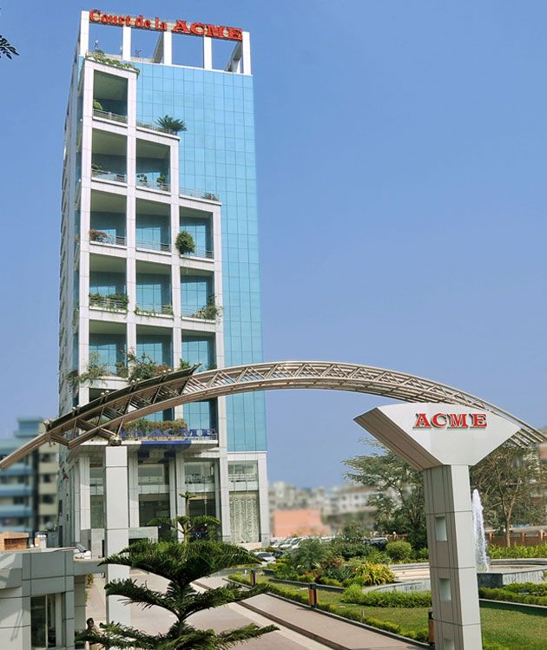

ACME continuously aim to expand its production facilities, add employees and increase its sales and marketing efforts. Out of about 300 pharmaceutical companies in the country, according to the latest statistics The ACME Labs is the top four. ACME has also expand to strengthen its network in national and international marketing operations to export its products abroad. We are optimistic about our continued growth and success.

Over the years our high achievement drive, our hard working and skilled staff and confidence in our quality products have contributed to our growth. We have definite goals that inspire us and we believe to be possible for us to reach. We continuously aim to reach our goal of being the beat in our field which indeed is what ACME literally stands for.
ACME’s product lines contain three categories, at present. These are herbal, allopathic, and animal health. Each category have a wide variety of products. The main activities of ACME are to Contract Manufacturing, Sales & Distribution. ACME is exporting medicines to 16 countries in all dosage forms and competitive price. Its head quarter in Bangladesh and It has market coverage Sri Lanka, Nepal, Myanmar, Philippine, Afghanistan, Hong Kong.
ACME Laboratories is the second largest manufacturer and exporter of Human, Herbal and Animal Health Pharmaceutical Products in Bangladesh. The ACME Laboratories Ltd, the pharmaceutical and the flagship company of the ACME Group, is a manufacturer and global exporter of human, herbal and veterinary pharmaceutical products. Since 1990 the company has achieved an average growth rate of 25% compared to 13% registered by the pharmaceutical sector of the country. The ACME Agrovet& Beverages Ltd. in 2005. Primarily it started with a small range of products like ACME mango and orange juice, which is followed by the introduction of ACME mineral water. Now The ACME Agrovet& Beverages Ltd. is pondering to introduce a wide variety of products, some of which are under process of development. Latest of their product is ACME Spice and ACME Premium Gold Tea. It has established a modernized plan in Bangladesh located at Hemayetpur. The plant is equipped with modernizes technological facilities and run by qualified personnel in accordance with the stringent guideline of BSTI.

2.2 Core Values:

Ensuring health vigor and happiness is the philosophy of the ACME Agrovote and Beverage.

2.3 Core Competencies:

Basically core competency refers that what make your organization different from competitors. Here in ACME they used high technology machineries, and main focused in quality production rather than mass production.

2.4 Core Strength:
- The ACME Agrovet and Beverage Ltd have got the investment by The ACME group. The goodwill of the Pharmaceutical business accordingly the marketing channels and distribution resources are being used as well as possible.
- The Office premises, experience, Management and manufacturer experience of the ACME group is a huge strength for The ACME Agrovet and Beverage Ltd.
- The Quality of the products of The ACME Agrovet and Beverages Ltd. is better than most of the local FMCG companies. Comparing the quality, the prices of the products are within the range of the target market segment.

2.5 Vision of the Company:

“Our vision is to reach out even to the remotest areas of Bangladesh and improve lives with quality products at an affordable price.”- Vision statement of Acme Agrovet& Beverages Ltd.

2.6 Mission of the Company:

“Our holistic approach is to ensure Health and Happiness for all by manufacturing ethical products of the highest quality at affordable prices and reaching out even to the remotest areas by proper distribution network. We view ourselves as partners with our customers, our employees and our environment.”- Mission statement of Acme Agrovet& Beverages Ltd.

2.7 Inception of the ACME Agrovet& Beverages Ltd:

ACME starts its journey in 1954 with a small pharmaceutical production facility. In the year 2005, ACME celebrated it is 50th anniversary of establishment. Over a little more than 50years, ACME has become one of the largest conglomerates in the country. In pursuit of excellence, ACME flourished its business in various sectors including pharmaceutical, FMCG/ Agrovet and Beverages, Textile and information Technology. With a yearly turnover of $70m and work force of more than 3200 ACME has become a phenomenon in the country.
Using the experience of manufacturing ethical medicine also ACME ventured to establish.

In the mentioned section, the growth and foundation of ACME group will be presented (ACME, 2015):
1954: ACME Laboratories established as a proprietorship for manufacturing Pharmaceutical items.
1976: ACME Laboratories converted into a private limited company.
2008: Introduces to produce Tablet and Capsule in new premises.
2003: Commercial operation with modern facility at Dhamrai, 6 acres land 32 km from Dhaka.
1987: Cream and ointment added in production.
2010: Achieve average 25% growth rate compared to the 13% registered by pharmaceutical sectors.
1992: Introduce inject able products.
2007: Agro vet Division of manufacturing of veterinary and animal health care drugs in independent factory.
2005: Establishment of “The ACME Agrovet and Beverages Ltd” and forward ACME’s footprint in the FMCG sector in Bangladesh.

2.8 Products of ACME Agrovet& Beverage Ltd:

The ACME Agrovet and Beverages Ltd. started its Journey in 2005 with orange and mango juice. Then it introduced drinking mineral water. Their Latest product is ACME Premium Gold Tea. It has established a modernized plan in Bangladesh located at Hemayetpur. The plant is equipped with modernized technological facilities and run by qualified personnel in accordance with the stringent guideline of BSTI.
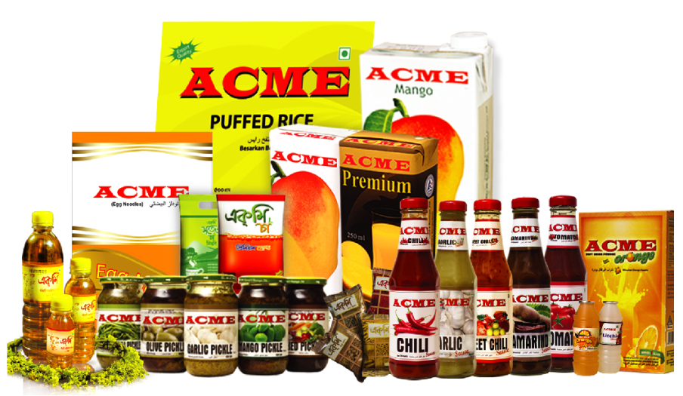
ACME PRIMIUM DRINKING WATER: ACME premium drinking water filtered with reverse osmosis system makes ACME PRIMIUM water free from Arsenic and comes in pet bottled: 500 ml, 1000 ml and 2-liter size.
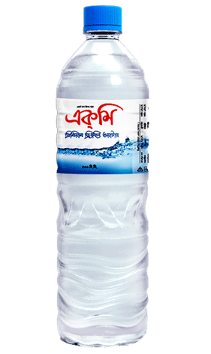

ACME PREMIUM & CLASSIC MANGO DRINKS: Nutritious and pure mango drinks come in 150 ml, 250 ml and 1000 ml.

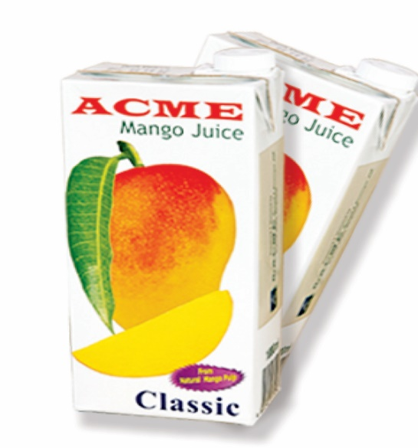
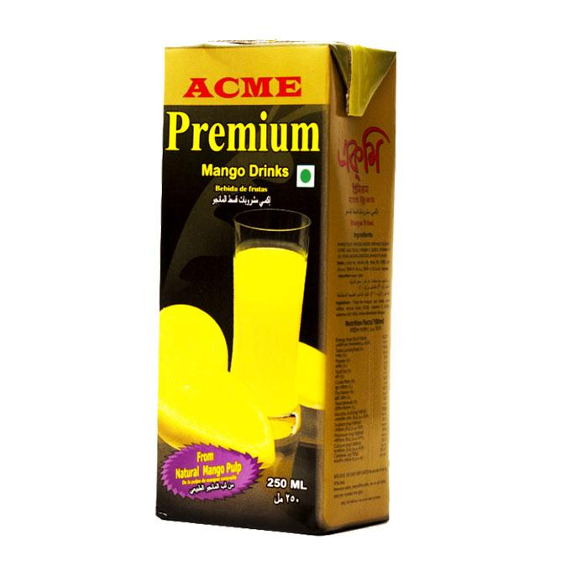

ACME PREMIUM TEA: Best blend and collected from selected garden, fresh ACME premium tea, BOP and dust comes in reasonable 50mg, 200mg, 400mg and 1000mg.
ACME TEA PREMIUM GOLD: ACME Tea premium gold, a supreme blend of CTC clones. It is unique for its aroma, color and taste. It contains natural antioxidants. Its natural extracts refreshes and revitalizes you and keeps you fresh and healthy.
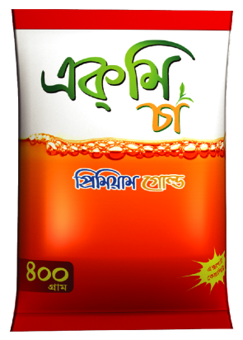

  - Now Available in 400g pack.
  - Various size tea packs will be available in market 10g, 50g, 100g, 200g & 500g packs.
ACME MUSTERED OIL: Made from raw and classified seeds, ACME mustered oil comes in 80ml, 200ml, and 500ml.
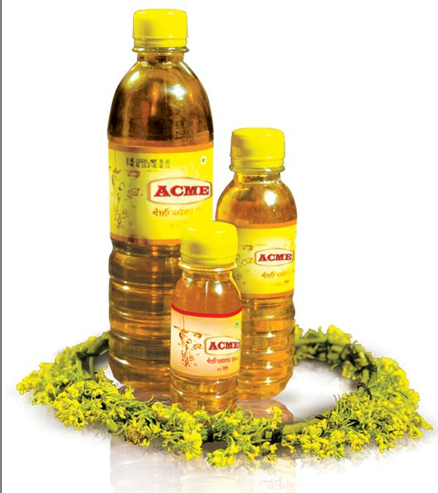
ACME SPICES: From the test of DESHI masala, ACME spices are manufactured from premium quality harvests for chili, turmeric, cumin and coriander powder available in 15 gm, 50 gm, 100 gm and 200 gm.
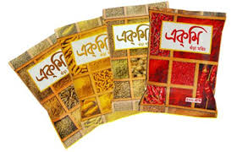

ACME EGG NOODLES: Healthy and testy egg noodles made from wheat flour, powder source of great energy value comes in 150 gm, 180 gm.
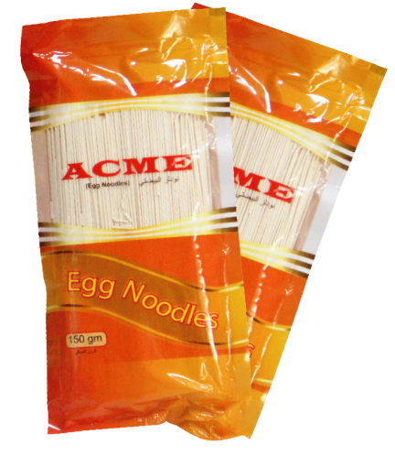

ACME FRIED PEAS: Good snakes start with ACME fried peas.
- It is available in 30 gm pack.

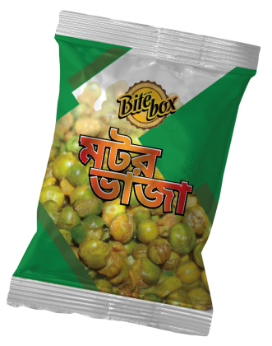

FUROOT LYCHEE CUP JELLY: Fun product furoot lychee dissolves in the yummiest way and manufactured with total hygiene and care.
- Available in 90 pcs jar of 12 gm each

ACME ORANGE SOFT DRINKS: With natural taste of orange, ACME orange soft drink powder is energetic and refreshing.
- As well as available in 8gm, 70gm, 125gm and 250 gm.

ACME PICKELS: Healthy and testy ACME pickles comes in 400 gm bottle with chili, garlic, olive, mango mixed flavor all year around.
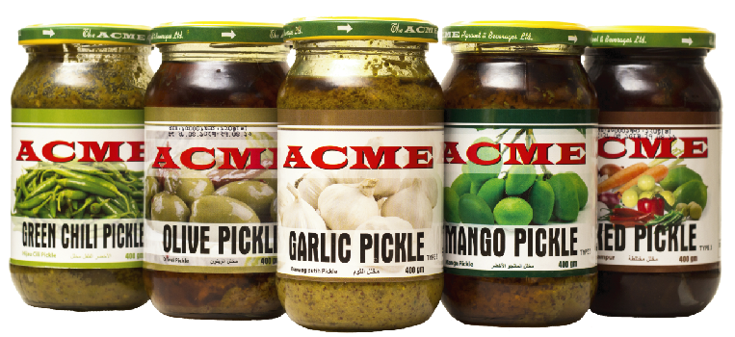

ACME SAUCE: To increase the test of food ACME introduced ACME SAUCE of tomato, garlic, tamarind, chili& sweet flavor comes in 350 ml bottle.
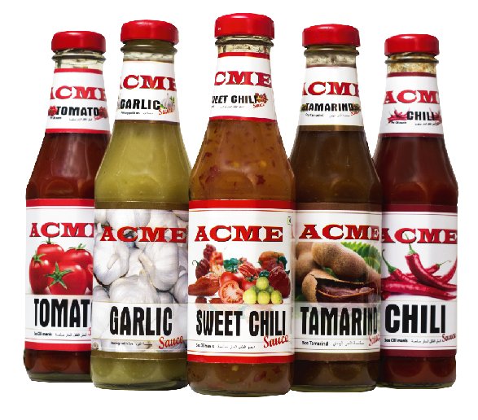

ACME TESTY SALINE: Rehydrate yourself with best quality oral ACME tasty saline.
- Available in 20 mg pack for 500 ml water.
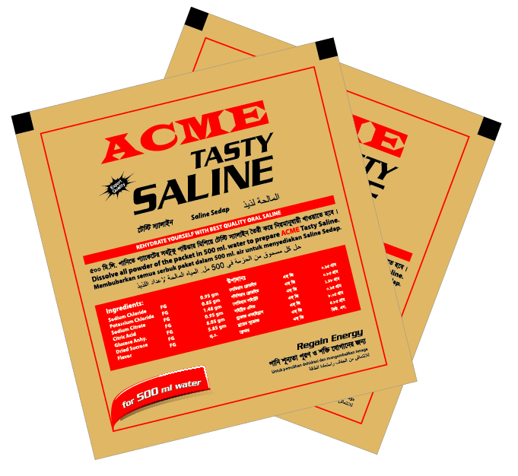
ACME TAMARIND CHUTNEY: Mouth-watering test of ACME tamarind chutney available in 20mg pack.
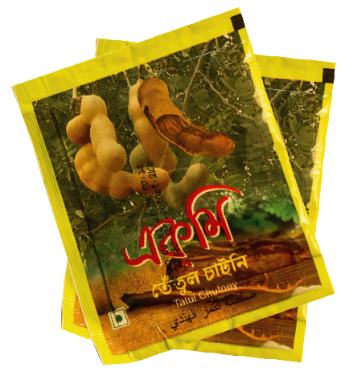
ACME ORANGE AND LITCHI DRINK: Fun drink products for children with great fruit test comes in 170ml pet bottle.
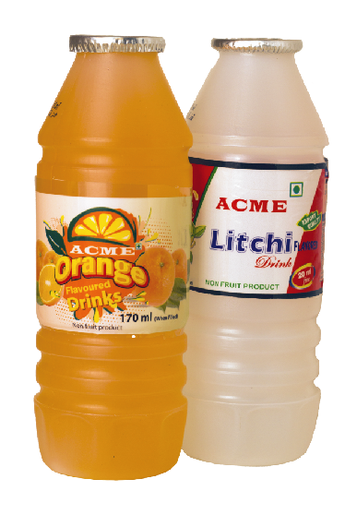
ACME CURRY POWDER: For enormous test of DESHI curry, ACME Curry powder for beef, chicken, mixed and with garam masala in 50 gm box pack is available.
ACME FRIED DAAL: Extra spice snacks with selected mungh pal, ACME frieddaal available in 30 gm sachet pack.
ACME LACHCHA SEMAI: Made from pure wheat and flour, ACME lachchasemai is the best dessert in town.
- Local size available in 200gm foils pack.
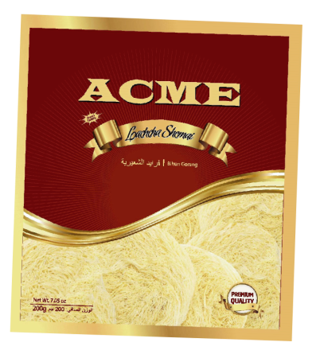

ACME SAUCE SACHET:Tomato ketchup and sweet chili sauce are also available in the market.
- SKU 10gm pack size.

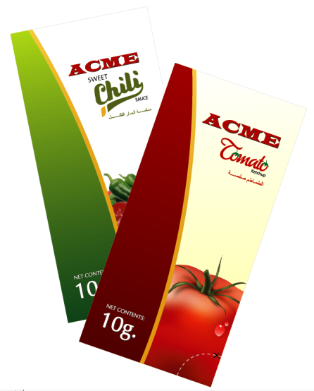

Some Picture of ACME’s Product:
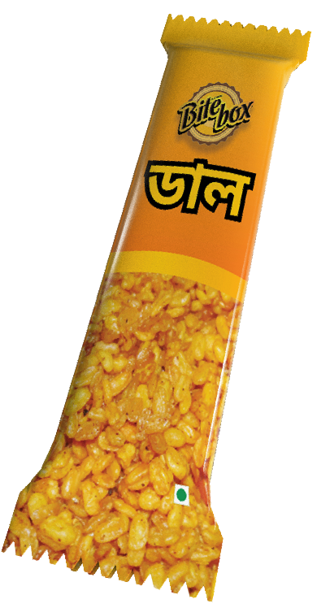

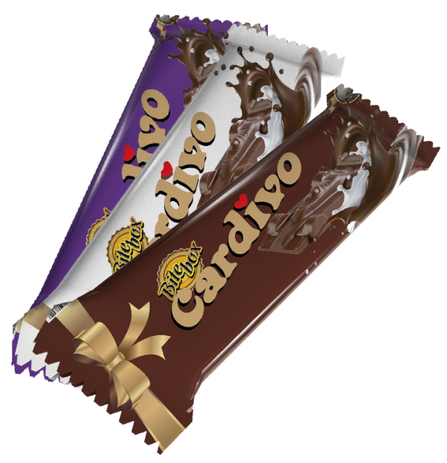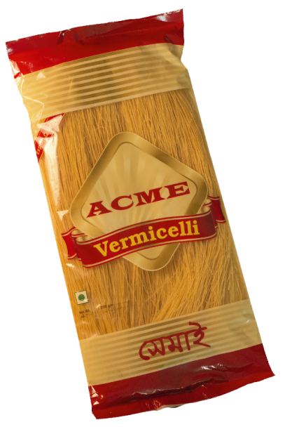

2.9 Board of Directors
Managing Director
Executive Director
Directors
RSM
SALES

SM
AM
SR
Brand Executive
Brand Officer

Marketing Manager
Directly Reports to
National Sales Manager
Head of Accounts
Head of Human Resource mManagement
Executive Officer
Junior Officer
Manager
Senior Manager
Director
Chairman

2.11 Corporate Social Responsibility

- As a part of CSR, ACME Agrovet and Beverage Limited have been Providing medical facilities and other support to 23 HIV positive patients since 2006.
- ACME stands by disabled and underprivileged children.
- ACME IT has awarded scholarship to 65 meritorious and needy student

2.12 Job Experience at ACME Agrovet & Beverages Limited.

This part of the report paper presents my internship position in the ACME Agrovet and Beverages Ltd, my core responsibilities and work experiences in case of my internship period.
Internship Position:
I have done my internship period at ACME Agrovet and Beverages Limited. I was placed in the Brand Marketing Department in Head office, ¼ Kallaynpur, Mirpur Road. I had joined the internship program on 11 June, 2019.
In my internship period I have no idea about my organizational position. I have worked there 5 days in a week. Office hour starts from 8.30 A.M to 6.00 P.M. same as office hour for other officials or designated personnel. At the very first day of my internship Muhammad Arman Haidar, Officer at department of Accounts & Finance introduce me with Salahuddin Ahmed Sr. Executive then he Introduce me with Ashiqur Rahman, Senior Executive at Brand Marketing Department and he was assigned for my supervisor as well as he introduce me the code of conduct of the organization and my responsibility.

Job Responsibilities:

Inside and outside of the office I have to experiences a lot of things. In the following section I am presenting them.
- At first I did potential outlet information for ACME Agrovet and Beverages Limited and those information input in the excel workbook.
- After that I am doing Van Branding.
- Calculation of t-shirt for promotional and sales force aspects of 2018 to 2019 July.
- Did Market survey for competitors price analysis.
- Work as a supervisor when storage of marketing department changes.
- Create product portfolio and data entry for web development.
- Involves in new product development such as Mango Powder Drinks .( Sample Panel test)
- Doing field work for market analysis of Tea.
- Distributing gift, Promotional logistics such as t-shirt, various types of products etc.
- Collecting sample for new product development.

2.13 Brief History about Juice industry in Bangladesh:

ACME Agrovet& Beverages Limited
The historical background of ACME Agrovet & Beverages limited is mentioned at (page number 10)

ACME group have eight sister concerns namely (ACME, 2015):
- The ACME Laboratories Ltd,
- The ACMUNIO International Pvt. Ltd,
- The ACME Agrovet and Beverages Ltd,
- The ACME IT Ltd,
- MARS Group,
- Sinha Printers Ltd,
- AMBE Clearing Limited,
- ACME Overseas Trading Ltd.

PRAN Food Limited
There are six seasons in Bangladesh. It has a good weather combination for agriculture and hence, the cultivation of fruits and vegetables. The opportunity to utilize this section for business inspired the late Amjad Khan Chowdhury to put his mastery to excellent use. He had a vision that would not only serve the society and its people, but would also create a good business that would redefine the food manufacturing industry. And thus, PRAN was born in the year 1981. A successful period of 5 years led to the diversification of PRAN’s operations into agriculture in 1986 through contract farming, with the coordination of AMCL, (Agriculture Marketing Company Limited)
PRAN further cemented its place in the industry through a food processing plant at Ghorashal in 1992. Coming through this period of endeavor, PRAN has now established itself as one of the top manufacturing companies and has set the grounds for development for any potentialities.
Beverages
PRAN has a wide variety of refreshing beverage lines. Brands of beverages like PRAN Frooto, PRAN UP, Power, PRAN Lassi are some of the renowned beverage brands from the company produced in 3 factories situated in different locations and 16 depots to carry out the production and distribution movements. Future plans for beverages industry include introducing Lassi in HDPE line, milk added drinks, drinking water jar & pouch business. PRAN is also introducing juice in carbonated soft drinks (CSD), and different type of category extension of the company.

Our Vision
Improving Livelihood

Our Mission
Poverty & hunger are curses. Our aim is to generate employment and earn dignity & self-respect for our compatriots through profitable enterprises.
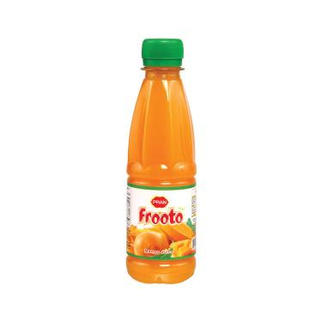

Sajeeb Group Limited:

One of the largest business groups of the country Sajeeb group of companies, begin its journey in 1982 and has been managing successfully since then. Over the years the group has expand its business functions in different industry sectors with its other sister concerns contributing to the overall socio economic development of the country.
A highly effective and innovative professional team is engaged in (PQC) Process Quality Control of our production. We give our top most priority on developing the best quality at each level of the production process in regard to maintain and operates international standards.
We ensure factory collect raw materials and rules, under good supervision and standards from our own pool of suppliers. We have employed state of the art technology in processing our products and use 100% food graded packaging to ensure the best product quality. Recently, we have achieved “100% Halal certification” for our beverages and drinks products from Halal Bangladesh Services (HBS).
Along with our own well-known brand name Sajeeb, we are also involved in marketing and manufacturing of the products of world famous brands like Shezan, Tang, Kolson, Nocilla, Bourn Vita and Oreo. Under the franchise of famous Shezan International Limited. We manufacture and market Shezan products in our country. Our good quality products have earned a huge goodwill in both the local and foreign markets.
Apart from our food & beverage products, we have agro-based products, agro-processing, real estate, insurance, readymade garments, telecommunications and electronic media business.
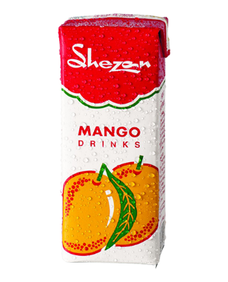
Our Concerns
- Sajeeb Foods and Beverage Ltd
- Hashem Foods Limited
- Hashem Agro Processing Limited
- Takaful Islami Insurance Ltd
- Hashem Flour Mills Ltd.
- Sajeeb Homes Limited
- MARS International
- Savvy Foods
- Sajeeb Logistics
- Hashem Auto Rice Mills
- Sajeeb Corporation

Tropicana Frutz:

PepsiCo has brought in Tropicana Frutz—a product of the world's number one packaged juice brand—for the Bangladesh market as part of efforts to widen its presence in the beverage category. Tropicana is known for offering high quality, refreshing juices and fruit beverages, the company said in a statement yesterday. Tropicana Frutz, which was launched last week, will be made and distributed nationwide by Transcom Beverages Ltd, PepsiCo's exclusive bottling partner in Bangladesh. The beverage will be available in mango, orange and apple flavors, according to the statement. Tropicana Frutz Mango offers an indulgent mango experience made from ashina mangoes grown by farmers in Bangladesh. TropicanaFrutz Apple gives the taste buds the perfect burst of apple, while Tropicana Frutz Orange with orange pulp offers a unique sensory experience in every sip, the company said. “Bangladesh is a very important market for us, and we are delighted to introduce the world's no. 1 packaged juice brand Tropicana here,” Debasish Deb, country manager of PepsiCo Bangladesh, said at its launch.

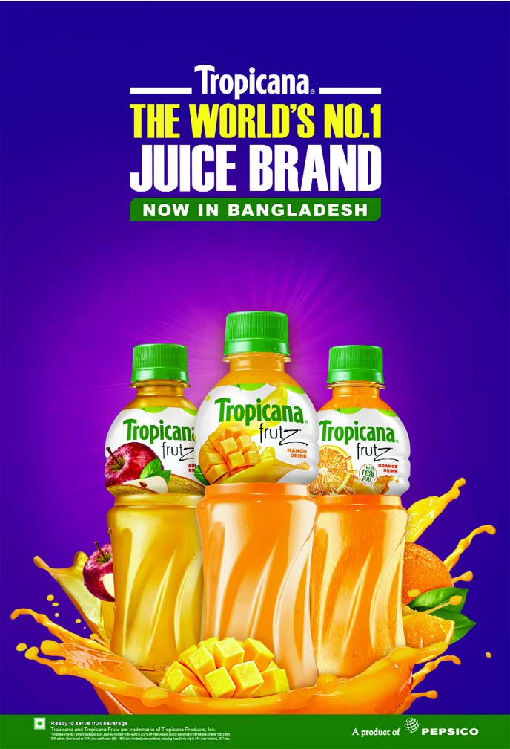
Number one packaged juice brand—for the Bangladesh market as part of efforts to widen its presence in the beverage category. Tropicana is known for offering high quality, refreshing juices and fruit beverages, the company said in a statement yesterday. Tropicana Frutz, which was launched last week, will be made and distributed nationwide by Transcom Beverages Ltd, PepsiCo's exclusive bottling partner in Bangladesh. The beverage will be available in mango, orange and apple flavors, according to the statement. Tropicana Frutz Mango offers an indulgent mango experience made from ashine mangoes grown by farmers in Bangladesh. Tropicana Frutz Apple gives the taste buds the perfect burst of apple, while Tropicana Frutz Orange with orange pulp offers a unique sensory experience in every sip, the company said. “Bangladesh is a very important market for us, and we are delighted to introduce the world's no. 1 packaged juice brand Tropicana here,” Debasish Deb, country manager of PepsiCo Bangladesh, said at its launch. He said Tropicana Frutz has been launched specifically keeping in mind the taste preferences and demand from Bangladeshi consumers.
“Our Tropicana fruit beverages are loved worldwide, and we hope that the refreshing range of Tropicana Frutz will be the perfect fit for consumers seeking everyday refreshment in a convenient on-the-go format.”
Tropicana Frutz Mango is priced at Tk 25 for 250ml and Tk 35 for 350ml, while Tropicana Frutz Orange and Apple are both available at Tk 40 for 350ml.“Tropicana Frutz is a great addition to PepsiCo's diverse portfolio in Bangladesh, as we look to widen our presence in the beverage category,” said Vishal Kaul, vice president for beverage category at PepsiCo. Tropicana“As we delved into taste preferences of our consumers in Bangladesh, we explored their love for fruit-based blends. Introducing juice drinks with the fruit expertise of a premium brand like Tropicana is, therefore, a natural direction for us.”Khurshid Irfan Chowdhury, managing director and CEO of Transcom Beverages, said, “Our partnership with PepsiCo has brought iconic global brands like 7UP, Pepsi, Mirinda, Aquafina and Mountain Dew, that have all captured the hearts of our consumers in Bangladesh. “We are delighted to bring the international brand experience of Tropicana to our consumers.” “At the same time, we are proud to be sourcing the best of our country's own popular ashina mango pulp for making the perfect tasting mango fruit drink,” he said. Chowdhury said the move to launch a premium brand like Tropicana is part of a strategic roadmap for expanding “our liquid refreshment portfolio with relevant offerings”.

ACI Foods Limited

ACI was established as the subsidiary of Imperial Chemical Industries (ICI) in the then East Pakistan in 1968. After independence the company has been incorporated in Bangladesh on the 24th of January 1973 as ICI Bangladesh Manufacturers Limited and also as Public Limited Company. This Company also obtained listing with Dhaka Stock Exchange on 28 December, 1976 and its first trading of shares took place on 9 March, 1994. Later on 5 May, 1992, ICI plc divested 70% of its shareholding to local management. Subsequently the company was registered in the name of Advanced Chemical Industries Limited. Listing with Chittagong Stock Exchange was made on 22 October 1995Advanced Chemical Industries (ACI) Limited is one of the leading conglomerates in Bangladesh, with a multinational heritage. The company has diversified into four major Strategic Business Units.

Our Mission
ACI’s mission is to enrich the quality of life of people through responsible application of knowledge, skills and technology. ACI is committed to the pursuit of excellence through world-class products, innovative processes and empowered employees to provide the highest level of satisfaction to its customers.

Our Vision
To realize the mission ACI will:
- Endeavor to attain a position of leadership in each category of its businesses.
- Attain a high level of productivity in all its operations through effective and efficient use of resources, adoption of appropriate technology and alignment with our core competencies.
- Develop its employees by encouraging empowerment and rewarding innovation.
- Promote an environment for learning and personal growth of its employees.
- Provide products and services of high and consistent quality, ensuring value for money to its customers.
- Encourage and assist in the qualitative improvement of the services of its suppliers and distributors.
- Establish harmonious relationship with the community and promote greater environmental responsibility within its sphere of influence.

Our values:
- Quality
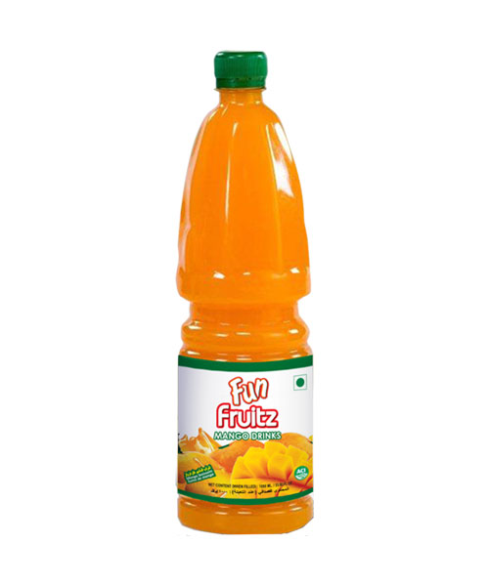
- Fairness
- Customer Focus
- Improvement
- Transparency
- Continuous
- Innovation

Akij Food & Beverage Ltd

Akij Food & Beverage Ltd. (henceforth to be termed as AFBL), a well-known brand name in Food Processing and Marketing sector in Bangladesh, begins its journey in 2006 with only 3 products. But within a long span of 10 years, the company broad its area of production in Food and Beverage sector by adding a good number of products which will attract the consumer’s expand and win commercial goodwill. This has been made possible by the visionary concept of its founder late Sk. Akijuddin and its owner Mr. Sk. Shamimuddin
It has established the factories of high standard with most modern technology and has been producing wide varieties just like carbonated soft drinks, energy drinks, juices, dairy products, snacks, chips, drinking water etc. The products of snacks and beverages by AFBL earns both international and national repute and find international market of South-East Asia, East Asia, Middle East and Africa. This is no doubt that these phenomenal achievement by a Bangladesh Company.

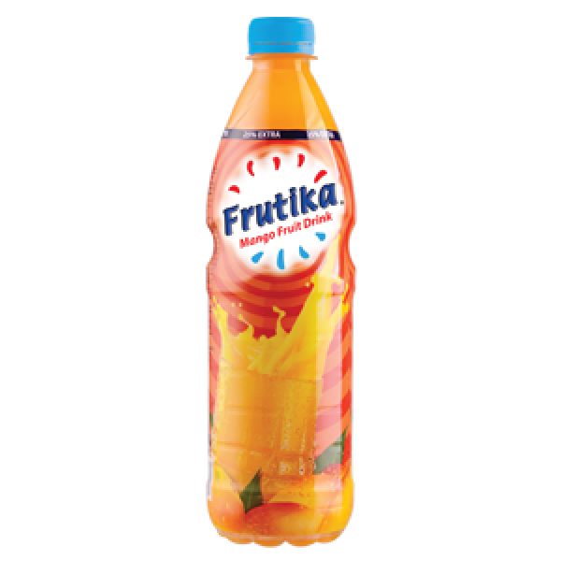

AFBL begin its production at 400 bpm in the section of carbonated soft drinks line and 300 bpm in the juice line. In a period of one and a half year, they have increased the level of their capacity at 1200 bpm. Now, this capacity is at the ground breaking rate of 5000 bpm. In this period, most of their brands earned the position of either no. 1 or nearing to it in their respective categories among the consumer groups.

Chapter: 3

Literature Review

Literature Review

Purchase Intention

Basically it derives from the need of a product which is driving the customer towards a purchase. Purchase intention is a kind of decision-making that studies the reason to buy a particular brand by consumer (Shah et al., 2012).Morinez et al. (2007) define purchase intention as a situation where consumer tends to buy a certain product in certain condition.

Importance of understanding customer Purchase intention

Consumers purchase intention for decision making is a critical process. Purchase intention basically included to the behavior, perceptions and attitudes of consumers. Accordingly purchase intention includes brand consciousness that means awareness, Emotional value means emotional attachment with the brand, quality perception refer to the quality of the product and perceived product price. Purchase intention is a key point for consumers to access and evaluate the specific product. Ghosh (1990) states that purchase intention are an effective tool to predict buying process. Purchase intention may be changed under the influence of price or perceived quality and value. In addition, consumers are affected by internal or external motivations during the buying process (Gogoi, 2013). Researchers have proposed six stages before deciding to buy the product, which are: awareness, knowledge, interest, preference, persuasion and purchase (Kotler & Armstrong, 2010) (Kawa et al., 2013).

Factors influencing consumers Purchase Intention

Actually there are several factors that affecting the consumers purchase intention such as celebrity endorsement, advertisement, promotional campaign accordingly four main factors that influence the purchase intention of a consumers:
- Brand Consciousness
- Quality Perception
- Emotional Value
- Perceived Product Price

1.Brand consciousness: Someone who is brand-conscious he or she only likes to buy products made by certain renowned companies. A brand-conscious company or organization is very concerned about what people think of its brand name and its products. Just like awareness of a brand as a distinct product that differentiate it from other companies or competitors accordingly brings competitive advantages.

Brand Consciousness
Purchase Intention

Awareness

Figure: 1
Relationship of Brand Consciousness and Purchase Intention: It refers to the awareness of such a type of stimulates a customer want to buy a product or service from a certain brand. It may be an attractive TVC, PVC some special packaging or any particular attribute that makes the product unique or may be add some value to the product which attracts the customer towards the product. A consumer’s purchase intention depends upon the level of satisfaction that he or she expects and receives from the marketers. If certain brand satisfies the consumer he or she will become a regular buyer or loyal consumer of the particular brand.

- If consumer has Brand Consciousness then they are more aware about the product and it influence positively in their mind set to purchase the product. ( Juice)
- Brand awareness has an impact on the decision making of a consumer about a particular product of a brand.

2. Quality Perception: Basically it indicates to the personal thought of a customer about a particular brand or a product. That means how a brand fulfills the consumer’s expectation by providing their product. Many organizations try to achieve perceived quality to get the competitive advantages. It can also be defined as the customer’s perception of the overall quality or superiority of a product or service with respect to its intended purpose, relative to alternatives.

Relationship between Quality perception & Purchase Intention: Perceived quality is, first, apperception by customers. Quality perception depending on the overall public image accordingly it helps the companies to get or attain loyal customers.

- If the quality perception of a brand is good then consumer purchase its product because perceived quality is the first thing that consumers consider when they purchase a product.

Quality Perception
Purchase Intention

Figure: 2

3. Emotional value: Emotional value is the fundamental or core key to build a successful business and create a strong brand. Identifying emotional value is the gateway to discovering and building a real emotional-value toward the brand or particular organization. People create fidelity and getting loyal to brands because they are emotionally attached with the certain brand.
Relationship between Emotional value and Purchase intention: Here the Organization makes some association with a particular brand and consumers so they become loyal and emotionally attached with the branded product.

- If emotional value works, means consumers are emotionally attached with a brand then they don’t think about price. They just want the product and consume.

Chain of Emotional Value:
Affiliation
Validation
Identity

Figure: 3

There is a saying that, if affiliation is speed-dating and validation is “going steady,” identity is a committed marriage. As the popular diamond saying goes, “Identity is forever.”
Emotional buyer don’t care about the price of the product, they are not price sensitive .They want those branded juice that brings pleasure for them.

4. Perceived Product Price: How a consumer can perceive the price of a product. Is the price will meet the expectation and provide better quality. Perceived value pricing is an important marketing strategy which helps firms to price a particular product in the market. Pricing a product on the basis of what the customer is ready to pay for it, is called as a Perceived-value pricing.
Relationship with Perceived Product Price and Purchase Intention: Here a consumer can perceive the price of the product based on their features or ingredients accordingly consumer also see value added service. The perceived relative price is the main factor of making the purchase, which is deemed to be fair, meaningful and worthwhile.

- A product is judged based on its perceived relative price in case of the benefits to be gained from the product, what consumers would be willing to pay for the product.
- Based on products quality and perceived product price consumer make their purchase decision.
- If the Perceived product price is good enough than consumer influence to make purchase as well as they are willing to pay the price for the product.

Conceptual Framework: The conceptual framework for this report is developed to identify the relationship between perceived relative price, perceived value and consumers’ purchase intentions in case of particular brand.

Purchase Intentions
Perceived Value Price
Perceived Value

Figure: 4

Overall Summary: These four factors influence the purchase intention of consumers. These factors are Brand Consciousness, Quality Perception, Emotional Value and Perceived Product Quality. All of these factors theoretically or empirically have created strong impact on purchase intention of consumers and choice of Brands.

Perceived Product Price

Emotional Value

Quality Perception

Purchase Intention

Brand Consciousness

Purchase Intention:

Figure: 5

All these four factors affect the consumers purchase intention. Consumers purchase intention for decision making is a complex process. Basically it comes from the need of a product which is driving the customer towards a purchase. Purchase intention is a kind of decision-making that studies the reason to buy a particular brand by consumer (Shah et al., 2012).

Figure: 6

Interpretation: In this study about Juice industry in Bangladesh 36.8% consumers intended to buy the brand juice when the need juice. Approximately 26.50% consumers are not price sensitive. If the company increases the price of the juice they continue to buy this same juice because emotional value attached with the consumers.

Chapter: 4

Data Collection, Analysis, Findings, and Discussions

Introduction
Here, in my internship report I have assigned to prepare a report in “A Study on Juice industry in Bangladesh”. So I have been selected 100 samples as respondents. In this chapter I am going to discuss about my sample size of present study, Data collection procedures, data analysis, findings, recommendation and conclusion.

Population or sample size of present study:
Population: For current study, three populations have been selected. Such as Students of several Universities, Businessman and Service holder.
Sample Unit: Students of faculty of School of Business and Economics.(SOBE)
Sample size: As I mentioned in my introduction part my sample size is 100.Most of them are Student, Businessman and Service holder. Most of the respondents are students of United International University.

Data Collection Procedures:
Data Source: There are two types of source for data collection.
- Primary Source
- Secondary Source
Primary data are collected from following sources:
- Individual consumer mainly (students) from School of Business & Economics (SOBE) of United International University.
- Particular people of the company, Service holder accordingly Businessman.
- Focus group discussions in order to find out the factors that affect most in consumers purchase Intention.
Secondary Data are collected from following sources:
Secondary data are collected from organizations, like marketing and brand research Articles, internet articles and publications, and also from concerned personnel from The ACME Agrovet and Beverages Ltd.

Data Collection Procedures: In my Internship report I collect data through online questionnaire with the help of social media. At first I made a questionnaire at Google doc. file and spread the link through online portal such as E-mail, Facebook etc.Secondary data are collected from organizations, like marketing and brand research Articles, internet articles etc.

Measurements:

To collect data from responds, a structured questionnaire is used that contains various items for the five variables.
To measure the consumer purchase intention following two items were used on five point Likert scale as given below.
Table: Purchase Intention measurement

- I intended to buy this brand when I need to buy juice.
- I plan to continue buying this brand juice even the company increases the price.
Table: 1
To collect data from respondents, a structured questionnaire is used that contains various items for the five variables. Four variables are dependent.
To measure the consumer purchase intention following two items were used PI and Brand Consciousness.
Likert Scale as given below:
Table: Brand Consciousness measurement

1. It is important to buy well known juice.
2. I try to strike to a certain brand in buying juice
3. I give importance on brand name to buy juice
Table: 2

To measure the consumer purchase intention following items were used purchase intention and quality perception.
Likert Scale as given bellow:
Table: Quality Perception measurement

1. This is a reliable juice brand.
2. The ingredients of this juice are suitable to meet my refreshment need.
3. This is a very credible juice brand.
4. Marketers of this juice are very emphatic to the customers.
Table: 3

To collect data from responds, a very well structured questionnaire is used that contains several items for the five variables, one independent variableinfluences four variables.

To measure the consumer purchase intention following items such as Purchase intention and emotional value here I was used five point Likert scale as given below.

Table: Emotional Value measurement

1. This branded juice makes me feel good.
2. This branded juice gives me pleasure.
3. This branded juice makes me want to use it.
4. I feel comfortable in use this branded juice.
Table: 4

To collect data from respondents a well-designed structured questionnaire is used that contains various items for five variables.
To measure consumer purchase intention following two items were used by five point Likert scale such as Perceived product price and Purchase intention.

Table: Perceived product price measurement

1. I would rate the price of the juice as lower than expected.
2. I would rate the price of the juice as higher than expected.
3. I would rate the price of this juice as expected.

Table: 5

Data Analysis: The following analysis of the research has finally arrived by using the data found from the questionnaire.

Demographic profile of the Respondents:

The demographic details of the main survey sample show that the majority of the respondents were males, includes 74% of the whole sample, while females are represented by only 24%. Accordingly 2% of the respondents are from other (Transgender).

Demographics | Percentage
Male | 74%
Female | 24%
Other | 2%
Table: 6

Figure: 7

Age: As well as 76.8% response comes from 21 to 25 ages, 10.1% responses come from 15 to 20 ages.9.1% response comes from 26 to 30 ages and 4% response arrived from 31 to 35 ages.

Age | Response
15-20 | 10.1%
21-25 | 76.8%
26-30 | 9.1%
31-35 | 4%

Table: 7

Figure: 8

Occupation: In my internship report I have selected 100 respondents of three occupations.83% response comes from student,8% response comes from Businessman & 9% response comes from Service holder.

Figure: 9

Discussion:
Brand Consciousness: Collected information is used as excel work book to make the bar Chart.

Figure: 10

Interpretation: In This report I select 100 sample as respondent and majority of them 60% respondents thinks that it is important to buy renowned brand Juice as well as 47% respondents assumes that they try to loyal with a particular brand accordingly 42% respondents would like to give importance brand name in case of buying juice.

Quality Perception: Based on products quality consumer buying decision changes, Here Juice industries follow Total Quality Management (TQM)

Figure: 11

Interpretation: In this section 46% consumer or respondents would like to reliable to a certain brand. Accordingly 53% consumers prefer that branded juice provide suitable ingredients. As well as 52% respondents assured that the juice are credible and approximately 50.5% consumers or respondents think that marketers of juice industry are empathic toward them.

Emotional Value: Emotional value is attached with consumers and takes place in the mind of the consumers. Here collect data are generated from Excel workbook so that we can easily interpret it,

Figure: 12

Interpretation: Identifying emotional value is the gateway to discovering and building real emotional-value toward the brand. Around 61% respondent feels good to drink Juice accordingly 58% respondent have pleasure to use the branded juice.32% consumer’s wants to repeat purchase with the particular brand because they have emotional attachment. Around 29% consumers or respondent feel comfortable while they drinking well branded juice.

Perceived Product Price: All this information collected from 100 respondents and develop the chat from excel workbook.

Figure: 13

Interpretation: Here, I am going to discuss about the perceived product price. Is the price will meet the expectation and provide better quality? Around 33% consumer rate price lower then accepted and they become neutral. In case of higher price 35% consumers rate price higher than expected and they also become neutral. Moreover 41% sensitive buyers they are concern about their expected price of a well-known branded and is it meet all of their requirements. Perceived product price is very complex to rate the price lower, higher or expected by the consumers. Because consumers mind are changing.

Brand Preference: The consumers predispositions toward a brand that varies depending on the salient beliefs that are activated at a given time.( D’Souza and Rao,) (2005).
The extent to which a consumer favors one brand over another ( Hellieret al.,) (2003)

Figure: 14

Analysis of Brand Preference: Around 37% consumers (respondents) like ACME Juice, 22% consumers favor Tropicana,16% like frutika,15% consumer like Pran ,9% consumers like Sehzan& 1% consumer like Fun fruitz. So here in my report based on 100 respondent ACME is the market leader in Bangladesh Juice Industry.

Findings:
The findings of the research entitled an evaluation of marketing objectives “A study on Juice Industry in Bangladesh” For this purpose I am doing survey about Six Bangladeshi Juice Industry through online questionnaire with the help of social media.

Positive findings:

- Maximum consumers’ have experience with the Juice Industry in Bangladesh.
- 37% out of 100% consumers prefer ACME premium and classic mango Juice.
- Based on 2015 the market share ACME Juice have 22% share in the market but Pran is the market leader having 46% market share. So ACME is market challenger in juice market.
- In this report 37% consumers prefer ACME rather than Pran and other Brands.
- Based on this internship report ACME is the market leader.
- ACME has a good brand image or reputation in the market as 42% of the respondents are agreeing with it.
- Consumers’ consider juices quality most when they go to buy a fruit juice from the market. But they also consider price, brand name, emotional attachment of the juice in the time of buying juice from the market.

Negative Findings:

- Although consumers’ have experience with the ACME Juice. But they claimed ACME is not best juice in the market.
- Respondents are not cooperative when they answering the questionnaire with the help of online portal like Facebook or E-mail.
- Many Respondents are biased when they answering the questionnaire.
- In my research questionnaire only 68 respondents answer the question that is under the purchase Intention.
- Some of the respondents are disagreeing with the statement about that they like juice.
- In my research 10% people don’t like juice so their answer should not be identical.

Figure: 15

Recommendation:
This study has explored and evaluated various areas relating to consumer purchase intention for different branded juice in Bangladesh. From this exploration and evaluation several recommendations are apparent which are given below.

- In case of Juice Industry, The marketer should be empathetic toward the customer by this consumers become loyal and their purchase intention increased.
- Juice Industry should take more and more promotional activities to make customers’ aware about Juice. This can be done by designing mind-blowing TV commercials, eye catching billboard and sponsoring games and sports like Cricket, football.
- Juice Industry should strong their distribution channels around the country to ensure the availability of juice in the every potential corner of the market.
- Availability can double the sales of Juice and create a strong position in the market.
- Proper training should be given to the territory managers, area managers and sales representatives so that they can manage the retailers to take the different types of Juice for sell.
- All Juice Industry should design their packaging attractively so that it must have to be aesthetically appealing.
- Packaging must be done in a manner that can ensure exact taste, smell, and color of the juice in the market.
- As consumers’ prior experience has significant impact on their brand preferences and purchase intention all juice industry should distribute more and more free sample in the market to give the consumers’ real taste of Juice.
- They can distribute free sample on the occasion of GPA 5 celebration after results have been published in different schools and colleges, victory day, Valentine’s Day, PahelaBoishake, and so on.

Specific Observation and Recommendation for ACME Agrovet and Beverages Limited:

- Although The ACME Agrovet and Beverages Ltd is a sister concern of ACME group, the department of marketing especially brand department must be enriched with skillful Employees.
- Latest technology should be introduced and also need to be upgraded.
- Employee can be trained for performing with the new technology.
- They must be facilitated with their salary in order to motivate them not to move other companies.
- Sometimes refreshment tour may be arranged to cheer them up.

Conclusion

My internship report basically provides you an idea of Juice industry in Bangladesh. Pran is the pioneer of Bangladeshi juice industry. Bangladesh is a Developing country and the increased amount of globalization changing consumers purchase intention in Juice Industry. Many well-known brand introduce different types of juice with various flavor and it considers as daily product of many people. Now In my research report with 100 samples ACME is the market leader and it capture 22% market share in the juice industry after that come Tropicana. Tropicana is known for providing high quality and refreshing juice and beverages. Now Tropicana in Bangladesh because Transcom beverages limited brings Tropicana fruitz.I have done my research with survey questionnaire around six juice industries in Bangladesh. In my survey I find that most of the consumers like ACME classic & Premium juice, Tropicana, Frutika, Frooto, Shezan&Funfrutz. I hope this report helps you to understand the position of juice industry in Bangladesh.

Reference
ACME Agrovet and Beverages Limited, Retrieval from June 30, Sunday, 2019
http://acmeagrovet.com/
Akij Food & Beverages Limited, Retrieval from July 2 Tuesday, 2019
https://www.google.com/search?rlz=1C1GCEU_enBD833BD833&ei=VhJBXdHaIsrWvgSG8Z7gCw&q=akij+frutika&oq=akij+fr&gs_l=psy-ab.1.0.0i22i30l3.3081.11679..14414...2.0..0.123.913.5j4......0....1..gws-wiz.......0i71j0i67j0j0i131j0i131i67.NF5UpDy_bcI
ACI Food & Beverages Limited (n.d) Data collected from 5 July, 2019
https://www.aci-bd.com/consumer.php
Hellier, P.K., Geursen, G.M., Carr, R.A. and Rickard, J.A. (2003).Customer repurchase intention: A general structural equation model, European Journal of Marketing, 37(11/12), 1763
Inzamam-Ul-Haque, Md. (2019 June 03). Personal Interview.Executive, Brand Marketing Department, Data Collection Retrieval from June 30, Sunday, 2019
Pran Foods Limited (n.d.).PranFrooto, Retrieval from June 30, Sunday, 2019from
https://www.pranfoods.net/brands/beverages/fruit-drink/pran-frooto
Rahman, Ashiqur.(2019 June 5) Personal Interview .Senior Executive, Brand Marketing Department at ACME Agrovet& Beverages Limited.
http://acmeagrovet.com/
Sajeeb Group Limited, Data retrieval from Wednesday July 3,2019
https://sajeebgroup.com.bd/
Purchase Intention, Shah et al. Retrieval from 2012.
The Daily Star, Wednesday, Retrieval from July 31, 2019
https://www.thedailystar.net/business/news/transcom-brings-tropicana-frutz-1727218
The economic time, Retrieval at 2016.Perceived value pricing.
https://economictimes.indiatimes.com/p/perceived-value-pricing/articlesshow/51807284.cms
MBA Askool>2016, purchase intention
https://www.mbaaskool.com/business-concepts/marketing-and-strategy-terms/10976

Appendix

Questionnaire

Gender
. Male .Female .Other

1. Age
. 15-20 .21-25 .26-30 .31-35 . 36-40
2. Occupation
. Student .Businessman . Service Holder
3. Do you like juice?
.Yes . No
4. Which brand do you prefer?

ACME | Fun Fruitz | Pran | Frutika | Tropicana | Sezhan

Brand Consciousness | Strongly Agree (1) | Agree  (2) | Neutral  (3) | Disagree  (4) | Strongly Disagree  (5)
1. | It is important to buy well known juice. | 1 | 2 | 3 | 4 | 5
2. | I try to strike to a certain brand in buying juice | 1 | 2 | 3 | 4 | 5
3. | I give importance on brand name to buy juice | 1 | 2 | 3 | 4 | 5
Quality Perception
4. | This is a reliable juice brand. | 1 | 2 | 3 | 4 | 5
5. | The ingredients of this juice are suitable to meet my refreshment need. | 1 | 2 | 3 | 4 | 5
6. | This is a very credible juice brand. | 1 | 2 | 3 | 4 | 5
7. | Marketers of this juice are very emphatic to the customers. | 1 | 2 | 3 | 4 | 5

Emotional Value |  | SA | A | N | D | SD
8. | This branded juice makes me feel good. | 1 | 2 | 3 | 4 | 5
9. | This branded juice gives me pleasure. | 1 | 2 | 3 | 4 | 5
10. | This branded juice makes me want to use it. | 1 | 2 | 3 | 4 | 5
11. | I feel comfortable in use this branded juice. | 1 | 2 | 3 | 4 | 5
Perceived Product Price
12 | I would rate the price of the juice as lower than expected. | 1 | 2 | 3 | 4 | 5
13 | I would rate the price of the juice as higher than expected. | 1 | 2 | 3 | 4 | 5
14 | I would rate the price of this juice as expected. | 1 | 2 | 3 | 4 | 5
Purchase Intention
15 | I intended to buy this brand when I need to buy juice. | 1 | 2 | 3 | 4 | 5
16 | I plan to continue buying this brand juice even the company increases the price. | 1 | 2 | 3 | 4 | 5

