

Project Report
ON
Fundamental and Technical Analysis: Tools Used in Stock Market

United International University
Project Report
ON
Fundamental and Technical Analysis: Tools Used in Stock Market

Supervised By:
Mosabbir Uddin Ahmad
Assistant Professor
School of Business and Economics
United International University

Prepared By:

Sk. Saroar Islam
ID: 111 141 430

Submission Date:
02 August, 2019

Letter of Transmittal

02 August, 2019
Mosabbir Uddin Ahmad
Assistant Professor
School of Business and Economics
United International University

Subject: Submission of Project report on “Fundamental and Technical Analysis: Tools Used in Stock Market”
Dear Sir,
With due respect, I hereby submit you the report on the topic as you have assigned me to prepare for my project paper. The report entitled “Fundamental and Technical Analysis: Tools Used in Stock Market”, which is a partial requirement for the completion of my BBA degree. Now I am looking forward for your kind appraisal regarding this project report.
You would be glad to hear that I have given my best effort to prepare this report. To
preparing this report, I have studied a lot of research papers, articles, blogs and gathered information. I have given my best efforts to prepare this project report, I tried to make it informative and practical which will be interesting to a beginner in the stock market. If there is any type of mistake or information gap in this report then you kindly consider it as my fault.
I hope, my project report will make you satisfy and I will be highly encouraged if you kindly accept this report. Your kind advice will encourage me to do further research in future.

Thanking you.
Sincerely yours,
…………………………………….
SK. Saroar Islam
ID: 111 141 430
BBA -Finance
United International University
Acknowledgement

Generally the success of a research report depends on the contribution of many people. First and foremost, praises and thanks to Allah, the Almighty, for showering blessings throughout the report and enabling me to complete this report.
I take this opportunity to disclose my insightful thankfulness and deepest honors to my supervisor Mosabbir Uddin Ahmad, (Assistant Professor, United International University) for his special guideline, monitoring, constant encourage, and thoughtful advice throughout the course of this project report. Without his guidance and cooperation it would be very hard for me to submit this report.
I am thankful for the other members who helped me to complete this project report by
providing their valuable information in their respective fields. This report is not free from
limitations and errors. There might still be some minor typing mistakes, despite my utmost
care. I do apologize for this.

Executive summary

Stock market prices fluctuate continuously due to the constant buying and selling in the market. These fluctuations in prices don't occur out of thin air, there are reasons behind these which can also be predictable. There are tools to analyze price movement in stock market. I have selected the topic " Fundamental and Technical Analysis: Tools Used in Stock Market " to provide a brief overview of these tools to the investors and traders. In this report I have discuss the about main two analysis method ; fundamental analysis and technical analysis. How fundamental analysis first evaluate the economic condition than Industry where company is doing business and finally company's fundamental factors i.e. liquidity situation, solvency situation, ability to generate profit, EPS can affect the intrinsic value to stock prices are given in this report. Here, I have discuss about technical analysis and its main assumptions. Also how different charts are drawn to represent stock market information in graphical from. I have tried to give a understanding of technical analysis indicators and how they give trend and price volatility signal to the traders. Lastly what is sentimental analysis and how it affect an individual trader is discussed.

Table of Contents

Introduction 8
Objective 8
Methodology 8
Scope 9
Limitations 9

Stock market 10
Fundamental analysis 11
Economic Analysis 12
Economic Growth 12
Interest rate and Inflation 12
Unemployment 13
Consumer Spending and Saving 13
Capital Goods Market 13
Foreign Direct investment 14
Monetary Policy 14
Tax structure 14

Industry Analysis 15
Cyclical Industries 15
Defensive Industries 15
Customers 15
Market Share 16
Industry Growth 16
Regulation 16

Company Analysis 17
Quantitative Factors 17
Analyzing Income Statement and Balance Sheet 17
Liquidity Ratios 18
Solvency Ratio 19
Profitability Ratios 21
Market Prospect Ratios 23

Technical Analysis 25
Assumptions of Technical Analysis 26
Charts 27
Line Charts 27
Bar charts 28
Candlestick Chart 29
Renko Chart 30

Basic Principles of Technical Analysis 31
Bullish 31
Bearish 31
Support Levels 31
Resistance Levels 31

Indicators of Technical Analysis 32
Simple Moving Average 32
Exponential Moving Average 33
Bollinger Bands 34
Relative Strength Index (RSI) 35
Moving Average Convergence Divergence (MACD) 36
Sentimental Analysis 38
Conclusion 39
References 41

Introduction

Objective

Main purpose of this report is to provide a basic understanding of fundamental and technical analysis. To give the new investors the fundamentals of analyzing who has no prior knowledge is the key objective. To make investors and traders educate and interested, make market less risky is focused here.

Methodology

To prepare this report I have collected information from different sources. sources are given
below:
Watching documentation of stock trending on YouTube
Discussion with the Supervisor teacher
Group discussions with the classmates
Related research papers
Topic related books
Various journals and articles
Various Stock market related websites
Newspaper and stock market related blogs

Scope

There are many scopes to study on Analysis tools used in Stock market. In this report I have tried to discuss the basics of the analysis tool. How to use Fundamental analysis and technical analysis in trading is focused here. By this paper one can get a clear concept about the safe investing process.

Limitations
Though I have given my best efforts to make this project paper more informative and
error free, but still there are some limitations:
This is a theory based descriptive report which consumes a lot of time.
More fund and time is needed to carry out study on this field.
Related information unavailability and accessibility.

Stock market

In simple words, stock market is a marketplace where company shares, securities, and other financial instruments are bought, sold, and traded. It is a collection of buyer and seller who trade stocks that represent ownership interests in companies. The stock market operates through a network of exchanges. Companies issue shares of their stock on an exchange, often to raise money to grow their business. Investors invest in those companies through buying share of those companies. Investors then buy and sell these stock among themselves similar to trading in a market. The stock exchange keeps track of supply and demand of every listed stock. Supply and demand aid to determine the price of every share. whenever the demand of a stock goes high the price of that stock tends to rise, and when the demand gets low and there is plenty of supply the price of that stock tends to fall.
Trading draws investors with its promise of money and freedom, challenge and excitement. But only way for an investor or a trader to make profit is to predict the market, when prices will go up and when prices will fall so he or she can buy or sell this profitable stocks. But how can an investor predicts a market that is constantly shifting position ? Through analyzing the market, and the factors that might affect the market. If an investor go in blindly, without knowing which stock might be in demand or in supply, and he might lose all his capital.

Fundamental analysis

Fundamental analysis is a process of predicting intrinsic value of an stock by examining related economic and financial factors that could influence its value in the future. Fundamental analysts study anything that can affect a stock's value, from macroeconomic factors such as the state of the economy and industry conditions to microeconomics factors like the effectiveness of the company's management. A fundamental investor believes, the market price of a stock tends to revert towards its intrinsic value. If intrinsic value of a stock is over the current market price, the investor would purchase the stock because he/she believes that the stock price would rise and move towards its intrinsic value. If intrinsic value of a stock is lower than the market
price, the investor would sell the stock since he/she believes that the stock price will fall and come closer to its intrinsic value.
To determine the intrinsic value of a company, the fundamental analysis takes a top-down approach. It involves analyzing shares of companies by first analyzing the economy, then the industry, and then the company itself.

Economic Analysis

In the first step of fundamental analyzing involves the study of the overall economy. Here, main aim in to determining if the economic climate is favorable and capable of encouraging the growth of the business sector, especially the capital market. If a company is operating in a market condition that support its operation economically and also will be favorable in the future then the company's value will also be growing. Therefore, to predict share value, an investor has to spend time understanding the forces operating in the overall economy.
Economic activities put an effect on corporate profit, not directly through tax policies but also through foreign policies and administrative procedures, so it is essential to predict the direction of the national economy. Zero growth rate of an economy can cause to lower business profits,
which will result in a lower share price and investors outlook of the company. Here are some important factors that affect the overall economy:

Economic Growth
Economic growth is calculated by a country's Gross Domestic Product (GDP) or Gross National Product (GNP). The total value of final goods and services produces within a year in known as GDP. Economic growth increases production of goods and services in a country, which increase the consumers spending. The increase in sale results in firm increase their investment spending and fund in hiring, which cause more income in the of consumers, thus resulting more spending.

Interest rate and Inflation
Interest rate is the cost at which consumer and firm borrow money. When interest rate is low, people can borrow more and can spend more, conversely when borrowing rate is high people spend less money.
Inflation is the increase in price of overall goods in an economy. When prices are too high, consumers tend to lower their spending which results in firms cutting back on investment spending. For this reason interest rate is used to control inflation, if the interest rate is high, people will be able to borrow less money, spending will decrease as a result economy will slow down and Inflation will decrease. Conversely, if interest rate is low, people will have more money to spend, which will result in a growing economy and Inflation will increase.

Unemployment
Unemployment rates reflects the number of unemployed person in the labor market. When the rate unemployment rate is low more money will go to the labor force, which will end up in consumers hand. And more people will be unemployed less money will to go the consumers, which will result in less spending. And when recession which cause more unemployment companies loses profit, consumers tend to save than spending money because of constant fear of losing jobs.

Consumer Spending and Saving
Employment and interest put an effect on consumer confidence. If the future economic expectation is high, consumer tend to spend more and save less. Conversely when if future economic expectation is low, consumers saves more and spend as little as possible, which put as effect is companies sale.

Capital Goods Market
Capital goods are necessary to produce more consumer goods. But investment in capital goods lower the Standard of living in short run, cause resources are use for capital goods instead of consumers goods. This sacrifice can bring positive result in long run when more consumer goods can be produces and standard of living will improve as a result.

Foreign Direct investment
Foreign Direct investments have different effect on different sectors of economy. If FDI flow in the primary sectors is often puts a negative effect in economic growth, but when FDI flow in the manufacturing sector in put s a positive effect. (Alfaro, 2003)

Monetary Policy
Monetary policy is mainly use for money supply. Factor that monetary policy contribute to the economic growth is price stability through with different tools and money supply.

Tax structure
There is an argument both for and against higher tax result in improve economic growth. Higher tax lead to higher government investment which lead to better infrastructure, improve R&D, and education, which causes economy's production capacity. On the contrary, higher tax prevent the incentive for company to produce more or the individuals spend more or supply more labor.

Industry Analysis

In a certain economic condition not all industry will be in favorable condition. Some will have the advantage over other and some will be undervalued. Industry analysis is the tool that gives analysts necessary information to assess which would be promising and valued company in an industry to invest.

Cyclical Industries
Some industry are linked with the economic growth, and move along with the economy, such as construction, manufacturing and banking industries. These industries depend on the consumer spending. When consumer spend more money they make more sale and if consumers save more they tend to lose business.

Defensive Industries
Contrary to the cyclical industries some industry considered stable in their earnings, poor economic condition doesn't affect them greatly because demand of their goods or services are fairly stable. Utilities, pharmaceuticals and fast moving consumer goods are considered defensive.

Customers
Number of customers of an company vary from industry to industry. Some Sector only supply its product to a hand full of customers, while some has a millions of customers. In term of losing customers those who serve a few will be always in greater risk. A change in economy or a change is tax will wipe out a large amount of sale.

Market Share
Market share indicates company's position in the industry. A high volumes of share means the company is one of the largest player in the market, which will help it to dictate price of its own goods and services as well as negotiate a good price with its suppliers. Also company will be able to collect a sizeable revenue in the industry when the industry boom occurs.

Industry Growth
Company Growth potential can be determine by overall market growth. If there is no new customers, company has to steal customers from its competitors to grow its business. So analyst has to examine the industry to determine its growth and also company's ability to divert customer from its competitors.

Regulation
Some industry are highly regulated by government. Industries like pharmaceutical where company has to go through long testing process before bring a new product in the market. Which cost money and time that add in the company's cost. In few cases profit margin in directly fix by the government. Utilities industries, where one or two companies make up the whole industry. While there is promise of huge profit but it limited by the regulation.

Company Analysis

Company analysis is analysis of the company's fundamentals. Here, analyst or investor evaluate company's profitability, profile and goods or services through analyzing the fundamental factors of a company. Despite a company being in a growing and promising industry it can fail to generate sales or profit. Fundamental factors have a more active role in determining company that has best stock value. Fundamental factors can be grouped into two types, quantitative and qualitative.

Quantitative Factors
Factors that can be measured in numerical term usually we call those quantitative. These are the fundamentals measured in number to evaluate a company asset, liability, revenue, cost, sales, profit, share holders equity etc.

Analyzing Income Statement and Balance Sheet
When investors try to get a knowledge about company's costs, sales and profit margin they look at the income statement of a company. It gives them the idea of company past performance also the growth compare to the overall industry. Revenue growth and earnings growth rate gives the investor the idea about company ability to generate future earnings.
Balance sheet keeps track of all the asset and liability of the company. From asset investor can know how much cash flow a company generate within a year. Investor feels confidence when a business holds more cash on hand, as it protect the company in case of poor market condition. To many inventories gives the investor the idea that company cannot generate enough sales, so inventories are piling up. When a company's receivable is increasing, it indicates company is failing to collect payments from customers. And in case of bad debt expense company will lose money. Here are some ratios that investor calculate to get a better picture of a company's fundamentals:

Liquidity Ratios
Liquidity ratios can tell an investor if the company is able to pay of its short-term debt when they arise and in a timely manner. Also it also give the investor the idea about how efficiently a company can convert its current assets into cash so that it doesn't have to look for external capital. Basic liquidity ratios are:

Current ratio
This ratio measure if a company can pay its current liability with its current assets. Current assets are Cash and bank, Inventories, Debtor, receivables, loan and advances, and others.

$$Current Ratio=\frac{Current Assets}{Current LIabilities}$$

Current liabilities are Creditor, Short-term loan, bank overdraft, outstanding expenses etc. Current ratio include inventories as a current assets. Inventories are not always easy to convert into cash which becomes a problem for company, for this reason company use the Quick Ratio. Usually 2:1 is the ideal ratio for the current ration, but it always vary from industry to industry.

Quick Ratio
Quick ratio is same as the current ratio expect it exclude inventories from current assets. Quick ratios mainly current assets such as cash or assets that can be convert into cash very easily divided by current liabilities.

Days Sales Outstanding (DSO)
DSO refers to the how long is take a company to collect payment from its customers after a sale. The longer it takes a company to collect payment the longer it has to run its operative activities with other sources of capitals.
$$DOS=\frac{Average Accounts recivable }{Revenue Per Day}$$

Solvency Ratio
From solvency ratios investors or analyst determine a company's ability to pay of its long term obligations and debts. A solvent company will be able to generate sufficient cash to meet its long- term liabilities. The probability of a company's defaulting on its debt depend on its solvency ratio.

Debt to Equity Ratio
Debt to Equity indicate how much debt company using compare to its shareholder's equity to finance its operations. When a D/E is high is means company is using more creditors money than the shareholders. Which puts company in more debt, and is risky for the shareholders.
$$D/E=\frac{Total Liability }{Shareholder's Equity}$$

Equity Ratio
This Ratio indicates how much of a company's assets are being finance with investors money i.e. shareholder's equity. It show what percentage of company's assets are owned by investor and also how leveraged the company is with debt. A high equity ratio is
$$Equity Ratio=\frac{Total Equity}{Total Assets}$$

always good which show company is in less debt and which will attract more investor for the company. Also new creditors usually doesn't want to give loan to a company with a low equity ratio, for the fear of default.

Debt Ratio
Debt Ratio indicates the financial leverage of a company. It measure the company's ability to pay off all liability by selling all assets. If the liability is higher than assets then the company is highly leveraged. Investor and Creditors use this ratio to measure company's current ability to pay debt also prepare for future in case of economic instability.
$$Debt Ratio=\frac{Total Liabilities}{Total Assets}$$

Profitability Ratios
Basically these ratios measures a company's ability to generate profit from its assets. When profitability ratios are low it give investor the indication that a company in unable to produce return on its investment in assets and inventories. These ratios show if a company's operations running well enough to achieve profit.

Gross Margin Ratio:
Gross margin ratio measure how much profit a business can make by selling its inventory and merchandise. Gross profit is the pure profit from sales after only deducting the cost
$$Gross Margin Ratio=\frac{Gross Margin}{Net Sales}$$

of goods. So, gross margin ratio doesn't consider any other expenses (i.e. operational expenses) in its calculation only the cost that comes from production of the goods.

Profit Margin Ratio:
Profit Margin Ratio measures how much profit a business generate from its sales after considering all expenses. It compares net income of a company to its net sales. Investor use this ratio to determine the amount of dividend will be distributed among shareholders and creditor use this to make sure there is enough money to pay back their loans. A high profit margin indicate a company is running efficiently and has a positive growth, on other hand if the ratio is low which indicate business has more expenses than income.

$$Profit Margin Ratio=\frac{Net Income}{Net Sales}$$
Return On Assets (ROA):
ROA is a profitability ratio that indicate how efficiently a business can manage its assets to generate profit. As asset's main purpose to generate profit, ROA helps both management and investor how well a company converting it assets to produce revenue.
$$Return On Assets=\frac{Net Income}{Total Assets}$$

If a company's ROA is high which means it's using its assets efficiently and company is making sufficient profit on its investment, and when ROA is low company is unable to generate profit against its assets.

Return On Equity (ROE) :
This ratio is very important to every investor, because it shows how well a company is using its shareholders money. In other words, ROE indicate the ability of a company to generate profit from its shareholders equity. Investors want to know if a company is utilizing their money profitably, also potential inventors will look into the company before they invest, in these cases ROE is very useful. A high ROE indicate company using its shareholders investment well enough to generate profit, and a low ROE means company is unable to utilize investment.

$$Return On Equity=\frac{Net Income}{Sharehold{er}^{'}s Equity}$$

Market Prospect Ratios
Market prospect ratios are very important to an investor, as these measure stock prices of an company against earnings and dividend rates. Stock price trend and current and future value of an stock can be determine from these ratios. These ratios show investor if they will receive earnings and dividends and at what rate.

Earnings Per Share (EPS)
EPS indicate if the profit is distributed among shareholders how much earnings shareholders will receive against per share. A higher EPS means company is profitable and it has more profit to distribute among shareholders conversely low EPS indicate company is not making significant profit to distribute among shareholders.

$$EPS=\frac{Net Income-Preferred Dividends}{Weighted Average Common Share Outstanding}$$

While calculating EPS, preferred dividends are excluded because EPS measures only how much profit will be distributed to each common share.

P/E Ratio or Price Earnings Ratio:
P/E ratio evaluates market value of a share or how much market will pay for a share compared to its current earnings. When P/E high investor know that market is expecting the share price to increase, and if P/E fall share price will also fall.

$$Price Earnings Ratio=\frac{Market value price per share}{Earnings Per Share}$$

Dividend Payout Ratio
This ratio measure the what percentage of dividend a company distribute among shareholders. It tells investor how much profit a company keepings to financing its operations and how much it giving to shareholders.

$$Dividend Payout Ratio=\frac{Total Dividends}{Net Income}$$

Technical Analysis

Technical analysis is a methodology of predicting future price of stock based on current market action. It collect data from trading activities like price movement and volume to evaluate and determine in which direction the price of that stock will go next. Any security with historical data can be measured by using technical analysis to evaluate its strength and weakness. Stocks, commodities, fixed-income, currencies, and other securities are evaluated with technical analysis. To use technical Analysis investors look into the charts that gives them the price movement and trading volume history of a certain stock, from these charts investor identify trends and changes in those trends.

Technical Analysis was first introduced by Charles Dow, who also formulated the Dow theory. After Charles Dow William P. Hamilton, Robert Rhea, Edson Gould and John Magee further developed Dow Theory concepts helping to form its basis. The concept of Dow Theory is the foundation of modern day technical analysis. The concept of Dow theory is that if one of its average climbs to an intermediate high and another average also follow it within reasonable time than the market is in an upward trend.

Assumptions of Technical Analysis

Unlike fundamental analysis technical analysis doesn't try to predict the intrinsic value of a stock, it tries to predict price pattern and trends by using previous price movement and volume. Technical analysis is founded based on some key assumptions.

The Market Discounts Everything
Technical analysis only consider the price of a stock, it ignore all the fundamental elements involve in a stock including risks. All the fundamental and risk that could affect a company and its stock, those are already calculated in a stock price of a company that is the main assumption of technical analysis. Some Experts criticize technical analysis for ignoring all the fundamental factors, on the other hand technical analyst consider that all the factors that could affect the price of a stock are already priced in, there is no need to examine the those again.

Price Moves In Trends
Technical analysts believe that price of any stock does not move randomly but they move in trends. This assumption is every important is technical analysis, because here main goal is to identify trends and predict where those trend might lead the price. This assumption was originally introduced by Dow Theory. Where it is assumed that price will only move is three direction i.e. up, down and sideways.

History Repeats Itself
In stock market a past pattern will repeat again in the future, because of market psychology and human behavior. which is the third assumption of technical analysis. Market participants tend to react to certain market condition same way they did 10 years ago, using charts pattern to analyze market analysts assume that price trends will follow its past, and history will repeat itself.

Charts

In Technical analysis charts represent price information of a stock in graphical from. A combination of price, volume and time intervals based on past data are shown in the charts. Generally charts where created by hand, but nowadays with help of technology they are drawn in computer. There are different type of charts such as line chart, candlestick chart, bar chart, Renko chart, point and figure chart. The of chart a investor or analyst use is depend on the information they want to use as part of their analysis.

Line Charts
These charts are consist a single line connecting only the closing prices of each time period going left to right. Line charts are the basis and most popular form of charts that are used for presenting a general view of past and current direction. While line chart is simple and provide a general view of price movement consisting closing point is each period, many investor want more information from a chart which can provide them with intraday movement of price.

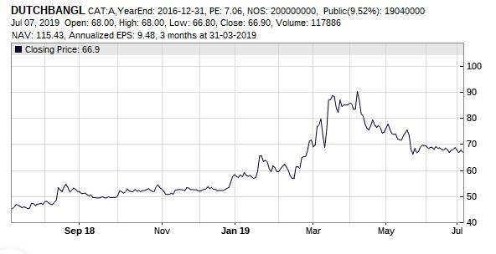
Figure: Line chart

This line chart is for Dutch Bangla Bank. It has been automatically generate through website for 1 year, September 2018 to July 2019. In the X axis it show the timeline and in the Y axis it show the price movement. That line it has drawn only represent by the closing prices. Investor who consider closing price far more important than opening price, high- low prices of each day they choose to use line charts.

Bar charts
Bar charts contain a series of vertical lines that indicate the price ranges i.e. openings, highs, lows and closings during certain time period. As Bar chart considers opening highs, lows and closing it also called as OHLC chart. Investor can discover the price patterns more easily as bar chart provide them with a intraday price range.

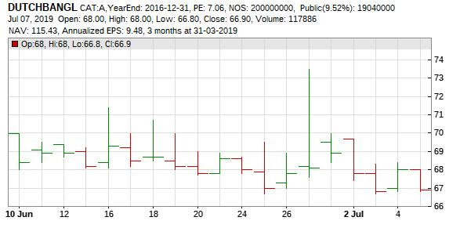
Figure: Bar chart

Bar Chart above, is for Dutch Bangla where it consist past 1 month's data. Same As line charts in the X axis it show the timeline and in the Y axis it show the price movement. Difference are the vertical lines and horizontal dash in them. Horizontal dash in the left side of vertical line meaning opening price and in the right meaning closing price. The higher vertical line have gone indicate prices rises to that level, conversely lower vertical line meaning price gone down to that level. A red line indicate bearish and a green line indicate bulling, every line in the graph represent a single day in the market. These line in the charts can also be presented as bars.

Candlestick Chart
This chart uses a candle like bar to represent price movement. There is two part of a candlestick, main body and shadow. The main body or thick part represent the difference between opening and closing prices where black or red meaning the stock closes on a lower price and if white or green stock closes in higher prices. The top shadow or the thin part of the candlestick indicate high price while bottom shadow indicates lowest price for that day.

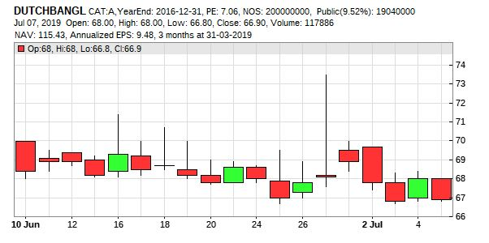
Figure: Candlestick chart

Above chart is for Dutch Bangla and created for 1 month. Let's take a look at 16 June, here market opened at 68.4 and closed at 69.3 which is shown as main body of the candle. Lowest price that was 68.1 as can be seen by the lower and of the shadow conversely highest price went to at 71.4, which is represent by the upper end of the shadow.

Renko Chart
Unlike most other charts Renko Chart contain only price movement. It has no indication of standardized time intervals or volumes. Chart is created by green or white brick when the price move up, and black or red brick for down price. Renko chart is a noiseless charting technique for traders who prefer simple way to identify support and resistances.

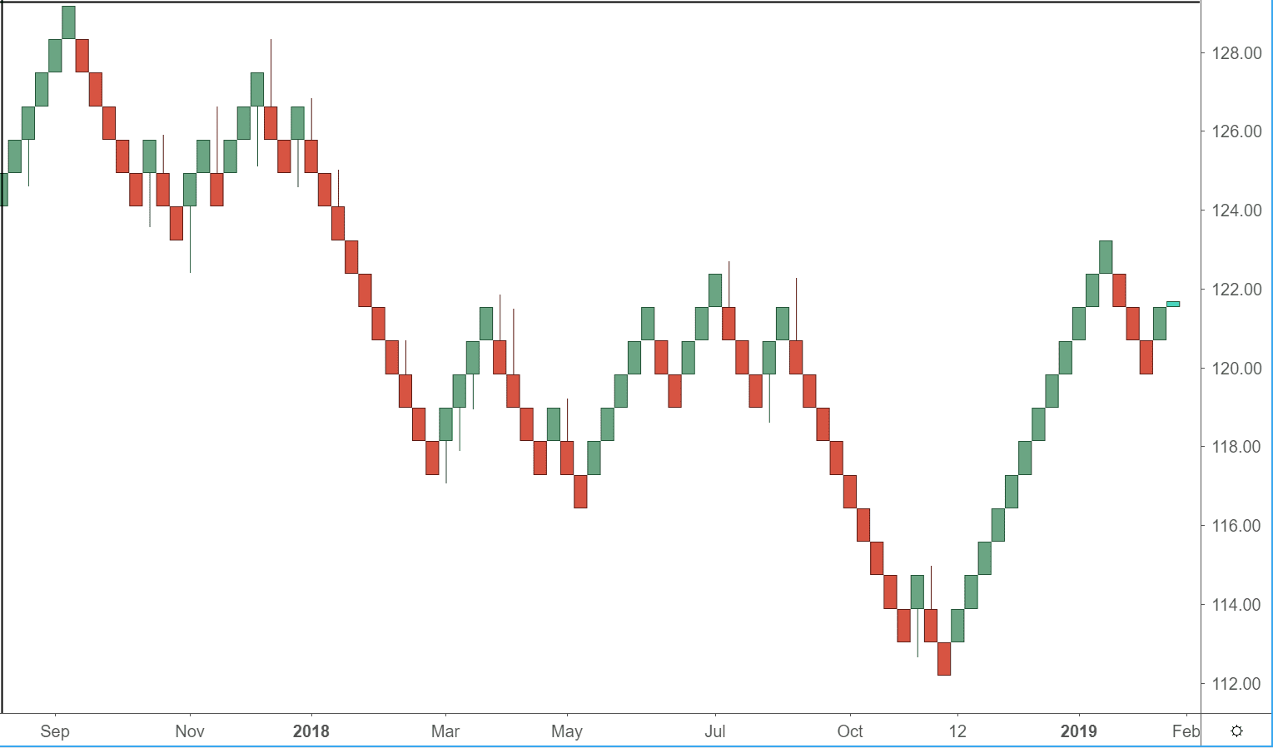

Figure: Renko chart

Basic Principles of Technical Analysis

Technical analysis is use to determine price action for a stock in order to make an investment decision. Before predicting the price movement technical analysis need to evaluate the market actions, for that some basic principles need to be followed.

Bullish
A bullish market or investor's bullish mindset terms are used when stock price most likely to rise. If market moves 10% upward, then the term "Bullish" is use. The term as name suggest came from the bull, who hits upward with its horns.

Bearish
The term "Bearish" represent market price will go down or its already going down. As the name suggest it came from bear, who hits downward with its pawns. Usually bearish represent the sellers in the market, who believes the prices will fall and they start selling.

Support Levels
Support level is specific level that is located below the actual price level, if the price falls and meet the support level, chances are high that it will take a bullish direction and go up. But if the price fall below the support level it will continue to fall to the next lower support level.

Resistance Levels
Resistance level located in the opposite direction of support level. When the price goes up and meet resistance levels, chances are high that it will take a bearish turn. But same as support level is the price break the resistance level it rise till it meet a higher resistance level.

Indicators of Technical Analysis

Technical analysts review charts to get the information about where the price is likely to go next and make buying and selling decision based on that. Reviewing charts involve figuring out the pattern or shape a chart forming, and indicator helps here to determine the direction price and volume might take. Investor and analyst use different types of indicator for different purposes. Here some of the basic indicators are given below:

Simple Moving Average
In technical analysis simple moving average (SMA) is the most popular moving average that is used by investors and analyst. Because of its simplicity and it's very easy to use investor and trader often use SMA over other tool to identify tread direction, it can also be used to generate potential buy or sell signals.

SMA is the average or mean of combination of the closing prices of certain time period then dividing that with that same time period. To understand it in a more simple term let's assume, closing price of a stock for last 5 days was: 70, 71, 65, 68, 70. Now add these prices and divide that with time period, which is 5. (70+71+65+68+70)/5= 68.8. SO 68.8 is the simple moving average for last 5 days.

SMA is commonly used for identify the trend direction. If the SMA line is moving up which indicate there is a upward trend, prices will rise. And if SMA line is moving down, there is downward trend and prices will fall.
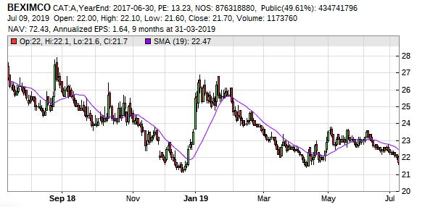

In the above figure Beximco's SMA for last 1 years is 22.47. SMA usually used to smooth price data. A longer period of time tend to smooth the result, but also introduce more lag between the source and the SMA.

Exponential Moving Average
Exponential moving average is similar to simple moving average but it places more weight in the recent data points, it called exponentially weighted moving average. It reacts significantly faster to recent price chances than SMA. Like other moving averages EMA is best used for indentify the direction of trend. So, traders usually use EMA with other indicators to determine the trend and measure the market validity. Day traders or others who use intraday information to analysis the fast moving market often use EMA over other moving average for their buying and selling decisions. When the EMA is going up , traders consider there is a upward trend, and when prices are going below EMA, it considers as a downward trend.

Moving averages also helps to indicates support and resistance level. The price action is supported by the rising EMA, while resistance level of the price action can be provided by a falling EMA. This reinforces the strategy of buying when the price is near the rising EMA and selling when the price is near the falling EMA.

Bollinger Bands
Bollinger Bands are volatility indicator that is drawn from one simple moving average and two standard deviation for the purpose of identifying extreme short-term prices chances. The SMA moves along the price and two standard deviation creates two outer bands, standard deviation are used as it is the common measure of volatility.

Outer bands are created adding and subtracting one standard deviation from the moving average. Outer bands can also provide support and resistance for a stock. If price is about to hit one outer band usually it bounces back to SMA or even to opposite outer band.

When the market is quiet meaning there is low volatility outer bands come closer to the SMA. A narrowing of the bands usually called Bollinger Squeeze, traders use it as entry point before markets gets volatile. When market gets volatile outer bands spread far apart from one another. A low volatility period generally followed by a high volatility period and high volatility followed by low volatility.

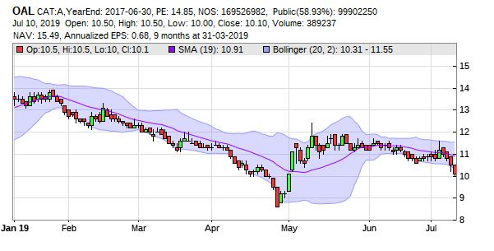
In the figure above it can be seen from February to April bands close together because of the low volatility. Then from April to June bands move far apart cause of the high volatility in the market. Also a high volatility that ended in January is followed by a low volatility which lasted for February to April, then again a high volatility followed it in the May .
Price movement in the Bollinger bands generally stay within the bands, a break out of price is a major event. If price of a stock moves outside of upper band it considered as overbought. And if stock price cross the lower band is considered as oversold.

Relative Strength Index (RSI)
RSI is oscillator indicator that is developed by J. Welles Wilder. It measure current price strength in relation to previous prices to evaluate if the stock is overbought or oversold. RSI represented as a line that moves between 0 to 100, generally 30 or below is considered as oversold and 70 or above is considered as overbought.

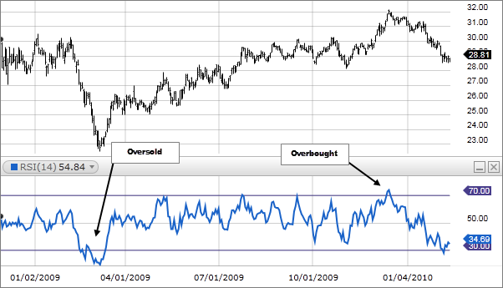

As described it is seen in the figure at 4/1/09 price went blow 30 so it considers as oversold and again at 01/04/10 when price when above 70 it is overbought. But in a very bearish market often 20 instead of 30 acts as normal oversold point, and in a very bullish market 80 instead of 70 act as normal overbought point for the stock.

Traders can use RSI as a buy and sell signal, if RSI cross above the oversold line a trader might buy. and if the RSI cross below the overbought line a trader might sell. RSI can also work as divergences. Traders can also use RSI as buy signal when price and RSI both in uptrend and RSI cross below 50 line, conversely it can be use as a sell signals when price and RSI both in downtrend and RSI cross below 50 line.

Moving Average Convergence Divergence (MACD)
MACD is trend following momentum indicator that show relationship between 2 moving averages. Even though it is an oscillator, usually it doesn't represent the condition of overbought and oversold. There are 3 components of MACD. First one is MACD line, which is 26 period moving average (a slower moving average) subtracted by 12 period moving average (a faster moving average), it is also called the main line. Second one is Signal line, which is 9 period EMA of the main line. And the last one is MACD Histogram, which represents the difference the between MACD line and Signal line.

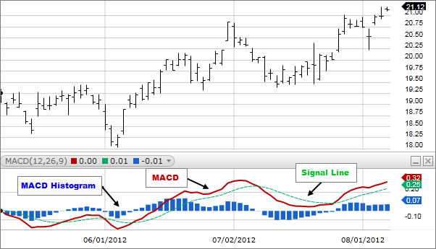

There are 3 basic method to use MACD. First way to use MACD is when main line and signal line cross over. If the MACD line cross above the signal it indicate the trend is upward, conversely if the MACD line cross below the signal line it means the market is bearish or trend is downward. Center line method is another way of using MACD, if the MACD line cross over the zero it indicate that trend direction has changed.

Lastly the divergence method, it can signal an end of trend when MACD diverges from the price action. When price falls down but MACD does not follow the price action by making a new low it indicates a bullish market will turn up soon. Same goes for rising price, if the MACD does not follow the new uptrend, prices will soon go down.

Sentimental Analysis

Besides the Fundamental and Technical analysis there is another fairly new type of analysis that is called Sentimental analysis. It is basically based on traders opinions, market views and instinct. Every trader has their own opinions and ideas about why market is moving in a certain way and how will market react in the future. When all the traders sentiment combine it creates a new sentiment for the market. To understand this market sentiment and trade based on that is essentially sentiment analysis.

Let's assume one single trader thinks a certain stock will go bullish, but the whole market is in the bearish mood, despite fundamental and technical what analysis say market will go downward. Same goes for if the market is in the bullish mood, and a single trader thinks prices will fall, others will make profit from the bullish market and that single trader will lose money. So a trader has to combine sentimental analysis with others tools to evaluate the market.

Conclusion

As days passes number of investor and traders are increasing rapidly. Everyone wants to make a profit in the stock market but not everyone understand the market or how it works. People blindly invest their money in the stock market believing they will be able to predict future stock price just by look at current price. And there is another group of people do not know anything about stock analysis and believe it does not work and only way to predict the price is through inside information,
Main purpose of this paper is to give a basic knowledge about the analyzing tools that traders use as a daily basis to the new investors and traders. Fundamental analysis and technical analysis was the main focus here. Whenever we talk about analyzing tools a comparison always comes between fundamental analysis and technical analysis.

Fundamental analysis is best suited for long-term investor who evaluate economy, industry and company to determine the intrinsic value of a stock, where as technical analysis is best suited for short-term market analysis where trader uses charts and indicators to determine the trends and price movements. But this does not mean an investor only has to use one, often time investors combine FA and TA to determine the best possible decision. Fundamental analysis a time consuming process, one has to evaluate all the fundamental factor that could affect a company in anyway. So investors to invest in long term can afford to use only FA. But traders who invest for a very short term usually use TA.

Whether a trader is day trader, swing trader or position trader without knowing the technical analysis he/she won't be able to improve his/her performance in the market. TA gives a trader all the current information regarding a stock. TA's of the main assumption is market discount all.
A trader who has 10 minutes to make a decision to sell or hold stocks can't afford the look into the company's fundamental. Charts and indicators of technical analysis will show that trade whether trend is upward or downward, chances of prices movement.
For a trader there is different type of Charts and indicator available. In line chart where it only shows the closing price movement, and in bar and candlestick charts where opening, high, low and closing all shows. After choosing the preferable chart trader has the option to determine which indicator to use. Some indicator will tell the trend movement, some will give the trend momentum, and some will indicate price volatility and volume. One single indicator can never provide a full picture, so trader use combination of indicators to make their buying and selling decision.

In Conclusion, investor and traders doesn't matter if it is long term or short term investment should understand the market, analysis the market before putting all their life saving in the stock market.

References

- Obamuyi, T. M. (2013). Factors influencing investment decisions in capital market: A
study of individual investors in Nigeria. Organizations and Markets in Emerging
Economies, 4(1), 141-161.
- Suciu, T. (2013). Elements of stock market analysis. Bulletin of the Transylvania
University of Brasov, 6(2), 153-160.
- Sureshkumar, K. K., & Elango, N. M. (2011). An efficient approach to forecast Indian
stock market price and their performance analysis. International Journal of Computer
Application, 34(5), 44-49
- Lui, Y. H., & Mole, D. (1998). The use of fundamental and technical analyses by foreign
exchange dealers: Hong Kong evidence. Journal of International Money and Finance,
17(3), 535-545.
- https://www.slideshare.net/harimanikandan7/stock-market-project-for-mba-finance
- https://www.visualcapitalist.com/12-types-technical-indicators-stocks/
- https://www.tradebrains.in/how-to-do-fundamental-analysis-on-stocks-in-india/
- https://www.investopedia.com/terms/r/ratioanalysis.asp
- https://www.investarindia.com/blog/technical-analysis-charts/
- https://corporatefinanceinstitute.com/resources/knowledge/trading-investing/technical-analysis/
- https://stockbangladesh.com/dse/stock/dsex/dse-broad-index/chart/technical-analysis
- https://forextraininggroup.com/basic-principles-of-technical-analysis-in-the-fx-market/
- https://www.thebalance.com/why-you-should-ignore-fundamentals-day-trading-1031374
- https://www.wallstreetmojo.com/fundamental-analysis-vs-technical-analysis/

