Internship Report





Abdullah Al Mamun
DATAPATH LIMITED
Internship Report

Submitted To:
Dr. Seyama Sultana
Assistant Professor
SOBE
United International University
Submitted By:
Abdullah Al Mamun
ID: 111 151 255
Major in Marketing
Bachelor of Business Administration (BBA)


United International University
Date of submission: February 8, 2020

Letter of Transmittal

January 24, 2020
Dr. Seyama Sultana
Assistant Professor
SOBE
United International University
Subject: Submission of internship report.

Dear Ma'am,
I am submitting my internship report to you within the given time. I had attempted my level to have interaction, adjust and determine the retirement activities of DataPath Ltd. And all things had been mentioning was my own experience. To formulate my internship report, need a lot of afford to gather information’s concerning USA retirement industry and Bangladesh retirement provident fund.
Meanwhile, I found that retirement idea engineering is promising and rational for me. This may help me mark up to build my career in the future. I might prefer to convey for your support to giving American state the scope to have interaction within the internship program.

Sincerely Yours,
___________________
Abdullah Al Mamun
ID: 111 151 255
United International University

Acknowledgments

I would like to explicit my deepest notion to all those who furnished me the opportunity to complete this file. Fast of all, I would really like to offer my gratitude to the Almighty Allah for giving me competencies to paintings hard. I am also thankful to my dad and mom who were supplied me with the necessities of like on account that my early childhood. It is a possibility for the students to get familiar with the real-life scenario through this program.
The inspiration of this report is prepared through Abdullah al Mamun under the supervision and steerage of Prof. Dr. Seyama Sultana, United International University to satisfy the requirements of BBA degree.
I am an employee of DataPath Ltd. From 2d October 2019. It is very tough for me to good enough USA retirement process. HR director of Data-route Ltd. helped me with the aid of providing different opportunity of learning. He also furnished me some critical advice and steerage for preparing this internship document and company culture.
I would really like to dedicate special thanks to the ones people without whom it was hard me to keep my internship report. My special thanks go to Farzana Haque Manager (Deconversion Department), and thanks to Nazmul Islam, Sr. Executive (Distribution Department), and Kamruzzaman Milon, Manager (Sales department), Ronald, Senior Executive (Sales department) for helping me in every way to finish my internship efficiently.
Finally, I would like to thank my other intern colleague for their help and honest suggestions.

Executive Summary

During my last semester of BBA program, I have achieved my internship at DataPath Ltd. To have a practical exposure.
To increase the physical, monetary and intellectual well-being of personnel and their families, employees typically provide benefits such as health and existence insurance, entertainment time, inability earnings and retirement plan. The US authorities is an excessive amount of aware and warm approximately shielding the proper of the retired humans and receives under manage them financially in retired life. The retirement plan also supports the corporation to have tax savings on the advantage of the company if he sustains the plan in line with IRS and DOL guidelines. Ineffectiveness to satisfy with the guidelines will result in inability of the plan and it will likely be subject to amercement. It is high priced for an employer to keep the function of a retirement plan. So, organization outsource the characteristic to a third celebration which is also knows as third birthday party administrator. DataPath is an outsourcing business enterprise which act and characteristic of a retirement plans.
There are many outsourcing organizations in Bangladesh but very few groups are like DataPath Ltd. Because DataPath is US based totally organization and deals with US retirement plans. So, it also affects the manner of life and values of the employer. Our organization goal is to offer TPA service and offer retirement plan solution our client.
Last 4 months of my internship learned a lot about the practical and characteristic of US retirement plan industry. Although it’s hard to relate the function of DataPath Ltd. With any other organization in Bangladesh, however the skills and knowledge I gain from DataPath will help me loads for my destiny carrier.

Table of Contents
Letter of Transmittal i
Acknowledgments ii
Executive Summary iii
List of Figures vi
List of Abbreviation vi
CHAPTER I: INTRODUCTION 1
1.1 Background of the Report 1
1.2 Objective of the Report 1
1.3 Motivation of the Report 2
1.4 Scope and limitation of the Report 3
1.5 Definition of key terms 4
CHAPTER II: COMPANY AND INDUSTRY PREVIEW 6
2.1 Company Analysis 6
2.1.1 Overview and history 6
2.1.2 Trend and growth 7
2.1.3 Customer mix 7
2.1.4 Services mix 7
2.1.5 Operations 13
2.1.6 SWOT analysis 18
2.2 Industry analysis 22
2.2.1 Specification of the industry 22
2.2.2 Size, trend, maturity, of the industry 23
2.2.3 External economic factors 23
2.2.4 Technological factors 23
2.2.5 Barriers to entry 23
2.2.6 Supplier and Buyer power 24
2.2.7 Threat of Substitutes 24
2.2.8 Industry rivalry 25
CHAPTER III: INTERNSHIP EXPERIENCE 26
3.1 Position, duties and responsibilities 26
3.2 Training 26
3.3 Contribution to department function 29
3.4 Evaluation 40
3.5 Skills applied 41
3.6 New skills developed 41
3.7 Application of academic knowledge 44
CHAPTER IV: CONCLUSION AND KEY FACTS 45
4.1 Recommendations for improving departmental operations 45
4.2 Conclusion 46
Reference 47

List of Figures

- Figure 2.1.5: Operations
- Figure 2.1.6: SWOT analysis
- Figure 2.2.7 and 2.2.8: Threat of substitutes and Industry rivalry
- Figure 3.2: Training
- Figure 3.6: Unify
- Figure 3.6: Relius
- Figure 3.6: Relius

List of Abbreviation

TPA : Third Party Administration
RK : Record Keeping
ACP : Average Contribution Percentage
ADP : Average Deferral Percentage
ASPPA : American Society of Pension Professionals & Actuaries
DOL : Department of Labor
IRS : Internal Revenue Services
IRC : Internal Revenue Code
RPF : Retirement Provident Fund
SIMPLE : Savings Incentive Match Plans for Employees

CHAPTER I: INTRODUCTION

Background of the Report

Internship is the method to give an excellent application of the theoretical understanding. The rule and performing and the writing technique of American retirement plans are very complex. To appreciate all the things and act for this reason is very tough even for US organizations. And it is very costly to maintain in residence retirement plan reporting dept. That’s way they hired third party administrator July business service that's the mother corporation of DataPath Ltd. The difficult nature of the works makes it tougher to train new employees to prepare together allocation report. Both trainer and trainees face different type of issues at some point of and after training period. For BBA student it is very important to link theoretical understanding with practical experience. DataPath Ltd. has conferred me the scope to have my internship program for 4 months. I already learned important issues regarding project and plan termination.

Objective of the Report

The targets of the report are to produce thoughtful analysis of the outsourcing company in USA and Bangladesh, analysis of the company “DataPath Ltd”. The report also summarizes my internship enjoy in DataPath Ltd.

Specific Objective
The goal of this connection report to get an Idea about the United States retirement advantage plans and think about the principle’s arrangement of the retirement business of the United States. How the retirement plan functions and how the member of the plans gets benefits after retirement. To know how the world's most well-off monetary nation how they applied their arrangement so that after the retirement member can get numerous advantages. Furthermore, generally get Experian on Bangladeshi corporates world to pick up information by finishing this report.

Broad Objective
The broad objectives of this research are:
- To assemble information about United States Retirement plan industry.
- To think about the administration and straightforwardness of their retirement plan.
- To know how RK work as per the customer imminent.

1.3 Motivation of the Report

Bangladesh is one of the rapidly creating countries of this presence where simply the Youths are endeavoring to change the overall population and the lifestyles. They fight with destitution; they fight with the joblessness issue and oversee political issues. They are to stand up to the poor guidance course of action of Bangladesh, and they don't get any extra advantages while dealing with online stage. Even though, administering body is making moves to speedier the present moderate web speed; these youths of Bangladesh are attempting snatch best occupations for them from the re-appropriating business center. Likewise, promoter and business visionary from wherever all through the world found the whole matter of re-appropriating in Bangladesh more affordable with a raised necessity.
Business Process Outsourcing (BPO) is a system of re-appropriating which includes the subcontracting of the activities and getting the obligations of a business capacities to a third-party specialist cooperative. BPO consistently suggests near shore re-appropriating and is ordinarily organized into Back office redistributing and front office re-appropriating. BPO contracted outside an association's nation is called Offshore Outsourcing. Likewise, if BPO is contracted to an association's neighboring country is called near shore re-apportionment.

1.4 Scope and limitation of the Report

Scope of the report

Scope means the area on which the study must be done. This report covers the areas concerned with the process and management of doing retirement plan by DataPath. I highlight the Sales and Deconversion department of retirement plan for my study. People who are working there, their experience, gone plan reports everything helps me to make the study report. This report is also highlighted the present US regulations on retirement plans, adjustment in the rules will make the related portions obsolete.

Limitation of the study

Despite the truth that to set up this report got satisfactory help from Instructor and the Deconversion and Sales team, there were few constraints had to confront. Those are given below
- Time requirement.
- Less free substance approximately this challenge at the web.
- Could not make use of couple of vital papers and report facts when you consider that those facts will use with the end intention of association.
- To ensure the authoritative thriller a few sections of the reports probably might not be so interior and out what it must be.

1.5 Definition of key terms

Marketing Theory
Marketing is a process of CCDVTP which stands for “create, communicate, deliver the value to the target market at a profit”, a term that has been popularized by Philip Kotler.

Customer mix
Customer mix is the sales driven by a certain type of customer segment expressed as a percentage of business's Customer mix sale.

Service marketing
Service marketing mix is a phrase used to describe seven factors used when marketing services: product, price, place, promotion, people, process and physical evidence.

Operations management
Operations management is the administration of business practices to create the highest level of efficiency possible within an organization.

Technological factors
Technological factors are variables that are being used for evaluating available alternatives with respect to technological capabilities.

Barriers to entry
Barriers to entry are the economic term describing the existence of high start-up costs or other obstacles that prevent new competitors from easily entering an industry or area of business.

Supplier power
Supplier power is the degree of control a provider of goods or services can exert on its buyers. Supplier power is linked to the ability of suppliers to increase prices, decrease quality, or limit the number of products they will sell.

Buyer Power
Porter's Five Forces of buyer bargaining power refers to the pressure consumers can exert on businesses to get them to provide higher quality products, better customer service, and lower prices.

The threat of substitutes
The threat of substitutes is the availability of other products that a customer could purchase from outside an industry.

Industry rivalry
The intensity of rivalry among competitors in an industry refers to the extent to which firms within an industry put pressure on one another and limit each other's profit potential. If rivalry is fierce, then competitors are trying to steal profit and market share from one another.

CHAPTER II: COMPANY AND INDUSTRY PREVIEW

2.1 Company Analysis

DataPath is a private limited outsourcing company working for July business service which provide third party administrator (TPA) services for American retirement and pension plans which is in Waco, Taxes, USA and operating jointly in the USA and Bangladesh. DataPath limited assemble unequalled realization, mass capabilities over the retirement business and related business capabilities.

Overview and history

DataPath Limited is the first registered outsourcing company in Bangladesh which operated by July Business Service. July Business Service is the mother company of DataPath limited where John Humphrey and Jim Hudson are the owner. July Business Service is one of the top listed company in United States. July Business Service known as professional service firm which is committed to delivering retirement plan and other administrative services to business client.
July Business Services partners with employers and financial advisors to provide retirement plan, administration and recordkeeping services. July Business service founded in 1994, July provide services approximately 93,364 clients in all 52 states in USA.
DataPath Limited was established in 2006 with a small office at Uttara, with very restrained operations as experimental basis. At the start it was presenting supportive operations for July. In the start days it hired talented personnel who can apprehend the work with an entire number of six personnel. Later, in 2010, DataPath moved to Gulshan as it grew in numbers to 50 personnel. Already then July was absolutely depending on DataPath due to the fact they have been doing all the work from Bangladesh and July decided to downsize their personnel inside the United States. In 2015 DataPath was developing rapidly, had to hire hundreds of human beings and moved to Mohakhali in a15’000 square ft house because of the fact more Third-Party Administrators desired to outsource their business method to Data Path, as they may be now experts within the retirement plan industry. Now DataPath has eight different clients apart from July Business Services and foreseeing many greater inside the future.

Trend and growth
DataPath Limited.is doing a rising business for the end solution for their client. At the point when the data is assembled or document received then they are procedure, move, and made a supporting record to process structure which will going to be submitted to IRS. DataPath Limited. continually attempting to give an important arrangement that can help to client for simple comprehension.

Customer mix
DataPath is a private Limited outsourcing company which is working for July Business Services in Bangladesh. So, our primary client is July Business Services. The people of USA are additionally our client however through the July Business Services.

Services mix
July Business Services and for their benefit DataPath Limited is giving the following services to its US clients.

Plan Design
Retirement plan are primarily arranged to meet every business one of a kind objective and technique. Regardless of whether worker enrollment and maintenance or boosting benefits for the key job representatives and plan planned consistently examine with specialist through customer administration administrator.

Plan setup
To effectively set up retirement plan or to change over the current arrangement from current provider. DataPath limited committed setup group team hands-on services to organize all aspect of plan setup. Our services include:
- Setup paperwork
- Volume Submitter Doc
- Loan policy
- Submission contribution
- Transfer asset through account
- Doc from previous provider
- Takeover plan needs special care

Plan administration

July's specialists have more than 25 years of plan administration experience and are specialists in this exceptionally specialized field. A team of experience professionals presented as an account representative will serve client’s plan.
DataPath specialists have more than 5 years of plan administration experience and are specialists in this exceptionally specialized field. A team of experience professionals presented as an account representative will serve client’s plan.

Plan Operation Support

It gives everything the customer needs to boost the estimation of plan, including phone and email access to its advisors. Its plan operation support service includes the following:
- Eligibility Calculation
- Vesting Calculation
- Contribution Allocation
- Loan and Distribution Processing

Compliance Testing

Its account representative gives total consistence testing service to keep up the fidelity of client’s plan. Its compliance testing services include the following:
- Top Heavy Testing
- ACP & ADP Testing
- Minimum Coverage Testing
- General Nondiscrimination Testing

Tax Compliance

DataPath advisors deliver signature-prepared tax return forms to satisfy all tax filing requirement. Tax compliance services include the following:
- Form 5500
- Form 5330
- Form 1099-R & Form 945
- Form 5310(For plan termination)

Plan recordkeeping

July and DataPath give automated recordkeeping administrations through their group partners and through July's day by day valuation recordkeeping stage:
- 24 Hour Internet Access
- Day by day Valuation of Accounts
- Plan Sponsor Account Access
- Quarterly Participant Statements

Participant services

Through its alliance associations with financial provider, July makes accessible top-quality instruments for participant to anticipate and accomplish a secure financial future.

Payroll service

A single provider for retirement and finance administrations decreases clients work pressure and increment accuracy and effectiveness. July service ensures are probably the most grounded in the business, however we will likely process your finance mistake free without fail.

Fringe Benefit

July services provide the following benefits:
- Medicinal repayment plans
- Adaptable spending records and Section 125 Fringe Benefit Plans
- Health Reimbursement Arrangements (HRAs)
- VEBA and other specialized funding designs
- Premium-only plans
- Different types of repayment or cases handling programs

Enrollment Materials

July give an insightful choice to client to fund utilizing under July recordkeeping service they are guaranteeing and security for their financial data.
- Worksheet risk measure
- Form enrolled
- Workbook enrolls
- Education Invested.
- Sheets contribute reasons

Investment Advice

At the point when percipients invest their employee and employer portion then they follow the rule to invest and that rule provide through online from DataPath. July consistently attempt to be careful and secure from cyber-attack. Clients additionally ensure and afterward they invest portion of amount with appropriate direction for our specialist. DataPath serves all the regulatory work for July Business Services through July's software and presented the softcopy of the entirety of its work through its own trusted network.

Operations

DataPath limited Begun their journey with small number of employee and gradually the owner formed a team of skilled people.
Building skilled people team
July consistently have moderate impressive development in retirement plan industry and included number of employer and employee through this reputation. Also, July and DataPath consistently attempt to get in touch with one another through cooperative way.
- Employee Culture
- Consulting team
- Service Delivery
- New business team
- ERISA consulting
- Distribution team
- Develop key employee
- Marketing and sales presence

Building strategic partnership
DataPath additionally keeps up some association with American fund, MRF, MassMutual and other. Those well-disposed connections need to attain well good will and work should be easier for all the RK site and TPA service provider.
DataPath limited follows their very own hierarchical structure for their operations which is appeared in the table-
Figure 2.1.5: Operations

Accounting Department

In Accounting department, accounting and financial support for DataPath provide by the accounting team. This department works on various issues like billing all the works to other department, records of stock, compensation for the employees, financial statement and so on.

Allocation department

The aim of allocation department is allocated to dispense each plan member’s cash for consistently and gives data to work process 5500. As July is the mother company, allocation team retrieved by all their works and prepare different files to provide all the essential information to other department.

Distribution Department

Distribution department deals with the disbursement of the money for each participant when he/she in the stage of retirement, termination or transferring money from one provider to another. For doing this sort of work, they required a software called RELIEUS. This department assure the cash move to their clients.

ERISA Consulting/ Plan Document Department

ERISA department prepare plan document from archive data gave by the installation and sales department. Plan archives have in common with Profit sharing plan, 401 (k) plans, Safe Harbor Plan, Safe Harbor 401 (k) plan which normally content at least 40 pages with law, rules and guideline and how these will influence the arrangement. They ensure the correct information which will be followed by other departments.

Workflow 5500 Department

In DataPath, work process 5500 gets ready „Form 5500‟ for each plan for July. The Form 5500 is the Annual Return/Report of Employee Benefit Plan for submitting to the department of labor. As indicated by Department of Labor, sponsor or administrator of an employee benefit plan subject to ERISA must record data about each benefit plan for each year.

Human Resource Department

In DataPath, HR department keep up the earth of the association. HR department constantly required to ensure the security of the association or its employee. Other than that, all the recruitment strategy, speaking with every department and giving preparing backing to the employees by HR.

IT Department

DataPath limited gives administration through the most recent advances, it likewise requires IT support each day. The IT department maintain the system of the company and maintenance of the electronic device.

New Business/installation

New Business department updates all the information into the database and ensure the precision of the information. All the information is given by the sales department of DataPath.

Outsourcing Department

In DataPath, most of the department connected to July however outsourcing department works for other TPA rather than July. Each group of outsourcing department works with various TPA by giving various administrations like arrangement survey, plan process, accommodate and so on. Right now, this office has 9 TPA clients.

Recordkeeping Department

The activity of this department is to follow who's in the plan, what investment they possess, and what money is going in or out. Record keeping is the trading house working in DataPath for July.

Sales Department

In July, sales group converses with various clients for taking the retirement plan. Normally, each plan requires two kinds of individuals (Financial Advisor and Employer/Sponsor/Plan Sponsor) to create a plan for the company. In DataPath, sales department plan desk work for July.
Software Development Department

Software development department works with the product and interior database which are made by them. This division takes a shot at various tasks and improves the product framework by structure, establishment and testing for DataPath.

SWOT analysis

Strengths
Solid organization culture:
DataPath ltd provides a solid organization culture. They develop a culture of help and coordinated effort where everybody helps each other to learn and develop aptitudes. It has own prayer hall for men and women where everyone prays which creates a friendly environment between colleagues. DataPath have its own kitchen territory where staffs do their lunch. DataPath additionally organize distinctive cultural programs for staffs.

Attractive pay and leave system:
DataPath gives multiple times reward in a year with appealing compensation. Furthermore, keeps USA rules for leave and holydays. DataPath offers 2 off day in a week and workers can likewise appreciate short leave. They likewise pay extra as indicated by Bangladeshi occasions as they offer occasions as indicated by USA rules.

Quality and operational control:
Data-path have strong organizational formation. Manager always assign task with a reviewer and supervisor. Though every task is committed with detailed concentration and under the consultancy of supervisor. There is a reviewer who checks the complete task. So, the probability of mistake is .0000001%. Data-path follows a great technique to control the quality of their work.

Expertise:
Since 2005, DataPath is constantly developing by demonstrating their skill. July get strong activity from Data-Path Ltd. from asking. At that point this organization enlisted the capable representatives to work for the July Services. At the outset years it had under 10 representatives. Presently almost 150 splendid hands are working here. DataPath constantly attempted to adapt up to the innovative change and built up their staff's ability as indicated by that change. With experience and gifted workers, Data-path is serving July benefits with greater unwavering quality.

Client driven procedure:
Solid business relations and customer driven methodology by July benefits help the staffs in making industry based, manageable value for their consulting partners.

Weakness:
Absence of practical knowledge:
Individuals who work in outsourcing industry can't develop reasonable information on field work. Because outsourcing is absolutely PC based occupation. This experience of outsourcing occupation will just place an incentive for next outsourcing work. Along these lines, employees of representative leaves the activity for their future chances to work in down to earth field in business industry.

Dependency on July services:
Data-path procedures operational files for July services. Employee of July services upload statistics of participant in server. After that, personnel of data-direction approaches files with the help of uploaded information in server. So, data-path rely on July service for records of participants.

Figure 2.1.6: SWOT analysis

External factor:

Opportunities:
High quality IT education market
Increasing use of era in Businesses has opened a wide marketplace for IT staff. People are greater like to explore technology in their business in place rather than following old tradition of business process. So, there will be a huge call for of IT expert. This era needs bunch of professional staff that may outsource any work the use of generation. There is a large possibility for professional staff that is practicing on this discipline from now. Data-path will earn extra reliability in destiny as the company is capable of provide fine services on this sector while the call for is simply arising.

Development of business:
Right now, DataPath is just preparing operational documents for July benefits. In future DataPath may work for different customers as like July benefits. It might likewise build its number of administrations as per future interest because of technological changes.

Threats:
Lack of data safety systems:
The most important part of an outsourcing organization is the information technology domain. As this allows entire organization to awareness on their core business. Data security is the principle difficulty while it come about outsourcing business. Now hackers can without difficulty get excess through phish email. So, business enterprise wishes to be great careful from hacker.

Increased Competition:
In future, greater human beings will run after this sector. So, there will be extra substitute product inside the worldwide market via online. Ultimately, it's going to create opposition of equal provider internationally to empower in cost saving strategy. The battle will create for organization to provide top rate service with cheaper rate.

Low return on investment
When outsourcing is not managed well by authority and overall performance expectations are not nicely matched between the provider and the buyer, the outcome results can cause a low ROI, or maybe failure.

2.2 Industry analysis

Specification of the industry

Outsourcing

Outsourcing is a sort of business where third party involved. Like external service provider promises to logistic help and IT Services. There are a variety of work performed via the TPA (Third Party Administrator) the ones are application development, regular basis application maintenance. It can give opportunity to the purchaser to customize their product primarily based on their requirement.

Size, trend, maturity, of the industry

Outsourcing is a massive business. This trend is rising day by day. When recognize stage of outsourcing begin to growth nearly the world during the last decennia or two, one may also ask why? Only one argument might be the fastness technological innovation. Answer is - with this simple idea of outsourcing anything from payroll to advertising to know-how about the American retirement plan industry HR to legal. Now through outsourcing we can serve so many companies and may utilize manpower of the world.

External economic factors

Massive Outsourcing Company can settle business scale and offer business succession solutions. Client benefit shape that scale without making any funding themselves. It’s apparent that, this price needs to be paid for, however the outsourcing organization cans expansion the total cost among customer, so no single client bears the entire worth.

Technological factors

With the help of outsource we can have the support of disposing of obsolescence. Technological development is increment quickly. Specialized outsourcing company are better than other to address which could minimize threat thru fund development. System is too much automated that customer can change immediately without being tagged into long time touch or any other investment.

Barriers to entry

To enter this sector one need big technical guide of skilled people and large capital to establish such IT based company.

Supplier and Buyer power

In outsourcing, Supplier and purchaser relation is not visible however in this system supplier operating overall performance is more potential as an advisor. Expertise’s to deal with this sort of team of workers are without delay for the interest between each aspects of the party. Their transactional relation is also different. So, if the supplier overall performance will improve then the output of the product is also improved. We can say that, past great execution of supplier which expand upon trust can build their purchasing power where then again Buyer, who needs professional hard worker and understanding polished paintings are inclined to pay more based on believe and information of suppler however they also preserve sturdy position as competition is increasing daily between service provider (supplier).

Threat of Substitutes

There are plenty of companies in the Europe who are giving outsourcing services. In Bangladesh this industry is developing nowadays. Govt. Of Bangladesh additionally encouraging this Industry. Govt. Of Bangladesh is arranging training for youth for nothing of cost. So, it is expected that, in near future Bangladesh will able to make skilled and expertise human beings to catch this opportunity. So, there will be huge competition. So, the threat of substitute is high.

Figure 2.2.7 and 2.2.8: Threat of substitutes and Industry rivalry

Industry rivalry

The overall Outsourcing competitiveness in outsourcing industry common to potential. Subsist specialist companies are seeking to expand their variety of the service and newcomer are try and involved in the market to sustain. In this industry client are maintain strong role to compete with other competitor and different services. For long term relationships need lot of investment in the market to benefit some profit and strong holding benefits. Though everybody is aware of the worthwhile side of this industry, it’s very difficult to construct a professional company with full of skilled labor and benefit.

CHAPTER III: INTERNSHIP EXPERIENCE

3.1 Position, duties and responsibilities

I am doing 4-month intern in DataPath ltd. in both Sales and Deconversion department. I am responsible for many plan terminations in Deconversion department and responsible in sales department to adding advisor and check statement. All of them are tax related form of terminated participant of 401(k) pension plan. DataPath follows all policies according to USA, because our participant comes through July services and all the participant lives in USA.

3.2 Training

I received training from supervisor Farzana Haque, Manager (Deconversion department) for project setup, bulk project setup and release distribution and Md Nazmul, Executive officer (Distribution department), gave me training for participant form check .and I also receive training from supervisor Kamruzzaman Milon, Manager (Sales department) and Ronald, Senior Executive (Sales department). When any participant terminates or departure from plan, Govt. of USA ensures that no money left in the organization and verifies the taxable amount. And for that each participant needs to do the paperwork which contains details about their account calculation and personal information details. And we do the paperwork for them. I also received training for online security which is online based. And one need to pass the exam to complete the training. And I got the certificate for 2019 becoming a human firewall.



Figure 3.2: Training

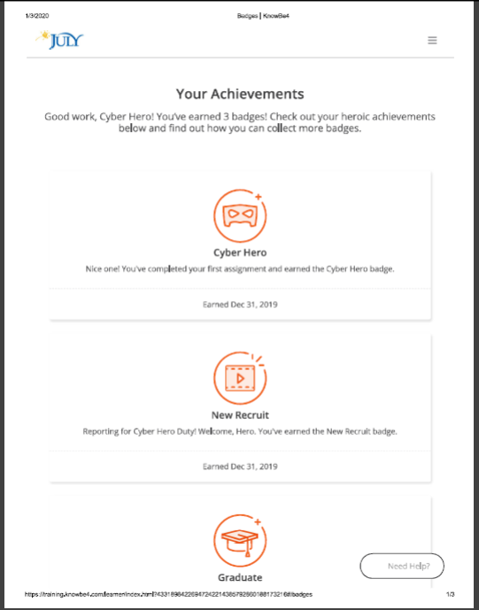

Figure 3.2: Training

3.3 Contribution to department function

Sales and marketing procedures Of DataPath Ltd.

Services of Sales and Marketing
I have also some knowledge about sales and marketing department of DataPath ltd. Sales and marketing department is the direct department of July business services. Sales and marketing are another important department of DataPath ltd.
Sales and Marketing department provides-
- Promote and sell Plans to new clients
- Maintain communication with new clients
- Maintain communication among July, financial advisor, different TPA etc.
Sales and Marketing department strongly maintains their client’s services. Sales and marketing department additionally doing related
- Funding statements for each yearly, quarterly, monthly
- Financial Advisor addition of their software (UNIFY)
- Company Addition in their software.
- Create investment accounts of their software.
- This department maintains all the employees’ information of working hours.

Investment statement maintaining procedure
Investment statements are the statement of the month-to-month basis of each participant of that company. This department renamed each investment first then they offer statements in their destination thru software program move. If you are doing wrong about funding announcement, then the declaration is not going to destination. You need to correct the statement and once more flow the statement thru software program.
For example, right here I even have given two pictures of investment statement of July business service-

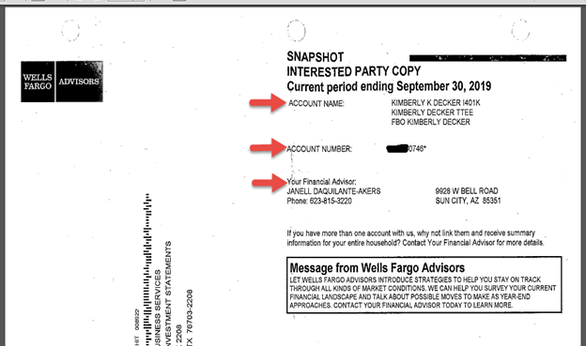

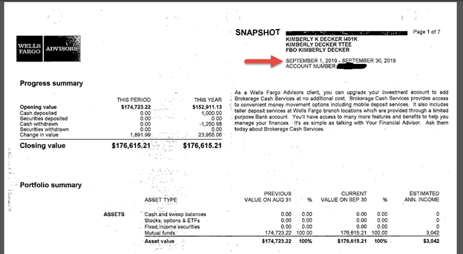

Now I can explain how I did rename the investment file. First, I checked the account number, statement period, plan call and monetary advisor name. Then visit save as option (ctrl+shift+S). Shop as kind is pdf file. File name according to these two pictures: Account Name-statement starting period-statement ending period (33820315-09012019-09302019). One more important thing is that (month/day/year) structure should follow.

New contact adding process
When I want to add any financial advisor or any man or woman in Unify. I need to be following the 2 steps.
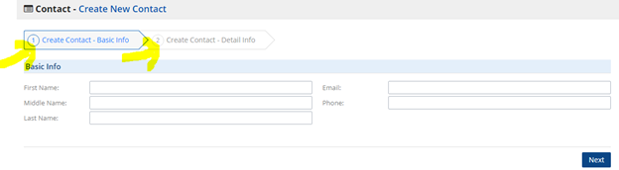
Step 01: Basic Information and then
Step 02: Details information (shipping address, mailing address, professions, zip code, state, city, company name etc.)

New Company Adding process
When I want to add any company in Unify. I need be filling up the gaps information’s. For new company options is here-
- Name
- Website
- Entity Type
- Shipping / Physical Address
- Mailing Address etc.

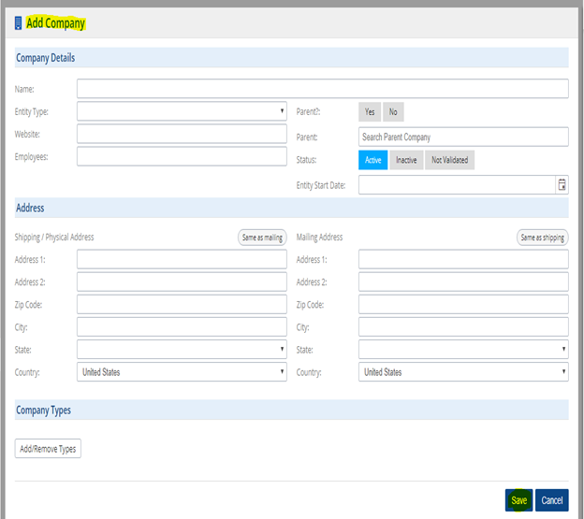

All the information’s are not required. You must fill up company name, company type and country also. In this method you can add the company in Unify software.

Deconversion procedures Of DataPath Ltd.

I have also some knowledge about Deconversion department of DataPath ltd. Deconversion department is the direct department of July business services. Deconversion is another important department of DataPath ltd.

Work Related Activities
During the Internship application, I worked with Deconversion Department in which numerous sorts of works were done by me. I had the option to test the Relius programming program evaluation if the whole is okay. A Relius programming program enumeration containing all representatives' data alongside Social Security Number, Name, Date of Birth, lease date, reimbursement and heaps of various arrangement related insights. Each part of the registration needs to be checked with the previous arrangement a year's enumeration document and the one which has been brought into the Relius programming program. Relius is the principle programming program that is utilized in DataPath that incorporates all the records and data. The evaluation checking process is cultivated by utilizing Microsoft Excel utilizing different equations. This is significant as I should decide it out if the representatives are incorporated inside the evaluation viably or not.
Presently I am presenting here the dissemination group and their exercises and my commitments later. There are four stages inside the Distribution gathering, they are-

- Team leader
Team leader handle and give proposals if any emergency rise and deal with the entire group with the guide of help team. He is liable for all workers underneath him and their activities.
.

B) Senior Executive-Night crew
Night group executives acquire the complete request (i.e. Loan, hardship, termination, in-services, ADP/ACP, Minimum Requirement Distribution (MRD), etc.). Night group additionally responsible to update, Maintain and entry the request into precise software program for all request received.

C) Senior Executive or reviewer
Senior Executives or analysts are capable to audit the handled conveyance to make it mistakes liberates, post demand in exact way (for example by means of fax, email, online and so forth.) to archive guardian or to design. They additionally are responsible to offer direct assistance to the processors. Here and there if essential, they furthermore help processors by strategy some circulation.

D) Executive or processor
Administrators are capable to break down solicitation of dispersion. They likewise are dependable to technique reliable with the appropriation system. They are mindful to stay up with the latest the record of post contributions exercises "paid out".

Responsibilities of Mine
During my entry level position program, I did numerous styles of exercises with Deconversion group in DataPath Ltd. Yet, my principle obligation went into to take care of Deconversion related exercises. Toward the beginning of the day first I needed to check the assignments and case line. Some name of the commitments is – Distribution structure development, Release member payouts, Plan term structure got, TPA director refreshes Send payout political race to member, Perform last structure refreshes and so on. At the point when any arrangement chooses to move their arrangement to other TPA or Record-keeper and while any plan want to shut their plan then that kinds of sports are regarded in instances queue. My different activities are describing below:

- Census checking

In the wake of finishing the two-retirement plan major books, I become permitted to check the all-out evaluation if the sum is okay. A registration is a record which is sent by the business containing all workers 'data: Social Security Number, Name, Date of Birth, lease date, reimbursement and a lot of other arrangement related realities. Each unmarried segment order to be checked with the first arrangement year's registration report and the main which has been brought into the Relius programming. Relius is the standard programming program wherein all the data and measurements are entered. The total statistics checking procedure is done by means of Microsoft Excel utilizing various recipes. This a piece of the arrangement framework is urgent as we should decide out if the staff are incorporated adequately or not.

- Collection of Reports from the purchaser

To complete a year surrender organization, a retirement plan master for the most part gets the accompanying data from the arrangement support/customer. Representative statistics (worker realities comprehensive of call, social wellbeing number, date of birth, date of contract, remuneration and so forth.)
- A copy of the earlier 12 months’ Form 5500 (Annual Return Report)
- Financial facts (account interest) / Investment statement
- Supplemental statistics approximately the plan sponsor

- Plan Document Analysis

In the wake of gathering all the essential records from the customer, presently I should examine the arrangement archive. The arrangement record highlights on the grounds that the rulebook for the activity of the arrangement. Inability to follow the details of the arrangement record comprises an operational defect that could require remedial measures and would bring about lost affirmed status. The arrangement report additionally plots the way wherein members or recipients might be qualified for get profits by the arrangement and the amount of those favorable circumstances. Along these lines, everything referred to inside the arrangement report need to be broke down consummately so the arrangement can be prepared inside the correct way.

- Trust Accounting

Trust accounting at year-surrender proposes the immense photograph of money related enthusiasm for the arrangement, rather than the little picture outlined by utilizing the designation and valuation approaches on an ordinary reason for the man or lady benefactors. To affirm that foreseen exchanges had been prepared appropriately for everyday valuation, the arrangement's finished presentation should be breaking down. Trust bookkeeping serves the accompanying capacities in plan the executives:

- Validates plan assets meet expectations in shape (plan record) and operation (management).

- Examination of agree with fund hobby to perceive prohibited transactions and different unusual entries.

- Preparation of 12 months-end economic statements for use by using the patron, auditor and in governmental reporting.

The Balance Sheet offers the economic position of a plan at the end of the accounting period. It shows the assets and liabilities by way of principal category (e.g., cash, investments (recognized by way of type) and expenses because of be paid).
Trust accounting is said to be in stability or reconciled when:

- The net property on the Balance Sheet for the prior 12 months, plus the net profits from the Income Statement for the cutting-edge year, healthy the net assets on the Balance Sheet for the modern-day year.

- The cash balance on the Summary of Cash Receipts and Disbursements and the Balance Sheet for the year are the same.

- Submit to reviewer

After completing all the above alluded to steps, the absolute last advance is to post all the surveys for an assessment to the administrator so that nothing incorrectly goes to the supporter. The commentator assessments the whole arrangement, gives an input, by means of slip-ups offers again to the arrangement overseer and again gets the entire arrangement in the correct way. Subsequent to completing the entire thing inside the correct way, the commentator readies a letter for the customer and sends it to the arrangement support.

Features and Benefits

Our Automatic Rollover Services include several functions and blessings for plan sponsors and participants, including:

- Decrease Administrative Burden –

At the point when a specialist leaves your organization, Rollover Systems, LLC works cautiously with July Business Services to control the entire circulation technique, including scanning for lost people, mailing dispersion parcels, finding lost members, and providing free advising to people about their conveyance alternatives.

- Reduce Fees –

As a part of this administration, Rollover System proactively deals with the force-out of ended members with little vested record adjusts under $5000, subsequently diminishing arrangement organization and recordkeeping expenses.

- Locate Lost Participants–

Rollover Systems proactively attempts to find lost individual and could precisely Rollover balances to a Safe Harbor IRA in consistence with ERISA DOL and IRS Regulations.

- Reduce Fiduciary Liability –

At the point when people progress out of your arrangement, you might not have guardian obligation and lawful duty regarding these player accounts going ahead.

- Increase Participant Retirement Readiness –

Terminated contributors will approach confirmed Rollover Counselors for customized, target tutoring and direction about their appropriation choices. They can even have gotten right of passage to autonomous subsidizing answers from many zenith suppliers.

Other Relevant Activities:

- All the employees of Data Path are spoken with each extraordinary through Skype. I transformed into went up against any issue for the term of my temporary job period concerning business related issue; I thumped my seniors through Skype to cure the issue.
- I got guidelines of doing discovering the one feature uncovered paper its other viewpoint was clear and sifting through the ones paper which aren't reusable.

- I needed to plan ordinary work record and sent that to my group head.

3.4 Evaluation

DataPath has unique way of evaluation. They assigned task by the software program and assigned a reviewer for the review of my project. If there may be no error, the reviewer sent the task to another department for in addition process. And the software program keeps file of each click. That’s how each task evaluated by using senior executives and manager.

3.5 Skills applied

DataPath ltd mainly does IT based work. My computer abilities helped me to regulate with its working environment. For a daily basis I had to use unify, relius, outlook, Skype and adobe, eCopy, excel to prepare all of projects.

3.6 New skills developed

I was capable of learn about their internal software like Unify and relius.
Unify:

In Unify, we can excess to all 401(k) plan and project details. We can update each project by our individual July ID which is created by IT dept. Our daily task is assigned our supervisor through our individual account. Unify is used for numerous purposes to complete the project.

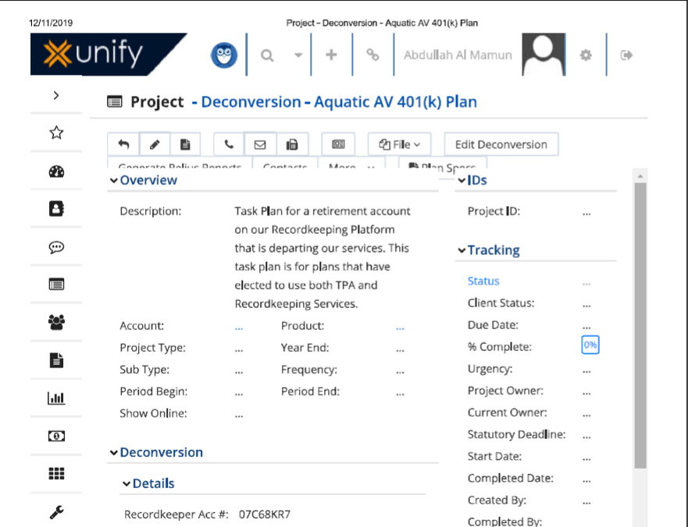

Figure 3.6: Unify

Relius:

This server has a group of information about participant which is used to create form.
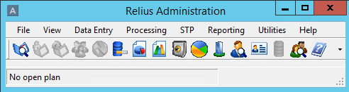

Figure 3.6: Relius

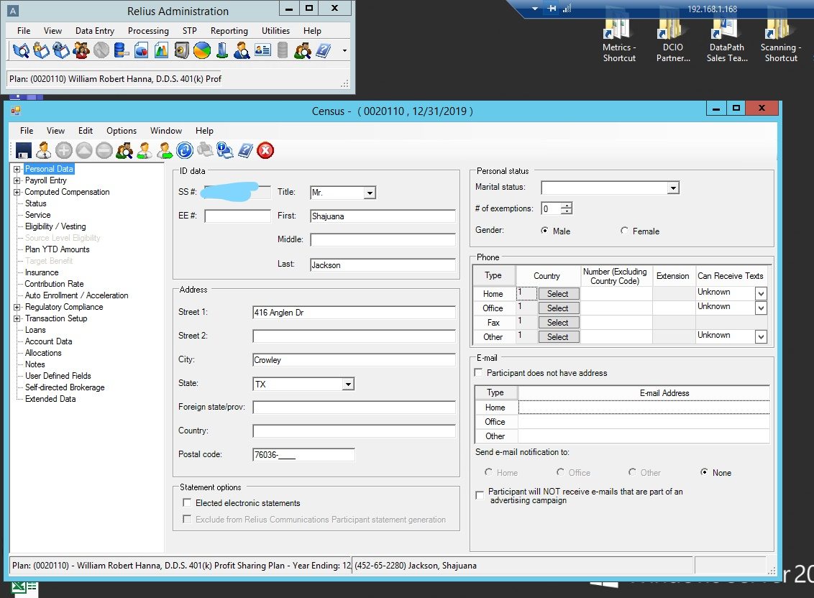

Figure 3.6 Relius

3.7 Application of academic knowledge

From the academic knowledge, computer skilled helped me to cope-up with their office culture. Knowledge of Microsoft excel, keyboard short cuts raised my work efficiency.

CHAPTER IV: CONCLUSION AND KEY FACTS

4.1 Recommendations for improving departmental operations

Working Process guidelines to make training process easier
All new employees must develop themselves training on work related areas. So, it will be easier for employees if DataPath provide an instruction for different tasks. The employee also follows for few weeks with actual works. They can make slip-ups as it is their first hands on. So, I also think DataPath should make some sample of work for the new employees to practice.

Developing software
Most of the work of DataPath done by UNIFY and Relius. A single Relius account costs massive amount of money each year. DataPath have a software development team and they are currently developing limited access for UNIFY. Surely this will increase the speed of work. But they should also develop software for Relius alternative which can save a lot of cost.

Faster Internet Connection:
Data-path Ltd is an outsourcing company they are depended on internet to process all the activities. Loading problem, slow downloading makes hamper for quick process of each task. Although the Data-path has a very reliable internet connection but sometimes the speed is not satisfactory. So, Data-path can take advantage of faster internet connection to speed up the flow of work

4.2 Conclusion

There are many outsourcing companies in Bangladesh however very few companies are like DataPath Ltd. Because Data-path US based totally organization and deals with US retirement plans. So, it also influences the way of life and values of the company. Our organization aim is to provide TPA service and offer retirement plan solution our client.
From 2008 DataPath is showing how fast the company is growing in the IT sector. It is getting everything whatever it needs to reach on the top of the BPO outsourcing industry. In this report over all information of what Data-path is and different service shown which they provide to the USA people as a third-party administrator and their work procedures in accordance with my internship. Outsourcing companies are now becoming more popular in various practices. In accordance with, throughout this report it was tried to show up various practices of the company, constraints and challenges I have faced during the internship period, the things I have learned and what the work I did at sales and Deconversion department.

Reference

- Application Xtender- Software Manual
- ASPPA Allocation Procedure Manual
- Guidelines for Retirement Benefit Plan, Published from DOL (Department of Labor), edition 2008
- IRS (Internal Revenue Service) Reporting Guidelines for Retirement Benefit Plan, Published from IRS, edition 2008
- Relius Administration- Software Manual
- Retirement Plan Fundamentals-1, Published from ASPPA, edition 2008
- Retirement Plan Fundamentals-2, Published from ASPPA, edition 2008
- TPA Manager- Software Manual
- www.julyservices.com
- www.hartfordlife.com
- www.airroc.org.tw/ISLSSL2005/program/doc/III-2.doc
- www.jhancockpensions.com

