Internships Report
SME Services of BRAC Bank Limited


Internship Report On
“SME Services of BRAC Bank Ltd.”

Prepared For
Dr. Khandoker Mahmudur Rahman
Associate Professor
School of Business & Economics
United International University (UIU)

Prepared By
Swaraj Debnath
ID - 111151575
School of Business & Economics
United International University

Letter of Transmittal
Date: 14/9/2019
Dr. Khandoker Mahmudur Rahman
Associate Professor
School of Business and Economics
United International University

Subject: Submission of the Internship Report
Dear Sir,
I would like to submit my internship report named “SME Services of BRAC Bank Ltd”. This report has been prepared for fulfillment of BBA program under United International University.
BRAC bank is the largest commercial bank in our country. They started their journey in 2004 but within this few years they have gained huge market share and positioned their selves as a market leader. SME is such a segment, which is first introduced by BRAC bank and it helps BRAC bank to reach at this present stage.
Whereas I was planning this report, I attempted to take after the directions and suggestion that you have given me, It has been exceptionally energizing and curiously whereas I was working in BRAC Bank. I have enjoyed my internship period in BRAC Bank. The administration of BRAC Bank has aided me, when I was required.
Sincerely,
Swaraj Debnath
ID-111151575

ACKNOWLEDGEMENT

I would like to thank the internship Supervisor, Dr. Khandoker Mahmudur Rahman who has helped me in every step of my internship. I am very much grateful to Ms. Rumana Wasih (HR) and Mr. Shajed Al Haque (Senior Manager) for giving me the opportunity to complete my internship at BRAC Bank Ltd. I am beyond any doubt that their energetic administrative exercise will donate motivation to anyone to construct one’s career legitimately. I also thank Mr, Mansib Intisar Khan(Associate Manager) and all members of BRAC Bank Ltd. for their assist to prepare my report by giving valuable information To know their viewpoint, feeling, ideology and procedure I have worked with them closely for three months. I will be thankful to those who will read the report and will get benefit from this reporting both present and future.

DECLARATION

I am Swaraj Debnath, student of School of Business and Economic (Marketing) of United International University, Bangladesh, do hereby declare that the internship Repot on “SME Services of BRAC Bank Ltd.” is an original work of mine and it has not been previously used for any degree, article, scholarship, or research.

________________
Swaraj Debnath
ID No: 111151574
School of Business and Economics
United International University

Executive Summary
This report is ready as a prerequisite for the effective completion of my internship program at BRAC Bank Limited (Head Office). This report contains seven major parts. In the first part, I want to represent the whole journey to accomplish this report. In the second part, I want to describe the overview of the bank, where I try to present the history of the BRAC Bank, mission, vision, objective, the meaning of BRAC Bank’s logo and slogan. In this second part, I also try to give a summary of every department’s responsibility and activities. What I have learned from this three months internship period, it is also included here. In the third part, I try to represent a success story of an entrepreneur. I have discussed regarding all kinds of SME products, facility and criteria in the fourth part, which is basically the main topic of this report. The fifth part is quite interesting, where I discussed marketing aspect of this bank and here I also give my opinion regarding the market and strategic issue. The last and final part is about from this three months internship, what shortage I found and my own opinion to mitigate that particular shortage and conclusion.

Table of Contents
Chapter-1 1
1.1 Introduction 1
1.2 Topic of the Report 1
1.3 Origin of the Report 1
1.4 Background of the report 1
1.5 Objective of the Report 2
1.5.1 General Objective 2
1.5.2 Broad Objective 2
1.5.3 Specific Objective 2
1.6 Scope of the Report 3
1.7 Methodology of the Report 3
1.7.1 Primary Sources 3
1.7.2 Secondary sources 3
1.8 Limitation 3
Chapter-2 3
2.1 Company profile 3
2.2 Corporate data 4
2.3 Corporate Vision 4
2.4 Corporate Missions 4
2.5 Corporate values 5
2.5.1 External 5
2.5.2 Internal 6
2.6 Objective 7
2.7 Slogan. 7
2.8 Logo 7
2.9 Overview about BRACK bank’s division 7
2.9 .1 Primary Wings 8
2.9.2 Supportive wing 11
2.10 Growth of BRAC Bank 12
2.11 Segment wise profit 12
2.12 Subsidiaries of BRAC bank 13
2.13 Internship lesson from BRAC Bank 14
Chapter-3 14
3.0 Case Study 14
Chapter-4 15
4.1 SME Service of BRAC Bank 15
4.2 Types of SME product 15
4.2.1 Deposit Product 16
4.2.2 Loan Products 18
4.3 Required Documents 24
4.4 Present Client Status 24
4.5 Loan Disburse Process 25
4.6 Entrepreneur Selection Criteria. 26
4.7 Guarantor Selection Criteria 26
Chapter-5 27
5.1 Marketing aspect of BRAC Bank’s SME 27
5.1.1 Market Segmentation 27
5.1.2 Target Market 28
5.2 4C 29
5.3 My Opinion About BRAC Bank’s SME Market & Strategic Management Related 31
Chapter-6 36
6.1 Consumer Satisfaction Survey 36
6.2 Challenges Associated With The Study 36
6.3 Research Design 36
6.4 Data Sources 36
6.5 Survey Result 36
Chapter-7 39
7.1 SWOT Analysis 39
7.2 Finding 41
7.3 Recommendation 41
7.4 Conclusion 42
References 44

Chapter-1

1.1 Introduction
At now Bangladesh’s GDP growth on average 6.5 to 7% and it is gradually increasing day by day, which indicates a sound and healthy economy exist at present. At now our economy is far enough strong than our neighbor countries. At 2019 Bangladesh’s GDP is 7.4%, where our neighbor country’s GDP growth is lower than us, such as India=6.6%, Pakistan=3.29%, Myanmar=6.40%, and China=6.9%. Bangladesh is now role model for many countries. So we can easily realize that we have more scope and opportunity than other countries. But this kind of spectacular achievement only possible, when a country’s rural life is developed and created self-employment attitude throughout the country’s people. But it quite impossible for a small and medium category-based business visionary to start a business and make himself self-employed. They need proper support to make themselves self-employed. BRAC bank realized that by avoiding the majority of these rural people a country can’t go forward. As a result BRAC bank first introduced SME service to serve small and medium category based entrepreneur, where the client will get many kinds of the facility regarding build up a business. SME is not only for lending money but it also provides service to deposit. From where small and medium category based entrepreneur can save their money for building up their future sustainability for their business.

1.2 Topic of the Report
It is crucial to select a topic for internship report and a well-defined topic can help to explore what is going on the report. SME service of BRAC Bank topic has been assigned to me.

1.3 Origin of the Report
At present scholarly instruction isn’t enough to empower an understudy to compete with certainly and reach his objective without having an encounter of the exterior world. My report gives me an opportunity to share my practical knowledge regarding SME service of BRAC Bank. From where I could able to learn how they conduct with market and management related issues regarding SME.

1.4 Background of the report
The internship program which is a fundamental portion of the BBA program to accomplish the degree and work out a critical significant because it empowers a student to commonplace with the practical business exercises. It is a great opportunity for any student to work closely with the individuals of an organization and able learn almost every form of an organization’s function. This program empowers a student to create his explanatory ability and scholastic attitude. As an internship I have been appointed at Niketon Corporate branch of BRAC bank as an intern for three months. This report primarily centered on the SME services of BRAC bank.

1.5 Objective of the Report
Internship is a program that program makes to get the condition/ circumstance in real life. It is a career improvement action offer assistance a student to construct their career career. Basically it is the primary step of building their career.

1.5.1 General Objective
Completing this report with adequate information is objective of this report. Hence, it is exceptionally imperative for us to have target of our claim to carry out the report in arrange to have a legitimate rule all through the report.
- Try to understand about the process and structure of a general banking.
- To discover the link between scholastic instruction and the real practical field.
- To develop my knowledge about how bank implement market and management strategy in practical field, which will help me to build my career as marketing department in future.

1.5.2 Broad Objective
To discover and analyze the current market scenario and marketing plan of SME of BRAC Bank and discover distinctive tactics for BRAC bank.

1.5.3 Specific Objective
As a marketing background student, I try to explore the marketing strategy of BRAC bank’s SME and it is my specific objective for this report.
- To have knowledge about how BRAC bank operate their SME services.
- Finding out the target customer and segmentation of their SME.
- Giving them idea on how to enhance their SME services.
- Giving them idea on how they spread their SME network.

1.6 Scope of the Report
This report has been arranged through broad analysis with BRAC bank employees, client and honorable supervisor. While preparing this report, I had a great opportunity to have an in depth knowledge of general banking and at the same time their marketing activities.

1.7 Methodology of the Report
Due to perfect and precise study everyone has to follow some rules and regulations. For this report I took help from two sources:

1.7.1 Primary Sources
- Face to face conversation with the Project Supervisor
- Direct observations

1.7.2 Secondary sources
- Website of BRAC bank
- Wikipedia
- Annual report

1.8 Limitation
- Not provided with information which would make the report more informational because of confidential policy of the bank.
- Information presented in this report may not accepted by the banking expert.

Chapter-2

2.1 Company profile
BRAC bank is a part of BAC, International Finance Corporation (IFC) and Shorecape International. This bank begain its journey on 4th July 2001 with an aim to be the market dominator by giving various kinds of banking facilities. Sir Fazle Hasan Abed(Chairman) and Mr. Selim RF Hussain (CEO) are the main key people of this bank .At now almost 8000 employee affiliated with this bank. The main motto of this bank is to rise up the rural people by providing them SME type facility because BRAC bank’s management believes a country’s economy position strongly depended on the portion of rural people because they can contribute the most prompt creation of employment in our country.
At now BRAC bank has 447 ATM, 186 branches and 458 SME unit offices.

2.2 Corporate data
Beginning of banking operation | 2004, 4 July
1st SME unit office established | 2002, 1 January
Underwriting with Shore Cap as investor | 2003, 29 December
Underwriting with IFC as investor | 2004, 8 May
1st ATM established | 2005, 3 April
Privileged share issued | 2006, 31 January
Infosys and 3i infotech changing bank’s IT base contracted with BAC bank | 2006, 1 August
24×7 customer care service started | 2006, 9 September
Register with CSE | 2007, 24 January
Register with DSE | 2007, 28 January
Beginning of share trading in DSE & CSE | 2007, 31 January
Credit Card introduced | 2007, 6 February
Inaugurated Probasi Banking | 2007, 14 April
Introducing of Travel Rated Service (TRS) | 2007, 1 November
Introducing of Omnibus with 12 member banks | 2007, 20 November
Source: Annual Report of BRAC Bank Limited.

2.3 Corporate Vision
Creating a lucrative and socially conscious financial organization which will concern on market and business with growth potential, so that serving BRAC and its stakeholders to rise an enlightened, healthy democratic and poverty free Bangladesh.

2.4 Corporate Missions
- Enriching the SME sector.
- Regulating low cost deposit growth.
- Funding corporate asset for self-liability mobilization.
- Investing in rapid growing sector.
- Attempt to increase non-funded revenue.
- Charging 2% debt for maintaining a stable profitable growth.
- Implementing the regulated cooperation between the branches.
- Supervise various lines of business with one structured rule.
- Creating a highly driven and motivated team for making organization’s vison into reality.

2.5 Corporate values
They nourish two kinds of values, one for internal and another for external.

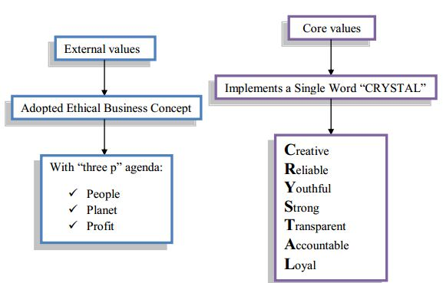

2.5.1 External
They believe that their main focal point is earning revenue for the organization but they also believe they have also responsibility toward people and planet. As a result BRAC bank do many kinds CSR activities often.

2.5.2 Internal
Internal values consist with 7 pillars and all of them in word they say “CRYSTAL”.
- C reflects to become creative. It motivates to think out of the box. A creative person is a valuable asset for an organization.
- R expresses Reliable. Anyone can trust easily a reliable person. So, before become a good employee try to become a reliable person.
- Y stands for remaining Youthful. Be a person of freshness and vibrant characteristic at work. Feel young at HEART and project enthusiasm during performing duties.
- S motivates to become strong. It basically refers a person’s mental and physical tolerance level.

- T means Transparent. A transparent person can achieve the reliability by all. So it can be said that Transparency and reliability is part of each other. So, every employee need to conscious about their personal and organization ethics and doing all activities with honesty.
- A reflects Accountable. It is part of a healthy and sound management structure.
- L means to become Loyal. It indicates create a long term healthy relationship with
Organization.

2.6 Objective
- Top to bottom motivate all employee to become enthusiastic to their work.
- Creating a strict ethical culture.
- Always try to seek consumer problem solution.
- Furnish and nourish the employee.
- Creating an integrated working environment system.
- Appreciating the talent.

2.7 Slogan.
“আস্থা অবিচল” This two word of Bangla is the slogan of BRAC bank.. This slogan reflects unbreacble trust on BRAC Bank.

2.8 Logo


Logo of the BRAC bank is very relevant with their mission, vision and objective. This logo build up with five specific indication.
- Square shape: It refers the stable organization’s structure.
- Golden proton: By yellow they want to mean prosperous and fertile land of our country.
- White borderline: Rising of white border refers the success of BRAC bank.
- Blue sky: It refers, many opportunities still exist to go ahead of the BRAC bank.
- Flashing circle: It means grasp the opportunity and go ahead.

2.9 Overview about BRACK bank’s division
BRAC bank’s structure basically categorized into two way, one is primary wing and another one is supportive wing. And they are part and parcel of BRAC bank. They are internally linked with each other like pulses of a human body.

Divison of BRAC Bank

Primary Wings
Supportive Wings

- SME
- Corporate
- Retail

- Human resources
- Finance
- Cash management
- Credit risk management
- Operation
- Company Secretariat
- Regulatory and internal control
- Operational risk management
- Treasury and Financial institution
- Information technology division
- Program management division
- Service quality division
- Corporate affair division

2.9 .1 Primary Wings
SME
The main motto of this division to motivate rural and women empowerment. Actually, the concept of SME derived from BRAC NGO. It is the only division which gives loan without any collateral. By the blessing of this SME 1.5 million, newly employment has generated. From the beginning of SME, it has disbursed more than 422,310,000,000 TK to our grass-root entrepreneurs and nourish those entrepreneurs until they reach in a stable position. Though the main targeted customers of SME are small, medium and women but they strongly focus on small sector rather than others. SME of BRAC bank is such a division, which helps to become our country’s economy healthy and sound.

Some products of SME

Corporate
The main targeted customers of this division are MNC, RMG, and manufacturing or service industry. The corporate division seeks to make relation with the customer and maintain that relationship by providing various kinds of corporate and banking facilities, such as working capital financing, project financing, lease financing, machinery financing. The corporate division also aids to manage many kinds required and essential documents, like, LC and other documents. This division’s main motto gives first priority to resolve the client’s problem. The team of corporate division also helps client’s business performance by providing them many kinds of suggestion and finance. Here bellow have shown some products of corporate.

Retail
The main motto of this division is to serves singular client instead of commercial client. Person, who want to full fill their internal and personal satisfaction, they are the main customer of this retail division. Here bellow have shown some products of retail.

2.9.2 Supportive wing
- Human Resources: Employees are the pillar of the organization because a good employee can help the organization to achieve the organization’s goal. So, this division always tries to seek good employee and develop them until they fit with the organization’s objectives and environment. All employee’s reward and salary also controlled by this division.
- Cash Management division: Collecting large amount fund is the main motto of this division.
- Credit Risk Management: Loan access, process, approve and verified are the main concern of this division.
- Operation: Loan disburse and repayment related activates are controlled by this division. Bond and custodial related services also accomplished by this division.
- Company Secretariat: This division’s main objective to maintain relation with Bangladesh Bank.
- Regulatory & Internal Control: Audit regarding all kind of activities are done by this division. External and internal audit are also done by them.
- Treasury & Financial: Their main motto is to regulate and fix interest rate. This division also responsible for maintaining balance sheet structure.

- Information Technology Division: They help to provide to set up and update technical infrastructure for BRAC Bank,
- Project Management: They actually set up many kinds of short term and long term project for the individual division.
- Service Quality Division: This division’s main motto is to maintain customer satisfaction. As a result they always observe customer’s feedback.
- Communication: Communication division’s main objective is to ensure branding, promotion and vendor management.
- Finance: Monitoring financial activities and analyzing them are the core objective of this Finance division.

2.10 Growth of BRAC Bank
The growth rate of BRAC Bank’s revenue is sound and healthy. As a result, we can see that the revenue growth of BRAC Bank is increasing year to year. In 2013 the revenue was 13953 million but in 2017 it became 23701 million. Only within five years, it jumps into 10million revenue. So, we can say that the motion of BRAC Bank’s revenue’s growth is speedy enough to achieve the dominator position in the banking sector.

2.11 Segment wise profit

The chart shows that the result of threes segment’s profit is pretty good. Though the SME segment slightly dive into the loss, which is 31%. And for this cause BRAC Bank already has taken initiative to focus more on this segment. As a result they are recruiting more Relationship Officer (RO) and spreading more SME unit office to cover the remote area of Bangladesh. On the other hand the Retail and Corporate position is sound and healthy. As a result retail achieved more than 25% profit and corporate gained 8% profit.

2.12 Subsidiaries of BRAC bank
This bank has 3 subsidiaries company. Which are centrally controlled by BRAC bank.
Bkash Ltd.
Bkash is mobile financing software. By which we can transact our money from any side and at any moment. The inception of its journey from 2010. BRAC Bank is the pioneer to launch this kind of facility. At 2018 the total customer was 30.95 million, where 18.69 million was active customer and day the ratio of its customer is increasing because of its user-friendly and attractive design. Developers of Bkash is still trying to enhance it to create this software more easily accessible.
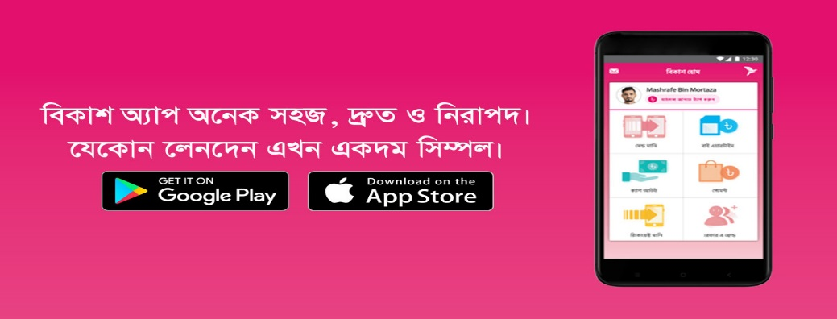

BRAC Sajan Ltd.
It is the largest remitter in Bangladesh, provides remittance related facility. Only from UK it covers more than 30 % market share capital. The vision of it to spread the network whole over the world but initially they want to spread their network in Srilanka, Pakistan, Poland and Africa to provide remittance facility to NRBs.
BRAC EPL LTD.
It is completely an investment bank and portfolio manager. EPL also act as a corporate advisory facility. EPL helps the company overcome the barrier by strategically optimizing the business growth.

2.13 Internship lesson from BRAC Bank
It was a great opportunity for me to work in head office of BRAC Bank. From here I know about how to deal in a corporate culture. I could able to know available products of SME and how they conduct with their clients. I also could realize and learn about the banking strategy. I observed that how each department internally linked with each other.

Chapter-3

3.0 Case Study
SME is a tremendous innovation by BRAC bank. Small and medium are the main targeted customer of its. It’s not helps to rise employment but also helps to enhance economy development. There are many people exist, who have become entrepreneur by the blessing of SME. Here bellow have discussed a success story of an entrepreneur.

Suchi Shoili is a handmade business, which is run by a married couple, Mr. Kabir and Mrs. Deeba. Basically initially Mrs. Deeba started this business in 2016. They currently read in a reputed private university and at the same time they operate their business and when they started their business they didn’t get any kind of family support. In the inception of this business, they couldn’t provide much varieties product because of lack of labor, machine and working capital. And they take the order and customer feedback by Facebook page. In 2017 they decided to expand their business. As a result, they took Tk100000 loan from Shopup ( Shopup is an NGO, which is jointly working with BRAC) and repaid that within the time. And again in 2018 they took total Tk 500000 loan and repaid that loan within the tenor. At present, they produce backpack, laptop pouch, ladies bag, vanity bag, pencil bag, makeup bag, etc., which are they sell from Tk 250 to max Tk1600 max price. Including them, they have five labor and three machines and also have a two room’s flat, from where they operate their business. Sometime outsource their work, in case the product is much expensive and exclusive. In this year they have decided to export their product. For this cause, they need more capital. So, they decided to take help from BRAC Bank. And they contacted with SME division of BRAC bank and requested to get Tk 600000 loan. As a result, Mrs. Deeba opens an account on Tara (Tara is a specialized loan product for women entrepreneur). And thus after a small banking procedure, they got their demanded loan with twelve-month tenor. At now they are going forward to achieve their dream.
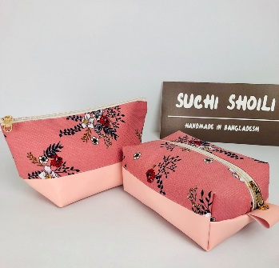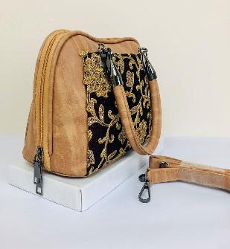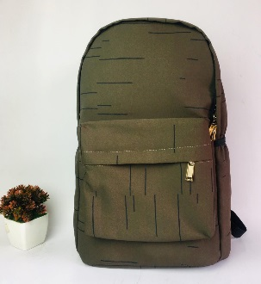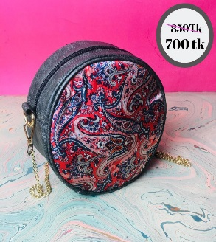

Chapter-4

4.1 SME Service of BRAC Bank
The foremost vital standard resource of Bangladesh is its individuals. As a nation, we fought for our independence and presently the accomplishment of financial lift is essential objective. Miniaturized scale money lenders are working here and giving exceptionally little sum of advance and on the other hand normal commercial banks have been giving greater sum of advances to bigger business and exchanging organizations. Most of the time the small and medium commerce were ignored .So, little business visionary can’t extend or begin their trade for missing of support as they have no property to donate as esteem to the commerce bank.
BRAC Bank firstly recognize that the Bangladesh includes an expensive showcase for SME credit. From 2002 BRAC Bank has begun to supply SMEs credit and until they are centering on wide based interest by serving small and medium visionary. It has been created strong network by creating 460 SME unit throughout the Bangladesh.

4.2 Types of SME product
We all know the major activities of a bank is collecting deposit and providing loan to its customer. So, by depending on this two activities, BRAC bank’s SME has two types of product, one is SME Deposit product and the other one is SME loan product.

4.2.1 Deposit Product
There are four kinds of SME deposit product exist. Each product has different criteria to fulfill different types of client’s demand.

Prapti
It is a current account but here client will get interest, if he maintains on average Tk 1,00,000 balance in his account.
Targeted customer | Sole proprietorship, Partnership, Private Ltd., NGO, Education institute, Association.
Interest | - Has chance to get up to 2% interest rate.  - Interest will be accumulated three times in a year.
Initial Deposit | - Tk 5000
Account maintenance Charge | - Tk 500 + 15% vat (2 tines in a year).  - Maintenance charge will be free, if client’s account has Tk 100000 or above this amount.)
Other Facility | - Internet Banking  - Call center facility

Shadhin
It is a type of current account, where hasn’t any kind of interest rate and charge.
Targeted customer | Sole proprietorship, Partnership, Private Ltd., NGO, Education institute, Association.
Interest | - Hasn’t any interest..
Initial Deposit | - Tk 1000
Account maintenance Charge | - Tk 500 + 15% vat (2 tines in a year).  - Maintenance charge will be free, if client’s account has Tk 25000 or above this amount.
Other Facility | - Internet Banking  - Call center facility  - There isn’t any kind of interest charge up to 100000.

Sonchoy
It is a saving account, where client can deposit their money on a monthly basis by any convenient installment. After crossing the maturity, client will get a handsome amount.
Installment | - Lowest installment Tk 500.
Other Facility | - Overdraft facility  - Convenient tenor

Prachurjo
It is a fixed deposit account facility for small and medium category based enterprenure,
Targeted customer | Sole proprietorship, Partnership, Private Ltd., NGO, Education institute, Association.
Interest | - Has lucrative interest rate, which will be applicable only after crossing maturity..
Initial Deposit | - Tk 100000
Account maintenance Charge | - It is not charge any many kind of maintenance fee.
Tenure | - Least 3 month and maximum 36 month.

4.2.2 Loan Products
BRAC always formulate its strategy from the perspective of the consumer. BRAC Bank know, formulating a strategy from the perspective of the product, which is call marketing myopia, it is nothing but a waste of time and resources. As a result, BRAC Bank has arranged its product segment into 3 categories. Which product require mortgage, that is secured loan and on the other hand which product needn’t any kind of mortgage that is unsecured.

Under this three loan segments there are 7 kinds of product exist. Each product has different specialty, which will help to satisfy different type of consumer. Here bellow have described about all of this products feature.

Ankur
It is a loan, which is specially made for grass root level entrepreneur.
Targeted customer | A person who first time decided to start any business in small category or need small amount of money to mobilize the business.
Loan Limit | BDT 3- 5 lac
Owner Business Experience | 2 Years
Interest | 22%
Tenor | Minimum 3 months to maximum 36 months.
Other Facility | - Needn’t any kind of security  - Term and Single installment facility

Anonno
Targeted customer | Sole proprietorship, Partnership, Private Ltd.
Loan Limit | BDT 3- 25 lac
Owner Business Experience | 2 Years
Interest | 19%
Tenor | Minimum 3 months to maximum 36 months.
Other Facility | - Needn’t any kind of security  - Term and Single installment facility
Restriction | - Client’s age needs to within 21 years to 65 years but only for the guarantor the age limit can be loose, such as, minimum 18 to 70 age.

Anonno Plus
It is actually a new form of Anonno. Here client will get more facility than Anonno.
Targeted customer | Sole proprietorship, Partnership, Private Ltd.
Loan Limit | BDT 25-100 lac(1crore)
Owner Business Experience | 5 Years
Interest | 15.5-16%
Tenor | Minimum 3 month to maximum 36 month.
Other Facility | - Needn’t any kind of security  - Term and Single installment facility

Tara
It is women entrepreneur specialized loan. Here BRAC puts many facilities because BRAC bank knows women are the key generator of an economy.
Targeted customer | Only for women entrepreneur.
Loan Limit | BDT 3 lac – 1 crore
Owner Business Experience | 2 Years
Interest | 9 %( It will be sustain until client cross 50 lac)
Tenor | Minimum 12 months to 60 months
Other Facility | - Needn’t any kind of security  - Term and Single installment facility  - Revolving loan  - Overdraft facility  - Tara SME entrepreneur service.  - Needn’t any kind of process fee.

Apurbo
Targeted customer | Basically those client, whose business is almost mature and want to expand their business more
Loan Limit | BDT 10-500 lac(5crore)
Owner Business Experience | 3Years
Interest | 13-14 % ( Depends on loan limit)
Tenor | Minimum 3 month to maximum 36 month.
Other Facility | - Term and Single installment facility  - Revolving loan  - Overdraft facility
Restriction | - Client’s age needs to within 21 years to 65 years but only for the guarantor the age limit can be loose, such as, minimum 18 to 70 age.

Bahon
For supporting transport facility to SME entrepreneur, BRAC bank introduced this type of product.
Targeted customer | Entrepreneur who wants to increase their business mobility by adding some transport.
Loan Limit | BDT 5-500 lac(5crore)
Owner Business Experience | 2 Years
Interest | It depends on amount of loan.
Tenor | Minimum 13 months to maximum 60 months.
Vehicle Type | SUV, Commercial vehicle, Micro bus, Truck, Van, Passenger vehicle
Other Facility | - Term Loan

Somridhi
The main focus of this product is to minimize barrier of export and import related issue by financing, managing document (LC and others) and by providing advices to entrepreneur.
Targeted customer | Entrepreneur who wants to expand their in overseas and wants to import unique or exclusive product or material from other country.
Loan Limit | BDT 1 lac to 1.50 crore but in revolving it will be BDT 10 lac to 5 crore.
Owner Business Experience | Minimum 3 years
Interest | 13-16 % (Depends on amount of loan).
Tenor | Minimum 120 days to Maximum 180 days.
Other Facility | - Term Loan  - Revolving Loan
Nirman
The inception of this product is to help the entrepreneur by helping them to make or increase the infrastructure facility. It is partially secured and unsecured. It means if the loan amount is small then there isn’t require any kind of mortgage but if the loan amount is huge then will require a mortgage.
Targeted customer | Sole proprietorship, Partnership, Private Ltd.
Loan Limit | BDT 3 lac to 500 lac ( 5 crore)
Owner Business Experience | Minimum 1 year
Interest | It depends on amount of loan.
Tenor | Minimum 12 to 96 months
Other Facility | - Term Loan
Restriction | - Client’s age needs to within 21 years to 65 years but only for the guarantor the age limit can be loose, such as, minimum 18 to 70 age.

4.3 Required Documents
- Up to date Trade License
- Customer & Guarantor NID
- 1 Family Guarantor & 1 Third Party Guarantor
- Bank Transaction (if available)
- E-TIN/ Up to date Tax Clearance Certificate for loan amount above BDT 5 lac
- MDTD/MDPD
- Loan Repayment Statement & Sanction Letter (for existing loans)
- PDC
- Rental Agreement/ Rent Receipt
- For Partnership Concern:
- Partnership Deed-on Non-Judicial StampTk. 2000

4.4 Present Client Status

From this chart we can easily realize that Anonno is the most popular than others. And other products demand are gradually increasing day by day.

4.5 Loan Disburse Process
Checking documents by credit analysist.
Selecting areas for SME unit officer.


Disbursing loan
Distributing CRO to that areas.
Accumulating all client’s document to credit risk management division.

After disbursing CRO checking all necessary materials.
Pursuing potential clients.

Collecting loan by CRO or actual borrower.
Preparing loan application

Verifying the client in physically.
Rejecting many client’s proposal due to inefficient and dissimilarities documents.

- Perusing Effective Endeavor: In this step CRO do analysis to find out the probable entrepreneur and verify the client physically.
- Credit Introduction: For acknowledging about various types of loan products, CRO introduces with loan products as per client’s demand.
- Collecting Necessary Information: It is most important part, here CRO tries to seek confidential and necessary information to judge the client’s viablity, such as, ownership of the business, business experience, main purpose of taking loan and so on.
- Enroll CIB Form: After collecting necessary information, CRO provides a CIB (Credit Information Bureau) form to client for filling and signing the form. If Client is unable to do this due to illiterate then CRO will do this work from the behalf of client. Then CRO sends this document to SME unit office.
- Providing CIB Report To Bangladesh Bank: After successfully collecting CIB form, SME unit office sends this form to Bangladesh Bank to collect CIB report.
- CIB Report From Bangladesh Bank: Within 7 to 10 days Bangladesh Bank provides CIB report to that particular SME unit, branch or head office.
- Sending Loan Proposal To Credit Risk Management Division: When SME unit got CIB report then it sends CIB report and loan proposal to Cresit risk management division to verify and justify the loan proposal.
- Loan sanction: After sorting out loan proposal from credit division and if all the documents are well managed then there will be held a board meeting before disbursing. If all the members of that meeting agree to disburse then the loan will be sanctioned.

4.6 Entrepreneur Selection Criteria.
- The business visionary ought to be physically able and in great well-being and need to be age within 18 years to 65 years.
- The business visionary must have the fundamental specialized aptitude to run the business.
- The business visionary must have a satisfactory social position within the community.
- Need to be capable to take challenge and take forward the business with enthusiastically.
- Providers or lenders ought to authenticate that he pays on time is common in general nature.
- Precise sign of source of salary and sensible capacity to spare.

4.7 Guarantor Selection Criteria
- The underwriter must have the capacity to reimburse the complete credit and is financially dissolved.
- The underwriter ought to know the business visionary sensible well and ought to ideally live within the same community
- Political pioneer, armed force and devout pioneer cannot be chosen as a underwriter.

Chapter-5

5.1 Marketing aspect of BRAC Bank’s SME
BRAC Bank strictly follow market concept to formulate a well balance market strategy. Because a well market strategy helps an organization by various ways, such as:
- Helps to understand an organization’s target customers and how that particular target customer can be satisfied. .
- A good market strategy helps to find out its competitor. At the same time, a strong market strategy assist an organization to find out its organization’s blind point and execute the action as per that way.
- Increasing brand awareness, which is totally depends on a well-balanced market strategy.
- Helps to set up feasible time frame and goal.

5.1.1 Market Segmentation
Here bellow we tried to segment the SME according to marketing concept. For this cause we classify the whole SME under four major variable criteria, such as geographic, demographic, psychographic and behavioral.
Geographic
Region: BRAC bank has 467 SME unit all over the Bangladesh to serve people.
Area: The main motive of SME to develop rural and semi urban area.
Demographic
Age: In BRAC bank they provide this SME service, if person is within18 years to 65 years.
Gender: Male and female both are applicable for this service. Especially for female BRAC bank made a product, which name is "Tara" to encourage themselves to make self-employed.
Income: low, lower middle and middle income based people are the major clients of SME.
Occupation: Unskilled worker, skilled worker, petty traders, shop owners and self-employed person.
Education: Most of the SME clients are illiterate or class 5, 8, SSC or HSC passed.
Socio- Economic Classification: E2, E1, D, C, B2 (Here E2, E1, D is the most lowest segment on the other hand C and B2 is the middle segment)
Psychographic
Personality: SME clients are basically ambitious category’s because they have the vision to make themselves self-employed.
Behavioral
Loyalty status: If any SME client takes service from here, he or she will become loyal customer due to BRA bank’s well-managed services.
Attitude toward product: Enthusiastic and positive
Readiness stage: Desirous and intending to take service.
Benefits: BRAC Bank provides better loan facility than others, which will help an individual to contribute in the economy.

5.1.2 Target Market
It refers to classify some group of markets according to their feature and criteria. It is necessary to select a particular group of people from the selected segment because it helps to find out potential customer. For this cause organization also can give them special service and nourish them to become potential customer. BRAC Bank follows niche market strategy in SME. We know niche strategy is such a process where marketing strategy focuses on unique target market instead of everyone. In BRAC bank SME has seven or eight major products which have unique target customer.
Products | Targeted Customers
- Ankur  - Anonno  - Anonno Plus  - Apurbo | This four types of products main motive is to serve those people, who want to make themselves self-employed. Though the motto of this four products is same but from loan amount, interest charge and tenure perspective they are different from each other.
- Bahon | Those clients, who are want to integrate transport facility in their business.
- Tara | Targeted clients are women. The main motto of this product is to make women empowerment.
- Somridhi | Those clients, who are want to expand their market into the foreign market or want to import something rare and exclusive products in our country.
- Nirman | Those clients, who are want to enhance their business’s infrastructure facility.

Though the market is huge, here exist many opportunity and scope but SME segmented their services only for fresh or medium category based entrepreneur. As a result, SME hasn’t any interest in corporate and retail clients. So, finally, we can say that they follow a niche market strategy.

5.2 4C
4C is an update version of 4P. The main reason behind its inception is to remove market myopia related problem. 4P thinks from the perspective of production but 4C thinks from the perspective of consumer. As a result in this modern era many reputed organization follow 4C because consumer are the main resources of an organization. Formulating strategy without including consumer is nothing but wastes of resources and time. As a result consumer are the king of an organization.
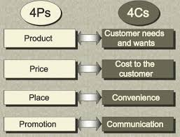
Customer need and demand
BRAC bank SME has seven major products because each client has each kind of need and demand. Some of the client have ability to give mortgage on the other hand some haven’t ability to give mortgage. At the same time some of the clients want high amount of loan on the other hand some of the clients want low amount of loan. As a result each 7 products are different from each other. Such as: Bahon product’s motto is to finance on transport facility to enhance entrepreneur’s mobility on the other hand Nirman product’s motto is to enhance owner’s infrastructure facility.
Cost to the consumer
It’s not only refers the price of amount a client need to give for getting his facility rather it also indicates a client’s time, effort and opportunity cost. For surviving in this competitive market need to focus on consumer satisfaction, which is closely inter related with cost of a customer. So, BRAC Bank initially has taken many steps to reduce cost of a consumer. Some major steps have shown below.
- After taking first loan, BRAC bank charges low interest rate to that particular client for his further loan.
- BRAC bank doesn’t take any procedure or miscellaneous charges, which will help to minimize consumer cost.
- BRAC bank takes short time to process a loan because it gives value to client’s time. IF CIB and other documents are well managed then it takes minimum 15-20 days for a loan sanction.
Convenience
It refers the location related facility. For the convenience of SME costumer, BRAC bank establish 460 SME unit throughout the Bangladesh and day by day the unit is increasing.
Communication
If an organization wants to survive in this competitive market then that organization needs a proper network with the various channel. As a result, recently BRAC bank has taken steps to recruit more CRO (Customer Relationship Officer) to provide their message and getting their feedback to consumers. BRAC bank also has dedicated call center for customer service and it is opened 7 days for 24 hours.

5.3 My Opinion About BRAC Bank’s SME Market & Strategic Management Related
- Grabbing The Pawn Method: It refers that a BRAC bank’s SME should make strategic partner with low or medium category based competitor, which has a low market share and growth rate, compared to BRAC bank’s SME. This method always want to avoid to make strategic partnerships with equal or higher category based competitor because an equal or higher category based partner doesn’t obey your command, as like medium or low category based partner.
- Find The Blind Point: It refers to find out competitor’s weakness and take as per action. For example, if BRAC bank SME can realize that the network of that particular competitor still doesn’t reach then BRAC bank should spread its SME network before reaching its competitor to that particular zone. It will help BRAC bank to achieve first- mover advantage.
- Provide After Sale Service: It helps to make a long term relationship with the client. At the same time, it will help to raise the price. As a result, if SME division of BRAC bank provides some sort of services, after getting the actual service, such as health insurance, Hajj service package then it will help to raise client’s loyalty and spreading positive word of mouth and because of this brand equity of BRAC bank will become high.
- Satellite Head Office: Depending on one head office is nothing but decreasing efficiency. It could be better if they had at least two satellite SME head office then the main head office could execute their plan and disburse target easily. It also could help to minimize bureaucratic related issues.
- Need To Open An Islamic Formation Bank Segment in SME: We know the customer is the king of an organization. So, an organization needs to give first priority to its customer need and demand. Naturally, we Asian people have more or less weakness toward our religion. Each religion contains each kind of norms and culture, which can directly impact our economy. For example, Burger King is a reputed burger company throughout the world. They successfully operate their business all around the world from their inception. But recently they have observed that they losses many clients due to they haven’t any kind of veg item. In India, many consumers strictly believe in the vegetarian concept. After ensuring this issue they introduced veg burger and other items, which helped them to boost their sell. It means giving respect to your client’s norm and value. In Bangladesh’s, most of the people are Islam believer. But the problem is many of the Islam believers believe that traditional bank concept is against their religious norms and values. For this cause, they introduce a new style of bank policy, which is guided by Islamic Shariah principle. So, if it is possible to integrate Islamic Shariah segment in the SME then the sale of SME products can become high.
- BCG Matrix: It is such a matrix, which is created by Boston Consulting Group. It helps to identify the product’s position of an organization. This matrix basically based on two parameter, one is market share and the other one is market growth. It not only helps to identify product’s position but also it helps to formulate further strategy. Here bellow I tried to put SME’s products under the BCG matrix formation.

Star  - Nirman  - Ankur | Question Mark  - Anonno +  - Apurbo  - Tara
Cash Cow  - Anonno | Dogs  - Bahon  - Somridhi

- Cash Cow: It is such a position, where market share is high but market growth is low because that product reached the optimum level. Organization should maintain this category’s product position. Anonno is a product of SME, which we can put it under this category because it has almost 91,000 clients, which is higher than any other product client’s number but at now this product’s growth rate is low compared to other products. We can use this category’s product’s revenue to support any selective product of question mark.
- Star: We can put Nirman and Ankur under this category. This two product’s market growth is high and due to high growth rate in market, their market share is also increasing day by day. Market penetration is the main treatment of this category’s product. Until reach the cash cow position of this category’s product, need to apply aggressive market strategy.
- Question Mark: We can put Anonno Plus, Apurbo and Tara under this category. The market growth rate is high. At the same time market has demand due to their lucrative feature and criteria but market share is low compared star category product. This product need proper nourishment, analysis and also need proper time to enhance this category’s product market share.
- Dogs: Bahon and Somridhi are under this category’s producet due to their low market growth and share. Divesor harvest is the appropriate treatment for this category’s product.

- Ansoff Matrix: It is such a matrix, which helps an organization to expand their market or product. Here bellow I have shown some strategy to expand SME by following Ansoff matrix.
- Market Penetration: It is the safest zone than other three option. Here just need to focus on promotional strategy for increasing their existing product’s sell. Example: SME division can arrange many promotional strategy, such as advertisement, seminar for increasing their product’s sell.
- Product Development: From my perspective, I think SME should introduce agro based product because the main purpose of SME is to develop rural people and most of the rural people depend on agriculture related occupation. This should be low amount of loan, low interest charge and it should be seasonal base.
- Market Development: Spreading the SME network into the competitor’s blind spot.
- Diversification: Integrating between SME and Retail and create a fusion product and launch that product, where BRAC bank didn’t do any sort of activities previous.

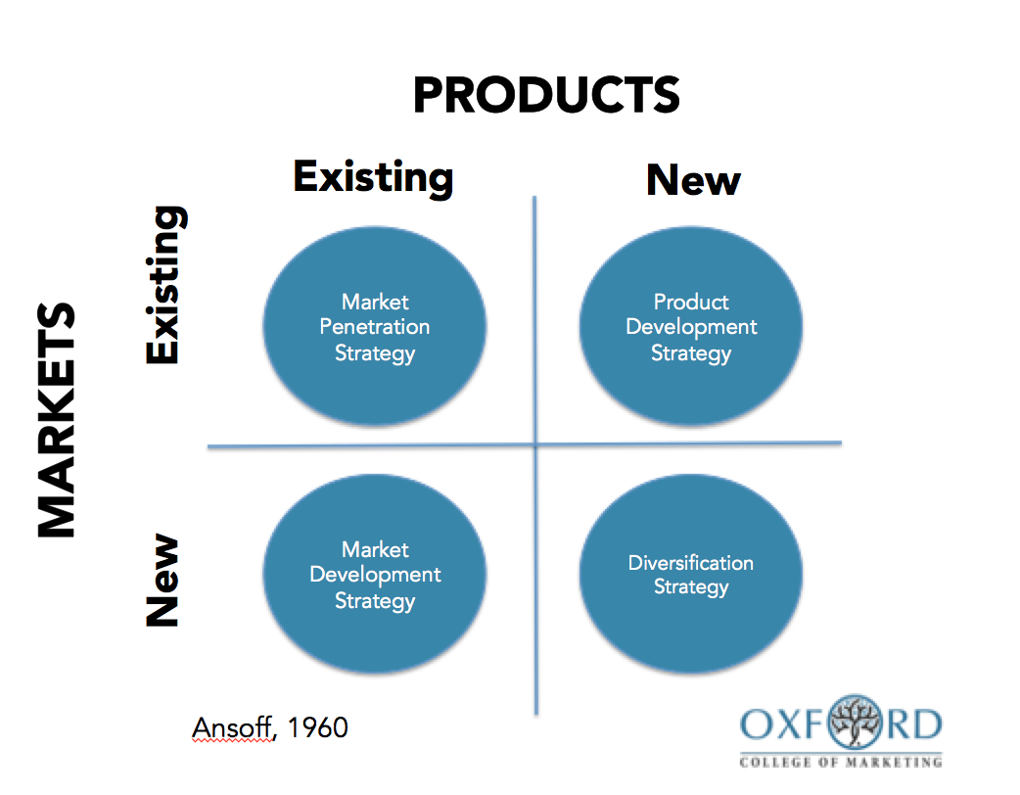

- Stakeholders Mapping and Business Strategy: According this mapping process, we can classify our stakeholders into four categories and it also helps us to how to deal with each category type stakeholder.

Government  (Keep Satisfied)  - Keep informed  - Keep happy  - Keep distance | Board of Directors  (Manage Closely)  - Keep happy  - Be careful  - Keep proximity
Disregarded People  (Minimum Effort)  - Keep in mind | Consumer  (Informed)  - Keep in mind  - Keep informed

- Government: Government has low interest in any organization but has high power to command and control any organization, which indicates the Government has high authority power. So, an organization needs to satisfy the government by maintaining rules and regulation, which was held by the government.
- Board of Directors: Board of directors has high interest and high power to claim and control over an organization. Organization’s subordinates need to try to keep them happy by success their mission, vision, and objective.
- Consumer: They have high interest about a company but have low power over the organization. Selectively they haven’t any power but collectively they have power more than a government because an organization’s whole performance depend on consumer’s satisfaction.
- Disregarded Consumer: Special child, disabled people are in this category’s. Maybe they haven’t any interest and power toward an organization but they are part of our society and organization can do lots of CSR (Corporate Social Responsibility) for them.

- Community: It’s a brand resonance level’s a major portion. A strong community helps to enhance brand equity. Distinguishing proof with a brand community may reflect a vital social wonder in which the client feels a connection or association with other individuals related to the brand. Under a community brand user, fellow brand user, customer or employee act as a representative of a brand. It not only helps to make a strong bond between the brand and the consumer but also it helps to sustain a long term relationship with the customers. A community can be alive in online or offline. For online BRAC bank SME can create an online portal, from where any SME clients can share their success story or opinion and that can able to see, give feed reaction the other entrepreneur. On the other hand, if BRAC bank SME wants to create this in offline then they need to arrange a seminar annually, where every entrepreneur shares their opinion on each other. Can create some documentary movies on top-rated success entrepreneur and that will display on that seminar. The participated entrepreneur will get many types of reward, such as delicious food, BRAC bank logo T-shirt and many others. And this kind of community seminar should be a perpetual process. It will help create long term relationship with the brand and at the same time, this will help to spread the positive word of mouth, which will help to increase brand equity.
- Character: BRAC bank can use character to promote their brand Character is a special form of brand symbol .These characters are basically take from our daily life and also sometime take from our fantasy. So, characters can be human, animal or something, which we can relate with that particular product. It provides a major role in advertising and camping. Due to its rich in imagery and gorgeous color, it helps to create brand awareness. By a character symbol a consumer can form relationship with brand easily. The other major advantage of using character is, it hasn’t any direct product meaning. As a result it can easily convert across any product categories. For this cause reputed brand, such as Vodafone, 7up, MacDonald and many other reputed brands character to enhance their brand equity.

Chapter-6

6.1 Consumer Satisfaction Survey
The survey refers to in-depth analysis and observation of any subject. As a result, I conducted a survey, which is on client satisfaction of SME. It is important to know about its client satisfaction level because customers are the king of an organization. For this cause, it is necessary for themselves to know about their consumers, otherwise there will be a chance to create marketing myopia environment, which isn’t applicable by modern marketing method. This survey will help BRAC Bank to know about their client’s problem and what they want in the future.
I surveyed on 30 clients (n=30) and I segmented the whole survey on five categories. From where I try to represent each category’s client satisfaction level.

6.2 Challenges Associated With The Study
When I did this study, I faced some challenges regarding survey analysis. Here bellow have describe briefly about limitation regarding my survey.
- Size of the sample: The survey sample size is too small. It isn’t enough big to bring out a significant value.
- Limitation of Likert scale: The main limitation of Likert scale is, it doesn't provide detail insight information to anyone as an open-ended question. Another fact is Likert is totally a self-realization matter. For this cause, it is necessary to fill the questionnaire by themselves but unfortunately due to some clients were illiterate, felt bored and some of them thought it was just a waste of time, as a result, I had to fill the question behalf of themselves. For this cause sometimes I felt trouble to identify their exact satisfaction level.
- Absent of standard question: Though it was my fault but I think this questionnaire could be more specific, refined and informative.

6.3 Research Design
This research is based on qualitative structure. Where it has focus group, which is consist of 30 sample and questionnaire of this research designed with close ended structure.

6.4 Data Sources
Primary source of data includes formal interview, questionnaire interview and observation.

6.5 Survey Result
As I previously mentioned that I segmented the whole questionnaire among five categories. Here bellow have shown each category’s result briefly.

SME Services

Around 74% of clients satisfied with our SME services.12 % presents the dissatisfaction level, which was mainly created for loan closing related problem and for the high rate of SME interest rate. 13% neutral indicates two category’s clients, who didn't take all kinds of services yet and on the other hand who aren't much satisfied and dissatisfy with our present services.

Bank Services

Around 64 % of clients satisfied with our banking services. 26% reflects dissatisfaction level, which was mainly occurred for the inefficient and unskilled employee in cashier and clients want at least two dedicated SME line in the cashier and it is a the major issue because for this cause many SME clients switched to another bank.
Employee Behavior

From this chart we can easily understand that almost 98% clients satisfied with BRAC Bank employee’s behavior.
Bank Environment

Here also we can see above 95% clients satisfied with our banking environment. They haven’t any complain regarding location and decoration of this bank. They are much satisfied with current situation.

Personal Opinion & Recommendation

It is a big achievement for BRAC bank that overall 100% of clients personally satisfied and they want to maintain a long term relationship with this bank. The ratio of dissatisfaction level indicates our clients don’t want to switch another bank or branch but due to two questions were arranged as like negative centric in this segment, as a result, the dissatisfaction level became so high. Actually that two specific questions were tricky questions to find out the true opinion from the clients. Fortunately, I got positive feedback.

Chapter-7

7.1 SWOT Analysis
Differentiating between strength, weakness, opportunity and threat is call the SWOT analysis. It helps to formulate the strategy. At the same time it also helps to understand organization’s own blind spot. As a result it works like radar to navigate the organization by surviving in the market tactically. For this cause BRAC bank always conscious about this four factors.
Strength  - Enormous reputation due to its premium quality service.  - Has the NGO support.  - Enrich brand reputation by sponsoring Bangladesh cricket team.  - Strong network throughout the country and BRAC bank has a plan to spread this network more by establishing more branches and SME units.  - It has experienced and dedicated board of directors  - It has skilled human resources.  - It focuses on consumer need rather than organization strategy.  - Modern and transparency culture.  - Capital base of BRAC bank is much strong than any other bank.  - It provides long term tenure facility than other banks. | Weakness  - For sanction a loan need to depend on board of directors.  - High interest rate than other bank.
Opportunity  - Has the opportunity to expand market.  - It can wander into green financing. | Threat  - Competitive market  - Upcoming national and multinational bank.

7.2 Finding
We know that BRAC bank is one of the quickest developing bank in Bangladesh. This bank is the biggest commercial SME nation and 4th largest SME bank within the world in terms of extraordinary credit sum. It plays a crucial part within the SME division of Bangladesh. BRAC bank has taken distinctive tactics for the advancement of this segment, since it is the most beneficial item for BBL. SME credit may be an advance given particularly to business visionaries who are experienced little or middle businessman. Although from my 3 months internship period, I found some shortages of SME segment of BBL. Here bellow has shown about the shortages of SME.
- Need of showcasing exercises within the urban range, though other competitors are giving more advertisement at distinctive spot.
- Lack of package service facility. From where client will get integrated services.
- Due to the centralized system, there exist some sort of bureaucratic problems.
- Less focus on promotional strategy. As a result, many of the clients don't know about their existed products and facility.
- BRAC bank follows the Red Ocean strategy which means they always seek to beat the competitor and bound within the existing demand, which is not applicable by modern management strategy.

7.3 Recommendation
For superior enhancement of SME,BBL can consider the bellow suggestions.
- Try to focus on value addition instead of reducing the interest charge.
- Enhance the marketing activities in rural and semi urban area.
- Need to create such software, from where client will know about his procedure of loan, the debt amount, interest rate, tenure, warning alarm before the maturity of tenure and many other features. Finally, this kind of software can be operated by the client’s smartphone.
- Actualize strict and ceaseless checking framework of the recuperation prepare.
- Prepare the CROs more updated, so that clients may not confront any inconvenience whereas getting and reimbursing the advance.
- Observing CROs activities by the ZO (Zonal Officers) since some of the time they are covering up data and make mistakes to get ready money related explanations and other records.
- Uncommon inspirational program must be taken to persuade the CROs (Customer Relationship Officers), since it has been watched by the analyst objective is very difficult. So, to obtain the total proficiency they got to be well propelled.
- Audit report should be more strictly processed by Risk Management department, so that conceivable defaulter may not get the advance.
- Need to create a specialized cross functional team.
- Need to give advance to leather and jewelry sector’s entrepreneur.
- BRAC bank need to follow Denim’s 14 principle.

7.4 Conclusion
To be a part of internship in BRAC Bank Limited is a great opportunity for me to acquire practical knowledge. As a result I can relate my theoretical knowledge with this three months valuable practical experience and we all know that without practical experience, it is like a blind man walk in a road.
In Bangladesh there are many commercial banks and BRAC bank is one of them. This report can be guideline for long term plan and prime objective for surviving in the current competitive market.
SME plays a crucial part in our economy for growing our GDP. SME is the foremost division to grow and it has possibility to explore the SME all through the nation. The victory of SME depends on the skill and commitment of the field level officers. For this cause, CROs (Customer Relationship Officer) need persistent preparing and inspiration to run the SME banking effectively.

References
- Bank Ltd., B. (2019). Brac Bank. [online] Bracbank.com. Available at: https://www.bracbank.com/en/ [Accessed 12 Sep. 2019].
- Report, A. (2019). [online] Available at: https://www.bracbank.com › old › financialstatement › annualreport_2017 [Accessed 12 Sep. 2019].
- Kotler, P. (2019). Marketing Management. 14th ed. Pearson.
- Keller, K. (2019). Strategic Brand Management. 4th ed. Pearson.
- Lynch, R. (2019). Strategic Management. 7th ed. Pearson.

