
INTERNSHIP REPORT
IFIC BANK LTD.


February 24, 2021



INTERNSHIP REPORT
ON
HUMAN RESOURCE MANAGEMENT PRACTICES OF IFIC BANK LTD.

Submitted to:
Md.Kazimul Hoque
Assistant Professor
School of Business & Economics
United International University

Submitted by:
Sara Jahan
ID: 111162120
School of Business & Economics
United International University

Date of Submission: 24th February, 2021

LETTER OF TRANSMITTAL

Date: 24.02.2021
Md. Kazimul Hoque
Assistant Professor
School of Business & Economics
United International University
Subject: Submission of Internship Report

Dear Sir,
I am here by submitting my Internship Report which is a part of the BBA program curriculum. It is my great pleasure to place my internship report for your kind approval.
This report is based on “Human Resource Management Practices of IFIC BANK LTD”. I have got the opportunity to work in a renowned first generation bank of Bangladesh, IFIC BANK LTD. (Lalmatia Branch), in the operations department for 3 months under the supervision of Mr.Abul Kalam Azad, Branch Manager at IFIC BANK Lalmatia Branch. During my internship period, I did not only learn about the human resource practices of the bank, but also regarding various works in the operations department. Therefore, now I am not only more knowledgeable about the human resource practices that a bank generally uses, but also gained insight about the organizational culture. While preparing this internship report, I acted in accordance with the recommendations of my organization supervisor as well as followed the guidelines & instructions given by you. I have tried my best to avoid my deficiencies. Please be kind enough to receive my report and provide your valuable judgment on it. If any discrepancies arise, I will be glad to clarify them.
Sincerely Yours
Sara Jahan
ID: 111162120
School of Business & Economics
United International University
ACKNOWLEDGEMENT

I express my deepest gratitude to my Faculty Advisor, Md.Kazimul Hoque, Assistant Professor, School of Business & Economics, United International University, for his wholehearted supervision during my internship period, for taking part in useful decision & giving necessary advices and guidance.

I would like to specially thank Mr. Abul Kalam Azad, Branch Manager of IFIC Bank Lalmatia Branch, who despite being very occupied with his duties, took time out of his busy schedule, to hear, guide and supervise me and allowing me to work on my project at their estimée organisation.

I extend my gratitude to the whole “CCC” (Career Counseling Center) department of United International University for arranging the Internship Program that is extremely helpful for any student since this program familiarizes the students with how an organization operates in a practical setting and how the students should behave in a corporate environment.

In the end, I would like to thank all the professionals that I had the gratification to work with in IFIC BANK LTD. during my internship period. They attended all my queries and assisted me throughout my whole internship period.

AUTHOR’S DECLARATION
I, Sara Jahan, solemnly declare that this report titled “HUMAN RESOURCE MANAGEMENT PRACTICES OF IFIC BANK LTD.” is based on my internship experience, the knowledge that I have gained through those times under the supervision of my University Faculty Advisor and supervisor Md. Kazimul Hoque sir, as well as the theoretical knowledge that I have acquired through all the courses that I have studied in the University.

I affirm that the information mentioned and conclusions derived are based on my own research and where the information have been collected from sources such as publications, other research papers and reports are given due credit and their details are mentioned in the “Bibliography” part of this report.

The work in this report is authentic and is completed by me under the supervision of my advisor Md. Kazimul Hoque. This report hasn’t been submitted to any other institution of Bangladesh or outside of Bangladesh and I have followed all the guidelines provided to me by my advisor while preparing this report.

Sara Jahan
ID: 111162120
School of Business and Economics
United International University

EXECUTIVE SUMMARY

This report is prepared based on my three month long practical experience in IFIC BANK LTD. This internship helped me to learn about the realistic scenario of a financial institution. A well-functioning financial structure is vital to a modern economy and banks execute key functions for society. International Finance Investment and Commerce Bank Limited (IFIC Bank) is a first generation, full-fledged commercial bank in Bangladesh. At present it is a very popular private commercial bank with 154 numbers of branches and 285 numbers of sub-branches all over Bangladesh. It is set to open 215 more sub-branches by the end of the year 2021. IFIC Bank has been providing the best of services to their clients by helping them to plan, control, safeguard and cultivate their wealth. They come up with innovative ideas to create the finest possible products and customized banking services in order to serve their customers in a very pleasant and sincere manner. The functions of IFIC Bank cover various services and efficient activities to individuals, big and small firms, associations, governmental movements and various other agencies as well.

The beginning of the report includes an organization profile of IFIC Bank LTD. which includes its background, mission, vision, core values, products and services they offer, their corporate culture and the organizational hierarchy. Afterwards, the next section contains information about my internship experience and job responsibility duringthe 3 months of the internship period. The next section comprises of the topic of this report which covers areas like the recruitment & selection process, training & development, compensation management, performance appraisal and career development etc. Each chapter in that section will contain detailed explanation of the human resource functions. The next chapter will be about the findings of the report. Lastly, based on the analysis, findings, I will include recommendations about what the bank should or shouldn’t do in order to overcome its lacking and improve as it moves forward.
Contents
CHAPTER 1: 1
INTRODUCTION 1
1.1 Origin of the Report 2
1.2 Background of the Report 2
1.3 Objectives of the Study 2
1.3.1 Primary Objective 2
1.3.2 Secondary Objective 3
1.4.1 Primary Data 3
1.4.2 Secondary Data 3
1.4.3 Methods of collecting data 3
1.4.4 Scope of the report 4
1.5 Limitations 4
CHAPTER 2: 5
LITERATURE REVIEW 5
CHAPTER: 3 8
OVERVIEW OF THE COMPANY 8
3.1 History of IFIC Bank Ltd 9
3.2 Strategic priority of IFIC Bank 9
3.3 Mission 10
3.4 Vision 10
3.5 Core Values 10
3.6 Corporate Culture of IFIC Bank Ltd 11
3.7 Organization Hierarchy 12
3.8 Organogram of Lalmatia Branch 13
3.9 Product & Service Information 14
CHAPTER: 4 16
INTERNSHIP EXPERIENCE AT IFIC BANK LTD (LALMATIA BRANCH) 16
4.1 Internship Activity 17
4.2 Job Description and Responsibilities 17
4.3 Learning Outcomes 17
CHAPTER: 5 18
HRM PRACTICES OF IFIC BANK LTD. 18
5.1 Human Resource Department of IFIC Bank Ltd 19
5.1.1 Human Resource Compliance at IFIC Bank Ltd. 19
5.2 Human Resource Planning of IFIC Bank Ltd 20
5.2.1 Recruitment & Selection Process of IFIC Bank Ltd 21
5.2.2 Transfer of Employees 24
5.3 Training & Development 25
5.3.1 Brief History about IFIC Bank’s Training & Development Program 26
5.3.2 Training and Development Process of IFIC Bank 26
5.3.3 Training Techniques followed by IFIC Bank 29
5.3.4 Some Major Training Providers of IFIC Bank Ltd 31
5.3.5 Types of Training IFIC Bank provides 31
5.3.6 Training & Development Topics in IFIC Bank Ltd. 32
5.4 Performance Appraisal System in IFIC Bank Ltd. 33
5.4.1 Management by Objective (MBO) 34
5.4.2 Balance Scorecard 34
5.4.3 Performance Rating Scale of IFIC Bank Ltd 35
5.4.4 Key Performance Indicator (KPI) 35
5.4.5 Performance Justification for “Outstanding” & “Very Good” Performers 36
5.4.6 Counseling for Weak Performers 37
5.4.7 Compliance 37
5.4.8 Implication of Performance Appraisal 38
5.5 Compensation Policy 39
5.5.1 Bonus & Benefits 39
5.5.2 Allowances 40
5.5.3 Calculation of Net Salary 41
5.5.4 Health & Work Life Balance 41
5.5.5 Leave Management 41
5.6 Career Development in IFIC Bank Ltd 43
5.6.1 Process of Promotion in IFIC Bank 44
5.6.2 Promotion Examination Criteria 44
CHAPTER: 6 45
FINDINGS, RECOMMENDATIONS & CONCLUSION 45
6.1 Findings 46
6.2 Recommendations 46
6.3 Conclusion 47
Bibliography 48
Appendix 1

List of Figures
Figure 1: Strategic Priority of IFIC Bank 9
Figure 2: Core Values of IFIC Bank Ltd. 10
Figure 3: Organizational Hierarchy 12
Figure 4: Organogram of IFIC Lalmatia Branch 13
Figure 5: HR Planning of IFIC Bank Ltd 20
Figure 6: 7 step process of Human Resource Planning 21
Figure 7: Job Description of IFIC Bank Ltd 22
Figure 8: Objectives o Transfer of Employee 24
Figure 9: Training Process followed by IFIC Bank Ltd. 26
Figure 10: Evaluation Process of Training Program 28
Figure 11: Number of Participants in the year 2018 & 2019 32
Figure 12: Reasons for Using Balance Scorecard 34
Figure 13: Overall Rating Scale 35
Figure 14: Points Allocation. 36
Figure 15: Leave Management of IFIC Bank Ltd 42
Figure 16: Promotion Exam Criteria of IFIC Bank Ltd 44

CHAPTER 1:

INTRODUCTION

1.1 Origin of the Report
This report has been prepared in order to fulfill the requirements of the Internship Program of School of Business & Economics, United International University. As part of the program, I was required to not only work as an intern for a period of 3 months in the organization, but also prepare a report which is based on the analysis of IFIC Bank LTD. in order to demonstrate my understanding of the theoretical “human resource practices” knowledge in combination with the practical, real life scenario of a banking organization. The main purpose of this report is to investigate in depth, detailed information about the HR practices of IFIC Bank that I have gathered during my internship period. During this phase, I got the opportunity to have first-hand experience of real-life organizational issues and how it deals with those. I worked under Mr.Abul Kalam Azad (Branch Manager) & my internship supervisor is Md.Kazimul Hoque.

1.2 Background of the Report
I have mainly worked in 2 departments of IFIC Bank Lalmatia Branch, one is the operations department and the other is the loan/credit department. In this report I have included details about IFIC Bank Ltd. in general, i.e., what their mission, vision, goal is, what are the values that they stand for, products and services that they offer to their stakeholders and an overall overview and history of this bank. However, the foreground of this report is definitely an analysis of the HR practices that the bank makes use of since this is the topic of this report and therefore, this entire report is based on that.

1.3 Objectives of the Study
The detailed objective of the report has been categorized into two parts:

1.3.1 Primary Objective
Primary objective of the report is to meet the condition of the internship program. As my major course is “Human Resource Management”, I had to get the refection of academic learning in practical life through analyzing the human resource practices of IFIC Bank Ltd.

1.3.2 Secondary Objective
- To understand & analyze the overall human resource practices of IFIC Bank Ltd.
- To identify activities related to recruitment & selection, training & development of employees at IFIC Bank Ltd.
- To identify how employees are appraised based on their performance.
- To identify how employees are compensated.
- To relate theoretical learning with real life scenario

1.4 Methodology
This report has been made with the help of a combination of both primary & secondary data.

1.4.1 Primary Data
Primary data is collected from-
- Face to face communication with employees.
- Face to face meetings with my supervisors every 2 weeks.
- Personal experience gained from the internship.

1.4.2 Secondary Data
Secondary Data is collected from-
- Annual reports of IFIC.
- Data collected from “IFIC Insight”
- Bank Records.
- Journals of the bank.
- Official website of IFIC Bank.
- HR Books.

1.4.3 Methods of collecting data
- Face to face interviews with the bank officials
- Observation of all the officials and staff of the branch.
- Documents and records
- Regular meeting with my supervisors where I asked them questions about HR practices of the bank.

1.4.4 Scope of the report
This report covers the aspects of the HR practices of IFIC Bank Ltd. This comprehensive report discloses a pragmatic observation of IFIC Bank Ltd. Finally, the report will state some assessment of the bank and recommendations for development.

1.5 Limitations
There were few limitations that I have had to come across during the composition of this report. Firstly, the officers were reluctant to disclose few information regarding the internal policy of the bank as it would hamper the organization’s confidentiality. Some officers were also not very well informed about the HR policies since they themselves were new to the organization and just recently joined. The officers also had very hectic working schedule which is why it was difficult for them to focus their attention on me and answer my queries even though they tried their best. Thus, it posed as a limitation for me as I couldn’t get hold of proper information in time. Lastly, the shortage of internship period is also a limitation as many of the aspects could not be discussed.

CHAPTER 2:

LITERATURE REVIEW

The term “Personnel Management”, which means the management of employees, has metamorphosed into “Human Resource Management” in the USA and UK over the last ten years. (Legge, 1995). The author here states how the description of managing employees in an organization has changed over the years and eventually led to the use of the phrase “human resource management” which is basically the practice of recruiting, deploying and managing an organization’s employees.
Every organization in the globe has to adopt HR practices in order to merely function at the very least. Without a sound Human Resource Management system, an organization cannot thrive for long enough, let alone be successful since HR practices include the indispensable content upon which an organization stands and those contents are the human resource planning, recruitment & selection of individuals, a competitive compensation and benefits package, effective training and developmental programs equipped with contemporary and state of the art tools and materials and an unbiased performance appraisal management system. (Lamba & Choudhary, 2013).
A competitive and attractive salary package attracts competent employees to the organization and this has been stated in numerous researches carried out by various researchers. Organizations increasingly have come to truly believe how important a sound human resource practices system is when it comes to getting committed and dedicated people to work for their organizations with the corresponding goal to achieve the vision and mission of the organization. (Mehta, 2016). The author believes that banks have increasingly started to put high magnitude on human resource practices in order to motivate them, make them committed towards the organization and thus generate an increased level of employee engagement.
According to Werner & DeSimone, “recruitment and selection methods are planned for the detection of prospective applicants for current and future jobs and make suitable choices” (Werner & DeSimone, 2009). Another author stated that recruitment is the process of attracting individuals on a timely basis in adequate numbers with proper qualifications to apply for jobs with an organization (Mondy & Mondy, 2014). Another author indicated that the effectiveness of recruitment can be measured in terms of quality and quantity of the applicant pool (Durai, 2010). Therefore, recruitment needs to exert a pull on not just applicants, but qualified candidates and persuade them to apply for a job.
The world is changing every single day and to keep up with the ever changing work environment and multifaceted demands of businesses, an organization needs to provide its employees with well-organized training sessions which will cover aspects of not only work related topics, but topics based on organizational behavior, code of conduct, importance of leadership, behavior with clients etc. Providing training and developmental programs to employees is extremely pivotal and holds great significance when it comes to expanding the knowledge base of the employees which in turn leads to them implementing whatever they have learned from the sessions in their day to day tasks, hence, higher productivity as a result of learning.

Another significant component in the human resource practices of an organization is the performance appraisal system which assists the organization to determine the best, average, moderate, poor or weak performers by measuring employees’ performance with necessary tools. Performance appraisal is an instrument to differentiate between strong performers and poor performers; the results of performance appraisal encourages the better performers to hold onto their good performance whereas the weaker ones are either given all the help they need to become better performers or in extreme cases, be reprimanded. (Rani, Kumar, & Kumar, 2014)
Gilmore & Williams pointed out that compensation is an HR appliance which aims to improve employee performance and behaviors (Gilmore & Williams, 2009). According to (Irshad, 2008) “every organization wants the finest people to work for it and makes every attempt to add to their achievements”. Better compensation policy means being able to attract the best employees from competitors and making them work for your company.
The banking industries in Bangladesh have realized the effectiveness and efficiency of human resource management practices which includes human resource planning, recruitment & selection, training & development, performance appraisal & compensation) and the relationship between these strategies & organizational performances. Thus, they are now making use of modern-day tactics to develop well-structured human resource practices and moving away from the traditional tools. Banks in Bangladesh are more aware of putting great emphasis, value and investment on human resource practices because it makes the employees more committed, motivated, encouraged, satisfied and as a result it leads to overall organization success.

CHAPTER: 3

OVERVIEW OF THE COMPANY

3.1 History of IFIC Bank Ltd
IFIC (International Finance Investment and Commerce) Bank started its journey back in 1976 as a joint venture between the Government of Bangladesh and Sponsors in the private sector and the goal of this bank was to operate in the country as a finance company, while also establishing joint ventures abroad. IFIC Bank turned into a fully operational commercial bank once the Government decided to allow banks in the private sector in the year 1983. As of 2020, a total of 154 branches and 344 sub-branches of IFIC Bank continuously work with the sole purpose of fulfilling the mission and vision of the bank and achieving the goals and it does so with the help of a dedicated and adept workforce. IFIC Bank is not only committed to providing the best service to its clients but also care immensely about the welfare of the community as a whole since they want to thrive in a prosperous economy in order to be able to create more innovative and better performing products and services.

3.2 Strategic priority of IFIC Bank
In order to achieve the goals of the bank, the organization needs to put its focus on few values which are in line with the organizations’ vision & mission. These values are called strategic priorities. A figure listing all the strategic priorities of IFIC Bank’s is as follows:
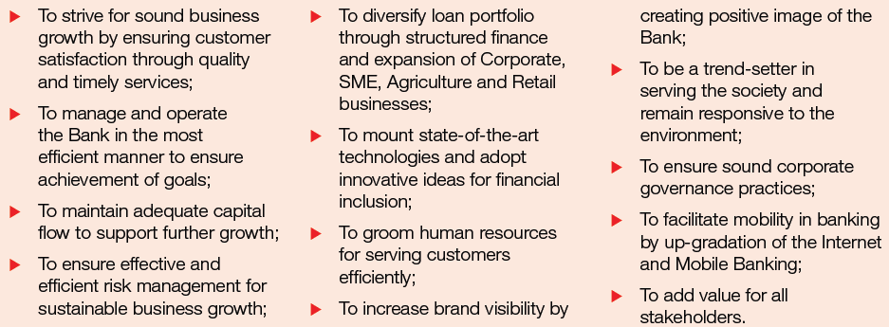
Figure 1: Strategic Priority of IFIC Bank

3.3 Mission
IFIC Bank’s Mission is to provide service to their clients with the assistance of a skilled and dedicated workforce whose inventive talents, innovative actions and competitive edge make their position exceptional in giving quality service to all institutions and individuals that they care for.

3.4 Vision
Vision of IFIC is to be the preferred financial service provider through innovative, sustainable and inclusive growth and deliver the best in class value to all stakeholders.

3.5 Core Values
Core values refer to the underlying basis upon which the employees perform their work and carry themselves within the organization. It basically is the essence of the entire organization and consists of all the values that an organization stands by. IFIC Bank relies upon its core values everyday in all the things that they do. IFIC Bank’s core values are mentioned in Figure: 2
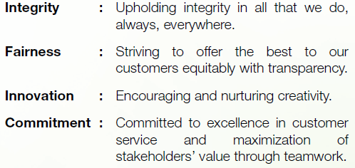

Figure 2: Core Values of IFIC Bank Ltd.

3.6 Corporate Culture of IFIC Bank Ltd
Corporate Culture basically indicates the company’s attitudes and behaviors that dictate how the employees and management deal with external business affairs. Corporate Culture is frequently implicit, i.e., it is not directly expressed and it evolves gradually from the accumulated attributes of the individuals that the company hires. An organization’s corporate culture is reflected in every aspect of its operations including dress code, employee compensation and benefits, recruitment and selection process, office hours, employees’ behavior with one another, behavior with clients, office arrangements etc. (Tarver, 2020).
IFIC Bank Ltd. has a remarkable corporate culture wherein the employees see themselves as a team who are working mutually towards the same goal of achieving the goals of the bank and its development. The advantages of a healthy corporate culture include higher productivity, increased revenue, and a healthier workforce that is dedicated to organizational success (S.Meier, 2020).

3.7 Organization Hierarchy
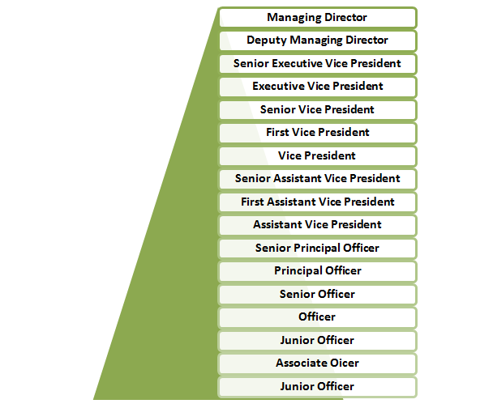

Figure 3: Organizational Hierarchy

3.8 Organogram of Lalmatia Branch
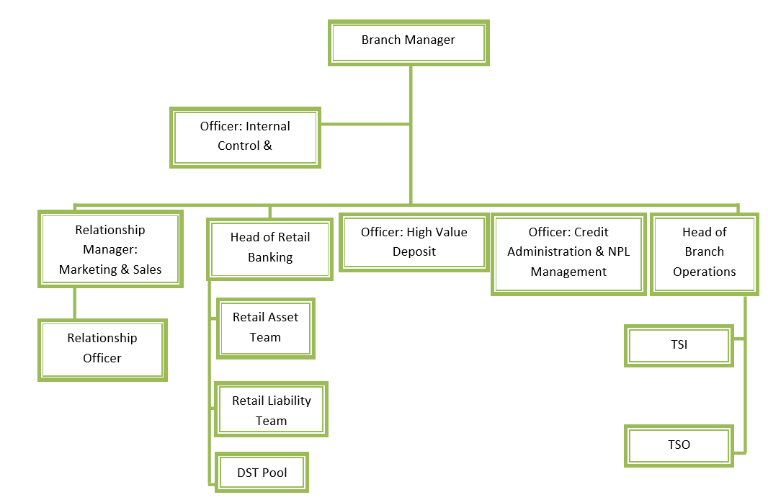
Figure 4: Organogram of IFIC Lalmatia Branch

3.9 Product & Service Information

A. Deposit Product
- IFIC Aamar Account
- IFIC Shohoj Account
- Savings Bank Deposit
- Super Savings Plus (SSP)-More Money
- Sanchita-Female Savings Account
- Smart Savings Account
- Duranta-Savings Account for Students
- 10 Taka Savings Account
- Payroll Savings Account
- Special Notice Deposit (SND)
- Corporate Plus
- IFIC Aamar Bhobishawt
- Pensions Savings Scheme (PSS)
- Fixed Deposit
- Monthly Income Scheme (Protimash)
- Monthly Income Scheme (Arjon)
- Double Return Deposit Scheme (DRDS)
- School Savings Plan-A Plus
- Freedom- Flexi DPS
- Millionaire Dream Plan (MDP)
- PSS-Joma
B. Foreign Currency Deposit
- Foreign Currency Deposit (FCD)
- Resident Foreign Currency Deposit (RFCD)
- Non-Resident Foreign Currency Deposit (NFCD)

C. Loans/Finance
- IFIC Aamar Bari
- Salary Loan
- Auto Loan
- Personal Loan
- Secured Loan (Cash Collateral)
- IFIC Shohoj Loan

CHAPTER: 4

INTERNSHIP EXPERIENCE AT IFIC BANK LTD (LALMATIA BRANCH)

4.1 Internship Activity
I have worked as an intern at IFIC Bank Limited Lalmatia Branch from 18th of October till 14th of January. This 3-month internship program gave me the opportunity to gain knowledge about the real-world corporate environment and culture which will be valuable in shaping my career. I did not only learn about the Human Resource Practices of this bank, but also regarding the operations of the general banking department as most of my internship period was spent there and the loan department. Furthermore, combined with the usual desk works, I have learned a lot about how to deal with different issues, responding quickly to customers’ needs and queries, observing different customer behavior, how the employees’ behave in the organization and how it reflects on their work &, organizational behavior in general all of which helped me to gain practical banking experience.

4.2 Job Description and Responsibilities
- Calculate Key Performance Indicator, (Qualitative & Quantitative) of the employees in the Annual Performance Appraisal Form.
- Help customers to fill up the account opening form.
- Attending to customers’ queries.
- Hand over cheque book, debit card and PIN to customers.
- Maintain different types of register books.
- Receive inward and outward mails.

4.3 Learning Outcomes
- Allocating time effectively
- Adapting to a new environment
- Serving customers of different backgrounds
- Understanding workplace behavior and code of conduct
- Gained detailed idea about the human resource activities such as how they recruit individuals, how they train them, compensate them, appraise them etc.
- Developing individual responsibility
- Learning professionalism

CHAPTER: 5

HRM PRACTICES OF IFIC BANK LTD.

5.1 Human Resource Department of IFIC Bank Ltd
IFIC Bank gives credence to the fact that its people are the indispensable factor that leads them to the attainment of their goals and acknowledges their competence and expertise to devise their business development strategy. The three pillars that IFIC Bank’s HR Department believes are imperative to achieve long term sustainable growth is:
- People
- Process
- Technology
This is the reason why the HR division of IFIC Bank takes the initiative to construct a meritocracy based culture where everyone has a right to openly and frequently put forth their opinions and decisions are made based on those opinions that they deem as best and suitable. The recruitment team of the bank works relentlessly to attract people who imbibe qualities such as leadership skills, self motivation, quick decision making and initiation. They do everything in their power to turn their employees into responsible corporate citizens who constitute all the required skills and competencies. The HR department of IFIC Bank Ltd. supports and equips them with tools so that they can transcend with exceptional ingenuity and that is done through many varied employee engagement activities. IFIC Bank’s HR Department pays close attention to its employees’ employment experience in the organization through its Human Resource practices. (Human Resource Development (HRD)).

5.1.1 Human Resource Compliance at IFIC Bank Ltd.
For the sake of maintaining and conserving clarity and fair competitive conditions among the employees, IFIC Bank conforms to every pertinent human resource related rules & regulations. IFIC Bank makes sure it preserves HR compliance at every level of the organization. The bank encourages all of its employees to adhere to not only the HR policies of the bank, but also to the laws of Bangladesh and it does so through its various training programs. IFIC Bank has set up every HR policy that covers all the facets starting from recruitment to retirement. The bank also has a law which focuses on the quasi-judicial disciplinary activities for dealing with all sorts of misdemeanors committed by any delinquent employee.

5.2 Human Resource Planning of IFIC Bank Ltd
Human Resource Planning is the systematic and strategic method which is used in order to gain an understanding of two main concerns which is the present state of human resources within the organization and the second one is predicting the need for workforce in the future which in simple words translate to “Forecasting Demand” of employees. Both of these concerns are very significant since an organization needs to have a clear understanding of whether it is sufficiently equipped with the proper employees at present or do they need to recruit more and optimize the deployment of those employees in order to achieve the strategic business goals and react to the changes in market and the fluctuating environment of the business scenario in general. (Goddard, 2020).

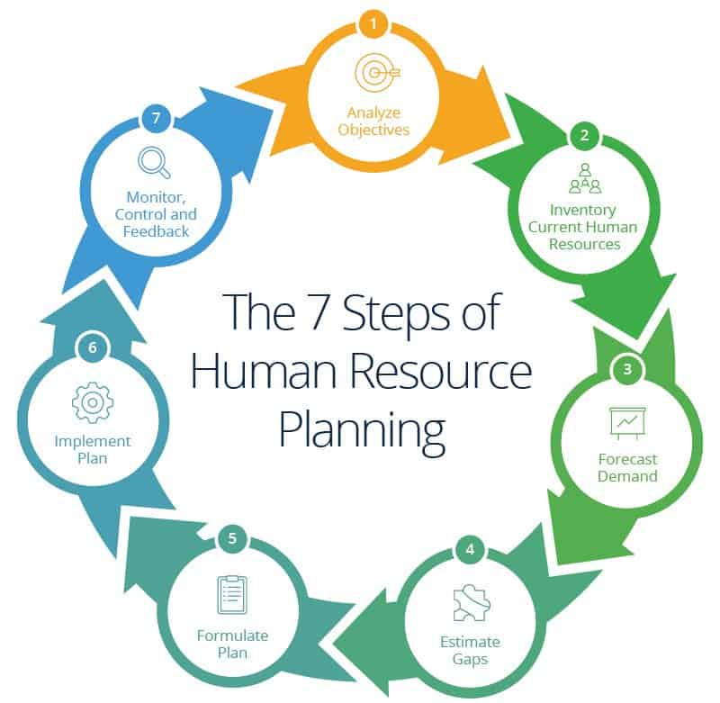
Figure 5: HR Planning of IFIC Bank Ltd

The main goal of IFIC Bank’s human resource planning is to make sure that the right people will be in the right position, at the right time by virtue of their individual attributes. IFIC Bank follows this 7-step process shown in Figure: 6
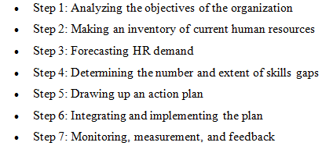
Figure 6: 7 step process of Human Resource Planning

Round the year, IFIC Bank circulates the internal job posting circular (IJPC) openly to all employees to fill up the vacant functional positions at the branches and departments/divisions/unit at head office through a transparent & merit-based placement process. One of the biggest advantages of internal job posting circular is that it provides a career development opportunity for the employees of the bank through upward mobility which in turn leads to an increased rate of employee retention within the organization.

5.2.1 Recruitment & Selection Process of IFIC Bank Ltd

Recruitment is the process of attracting qualified candidates for a job role and Selection is the process of identifying and selecting the right candidate for those jobs. The contributions of each employee play a fundamental role in the sustenance and development of a business. For this reason, it is tremendously vital to select the right person for the job. The impact to a business when they hire the wrong candidate is often much more than not hiring a person at all. In addition to being an operational activity, recruitment is also a key strategic movement for any organization (Empxtrack, 2013).
IFIC Bank focuses on recruiting self-motivated & potential young people through a multi-step merit-based recruitment and selection process.

5.2.1.1 Recruitment and Selection Procedure for Entry Level Positions

- Job Analysis
Job analysis contains the detailed information about the duties, key responsibilities, skills and knowledge that the job requires and expects an employee to have in order to work for them. Job analysis creates information which is needed to write job description and job specification. IFIC Bank conducts the job analysis process and with the help of it they write the job description.
- Job Description

A job description is a document that clearly states the essential job requirements, job duties, job responsibilities, and skills required to carry out a specific role (Better Team). IFIC Bank includes a job description in the job circulars. One such example of a job description of IFIC Bank for the position of Transaction Service Officer is as follows:
Figure 7: Job Description of IFIC Bank Ltd

- Job Circular
IFIC Bank puts out job circular of entry level positions in different places. The circulars can be seen on IFIC Career website, on apps like “BDjobs”, “Chakrir Khobor”, “LinkedIn” etc. and newspapers.

- Submission of CV
Interested candidates will drop their CV through online portals or sometimes even physically drop the CV.

- Initial Interview
After receiving all the CVs, people from the HR department screen those CVs. They then call the candidates who do meet the job requirements for the initial interview. Usually, the initial interviews were held face to face. However, because of the pandemic situation now, the initial panel interview is held on Zoom.

- Written Exam
After the initial interview session, candidates are to sit for a written exam which includes questions from Bengali, English & Mathematics to evaluate how good they are in these subjects.

- Computer Test
Candidates who do well in the written exams are then called/messaged/mailed to sit for the next step which is the computer test which will evaluate their computer literacy and to see whether the candidates possess the knowledge and ability to use computers and technology efficiently. (LaPlant) (http://www.csplacement.com/downloads/WhyComputerSkillsareImportant.pdf)

- Final Interview
Candidates who ace the computer test are then called for a final interview in the head office. Even though the final interview is held on the head office, candidates are seated in a separate room where they are connected on Zoom with the interview panelists as a precautionary measure due to covid-19.

- Appointment & Placement
After 2 to 3 days, candidates who got selected are mailed an appointment letter which will include information about where the employee should show up for work, the start date of the position, the expected work schedule, the compensation package details and few other documents which the employee has to thoroughly go through and sign and submit those on the joining day.

5.2.2 Transfer of Employees
Transfer of employees is also an integral part of human resource planning. It is the movement of an employee to a different branch; division/department and it can be either within the city the employee is already working in or outside of the city. Transfer helps the employees to learn how to work in a new environment, utilize their skills and talents in a branch/division/department which may not have been performing so well and thus helping in increasing the overall productivity of that particular branch/division/department.
Objectives of Transfer:
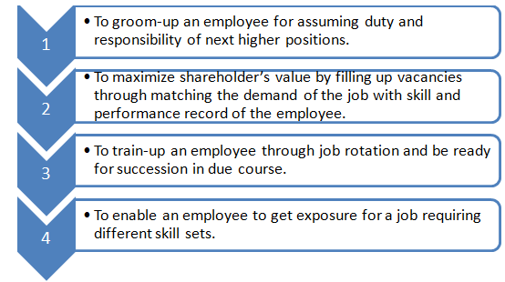
Figure 8: Objectives o Transfer of Employee
Administering Transfer
- When there is a vacancy in any functional position, the Human Resource Management Division may give an internal job posting announcement where content, job requirement and dimension shall be mentioned explicitly.
- Selection committee will evaluate employees’ skill set and relevant experience to perform the job of that vacant position and will give recommendation for the best suitable candidate.
- If no suitable employee is found against the internal job announcement for vacancy, the HRM division will transfer an employee at that vacant position for greater interest of the bank, as deemed appropriate or will go for external recruitment with approval from appropriate level of authority.

5.3 Training & Development
Training and Development is a subsystem of an organization which focuses on the development of the performance of employees. Training is an educational process which involves the sharpening of skills, concepts, changing of attitude and gaining more knowledge to develop the performance of the employees. With the help of efficient and high quality training programs, employees can gain and develop more skills and knowledge that the job requires them to have, which in due course helps a company improve (MBA Skool Team, 2020).
In order to enable employees to acquire and develop knowledge and skills and keep pace with the ever changing globe, all members/staff of IFIC are provided with appropriate and advanced training. IFIC Bank arranges customized training for its employees depending on the employees’ roles and duties in the organization and in addition to that, to ensure that the compliance policies, compliance culture, rules, core values of the organization are understood by all employees at every level of the organization, IFIC Bank arranges basic training courses which only imparts knowledge about these matters. This is done so that all the employees fully comprehend what the organization is all about, the values that it stands by, how the employees are expected to behave within the premises of the organization and their attitude towards their work. Therefore, training programs not only offer the employees’ with knowledge and skills that they need to do their work, but also creates in them a shared understanding that they all need to have the same vision of achieving the goals of the bank to be able to enjoy organizational success

5.3.1 Brief History about IFIC Bank’s Training & Development Program
IFIC Bank believes in continuous development of its employees so that they can be always prepared for changes in the extremely competitive industry. Therefore, the training and development plans of IFIC ceaselessly invest in inclusive training plan to create greater understanding of roles and responsibilities within them. IFIC Bank not only emphasizes in core banking skills of employees, but also boosts up their soft skills and leadership capabilities. IFIC Bank arranges training programs to fulfill regulatory requirements and nominates its employees to the training programs organized by local institutes.
Being one of the oldest training institutes in the private sector, IFIC Bank Training Academy is well resourced with the best materials to cater to the skill and knowledge development needs of its employees and they do so by making the best in class trainers offer their training services. Not only that, IFIC Bank frequently practices sending their deserving employees in the best training institutions to countries outside Bangladesh. (IFIC Bank Limited).

5.3.2 Training and Development Process of IFIC Bank
IFIC Bank follows the training process given in the figure below:
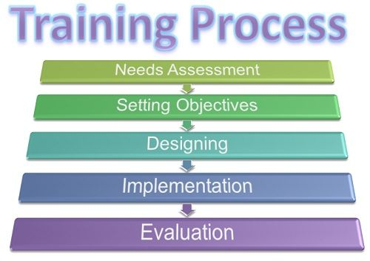
Figure 9: Training Process followed by IFIC Bank Ltd.
  - Needs Assessment: This is the first step where IFIC Bank Ltd. assesses whether its employees need training or not. The supervisor observes whether there is any gap between employee’s actual performance and the performance that is expected of him/her. This is mainly done after appraising the employee’s performance which determines which topics the employee needs training on, the mode of training, whether it is on the job or off the job and lastly, where to organize the training, e.g. In house/External/Local/Foreign)

  - Setting Objectives: Once it has been assessed that the employee needs training, the supervisor’s next step will be to set objectives for why the training is to take place. The objectives could be set on the basis of skill gap, which is basically the skills that is required of the employee but the employee does not possess it (Business Jargons).

  - Designing: In this step, the organization ensures that the training program is designed in such a way that it is in line with the set objectives. In this step, the organization designs how the training will be conducted, where it will take place, what is the scale of the training, who will be the trainee, number of trainees per session etc. Additional things that needs to be taken into consideration in this step is regarding the training contents, materials, notes, instruments and training requisites.

  - Implementation: After designing the training program, the next step is to put it into action, which is basically the actual training session taking place at the decided time and venue either in-house or outside the organization. It is important to take the training session in a very interactive way to keep the trainees’ attention fixed because an interactive training session helps the trainees to absorb information more conveniently.

  - Evaluation: After the training is done, the employees are asked to give their feedback on the training session. This is done to measure the effectiveness of the program. IFIC Bank invests a huge amount of money on each training program, therefore, it is a must to find out through the evaluation process, whether each trainee found the training program helpful or not so that it can determine the weak spots, if any, and rectify the next session. IFIC Bank uses the Kirkpatrick’s Four Level Training Evaluation Model
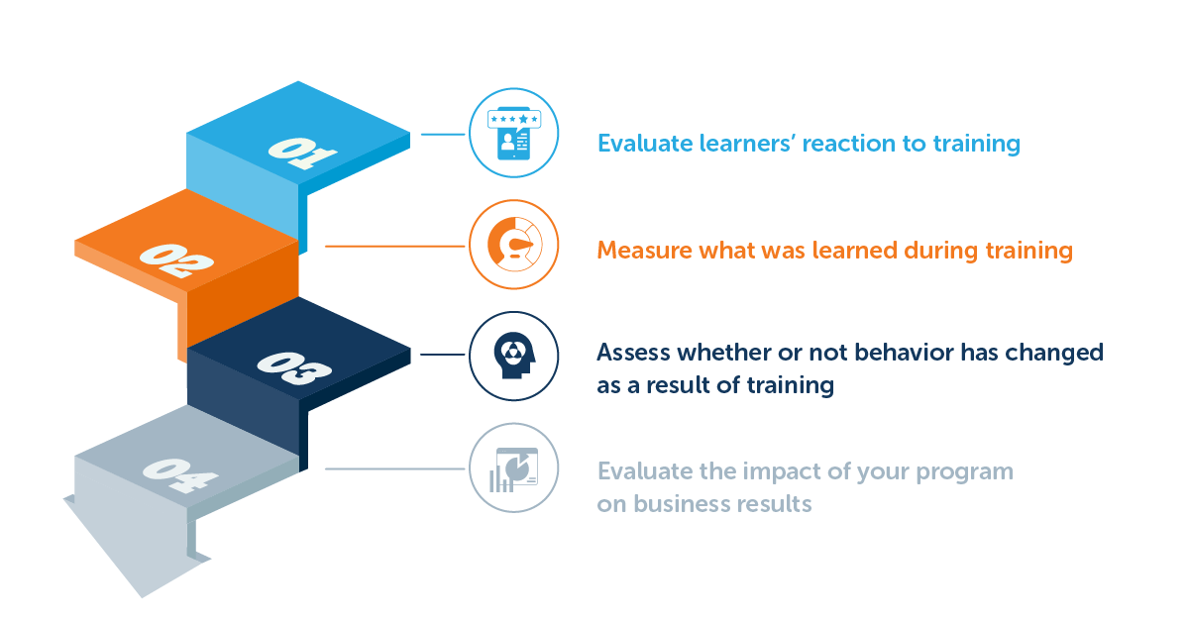
Figure 10: Evaluation Process of Training Program

Step 1- Evaluate Learners’ Reactions to Training: After the training, the trainer asks the trainees to complete a survey which consists of questions regarding their overall experience and satisfaction regarding the training session.
Step 2- Measure What Was Learned During Training: This measurement is done by the trainer where he/she assesses how much the knowledge already possessed by the trainee has changed in regards to the topics discussed in the training session pre training.
Step 3- Assess Whether or Not (and how much) Behavior Has Changed as a Result of Training: This is done through measuring behavior change through workplace observations.
Step 4- Evaluate the Impact of the Employee Training Program on Business Results: In this step, results such as productivity, workplace behavior, the depth of knowledge that the employees possess regarding the work that they are doing & efficiency are measured to gather an idea about how much, whether negatively or positively, the training session has impacted on the employees’ learning.

5.3.3 Training Techniques followed by IFIC Bank
- On the Job Training
- Off the Job Training
On the Job Training
IFIC Bank trains the newly recruited employees while they are conducting their day to day activities as part of their job. Types of “on the job training” include the following:
- Job Rotation
IFIC Bank practices job rotation among its employees where it makes the employee move from one job to another with the purpose of making the employee familiar and knowledgeable about the different tasks that are being carried out in different departments. (Business Jargons).
- Coaching & Mentoring
Another type of on the job training is Coaching & Mentoring which IFIC practices where the supervisor continuously gives his/her feedback and valuable judgment to the employee on how the employee is performing the tasks and suggests them to make changes in their working pattern whenever and wherever applicable. Constant coaching and mentoring as part of “on the job training” prevents the employee from making frequent errors in their work. (Naorem, D).
- Special Assignments
In this technique, employees are assigned a project which they have to work on either individually or as a team. The project will be related o the tasks that the employees conducts in his/her functional areas. This type of training is especially helpful when it comes to making the trainees understand that one should look at a situation from multiple perspectives rather than just using shortcuts to get to the point. Another advantage of this technique is that it makes each trainee work with others having diverse standpoints.

Off the Job Training
IFIC Bank also regularly conducts off the job training by highly experienced and skilled trainers wherein employees are trained at a site away from the actual work environment. It often utilizes lectures, case studies, role playing, simulation, etc. Employees who do exceedingly well in these training sessions are awarded with certificates, bonuses, and the chance to attend training sessions which are held outside of the country.
- Case Studies
Case studies are a written description of hypothetical situation. At the end of the case study there will be a question or multiple questions which requires the trainee to think deeply and devise strategies in order to solve the case study. The trainees can come up with multiple solutions and answers and after that the instructor will discuss all the pros and cons of the solutions/answers. This method is especially helpful in determining the trainees’ decision making abilities with data that is provided to them in a limited scale, in a short period of time. (whatishumanresource.com)
- Role Playing
In this method, the trainers assign two or more trainers with specific roles to play in a situation that is fictional yet connected to the training topic. Then and there, the trainees will have to act and play their roles without any help of any sort of pre written dialogue or script. This is done to have an understanding of how the trainee will actually be behaving had the situation been realistic. The role players have to speedily act in response to the situation and respond to it as they would in the genuine one. Basically in this process the trainees will be behaving or reacting realistically in a situation that is fictional.
- Classroom Lectures
This technique simply means that trainers will provide training to the trainees in the form of lectures within a classroom setting.
- Computer-Based Training (CBT)
Computer-Based Training (CBT) involves the use of a personal or networked computer for the delivery and access of training programs. CBT can be synchronous and asynchronous, as well as online, web-based, mobile, and distance learning (Training Industry). This method has been used by IFIC Bank Ltd. more in some training sessions recently due to the ongoing pandemic situation. Some training sessions are now held on a platform called “Zoom” where the training takes place online in the trainer’s and trainees’ personal computer/laptop/smartphone.

5.3.4 Some Major Training Providers of IFIC Bank Ltd
- IFIC Bank Training Institute
- BBTA (Bangladesh Bank Training Academy
- BIBM (Bangladesh Institute of Bank Management)
- Bangladesh Association of Banks (BAB) Research & Training Center
- Enterprise Transformation
- Malaysian Institute of Management (MIM)

5.3.5 Types of Training IFIC Bank provides
- In-house Training
- Core Banking Training
- Soft Skills Training
- Customized Training
- Local External Training
- Outreach Training and Abroad Training
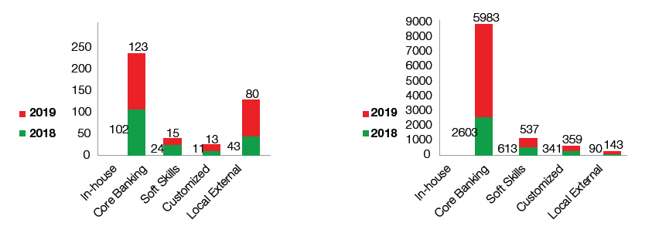
Figure 11: Number of Participants in the year 2018 & 2019

5.3.6 Training & Development Topics in IFIC Bank Ltd.
Training topics for new joiners
- Induction Course
- Basics of Banking
- Management Trainee Development Program.
- Credit Management
Other training topics include:
- Leadership Development
- Strategic Management
- Trade Processing
- Money Laundering Prevention Act, 2012
- Laundering (Amendment) Act, 2015
- Anti-terrorism Act, 2009
- Anti-terrorism (Amendment) Act, 2013
- Integrated Supervision System (ISS)
- Financial Crime Compliance Academy
- Land and Loan Documentation
- Gender Equality and Health Awareness
- Training on Digital Account Opening Form (AOF) & e-KYC
- Implementation Remittance Software
- Training on Fusion Banking Teller
- Training Program on Uposhakha (sub-branches) Operations
- Sales and Negotiation
- Leading Teams
- Team Building and Leadership
- Relationship Based Marketing

5.4 Performance Appraisal System in IFIC Bank Ltd.

Performance Appraisal aims to evaluate the performance of employees in a systematic way and to understand the abilities of a person for further growth and development (Juneja). The purpose of a performance appraisal is two-fold: It helps the organization to determine whether the employees are making valuable contributions and meeting the specific needs of the organizations and the second one is the employees making use of the evaluation to identify areas where they need to improve and develop themselves (Valamis, 2018).
The employees are given the annual performance appraisal form in which they will fill up the self-appraisal part following the general guideline mentioned. Appraisal Unit of the employees will be the place of posting. Appraisee is required to submit the duly filled up appraisal form to his/her supervisor within 02 (two) working days of receiving the form. Then the supervisor will fill up the form. While assessing employee performance, appraiser and appraise will have a one to one session about appraisee’s achievements and mutually agree thereon. Both appraise and appraiser are required to be objective in assessing individual KPI and match the incumbents’ performance with the description of six performance level mentioned in the “Overall Rating Scale” table. Before sending the score and form to HR, the appraiser will ensure that the appraisee is informed about the final score and rating. After that the Branch Manager/Head of Division will send employee-wise performance rating and marks using the prescribed excel format via E-mail to the HR Department within 05 (five) working days. If any employee disagrees with his/her appraiser regarding performance appraisal score, respective employee will intimate the issue with proper justification mentioning the facts and figure to HR Department.
IFIC Bank Ltd.’s performance appraisal system is a modern and effective one which is based on the theory of Management by Objectives (MBO). The Balanced Scorecard model is followed in administering each employee’s Key Performance Indicators (KPI) which has a direct impact on the overall business performance of IFIC Bank. The Balance scorecard model and KPI is used together because it greatly assists in aligning the performance of the employees with the goals of the bank. The KPIs help IFIC Bank Ltd. to determine if the entire organization is moving in the right direction or not.

5.4.1 Management by Objective (MBO)
As mentioned earlier, the performance appraisal system of IFIC Bank is based on MBO which is basically both the employee and management agreeing when it comes to interpreting objectives with the purpose of improving the performance of the overall organization. IFIC Bank believes that including its employees while setting objectives increases their commitment level and they feel appreciated since they are given the opportunity to have a say and it makes them feel that their opinion is valued. Thus, the individual employee’s goal becomes aligned with the goals of the bank (Hayes, 2020).

5.4.2 Balance Scorecard
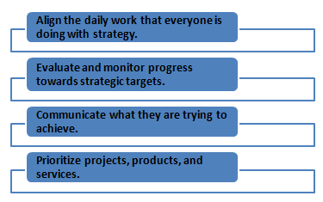
The balanced scorecard (BSC) is a strategic planning and management system. IFIC Bank uses BSCs to:
Figure 12: Reasons for Using Balance Scorecard

5.4.3 Performance Rating Scale of IFIC Bank Ltd
At IFIC Bank, the newly joined employees undergo basic training courses for three to four months from their joining and upon the participation in those training courses the newly recruited employees will be evaluated. Regular employees are appraised annually. For regular employees, the performance rating scale and rating point is as follows:

Overall Rating Scale
Performance Level | Definition | Rating Points
- Outstanding | Greatly exceeded expected level of performance & a role model. | 150% to 200%
- Very Good | Exceeded expected level of performance at all times. | 120% to below 150%
- Good | Met the expected level of performance all time & sometimes exceeded it. | 100% to below 120%
- Moderate | Met the expected level of performance most of the time. | 80% to below 100%
- Below Satisfactory | Failed to achieve the expected level of performance but sometimes achieved it. | 50% to below 80%
- Unacceptable | Failed to achieve the expected level of performance. | 0% to below 80%

Figure 13: Overall Rating Scale

5.4.4 Key Performance Indicator (KPI)
A Key Performance Indicator (KPI) is a measurable value that demonstrates how effectively a company is achieving key business objectives. Organizations use KPIs at multiple levels to evaluate their success at reaching targets. (Klipfolio, 2021). The two types of KPIs that IFIC Bank uses are Qualitative & Quantitative.

Point allocation:
TABLE-1 (FOR QUANTITATIVE KPI) | TABLE-2 (FOR QUANLITATIVE KPI)
Achievements Points Allocation  200% or more: 200% on the allocated point  : As per achievement percentage | Achievements Points Allocation  Outstanding: 150%-200% on the allocated point  Very Good: 120%-below 150% on the allocated point  Good: 100%-below 120% on the allocated point  Moderate: 80%-below 100% on the allocated point  Below Satisfactory: 50%-below 80% on the allocated point  Satisfactory: 0%-below 50% on the allocated point

Figure 14: Points Allocation.
- Quantitative KPI- These are KPIs that can be measured numerically (Shareholder’s Goal)
- Qualitative KPI- These are KPIs that cannot be measured numerically (Leadership & Teamwork)
The Quantitative KPI, which is the shareholder’s goal, will be marked out of 80 points. The Qualitative KPI, which is leadership & teamwork, will be marked out of 20 points. This makes a total of 100 points. Based on these points, the appraiser has to give an overall performance rating to each employee.

5.4.5 Performance Justification for “Outstanding” & “Very Good” Performers
The appraiser must give justification for the appraisee evaluated as “Outstanding” or “Very Good”. The appraiser must justify his/her performance with one or more distinguishable and noteworthy achievements, applicable for the relevant part, i.e. “Shareholder’s Goal” & “Leadership & Teamwork” during the appraisal year. Additionally, the following will have to be ensured fore “Share Holder’s Goal”:
- S(he) must make long term value addition to the business by acting as a game changer within his/her scope.
- Such value additions could be in various forms, i.e. Process Reengineering/Improvement, Cost Rationalization or Revenue Enhancement, Control Mechanism Improvement.

5.4.6 Counseling for Weak Performers
IFIC makes sure that they leave no stone unturned when it comes to helping the weak performers. That is why; they provide them with counseling in an attempt to give them an opportunity where they can improve their performance. The counseling is essentially intended to help direct the employee onto a successful performance. Failure to make immediate improvement after the counseling could result in reprimand. The counseling is given for one or more of the following reasons:
- Attendance
- Behavior/Teamwork
- Insubordination/Inappropriate Conduct
- Inappropriate Dress
- Safety Violation
- Substandard Work
- Habitual Violation of the Organizational Rules & Regulations
- Failure in Business Target or Job Assignment Completion
After the specific reason(s) for counseling has been identified, the supervisor/manager then writes in details about the employee’s Business Objectives/KPIs/Incident Description & Timeline and provide him/her with multiple guidelines to overcome his/her shortcomings on the specific areas mentioned.
Lastly, the employee also has to leave a comment on whether he/she agrees with the entire counseling in general or not.

5.4.7 Compliance
Compliance denotes behavior that conforms to the rules and regulations of the bank and the ability to meet specific performance standards. Any non-compliance (related to KPI, Code of Conduct, Incident, etc.) will negatively impact Performance Appraisal; the appraisee will be negatively marked. This is shown as a separate segment in the annual performance appraisal form; the HR Department has decided to make this change from the year 2020 and onwards.

5.4.8 Implication of Performance Appraisal
Performance appraisal system generates feedback about employees’ performance annually which is used in making further decisions about what to do with the employee. In simple words, if the employee is categorized as a strong performer he/she will be awarded, if the employee is a weak performer, he/she will have to face necessary consequences. The following implications of performance appraisal at IFIC Bank Ltd. are given below:
- It motivates strong performing employees to up hold their exemplary performance. Best performers get better pay, benefits packages, awards and bonuses.
- Employees that lag either don’t get any bonuses or get reprimanded for serious misconducts. Punishments include dismissal, termination, removable, warning fine, stoppage of promotion from the job.
- It acts as a steppingstone to a faster route to promotions for those who showed exemplary performance annually.
- It provides the employee with a structured process on how to approach the management regarding discussions, identifying issues, working on lacking and setting up both long- & short-term goals.
- The rewards and bonuses that the outstanding performers receive lead to higher employee engagement, increased productivity and better performance which in turn make the organization more successful financially.
- IFIC Bank uses data acquired from appraisals to design training programs that are well suited for each employee’s needs. This helps the employee to gather knowledge & learn skills in the relevant areas and thus, increases his/her probability of getting promoted in the company.

5.5 Compensation Policy
IFIC Bank Ltd offers attractive compensation package for their employees which is divided into two parts:

- Direct Compensation: Monetary compensation that an employee receives directly from his/her workplace.
- Base Pay: Employees receive monthly salary in the form of cash.
- Incentive Pay: Festival bonus, performance bonus, bonuses they receive upon fulfillment of target.
- Allowance: Employees of IFIC Bank receives house rent allowance, medical allowance, conveyance allowance and other allowances.

- Indirect Compensation: Benefit to the employee that doesn't come in the form of cash.
- Protection Programs: Health Insurance Scheme, emergency medical services to its employees, Life Insurance.
- Pay for time not worked: Includes vacation, annual leave, holiday, sick leave, study leave, extraordinary leave, and maternity leave.
- Long Term Service Benefits: As a part of long-term service benefits, Long Term Service Benefits include Provident Fund, Gratuity Fund, Earned Leave Encashment all of which is provided as per IFIC Bank’s compensation & benefits policy as well as Bangladesh Labor Law.
- Other Benefits: Staff House Building Loan, Car Purchase Finance Scheme, Salary Overdraft & Staff Salary Loan.

5.5.1 Bonus & Benefits
- Performance Bonus: A performance-based bonus is an extra compensation granted to an employee as a reward for reaching pre-established goals and benchmarks or for doing exceptionally well in the annual performance appraisal.
- Festival Bonus: Employees are entitled to receive 2 festival bonuses per year on the occasions of Eid-Ul-Azha and Eid-Ul-Fitr and employees of different religion gets that bonus during their respective religious festivals. Employees in IFIC Bank Ltd. also get another bonus which is the “Pohela Baishakh” (Bengali New Year) bonus; it is 20% of their basic salary.
- Provident Fund (PF): A provident fund (PF) is a compulsory, government-managed retirement savings scheme wherein both the employee and the employer make equal contribute to the scheme and the employee can avail the lump sum amount with interest on retirement. At IFIC Bank, 10% of basic salary is contributed by the employer and the employee (total 20% contributed by both) in the employee’s monthly salary scheme. Even though this is a payment received in the form of cash, the mere nature of it tends to put it in the indirect compensation category. The PF is deducted from the gross salary.
- Gratuity Fund: Gratuity is a sum of money paid by an employer to an employee for services rendered in the company when the employee is going to retire. IFIC Bank has given it to regular and permanent employees who have completed at least 10 years of continuous service. The calculation of Gratuity Fund is as follows:
Gratuity Fund= Last month’s basic salary x Number of years completed in the organization
- Earned Leave Encashment (EFE): IFIC offers this benefit; it is the encashment of accumulated leave which can be availed by an employee at the time of retirement, during the continuation of service or at the time of leaving the job.

5.5.2 Allowances
All the allowances are exempt from income tax.
- House Rent Allowance (HRA): IFIC Bank offers house rent allowance to its employees as per Bangladesh Law which is 50% of basic salary.
- Medical Allowance: Medical allowance is provided to IFIC Bank employees as 10% of their basic salary.
- Conveyance Allowance: IFIC Bank provides conveyance allowance to its employees which are basically the cost of transportation from their residence to workplace. This is a fixed amount.

5.5.3 Calculation of Net Salary

Net Salary= Gross Salary (Basic Salary+ HRA+ Medical Allowance+ Conveyance Allowance+ Other Allowance) – Gross Deductions (PF employee and employer contribution+ Income Tax)

5.5.4 Health & Work Life Balance
Having a healthy work life balance enables employees to stay sustainably engaged which ultimately leads to higher productivity in work. As IFIC Bank cares for the well being of its employees, it has made sure that all of its branches and the Head Office is equipped with modern safety measures. The Bank periodically arranges well-being programs for its employees with the assistance of external experts. Employees of IFIC Bank do not only get medical insurance facilities for themselves, but their family members can also avail it now. They have a very well-organized Leave Management Program so that they can maintain a healthy balance between work and personal life.

5.5.5 Leave Management
IFIC Bank follows the below mentioned Leave Management Process which is the process of managing employee time-off requests in a fair, exact, and well-organized way. IFIC Bank Ltd. also ensures that they are following the Bangladesh Labor Law properly in regard to leave management.
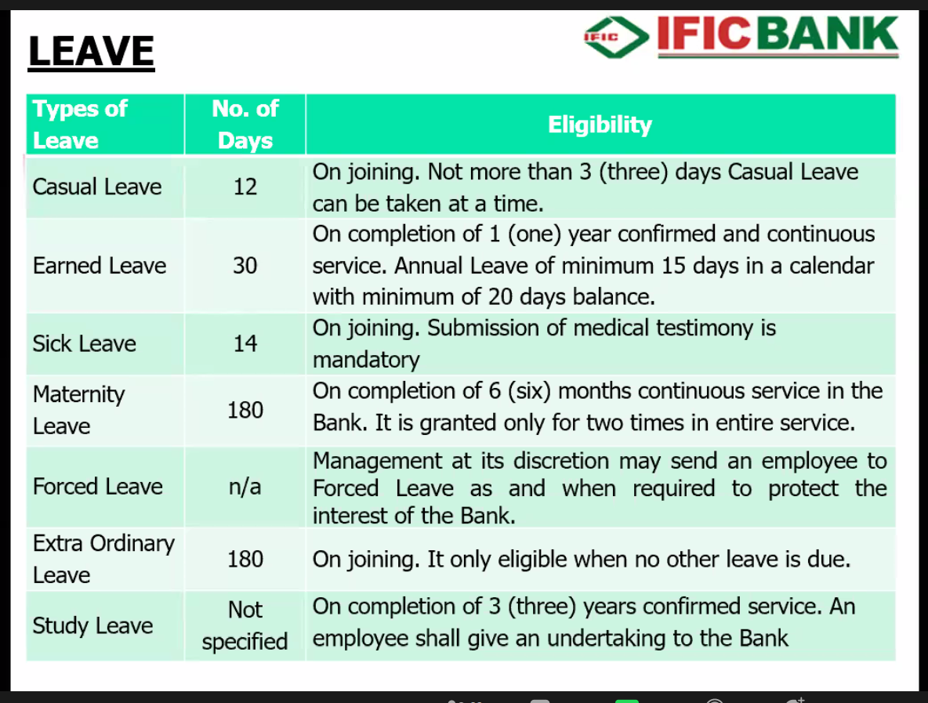
Figure 15: Leave Management of IFIC Bank Ltd
- Casual Leave: Casual Leaves are the ones which are provided for urgent or unpredicted matters to the employees.
- Earned Leave: This is basically annual leave or paid time off which is a minimum of 15 days a year and the employee who completed one year of continuous service may use it for whatever situation he/she wants.
- Sick Leave: This is a paid time off work where employees avail this leave when they need to address their health needs.
- Maternity Leave: IFIC Bank provides maternity leave of 180 days to pregnant women who have completed six months of continuous service in the bank.
- Forced Leave: This is a type of leave where the employee is required to go on leave for however many days the management deems as fit.
- Extraordinary Leave: This leave is granted under special circumstances and it is only qualified when no other leave is due and admissible.
- Study Leave: Leave of absence from work granted in order to allow an employee time to study or carry out research. The number of days in this case is not specified. This leave can only be availed by employees of IFIC Bank who completed 3 years of confirmed service.

5.6 Career Development in IFIC Bank Ltd
With the help of tools like training, education & developmental programs arranged by the organization, IFIC Bank Ltd. supports its employees to develop their career and guides them for a faster upward mobility in the organizational hierarchy. This is a systematic process and it is known as Career Development.
IFIC Bank Ltd. Bank puts high value on the development of the human resources which makes its people more competent, more industrious and motivated to reach to the top of the hierarchical position.
IFIC Bank Ltd. provides its employees with an attractive career development opportunity that focuses energy on helping employees develop and pursue a career path through a number of different ways which includes the best quality training programs, talent acquisition, talent development and succession planning, restructuring its organogram based on the volume of business, change of technology, automation of the process, business intricacy and functionality, and placing its employees at the right place. IFIC Bank has created a supportive environment where employees can reach their full potential. The Bank has developed a diverse workforce by implementing progressive human resource management policies through organizational and employee development, compensation & benefits policy, Human Resource Information System (HRIS) and the usage of modern day tools to measure performance of the employees. The bank’s human resource policy puts great emphasis on providing job satisfaction to its employees through growth opportunities and acknowledgement of the demonstration of exemplary performance throughout their work.

5.6.1 Process of Promotion in IFIC Bank

- In order to implement the promotion procedures of employees of the bank, the MD (Managing Director) of IFIC Bank has formed a committee known as the “PROMOTION COMMITTEE”.
- The “Promotion Committee” is given the responsibility of analyzing the employees who have been selected for potential promotion and they will assess whether the selected candidates are deserving of the new position or not. If the potential candidate has met all the requirements, an interview might be held at an appropriate time.
- After completion of all requirements and formalities of choosing the employee who has been selected for the promotion, the Committee will recommend the employee for promotion to the people in the HR Department who will take the final decision or the committee may reschedule the promotion for assessing the employee’s performance in the new position for a specific period until they are confident about their decision of promoting the employee.

5.6.2 Promotion Examination Criteria
The decision for promotion is based heavily on an employee's performance in their current position and whether they display readiness for a position with additional responsibilities. After that, the main way to determine their capability is through an examination which will reveal whether they are fit for the promotion or not.

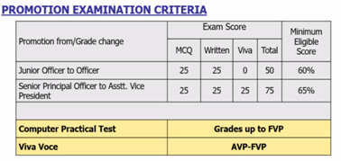
Figure 16: Promotion Exam Criteria of IFIC Bank Ltd

CHAPTER: 6

FINDINGS, RECOMMENDATIONS & CONCLUSION

6.1 Findings
- IFIC Bank has a well functional HR department
- IFIC Bank’s human resource planning is an effective one because this process helps them to meet the future demand of human resource in the organization as they always have contingency plans ready and can use them as soon as they are faced with a shortage of employees.
- IFIC Bank invests heavily on training and development programs. In addition to providing foundation training to its employees, IFIC Bank arranges the best, extensive training and development programs for its employees to ensure their employees remain the frontrunners in the field.
- IFIC Bank has an effective performance appraisal system which provides data about employee’s performance as consistent, reliable and valid.
- IFIC Bank has a competitive and attractive compensation package and several benefits which helps keep its employees motivated.
- IFIC Bank is a healthy organization which provides ample growth and development opportunities to its employees through its career development activities.

6.2 Recommendations
I have discussed regarding the human resource practices of IFIC Bank Ltd based on what I have learned during my internship period which includes the basic details of this bank and most importantly in depth discussion regarding the HR practices of the bank. In spite of the fact that the HRM Division of the bank centers all its decisions on making continuous efforts to develop its human resource practices, there are still some lacking that need to be overcome for much smoother functioning of the organization.
- Even though “transfer” is an important part of learning how to work in a new environment, IFIC Bank seems to do it more frequently than normal which in many cases, instead of being advantageous to the employee is de-motivating since relocating is a stressful and complicated process; this may result in reduced staff retention.
- IFIC Bank needs to take part in external recruitment efforts in career and job fairs held at University campuses as it will open them up to more young talents.
- IFIC Bank must incorporate a 360-degree performance appraisal system which is a multi-source feedback where employees, subordinates and supervisors will appraise each other. This will result in personal development, more self-awareness and enhance performance.
- IFIC Bank needs to invest more on good banking software because software issues experienced by the employees in the bank are an HR roadblock as it reduces staff productivity.
- Oftentimes, reaching the target seems to be the only best thing that a bank employee does in order to attain rewards and recognition, however IFIC Bank can create stretch goals which are goals set beyond the individual’s existing capability. If done correctly, it will motivate employees to push beyond their limitations and make major breakthroughs for the organization.

6.3 Conclusion
To sum up everything that has been stated so far, even though IFIC Bank’s HR department does put high magnitude on its human resource practices, my thoughts on the matter are that it would be even more rewarding if it were to take into consideration the abovementioned recommendations. IFIC Bank’s human resource planning which has a well-structured recruitment & selection process, state of the art training and developmental programs, rewards and compensation policy and other initiatives taken to develop their employees have generated excellent outcomes which is a testament to the success of the organization as a whole. However, I do believe IFIC Bank can reach even greater heights and better results if it follows the recommendations mentioned above.

Bibliography
Better Team. (n.d.). Job Descriptions. Retrieved from Better Team: https://www.betterteam.com/job-descriptions
Business Jargons. (n.d.). Job Rotation. Retrieved from Business Jargons: https://businessjargons.com/job-rotation.html
Business Jargons. (n.d.). Training Process. Retrieved from Business Jargons: https://businessjargons.com/training-process.html
Durai, P. (2010). Human resource management. New Delhi: Pearson education, New Delhi, India.
Empxtrack. (2013, June Tuesday). Recruitment and selection – The most important HR function. Retrieved from Empxtrack: https://empxtrack.com/blog/recruitment-and-selection-the-most-important-hr-function/
Gilmore, S., & Williams, S. (2009). Human resource management. Oxford University presses INC, New York.
Goddard, W. (2020, April Monday). Why Is Human Resource Planning Important? Retrieved from IT Chronicles: https://itchronicles.com/human-resources/why-is-human-resource-planning-important/
Hayes, A. (2020, December 27). Management by Objectives (MBO). Retrieved from Investopedia.com: https://www.investopedia.com/terms/m/management-by-objectives.asp
Human Resource Development (HRD). (n.d.). Retrieved from IFIC Bank: https://www.ificbank.com.bd/aboutus/human-resource-development-hrd
IFIC Bank. (2021). About Us. Retrieved from IFIC BANK: https://www.ificbank.com.bd/
IFIC Bank Limited. (n.d.). About Us: Human Resource Development (HRD). Retrieved from IFIC Bank Limited: https://www.ificbank.com.bd/aboutus/human-resource-development-hrd
Irshad, A. (2008). Problems and challenges in human resource management: A case of large organization in Pakistan. Journal of Commerce and Social Sciences, 1.
Juneja, P. (n.d.). Performance Appraisal. Retrieved from Management Study Guide: https://www.managementstudyguide.com/performance-appraisal.htm
Klipfolio. (2021). What is a KPI? Definition, Best-Practices, and Examples. Retrieved from Klipfolio.com: https://www.klipfolio.com/resources/articles/what-is-a-key-performance-indicator
Lamba, S., & Choudhary, N. (2013). HUMAN RESOURCE MANAGEMENT PRACTICES . IMPACT OF HRM PRACTICES ON ORGANIZATIONAL COMMITMENT OF EMPLOYEES .
LaPlant, K. (n.d.). Why Computer Skills Are Important. Retrieved from CS Placement: http://www.csplacement.com/downloads/WhyComputerSkillsareImportant.pdf
Legge, K. (1995). What is human resource management? Palgrave, London.
MBA Skool Team. (2020, May Friday). Training and Development. Retrieved from MBA Skool.com: https://www.mbaskool.com/business-concepts/human-resources-hr-terms/8685-training-and-development.html
Mehta, E. (2016). Literature Review on HR Practice in Banking Sector. International Research Journal of Engineering, IT and Scientific Research , https://www.researchgate.net/deref/http%3A%2F%2Fdx.doi.org%2F10.21744%2Firjeis.v2i7.149.
Mondy, R., & Mondy, J. (2014). Human resource management (Thirteen Edition). Global Edition, Pearson education Limited, Courier/Kendallville, United State of America.
Naorem, D. (n.d.). On the Job Training Methods. Retrieved from Economics Discussion: https://www.economicsdiscussion.net/job-training/on-the-job-training-methods/31626
Rani, L., Kumar, N., & Kumar, S. (2014). PERFORMANCE APPRAISALS RESEARCH: A STUDY OF PERFORMANCE APPRAISALS PRACTICES IN PRIVATE BANKS. National Monthly Refereed Journal of Research In Commerce & Management .
S.Meier, D. (2020, October). Small Business. Retrieved from Chron: https://smallbusiness.chron.com/importance-healthy-corporate-culture-20899.html
Tarver, E. (2020, July). Business Essentials. Retrieved from Investopedia: https://www.investopedia.com/terms/c/corporate-culture.asp
Training Industry. (n.d.). Computer-Based Training (CBT). Retrieved from Training Industry: https://trainingindustry.com/glossary/computer-based-training-cbt/
Valamis. (2018, October 24). Performance Appraisal. Retrieved from Valamis: https://www.valamis.com/hub/performance-appraisal
Werner, J., & DeSimone, R. (2009). Human resource development (Fifth Edition). International student edition, south-western Cengage Learning, USA.
whatishumanresource.com. (n.d.). Off-the-job training methods. Retrieved 02 03, 2021, from whatishumanresource.com: http://www.whatishumanresource.com/off-the-job-methods

Appendix
I have attached the performance appraisal form, employee counseling form and my appointment letter, joining report and work experience certificate.


Appointment Letter

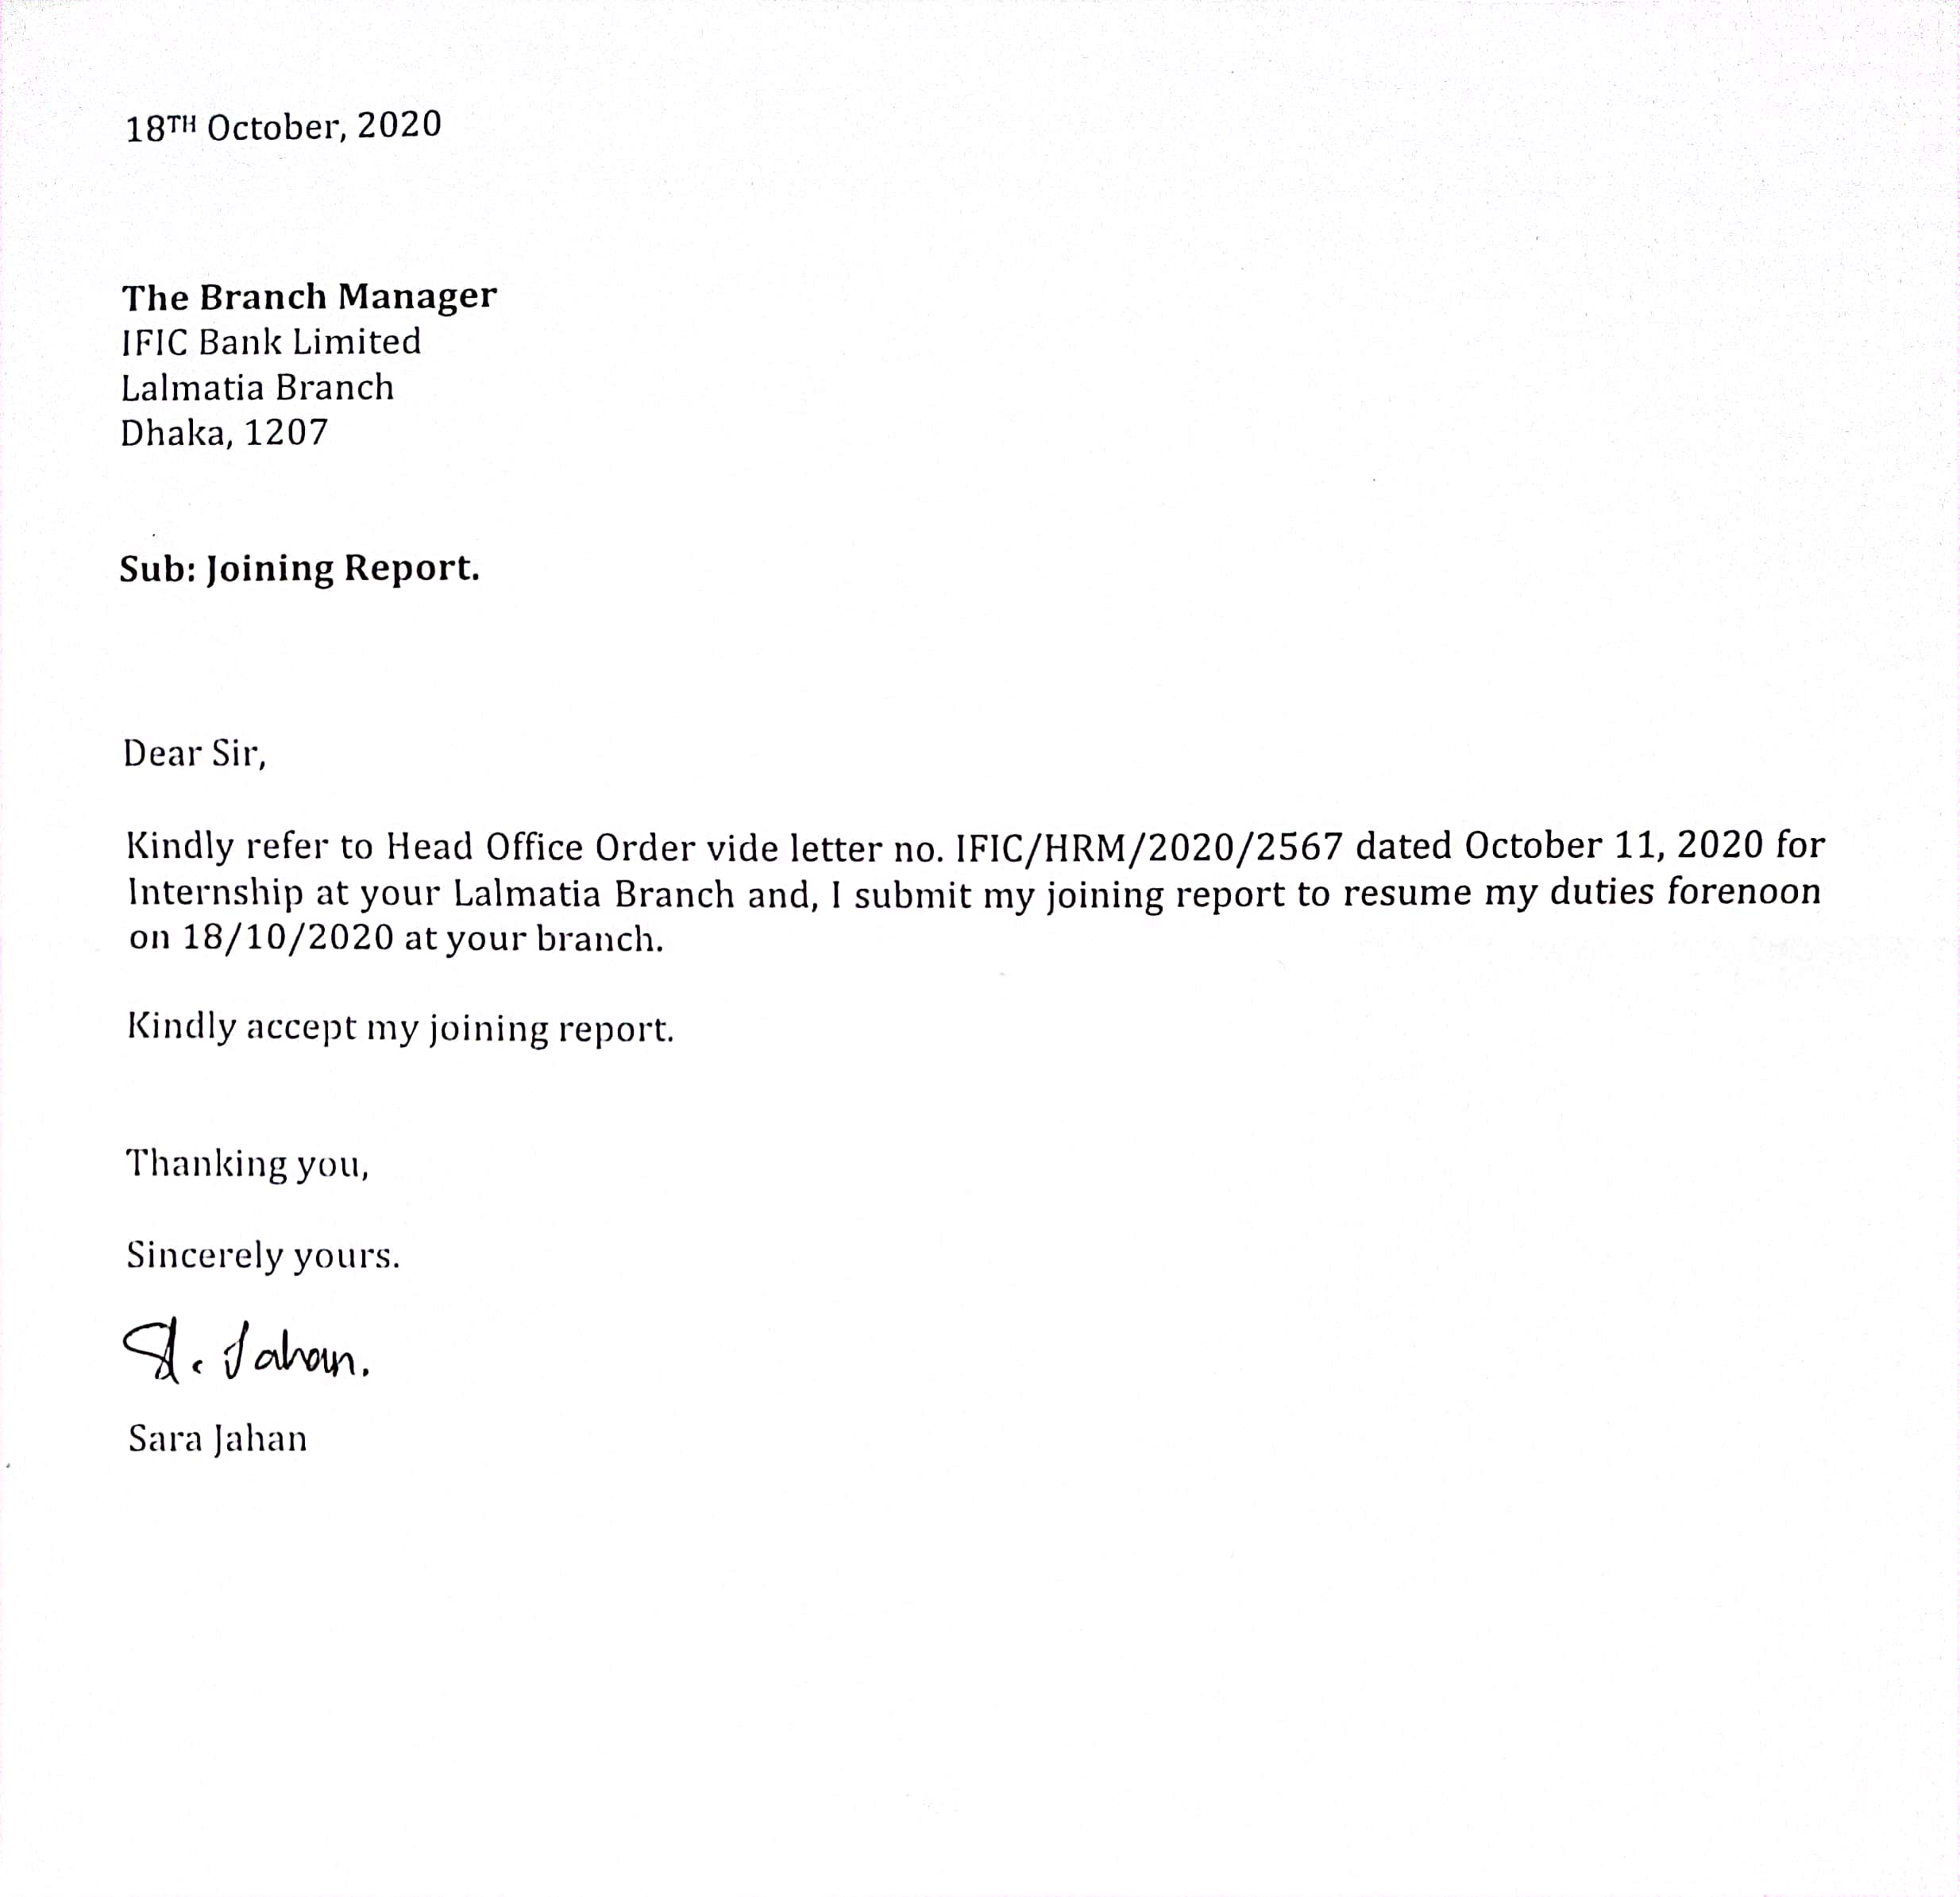
Joining Report


Work Experience Certificate


Employee Counseling Form at IFIC Bank Ltd.

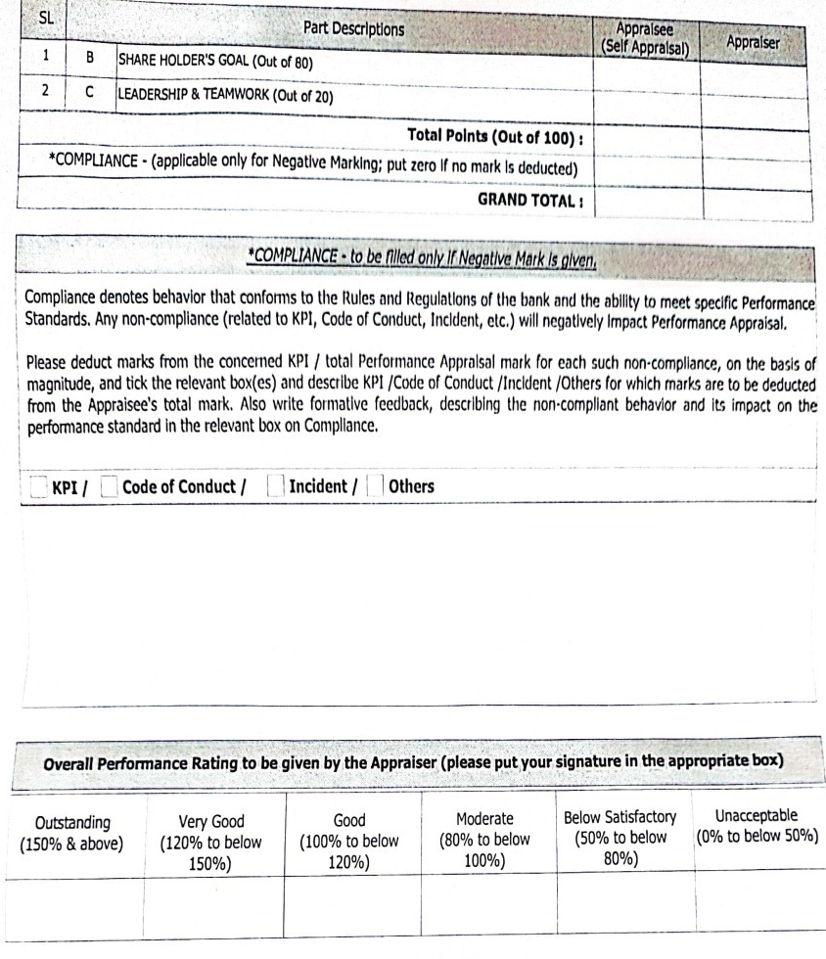
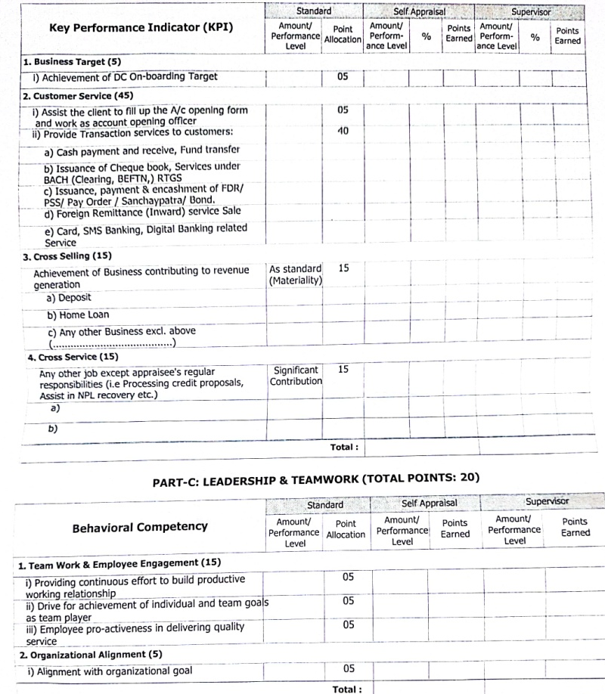

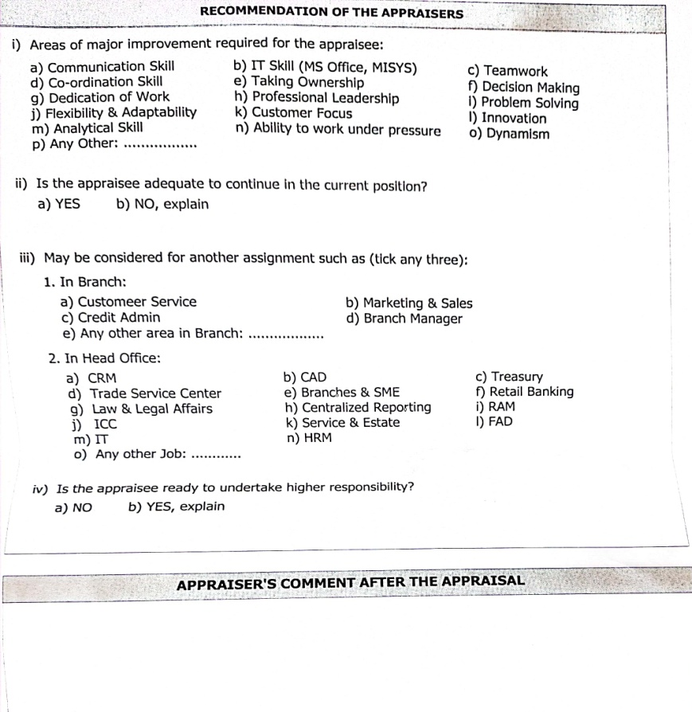
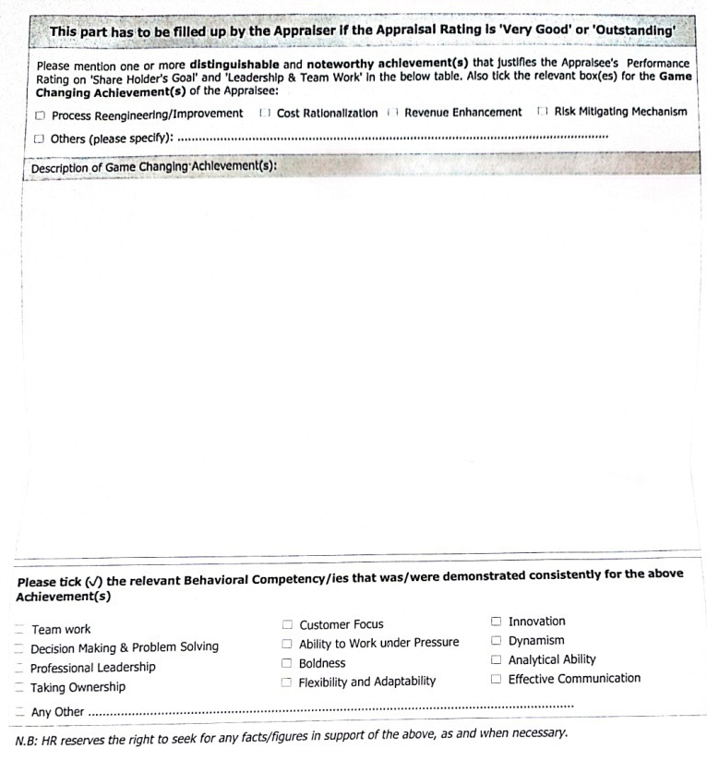

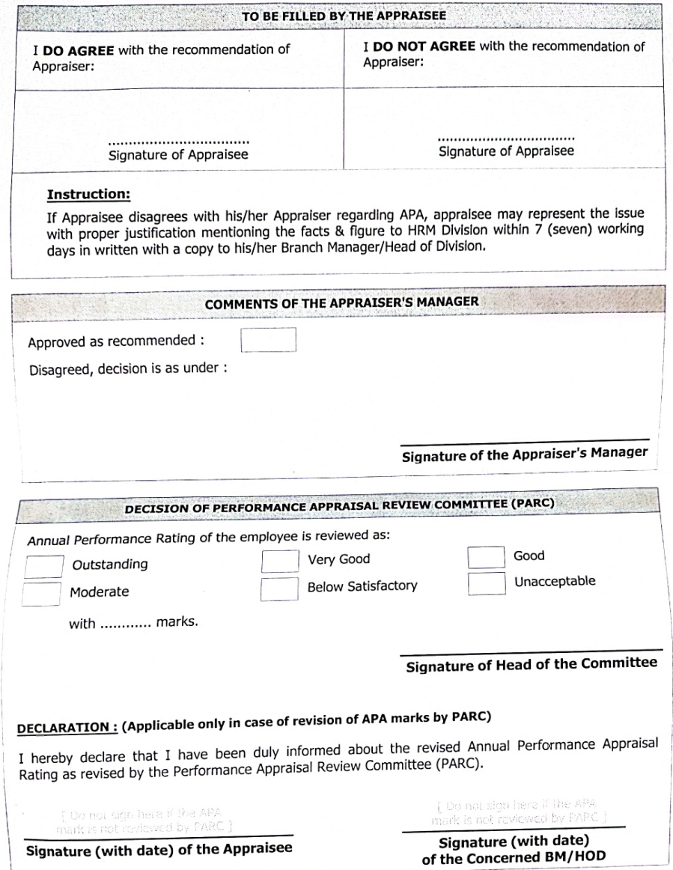
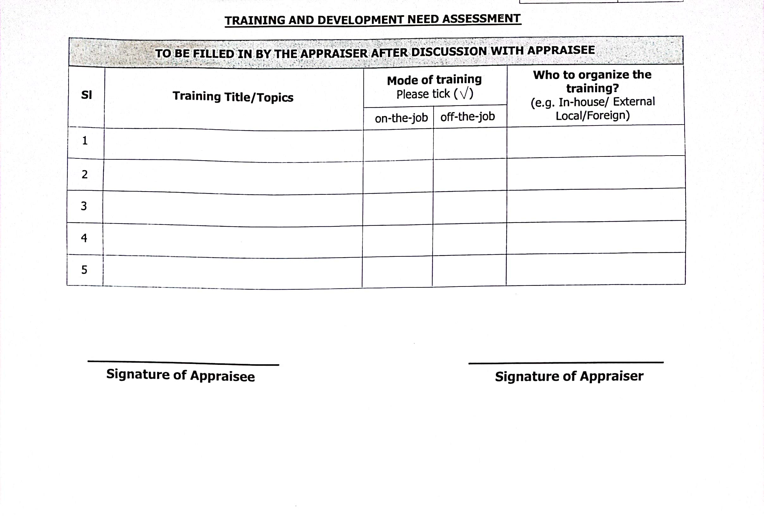

Annual Appraisal Form of IFIC Bank Ltd.

