

UNITED INTERNATIONAL UNIVERSITY

Internship Report on

Talent Acquisition and Talent Management Practices at Akij Resources Limited

Submitted To Ishrat Sultana Assistant Professor
School of Business & Economics United International University Submitted By
Mehreen Rahman ID: 111 172 056

Date of submission: 10th June, 2022

Letter of Transmittal

10th June, 2022 Ishrat Sultana Assistant Professor
School of Business and Economics United International University
Subject: Submission of internship report on ‘Talent Acquisition and Talent Management practices’ at Akij Resources Limited.

Dear Ma’am,

It is an immense pleasure for me to able to submit my internship report on “Akij Resources Limited”. This report was assigned to me as a requirement of my internship program. I have completed my 3 months internship program at Akij House. This program helped me gain real life experience of corporate world as well as Human Resources Management field.
I sincerely hope that you will be pleased with my work. I am open to any clarification on the report.

Thanking you, Mehreen Rahman 111 172 056

Acknowledgement

While preparing this report, I have been benefited from a number of sources. At first, I want to express my humble gratitude to my honorable faculty, Mrs. Ishrat Sultana. I am grateful to her for learning a lot of valuable insights regarding this report. Without her proper guidelines, supervision and valuable suggestions I couldn’t be able to prepare this report fruitfully.

Second, I want to express my gratitude to my mentors during my internship S.M Akramuzzaman (Senior Officer, HR) and Kazi Sumaiya Hossain (Senior Officer, HR). They helped me provide all the necessary information I needed to prepare this report.

Third, I want to express my gratitude to my office colleagues who cooperated and helped me throughout the time to learn.

Executive Summary

This report is the outcome of my three months internship program at Akij Resources Limited, Head Office. Throughout these three months, I have gained a lot of practical knowledge about corporate world besides Human Resource related activities.
The main objective of this report is to include a study of Talent Acquisition and Talent Management practices in Akij Resources Limited- Akij Group. Both primary and secondary sources have been used to accompany this study and prepare the report.
In the first part of this report, I have discussed some mainstream topics such as background, methodology, objective and limitations of the report.
In the second part, I have summarized many journals and articles regarding HRM functions and importance in my own language
In the third part, we have discussed the history, mission-vision, product-service details, values, core competencies of the company. From this part a person can easily get an idea about Akij Resources Ltd.
In the fourth part, I have discussed about the practices of Talent Acquisition (TA) and Talent Management (TM) and other HR functions of the company. TA team does one year manpower planning following the five years strategic business plan of the company. They follow two types evaluation while recruiting new employees. One is behavioral based evaluation and other is competency based evaluation. TM team evaluates its employees on a regular basis to determine which employees are the best. To find outstanding talent, follow these three steps- Talent mapping, Success profiling and Performance monitoring.
In the fifth part, I have analyzed the overall Talent Acquisition and Talent Management practices of the company. Thy follow a long-term HR strategy focused at meeting organizational objectives by attracting top talent and motivating them to contribute their unique abilities to the company. Their strategy is very structured and effective. Lastly, in sixth part, I have tried to draw a conclusion and give my recommendation for the company.

Table of Contents

Chapter 1.0: Introduction 7
  - Objective of the Study 8
    - Broad Objective 8
    - Specific Objectives 8
  - Methodology of the Study 9
  - Scopes and Limitations of the Study 9
Chapter 2.0: Literature Review 10
Chapter 3.0: Company Overview 18
  - Akij Group at a glance 18
  - Product and Service 19
  - Mission Statement 23
  - Vision Statement 23
  - Values 23
  - Core Competencies 23
  - Akij Brand 23
  - Akij Resources Limited's Management Process 24
  - Organogram 25
Chapter 4.0: Talent Acquisition and Talent Management practices in Akij Resources Limited 26
  - Talent Acquisition 26
    - Strategic Business Planning 26
    - Manpower Planning 26
    - Recruitment and Selection ……………………………………………………………….. 27
    - Induction 32
    - Management Trainee Officer Program (MTO) 37
  - Talent Management 37
    - Training & Development Programs for Talent Management 38
  - Other functions of HR of Akij Resources Limited 38
    - Training and Development 38
    - Performance Management System 41
    - Compensation and benefits 41
    - Compliance and Safety Management 42
  - HRM practice during Covid-19 pandemic 43
Chapter 5.0: Findings and Analysis 45
Chapter 6.0: Recommendation and Conclusion 47
  - Recommendation 47
  - Conclusion 48
Bibliography 49
Appendix 50

Chapter 1.0: Introduction


These days, education is now not only limited to books and classrooms. In today's world, education is the instrument for understanding the real world and applying knowledge to the improvement of both society and business. From education, the theoretical information is gained from courses of study, which is just half of the subject matter. Practical awareness has no substitute. Therefore, the Department of Business Administration of United International University provides an opportunity for its prospective BBA degree holders to obtain at least 3 months of practical experience, known as Internship Program. And a report is expected to be prepared to summarize the analysis, findings, and knowledge gained from this program by the intern.
This internship report is, therefore, a fundamental academic prerequisite for the completion of the BBA Program in the major area of Human Resources Management under the Department of Business Administration, United International University. The report title ‘Talent Acquisition & Talent Management Practices in Akij Resources Limited’ is based on a study conducted at Akij House, Head office, during the internship time. It includes, from the general corporate viewpoint, a concrete idea of the overall Talent Acquisition & Talent Management Practices. This topic is assigned by my supervisor and has to be submitted to both the department and the office.
The internship program is a partial graduation prerequisite. It offers a fantastic opportunity for every student to get some great and brilliant ideas about the practice field. The preparation of an Internship Report that improves academic skills as a successful graduate is also a daunting experience. As the corporate sector has emerged as the most important player in our economy and also provides a passionate career growth climate, it has been my primary aim to complete internships in this type of business institution since the very beginning of the BBA program.

I have worked as an intern at Akij Resources Limited (Akij House) for thirteen weeks from 1st November 2021 to 6th January 2022 in different wings of Human Resources Department according to their requirements.

1.1 Objective of the Study

1.1.1 Broad Objective
The main objective of this report is to analyze the Talent Acquisition & Talent Management Practices in Akij Resources Limited besides other Human Resources Functions.

1.1.2 Specific Objectives
      - To assess overall HRM functions of the company.
      - To assess the effectiveness of Talent Acquisition process in the Company.
      - To assess the effectiveness of Talent Management process in the Company.
      - To evaluate how company’s success is affected by the Talent Acquisition and Talent Management practices in Akij Resources Limited.

1.2 Methodology of the Study

To complete my report, I used two types of data sources. One is primary data & the other is secondary data.
For primary data, I haven a taken a detailed interview of one of my mentors at Akij Resources Ltd and collected all the necessary data I needed to prepare this report.
For secondary data, I have gone through the official website of Akij Resources Limited, previous research reports/articles/journals, different textbooks, and different data from internet.

1.3 Scopes and Limitations of the Study
The analysis was carried out from start to finish making it a complete and true one. Other colleagues and interns were also helpful in this regard. Most importantly, my reporting supervisor supported me in every possible way.
However, in the way of performing the analysis, several problems arose. The following limitations included in the study:
    - Information needed for a much more in-depth examination could not be acquired due to time constraints.
    - Organizations limit themselves to sharing their internal information much of the time. It was difficult to get all the necessary details to prepare the report.
    - Lack of experience in corporate life.

Chapter 2.0: Literature Review

Human resource management (HRM) is a set of organizational operations aimed at attracting, training, and retaining a productive workforce. Human resource management operates in a dynamic and constantly changing environment. The Human Resources Management (HRM) department does a variety of duties, including determining hiring needs and whether to go for contract employees or hire new employees to satisfy these needs, recruiting and training talents, assuring they are top performers and ensuring human and management procedures comply with various standards. Duties also involve managing approach to employee compensation and benefits, employee information, and recruitment policy. HRM is about managing an organization's people and processes in order to meet the organization's goals and strategies, along with the goals and demands of employees. An HR manager's primary responsibility is to properly delegate work among Human resource professionals and line management while integrating corporate operations and strategy across a wide range of cultures, products, and ideas. HRM must include the following roles and consequences of diverse workforce, legal constraints, performance appraisal, training, and professional growth of the organization, in addition to local employee difficulties.
HRM in the twenty-first century, according to Monody & Noe (2005), is a method that employs employees' abilities and expertise to accomplish organizational objectives. Similarly, Tzafrir et al. (2004) stated that it is the HR department's obligation to be more focused on employees' benefits and issues because they play a vital role in any organization's performance. HRM, according to Beardwell, Halden, and Claydon (2004), is described as the rules, regulations, and procedures that govern the level of employee engagement inside a company. The HRM section was known as "Personnel" in the 1970s, but as time passed and it grew to be known as "Personnel Management" between 1945 and 1979, it had an impact on employee legislation and administration.

Stephen Bach (2005:3) argues Managing Human Resources: Recruitment And selection in Transition that, compared to a decade earlier, much of the debate about the concept of HRM has faded away. He believes that this is due in part to the employment of a larger and more inclusive
definition of HRM. Bach (p.4), on the other hand, illustrates that the discussion is still going on by disputing with Boxall and Purcell's (2003:1) assertion that HRM refers to:
"... all operations related to the administration of the firm's employee relationship." Both the phrases 'employee relations' and 'labor management' shall be used interchangeably."
Bach claims that this description is "a little too wide," claiming that it is difficult to:

- Highlight any distinguishing characteristics or ideals that underpin HRM
- Highlight any distinguishing characteristics or ideals that underpin HRM
- Recognize the debate over human resource management.

HRM, according to Bach, varies from employee relations in that it focuses on management procedures and has a propensity to overlook employee interests. In fact, he maintains a number of 'hard' viewpoints on HRM:
HRM is focused on organizational effectiveness and is unitary (employer and employee interest must be aligned). Other stakeholders' interests, such as employees', are ignored. There is a strong focus on individual job satisfaction and motivation in the particular firm – specifically, within the company. As a result, external and collective (unionization) issues are downplayed. HRM in a Business Framework, 2nd Edition, examines the meaning and application of the word "human resource management," presents a variety of textbook definitions, and offers a proper definition for the journal:
'A people management philosophy based on the premise that human resources management are the most significant factor in long-term corporate performance. A business achieves a competitive advantage by successfully utilizing its people, relying on their skills and innovation

to achieve well defined goals. HRM aims to find and hire skilled, flexible, and devoted employees, as well as manage and reward their performance and build critical competencies.'
Human resource management has indeed been offered as a revolutionary replacement to people management consists of new, cutting-edge ideas that would replace personnel management's outdated and ineffective policies. The transformation, in reality, has been weak. The market for talented and qualified employees is fiercely competitive and costly. Adding new employees can cause problems for current employees. It also takes time for new employees to gain 'cultural awareness,' product/process/organization expertise, and experience.
HRM Impact: Then again, this is the argument provided by HRM models for prioritizing human resources over other resources. As probable explanations, the following were suggested:
- Inadequate research. Not due to a lack of effort, but rather due to a lack of defined, agreed-upon frameworks in which to do comparison analysis. The fundamental problem was thought to be HRM's own uncertainty.
- Intangibility. If humans are "intangible resource," we face an enormous obstacle: intangibles are, by definition, unquantifiable!
Since then, progress has been achieved in terms of defining the problem and assessing the outcomes. Short-term contracts, a lack of company commitment to job security, poor levels of training, and unskilled human resource practices, for example, were found to be negatively connected with corporate performance. They discovered a link between good business performance and 'high-road' work practices – 'high commitment' organizations or 'transformed' workplaces – in contrast. They also discovered that when HR practices are provided as a whole package, or 'bundle,' of practices, they are more likely to contribute to competitive success.
- Communication with employees via technology.
- Health-care costs are on the rise.
- Increased intellectual property vulnerability.

- Talent management.

- High-skilled workers are in higher demand than low-skilled workers.

- A labor shortage exists.

- Transition from a manufacturing-based economy to a service-based economy.

- The government's employment-related laws are becoming more stringent.
- Pay special attention to domestic safety and security.

- The ability to use technology to keep a better eye on staff.

These are American perspectives, although many of these phenomena are likely to resonate with practitioners in other nations. Although the HR function is obviously transitioning from "service provider" to "business partner," the demands and expectations of this new position can also be satisfied by line supervisors or contractors. As a result, for human resource managers, changing positions is both a huge opportunity and a huge threat. Although the HR function is obviously transitioning from "service provider" to "business partner," the requirements and needs of this new position can be handled by line managers or external providers. As a result, for human resource managers, the shift in responsibilities is both an opportunity and a threat. The future HR role will be very different from that of the past, and that organizations must realize this in order to maximize the value of intellectual workers and professionals. According to and strategic literature, intellectual capital, learning processes, and organizational agility are becoming more important. HRM specialists, they suggest, might play a key role since issues such as how to attract, engage, and develop individuals with scarce but vital skills, as well as building effective work organization processes, are critical in knowledge-based competitiveness.

Importance of Human Resource Management:

Prior to the mid-1960s, personnel departments were frequently seen as "health and happiness" staff in corporations. Prepare business picnics, schedule vacations, enroll employees in health- care coverage, and plan retirement celebrations were among their key responsibilities. During the last three decades, that has surely chanted. Employees must now comply with several new federal and state laws involving hiring and employment practices. Jobs have altered as well. They've become more technological, necessitating personnel with more skids. Furthermore, the lines between jobs are getting increasingly blurred. Previously, a person would work in a certain department, on specific fob risks with those who handled comparable fobs. Today's workers, on the other hand, are just as likely to find themselves on project teams among people from all throughout the company. Others may work from home for the majority of the day, rarely seeing their coworkers. Global competition has raised the necessity of organizations enhancing the efficiency of their workforce and searching the globe for the best-qualified workers, necessitating the hiring of HRM specialists with backgrounds in psychology, sociology, organizational and work design, and law.
Organizations must hire eligible candidates regardless of race, religion, sex, disability, color or origin, according to federal law, and someone must guarantee that this is done. Employees must be trained in order to function effectively inside the organization, and this must be overseen by someone. Furthermore, once an employee has been employed and trained, the company must provide for the individual's ongoing personal growth. Practices are required to make sure that these personnel continue to contribute to the organization's success. The work atmosphere must be designed to encourage employees to stay with the company while also attracting new applications. Of course, the "someones" we allude to are human resource specialists who are in charge of carting our activities around. Human resource experts are critical components of every organization's success today. A different level of understanding is required. Human resource management and employee personal development courses are based on workplace psychology ideas. Some courses are competency-based, and they teach practitioners how to assess and

develop individuals in the workplace. Courses like Time Management, Conflict Resolution and Stress Management to aid in the development of all employees. They also participate in team- building and motivational events, as well as skill development for people looking for work.
However, it also provides a new challenge for managers and supervisors, as they must comprehend and implement the new HR Management model, as well as acquire the required distinctions between traditional management and the emerging empowering style. This course is aimed to give any Manager or Supervisor some "real life skills" and "ideas" for becoming an empowered leader and establishing their credibility as a successful supervisor.
HR Planning
Human resource planning (HRP) is a continual process of systematic planning ahead to ensure that an organization's most important asset—best employees—is used to its full potential. Human resource planning guarantees the optimum fit between employees and employment while preventing human shortages and surpluses. HR Planning is a crucial strategy because it indicates capability gaps which might hamper successful execution. HR planning has been considered as a significant help in determining the areas where it should improve in order to become successful, as well as a means of developing a sharper focus of the function on the organization's business. HR planning is also riddled with inconsistencies in terms of employee rights. Manpower planning – as well as other long term methods for monitoring and adjusting the rise and fall of an organization's employees gave the employment contract more predictability and reduced transaction costs (cf. Marsden 1999 ).

Recruitment and Selection

The process of putting the right person in the right place at the right time is known as recruitment. It is vital to the success of an organization. Not only for the HR department, as well as for line managers that are becoming more involved in the hiring process, recruitment is a key task. Everyone involved in the recruitment process should be well-versed in the necessary skills and information (CIPD, 2014). Attracting, hiring, and keeping a skilled, devoted, and well- motivated workforce demands a significant amount of thought and resources. This is, without a doubt, one of the most essential HR tasks. Developing a job description, advertising job openings, screening applications, holding interview, making offers, and negotiating salary and benefits are all necessary steps in this process.

Training and Development

A learning and development strategy is an organizational strategy that identifies the workforce capabilities, competencies, or skills needed to ensure a long-term, successful business, as well as the methods for enhancing these capabilities (CIPD, 2014). Learning is a biological process that results in the ability to change performance and is linked to experience instead of development (Ribeaux & Poppleton, 1978). Intelligence is now commonly recognized as more than just a cognitive ability (see the hypothesis of multiple intelligences) (Gardner, 1985), and Emotional intelligence has gotten a lot of attention recently (Pickard, 1999). Learning is thus not only a cognitive process involving the symbolic integration of knowledge (just like in academic knowledge), but also an emotive and bodily activity (Binsted, 1980). Emotion, nerves, and muscle all play a role in the process.

Performance Appraisal Management

Performance evaluation is a procedure in which employees and those concerned with their performance, often line managers, participate in a discourse regarding their performance and development, as well as the support they require in their role. It's utilized to evaluate recent performance as well as focus on future goals, opportunities, and resources (CIPD, 2014). The performance evaluation is a discussion and evaluation of an employee's performance on specified tasks and responsibilities. The appraisal is based on the employee's performance in his job, not on the employee's personality traits. This procedure, also known as an annual review, performance appraisal, career development session, is used to document an employee's job performance.

Compensation and Benefits

If the company adapts innovative ways of giving benefits to employees, it is much more likely to succeed. Non-traditional incentives that might attract and keep new skilled workers include: (1) Flexible work schedules or workdays; (2) Prolonged paid holidays; (3) Paternity leaves; (4) Tuition assistance plan; and (5) Award and acknowledgement programs, (6) Training courses;
(7) corporate gymnasium membership discount; (8) Healthcare insurance; 9) Life insurance; 10) Disability insurance; (11) Pension; (12) Dismemberment insurance; (13) Leave transfer; (14) Healthcare coverage.

Compliance

HRM ensures that the organization complies with all labor, tax, and employment rules, which is critical to its survival. Noncompliance with hiring practices, workplace conditions, tax allowance, mandatory working hours, overtime, breaks, minimum pay, and discriminatory legislation can influence productivity and, eventually profitability of the company.
HRM's emergence in the twenty-first century has made it a priority to build excellent working relationships. It will boost HR productivity and performance while also assisting in the development of successful interpersonal interactions. Organizations gain a competitive advantage when they focus on HRM practices. These methods involve staff recruiting, selection, and encouragement in order to promote workplace diversity, manage knowledge and creativity, and put a greater emphasis on employee development and engagement. Solutions could be given by focusing on HR aspects that influence human resource in the twenty-first century. Competitive advantage can be gained and organizational productivity increased as a result of the dedicated and thoughtful approach utilized in HR management. Organizations are being encouraged to employ a variety of techniques in the framework of HRM, which, it is said, would increase company global competitiveness. As a result, organizational reform projects follow sequentially. Although practitioners and academics seem to agree that assessment is an important phase in any process of continuous improvement, the reality is that little has been accomplished

to examine the impact and level of success of each effort before organizations move forward. HRM today expects to add value to the strategic application for individuals, as well as the fact that employee initiatives have a measurable influence on the business. As a result, HRM's expanded position includes a variety of activities, strategic direction, and measurements to assess value.

Chapter 3.0: Company Overview

3.1 Akij Group at a glance
Akij Group is Bangladesh's one of the leading group of companies in Bangladesh. Textiles, tobacco, food and beverage, cement, ceramics, printing and packaging, medicines, consumer items, and other businesses are all part of this conglomerate.
Akij Group has five main business clusters. Those are Akij Holdings limited, Akij Assets Limited, Akij Insaf Limited, Akij Venture Limited, Akij Resources Limited. The main focus point of this report is Akij Resources Limited.
Akij Resources Limited. ARL is a brand-new business cluster that began operations in 2020 under the leadership of Sheikh Jashim Uddin, managing director of Akij Group. Akij Resources Limited is made up of five core business units: Akij Cement Company Ltd, Akij Shipping Lines Ltd, Bluepill Ltd., iBos, and Magnum Steel Industries Ltd, with a total workforce of over 3300 workers.

3.2 Product and Service

Akij Cement Company Limited

Akij Cement Company Limited is a company that manufactures cement. It was founded on November 3rd, 2002 by late Sheikh Akij Uddin, has gone a long way since then. ACCL employs over 1000 employees. They have factories in Nabigonj, Kadam Rasul, Bandar, and Narayangonj. Akij Cement Company can produce 9280 tons of cement per day.
    - Portland Composite Cement (PCC) CEM II/B-M: Superior grade cement based on fly ash free blast furnace iron slag, especially for strong and durable concrete in hostile environments.
    - Portland Composite Cement (PCC) CEM II/A-M: This type of cement is utilized in mass constructions such as huge piers, hefty abutments, and retaining walls because it contains more clinker and blast furnace iron slag.
    - Portland Cement (PC) CEM I: Portland cement is a general-purpose cement that contains more than 95 percent high-quality clinker and is utilized in a variety of applications such as high-rise buildings and bridges.
    - Akij Cement produces ready-mix concrete. Ready-mix concrete is made using the highest-quality raw ingredients, which are thoroughly evaluated in the plant's own laboratory before being allowed for usage.

Akij Shipping Lines Limited

Akij Shipping Line Limited was founded on September 9th, 2010, with a major concentration on dry bulk cargo transportation. ASLL has a total of ten active boats and about 750 employees. Akij Shipping Line Limited also has a branch in Singapore where they provide services.
    - SHIP OWNERS

    - CHARTERING
    - TECHNICAL MANAGEMENT
    - CREW MANAGEMENT
    - SHIP BROKERS
    - TRADING
    - SHIP AGENCY
    - COASTAL VESSEL

Magnum Steel Industries Limited

Magnum was founded in 2007 and specializes on three product segments. Magnum is now proudly affiliated with the Akij Group.
    - Mild Steel Billet: Magnum has its own world-class melting factory that produces high- quality, low-carbon Mild Steel Billets.
    - Magnum Supreme 500W: Magnum Steel offers its Supreme 500W, the highest grade of steel bars included in the Bangladesh Standards and Testing Institution's standards for steel bars for concrete reinforcement (BSTI).
    - Magnum 400: Magnum Steel also manufactures Magnum 400, which has minimum yield strength of 415 MPa (equivalent to 60,000 psi)

Blue Pill Limited

BLUE PILL LIMITED provides a wide range of services, including information technology, consulting, customer service and support and business process outsourcing. BPL's industry experience and well-cultivated offshore liaison(s) enables them to remain devoted to providing maximum value, high quality, and low-cost Business Processing and IT services to their potential clients. They have provided a broad spectrum of Outsourcing Services, IT

Services, and Solutions to businesses and industry leaders, both large and small, since their establishment in 2014. They provide the finest solutions for every department in their business. End-to-end solutions are part of the Business Process Outsourcing offering. They provide it all, and they do it in a way that is both customer-friendly and customizable.
    - Consulting
    - Analysis & Analytics
    - Cloud Infrastructure
    - Enterprise Application
    - Microsoft
    - Cognitive Business Operation
    - Automation & Industrial Engineering
    - Cloud app, Microservices, API
    - Cyber Security
    - Manage IT Service
    - Contact Center Services
    - Document Management Services
    - Digital Marketing
    - Reference Verification

iBOS Limited

iBOS Limited is a software firm and a subsidiary of AKIJ with extensive expertise in manufacturing ERP solutions, business process optimization, and web development. They identify themselves as issue solvers in the business world, providing comprehensive, integrated, and intelligent industry-specific business solutions.
    - iBOS HRM
    - iBOS Accounting

    - iBOS RTM
    - iBOS SME
    - iBOS Enterprise

Akij Essentials Limited

Akij Essentials Limited is a new business unit of Akij Resources Limited. AEL has food commodities such sugar, salt. oil, rice, atta, maida etc.
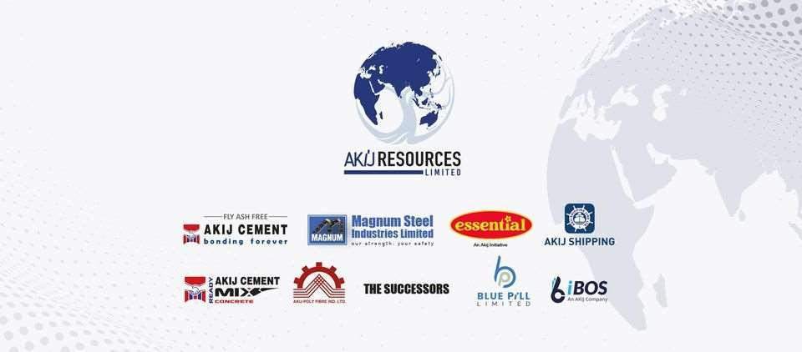

3.3 Mission Statement
„Ensure best quality products and services through continuous improvement that benefits society and environment‟

3.4 Vision Statement
„Be the benchmark of customer‟s choice‟

3.5 Values
- Customer Centric
- Positivity
- Ownership
- Innovative
- Teamwork

3.6 Core Competencies
- Process Orient
- Quality Focused
- Compliance
- Cost Efficiency
- Innovative

3.7 Akij Brand

Over the years, Akij has developed a strong brand image in the market. In this competitive era, when it is difficult to stand out with only one product, Akij focuses in producing the best in all fields. All of these businesses are consistently putting the brand in the lead. A company's vision is essentially a dream that the company seeks to achieve, whether it is practical or not. Akij is focussed on e xpanding the business internationally and becoming one of the worlds largest market leaders.

3.8 Akij Resources Limited's Management Process

In Akij Resources ltd, management is extremely centralized. Each employee reports to his/her immediate supervisor. Supervisors are supposed to lead and make decisions for them. All decisions are reviewed by the company's top management. Akij Group uses a multi-channel, cross-communication approach. The company's management normally conducts a conference every two months or on a fixed day to thoroughly analyze the current and near future scenario of the organization and its operations. To make quick decisions, all sister companies remain connected to the head office through the internet.

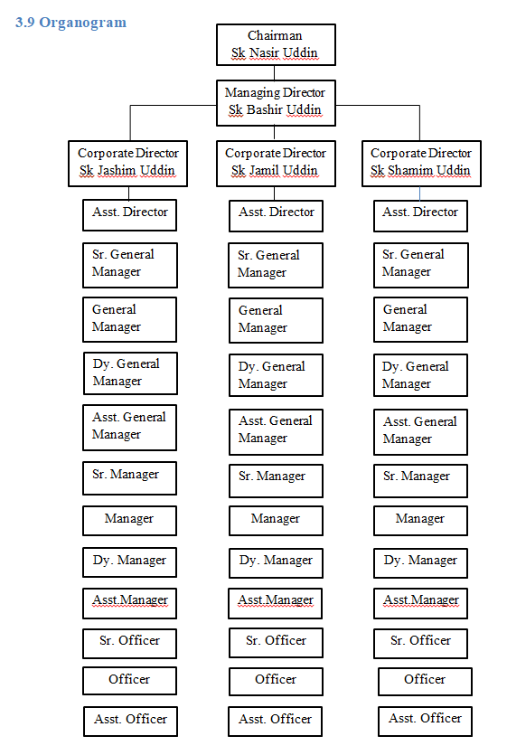

Chapter 4.0: Talent Acquisition and Talent Management practices in Akij Resources Limited

4.1 Talent Acquisition

Employers use talent acquisition to recruit, track, and interview job prospects, as well as onboard and train new workers. This is usually handled by the human resources department. Talent acquisition is generally considered as a strategic approach to the early phases of talent management, which is the process through which employers hire, deploy, train, and evaluate employees' performance and compensation. Finding and recruiting the right people is a vital part of a company's business plan, and it has a direct impact on its future performance. A company's productivity, decision-making, and motivation are all likely to suffer if it doesn't hire the right people. In a competitive market, such factors make it difficult for a company to remain sustainable.

4.1.1 Strategic Business Planning

Since Akij Group is divided into 5 business clusters so it has several units under each business clusters. Every unit strategy to conduct business is different. So each unit does long term strategic business planning. Akij Group does 5 years strategic business unit planning first. This includes what and how the strategies will be conducted within the next 5 years.

4.1.2 Manpower Planning

After reviewing the strategic planning for each business unit, Human Resource department does the manpower planning to meet the shortage of employees and replace an existing employee. When a department needs employees, they issue a Recruitment Requisition Form (RRF). The RRF needs to be signed by Head of HR and Chief Operating Officer. Then it gets updated at vacancy. HR department receives the recruitment requisition form from the department and

function head with proper job description and job specification. They prepare primary Job Advertisement based on Job Description and Job Specification. Then they send it to Organization Development to revise and finalize it with concerned department representative. After finalization, TA team posts the Job Ad on BD Jobs, Linkedin, Newspapers.

4.1.3 Recruitment and Selection
They receive a massive number of CVs after posting the job ad. TA team does initial CV screening from BD Jobs and career mail based on job requirements. Then they send the CVs to the department head for second screening. After the second screening by department head, TA team of HR department receives the CVs for final reviewing.
The finally selected CVs get interview call and message via phone. TA team arranges the interview session for the confirmed candidates and sends refreshment requisition mail to Admin department for candidates. Candidates (up to senior officer) have to sit for a written test first. TA team collects subject related questionnaire for written test from department head. They print questionnaire, cv and evaluation form.
There are two types of evaluation form. One is Behavioral-based evaluation form another is
Competency-based evaluation form.

Behavioral based evaluation form: Akij Group uses a behavioral-based interviewing approach to examine candidates' previous behavior in various situations in order to anticipate their future performance. It's simpler to forecast performance based on a candidate's prior performance than it is to assume. They use this technique for candidates up to senior officer position. They rate candidates from Poor(1) to Superior(5) based on customer centric, service orientation, ownership, pro-activeness, team work, job knowledge, positivity rating criteria. They note down candidate‟s strength area and area of improvement.

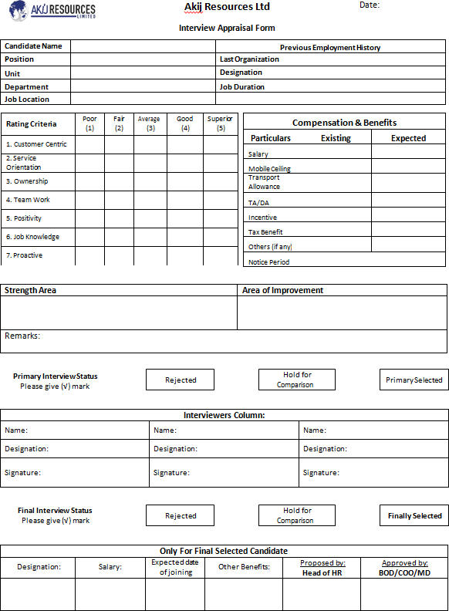

Competency based evaluation form: For candidates from Assistant Manager to above Akij Group uses competency-based evaluation approach. Competency interviews are conducted based on the abilities necessary to do the job. The notion here is that if you've used these talents previously, you'll be able to repeat them to the required standard. The interviewers look for the key indicators that indicate the competency's needs.
These are some examples of competency questions:
-Tell me about a moment when you helped a coworker who was having difficulty with a task.
-Please explain how you guarantee that you provide the finest possible customer service.
-Tell me about a time when you had to adjust to a change in your work environment.
In competency assessment, interviewees are being assessed based on some behavioral competencies such customer centric, service orientation, ownership, proactive-ness, team work, job knowledge, positivity, leadership abilities, achievement orientation, clarity of thoughts, analytical ability.

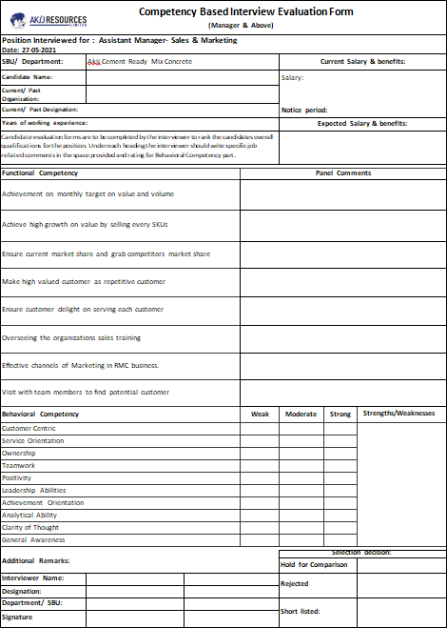

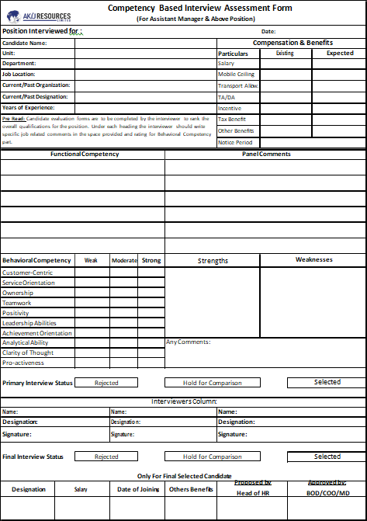

The selected candidates from first level interview get call and text for second level interview. TA team organize everything for interview board according to interview board matrix such as calling candidates, sending email to board members, preparing attendance sheet, booking room, printing out all the necessary documents. When the interview is done, they take sign and comment on evaluation form and finalize candidates for final interview.
Confirmed candidates from second level interview get call and text for final interview within one week. TA team confirms final interview schedule with COO, sends an interview invitation email to him and locks the time and date in calendar. On the day of final interview, they book room, arrange interview board, take signature from interview board members. The interview session gets closed when they select the final candidates for the vacant positions.
TA team collects salary information from concerned department for payroll. Then they call the finally selected candidates to negotiate within a week. If they agree, TA team sends offer letter via email. Then they take the evaluation form of the final candidates to the Head of HR to get signed. Before the date of joining of new employees, they prepare appointment letter and get it signed by the DGM of HR department.

4.1.4 Induction

On the day of induction, they prepare an induction list on excel sheet. When the new employees arrive at office, they take sign from them on the list. After that, they receive required documents from candidates with offer acceptance letter, verify all the documents (NID, Certificates, Clearance letter) to keep a personal file for each employee and finally handover them their appointment letter.
After all the formalities, a manager from training and development wing, give them a brief overview of the company and its rules and regulations.

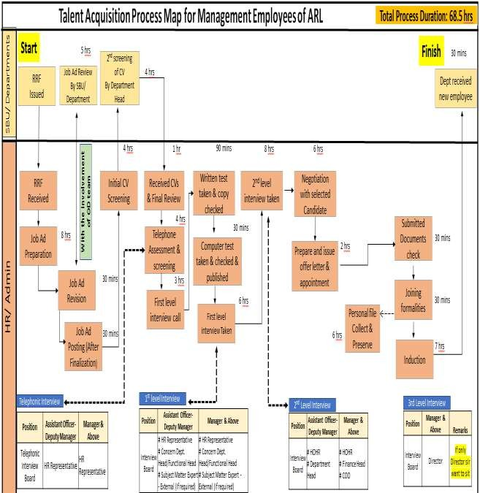

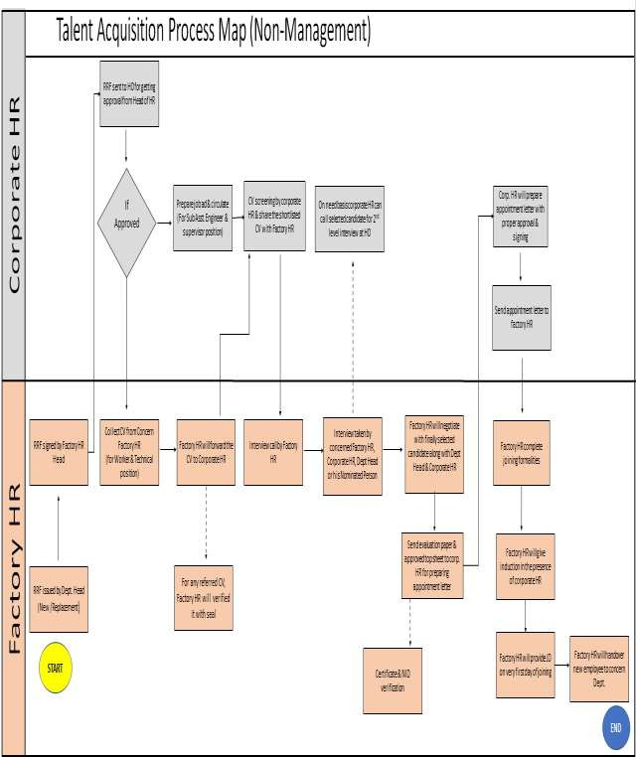

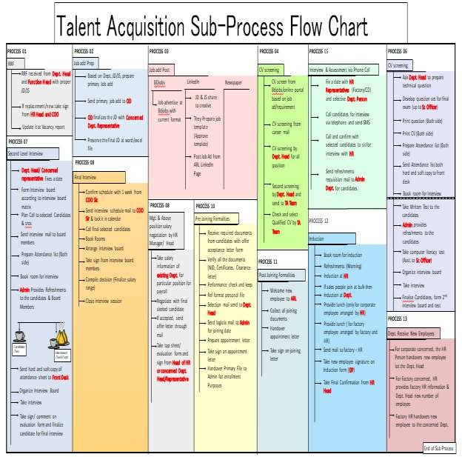

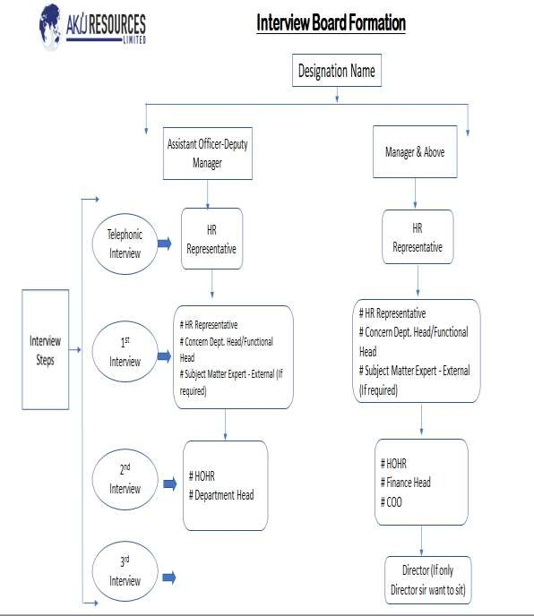

4.1.5 Management Trainee Officer Program (MTO)
The upcoming plan for hunting fresh talents is Management Trainee Program. They are looking for fresh graduates from different universities and departments for this MTO program. First one year will be probationary year. After that they will be assigned under a particular function.
The candidates will go through 3 levels of assessments:
- Written test
- Case solving and Presentation
- Interview

4.2 Talent Management

According to Akij Group, Talent management is the process of developing, inspiring, and engaging people to help them become better employees. It's all about human capital management. Every employee is seen as a potential talent. The goal of talent management adaptation is to aid the company's growth and achievement of its strategic goals and objectives. Akij Group also believes that this is necessary for the company's long-term sustainability and will aid the company in meeting future challenges. The goal also includes the capacity to cultivate the right people and drive the business in the long run. Its purpose is to maintain business continuity and leadership.
The talent management process, according to Akij Group, must be structured and organized and management support is a critical success component in managing talent. They're attempting to institutionalize the correct procedure, governance, structure, and technology throughout the organization. As a result, no matter who manages the organization, the talent management process may continue. Akij Group evaluates its employees on a regular basis to determine which employees are the best. To find outstanding talent, follow these three steps. The top 5% of the company's talent pool is considered high talent. Those with high capabilities, potential, and performance are considered top talents. The first 20% will have their potential and performance

evaluated before their numbers are reduced to 5% for all levels. The top 5% of the company's total talent pool are the top performers. High capabilities, high potential, and high performance are the characteristics of elite talents. Before their numbers are shaved down to 5% for the whole tiers, the first 20% will go through a potential and performance review. They created a success profile for significant positions in the organization, which includes the competences, experience, skill and knowledge that make a person competent in the job. Those who fit this profile among the top 5% will be recommended for the elite talent pool or succession planning pool. The growth of those who have been designated as outstanding performers is continuously monitored.

4.2.1 Training & Development Programs for Talent Management
Job rotation, role enhancement and mentoring are all part of Akij Group's talent management training and development program. Talents are alternated in terms of their roles, exposing them to different duties and allowing them to learn new things. They are also being taught by a coach who is in charge of their development, and their responsibility is being expanded in terms of teaching them new skills and knowledge.

4.3 Other functions of HR of Akij Resources Limited

4.3.1 Training and Development
The transmission of particular skills, abilities, and knowledge to an employee is referred to as training and development. As a result, Training and Development may be defined as an effort to improve present and future employee performance by boosting an employee's ability to perform through learning, typically by improving an employee's attitude or growing his or her skills and knowledge. Akij Resources Limited invests a significant amount of money on training and development. Each ARL employee goes through these training sessions in order to improve their performance on the job. Both new and existing employees participate in these training and development programs.

In-house Training: In-house training is done by Akij Resources Ltd's own trainer. This program includes job-specific as well as need-based training. It also includes an orientation program. This program is designed for both new and existing employees.
Induction Training: For new workers, ARL organizes an induction training session. This training program gives new employees a quick and accurate overview of the organization and familiarizes them with the company's culture. It also encourages communication between supervisors and newly recruited, as well as making new employees more adaptable and comfortable in their roles.
Evaluation: Evaluation after a training program is an important step. There are two types of evaluations:
- Training program evaluation: Akij Resources Limited's L&D division conducts training program evaluations to see if the training has had the desired result. It also assures if the participants are able to fully understand and apply what they have learned in the program
ARL uses the following six criteria to assess their training program:
  - The training helped me in carrying out my responsibilities.
  - Course material description, arrangement, and sequencing
  - The trainer's approach and training method were easy to understand.
  - Knowledge, presenting skills, and punctuality of the trainer
  - Would you recommend that your colleague attend the training?
  - Level of logistical and operational assistance

Training Evaluation Rating Scale:
  - Excellent = 5
  - Good = 4
  - Satisfactory = 3
  - Poor = 2
  - Very poor = 1

- Trainer evaluation: In addition to the assessment of training, Trainer assessment is also conducted by the L&D division. T the participants of that training program rate the trainers based on their training skills. They learn how successful trainers are in delivering to the participants through trainer assessment.
Akij Resources Limited evaluates trainers based on the following nine criteria:
  - Trainer's punctuality
  - The trainer encouraged audience to ask questions.
  - Trainer talked loudly and clearly.
  - During the session, the trainer was able to address questions.
  - Trainer was responsive and friendly.
  - The content presentation was interesting
  - Trainer was able to successfully manage his session time.
  - How would you rate the trainer's overall abilities?

Trainer Evaluation Rating Scale:
  - Excellent = 4
  - Good = 3
  - Moderate = 2
  - Poor = 1

4.3.2 Performance Management System

Performance management is important for keeping employees productive and motivated. Successful performance management requires effective leadership, specific goal, and honest feedback.
The annual performance review, in which the employee is evaluated by his or her supervisor, is one of the performance management techniques. It also includes 360-degree feedback techniques, in which the employee's performance is evaluated by colleagues, supervisors, subordinates, and sometimes customers. These sorts of tools can be quite useful in evaluating employees. After 6 months or 1 year of probationary period, employee performance gets evaluated. If the performance is satisfactory, the employee receives confirmation letter.
Managers and supervisors analyze employee performance and provide required feedback, as well as decide on future promotions, incentives, and compensation increases based on these evaluations.

4.3.3 Compensation and benefits

Compensation and benefits relate to the pay, monetary, and non-monetary benefits that an organization provides to its employees at work. It is a key tool used by Human Resource Managers to help individuals reach their full potential at work. Compensation and Benefits takes care of everything, from internal motivation to increased production. Compensation is an important part of Human Resource Management since it helps to improve the overall performance and effectiveness of the employees that work for the company. Every company's compensation strategy is at its core! Benefits obtained via settlement keep employees alive or maintain them for the long term in the company, just as heartbeat is one of the most important components for human existence. It generally encourages employees in a variety of hidden ways, boosting their desire to give it their all in order to win more and more incentives.

Akij Group provides both monetary and non-monetary compensation to its employees. Monetary compensations are:
- Provident Fund
- Gratuity
- Festive Bonus
- Profit Sharing
Non-monetary compensations are:
- Mobile Phone Reimbursement
- Public Recognition
- Promotion opportunities
- Traveling Allowance and Dearness Allowance

4.3.4 Compliance and Safety Management

Compliance and safety management is one of the most important aspects of corporate growth. It's tough to move forward without a safe and healthy team.
In Akij Group, Safety compliance management is a priority to achieve overall performance. They don‟t put aside workers safety issues. Compliance and safety management team makes sure all the labor laws are being followed by the organization to maintain a safe and healthy work environment for the employees. They arrange effective training programs for workers so that the workers can comply with safety rules. In those programs, they enlighten and aware the workers of everyday risks.

4.4 HRM practice during Covid-19 pandemic

The COVID-19 situation caused significant changes within organizations that were required to keep the organization's activities running. It has put our world into new territory. Some employees were laid off or requested to go on temporary layoff, while others have had their salary and remuneration reduced. Furthermore, bulk of surviving employees worked remotely from home. Many survivors were experiencing psychological difficulties and had no idea where the axe will fall next. Because of the requirement to follow COVID 19 standards of physical and social distance, human interactions remained suspended. The situation created by the COVID-19 epidemic created a long-term impact on employees' psychological well-being, produced anxiety for many and as a result employees’ performance was getting affected. Since employees are an organization's most valuable resource, the company must also look after their well-being. As a result, pandemic caused a significant challenge in HRM practices to reduce the COVID-19 pandemic's harmful effects on employees.
During the pandemic, all the work activities had been done online in Akij Group. Akij Resources Limited’s HR team was on the front line. They faced various challenges such as providing proper employee engagement and interaction, motivating employees, managing office hour. They tried their best to make employees' lives easier because they were not only responsible for managing business requirements, but also for understanding employee anxieties. HR team took action to assist and prioritize their employees' emotional and mental well-being. During work from home, there wasn’t any fixed working hour which was stressful to some extent. So, HR team arranged online training session on stress management besides other training sessions. They were engaged in a two-way discussion with employees to assist them release and express their isolation anxieties. Strong technological, institutional and human resource interventions were required to find a way to deal with these new realities. During the pandemic, HR team prioritized critical recruiting with a greater emphasis on digital hiring and onboarding. They used Zoom platform from taking interviews to onboarding them. Their online recruitment process was so efficient. It saved money and time for employees and employers both. Even after the pandemic, they still take online interviews in case of emergency and urgency. Performance management had been badly interrupted as a result of the COVID-19 pandemic. Employees rely on their
supervisors for guidance during the time of instability and transition and performance management is vital for communicating the company's strategic direction. Managers cannot provide employees accurate and relevant feedback to help them improve future performance unless they have access to performance data. So it was quite difficult to measure performance during pandemic. Employees received 100% of their salary for the first 3 months and after that they received 70% of their salary in lockdown.
The position of the HR manager has become even more important than ever in assuming the strategic role of guiding the company and its employees through these hard times and beyond. Human resource managers faced with the challenging challenge of diving into the "dark window" in order to help their employees overcome the uncertainties occurring in workplace. During pandemic employees confronted with issues that they may not have foreseen even before entering the firm. When people decide to enter a certain workplace, they generally evaluate the conditions that exist in the organization that are relevant to the job but COVID-19 has affected the normal operations of businesses. The ability to successfully detect, diagnose, and devise context-relevant actions to assist employees in navigating this phase of "living with the unexpected new reality" will go a long way toward ensuring the organization's long-term viability and reducing employee burnout. Those concerned in the work life balance and its relationship to overall quality of life have always been concerned about work-life balance. Its goal is to improve an employee's quality of life while also increasing workplace efficiency. Employees with work-life balance are more productive and innovative, whereas employees with a disrupted work-life balance are more likely to be depressed and unsatisfied. COVID-19 has significantly blurred the line between workers' social and professional lives, disrupting work-life balance and creating work-life conflict. One example is the need to hold business meetings via video platforms, which requires employees to prepare their background in ways that are appropriate for these zoom or video meetings. It was even more difficult for the employees with child or newborn. In these situations, the person had no control over who shouts or interferes during the live broadcast. Companies all across the world have been bound to ask workers to work from home due to the outbreak of the coronavirus. As the WFH culture spreads, so does the usage of video conferencing solutions to meet the evolving needs of employees. In such conditions, an employee's performance is largely determined by how he or she portrays individual task on online platforms, rather than the quality of the job itself. As a result, working smarter will become increasingly important to employees and employers in the future.

Chapter 5.0: Findings and Analysis

The purpose of this chapter is to summarize the findings, as well as to correlate the research findings with the study's objectives and to explain the conclusion drawn.

After analyzing the data from the interview taken, I have understood that having a strong talent acquisition strategy allows businesses to recruit the best potential employees and helps in improving company’s performance and growth. Akij Resources Ltd has a strong Talent Acquisition team. They follow a long-term HR strategy focused at meeting organizational objectives by attracting top talent and motivating them to contribute their unique abilities to the company. Their strategy is very structured and effective.

After onboarding the talents in the organization, they take some effective steps to retain these talents through Competency mapping, Assessment center, Succession planning and Leadership program. These programs help employees to be more productive and motivated towards the job.

Employees at Akij Resources Ltd. have a wide range of training opportunities. These trainings are also planned and conducted by some of the country's best trainers. These trainings are quite beneficial to the employees' learning. Participating in this training will help employees to learn and grow as professionals.

The performance of employees in Akij Resources Limited is very positive. Employees finishes work on time, employees are prepared to enhance the quality of service, employees are pleased to see the company's progress, employees are eager to work for the company, employees are able to assume the consequences of faulty work, employees display ingenuity by initiating new ideas to improve performance, employees know and appreciated the needs of customers, employees are able to fulfill the targets set and employees are experienced and therefore company can rely on them to perform tasks assigned. They can meet their KPI and work by targeting their KPI. Every employee has their own job description to perform their specific tasks. But the work environment is very outdated and rigid. Many professional employees have been working here since so long. They should be given more opportunities to get the best out of them. There are fewer female employees in most of the departments. The ratio should be 50:50. Females should be prioritized more in case of recruitment and promotion.

Akij Resources Limited has a healthy work environment. The company emphasizes on employee individual performance and leadership that is highly respected by employees. It makes every effort to please customers, has a specified organizational structure with roles and responsibilities, promotes the free flow of contact between superiors and subordinates, manages organizational dispute in a more professional matter, enforces beneficial human resource management practices, supports employee engagement, encourages innovation, engages workers in decision-making, facilitates professionalism in service provision and incorporates organizational goals.

Chapter 6.0: Recommendation and Conclusion

6.1 Recommendation

- Akij should move towards strategic HR approaches to cope up with the cultural changes all over the world. Cultural change is becoming a crying need so management should try their best to change their existing rigid and traditional culture. Work environment should be more flexible to increase employee engagement, productivity and retention. To make this process even faster I think people of new generation can make a huge difference with their new ideas. So, they should be given chance here.
- Use of modern technology in the office should be increased. Some of the employees are still not interested in using modern technology. By using modern technology they can do the work more efficiently.
- Talent Acquisition team must start using Automated Resume Screening software. It helps to organize all the resumes received which will save their time a lot as they will not need to screen from thousand resumes anymore.
- Their strategic planning should be stronger. They can use software to keep employee information- what kind of skilled employees they have and estimate future qualified employee requirements like other big companies.
- Authority should verify the identity of the person in the photograph that the candidates submitted with their resume when candidates appear for interview/written exam.
- The number of people working in HR is relatively low in comparison to the overall number of employees working in various departments. Akij should consider growing its HR department by hiring qualified and skilled HR personnel.
- The number of female employees is very low in every department. This huge gender gap should be filled by hiring more female employees in the organization.
- Interns should be given some sort of training that they can add in their CVs.
- Both male and female use the same washroom in Akij so there should be different washrooms for male and female employees since it is very awkward to share the same washroom.

6.2 Conclusion

Everyone is aware that reality differs significantly from what we have learned in our theory books. A person can only perceive and understand the world if he or she actively participates in the operations. The situation is the same in the internship. After being more connected with the organization's procedures and people, I was able to see many things that I couldn't see from just reading books. We can see from the above discussion that Akij Group Ltd. is one of Bangladesh's top groups of companies. It has a wide range of products and services in the market.

This report includes both the basic HRM practices and the organized talent acquisition and talent management practices of the company. According to Akij Resources Limited, Talent Acquisition and Talent Management is a key driver of organizational success and competitive advantage. They emphasize on finding the appropriate talent early in the recruitment process. They are able to keep their turnover rate below the industry average, but they are still having trouble retaining talent in the long run due to a lack of a competitive mechanism for maintaining and retaining talent. The culture of ARL allows for efficient and effective management of employees in the workforce. The popular path of making perfect use of resources in the same cultural association contributes to the organization's positive growth. They invest huge amount of money in employee training. These training opportunities are very much beneficial for employee self-development and the company as well. In every six months, employee performance in the organization get evaluated and based on the evaluation they get increment and bonus.
To sum up, the basic HRM and the organized talent acquisition and talent management practices in Akij Resources Ltd. is extremely efficient and effective but, then again, the organization's human resource management department must consistently contribute to look after this issue since coping up with today’s dynamic business environment is very challenging.

Bibliography

Retrieved from https://www.akij.net/. http://www.magnumbd.com/about/
Leading Cloud Based Software Solution | iBOS Limited. iBOS Limited. Retrieved from https://ibos.io/.
Retrieved from https://www.bluepill.com.bd/. Retrieved from https://www.akijcement.com/. Retrieved from https://www.akijshipping.com/
Aslam, H., Aslam, M., Ali, N. and Habib, B., 2014. Importance of Human Resource Management in 21st Century: A Theoretical Perspective. International Journal of Human Resource Studies, 3(3), p.87.
Taslim Ahammad, 2017. Personnel Management to Human Resource Management (HRM): How HRM Functions?. Journal of Modern Accounting and Auditing, 13(9).
John Attupuram, P., Sequeira, A. and Gopalakrishnan, S., 2015. Talent Acquisition Process in a Multinational Company: A Case Study. SSRN Electronic Journal,.
Ren, S. and Jackson, S., 2020. HRM institutional entrepreneurship for sustainable business organizations. Human Resource Management Review, 30(3), p.100691. https://www.emerald.com/insight/content/doi/10.1108/00483480610702692/full/html, 2006. Wei, L. and Lau, C., 2005. Market orientation, HRM importance and competency: determinants of strategic HRM in Chinese firms. The International Journal of Human Resource Management, 16(10), pp.1901-1918.
Hagan, C., 1996. The core competence organization: Implications for human resource practices. Human Resource Management Review, 6(2), pp.147-16

Appendix

Interview Questionnaire

- What are the steps of talent acquisition process in Akij Group?
- How does Akij Group do the strategic business planning?
- How does Akij Group do the manpower planning?
- How do you meet the shortage of employees?
- How do you conduct the recruitment process in case of replacing an employee?
- What would you do to make an effective onboarding process?
- What strategies would you use to retain more talent?
- What strategies would you use to attract more talent?
- How do you decide whether the talent acquisition job is successful or not?
- What are the steps of Talent Management in Akij Group?
- What is your upcoming plan for talent hunting?
- How did you conduct the Talent Acquisition process during the pandemic?
- How was experience with online recruiting?
- What are the recruitment sources of Akij Group?
- How did you conduct the recruitment process during Pandemic?
- How did you measure performance during Pandemic?
- What was the working hour during work pandemic?
- How did Akij Group conduct training and development sessions during pandemic?

