

INTERNSHIP TITLE
Retail banking of BRAC Bank Limited

Prepared by
Shahinur Akter Shimu
ID: 111 141 276
BBA, School of Business and Economics
United International University

Supervised by
Mr. Mohammad Tariq Hasan
Assistant Professor
School of Business and Economics
United International University

Date of Submission: 26th December2018.

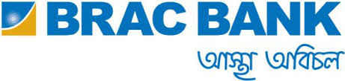

Internship Report

On

Retail Banking of BRAC Bank Limited


Letter of Acknowledgement

At the beginning I want to thank my almighty Allah, who made me capable to continue my everyday tasks in the workplace during the whole period of my internship program. I also like to express my sincere gratitude & appreciation to my advisor Mr.Mohammad Tariq Hasan Assistant professor, school of business and economics, United International University, who has been glad to give me right approach, guidance and support which helped me a lot in writing this report. I am grateful to him for his constant help and supervision, proposals and giving me important data that was especially required for the fulfillment of this report.
It was not the easiest task to complete the report on “Retail banking” where all the information need to be gathered properly, analyzed and represent in a descriptive manner. There are so many individuals who had helped, encouraged to complete the report successfully.
Then, I would like to express my sincere gratitude to, MR. ANOWAR JAHID, unit head of deposit division and MR. RUBLE KANTI BARUA, associate manager of deposit division for overseeing me throughout my time as an intern of Account Services department.
Last of all I want to thanks to all of my friends, my family and work colleagues who helped me giving guidance and provide adequate information for preparing this report.

Letter of Transmittal

26th December 2018
Mr.Mohammad Tariq Hasan
Assistant Professor
School of Business & Economics
United International University, Dhaka.

Subject: Submission of internship report on “Retail banking of BRAC Bank Ltd”.

Dear Sir,
I want to thank you for the directions and support you have given me over the span of this report. This would be difficult for me to finish. With profound appreciation, I would like to thank ANOWAR JAHID, unit head of deposit organization and RUBEL KANTI BARUA, associate manager of deposit organization for giving me supportive supervision during my internship period. I gathered data that I thought would serve to prove my points in this report. This practical information and experience assembled through my report planning will limitlessly help in my future.
I am truly grateful on the chance that you edify me with your consideration and perspective in regards to the report. Additionally, on the off chance that you wish to enquire about a part of my report, I would happily answer your questions. Much thank to you again for your help and tolerance.
Your Sincerely,
Shahinur Akter Shimu
ID: 111 141 276
Dept. : B.B.A

Letter of Endorsement

This is to clarify that SHAHINUR AKTER SHIMU a student of United International University has successfully complete her internship program entitled “Retail Banking of BRAC Bank Limited” at BRAC Bank Limited under my effective supervision as the partial completion for the program of BBA degree. She has established her process according to my guideline and active participation. She tried her level best to make this report informative and efficacious. I hope her hard work will assist her in pursuing a great career path in future.

______________________________

Mr.Mohammad Tariq Hasan
Assistant Professor
School of Business & Economics
United International University

Declaration

This is to inform that this report “Retail Banking of BRAC Bank Limited” has been prepared as a part of my internship program. It is a compulsory part of my Bachelor of Business Administration program to submit an internship report. I was inspired and instructed by my supervisor Mr. Mohammad Tariq Hasan, Assistant Professor, United International University.

______________________________

Shahinur Akter Shimu
ID: 111 141 276
United International University

 | Table of Contents
Chapters |  | Page Number
Chapter 1
 | Introduction | 1
1.1 | Background | 2
1.2 | Brief introduction of the organization | 2
1.3 | Objective of the report | 3
1.4 | Rationale of the study | 3
1.5 | Scope of the study | 4
1.6 | Limitation of the study | 4
Chapter 2
 | Methodology of the study | 6
2.1 | Methodology | 7
Chapter 3
 | Organizational Background and industry perspective | 9
3.1 | Banking industry scenario in Bangladesh | 10
3.2 | Objectives of a bank | 10
3.3 | Banker-Customer relationship | 11
3.4 | Over view of BRAC Bank Limited | 12
3.5 | Mission statement | 15
3.6 | Vision statement | 16
3.7 | Achievement and awards | 16
3.8 | Core objective | 16
3.9 | Focus of BRAC Bank | 17
3.10 | Strategies of BBL | 18
3.11 | Board of directors | 18
3.12 | Products and services of BBL | 19
3.13 | Retail banking | 20
3.14 | Retail products | 20
3.15 | Retail banking system | 21
3.16 | Segment of retail banking | 21
3.17 | Retail banking products | 23
3.18 | Card products | 30
3.19 | SWOT Analysis | 31
Chapter 4
 | Finding and analysis | 36
4.1 | Finding and analysis | 37
4.2 | Comparison with the banking industry | 37
Chapter 5
 | Recommendation and Conclusion | 40
5.1 | Recommendation | 41
5.2 | Conclusion | 42
Chapter 6
 | Appendix | 43

LIST OF TABLE
Table no | Title of Table | Page no
3.1 | Profile of BBL | 12
3.2 | Shareholding structure of BBL | 14
3.3 | Board of directors | 19
3.4 | Loan products | 23
3.5 | Summary of SWOT analysis | 35
4.1 | Comparison with industry | 37

LIST OF FIGURE

Figure no | Title of Figure | Page no
3.1 | Process | 22
3.2 | Loan products | 24 - 27
3.3 | Card products | 30
3.4 | Debit cards | 31

Executive Summary

This report represents working experience in private commercial Bank ”BRAC Bank Limited” as internship report for BBA program. BRAC Bank desires to set standards as the market pioneer in Bangladesh. BRAC Bank shows that, how a locally owned institution can provide efficient friendly and modern full service banking on a profitable basis. The main purpose of the study is to get knowledge about BRAC bank retail banking service of BRAC Bank Ltd and also gaining the practical experience of corporate life and the theoretical knowledge in the real life. Throughout the whole program, different experiences have been gathered by working in several departments of BRAC Bank. This internship report discloses the background, history of the organization, product, & services provided by the bank and recommendation given best on the experiences gathered. In this report, different types of strategies are discussed that the bank used to promote their products & services and for the assessment of their employees. The mission, vision, & management of BRAC Bank has also discussed briefly in this report. But main focus of this report is retail banking. Different types of retail products and their basic features are discussed elaborately in this report. Best on the findings and analysis comparisons with other banking sectors have also been made.
Lastly, this report includes with some positive and negative findings from my overall internship experience at BRAC Bank Ltd. All the departments in the bank work co-dependently and together they are developing new business ideas & taking the bank’s business to new heights. So the bank always gives their best effort to provide quality services to the customer.

List of Acronyms

BRAC = Bangladesh Rural Advancement Committee
BBL = BRAC Bank Limited
PO = Payment Order
DD = Demand Draft
MT = Mail Transfer
FD = Fixed Deposit
STD = Short Term Deposit
SOD = Security Overdraft
CC = Cash Credit
ARM = Associate Relationship Manager
BSSO = Branch Sales & Service Officer
CSM = Customer Service Officer
CASA = Current Account & Saving Account
CSR = Corporate Social Responsibility
IFC = International Finance Corporation
KYC = Know Your Customer
NCS = Nation Wide Collection System
CCSO = Cash & Client Service Officer
RM = Relationship Manager
ROA = Return On Assets
ROE = Return On Equity
ROI = Return On Investment
SRM = Senior Relationship Manager
SWOT = Strengths, Weaknesses, Opportunities, Threats
TD = Term Deposit

Chapter 1

Introduction

Background

An internship is a program of a student who works in an organization to gain practical knowledge of the working environment, gather work experience and fulfill requirements for qualification. As a mandatory requirement to complete graduation, the internship program is being completed in a renowned banking institution named “BRAC Bank Limited”. It is 3 months long internship program and throughout the whole program, it is a great opportunity to gather practical knowledge regarding banking systems and operations. Officially appointment was given to work in the retail division of the bank. This report is based on “Retail banking of BRAC Bank Limited”, It will present the historical background of the company, different products, and services of the company, different types of accounts, loans, findings, and recommendations based on the experiences gathered.

Brief Introduction of the Organization

BRAC Bank Limited is a prominent commercial private Bank in Bangladesh, introduced by Sir Fazli Hasan Abed (founder and chairman of BRAC, NGO) on 4 July 2001. BBL is mainly owned by the largest NGO “BRAC” in Bangladesh. BRAC Bank has positioned itself as one of the most innovative and technological advanced bank in Bangladesh. It is a new generation Bank with a focus to meet diverse financial needs of a growing and developing economy. Since inception BRAC Bank Limited has shown prominent growth in the banking sector. BBL main purpose is to do all kinds of banking activities in Bangladesh with a special focus on currently underserved enterprises and households across the rural-urban spectrum.

Objective of the Report

The core objective of the placement of program is to gather practical information about the banking sector and find out the correlation between theories and practicalities of the banking system the objectives of the report are described below:

Broad Objectives:
- To fulfill graduation program
- To gain practical working experience
- Proper use of academic knowledge in the practical field
- To know about the internal control department activities in BRAC Bank

Specific Objective:
- To understand the control structure of BRAC Bank practically
- To learn about the retails banking sector of BRAC Bank
- To find out the internal control policy and Bangladesh Bank rules
- To know the overall banking customer relationship
- Probable recommendation to overcome those problems

Rationale of the study

This report is on “Retail banking of BRAC Bank Limited” commence as it is a part of my internship program which is required by the Bachelor of Business Administration to perform a practical knowledge in any organization. For this requirement to fulfill I have done 3 months internship program in BRAC Bank Ltd, Head office, Gulshan-1, Dhaka. This internship program is very much helpful for every student to understand the corporate environment and gain real-life experiences. This program helps to bridge the gap between theoretical knowledge and practical experience.

Scope of the Study

The scopes of this report were limited to the overall description of the organizational structure, management policies and other analysis. This internship report covers the retail banking sector of BRAC Bank. The data and related information are collected from various sources for preparing this report, through the employees of the bank and had a conversation with the customers.

Followings are the scopes of the report –
1. Finding complete overview of BRAC Bank Limited and its three main components which are Retail, Corporate and SME.
2. To assembled required data effectively.
3. The supervisors of my workplace are very much helpful.
4. In any occurrence related to findings of information got a support.

Limitation of the Study

My internship period in BRAC Bank Limited is only 3 months. It was a wonderful experience to work in one of the best banks in this country. I tried my best to have an understanding of the whole banking process during my internship period. Unfortunately, there were some limitations for which I was unable to learn and understand the whole banking process. These limitations are described below:

Classified information: Banks are run by total secrecy. For my report, it was very important for me to know the exact number of accounts opening each year and the percentage of man and women among them. I could have shown the trend in increase of women getting loans thorough out the year. But these are considered as classified information for that reason I could not get these kinds of information.

Time constraint: A good research needs time and money to conduct. As, I was working for the past 3 months, I could not get the time for proper research and this report would have been more informative if I was given more time at the bank interviewing employees and clients.

Uncooperative clients: Clients found it Strange, when they were asked about their banking information; as, these are sensitive information, and it was very hard to get a proper response from them. There was no incentive for them to answer my questions and some ignored as it was wasting their time. If there were monetary incentives for them to answer my questions it would have been very helpful.

Chapter 2

Methodology of the Study

2.1. Methodology

a. Study design
Methodology is a method to gather data and information. The study requires methodology to make the report. The information and data are collected and divided into several categories. All data is collected from the bank and related sources. The main motive was to get an idea about the whole process of the bank.
Statistical data and relevant information were collected from related sources which are including several journals and booklets.

b. Data collection method
Primary and secondary both source have been used to collect data.

- Primary Sources

- Face to face communication with the bank officers and staffs
- Informal conversation with the other divisions’ employees.
- Practical deskwork
- Conversation with senior product manager Sarah Anam and Mehruba Reza, Associate manager Rubel Kanti Barua
- Direct participation in the activities of retail banking division.

- Secondary Sources

- Annual report of BRAC Bank Limited.
- Official website & Facebook page of BRAC Bank Limited.
- Unpublished data received from the branch.
- Different books, bank manuals, annual report etc., Related to the topics.
- Previous internship reports.
- Bangladesh Bank circulars.

c. Data Analysis:
Data is analyzed by using Microsoft Word. Though this report is prepared based on information collecting from different sources and the main focus is being given on the information gathered from practical experiences. All data made this report more informative.

d. Survey
I am going to find the customer relationship level through “Retail Banking” of BRAC Bank Limited. The provided information will be treat as confidential and use only for my academic purpose. I use this data for frequencies, averages and other statistical calculations. This survey related to descriptive research which is answers the questions who where what when and how.

Chapter 3

Organizational Background and Industry Perspective

3.1. Banking Industry Scenario in Bangladesh

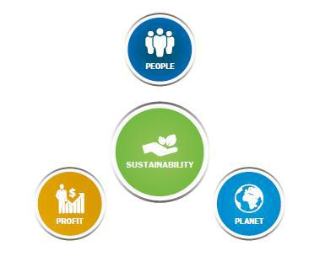
The Banking sector is one of the major contributors to the Bangladesh economy with the commercial sector playing vital role in the financial segment. After the liberation, Bangladesh went through a very weak phases of development in banking sector. The banking division in Bangladesh enter with six nationalized commercialized banks, two state owned specialized banks and three foreign banks after Bangladesh attained independence in 1971. When the banks were becoming the burden through some elements of irregularities as the role of central bank, The Bangladesh Bank (BB) started adopting measures to drawing banking institutions on right track. The commercial banks play a major role in making Bangladesh’s economy through its contributions. Until now the prevalence of public sector management of banks left some gloomy effects in the money market and in the economy. But now the scenario is changed. The banks are also helping in the economy by adopting smart techniques and decision to reduce the bad loan & investing in more secure place. The primary function of a bank is to borrow from individuals, non-individuals as saving and give them interest on their savings and make loans at a higher interest rate. These initiatives are not only good for banks but also good for Bangladesh economy as investors are improving their business decision and constructing more innovative business plan.

3.2. Objectives of a Bank

A bank is a financial organization which primary function is borrowing and lending money. Banks take deposits from customers and in return paying customers an interest. The bank then uses these deposits to lend to other customers. The difference between the two interest rates is the profit margin of a bank. Bangladesh economic sector is basically run by the banking sector. Bangladesh banking sector is still underdeveloped especially government banks, now private banks are trying to develop the banking sectors by following the developed countries. Types of banking sectors are:

- Commercial Banks (BBL, DBBL, Bank Asia etc.)
- Non-Commercial Banks (IDLC, IPDC, LangkaBangla etc.)
At the present time, modern banking provides many other banking facilities like transfer money from one country to another, pay utility bills, providing tuition fees of educational institutions etc. The beginning of modern banking is the consequence of commercial bank.
Some objectives of overall banking industries are given below:
- To collect public money for savings at a lower interest rate and lend money to the public at a higher interest rate.
- Increase capital through savings.
- To maximize profit and to conduct overall economic activities.
- To assist government for social economic development.
- Enhance tendency to save money amongst people.

3.3. Banker-Customer Relationship

The banker-customer relationship depends upon the nature of the products or services provided by a banker. They provide various other services like lockers facilities and collecting cheques or other financial instrument as there agent. The banker-customer relationships can be classified as follows:
- Debtor- Creditor
- Creditor-Debtor
- Lesser-Lessee
- Agent-Principle
- Bailee-Bailer

3.4. Overview of BRAC Bank Ltd.

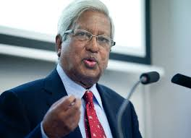
BRAC Bank Limited is a prominent commercial private bank, initiated by Sir Fazle Hasan Abed (founder and chairman of BRAC, NGO) on July 4, 2001. Since inauguration BRAC Bank Ltd. has shown remarkable growth in the banking sector. It has been the fastest growing bank in 2004 & 2005. Now the bank has a network of 181 Branches, 469 ATMs, 81 CDMs, 448 SME Unit Offices and 229 remittance delivery points across the country. The banking facilities BBL provides are General Banking under which retail banking and agent banking, mobile banking (BKash) operates.

Table 3.1.
Profile of BBL.
Type | Public Limited
Industry | Financial Services Banking
Founded | 4 July 2001
Headquarters | 220/B Gulshan Tejgaon Link Road, Dhaka 1208  Dhaka, Bangladesh
Key people | Sir Fazle Hasan Abed KCMG, Chairman  Mr. Selim RF Hussain, Managing Director & CEO
Revenue | ৳926 crore (US$120 million)
Number of employees | 8000
Parent | BRAC, IFC
Website | www.bracbank.com
Source: https://en.wikipedia.org/wiki/BRAC_Bank_Limited
It provides services to customers are:
- Commercial Banking (Deposit Account- DPS, FDR)
- Consumer Banking (Retail Banking)
- Foreign & Internal Remittances,
- Mobil Banking
- Financial Services
- Non-individual Banking,
- Asset and liability management etc.
As a completely operational commercial bank, BRAC Bank focuses on pursuing unexplored market niches in the small and medium enterprise business. In small business landing, BRAC Bank has fast growing remittance, savings mobilization and consumer lending businesses. In the recent years BRAC Bank introduce many more services and products as well as add a wider network of SME unit offices, Retail Branches and ATMs across the country. BBL has emerged as the market leader in SME business, over time it has increased its focus on Retail and Corporate Businesses to reach the broader market segments and diversify the portfolio. With its team of over 6,500 employees, the bank serves more than 1,600,000 individual customers through its diverse range of banking solutions.
BRAC Bank is one of the initiators in internet banking service provider in Bangladesh. There service includes statement, bill payment, funds transfer among others. BBL is always active in various social activities, which increased its reputation and growth over the period of time. They achieved various national and international awards for playing such a kind role in the progress of Bangladesh.

Table 3.2
Shareholding Structure of BRAC Bank Limited

https://www.bracbank.com/Shareholding-Structure.php

Diagram: BRAC Bank Limited’s Shareholders’ structure.

3.5. Mission Statement

- Sustained growth in Small and Medium Enterprise (SME) sector.
- Continuous low cost deposit growth with controlled growth in Retained Assets.
- Corporate Assets to be funded through self-liability mobilization investment in faster growing sectors.
- Continues effort to increase non-funded income.
- To maintain a steady profitable growth keep our debt charges at 2%.
- Achieve efficient synergies between the bank’s branches products and services.
- Manage various modes of business in a strict condition with no compromise on service quality.
- Keep a diverse, expert team fully motivated and driven towards realizing the banks’ vision into reality.

3.6. Vision Statement

BRAC Bank Limited vision is “Building a profitable and socially responsible financial institution focused on market and business with growth potential, thereby assisting BRAC and its stakeholders build a just, enlightened, healthy, democratic and poverty free Bangladesh”.

3.7. Achievement and Awards

- BRAC Bank wins prestigious ‘Sustainable Marketing Excellence Awards’ from CMO Asia on July 31, 2014.
- Hong Kong-based magazine Asia money has awarded BRAC Bank as the "Best Bank for SMEs".
- BRAC Bank won Institute of Chartered Accountants of Bangladesh (ICAB)Best Published Annual Reports 2016 -Private Sector Banks.
- BRAC Bank won South Asia’s most prestigious corporate disclosure honors, South Asian Federation of Accountants (SAFA) Award for Best Presented Annual Report 2016.
- BRAC Bank Limited has won prestigious 'Best Bank in Bangladesh Award' from Finance Asia as part of Country Awards for Achievement 2013.
- BRAC Bank received National Award as the Highest VAT payer for the financial year 2007-2008.

3.8. Core Objective

The objective is specific and targeted. BBL committed to fulfill its customers requirements.
BRAC Bank Limited core objective are described as below:

3.9. Focus of BRAC Bank

BBL‘s main concentration is to provide all types of services and facilities to customers. The services they cover are basically:
- Advanced and modern banking facilities.
- Foreign and internal remittances.
- Deposits / Savings accounts
- Business-related services
- Different Monetary Services
- Asset & liability management
- Mobile banking
- Internet Banking

3.10. Strategies of BBL

Following are the strategies they follow for better banking service-
- To gain client satisfaction through provide better services on a timely basis
- Monitor whether they could able to meet their customers’ necessities.
- To operate banking activities in the most efficient and effective manner.
- Try to build a closer relationship with customers by contacting directly
- To find customers’ credit and other banking needs.
- To develop financial performance and control cost.
- Organizational efficiency can be promoted by disclosing company’s policies, procedures, and performance on a timely basis.
- Keep rules, processes and practices up-to-date in order to develop the procedures to provide better- quality service to clients.
- Trained all staffs properly and give them sufficient facilities so that they can fulfill customers’ necessities.

3.11. Board of directors

BRAC Bank’s top management makes all the major decision. Board of directors is responsible for taking serious decisions regarding companies. They are not directly concerned with the day-to-day operation of bank. Boards of directors confer their authority to its management committee, which is called MANCOM. The Chairman of BBL is Mr. Fazle Hasan Abed. Different branches have different managers and deputy managers who play a key role in monitoring the branch’s activities and take necessary decision on regular basis.

Table 3.3

Board of directors

Sl No. | Name of the Directors | Designation
01 | Sir Fazle Hasan Abed,KCMG | Chairman
02 | Shib Narayan Kairy | Nominated Director
03 | Nihad Kabir | Nominated Director
04 | Kazi Mahmood Sattar | Independent Director
05 | Kaiser Kabir | Nominated Director
06 | Dr. Ahsan H Mansur | Independent Director
07 | Asif Saleh | Nominated Director
08 | Fahima Chudhury | Independent Director
09 | Salim R.F. Hussain | Managing Director & CEO
https://www.bracbank.com/Board-Directors.php

3.12. Products and Services of BRAC Bank Limited

Product means the “Features” with 186 Branches, 460 SME Unit Offices and more than 440 ATMs, BBL offers a wide range of financial solutions in Bangladesh. Different types of products offered by BBL are:
Deposits Product
- Current Deposits
- Saving Deposit
- Deposits on terms
- Special Notice Deposits
- Monthly terms Deposits
- Other deposits permitted by head office etc.
Types of Accounts
- Current Account (For Business purpose)
- Non-Current Account (Single / Individual Account)

3.13. Retail Banking

Retail banking is consumer banking; it is banking systems where services are provided to individuals customers. BRAC Bank’s retail banking, with 186 Branches, contains a wide range of products and services which include current accounts, saving accounts, term deposits, loans, and debit / credit card services. Clients can have the comfort of branch banking and the Alternative channel services through Internet Banking, Call center, SMS banking and e-statement. BBL Retail banking customers are served through a network of 186 branches, 14 Premium banking Lounges, 440 ATMs and 81 CDMs.

3.14. Retail Products

Retail banking division has several departments:
- Deposits and NFB, products
- Retail Loan
- Customer experience
- Cards
- Alternative Delivery Channel
- Acquiring department-deals with business obtaining
- Sales governance
In 2016 BRAC Bank’s retail business surpassed desire and accomplished the most astounding asset development, with 55% of an industry record. BBL retail banking becoming the largest retail asset portfolio in the market the bank’s retail banking assets crossed BDT 3,375 crore as of December 31, 2016.

3.15. Retail Banking System

- In order to maintain retail banking customer should open an account in the designate bank in the area of a unit office.
- Board of Directors should approve consumer credit policy.
- The bank shall develop a specific Product Program Guide for consumer finance activity. The program consists of
- The objective / quantitative parameters for the eligibility of the borrower.
- To determine the maximum permissible limit of a borrower.
- Maximum permissible coverage banks will taka against each product.

3.16. Segment of Retail Banking

According to their customer profile BRAC Bank has recently changed the way of banking segment by their retail business. The segments are given below:
- Premium Banking
- Supreme Banking
- Excel Banking
- Easy Banking

Premium Banking
Clients who maintain at least BDT 50 lac on 6 month average are called premium customers.
They are given high priority and they also receive gifts, discounts and special services from
BRAC Bank Limited. Currently the company has over 1000 premium customers.

Supreme Banking
Clients who maintain at least BDT 10 lac to less than 50 lac or equal on 6 month on average are treated as supreme customers. They enjoy separate service booth and cash deposit booth in the branches and get many other facilities.

Excel Banking
Clients who maintain at least BDT 50 thousand to below BDT 10 lac on a 6 month average are called as supreme customers

Easy Banking
These are general day to day customers who depends traditional banking from the bank. They are only required to maintain a balance of 50 thousand.

Process:

Figure: 3.1 Process

3.17. Retail banking Products:
BRAC Bank has three types of products in retail banking

Loan Products
Cards Products
Deposit products

Loan Products:
A loan is a sum of money which is borrowed from banks or other sources in terms of conditions to pay back within specified period with interest. BRAC Bank Limited offers term loan based on short term and long term funds. Depend on the customer demand wide ranges of retail loans are given.

Table 3.4

Loan products

There are wide range of loan products are featured in order to fulfill the consumer demands. The product details are as follow -

Loan products

Figure: 3.2 Loan Products
(Source: BBL website)

Deposit products
BBL has several features to meet the everyday financial demand of an individual's life.
Savings Account
Current Account
Term Deposits

Savings Account:
BRAC Bank provides several type of regular savings account offering interest on deposit amount. Cheque book and SMS facility also provide with this account. This account is divided into 4 parts
.

Triple Benefit Account (TBS)
Savings Classic Account
Future Star Account
Aparajita Account.

The savings account is a considerable demand deposit and can be withdrawn by the customer only by using check. Saving account offers high interest rate and interest is credited to the account every month on the customers’ monthly balance. Benefits obtained from savings account are –

- Interest is paid on the daily balancing method.

- No restrictions are imposed on the number of withdrawals and no hidden cuts or penalty rules are given on the account.

- The account holder will be able to pertain for the personal loan packages and will also be eligible to open another account and deposit fixed amount in the bank.

- The Account holder will receive special management at the moment of handing out their loan applications and furthermore, will obtain discounts on transmittal occasions.

Current Account:

Current account is a checking account for day to day need of customers. This account holder can easily deposit and withdraw money from their account and also provided online banking facility without providing any charge. The account can be opened by business persons aged 18 years and above. Current account is divided into four segments:

- Current Classic Account

- Current Plus Account

- Ezee Account

- Salary Account

No restrictions are imposed on number and amount of size of the withdrawal.
There are no requirements for giving notice before making a withdrawal.

Term Deposits:

Term deposits are mainly known for time deposits or time liabilities. Before opening a term deposit account, the customer needs to open an account in the bank. The customer has to fill up am application form that contains followed by the amount in figures, Beneficiary’s name and address, period, rate of interest, date of issue and date of maturity. Term Deposits are comprised of six segments and they are following-
DPS
Fixed Deposit General
Flexi DPS
Interest First Fixed Deposit
Freedom Fixed Deposit (FFD)
Abiram Fixed Deposit
Unit Fixed Deposit.

The opening of SAVINGS, CURRENT AND TERM DEPOSIT account:

- The opening prescribed account form should be signed by the applicant in front of the BM/RM/CSM and specimen signature card should be signed by the applicant in front of them also.
- The introducer must bring two copy passport sizes photograph that must be attested.
- Any of the following identification documents including current valid passport, Proof of address, ID card, Commissioner Certificate etc. In this case, Certifier should attest applicant’s photograph along with the signature.
(SOURCE: BBL Website, Deposit Products)

3.18. Cards product:
In order to enhance the e-commerce and online banking facility BRAC Bank offer huge collections of card products. The card holders enjoy all kind of benefits offered and services provided by BBL. Every year BBL provides some offer and depending upon the offer annual fee is waived from various cards. The card details are as follow -

Figure 3.3 Card Products

Debit Cards

Figure 3.4 Debit Cards

3.19. SWOT Analysis

SWOT analysis provides insights about the strengths and weaknesses of a business entity, and depicts an image of the business environment measuring the opportunities and threats. SWOT stands for Strengths, Weaknesses, Opportunities and Threats. SWOT analysis helps the organization to identify how to evaluate its performance and scan the macro environment, which in turn would help organization to navigate in the turbulent ocean of competition. It helps the organization to evaluate its performance and help to increase opportunities and avoid threats.

SWOT
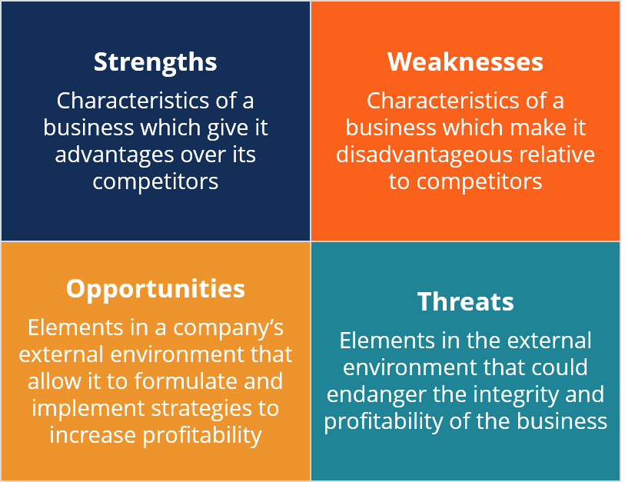

SWOT analysis of BBL is described below

Strength:
- BRAC Bank has a strong technology system behind its all functions and activities.
- The Bank personnel is well trained and experienced and well educated.
- The Bank has well reputation in the market.
- BRAC Bank provides largest banking service among all the commercial banks.
- BBL has a huge manpower and network all over the country that helps BBL to knock at the door of some customers which were out of banking touch.
- The working environment is very friendly: everyone is very co-operative to each other. There are no boundaries or barriers between superiors and employees so that communications can easily occur.
- Internet banking, mobile banking, and all other internet based advanced technologies are provided to its customers at free of cost.
- Better employee motivation generation through internal recruitment opportunity.
- ATM booths are available all over the country.
- The Bank has reached the high growth rate of profit, deposits and investments.
- BBL has a strongest technology system.
- The Bank provides its customers all local remittance facilities, such as TT, DD, and PO etc. at free of cost.

Weaknesses

- Because of huge manpower, BRAC Bank takes many steps but they cannot implement all their steps because of its weak monitoring system.
- The branches of the bank have to wait for the head office to take any decisions
- Interest rate higher than some other private commercial bank is one of the weak points of BBL.
- Minimum balances and annual charges are too high.
- Because of BBL huge number of customer most of time its branches get jam packed at pick hour.
- Branch offices are only available in large and metropolitan cities.
- BBL offered remuneration package to their employee is lower than other private bank.
- The bank provides online banking and ATM services which are limited and needs to improve.
- The interest rate of fixed deposit and DPS are low compared to the other banks.
- BBL Online recruitment system is not upgraded.

Opportunities:

- BRAC Bank provides more services to its cards.
- Through lending, BRAC Bank Limited can help small and medium enterprise.
- Expanding branches in the rural and undeveloped areas they can enrich their banking services.
- BRAC Bank employees are less than 30 years as thereby they can bring more out puts from its young employees.
- BBL can increase its customers saving options by providing more different saving schemes.
- AS BRAC Bank changed its target from product to customer it may allow them to expand some new group of customers.
- BRAC Bank can make its ATM services and online banking facilities easier to compete with other banks.
- By increasing interest rates on deposits schemes, they can bring more customers.

Threats:

- Foreign Banks are threats for BRAC Bank.
- Economic condition in Bangladesh is very poor.
- Political volatility is another thread for BRAC Bank.
- New competitors are increased day by day.
- Bangladesh Bank puts on some strict rules and regulation to the private bank which may become difficult for BRAC Bank to follow.
- Other Banks such as CITY Bank, BANK ASIA, PRIME Bank etc. are its main opponent.

Table 3.5

Summary of SWOT analysis

Strength  - Company reputation and goodwill.  - Provide quality services to customers  - Facilities and equipments  - Available ATM booths facilities.  - Interactive corporate culture.  - Experienced management.  - Team work at mid level and low level.  - Internet banking, mobile banking all other internet based advantages. | Weaknesses  - Low remuneration package  - Internet services need to be improved.  - Low interest rate on DPS and FDR.
Opportunities  - Expand branches in rural areas.  - Introduce more saving schemes.  - International operation | Threats  - Multinational Banks.  - Poor economic condition.  - Main rivals are upcoming banks.

Chapter 4

Finding and analysis

4.1. Finding and Analysis

It was my first time experience working as corporate officer in an office. It was a great deal for me to work there as I did not know that I have to do or what will be my task there and how I will have to perform in the office. I kept my strength and confidently I show my ability to work. The task in this department was findings the errors of documents, check the vouchers, take actions for the correction, make communication with the other departments where necessary, keep informing my supervisor, checking the excels, prepare statements, match the documents with the data base information, match the amounts etc.

4.2. Comparison with the banking industry

Every bank in Bangladesh followed Bangladesh Banks’ rules and regulation after that each of them has some different strategies and policies which make them unique then others. Such differentiation produces various options for customers to choose affordable products. Comparison with the overall banking with BRAC BANK is given below:

Table 4.1

Comparison with industry

Products and Services |  | BRAC Bank | Banking Industry | Comment
Loan Product | Home Loan | Interest rate 8% & for taking over it would be 11%. | Other banks interest rate is high. Starts at 11% & maximum rate is more than 14%. | BBL has comparatively low interest rates on loans than other banks in Bangladesh.
Loan Product | Car Loan | The interest rate is 10.75% | Most of the bank’s interest rate is 12% & highest 15%.
Loan Product | Personal Loan | Interest rate starts from 9.75% - 12.75% depends on various customers segments. | The interest rate is high on other banks. Maximum banks charged interest more than 13%.
Other Products | Individual Account & Non-Individual Account | Saving account, Current account, student account, salary accounts etc. | Different types of accounts provided by other banks like Triple Benefits savings account, Young stars savings account etc. | BBL has few products for savings than other commercial banks. Annual fees, service charges are very high and interest on savings is low.
Other Products | Fees & Charges | Annual fees & charges are high. | Annual fees vary from bank to bank. Many of them have comparatively low annual fees.
Other Products | Annual Interest | Interest gives on savings is low. | Many banks provide high interest on savings.
Other Products | DPS & FDR | The interest rate is 5%. | Current industry interest rate is around 4% - 9%. | BBL interest rate is low on DPS & FDR.
Services | Internet Banking,  Mobile Banking | Internet banking fund transfer through 2FA. BBL apps facilities etc. SMS alert, Bkash banking. | Current banking industry provides fast internet facilities. City Bank, DBBL, SCB is on the top 5 to provide mobile apps facilities. | BBL internet and mobile banking is a little behind than other banking industries.
Services | ATM Booth | Available ATM booths facilities. | ATM booths are not enough. Banks have not yet expanded their facilities outside branches. | BBL is the introducer of ATM booths in Bangladesh.

The main focus of this internship program is basically a retail division of BRAC Bank. While collective information and analyzing it some major findings are acknowledged. The followings are identified while preparing this report:

Positive findings:

- BRAC Bank Limited has a friendly & interactive corporate culture. Hidden barriers or boundaries between the superiors and the subordinates are strictly prohibited in BBL.

- Customers and the bankers are very pleased about BBL banking Environment. They all pursue a great attitude about the bank.

- The bank’s highly skilled management team is also a major strength for the bank. Their dedicated management teams are continuously contributing towards further growth and development of the bank with their years of banking experience, skills & expertise.

- BRAC Bank’s Premium Banking, Cards, & Women Banking services offer wide range of exclusive facilities for their customers unlike any other banks.

- The management teams and employees are extremely focused toward customer experience and service quality, and deal every customer query or complaints with care & utmost importance.

Negative findings

- Changes in service charges, interest rates and other banking policies are not frequently updated on the website. Also there are some hidden charges which are not clearly communicated to the customers sometimes.

- Most of the exclusive services of Priority Banking are available only for Dhaka and Chittagong residents only. This is creating a very dissatisfied customer base residing in other parts of the country.

- The centralized banking system is slowing down service delivery. Sometimes the branch relationship managers have to wait for days for approval from the head office.

- It is common for bankers to work for long hours, sometimes even for over 12 hours a day, but compared to their hard work the bank’s compensation package for its employees is not very satisfactory.

Chapter 5

Recommendation and conclusion

5.1. Recommendation

It is very common to have some good sides and also problematic sides of an organization. As an intern from my little knowledge it is quite difficult to give recommendation such a developing organization. Still from my learning and observation some recommendations are as follows:
- The Bank should reveal "Hidden Charges" in front of the customers.
- The customers have many complained about the charges; so for customers satisfaction bank should reduce the charges.
- BBL should recruit more employees, so they can provide the customers better services within a short time.
- The bank should provide striking compensation to gain the loyalty and dedication of the employees to stay with the company.
- For the well being of employees the bank should develop motivational and instruction program.
- Executive surveillance and co-operation should be in appropriate way.
- Employees working in the Bank should have a personal “FINACLE” ID and they must be well known about the rules and procedures of the software.
- An organization is as good as their employees. During my internship period, I noticed the internal politics in that organization is way too much. If people are worried about other people all the time, they will have very few times to get their work done. BRAC Bank should teach their employees about behavior methods as well as etiquettes. Work environment should be helpful not toxic. BBL should look at this very closely.

5.2. Conclusion

An efficient and well organized financial institution plays a dynamic role in the economic development of a country. BRAC Bank Limited is one of the advanced, technological commercial bank in Bangladesh. Hence, the prominent success of BRAC Bank Limited over the years is adding new strength to the banking sector of Bangladesh. It has a huge skillful management team to maintain around 186+ branches across the country.
After achieving a strong market position in SME Banking the bank has focused its strategies on expanding its Retail businesses. With increasing customer base and new product developments in Retail Banking the bank is reaching new heights every year. Using their value-based banking services and dedicated management team it is not impossible for the bank to achieve its latest resolution of becoming the best bank in the country.
Although this report presents BBL is in a better position, it has few obstacles to overcome to sustain the position. The achievement of a bank depends on the quality of services it provides. Customer satisfaction is the only way to achieve its ultimate goal. By providing quality services customers’ satisfaction can be achieved. So the continuous development of the services will definitely make BRAC Bank Limited the best bank in Bangladesh.
Last of all, I would like to tell that by working in BBL as an intern helped me to know more about corporate culture and the several aspects to work in the banking industry. After working in the sector I learn the fact that how this industry faces challenges and uses several strategies to overcome it. This report is an exposure of my working experience and my knowledge. Employees of the bank were always in hard work but after that they managed to help me to collect information about the report. Although the institution have some drawbacks in the performance management but the bank is progressing day by day. I wish a progressive future of the Bank.

Chapter 6

Appendix

6.1. BIBLIOGRAPHY

- Annual report of BRAC Bank Limited.
- Valuable discussion with supervisor, line managers and other officers working in BRAC Bank.
- Prospectus of BRAC Bank Limited published in 2016.
- Retail manual of BRAC Bank Limited.
- Training providers and HR department of BRAC Bank Limited.

6.2. References

Annual Report 2017. BRAC Bank. Retrieved November 15, 2018
Annual Report 2016. BRAC Bank. Retrieved from:
https://www.bracbank.com/financialstatement/Annual%20Report%202016.pdf
BRAC Bank undertakes training on branch operations manager dev progm. (2018, June 15). Retrieved November 20, 2018, from https://thefinancialexpress.com.bd/public/trade/brac-bankundertakes-training-on-branch-operations-manager-dev-progm-1529044918

Deposit Interest Rate. BRAC Bank. Retrieved from: https://www.bracbank.com/Schedule-of-Charges.php
Hossain, A.H.M.M. (2017, May). BRAC Bank launches 'TARA'. The Financial Express. Retrieved from: http://www.thefinancialexpress-bd.com/2017/05/05/69329/BRAC-Bank-launches-
Plaehn, T. (2008, November). How to Understand Interest That Is "Accrued Daily and Compounded Monthly". Sapling. Retrieved from: https://www.sapling.com/4584648/that-accrued-daily-compounded-monthly
Retail Banking. BRAC Bank. Retrieved from: https://www.bracbank.com/retail_banking.php
“Company Profile”. (2018). Retrieved November 11, 2018, from BRAC Bank Limited https://www.bracbank.com/company_profile.php

Schedule of Charges for Retail Banking. BRAC Bank. Retrieved from:
https://www.bracbank.com/Schedule-of-Charges.php
Shetty, A. (2016, May). What is the difference between a current and savings bank account?. Quora. Retrieved from: https://www.quora.com/What-is-the-difference-between-a-current-and-savings-bank-account

APPENDIX
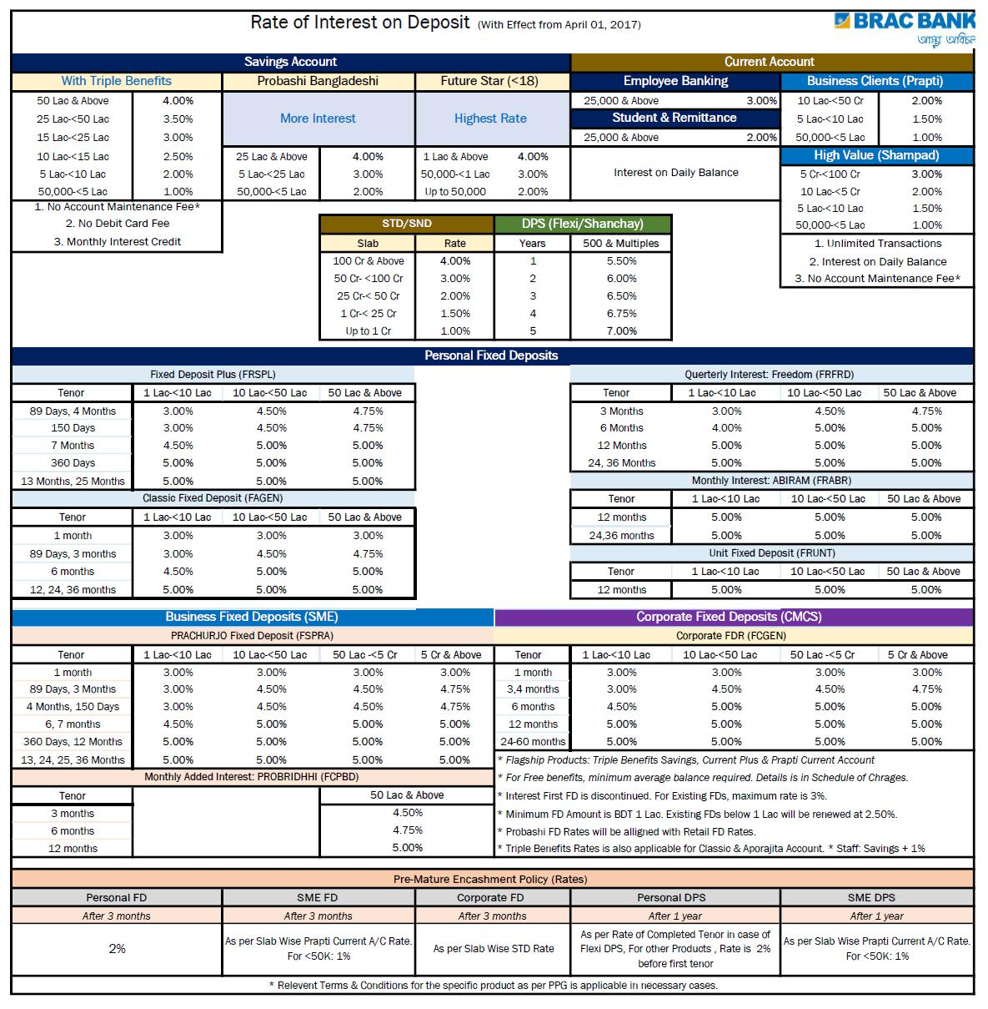

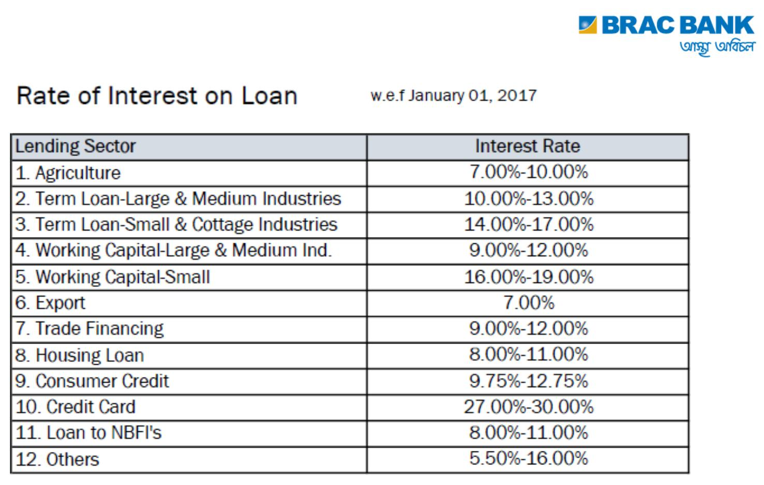

ANNEX

Survey Questionnaire

Dear Sir, I am a student of BBA department of United International University. I am going to find the customer relationship level through “Retail Banking” of BRAC Bank Limited. The provided information will be treat as confidential and use only for my academic purpose. Thank you very much for your kind collaboration.

Please read the question carefully and just put a tick ( √ ) and kindly give your decisions.
Part-A

Gender: Male or Female
Age: 25 or less to 71 or above.
Occupation: Student Service Holder Business Unemployed Retired person
Income Level (Monthly income in BDT): 20,000 or less to 100,000 or above.
Education Level: Below Graduation to Ph.D.

Part-B
Organizational part

How long you are with BRAC Bank Limited?
- 1-2 years
- 2-5 years
- 5-8 years
- More than 8 years.

After segmentation of customer type like supreme or excel, how better the service is?
- More convenient
- Previous type was better
- Downsizing

Which change of this segmentation you like most?
- Internet banking facility
- Deposit based facility
- Privilege facility on shopping
BRAC Bank’s customer service level compared to other banks?
- Very Satisfied
- Satisfied
- Neutral
- Dissatisfied
- Very dissatisfied
The best reason for what you want to keep relationship with BBL?
- Customer service
- Alternate banking
- Privilege facility for different customers
- Better package of interest rate
How much you are satisfied about overall BBL
- Very Satisfied
- Satisfied
- Neutral
- Dissatisfied
- Very dissatisfied

Please mark as you are a categorized customer of BBL:

Serial no | Status | Strongly Agree  1 | Agree  2 | Neutral  3 | Disagree  4 | Strongly Agree  5
6 | Customer service officers BBL is very helpful
7 | You get informed about update of BRAC Bank Limited regularly
8 | BBL alternate banking is very effective for you
9 | BBL has a dedicated customer call center
10 | You use the value added services of BBL
11 | BBL cares about their customers well
12 | You are satisfied with the initiatives of BBL
13 | You appreciate all new initiatives of BBL
14 | You would like to be with BBL for a longer period of time
15 | Segmentation brings any benefit to you
16 | As a user of BBL Credit Card you get discount from all of the pay flex merchant shops
17 | BBL ATM booth works properly
18 | You are aware about the privileged supreme card of BBL
19 | BBL does have a good future
20 | BBL should come with more new products and services

Gender
 | Frequency | Percent
Male | 66 | 34.0
Female | 34 | 66.0
Total | 100 | 100.0

I have found 100 samples from two branches of BBL. Out of these 100 customers 34 are female and 66 are male. It means 34% are female and 66% are male on my survey.

Age
 | Frequency | Percent
25 or less | 6 | 6.0
26 – 40 | 18 | 18.0
41 – 55 | 52 | 52.0
56 – 70 | 20 | 20.0
71 – above | 4 | 4.0
Total | 100 | 100.0

Most of the customers are in between 41-55 years old, 52 out of 100 customers are in this age group. 20 customers are in between 56-70 years old. 18 customers are in between 26-40 years old. 52% customers are in between 41-55 years old, the reason behind it the trustworthiness.

Income Level

 | Frequency | Percent
20000 or less | 14 | 14.0
21000 – 50000 | 46 | 46.0
51000 – 80000 | 26 | 26.0
81000 – 100000 | 10 | 10.0
100000 – above | 4 | 4.0
Total | 100 | 100.0

Maximum customer’s income level is between at group of 21000-50000. 13 customers out of 50 are in between at group of 51000-80000. 7 customers are in between 20000 or less. Only 4% customers of BBL have an income range of more than 1 lac so I guess BBL should look to this income level people also.

Education Level

 | Frequency | Percent
Below Graduate | 32 | 32.0
Graduate | 56 | 56.0
Post Graduate | 8 | 8.0
Ph.D. | 4 | 4.0
Total | 100 | 100.0

56% customers are graduated whereas 32% customers are graduation. 8% customers are post graduated and 4% customers are Ph.D.

Occupation

 | Frequency | Percent
Student | 8 | 8.0
Service Holder | 34 | 34.0
Unemployed | 46 | 46.0
Business | 6 | 6.0
Retired Person | 6 | 6.0
Total | 100 | 100.0

About 46% customer’s occupation of BBL is business and 34% customers are service holder.

Whereas 8 customers are student and 6% are retired person and 6% are unemployed.

You maintaining an account with BRAC Bank Limited

Relationship Level
 | Frequency | Percent
1-2 years | 20 | 20.0
2-5 years | 50 | 50.0
5-8 years | 22 | 22.0
More than 8 years | 8 | 8.0
Total | 100 | 100.0

BBL is the prominent private commercial bank in Bangladesh. That’s why the customer relations are build day by day. We can see the trend of account maintaining of customers.

Service after segmentation of customer
 | Frequency | Percent
More convenient | 76 | 76.0
Previous was better | 18 | 18.0
Downgrading | 6 | 6.0
Total | 100 | 100.0

We can see that most of the customers are agree that after applying RBBM, the service has been more convenient from previous days.

Change of the segmentation you like most

 | Frequency | Percent
Categorized customer service | 36 | 36.0
Internet banking | 20 | 20.0
Deposit based facility | 24 | 24.0
Privilege facility | 20 | 20.0
Total | 100 | 100.0

20% customers have shown their interest to the privilege facility after being categorized of BBL.

BRAC Bank’s customer service compared to other banks

 | Frequency | Percent
Very satisfied | 8 | 8.0
Satisfied | 46 | 46.0
Neutral | 30 | 30.0
Dissatisfied | 10 | 10.0
Very dissatisfied | 6 | 6.0
Total | 100 | 100.0

46% customers are satisfied and 30% customers are neutral of BRAC Bank customer service. So BBL should take care few of these neutral customers satisfied.

BRAC Bank does have a good future

 | Frequency | Percent
Strongly agree | 22 | 22.0
Agree | 58 | 58.0
Neutral | 10 | 10.0
Disagree | 10 | 10.0
Total | 100 | 100.0

58% BRAC Bank customers do think that BBL does have a good future. BBL is the prominent bank in the country and within this short period of time BBL is able to leave a footprint all over the country.

BBL ATM booth work properly
 | Frequency | Percent
Strongly Agree | 14 | 14.0
Agree | 70 | 70.0
Neutral | 12 | 12.0
Disagree | 4 | 4.0
Total | 100 | 100.0

84% customers do agree that BBL ATM booth works properly. Negligible customers didn’t agree with the statement.

Dedicated customer call center
 | Frequency | Percent
Strongly Agree | 8 | 8.0
Agree | 52 | 52.0
Neutral | 32 | 32.0
Disagree | 8 | 8.0
Total | 100 | 100.0

60% customers are agreed about dedicated customer call center of BBL and 32% customers cannot reach to call center easily only 8% customers don’t like.

Satisfaction level about overall BBL
 | Frequency | Percent
Very satisfied | 8 | 8.0
Satisfied | 38 | 38.0
Neutral | 34 | 34.0
Dissatisfied | 14 | 14.0
Very dissatisfied | 6 | 6.0
Total | 100 | 100.0

46% customers are satisfied and 34% customers are neutral regarding their relationship with BBL. So BBL could make rest 20% of their customers to satisfy.

Customer service officer is very helpful
 | Frequency | Percent
Strongly Agree | 8 | 8.0
Agree | 42 | 42.0
Neutral | 40 | 40.0
Disagree | 8 | 8.0
Strongly Disagree | 2 | 2.0
Total | 100 | 100.0

50% customers are agreed that customer service officers of BRAC Bank are helpful. 40% customers are neutral and 10% of customers are disagreed with this statement.

Alternate banking of BBL is very effective to you

 | Frequency | Percent
Agree | 36 | 36.0
Neutral | 50 | 50.0
Disagree | 10 | 10.0
Strongly Disagree | 4 | 4.0
Total | 100 | 100.0

36% customers have agreed that alternate banking is effective at BBL. 50% customers are neutral so I do think that BRAC Bank should increase the effectiveness of their alternate banking.

Get informed from BBL regularly

 | Frequency | Percent
Strongly Agree | 4 | 4.0
Agree | 56 | 56.0
Neutral | 30 | 30.0
Disagree | 10 | 1.0
Total | 100 | 100.0

60% customers are agreed that they get informed of any update from BRAC Bank Limited regularly and 30% customers are neutral. From this survey 10% are disagreed that means they don’t get informed from BBL.

