
Internship Report
Analysis of the Banking Industry of Bangladesh & AB Bank Limited
An Internship Experience Perspective

Submitted to:
Dr. Md Mohan Uddin
Professor
School of Business & Economics
United International University

Submitted by:
Maina Alam Alin
ID: 111 152 122
BBA Program
School of Business & Economics
United International University

Date of submission: 04.06.2024

Letter of Transmittal
Date: 04-06-2024
To
Dr. Md Mohan Uddin
Professor
United International University
School of Business and Economics

Subject: Report Submission on “The Banking Industry of Bangladesh and AB Bank Limited”.

Dear Sir,
I am pleased to present you my internship report on “The Banking Industry of Bangladesh and the AB Bank Limited’’ which I have done under your instruction. I am grateful to you for giving me the opportunity to work on such a topic for which I have learned so many things and gathered an enormous knowledge about our banking industry. This internship and my report are a part of my BBA program, so it is very important for me.

To make this report I have conducted discussion with some of the officers of the bank and also used my personal observation. I have collected my required data, documents etc. from them and tried my level best to put it on my report.
Your acceptance and appreciation are very important and it will motivate me a lot. I would like to clarify all the things if there is a need of any explanations. Would you please accept my internship report and oblige me thereby?
Thank you.

Sincerely yours,

Maina Alam Alin
ID: 111 152 122
BBA Program
School of Business & Economics
United International University
Acknowledgement
At first, I would like to express my gratitude to almighty Allah for special blessings in completing my internship report. The Internship report titled as “The Banking Industry of Bangladesh and the AB Bank Limited” -which has been prepared for the requirement of BBA degree.

I am very pleased to my supervisor Dr. Md Mohan Uddin, Professor, School of Business and Economics, United International University, for his instructions and support in completing my internship report and suggestions from the very beginning of starting this report.

Lastly, I would like to express my gratitude to all the employees of the AB Bank Limited. Specially I would thank Mr. Md. Wahid Imam Khan, SVP & Branch Manager, Mr. Syed Md. Foiz Bin Mahfuz, SVP & Branch Manager, Mr. Muhammad Saiful Islam, AVP & Manager Operations at AB Bank ltd, Mrs. Sayeeda Rabeya Khanam, SAVP, Mr. Md.Muniruzzaman, AVP, MR. A.S.M. Ziaul Islam, AVP, AB Bank ltd, Motijheel Branch who helped me throughout my internship period and taught me about corporate life.

Executive Summary

This report is on Analysis of the Bangladesh Banking Industry and Analysis of the AB Bank Limited. This report is prepared for the requirement of my BBA program and supervised by Dr. Md Mohan Uddin, Professor, United International University. The general objective of this report is to give an overview of the banking industry of Bangladesh particularly the AB Bank Limited and the internship experience. There are also some specific objectives which are to present the scenario of the banking industry of Bangladesh and the AB Bank Limited and the internship experience of the author with some recommendations for those three particular topics.
There are five chapters in this report. In three months given internship period why I choose the banking sector, the influence of bank in financial and economic growth, the significance of this report not only to refer others but also the proof of my knowledge and skills growth and my limitations are described in chapter one. In chapter two I described the type, size, maturity level, new trends, flexible laws, use of technology, the rivals and the opportunity of banking industries in Bangladesh. In chapter three I described all the analysis of my chosen bank. My opportunity and experience to work in all the departments is written in chapter four. As a small experience gainer my recommendations are written in last chapter. The current state of the banking sector in Bangladesh and the performance of AB Bank Limited are the report's main conclusions. Bangladesh's banking sector is expanding daily, but what are the obstacles they are currently facing and what is being said about it internationally? A specific bank's function is another finding based on the author's observation and experience.

Table of Contents
Chapter 1: Introduction .................................................................................... 7
Introduction ......................................................................................................... 8
1.1. Background ……………... ............................................................... 8
1.2 Objectives of the Report ..................................................................... 10
1.3 Significance of the Report .................................................................. 11
1.4 Limitation ....................................................................................... 11

Chapter 2: Analysis of the Banking Industry ................................................. 12
2. Analysis of the industry ................................................................................... 13
2.1. Specification of the industry ............................................................. 14
2.2. Size, trend and maturity of the industry ........................................... 19
2.3. Seasonality ........................................................................................ 21
2.4. External economic factors ............................................................... 22
2.5. Technological factors ....................................................................... 24
2.6. Political, legal and regulatory factors ............................................... 25
2.7. Barriers to entry ................................................................................ 27
2.8. Supplier power ................................................................................... 27
2.9. Buyer power ....................................................................................... 28
2.10. Threat to substitutes ......................................................................... 28
2.11. Industry rivalry ................................................................................. 28
2.12. Summary of challenges and opportunities ........................................ 29

Chapter 3: Analysis of the organization .......................................................... 31
3.1. Overview and History ........................................................................ 32
3.2. Company profile................................................................................. 35
3.3. AB Bank Structure............................................................................. 36
3.4. Shareholders’ Information.................................................................. 37
3.5. Last 10 Years’ Performance .............................................................. 39
3.6. Board of Directors............................................................................. 41
3.7. Management .................................................................................... 43
3.8 Services of AB Bank......................... ................................................ 44
3.9 Graphical Presentation Growth.......................................................... 46
3.10 Product/service mix.......................................................................... 51
3.11 Agent Banking Service..................................................................... 56
3.12 Credit Risk........................................................................................ 57
3.13 Corporate Social Responsibilities of the AB Bank Limited............. 58
3.14 SWOT analysis................................................................................. 58
3.7 Steps/strategies to meet the challenges and opportunities................... 60

Chapter 4: Internship Experience ....................................................................... 62
4.1. Position, Duties and responsibilities ................................................... 63
4.2. Training ................................................................................................ 63
4.3. Contribution to departmental functions ............................................... 63
4.4. Evaluation ............................................................................................ 64
4.5. Mystery Shopping Implementation on Covered Branches .................. 65
4.6. Benefits of the assessment.................................................................... 66
4.7. Business Threats................................................................................. 66
4.8 New skills developed........................................................................... 66
4.9 Application of academic knowledge................................................... 67
4.10 Findings............................................................................................ 67

Chapter 5: Recommendations ........................................................................... 69
5.1. Recommendations.............................................................................. 70

Chapter 6: Conclusion ....................................................................................... 72
6.1 Conclusion ..................................................................................................... 73

References ........................................................................................................... 74

Chapter 1
Introduction
- Introduction:
One successful graduation requirement is an internship. Any student can take advantage of this fantastic opportunity to learn some significant and creative concepts about the practical field. Making an internship report, which develops intellectual capacity in a qualified graduate, is also a difficult experience. In accordance with the prerequisites for completing the BBA program, I was given a three-month internship at AB Bank Limited. I plan to prepare my internship report on the banking industry because it has become the most significant player in our economy and because it provides a passionate environment for professional development.
Foreign trading is one of the commercial bank's main business operations. Trade between different nations is dependent on the close relationship between the trading parties. Foreign operations experience is required for this situation. The bank is known as rending international banking operation when it offers such a service. Import-related transactions predominate when dealing with foreign nations; export and international remittances are included in the category of foreign exchange transactions preview. A flow of goods from seller to buyer and of money from buyer to seller are necessary for international trade. In this instance, the bank serves as a crucial intermediary between the seller and the buyer.

  - Background:
Since economic growth is a crucial gauge of a government's effectiveness, economists work tirelessly to assist decision-makers in this area by precisely identifying the dynamics and factors that influence this indicator. However, in order to enhance economic growth, financial and monetary markets play a vital role in allocating the economy's available funds to the producing and industrial sectors. According to some economists, countries' economies grow because of their enlarged financial markets.

Financial development and economic growth have been the focus of extensive research in recent years. Their significant contributions to financial liberalization laid the groundwork for the resurgence of interest in the role of financial intermediation during the process of economic growth. The endogenous development theory emerged as a new light on the relationship between financial and economic development. Countries with better developed financial systems tend to grow faster. In order to account for social, institutional, and political disparities, experimental studies that are currently available concentrate on the impact of financial development across the nation. Additionally, studies on the economy at the national level demonstrate that small, regional, and locally owned banks may behave significantly differently from large, national, and non-locally owned banks while cross-country experimental studies are unable to fully capture the impact of the unique characteristics of the banking system on regional economic development. Local banks in rural areas could enhance financing options for small and medium-sized businesses and support entrepreneurship in developing nations where insufficient and unsatisfactory access to financial services hinders economic growth. At that point, we can presume that macroeconomic environments and political governance, including those pertaining to industry, banking regulation, education, health, and monetary and exchange rate policies, are largely consistent across all regions. The financial system in Bangladesh has demonstrated the limited availability of equity markets as a source of funding, which is only available to the biggest corporations and is bank-based. The following figure displays the history of Bangladesh's banking sector 1.1.
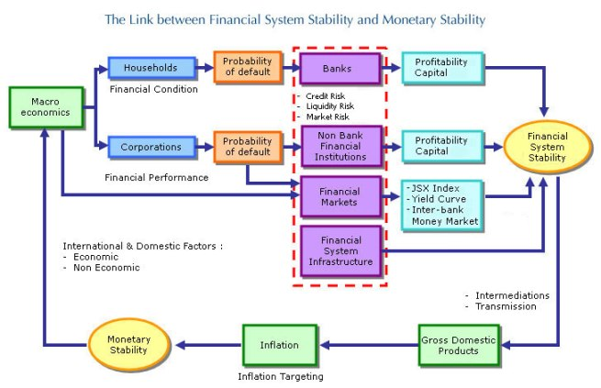
Figure: 1.1: Background of banking industry of Bangladesh.

Therefore, it is expected that the bank, rather than the financial markets, will be the main source of funding for the majority of economic activities in figure 1.1. This leads us to focus on the structural variations in the banking sector across regions in order to offer more profound understandings of the relationship between finance and growth. Common functional requirements for financial intermediaries include capitalization, capital sufficiency, restrictions on bank branching, and limitations on individual borrowers and shareholders.
Twelve commercial banks merged to form Bangladesh's first nationalized commercial banks in 1972. Some of the main goals of this nationalization were to increase domestic investment and decrease capital flight to foreign countries. These banks were operating in Bangladesh prior to independence, allowing the poor access to funds.
With time, those banks altered their tactics and policies, which did not align with the government's class-based banking regulations. Based on the operations of commercial banks, it has been observed that the banking industry has not made significant progress since nationalization. the proper part that nationalized banks were unable to play in the implementation of government policies and programs. As a result, a trend of bank denationalization began in the middle of the 1980s.
According to data from the government and other sources, GDP growth in Bangladesh over the past two years has been more than seven percent, indicating some impressive economic development.
For the purpose of the payment system and other banking operations, one bank is connected to other banks. A single bank's failure impacts not just its depositors and stockholders, but also the remaining banks and businesses as a whole. A single bank failure is seen as a catastrophe for the economy and creates a state of emergency.

1.2. Objectives:
The objectives of this report are the following-
- To analyze the Banking Industry of Bangladesh.
- To analyze The AB Bank Limited,
- To describe the internship experience.

  - Significance of the Report:
This report holds greater significance as a reference document that will aid in the development of my future career. The banking industry, The AB Bank Limited, my internship experience, and my suggestions for enhancing departmental operations and self-performance are all included in this report. I'm currently an intern at The AB Bank Limited, and I think doing an internship is a great experience. I will gain knowledge and self-evaluation from this internship report, which is crucial to achieving my long-term objective. My internship has given me practical knowledge about the corporate world, which I will first apply to real-world experience through this report. Additionally, a lot of policymakers, businesspeople, or industrialists might find this report useful. They can observe the current Bangladeshi market situation and use the up-to-date information in this report to help their businesses make money. Thus, this report's significance regarding the banking sector in Bangladesh and The AB Bank Limited is substantial.

1.4 Limitation:
Nothing is ahead of limitations. The major limitations that the author faced during her internship period are as follows:

- The primary research limitation of this internship report is the lack of prior research on AB Bank. Thus, secondary data were hard to come by.
- A few cops experienced occasional discomfort because they were focused on their work. They occasionally refused to collaborate with the author while maintaining their official tasks.
- For the purpose of maintaining the organization's privacy, the authority withheld a lot of information.
- There is limited information on their website.
- This study covers a very brief time span. It was not enough time for the author to finish this report in the 90 dates that she had available. She was therefore unable to conduct a thorough investigation. The majority of the time the officials were too busy to offer much time.

Chapter 2
Analysis of the Banking industry

2. Analysis of the Banking industry
The industry analysis report provides insight into the company's financial situation, highlighting the assessment of whether it will be worthwhile for stakeholders to invest in this kind of business and suggesting courses of action to follow in the event that any negative developments occur. A nation's banking system can be thought of as a barometer for its level of economic prosperity. Modern trade and commerce depend on a strong banking system. Bangladesh's banking sector has been essential in helping the country's various economic sectors by mobilizing savings. The industry has faced a number of difficulties along the way that are comparable to those faced by many developing nations in their formative years.

Bangladesh's banking industry was crucial to both the country's recovery from the Covid-19 pandemic and its ability to lessen the negative consequences of the conflict between Russia and Ukraine. In order to meet the demands of the public and private sectors, Bangladesh Bank's monetary policy stance and FY22 monetary program were designed to maintain the essential liquidity in the banking system along with a lower market interest rate regime. The monetary and credit programs for FY23 will take a cautious approach to policy, tightening the money supply to reduce inflation and exchange rate pressures while bolstering the process of economic recovery while also ensuring the required flow of capital to the sector's productive and job-creating activities in order to foster long-term economic growth. In order to lessen the pressure on the Bangladeshi Taka's depreciation, safeguard foreign reserves, and manage inflation, BB's monetary policy also aims to discourage the import of luxury goods and to encourage the development of economic activities that can substitute imports.
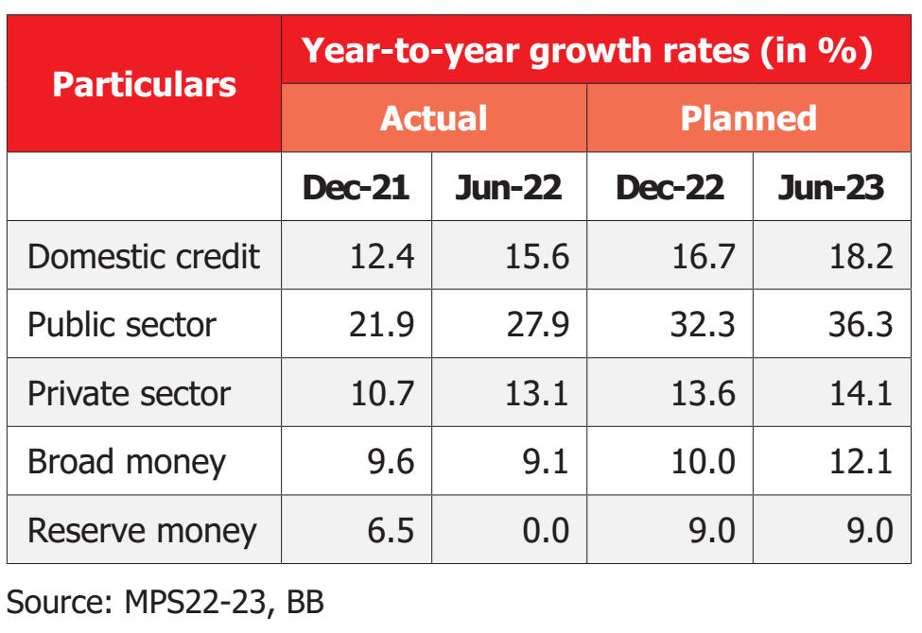

2.1. Specification of the industry:
My internship is with The AB Bank Limited, which is a part of the banking sector.
An important factor in the nation's economic growth is the banking sector. At the beginning of the twenty-first century, the biggest banks in the industrialized world evolved into increasingly sophisticated financial institutions. These banks manage billions of dollars' worth of assets and provide a vast array of services to global markets. Modern technology supports banks as they work to identify new business positions, implement cutting-edge strategies, flourish with customized services, and seize new market opportunities. Further financial industry diversification, deregulation, consolidation, and globalization will all contribute to the banking sector's increased complexity. Despite this, there are differences in the way the banking industry operates globally. Accordingly, the majority of bankers make the following assumptions about their corporate clients:
Commercial banking:
Services provided by commercial banking include foreign exchange, credit, deposit, and cash management. Payroll services, bank reconciliation, and money transfers are all included in cash management services. Commercial loans, asset-based financing, and credit lines are examples of credit services. Checking and savings account services are examples of deposit services.
Investment banking:
Investment banking encompasses a range of financial services such as asset securitization, mergers and acquisitions, corporate restructuring, securities underwriting, and merger coverage. It also involves the placement of debt securities with institutional investors.
Following independence, Bangladesh's banking sector consisted of six state-owned commercialized banks, two state-owned specialized banks, and three foreign banks.
Bangladesh's banking sector began with six state-owned commercialized banks, two state-owned specialized banks, and three foreign banks following independence. With the entry of private banks, Bangladesh's banking sector expanded dramatically during the 1980s. There are currently two main categories of banks in Bangladesh:
- Scheduled banks: Scheduled banks are the banks which get license under bank company act, 1991.
- Nonscheduled banks: Nonscheduled banks are those that are created with a specific goal in mind and operate in accordance with laws passed to achieve that goal. Banks that are created with a specific goal in mind and function under laws that have been passed to achieve that goal. All of the scheduled banks' capabilities that nonscheduled banks are unable to provide.
- Ansar VDP Unnayan Bank
- Karmashangosthan Bank
- Grameen Bank
- Jubilee Bank

Bangladesh Bank, which is permitted to do so by the Bank Company Act of 1991 and the Bangladesh Bank Order of 1972, oversees and controls 56 scheduled banks in Bangladesh. The scheduled banks are categorized into the following categories:

- State-owned commercial banks (SCBs): Six state-owned commercial banks in Bangladesh are either wholly or mostly owned by the country's government. The following are these:

- Sonali Bank Limited
- Janata Bank Limited
- Agrani Bank Limited
- Rupali Bank Limited
- BASIC Bank Limited
- Bangladesh Development Bank Limited
- Specialized banks (SDBs): Three specialized banks were established for particular goals such as industrial or agricultural development. The Bangladeshi government owns all or most of these banks. The following are these.-
- Bangladesh Krishi Bank
- Rajshahi Krishi Unnayan Bank
- Probashi Kallyan Bank

- Private commercial banks (PCBs):
There are currently 41 privately owned commercial banks operating in Bangladesh. Additionally, private entities own the majority of them. There are two categories for these banks: Traditional PCBs:
There are currently thirty-three traditional PCBs in use in Bangladesh's industry. They are carrying out banking operations using traditional methods, such as interest-based procedures. These are-
- AB Bank Limited
- Bangladesh Commerce Bank Limited
- Bank Asia Limited
- BRAC Bank Limited
- City Bank Limited
- Dhaka Bank Limited
- Dutch-Bangla Bank Limited
- Eastern Bank Limited
- EXIM bank Ltd
- IFIC Bank Limited
- Jamuna Bank Limited
- Meghna Bank Limited
- Mercantile Bank Limited
- Modhumoti Bank Limited
- Mutual Trust Bank Limited
- National Bank Limited
- National Credit & Commerce Bank Limited
- NRB Bank Limited
- NRB commercial Bank Ltd
- NRB Global Bank Limited
- One Bank Limited
- Premier Bank Limited
- Prime Bank Limited
- Pubali Bank Limited
- Shimanto Bank Ltd
- Standard Bank Limited
- The Farmers Bank Limited
- Trust Bank Limited
- United Commercial Bank Limited
- Uttara Bank Limited
- Union Bank Ltd

Islami Shariah Based PCBs:
Eight PCBs with an Islamic Shariah foundation operate in Bangladesh's banking sector. Additionally, they carry out banking operations based on Islamic Shariah principles, such as the Profit-Loss Sharing (PLS) model. These are-
- Al-Arafah Islami Bank Limited
- EXIM Bank Limited
- First Security Islami Bank Limited
- Islami Bank Bangladesh Limited
- Shahjalal Islami Bank Limited
- Social Islami Bank Limited
- Foreign commercial banks (FCBs): Nine foreign commercial banks, which are branches of larger banks overseas, are currently active in Bangladesh.. These are-

- Bank Al-Falah Limited
- Citibank N.A
- Commercial Bank of Ceylon PLC
- Habib Bank Limited
- HSBC
- National Bank of Pakistan
- Standard Chartered Bank
- State Bank of India
- Woori Bank

Our nation's central bank is Bangladesh Bank. Both nationalized and private commercial banks that are scheduled are under the supervision, control, and care of Bangladesh Bank. Prior to liberation, it was established by merging the operations of the twelve banks operating in Bangladesh, as shown in table 2.1 below:

Existing Bank | New Bank | Authorized Capital (Lac Tk.) | Paid-up Capital (Lac Tk.)
The National Bank of Pakistan, The Bank of Behawalpur Ltd. | Sonali Bank | 500 | 200
The Premier Bank Ltd., The Habib Bank Ltd., The Commerce Bank Ltd. Agrani Bank | Agrani Bank | 500 | 100
The United Bank Ltd., The Union Bank Ltd. | Janata Bank | 500 | 100
The Muslim Commercial Bank Ltd., The Standard Bank Ltd | Rupali Bank | 500 | 100
The Austrasia Bank Ltd., The Eastern Mercantile Bank Ltd. | Pubali Bank | 500 | 100
The Eastern Banking Corporation Ltd. | Uttara Bank | 500 | 100
Table 2.1: Banking History of Bangladesh

Twelve financial companies that conducted business in Bangladesh following its independence. And on March 26, 1972, the President of the People's Republic of Bangladesh issued Presidential Order No. 26 of 1972, also known as The Bangladesh Bank Order, 1972, nationalizing them.

2.2. Size, trend and maturity of the industry:
2.2.1. Size:
The size of the banking industry can be determined in a number of ways, including production volume, total revenue, customer base, and so forth. Furthermore, because both the total amount of deposits and advances are taken into account, the calculation of market size for the banking sector is highly correlated.

2.2.2. New Trends of Banking Industry:
Over the past few decades, there has been an increasing convergence of investment and commercial bank activities in response to financial sector deregulation. Certain commercial banks and investment firms currently compete directly with one another in the areas of private placements, project financing, bond underwriting, money market operations, and financial recommendations. Furthermore, Bangladesh has seen greater business variations as a result of the contemporary banking sector. Certain banks are venturing into the insurance, investment, and portfolio management sectors in the highly competitive world of industry. Because of all these variations, banks are now a significant player in the world of international business. Additionally, the banking sector in Bangladesh has seen some significant new developments, including the following:

- Trend of Electronic Banking:
E-banking is Bangladesh's newest method of delivering financial services. E-banking is the term used to describe a variety of computer or mobile services that allow a bank's client to request information and perform the majority of retail banking functions. There are three different generations of electronic banking: the first, second, and third generations. These are displayed in figure 2.1 below.
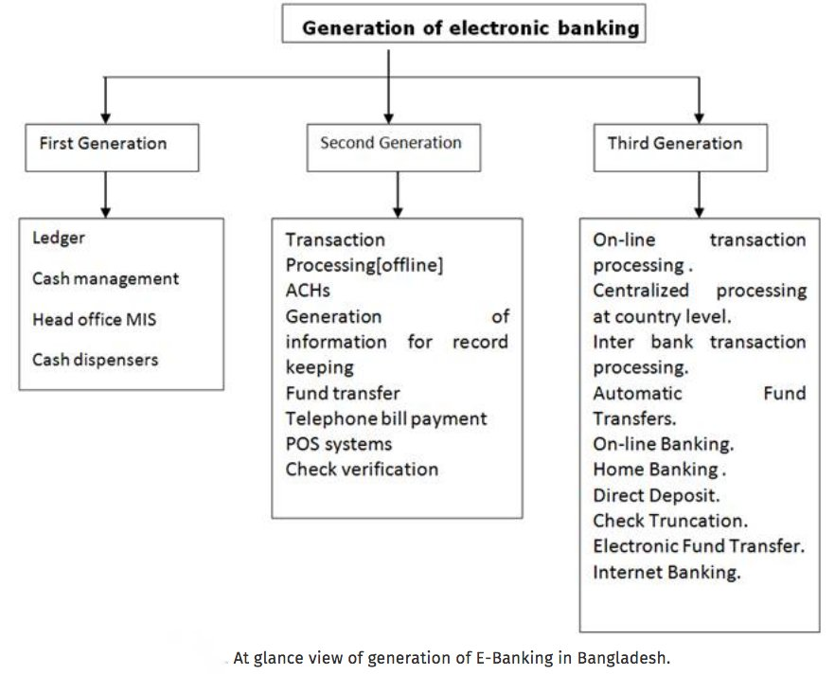
Figure 2.1: Generation of e-banking in Bangladesh
The first, second, and third generations of electronic banking have been covered in Figure 2.1. The following phrases can also be used to describe e-banking:
• Online banking via the internet.
• Banking over the phone.
• Online and mobile banking.
• Online or offline banking.

2.2.3. Maturity of the banking Industry:
The Bangladeshi banking sector is currently in its growing stage of maturity. Nearly every year, new clients visit various banks to open accounts, and new private banks are opening branches in two or three months. As a result, as of July 30, 2001, Bangladesh was home to four nationalized commercial banks, five specialized banks, thirty local private commercial banks, and twelve foreign commercial banks. Additionally, as of July 30, 2001, the banks had 7,462,785 advance accounts and 27,881,322 deposit accounts.

  - Seasonality:
Seasonal trends are significant issues for Bangladesh's retail and investment banks as well as the banking sector as a whole. Seasonality is most frequently associated with retail industries and agricultural commodities. The demand for capital, which banks deal in commodities, may seem unexpected in a broad, well-established capital market. The global economy's wide distribution is currently the most significant seasonal variation. It makes sense to assume that there are significant seasonal variations in Bangladesh when it comes to the borrowing and funding requirements for different industries. Furthermore, it would seem that over the course of a year, the total demand for capital across all demographic groups and business sectors would be relatively stable. Nonetheless, the monthly volume of new loans, which is the primary indicator of seasonal trends in the banking sector, is readily discernible.
The basic seasonal pattern of the banking sector in Bangladesh is a period of annual lows in late January and February, followed by a spike in loans starting in March and rising sharply through May, usually peaking in early June. The demand for banking services usually stays relatively flat or declines slightly during the summer months. From early October to early January, the banking institutions' services remain consistent, and the banking industry as a whole tends to see stability in growth during this time. However, the yearly pattern in the financial sector can be ascertained by looking at loan activity and the demand for investment services examining the financial and banking industry's stock performance over a twenty-year period, from 1995 to 2015. The two months with the highest average returns on investment for bank stocks were March and April. Following that, the next period of stock return is from October to December; historically, the finance sector has observed that February is the month with the lowest performance for bank stock. This seasonal pattern is caused by similar seasonality in Bangladesh's banking industry's interest rates.
Since interest rates are at their lowest in the spring and fall and at their highest in the winter and summer, most businesses are undoubtedly attempting to secure significant funding during this period, when rates are at their lowest. History indicates that spring is the prime time to buy a house. This pattern of activity is followed by a rise in applications for home mortgages in the months of March, April, and May. The last, but certainly not least, element that sets off the seasonal pattern in the banking sector is the wintertime spike in demand for investment servicesDuring this time, when clients make significant adjustments to their investments—such as year-end or year-beginning moves—portfolio and fund managers rebalance a lot in an effort to help individuals receive tax benefits. One significant factor contributing to the seasonal growth of the banking and financial institutions sectors may be the process of planning for tax repayment.

2.4 External economic factors:
Bangladesh's economy is experiencing instability due to the global economy's trend towards recession. Bangladesh's banking sector must therefore function in this particular economic climate. There are significant factors that have a big impact on the banking industry. such as the money supply and the economy's total demand. Bangladesh's low national savings, as measured by an international standard, point to the country's sluggish bank deposit growth. Low savings ultimately leads to low per capita income, a high dependency ratio, urbanization, inadequate infrastructure in rural areas, and inflation, which raises prices. Inflation is high as a result of rising food prices. Due to high inflation, there is a high level of poverty and stress on the productive volume. Because the banking industry operates in Bangladesh, all of these facts about the country's economy have an impact on it.
The banking sector has established itself as one of the most significant financial industries in any economy. Undoubtedly, a nation's economic potential can either increase or decrease based on the bank's performance. One of the main industries that contributed most to the observed economic collapses during the Great Depression of 1929 and the Economic Recession of 2008 was the banking sector. Thus, it is critical to examine the economic variables influencing the banking industry.
There exist specific factors in Bangladesh that impact banks, their operations, and their success or lack thereof. Five external economic factors have been identified as critical factors that could impact banks globally-

2.4.1 Inflation Rates:
Point-to-point inflation has been increasing since January 2022 and reached a peak of 9.5% in August 2022 before falling to 8.78% in February 2023. Both food and non-food inflation contributed to the spike in the inflation rate during the final quarter of FY22. Decelerating food inflation at the start of FY23 somewhat reduced the inflation rate. Bloomberg reports that the previous FY22 inflation target of 5.6% has been revised to 7.5% for FY23..
2.4.2 The income of the country and its economic level:
During economic booms, banks tend to do better than during recessions. The amount of capital that banks can access depends on the nation's income. The nation's income also sets spending and borrowing restrictions, and it is a key component of Bangladesh's banking sector. Governments in countries with sufficient income have the ability to recover banks that encounter financial difficulties.

    - Economic policies:
Different macroeconomic policies have an impact on Bangladesh's banking sector. A nation may occasionally adopt unfavorable policies. The banking sector loses macroeconomic policies that can make all the difference and difficulty if a nation adopts unfavorable policies. Furthermore, the banking sector will eventually lose its vital growth.

    - Laws and regulations:
Financial organizations must operate within a specific regulatory framework in each nation in order to perform advisory, supervisory, or monitoring functions. These laws, which are crucial for the banking sector in Bangladesh, govern both small-scale decisions like banking services, interest rates, and loan regulations, as well as major decisions like opening and closing hours. The banking industry may be unable to conduct business in a nation with stringent laws and regulations. In an attempt to increase profits, certain banks may easily lose focus in the face of a lax regulator. Therefore, the liberal regulator poses a serious risk to all banks. Consequently, it's critical to uphold a sensible regulatory framework that takes into account the needs of the bank and its customers.

    - Exchange Rates across the world:
The exchange rate is a global issue that has an impact on people all over the world. Strong currencies like the US dollar, British pound, European Euro, Japanese Yen, and Canadian dollar, among others, have a broad impact on other currencies and financial markets. When these currencies' exchange rates decline, the banking sector may face difficulties.

  - Technological factors:
Technological factors are variables that have to do with technology's development, availability, and existence. This could involve anything from engine efficiency to processing power. Unless we stand back and examine every piece of technology that is employed on a daily basis in the banking industry, it may be difficult to determine how technological advancements can directly impact the sector. Technology has a significant influence on how many things are done in Bangladesh's banking sector.
Typical instances of technological factors influencing Bangladesh's banking sector include:
- The availability of three-dimensional technology
- Computing power or speed of calculation
- The ability of computers to produce numbers that are actually "random"
- engine performance
- Internet access
- Charging wirelessly
- Mechanization
- Cryptography security.

Many banks offer mobile apps that allow users to pay bills, transfer money, and keep track of accounts on their smartphones. Smartphones are capable of scanning checks, and banks can create them on their premises. By making this adjustment and removing the need for direct operations to handle this matter with the branch, it supports saving paper.
Debit cards are also being changed. Chips have been introduced because users are requesting to insert their cards rather than swipe them from debit machines. Other nations, including Canada, have adopted a tap option. There is no pin number needed for a transaction to be completed; all that is needed is tapping the debit card onto the terminal. to facilitate purchases without the need for bank intervention by implementing these user-friendly changes.
At work, even banks themselves are utilizing technology. Telecommuting is being used to incorporate virtual meetings, eliminating the need for in-person gatherings.

With easily accessible apps and internet services, technology is assisting consumers in both saving and spending money. It's no longer necessary for users to visit their branch for many daily transactions. As a result, less paper is used and less gas is used to travel to and from banking locations.
Banks abide by trade agreements, privacy laws, and consumer laws. Because more and more banking transactions are being conducted via technology, they also need to have excellent cyber security.
As technology has advanced and become more widely used, it has opened up numerous opportunities for a wide range of industries. These days, automated teller machines have supplanted traditional ones. Consequently, the entire banking system has been automated, ensuring system transparency. The client's trust has grown as a result. Internet technology has made online banking commonplace in the West and is also becoming more and more popular in Bangladesh, opening up new career opportunities.

  - Political, legal and regulatory factors:
2.6.1 Political factors:
In addition to the general conditions of Bangladesh, foreign investors and multinational nations have also been impacted by the political instability that the country has experienced and continues to experience. Because of how the political climate in the nation influences banking, the central bank of Bangladesh has complete control over the operations of both domestic and foreign banks. Foreign investors are reluctant to hold onto their money because they fear frauds (such as the recent corruption scandals at SONALI Bank PLC), political unpredictability, and Bangladesh's notoriously chaotic culture. Additionally, other political ferocities like "HORTAAL" hinder banking operations.
The appalling results of the finance ministry's overreach are evident in the licensing of new banks. "Private banks that received licenses due to political considerations a few years ago have not performed up to par. Additionally, there have been several allegations of money laundering through some of these banks, according to prominent economist Dr. Debapriya Bhattacharya. Furthermore, prior to opening for business, the nine new banks were granted four conditions by the Bangladesh Bank. Since they have not met these requirements, they are now pressuring the Bangladesh Bank to lower those requirements. The Bangladesh bank could not fully monitor these banks even though some of them were linked to loan scams, aggressive lending, and breaking banking rules and regulations, among other things, posing threats to the banking industry, according to the Bangladesh bank's own valuation, because those with political clout owned these banks. In the words of Dr. Debapriya Bhattacharya, "the government essentially went on to increase the control of the family members of bank owners by amending the banking law and regulations, not only were no preventive measures taken.”.

2.6.2 Legal factors:
Bangladesh's economy has grown less rapidly as investment has slowed down due to the unreliability of the legal system and the judiciary's lack of independence. Due to certain illegal factors, the state of law and order in Bangladesh's banking sector has gotten worse. Many investors who have already made investments face insecurity and threats as a result. Furthermore, the prospective foreign investors have changed their minds. A number of laws affect Bangladesh's banking sector. The banking industry is heavily regulated and subject to oversight due to the significant legal risks involved. To control this banking sector, several laws have been proposed in Bangladesh. The government ought to include social responsibility and customer concerns as legal considerations in banking industry of Bangladesh.

    - Regulatory factors:
The central bank of Bangladesh, Bangladesh Bank, imposed administrative regulations on the banking sector. Banks with minimum paid-up capital and reserve requirements are necessary for Bangladeshi banks. Furthermore, Bangladesh Bank mandates that no company, individual, or family hold more than 10% of the bank's shares, either jointly, individually, or both. With prior approval from the government, Bangladesh Bank is free to alter its policy regarding the reservation of risk-based capital for assets at any time. The Bangladesh bank may decide to regulate advances in accordance with banking industry standards. Bangladesh Bank has direct power to name a new CEO, General Manager, or Managing Director. The Bangladesh bank also takes the place of a banking corporation's board of directors. Bangladesh Bank additionally functions as an official liquidator. It has the direct power to give banking companies guidelines. Additionally, Bangladesh Bank removes directors when it believes that doing so might be in the public interest.

  - Barriers to entry:
There are not many obstacles to entry in the banking industry.
2.7.1. Establishment criteria:
A new bank's ability to open in Bangladesh is restricted by a number of laws, including minimum capital and licensing requirements.
2.7.2 Fixed investments:
An IT infrastructure, branch network, ATMs, and online banking are requirements for a new bank. These will be very expensive.
    - Staff:
Being a new bank, there will initially need to be experienced employees. The bank must be able to entice these employees away from their current positions by offering the right kind of incentives.
    - Competition or Saturated market:
The current banks have already extensively developed the market. The bank must have the ability to change things. This may be accomplished by means of their services, pricing, marketing, or product line. However, since this will serve as the cornerstone of their strategy, a bank must make a decision and start planning early.

  - Supplier Power:
Information technology has strengthened depositors' and investors' bargaining power in Bangladesh's banking sector. Authorized depositors are part of the online and mobile banking development. While customers search for loans at the lowest interest rate, depositors can quickly use the internet to obtain their services and determine which bank is offering the highest interest rate. As a result, depositor options have expanded in tandem with the banking industry's increased price sensitivity.

  - Buyer Power:
Customers have a fair amount of negotiating power. The primary factor influencing buyers' power is high substituting costs, but the individual doesn't represent much of a threat to Bangladesh's banking sector. Certain services include checking, savings, mortgages, and banking needs, among others. It can be very difficult for someone who uses a bank's services to transfer to another bank in order to obtain banking services. In an attempt to persuade customers to transfer banks, they frequently cut the switching costs; however, the majority of customers still decide to keep their current account.. Because of the internet's power, the customer's influence in Bangladesh's banking sector has also grown significantly. In terms of account opening or maintenance fees, the internet has significantly decreased costs while substantially enhancing customer comfort.

  - Threat of substitutes:
In Bangladesh, alternative financial organizations handle a large portion of the financial transactions and activities related to leasing. However, the scale of these lending and finance companies is much too small. These institutions can reduce the commercial banks' profit margin.
United Leasing Company, Industrial Promotion and Development Corporation (IPDC), and Industrial Development and Leasing Company Ltd. (IDLC) are the major participants in these organizations. These organizations provide industrial leasing to numerous companies across the nation. Furthermore, Vanik Bangladesh Ltd., a merchant bank, is a potential competitor to Bangladesh's banking sector since it provides investment advice and credit services in addition to other financial services. However, some of the bank's activities, such as exporting or importing have no substitutes.
.
  - Industry rivalry:
The banking sector is regarded as having fierce competition. Almost everyone who needs banking services already has access to them because the financial services sector has existed for hundreds of years. Because of this, banks have to work hard to keep clients and customers from switching to competitors' banks.
Nowadays, there is a tendency for the same customer base from local and foreign banks to compete directly with one another. It is found that foreign banks are local banks' direct competitors for the same clientele and market share in the banking sector. Additionally, the local banks still have an advantage because of the long-standing trust relationships they have with their clients. Because of how easy it is to imitate the transparent banking system, rivalry amongst competitors is growing daily as local banks can copy their strategies very quickly. Local banks target the middle-class and upper-middle-class segments of the customer base that currently patronizes multinational banks. Additionally, neighborhood banks never stop attempting to win over these clients. When compared to government banks, they have higher interest payback rates and relatively lower interest rates. Since they have drastically reduced switching costs, they pose a serious threat to Bangladesh's banking industry's clientele.

  - Summary of challenges and opportunities:
Bangladesh's banking sector is presently experiencing a severe crisis. Every day, more loans are going into default. However, for a variety of reasons, this industry is currently experiencing a severe liquidity crisis. The crisis is being exacerbated by multiple levels of political meddling, unethical and corrupt banking practices, and unhealthy bank competition. This industry is rife with instances of poor accountability, transparency, and governance. The following list includes a few issues facing Bangladesh's banking sector:
- Bangladeshi private commercial banks are experiencing a liquidity crisis.
- Taking money out of private commercial banks.
- Reduce export earnings while raising import expenses.
- Decline in overseas remittances as a result of the unauthorized mobile banking network.
- Laundering of money.
- Unusual competition between banks for the collection of deposits.
- Not adhering to the correct procedures when approving and paying loans.
- Lack of diligent loan monitoring.
- Absence of accountability, transparency, and sound governance.
- Unethical behavior or corruption
- An excessive amount of banks in Bangladesh, a small country
- Weakness of laws.
- Unbalanced financial system.
- An uneven political landscape.
- Lack of confidence of general people on banks.
- Minimal remittance.
- Inadequate oversight by Bangladesh Bank's central bank

Bangladesh's banking industry has a plethora of opportunities. Below are some opportunities for Bangladesh's banking sector:
- Bangladesh's banking sector has a fantastic chance to grow into a significant economic force in the country.
- Bangladesh is home to a large population. This benefit might hasten the banking sector's development and expansion in Bangladesh.
- The banking sector in Bangladesh has the capacity to guarantee appropriate product and service superiority in accordance with the demands of the international market.
- Bangladesh is home to ten international banks, but as of yet there is only one Japanese bank. Therefore, there are plenty of opportunities for Japanese banks to open branches in Bangladesh.
- Banks carry out tasks that businesses are unable to complete on their own.
- Banks have access to markets, financial institutions, and traders that businesses or individuals most likely could not.
- Banks are able to obtain the best possible deals for their customers by utilizing their expertise and connections.
- Simple access to information about international norms and regulations for oversight, monetary management, and other central banking tasks
- Utilize Bangladesh Bank's independence and the technical assistance provided by development partners.
- New technology and instrument development in the banking system; increased autonomy and authority granted by modifications to laws and regulations in Bangladesh's banking sector.

Chapter 3
Analysis of the organization

  - Overview and history:
3.1.1 Overview of the AB Bank:
ABL has successfully established a unique brand both domestically and internationally by offering a variety of banking products that meet the needs and expectations of the populace. In the 1980s, ABL was the first bank to enable garment industry entrepreneurs to take out back-to-back LC facilities with no margin, which helped the sector grow to its current state. This has not only increased the nation's foreign exchange reserves but also given a sizable portion of the labor force in the nation new job opportunities. Being a trailblazer in this field, ABL's name will always be in gold letters.
ABL was the first to support the ready-to-wear industry and continues to be the biggest financier in this field. When Bangladesh's garment industry was going through a trial period in the early 1980s, the bank saw the industry's bright future and provided financing to worthy and promising business owners. It gave them financial support as well as market knowledge and guidance, and now the apparel industry accounts for roughly 66% of all exports from the nation.

3.1.2 Historical background of the AB Bank:
Presenting Bangladesh's first private sector bank, AB Bank Limited, established on December 31, 1981. Formerly known as Arab Bangladesh Bank, it began operations on April 12, 1982, with the goal of becoming the nation's top-performing bank.
With the goal of becoming the top service provider, AB has developed a golden heritage and an envied legacy that few could match. This legacy benefits its clients, shareholders, employees, and the community in which it operates. Over the course of the last 41 years, AB has accomplished many milestones and implemented many changes, all while staying true to its goal of becoming Bangladesh's technologically advanced and innovative bank. AB has successfully introduced internet banking, SMS banking, cutting edge ICT, state-of-the-art network solution, 24/7 ATM service, and many other e-products to excel in this new era of technological triumph.

Over the past 40 years, AB has significantly expanded its services both domestically and internationally. The bank first opened for business on April 12, 1982, in Karwan Bazar. Today, it operates 105 branches nationwide, including one overseas location in Mumbai, India, and more than 270 ATMs. Its primary banking operations are linked to five subsidiary companies, one of which is an offshore banking unit, and custodial services. In order to expand its international operations, the Bank established a representative office in Yangon, Myanmar.

3.1.3 Vision of the AB Bank:
“To be the trendsetter for innovative banking with excellence & perfection”

3.1.4 Mission of the AB Bank:
“To be the best performing bank in the country”

3.1.5 Values of the AB Bank:
Our Compliances
Giving our customers the best financial support with corporate integrity—that is, a fully compliant bank along with involvement in social development—means that we prioritize adherence to national policies and objectives.
Our Shareholders
Through steadfast, responsible performance, we guarantee the highest returns for our investors.
Our Customers
We prioritize our customers' needs above all else, and we work tirelessly to ensure that they are completely satisfied.
Our Team Members
We guarantee that every employee contributes to the success of ABBL by offering stable, fulfilling work.

3.1.6 The Rebranding
AB made a deliberate effort to revive its former identity, which it had for 25 arduous years as Arab Bangladesh Bank Limited. As a result, on November 14, 2007, Bangladesh Bank officially adopted the new name AB Bank Limited. The new logo for the bank represents the fusion of trust and camaraderie. It created its logo with a modern theme while adhering to its vision, mission, and core values. The new logo symbolizes our cultural "Sheetal pati" since it shows how we connect with our customers and attend to all of their needs. Thus, "Bonding" is the new AB spirit".

3.1.7 Product Gallery
By offering a vast array of diversified products and services, AB has now solidified its standing with the nation's highest rated banks. AB provides a broad selection of loan and depository products to almost satisfy the needs of every consumer group. AB offers almost all banking products, ranging from Student Banking to Priority Banking. The product gallery offers a wealth of information, and cutting-edge offerings are presented in the areas of consumer loans, ATMs, Internet and SMS banking, remittance services, Treasury Products and Services, Women's Entrepreneurship, Small and Medium Enterprise (SME) credit, and Debit and Credit Cards (Local & International). Corporate Finance; Investment Banking; Specialized Products and Services for NRBs; Priority Banking; Growing and Developing Its Islamic Banking Activities; and Customer Service. Dedicated Relationship Managers at AB are committed to helping customers manage their finances, maintain their lifestyles, and prioritize their needs no matter where life takes them. AB also offers high-quality products and services.

3.2 Company profile:
Name of the company: AB Bank limited
Sub Industry Group: Private Commercial Bank
Company Form: Public Limited Company
Corporate Office: BCIC Bhaban 30-31, Dilkusha C/A, Dhaka, Bangladesh
Date of Incorporation: 12 April 1982
President & Managing Director: Mr. Kaiser A. Chowdhury
Auditors: ACNABIN
Authorized Capital: 600, 00, 00, 000/

Table-3.1: Sponsors of AB bank

Bangladeshi Sponsors | 20%
Bangladeshi General Public | 15%
Bangladesh Government | 05%
Dubai Bank Ltd | 60%

Capital structure of AB Bank Limited:
Bangladeshi sponsors/ Directors: 50%
Bangladeshi General Public: 49.43%
Govt. of Bangladesh: 0.57%

3.3 AB Bank Structure
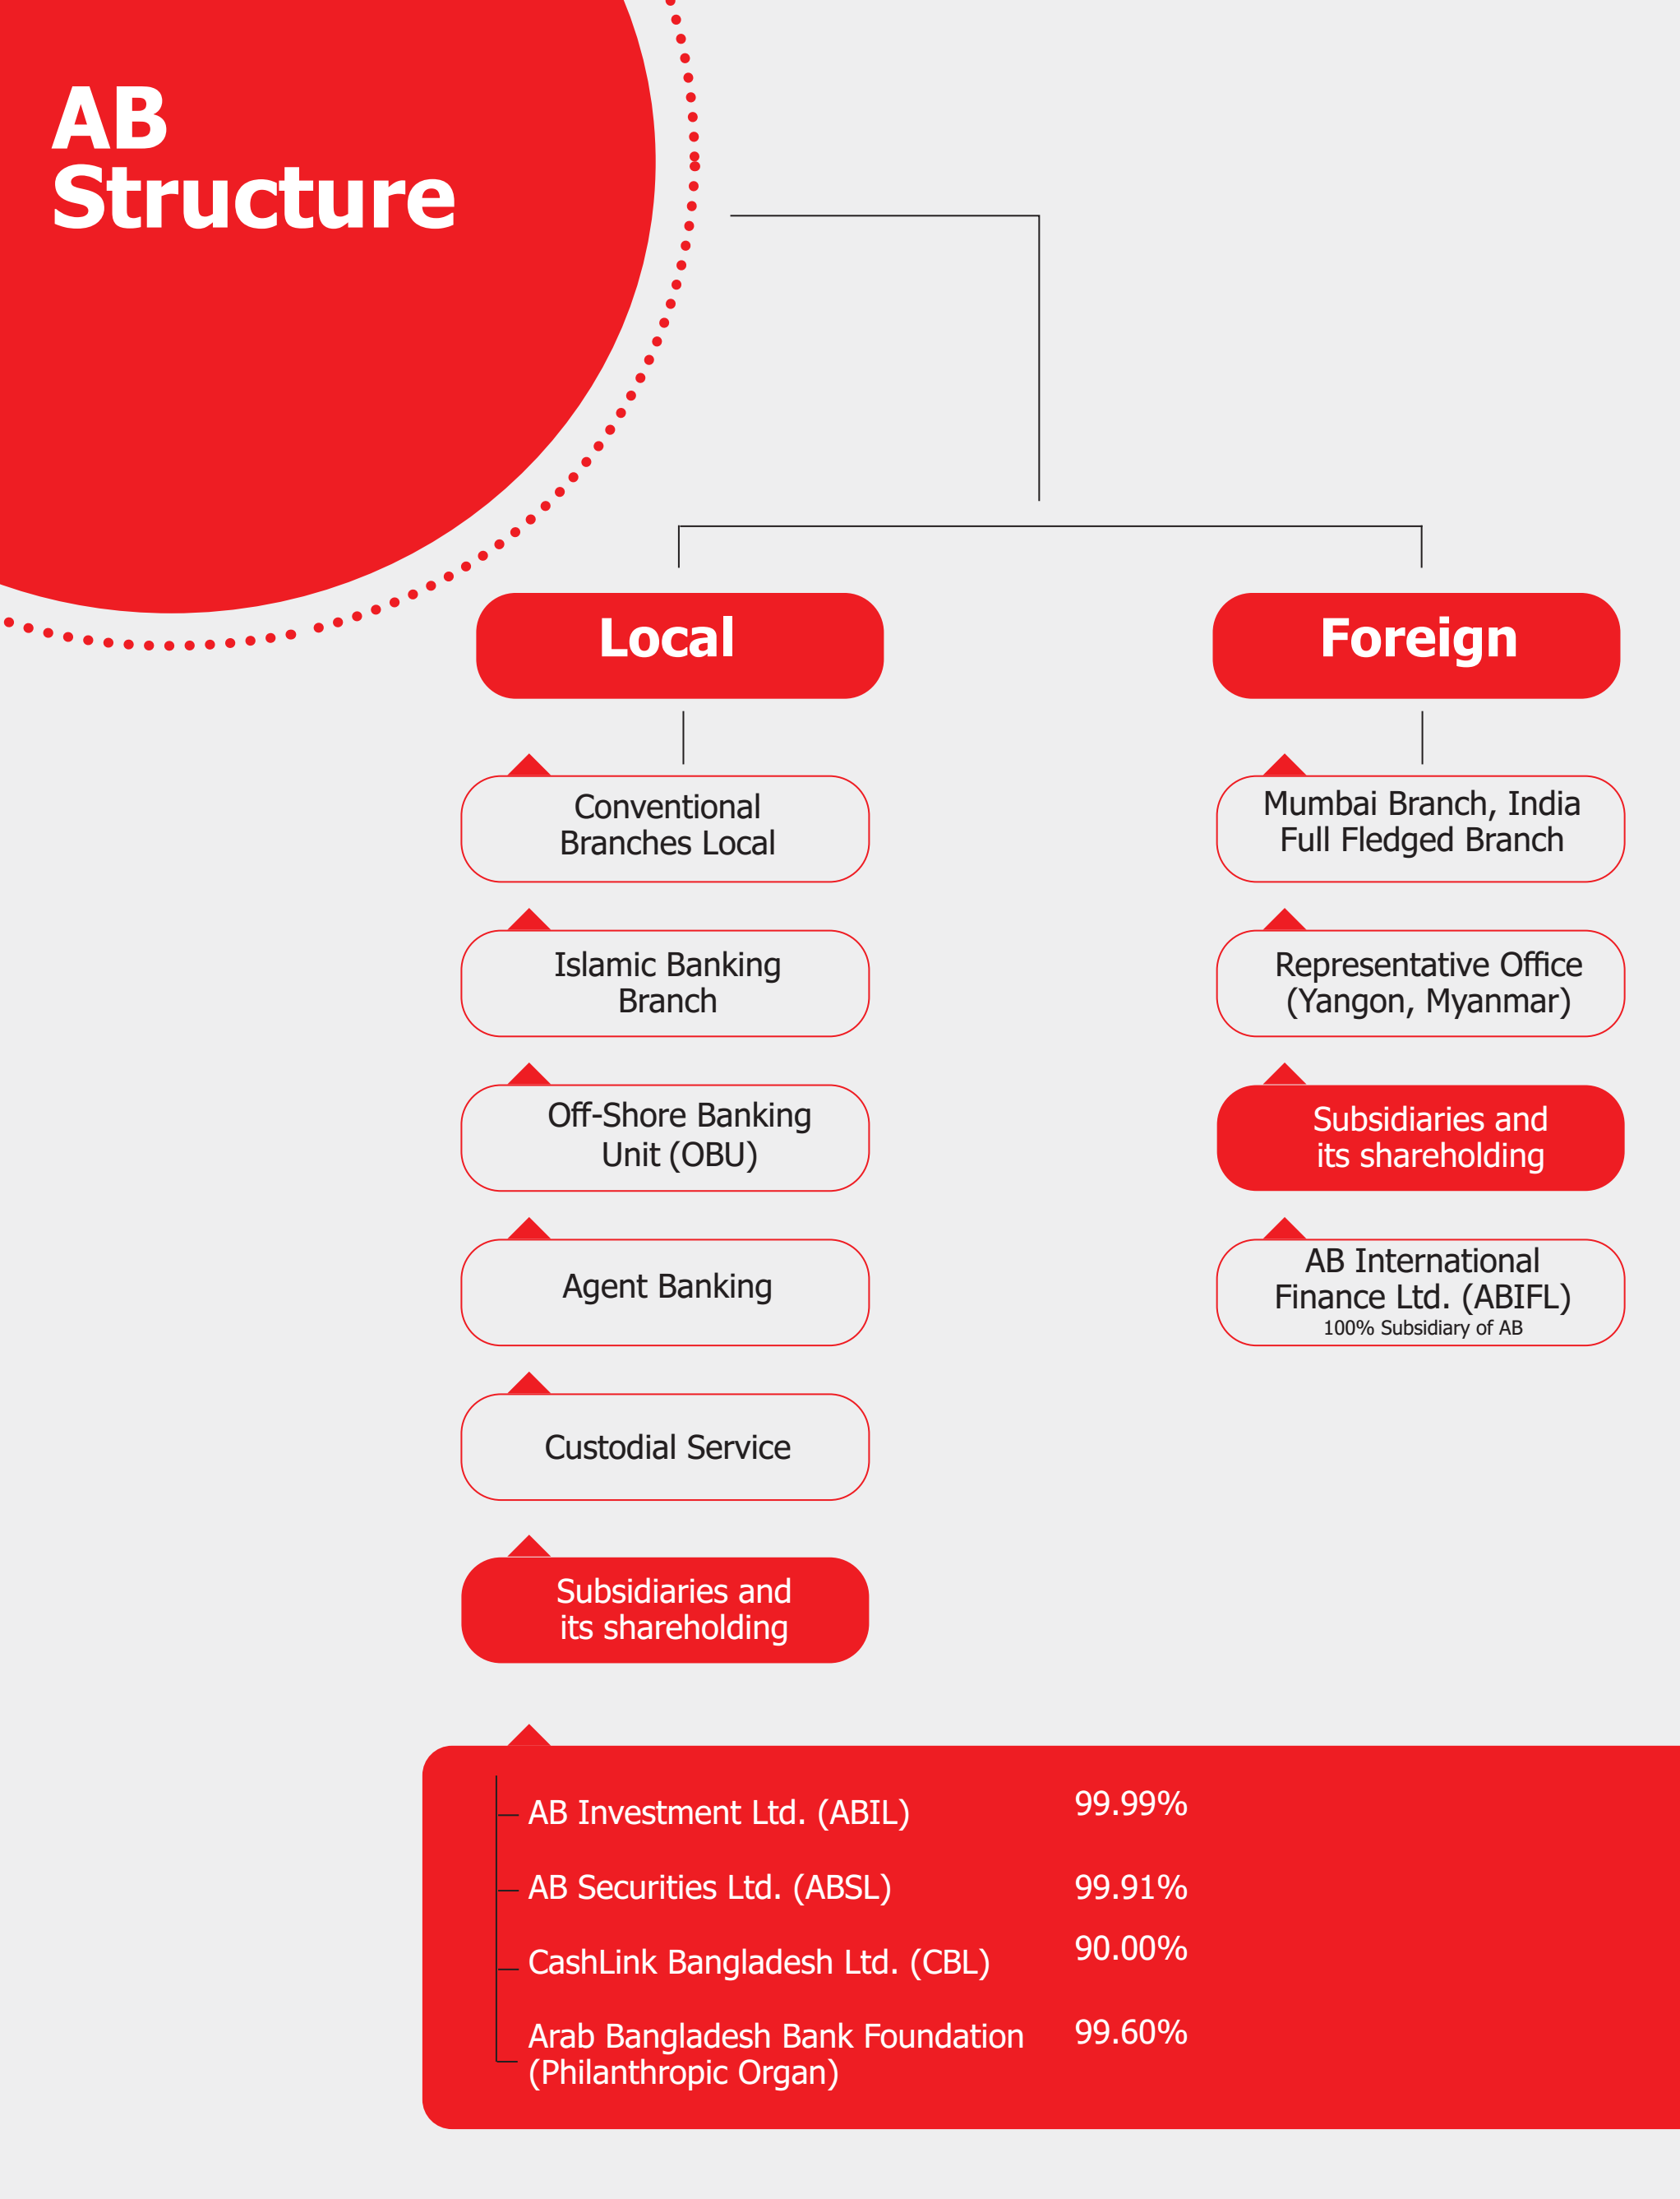
Sources: AB Bank Limited Annual Report 2023
Figure-3.1: AB Structure
AB operates along with 105 branches nationwide with commercial banking, islamic banking, agent banking and custodial services. Also established a branch in Mumbai, India and a representative office in Yangon, Mayanmar.
3.4 Shareholders’ Information
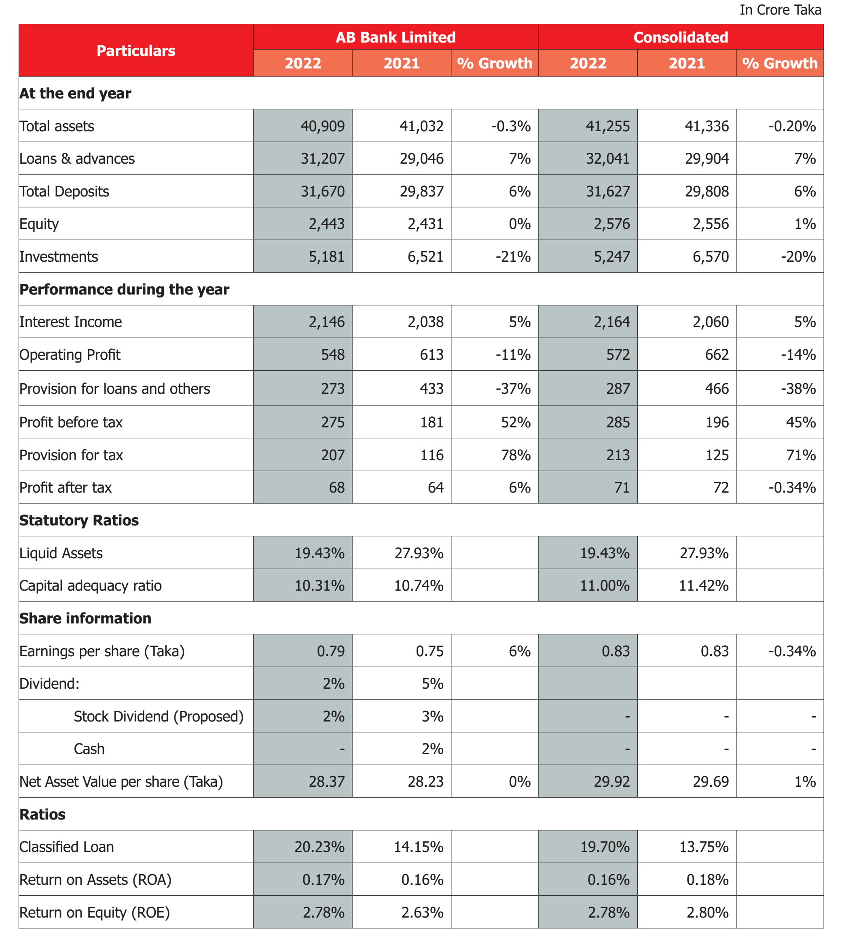
Sources: AB Bank Limited Annual Report 2023
Figure-3.2: Financial Statement
The figure shows the financial statement of AB Bank and its other subsidiaries. the chart shows a little bit shortage of liquid assets in year 2022 which indicates a shortage of bank deposit. But in overall if we look at the increase in EPS in year 2022 gives a profitable ROE, which is a good sign.

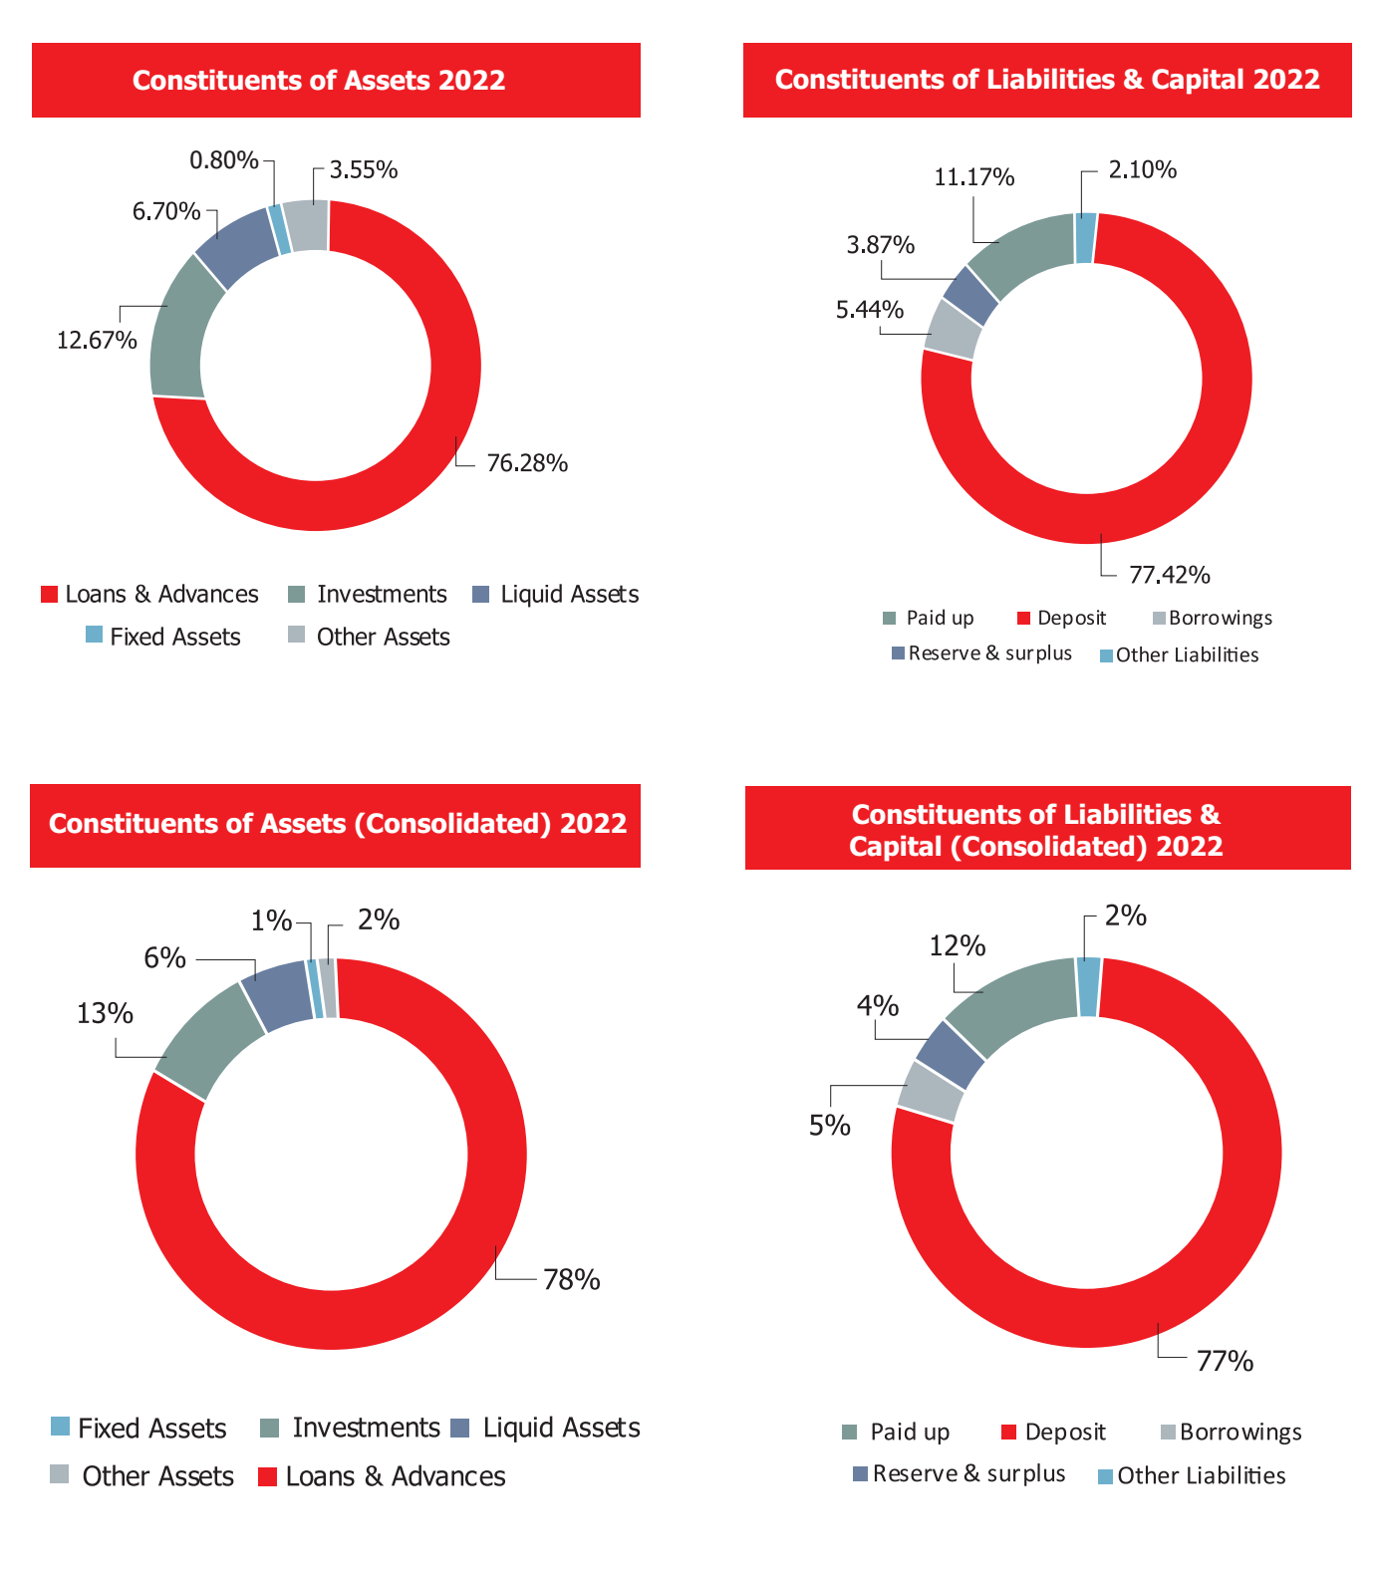
Sources: AB Bank Limited Annual Report 2023
Figure-3.3: Financial Summery

3.5 Last 10 Years’ Performance
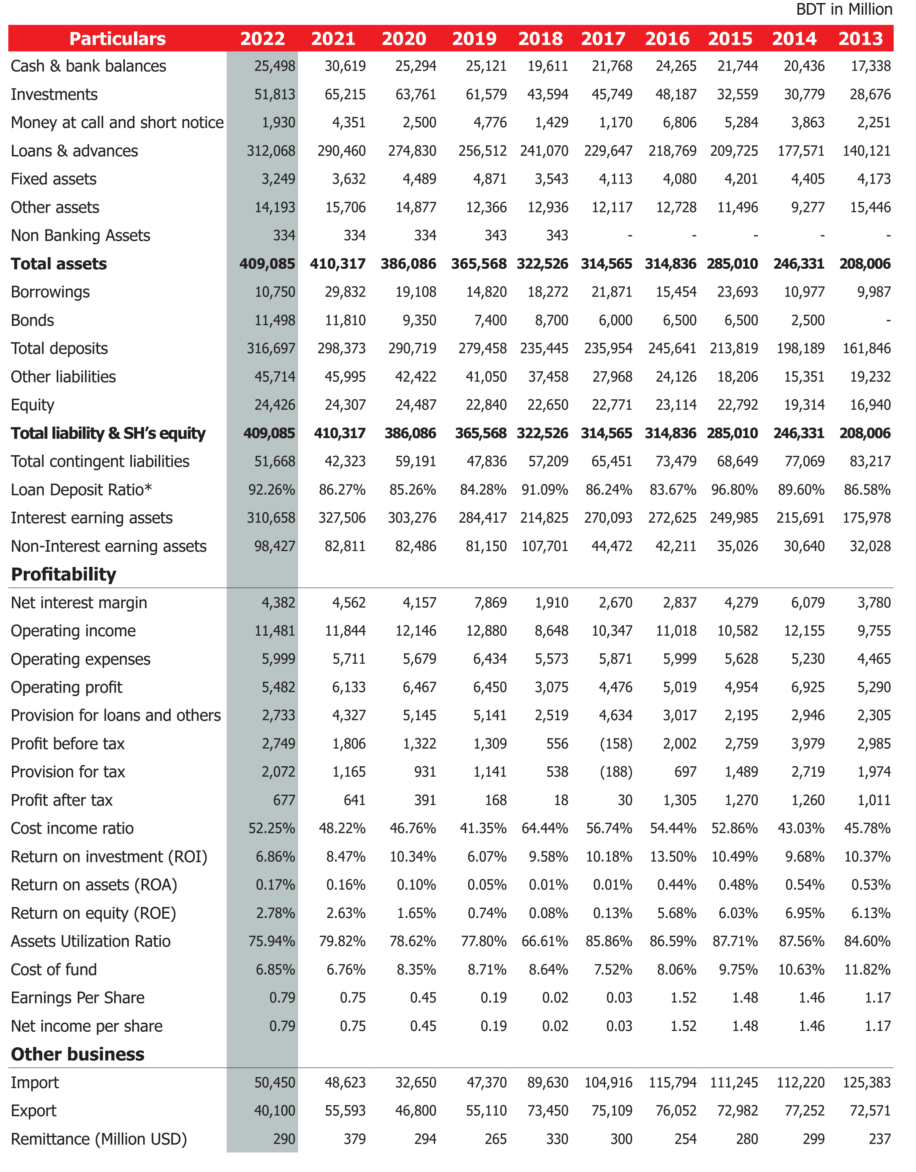
Sources: AB Bank Limited Annual Report 2023

Figure-3.4: 10 years’ Performance Report
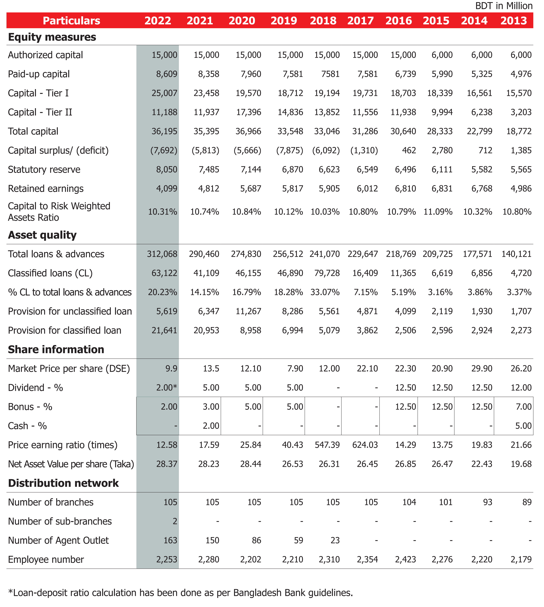
Sources: AB Bank Limited Annual Report 2023
Figure-3.4: 10 years’ Performance Report
The figure shows that AB bank is gradually growing its performance over the year.
3.6 Board of Directors
The Board of Directors (BODs) of ABBL was composed of ten members, with Mr. Faisal M. Khan serving as the chairman. The BODs met nine times in 2014. The Board of Directors of the Bank meets once a month on average, but may convene more frequently if necessary. The board develops policies, establishes strategic directions, approves business plans, reviews a range of activities, and gives management the guidance they need to run profitable and competitive operations. In line with the directives of the central bank, the Board also guarantees efficient risk management throughout the Bank. The Executive Committee and the Audit Committee are the two subcommittees of the Board. Below is a description of those committees' duties:
Executive Committee
Under the direction of Mr. Sajedur Seraj, Vice Chairman ABBL, the Board's Executive Committee, comprising 5 members (including the Chairman), examines all loan and advance proposals that do not come under the purview of the Managing Director. The committee is also in charge of administration, the investment side of things, business growth, the acquisition of bank property, loan rescheduling, etc. The Board evaluates the operational outcomes and upholds the decisions made in all Executive Committee meetings.
Audit Committee
According to Bangladesh Bank's BRPD Circular No. 12 of December 23, 2002, the Board established an Audit Committee in 2011 with three members. The Committee meets on a regular basis to review and monitor financial reporting, internal control and audit functions, regulatory compliance, and other operational activities. The Committee is chaired by Mr. M. Wahidul Haque and consists of Mr. Sajedur Seraj, Mr. Golam Sarwar, and Mr. M. Wahidul Haque. The Committee places special emphasis on areas like risk management system, Bank's computerized system and its use, and so on. The committee convened seven times in 2014.
Delegation of Authority
Delegating authority is crucial to ensuring that clients receive timely and effective services. But the rule ought to be, "business comes first, safety comes second." At various operational levels, ABBL plans to assign specific authority to its executives. The Executive Committee now has the authority to make decisions about operational and approval processes, thanks to a BOD directive. By means of a power of attorney, the Board has additionally granted the Managing Director specific authority.

Internal Control and Internal Audit System
2011 saw ABBL implement a preemptive risk management plan as part of its business expansion strategy in order to address operational risks and meet compliance requirements. The Bank began implementing Risk Based Audit throughout the entire Bank in 2011. The HO's branches and divisions submitted risk-based audit reports to the BOD for the first time. Such a parameterized health report helped the bank's risk management plan by generating an overall risk rating for the bank. In 2012, a new risk-based audit system was used to audit 26 branches; this year, the bank hopes to audit every branch using the same system. The Departmental Control Function Checklist, Quarterly Operations Report, Loan Documentation Checklist, and other risk management tools were revitalized by ABBL.
Every branch is subject to an internal audit by ABBL's Internal Control & Compliance Division once a year. In the event of a unique occurrence, the team also conducts audits. The division responsible for audits and inspections operates independently and with complete autonomy. Without prior permission, the team is free to audit any branch or department at any time. This division held training sessions on a variety of Risk Management and Compliance topics, such as Anti Money Laundering matters, for Branch Managers and other staff members throughout the year. The following tasks were carried out by the Internal Control and Compliance Division last year:
- Audit of 104 branches,
Accounting and Auditing
Reputable software developer Misys Equation Banking System, which covers the general ledger and numerous operational aspects, is the accounting software used by ABBL. The Bank's auditor claims that the financial statements seem to include all required disclosures required by the regulatory framework, including adherence to the terms of the Bangladesh Accounting Standard (BAS), as stated in the relevant BRPD circular. Reputable chartered accounting firm M/S ACNABIN audited the annual financial statements, and they produced an unqualified audit report for the relevant year.
3.7 Management
Mr. Kaiser A. Chowdhury, the company's president and managing director, is in charge of management at ABBL. With a long banking career, Mr. Chowdhury is one of the nation's senior bankers. In 1975, he began his banking career as a trainee officer at ANZ Grindlays Bank Ltd (now Standard Chartered Bank), where he remained until 1999.
Later that year, he began working as an executive vice president for One Bank Limited, where he remained until 2004 (now as a DMD). He continued to work for ABBL after joining the Arab Bangladesh Bank Limited (now known as AB Bank Ltd) in 2010. The other senior management team members support Mr. Chowdhury in carrying out the day-to-day operations of the bank.
The Bank has established the following committees to ensure efficient operation:
A weekly meeting of the Management Committee (MANCOM), which is led by the Managing Director and consists of ten senior members of management, is held to discuss pertinent issues pertaining to the Bank's operations. MANCOM's responsibilities include setting and reviewing management policies, setting business objectives and operational initiatives, ensuring that all business plans are implemented smoothly and periodically reviewing them in light of changing circumstances, linking all functional activities at the headquarters and branches, conducting a periodic review of management activities, and more.
B. The Managing Director is in charge of the Credit Committee, which is in charge of reviewing all credit proposals that come from the CRM Division, making decisions and recommendations in accordance with delegation guidelines, reviewing business strategies and performance, the status of loans and advances, providing credit-related MIS to the Board or EC for review, and so on. There are five people on the committee.
C. The Managing Director is in charge of the Asset Liability Management Committee (ALCO), which is in charge of balance sheet risk management. There are seven people on the committee.

Branch Network
As on 2022, AB Bank had 101 branches including 1 (one) Islamic branch in Kakrail, Dhaka and 1 (one) overseas branch in Mumbai, areas of Bangladesh.
Table- 3.2: Division wise branches location of AB bank

Division Name | Number Of Branches
Dhaka Division | 44
Chittagong Division | 28
Sylhet Division | 10
Khulna Division | 6
Rajshahi Division | 6
Rangpur Division | 4
Barisal Division | 1
Mymensing Division | 2

3.8 Services of AB Bank
AB Bank Provide the following services to its customer
- Retail Banking: AB bank has a wide range of products to suit everyone’s need, like savings acoount ,current account, FDR account, AB Jonmobhumi (for NRB), Double deposit scheme, AB Nischinto (an FD account with free life insurance), AB Height (with inherent credit card) and more. Loan facilities with-
- personal loan, auto loan, home loan
- Secured loan or personal overdraft
- Corporate banking: For development and growth of corporate sector AB bank comes with AB Corporate Finace and AB Structured Finance.
- SME banking: Gati (part of business’s working capital), Proshar (long term finance), most popular Awparajita (to encourage female entrepreneurs)
- Loan syndication; Gives tailor made solutions for a financial need.
- Islami banking: Welfare based banking without charges and interest, first opened its branch in kakrail in 2004.
- Other Services
- AB investment banking: ABIL, subsidiary of AB bank provides the merchant bank services.
- Card service: Dual Currency Debit card, Credit card, 0% EMI partners, Discount partners
- Money Transfer (western Union)Locker service
- Remittance service: AB Jonmobhumi account holders can get 1% extra incentive with 2.5% govt. incentives.
- ATM service: 250+ ATM booths nationwide on 24/7 service basis. Accepts other NPSB member banks card with minimum charges.
- Foreign trade: Outward TT, Inward TT. Remittance, FDD (Wage Bond)
- Internet Banking: With the application AB Direct can operate ones banking without going to the bank.

3.9 Graphical Presentation Growth:
Table 3.3 : Deposits
Year | 2018 | 2019 | 2020 | 2021 | 2022
Deposits | 235445 | 279458 | 290719 | 298373 | 316697

Sources: AB Bank Limited Annual Report 2023
Figure 3.5: Deposits
Table 3.3 and the graph in figure 3.5 shows over 5 years AB bank gradually increasing deposits with target achieving.
Table 3.4: Loan & Advances
Year | 2018 | 2019 | 2020 | 2021 | 2022
Loan & Advances | 241070 | 256512 | 274830 | 290460 | 312068

Figure 3.6: Loan & Advances
Ab Bank is increasing its loan giving schemes as it has increasing liquid capital.

Table 3.5:Equity
Year | 2018 | 2019 | 2020 | 2021 | 2022
Equity | 22650 | 22840 | 24487 | 24307 | 24426

Figure 3.7: Equity
over the last three years AB bank maitaining a similar amount of equity.

Table 3.6: Capital
Year | 2018 | 2019 | 2020 | 2021 | 2022
Capital | 33046 | 33548 | 36966 | 353958 | 36195

Figure 3.8: Capital
AB bank is trying to increase the capital amount to cope with the competitive market.
Table 3.7: Export
Year | 2018 | 2019 | 2020 | 2021 | 2022
Export | 73450 | 55110 | 468900 | 55593 | 40100

Figure 3.9: Export
key factor section of the bank with many RMG companies and others keeping a pace even in slowdown pendamic period.

Table 3.8:Import
Year | 2018 | 2019 | 2020 | 2021 | 2022
Import | 89630 | 47370 | 32650 | 45623 | 50450

Figure 3.10: Import
As bangladesh Govt. lined a barrier in imports, AB bank operating the import section with 100% margin.
Table 3.9: Remittance
Year | 2018 | 2019 | 2020 | 2021 | 2022
Remittance | 330 | 265 | 294 | 379 | 290

Figure 3.11: Remittance
in compitative era, Ab bank is also keeping a similar margin of remittance receiver over the year.
Table 3.10: Return on Assets (ROA)
Year | 2018 | 2019 | 2020 | 2021 | 2022
Return on Assets (ROA) | 0.01% | 0.05% | 0.10% | 0.16% | 0.17%

Figure 3.12 Return on Assets (ROA)
Table 3.11: Return on Equity (ROE)
Year | 2018 | 2019 | 2020 | 2021 | 2022
Return on Equity (ROE) | 0.08% | 0.74% | 1.65% | 2.63% | 2.78%

Sources: AB Bank Limited Annual Report 2023
Figure 3.13: Return on Equity (ROE)
In five years AB bank makes a drastic change in ROE with its subsidiary AIBL.

3.10 Product/service mix:
There are various goods and services offered by AB Bank Limited. The following are these. –
Products and Services of AB Bank Limited
- Retail Banking
- Corporate Banking
- SME Banking
- Project Finance
- Loan Syndication
- Lending Rates
- Deposit Rates
- Exchange Rates
- NRB Banking
- Money Transfer
- Islami Banking
- Investment Banking
- Cards

Here I discuss about:
- Corporate Banking
- SME Banking
- Project Finance
- Loan Syndication
- Islamic Banking
- Cards

3.10.1. ATM Services:
Across the nation, there are ABBL ATMs next to our homes, in our offices, at the market, at the university, in colleges and schools, at airports, at train stations, and other locations. You can carry out the following tasks using any ABBL ATM pool across the nation:
Mini statement printing, PIN (Personal Identification Number) change, cash withdrawal available 24 hours a day, 7 days a week, 365 days a year, cash deposit to a specific number of ATMs, and account balance inquiries
The ABBL Credit card and the ABBL Easy ATM / POS card are accepted at all ATMs.

3.10.2 Foreign trade:
ABBL extends finance to the importers in the form of:
- Opening of L/C (Foreign/Local)
- Credit against Trust Receipt for retirement of import bills.
- Short term & medium term loans for installation of imported
Import Finance:
ABBL extends finance to the importers in the form of:
- Opening of L/C
- Credit against Trust Receipt for retirement of import bills.
Export Finance:
ABBL extends finance to the exporters in the form of:
- Pre-Shipment finance
- Post-Shipment finance

3.10.3 SME Banking Service:
Given the number, importance, and contribution of SMEs, AB Bank has supported this industry over the past 20 years by offering a variety of loan programs. SMEs currently account for 54% of the bank's total loan portfolio; therefore, they merit special consideration in our forecasts, projections, and plans.
- As such the bank has emphasized on the following issues:
- to offer the SME sector the best services possible
- to greatly expand ABBL's portfolio of SMEs
- to raise the standard of ABBL's holdings
- SMEs in which AB Bank has so far made contributions:
- Agricultural equipment
- Fruit Preservation Dairy Products Poultry Animal Feed
- Accommodations & Dining
- Clothing Add-ons
- Products made of leather
- Polymer-based item
- Pieces of furniture: Wooden & Metal Printing & Packaging Ink Painting
- Hospitals and Clinics Wire & Cable Aluminum Cement and Lime Plaster
- Scientific and Engineering Instruments

3.10.4 Retail Banking
- ABBL offers two different loan kinds under retail banking. These are:
- Unprotected Credit
- Safe Deposit Box
What are the unsecured loans?
- Auto Loan Personal Loan
- Simple Loan (For Leaders)
- Loan for Jewellery - Gold Grace
- Loan for Home/Office Furnishings/Renovation
- Employee Loan
- Loan for Education
These loans are secured:
- Individual Loan
- Individual Overdraft
3.10.5 Loan syndication
A rising idea in Bangladesh's banking industry is syndicatation, also known as club financing. By using a consensus or cumulative judgment and the monitoring of several banks and financial institutions, syndicated finance increases the quality of loans while diversifying the risk that a single bank bears on a single borrower. The first private sector bank, AB Bank, also took the initiative to adjust to this expanding idea. For the first time, AB Bank and AB Bank Ltd. arranged a club financing in 1997 to raise Tk. 6700 lac, of which Tk. 5700 lac was financed by ABBL and Tk. 1000 lac was financed by Dhaka Bank. In order to raise Tk 3563 Lac, AB Bank arranged with IPDC for its second syndicated credit facility in 1999. AB Bank hasn't looked back since. As Lead Arranger, AB Bank has raised a total of Tk. 25989.56 Lac between 1997 and 2012 to date. We have occasionally collaborated on these syndications with the following banks: Dhaka Bank, IPDC, EXIM Bank, Bank Asia, Oriental Bank, NCC Bank, The City Bank, Trust Bank, and Bank Asia. Additionally, AB Bank has taken part in a number of syndications organized by other banks, six (six) of which have been successfully completed to date. In these completed syndications, AB Bank had a Tk. 4700 Lac exposure.

3.10.6 Islami banking
In order to provide Islamic banking services that adhere to the principles of Islamic Shariah, AB Bank established the Islamic Banking Wing. On December 23, 2004, the branch opened fully and began operations. The branch is located at 82, Kakrail, Ramna, and Dhaka and is known as the AB Bank Islami Banking Branch, Kakrail. Mr. M. Azizul Huq, a well-known Islami banker, has become an Islami banking consultant for the bank. At the head office and branch levels, he actively supervises a committed group of seasoned Islamic bankers. To oversee Islamic banking matters, a capable Shariah Council comprising of Islamic scholars, Ulema, Fukaha, and Islamic bankers has also been established. It is led by Mr. Shah Abdul Hannan, a well-known Islamic scholar and former Secretary of the Government of Bangladesh. The bank's management and board of directors are keen to advance the Islamic banking system within the organization with the goal of soon opening additional Islamic branches. AB Bank is already a member of the Central Shariah Board for Islamic Banks of Bangladesh and the Islamic Banks Consultative Forum (IBCF).
Under this wing AB Bank extends the following Islamic banking services:
- Deposit services
- Investment services
Under Deposit services the following services are being rendered:
- Mudaraba Savings Account
- Mudaraba Short Noticed Account
- Mudaraba Term Deposit Account (with different terms)
- Mudaraba Monthly Profit Account
- Al-Wadiah Current Deposit Account
- Mudaraba Deposit Pension Scheme

3.11 Agent Banking Service:
AB Agent Banking was founded in 2018 with the goal of offering financial services to the largely unbanked populations, particularly those from the geographically dispersed locations. Clients of Agent Banking Outlets can access all fundamental banking services at any agent outlet nationwide, as well as at any AB Bank branch or sub-branch. AB Agent Banking promotes entrepreneurs to become agents because doing so not only opens up financial opportunities but also gives the agent a distinctive identity in the community. An agent can have a big impact on his or her community in terms of social and financial impact as well as increasing the demographic's financial inclusion. AB The goals of agent banking have always been to lower the risks involved in providing services and to advance technological capabilities to guarantee seamless banking services via the agents. In order to improve the services we provide and their quality, the Agent Banking Division launched several new initiatives in 2022. These initiatives included making microloans easier, holding nationwide agent meetings in which the President and Managing Director were present along with members of the Senior Management Team, and working with Kachari Boithok to raise awareness of banking in the local communities. In 2023, the Agent Banking Division intends to open over 1,000 Agent Outlets to guarantee that the majority of Upazilas will have access to our banking services at the district level.
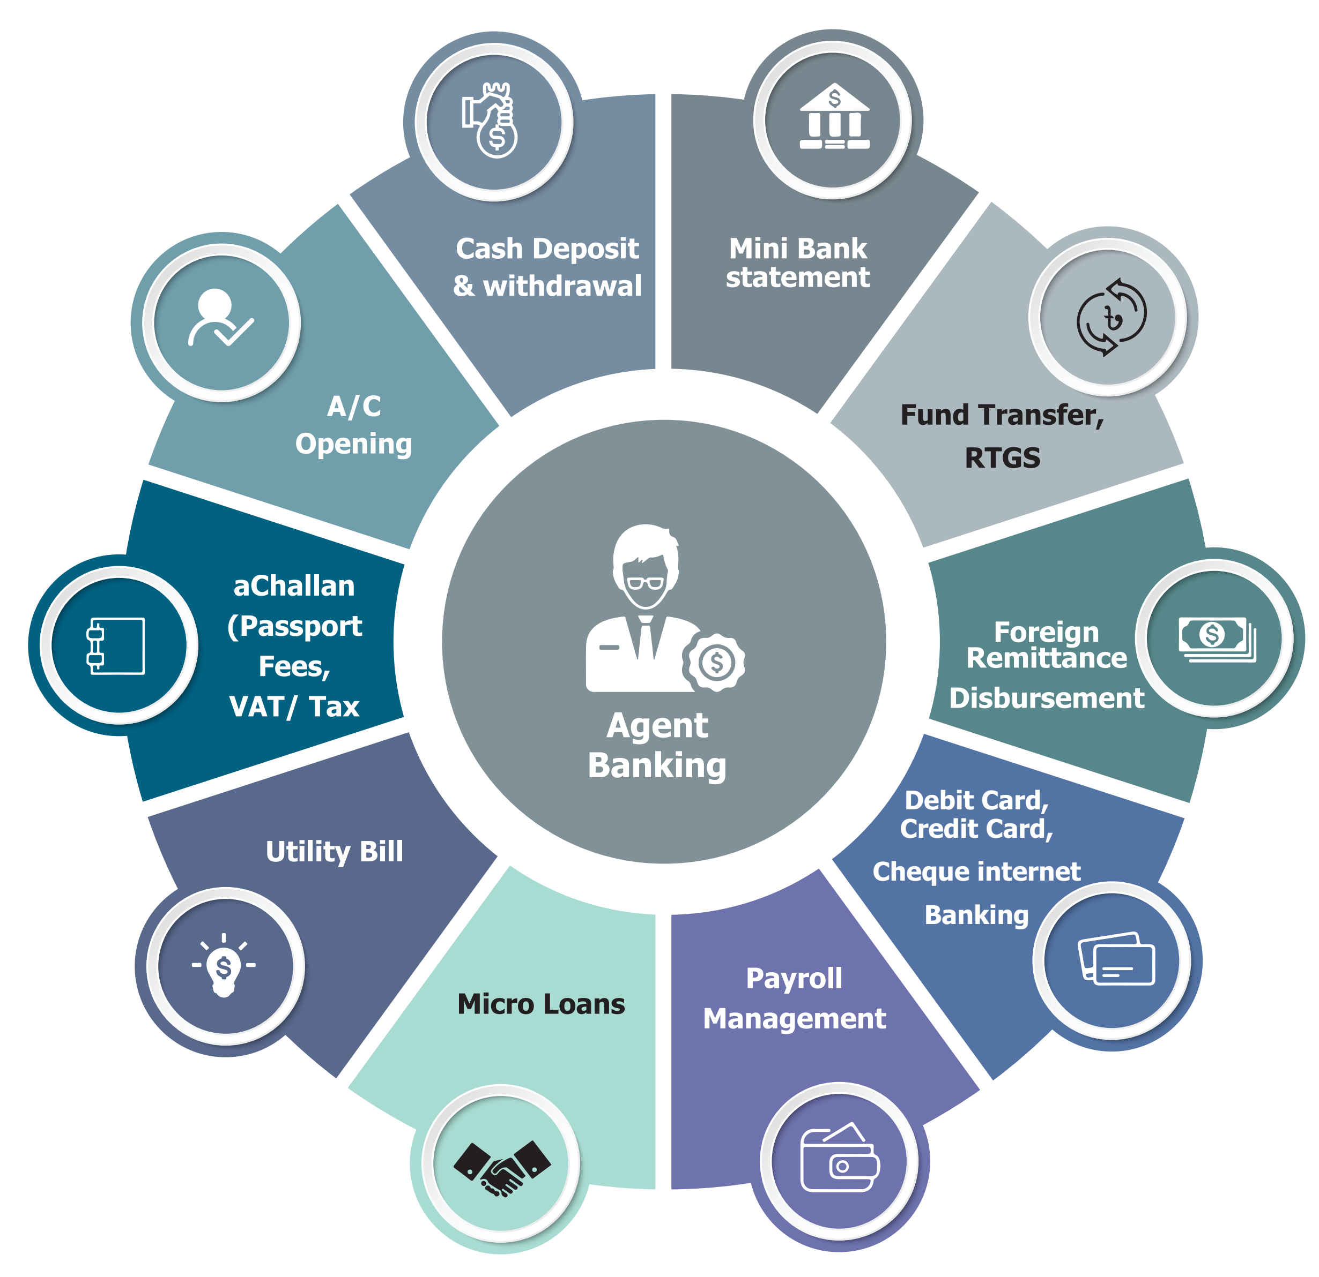
Figure 3.14: Agent Banking
Tbale 3.12: Agent Banking Number of Accounts Trend AB Bank
Year | 2018 | 2019 | 2020 | 2021 | 2022
Agent Banking Number of Accounts Trend AB Bank | 2000 | 14000 | 22000 | 33407 | 49098

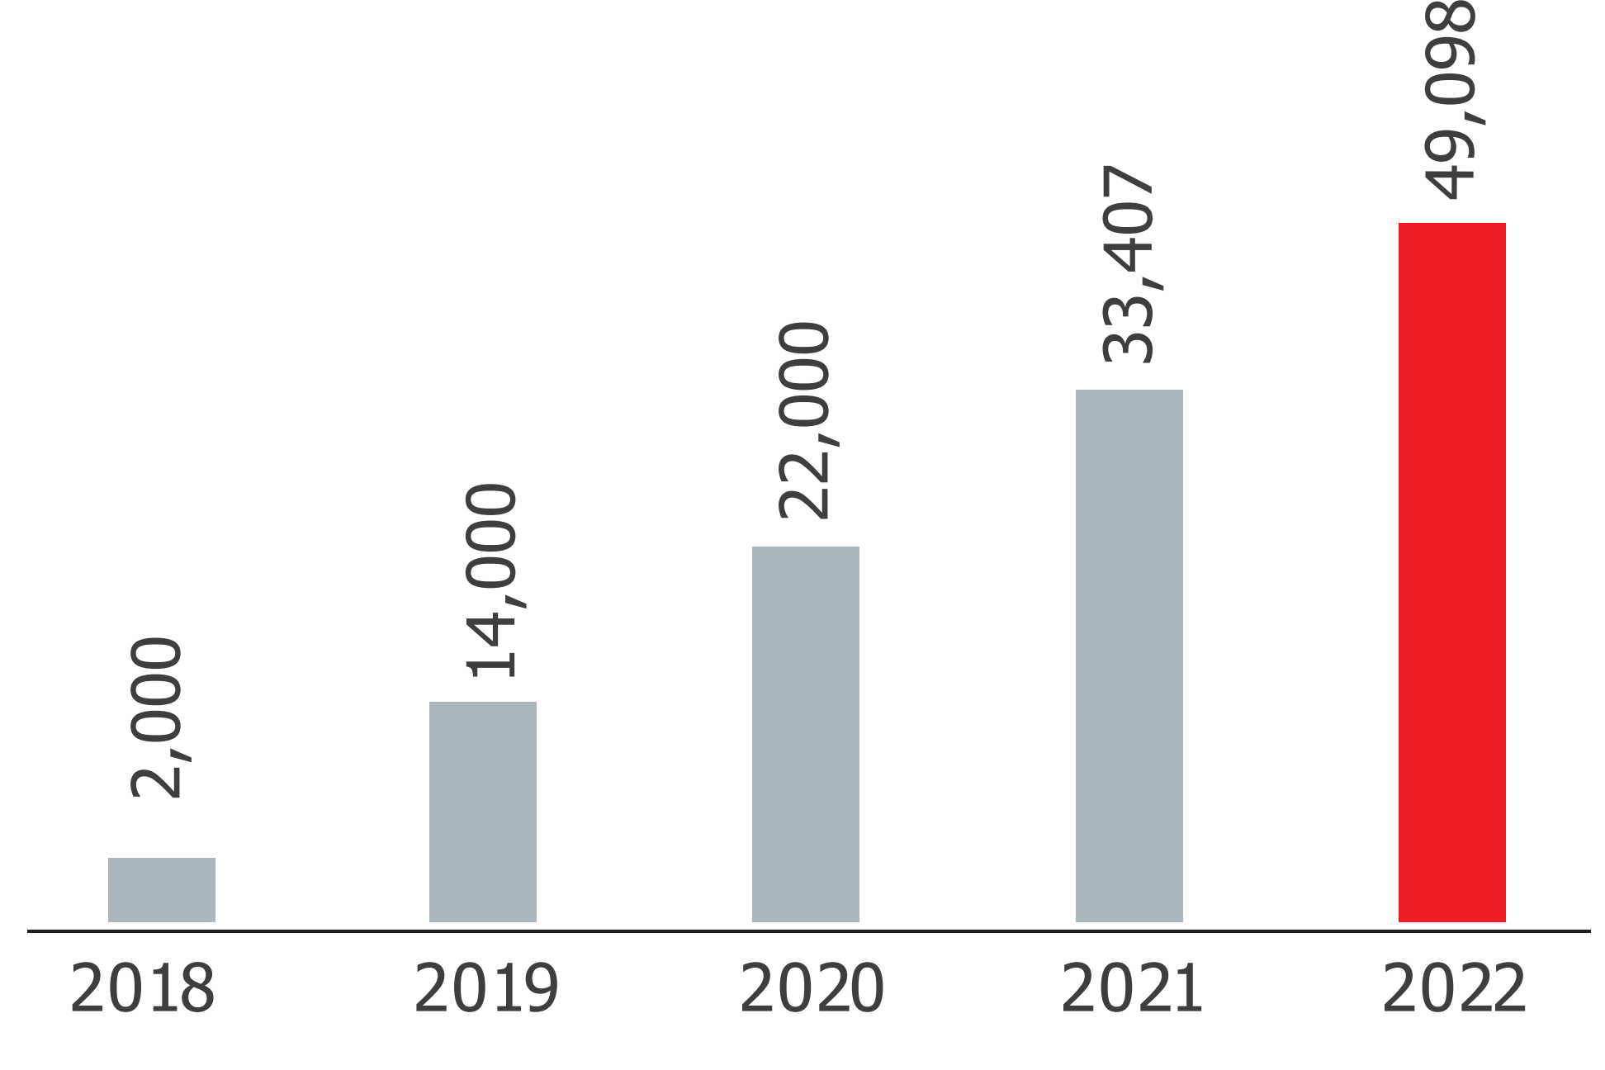

Figure 3.15: Agent Banking Number of Accounts

Table 3.13: Agent Banking Deposit Mix
 | Fixed Deposit | Scheme | Savings | Current
Rate | 25% | 34% | 35% | 8%

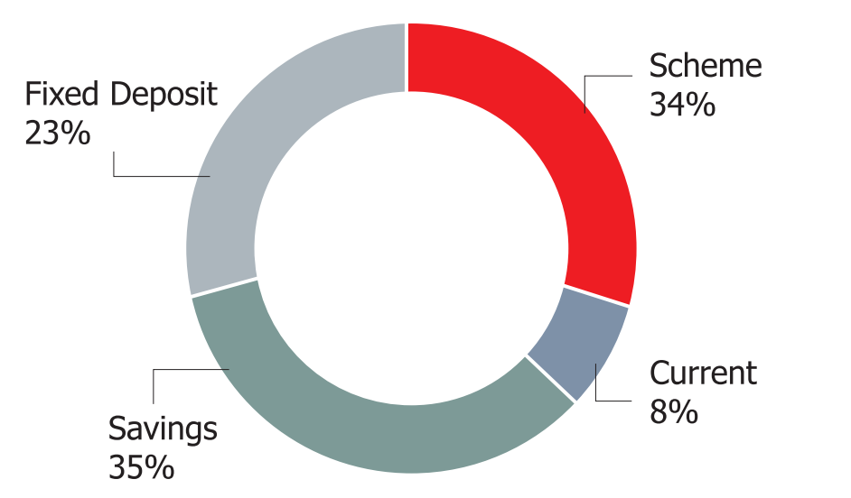
Figure 3.16: Agent Banking Deposit Mix

3.12 Credit Risk
The Latin word "Credo," which means "I believe," is where the word "credit" originates. It is the faith of a lender in the ability, potential ability, and intention of an individual, business, or firm to repay. Put differently, credit is the power to demand goods or services from another party in exchange for a pledge to pay for those goods or services at a future date. Credit is a bank's primary source of income, but when it is misused, it can have disastrous effects on the bank and the economy as a whole.
In addition to guaranteeing the ideal point of loan and advance and their effective management, the goal of credit management is to maximize performing assets and minimize non-performing assets. In the dynamic field of credit management, a certain level of long-term planning is required to allocate funds across various fields, minimize risk, and maximize return on investment. To minimize default and guarantee timely repayment, constant oversight, monitoring, and follow-up are essential. In actuality, the credit portfolio is an essential component of the bank's success in addition to making up its asset structure. The bank's credit policy, credit portfolio, loan and advance monitoring, supervision, and follow-up all play a part in the overall success of credit management. Thus, it is necessary to examine ABBL's credit policy, credit procedure, and credit portfolio quality when examining its credit management.

3.13 Corporate Social Responsibilities of the AB Bank Limited
An organization's social responsibility in the twenty-first century cannot be avoided. According to the societal marketing concept, an organization should consider the needs, desires, and interests of its target markets. Then, it ought to provide better service to clients in a way that preserves or enhances their well-being as well as the welfare of society. The bank is aware of how critical it is to support the general public, local communities, and society at large in addition to taking part in environmental preservation and protection for a sustainable future. ABBL participates in a variety of social activities each year. These include giving talent awards to students, making financial contributions to the disable fund, raising public awareness, and investing in beatification. ABBL provides assistance to those impacted by Sidor. Since no one in society can avoid their obligations, ABBL views this as a positive and hopes to collaborate with a suitable segment in the future to fulfill its corporate social responsibility.

3.14 SWOT analysis:
An organization's external opportunities and threats are analyzed along with its internal strengths and weaknesses using the SWOT method. I have investigated the AB Bank Limited's internal strengths and weaknesses as well as some external opportunities and threats. The following are these:

3.14.1. Strengths:
- The first bank in the private sector is AB Bank.
- Dependable Workplace offers comfortable, high-quality services across a range of banking operations
- Bank gained the public's confidence and trust; strong brand image

- Empowered Workforce: ABBL's human resources are meticulously planned and handled. Since the beginning, senior management has valued empowered workers and declined to participate in every aspect of the business. These workers are allowed to develop as the company grows rather than feeling constrained by their position of authority.
- ABBL employees exhibit a strong sense of bonding and belonging, making them a valuable asset. The workers at ABBL feel proud of and a sense of belonging to the organization, and they are deeply committed to it. One of ABBL's primary strengths is its robust organizational culture.
- Information technology: All employees now have access to personal computers, email, and online banking, which makes their work easier, faster, and more professional. Through Flex Cube, employees can receive a variety of benefits, salaries, and financial incentives directly into their bank accounts.
- Different Staff Loans: ABBL offers a range of staff loans that boost employee satisfaction by providing them with financial benefits that allow them to work more diligently and stress-free.
- Employee Evaluation: The Human Resources Division's employee evaluation procedure has grown in strength as a result of its impartial judgment and ability to inspire confidence in the department among its fellow employees.
- Centralized banking reduces internal conflicts between branches and the head office significantly because the core functions of the business are coordinated by the head office.

3.14.2. Weakness:
The following lists the AB Bank's weaknesses:
- Slow adoption of the new system; lower-quality goods and services compared to other banks, such as ATM cards
- There are certain banking procedures that are overly formal and drawn out.
- Job Summary: A job description is an essential requirement for every position in order to select the best candidate based on the necessary experience and skill set. The HR Division still does not prepare or compile job descriptions in their entirety.
- Pay and Benefits: The Human Resources Division provides ABBL's employees with pay and benefits via two distinct software programs called EZHR and Flex Cube. Both of those pieces of software have numerous limitations and are not very flexible.

3.14.3. Opportunities:
The AB Bank Limited has the following opportunities-
- Act quickly in a competitive market.
- Provide better services and products than other banks.
- moving forward more quickly with the new system
- Management Information System: It is impossible to ignore the significance of MIS in modern business operations. The Human Resources Department remains involved. HRD at ABBL is fully capable of developing new MIS and utilizing it for diverse manpower reporting needs.
- Research and Development: Despite possessing nearly all the necessary resources to oversee significant research and development endeavors, ABBL has made only modest progress in this domain.
- Salary Survey: ABBL will begin conducting its salary survey in collaboration with the most reputable consultant in Bangladesh.
- Training and Learning: Providing executives with the necessary tools to adapt to changing circumstances and stay current and informed is largely dependent on training and learning. In this regard, ABBL will make the most of its energy and ability by launching a library, setting up extensive elements, etc. shortly.
3.14.4. Threats:
The AB Bank Limited has the following threats-
- modern banking infrastructure
- The rivals
- Money laundering
- Competitive Salary and Turnover: Because ABBL's compensation package falls short of what the market will bear, employee turnover is steadily rising.

- Bank policy and new, multinational corporations pose a threat to ABBL because they are likely to raise employee salary expectations and implement new HR procedures that will likely make current employees unhappy.
- Bangladesh Bank Regulation/Legislation: The human resources policy and scope are subject to sudden and arbitrary changes based on the bank's regulations and laws.

3.7 Steps/strategies to meet the challenges and opportunities:
- Not saying Salam, Good Morning, or Good Evening to customers
- Not using "Sir" or "Mam" when speaking to customers.
- not giving the customer a seat even though one was available
- not making an introduction to clients
- The staff did not follow up with a "Anything I can help with?" question after the discussion.
- unwillingness to provide clients with business cards
- Failing to express gratitude for a service rendered
- Not extending an invitation to clients to come back

Chapter 4
Internship experience

4.1 Position, duties and responsibilities:
I was assigned by the AB Bank personnel’s as an intern in the AB Bank Motijheel Branch. address: BDBL Building, 08, DIT Avenue, Motijheel, Dhaka. I have carried out a variety of tasks and obligations there. I was employed by AB bank to experience all the banking departments. I worked in the customer service department there, which was made up of the branch's clearing and check, foreign exchange, and card departments. I worked in Import section where I have to check LCAF, Bill of entry, Bill of exchange and insurance calculation. I had the opportunity to work in Credit department includes RO and CAM. In addition, I had to fill out forms for opening accounts and FDRs, deliver cards and pins, destroy them, fill out loan applications, reconcile the information, close the account, designate a nominee, sign documents, or change the address of an existing account, among other tasks.

4.2 Training:
After beginning work at the AB Bank, I attended two training sessions. That was education in a structured environment. An orientation session covering the guidelines for the internship course was held on the first day of enrollment. In the middle of the internship, there was a second training that covered rules and regulations.

Branches covered under the study
The following branches of AB Bank Ltd in Dhaka city at Motijheel Branch was covered for the internship report state Internship program period of 3 months from 24 July 2022 to 23 October 2022.

4.3 Contribution of departmental functions:
The AB Bank's functions are divided among several departments. The following is how I contribute to departmental functions: -
4.3.1. Card department:
My primary contribution was made in the Card division. Here, I spent the majority of my time serially sorting various card types and keeping track of how many were delivered and received each day. I've completed the recommendation form. I entered the account number, date, serial number, and other information for these cards. I was also given the responsibility of serving as this service area's assistant while I was an intern at AB Bank. Delivering debit credit cards to customers, for instance, might involve keeping track of the regular cards that are delivered by the courier and reconciling the cards. For the purpose of keeping track of the cards, there were four register books: two for newly issued cards and two more for lost and stolen cards. In both situations, cards and pins are kept safe by two different people.

4.3.2. Check department:
My involvement in the check department was limited to call center support and activities pertaining to check books. I did give the customers a call to let them know that their checkbook was available for pickup.

4.3.3. L/C department:
I have assisted the manager of the L/C department in organizing the various documents in the L/C file. In addition, I have taken on numerous additional roles to support the managers of every other department whenever they need it.

4.4 Evaluation:
Questions about specific products or services: opening and closing accounts, being eligible to use credit cards, debit cards, and ATMs, Inquiry regarding various deposit plans and products, inquiry regarding various loan options, Nominee Alteration, Signature, Change, Contact Information Change, Assign Mandate, Pay order Issue.
- Assessment on FDOs and Tellers were based on the following attributes
- Greeting and Speaking Proficiencies
- Skills in Listening
- Courtesy and Politeness
- Clothes and Self-Management Goods, Services Concentration and Timeliness
- Talk Final Skills
- Through observation, a qualitative evaluation of the branches was carried out in relation to the following criteria.
- primarily the cleanliness and accessibility of the branch exteriors
- The security guard and staff at the entrance are courteous.
- Staff responsiveness in managing the queue
- the physical environment's cleanliness
- Inside the branch, the customer area
- The noise level of the staff
- Arrangement of seats
- employees' neat, businesslike attire, including the security guards'
- Using name tags and badges
- Brochures are available
- Deposit and bill payment forms are available.
- the branch's internal temperature
- Cleanliness and availability of restrooms
- Staff availability on the sales and service floors
- Order of signing
- The availability of a complaint box in a prominent location

4.5 Mystery Shopping Implementation on Covered Branches
1. The state of Branches: Principal Branch
Account Opening
Principal Branch Branch Officials made appropriate eye contact with me during our conversation. They spoke clearly and loudly enough. The customer found the conversational pace comfortable and the explanations were made without resorting to technical banking jargon.
Remittance
The mystery shopping (which I did) was satisfactorily assisted by Branch officials. They explained everything in detail without using any fancy words from banking.
Loan
Branch officials provided a detailed explanation of the mystery shopping team's loan process.

Branch Observation
I saw that the branch officials were dressed appropriately. Both the branch's branding and its physical space were in acceptable condition. The branch's washroom was discovered to be musty and odorous.

4.6 Benefits of the assessment
The bank's management will be aware of AB Bank's vendor service level in comparison to its competitors. The level of vendor satisfaction will be determined by analyzing various customer segments, including those with a high exposure to liabilities and assets. The bank's customer service complaint management cell will set up corrective measures like control, education, seminars, and discussions as a follow-up. In order to improve branch profitability and integrated marketing communication, target market activities can be strengthened. The results of the pilot study may be repeated at all branches whenever necessary, at the discretion of management.

4.7 Business Threats
- Getting and keeping customers is a business's primary goal. Loyal customers are the product of satisfied customers. Nonetheless, staff conduct and informal chats can occasionally damage a business's reputation down the road. Some incidents were noted during the survey, and they are listed below:
- Several FDOs pushed mystery shoppers to apply for loans from different banks.
- A few FDOs exhibited a propensity to refrain from rendering services.
- Some officers in the branch talked too loudly.
- Workflow was impeded at the teller counter by certain officers congregating around it.

4.8 New skills developed:
I have gained a great deal of new skills from my internship at AB Bank. I learned from the bank how the officers meticulously and methodically complete every task after I started as an intern. Below is a discussion of the new skills I have gained from this internship experience:

- I have encountered the situation in corporate life where I have to work eight hours a day. This is a significant advancement for me.
- My understanding of the function of branches in the banking sector has grown.
- My internship has taught me how to deal with customers, give them service, communicate with them, and comprehend their needs and demands.
- I've learned how to establish and maintain long-lasting business relationships from AB Bank.
- My internship at AB Bank taught me how to collaborate with coworkers when I was working with them.
- This internship has improved my ability to focus, and I now know how to give my work my whole attention in order to finish it on time.
- My self-confidence has grown as a result of the internship program, which has taught me how to overcome obstacles and finish any task correctly.

4.9 Application of academic knowledge:
During my internship at AB Bank, I applied my academic knowledge sparingly. When clients asked to know at the current rate for that day, I occasionally had to convert US dollar amounts into BDT. In the department of the branch operation manager, I have applied my understanding of income statements and balance sheets. Furthermore, I have dealt with a variety of customers by applying my understanding of consumer behavior.

4.10 Findings
The bank you can trust is Arab Bangladesh Bank.
- We place the utmost importance on credit risk management. Customer care is the bank's central tenet. It constantly updates its technology and system using industry-recognized best practices.
- With the assistance of the nation's trained, competent, and informed bankers, it has been providing banking services, including traditional interest-based banking, for the past 13 years.
- It is carrying out its value-based business and making sure that it fulfills its social obligations. In a short amount of time, the bank became one of the best-performing banks by paying its shareholders the highest dividend rate in a convenient time.
- According to my research, Arab Bangladesh Bank Ltd.'s financial analysis is performing admirably. Growing yearly and making more money than the recently established banks. It offers a range of savings plans for different customer levels to put aside extra money, as well as a range of customer services that help the bank become well-known and well-liked throughout the nation while maintaining a value-based business.
- Ultimately, my research confirms that Arab Bangladesh Bank Ltd. is a reliable partner for you.

Chapter 5
Recommendations

5.1 Recommendations
In light of the aforementioned discussions, the government and Bangladesh Bank, the nation's central bank, have developed some recommendations aimed at bringing stability to the foreign exchange market both in the short and long terms. They are debating the following:
Control Inflation: By lowering the amount of money in the economy, the central bank must implement effective measures to control inflation. One key element in keeping inflation under control is the central bank's implementation of a tighter monetary policy. However, the government's deficit budget increases government debt significantly and prolongs the inflationary environment. The associated elements for lowering the budget deficit
Reduce Trade Deficit: Increasing the volume of goods and services exported is a crucial step in reducing the trade deficit. Bangladesh is a nation that depends on imports. Food and petroleum are the two main importable goods. Local industrialization is crucial, particularly in the food industry (producing substitute foods) and other exportable goods to lower the government's enormous liability.
Improving Foreign Direct Investment: Long-term capital inflow into the nation may be improved by a sufficient amount of foreign direct investment. The government of Bangladesh has a certain policy for attracting FDI. Ensuring political stability, infrastructure development, good governance, and utility will encourage more foreign investment in the nation.
Short-Term Foreign Borrowings: Obtaining funds from overseas sources is an additional means of facilitating market liquidity. The issue with short-term borrowing, however, is that it puts the nation at risk of becoming "Debt-trapped" if it cannot make its loan payments on schedule. It becomes harder to withdraw money from the market once foreign currency is introduced. This is a reminder of the Central Bank of the Philippines in the early 1990s. Huge foreign liability resulting from short-term borrowing to satisfy local market demand. Its capital base was continually depleted by losses, and in 1993 it declared bankruptcy. Reestablishing the nation's new central bank took twenty-five years.
Therefore, concessionary loans at low interest rates from the World Bank, ADB, and other bilateral donors may be a better option than borrowing money from outside sources to close the continuous gap in the market.

Effective Capital Market: The development of the capital market is crucial to establishing stability in the foreign exchange market. It is imperative to prioritize ensuring sufficient inflow of Foreign Portfolio Investment (FPI), sound governance, and capital market security.
The exchange rate market may benefit from the introduction of different derivative products such as options, currency swaps, interest caps, interest swaps, futures, forwards, etc., as well as from large portfolio investments.

Creation of a Domestic Foreign Exchange Market: A formal forum for the foreign exchange market should be established, involving independent professional bodies, the dealers association, Bangladesh Bank, and other pertinent government officials. The fore market would be supported logistically and hosted on this forum. In an ideal world, this forum would create a safe online marketplace that would only be accessible to participants or members. All of the logistical assistance needed to complete the forex transactions between the members and participating organizations could be obtained from this website.
Central Bank Autonomy: The economy would benefit from the central bank's autonomy. The central bank ought to function autonomously and fully automated.

Chapter 6
Conclusion

6.1 Conclusion:
This study demonstrates the beneficial effects of a floating exchange rate regime on economic growth. There was a fairly stable and seamless shift from the fixed rate regime to the floating rate regime. Over the long run of the new exchange rate regime, there is a notable increase in the basic economic variables. Analysis of the export, worker remittance, and foreign reserve trends revealed significant increases in each of these areas. However, the continued depreciation of the currency combined with high inflation is starting to pose a problem for the government and regulators. With the high rate of inflation in the economy, there is a growing gap between the supply and demand for foreign currency on the market, which causes the value of local currency to continuously decline. The main causes of the currency depreciation have been identified as low foreign direct investment, trade deficit, government debt, and inflation. A few recommendations were made by the study for the government and central banks. Instead of being reactive, the regulation ought to be proactive. This new regime has some potential, and in order to take advantage of it, regulators and the government should act appropriately.

References:
Books:
- Bangladesh Electronic Funds Transfer Network (BEFTN) Operation Rules, Bangladesh Bank, August 2010.
- Decenzo A. David & Robbin P. Stephen & Sons Wiley Johe, Human Resource Management, Inc, Singapur, Copyright 2003.
- Dessler Gary, Human Resource Management, Pessonns Education Pte Ltd. India.
- Khan Awal Abdul, Human Resource Management & Industrial Relations, Abir Publication, 1st edition.
- Operation Management, William J. Stevenson (8th Edition).

Report
- Annual Report of Arab Bangladesh Bank Ltd (2018-2022)
- Foreign Investigation of Arab Bangladesh Bank Ltd.
- Foreign Exchange Manual of Arab Bangladesh Bank Ltd, by Training Institute.

Websites
- www.abbank.org.bd.com
- https://abbl.com/
- www.bangladesh-bank.org
- https://abbl.com/investor-relations/
- https://abbl.com/corporate-information-of-ab-bank-limited/
- https://abbl.com/board-of-directors/
- https://abbl.com/senior-management-team/

