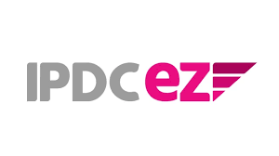



Internship Report
On
Digital Marketing Management of IPDC EZ



Submitted By
Brizet Troyee Joydhar
ID: 111 191 153
BBA Program
School of Business and Economics
Date of Submission: December 26, 2024

Submitted to
Muhammad Hasan Al-Mamun
Assistant Professor
School of Business & Economics
United International University

Letter of Transmittal
December 26, 2024
To
The Supervisor
Muhammad Hasan Al-Mamun
Assistant Professor
School of Business and Economics United International University Subject: Submission of Internship Report
Dear Sir, I submit herewith the attached internship report on “Digital Marketing Management of IPDC EZ”. The submitted report was prepared by the knowledge that I have gathered during the internship period at IPDC Finance in IPDC EZ.
While processing this report, I gave my best to maintain the highest of qualities in terms of writing, collecting information and data analysis. Furthermore, while making this report I have followed all the instructions given and there are some references which are taken from different sources to facilitate my report and make it as informative as possible.
I would be thankful if you place your insightful judgment on my efforts. However, I will be glad to clarify if there is any confusion that may arise. I hope you find this report satisfactory.
Sincerely
Brizet Troyee Joydhar
ID: 111 191 153
BBA Program
School of Business and Economics
United International University

Acknowledgment

I want to use this opportunity to express my sincere gratitude to Muhammad Hasan Al-Mamun
sir, who deserves the highest praise for assisting me with multiple consultations throughout the internship period. He has cheerfully helped me in all of my challenges and doubts about this report. I am deeply thankful to my honorable faculty who took an interest in my report and supported me till the end.
I would also like to thank IPDC Finance Limited for providing me with this Internship opportunity. The knowledge and experience I have gained from this Internship will definitely help me in the future. I would also like to thank my organizational supervisor Md Ismail Hossen, Senior Executive in Corporate Business at IPDC Finance Limited, who guided me throughout my internship. Lastly, I would like to thank everyone who directly and indirectly guided and supported me in making this report.

Table of content
Executive Summary ----------------------------------------------------------------------------------------06
Chapter 1: Introduction-------------------------------------------------------------------------------------07
  - Digital Marketing: An Introduction------------------------------------------------------------------08
  - Company Profile----------------------------------------------------------------------------------------11
Chapter 2: Organizational Background and Competitive Analysis-----------------------------------14
2.1 Organizational Background--------------------------------------------------------------------------15
2.2 Competitive Analysis-----------------------------------------------------------------------------------20
2.3 SWOT analysis------------------------------------------------------------------------------------------21
Chapter 3: Objectives and Methodology-----------------------------------------------------------------25
3.1 Objectives----------------------------------------------------------------------------------------------- 26
3.2 Methodology---------------------------------------------------------------------------------------------27
Chapter 4: Findings of the Study --------------------------------------------------------------------------29
4.1 Findings of the Study---------------------------------------------------------------------------------- 30
Chapter 5: Recommendations and Conclusion----------------------------------------------------------34
5.1 Recommendations-------------------------------------------------------------------------------------.35
5.2 Conclusion-----------------------------------------------------------------------------------------------36

Executive Summary

IPDC EZ is a new company acting as a one-stop virtual market space for essential items. They have made a new way of shopping by allowing phone-based payments without hidden fees when paying in installments. Their partners can use their platform to facilitate the required transactions. The report intends to evaluate the digital marketing management efforts of the aforesaid company.

IPDC EZ provides a user-friendly app for customers and merchants, and an easy process to follow. Its security and customer service make it more attractive and, it helps to boost e-commerce growth in Bangladesh. IPDC EZ also supports healthcare needs through the app, offering funds and doctor appointments.

To keep customers engaged, IPDC EZ regularly shares special deals, videos, and campaigns on social media. They were found to keep on giving new offers to keep customers attracted and retained. The IPDC EZ app is designed for easy use serving customer needs and requirements. Their "Buy now pay later" option offers customers a convenient service. When using this app, customers can enjoy a hassle-free experience, as it reduces the need for paperwork, and makes life simple.

Considering the structural strength of the organization, supporting infrastructural facilities, and marketing orientation, it can be expected that IPDC will continue to evolve as a solution provider both to the customers and merchants by the apt use of digital marketing.

Key Words: IPDC EZ, Digital Marketing

Chapter 1: Introduction

Chapter- 1

1.1 Digital Marketing: An Introduction
Digital marketing is a type of marketing that uses the internet and various digital technologies, including desktop computers, mobile devices, and online platforms, to advertise and market products and services. Internet has spread exponentially and now internet is also a part of any organization’s marketing efforts. Starting from promoting what a company is about to what product they sell; marketers share all the details in the social media.

In present time, digital marketing is about how companies use the internet and technology to tell people about their products and make them interested to buy them. It is like using the internet to advertise and sell things.

Digital marketing has changed a lot in recent years. It is not only about putting ads on websites; it also encompasses using social media, emails, and other online avenues to get people interested in what a company has to offer and to increase the sales of the company’s offerings.

If metaphor is to be used, it can be said that companies use digital marketing to talk to you online, show you product, and make you want to buy it. There are tools like SEO (to show up on Google), social media (to connect with you on Facebook, Instagram, etc.), and emails (to send you special offers) to engage the customers online. Now if a company wants to do well, they need to be good at digital marketing because that is how they reach and connect with most customers nowadays. Digital marketing also influences customers to buy a product. It makes the customer to think that the product is necessary and that the customer needs to purchase it.

Digital marketing is a convenient and effective way for companies to talk to different groups of people on the internet. They can show one group one type of ad and another group a different type of ad, depending on what those people like and do online. This way, the ads are more interesting to individual person; being more customized and more relevant. Digital marketing also can use posters that are given online. Promoting a product by posting is sometimes very effective.
Digital marketing also includes affiliate marketing, marketing analytics, content marketing, mobile marketing, website marketing, pay-per-click etc. In affiliate marketing, influencers promoter their products in different platform like Facebook, Instagram, YouTube etc. Influencers in return receive some commission when sales are made. Nowadays many more number of businesses use affiliate marketing to promote their products. YouTube is the most popular for video marketing. A significant number of companies are using video marketing to sell their products. Marketers often upload video in YouTube where customers can comment, see reviews, and share. Video marketing is also used in Instagram, Facebook, Tiktok and in many more places like these.

Content marketing is also a part of digital marketing. It is an approach that focuses on describing some valuable, relevant and consistent content that attracts the customers. Content marketing doesn’t pitch the product; it provides some relevant and useful information relevant to the target audience. Content marketing is mostly used in podcast videos, blog post and many such avenues.

Pay-per-click is a paid advertisement. It’s a short-term marketing. As long as a marketer is paying for the ad it will keep showing. Once marketer stops paying it will no longer show. Pay-per-click is mostly seen in search results page, browsing the web, YouTube videos and using mobile app. Marketers also pays only if a customer clicks on the ad and visits webwide.

Social media marketing is a vital part of digital marketing. Through social media marketers can promote their products. Mostly social media promotes content that attracts customers to purchase products. The contents that are shared are mostly for the target audience.

Basically, digital marketing is about using the internet and tech in an intelligent way to talk to people, give them stuff they like, and make friends with them. It is something every business needs in today's digital world to do well and connect with its customers and engage them online.

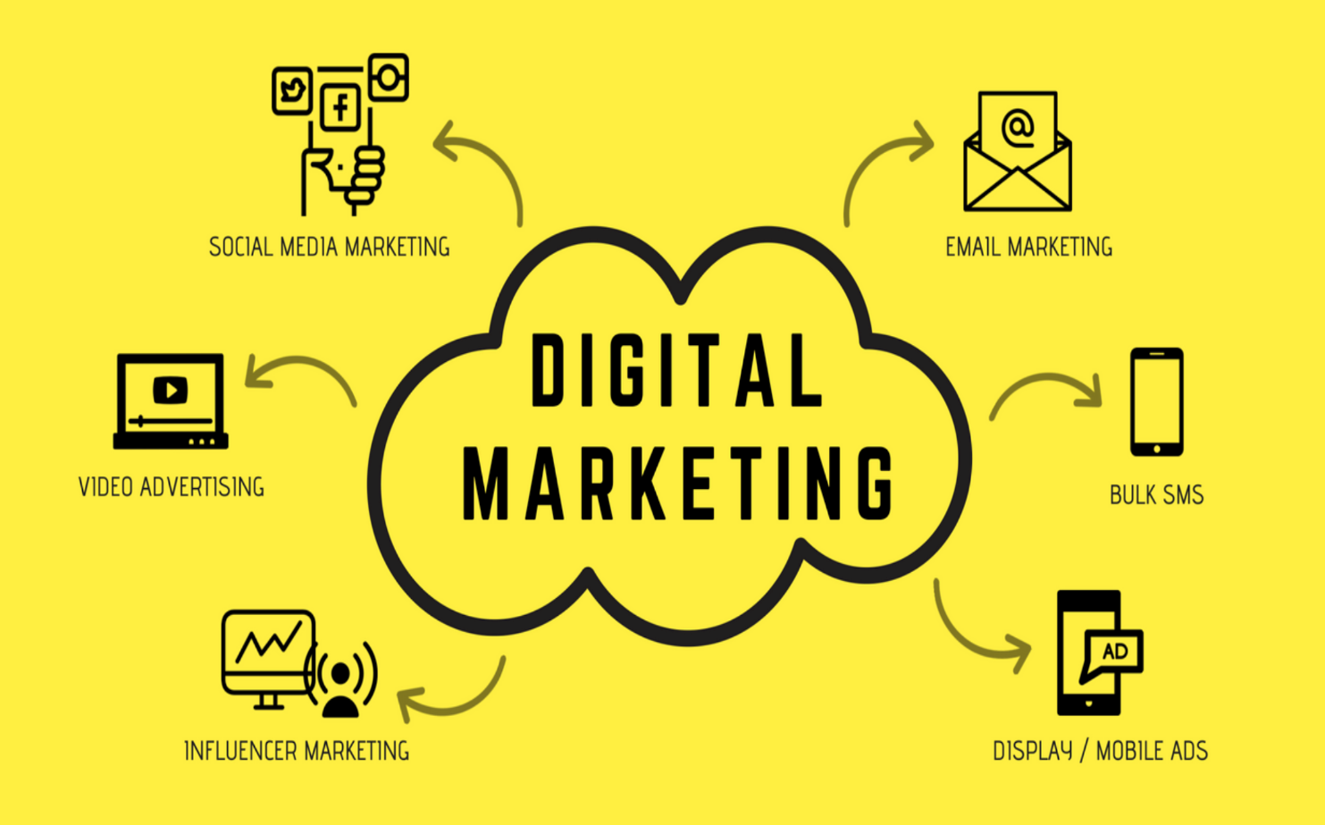

  - Company profile

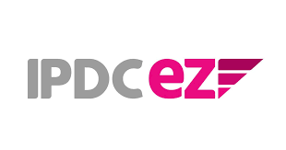
IPDC Finance Limited (formerly known as Industrial Promotion and Development Company of Bangladesh Limited) was established in 1981 with the primary goal of helping commerce and industries of the country ushered in the new wave of industrialization after the independence of the country. With such a noble goal and intention, the company developed financial products and services, which together helped them to lay the groundwork for Bangladesh's top corporations.

Company Mission
To enable our customers and communities to live unbound and to live to their fullest potential by extending innovative financial solutions in a friendly, timely, transparent, and cost-effective manner.

Company Vision
To become the most passionate financial brand in the country with a special focus on youth, women and under-served areas.

Core Values
We will provide exceptional customer service by:
- Serving our customers with passion and honesty
- Going above and beyond the call of duty continually seeking out new ideas.

Core Strengths
- Strong and varied Board of Directors
- Skilled management
- Quality asset base
- Strong governance and regulatory compliance
- Strong Capital base
- Remarkable customer service and experience
- Exceptional corporate culture.

Guiding Principles
- Conducting business with the uppermost levels of honesty
- representing a strong determination to win in the market
- Encouraging diversity in the workplace
- Encouraging under-served and under-penetrated people with suitable products and services
- Supporting the spirit of teamwork and association
- Binding the power of technology to bring better customer experience and results
- Setting the standards of corporate citizenship through expansively engaging in community development initiatives. (Annual Report IPDC, 2021.)

Corporate Division/ Operation Details

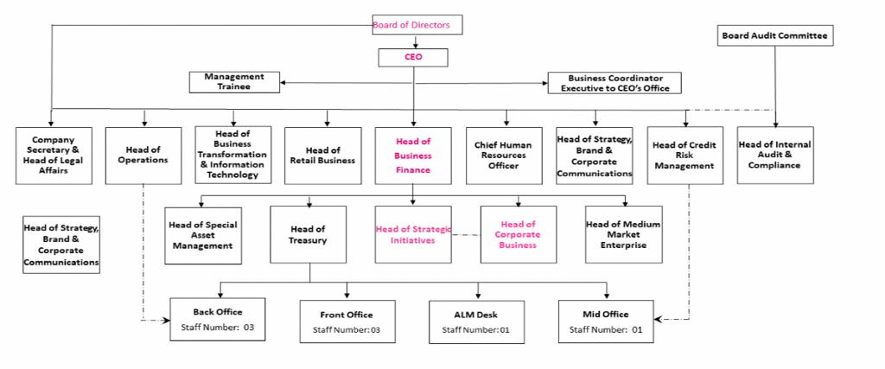

Figure 1:Organizational chart of IPDC finance Limited 2022

Chapter 2: Organizational Background and Competitive Analysis

Chapter- 2
2.1 Organizational Background
IPDC Finance Limited, the first non-banking financial institution established in Bangladesh back in 1981, recently earned an excellent rating from the Credit Rating Agency of Bangladesh (CRAB).

IPDC is the very first private non-banking financial company in the country. They offer various financial services, like helping big companies with their finances, helping small and medium-sized businesses with supply chain financing, and providing services to regular people for managing their money and investments. They basically help all kinds of businesses and individuals with their financial needs and provides loans.

They were given an AA1 rating for their long-term financial stability and an ST-1 rating for their short-term financial strength. This AA1 rating shows that IPDC is really skilled at handling their finances and can be trusted to keep their financial commitments. It also has a five-star rating for being really good at managing money. So, IPDC Finance Limited has shown they are very responsible when it comes to finances. IPDC provides loans for different things like buying a home, a car, or for personal needs. They have 15 branches in various cities, including Dhaka, Chattogram, Khulna, Sylhet, Rajshahi, Rangpur, Faridpur, and Mymensingh, where they offer these loan services and other financial assistance to businesses and individuals.

To apply for any service in IPDC is easy and welcoming. Home loans are mostly offered to service holder, businessman, landlords and self-employed. The process to apply is also easy, one only needs few documents like – copy of NID, photography, bill copy, bio data, salaries slip, bank statement, Tin copy, Trade License of the business, and other necessary documents.

IPDC has also launched a product called IPDC EZ where one can get card-less financing solution that is providing customers with options to purchase consumer goods on credit. IPDC EZ is a service that links lots of stores with people who want to buy things like electronics, furniture, and more. With IPDC EZ, you can buy these items and pay for them in installments, even if you don't have a credit card.
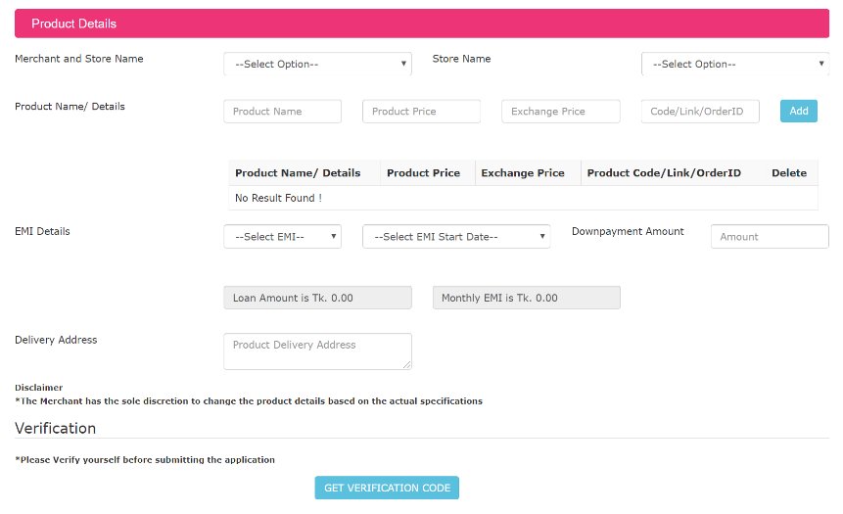
To get service from the EZ customer has to download the app first. The app is on play store or app store. Customer also has to provide some necessary documents such as –
- Salary Certificate/Pay slip
- Bank Statement
- Reference ID
- Employment ID & Photos

EZ provides a maximum amount of loan of BDT 4,99,999, but the amount depends on customer profile and their eligibility. After getting the loan amount, one can apply for NOC (no objection certificate). A customer can also apply for increasing their amount. In this case customer can mail and ask for enhancing the loan amount. Enhancing the amount depends on customer profile. The minimum salary needs to be BDT 20,000 monthly to apply for loan installments. The following professionals can apply for the IPDC EZ loan.
- Businessmen
- Landlords
- Self-employed professionals
- Doctors
- Public/Private service holders

EZ sells many different things like electronics, smart gadgets, home stuff, furniture, and decorations, and online items. To get permission to buy on credit, you should have at least BDT 20,000 in your bank account each month. Customer can only order a product that is more than BDT 10,000. The products that are uploaded in their websites are of value more than BDT 10,000. If you don't pay your monthly bill on time, IPDC will add a 2% extra charge starting the next day. You can either keep enough money in your account for EZ to take, or you can pay with Bkash. Having Bkash option helps the customer to pay. There are a lot of customers who prefers to keep money in Bkash and also in their assigned bank account. IPDC lets you pay back the money you borrow over a period of 3 to 24 months.

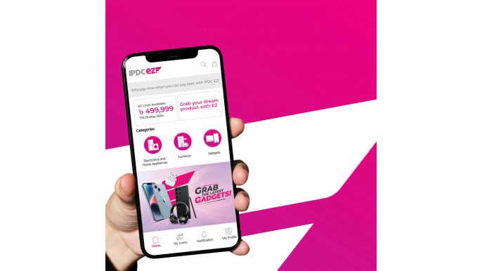

EZ offers a digital platform that gives a marketplace for businesses to sell their products or services. The application is managed by IPDC, but there are some merchants who has the permission to operate on it. EZ has introduced a separate app specially for these merchants, known as IPDC EZ Business.
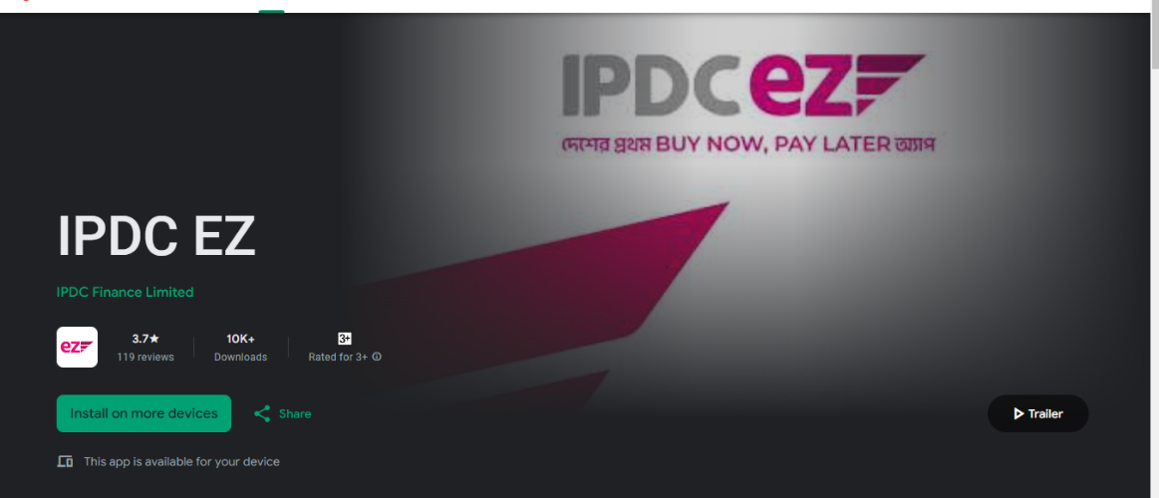

The EZ app offers a virtual market place where different merchants can showcase their products online. This platform allows customers to enjoy both online and in-store EMI services, which making it easier to buy things now and pay for them later. The businesses partnered with EZ are:
- Transcom digital
- Selextra
- Pickaboo
- Esquire Electronics
- M.k electronics
- Star Tech
- Best Electronics
- Rasel Sports
- Mobile Zone
- Pickaboo
- Hair Bangladesh
- Rangs Electronics
- Zara electronics
- Shamim electronic
- Hitachi
- Pie International
- Praava Health
- P2P Furniture
- Mobile Zone
- Mukul Trading
- Nadia Furniture
- Mobile Gallery
- iStore Bangladesh
- Fitness Inside
- Fitness Mart

There are many more merchants. The list is by no means complete. EZ allows merchants to sell their products through their app and in return they charge an amount computed through a standardized procedure. This app also shows the MRP and sales price which help to grab the attention of the customers. EZ also promotes the products, offers product detail and other information about the products. Merchant can also monitor their products and sells using the merchant app. Some merchant can also add their product themselves. Merchant also gives special discounts on apps to increase the sales of their own.

2.2 Competitive Analysis

The EZ app provides an online marketplace for buying goods and services coupled with a 0% EMI payment system. One of its main rivals is the physical, offline stores. EZ attracts customers by offering loans, and similarly, traditional stores also offer EMI options during purchases. Despite that, many customers prefer the tangible experience of shopping in physical stores rather than choosing for online services.

Offline stores have their advantages, such as immediate product availability, unlike digital platforms where customers must wait for delivery. Physical stores are also favored because customers often prefer to physically inspect products before buying. Moreover, EMI options are typically more reasonable for credit card holders at physical stores, and EZ's target audience closely appears to be this group. People from a similar group find it more convenient to use the offline store option rather than the mobile app.

On the other hand, banks also act as rivals. They offer financial supports that attract and keep the audience. Besides that, companies selling products provide their own EMI systems, which makes purchases easier. This also helps to build trust among customers. Mostly banks can also be considered as less hassle as some customers already has credit card and can have a significant amount form that. Banks somehow can be more reliable than an app to the customers as they already have an account there.

There are other apps which can be competitors as well. Such as Daraz. The products that Daraz offers are also similar. Daraz also offers products like TV, refrigerator, AC, micro-oven, phone and many more electronics and home-appliances. It has captured a good number of customers in the market; it also has a loyal customer base. Daraz also provides installment offer up to 6 months. It also provides some additional service like return options, Daraz verified, number of people who has purchased and many other options.
2.3 SWOT Analysis

SWOT analysis is a framework that helps to analysis a company’s strength, weakness, opportunity and threats that the company can face. It assesses the internal and external factor of a company. SWOT analysis helps to take decision in what will help the company to grow. It is designed by monitoring the fact-based analysis, realistic, data-driven look and many more things. Its also like a mirror to the company where they can find out what to improve, what their advantage are and what problems they can face in future. SWOT analysis is also helping the investors and competitors to understand where the company is heading.
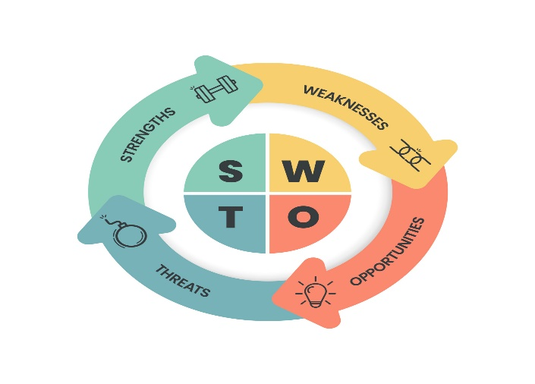

Each organization comes with its own set of advantages and challenges. While EZ enjoys the benefit of being a first mover, it has also encountered both positive and negative aspects. EZ brings its own strength, weakness, threat and opportunities.

Strengths:

First mover advantage
Enjoy a discount of BDT 10,000/-
0% interest financing for up to 24 months
Convenient card-less EMI facility
No hidden charges to worry about

Weakness:

It's challenging to communicate the message effectively.
The app requires improvement.
It should be made more easier for users.

Opportunity:

Grab the market opportunity.
Enhance the quality of the app.
Build greater confidence or credibility.
Great a loyal customer base.
Threats:

There is a possibility for additional competitors to join the market in future,
Changes in dollar price.
Merchants also offer EMI systems.
Other banks also provide loans.

Chapter 3: Objectives and Methodology

Chapter – 3
3.1 Objectives
The objectives of the study can be briefly summarized below:
- To describe the evolution of the IPDC EZ as an organization
- To evaluate the marketing strategies of the organization
- To evaluate the digital marketing efforts of IPDC EZ, particularly their content marketing strategy
- To explain the strategy for achieving the desired reach. By seeing the likes, comments, and views.
- To evaluate the digital presence of the market offerings.

3.2 Methodology

Data that are collected are both primary and secondary data.
Primary data are collected from the app review, customer feedback, customer details, and mails.
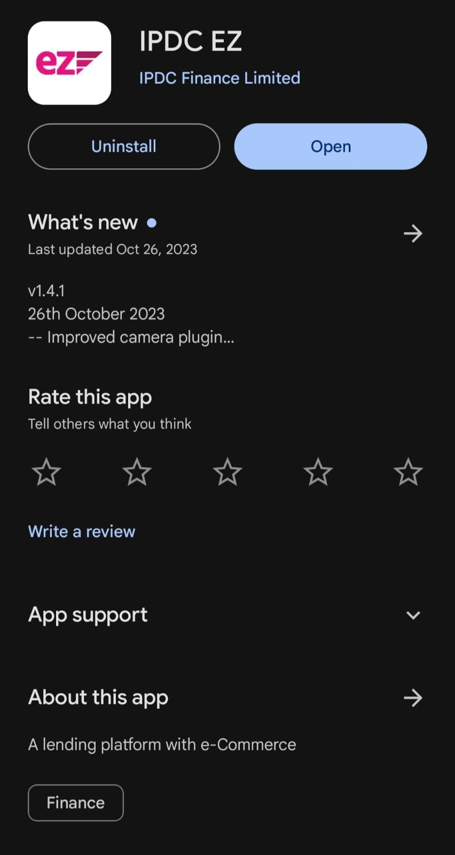
The EZ app requires customers to complete a registration process, during which their personal information is gathered. Furthermore, customers can provide feedback and report any issues they face through app reviews. Data were also collected through the app's rating system, where customers can rate the service on a 5-point Likert scale. The review process also includes an option for customers to leave comments, expressing their thoughts and experiences with the app.

Furthermore, data collection extends to the customer care service, where consumers can reach out for any kind of help by dialing 16519. This service allows customers to seek help or gather information they require, and the information are recorded for data analysis. Also, data is gathered through email communication with the customers.

EZ is active in social media platforms such as Facebook and Instagram to engage with its customers. Through posts and interaction on these platforms, data are collected, including comments and responses from customers. IPDC has developed an app for their merchants, which allows certain merchants to upload details about their products or services. This app is mainly used for gathering data, and the information provided by the merchants is used later on.

Secondary data primarily are information that are found as customer's past purchases. When the organization providing a loan, they analysis customer's previous history. Based on these findings, a decision is made to either approve or deny the loan. Also, the customer's previous loan repayment history plays a significant role in influencing this decision.

Chapter 4: Findings of the Study

Chapter – 4
Finding of the Study: The digital marketing management efforts of IPDC EZ was intended to be analyzed systematically by the 7As Schema used for evaluating the digital marketing efforts of any organization. The abbreviation 7A stands for:
- Agility
- Authenticity
- Attention
- Audience
- Authority
- Action
- Acceleration

These previously mentioned 7As have become popular as a marketing mix of digital marketing. Most organization develops their digital marketing efforts in terms of agility, authenticity, attention, audience, authority, action, and acceleration. Therefore any effort to evaluate the digital marketing efforts of any organization should be guided by these previously mentioned seven elements. This section of the report intends to explain the digital marketing efforts of IPDC EZ by using the 7A schema of digital marketing mix.

  - Agility – An agility mindset is where one can identify customer preferences and provides guidance on what will be beneficial to them. EZ has adopted a 0% EMI as a main part of their content marketing strategy, increasing their social media movement. They frequently share these promotions on their social media channels.

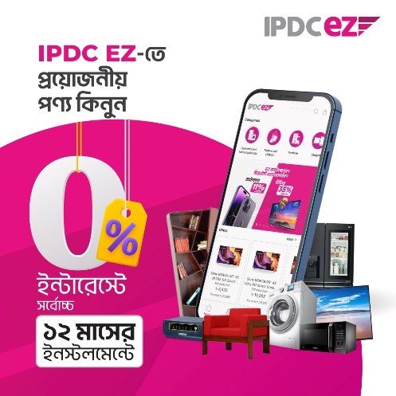

  - Authenticity – Customers want the most trusted marketplace. Customers want a genuine marketplace where they can rely. EZ gives the opportunity to the customer to give reviews and campaigns to build trust with their customers. Also, they share their achievements on social media platforms to build credibility. EZ also replies to the comments to connect to the customers more in an engaging manner.
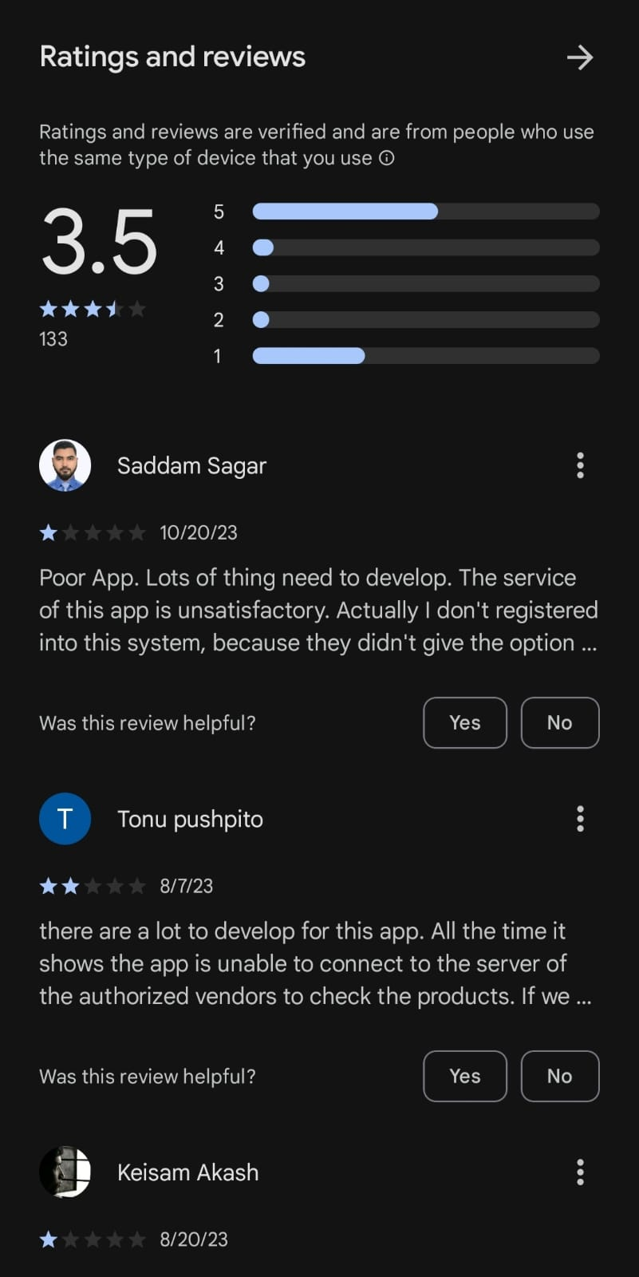

  - Attention – The saying goes, "the first impression is the lasting impression." To get the customer's interest, EZ posts attention-grabbing headlines, maintains simplicity, and creates a sense of importance to prompt their action. EZ also promotes their product in different events such as promoting their products in university, organizing different events, and using posters in different showroom and many such places.

  - Audience – EZ customize their product advertisements to attract their specific target audience. They frequently provide discounts on products that are consistent with their customers' needs, such as offering refrigerator deals during Eid and similar occasions. They often give different discount offer like – 11 sale, black Friday and many more.

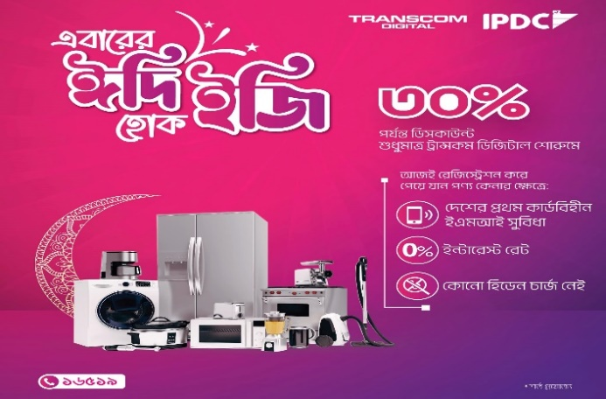

  - Authority – To keep customer loyalty is to keep their trust. EZ has attached their customer by their brand's unique voice; they placed a strong importance on customer care, and delivered massage simplicity and user-friendliness. When customers want to raise issues, they have the option to contact EZ through email or hotline number. Furthermore, the messages conveyed in their social media posts are straightforward and easily understood. EZ also replies to the comments in the comment section where they interact with their customers and solve their problems.

  - Action – EZ is like a one-stop shop where customers can find various products from different brands in one place. To make this possible, the EZ app has teamed up with a variety of merchants and their physical stores all across Bangladesh. Some of these merchants include Pikaboo, Praava Health, Transcom, Haier Bangladesh, Esquire Electronics, Best Electronics Limited, and many more.

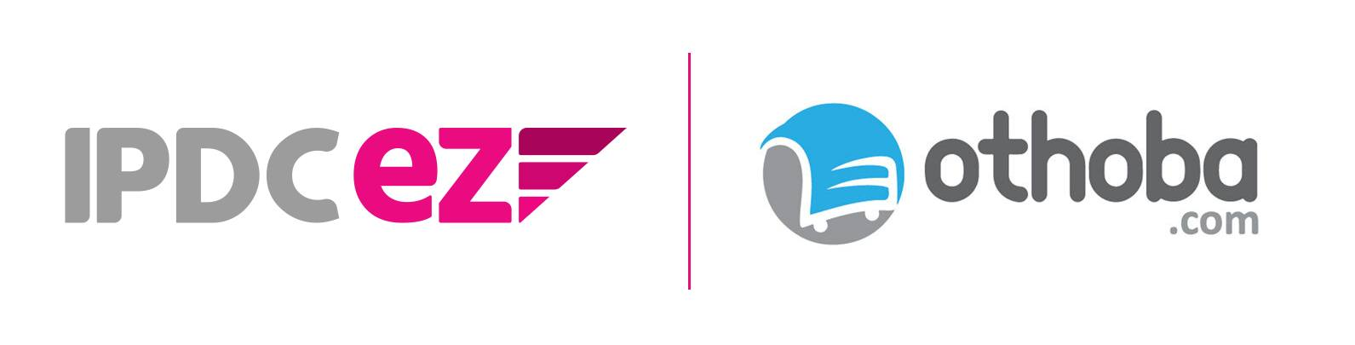

  - Acceleration – EZ consistently introduces fresh and unique ideas. Even though they have the first mover advantage in the market, they maintain customer’s interest in their products by regularly sharing content, including videos on their webpage, and sending emails. EZ share contents according to the customers’ needs and interests.

Chapter 5: Recommendation and Conclusion

Chapter – 5

5.1 Recommendations

There is always a place for improvement. Through my time working with IPDC EZ I would recommend to improve some things that can help to grab more customers. The recommendations are given below:

- They should make the app more user-friendly and interactive.
- They should develop a strategic and tactical plan to fight against the lack of awareness among the people about their services.
- Their promotional programs should be more segment-specific and more frequent in numbers.
- Their support services should be improved and the improved support services should be integrated in their service-profit value chain.
- They should try to increase their presence in the social media. They should devote more time, energy, and resources to increase their social media marketing efforts.
- They should provide more gaudiness on how to use the app. They can develop a user manual for using their app that would facilitate the use of the app.
- They can ask the merchants to include more information about their products. Details given in the product description section can reduce the customers’ perceived risks,
- All product description should be accompanied by the true visual depiction of the products.

5.2 Conclusion

IPDC EZ is a new portfolio for the company. It is like a one-stop shop virtual market place where one can get all essential stuffs in one market space. They have built a way to buy things using one’s phone instead of a card, and when one pays one can get a loan without any card simply by applying, where there are no hidden charges. They've also partnered with different stores so they can use their platform for various needs.
EZ has its own app, which both customers and merchants can install easily. By following a few simple steps, anyone can use the app. The app is available in play store and in app store. It is known for its safe ways to pay and great customer service, which is why lots of people trust it. In fact, it's one of the most popular places to shop online in Bangladesh, and it has helped make online shopping in the country grow. Besides shopping, it also helps with healthcare. If one needs money for healthcare or wants to make a doctor's appointment, one can do it through the app. You can book appointment or do payments using the app.
EZ regularly uses social media to share things like special deals, videos, and campaigns. They do this to make sure their customers stay engaged and interested. Moreover, they are always coming up with new offers to keep things exciting. The EZ app is easy to use and fulfills customer requirements.

References

IPDC. (n.d.). Home. IPDC. https://www.ipdcbd.com/
IPDC. (n.d.). FAQ_EZ_Samsung_S23.pdf. IPDC. https://www.ipdcbd.com/allcampaigns/s23/FAQ_EZ_Samsung_S23.pdf
IPDC. (2022). IPDC Annual Report 2022. IPDC. https://www.ipdcbd.com/areport/IPDC_annual_report_2022.pdf
Agency Cloud 9. (n.d.). The 7 A's of Marketing. Agency Cloud 9. https://agencycloud9.com/blog/the-7-as-of-marketing/#:~:text=The%207%20A's%20of%20marketing%20are%20agility%2C%20authenticity%2C%20attention%2C,you've%20never%20seen%20before
Investopedia. (n.d.). Social Media Marketing (SMM). Investopedia. https://www.investopedia.com/terms/s/social-media-marketing-smm.asp

