Internship Report

Developing Effective Communications of Clemon

Prepared For
Dr. Khandoker Mahmudur Rahman
Associate Professor
& Director of BBA Program
School of Business & Economics
United International University (UIU)

Prepared By
Md. Mahmudur Rahman
ID - 111 141 200
School of Business & Economics
United International University

Letter of Transmittal
5th September, 2018

Dr. Khandoker Mahmudur Rahman
Associate Professor
School of Business and Economics
United International University

Subject: Submission of the Internship Report

Dear Sir,

I would like to submit my internship report titled “Developing effective communications of Clemon”, which has been prepared as a requirement for the completion of the BBA Program of United International University.
At the time of working on the report, I have tried to follow the guideline that you have advised. It has been a good experience and I have enjoyed my internship period at Akij Food & Beverage Ltd (AFBL). The total team of AFBL was also cooperative whenever anything needed.
Thanking you for your kind supervision.

Sincerely yours
Md. Mahmudur Rahman
ID No: 111 141 200
ACKNOWLEDGEMENT
I would like to thank the internship Supervisor, Dr.Khandoker Mahmudur Rahman who has helped me with guidance of my internship. I am grateful to the all teachers of United International University (UIU). Their guidelines give inspiration to anyone to build one’s career properly.
I would like to thank Sheikh Basir Uddin (Managing Director) and Md. Abdul Aziz (Assistant Manager, Brand Marketing) and all individual of Akij Food & Beverage Ltd. for their support that I have been provided for preparing my report. I have practically work with them, try to share their perception, and on the basis of my realization, I have prepared report from my own point of view.

DECLARATION

I am Md. Mahmudur Rahman, student of School of Business and Economic (Marketing) of United International University, Bangladesh, do hereby declare that the internship report on “Developing effective communications of Clemon” is an original work and has not been previously submitted for any degree, diploma, title, or recognition.

________________
Md. Mahmudur Rahman
ID No: 111 141 200
School of Business and Economics
United International University

Table of contents

Part Page
Executive Summary vii
1 Background of the report 1
1.1 Topic of the report 1
1.2 Objectives of the Report: 1
1.3 Scope of the Study 2
1.4 Methodology: 2
1.5 Limitation of the report: 3
2 ORGANIZATION PART 4
2.1 Akij Group: An Overview 4
2.2 Factual Data: 6
2.3 Hierarchical Structure (Akij Group): 7
2.4 History of AFBL 8
2.4.1 Vision of AFBL 9
2.4.2 Mission of AFBL 10
2.4.3 Goal of AFBL 10
2.4.4 Business Philosophy of AFBL 10
2.4.5 Objective of AFBL 10
2.4.6 AFBL: Morale, Ethics & Values: 11
2.4.7 Factory & Machinery: 11
2.4.8 Different bureaus of Akij Food and Beverage Limited are 13
2.4.9 Division of Bangladesh: 13
2.4.10 Products and Services: 14
3 Project Part 17
3.1 Developing Effective Communications: 17
3.1.1 Identify the Target Audience of Clemon: 18
3.1.2 Determining the Communications Objectives: 19
3.1.3 Designing the communications: 19
3.1.4 Select the communication channel: 20
3.1.5 Establishing the marketing communication budget: 20
3.1.6 Taking decision for the marketing communication mix: 20
3.1.7 Measuring the communication result: 34
4 Recommendation: 41
5 Conclusion 42

List of Tables
Table No. | Title | Page no.
Table-1 | Brand Activities Calendar : 2017-2018 | 23
Table-2 | Brand Objective Sheet (Clemon) 2017–2018 comparing with  2016-2017 | 35

List of Figures
Figure No. | Title | Page no.
Figure-2.1 | Organizational Structure (Akij Group) | 7
Figure- 3.1 | Developing effective communications | 18
Figure- 3.2 | Tools of promotional mix | 22
Figure- 3.3 | ATL, BTL & TTL | 33
Figure- 3.4 | Brand Clemon’s Volume sold Vs Projection | 39
Figure- 3.5 | Competitors- Market share | 39
Figure- 3.6 | Toma | 40

Executive Summary
The report contains about Akij Group and company history. Akij Food & Beverage Ltd. profile and data about the brands & products. Specially the report is about the brand Clemon ( a clear soft drink). The tagline of Clemon is of uranto freshness. Different promotional tools of Clemon and their engagement which makes the integrated marketing communication has been described. How Clemon’s mode of communication reaches to the target audience. The overall effect is a boost in the company’s profit margins. This report also contains objectives, values, brand strategies, strategic map of Clemon following that the brand wants to reach the destination.
Different events are shown those carry the brand identity Clemon- ofuranto freshness. Brand objective, market share , toma, brand awareness are also shown with the best possible way.
Recommendations are given shortly. To find the effective communications for eight process are followed those are identify the target audience, determine objectives, design communications, select channels, establish budget, decide on media mix, measure results and manage integrated marketing communications.

Background of the report

Internship is the mandatory course for all BBA students to fulfill the graduation because it gives firsthand experience of the complexities of practical life. As a result it benefits the students to relate acquired knowledge with practical job life. The prime objective of the internship program is to work under organizational environment so that we can turn up ourselves as professionals with practical experience and can get an opportunity to use the theoretical knowledge with real life situation. I have tried to prepare this report on the basis of practical knowledge, which I gather from this organization. As a part our BBA program I had to accomplish my internship from an organization. And in this process I have completed 3 months internship in Akij Food & Beverage Ltd. Akij Food & Beverage Ltd. Which is one of the largest organizations in Bangladesh. This company has many sections and I have worked in the brand department.

Topic of the report

As it is a mandatory policy to give a report upon any topic on the company that I have completed my internship. I have selected the topic titled Developing effective communications of Clemon owned by Akij Food & Beverage Ltd.”

Objectives of the Report

The study initiated to explore and examine the present promotional activities of Clemon and the specially the objective of the study as follows:

- To understand effective communications of Clemon.
- To identify the branding objectives of Clemon.
- To analysis the brand position of Clemon.

Scope of the Study

The scope of the study may be stated as under:

- The study would help top management in planning and decision marketing strategy.
- The study would help management in identifying the key areas.
- The study would aware the top management to take corrective and appropriate measure timely to improve the company’s branding position and other performance.

Methodology
I have used both primary and secondary data for preparing this report. But most of the data are collected from primary source. I observed various activities of Akij Food & Beverage Ltd. My practical experience in AKIJ Food & Beverage Ltd. (brand department) was a great source of information.

- Primary source of Data:
Primary data is collected through unstructured personal interview with officials of Akij Food & Beverage Ltd.
Day to day desk job (Informal conversation with the employees)
A primary source is a document, speech, or other sort of evidence written, created or otherwise produced during the time under study. Primary sources offer an inside view of a particular event.
The sources are as follows Face-to-face conversation with the Executives and officers of Akij food.

- Secondary source of Data
Annual report of Akij Food &Beverage Ltd.
Recently held event & activation of Akij Food &Beverage Ltd.
Prospectus of Akij Food &Beverage Ltd.
Internet, Web-sites.

Limitation of the report
The limitations of the report including the following:
- Lack of knowledge about brand: Unfortunately I could not do the brand management course in university because of unavailability. So I did not have any pre knowledge about brand. So it was very difficult cope up with the situation.
- Lack of time: One of the major limitations of the study was limited time. Attending office regularly is mandatory. After attending office preparing report day to day basis was quite hard that hampered to prepare a fruitful report.
- Administrative secrecy: Another major problem every private company maintains some secrecy of its brand.
- Lack of knowledge about (AFBL)
Lack of self-knowledge concerning report preparation, was also a limiting factor in preparing a better report.

ORGANIZATION PART

Akij Group: An Overview

History:
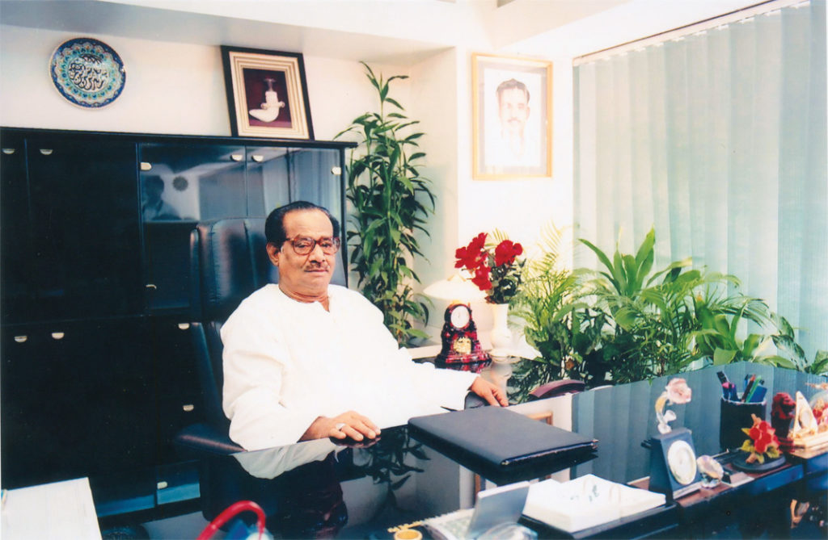
AKIJ GROUP OF INDUSTRIES is thought to be a standout amongst the most matured enterprises that is as yet maintaining with incredible achievement and flourishing. It was over fifty years back the organization went into the market. Organizer, Entrepreneur and life time Chairman Late Mr. Sheik Akij Uddin began the business in 1950s with a solitary result of cigarette naming AkijBiri. The brand is one of the outstanding units of Akij Group and it is thought to be one of the most seasoned and most understood items everywhere throughout the nation and in the couple of overseas market also. At that point in the late 70s Dhaka Tobacco Industries went to the grip of Akij Group when government chose to disinvest and hand over the processing plant to the private division from the nationalized part. It was the core turning phase of Akij Group and from that point onwards this element expanded its business in different units and achieved the apex of progress.
From such little beginnings, it has ventured into one of the best enterprises in Bangladesh, and not just in estimate. Akij Group is glad for its great quality and amazing administration by esteeming its purchasers as one of a kind people and attempting best to give stock to suit the requirements of each unmistakable buyer gathering. AKIJ assemble has never constrained it’s intends to benefit making. Other than having an impact in building up the nation economically, it has likewise endeavored to protect its condition and culture. The gathering dependably endeavors to limit wastage at most extreme level; every one of their production lines have been developed because of reusing and the earth. The less-benefit making worries of the Group are included straightforwardly in managing the advance of Bangladesh. Countless are utilized by them and minded as individuals from the AKIJ family. The historical backdrop of Akij Group extends back to later piece of the forties. In its early stages, the Group began in humble route with jute exchanging which was known as the brilliant fiber of the nation, gaining most net worthy measure of outside trade. Akij Group's persistent endeavors with dynamic administration and support from their various customers have driven the Group in differentiating its business exercises. The Group went into assembling carefully handcrafted cigarettes prominently known as "Biris" as said above. This division gave a gigantic lift to the income winning of the Group and also making a considerable commitment to government exchequer.
With the progression of time, the Group attempted new pursuits and by and by there are 26 units of ventures under its share like food& drinks, cigarettes, high quality cigarettes, printing and bundling, jute plants, materials, Hand load up, Particle loads up, Matches, Cement, pharmaceutical, cowhide preparing and land business are in activity, providing food employments for more than 50,000 individuals in different classifications.
The Group has plans for setting up more tasks. The ventures are as of now in pipeline. Outside speculators have demonstrated unmistakable fascination in joining with Akij gather for joint endeavors. This will help the country's economy and in addition make openings for work to different experts.

Factual Data
Akij Group is definitely not an open constrained organization and not enrolled in the stock trade showcase. It is a total exclusive wander with no outer open offer and corporate offer. Every one of the endeavors of AKIJ Group is qualified for be productive and this angle makes them amazingly fiscally solid in the market
The executives are the posterity of the late director and organizer. Akij Group of Industries are working and performing in the ideal level and is thought to be one of the best driving ventures in Bangladesh; But no obligation in the market.
Total number of representatives: 50000 (approx.) in different classes.
Units of AKIJ Group:
  - Akij Jute Mills Ltd.
  - Akij Food and Beverages Ltd.
  - Akij Textile Mills Ltd.
  - Akij Cement Company Ltd.
  - Akij Ceramics Ltd.
  - Sk. Akijuddin ltd. proprietor of Dhaka tobacco ind.
  - Akij Flour Mills Ltd.
  - Akij Plastics Ltd.
  - Akij Printing and Packages Ltd.
  - Akij Particle Board Mills Ltd.
  - Akij Match Factory Ltd.
  - Perfect Tobacco Company Ltd.
  - Akij Corporation Ltd.
  - Akij Poly Fiber Industries Ltd.
  - Akij Shipping Line Ltd.
  - Akij Ocean Line Ltd.
  - AkijZarda Factory Ltd.
  - Akij Steel Mills Ltd.

Hierarchical Structure (Akij Group)
Head office of Akij bunch is a multistoried building naming AKIJ House arranged at 128 BirUttamSawkatSarak, Gulshan Link Road, Dhaka-1208. Another is Akij Chamber arranged at Motijhil. Akij Group keeps up an authoritative structure where bureaucratic condition wins in the work put. Basic leadership forms are exceptionally concentrated towards the chiefs and best level administrators. Organ gram of the gathering is graphically appeared in the accompanying page:

Figure 2.1: Organizational Structure (Akij Group)

Every one of the organizations has its own particular executives who are the posterity of Late Mr. Sheik Akij Uddin. What's more, for each organization there is partner chief and general trough responsible to the separate executives for their activities.
The accompanying divisions:
  - Human asset (HR) Department
  - Finance and Accounts Department
  - Audit Department
  - Administration Department
  - Purchase Department
  - Import and Export Department
  - Ad and Creative Department
  - IT Department
  - Transport Department
Those are normal for each of the enrolled organizations said above and every office has singular sub-units working independently for every one of the organizations.
With all these, Akij Group has end up being a massive industry which incorporates different class of business and are seething accomplishment towards each division. Recently Akij Group has spellbound a gigantic wander in the refreshment market of Bangladesh and has entered in the market with the name AKIJ Food and Beverage Limited (AFBL).

History of AFBL


Akij Food and Beverage Ltd (AFBL), a stress of Akij Group and a noteworthy name in Food Processing and Marketing Sectors, is an eventual outcome of visionary thought of Mr. Sk. Akij Uddin. AFBL started its assignment in the year 2006. AFBL is a Project worth $70 million and is set up by the Parental Company Akij Group. AFBL produces a broad assortment of Snacks and Beverage for both National and International Market. Around in three years time span most by far of the brands ended up being exceptional in their specific classes. AFBL concentrated on soft drinks, regular item squeeze, deplete, water and snacks and amassed together these divisions in another assembling plant discovered same 50 kilometers outside from capital Dhaka in Krishanapura, Dhamrai, quality was the basic objective of the coordinator Late Mr. Sk. Akij Uddin that is the reason his expression is "Uncompromising quality even in unpleasant situation" the main power behind the achievement of Akij Food and Beverage Ltd.
As the Beverage business has ended up being more forceful and testing in the coming years, it leaves with assurances of ensuring quality in the dominant part of its things. To bring the vision of this visionary business visionary into reality AFBL has been worked with most present day working workplaces of European root for planning and Packing including aseptic filling line which in single case in the entire subcontinent. It was more than fifty years back, that AKIJ GROUP ascended into the Bangladesh publicize like an obscure island in the guide as a little merchants. From such a little beginnings, they have formed into a standout amongst other mix in Bangladesh. By and by Akij Group is the most lifted TAX payer in the Republic Government of Bangladesh ensuring mind blowing quality and organization to the regarded purchasers. Akij Food and Beverage Ltd has won the most outrageous satisfaction of the customers by conveying best quality things and essentially transformed into a threat for both national and overall brands in the country inside a concise time allotment. To crown everything, Functional Distributors, Strategic Sales Forces and set up Suppliers are the genuine givers remembering the true objective to give quality things to our regarded buyers. Akij Food and Beverage Ltd. (AFBL) shows it's thankfulness to each one of the delegates who have joined as a gathering today and moving to achieve the "VISION" of AFBL in a body with full conviction.

Vision of AFBL
To be the main sustenance and Beverage brands exceeding expectations in item quality, social, specialized and showcasing imagination and administration to AFBL's clients through the aptitudes and extremely cheerful responsibility of its representatives.

As indicated by Late Mr. Sheik Akij Uddin with respect to Akij Food and Beverage Limited (AFBL)- "We will create and present those great quality items in the market that we ourselves and our family will dependably utilize; we won't simply deliver items for the customers in the market and let our family devour other overseas items".

Mission of AFBL
To pick up a best position in Food and Beverage segment. Finding and understanding the wants and needs of the network and working in congruity with our customers, representatives and business accomplices

Goal of AFBL
To achieve market leadership, profitability, good corporate citizenship and a sustainable growth.

Business Philosophy of AFBL
In soft drink industry, there are numerous national and overseas organizations. Akij Food and Beverage wants to be a one of a kind nearby FMCG maker with a similar nature of the overseas organization. For this reason AFBL produces CSD, Snacks, Milk and Juice for youthful target bunch who love to lead stylist life.
Main slogan of AFBL is: “Brings Quality in Life”.

Objective of AFBL
The principle target of the organization is to build strong piece of the pie in related differentiated products in Bangladesh and to guarantee the potential clients of the quality of the items.

AFBL: Morale, Ethics & Values
- Believing in quality and perfection in benefit
- Believing open correspondence, individual obligations, honesty, and dynamic interest
- Supporting the variety in creativity and share of thoughts & ideas
- Building society of learning in view of administration, cooperation, responsibility, and co-activity.
The 4ps of Product, Price, Place, and Promotion are subjected to their central goal and to execute and co-ordinate them appropriately keeping in mind the end goal to maintain and upgrade customer fulfillment and furthermore experience legitimate gainfulness.

Factory & Machinery

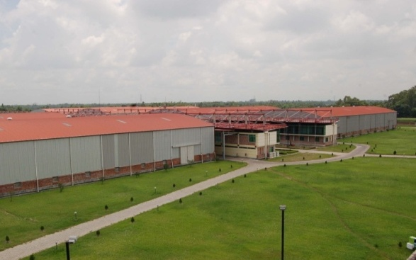
Processing plant of Akij Food and drink Ltd has been set up in a delightful site at Krishnapur, Dhamrai, Dhaka. It has accompanied extraordinary compared to other sustenance and refreshment industry in Bangladesh. Every one of the apparatuses are being foreign made from two universal all around presumed organizations in Germany naming The Krones Group, headquartered in Neutraubling, Germany and Ningbo Sipa Safety Equipment Co. Ltd. Every one of the apparatuses are completely programmed and carefully controlled. Such innovative generation plants that is sensible to dismiss items itself that neglects to meet standard level that has been set. Altogether there are just six organizations in the sub-mainland utilizing such advanced apparatuses to fabricate CSD items, and among those organizations AFBL is one of them. This factor mirrors the nature of the plant and the apparatuses which thus mirrors the quality standard of the results of AFBL. For any specialized breakdown exceedingly experienced and prepared architects are there to serve round the clock.
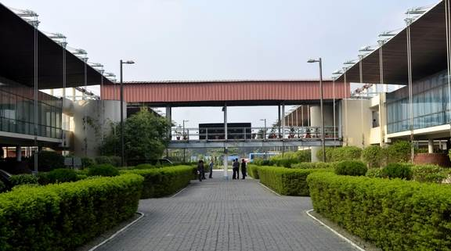

Different bureaus of Akij Food and Beverage Limited are
- Human Resource
- Admin
- Training and Development
- Business Development
- Research and Development
- Brand
- Sales and Trade Marketing
- Event and Activation
- Export
- Media
- Design
- IT
- Accounts and Finance
- Outdoor Management
- Corporate Sales
- Clemon Sports
- MIS

Division of Bangladesh:
Total area of Bangladesh is divided into many segments for the ease of delivering products.
RAT stands for R=Region A=Area T= Territory. Overall Bangladesh is divided into 9 regions, then those 9 regions are divided into 27 areas. Again those 27 areas are divided into different territories and those territories are divided into different points. There are four layers for dividing the whole market. A graph is given below:

For region RSM= Regional Sales Manager, area; ASM= Area Sales Manager, territory; TSM= Territory Sales Manager, point; PSM= Point Sales Manager are recruited for boosting sales.
As per the command from AFBL executives business is run all over the Bangladesh.

Products and Services:

Product Category | Brand Name | Size
Cola | MOJO | 250ml pet and can, 500ml pet, 1litre pet, 2 litre pet
Cloudy Lemon | Lemu | 150ml can, 250ml pet and can, 500ml pet, 1litre pet, 2litre pet
Energy Drink | Speed, Houston | 250ml pet and can
Mineral Balanced Water | Spa, Rivera | 500ml pet, 1 liter pet, 2.15 liter pet, 5 Liter pet
Juice | Fruitika (Mango, Red Grape, Orange)  Aafi (Juice and ZiraaPani) | 250ml pet,250 & 500 ml tetra pack and pet, 1 liter pet
Milk | Farm Fresh UHT milk | 250ml and 500 ml tetra pack
Malt Beverage | Wild Brew | 250ml can
Snacks | Cheeky Monkey  Cheese Puffs  (Vegetables Masala, Magic Masala) | 15/30gm Foil pack  15/30gm Foil pack  15/30gm Foil pack

.

Project Part
Clemon is a clear soft drink (CSD) brand of Akij Food & Beverage Ltd. Clemon was launched at 2006 at the time of beginning of Akij Food & Beverage Ltd. Here throughout the project part I have discussed about developing effective communications of Clemon. The tagline of Clemon is “ofuranto freshness”. Bangladeshi people are sports lover. Specially majorities of the people are young (aged from 15 to 25). Sports carry an important emotion for them. As an internationally uprising dominating country in cricket people find their happiness & sorrows in cricket. Clemon is also attached with cricket. It has a particular wing called Clemon sports which involves with various outdoor sports related arrangement with the theme “ofuranto freshness”. This theme also takes the core sight for any campaign or any promotion. Any special national day are celebrated and special national/ international event are covered with the attachment of this brand with the coverage “ofuranto freshness”.

Developing Effective Communications
To develop an effective communication some steps have to follow. By following those essential steps a brand can reach to the desired goal. There are eight consecutive steps in implementing effective communications. Here following the steps are shown-
Graph 3.1: Developing effective communications process

Identify the Target Audience of Clemon:
There should be a clear understanding about the target audience. Clemon targets-
- Youth
- Sporty
- Trendy
- Recent graduates/ job holders
- Aged(15 to 35)
There are two important questions; custodian of Clemon should find out the answer of those-
- Is the target loyal to the brand? And the percentage of target loyal
- Is the target loyal to a competitor?
Then how custodian of Clemon can conduct image analysis by profiling the target audience regarding brand knowledge.
Target audience contains crucial influence on the communicator’s decisions regarding
- What to say
- How to say
- When to say
- Where to say
- To whom to say

Determining the Communications Objectives:
According to John R. Rossiter and Lary Percy there are four possible objectives-
- Category Need 2. Brand Awareness 3. Brand Attitude 4. Brand Purchase Intention
We will focus on Brand Awareness,
Brand Awareness:
Consumer’s ability to recall or recognize the brand Clemon. Brand awareness creates a base for brand equity.

Designing the communications:
There are three things to explore-
Message strategy (what to say): Clemon’s tagline is “ofuranto freshness”. Brand custodian searches for themes, appeals or ideas those will tie with the brand/ brand positioning.
Ideas are chosen related to freshness for every campaign of Clemon.
Creative strategy (how to say): How a message is being expressed the effectiveness of communication relies on that.
Informational Appeals: It describes about product. Clemon is about freshness so this message is delivered as an informational appeal
Transformational Appeals: It describes about non product related benefit or image
Clemon follows informational appeal to create it’s image.
Message source(who should say): Sometimes many brands are endorsed with celebrity which can achieve higher attention but Clemon’s message are delivered by youth though they are not much familiar but the content is fully attached with positioning theme of Clemon- freshness

Select the communication channel:
- Personal communication channel like e-mail 2. Non personal communication channel like television, radio, newspaper
Specific channels are selected for delivering the message. Some most used channels are shown below-
Television channels | Radio channels | Newspaper
NTV | Radio foorti | Prothom alo
ATN Bangla | Dhaka fm | Bangladesh protidin
RTV | Radio today | The Daily Star
Channel 24 | Radio aamar

Establishing the marketing communication budget:
There are following methods-
- Affordable method
- Percentage of sales method
- Competitive parity method
- Objective and task method- by defining specific objective budget is created. This is actually the method which is followed for Clemon- the percentage should be reached by advertising, developing the market share goal etc are set by authority.

Taking decision for the marketing communication mix:
Promotional Mix-
A company uses the mixing of promotional tools to communicate customer value & build customer relationship.
Advertising, Sales promotion, personal selling, Public relations these four tools are used an integrated way to send the message “ Clemon- ofuranto freshness”.
Advertising: Paid form of non personal promotion of Clemon. Through following vehicles the communicative message is send-
Television, Radio, Newspaper these vehicles are used keeping in consideration of right TV & Radio channels, print medias and right timing of broadcasting ,telecasting or publishing the message.
Sales promotion: Short duration of discounts, incentives/gifts to encourage the customers for buying Clemon.
Sometimes higher SKU clemons are sold in lower price or gifts are given like glass or something else with higher SKU.
Different tactical campaign of consumer preferences for higher SKU’s are also arranged with the objective- Improving the sales volume of higher SKU’s as well as increasing the brand awareness.
Public relations: Creating good corporate image Clemon arranges special events & sponsorship programs.
Personal selling: It is happened for making sales and building a relationship. Trade offers are given for the distributors. Some slab programs are arranged for retailers.
In a short, an integrated marketing communication happens when these four tools are engaged together.

Graph 3.2: Promotional tools
Below a calendar is given from where promotional mix we can easily observe.
A pre-planned calendar is given below; throughout the year various promotional activities are executed following this calendar. Month wise different programs are scheduled and performed. Cultural various periods are kept in consideration. From the following calendar it can be easily understood that throughout year different TV & Radio Sponsorship programs make a good impact for the brand. Giant programs of Clemon are-
- Clemon Mega Beach Carnival
- Clemon Eid- Ul- Azha CSR Program
- Clemon Indoor Uni Cricket
- Clemon City Carnival

Brand Activities Calendar : 2017-2018
 | Jul-17 | Aug-17 | Sep-17 | Oct-17 | Nov-17 | Dec-17
Activity 1 | Clemon Freshness  Hour @ Radio | Clemon Freshness  Hour @ Radio | Clemon Freshness  Hour @ Radio | Clemon Freshness Hour @ Radio | Clemon Freshness Hour @ Radio | Clemon Freshness  Hour @ Radio
Activity2 |  | Clemon Tactical Campaign  - Higher SKU (Glass Free) - CP (ATL+BTL) | Clemon Tactical Campaign  - Higher SKU (Glass Free) - CP (ATL+BTL)
Activity3 |  | Clemon EID - Ul - Azha CSR (ATL+BTL) & Super Shop Activation | World Tourism Day With Bangladesh Porjotan Corporation(BPC) |  |  | City Carnival
Activity4 | Academies infrastructural development, academy Branding, Academy Player performance award & others+Clemon Sports Shop Modification+Skill Camp 1( 5 Days) | Digital Image content Development + School Program +Academy Cricket Ball Purchase and other logistic purchase+ School Program | Indoor Corporate Cricket 2017 ( Sponsorship & Cricket Team) +Skill Camp 1 (5 Days) | School Program +Skill Camp 1 (5 Days) + Skill Camp 1 (5 Days) + Different Sponsorship Program - CS | Outdoor University Cricket Tournament + Skill Camp 1 (5 Days) + Different Sponsorship Program - CS | Cricket Tournament (Division, District, Upojila and School) +Digital Image Content Development & Facebook Advertisement+ Special Camp 20 days for selected players from our academy - CS
Activity5 |  |  | Digital Celebrity Activation | Digital Celebrity Activation | Different  Sponsorship | Different  Sponsorship
Activity6 | Others  Digital Marketing |  |  |  | Others  Digital Marketing | Others  Digital Marketing
Activity7 | TV & Radio  Sponsorship | TV & Radio Sponsorship | TV & Radio  Sponsorship | TV & Radio  Sponsorship | TV & Radio  Sponsorship | TV & Radio  Sponsorship
Activity8 | Outdoor Extra | Outdoor Extra | Outdoor Extra | Outdoor Extra | Outdoor Extra | Outdoor Extra
Activity9 | Sponsor Program | Sponsor Program | Sponsor Program | Sponsor Program | Sponsor Program | Sponsor Program

 | Jan-18 | Feb-18 | Mar-18 | Apr-18 | May-18 | Jun-18
Activity1 | Clemon Freshness Hour @ Radio | Clemon Freshness Hour @ Radio | Clemon Freshness Hour @ Radio | Clemon Freshness Hour @ Radio | Clemon Freshness Hour @ Radio | Clemon Freshness Hour @ Radio
Activity2 | BPL Act. | Clemon Thematic  Campaign  (ATL +BTL) | Clemon Thematic  Campaign  (ATL +BTL) | Clemon Thematic  Campaign  (ATL +BTL) | Clemon CP (500 ml) | Clemon CP (500 ml)
Activity3 |  |  | Clemon Mega Beach Carnival |  | World Cup Match Showing
Activity4 | Different Sponsorship Program + Cricket Tournament (Division, District, Upojila and School) | Our Academy Cricket Tournament + Annual Sports Participation event ( Cycle for alrounder )+School Program | Cricket Tournament (Division, District, Upojila and School )+Digital Image Content Development & Facebook Advertisement+ Clemon School Cricket Tournament (Pilot Program in District) | Skill Camp 2 (7 Days)+ Clemon Indoor Uni Cricket 2018+Skill Camp 2 (7 Days) | Skill Camp 2 (7 Days) + Skill Camp 2 (7 Days) + Different Sponsorship Program | Skill Camp 2 (7 Days) +Clemon Coaches Training Program
Activity5 | Different  Sponsorship | Different  Sponsorship | Different  Sponsorship | Different  Sponsorship
Activity6 |  | Moment Of Freshness | Moment Of Freshness | Clemon Indoor Uni Cricket
Activity7 | TV & Radio  Sponsorship | TV & Radio  Sponsorship | TV & Radio  Sponsorship | TV & Radio  Sponsorship | TV & Radio  Sponsorship | TV & Radio  Sponsorship
Activity8 | Outdoor Extra | Outdoor Extra | Outdoor Extra | Outdoor Extra | Outdoor Extra | Outdoor Extra
Activity9 | Sponsor Program | Sponsor Program | Sponsor Program | Sponsor Program | Sponsor Program | Sponsor Program

CLEMON”- an established clear drink Brand of Bangladesh, owned by Akij Food & Beverage Ltd. Distinguished as the clear lemon drink in the country. The brand sustaining in the market with a good number of Market Coverage. Under the Brand Clemon there are several popular event are going on like Clemon Mega Beach carnival. Brand Clemon successfully arranged the largest beach feast in the country for seven times. From 23 to 26 march, the event Usually held on Laboni Beach point in Cox’sBazar where different refreshing moment like Fireworks, Beach Scooter, Rock climbing, Rally, Helicopter ride, Clemon walkway, Color Combat, Concert & Cleaning Activities & Many more is taking place. Through all of the activities, we will present the viewers as well as guests the attachment of unlimited freshness with Brand Clemon & uplift the tourism in Bangladesh. Brand Clemon is always determined to spread freshness in every spheres of life.
Freshness Rally
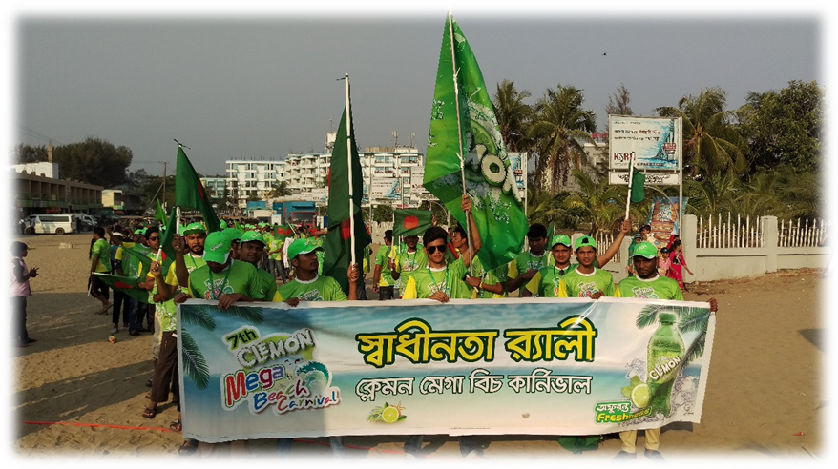Hit &Win-
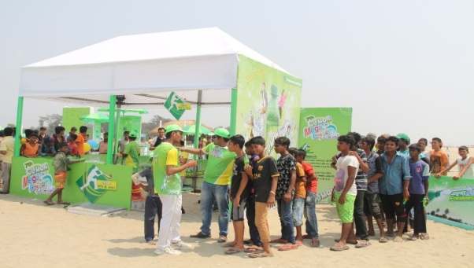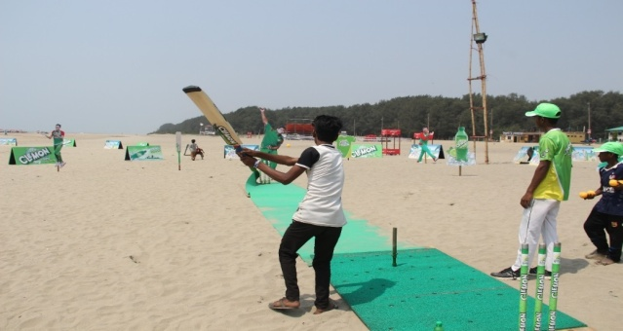
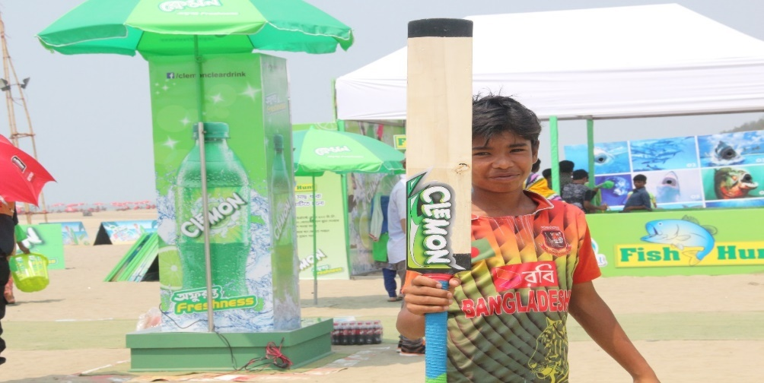

Tour De Freshness
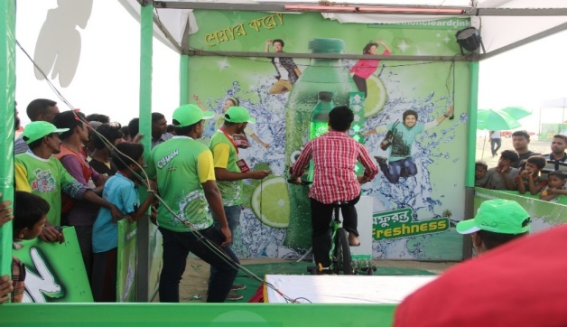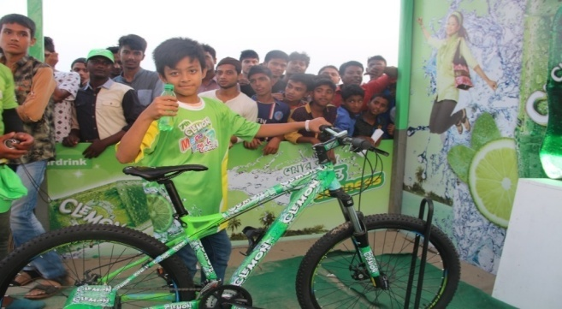KidsZone
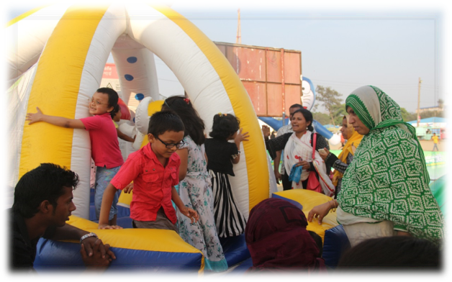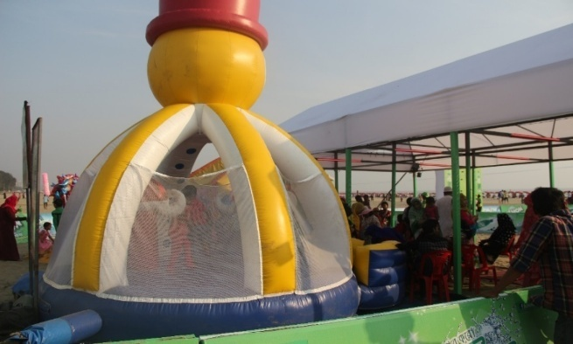World of Freshness
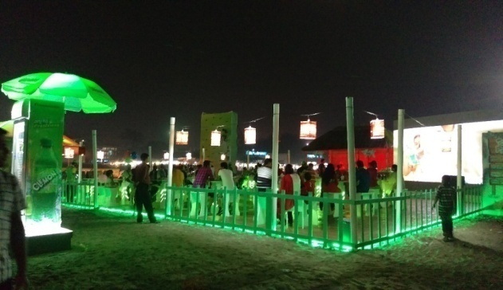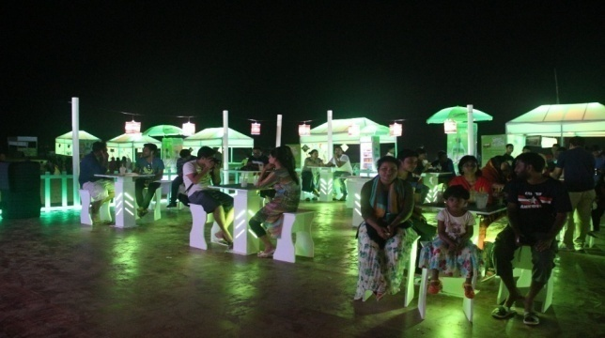
Fish Hunt Catch it
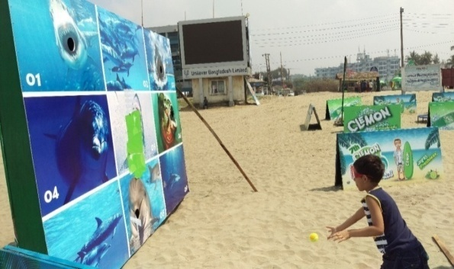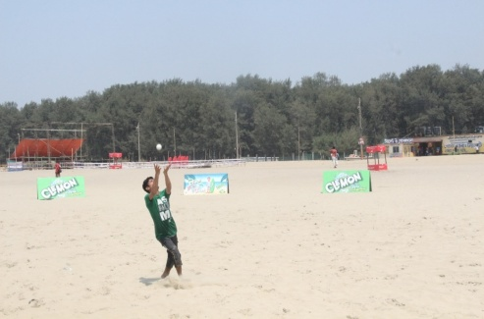
Color Combat Basket Ball

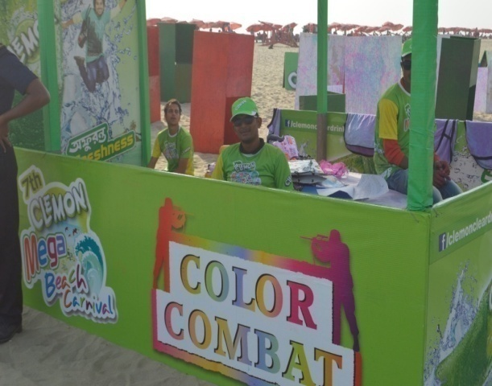 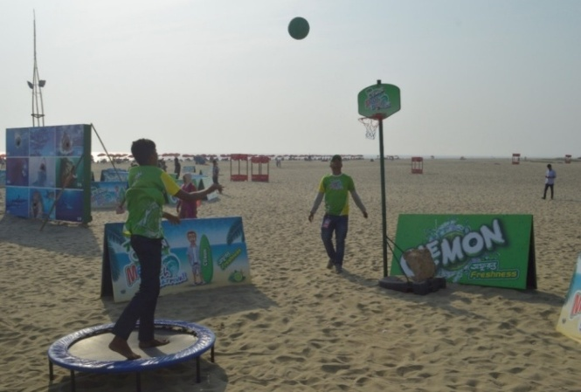Rock climbing
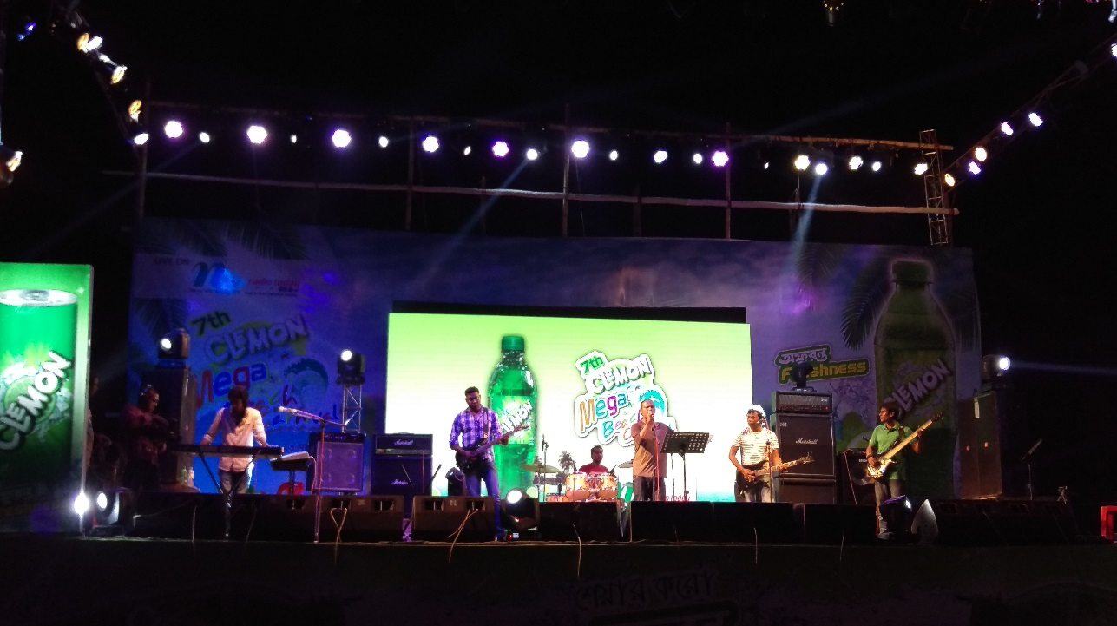
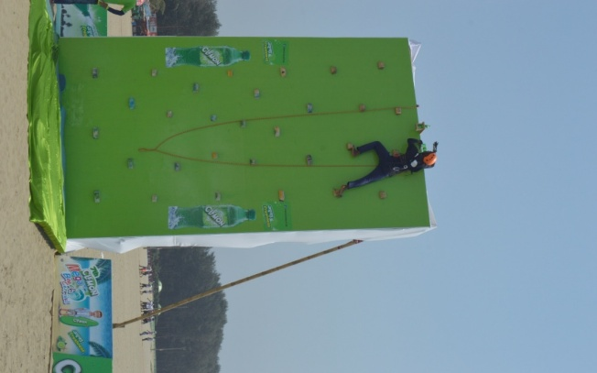
Concert

CSR program is one of the significant touch of “Brand Clemon”. Since every organization should have corporate responsibility toward society, as a part of this Akij Food & Beverage Ltd. has been continuing making city neat & clean program and delivering the message of neat & clean across the country through TVC, RDC & Digital for the years at the time of Eid-Ul-Azha. Generally, During Eid-Ul-Azha most of the Metro city becomes polluted through throwing of different dirty materials. Through this CSR program AFBL is trying to make the city neat & clean with the participation of people in every sphere of life as pay of line for Clemon is “Ofuronto Freshness”
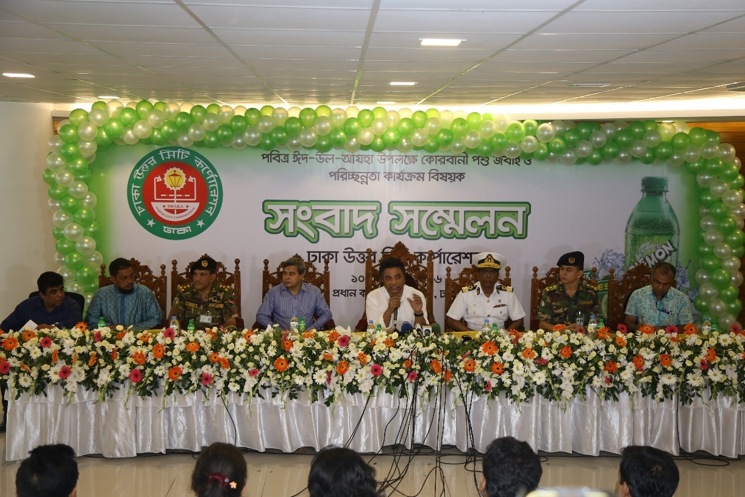
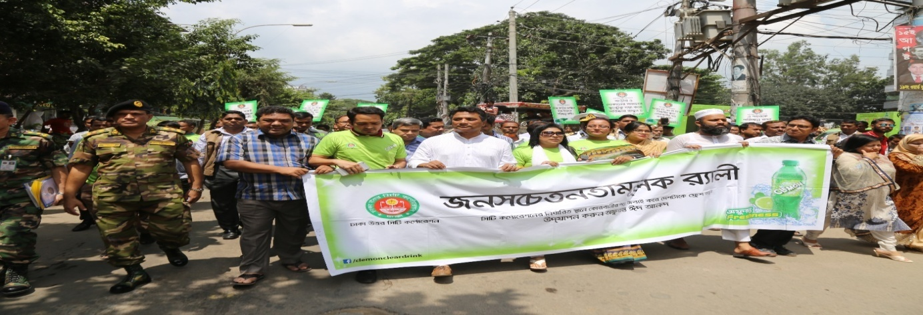
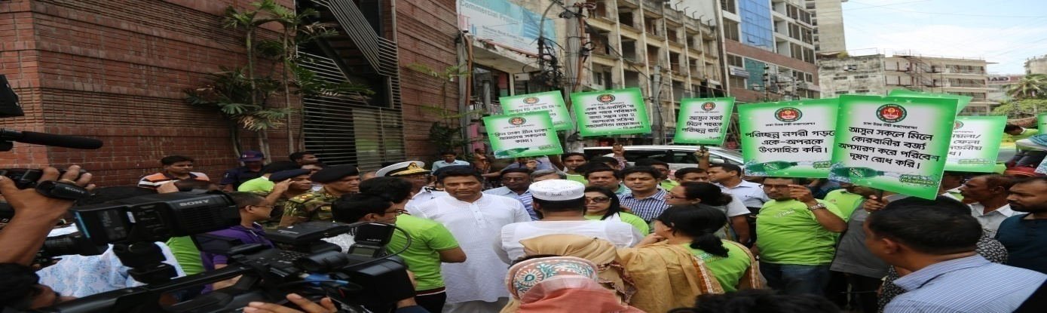
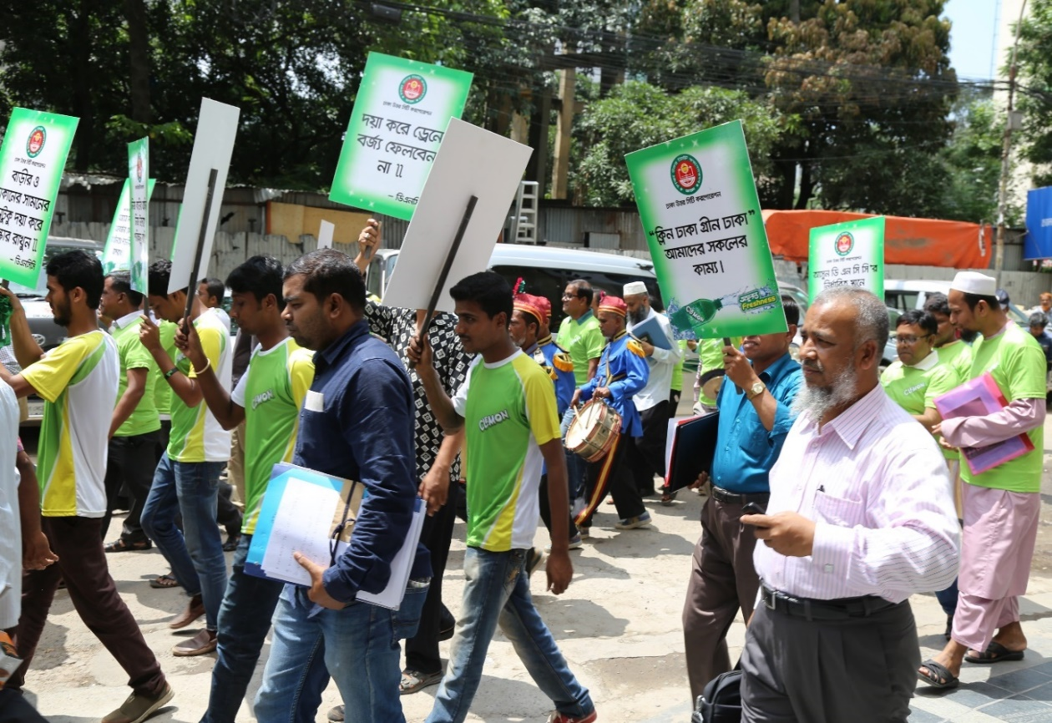
Clemon indoor Uni cricket :
Indoor unicricket is an event where Clemon tries to engage university students to meet together. Players from different universities play for their universities and general students come to indoor stadium situated at Mirpur, Dhaka to support their team. An amazing atmosphere is created all around. Such a way Clemon wants to create brand awareness of it.
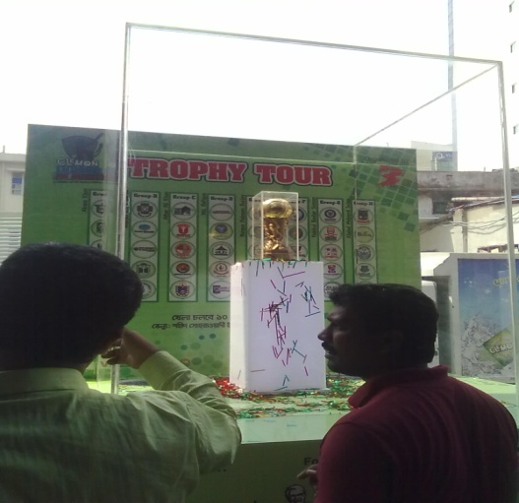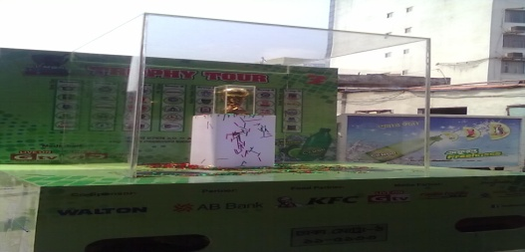
City Carnival
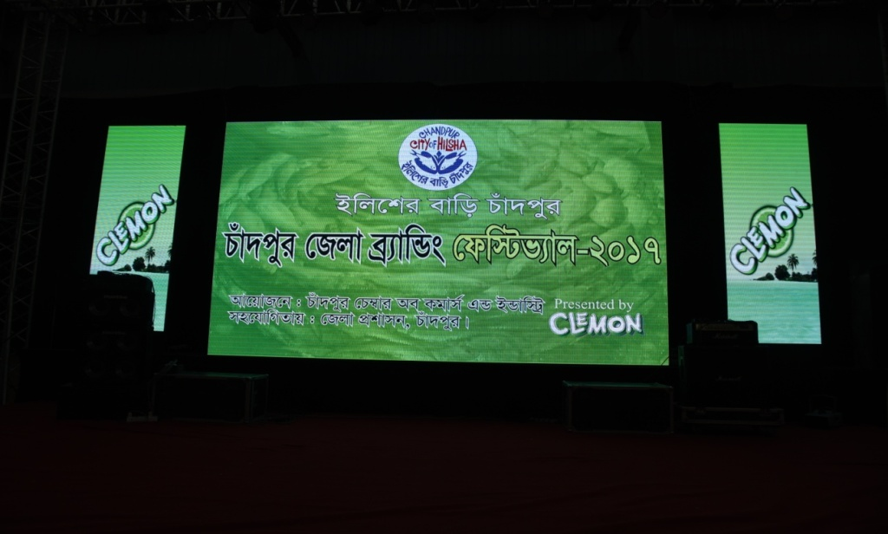
Get together of people: The event was a huge get together of different category of people. It was very refreshing for all the people to gather around a place and gossip.
Exhibition of Bengali food culture: For the aggression of western and fast food items, people are forgetting what types of traditional and tasty foods were available in our country. This event let people know about a glorious past of tasty food just made with Hilsha Fish.
Availability of fresh Hilsha Fish: In the event, fresh Hilsha from chadpur was also sold which became very favorite to people.
Mind refreshing cultural show: There was a small cultural show which was very much eye soothing and mind refreshing. People get to know about different talented artists from chadpur.
Venue environment: Venue environment was very friendly. The event had a festive nature which attracted people very much. People gathered around and talked about their life and enjoyed a lot there.
Recognition of the best citizens: The best citizens from chadpur was gave recognition in this event. This allows the people from the country to know about the best men from that particular area Which was very much encouraging to them.
Brand recognition: People get to know about the brand Clemon in the event. They also get to know that Clemon represents freshness. As freshness is related to Hilsha, that’s why this brand was interested for that event.
City carnival is a good example for BTL. Like Chandpur city many other cities are also kept in consideration gradually to promote along with the brand Clemon with the theme Freshness.

`Graph 3.3: ATL, BTL & TTL

Which campaign will be considered in which tactical way through ATL, BTL and TTL that is determined
ATL: ATL for above the line. ATL marketing would be used to build general brand and awareness of the brand. The following kinds of media would be considered ATL marketing activity:
- Television advertising
- Radio advertising
- Newspaper advertising
For example- 2018 Clemon CSR program related advertising
BTL: BTL for below the line. BTL marketing is used to build direct marketing campaign in a large or focused city. Particular region of the total market is considered to be focused. Like-
- One to one communication
- Door to door
- Event
For example- with Dhaka north city corporation different activities completed, picture about that event shown earlier.
TTL: TTL for through the line. Both ATL and BTL mixture through digital platform. Ex-Online platform, social media- facebook, youtube etc

Measuring the communication result:
After completion of any campaign or any promotion research is done for comparison of objective of that campaign and achievement. Reach and frequency, recall, brand awareness, purchase intention etc objectives are measured.
Here following brand Clemon’s achievement of the year 2016-2017 is given and also the objective of the year 2107-2018 is compared.
Brand Objective Sheet (Clemon) 2017 – 2018 comparing with 2016-2017
Brand | SKU | Volume (2016 - 17) | Volume ( 2017 - 18) | Growth
Brand | 250 ml (Can) | 9594 | 31000 | 69%
Brand | 250 ml | 3634550 | 4,500,000 | 19%
Brand | 500 ml | 215780 | 350,000 | 38%
Brand | 1000 ml | 281411 | 404,000 | 30%
Brand | 2000 ml | 165921 | 219,000 | 24%
 | Name | Market Share ( 2016 - 17) | Market Share (2017 - 18) - Projection | Growth
Competitors | Clemon | 9% | Clemon: 11% | 24%
Competitors | 7 Up | 46% | Clemon: 11% | 2%
Competitors | SPRITE | 17% | Clemon: 11% | 6%
Competitors | Pran Up | 10% | Clemon: 11% | -10%
Competitors | Mountain Dew | 3% | Clemon: 11% | 20%
Competitors | Fizz Up | 6% | Clemon: 11% | -17%
Competitors | Others | 10% | Clemon: 11% | 20%
 |  | TOMA ( 2016 - 17) | TOMA ( 2017 - 18) - Projection | Growth
Top Of the Mind Awareness (TOMA) | Clemon | 8% | Clemon: 11% | 38%
Top Of the Mind Awareness (TOMA) | 7 Up | 59% | Clemon: 11%
Top Of the Mind Awareness (TOMA) | SPRITE | 17% | Clemon: 11%
Top Of the Mind Awareness (TOMA) | Pran Up | 4% | Clemon: 11%
Top Of the Mind Awareness (TOMA) | Mountain Dew | 9% | Clemon: 11%
Top Of the Mind Awareness (TOMA) | Fizz Up | 3% | Clemon: 11%
Top Of the Mind Awareness (TOMA) |  | Awareness ( 2016 - 17) | Awareness( 2017 - 18) - Projection | Growth
Brand Awareness | Clemon | 67% | Clemon: 75% | 8%
Brand Awareness | 7 Up | 98% | Clemon: 75%
Brand Awareness | SPRITE | 86% | Clemon: 75%
Brand Awareness | Pran Up | 34% | Clemon: 75%
Brand Awareness | Mountain Dew | 51% | Clemon: 75%
Brand Awareness | Fizz Up | 31% | Clemon: 75%
ATL | Activities | Objective | New/ Existing | Spending ( 2016 - 17) | Spending ( 2017- 18) - Projection
ATL | Clemon EID CSR | Increasing Brand Awareness | Existing | 855,000 | 1000000
ATL | Clemon HSKU Bat/ Ball Offer | Increasing Brand Awareness | New | 2250000 | 2362500
ATL | Clemon Indoor Uni Cricket | Increasing Brand Awareness | Existing | 2133912 | 2347303
ATL | Clemon Ramadan CP Campaign | Increasing Brand Awareness | New |  | 5335000
ATL | Clemon World Tourism Day Celebration | Increasing Brand Awareness | New | 550000 | 605000
ATL | Clemon BPL Activation | Increasing Brand Awareness | Existing | 100000 | 110000
ATL | Clemon Media & Eid Filler Campaign | Increasing Brand Awareness | Existing |  | 34125000
BTL | Activities | Objective | New/ Existing | Spending ( 2016 - 17) | Spending ( 2017- 18) - Projection
BTL | Clemon EID CSR | Increasing Brand Awareness | Existing | 2500000 | 2750000
BTL | Clemon HSKU Bat/ Ball Offer | Increasing Brand Awareness | New | 425000 | 467500
BTL | Clemon Indoor Uni Cricket | Increasing Brand Awareness | Existing | 549578 | 604536
BTL | Clemon Ramadan CP Campaign | Increasing Brand Awareness | New | 500000 | 550000
BTL | Clemon World Tourism Day Celebration | Increasing Brand Awareness | New | 1250000 | 1375000
BTL | Clemon Household Campaign | Increasing Brand Awareness | New | 235000 | 258500
BTL | Clemon Football/ Cricket Match Showing | Increasing Brand Awareness | New | 132500 | 145750
BTL | Clemon Sales Activation @ Pohela Boishak | Increasing Brand Awareness | Existing | 75000 | 82500
BTL | Clemon BPL Activation | Increasing Brand Awareness | Existing | 8300000 | 9130000
BTL | Clemon Super Shop Activition (EID) | Increasing Brand Awareness | Existing | 475000 | 522500
 | Clemon Sports Activities | Increasing Brand Awareness | Existing |  | 14080000
 | Different Sponsorship | Increasing Brand Awareness | Existing | 100000 | 110000
Digital | Activities | Objective | New/ Existing | Spending ( 2016 - 17) | Spending ( 2017- 18) - Projection
Digital | Clemon EID CSR | Increasing Brand Awareness | Existing | 550000 | 605000
Digital | Clemon HSKU Bat/ Ball Offer | Increasing Brand Awareness | New | 115000 | 126500
Digital | Clemon Indoor Uni Cricket | Increasing Brand Awareness | Existing | 350000 | 385000
Digital | Clemon Ramadan CP Campaign | Increasing Brand Awareness | New | 125000 | 137500
Digital | Clemon World Tourism Day Celebration | Increasing Brand Awareness | New | 560000 | 616000
Digital | Clemon BPL Activation | Increasing Brand Awareness | Existing | 500000 | 550000

Here following the graphs are shown regarding Volume sold, Market share & Toma for the year (2016-2017) and projection for the year (2017-2018)

Graph 3.4: Clemon- volume sold vs. projection

Graph 3.5: Competitors- Market Share

Graph 3.6: Brand Awareness

Graph 3.7: Top of the mind awareness (TOMA)

Recommendation:
- All promotional activities any organization does for achieving the ultimate target sales. Sales can be achieved various ways like push selling. Sales achievement can be gained in a good percentage but a very clear intention of brand custodian should have how the customers can be brand loyal.
- Keeping in consideration how the brand equity can be increased. This long term thinking helps a brand to reach an extraordinary destination.
- Whether the campaign has met the objective or not that should be measured accurately.
- Finding out the lacking of the campaign to improve the project next time.
- More idea generation for a campaign.
- All steps in developing effective communications should be performed well. If every step is clear then a fruitful result can be got
- Proper data based work will to get effective result
- After completion of any communication successful measurement of result should be found. Though it is the most difficult job but it should performed in best possible way
- Throughout the year Clemon has different campaign can be found from yearly calendar, new different campaign be added.
- The yearly plan has that is also very good but successful campaign is the ultimate goal all related to Clemon should think properly.

Conclusion

Bangladeshi market is a huge market considering population. Demand of this huge market is really high. To fulfill those demand many Clear soft drinks are available in the market. Clemon is one of them. Throughout the report Clemon, a brand of Akij Food & Beverage Ltd.is considered for its all promotional activities. How the promotional activities are took place those have been shown by developing effective communications. Clemon brand custodians are trying to increase it’s market share in term of sales and who doesn’t? That healthy initiatives can be taken but they always should keep in mind the quality of the product which they are doing. Marketers are not only selling product for doing business, they should think themselves as a problem solver. Clear soft drinks are solving the thirsty need of people but they should be well maintained in term of nutrition.

Referances:
- Marketing Management: A south asian perspective(14th edition) by Philip Kotlar, Kevin Lane Keller, Abraham Koshy and Mithileshwar Jha
- Principles of Marketing : A south asian perspective (13th edition) by Philip Kotlar, Gary Armstrong, Prafulla Y. Agnihotri and Ehsan ul Haque
- https://www.akij.net

