A STUDY ON

The evolution of the features and patterns of advertisement in the mainstream media of Bangladesh



A study on
The evolution of the features and patterns of advertisement in the mainstream media of Bangladesh

SUBMIITED TO
Dr. Md. Shariful Alam
Associate Professor & Deputy Director
BBA Program
United International University
SUBMITTED BY
Aninda Ghosh
111 152 105
MAJOR: MARKETING
TRIMESTER: Summer 2021
DATE OF SUBMISSION: 31st March,2022

Letter of Transmittal

March 31, 2022
Dr. Md. Shariful Alam
Associate Professor & Deputy Director
BBA Program
United International University

Subject: Submission of Project Report on “The evolution of the features and patterns of advertisement in the mainstream media of Bangladesh”
Dear Sir,
With great gratification I am submitting my project report on “The evolution of the features and patterns of advertisement in the mainstream media of Bangladesh” that you have assigned me as an essential requirement of project program. It is really an enormous prospect for me to gather vast information and grasp the subject matter in an appropriate way. I have found the study is quite interesting, beneficial, and insightful and tried my level best to prepare an effective and creditable report
I honestly, not only anticipate that my analysis will assist to provide a clear idea about the overall condition of “The evolution of the features and patterns of advertisement in the mainstream media of Bangladesh”, but also optimistic enough to believe that you will find this report worth for all the labor I have put in it. I welcome your entire query & take pride to answer them. Your sincerely,
Student name : Aninda Ghosh
ID : 111 152 105

Declaration of the Student
I am Aninda Ghosh, the student of Bachelor of Business Administration major in Marketing ID: 111 152 105 would like to somberly declaration that the Project report on “The evolution of the features and pattern of advertisement in mainstream media of Bangladesh” which has been authentically prepared by me. While preparing this report, I didn’t breach any copyright act intentionally. I am further declaring that I didn’t submit this report anywhere for awarding any degree, diploma or certificate.

I also confirm that the report is only prepared for my academic requirement not for any other purposes.

Sincerely yours,

………………..

Acknowledgement

This is a successful accomplishment of this project work is the outcome of the contribution of number of people, especially those who have given the time and effort to share their thoughts and suggestions to improve the report. At the beginning, I would like to pay my humble gratitude to the Almighty for giving me the ability to work hard under pressure. However, the space involved does not allow us to mention everybody individually. It gives me pleasure to thank a large number of individuals for their cordial cooperation and encouragement who have contributed directly or indirectly in preparing this project. This is a great pleasure for me to be assigned under the guidance of my instructor of United International University. I am very grateful to him for all his kind cooperation and guidance in preparing this project paper. His valuable suggestions & guidelines helped me a lot to prepare this report in a well-organized manner. The knowledge and experience gained during the recruitment and selection process in both the public and private sectors. I'd want to express my gratitude to everyone who has shared their thoughts on my work, given me with useful information, questioned me, and complimented me. My acknowledgement is insufficient to convey how important their input was to this report, and how grateful I am to them. I want to thank each and every one of them from the bottom of my heart.

Finally, I like to thank all the people who have directly or indirectly contributed in preparing this report.

Executive Summary

One of the most important activities of a company is advertising. A great advertisement for a product generates a lot of interest in the market and builds a respectable value. They also maintain a true flow and connection between clients and businesses. It also creates the right environment in the mind of the customer for the message they need to deliver.
This form of advertising hasn't always been the same. In terms of demonstrating our general population's way of life and customs, it has come a long way since the past. This is the study which will assist us with understanding the advancement of that culture and its impact on the contemporary people of Bangladesh from the earliest starting point. It generally portrayed its way of life reasoning thoughts in each circle of life.
Thus, the purpose of this investigation is to discover the various impressions of advertising in our country from the beginning. We can also learn about the history, the current situation, and the method for publicizing our country's current daily life and situation. This study will provide a comprehensive analysis and genuine reflection of advertising in our country.

 | List of Tables, | Charts and Images
 | Name | Page number
 | Figure 0-I | 19
 | Figure 0-II | 20
 | Figure 0-III | 26
 | Figure 0-IV | 26
 | Chart 1-16 | 42-51

 | List of Abbreviation
 | UIU | FMCG
 | SBU | TV
 | BTV | ACI
 | AD | LTD
 | JWTA | WPP
 | TVC | TBWA

Contents
Letter of Transmittal 3
Executive Summary 6
Chapter 1 10
(Introduction of the Study) 10
1. Introduction: 11
1.1 Background of the Study: 11
1.3 Statement of the Problems: 13
1.3 Objectives of the Study: 13
1.3.2 Specific Objectives: 14
1.3.5 Scope of the Study: 15
1.5 Significance or Importance of the Study: 15
1.6 Limitations of the study: 15
Chapter 2 17
(Review of the literature) 17
2.1 Introduction: 18
2,2 Industry Analysis : 19
2.2.4 (Technological factors): 24
2.2.5 Barriers to entry: 26
2.2.6 & 2.2.7 Supplier power & Buyer power: 27
2.2.8 Industry Rivalry: 27
2.3 Literature Review: 28
(Research Method) 31
3.1 Introduction : 32
3.2 Research Design: I survey among the Dhaka city from given from students, general people companies employee’s and those are Asiatic, Jarvis digital, madmen digital, bitopi and Magnito digital. 32
3.3 Sample: 32
3.4 Questionnaires Development: 33
3.5 Data analysis plan: 33
Chapter 4 34
(Research Findings) 34
(Discussion) 49
5.1 Suggestion for future Research: 50
5.2 Recommendations: 50
References: 53

Chapter 1

(Introduction of the Study)

1. Introduction:
Advertisement is like a window and a shape of a society. A country and its customs, cultures and people are mostly reflected through advertising. So, we can say it is a mouthpiece of a country and a society.

With the growing population of the world, it is a natural thing that there is a great demand for products of all kinds. This demand for products means that there is an obvious need to create such products and launch them in the markets. Another factor at work here is the growing industry which manufactures everything imaginable. Hence, there is a subsequent need to let people know about these products. Here come the notion of advertisement

Advertisement is the most powerful medium for boosting communication, and it has got a lot of attention in this study. Advertisement is a dynamic and ever-changing notion. It is chasing people who are the primary focus and subject of anthropological investigation and study.

A descriptive framework studied in order to understand the features and patters of advertisement, changing pattern of advertisement, reflection of advertisement, prospection of advertisement, effects of advertisement and legal aspects of advertisement. As a purpose, this study aims at gaining ability for researchers to understand history, trends and influential aspects of advertisement in our country from marketing view.

1.1 Background of the Study:

Advertisements were seen as key issues in any company at the end of the 1980s. These challenges are generally seen in two scenarios: one is public education, and the other is raising public awareness of certain items and services. It's hard to believe that advertising and digital marketing were only getting started in our country a few years ago. Digital devices aren't exactly easy to use. The major means of communication were posters, banners, and television. People used to exclusively watch television, and there was only one channel for commercials to reach a large audience.
The television channel was the only means of mass communication, and marketers utilized a straightforward and straightforward approach to advertising in order for consumers to grasp the fundamentals of the product. However, after 1990, people discover they don't appreciate the old advertisements as much as they used to and demand more from the advertisements they are seeing, resulting in the end of an era. From that time till now, the advertising industry has evolved and generated a competition among marketers to be the first to reach out to customers and deliver their messages in a meaningful way that they enjoy. We now live in a time where advertisements fly in the face of all we know and are only a click away.
We're also moving away from it now, for the purpose of future reference. So this is a study that will help us understand how advertising evolves over time to meet the demands of consumers and customers, as well as what the future of advertising might look like from the perspective of our country.

Origin of the Study:
This project paper is prepared as a requirement for the BBA program in United International University. This project paper is being submitted to Md. Shariful Alam Faculty of Business Administration in United International University. This project paper shows the evolution of the features and patterns of advertisement in the mainstream media of Bangladesh. By finding the data’s and information from different informative sector like website, newspaper etc. This report helped me to know about this interesting topics.

1.3 Statement of the Problems:
The pattern and different way of approaching to the customers is common in our country. It means it becomes a challenge and competition for the marketers. So, with the rapid growth the process is going to be even more challenging. In fact, this can probably face one or more of the problems below.

- Digital landscape is growing: not keeping up the culture.
- Not getting the right exposer
- Increasing Costs.
- Narrow Study

1.3 Objectives of the Study:

1.3.1 Primary Objectives:

- The purpose of this study is to look at the characteristics or feature of advertising in the mainstream media and how they develop over time.

- A marketer may make better selections for any advertising agency or manufacturer if they have a wide awareness of how advertising evolves over time in response to culture and taste. It aids in the adaptation of client preferences and the most efficient delivery of goods to the customer's thinking.

1.3.2 Specific Objectives:


- To find out the historical background of Bangladeshi advertisement.

- To find out the trends and influence of Bangladeshi advertisement.

- To find out the functions and roles of Bangladeshi advertisement.

- To find out peoples’ expectations from Bangladeshi advertisement.

- To find out procedures and system of Bangladeshi advertisement.

1.3.5 Scope of the Study:

As the title suggested, all the population in Bangladesh is the population of interest of this study. The title suggested, only a few researches are found from other disciplines like Electrical and Communication Engineering, Computer Science and Engineering etc. in this sector. But advertisement is related to every spheres of life of all the people of the world from pre-birth to post-death. Marketers seeks about people and aims for people. Our main research point of view is to know everything related to people. There is lack of research in this field so future researchers on this particular field may require looking at issues like cultural factors of the concerned communities and global phenomena.

1.5 Significance or Importance of the Study:

    - Why knowing changes features and pattern of advertisement Matters?

Advertising positively impacts society because it helps maintain mass communications media, making them much less expensive for the public. Advertisement helps people to have a great communication between customers and the company so keeping up the culture and must have a continuous relationship with customers in a longer period of time. Great deal of advertisement shows when a company care for their customers.so knowing the current features and changes of its pattern is a must for them.

1.6 Limitations of the study:

Although there were some scope doing this study, I had also some limitations too.
a) Information on literature about the research topic is rarely available
b) It is harder to conduct a worthy research work due to lack of experience, skill and inadequate information.
c) The expertise of the research design is limited.
d) Unwillingness of providing information.
e) Agencies official rule bindings.
f) Respond had fewer tendencies to provide information, because they are always busy for their own tasks.
g) Time constraint was one of the major of the major problems.

Chapter 2

(Review of the literature)

2.1 Introduction:
Advertising is non-personal communication of information, normally paid for and influential in nature, educating about products, services, and thoughts or experiences by recognized sponsor through different media.
Media have been the oldest and solid methods for advertising. Throughout the years, numerous organizations have taken the advantage of this wellspring of advertising and have picked up profits. Organizations spend a lot of cash for media advertising, yet their success relies on picking the best advertising media or advertising tool. It is suggested to choose that sort of media or tools that is generally reasonable to the product and services offered by a business.
Advertising is any sort of paid form of non-personal introduction and promotions of thoughts, products, or services by a recognized sponsor or the organization.
The advertising agency or the advertising tools has developed to give us the particular information, skills and experience expected to deliver successful advertisement campaign
Media advertising consists of different methods for advertising the product, services or experience. From starting of advertising. The newspapers, TV, magazines, billboards, handouts, radio, web, yellow pages, and direct mails. The principle motive of utilizing media for advertising is to draw in crowds and in this manner create more income by expanding the sale of the product.
The objective of this research is to investigate in the case of advertisement whether it’s changing according to the cultural as well as the outer world coping up with them and also it can be a viable solution as well as option for businesses in Bangladesh as a successful method for advertising their products.
Regardless of whether a business is promoting or campaigning, marketing its product or services, its idea to the client should be interesting enough to make a move. If a business genuinely needs to sustain in this difficult world of business, it is necessary that should consistently utilize a progression of advancing insights that the vast majority are not utilizing. And more, probably the best mystery is - which sounds really clear, however is as yet a mystery to a great many people.
Placing a great deal of cash in advertisement doesn't ensure achievement. Therefore, put a significant intention to acceptor and give priority need to the content.
The advertisement has become such a tool in showcasing correspondence wonder for the sponsors that they can arrive at their customers for all virtually and purposes anyplace, anytime.

2,2 Industry Analysis :
Aalo, Aalo, BeshiAalo… Olympic Battery – Would you be able to remember the TVC? Or on the other hand Kaporkachar sera saban Wheel? Or on the other hand the phenomenal and consistently recollecting – Maacher raja Ilish, battir raja philips?
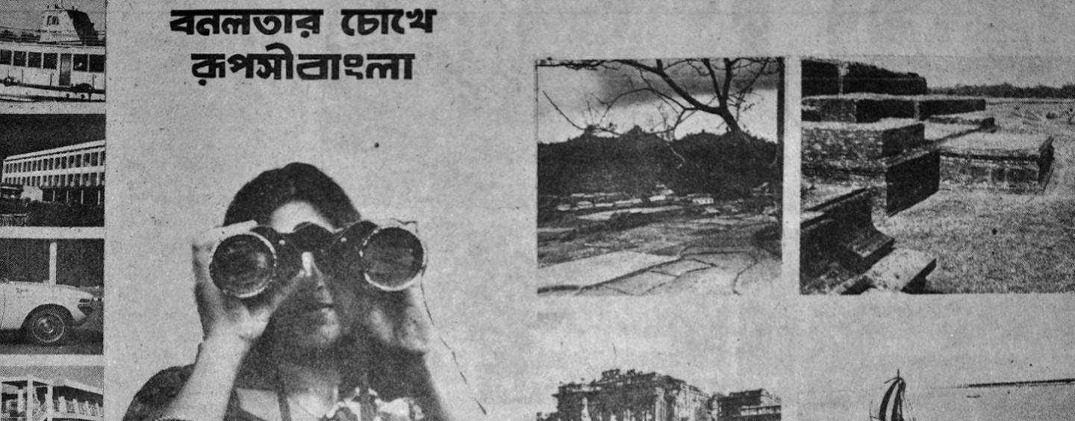
Figure 0-I

Sources: (Evolution of Branding in Bangladesh, n.d.)

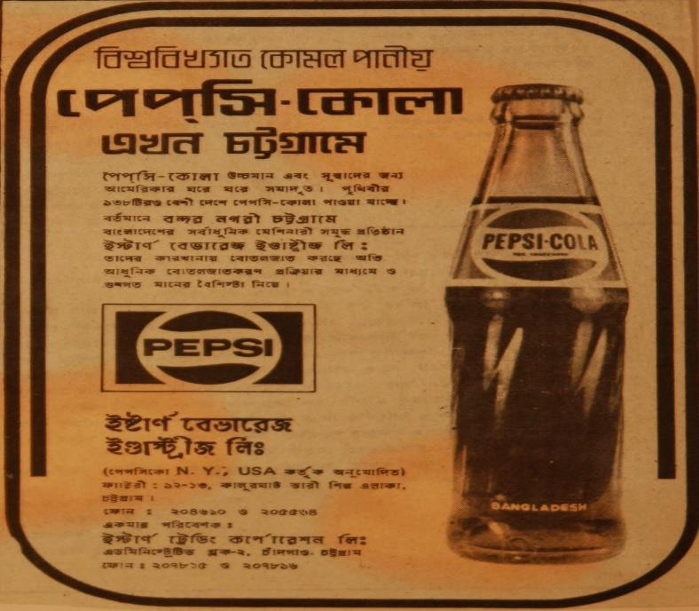

Figure 0-II

Sources: (Discover ideas about Pepsi Cola, n.d.)
Client: Eastern Beverage Industries Ltd. Brand: Pepsi
Agency: Bitopi

Indeed, we are discussing the beginning period of ad in Bangladesh.
Organizations in Bangladesh genuinely began getting the influence of brands during this time (in the mid 90's) with the development of TV especially BTV as the sole Station with the span of greater part individuals of Bangladesh. Marking around then was for the most part to make the item striking to the purchasers crosswise over nation.
Brands like Olympic Battery, with its jingle, and Sweet-smelling cleanser, with its halal cleanser recommendation, captured the greatest point of mind of the outstanding quality of the consumer without lifting a finger to produce publicity by using the lone correspondence channel, BTV.
Nonetheless, just remarkable quality without consistent advancement of being important and unique can't drive the development of brands, which has been seen in the following stage, which we term the "Improvement Phase" of advertising in Bangladesh. (Evolution of Branding in Bangladesh, n.d.)

2.3Size, trend, maturity of the industry:
The twenty-first century has provided new opportunities for individuals from all areas of life, just as it does for the rest of the globe. In Bangladesh, this has resulted in new metrics in the lives of customers as well as new challenges for brands and ads. A portion of the key significant occasions of this time was:
- The telecom blasts.
- Development of new stations with the test of enhanced purchasers’ consideration.
Also, Development of neighborhood brands adjacent to their global partners RC cola, Keya, Magic, Summit and so on.

The fear of commoditization of brands was also felt by the media and correspondence organizations, which were highly renowned in the 1990s for their saliency-based communication. GP with its 'ubiquity-solid system-passionate' interface message with the removed old one that was saliency focused and Lux with 'magnificence' are two of the leading brands at the time that realized the need for a strong message as well as creating brand affiliations.
Overflow impacts of Indian adverts also started to come is Bangladesh and made the method for various topical correspondences separated from the saliency-based correspondence of 90s.
After that strong purpose of brand emotion and definition started to play vital job.
Telecom and FMCG sectors started showing up its appearances in once in a while. This industry also made the showcasing of different routes for communication.
At that point people have just observed adverts are not just musical jingles and brands have understood that buyers' adoration and trust can't be earned by exclusively counts on saliency- based correspondence. (Evolution of Branding in Bangladesh, n.d)
From that starting point in our nation the greater part of the advertisements is emotion based than innovative (GP's Adv). Greatest advertiser organizations give more attention on products than the advantages and experiences are created by the products (Banglalink's Adv). Many advertising firms picks to fake information in their advertisement (fair and lovely). In our nation promoting isn't pre and post tried by customers. They attempt to connect among product and advertisement. They overlook that they need to interface among exposure, item qualities, benefits, values, culture, character, and customers. (Ahmed, ISSN 2222-2839 (Online) Vol 3, No.5, 2011It might appear to be astonishing that although some advertising organization, for example, Bitopi, Asiatic, (previously East Asiatic) and Interspeed (previously Interspan) were in presence even before the independence of Bangladesh, advertising still doesn't appear to appreciate the status of a full-scale proficient industry in its own privilege in our nation. Before independence, there was next to no advertising in the nation because of insufficient industrialization. Is all the more astounding that however 48 years have passed since freedom, there is not really any study of development of the advancement of publicizing in Bangladesh. The couple of study that have been led from a buyer point of view are not really open even to scholastic scientists. The requirement for further scholastic research as of right now appears, like never before, relevant (Anwar)

2.2.3 External factors
From 1917 to the present, the workload had increased to the point where it was no longer simply copywriting for the publicist, but a range of other jobs as well. During the government time, some agencies grew into promoting and showing advocates for publicists. Statistical surveys, media testing, marketing administration, dispersed development, works of art, etching monitoring, and other forms of organization administration are now in use.
But in our country, there was next to no promoting practice in Bangladesh before autonomy (1971) because of insufficient industrialization and learning. Requests for specific promoting organizations were restricted. Pioneers in
the field, for example, Bitopi, East Asiatic (presently Asiatic), and Interspan entered the market nearly in the year1967.
Other advertising agencies began their business after freedom. Presently the all-out quantities of advertising firms are just about seven hundred including unregistered.

But are some other firm who are recently making some names are

In the country, there is no legal system for tracking advertising companies. According to official media reports, Bangladesh Television has registered 150 agencies (BTV). On the other hand, the top nine advertising agencies in the country control the majority of the market.
These agencies are Adcomm, Asiatic, Bitopi, Unitrend, Grey, Jarvis digital, Interspeed, Popular, Madonna and Matra. Other advertising agencies claim only a low share, while the rest is accrued to in-house advertisement of business firms and enterprises. Leading advertisement agencies list are Ad comm Ltd, Media Comm Ltd ,Tint Communication ,Asiatic Marketing Communication Ltd, Neptune Adverting, Universal Media, Benchmark Limited, Nimbus Adverting, Unitrend Ltd, Beach Adverting, Nishu Advertising ,ZANALA Bangladesh, Bitopi Adverting ,Popular Advertising ,ACI Media Expression Ltd, Prism Andes Ltd ,Grey Advertising Bangladesh, Protishabda AD, Headquarter Interface Communications, Roop Communications.
AD SCIENCE, Interspeed, Advertising Step Media Ltd, Bicon Ad, madmen digital ,Mattra Tribune, Advertising Care, Ad Charisma, Chowdhury Advertising, Confidence DeshProcharoni. Dhara Ad Discovery Don Advertising. DP7 Elegant Advertising. Expressions Ltd. Gemini Genesis Glory Ad. GUNGCHIL Goti Media Ltd. Images Impression Ltd. Inter Ad. Private Ltd, Madona Media plus.Mediamix Enterprise Ltd. PoliAdverting. Prova Ad Corner. Rubicon Sani Advertising. Sharna Trade International the Austral Publicity Turn Communications Vision Advertising Wings. AdvertisingtheProgoti. Adverting Rekhayon. Advertising Ltd, Arani Advertising.
Till now, just some of the journals has observationally broke down Bangladeshi advertisements from linguistic and moral points of view. They take at commercial business advertisements and shows how certain semantic convincing techniques are utilized to control buyers. However, in spite of concentrating on linguistic and moral viewpoints in Bangladeshi advertisements, he doesn't make reference to anything about the need of a particular code of ethic or educational ads ( Deceptive Advertising: A Case Study of Advertising Claims in Bangladeshi Commercials) Advertising that misdirect purchasers about products or services would consider as unethical irrespective of that particular and specific culture, social, religion, or political standards of the nation. ( Spence, E. and Van Heekeren, B. (2005), )
The utilization of sex in advertising can be profoundly overt or incredibly subtle. It ranges from moderately presentations of sexual acts, to the utilization of basic cosmetic to enhance attractive features.

2.2.4 (Technological factors):

Advertising at present period:
Those were lovely to hear over and over however not great enough to catch the eye. Consequently, the top brands of this period drove the game with seriously separated recommendation like Horlicks being an extraordinary entertainer for moms continually strained about her youngster's physical and mental/Reasonable and Stunning – certainty and enabling ladies/Grameen Telephone– The inescapable ruler brand remaining next to individuals when it is tied in with associating at crisis Incredible brands today are not just practically separated, they make further significance and enthusiastic reverberation to purchasers' brain too.
Along these lines, the TVCs of telecom administrators began to hit branded with young, fun, move, show, and emotion in communication messaging. We began to realize the need for independence from FMCG brands in order to stay on the ball. However, looking back on those years, it would appear to be a joke to discuss what many refer to as online life, such as Facebook, WhatsApp, and Android.
During this time, a number of significant events occurred that altered the lives of consumers in ways we could not have predicted ten years ago. As a result, the process of promoting a brand became increasingly complex: 4G, cell phones, Android, Facebook, and other web-based life advancements.

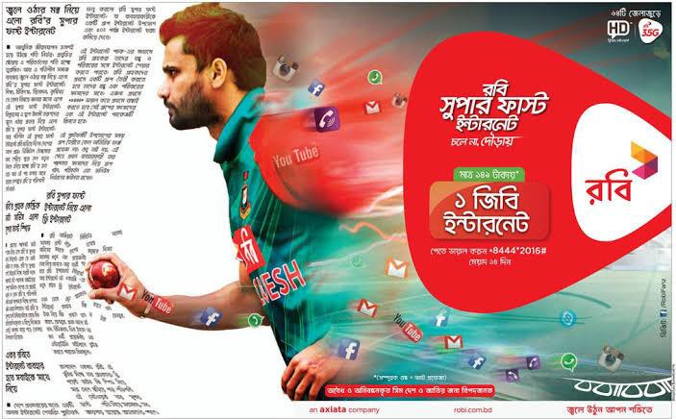

Figure 0-III Figure 0-IV

Sources (Robi 4g internet, march 2019) Sources (NO DORAI poster, 2019)

Twenty to thirty-year-old’s/age have become the biggest customer portion and spenders in the market who are continually admiring the worldwide culture and brands also.
For the use of wide spread of advertisement Neighborhood brands are testing worldwide brands like Ensemble, Sandalina, Chaka, Peak and even some Bangladeshi brands are going worldwide like – Pran
Development of nourishment and style brands
flourish of online based business (connected with MFS/bKash) with the shorter capacity to focus just as quicker exchange technique empowered with good budget Help (bKash).
As we enter in 2019, we can see that brands are more important now than in previous timeframes when the entire nation and economy are on the rise. Shopper portions are becoming more grounded in every category, and effective brands are consistently creating significant differentiation. Regardless of whether it's advertising by means of old backups like TV, papers, and radio or newer media like mobile phones and web-based, earning buyer trust is the sacred goal of a successful campaign, according to Nielsen's most recent promotional report. The uplifting news for promoters is that buyers around the world are more convinced now than they were quite a long time prior. Truth be told, the examination reveals that trust in web-based publicizing is expanding, as is trust in advertisements on TV, radio, and film screens.
Now The computerized advertising ecosystem system is quickly developing nowadays, as advertisers keep on adjusting to new platform, gadgets, and promotion designs (business insider digital trend , n.d.)

2.2.5 Barriers to entry:
Now a days the hypotheses and research methods of mental and psychological human studies have a lot to offer business, particularly showcasing and promoting .It is for all intents and purposes difficult to escape from promoting, yet we know so minimal about it. Visual (pictorial) and verbal (textual) components in advertisements work to send the fitting message to the intended interest group.
In Bangladesh, marketing is concerned with fundamental issues such as communication, development, and so on. The advertising industry and my research are inextricably linked. Advertising and cultural changes in my opinion, are inextricably linked. Research is the most important aspect of creating an advertisement. When conducting research, one must keep the environment in mind. Research is based on recent as well as previously used information, so by observing changes in patterns and evolution, we can get a good idea of how the advertisement is progressing and may progress in the future. So this is the research that will assist you in learning these.

2.2.6 & 2.2.7 Supplier power & Buyer power:
To know about the further side of evolution of the features and changes patterns of advertisement in the media of Bangladesh from different journal and article and try to find out the proper information on it. Though given article is not directly connected with our country recruitment and selection policy but there is some important information is given here.

2.2.8 Industry Rivalry:
According to the topic this kind of report is not available properly in a comparative way, so there are not enough data to fix the project requirement to the point. I tried my best to collect the information from available journal, article and verified website.

2.3 Literature Review:
An organizational profile, also known as a corporate profile, consists of basic information about the firm's history and progress, its past performance and expected future progress, the company's reputation, and specifics about the items and services it offers.

- Magnito Digital: Magnito Digital is a full-service digital marketing business that focuses on providing end-to-end digital marketing solutions. They help consumers with search, social, display, and mobile marketing, among other things. They offer custom-made things that allow them to cater to a wide range of clients' needs. They are at the very top of the priority list.

- Grey Advertising Bangladesh: Founded in New York City's garment district as a one-man, one-room retail business, Grey Group has grown to become one of the world's leading advertising and marketing agency networks. Grey Advertising Bangladesh Ltd., the Grey Group's Bangladesh branch, is the country's first and only truly global advertising firm. Grey Advertising Bangladesh Ltd. has grown to become the country's most prestigious and sought-after agency by adhering to the global ethos of producing "famously effective" work. It is ranked number two on this list.

- Asiatic JWT: Asiatic JWT is one of Bangladesh's oldest and largest communication firms. It is ranked number three on this list. It also collaborates with the finest brands, as determined by third parties, and has received the most accolades of any Bangladeshi agency. JWT is related with Asiatic JWT.
The world's oldest and largest advertising agency, which is part of WPP, the holding corporation with the largest proportion of the global communication sector, Asiatic JWT is the flagship of Asiatic 360, Bangladesh's largest and most complete communication organization. Mindshare, Maxus, and Media-Edge CIA are three additional WPP firms that are part of the group's media companies throughout the world. Asiatic Events, Dhonichitra, MRC-Mode, Forethought PR, and five more firms are included in the group.
- Zanala Bangladesh: Zanala Bangladesh is a new-age marketing and communication firm. They create identity and communication strategies for all types of media, whether it's for product or service marketing or societal awareness. They have the people, the know-how, and the professional expertise to help you stand out in the market. They've collaborated with huge companies like UNICEF and Unilever, as well as a slew of smaller businesses. Graphic design, brand identity, and audio visual are among the services they provide, as are events and activations, campaigns, online and new media, and even kiosks. They are ranked fourth on this list.

- Bitopi Advertising: Bitopi Advertising, a Leo Burnett affiliateOn this list, they are ranked fifth. Their Facebook page has 7,606 likes. They are one of Bangladesh's top advertising agencies, with offices in Dhaka. They specialize in branding and advertising, and their efforts in Bangladesh have garnered honors. They are sure to produce excellent services and assist your company in growing in Bangladesh since they are backed by one of the industry's largest and most renowned companies.

6.StrateGeek Digital:Situated in Dhaka, Bangladesh, StrategieGeek Digital is an award-winning digital marketing agency that takes pleasure in developing and implementing some of Bangladesh's most groundbreaking online campaigns. Strate Geek was officially founded in 2014, but it has been in existence since 2012. It was previously the digital branch of Maverick Studios. As an autonomous SBU, the firm benefits from a laser-focused industry focus while maintaining content creation and development skills through agreements with Maverick Studios and Ice9 Interactive Ltd. It is ranked sixth on this list.

7.TBWA\Benchmark: 7.TBWABenchmark: TBWABenchmark is a renowned creative services firm in Bangladesh, with clients including Standard Chartered, Grameenphone, Apollo Hospitals, Grameen Danone, Pizza Hut, KFC, HP, and SMC. TBWABenchmark is a top-ranking agency in terms of both creative reputation and annual turnover, with over 30 people. TBWABenchmark works across all disciplines to generate great business results for their customers as a totally integrated agency. They provide new insights on brand narrative and engagement by utilizing their global strategic planning tools, disruption, and media arts. They are ranked seventh on this list.
In Bangladesh, advertising agencies play a critical role in the promotion of goods and services. They assist in the introduction of a company's products and services to customers and end users. They aid in the development of a positive image for the firm, its products, and services. They are putting their best efforts into creating a captivating advertisement. Nowadays agency industries are active.

Chapter 3

(Research Method)

3.1 Introduction :
Advertisement process for a company or product is one of the vast practices in the overall private and public organization in our country. There are lots of company belongs to our country and the number of companies cannot display accurately through the information of local media, article and journal. But I am trying to show a probable number of companies.

3.2 Research Design: I survey among the Dhaka city from given from students, general people companies employee’s and those are Asiatic, Jarvis digital, madmen digital, bitopi and Magnito digital.

3.3 Sample:
I select five companies randomly for doing survey among employees and all the question are choose on basis of project topic demand.

Data Collection :
Data are collected from both primary and secondary data sources. The data sources are described below:

a) Primary Data Sources:
      - Personal discussion with the officers and executives.
      - Questionnaire interview with the employee.
      - Many of agency’s past and recent activities on the topic.

b) Secondary Data Sources:

      - Annual report of companies.
      - Different papers and forms related to information.
      - Official website.
      - Different websites.
      - Other published documents provided by companies.

3.4 Questionnaires Development:
This questionnaires development section has given below to chapter 5 .

3.5 Data analysis plan:
This report was created using data gathered from a variety of sources. Despite this, I have placed more emphasis on my practical observations. Almost the whole report is made up of my observations. Various sorts of information on current cultural policies and procedures are required for the study. In preparing this project report, I used both primary and secondary data.

Chapter 4

(Research Findings)

Analysis and Findings:

Demographic profile of the respondents:

    - Respondents Age:

a. 15-20 Years | 8.75%
b. 20-22 Years | 15.62%
c. 22-25 Years | 59.38 %
d. 25+ Years | 6.25 %

    - Profession:

Student | 28.12 %
Government Job | 21.88 %
Private Job | 31.25 %
Business | 12.5 %
Others | 6.25 %
    - Gender:
Male 76.25 %
Female 23.75 %
    - Education:

HSC or below | 21.88 %
Graduate | 53.12 %
Post Graduate | 25 %
    - Area: Dhaka Division 88 % Chittagong Division 12

GOLDEN ERA OF ADVERTISEMENT

1981-1990s
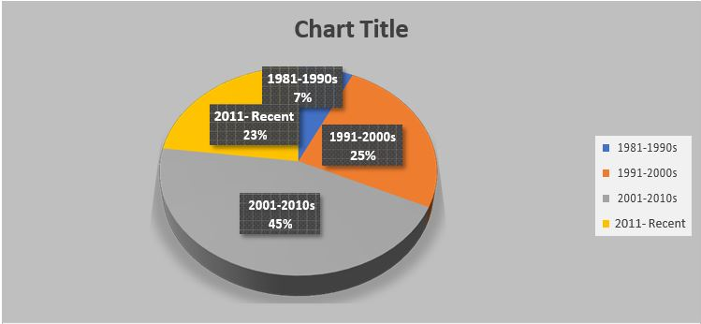
7%
Fig 1: Here in this pie chart we can see that the golden era of advertisement people thinks is 2001-2010 mostly because they are nostalgia to that era. People are taking positively also the recent era of advertisements

Watching ads regularly


Chart Title
20%
3%
15%
Strongly Disagree
Disagree Neutral
32%
30%
Agree
Strongly Agree
Fig 2: Maximum respondent agreed with that they watch ads regularly Second highest strongly agree with that and they have to say even if they try to skip it sometime, they watch it because they like it and sometime, they have to see it forcibly

Enjoyment


Chart Title
16%
8%
19%
17%
40%
Strongly Disagree
Disagree Neutral Agree
Strongly Agree

Fig 3: In here mostly respondence gave answer to neutral as they have to say sometimes, they really do like watching some ads and sometimes they don’t

Now a days TV is the medium for mostly watching advertisement.


Chart Title
11%
15%
42%
9%
23%
Strongly Disagree
Disagree Neutral Agree
Strongly Agree

Fig 4: Most of the respondence had to say no to that as they think unlike past online and others is the medium for mostly watching ad and for today’s time TV is not at the highest-level point as it were

Do ads match with our practical life


Chart Title
12%
25%
24%
24%
15%
Strongly Disagree
Disagree Neutral Agree
Strongly Agree
Most respondent had to say about it is sometimes ads do match their real life and sometimes they don’t.

Ads are necessary for our daily life


Chart Title
8%
25%
11%
19%
37%
Strongly Disagree
Disagree Neutral Agree
Strongly Agree
Fig 6: most respondent agreed and strongly agreed on that because they think without ad, they won’t able to about new product or the necessity they going to need to their life properly

You watch ads because you are bound to watch it


Chart Title
25%
19%
Strongly Disagree
Disagree
15%
Neutral
Agree
26%
15%
Strongly Agree
Fig7: the respondent agreed and strongly agreed on that because while watching any medium sometimes they have to watch ad forcibly and they can’t try to stop it.

You wish to watch old age ads again or do you miss them


Chart Title
8%
30%
16%
17%
29%
Strongly Disagree
Disagree Neutral Agree
Strongly Agree
Fig 8: Most of the people agree that selection because they think its reminds them of that era because it usually makes them nostalgic thinking about the era they grew up.

If we compare old age ads with that of present, do you think ads are changing

Chart Title
4%6%
12%
52%
26%
Strongly Disagree
Disagree Neutral Agree
Strongly Agree
Fig 9: The ads are definitely changing the way result shows almost positive 52% is strongly agree with it.

If changes occur, they are positively changing


Chart Title
12% 15%
12%
19%
42%
Strongly Disagree
Disagree Neutral Agree
Strongly Agree

Fig 10: most respondence are on neutral on that section because they think some advertisement are positively changing and some are other ways

Do you think old age ads could be seen freely in front of all


Chart Title
12%%3%
Strongly Disagree
27%
Disagree
Neutral
67%
Agree
Strongly Agree
Fig 11: Here we can see that respondence strongly agreed with that section with 67% strongly agreed

Do you think modern ads can be seen freely in front of all


Chart Title
29%
38%
10%
19%
Strongly Disagree
Disagree Neutral Agree
Strongly Agree
4%

Fig 12: people are also agreed to this section mostly but less than old ads they use to watch with their family

Do you think present ads reflect our real Bangladesh?


Chart Title
9%
27%
8%
Strongly Disagree
Disagree
21%
35%
Neutral
Agree
Strongly Agree
Fig 13: Here mostly people agreed on that section telling without imaginary ad the ad shows reflects real Bangladesh.

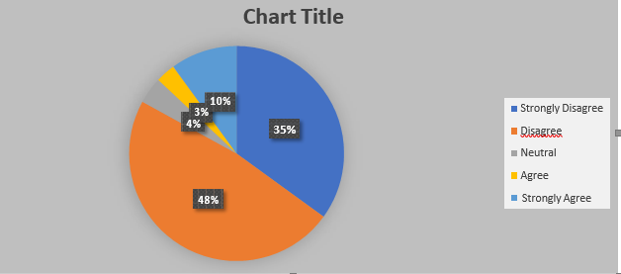
You think present ads system will survive in future

Fig14: mostly people have to disagree to that they feel these thing changes always and it will change in future

How do ads appear to you?

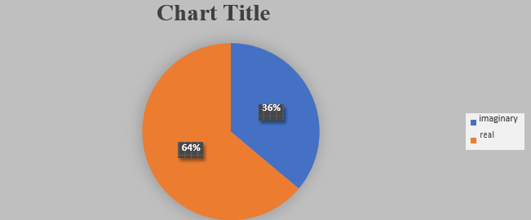

FIG 15- most respondence have to say about it is they see more real add imaginary

Which ads are comparatively more preferable to you?

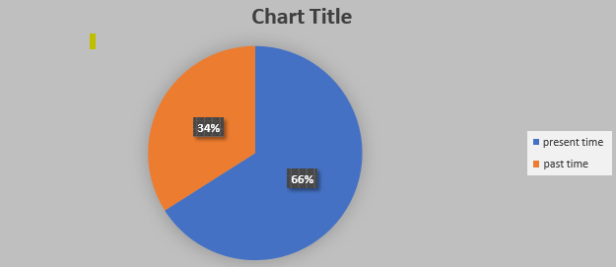

Fig16: most respondence likes present times ad preferably because compare to old times they are more fun and likable to watch.

Chapter 5

(Discussion)

5.1 Suggestion for future Research:
Recent ads have changed to a bigger extent comparing to the old day’s ads. It has been done because of difference as the use of new technology and the presentation and also where is changing in advertisement field portraying our society and culture. It is also leading us to a society and culture where there is nothing unique rather is a blend of several cultures. Advertisement works like a boast to social and social change and lead the general public to worldwide culture. It is far simpler for advertisements since where motion pictures or shows speak to our own way of life, promotions mirror the outside culture in the vast majority of the cases. Their proposal for the individuals who make commercials was same to the answer of the general respondents and for the individuals who watch ads was same to the answer on the advertisement's organizations.

5.2 Recommendations:
To increase effectiveness, efficiency and quality of advertisement and keeping up with people to like with the evolution and changing in following sector the recommendations should be taken:

    - The advertising agencies should have employees who give customers and peoples personal attention. Agencies should understand the actual need. The firm should have the people’s best interests at heart.
It is important to remember that advertisements tend to persuade and affect children. Because of this, electric media adverts should be directed to people who are able to improve children’s need.
    - The results of this study suggest the need to design specific educational strategies that deal with effectiveness, efficiency and quality of the positive effects of television advertisements.
    - Although there are rules and regulation of controlling advertisement issues but sometime agencies broke it. So, authority should look on this.
    - People of our country seem advertisement effective. After all they want to improve the quality of this sector. Using of women body should be culturally.
    - Advertisement agencies should increase their research facility so that they could aware of their limitation.
    - Every public and private should have a fair and efficient complaints resolution.
    - Lacks of theoretical knowledge in this sector can hamper the study of this sector. We should increase our research in this sector.

    - Better ads should be produced based on real life stories.
    - Advertisement should be tasteful for everyone’s acceptance.
    - Directors and Producers should be adequate educated and cultured.
    - More ads should be produced for the educated audiences.
    - Educated actors and actresses should be there.

5.3 Conclusion: Advertising can be used to build up a long-term picture of a product or set off rapid sales. Geographically, advertising can be successful. The features and patterns of advertisement discipline that form the advertisement environment are very important. So, it can be a marketing study matter. This discipline's objectives are to inspire humans for their unique purposes. People are constantly accepting advertisements from a variety of media, consciously or unconsciously. Within marketing studies, it is of prime concern to recognize this matter. So, it has grown to be a social and cultural phenomenon. Social and cultural marketing can provide an interest for this purpose. Its demand has increased. From advertisements, people get motivation and pay cash to purchase products. So, it can also become an economic matter to learn about this material. Advertising has turned out to be a frequent buzzword in this modern era. It uses present-day science, data, and technological tools. Nowadays, commercials have moved from the digital to the real world; from cyberspace to the real world; from the outside to the inside and from the local to the global. Most of the advertisements are in visual form. So, it can additionally become a problem of visual marketing research. If we want to benefit from it, we must amass both theoretical and practical knowledge of the advertising sector. If college students got access to cutting-edge lab facilities from their universities, then they would be in a position to produce fantastic advertisements and this industry would be more favorable for professional development.

References:

Bibliography
(n.d.). Retrieved from http://en.wikipedia.org/wiki/sex in advertising
Basu, S. (2000). . (n.d.). Retrieved from Advertising trend in India” Scandinavian Journal of Management : Sylhet, Bangladesh, 01 jun, 2015, retrieved from, https://www.google.com.bd
Deceptive Advertising: A Case Study of Advertising Claims in Bangladeshi Commercials. (n.d.). AIUB Journal of Business and Economics, Vol. 3, No. 2 .
International Data Corporation (2006) . (n.d.). Retrieved from Mobile entertainment services not particularly popular among American consumers: http://www.idc.com/getdoc.jsp?containerId=prUS20475506
International Data Corporation Aisa-Pacifi c ( 2002 ). (retrieved Sylhet, Bangladesh, 01 Jun, 2015). Retrieved from Unwiring the internet: An end-user perspective: http://www.idc.com.sg/Press/2002/APPR- unwiring.htm
Spence, E. and Van Heekeren, B. (2005), . (n.d.). Advertising Ethics: Basic Ethics in Action, Upper Saddle River, New Jersey: Prentice Hall.
Ahmed, S. (. ( ISSN 2222-2839 (Online) Vol 3, No.5, 2011,). ‘Historical Perspective and Evaluation of Advertising Firms inBangladesh’,. European Journal of Business and Management ISSN 2222-1905 (Paper, www.iiste.org,.
Anwar, S. F. (n.d.). Advertising. In Banglapedia: National Encyclopedia of Bangladesh, Vol. 1. Dhaka. Asiatic Society of Bangladesh.
Belch, E. G. (n.d.). “The Promotional Mix”, Advertising and Promotion,. In t. M.-H. 7th ed..
business insider digital trend . (n.d.). Retrieved from http://www.businessinsider.com/digital-trends-to-watch-for-in- advertising-20143?op=1
Discover ideas about Pepsi Cola. (n.d.). Retrieved from https://www.pinterest.com/pin/443041682066524406/
Evolution of Branding in Bangladesh. (n.d.). Retrieved from brand forum bangladesh: http://bbf.digital/evolution-of- branding-in-bangladesh
Hassan, Mustafa Mahmud. (2016). Business Habit. Retrieved from Top Ten Advertising Agencies in Bangladesh: https://www.businesshabit.com/@onzsolutions/top-ten-advertising-agencies-in.html/comment/3
Ho, J. ((2004) ). ‘Yams see bright future for online adverts’,The Taipei Times . Retrieved from http://www.taipeitimes.com/News/biz/archives/2004/01/14/2003087598
Hoffman, K., Parejo, M., Bessant, J. and Perren, L. (n.d.). In K. P. Hoffman, : A Literature Review’, Technovation‘Small Firms, R&D, Technology and Innovation in the UK (pp. 18(1): 39–55.).
http://ethos.anthro.illinois.edu . (n.d.).
http://www.nielsen.com/us/en/insights/news/2013/under-the-influence-consumertrust-in-advertising.html. (n.d.). Retrieved from http://www.nielsen.com/us/en/insights/news/2013/under-the-influence-consumertrust-in- advertising.html
Kotler, Phlip and Armstrong, Gray (2004),. (n.d.). In P. a. Kotler, Marketing Management, (9th edition), (p. pp637).
Pearson Education Inc.
NO DORAI poster. (2019). Retrieved from https://www.imdb.com/title/tt9892338/
Robi 4g internet. (march 2019). Retrieved from https://www.robi.com.bd/en
Sanage, C.H. (1939),. (n.d.). In The Advertising Agency”, Advertising Theory and Practice (seventh edition), (pp. pp.625-647). Business Publication.
Shariar Haque, M. (2012). ‘Discourse Structures in Bangladeshi Educational Advertisements: A Critique’. Discourse of Advertising.

